Artificial Neural Network for Forecasting Car Mileage per Gallon in the City

Mohsen Afana, Jomana Ahmed, Bayan Harb, Bassem S. Abu-Nasser, Samy S. Abu-Naser
Department of Information Technology,
Faculty of Engineering & Information Technology,
Al-Azhar University - Gaza, Palestine
abunaser@alazhar.edu.ps

Abstract
In this paper an Artificial Neural Network (ANN) model was used to help cars dealers recognize the many characteristics of cars, including manufacturers, their location and classification of cars according to several categories including: Make, Model, Type, Origin, DriveTrain, MSRP, Invoice, EngineSize, Cylinders, Horsepower, MPG_Highway, Weight, Wheelbase, Length. ANN was used in prediction of the number of miles per gallon when the car is driven in the city(MPG_City). The results showed that ANN model was able to predict MPG_City with 97.50 % accuracy. The factor of DriveTrain has the most influence on MPG_City evaluation. Similar studies can be carried out for the evaluation of other characteristics of cars.

Keywords: Artificial Neural Networks, Dataset, Cars, ANN, Cars Types

- Introduction
This study evaluates the utilization of neural networks for predicting suitability of a car. It justifies the use of neural networks in this industry for the prediction process. Generally, car manufacturing industries include design, development, manufacturing, marketing and sale of different equipment for motor vehicles. The set of companies and factories involved in design, manufacturing, marketing, and sale of motor vehicles are a part of this industry.
In 2017, more than 97.3 million motor vehicles including regular cars and commercial cars were manufactured around the world. In 2017, a total number of 96.8 million cars were sold in the world, with 25.2 million sold in Europe, 32.6 million sold in Asia and Pacific Region, 25.8 million sold in the US and Canada, 4.6 million sold in Latin America, 7.4 million sold in the Middle East, and 1.2 million sold in Africa[7].
When the market was suffering a recession in the US and Japan, Asia and South America expressively grew and got sturdier. It appears that big markets in Russia, Brazil, India and China have practiced a rapid growth. The car industry, as one of the biggest industries in the world holding a great amount of persons, financial and time resources, is in grim need of precise predictions of its future and its contestants to reach great and sensitive decisions.
Maybe one of the major concerns of the managers and manufacturers in the car industry and the investors in this field is the prediction of cars sales and arrangement for the future manufacturing volume. If managers can have a more precise prediction regarding the future sales volume and car demand, they can unconditionally enhance the investment volume, used workforce and optimally use time to reach optimal decisions and convey their instruction plans.

- Objectives
The main aim of this study is to determine Cars which would be suitable and do well for the customer. There are many companies who make cars around the world each company makes a lot of cars for a different customer.
The quality of car delivered for any customer influences the response to the car dealer, so we must learn how to choose correctly the car because it affects the economy of society.

- The Artificial Neural Networks
Artificial neural networks are one of the key tools used in machine learning. As the neural fragment of their name proposes, they are brain-inspired systems which are envisioned to imitate how persons learn. Neural networks made of input and output layers, besides (in most cases) a hidden layer comprising units that transmute the input into roughly that the output layer can practice. They are outstanding tools for discovering patterns which are far excessively complex or many for a human programmer to quote and teach the machine to identify [1-3].

While neural networks (also named perceptrons) have been around since the 1940s, it is only in the last several years where they have become a successful application of artificial intelligence. This is due to the algorithm backpropagation, which allows networks to adjust their hidden layers of neurons in situations where the outcome doesn’t match what the creator is hoping for — like a network designed to recognize oranges, which misidentifies an apple, for example[3-5].
Another significant issue in ANN has been the appearance of deep learning neural networks, in which different layers of a multilayer network excerpt different features until it can recognize what it is looking for.
For a basic idea of how a deep learning neural network learns, imagine a factory line. After the raw materials (the data set) are input, they are then passed down the conveyer belt, with each subsequent stop or layer extracting a different set of high-level features. If the network should recognize an object, the first layer might examine the brightness of its pixels [6].
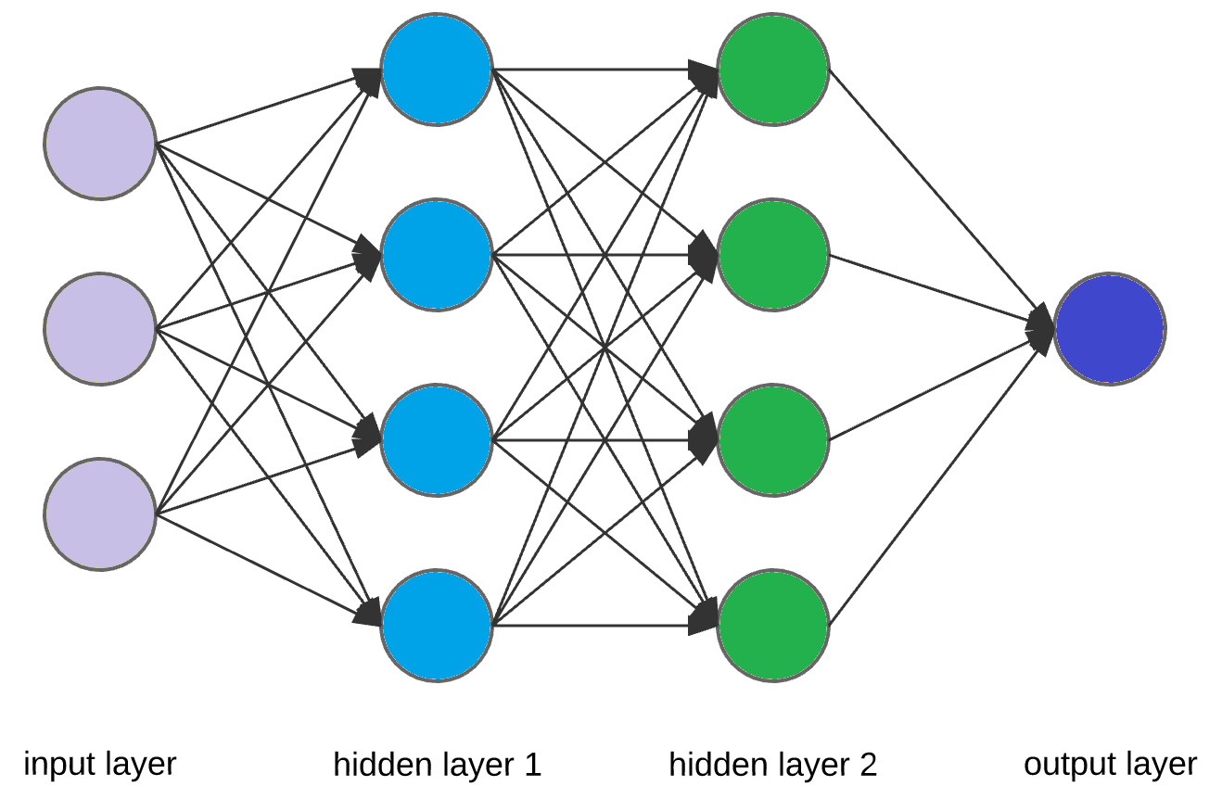

Figure 1: Typical ANN architecture
The next layer could then identify any edges in the image, based on lines of similar pixels. After this, another layer may recognize textures and shapes, and so on. By the time the fourth or fifth layer is reached, the deep learning net will have created complex feature detectors. It can figure out that certain image elements (such as a pair of eyes, a nose, and a mouth) are commonly found together.
Once this is done, the researchers who have trained the network can give labels to the output, and then use backpropagation to correct any mistakes which have been made. After a while, the network can carry out its own classification tasks with no need of humans to help every time.
Beyond this, there are different types of learning, such as supervised or unsupervised learning or reinforcement learning, in which the network learns for itself by trying to maximize its score — as memorably carried out by Google DeepMind’s Atari game-playing bot [4].
3.1 Types of neural network
There are multiple types of neural network, each of which comes with their own specific use cases and levels of complexity. The most basic type of neural net is called a feedforward neural network, in which information travels in only one direction from input to output.
A more widely used type of network is the recurrent neural network, in which data can flow in multiple directions. These neural networks possess greater learning abilities and are widely used for more complex tasks such as learning handwriting or language recognition.
There are also convolutional neural networks, Boltzmann machine networks, Hopfield networks, and a variety of others. Picking the right network for your task depends on the data you have to train it with, and the specific application you have in mind. Sometimes, it may be desirable to use multiple approaches, such as would be the case with a challenging task like voice recognition.

3.2 The tasks that neural network can do:
From making cars drive autonomously on the roads, to generating shockingly realistic CGI faces, to machine translation, to fraud detection, to reading our minds, to recognizing when a cat is in the garden and turning on the sprinklers; neural nets are behind many of the biggest advances in Artificial Intelligence.

Broadly speaking, however, they are designed for spotting patterns in data. Specific tasks could include classification (classifying data sets into pre-defined classes), clustering (classifying data into different undefined categories), and prediction (using past events to guess future ones, like the stock market or movie box office).

3.3 How ANN learns:
In the same way that we learn from experience in our lives, neural networks require data to learn. In most cases, the more data that can be thrown at a neural network, the more accurate it will become. Think of it like any task you do over and over. Over time, you gradually get more efficient and make fewer mistakes.

When researchers or computer scientists set out to train a neural network, they typically divide their data into three sets. First is a training set, which helps the network establish the various weights between its nodes. After this, they fine-tune it using a validation data set. Finally, they’ll use a test set to see if it can successfully turn the input into the desired output.

3.4 Limitations of neural networks
On a technical level, one of the bigger challenges is the amount of time it takes to train networks, which can require a considerable amount of compute power for more complex tasks. The biggest issue, however, is that neural networks are black boxes, in which the user feeds in data and receives answers. They can fine-tune the answers, but they don’t have access to the exact decision making process.

This is a problem where many researchers are actively working on, but it will only become more pressing as artificial neural networks play a bigger and bigger role in our lives.

- Methodology
By looking deeply through the cars types and soliciting the experience of human experts on cars' performance, several factors that are having influence customer response were outlined. These factors were cautiously studied and synchronized into a convenient number appropriate for computer coding within the Just Neural Network (JNN) environment.

These factors were classified as input variables as shown in table 1.
The output variables embody some likely levels of performance of cars in terms of Excel file with a study summary performance of cars as shown in table 2.

4.1 The Input Variables:
This car dataset has attributes relating to cars such Make, model, type, organ, invoice, Cylinders, etc.

Table1: Input Attributes
Attributes: | Usage: | Type: | Range:
Make | Input | Alphabetic
Model | Input | Alphabetic
Type | Input | Alphabetic
Origin | Input | Alphabetic
DriveTrain | Input | Alphabetic
MSRP | Input | Numeric | $10,280 to $192,465
Invoice | Input | Numeric | $9,875 to $173,560
EngineSize | Input | Numeric | 1 to 8
Cylinders | Input | Numeric | 3 to 12
Horsepower | Input | Numeric | 73 to 500
MPG_Highway | Input | Numeric | 12 to 66
Weight | Input | Numeric | 1,850 to 7,190
Wheelbase | Input | Numeric | 89 to 143
Length | Input | Numeric | 144 to 238

4.2 The output Variable:
The attribute which represents the output variable is called MPG_City (Number of miles per gallon when the car is driven in the city).

Table2: shows the output variable
Attributes: | Usage: | Type: | Values: | Range:
MPG_City | Output | Numeric | Number of miles per gallon | 10 to 60

4.3 Network design and optimization
The main goal of the work presented in this section was done to find which one of the various feed-forward backpropagation ANN combinations and architectures would be the best for predicting car mileage per gallon when driven in the city and also the network architecture that would be suitable for the small dataset available for the training.
The design and optimization of the ANN network was implemented out in three steps. In the first step the fundamental parameters for the network, like the transfer functions and the training functions have been examined.
In the second step the pre-processing of the data that is proper for the network has been examined. Finally,
In the third step of the network optimization has been implemented to find the most proper number of hidden layers and the number of proper neurons in each layer. It has been proposed by many researchers that the selection of all the factors that have been defined above is a trial and error process [1].

4.4 Evaluation of the ANN Model
There are 628 instances in the car data set. The data set then was divided into a training set (428) with a percentage of (69%) and a validation set (200) with a percentage of (31%).

The final optimized ANN model comprised five layers:
- One input layer which has 14 input (14 attributes),
- Three hidden layers, the first hidden layer has three neurons, the second hidden layer has one neuron, and the third hidden layer has 7 neurons.
- One output layer with one neuron.

The final optimized ANN model was trained with the training data set and then validated with the validation data set.
The final optimized ANN model architecture is shown in Figure 3. The most important factors contributing in ANN model was determined and the most influential factor was DriveTrain as shown in Figure 4.
The training and validation summary is shown in Figure 2 and Figure 5. The accuracy of predication of MPG_City was 99.5% and the number of cycles was 27,646 as shown in Figure 5.

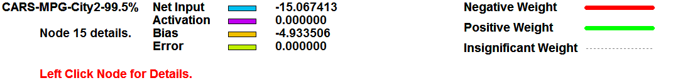
Figure 2: Final ANN model summary

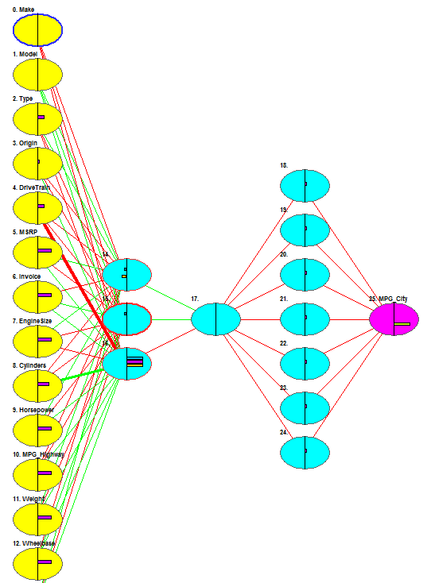
Figure 3: Final ANN model Architecture

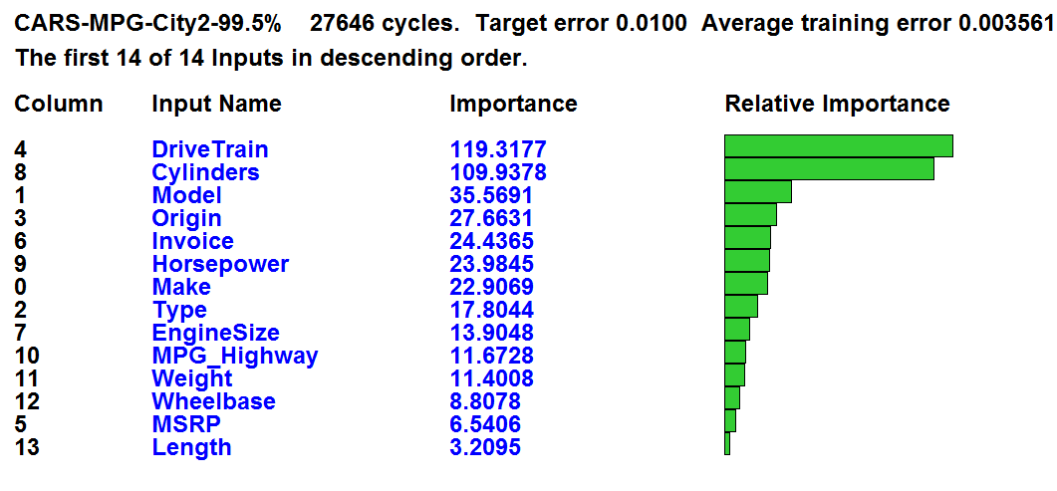
Figure 4: Most influencing factories on ANN model

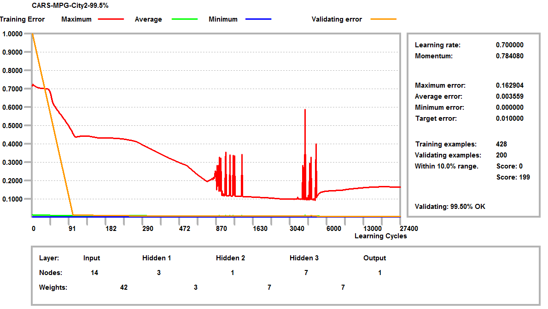
Figure 5: Training and validation Summary

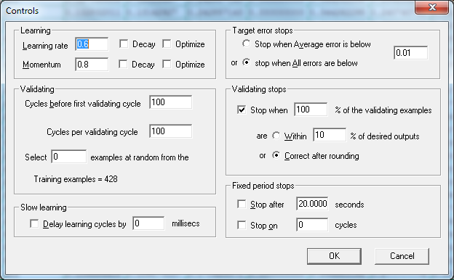
Figure 6: Control of the parameter of the ANN Model

- Conclusion
Acceptance of the product of increasing concern, the Car makers must know which factors influencing customers' buying decisions. Recently, deep evaluation of the product acceptability has been done, unfortunately, manufacturers repeatedly misinterpret the real needs of consumers, and how to test the acceptability of the product is the vital matter of product development.

In this paper, for the evaluation of car lines empirical research, using ANN for the evaluation of automotive forecasting a comparative study, the experimental results show that, ANN can assess car evaluation prediction well. In the evaluation of the car: the most significant factors of the ANN model were identified, and the accuracy of predication of the MPG_City was 99.5%.

References

- J. A. Lee, D. P. Almond and B. Harris, “The use of neural networks for prediction of fatigue lives of composite materials”, Composites: Part A, 30, (1999), pp.1159–1169.
- C. A. O. Nascimento, R. Giudici and R. Guardani, “Neural network based approach for optimization of industrial chemical processes”, Computers and Chemical Engineering, vol. 24, (2000), pp. 2303–2314.
- S. J. Russell and P. Norvig, “Artificial Intelligence A Modern Approach”, Prentice Hall, (2010). p. 578. ISBN 978-0-13-604259-4. The most popular method for learning in multilayer networks is called Back-propagation.
- V. K. Ojha, A. Abraham and V. Snášel, "Metaheuristic design of feedforward neural networks: A review of two decades of research". Engineering Applications of Artificial Intelligence, vol. 60, (2017), pp. 97–116.
- L. Ran, Y. Zhang, Q. Zhang and T. Yang, "Convolutional Neural Network-Based Robot Navigation Using Uncalibrated Spherical Images", Sensors, vol. 17, no. 6 (2017), 1341. doi:10.3390/s17061341. ISSN 1424-8220. PMC 5492478. PMID 28604624.
- D. Graupe, “Deep Learning Neural Networks: Design and Case Studies”, World Scientific Publishing Co Inc, (2016), pp. 57–110. ISBN 978-981-314-647-1.
- International Organization of Motor Vehicle Manufacturers (OICA). "2017 Production Statistics". OICA. Retrieved 2018-07-25.
- S. S. Abu-Naser, H. El-Hissi, M. Abu-Rass and N. El-Khozondar, “An expert system for endocrine diagnosis and treatments using JESS”. Journal of Artificial Intelligence; Scialert, vol. 3, no. 4, (2010), pp. 239-251.
- B. S. Abu-Nasser and S. S. Abu-Naser, “Cognitive System for Helping Farmers in Diagnosing Watermelon Diseases”, International Journal of Academic Information Systems Research (IJAISR), vol. 2, no. 7, (2018), pp. 1-7.
- A. W. Dahouk and S. S. Abu-Naser, “A Proposed Knowledge Based System for Desktop PC Troubleshooting”, International Journal of Academic Pedagogical Research (IJAPR), vol. 2, no. 6, (2018), pp. 1-8.
- A. Mrouf, I. Albatish, M. Mosa and S. S. Abu Naser, “Knowledge Based System for Long-term Abdominal Pain (Stomach Pain) Diagnosis and Treatment”, International Journal of Engineering and Information Systems (IJEAIS), vol. 1, no. 4, (2017), pp.71-88.
- S. S. A. Naser and M. M. Hilles, “An expert system for shoulder problems using CLIPS”, World Wide Journal of Multidisciplinary Research and Development, vol. 2, no. 5, (2016), pp.1-8.
- S. S. A. Naser and H. A. A. Hasanein, “Ear Diseases Diagnosis Expert System Using SL5 Object”, World Wide Journal of Multidisciplinary Research and Development, vol. 2, no. 4, (2016), pp. 41-47.
- B. S. Abu-Nasser, “Medical Expert Systems Survey”, International Journal of Engineering and Information Systems, vol. 1, no. 7, (2017), pp. 218-224.
- S. Abu Naser, I. Zaqout, M. A. Ghosh, R. Atallah and E. Alajrami, “Predicting Student Performance Using Artificial Neural Network: in the Faculty of Engineering and Information Technology”, International Journal of Hybrid Information Technology, vol. 8, no. 2, (2015), pp. 221-228.
- A. Elzamly, S. S. Abu Naser, B. Hussin and M. Doheir, “Predicting Software Analysis Process Risks Using Linear Stepwise Discriminant Analysis: Statistical Methods”, Int. J. Adv. Inf. Sci. Technol, vol. 38, no. 38, (2015), pp. 108-115.
- S. S. Abu Naser, “Predicting learners performance using artificial neural networks in linear programming intelligent tutoring system”, International Journal of Artificial Intelligence & Applications, vol. 3, no. 2. (2012), pp. 65-80.
- A. Elzamly, B. Hussin, S. S. Abu Naser, T. Shibutani and M. Doheir, “Predicting Critical Cloud Computing Security Issues using Artificial Neural Network (ANNs) Algorithms in Banking Organizations”, International Journal of Information Technology and Electrical Engineering, vol. 6, no. 2. (2017), pp. 40-45.
- S. S. Abu Naser and M. H. Al-Bayed, “Detecting Health Problems Related to Addiction of Video Game Playing Using an Expert System”, World Wide Journal of Multidisciplinary Research and Development, vol. 2, no. 9, (2016), pp.7-12.
- M. Al-Shawwa, A. Al-Absi, S. Abu Hassanein, K. Abu Baraka and S. S. Abu-Naser, “Predicting Temperature and Humidity in the Surrounding Environment Using Artificial Neural Network”, International Journal of Academic Pedagogical Research (IJAPR), vol. 2, no. 9, (2018), pp.1-6.
- S. H. Almurshidi and S. S. Abu-Naser, “EXPERT SYSTEM FOR DIAGNOSING BREAST CANCER. Al-Azhar University, Gaza, Palestine”, (2018).
- M. J. Abu Ghali, M. N. Mukhaimer, M. K. Abu Yousef and S.S. Abu Naser, “Expert System for Problems of Teeth and Gums”, International Journal of Engineering and Information Systems (IJEAIS), vol. 1, no.4, (2017), pp. 198-206.
- M. El Agha, A. Jarghon and S. S. Abu Naser, “Polymyalgia Rheumatic Expert System”, International Journal of Engineering and Information Systems (IJEAIS), vol. 1, no.4, (2017), pp.125-137.
- H. A. Al Rekhawi, A. A. Ayyad and S. S. Abu Naser, “Rickets Expert System Diagnoses and Treatment”, International Journal of Engineering and Information Systems (IJEAIS), vol. 1, no. 4, (2017), pp. 149-159.
- A. Nabahin, A. Abou Eloun and S. S. Abu Naser, “Expert System for Hair Loss Diagnosis and Treatment”, International Journal of Engineering and Information Systems (IJEAIS), vol. 1, no. 4, (2017), pp.160-169.
- S. R. Qwaider and S. S. Abu Naser, “Expert System for Diagnosing Ankle Diseases”, International Journal of Engineering and Information Systems (IJEAIS), vol. 1, no. 4, (2017), pp. 89-101.
- R. Khella and S. S. Abu-Naser, “Rule Based System for Chest Pain in Infants and Children”, International Journal of Engineering and Information Systems, vol. 1, no. 4, (2017), pp. 138-148.
- J. Y. AbuEl-Reesh and S. S. Abu Naser, “A Knowledge Based System for Diagnosing Shortness of Breath in Infants and Children”, International Journal of Engineering and Information Systems (IJEAIS), vol. 1, no. 4, (2017), pp.102-115.

