Irfan Ajvazi

Hieroglyphs In Ancient Egypt

Tesla Academy of Sciences

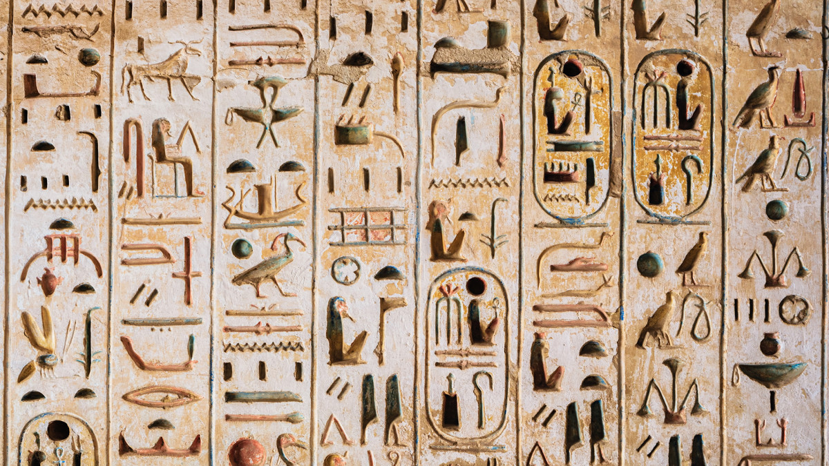

Hieroglyphs In Ancient Egypt

Throughout history in Ancient Egypt, information has been passed on from one generation to another. Information about culture and traditions has been passed on verbally and through scripts. From the time of the Old Kingdom (3100 B.C) in Ancient Egypt, hieroglyphs were used as a tool to pass on information about their history, culture and everyday lifestyle. Hieroglyphs, hieratic and demotic are three stages of writing that were practised throughout  Ancient Egypt ’s history. This paper will briefly explain the history and use of hieroglyphs in the Ancient Egyptian times.

It started off as pictures that were drawn in caves and on rocks around 5000 BC.As time passed by, the pictures evolved and turned out to be the hieroglyphic scripts. The question was what do they mean and what were they used for? (Wilson, 2003, P.2)

Scholars have spent so many years trying to decipher the script because they knew that deciphering the script was the key to understanding the Ancient Egyptian civilization. During Napoleon’s invasion of Egypt in 1799, a stone known as the “Rosetta Stone “ was discovered which helped decipher the hieroglyphs. The Rosetta Stone was an irregularly-shaped slab of black basalt that was discovered near a little town that was known as the “Rosetta.” The stone had a text recorded in three different scripts which were hieroglyphic, Demotic and Greek. The texts were written from right to left. Many scholars were able to understand the Greek and Demotic text, but they struggled to understand the hieroglyphic part of the text. A Frenchman named Jean –Francois Champollion was the first person to decipher the hieroglyphic part of the text in 1822. (Malek, 2002, P.5)

In 196 BC, the Rosetta Stone was written by a group of priest...

... middle of paper ...

...vidence it can be seen that people in Ancient Egypt were able to practice their religion in the form of writing.

Overall literature in Ancient Egypt was divided into three different phases. It started off with the hieroglyphs, then hieratic then demotic. Each type of writing was created for a reason. The hieratic was formed to help scribes for their office work and demotic was created under the belief that it might solve political issues. Without the discovery of the Rosetta Stone the history behind hieroglyphs would have not been discovered.

Literature is not just a paper and a pen, literature is the key to understanding a culture. Through the use of writing such as hieroglyphs, Ancient Egypt was able to solve political issues, practice their religion, and keep track of their past. Based on all this literature should be given great importance in today’s society.