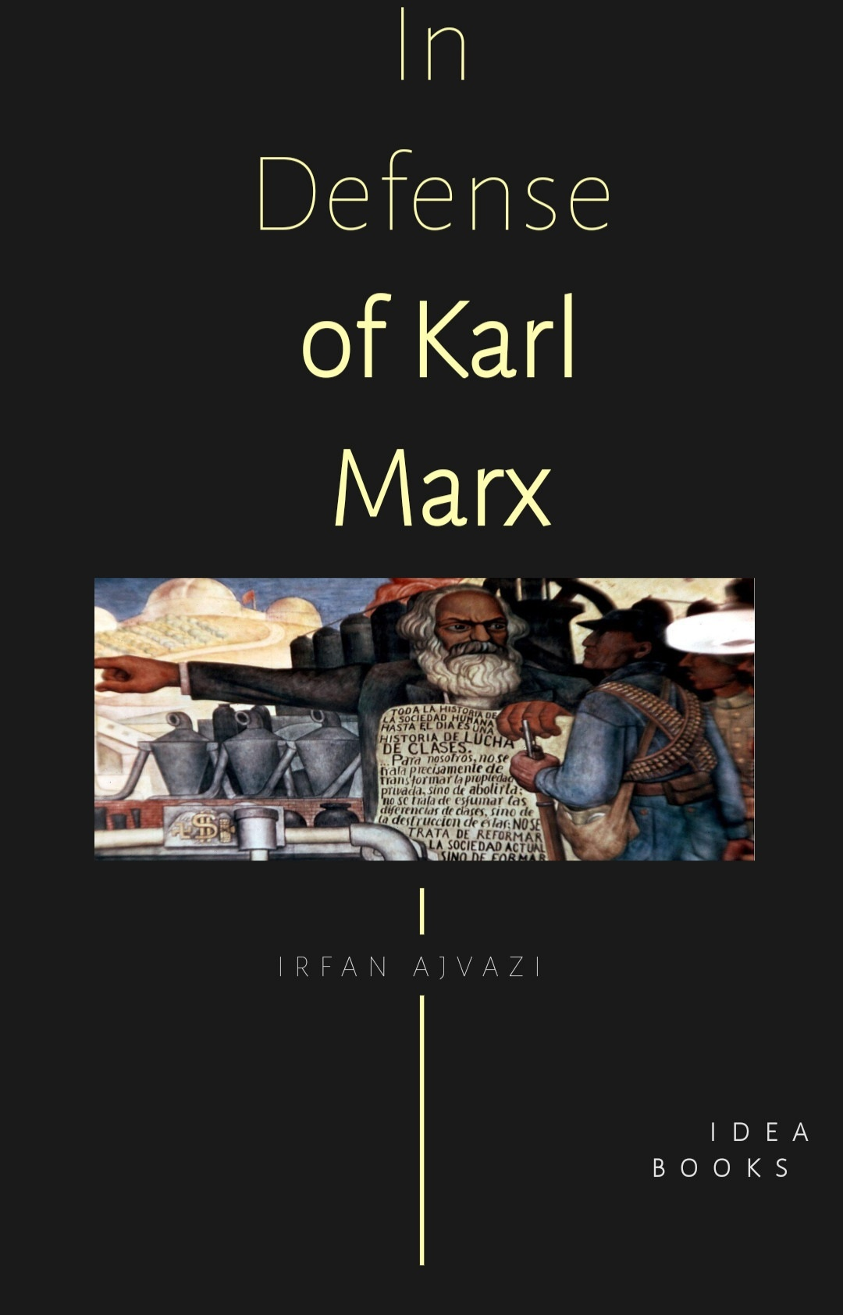

Chapter 1. **The Brave New World of Bill Gates and Big Telecom**

Imagine a world where the government doesn’t need police officers to apprehend those surfers or ticket you when you violate social distancing with your girlfriend. Suppose that computers discover your beach trip by tracking your movements using a stream of information from your cell phone, your car, your GPS, facial recognition technology integrated with real-time surveillance from satellites,

mounted cameras, and implanted chips. Desk-bound prosecutors or robots will notify you of your violation by text while simultaneously withdrawing your $1,000 penalty in cryptocurrency from your payroll account. Welcome to Bill Gates’ America. It’s right around the corner.

Gates, Elon Musk, Amazon, Facebook, and Telecom are launching the flagships for the

new Gold Rush, a teeming fleet of 50,000 satellites and a network of 2,000,000 ground antennas and cell towers to strip mine data from our smart devices. This microwave radiation-emitting spider web will allow Big Data/Big Telecom and Big Brother to capture what happens inside and outside every person at every moment of life. Gates will harvest, control, sort, characterize, analyze, and sell millions of terabytes of personal information from smart devices—private health data, medical records, our shopping habits, our biometric and

behavioral responses to advertising, our children’s ability to learn, our facial expressions, and conversations overheard by Siri, Alexa, and your open cell phone’s microphones. His and other corporations will use these analytics to develop Artificial Intelligence (AI) and turn you into a predictable, easily-manipulated consuming machine.

Corporations will use Gates’ 5G surveillance system to sell products and escalate AI capacity. Governments will use it to transition the globe to a

totalitarian singularity more despotic than Orwell ever imagined. Silicon Valley titans like Elon Musk, Peter Thiel, and Google’s Chief Engineer Ray Kurzweil talk longingly of “transhumanism,” the process by which humanity will transition to become part-human, part-machine via genetic engineering and surgical implants.

Bill Gates is investing heavily to accelerate this altered reality. His ambition to tag us all with injected subdermal vaccine data chips seems to be merely a

steppingstone toward an all-encompassing surveillance state.

Gates will even control your body, your bedroom, your medicine cabinet and even women’s menstrual and ovulation cycles. He invested approximately $18 million in MicroCHIPS, a company that among other chip-based devices, develops birth-control implant chips with wireless on/off switches and chips for drug-

delivery that allow a single implant to store and precisely deliver hundreds of therapeutic doses over months or years. The implants will be operated wirelessly by the patient to deliver medication. Knowing of Gates’ missionary zeal for population control, however, some customers might worry that the system could be remotely activated as well.

**2. Keynes is Dead; Long Live Marx!**

Many liberal economists envisioned a new dawn of Keynesianism in the 2008 financial meltdown. Nearly six years later, it is clear that the much-hoped-for Keynesian prescriptions are completely ignored. Why? Keynesian economists’ answer: “neoliberal ideology,” which they trace back to President Reagan.

This study argues, by contrast, that the transition from Keynesian

to neoliberal economics has much deeper roots than pure ideology; that the transition started long before Reagan was elected President; that the Keynesian reliance on the ability of the government to re-regulate and revive the economy through policies of demand management rests on a hopeful perception that the state can control capitalism; and that, contrary to such wishful perceptions, public policies are more than simply administrative or technical matters of choice—more importantly, they are class policies.

The study further argues that the Marxian theory of unemployment, based on his theory of the reserve army of labor, provides a much robust explanation of the protracted high levels of unemployment than the Keynesian view, which attributes the plague of unemployment to the “misguided policies of neoliberalism.” Likewise, the Marxian theory of subsistence or near-poverty wages provides a more cogent account of how or why such poverty levels of wages, as well as a generalized

predominance of misery, can go hand-in-hand with high levels of profits and concentrated wealth than the Keynesian perceptions, which view high levels of employment and wages as necessary conditions for an expansionary economic cycle [1].

**Deeper than “Neoliberal Ideology”**

The questioning and the gradual abandonment of the Keynesian demand management strategies took place not simply because of purely ideological proclivities of “right-wing” Republicans or the

personal preferences of Ronald Reagan, as many liberal and radical economists argue, but because of actual structural changes in economic or market conditions, both nationally and internationally. New Deal–Social Democratic policies were pursued in the aftermath of the Great Depression as long as the politically-awakened workers and other grassroots, as well as the favorable economic conditions of the time, rendered such policies effective. Those favorable conditions included the need to invest in and rebuild the

devastated post-war economies around the world, the nearly unlimited demand for U.S. manufactures, both at home and abroad, and the lack of competition for both U.S. capital and labor. These propitious circumstances, along with the pressure from below, allowed U.S. workers to demand respectable wages and benefits while at the same time enjoying higher rates of employment. The high wages and the strong demand then served as a delightful stimulus that precipitated the long expansionary cycle of the immediate post-war

period in the manner of a virtuous circle.

By the late 1960s and early 1970s, however, both U.S. capital and labor were no longer unrivaled in global markets. Furthermore, during the long cycle of the immediate post-war expansion U.S. manufacturers had invested so much in fixed capital, or capacity building, that by the late 1960s their profit rates had begun to decline as the enormous amounts of the so-called “sunk costs,” mainly in the form of plant and equipment, had become too

high [2].

More than anything else, it was these important changes in the actual conditions of production, and the concomitant realignment of global markets, which occasioned the gradual reservations and the ultimate abandonment of the Keynesian economics. Contrary to the repeated claims of the liberal/Keynesian partisans, it was not Ronald Reagan’s ideas or schemes that lay behind the plans of dismantling the New Deal reforms; rather, it was the

globalization, first, of capital and, then, of labor that rendered Keynesian-type economic policies no longer attractive to capitalist profitability, and brought forth Ronald Reagan and neoliberal austerity economics [3].

It should be emphasized that Keynesian stabilization policies were not abandoned for purely ideological reasons; i.e., because, as many critics of neo-liberalism argue, a laissez-faire animus spread from Chicago, infecting politicians of all parties and persuading them of the benefits of

free markets. . . . Keynesian systems of financial regulation (capital controls and managed exchange rates) could not withstand the growing pools of unregulated international credit, the Euromarkets, which came to dominate international finance [4].

When financial regulations, capital controls and a new international monetary system were established at the Bretton Woods (NH, New England) Conference in the immediate aftermath of WW II, international financial or credit markets were effectively non-

existent. The U.S. dollar (and to lesser extent gold) was, by and large, the only means of international trade and credit. Under those circumstances, international credit took place largely through the International Monetary Fund (IMF) and the central banks of the lending/borrowing countries—hence, the enforceability of controls.

This picture of international credit/financial markets, however, gradually changed; and by the late 1960 and early1970s, those markets had grown to the tune of

hundreds of billions of dollars, thereby allowing international credit transactions outside of the IMF–central banks channels. The two major factors that significantly contributed to drastic inflation of international financial markets were (a) the computer-generated international credit, and (b) the immense proliferation of Eurodollars, i.e. U.S. dollars deposited in overseas banks. The footloose-and-fancy-free global finance/credit has grown so big during the past several decades that it has made domestic or national controls and regulations

virtually ineffectual:

Critics of international finance have made various proposals to stabilize the system and make it more appropriate to the purposes of economic and social development. The most common suggestion has been a return to the cross-border capital controls that existed during the 1940s and the 1950s. Such controls, in many cases, were not eliminated until the 1990s. However, international bank deposits and financial assets held abroad are now so large that it would be difficult to

enforce such controls. Indeed, the main reason for getting rid of such regulations was precisely because they could not be enforced [5].

It is obvious, then, that the weakening or undermining of control and/or regulatory safeguards was brought about not so much by purely ideological tendencies of certain politicians or policy makers as it was by the actual developments in international financial markets.

3. **Human Rights: A Marxian perspective**

For nearly three hundred and fifty years, human rights have been important, if not dominant, instruments in the endeavor for social justice. For much of this history, contestants have cited universal rights as marking their position on the field of struggle.

It is equally important to notice

that before the seventeenth century, social justice was more often than not contested in a language other than rights-talk.

If Froissart’s *Chronicles* are to be believed, the *Jacquerie* of the French countryside and the English peasantry of the 1381 uprising knew no full-blown notion of universal human rights. Instead, they sought to replace unjust lords or appeal to their regent for redress from injustice. It was not their rights that they demanded — for they knew of none — but a measure of fairness or humane

treatment.

John Ball, a leader of the English rebellion that came within a deceitful moment of winning peasant “liberation” in 1381, was said to have preached: “We are called serfs and beaten if we are slow in our service to them, yet we have no sovereign lord we can complain to, none to hear us and do us justice. Let us go to the King — he is young — and show him how we are oppressed, and tell him that we want things to be changed, or that we shall change them ourselves.”[1] It was the

wisdom and the sense of justice embodied in a higher power appealed to here and not a set of rights, a higher power who would prove treacherous in the end. As a translator of Froissart’s *Chronicles***,**Geoffrey Brereton, affirms, Froissart “uses no word exactly corresponding to ‘equal’.” Rather, he uses “all one” or “all together” for a shared fate. Equality, it appears, is a necessary condition of our modern use of “universal rights” and not witnessed by Froissart

Less than three hundred years later, human rights, universal rights, had established a solid beach head in social justice thinking. Heralding a new age of constitutions (the codification of rights), the English Civil War provoked debates over a world devoid of feudal privilege and divine right. By the 1640’s in England, the notion of “natural” rights — universal in scope — occupied the adherents of militant anti-sovereigns like Cromwell. The Levellers, a radical faction in the anti-crown movement, stood for

the equality and universality of human rights.

It was also at this time that an inherent “problem” was exposed with the celebrated doctrine embraced by the seventeenth-century revolutionaries, a problem

It is this ill-fit of property rights that has always challenged human rights doctrine. It is hard to square the universality of possession as well as the equality of exercise and enjoyment promised by declarations of human rights with

the asymmetries and inequalities of alleged property rights. It is difficult to find equality and universality in the distribution of property. Nonetheless, apologists for the right to property have craftily defended it by conflating the inalienability of rights with the inalienability of property (as opposed to the inalienability of the*right*to property).

that lingers to this day. Henry Ireton, a general in Cromwell’s army and a man ill disposed toward the Levellers advocacy of

commoners, argued during the Putney Church debates:

All the main thing that I speak for, is because I would have an eye to property. I hope we do not come here to contend for victory — but let every man consider to himself that he do not go to take away all property. For here is the case of the most fundamental part of the constitution of the kingdom, which if you take away, you take away all by that…by that same right of nature (whatever it be) that you pretend, by which you can say, one man hath an equal right with

another to the choosing of him that shall govern him — by that same right of nature he hath the same right in any goods he sees — meat, drink, clothes — to take and use them for his sustenance.[2]

REPORT THIS ADPRIVACY SETTINGS

This is indeed a simple, but clever argument and one seldom tackled by academic philosophers to this day. Ireton assumes that property ownership (individual, non-equal, non-universal) is historically prior, logically prior, and also sacrosanct

in contrast to the “rights” of the radicals. In his view, no one could seriously deny the validity of property ownership. But if we grant that rights exist that have universal and equal applicability and are naturally based, then we must recognize that everyone equally has a right to acquire anything held as someone’s property. Thus, the idea of a universal, equal right to choose who governs cannot be recognized without sanctioning the right to violate property ownership. Ireton is confident that no one engaged in the debate

would want that result.

It is in this early formulation that Marx develops the notion of human rights in the service of*homo economicus*– humans concerned only with their individual, asocial, self interest.

This theme is further developed in a later work, *Capital*, where the domain of capitalist relations of production is claimed as co-extensive with the domain of

human rights. Moreover, they mutually advantage each other: human rights provide the moral and legal (institutional) framework for the “fair” exchange of labor power for wages. And the capitalist mode of production generates and compels the individualism and self-interest essential for the allure of individual human rights.

This sphere that we are deserting, within whose boundaries the sale and purchase of labour-power goes on, is in fact a very Eden of the innate rights of man. There

alone rule Freedom, Equality, Property and Bentham. Freedom, because both buyer and seller of a commodity, say of labour-power, are constrained only by their own free will. They contract as free agents, and the agreement they come to, is but the form in which they give legal expression to their common will. Equality, because each enters into relation with the other, as with a simple owner of commodities, and they exchange equivalent for equivalent. Property, because each disposes only of what is his own. And Bentham, because each looks only to

himself. The only force that brings them together and puts them in relation with each other, is the selfishness, the gain and the private interests of each. Each looks to himself only, and no one troubles himself about the rest, and just because they do so, do they all, in accordance with the pre-established harmony of things, or under the auspices of an all-shrewd providence, work together to their mutual advantage, for the common weal and in the interest of all.[9]

Perhaps no one saw institutions,



practices, and the other artifacts of human history as adaptive, evolving social constructs as did Karl Marx. For Marx, social entities such as human rights were mere epiphenomena for social relations.[7] Put differently, rights-talk is merely a shorthand for a set of

conventions linked to a particular era of human history, an era (and set of conventions) defined by the contemporaneous mechanism for providing for the material needs and wants of human beings.

Marx’s strict methodological commitment to the historical method, his consistent search for the social determinants of human institutions and conventions likely explain his brief encounters and

It is the intimate linkage of human rights and the capitalist mode of

production that define Marx’s view and the Marxist understanding of the ascendency and ubiquity of rights-talk in political discourse. For Marxists, declarations and codifications of human rights are inseparable from their role in bourgeois society, their place in the social fabric of capitalism. Human rights doctrine serves as a secure and compatible foundation for morality, law, and politics in the ascendency and maturation of the capitalist mode of production. Friedrich Engels summarized the Marxist opinion of human rights in *Socialism: Utopian and*

*Scientific*:

The great men, who in France prepared men’s minds for the coming revolution, were themselves extreme revolutionists. They recognized no external authority of any kind whatever. Religion, natural science, society, political institutions – everything was subjected to the most unsparing criticism: everything must justify its existence before the judgment-seat of reason or give up existence. Reason became the sole measure of everything. It was

the time when, as Hegel says, the world stood upon its head: first in the sense that the human head, and the principles arrived at by its thought, claimed to be the basis of all human action and association; but by and by, also, in the wider sense that the reality which was in contradiction to these principles had, in fact, to be turned upside down. Every form of society and government then existing, every old traditional notion, was flung into the lumber-room as irrational; the world had hitherto allowed itself to be led solely by prejudices; everything in the past

deserved only pity and contempt. Now, for the first time, appeared the light of day, the kingdom of reason; henceforth superstition, injustice, privilege, oppression, were to be superseded by eternal truth, eternal Right, equality based on Nature and the inalienable rights of man.

REPORT THIS ADPRIVACY SETTINGS

We know today that this kingdom of reason was nothing more than the idealized kingdom of the bourgeoisie; that this eternal Right

found its realization in bourgeois justice; that this equality reduced itself to bourgeois equality before the law; that bourgeois property was proclaimed as one of the essential rights of man; and that the government of reason, the *Contrat Social* of Rousseau, came into being, and only could come into being, as a democratic bourgeois republic. The great thinkers of the 18th century could, no more than their predecessors, go beyond the limits imposed upon them by their epoch.[10]

Thus, human rights are elements

of a world view — a superstructure, if you will — spawned by the emergence of capitalism and sustained by it. Individual rights, inalienable and universal, constitute the moral, legal, and political framework most compatible and agreeable with the capitalist system.

That is not to condemn human rights, but to place their emergence and development in the context of the emergence and development of capitalism. Insofar as capitalism was a liberating force, human rights

counted as the basis for a more just and liberating society. The emancipation of the bourgeoisie was, in important ways, a giant step in the emancipation of the masses, the advance of working people. In fact, declarations of and constitutions acknowledging human rights inspired millions to struggle for greater participation in civic and political life in bourgeois republics. The call for human rights has served the fight against the bondage of slavery, the struggle for universal suffrage and many other essential reforms. While these reforms often draw

upon human rights, they only go so far as to “perfect” and “complete” the promise of the bourgeois epoch. They do not challenge it.

dismissive attitude toward human rights. He saw them as artifacts of the rise of the bourgeoisie to be the dominant social force in the modern era. Human rights slogans, codes, and constitutions were the tools for unshackling and promoting this emerging ruling class and its world view.

In *Bruno Bauer, Die Judenfrage*, Marx understands the rights of man as both canonizing individualism and defining the bounds of social life:

REPORT THIS ADPRIVACY SETTINGS

None of the supposed rights of man, therefore, go beyond the egoistic man…that is, an individual separated from the community, withdrawn into himself, wholly preoccupied with his private interest and acting in accordance with his private caprice…The only

bond between men is natural necessity, need and private interest, the preservation of their private property and their egoistic persons.[8]

It is in this early formulation that Marx develops the notion of human rights in the service of*homo economicus*– humans concerned only with their individual, asocial, self interest.

This theme is further developed in a later work, *Capital*, where the domain of capitalist relations of production is claimed as co-

extensive with the domain of human rights. Moreover, they mutually advantage each other: human rights provide the moral and legal (institutional) framework for the “fair” exchange of labor power for wages. And the capitalist mode of production generates and compels the individualism and self-interest essential for the allure of individual human rights.

This sphere that we are deserting, within whose boundaries the sale and purchase of labour-power goes on, is in fact a very Eden of

the innate rights of man. There alone rule Freedom, Equality, Property and Bentham. Freedom, because both buyer and seller of a commodity, say of labour-power, are constrained only by their own free will. They contract as free agents, and the agreement they come to, is but the form in which they give legal expression to their common will. Equality, because each enters into relation with the other, as with a simple owner of commodities, and they exchange equivalent for equivalent. Property, because each disposes only of what is his own. And Bentham,

because each looks only to himself. The only force that brings them together and puts them in relation with each other, is the selfishness, the gain and the private interests of each. Each looks to himself only, and no one troubles himself about the rest, and just because they do so, do they all, in accordance with the pre-established harmony of things, or under the auspices of an all-shrewd providence, work together to their mutual advantage, for the common weal and in the interest of all.[9]



**Understanding and Misunderstanding the Marxist Critique of Human Rights**

Marxists have never been hostile to human rights doctrines *per se.* They have, however, criticized the fetishism of human rights and

denied them unique status as the sole or central arbiter of morality and social justice. They have disputed their authority for all times and for all places.

Throughout the twentieth century, Marxists have couched many radical demands in the language of rights, from unionization campaigns to national self-determination. Communists have fought for the right to a fair trial

While rights declarations proliferated after the Second



World War, they increasingly reflected Cold War differences, radical differences in world-view. More and more, covenants and declarations expressed ideological positions shaped by the balance of forces in international bodies like the UN. This stage in the evolution of human rights doctrine became a

battle ground staked out by advocates for socialism and advocates for capitalism. Of course it was not postured as such in the capitalist West, but as a struggle between those respectful of human rights and others who trampled them. Thanks to Cold War ideologues like Isaiah Berlin,[11] human rights came to be identified with the set

When human rights became a crucial weapon in the West’s Cold War struggle with the Soviet Union, the Western powers went

to great lengths to showcase the civil rights enshrined in their respective liberal constitutions. Side-stepping the limitations on freedoms of action imposed by economic inequality, these regimes conjured a picture of the carefree expression of speech, unlimited travel, and personal success.

An example of the efficacy of human rights as a political weapon emerged early in the Cold War. Socialist construction of Eastern Germany produced tens of thousands of educated, trained,

but modestly compensated professionals. The less egalitarian West enticed many to leave the East for opportunities to grow personally prosperous. Given a common language, culture, and proximity, “defecting” came at little cost. Not only did this tactic drain the East of skills, but it also effectively stole the resources devoted to professional training, and eroded any sense of social solidarity. Faced with mounting losses, the East built the infamous Berlin Wall. While the East owned a credible explanation for the Wall, the US and its allies voiced

outrage at the violation of human rights. The absolutism of human rights proved to be a powerful foil to the practicality of the Wall. The lesson was well learned by Western propagandists.

REPORT THIS ADPRIVACY SETTINGS

Of course the West failed the test of consistency. Human rights were an obvious embarrassment to Western powers who maintained friendly and close relations with regimes that were scornful of human rights, but resolutely anti-

Communist. Instead of hostility, the US retained close links with the apartheid regime in South Africa under the hypocritical policy of “constructive engagement” as well as other despicable governments.

And since the end of the Cold War, the US and many of its allies have shed the pretense of bastions of human rights, a tacit admission of their service to Cold War goals. The creation of a “big brother” state by the Bush administration and its further development by the Obama administration in the US

underscores official cynicism about human rights to privacy, speech, and association. And the quiescence of the major human rights organizations to this development reeks of hypocrisy. The claimed surveillance of civil society by the so-called “totalitarians” of the past pale in comparison with the technological means available to and in actual use by the US national security apparatus.

of rights compatible with the capitalist order and the middle

classes.

To my knowledge, no human rights campaign has ever been mounted by the human rights establishment in defense of Article 25 of the 1948 UN Universal Declaration of Human Rights, the article that guarantees “a standard of living adequate for the health and well being…including food, clothing, housing and medical care, and necessary social services.”

REPORT THIS ADPRIVACY SETTINGS

Whether they sprung from sincere motives or not, human rights organizations flourished during the Cold War with generous overt support from well-off supporters, foundations, and even corporations. Covert support from Western security services were suspected as well. Interestingly, some of today’s more prominent rights-based NGOs (The International Republican Institute, The National Democratic Institute for International Affairs, National Endowment for Democracy, International Foundation for

Electoral Systems, etc) are very thinly veiled conduits for US government funds. That the evolution of human rights has been shaped by large and biased political considerations is unquestionable. That advocacy has been tainted, compromised, and corrupted on many occasions is equally unquestionable.

Since the demise of the European socialist community, NATO and its capitalist masters have tarnished the reputation of human rights doctrine by dismantling Yugoslavia, destroying Libyan civil

society, and now threatening Syrian sovereignty, all under the banner of human rights. While tens of thousands have died in these violations of the fundamental rights to self-determination and non-interference, the human rights establishment has been largely silent about both the human costs and the attendant hypocrisy.

for many victims of prejudice and injustice. They have been prominent among those who have advanced the cause of the civil

rights of racially and nationally oppressed groups. And they have fought for their own rights to free association, speech, and the dissemination of ideas.

Most significantly, Communists have been decisive in enriching human rights declarations after the Second World War to include positive rights to employment, shelter, welfare, and the many other rights that are constitutive of economic justice. Certainly some New Deal liberals and European social democrats supported these social rights as well, but the Soviet

Union and other socialist countries advocated for the most robust and complete social rights while representatives of capitalist countries sought to limit rights declarations to individual rights protective of actions, space, and property.

REPORT THIS ADPRIVACY SETTINGS

Socialist countries also took the lead in pressing the decolonization process through international agreement on the right of a nation or people to self-

determination, a right not eagerly welcomed by colonial powers and their allies.

Yet the Marxist criticism of human rights is not limited to the charges of inconsistency, special pleading (hypocrisy), and cynicism. Marxists also object that human rights doctrines often crowd out other worthy counter-doctrines. Whether a constitution of human rights can be constructed without the right to property and its sanctity is for others to decide. But the fact is that the so-called right to property has constituted

the fundamental obstacle to acceptance of the Marxist counter-vision. The rise of capitalism gave birth not only to human rights doctrines, but a counter-instrument of social justice: the concept of labor exploitation. A trip to the Oxford English Dictionary will reveal that the English usage of “exploitation” in its application to humans coincides roughly with the ascendency of industrial capitalism and especially advocacy for labor.

REPORT THIS ADPRIVACY

SETTINGS

While Karl Marx neither planted the idea or first used it in defense of workers, he and Friedrich Engels undoubtedly made it a centerpiece of radical social criticism and placed its elimination at the top of working class goals. For most of the modern era, the elimination of exploitation of man by man has stood as the primary slogan of the working class movement.

But eliminating exploitation intersects and conflicts precisely

with the absolute and unalienable right to property. In the Marxian sense, exploitation is the logical consequence of the private ownership of the means of production; there could be no persistent and systemic labor exploitation (in the Marxist technical sense) without the institution of private property and its set of protective rights.

6. **Orwell, Huxley and America’s plunge into Authoritarianism**



In spite of their differing perceptions of the architecture of the totalitarian superstate and how it exercised power and control over its residents, George Orwell and Aldous Huxley shared a fundamental conviction. They both argued that the established democracies of the West were

moving quickly toward an historical moment when they would willingly relinquish the noble promises and ideals of liberal democracy and enter that menacing space where totalitarianism perverts the modern ideals of justice, freedom, and political emancipation. Both believed that Western democracies were devolving into

[Credit: duncan c .]

Orwell’s Big Brother of 1984 has been upgraded in the 2015 edition.

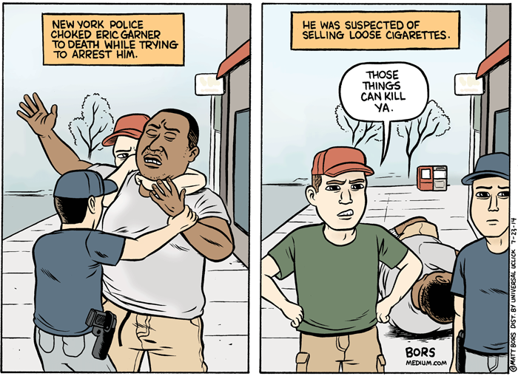

As Zygmunt Bauman points out, if the older Big Brother presided over traditional enclosures such as military barracks, prisons, schools, and countless other big and small panopticons, the updated Big Brother is not only concerned with inclusion and the death of privacy, but also the suppression of dissent and the widening of the

politics of exclusion.[5] Keeping people out is the extended face of Big Brother who now patrols borders, hospitals, and other public spaces in order to spot “the people who do not fit in the places they are in, banishing them from the place and departing them ‘where they belong,’ or better still never allowing them to come anywhere near in the first place.”[6]

In the advent of the recent display of police force in Ferguson, Missouri and Baltimore, Maryland it is unfair to view the impact of

the rapid militarization of local police on poor black communities as nothing short of terrifying and symptomatic of the violence that takes place in authoritarian societies. For instance, according to a recent report produced by the Malcolm X Grassroots Movement entitled *Operation Ghetto Storm*, ‘police officers, security guards, or self-appointed vigilantes extra judicially killed at least 313 African-Americans in 2012…This means a black person was killed by a security officer every 28 hours.’ Michelle Alexander adds to the racist nature of the punishing

state by pointing out that “There are more African American adults under correctional control today — in prison or jail, on probation or parole — than were enslaved in 1850, a decade before the Civil War began.”[8] Meanwhile the real violence used by the state against poor minorities of color, women, immigrants, and low income adults barely gets mentioned, except when it is so spectacularly visible that it cannot be ignored as in the cases of Eric Garner who was choked to death by a New York City policeman after he was confronted for illegally selling

untaxed cigarettes. Or the case of Freddie Gray who had his spine severed and voice box crushed for making eye contact with a cop. These cases are not exceptional. For too many blacks, the police have turned their neighborhoods into war zones where cops parading as soldiers act with impunity.

Fear and isolation constitute an updated version of Big Brother. Fear is managed and is buttressed by a neoliberal logic that embraces the notion that while fear be accepted as a general

condition of society, how it is dealt with by members of the American public be relegated to the realm of the private, dealt with exclusively as an individual consideration, largely removed from the collapse of authoritarian control and democratic rule, and posited onto the individual’s fear of the other. In the surveillance state, fear is misplaced from the political sphere and emergence of an authoritarian government to the personal concern with the fear of surviving, not getting ahead, unemployment, and the danger posed by the growing legions of

the interminable others.  As the older order dies, a new one struggles to be born, one that often produces a liminal space that gives rise to monsters, all too willing to kidnap, torture, and spy on law abiding citizens while violating civil liberties.[9] As Antonio Gramsci once suggested, such an interregnum offers no political guarantees, but it does provide or at least gestures towards the conditions to re-imagine “what is to be done,” how it might be done, and who is going to do it.[10]

REPORT THIS ADPRIVACY SETTINGS

Orwell’s *1984* continues to serve as a brilliant and important metaphor for mapping the expansive trajectory of global surveillance, authoritarianism, and the suppression of dissent that has characterized the first decades of the new millennium. The older modes of surveillance to which Orwell pointed, including his warnings regarding the dangers of microphones and giant telescreens that watch and listen are surprisingly limited when

compared with the varied means now available for spying on people. Orwell would be astonished by this contemporary, refashioned “Big Brother” given the threat the new surveillance state poses because of its reach and the alleged “advance” of technologies that far outstretch anything he could have imagined—technologies that pose a much greater threat to both the personal privacy of citizens *and* the control exercised by sovereign power.

In spite of his vivid imagination, “Orwell never could have imagined

that the National Security Agency (NSA) would amass metadata on billions of our phone calls and 200 million of our text messages every day. Orwell could not have foreseen that our government would read the content of our emails, file transfers, and live chats from the social media we use.”[11] Edward Snowden and other critics are correct about the dangers of the state’s infringement of privacy rights, but their analysis should be taken further by linking the issue of citizen surveillance with the rise of “networked societies,” global

flows of power, and the emergence of a totalitarian ethos that defies even state-based control.[12] For Orwell, domination was state imposed and bore the heavy hand of unremitting repression and a smothering language that eviscerated any appearance of dissent, erased historical memory, and turned the truth into its opposite. For Orwell, individual freedom was at risk under the heavy hand of state terrorism.

This is the Big Brother that pushes youthful protests out of the public spaces they attempt to occupy. This is the hyper-nationalistic Big Brother clinging to notions of racial purity and American exceptionalism as a driving force in creating a country that has come to resemble an open air prison for the dispossessed. This is the Big Brother whose split personality portends the dark authoritarian universe of the 1 percent with their control over the economy and use of paramilitarised police forces, on the one hand, and, on the other,

their retreat into gated communities manned by SWAT-like security forces.

The increasing militarization of local police forces who are now armed with weapons from the battlefields of Iraq and Afghanistan has transformed how the police respond to dealing with the public. Cops have been transformed into soldiers just as dialogue and community policing have been replaced by military-style practices that are way out of proportion to the crimes the police are trained to address. For

instance, *The Economist*reported that:

SWAT teams were deployed about 3,000 times in 1980 but are now used around 50,000 times a year. Some cities use them for routine patrols in high-crime areas. Baltimore and Dallas have used them to break up poker games. In 2010 New Haven, Connecticut sent a SWAT team to a bar suspected of serving under-age drinkers. That same year heavily-armed police raided barber shops around Orlando, Florida; they said they were hunting for guns and

drugs but ended up arresting 34 people for “barbering without a license.” Maricopa County, Arizona sent a SWAT team into the living room of Jesus Llovera, who was suspected of organizing cockfights.[7]

REPORT THIS ADPRIVACY SETTINGS

pathological states in which politics was recognized in the interest of death over life and justice. Both were unequivocal in the shared understanding that the

future of civilization was on the verge of total domination or what Hannah Arendt called “dark times.”

While Neil Postman and other critical descendants have pitted Orwell and Huxley against each other because of their distinctively separate notions of a future dystopian society,[1] I believe that the dark shadow of authoritarianism that shrouds American society like a thick veil can be lifted by re-examining Orwell’s prescient dystopian fable *1984* as well as Huxley’s *Brave New World* in light

of contemporary neoliberal ascendancy. Rather than pit their dystopian visions against each other, it might be more productive to see them as complementing each other, especially at a time when to quote Antonio Gramsci “The old world is dying and the new world struggles to be born. Now is the time of monsters.”[2]

REPORT THIS ADPRIVACY SETTINGS

Both authors provide insights into the merging of the totalitarian elements that constitute a new

and more hybridized form of authoritarian control, appearing less as fiction than a threatening portend of the unfolding 21st century. Consumer fantasies and authoritarian control, “Big Brother” intelligence agencies and the voracious seductions of privatized pleasures, along with the rise of the punishing state—which criminalizes an increasing number of behaviors and invests in institutions that incarcerate and are organized principally for the production of violence–and the collapse of democratic public spheres into narrow market-driven

orbits of privatization–these now constitute the new order of authoritarianism.

Orwell’s “Big Brother” found more recently a new incarnation in the revelations of government lawlessness and corporate spying by whistleblowers such as Chelsea Manning, Jeremy Hammond, and Edward Snowden.[3] All of these individuals revealed a government that lied about its intelligence operations, illegally spied on millions of people who were not considered terrorists or had committed no crime, and

collected data from every conceivable electronic source to be stored and potentially used to squelch dissent, blackmail people, or just intimidate those who fight to make corporate and state power accountable.[4] Orwell offered his readers an image of the modern state in which privacy was no longer valued as a civil virtue and a basic human right, nor perceived as a measure of the robust strength of a healthy and thriving democracy. In Orwell’s dystopia the right to privacy had come under egregious assault, but the ruthless transgressions of

privacy pointed to something more sinister than the violation of individual rights. The claim to privacy, for Orwell, represented a moral and political principle by which to assess the nature, power, and severity of an emerging totalitarian state. Orwell’s warning was intended to shed light on the horrors of totalitarianism, the corruption of language, the production of a pervasive stupidity, and the endless regimes of state spying imposed on citizens in the mid-20th-century.

Orwell opened a door for all to see

a “nightmarish future” in which everyday life becomes harsh, an object of state surveillance, and control—a society in which the slogan “ignorance becomes strength” morphs into a guiding principle of mainstream media, education, and the culture of politics. Huxley shared Orwell’s concern about ignorance as a political tool of the elite, enforced through surveillance and the banning of books, dissent, and critical thought itself. But Huxley, believed that social control and the propagation of ignorance would be introduced by those in

power through the political tools of pleasure and distraction. Huxley thought this might take place through drugs and genetic engineering, but the real drugs and social planning of late modernity lie in the presence of an entertainment and public pedagogy industry that trades in pleasure and idiocy, most evident in the merging of neoliberalism, celebrity culture, and the control of commanding cultural apparatuses extending from Hollywood movies and video games to mainstream television, news, and the social media.

In Orwell’s world, individual freedom and privacy were under attack from outside forces. For Huxley, in contrast, freedom and privacy were willingly given up as part of the seductions of a soft authoritarianism, with its vast machinery of manufactured needs, desires, and identities. This new mode of persuasion seduced people into chasing commodities, and infantilized them through the mass production of easily digestible entertainment, disposable goods, and new

scientific advances in which any viable sense of agency was undermined. The conditions for critical thought dissolved into the limited pleasures instant gratification wrought through the use of technologies and consuming practices that dampened, if not obliterated, the very possibility of thinking itself. Orwell’s dark image is the stuff of government oppression whereas Huxley’s is the stuff of distractions, diversions, and the transformation of privacy into a cheap and sensational performance for public display.

Neil Postman, writing in a different time and worried about the destructive anti-intellectual influence of television sided with Huxley and believed that repression was now on the side of entertainment and the propensity of the American public to amuse themselves to death.[13] His attempt to differentiate Huxley’s dystopian vision from Orwell’s is worth noting. He writes:

Orwell warns that we will be overcome by an externally imposed oppression. But in Huxley’s vision, no Big Brother is

required to deprive people of their autonomy, maturity and history. As he saw it, people will come to love their oppression, to adore the technologies that undo their capacities to think. What Orwell feared were those who would ban books. What Huxley feared was that there would be no reason to ban a book, for there would be no one who wanted to read one. Orwell feared those who would deprive us of information. Huxley feared those who would give us so much that we would be reduced to passivity and egoism. Orwell feared that the truth would be

concealed from us. Huxley feared the truth would be drowned in a sea of irrelevance. Orwell feared we would become a captive culture. … As Huxley remarked in *Brave New World Revisited,*the civil libertarians and rationalists who are ever on the alert to oppose tyranny “failed to take into account man’s almost infinite appetite for distractions.” In *1984,*Huxley added, people are controlled by inflicting pain. In *Brave New World,*they are controlled by inflicting pleasure. In short, Orwell feared that what we hate will ruin us. Huxley feared

that what we love will ruin us.[14]

REPORT THIS ADPRIVACY SETTINGS

Echoes of Huxley’s insights play out in the willingness of millions of people who voluntarily hand over personal information whether in the service of the strange sociality prompted by social media or in homage to the new surveillance state. New surveillance technologies employed by major servers providers now focus on diverse consumer populations who are

targeted in the collection of endless amounts of personal information as they move from one site to the next, one geopolitical region to the next, and across multiple screens and digital apparatuses. As Ariel Dorfman points out, “social media users gladly give up their liberty and privacy, invariably for the most benevolent of platitudes and reasons,”[15] all the while endlessly shopping online, updating Facebook, and texting. Indeed, surveillance technologies are now present in virtually every public and private space – such

as video cameras in streets, commercial establishments, workplaces, and even schools as well as the myriad scanners at entry points of airports, retail stores, sporting events, and so on – and function as control mechanisms that become normalized through their heightened visibility. In addition, the all-encompassing world of corporate and state surveillance is aided by our endless array of personal devices that chart, via GPS tracking, our every move, our every choice, and every pleasure.

At the same time, Orwell’s warning about “Big Brother” applies not simply to an authoritarian-surveillance state but also to commanding financial institutions and corporations who have made diverse modes of surveillance a ubiquitous feature of daily life. Corporations use the new technologies to track spending habits and collect data points from social media so as to provide us with consumer goods that match our desires, employ face recognition technologies to alert store salesperson to our credit

ratings, and so it goes. Heidi Boghosian points out that if omniscient state control in Orwell’s *1984*is embodied by the two-way television sets present in each home, then in “our own modern adaptation, it is symbolized by the location-tracking cell phones we willingly carry in our pockets and the microchip-embedded clothes we wear on our bodies.”[16] In this instance, the surveillance state is one that not only listens, watches, and gathers massive amounts of information through data mining, allegedly for the purpose of

identifying “security threats.” It also acculturates the public into accepting the intrusion of commercial surveillance technologies – and, perhaps more vitally, the acceptance of privatized, commodified values – into all aspects of their lives. In other words, the most dangerous repercussions of a near total loss of privacy involve more than the unwarranted collecting of information by the government: we must also be attentive to the ways in which being spied on has become not only *normalized*, but even enticing, as corporations up

the pleasure quotient for consumers who use new digital technologies and social networks – not least of all by and for simulating experiences of community.

Many individuals, especially young people, now run from privacy and increasingly demand services in which they can share every personal facet of their lives. While Orwell’s vision touches upon this type of control, there is a notable difference that he did not foresee. According to Pete Cashmore, while Orwell’s “Thought Police

tracked you without permission, some consumers are now comfortable with sharing their every move online.”[17] The state and corporate cultural apparatuses now collude to socialize everyone – especially young people – into a regime of security and commodification in which their identities, values, and desires are inextricably tied to a culture of commodified addictions, self-help, therapy, and social indifference. Intelligence networks now inhabit the world of major corporations such as Disney and the Bank of America as well

as the secret domains of the NSA, FBI and fifteen other intelligence agencies. As Edward Snowden’s revelations about the PRISM program revealed, the NSA also collected personal data from all of the major high tech giant service providers who according to a senior lawyer for the NSA, “were fully aware of the surveillance agency’s widespread collection of data.”[18]

REPORT THIS ADPRIVACY SETTINGS

The fact is that Orwell’s and

Huxley’s ironic representations of the modern totalitarian state – along with their implied defense of a democratic ideal rooted in the right to privacy and the right to be educated in the capacity to be autonomous and critical thinkers – has been transformed and mutilated almost beyond recognition by the material and ideological registers of a worldwide neoliberal order. Just as we can envision Orwell’s and Huxley’s dystopian fables morphing over time from “realistic novels” into a “real life documentary,” and now into a

form of “reality TV,” privacy and freedom have been radically altered in an age of permanent, non-stop global exchange and circulation. That is, in the current moment, the right to privacy and freedom have been usurped by the seductions of a narcissistic culture and casino capitalism’s unending desire to turn every relationship into an act of commerce and to make all aspects of daily life subject to market forces under watchful eyes of both government and corporate regimes of surveillance. In a world devoid of care, compassion, and

protection, personal privacy and freedom are no longer connected and resuscitated through its connection to public life, the common good, or a vulnerability born of the recognition of the frailty of human life. Culture loses its power as the bearer of public memory, civic literacy, and the lessons of history in a social order where the worst excesses of capitalism are left unchecked and a consumerist ethic “makes impossible any shared recognition of common interests or goals.”[19] With the rise of the punishing state along with a kind of willful

amnesia taking hold of the larger culture, we see little more than a paralyzing fear and apathy in response to the increasing exposure of formerly private spheres to data mining and manipulation, while the concept of privacy itself has all but expired under a “broad set of panoptic practices.”[20]

With individuals more or less succumbing to this insidious cultural shift in their daily lives, there is nothing to prevent widespread collective indifference to the growth of a surveillance

culture, let alone an authoritarian state.The worse fears of Huxley and Orwell merge into a dead zone of historical amnesia as more and more people embrace any and every new electronic device regardless of the risks it might pose in terms of granting corporations and governments increased access to and power over their choices and movements. Detailed personal information flows from the sphere of entertainment to the deadly serious and integrated spheres of capital accumulation and policing as they are collected and sold to

business and government agencies who track the populace for either commercial purposes or for fear of a possible threat to the social order and its established institutions of power. Power now imprisons not only bodies under a regime of surveillance and a mass incarceration state but also subjectivity itself as the threat of state control is now coupled with the seductions of the new forms of passive inducing soma: electronic technologies, a pervasive commodified landscape, and a mind numbing celebrity culture.

REPORT THIS ADPRIVACY SETTINGS

Underlying these everyday conveniences of modern life, as Boghosian documents in great detail, is the growing Orwellian partnership between the militarized state and private security companies in the United States. Each day, new evidence surfaces pointing to the emergence of a police state that has produced ever more sophisticated methods for surveillance in order to enforce a

mass suppression of the most essential tools for democratic dissent: “the press, political activists, civil rights advocates and conscientious insiders who blow the whistle on corporate malfeasance and government abuse.”[21] As Boghosian points out, “By claiming that anyone who questions authority or engages in undesired political speech is a potential terrorist threat, this government-corporate partnership makes a mockery of civil liberties.”[22] Nowhere is this more evident than in American public schools where a youth are

being taught that they are a generation of suspects, subject to the presence of armed police and security guards, drug sniffing dogs, and an array of surveillance apparatuses that chart their every move, not to mention in some cases how they respond emotionally to certain pedagogical practices.

Whistleblowers are not only punished by the government; their lives are also turned upside down in the process by private surveillance agencies and major corporations who now work in

tandem. For instance, the Bank of America assembled 15 to 20 bank officials and retained the law firm of Hunton & Williams in order to devise “various schemes to attack WikiLeaks and Greenwald whom they thought were about to release damaging information about the bank.”[23] It is worth repeating that Orwell’s vision of surveillance and the totalitarian state look mild next to the emergence of a corporate-private-state surveillance system that wants to tap into every conceivable mode of communication, collect endless amounts of metadata to be stored

in vast intelligence storage sites around the country, and use that data to repress any vestige of dissent.[24]

As Huxley anticipated, any critical analysis must move beyond documenting abuses of power to how addressing contemporary neoliberal modernity has created a social order in which individuals become complicit with authoritarianism. That is, how is unfreedom internalized? What and how do state and corporate controlled institutions, cultural apparatuses, social relations, and

policies contribute to making a society’s plunge into dark times self-generating as Huxley predicted? Put differently, what is the educative nature of a repressive politics and how does it function to secure the consent of the American public? And, most importantly, how can it be challenged and under what circumstances? Aided by a public pedagogy, produced and circulated through a machinery of consumption and public relations tactics, a growing regime of repression works through the homogenizing forces of the

market to support the widespread embrace of an authoritarian culture and police state.

7. **Insurgent democracy**

The third aim is to try and offer some thoughts on how from the perspective of political theory in general, and democratic theory in particular, we might fruitfully reflect on current democratic strivings throughout the world. I suppose this could be seen as a two-way relationship: do current events suggest that we need a

new, or at least a different, kind of democratic theory, that we should revise or update our theoretical view of democracy as a type of political system, or type of society? In that case we are moving from events to theory, modifying the theory in the light of changes in the real world. But equally, the relationship can be seen as going in the opposite direction: can political or democratic theorists use their conceptual apparatus and ideas to illuminate the struggles and conflicts that are going on, and to identify certain problems, certain

blockages to the political progress and implications of these events, and offer something of significance that more empirical or narrative accounts cannot offer? Can the honour of political theory be saved in that way? So whether from practice to theory, or from theory to practice, how might (or how should) democratic theory be developed in the light of current events throughout the world?

REPORT THIS ADPRIVACY SETTINGS

In an article in the latest issue

of *New Left Review,* called ‘Spring Confronts Summer’, Mike Davis writes that ‘The electrifying protests of 2011 — the on-going Arab Spring, the ‘hot’ Iberian and Hellenic summers, the ‘occupied’ fall in the United States — inevitably have been compared to the *anni mirabiles* of 1848, 1905, 1968 and 1989’. It is interesting that 1917 does not count for him in this list of miracle years. But he is no doubt right to warn that  ‘As the fates of previous *journées révolutionnaires*warn us, spring is the shortest of seasons, especially when the communards fight in the

name of a ‘different world’ for which they have no real blueprint or even idealised image’. But whatever one may think of those utterances, Davis modestly announces that his speculations are ‘simply a thinking-out-loud about some of the historical specificities of the 2011 events’.

What then should be the concern of political theory? I take inspiration from a paper by the American political theorist Jeffery Isaac, called ‘The Strange Silence of Political Theory’. This article is a kind of lament for the fact that

American political theorists paid little attention to the significance of the collapse of Communism in and after 1989, but I think that its arguments are of relevance now. Isaac argues that the lack of theoretical reflection on the collapse of Communism cannot be justified by a reluctance to interpret current events, contrasting this with the willingness of classic political theorists to give judgements on the burning issues of their time, and he says ‘Is it possible to imagine such a posture being assumed by Locke or Paine, Kant

or Hegel?’. He criticises what he describes as ‘the discrepancy between passionate engagement in current events that characterised most of the foundational writers of contemporary political theory and the disconnection of contemporary political theorists themselves’. Indeed Isaac waxes lyrical when criticising what he sees as the failure of (American) political theorists to reflect on the ideas and movements that contributed to the collapse of Communism, when he writes that ‘Political theory fiddles while the

fire of freedom spreads, and perhaps the world burns’!

REPORT THIS ADPRIVACY SETTINGS

Isaac contrasts the willingness of the great political theorists of the past to engage in analysis of the events of their time (for example Kant’s comments on the French Revolution) with the abstraction and self-absorption of contemporary academic political theorists: ‘too many political theorists speak only to themselves, preferring esoteric

languages to plain expression, seemingly profound formulations to common sense’, he argues. It also seems to me that the purpose of political theory is to try and illuminate and analyse the events of our time. To go back to Mike Davis’ article, if the year of 2011 was a year which saw a range of diverse movements trying to extend and deepen democracy, then surely it behoves us as political theorists to try and understand the ways in which these movements challenged not just existing structures of power but the ways in which they offered,

at least potentially, new understandings of what democracy means. Theory can learn from practice, but democratic practice can perhaps be stimulated by theoretical debate and investigation.

The task of political theory must be to try and make sense of current developments, of revolutionary challenges to the existing order, if indeed that is what we are witnessing in the contemporary world. One may be sceptical of comparisons of 2011 with 1848, 1905, or even with 1968

and 1989, because we may not be convinced that the current wave of democratic activity does qualify as a revolution comparable with the events of those other years.

If the tasks of political theory are then set for it by ongoing struggles in the real world, let me just clear out of the way some of the ways in which political theorists should not seek to go about these tasks. It seems that to see the task of political theory in a defensive or pessimistic mode as being concerned with minimising danger, risk or averting

serious harm, is to take too negative a view of the human subject, or agent, and also to underestimate the creative role of ongoing democratic strivings. To discuss liberalism as ‘the liberalism of fear’ is to downplay aspirations to human freedom and to reject a more expansive view of the human condition or at least the potentialities of political action to create a new subject of political action, namely the active demos. This is rather vague, but to see political theory as concerned with minimising harm is to take too restricted and negative a view,

since what has been placed on the agenda by recent events are a range of movements which go beyond that, which in the broadest sense are trying to carve out a more active role for the citizen, whether acting in solidarity or seeking to secure basic rights of the citizen denied in practice. Political theory must seek to explore this more expansive view of the political subject, of human beings as ‘political animals’ who can come together in an active and creative way. This view of human beings as active creators seeking to establish what Gramsci

called a new ‘collective will’ (*voluntà collettiva*) is in line with a long tradition of political thought, not just in the Marxist tradition but including thinkers like Rousseau who were concerned with new modes of democratic action. A democratic theory adequate to our time has to take a more positive view of the human subject or agent, and to go beyond this limited and fearful philosophy which seems concerned only to avert danger.

REPORT THIS ADPRIVACY SETTINGS

In similar vein, talk of depoliticisation and the forces which split up collective agency is indeed relevant, but that while we do need to be aware of ‘liquid modernity’ and the fragmentation of the formerly more cohesive agencies of radical politics, notably the working class movement, that is only one side of the picture. Mike Davis, to quote him again, writes as follows: ‘Western post-Marxists — living in countries where the absolute or relative size of the manufacturing workforce has shrunk dramatically

in the last generation — lazily ruminate on whether or not ‘proletarian agency’ is now obsolete, obliging us to think in terms of ‘multitudes’, horizontal spontaneities, whatever’. Davis invokes ‘Two hundred million Chinese factory workers, miners and construction labourers’ as ‘the most dangerous class on the planet’. We may not necessarily agree with him that talk of the obsolescence of proletarian agency is an example of lazy rumination, but it would suggest that one of the things on which political theorists ought to reflect

is the constitution of new forms of political agency and new sources of radical politics. Instead of bandying around concepts like ‘depoliticisation’ we should take a hint from Paul Mason’s recent study, *Why it’s* *Kicking Off Everywhere*, where he analyses a new collective agency composed of three elements that he defines as ‘enraged students, youth from the urban underclass, and the big battalions of organised labour’ (p. 61). I am not sure if speaking in a university environment one should quote aloud Mason’s claim that ‘At the centre of all the protest

movements is a new sociological type: the graduate with no future’, (p. 66), but perhaps more safely one can refer to Mason’s concept of ‘the Jacobin with a laptop’, and his claim that ‘the masses have developed a new collective practice’.

The third way *not* to do political theory is to concentrate exclusively on great figures of political theory from the past and to seek to provide new readings of their work in the hope that this will illuminate our present concerns and debates. We should continue

with reading, studying, researching on the history of political thought and of the classical canon, but we should be sceptical that doing that will provide us with the means of understanding present problems, which are distinctively new and which require new frameworks of understanding, which might go beyond those inherited from the classical tradition of political theorising. Take this quote from Marx’s *Grundrisse*,  and maybe it is not wholly relevant, but when he writes about Greek art, and poses the question, ‘is Achilles possible with powder and lead? Or

the *Illiad* with the printing press, not to mention the printing machine?’ we may give our own version of this as along the following lines, ‘Is Aristotle possible, or relevant, with the Internet and Twitter? Is de Tocqueville helpful in understanding new forms of democratic politics which a conservative aristocrat from Normandy could not begin to comprehend?’ Can the classics of the past help us to respond to new problems? I would suggest in all modesty that we have to respond to contemporary problems using

new concepts and new frameworks, even though the attempt to develop a new framework can be helped by considering how classical political thinkers tried to do the same for the events of their day. Political theory has to be rooted in concerns of the present, and so we must aspire to be our own Locke, Marx, Rousseau or whatever, trying to conceptualise the problems of our time while being aware of how those great thinkers did the job for their day. Perhaps de Tocqueville is correct when in the introduction to his

great work *Democracy in America* he states that ‘A new political science is needed for a world itself quite new’. A new political theory is needed for our new contemporary world, to deal with questions with which an earlier age was unacquainted.

REPORT THIS ADPRIVACY SETTINGS

So to sum up, (to adopt a phrase of the late Brian Barry) ‘rolling the classics around in our mouths like fine old brandy’ are ways of doing political theory which do not

contribute to this end of analysing our contemporary world and, perhaps, in a modest way seeking to improve it, thus realising what Jeffrey Isaac in the above-mentioned article says is the task of political theory, ‘opening ourselves up to the dramatic political experiences of our time and to think for ourselves about them in innovative and serious ways’. Having said all that in rather critical and negative ways, how might we begin to do that with regard to contemporary democratic strivings?

Let us look at a short summary of the book by Miguel Abensour, *Democracy against the State*, and explain what he means by ‘democracy against the state’ and by his idea of ‘insurgent democracy’. Certainly at first glance it looks as though these two ideas of ‘democracy against the state’ and ‘insurgent democracy’ are fruitful ones and offer a new understanding of democracy. The wave of democratic activity world-wide does seem to be directed ‘against the state’, at least in the sense that whether in Egypt or London or

Washington protesters are demanding that the state be made responsive to their demands and (in the case of the Arab Spring) cease to act in a repressive and monolithic way which refuses to treat its citizens as the repositories of sovereignty. On the contrary, the state used to manipulate elections and insulate itself from pressures from below, seeing its role as being in alliance with powerful economic interests (indeed, as I understand it, in Egypt the military state was also one which controlled and dominated vast economic assets

and enterprises). So much of the current protests are directed against the state, demanding either that the state loosens its repressive grip or, and this seems to apply to protest movements in established liberal-democratic systems, that the state takes a more distanced stance towards powerful banking and capitalist interests and in that way makes some gestures towards a more egalitarian social and political order. And many of the democratic movements today are examples of ‘insurgent democracy’ in that (as in Syria) they are in a state of

insurgency towards the existing order. So at the very least contemporary mass movements do seem to be suggesting a model of democracy which sees the demos — the people — as an active creative subject, acting to secure its rights, and demanding state action to limit the power of banks and other holders of economic power.

REPORT THIS ADPRIVACY SETTINGS

We can see that this implies an understanding of democracy

which challenges a Schumpeter view that democracy is merely a matter of the masses choosing between competing teams of leaders, and that they have no effective role once that task has been done. So ‘democracy against the state’ and ‘insurgent democracy’ seem on first glance to be suggestive descriptors of what is going on before our very eyes, and also to encapsulate within themselves a normative view of democracy that invests the citizens with a more creative and active role, of living up to their formal title of holders of sovereign

power.  But we need to probe these two terms of ‘democracy against the state’ and ‘insurgent democracy’ further.

So, what does Abensour mean by ‘democracy against the state’? His book is in large part an analysis of Marx’s 1843*Critique of Hegel’s Doctrine of the State*, which has to be distinguished from the better-known (and shorter) document, also dated 1843, called *A Contribution to the Critique of Hegel’s Philosophy of Right. Introduction*. This latter document is the one where Marx announced

the role of the proletariat as, ‘a class which is the dissolution of all classes’. However, the longer critique, sometimes referred to as the Kreuznach critique, after the town where Marx spent the summer of 1843, ‘immersing himself in intensive reading and producing a long and detailed critique of Hegel’s *Philosophy of Right*, as Avineri says, contains this sentence, which Abensour, if I have understood him correctly, makes the basis of his interpretation. Marx wrote that:

In democracy the state as

particular is only particular, and as universal it is really universal; i.e. it is not something determinate set off against other contents. In modern times the French have understood this to mean that the *political state disappears* in a true democracy. This is correct in the sense that the political state, the constitution, is no longer equivalent to the whole.

**8. Fighting neo-liberalism with education and activism**

This is a revolutionary period in world history. The collapse of finance capitalism, the bankers’ bailouts across the globe, the continuing bankers’ bonuses, and the intrinsic problems of finance capitalism have, under current `bourgeois’ parliamentarist rule, resulted in ordinary families, workers and communities,`paying for the crisis’. All this, while the national and international capitalist classes and organisations impose austerity capitalism on a reeling public and public educational, social, health

and welfare systems. This `austerity capitalism’ has led to an eruption of discontent-against political, economic and financial dictatorship, through the Arab Spring, the *indignados* in Spain, the Occupy movements throughout the world, and the million strong protests against the 13 Feb 2012 austerity programme enforced by the international capitalist `troika’ (European Central bank, International Monetary Fund, and the European Commission) on the Greek people.

These developments raise

questions about the nature of bourgeois capitalist parliamentarist democracy as much as they do about the nature and morality and cruel impacts of capitalist economy — of life under/within capitalism. They also raise questions about social and economic inequality, meritocracy, equality and egalitarianism, and the role of education and of political activism.

A question that must be asked is how does the socio-economic and political system of a country work in complicity with the corporate

media and how does this impact the school system? There is no automatic mechanistic and deterministic relationship between an economic structure, such as the capitalist economic structure and resulting social relationships on the one hand, and society’s social and political structures on the other. But there is a relationship, even if not mechanistic and unproblematic. There is resistance, at various levels, by individuals, by groups, in what is a permanent `culture war’ between the ideas of the ruling capitalist class and their

mouthpieces, and resistant, counter-hegemonic individuals and groups, such as students, critical intellectuals, and organizations such as workers’ organizations (though many have been `incorporated’ into the system).

REPORT THIS ADPRIVACY SETTINGS

It is fair to say, drawing on Althusser’s (1971) and Gramsci’s (1971) Marxist conceptual framework, that the apparatuses of the state do not brook much

dissent for long: if it starts to threaten either the riches of the rich, or the capitalist system itself, which is essentially the same thing, then the state steps in, using either the wagging finger warning of repercussions, the iron fist in a velvet glove, or, ultimately the hammer of tear gas, bullets and prison cells.

Schools and universities, echoing Althusser (1971) are ideological state apparatuses whose purpose, for the capitalist class, is to preach and instill pro-capitalist and anti-socialist beliefs and, as

Rikowski (for example, 2001, 2004) argues, to re-produce tiered hierarchicalised and socialized /quiescent labour power for the workplace.

The same is true of the media. Those who own the Press, control the Press. Views alternative to capitalism are mocked, vilified, and ignored, if they are fundamental rather than cosmetic alternatives. Within schools and universities, and vocational colleges, it is true that oppositional teachers/faculty in the public education system in

Britain and the U.S. do get sidelined for promotion, isolated, and dismissed. For example, in the U.S. Henry Giroux and Peter McLaren, and in Britain, my comrades in the Hillcole Group, Mike Cole, Glenn Rikowski (including myself) suffered many years of management hostility at various, if not all, of our employing schools and universities.

One difference between the media and schooling/education state apparatuses is that the control by media bosses is *more*complete than that of school and university

bosses/management. While there *is* contestation, fighting the culture wars, within both sets of apparatuses, with resistant and counter-hegemonic individuals and groups battling within each apparatus, the spaces for socialist, or liberal ideology, praxis, and social relationships, exist more fully in education than in the more easily `hired and fired’ mass media. Even the `impartial’ BBC in the UK rarely allows socialist or radical left speakers, such as Salma Yaqoob, George Galloway, or socialist trade union leader, Bob Crow on to programmes like

`Question Time’. And the days when trade union leaders were routinely interviewed on BBC radio and television are long gone, their places filled by business leaders and public relations apologists for Capital. Even the 24 news programmes in the UK such as SkyNews and BBC24 now have, in addition to Showbiz sections, lengthy Business News sections. These are new developments over the last 20 years in Britain, the crowding out of `unsafe’ alternatives, by brain numbing Showbiz infotainment, and by huge attention lavished on pro-

capitalist ideology, its ‘stars’ and its spokespeople.

REPORT THIS ADPRIVACY SETTINGS

***

This extends to treatment of war. Despite, over the years, a clear majority of the British general public wanting an end to the war in Afghanistan, and a withdrawal of British troops, such opinions, until recently, when the body count has been rising (the Afghani body-count is rarely mentioned in the

British/USA capitalist Press) are hardly heard on British radio and television. As for public control, a large majority of the British public support the re-nationalisation of the privatized railway system in Britain. But you do not hear much of that in the media. In Britain, the public is considerably to the left of the three major parties: Conservatives, Liberal Democrats and Labour. The same is true in Greece, where none of the major parties, from the `moderate right-wing’ New Democracy, to the neoliberal post social democratic PASOK are opposing the cuts, the

austerity programme – something unprecedented in severity in any `democratic’ European state since the Second World War. All the bourgeois parties, whether from the right, the centre, or the former social democratic moderate left, say there is no alternative to the austerity programme. None talk of taxing the wealth of the rich instead, or of renouncing the debt, for example.

***

So how does, and how has the capitalist system impacted the

school system in Britain? Scotland and Northern Ireland have major devolved powers from the UK Parliament concerning education, while Wales has some devolved powers. Yet, there are very pronounced similarities between U.S. and England/Wales education policies. The G.W. Bush administration engaged in policy borrowing– from the increased marketisation, stratification, and importation of new public managerialism and commercial interest in state/public education that were introduced by the Thatcher

governments(1979-1990) in legislation such as the Education Reform Act of 1988.  The No Child Left Behind legislation has had very similar impacts in the United States. David Hursh (2005) writes on these similarities. There has been extensive `policy borrowing’ of neoliberal ideas and policies on education globally (Hill, 2006a, 2009a,b).

In the competitive market system of schooling in England, where schools are ranked on published ‘league tables’ of SATs and 16+ exam (GCSE, the General

Certificate of Secondary Education) attainments, ‘rich’ schools have got richer, and so called ‘sink schools’ have sunk further. By hook or by crook, ‘high performing’ schools manage to select those children who have more, to use Bourdieu’s term (Bourdieu and Passeron, 1977; Hill, 2009c, Millar, 2012) high-status ‘cultural capital’. Those schools become more ‘middle class’, and low-performing schools more ‘working class’. Class differentiation has increased. And, as a feature of neoliberal capitalist discourse

(and resulting policy) on education, it is the teachers and the public sector professionals that are blamed, rather than the high stakes testing, competitive education system itself, and its structural discrimination against the working class and some ethnic minorities. The evident that people are harassed, demeaned, violated, spat upon, attacked, and killed because of their sexuality, sex, `race’/ethnicity or religion. It is also evident that — and this is readily apparent and recognised in academic discourse, in political mobilizations, and in homes and

streets and workplaces — we have multiple subjectivities, which come to the fore in our own minds and in the actions of others towards us.

Social class is segmented in two ways. It is stratified vertically by different social class strata or groups — for example, unskilled workers as the bottom stratum, skilled workers as a stratum above, then ‘white collar’ lower middle class sitting, in diagrammatic terms on top of those two groups and so on with layer upon layer of different social

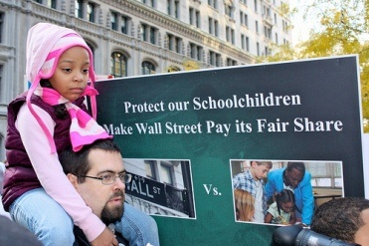

class strata on top. These strata/groups are characterised by different levels of reward, power, autonomy, health, and, indeed, actual length of life. But social class is also segmented horizontally by ‘race’ and by gender, for example. Hence, we have a ‘raced’ and gendered class.

Second, concerning social class

analysis; a classical Marxist would hold to a binary analysis of class (see Hill, 1999; Kelsh and Hill, 2006; Greaves, Hill and Maisuria, 2007) but recognize the existence of different strata within the working class, that class of people who sell their labor power.

REPORT THIS ADPRIVACY

To turn from the relationship between class, education and neoliberalism, a related question is, can we have equity and social equality in a capitalist society

such as the UK or the United States or Greece or Singapore? Within capitalist societies there are, and can be, varying degrees of equity/inequity, social equality/inequality. Capitalist society can be regulated to control profits and spread wealth, in the form of wages/salaries/income, and also in the form of the social wage, the welfare state, unemployment benefits, housing benefit/subsidy for the low paid, free universal health care, and state pensions. This is what a social democratic version of capitalist governments have gone for — at least in times

of boom, where there is enough profit in the eyes of significant sectors of the capitalist class for large profits, and enough too, for spending on actual and social wage rises. This happened most notably, in what the French call `*les trente glorieuses*’, the thirty glorious years after the Second World War, when welfare states were demanded by workers’ organizations and workers’ parties, and enacted across much of the developed capitalist world. With respect to `revisionist’, or social democratic, it is important to note that Marx and Engels

in *The Communist Manifesto*([1848]/(1985)) recognize that it is necessary to “fight for the attainment of the immediate aims of the working class” (p.119).

REPORT THIS ADPRIVACY SETTINGS

Where we socialists and Marxists disagree with reformists, or `revisionists’, is that we fight for reformist improvements within capitalist society, but *from a critical position*. By ‘critical position’,  we mean a Marxist

position, based on Marxist analysis of the essentially exploitative class-based nature of capitalist economy and society, and a determination to replace capitalism by socialism.

In Marxist analysis there can never be economic equity and social equity within capitalist systems. For Marxists what is important is not just social mobility, but how equitable or egalitarian a society is. A functioning meritocracy is an unequal route to a hugely unequal society, hugely unequal pay packets, and hugely stratified

societies. The 1% in Singapore or Finland or Japan may have wealth and income less disproportionate to the bottom 99% or bottom 25% or 10% than that held  by the top 1% in the USA, or Britain, or Greece or Ireland; but the differences between that top 1%, the top capitalists and their top managers and bankers are still staggeringly huge. Just to take one example of inequality, in 2010 in London, the top 10% of society had on average a wealth of £933,563 compared to the meagre £3,420 of the poorest 10% – a wealth multiple of 273 (Ramesh, 2010). This is the

multiple of the top 10%. The multiple of the top 1% would be in the thousands. This level of inequality has not been seen since the days of the slave trade. We really are seeing the impoverishment and to use a Marxist term, `immiseration’ (Greaves, Hill and Maisuria, 2007) of the working class in countries such as Greece and Britain.

Capitalist economies and societies vary enormously in terms of how an economy/society is. Countries range from hugely

unequal rich societies such as the USA, the UK and Portugal — the most unequal of the `rich’ countries on the planet, to the least unequal of those rich societies. The most equal are Scandinavian countries such as Finland and Sweden, and East Asian countries such as Japan and Taiwan and Singapore. These measurements, related to the gini co-efficient, the difference between the income and wealth of the richest section of society as compared to the poorest, are set out remarkably clearly in Wilkinson and Pickett’s

startling *The Spirit Level* (2009).

The widespread use of Weberian/neo-Weberian/lifestyle/consumption-based classifications of social class ‘hide’ the capitalist class and the relations of production — the source of the Marxist definition of class, and serve to segment and divide the working class — that class of workers (and dependents) who sell their labor-power. The Occupy Wall Street slogans about 99% against 1% are a pretty accurate application of the

classical Marxist notion of class, with the 1% of the population who are the capitalists, exploiting the rest of the population who, whatever the descriptions applied to them, ‘middle class’, `working class’, `working middle class’ etc. share the major characteristic of Marxist class analysis of the working class. They are all exploited by the capitalist class which makes profit from the surplus value produced by their labor power.

In relation to social class and education, Steven J. Ball’s writings

show how ‘middle class’ parents take ‘positional advantage’ in a market system (Ball, 2003, 2006).  Thatcher’s policies (1979-1990), continued by her Conservative successor  (John Major, 1990-1997) and intensified by the Blair `New Labour’ (1997- 2007) and Brown `New Labour’ governments (2007-2010), have to a large extent destroyed the system of all ability, mixed social class comprehensive schools in Britain (see Hill, 2006b). This process has been intensified by the current Conservative-Liberal Democrat (`Con-Dem’) Coalition

government (elected in June 2010) policy of allowing virtually any group of parents to set up ‘free school’ (funded by the taxpayer, but likely at some stage to be run by for-profit education companies) and to allow any high-achieving primary (in the USA, ‘elementary’) school and secondary (in the USA ‘high’) school, to become an ‘Academy’. Academies are a set of schools with greater autonomy over admissions, the curriculum, teachers’ pay, the school workforce skill-mix, the budget; schools that are also taxpayer

funded but outside the control of the democratically elected and accountable local education authority (in the USA, ‘school district’) (Millar, 2012).  The American equivalent of ‘Academies’ are Charter Schools. Currently in England and Wales Academies are pretty much handed over to rich businessmen or to religious/charity organisations to run. (There is an excellent website exposing them run by the Anti-Academies Alliance, antiacademies.org.uk).

The rich do not have to bother

maneuvering for positional class advantage. They buy it. With school fees at private (independent) schools being as much for one child as two to three times the total income of the minimum waged and the lower paid. In Britain, around 7% of the children in the country have privileged education bought for them in private schools. And they go to the most prestigious universities, and get the top jobs in hugely disproportionate numbers.

The National Curriculum for

schools, introduced by the Conservative government in the 1988 legislation (The Education Reform Act), has been policed by inspection since then with dire penalties — ultimately job-losses for those who are non-compliant or who are at the foot of the league tables. Of course it is the schools in the poor areas, often those with the most committed teachers, that are near/at the bottom of the attainment league tables. The attainment map (of results for SATS and for GCSEs) in Britain mirrors the map of social deprivation, more specifically, the

map showing the percentage of students receiving ‘Free School Meals’ (FSM). Nationally the FSM figure is around 13%. It varies from school to school, from local education authority from virtually zero percent, to schools where most students are poor enough to qualify for and receive FSM.

"However much social mobility there is in a capitalist society, however much such societies facilitate and are marked by

meritocracy, however equal the chances of `getting on’, of attaining a well-paid job are, meritocratic capitalism is characterized by this: equal chances to reach extremely unequal positions. Equal chances to reach positions that differ hugely in terms of income, wealth, length of life, and, even more marked by differentiation, the length of healthy life. Capitalism and equality are incompatible, both in empirical terms and in theoretical terms. Capitalist economic relations are essentially anti-egalitarian. Profit is the life

blood of capitalism. Capitalists profit from the surplus value taken from the labor power of workers. This is an exploitative and anti-egalitarian relationship.

And, in connection with meritocracy, just as in history it tends to be the victors that write the ‘official’ narrative. It is the winners within a meritocratic system who decide `what is merit’. In England over the last 50 years there have been many criteria used in, for example secondary schooling to grade and rank and reward students. Since the

implementation of the national curriculum for schools following the 1988 Education reform Act, the criteria for success are embedded in the GCSEs (General Certificate of Education) as they are the sole academic measurement for how well students have performed individually in gaining `mastery’ of particular subjects. However, within the more student centred, `liberal-progressive’ era in English education of the 1960s and early 1970s, and during the contemporaneous period, in some city areas, of attempts at socialist

education (see Hill, 2001), then students were also deemed meritorious, and were graded on such criteria as `ability to work co-operatively in groups’, `concern for others’, and assessment patterns, in both some schools and universities, graded students not individually but in their groups, with a group grade."

So then, what role should teachers within schools, colleges, universities, those of us who are critical of capitalist education, play? What is, or can be, or should be, the role of critical pedagogues

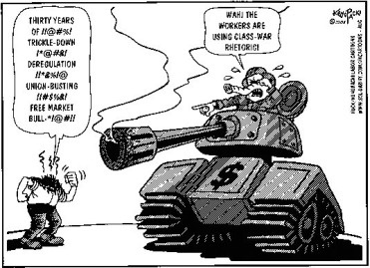

in fighting against capitalism?

Teachers should be actively involved in the fights for economic and social justice. They should be critical, organic, public, socialist, transformative intellectuals, who are activists.  Each of those five descriptors is important. Organic is being part of, knowing about,

living, and representing the section of the class you are representing. *Public*means going public, speaking out, and defying intimidation. *Socialist* means being egalitarian, working for an egalitarian, and non-capitalist society, where the wealth (such as ‘the commanding heights of the economy’– banks, industry, and public utilities) of the country is

It is also useful to note some contemporary developments in mass protest, social democracy and socialism. Mass protest has

erupted internationally against the burgeoning and increasingly evident gross iniquities between the pockets and the lives and the bonuses of the bankers, and the increasing impoverishment of billions of workers across many countries. We are now in an era, like in 1848 and 1968 or the period 1917-20, of a semi-global movement for change — in some countries, a revolutionary or pre-revolutionary or potentially revolutionary situation. The recent (2011-2012) Occupy Wall Street movement that spread across the USA has its parallels across the

world, paralleled in UKUncut denouncing tax-avoidance by the rich and by corporations, activities and mass student and worker demonstrations in 2009-2011 in Britain, the occupations and mass strikes/protests across Greece, and developing protests in Ireland and many other countries. And that is just in the ‘rich world’. Obviously mass protests are happening through the Arab world, too, and, less reported, in India, China, Eastern Europe and elsewhere.

REPORT THIS ADPRIVACY

SETTINGS

In the face of immensely increased capitalist attacks in their class war from above (Harvey, 2005) we must have change; but not a vapid notion of change. Mass action by Occupy Wall Street and UKUncut demonstrations are brilliant, imaginative, and educational for the public and for participants. But for mass action to be successful, we need also the organised weight, history and power of the organised working class. This means trade unionists, workers

(‘working and middle class’), student and socialist organisations, and new social movements and activist campaigners working together. Large scale demos are brilliant, but they are not enough. We need a political programme/set of ideas that is socialist/Marxist-democratic, pluralist, egalitarian…for the 99% not the 1%.

Socialists/Marxists and communists need to give some leadership in the current protests against the rich, against neoliberal capitalism, against capitalism

itself, in Greece, Ireland, USA, UK, Bahrain, Syria, Egypt, Libya, Tunisia etc. We can and should work to offer and seek to provide ideological, strategic, and tactical leadership. Not using a specific blueprint of stages, and recognizing that the historical and contemporary balance of class forces varies from country to country. And working with and listening to other progressive forces.

But ultimately, we want more than the lowest common denominator of a million voices in Tahrir

Square, Egypt, or Syntagma Square, Greece, or Trafalgar Square/Hyde Park in London. We want what Trotsky called ‘permanent revolution’, the need to progress beyond the bourgeois democratic revolution, in Africa and elsewhere. We need to go beyond replacing a set of White capitalists and imperialists with African or Asian capitalists in a neo-colonial economy. And in the USA to go beyond one set of (Democratic supporting) billionaire capitalists replacing a different set of (Republican supporting) billionaire capitalists.

So the concept and practice of ‘permanent revolution’ means going beyond the bourgeois democratic revolution into a socialist revolution.

How then would citizens be active participants in political and educational decision-making processes? As in the Chartists of 1848, to the first dock strikes in London in the 1870s, to the one General Strike in Britain (in 1926), through more recently to the inner-city rebellions of 1981 and 1985, or Black and White urban youth rebelling against the Thatcherite

recession/joblessness/police harassment, the poll tax rebellion of 1990-91: we need direct action.

owned collectively. By socialist, and I know this sounds truistic, I mean not just a  socialist, but a democratic socialist rather than an authoritarian or totalitarian  socialist — one where there is pluralism and also ‘free elections’ where a government can be replaced by the vote of the population. This is the case in socialist Venezuela. There President Hugo Chavez (much

vilified by the international capitalist Press) has been democratically elected more times than virtually any other living head of state.

By *transformative*we mean using out abilities, teaching, membership, and leadership to critique and work towards reconstruction. *Intellectual*in the Gramscian sense (Gramsci, 1971; Giroux, 1988) recognizes that all people can think and do intellectualize. But that those of us who are educational or cultural or political workers have a unique

position — and responsibility. Our job as teachers, as educators, is to think, to deal in thought. We have the luxury to think about, teach, and discuss ideas with others.

But our duty as socialist critical transformative activist intellectuals is more than this. It is to offer intellectual stimulus, analysis, utopianism, hope, vision — and an analysis of how to get there — organization. Hence I think it necessary to add, to critical, organic, public, socialist, transformative, and intellectual, the characteristic of ‘activist’.

We must go beyond critique, beyond deconstruction. We must also be *reconstructive*, and develop and work systems that are collegial, socially and environmentally responsible and egalitarian; that are anti-racist, anti-sexist, anti-homophobic. What is fundamental in critical policy is to interrogate policy at all levels, and ask `who wins and who loses.’ And in designing programmes, pedagogies, action plans, government legislation, education policies, fiscal, economic and

employment policies, we should look at policies through a class perspective, which (`raced’ and gendered) class, and class strata stand to win or lose, and what will they win/lose, and how? How, if necessary, such policies and plans can be resisted. In doing so we must critically interrogate our own policies, and avoid leaders, whether intellectual or political, holding aloft predesigned packages/gifts/policies. Such policies and programmes and exhortations (e.g. Hill, 2007a, b; Hillcole Group, 1997; McLaren, 2005; McLaren and

Farahmandpur, 2004) need to be democratically considered and developed, rather than `handed down’ (Rikowski, 2004). However, we do have a function as intellectuals, and as political activists to actually consider and develop proposals — for them to be discussed and considered. We need to beware of `the tyranny of leaderlessness’.

What about universities that have been following a corporate, neoliberal model of education? How should we, as critical public intellectuals, fight against this

corporate form of education?

This is difficult. You get fired. Our jobs are made redundant, especially if we are activists who speak out. We fight with whatever means we have. That means being an activist at the micro, the meso and the macro levels. For many activists, it can mean being active at the micro-level — in our classrooms and lecture halls and seminars and families; at the meso-level – in the local branch of the trade union or social movement  or protest/ issue campaign; and at the macro-level,

being involved at national level in such organisations, campaigns and parties.

At national level, there are strategic debates over how wide we spread the net, the search, and the organizational forms embracing allies. Do Marxists, firstly, go for `revolutionary unity’ and work mainly with other Marxist groups that want to replace capitalism by socialism? Or, secondly, work within a `united front’, with social democrats `revisionists’, `reformists’ — those who seek no more than to reform

capitalism, banding together with them, typically to resist austerity cuts in national and local social spending budgets, job cuts and privatisation. Or, thirdly, work with much broader coalitions, or `fronts’, drawing in, for example, liberal capitalist, liberal democratic and religious leaders and followers who might not take pro-working class perspectives at all. These are `popular fronts’, as for example prior to the Second World War in Spain and Portugal, and in the 1970s Anti-Nazi league in Britain, uniting varying ideological positions on the one

main issue of opposing Fascism.

REPORT THIS ADPRIVACY SETTINGS

The danger with such popular fronts is that they become the unity of the lowest common denominator, lacking in political education, other than the powerful experience of ‘being there’– and of sometimes winning.

Perhaps the current situation demands a radical recomposition of the Left. But this is easier said than done. There are state agent

provocateurs. There are histories of personal and group antagonisms, different modes of organization (strong democratic centralist top-down control within the party, or pluralist democracy, for example), and outright sectarianism. This distrust between different political formations continues to disable `revolutionary left unity’ and `united front’ recomposition. It is not easy, but struggle on the streets and in mass campaigns are helping and can help bring different groups together. If the moment is to be seized, it has to

be done.

Through the wider struggles and our involvement, we can carry out what Marx called for, the development of class consciousness, a consciousness in which workers see through the lies and blindfolds of media manipulation and scholastic segregation, and become committed to class struggle. And this includes the development of visions of alternative socialist futures, as well as socialist present day schema and developments, in education, for

example.

But can democracy be possible in a capitalist country controlled by CEOs of corporations that are oppressive to workers, impose cuts to salaries, pension rights, labor (union) rights, social and welfare provisions and benefits, to welfare states themselves?  Can capitalism and democracy go hand in hand? But yet again, what is democracy: the ability to vote every four or five years for candidates who have had to pass through political machines to get selected. Capitalism is essentially

anti-democratic, it is about misleading, duping and cheating the people to ensure that the plutocracy, the capitalist class, retains and increases its wealth, power and control. And it is doing a good job with this system of ‘bourgeois democracy’.

Yet by virtue of periodic elections, open to major change, Hugo Chavez in Venezuela and Evo Morales in Bolivia — both socialist radicals (who are not perfect) redistributing wealth, land, power, services, welfare, to the masses, taking away from the capitalist

oligarchies — benefitted from this imperfect model of periodic elections. Despite their imperfections, Chavez, and Morales, (and the unelected Castro governments in Cuba) have spread education, health care, the enhanced material conditions of existence for millions of workers, and, at a cultural level, promoted independencia. And in Western Europe, in the post-WW2 period, many countries elected redistributive social democratic governments, which did, for some decades (and still in Scandinavia), substantially removed fear of

hunger, disease and destitution from their populations.

REPORT THIS ADPRIVACY SETTINGS

But parliamentarism is not enough. In Europe, at this time of massive assaults on the material life of workers, there are now millions on the streets in Greece, France, Italy, Portugal, Spain, and Britain, strikes and mass mobilisations that can stop and reverse the cuts being carried out in this era of austerity capitalism; an era marked by huge pay cuts

for public sector workers (for example 30% actual pay cuts for all public sector workers in Greece, with 150,000 public sector layoffs to take place by 2015, and a cut of 22% in the national minimum wage) (Eagainst, 2012; Sotiris, 2012a); changes to pension arrangements (with workers across Europe having to work longer to receive pensions that are smaller), mass lay-offs of public sector workers, large-scale cuts to social, welfare services and benefits; in England, the tripling of undergraduate fees to around £9,000 per annum, and the

withdrawal of grants (the Education Maintenance Allowance that was worth up to £30 a week for students) to encourage and enable children from poor families to stay studying after the age of 16, and mass privatisation.

Parliament/Congress/the Town Council/Municipality can indeed be a valuable forum/platform for resistance, and valuable for enacting major reforms (such as pensions, free education, free health services) but it is direct action — such as the defeat of the Poll Tax — officially, the

Community Charge — in Britain in 1990/91 (*Socialist Worker*, 2010) that often has more effect than well padded wallets and posteriors of leaders and parliamentarians who are either mega-rich or who are usually in the pockets of the multinationals, corporations, and the capitalist class.

On a smaller scale, in workplaces, staffrooms, then we have to fight for egalitarian social relationships, for manager and boss

accountability to workers and consumers. We have to require transparency, about ‘who wins’ and ‘who loses’ in any particular situation. And we have to, as critical cultural workers and political activists, to co-develop, work to develop, have knowledge of/commitment to critical pedagogies, radical democracy, socialist democracy, and not just social justice/dignity; but to the economic relations (of co-ownership, workers’ control, collective ownership, accompanied by flattened differentials between rich, middle

income and poor, of a comprehensive welfare state) that actually gives material meaning to the cultural acceptance of dignity and difference.

After all is said, can American imperialism take a different form or direction in the time ahead? No Empire lives forever, not the Roman Empire, the Soviet Empire, the British Empire or the *Bellum Americanum*. The US state is in more of a Fascist direction, with the intolerance of dissent typified by Bush’s ‘Patriot Act’, Cheney’s promotion of torture of suspects,

‘extraordinary rendition’ and Guantanamo, and more recently, Obama signing into law the National Defense Authorization Act (NDAA), with the capacity to `disappear’ those deemed `threats’. We seem headed for a dystopian future.

But having said that, *we never know*. We never know when a particular liberatory, emancipatory moment will arise, moments such as ‘The Arab Spring’ of 2011, or the French Revolution of 1789, or the Russian Revolution of 1917,  or the English Revolution of 1648:

when a balance of class forces will alter, when peoples’ determination, hope, organization, will create a revolutionary situation, a possibility of making major change, of reconstituting the economic, political, social structures of economy, polity, and society, and of transitioning from capitalism into democratic socialism. That is our project, as socialist political and union activists, as radical democratic teachers, as critical pedagogues, or, better still as Peter McLaren proposes, as *revolutionary critical pedagogues*. We have to work for

democratic socialism, where we can contribute to the anger, the analysis, the hope and utopianism, the organization, and the achievement of an egalitarian economy, society and polity.

REPORT THIS ADPRIVACY SETTINGS

It takes courage, what Freire (2001) called ‘civic courage’. But that is the alternative. To be explicit or complicit in the cruelty that is capitalism, the obscenity of unimaginable inequality, exploitation and oppression, the

death of the dreams of millions, the ghettoisation of despair and hardship, the environmental social and educational degradation that ruins our planet and peoples while lavishly enriching the few capitalists and their senior servants.

So, are we to be explicit or complicit in our servile, or self-justified, acceptance of the currently exponentially expanding capitalist kleptocracy. Or do we take a principled stand and stand up for humanity and social justice, for the rather more

fundamental *economic justice* and massive redistribution of wealth, income, power, life chances, and for a critical — and self-critical —  democratic socialist, anti-capitalist, future?  That is the choice. In current day terms, and in the words of Panagiotis Sotiris (2012b), “lets hope that Greece instead of a testing ground for extreme neoliberal reforms will eventually become a laboratory of social change”. We need to work, in Greece as elsewhere, for that social change to be Democratic Socialism/Marxism, (not social democracy, which is exhausted

and pro-capitalist), rather than neoliberal immiseration and barbarism, Fascism, or military rule. The time for a minimum programme (of mitigating the Greek/British/Irish etc.) austerity within a capitalist framework is over. It is time for a maximum programme: for a socialist transformation and replacement of capitalism.

**References**

Althusser, L. (1971) “Ideology and State Apparatus.” In L. Althusser, *Lenin and Philosophy*

*and Other Essays*. London: New Left Books.

Freire, P. (2001) *Pedagogy of Freedom: Ethics, Democracy and Civic Courage*.  Lanham, Maryland, USA: Rowman and Littlefield.

Giroux, H. (1988) *Teachers as Intellectuals: Toward a Critical Pedagogy of Learning*. Granby, Massachusetts, USA: Bergin and Garvey.

Gramsci, A. (1971) *Selections from the Prison Notebooks*. London: Lawrence and Wishart

Greaves, N., Hill, D. and Maisuria, A. (2007) “Embourgeoisment, Immiseration, Commodification — Marxism Revisited: a Critique of Education in Capitalist Systems.” *Journal for Critical Education Policy Studies*, 5(1).Online at http://www.jceps.com/index.php?pageID=article&articleID=83

Harvey, D. (2005) *A Brief History of Neoliberalism*. Oxford, England: Oxford University Press.

Hill, D. (1999) Social Class and

Education. In D. Matheson and I. Grosvenor (eds.)*An Introduction to the Study of Education*. pp. 84-102. London: David Fulton. Online at

Hill, D. (2001) Equality, Ideology and Education Policy. In D. Hill and M. Cole (eds.), *Schooling and Equality: Fact, Concept and Policy*. pp. 7-34. London: Kogan Page. Online at

Hill, D. (2006a) “Education Services Liberalization.” In E. Rosskam (ed.) *Winners or Losers? Liberalizing public services* pp.

3-54. Geneva: International Labour Organisation.

Marx, K., & Engels, F. (1848/1985).*The Communist Manifesto*. New York: Penguin Books.

McLaren, P. (2005). *Capitalists and Conquerors: A Critical Pedagogy Against Empire* Lanham, MD: Rowman and Littlefield.

McLaren, P. and Farahmandpur, R. (2004). *Capitalists and*

*Conquerors: Critical Pedagogy Against Empire*. Lanham, MD: Rowman and Littlefield.

Marx, K., & Engels, F. (1848/1985).*The Communist Manifesto*. New York: Penguin Books.

McLaren, P. (2005). *Capitalists and Conquerors: A Critical Pedagogy Against Empire* Lanham, MD: Rowman and Littlefield.

McLaren, P. and Farahmandpur, R. (2004). *Capitalists and*

*Conquerors: Critical Pedagogy Against Empire*. Lanham, MD: Rowman and Littlefield.

**Revolutionary philosophy and philosophers: a plea and a program**

Could we, today, imagine Nietzsche submitting a journal paper or a manuscript? Could we imagine his work being accepted? Of course not. Why not? What does the impossibility of

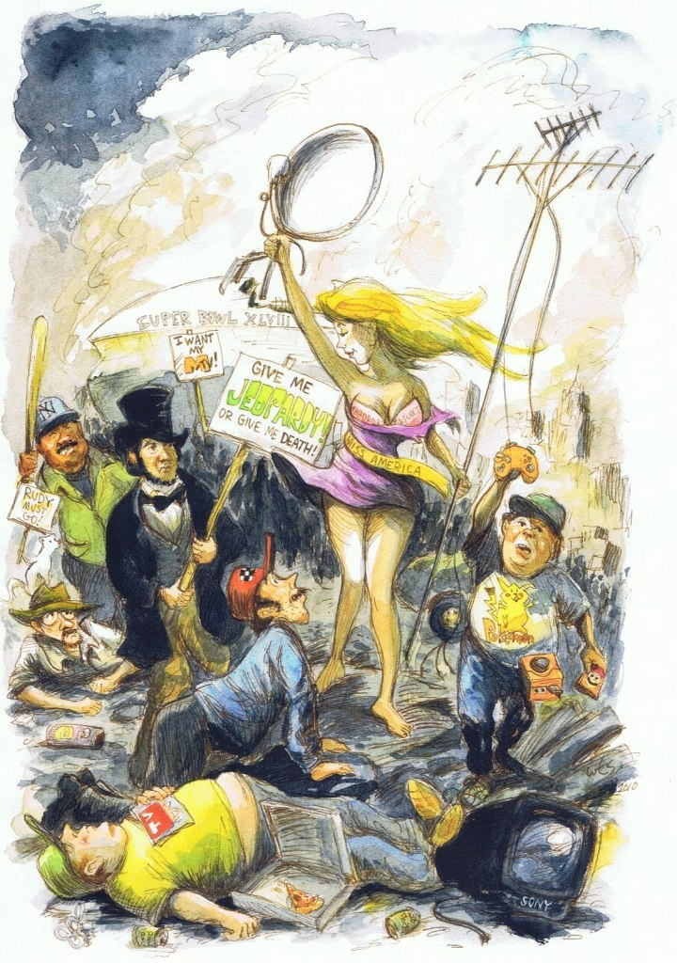

imagining such a scenario say about the contemporary state of philosophy and philosophers? Many things, almost all of them critical. Philosophy, in both its analytic and Continental guises, has predominantly failed, betraying itself and the world. For

example, only very recently have philosophers begun to speak of love, of wisdom – indeed, of the love of wisdom, which is the very meaning of the word *philosophy*.

But let’s forget about “love” or “wisdom” for the time being – let’s even forget about the forgetting of Being: in an age of multiplying and accelerating systemic crises and catastrophes (ecological, financial, religious, etc.), such

[Graphic: Andy Boerger]



I’m not arguing here that there is/shall be no place for philosophical description and analysis – indeed, the past century has witnessed some marvelous strides in this regard: existentialism, phenomenology, deconstruction are all exemplary ways of interpreting the world. Indeed, these and other epistemic currents have revolutionary potential – though one might

argue that some currents and/or sub-currents have been more stridently ethico-politically constructive than others. In any case, the emphasis has been on description rather than prescription, on deconstruction rather than reconstruction. Ultimately, what we require is both,

[Graphic: hannaharendtcenter.org]

**Conceiving the Blueprint**

A first task would be to build a global network of thinkers from a

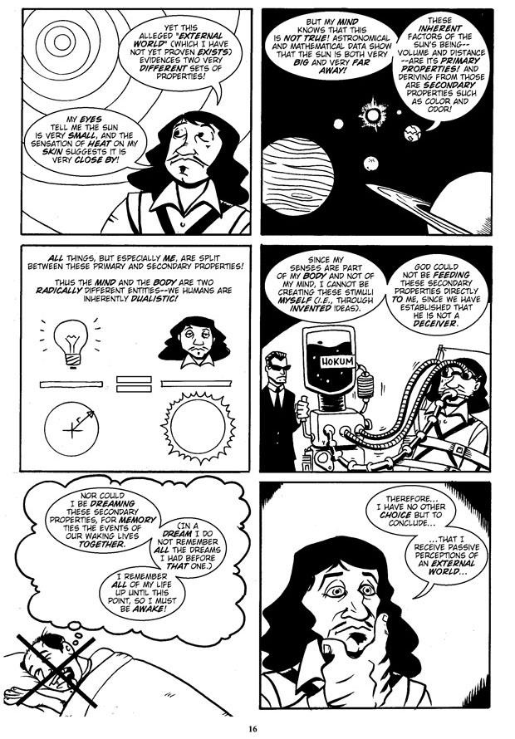

broad spectrum of the humanities and other disciplines, such as philosophy, economics, politics, education, theology, etc. This body shall attempt to attract the most powerful thinkers, “strong” thinkers both in terms of cognitive rigor and unwavering courage

(one could perhaps imagine the likes of Antonio Negri, Cornel West, Noam Chomsky, Slavoj Žižek, etc., being involved in such an enterprise). The thinkers would work collaboratively to create a blueprint for a new global order, an architectonics for a revolutionary society. With today’s communications technologies (Internet, social media, smart phones, etc.), such a global alliance is certainly achievable.

REPORT THIS ADPRIVACY SETTINGS

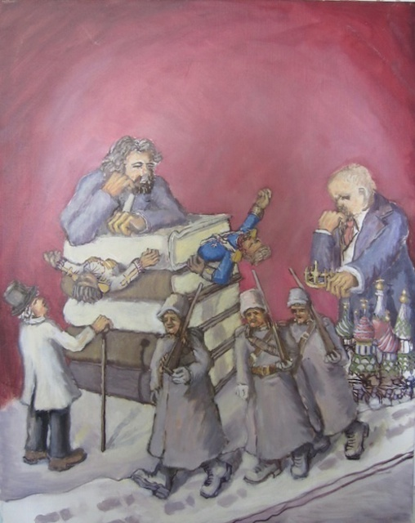

[Graphic: Action Philosophers]

Given the contemporary reclamation of singularity, exception, and so on, while the architectonics of this new global Republic will be comprehensive,

stipulating the necessary and sufficient amount of content, specifications, and limits, it shall simultaneously remain as open-ended and revisable as possible, so that the new society that is founded on it is able to negotiate and incorporate new knowledge and unforeseen/unforeseeable contexts and exceptions. So there will be a certain degree of openness and malleability to prevent dogmatic hardening and

[Graphic: Wendy Lippincott]

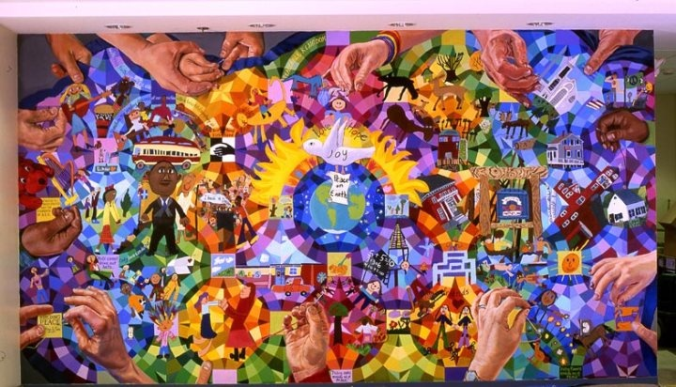

**Advocating the Blueprint**

Given that the blueprint shall be thoughtful, and therefore just, ecological, and so on, it is anticipated to be highly persuasive and convincing to its “stakeholders” – i.e., rational members of society. So, by taking the necessary time to carefully conceive the architectonics of a new society, there is greater

likelihood that more and more people will be attracted to it, moved by it, and motivated to participate in its implementation. The greater the blueprint’s traction, the greater the movement’s critical mass, and the greater its critical mass, the greater the likelihood of its

[Graphic: students of David Fichter]

**Implementing the Blueprint**

What next? We may begin with the reasonable assumption that the

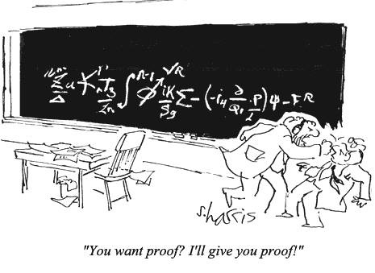

network of revolutionary thinkers will devise a System which requires altering existing power-relations, modes of production, and so on. For instance, it would be surprising in the extreme if contemporary capitalism – with its literally ­*all-consuming* desire for constant growth and greater profits – were to be retained as

the new society’s dominant economic mode. After all, I expect that a radically more rational economic system shall be envisaged by the network of thinkers, one which takes into account, for example, planetary limits, which fiercely contradicts the capitalist drive for endless growth. (So the challenge for any “neo-capitalist” possibility I cited

The second point is absolutely crucial. Rather than doing violence to “violence” by insisting upon its homogeneity, we must

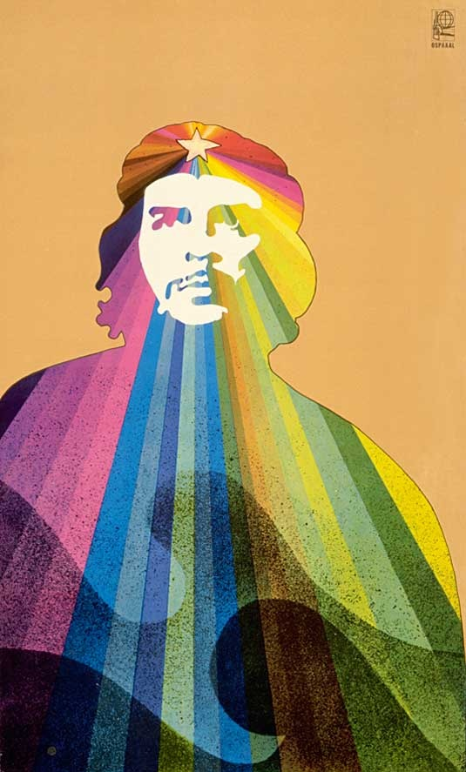

emphatically insist upon its heterogeneity. In other words, we must nuance the notion of “violence” – indeed, we must *differentiate*it. “Violence” is not *one*homogeneous thing; it is *many*,*multiple*, *plural*. In other words: *there are violences*. We

must discern between rational and irrational violences; between good and bad violences; between ethical and unethical violences (Žižek has articulated this difference)[8].

Indeed, to return to one of philosophy’s other eternal themes, love itself is violent. Both Žižek and Alain Badiou have incisively analyzed love’s violence. How, then, could love be violent? Even –

REPORT THIS ADPRIVACY SETTINGS



[Graphic: Alfredo Rostgaard]

Žižek convincingly argues that this paradoxical figuration of love accounts for the seemingly contradictory nature of the provocatively paradoxical comments of that exemplary revolutionary lover, Che Guevara.

On the one hand, Che contends: “At the risk of seeming ridiculous, let me say that the true revolutionary is guided by great feelings of love. It is impossible to think of a genuine revolutionary lacking this quality.”[13] On the other hand, he declares: Hatred is an element of struggle; relentless hatred of the enemy that impels us over and beyond the natural

**End notes:**

[1] Plato, *The Republic*, second ed., trans. Desmond Lee

(Harmondsworth: Penguin, 1974).

[2] Thomas More, *Utopia* (New York: Barnes & Noble Classics, 2005).

[3] Karl Marx, “Theses on Feuerbach” (1845). *Marx/Engels Internet Archive*. http://www.marxists.org/archive/marx/works/1845/theses/theses.htm.

[4] Paul W. Cockshott and Allin Cottrell, *Towards a New Socialism* (Nottingham: Russell Press, 1993).

[5] Žižek, “Occupy Wall Street: What is to be Done Next?”, *The Guardian*, April 24, 2012.

[6] *Zeitgeist 3: Moving Forward*. 2011. Dir. Peter Joseph. http://www.zeitgeistmovingforward.com/.

[7] Refer to, e.g., Russell Brand with Jeremy Paxman, “*Newsnight*: Paxman vs Brand – full interview on BBC.” Youtube. October 23, 2013. https://www.youtube.com/watch?v=3YR4CseY9pk.

[8] Refer to, e.g., Žižek, “A Plea for

Ethical Violence,” *The Bible and Critical Theory*32.1 (2004): (02)1-(02)15; *Violence: Six Sideways Reflections* (London: Profile Books, 2008).

REPORT THIS ADPRIVACY SETTINGS

[9] Žižek, “Love as a Political Category.” *Subversive Festival (No. 6)*. Zagreb, May 16, 2013. http://www.youtube.com/watch?v=b44IhiCuNw4.

[10] Alain Badiou, with Nicolas Truong, *In Praise of Love*, trans.

Peter Bush (New York: New Press, 2012).

[11] Žižek, “Love as a Political Category.”

[12] Žižek, *Living in the End Times* (London: Verso, 2010), 98.

[13] Ernesto Che Guevara, “Socialism and Man in Cuba” (1965), in *The Che Reader*, ed. David Deutschmann (North Melbourne: Ocean Press, 2003), 212-230.

[14] Ernsto Che Guevara, “Create

Two, Three, Many Vietnams (Message to the Tricontinental)” (1967), in *The Che Reader*, ed. David Deutschmann (North Melbourne: Ocean Press, 2003), 350-362.

[15] Žižek, “Love as a Political Category.”

[16] Žižek, *Demanding the Impossible*, ed. Yong-june Park (Cambridge: Polity Press), 114-115, 124-125.

limitations of man [*sic*] and transforms us into effective, violent, selective, and cold killing machines. Our soldiers must be thus; a people without hatred cannot vanquish a brutal enemy.[14]

How can these competing remarks be reconciled? Žižek explains:

These two apparently opposite stances are united in Che’s motto: *Hay que endurecerse sin perder jamás la ternura*. (“One must endure – become hard,

toughen oneself – without losing tenderness.”)  I think Guevara is here basically paraphrasing Christ’s declaration of the unity of love and sword. In both cases, the underlying paradox is that what makes love angelic, what elevates it over mere unstable, pathetic sentimentality is its cruelty itself, its link with violence.[15]

What we have, then, is a violence that inhabits both erotic and political love. Or, perhaps in a more nuanced way, we may say that erotic and political love are astir with violences that need to

be differentiated from any monolithically negative/bad forms of violence.

Lest you’re not convinced of the ‘manyness’ of violence, consider, as a final example, the violence that may be required in an act of self-defense: no rational person could argue that an innocent person should not protect themselves from being attacked, even when such protection involves violence. In a same/similar way, revolutionary violence – at least *our*transformative violence – would be

a *good*violence, for our revolution is *precisely*a “self-defense”: we’ll be defending ourselves and other creatures against our violators, defending a planet that cannot defend itself. In a similar vein, Žižek speaks of a “defensive violence” in the context of peaceful protest: if the power elite responds with violence, then we are ethically justified to counter such force with good violence.[16]

As bizarre as this differentiation of violence may initially appear to us peace-lovers, it turns out to be rigorously reasonable. And so,

while peaceful transformation is infinitely preferred by us peace-lovers, we realize that we may be forced to use force *if*the elites don’t voluntarily and non-violently surrender their power.

REPORT THIS ADPRIVACY SETTINGS

**Summoning**

It is perhaps unsurprising that philosophers have forgotten, repressed, ignored philosophy’s revolutionary calling: its reclamation and enactment

requires us to undertake daring and dangerous work. We (philosophers) are now summoned to participate in the conception, promotion, and implementation of a blueprint which may or may not involve risking our lives and even sacrificing them – a possibility that is not so original or radical once we evoke the good name of that exemplary revolutionary philosopher, Socrates. And if/when we survive the revolution, there may be some free time for us to resume the philosophical games we now play with such

breathtaking self-indulgence.

*and especially* – “romantic love”? This seemingly absurd notion is advanced by Žižek in a 2013 paper entitled “Love as a Political Category,”[9] and he (somewhat characteristically) launches his argument with reference to Badiou:

What is love? As Alain Badiou, our good friend, put it in his wonderful book, *In Praise of Love*,[10] there is always something traumatic or extremely violent in love. Love is a permanent emergency state.

You *fall* in love. You lose control. . . . [Y]ou passionately fall in love . . . everything is ruined. The entire balance of your life is lost. Everything is subordinated to this one person. I almost cannot imagine in normal daily life, outside war and so on, a more violent experience than that of love.

Anyone who has fallen in love will readily testify to the truth of its terrifying dimension. Unconvinced? Žižek reinforces his argument by incisively noting how contemporary dating agencies

attempt to subtract the vertiginous element. We want to be in love without “falling in love,” without exposing us to its terror. This may (help to) account for the fact that many people seem to be resistant to falling in love and instead seek the tranquility of casual encounters, “friends with benefits,” etc., as passionate love would violently interrupt our “safe,” routinized, consumer-hedonistic, atomistic lifestyles. Love’s violent dimension may also (help to) account for the fact that people often fear and resist falling in love *again*, going through its

trauma *again*.

REPORT THIS ADPRIVACY SETTINGS

In the very same text, Žižek seamlessly moves onto examining the violence in/of Christic love, a revolutionary hatred. I assume we’re all familiar with that extremely bewildering saying attributed to Jesus about “hating” one’s family. Žižek’s incisive exposition needs to be quoted in full:

“Father,” “mother,” and so on, here

condense the entire hierarchic social order, the network of relations of domination, subordination, and so on. So that the hatred Christ mentions is simply the hatred of established social hierarchy: “you are my follower, if instead of functioning as a part of social hierarchic order, you see as your true home, as it were, the Holy Spirit, an unconditionally egalitarian community.” The hatred enjoined by Christ is therefore not any kind of dialectical opposite of love, but the direct expression of love. Or as St. Paul put it, it is love that

enjoins us to unplug from our social community into which we were born, so that “there are neither men, nor women, neither Jews nor Greeks” [Žižek’s rendering of Galatians 3:28]. This is, I think, the very core of the Christian insight for me. God [*sic*] dies, Christ dies at the same time the Father [*sic*] dies; all that survives is the Holy Spirit, which is the first name of the Communist Party as we know. A radically egalitarian society which violently opposes social hierarchy, an immediate violent assertion of universal equality.[11]

I’m struck by the insight of this interpretation, of how it makes sense of a perplexing Christic notion (“hatred of one’s family”). It’s certainly a persuasive reading and even perhaps/probably a/the most convincing rendering, so we must not only remain open to it but are compelled to adopt it (unless an even more convincing interpretation becomes available, which is unlikely but possible). Given its cogency and force, this rendering reinforces Žižek’s confronting proposition that Christic *agape* is a violent political

love that justifiably expresses itself in revolution.[12]

above would differ from capitalism-as-we-know-it, if such a thing is possible). So I think the assumption stands: I anticipate radical structural change.

Involved in such change is, as I’ve already indicated, the expectation that there shall be alterations in relations of power. My cognitive inkling is that power shall be organized, concentrated and/or shared in different ways to the

status quo.

If that shall be the case, how will the power elite respond to such changes in power-relations?

One may envisage two basic scenarios (though we shouldn’t discount the possibility of others). A first possible response is that the powerful shall voluntarily surrender their power in the face of a multitude that embraces the blueprint and passionately expresses its support for its implementation in the form of peaceful mass demonstrations,

protests, and so on. With the multitude flexing its peaceful people-power, the hope is that the elite shall voluntarily transfer power to the movement. Its unequivocal desire is for a peaceful transference of power. In recent times, we witnessed something like this in the “Arab Spring.”

REPORT THIS ADPRIVACY SETTINGS

**Of Violences**

But what if the peaceful approach won’t work? What if glorious people-power alone won’t compel the oppressors to surrender their power? This is certainly a possibility – and perhaps even a probability – as history attests: greedy, stubborn elites often refuse to relinquish their power, even in the face of mass protests and insurrections, with the consequence of either retaining power (and even radicalizing it) or fighting for it to the bitter end. So it may be necessary for us revolutionaries to wrestle it from

the Establishment. In other words, what *may*be required – *as a “Plan B,” as a last resort ­*– is revolutionary violence. While peaceful revolution is infinitely preferred by us peace-lovers, we realize that we may be forced to use force. Part of the work that the network of thinkers must therefore undertake is to theorize, strategize and ready the revolutionary movement for the dire possibility of having to violently wrest asunder the power that the powerful may not be willing to surrender.

Indeed, I assume that the very suggestion of revolutionary violence may/will sound irrational, shocking, scandalous to our bleeding-hearted ears. So I’m compelled to offer a relatively lengthy justification, although, given the controversial nature of the subject-matter, it shall perhaps fall violently short of a sufficiently lengthy defense.

Let’s begin with an immediate and obvious objection: what if violent insurrection simply re-inscribes the cycle of destruction, and that the new System will retain

(perhaps in reconfigured ways) the very exploitations and oppressions that the revolution seeks to erase? To begin with, there is no doubt that there *is*a risk of the re-inscription of violence. Revolution is a gamble; the outcome is unknown. Indeed, we should even allow for the possibility that things may end up being worse – *if* such a possibility is indeed possible, but it’s probably improbable given the status quo. Still, it’s nonetheless possible. But surely this is a gamble that *must* be taken for philosophico-practical reasons,

both in terms of philosophy’s eternal call for change and in terms of our dire ethico-political circumstances, whereby the planet is already enduring various oppressions, exploitations, crises, and catastrophes.

REPORT THIS ADPRIVACY SETTINGS

success. The more “seductive” the Cause, the greater the chances of its fruition.

This is how I construe the

blueprint’s promotion will proceed. Once it reaches a sufficient level of “completion,” the network will advocate it, initially to other intellectuals. Philosophers shall thus be involved in this process of spreading the good news of the revolutionary blueprint to other philosophers, to other thinkers. Consequently, it shall be brought to the attention of university students and the broader intelligentsia. Its popularity shall also spread to artists and other creative people. In this regard, capturing the attention and obtaining the approval of

enlightened celebrities (Russell Brand immediately comes to mind)[7] shall probably be crucial for the movement’s success, for they often/usually generate greater publicity among the general public in shorter periods of time. Furthermore, revolution often/usually requires charismatic personas, and more of them tend to be found among the creative community.

REPORT THIS ADPRIVACY SETTINGS

The vigorous and hopefully viral

“marketing campaign” will spiral outwards, to ever-more-broader sectors of society – activists, trade unionists, and so on – gathering critical mass. With this kind of momentum, more and more of the oppressed shall be drawn to the blueprint, including the working poor and the unemployed. The stage would now be set for the third phase of the revolutionary process.

its attendant effects. Reification and dogmatism are enemies of the rational revolution, and so they

will not be accommodated by the thinking that conceives it. The blueprint must therefore be relatively flexible, constantly cognizant of its openness, revisability, and limits.

Obviously, the creation of an architectonics will be a massive, almost overwhelming undertaking, but I don’t think it’s out of the realm of possibility that our corporate brainpower is capable of it. We humans have achieved breathtaking achievements. Let’s remind ourselves that individuals have hitherto attempted such a

feat (including Plato and More). (The recent third installment of the popular *Zeitgeist*documentary series, which appears to be a collaborative project, has a prescriptive dimension, which is rather encouraging.)[6] So I think a blueprint is achievable – and I think philosophers – we lovers of Reason, its potency, its Enlightenmental ambition – should be the first to affirm its achievability.

Moreover, I also think a blueprint is necessary: without some kind of plan – albeit one with the kind

of flexibility that satisfactorily negotiates unforeseen contexts and circumstances – an aimless revolution will either run aground or go off-course. While it never claimed to be a revolutionary movement (perhaps it never claimed to be any thing at all), it wouldn’t be unreasonable to propose that the Occupy phenomenon stalled and died precisely because it lacked intention or direction. By definition, a *move*-ment moves by moving in a certain direction. I confirm the notion that revolutions have/can have a certain

“spontaneous” “event-al” dimension to them, but I contend that a certain amount of planning and programming is also crucial.

Given the difficulty and immensity of the task of devising this blueprint, this process will obviously take some time to complete, perhaps/probably *much* time to complete. The network will be compelled to work urgently and quite quickly (given the multiplying, accelerating crises and catastrophes), but it must not be rushed – or rushed *too much* – for

a couple of reasons. The most pressing reason for patience is that the more time that is spent on it, the more thoughtful it will be, and therefore it will be more just and ethical and ecological and so on. But producing the best possible blueprint isn’t crucial for its own sake, but also for fostering the tasks that follow its conception.

REPORT THIS ADPRIVACY SETTINGS

The network would recognize and be driven by the fact that what is needed for a truly rational society – and therefore a society that is truly just, ecological, ethical, etc. – seems to be either a massive reformation of the existing one or its transfiguration into quite a different one. In other words, the network would determine whether the new System would involve some kind of “neo-capitalism,” or some form of “neo-communism” (such as Cockshott and Cottrell’s *Towards a New Socialism*)[4], or some type of hybrid of the two, or something

else altogether.

REPORT THIS ADPRIVACY SETTINGS

However, I won’t offer much by way of content here, for several reasons: (1) I wish to emphasize the *collaborative* nature of the blueprint’s creation; (2) even though I have elsewhere sketched what I currently estimate to be some elements of its content, I also recognize that such a task somewhat significantly exceeds my cognitive capabilities; and (3) I’m limited by the scope of the

paper and by time restraints. With these provisos in my mind, my educated hunch is that the new society will be egalitarian, thoroughly ecological, and resolutely intolerant of the various oppressions, exploitations, and discriminations that pervade the globe. Phenomena such as classism, racism, sexism, homophobia, etc., will not be tolerated.

Of course, one cannot deny the human propensity for evil – theology calls it “original sin,” while psychoanalysis posits an

unconscious brimming with debaucherous desires. How shall the blueprint counter this seemingly ineradicable force? Developing Žižek’s insight that our focus should lie with changing a System that fosters this propensity (“the problem is not corruption or greed, the problem is the system that pushes you to be corrupt”)[5], my inkling is that our structures and institutions shall be required to impose the kind of rational discipline to foster the “conformity” necessary for a flourishing society and planet.

And given that I’m a philosopher of religion, I could also propose how the blueprint would negotiate the thorny question of religions and spiritualities. I anticipate that the architectonics shall proceed along a third way, between or beyond the absolutist renunciation of religion (as was the case with atheistic twentieth-century communism) and the contemporary hyper-pluralism or “multiculturalism” that often indiscriminately permits religious excesses (dogmatism, sexist practices, barbaric customs, and so on). Instead, the blueprint will

advance a “neo-secularity” that neither seeks the abolition of religion nor permits dogmas and practices that do not align with its reasonable, noble aims of emancipation and enlightenment. They’re just some of the characteristics that I envisage will be constitutive of the blueprint.

but the time has come – and seems to be quickly running out – for philosophers to be primarily driven by thought’s transformative ambition.

But, you may protest, how on Earth do philosophers change the world? More accurately and humbly: how do philosophers contribute to changing the world? Good question. Difficult question. But not an impossible one. I’ve been thinking about it for a few short years now, so my response to it is as introductory and tentative as it is ambitious and sweeping – and it can only be summarized here. Of course, as an introductory line of thinking, the premise is that this nascent thought shall be collaboratively developed over time. And like all

good pleas, I’m offering this one with the hope that it be received in a spirit of goodwill and open-mindedness, and that it be “heard” in the sense of being adjudicated according to the determinants of thoughtfulness and practicality.

REPORT THIS ADPRIVACY SETTINGS

And as for the program outlined here? Like any speculation, it’s inevitably provisional. But this doesn’t – or shouldn’t – make it any less rigorous or at least *sufficiently* rigorous. I have

learned from postmodern philosophy a certain humility, a certain tentativeness, but the time has come for us thinkers to overcome the paralysis that proceeds from a hyper-postmodern provisionalism, with its endless qualifications and nuances, refusing to offer any kind of agenda or program, for fear of closing off an open future. For this paralysis will ensure that the crises and catastrophes that are overwhelming us are likely to close off the possibility of us humans having any kind of future at all – which is worse than a

bleak one, for such a future may still contain the possibility of opening up a brighter one.

And so, I turn to laying out the three basic stages to the kind of revolutionary process I’ve begun thinking about, along the way showing what I anticipate philosophers will possibly/probably be required to do, doing what has already been called upon by philosophy to do.

failures pale in comparison to the fact that philosophers have largely

forgotten the *revolutionary essence* of philosophy. If philosophy begins in wonder, then it should end with frustration and the desire – indeed, the demand and the fight – for justice. If philosophy begins in wonder, then it ends with revolution.

Philosophy has *always been and always will be* revolutionary. But, alas, philosophers have forgotten its revolutionary calling, ignored it, denied it, suppressed it. But like any good repression, it returns – a return that is probably amplified and intensified by the increasingly

unignorable crises that surround us and engulf us. To think is to revolt against an unthinking or badly thinking world – but the ridicule to which we might respond to such a seemingly strange claim is testament to our unfaithfulness to philosophy’s radical core.

To be sure, the revolutionariness of philosophy has been occasionally recognized, remembered, advocated. Despite his many failings, Plato stayed true to philosophy by conceiving a radical new society with

his *Republic*.[1] Perhaps somewhat more obliquely, Thomas More stayed faithful to philosophy’s radical impulse with his *Utopia*.[2] And, of course, Karl Marx perfectly encapsulated this failure and forgetting by insisting that philosophy has thus far interpreted the world but hasn’t transformed it.[3] Of course, Marx himself didn’t contribute much content to the communistic vision, but at least he hadn’t forgotten philosophy’s revolutionary essence and indeed pleaded for it.

This is how I construe the



blueprint’s promotion will proceed. Once it reaches a sufficient level of “completion,” the network will advocate it, initially to other intellectuals. Philosophers shall thus be involved in this process of spreading the good news of the revolutionary blueprint to other philosophers, to other thinkers. Consequently, it shall be brought to the attention of university students and the broader

intelligentsia. Its popularity shall also spread to artists and other creative people. In this regard, capturing the attention and obtaining the approval of enlightened celebrities (Russell Brand immediately comes to mind)[7] shall probably be crucial for the movement’s success, for they

[Graphic: students of David Fichter]

**Implementing the Blueprint**

What next? We may begin with the reasonable assumption that the



network of revolutionary thinkers will devise a System which requires altering existing power-relations, modes of production, and so on. For instance, it would be surprising in the extreme if contemporary capitalism – with its literally ­*all-consuming* desire for constant growth and greater profits – were to be retained as

the new society’s dominant economic mode. After all, I expect that a radically more rational economic system shall be envisaged by the network of thinkers, one which takes into account, for example, planetary limits, which fiercely contradicts the capitalist drive for endless growth. (So the challenge for any “neo-capitalist” possibility I cited

The second point is absolutely crucial. Rather than doing violence to “violence” by insisting upon its homogeneity, we must



emphatically insist upon its heterogeneity. In other words, we must nuance the notion of “violence” – indeed, we must *differentiate*it. “Violence” is not *one*homogeneous thing; it is *many*,*multiple*, *plural*. In other words: *there are violences*. We

must discern between rational and irrational violences; between good and bad violences; between ethical and unethical violences (Žižek has articulated this difference)[8].

Indeed, to return to one of philosophy’s other eternal themes, love itself is violent. Both Žižek and Alain Badiou have incisively analyzed love’s violence. How, then, could love be violent? Even –

REPORT THIS ADPRIVACY SETTINGS



[Graphic: Alfredo Rostgaard]

Žižek convincingly argues that this paradoxical figuration of love accounts for the seemingly contradictory nature of the provocatively paradoxical comments of that exemplary revolutionary lover, Che Guevara.

On the one hand, Che contends: “At the risk of seeming ridiculous, let me say that the true revolutionary is guided by great feelings of love. It is impossible to think of a genuine revolutionary lacking this quality.”[13] On the other hand, he declares: Hatred is an element of struggle; relentless hatred of the enemy that impels us over and beyond the natural

**End notes:**

[1] Plato, *The Republic*, second ed., trans. Desmond Lee

(Harmondsworth: Penguin, 1974).

[2] Thomas More, *Utopia* (New York: Barnes & Noble Classics, 2005).

[3] Karl Marx, “Theses on Feuerbach” (1845). *Marx/Engels Internet Archive*. http://www.marxists.org/archive/marx/works/1845/theses/theses.htm.

[4] Paul W. Cockshott and Allin Cottrell, *Towards a New Socialism* (Nottingham: Russell Press, 1993).

[5] Žižek, “Occupy Wall Street: What is to be Done Next?”, *The Guardian*, April 24, 2012.

[6] *Zeitgeist 3: Moving Forward*. 2011. Dir. Peter Joseph. http://www.zeitgeistmovingforward.com/.

[7] Refer to, e.g., Russell Brand with Jeremy Paxman, “*Newsnight*: Paxman vs Brand – full interview on BBC.” Youtube. October 23, 2013. https://www.youtube.com/watch?v=3YR4CseY9pk.

[8] Refer to, e.g., Žižek, “A Plea for

Ethical Violence,” *The Bible and Critical Theory*32.1 (2004): (02)1-(02)15; *Violence: Six Sideways Reflections* (London: Profile Books, 2008).

REPORT THIS ADPRIVACY SETTINGS

[9] Žižek, “Love as a Political Category.” *Subversive Festival (No. 6)*. Zagreb, May 16, 2013. http://www.youtube.com/watch?v=b44IhiCuNw4.

[10] Alain Badiou, with Nicolas Truong, *In Praise of Love*, trans.

Peter Bush (New York: New Press, 2012).

[11] Žižek, “Love as a Political Category.”

[12] Žižek, *Living in the End Times* (London: Verso, 2010), 98.

[13] Ernesto Che Guevara, “Socialism and Man in Cuba” (1965), in *The Che Reader*, ed. David Deutschmann (North Melbourne: Ocean Press, 2003), 212-230.

[14] Ernsto Che Guevara, “Create

Two, Three, Many Vietnams (Message to the Tricontinental)” (1967), in *The Che Reader*, ed. David Deutschmann (North Melbourne: Ocean Press, 2003), 350-362.

[15] Žižek, “Love as a Political Category.”

[16] Žižek, *Demanding the Impossible*, ed. Yong-june Park (Cambridge: Polity Press), 114-115, 124-125.

limitations of man [*sic*] and transforms us into effective, violent, selective, and cold killing machines. Our soldiers must be thus; a people without hatred cannot vanquish a brutal enemy.[14]

How can these competing remarks be reconciled? Žižek explains:

These two apparently opposite stances are united in Che’s motto: *Hay que endurecerse sin perder jamás la ternura*. (“One must endure – become hard,

toughen oneself – without losing tenderness.”)  I think Guevara is here basically paraphrasing Christ’s declaration of the unity of love and sword. In both cases, the underlying paradox is that what makes love angelic, what elevates it over mere unstable, pathetic sentimentality is its cruelty itself, its link with violence.[15]

What we have, then, is a violence that inhabits both erotic and political love. Or, perhaps in a more nuanced way, we may say that erotic and political love are astir with violences that need to

be differentiated from any monolithically negative/bad forms of violence.

Lest you’re not convinced of the ‘manyness’ of violence, consider, as a final example, the violence that may be required in an act of self-defense: no rational person could argue that an innocent person should not protect themselves from being attacked, even when such protection involves violence. In a same/similar way, revolutionary violence – at least *our*transformative violence – would be

a *good*violence, for our revolution is *precisely*a “self-defense”: we’ll be defending ourselves and other creatures against our violators, defending a planet that cannot defend itself. In a similar vein, Žižek speaks of a “defensive violence” in the context of peaceful protest: if the power elite responds with violence, then we are ethically justified to counter such force with good violence.[16]

As bizarre as this differentiation of violence may initially appear to us peace-lovers, it turns out to be rigorously reasonable. And so,

while peaceful transformation is infinitely preferred by us peace-lovers, we realize that we may be forced to use force *if*the elites don’t voluntarily and non-violently surrender their power.

REPORT THIS ADPRIVACY SETTINGS

**Summoning**

It is perhaps unsurprising that philosophers have forgotten, repressed, ignored philosophy’s revolutionary calling: its reclamation and enactment

requires us to undertake daring and dangerous work. We (philosophers) are now summoned to participate in the conception, promotion, and implementation of a blueprint which may or may not involve risking our lives and even sacrificing them – a possibility that is not so original or radical once we evoke the good name of that exemplary revolutionary philosopher, Socrates. And if/when we survive the revolution, there may be some free time for us to resume the philosophical games we now play with such

breathtaking self-indulgence.

*and especially* – “romantic love”? This seemingly absurd notion is advanced by Žižek in a 2013 paper entitled “Love as a Political Category,”[9] and he (somewhat characteristically) launches his argument with reference to Badiou:

What is love? As Alain Badiou, our good friend, put it in his wonderful book, *In Praise of Love*,[10] there is always something traumatic or extremely violent in love. Love is a permanent emergency state.

You *fall* in love. You lose control. . . . [Y]ou passionately fall in love . . . everything is ruined. The entire balance of your life is lost. Everything is subordinated to this one person. I almost cannot imagine in normal daily life, outside war and so on, a more violent experience than that of love.

Anyone who has fallen in love will readily testify to the truth of its terrifying dimension. Unconvinced? Žižek reinforces his argument by incisively noting how contemporary dating agencies

attempt to subtract the vertiginous element. We want to be in love without “falling in love,” without exposing us to its terror. This may (help to) account for the fact that many people seem to be resistant to falling in love and instead seek the tranquility of casual encounters, “friends with benefits,” etc., as passionate love would violently interrupt our “safe,” routinized, consumer-hedonistic, atomistic lifestyles. Love’s violent dimension may also (help to) account for the fact that people often fear and resist falling in love *again*, going through its

trauma *again*.

REPORT THIS ADPRIVACY SETTINGS

In the very same text, Žižek seamlessly moves onto examining the violence in/of Christic love, a revolutionary hatred. I assume we’re all familiar with that extremely bewildering saying attributed to Jesus about “hating” one’s family. Žižek’s incisive exposition needs to be quoted in full:

“Father,” “mother,” and so on, here

condense the entire hierarchic social order, the network of relations of domination, subordination, and so on. So that the hatred Christ mentions is simply the hatred of established social hierarchy: “you are my follower, if instead of functioning as a part of social hierarchic order, you see as your true home, as it were, the Holy Spirit, an unconditionally egalitarian community.” The hatred enjoined by Christ is therefore not any kind of dialectical opposite of love, but the direct expression of love. Or as St. Paul put it, it is love that

enjoins us to unplug from our social community into which we were born, so that “there are neither men, nor women, neither Jews nor Greeks” [Žižek’s rendering of Galatians 3:28]. This is, I think, the very core of the Christian insight for me. God [*sic*] dies, Christ dies at the same time the Father [*sic*] dies; all that survives is the Holy Spirit, which is the first name of the Communist Party as we know. A radically egalitarian society which violently opposes social hierarchy, an immediate violent assertion of universal equality.[11]

I’m struck by the insight of this interpretation, of how it makes sense of a perplexing Christic notion (“hatred of one’s family”). It’s certainly a persuasive reading and even perhaps/probably a/the most convincing rendering, so we must not only remain open to it but are compelled to adopt it (unless an even more convincing interpretation becomes available, which is unlikely but possible). Given its cogency and force, this rendering reinforces Žižek’s confronting proposition that Christic *agape* is a violent political

love that justifiably expresses itself in revolution.[12]

above would differ from capitalism-as-we-know-it, if such a thing is possible). So I think the assumption stands: I anticipate radical structural change.

Involved in such change is, as I’ve already indicated, the expectation that there shall be alterations in relations of power. My cognitive inkling is that power shall be organized, concentrated and/or shared in different ways to the

status quo.

If that shall be the case, how will the power elite respond to such changes in power-relations?

One may envisage two basic scenarios (though we shouldn’t discount the possibility of others). A first possible response is that the powerful shall voluntarily surrender their power in the face of a multitude that embraces the blueprint and passionately expresses its support for its implementation in the form of peaceful mass demonstrations,

protests, and so on. With the multitude flexing its peaceful people-power, the hope is that the elite shall voluntarily transfer power to the movement. Its unequivocal desire is for a peaceful transference of power. In recent times, we witnessed something like this in the “Arab Spring.”

REPORT THIS ADPRIVACY SETTINGS

**Of Violences**

But what if the peaceful approach won’t work? What if glorious people-power alone won’t compel the oppressors to surrender their power? This is certainly a possibility – and perhaps even a probability – as history attests: greedy, stubborn elites often refuse to relinquish their power, even in the face of mass protests and insurrections, with the consequence of either retaining power (and even radicalizing it) or fighting for it to the bitter end. So it may be necessary for us revolutionaries to wrestle it from

the Establishment. In other words, what *may*be required – *as a “Plan B,” as a last resort ­*– is revolutionary violence. While peaceful revolution is infinitely preferred by us peace-lovers, we realize that we may be forced to use force. Part of the work that the network of thinkers must therefore undertake is to theorize, strategize and ready the revolutionary movement for the dire possibility of having to violently wrest asunder the power that the powerful may not be willing to surrender.

Indeed, I assume that the very suggestion of revolutionary violence may/will sound irrational, shocking, scandalous to our bleeding-hearted ears. So I’m compelled to offer a relatively lengthy justification, although, given the controversial nature of the subject-matter, it shall perhaps fall violently short of a sufficiently lengthy defense.

Let’s begin with an immediate and obvious objection: what if violent insurrection simply re-inscribes the cycle of destruction, and that the new System will retain

(perhaps in reconfigured ways) the very exploitations and oppressions that the revolution seeks to erase? To begin with, there is no doubt that there *is*a risk of the re-inscription of violence. Revolution is a gamble; the outcome is unknown. Indeed, we should even allow for the possibility that things may end up being worse – *if* such a possibility is indeed possible, but it’s probably improbable given the status quo. Still, it’s nonetheless possible. But surely this is a gamble that *must* be taken for philosophico-practical reasons,

both in terms of philosophy’s eternal call for change and in terms of our dire ethico-political circumstances, whereby the planet is already enduring various oppressions, exploitations, crises, and catastrophes.

REPORT THIS ADPRIVACY SETTINGS

often/usually generate greater publicity among the general public in shorter periods of time. Furthermore, revolution often/usually requires charismatic

personas, and more of them tend to be found among the creative community.

REPORT THIS ADPRIVACY SETTINGS

The vigorous and hopefully viral “marketing campaign” will spiral outwards, to ever-more-broader sectors of society – activists, trade unionists, and so on – gathering critical mass. With this kind of momentum, more and more of the oppressed shall be drawn to the blueprint, including the working poor and the

unemployed. The stage would now be set for the third phase of the revolutionary process.

**End notes:**

[1] Plato, *The Republic*, second ed., trans. Desmond Lee (Harmondsworth: Penguin, 1974).

[2] Thomas More, *Utopia* (New

York: Barnes & Noble Classics, 2005).

[3] Karl Marx, “Theses on Feuerbach” (1845). *Marx/Engels Internet Archive*. http://www.marxists.org/archive/marx/works/1845/theses/theses.htm.

[4] Paul W. Cockshott and Allin Cottrell, *Towards a New Socialism* (Nottingham: Russell Press, 1993).

[5] Žižek, “Occupy Wall Street: What is to be Done Next?”, *The Guardian*, April 24, 2012.

[6] *Zeitgeist 3: Moving Forward*. 2011. Dir. Peter Joseph. http://www.zeitgeistmovingforward.com/.

[7] Refer to, e.g., Russell Brand with Jeremy Paxman, “*Newsnight*: Paxman vs Brand – full interview on BBC.” Youtube. October 23, 2013. https://www.youtube.com/watch?v=3YR4CseY9pk.

[8] Refer to, e.g., Žižek, “A Plea for Ethical Violence,” *The Bible and Critical Theory*32.1 (2004): (02)1-(02)15; *Violence: Six Sideways*

*Reflections* (London: Profile Books, 2008).

[9] Žižek, “Love as a Political Category.” *Subversive Festival (No. 6)*. Zagreb, May 16, 2013. http://www.youtube.com/watch?v=b44IhiCuNw4.

[10] Alain Badiou, with Nicolas Truong, *In Praise of Love*, trans. Peter Bush (New York: New Press, 2012).

[11] Žižek, “Love as a Political Category.”

[12] Žižek, *Living in the End Times* (London: Verso, 2010), 98.

[13] Ernesto Che Guevara, “Socialism and Man in Cuba” (1965), in *The Che Reader*, ed. David Deutschmann (North Melbourne: Ocean Press, 2003), 212-230.

[14] Ernsto Che Guevara, “Create Two, Three, Many Vietnams (Message to the Tricontinental)” (1967), in *The Che Reader*, ed. David Deutschmann (North Melbourne: Ocean Press,

2003), 350-362.

[15] Žižek, “Love as a Political Category.”

[16] Žižek, *Demanding the Impossible*, ed. Yong-june Park (Cambridge: Polity Press), 114-115, 124-125.

9. **Reflections on resistance, reform, and revolution**

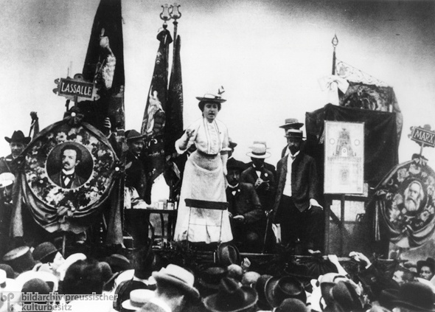

How can the respective political modes of resistance, reform, and revolution be deployed to advance social and individual freedom? How might they reinforce each other on a reciprocal basis? Today, with the recent upsurge in global activism, we stand on the precipice of what promises to herald the rebirth of such a

politics. These questions have acquired a renewed sense of urgency in this light. Now more than ever, they demand our attention if we are to forge a way forward without repeating the mistakes of the past.

Reform, revolution, and resistance — each of these concepts exercises a certain hold over the

Neither can the difficulty of relating these three concepts — reform, revolution, and resistance — be avoided by invoking the

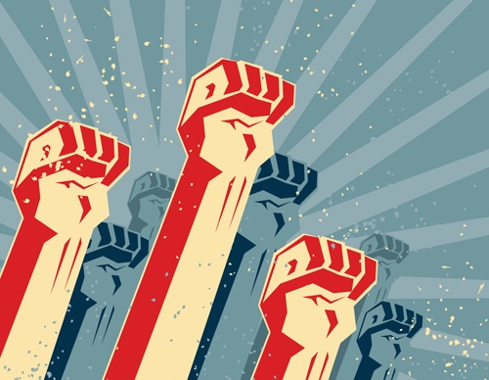

commonplace of a “diversity of tactics.” Each of these ostensibly refers to an overarching *strategy* for achieving emancipation, and thus cannot be reduced to a mere selection of *tactics*. With “resistance,” it is uncertain if this activity (or passivity) ever even attains to the level of a conscious strategy,

much less tactics. In Foucault’s metaphysics of power, resistance is an unconscious, automatic, and reflexive response to power relations wherever they exist. “Where there is power, there is resistance,” claims Foucault. As a statement, however, this says nothing of the world as it ought to be, or how such a world might be brought into existence. At most, it

**Resistance**

Of the three terms presently under investigation, “resistance” is the

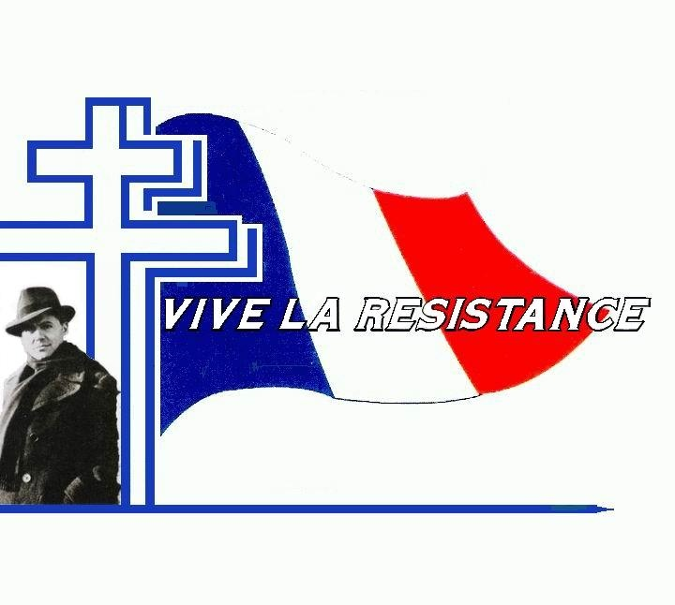

one of the most recent vintage, at least to the extent that it has been conceptualized and self-consciously used on the Left. A couple of preliminary remarks help to focus the discussion.

First, as Stephen Duncombe pointed out a few years ago, the

concept of “resistance” is inherently conservative.[2] It indicates the ability of something to maintain itself — i.e., to conserve or preserve its present state of existence — against outside influences that would otherwise change it. Resistance signifies not only defiance but

REPORT THIS ADPRIVACY SETTINGS

The concept of “resistance” was romanticized yet further through the experience of *La Résistance* in

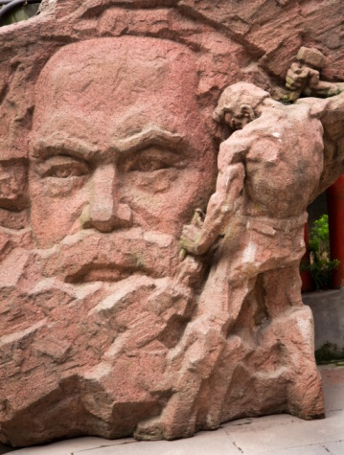

France fighting the collaborationist Vichy regime. Quite a few of the resistance’s most prominent heroes and martyrs belonged to the Communist movement. Even this case was not without its problems, however. The French

Communists’ much-touted “resistance” to fascist rule bore throughout the indelible imprint of Stalinist pop-frontism. As some perceptive Trotskyist critics noticed already in 1939, the strategy of the Popular Front only siphoned off revolutionary energy from the more militant sections of the French labour movement,

The transformation of the New Left into the self-proclaimed “post-political” or “post-ideological” Left placed a new premium on the concept of *cultural resistance*.[14]

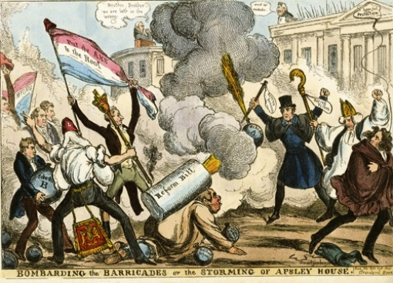

Sadly, by the late 1970s, postcolonialism’s and postmodernism’s most valuable contributions to radical politics already belonged to the past. The Albert Memmi of*The Colonizer and the Colonized*and the Frantz Fanon of *Black Skin, White Masks*(not *The Wretched of the Earth*)[15] were superior to Said,

as well as their own later incarnations. Said himself was vastly preferable to today’s figures, such as Bhabha, Spivak, or Chakrabarty. The same can basically be said of postmodernism. Lyotard the member of *Socialisme ou*

REPORT THIS ADPRIVACY SETTINGS

**Reform**

In its modern sense, “reform” stretches back quite a bit further.

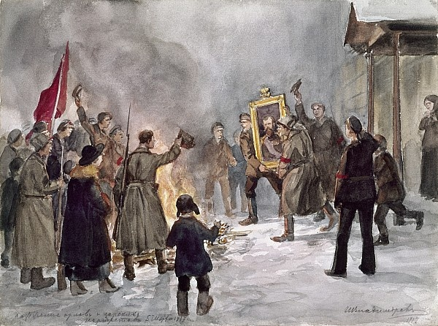

However, this should not be taken too far, to the point of anachronism. One might be tempted, for example, to include the Magna Carta in the history of reforms. It should be remembered, however, that the king’s concession to the feudal barony was not obtained through established legal channels, but at

the tip of a sword.

Though the history of successful, sweeping reforms begins in Britain with the Great Reform Act of 1832, demands for reform had a significant prehistory (dating all the way back to 1745 by some

Within the context of international Social Democracy, the struggle for reform was not conceived as separable from the goal of revolution until the end of the nineteenth century. The crisis of Second International Marxism that

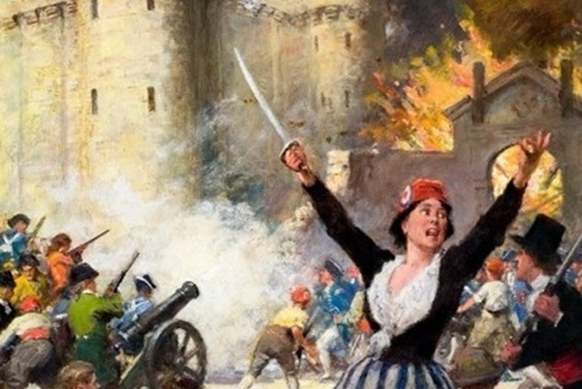

occurred during the Revisionist Debate of the 1890s was itself symptomatic of its *success* in building a mass movement. In other words, Bernstein’s contention that the working class could best realize its emancipation through a progression of social reforms[26] had itself been precipitated by the movement’s strength in achieving

parliamentary representation. It only became possible through the further articulation of working-class politics in the years after Marx’s death. Reform, as Luxemburg argued, is not so much the antithesis of revolution as it is

**Revolution**

If today the question of *reform* has once again entered into crisis, this is because the concept of *revolution* has lost its self-evidence. Luxemburg’s rejoinder to Bernstein steadfastly asserted

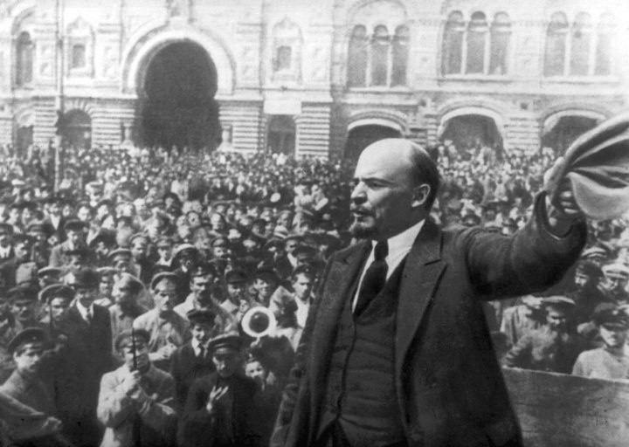

that “the conquest of political power has been the aim of all rising classes.”[28] And while Trotskii could categorically claim in 1924 — without hesitation — that “[b]y [revolutionary] strategy, we understand the art of conquest, i.e., the seizure of power”[29] it is not at all clear that this is still the case. The #Occupy

movement has, by contrast, by and large followed the strategy formulated by the Marxian autonomist John Holloway in 2002, to “change the world without taking power.” The subtitle to Holloway’s book says it all: “The meaning of revolution today.”[30]

Of course, a revolution cannot be accomplished all at once, in one fell swoop. At a certain level, there must be a dialectic between *process*and *event*involved in any truly revolutionary transformation. “The international

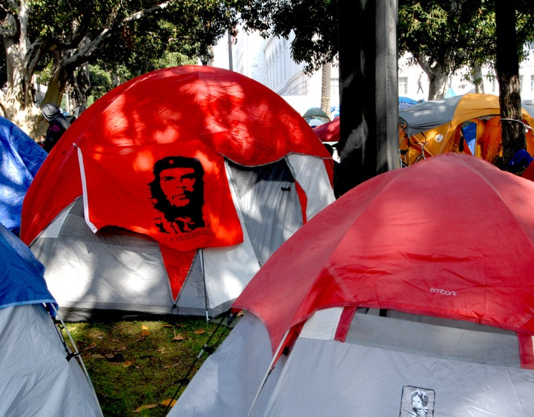

revolution,” Trotskii always reminded, “constitutes a permanent process, despite temporary declines and ebbs.”[35] Nevertheless, Trotskii was always sure to stress the unevenness of this process. “[H]istoric processes are…far from consisting…in a steady accumulation and continual ‘improvement’ of that

which exists. [History] has its transitions of quantity into quality, its crises, leaps, and backward lapses.”[36] Certainly, some continuity with the world before the revolution will remain, but there will be important discontinuities, as well. The

REPORT THIS ADPRIVACY SETTINGS

Among the #Occupy movement’s more militant sections, the French pamphlet on *The Coming Insurrection*still holds some

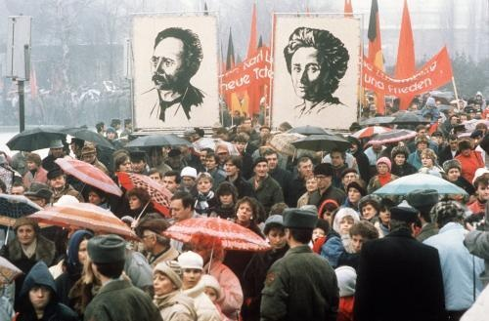

weight. With its paramilitary pose and radical chic, its knowing matter-of-factness, the rhetoric from this mini-manifesto remains fashionable in some circles. The book refrains from glamorizing violence as such, but much of its appeal clearly comes from its literal call to arms: “Take up arms,” it advises. “There is no such thing as a peaceful insurrection.

Weapons are necessary.”[39] *The Coming Insurrection*still pales in comparison to the bellicosity of past works from the anarchist canon (insofar as there is one). Certainly, anyone who has read the terrifying*Catechism of a*

**Reflections**

Having discussed these three terms in relative isolation from each other, it is now perhaps appropriate to reflect on how they might fit together to form a politics of the present. In so doing,



however, a fourth thought-figure intervenes: that of *emancipation*. Resistance, reform, and revolution are only meaningful to the extent that they realize emancipation as their end. It goes without saying that no single approach should be taken as the optimal solution in every case. Depending on the concrete contexts in which they move, different strengths and

weaknesses are revealed.

REPORT THIS ADPRIVACY SETTINGS

Today, “resistance” seems to take the form of preserving past

**End Notes:**

[1] Foucault, Michel. *The History of Sexuality, Volume 1: An Introduction*. (Pantheon Publishers. New York, NY: 1978). Pg. 95.

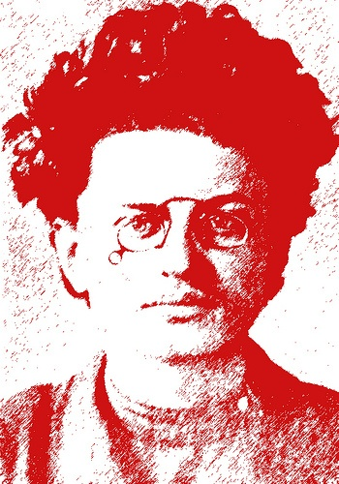

[2] “[The] political beginnings [of resistance] in the West are conservative; this helps to explain some of the politics of resistance. It’s Edmund Burke, the British conservative, who actually counsels resistance against the radical change of the French

image1627542602390.png

Revolution in 1790. About 75 years later, the same call was taken up by Mathew Arnold, who essentially argues for culture as a means of resistance against the tides of anarchic progress…Resistance has this sort of conservative cast in the 18th and 19th centuries.” Albert, Michael; Cutrone, Chris; Duncombe,

Stephen; and Holmes, Brian. “The

3 Rs: Reform, revolution, and ‘resistance’: The problematic forms of ‘anticapitalism’ today.” *The Platypus Review*. (№ 4. April, 2008).

REPORT THIS ADPRIVACY SETTINGS

[3] *Upping the Anti* editorial board. “With eyes wide open: Notes on crisis and resistance today.” *Upping the Anti*. (№ 10. May, 2010).

[4] To illustrate this ambivalence, it is only necessary to look at

Resistance Records, a white power label founded in 1999.

[5] Burke, Edmund. *Selected Works, Volume 2*: *Reflections on the Revolution in France*. (Liberty Fund. Indianapolis, IN: 1999). Pg 180.

[6] Proudhon, Pierre-Joseph. *Resistance to the revolution: Louis Blanc and Pierre Leroux*. Translated by Benjamin R. Tucker. *Property is Theft! An Anthology*. (AK Press. Baltimore, MA: 2011). Pgs. 495-508.

[7] “Notwithstanding the enthusiasm of the people, the Bill of 1831 encountered obstinate resistance from the House of Commons.” Paul, Alexander. *The History of Reform: A Record of the Struggle for the Representation of the People in Parliament*. (George Routledge & Sons. New York, NY: 1884). Pg. 138.

[8] Engels, Friedrich. “Letter to Marx in London, May 1, 1866.” Translated by Christopher Upward. *Collected Works, Volume 42: 1864-1868*. (International Publishers. New York, NY: 1987).

Pg. 269.

[9] “Imperialism is as much our ‘mortal’ enemy as is capitalism. That is so. No Marxist will forget, however, that capitalism is progressive compared with feudalism, and that imperialism is progressive compared with pre-monopoly capitalism. Hence, it is *not* every struggle against imperialism that we should support. We will *not* support a struggle of the reactionary classes against imperialism; we will *not* support an uprising of the reactionary classes against

imperialism and capitalism.

…Consequently, once [one] admits the need to support an uprising of an oppressed nation (‘actively resisting’ suppression means supporting the uprising), he also admits that a national uprising is *progressive*, that the establishment of a separate and new state, of new frontiers, etc., resulting from a successful uprising, is *progressive*.” Lenin, Vladimir Il’ich. *A Caricature of Marxism and Imperialist Economism*. Translated by M.S. Levin, Joe Fineberg, and others. *Collected Works, Volume*

*23: August 1916-March 1917*. (International Publishers. New York, NY: 1964). Pg. 63.

REPORT THIS ADPRIVACY SETTINGS

[10] “The tide of revolutionary unrest and the will to combat fascism rose high again in the French labour movement in 1934. The combined efforts of the Socialists and Stalinists succeeded in diverting the revolutionary ferment into the channels of popular frontism.” Spector, Maurice. “The Popular

Front’s Guilt.” *New International*. (Vol. 4, № 11: November 1938). Pg. 329.

[11] Bhabha, Homi. *The Location of Culture*. (Routledge. New York, NY: 1994). Pgs. 110-111.

[12] Sauvy, Alfred. “The Third World.” Translated by Christophe Campos. *General Theory of Population*. (Basic Books. New York, NY: 1969). Pgs. 204-218.

[13] “[T]he significance of Maoism, through the Great Proletarian Cultural Revolution in China,

transformed from seeming to be relevant only to peasant guerilla-based revolutionism and ‘new democracy’ in the post-colonial periphery, to becoming a modern form of Marxism with potential radical purchase in the core capitalist countries.” Cutrone, Chris. “The relevance of Lenin today.”

[14] Said, Edward. “At the rendezvous of victory.” *Culture and resistance: Conversations with Edward W. Said, Interviewed by David Barsamian*. (South End Press. Cambridge, MA: 2003). Pg.

159.

[15] Singh, Sunit. “Book review: Frantz Fanon’s *Black skin, white masks*.” *Platypus review*.

[16] Of the two, Susan Buck-Morss was perhaps correct when she recently pronounced that postcolonialism still shows more promise than the “conceptual dead-end” of postmodernism. Even then, she pointed out, the former has run up against certain limitations: “The postcolonial moment entailed shifts in culture and in politics — but in economics,

I’m not so sure.” Buck-Morss, Susan. “Postcolonialism or postmodernism? An interview conducted by Chris Mansour.” *Platypus Review*.

REPORT THIS ADPRIVACY SETTINGS

[17] “‘Resistance’ is rarely based on a reflexive analysis of possibilities for fundamental change that are both generated and suppressed by the dynamic heteronomous order of capital. ‘Resistance’ is an undialectical category that does not grasp its

own conditions of possibility; it fails to grasp the dynamic historical context of capital and its reconstitution of possibilities for both domination and emancipation, of which the ‘resisters’ do not recognize that that they are a part.” Postone, Moishe. “History and Helplessness: Mass Mobilization and Contemporary Forms of Anticapitalism.” *Public Culture*. (Vol. 18, № 1: 2006). Pg. 108.

…Žižek, in criticizing Foucault’s notion of resistance, writes: “It is Foucault who insists on the immanence of resistance to

Power, [but] it is Lacan who allows us to conceptualize the distinction between imaginary resistance (false transgression that reasserts the symbolic status quo and even serves as a positive condition of its functioning) and actual symbolic rearticulation via the intervention of the Real of an *act*.” Žižek, Slavoj. *The Ticklish Subject: The Absent Centre of Political Ontology*. (Verso Books. New York, NY: 2000). Pg. 262.

[18] Cutrone, Chris. “The 3 Rs: Reform, revolution, and ‘resistance’.”

[19] Locke, John. *Second Treatise on Government*. (Cambridge University Press. New York, NY: 2003). Pgs. 402-403. §207.

[20] “At what date does the story of Reform begin? The period most vividly associated with the word Reform in the mind of the modern politician is little more than half a century past; but the great struggle which culminated in the Act of 1832 had its real beginnings at a much earlier date…Such a convenient date is 1745.” Paul, Alexander. *The History of*

*Reform: A Record of the Struggle for the Representation of the People in Parliament*. (George Routledge & Sons. New York, NY: 1884). Pgs. 1-2.

[21] *Ibid.*, pgs. 16-19.

[22] “[N]umerous popular societies sprang into existence, the aim of which was always Parliamentary Reform. The revolutionary proceedings in France heightened the prevailing excitement.” *Ibid.*, pgs. 61-62.

[23] Bentham, Jeremy. “Plan of

Parliamentary Reform, in the form of a Catechism, Showing the Necessity of Radical, and the Inadequacy of Moderate, Reform.” *Collected Works, Volume 3*. (Oxford University Press. New York, NY: 2012). Pg. 433.

[24] “[I]n England the Civil War and ‘Glorious Revolution’ of the 17th century made possible what came to seem a compromise. The Whigs’ Reform Act of 1832 extended the electoral franchise to a good section of the middle class, but the working class, who supported the Whigs’ Reform

agitation, remained excluded from the franchise. Throughout the 1830s the radical press was persecuted, trade unionists transported, Ireland subjected to paramilitary police terror, and the hated workhouse system established by the New Poor Law.” Black, David. “The elusive ‘threads of historical progress’: The early chartists and the young Marx and Engels.” (№ 36. December 2011-January 2012).

[25] Marx, *Capital: A critique of political economy, volume 1*. Pgs. 389-411.

[26] “[The proletariat’s] influence would be much greater than it is today, if Social Democracy could find the courage to emancipate itself from phraseology that is, in fact, obsolete and to make up its mind to appear what it is in reality today: a democratic socialist party of reform.” Bernstein, Eduard. *The Preconditions of Socialism*. Translated by Henry Tudor. (Cambridge University Press. New York, NY: 1993). Pg. 186.

[27] Leonard, Spencer. “The decline of the Left in the twentieth

century: 2001.” *Platypus Review*. (№ 17. November 18th, 2009). Pg. 2.

[28] “Legislative reform and revolution are not different methods of historic development; they are different *factors* in the development of class society.” Luxemburg, Rosa. *Reform or Revolution?*Translated by Integer. (Haymarket Books. Chicago, IL: 2008). Pg. 89.

[29] Trotskii, Leon. *Lessons of October*. Translated by John G. Wright. (Bookmarks. London,

England: 1987). Pg. 16.

[30] “This…is the revolutionary challenge at the beginning of the twenty-first century: to change the world without taking power.” Holloway, John. *Change the World without Taking Power: The Meaning of Revolution Today*. (Pluto Press. Ann Arber, MI: 2010). Pg. 20.

[31] Sewell, William. “Historical Events as Transformations of Structures: Imagining the Revolution at the Bastille.” *Logics of history: Social theory and social*

*transformation*. (The University of Chicago Press. Chicago, IL: 2005). Pg. 235.

[32] *Ibid.*, pg. 227. My emphasis.

[33] Benjamin, Walter. “On the Concept of History.” Translated by Edmund Jephcott. *Selected Writings, Volume 4: 1938-1940*. (Harvard University Press. Cambridge, MA: 2003). Pg. 395.

[34] Lenin, Vladimir. *The State and Revolution: The Marxist Theory of the State and the Tasks of the Proletariat in the Revolution*.

Translated by Stepan Apresyan and Jim Priordan. *Collected Works, Volume 25: June-September 1917*. (International Publishers. New York, NY: 1974). Pg. 401.

[35] Trotskii, Leon. *The Permanent Revolution*. Translated by John G. Wright and Brian Pearce. *The Permanent Revolution & Results and Prospects*. (Pathfinder Press. New York, NY: 1978). Pg. 133.

[36] Trotskii, Leon. *The Revolution Betrayed: What is the Soviet Union and Where is it Going?* Translated

by Max Eastman. (Pathfinder Press. New York, NY: 1983). Pg. 48.

[37] Graeber, David. *Fragments of an Anarchist Anthropology*. (Prickly Paradigm Press. Chicago, IL: 2004). Pg. 50.

[38] *Ibid.*, pgs. 43-44.

[39] The Invisible Committee. *The Coming Insurrection*. (Semiotex(t)e. 2006). Pg. 84.

[40] In order to destroy the “formidable reactionary coalition”

inside Europe, Bakunin called on “the greater power of *the simultaneous revolutionary alliance and action of all the people of the civilized world*.” Bakunin, Mikhail. *Revolutionary Catechism*. Translated by Sam Dolgoff. *Bakunin on Anarchy*. (Vintage Books. New York, NY: 1972). Pg. 96.

[41] Kropotkin, Petr. “Revolutionary Government?” Translated by Paul Sharkey. *No Gods, No Masters*. (AK Press. Oakland, CA: 2005). Pg. 313.

[**Note:**This essay appears in rosswolfe.wordpress.com ]

measures of “reform,” measures that only were only passed in the first place because “revolution” presented itself as a distinct possibility. In Europe, meanwhile, the welfare state — the crown jewel of nearly a century’s worth of Social Democracy — is unraveling at an alarming rate. Neoliberal austerity still seems the order of the day. The question is less which tactic or strategy to follow at present than it is

to *recognize* what would be required to deploy them meaningfully. Resistance, reform, and revolution all aim to provide a solution to what Marx called “the riddle of history”: communism. To date, however, this riddle remains unsolved. In the absence of a viable international mass movement that could potentially overcome the rule of capital, answers are in short supply. Until such a movement is reconstituted, the only available options are micro-resistance, piecemeal reforms, and merely local/national revolutions — and the realization

of total social and individual freedom is forestalled.

*Revolutionary*, co-authored by Bakunin and Nechaev in 1870,will look back at *The Coming Insurrection*as mere child’s play. Still, there are traces of the old revolutionary notion of irreversibility in the Invisible Committee’s “insurrection.” Nevertheless, the imagination of *The Coming Insurrection*is for the most part limited to the experience of the 2005 riots in the Paris *banlieues*—scattered,

largely local affairs. World revolution is nowhere to be found in its pages.

It should be emphasized that these concepts of revolution departs not only from most of those passed down by Marxist theory through the ages, but also from the majority of anarchist ideas concerning revolution prior to 1968. Giants of revolutionary anarchism like Bakunin, Nechaev, and Malatesta each adhered to the vision of a massive, sudden uprising, a *simultaneous* break with the past taking place on

a *worldwide* scale.[40] Some, like Paul Brousse and Johann Most, advocated the “propaganda of the deed” — i.e., acts of spectacular terrorism — hoping to spur the masses to spontaneous action. Kropotkin understood “revolution” as “synonymous with…the toppling and overthrow of age-old institutions within the space of a few days, with violent demolition of established forms of property, with the destruction of caste, with the rapid change of received thinking.”[41] One would be hard-pressed to find any revolutionary program coming out of the

Occupy movement with such ambitious scope or intensity.

REPORT THIS ADPRIVACY SETTINGS

Such departures from the way “revolution” was previously understood should not be thought unacceptable, of course. Trying to hold anyone (let alone an anarchist) to the authority of past thinkers would be an exercise in futility. The real question is the following: What does it say about our own political moment that such past conceptions of

revolution seem so outlandish, impossible, and unthinkable to us today? Were yesterday’s notorious revolutionaries simply deluded, mistaken, and misguided? Or is it rather that we stand on political ground that is considerably worse than they did? Do we perhaps today inhabit a world in which politics has substantially regressed from the historical position it held a century ago?

structures of daily life would be radically rearranged, but certain prerevolutionary practices will no

doubt endure for some time.

REPORT THIS ADPRIVACY SETTINGS

The understanding of “revolution” just sketched can be usefully contrasted with that of David Graeber, whose thought has undeniably served as one of #Occupy’s greatest sources of inspiration. Graeber provides the clearest expression of revolution as a kind of continuous, never-ending *process* unpunctuated by events. Accordingly, he rejects the notion of history as marked by

qualitatively distinct “epochs”:

[T]here has been no one fundamental break in human history. No one can deny there have been massive quantitative changes: the amount of energy consumed, the speed at which humans can travel, the number of books produced and read…But…these quantitative changes do not…necessarily imply a change in quality: we are not living in a fundamentally different sort of society than has ever existed before, we are not living in a fundamentally different sort of

time.[37]

In Graeber’s opinion, the mistake underlying these conceptions of revolution as rupture consists in their Lukácsean assumption that abstractions like “capitalism” or “society” exist as real *totalities*. “[T]he habit of thought which defines…society as a totalizing system,” Graeber argues, “tends to lead almost inevitably to a view of revolutions as cataclysmic ruptures.”[38] In place of this more traditional version of what revolution may look like, Graeber instead advocates a

“prefigurative” politics of creating a microcosm of the society one would want to live in. This notion is not wholly without precedent: echoes can still be heard here of the old motto from the 1905 IWW Preamble, which prescribes “forming the structure of the new society within the shell of the old.” But it would be a mistake to think that all anarchists look to create models of prefiguration.

As with *resistance* and *reform*, the modern concept

of *revolution* arose historically. It should not be elevated into a transhistorical principle simply by virtue of the venerable status it enjoys in leftist political discourse. As suggested earlier, “revolution” was born alongside the Left itself, as its conceptual twin. William Sewell has perhaps contributed the most to understanding this historical dimension of “revolution”:

We are by now used to the notion that revolutions are radical transformations in political systems imposed by violent

uprisings of the people. We therefore do not see the extraordinary novelty of the claim that the taking of the Bastille was an act of revolution. Prior to the summer of 1789, the word revolution did not carry the implication of a change of political regime achieved by popular violence…In ordinary parlance,…[t]he “uprising” or “mutiny” of July 14th could…be designated by contemporaries as a “revolution,” but this was…not because it was a self-conscious attempt by the people to impose by force its sovereign will.[31]

REPORT THIS ADPRIVACY SETTINGS

For Sewell, the concept of “revolution” — at least in its modern meaning — designates a momentous and irrevocable “event.” “[E]vents should be conceived of as sequences of occurrences that result in transformations of structures,” he explains. “Such sequences begin with a *rupture*…[and] durably [transform] previous structures and practices.”[32] Any revolution worthy of the name would thus

seem to require a radical discontinuity with the past — “blasted out of the continuum of history,” as it were.[33] It would involve a sort of compressed temporality. Lenin is said to have once quipped that “there are decades where nothing happens; there are weeks when decades happen.” Revolution, in this model, would then necessarily hinge upon certain decisive moments — “turning points,” “breakthroughs,” “tipping points,” “points of no return,” “starts and fits,” etc. — moments after which nothing was ever the same, after which there

was no going back. Removing these moments from a revolution would mean “reducing…[it] to [the] vague notion of a slow, even, gradual change, [with an] absence of leaps and storms.”[34]

its practical result. The fact that reforms are even possible indicates that revolution is on the table.

However, the gains made through social reforms by the merging of European Social-Democracy (which drifted gradually rightward

following 1914) and liberalism (drifting leftward in Keynesian guise after 1933) are presently deteriorating under cutbacks. “The abandonment of emancipatory politics in our time has not been, as past revolutionary thinkers may have feared, an abandonment of revolution in favor of reformism,” Spencer Leonard recently observed. “Rather, because the revolutionary overcoming of capital is no longer imagined, reformism too is dead.”[27] Political events over the course of this last year seem to confirm Leonard’s judgment. The faint

murmurs that were heard early on in the #Occupy protests, which called for the reinstatement of Glass-Steagall or the creation of a “Jobs for All” program, have all but subsided. Placards have since appeared stating that “Capitalism cannot be Reformed.”

True enough. But what would reform even *look* like now that the Left is everywhere in retreat? Are the austerity measures in Europe, one wonders, examples of “reforms”? Bank bailouts and deregulation? Rescinded pensions and mass layoffs? Or has the fight

for reforms instead moved toward a totally different modality of engagement, becoming a purely *defensive* battle upholding the reforms of the past against the neoliberal onslaught? Must the struggle for new reforms be put on hold, if not abandoned completely? And are we really obligated to defend the last miserable scraps of the welfare state — the gutted remains of social programs initiated over sixty years ago? Today, the options of “reform *or* revolution” seem rather the inevitability of “deform *and*devolution.”

estimates). Originally, the meaning of “reform,” *stricto sensu*, was specifically related to matters of enfranchisement — “an extension of the electorate,” as it were.[20] The earliest calls for parliamentary reform, in the decades following the Glorious Revolution of 1688, pertained to widespread political corruption. In 1776, the “radical” (as opposed to “moderate”) parliamentarian John Wilkes first advanced a proposal for universal male suffrage, largely as a reaction to the American War

of Independence.[21] Nevertheless, such daring calls for democratization were highly anomalous at this point.

Clamoring for reform rapidly accelerated in the aftermath of the French Revolution of 1789, however.[22] Another great proponent of “radical” reform was the famous utilitarian philosopher, Jeremy Bentham. Even following Napoleon’s final defeat at Waterloo, on the eve of the Restoration, he posed the same disjunction Luxemburg would make eighty years later, albeit in a

quite different register: “[T]he country…is already on the very brink — reform or convulsion, such is the alternative.”[23] As Bentham realized, the world revolution of 1789 — even in its degraded imperial form under Bonaparte — had placed certain demands on the governments of Europe. This not only in the territories that the “Little Corporal” had conquered on the continent, either: the revolutionary imprint of that fateful year traveled across the English Channel, as well. So despite the best reactionary efforts of Tsar Nikolai I of Russia

and Count Metternich of Austria, Bentham still had the sense that something had irrevocably changed.

REPORT THIS ADPRIVACY SETTINGS

But Bentham would barely live to see the first fruits of his struggles for reform. The Great Reform Bill of 1832 granted broader voting rights to British adult males, at least in principle. Popular pressure for reforms had come in large part from the nascent labour movement. Despite its successful

passage, the numerous deficiencies and compromises in the legislation, along with its suppression of more radical measures, led many of its supporters to believe that these reforms had not gone far enough. The Chartist movement grew out of this overwhelming sense of dissatisfaction and persecution.[24] Immediately following the enactment of the 1832 Bill — *the* foundational act in the history of modern reform — the terrain on which the battle for reforms was waged shifted. Reforms no longer centered

exclusively on the issue of suffrage. Fresh on its heels came the Factory Act of 1833. Over the course of the next thirty years, the working class in Britain fought for the institution of regular limits to the working day. This was the struggle described in such riveting detail by Marx in *Capital*.[25]

*Barbarie* or theorist of postmodernism was far more worthwhile than Lyotard the relapsed Kantian aesthetician; the Baudrillard who wrote *The Mirror of Production* ought to be

prioritized over the author who later wrote *Simulacra and Simulation*. Either way, postcolonial and postmodernist politics never aspired to anything more than “resistance” to a seemingly all-powerful system of neoliberalism and globalization.[16]

REPORT THIS ADPRIVACY SETTINGS

Such is the genealogy of “resistance” on the Left. Down at Liberty Plaza last fall one would regularly see signs that read (in a

perverse Cartesianism): “I resist, therefore I exist.” The real efficacy of such resistance is difficult to ascertain, however. Recently, Marxian theorists such as Moishe Postone and Slavoj Žižek have suggested that politics based on resistance is often unwittingly complicit with the very systems they purport to resist.[17] It remains unclear, moreover, how resistance fits into any broader emancipatory program. As Chris Cutrone observes: “The Left today almost never speaks of freedom or emancipation, but only of ‘resistance’ to the dynamics of

change associated with capital and its transformations.”[18]

Of course, this is not to deny any and all emancipatory power to acts of “resistance.” But “resistance” can really only be called upon to preserve those freedoms of which one already has possession, against forces that seek to limit them. In this sense, the politics of resistance do not go beyond the “right of resistance” proclaimed by early liberals such as John Locke, who in his *Second Treatise on Government*wrote that “they who

use unjust force may be questioned, opposed, and resisted.”[19] An extension of inalienable bourgeois property, one possessed the right to protect his or her own “life and limbs.”

diverted into mindless campaigns of coalition building.[10] This is not to denigrate the sacrifice and valour of French resistance fighters, of course. It is only to point out the complex conditions under which such “resistance” took place.

Finally, in the hands of postmodern and postcolonial theory, “resistance” received the academy’s authoritative stamp of approval. It became consecrated as *the* standard mode of dissent under late capitalism. To provide just one example of the kind of needlessly baroque theoretical explanations given to “resistance” by postcolonialists, we need only look at Homi Bhabha’s 1994 work on *The Location of Culture*:

Resistance is not necessarily an oppositional act of political intention, nor is it the simple

negation or exclusion of the “content” of another culture, as a difference once perceived. It is the effect of an ambivalence produced within the rules of recognition of dominating discourses as they articulate the signs of cultural difference and re-implicate them within the deferential relations of colonial power — hierarchy, normalization, marginalization and so forth. For colonial domination is achieved through a process of disavowal that denies the chaos of its intervention as *Entstellung*, its dislocatory presence in order to

preserve the authority of its identity in the teleological narratives of historical and political evolutionism.[11]

REPORT THIS ADPRIVACY SETTINGS

For all his obscurity, Bhabha at least has the merit of elucidating the apolitical dimension of “resistance.” What is unclear from his explanation is whether a subject can actively “resist” forms of foreign, outside cultural domination “in order to preserve the authority” of more familiar,

traditional, native, or “indigenous” forms of domination. Postcolonial theory must be understood within the context of the Cold War politics out of which it first emerged. With the decline of revolutionary leftist politics in the most advanced industrial nations of the world, hopes for radical social transformation migrated to what the French demographer Alfred Sauvy dubbed the “Third World.”[12] These hopes eventually reached their ideological apotheosis in what has come to be known as *tiers-mondisme* [“Third-Worldism”].

That is to say, in the global system divided into blocs between the “First World” (the U.S. and its allies) and the so-called “Second World” (the U.S.S.R. and its allies), the primary site of political struggle now shifted to the “Third World” (the non-affiliated countries, often ex-colonies of European nations).

Ironically, such sentiments often survived the actual ideologies that engendered them. Enthusiasm for national liberation movements in formerly colonized regions continued in Western activist

circles long after the USSR and PRC in the East ceased funding them — the former following its dissolution in 1991, the latter after the *coup d’état* that overthrew the “Gang of Four” in 1976. At this point, the streams of postcolonialism (arising from capitalism’s periphery) and postmodernism (arising from its core) converged.[13] All the grand narratives of the past, it seemed, had collapsed. Edward Said’s *Orientalism* came out in 1978; Jean-François Lyotard’s *Postmodern Condition* was released a year

later. Both works are generally considered seminal within the postcolonial and postmodern canons, respectively. Significantly, however, each tendency — that is, postcolonialism and postmodernism — may be regarded as an outcome of the practical exhaustion and theoretical confusion brought about by the failure of the New Left. Tired, disillusioned, and largely depoliticized, the radicals who comprised the New Left now joined the very institutions they once opposed, becoming full-time academics or professional

activists.

REPORT THIS ADPRIVACY SETTINGS

also intransigence. As the editors of *Upping the Anti* put it a couple years back, “resistance” automatically assumes a “defensive posture.”[3] It thus appears to be politically ambivalent: it depends on what is being conserved and what is being resisted.[4]

Secondly, beyond its conceptual

dimension, the language of “resistance” is linked to conservatism at an historical level as well. At least, this is how recalcitrant elements of society originally understood their opposition to the Left ever since its inception in 1789. Against the rationalism and excesses of the French Revolution, the British statesman and archconservative Edmund Burke praised England for its stubborn “resistance” to radical projects of political modernization. He wrote:

Thanks to our sullen resistance to

innovation, thanks to the cold sluggishness of our national character, we still bear the stamp of our forefathers…We are not the converts of Rousseau; we are not the disciples of Voltaire; Helvétius has made no progress amongst us…We fear God; we look up with awe to kings; with affection to parliaments; with duty to magistrates; with reverence to priests; and with respect to nobility.[5]

REPORT THIS ADPRIVACY SETTINGS

As late as 1848, the term “resistance” was chiefly deployed by reactionaries. Under the July Monarchy of Louis Philippe, the conservative theorist and statesman Guizot led *le parti de la Résistance* against the more progressive *Parti du mouvement*. The influential anarchist Pierre-Joseph Proudhon reproached his contemporaries, Louis Blanc and Pierre Leroux, along these lines in 1849, for their “resistance to the revolution.”[6] The forces of reaction in Europe were not merely content to “resist” revolution, however. Later, in the struggle for

electoral reform in Britain in the 1830s, the Left once again had to contend with the “resistance” of conservative legislators.[7] During the 1860s, when a new Reform Bill threatened to extend the franchise to an even greater proportion of the population, a dissident segment of the Liberal Party — the “Adullamites” — motioned to resist these democratic measures. Engels’ judgment of this move was damning: “These Adullamites really are tremendous jackasses to put up such resistance to this pauvre Reform Bill, the most conservative thing that’s ever been

done here [England].”[8]

Only in the short twentieth century did “resistance” come to be associated with leftist politics, by virtue of a threefold historical development. First, it was ennobled through movements of opposition by colonial peoples in resisting imperial subjugation. But even here, the emancipatory character of “resistance” to imperialism was not always clear-cut. Lenin, whose theory of imperialism is so commonly invoked by Marxists and anarchists today, was wise

enough not to offer unqualified support to just any movement claiming to “resist” imperialist aggression. Uprisings against imperialism led by regressive social elements do not deserve to be cheered along by the Left in lieu of progressive alternatives that may not exist.[9]

only describes a fact of being.[1]

REPORT THIS ADPRIVACY SETTINGS

But perhaps all this already

assumes too much. The more fundamental question that presently confronts us is the following: What do reform, revolution, and resistance even *mean* today? In their modern usage these concepts each arose historically, in connection with concrete processes and events. These are hardly “perennial” categories reaching all the way back to the dawn of man; indeed, the oldest among them is only as old as the Left itself. A review of the contexts in which these concepts crystallized may help clarify their bearing on the

present. Not that history has the final word on what this or that term really signifies. Tracing the origins of a concept’s modern usage should not be thought of as a way to recover its “authentic” meaning. However, if a substantial revision has taken place in the conceptualization of reform, revolution, or resistance, we should be honest about this departure.

This is especially true with the category of “revolution,” which has undergone the most significant renovation in the discourse of

#Occupy. For if *reform* was the most problematic figure of thought for Luxemburg in 1900, and *resistance* for Platypus five years ago, then the most pressing concept in need of clarification for the Left right now is *revolution*. If former conceptions of revolution prove to be inadequate or unrealistic, this does not mean we are forbidden from using the word, of course. But we should at least be clear about the break, so as to not fool ourselves that we are somehow remaining loyal to the good old cause.

popular imagination of the Left. While they need not be conceived as mutually exclusive, the three have often sat in uneasy tension with one another over the course of the last century, however. The Polish Marxist Rosa Luxemburg famously counterposed the first two in her pamphlet*Reform or Revolution?*, written over a hundred years ago. In her view, this ultimately turned out to be a false dichotomy. Nevertheless, Luxemburg was addressing a real dilemma that had emerged along with the formation of the Second

International and the development of mass working-class politics in the late nineteenth century. Even if she was able to conclude that reforms could still be pursued within the framework of a revolutionary program — that is, without falling into *reformism* — this was by no means an obvious position to take.

REPORT THIS ADPRIVACY SETTINGS

Still less should we consider the matter done and settled with respect to our current context,

simply because a great figure like Luxemburg dealt with it in her own day. We do not have the luxury of resting on the accomplishments or insights of past thinkers. It is unclear whether the solution at which she arrived then holds true any longer. History can help us understand the *momentum* of the present carried over from the past, as well as possible futures toward which it may be tending. But it offers no prefabricated formulae for interpreting the present, no readymade guides to action.

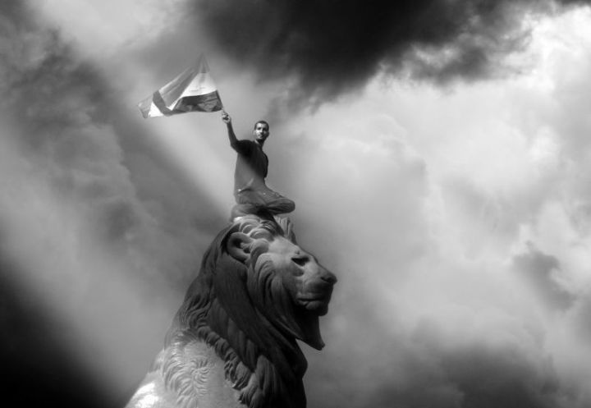

10.**What does Revolution mean today?**

On May 31st what began months before as opposition to the cutting down of trees in Taksim Square in

Istanbul exploded into country-wide opposition to the increasingly authoritarian rule of Prime Minister Recep Tayyip Erdogan.  As was the case with the Arab Spring and Occupy, the Turkish youth and workers’ movement caught global commentators unawares.  Turkey had been held up as a model of

REPORT THIS ADPRIVACY SETTINGS

Within this broad and abstract continuity there are also

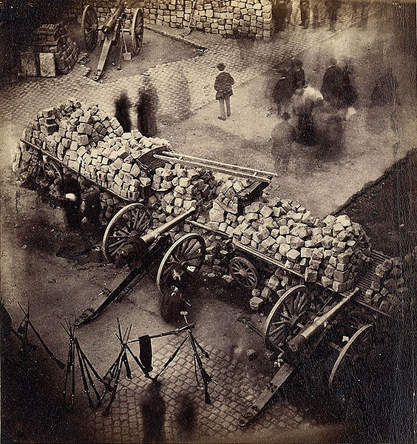

differences, and it is most important today to understand those differences.  While revolutions have always involved fundamental changes in value system, social institutions, and ruling class, the content of those fundamental changes — the

substance of the new value system, the character of the institutions, and the identity of the incipient ruling class — alters over history.  These changes of content have had implications for revolutionary form — its justifications, its methods, and its leaders.  Understanding these changes at this conjuncture in history is particularly important, because intensifying political instability across the globe

REPORT THIS ADPRIVACY SETTINGS

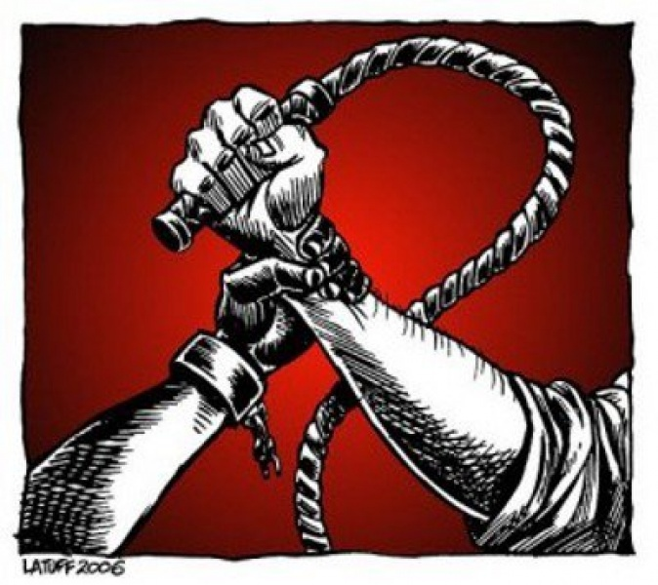

**I:  What has Revolution meant?**

In the ancient world political revolution was understood in essentially geometrical terms.  Societies were assumed to move in cycles of degeneration and development in which power

passed to different groups of people.  Thus “revolution” did refer to instances of structural social change, but these changes were plotted along a natural continuum of decline and restoration not itself subject to change by organized political means.  For example, in Plato’s typology of states in Book Eight of *The Republic,*democracy develops out of a revolution of the poor against

REPORT THIS ADPRIVACY SETTINGS

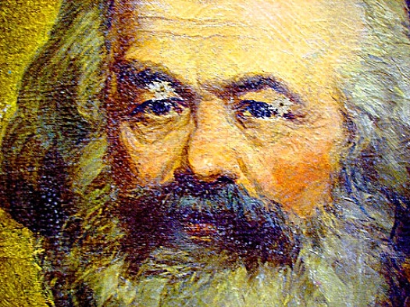

The philosophical, scientific, and political achievements of the seventeenth century gave rise to a self-ramifying series of increasingly radical changes in the eighteenth century.  These increasingly radical changes — the anti-colonial revolution of America against the British helped inspire the French Revolution which

asserted the *universal*rights of human beings which inspired the slave rebellion in San Domingo (Haiti) against French rule and the slave trade — were all predicated on the new legitimacy of the general practice of revolution. The basic idea of conservatism — that there is wisdom in the past — was discredited.  Conservatives now took on a historically new guise

Marx and Engels and the communist tradition they engendered altered the goal and the composition of revolutionary

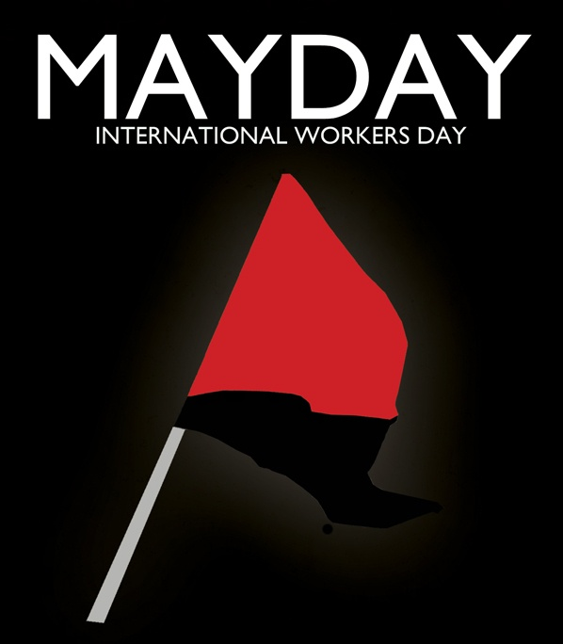

forces, substituting overcoming capitalist class structure for “tyranny” and the proletariat for the bourgeoisie, but maintaining the underlying justification for revolution first formulated in the Enlightenment.  The changes that Marx and Engels introduced

expressed the failure of the eighteenth century liberal-capitalist revolutions to satisfy the universal human interests  in whose name they claimed to speak.  At the same time, Marx and Engels did not reject the objective reality of those interests, but instead attempted to give them more comprehensive expression.  The impossibility of liberal-capitalism satisfying those universal interests is still cited as

The proletarian revolution thus triumphs over the conflicts that

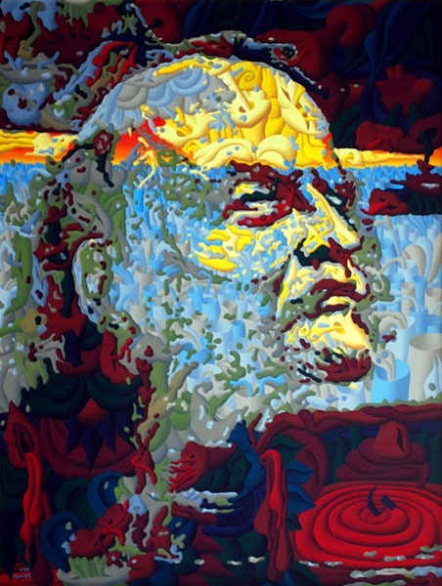

made all previous revolutions necessary:

Political power, properly so called, is merely the organized power of one class for oppressing another. If the proletariat during its contest with the bourgeoisie…makes itself

the ruling class, and , as such, sweeps away by force the old conditions of production, then it will, along with these conditions, have swept away the conditions for class antagonisms and classes generally, and will thereby have abolished its own supremacy as a class.  In place of the old bourgeois society…we shall have an association, in which the free development of each is the conditions of the free

This realist current in Marx and Engels is a through-line

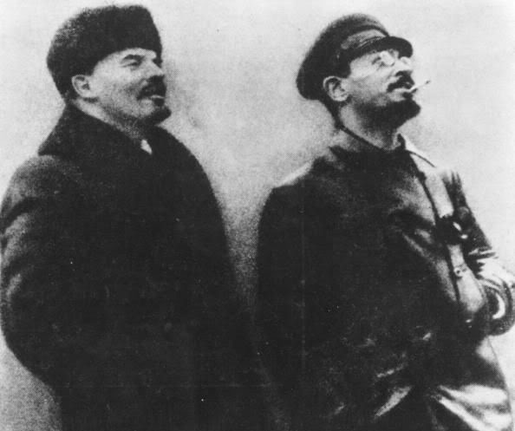

connecting their work to the great revolutionaries of the twentieth century, Lenin, Trotsky, Mao, and Che Guevara.  All believed, as Marx and Engels believed, that organized armed resistance was an instrumental necessity and not an intrinsic value.  If the exclusive control of the ruling class over

universally required life-resources could be achieved through argument, then persuasion would be preferable. Unfortunately, ruling classes are only interested in argument as a means of dividing opposition and attenuating the process of change.  The emergence of genuine democratic society thus requires armed struggle.  Those who reject revolutionary violence on principle

The most important difference between the political and social context in which opponents of



capitalism were working in the twentieth century and the social and political context in which they work in the twenty-first is the failure of the former’s revolutionary experiments. The political centre-piece of those experiments — the vanguard party — proved capable of seizing power, but not of democratizing

power once the period of initial instability had passed.  Indeed, that instability was overcome only through the “authoritarian means” Engels described.  The problem that Engels did not anticipate was that the practitioners of those authoritarian means continued to seek out and find new internal “enemies” long after the old ruling classes had ceased their

The need to reject armed violence and political vaguardism brings us to the third and most important difference between nineteenth and



twentieth century conceptions of revolution and today’s.  The difference is that in the nineteenth and twentieth centuries the battle of (political) democracy had not been won.  The space for democratic opposition in Russia, Germany, and China was constrained by vestiges of

monarchical authoritarianism; in the Global South, revolutionaries confronted violent, racist, colonial administrations.   Armed struggle was not a choice, it was, as Lenin argued, a necessity where there were no mature, functioning democratic alternatives.  For the reasons cited in points 1 and 2, armed vanguardism is no longer an option:  it has been discredited by the failure of twentieth century

**II:  What Revolution means today**

As noted, the legitimacy of

image1627542602856.png

revolution since the Enlightenment has been grounded in the universality of interests purportedly represented by revolutionary classes and served by their political organizations.  The failure of those organizations to create stable democratic socialist societies raises questions about the universality of the interests they serve.  For Marx,

the history of revolution was the history of the progressively more inclusive scope of revolutionary movements:  bourgeois parties served bourgeois interests, which were more universal than aristocratic interests, but still exclusionary.  The proletarian movement served proletarian interest, but these interests were

It is clear that there are universal human interests, but, as human, they do not fully coincide with the social interests of any particular class.  The universal interests of

image1627542602864.png

human beings are grounded in the need to satisfy certain fundamental natural and social requirements of biological life and social and cultural development.  Working people *share these interests*with every other human being.  The unique problem that working people face is that they cannot access those goods and

services their own labour produces without the money to pay for them, but labour markets do not necessarily provide labour and a living wage to all who need it.  This structural dependence of working people on labour markets for the money they require in order to purchase the natural and social necessities of life and human development gives them a cross-

First, although the working class is composed of people of different sexes and sexualities, different races and ethnicities, different

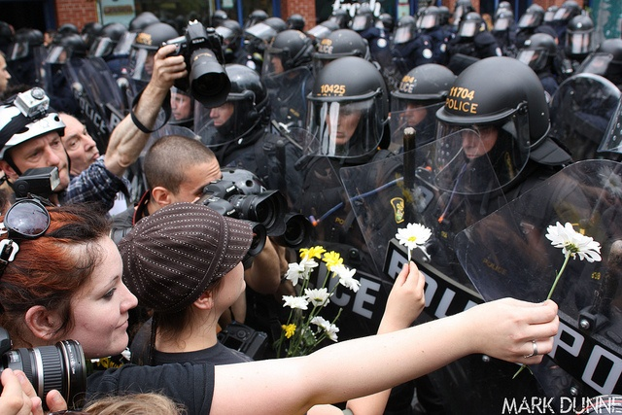

ranges of ability and interest, the ways in which these differences become grounds for oppression in a capitalist society cannot be understood through the lens of class exploitation.  However, they *can*all be understood through the lens of common life interests, which proves that class exploitation and the common life-interest are not identical.  While

every form of oppression has its own complex history, each is a form of systematic deprivation of some set of life-requirements.  The experience of oppression is the experience of structurally imposed barriers to free self-expression and development.  The ideological justification of oppression is also structurally

Third, and more practically, slogans of workers’ power do not move a majority of people today, even in those sites of intense capitalist crisis.  In Greece and



Spain, the radical left has been revivified by the crisis, but it does not speak the language of workers’ power, but of “real democracy.”[11] That which matters to people today is not that workers attain power as a class, but that the institutions of political democracy — themselves the inheritance of a longer

revolutionary heritage — actually function democratically, and not as the exclusive instruments of (especially finance) capital.  The old class divide is still present, the structural subordination of people’s life-requirements and life-horizons to money-value is still the fundamental material and normative problem, but no one believes that a vanguard worker’s

George Herbert Mead lacked the concept of universal life-interests and nowhere showed any understanding of the need to

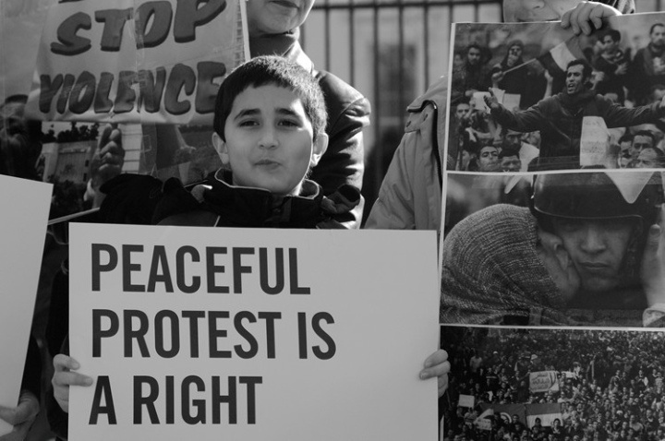

extend the principle of democracy into the economy, but he did understand its revolutionary significance.  “Democracy,” he argued “incorporated the principle of revolution into its institutions.  That is, when you set up a constitution, and one of the articles in it is that the constitution can be changed, then you have, in a certain sense, incorporated the

very process of revolution into the order of society.  Only now it is to be an ordered, a constitutional revolution, by such and such steps.”[15] What Mead and twentieth century followers like Habermas either ignored or downplayed is the way in which class power can constitute a structural impediment to the rule

**End notes:**

[1] Sungur Savran, “*C’est une Revolte, Pas (Encore) Une Revolution*,” *The Bullet*No. 834,

June 5th, 2013.  (http://www.socialistproject.ca/bullet/834.php)

of the shared life-interests in a formally democratic society.  Where class interests function to systematically block the rule of the shared life-interests, organized struggle against them is required.  But in a state that has already crossed the bridge between aristocracy and democracy this struggle, though organized and extra-parliamentary, in the workplace and streets and

neighbourhoods, need not be violent, because it is already legitimate by the constitutional norms that everyone claims to accept.  If those constitutional norms are not a sufficient principled basis to ensure the rule of the common life-interests, then the constitution can be amended, as Mead notes, or even, as in Venezuela, completely rewritten.  The point is:  the victory of democracy is the victory of political struggle over the conditions that necessitated armed violence and vanguardism.

REPORT THIS ADPRIVACY SETTINGS

Marx and Engels themselves were not blind to the possibilities that democracy — largely a result of working class and women’s struggles — afforded working people.[16]  As Hal Draper argued, “Marx was the first socialist thinker and leader who came to socialism *through*the struggle for liberal democracy.”[17] Marx himself argued to the International Working Men’s Association that “You know that the institutions, mores, and traditions of various

countries must be taken into consideration, and we do not deny that there are countries — such as America, England… where the workers can seize power by peaceful means.”[18] The traditions, mores, and institutions of every country in the Global North — the site from which global capitalist exploitation of all the peoples of the globe is launched and to which the vast majority of the wealth generated flows — rule out the possibility that groups who preach “arm the workers,”  “for the dictatorship of the proletariat” will have any political relevance.[19]

Overcoming the undemocratic power of the ruling class and money value will not be accomplished by nineteenth century means.  Nor, it should go without saying, will it be accomplished by voting for any existing political party.  It will be overcome through a combination of local struggles to protect existing life-value standards and nation-wide and global struggles, led by political movements yet to be created, to claim back control over the universally required life-resources currently exploited by the money-appropriating class and

the (formally) democratic institutions through which their rule is legitimated and protected.

What exactly that political movement — or, more likely, movements — will look like is an open question.  Occupy, The Movement for Real Democracy (Spain), Syriza (Greece), the Venezuelan socialist party are all experiments in finding that form.  That which they all share in common is the principle of democratic non-violence as the political foundation of opposition and demands for change.  Its

significance is brilliantly captured in this reflection on the Egyptian revolution: “This significance of Egypt…is threefold.  First is the moral force of non-violence… Second, non-violence of the multitude makes possible a new politics of inclusion.  And finally, it makes possible a radically different sense of the worth of the self.  Unlike violence, non-violence does not just resist and exclude.  It also embraces and includes, thereby opening up new possibilities.”[20]

The full flowering of those

possibilities takes longer than individual political agents would hope.  People understandably want to see solutions to the problems they have spent their lives fighting against come to fruition in their life time.  But such cannot always be the case, and trying to rush and force history often leads to far worse results than patience.  The Egyptian revolution has not yet achieved its social and economic aims; but would you rather be alive in Egypt to continue to fight, or dead in a civil war like Syria?

REPORT THIS ADPRIVACY SETTINGS

party is the political form that a workable solution requires.  There is a growing awareness that genuine progress towards the more comprehensive institutionalization of life values requires an end to the exclusive power of a single class, but that overcoming this rule is not going to be accomplished through a once and for all blow that knocks them from their perch.  Instead, the idea of revolutionary change

as an on-going process of learning and experimentation (Occupy, for example) is emerging.

While vanguardism has no purchase on the political imagination at present, it does not follow that nothing of use can be learned from its history.  In particular, Trotsky’s theory of the permanent revolution remains relevant, although not perhaps in the way he would have expected.  The theory maintained that in order to succeed the bourgeois democratic revolution in Russia would have to become socialist,

because the bourgeois democratic parties would consolidate their own rule as soon as they attained power, subordinating the workers and peasants to their class interests.[12]  The significance of his argument is not restricted to the unique circumstances of Russia, but is of general importance, for it is rooted in the idea that revolutions are not events but processes:  “It is not a question of a single ‘blow,’ or of a single day or month, but of a whole historical epoch.  It would be absurd to try to fix its duration in advance.”[13] If it is true that

revolutions take place over entire historical epochs, and that it is*impossible* to fix the duration of a revolution in advance, then it is *possible* to look differently at the epoch stretching from the Enlightenment to the present.  This entire epoch can be understood as a period of permanent revolution in which the material implications of democracy are being worked out.  Marxism and socialism are, in this view, not the antithesis of liberal-capitalism, but extensions and developments of the democratic principle first introduced during

the revolutions of the eighteenth century.  As we have seen, Marx and Engels saw the socialist revolution as part of the “battle for democracy,” and socialism is, in its most basic sense, democratization of economic relationships and institutions.

REPORT THIS ADPRIVACY SETTINGS

It is possible to read this epoch in this way because the idea of democracy is the real revolutionary rupture with the hierarchical and aristocratic

civilizations of the Middle Ages and antiquity.[14]  Democracy is the political form of the rule of the universal life-interest because it is the only political form that allows everyone to speak.  The universal life-interest is not an abstraction that exists apart from the individuals whose nature embodies it.  Nor is it the free-floating product of abstract political deliberations and argument.  It is the real basis of the existence of everyone as real  living individuals.  It is the substance from which democratic deliberation proceeds, not the

invention of those deliberations.  However, in hierarchical societies in which only those with the proper bloodlines or sex or colour are allowed a voice, the life-interests of the subaltern are defined for them, and never in ways that recognise the full scope of those life-interests.  Democracy is revolutionary both because it allows those who have been historically oppressed to say:  “We have the same scope of life-requirements as you, and we will take what we need because it is our due as individuals,” and it allows the response: “You are

right, but you do not have to take that which is your due by force, because your being human beings and your being members of a democracy entitles you that which you require, so all of us together will re-structure our institutions such that you receive that which you require.”

identical across particular cases.   Wherever one finds oppression, one finds ideologies of invidious hierarchy, according to which the oppressed group is not denied anything it actually needs,

because it is not ‘civilised’ or ‘rational’ enough to properly use that which the laws and mores of the society prevent it from accessing.  If class exploitation is not the common fount of all forms of oppression, then class consciousness cannot be the basis of political unity between working people and other oppressed groups, whether members of the working class or not.  Consciousness of the shared life-interest *could*be that basis, but its becoming so is not the automatic outcome of a reified dialectic of political development,

but deliberate political argument and construction.

Second, that which is required by each and all as universal condition of the development of the totality of human capacities goes beyond Marx’s “totality of the instruments of production.”  Working people have a *social*interest in owning and controlling the means of production, and a society grounded in life value presupposes a democratic economy in which universally required life-resources and productive institutions are

commonly owned.  But it also requires respect for life as an intrinsic value, recognition of the material priority of the biosphere as a life-support system, and consequent limits to productivity and economic ‘growth;’ it requires the capacity to slow down, to leave possibilities unrealized, to relate to each other mutualistically, to value receptivity and passivity and sensuousness.

It is true references to all of these requirements of a life-valuable society can be found in Marx and the Marxist tradition, but they are

not central to its understanding of revolutionary goals, much less revolutionary practices.  When it comes to revolutionary practice, Marx, Engels and the Marxist tradition tend towards ruthless political realism, focussing on revolution as an instrument by which one class power is replaced by another.  Taking and then maintaining power begin their lives as instruments of revolutionary values, but, historically, they have then become ends in themselves.  At the point where they become ends in themselves the rifles and

cannons that Engels said were to frighten the reactionaries get turned against anyone who questions any decision of the leading party faction.  From the life- value perspective, taking and maintaining power are only ever instrumental values and can never be allowed to become ends in themselves.  Successful life-value revolution is thus resolutely opposed to “by any means necessary” thinking.  Revolutionaries who are willing to do anything have always proven ready to do anything to *anybody,*including people

supposedly on their side.

REPORT THIS ADPRIVACY SETTINGS

class *social*interest in overcoming this structural dependence on labour and commodity markets.  The *universal*interests, however, are deeper —  they are the life-interests in need-based access to the full range of life-requirements which must be satisfied if the full range of human capacities is to be developed, expressed, and enjoyed in each human life.  The

political conflict is between classes, the moral fault line the political conflict reveals is between a ruling value system that prioritises money-value appropriation by the ruling class over the satisfaction of the universal life-interests.  If we agree with Marx that each successive revolution is construed on a more universal basis than the last, then a socialist revolution is not grounded in the social class interests of the proletariat, but the universal life-interests threatened by capitalist social dynamics and ruling-value system.

The revolution that is needed today is not a revolution of the proletariat against the bourgeoisie — even using those nineteenth century terms sounds anachronistic — but a revolution of the common life-interest against the life-blind dynamics of globalized capitalism, dynamics which are compromising the life-support capacity of the biosphere and which turn all life, bacterial, plant, animal and human into exploitable tools of their reproduction and expansion.  To be sure, working people, those

whose lives are dominated in almost every dimension by the need to compete for scarce work in order to merely live, must be at the forefront of new organizations of political opposition.  Their position in production still gives them tremendous potential social and political power, should this power be organized nationally and internationally.  But it is not workers as workers that embody the universal life-interest; the universal life-interest is basic, each human being is an embodiment of it, the content of the universal life-interest is

constitutive of what it is to be a human being.  Hence, consciousness of the universal life-interest is not identical to class consciousness.  Therefore, it cannot be represented by a vanguard party of the early twentieth century form.  We need to understand precisely why it cannot be.

REPORT THIS ADPRIVACY SETTINGS

universal, because the proletariat, the class whose labour is

responsible for social reproduction and development, has no need to exploit the labour of any other class.  “Only the proletarians of the present day,” Marx wrote,

who are completely shut off from all self-activity, are in a position to achieve a complete and no longer restricted self-activity, which consists in the appropriation of the totality of the productive forces and in the thus postulated development of a totality of capacities. All earlier revolutionary appropriations were restricted… In

all appropriations up to now, a mass of individuals remained subservient to a single instrument of production; in the appropriation by the proletarians, a mass of instruments of production must be made subject to each individual and property to all.[10]

REPORT THIS ADPRIVACY SETTINGS

Yet, in each case of twentieth century socialist revolution, the workers found themselves subordinated anew, not to a ruling class, but to the vanguard party

which began its life claiming to be the self-conscious expression of the universality of working class interests.  The reconstitution of the vanguard party as a permanent ruling power alienated from the lives and goals of working people raised questions, both about whether working class interests were really universal, and, more fundamentally, whether there were any universal human interests at all.

revolutions to produce stable democratic socialist alternatives

to capitalism, and struggles conducted on military terms will always prove favourable to states which enjoy an overwhelming military advantage against internal opposition.  However, there is also no need to fight on the terms of the twentieth century, because the principle, if not the practice, of democracy has been fully accepted and incorporated into the institutional structure of the major capitalist societies.  Democratic societies can change themselves if a stable majority of citizens is committed to changing them.  The major explosions in the

last five years — from the Arab Spring to Occupy to Turkey — have all been fuelled by demands that ruling classes *respect*ordinary people by *respecting*democracy.  Revolutionary vanguardism has been discredited in the popular imagination, mass democratic action has not.

REPORT THIS ADPRIVACY SETTINGS

In any society in which the democratic principle — all affected by a decision should be able to participate in its formulation and

execution — has been institutionalised, there is no legitimate way for ruling classes to prevent its more extensive and intensive application.[9]  Revolutionary politics today thus means building mass movements against the illegitimate attempts of ruling powers to prevent the legitimate extension and deepening of democratic governance of all major social institutions in the shared life-interest.  This conception of revolution — fundamental social change led by a clear understanding of common life-

interests achieved by means of peaceful democratic struggles of movements capable of winning by force of argument and not force of arms — is what oppositional movements require, not only to avoid the mistakes of the past, but to actually solve the structural problems of the present.  In the next section I will unpack this understanding of what revolution means today.

opposition.  The legacy of revolutionary vanguardism — purges, show trials, mass

detentions and executions — is a legacy only a fool or a psychopathic killer would want to risk repeating.  New forms of political organization are thus required, forms which somehow reconcile the goal of the complete transformation of capitalism into a democratic socialist life-economy and society with the political pluralism that everyone concerned in a credible way with advancing the project of sustainable human freedom accepts today.

REPORT THIS ADPRIVACY

SETTINGS

The second crucial difference between the political contexts of the nineteenth and early twentieth century and our own time concerns the relative balance of armed force between states and democratic opponents.  Engels’ belief that reactionaries can be “terrified” into compliance by revolutionary arms is made nonsense by the reactionaries having at their disposal the complement of weapons available to modern states.  Street fighting, barricades, and even small arms

are no match for tanks, drones, and stealth bombers.  No irregular popular militia is any military match for the states of the Global North; if any of those states ever chose to unleash the full killing-power of their military on oppositional movements, those opposition movements would be overwhelmed in a matter of hours.

Afghanistan is not a counter-example — although US and NATO forces have not defeated the Taliban, they have not unleashed the full means of violence available to them.  That which

constrains them from unleashing every device they have is not any response the Taliban could mount, but the political and moral cost, especially at home, the use of nuclear or biological weapons would have.  That ruling classes can still be constrained by political and moral costs tells us something of profound positive importance.  Today, revolutionary politics must be resolutely non-violent — the goal of movements for fundamental social change can no longer be to overthrow the state by force, but to overwhelm the state’s legitimacy through

organizing a gigantic, unified movement that rests on goals so obviously in the shared life-interest that the army and police forces refuse to protect the ruling powers, which must then concede as a consequence.  In this choice lies the difference between Egypt — a successful revolution that was captured by reactionary forces but in which the opposition lives to continue the struggle, and Syria, a brutal civil war that is hardening sectarian divisions and in which the fractured opposition is being slaughtered.

are not serious about the democratic values they claim to champion, because democracy is a way of life not an idea, such that anyone who values democracy wants to live in a democracy, and anyone who wants to live in a democracy must take up the challenges of building one in the actual historical conditions one faces.  “The petty bourgeois democrats, those sham socialists who replaced the class struggle by dreams of class harmony, even pictured the socialist transformation as a dreary fantasy

— not as the overthrow of the rule of the exploiting class, but as the peaceful submission of the minority to the majority which has become aware of its aims.”[8] Lenin’s historical experience contained no instance of peaceful institutionalization of universal human interests, but only the imprisonment, exile, and execution of those who defended them in practice.  Like Engels, he does not glorify revolutionary violence as a virtue; he laments it as a social necessity, but is willing to use it, because he is committed to realizing the values he champions

in theory in living practice.

The crucial point to take away from this brief survey of the development of the modern conception of revolution is that Condorcet, Marx, Engels, and Lenin are drawing their conclusions from concrete historical analysis of the political struggles of which they were a part or which formed the historical background to the struggles of which they were a part.  The differences in their arguments derive from differences of historical context; the continuities

from historical continuities.  The most important continuity is the claim that revolutions advance the universal interests of humanity, in this service to social progress lies both their necessity and their moral and political justification.  The most important difference is in the understanding of the social conditions required for the realization of those universal interests — overcoming the class structure of liberal-capitalism supported by Condorcet as the highest achievement of human struggle.  The same problem that confronted Marx and Engels in

relation to the bourgeois revolutions in whose shadow they lived confront socialists living today in the shadow of the twentieth century socialist revolutions:  what is continuous with and what is different from the social conditions of the twentieth century and what implications do these continuities and differences have for the meaning of revolution today?

REPORT THIS ADPRIVACY SETTINGS

The continuities between

twentieth and twenty-first century capitalism are clear.  Capitalism remains exploitative, alienating, inegalitarian, intolerant of genuine democratic self-governance in all major social institutions, regularly generative of violent domestic and international conflict, conducive to the over-development of the worst dispositions of the human personality (selfishness, greed, ego-centrism, self-importance, indifference to the sufferings of the others, and victim-blaming) and environmentally unsustainable.  The realization of the universal life-interests of

human beings — the satisfaction of their life-requirements in a sustainable economy that provides real opportunities for the expression and enjoyment of valuable life-capacities, democratic self-governance in all spheres of collective life, and peaceful international and domestic social relations conducive to the formation of creative, difference-embracing, mutualistic relationships and cultural expressions — still depends upon  overcoming the class structure of capitalism.  The universal life-interests of human

beings cannot be comprehensively satisfied when the natural resources and the social institutions required for their satisfaction remain under the more or less exclusive control of a minority class driven by the goal of maximal accumulation of money-value for itself.  But there are also at least three crucial differences between the social conditions of twenty-first century capitalism and early twentieth century capitalism that necessitate important changes in the meaning of revolution today.   I will discuss each of these

differences and then explain their implications for the contemporary conception of revolution in the next section.

development of all.[6]

The proletarian revolution is thus regarded by Marx and Engels as a regrettable necessity, part of the struggle for political power which ruling class intransigence forces upon the proletariat (as monarchical intransigence forced revolution on the bourgeois before).

Revolution is thus a break with the class structure of bourgeois society, but it is also continuous with those aspects of liberal capitalism that were of universal value, in particular, democracy.  Marx and Engels understood revolution as part of the “battle for democracy,” the elimination of the structural barriers capitalist society places in the way of substantive self-government.  Given the vehemence with which these structural barriers will be defended by the ruling class (because from their subjective

perspective these structural barriers are personal privileges) *battle*is necessary.  Hence, revolutions must remove the old ruling class by force and employ coercive tactics against reactionaries.  As Engels explains, “a revolution is certainly the most authoritarian thing there is:  it is an act whereby part of the population imposes its will upon the other part by means of rifles, bayonets, and cannon, all of which are highly authoritarian means.  And the victorious party must maintain its rule by means of terror which its arms inspire in the reactionaries.

[7]  Engels is not glorifying revolutionary violence, but drawing on the historical experience available to argue against those who oppose authoritarianism in the abstract that the democratic values they cherish can often not be advanced save by undemocratic means, because the old ruling class will protect its private interests at all costs.

REPORT THIS ADPRIVACY SETTINGS

the reason why revolution is both

necessary and legitimate.  “For each new class which puts itself in the place of one ruling before it is compelled, merely in order to carry through its aim…to present its interests as the common interest…it has to give its ideas the form of universality, and present them as the only rational, universally valid ones.”[5] Whether these interests are fully universal or not is a question decided by practice, not philosophy.  Thus, in abstract expression the class interests of the bourgeoisie in political freedom from absolute monarchy were universal, but once

institutionalized proved to be concretely opposed to the class interests of workers.  Hence, just as the bourgeoisie before it, the workers face a structural impediment to their freedom, an impediment which they can overcome only through a revolution of their own.

REPORT THIS ADPRIVACY SETTINGS

The difference between the class interest of workers and that of all previous classes is, according to Marx and Engels, that the

universal interests of human beings and the particular class interests of workers coincide.  If, therefore, the workers can successfully overthrow the capitalist class structure they would at the same time overthrow the social conditions — private and exclusive ownership of universally required life-resources and their exploitation for money-value — which require political tyranny.  In other words, the proletarian revolution would be the final revolution because its outcome — collective ownership and control of universally required

life-resources — abolishes the conditions which make any form of oppression necessary.  Since there would be no private and exclusive social power having to protect its particular interests from the majority, there is no longer any need for a repressive apparatus of any kind.

as *reactionaries*, social groups who resisted the progressive change for which revolutionaries were struggling.  Prior to the eighteenth century, radical breaks from tradition would have been

regarded as unnatural, monstrous denials of human nature; at the end of the eighteenth century revolution was regarded as necessary for the full development of human nature.  Condorcet provides a canonical formulation of this new idea of revolution.  Generalizing from his examination of European history he concludes:  “*Nous avons vu la raison humaine se former lentement par la progres naturels de la civilization; la superstition s’emparer d’elle pour la corrompre, et le despotisme degrader et engourdir les esprits sous les poids de*

*crainte et du malheur*.”[3]

Change, rather than stasis, progressive development, is natural, opposed only by superstition and the despots it serves.  Stasis is thus an unnatural check to social development which, since it is grounded in irrationality, will not cede to the force of the better argument, but only to force.  Revolution is thus necessary to overcome unnatural blockages to human historical development.  *Revolutions*might be political singularities, but the

principles upon which they rest are universal:  “*les philosophees des diverses nations embrassent, dans leur meditations, les interets de l’humanite entiere sans distinction de pays, de race ou de secte, formaient … un phalange fortement unie contre … tous les genres de tyrannie*.” [4]. This modern conception of revolution, as a political necessity forced on humanity by tyrannical power, is the template from which the Marxist conception of revolution was developed.

oligarchy, but in turn necessarily degenerates into tyranny, both the nadir of social organization and the first moment of the regenerative movement.[2]  There are two key differences between the ancient and modern conceptions of revolution.  The first is that the ancient conception does not recognise the possibility of permanent breaks between an unjust past and a just future, and the second is that it does not regard human beings as capable of full self-determination.  Societies cannot fully escape their past and human beings cannot

fully determine their social and political lives because human societies are embedded in natural cycles and forces beyond the reach of human politics.  The modern idea of revolution is born with the Enlightenment’s rejection of these core principles of ancient thought.

Enlightenment ideas about revolution were not created *ex nihilo*, but drew on a body of theory and political practice that had been developing throughout the seventeenth century.  Copernicus, Galileo, Descartes,

and Locke challenged scientific and philosophical orthodoxy and exposed its limitations.  Politically, the English Revolution of the 1640’s overthrew the monarchy and opened the door to the political power of an emerging capitalist landowning class, demonstrating as convincingly as one could imagine that social orders are impermanent and subject to deliberate change.  When combined, the critique of scientific and philosophical orthodoxy, the new discoveries that critique made possible, and the success of the English

Revolution formed a matrix within which a new idea of progress emerged.  The modern idea of revolution incorporated this new idea of progress.  Revolution came to mean a consciously organized social process whereby the shackles of the past (superstition, aristocratic rule) were cast off *once and for all.* Rather than orbit around an eternal cycle, revolution came to signify permanent break with the past that enabled permanent improvement in science, in technique, in political and social organization.

indicates that we may be entering a revolutionary period (one in which the subaltern classes refuse to be ruled in the old way and rulers cannot rule in the old way) at a time when revolutionary politics, at least in the Global North, is still associated with the catastrophe that was Stalinism.  The important question is thus not “what does revolution mean in the abstract,” but rather “what does revolution mean today?”  Can there be a revolutionary politics that learns from the failures of

twentieth century revolutions how to avoid degeneration into the violent rule of an undemocratic and unrepresentative “vanguard” claiming to speak in the interests of those it brutally oppresses?

In order to answer this question we need to proceed historically, first examining the difference between the ancient world’s understanding of revolution and the modern world’s, and then examining the emergence of the Marxist understanding of revolution from the modern.  Central to both the modern and

Marxist understanding of revolution is the idea that it involves the political overturning of conditions that block the institutionalization of universal human interests.  The difference between them comes down to a difference in understanding the content of those universal interests.  Revolution today retains the connection between politics and the removal of structural barriers to the institutionalization of universal human interests, but the failures of twentieth century forms of revolutionary practice entail refinements in the

understanding of the content of those interests and a rejection of vanguardism as a viable political means by which their more comprehensive institutionalization may be sought.  The twentieth century has made clear that militarization of revolutionary political struggle and the more comprehensive satisfaction of universal human interests are antithetical.  Revolutionary politics in the Global North today means using the spaces for democratic organization that previous revolutions have pried open for mass, militant, but resolutely non-

violent organizing and action against intransigent ruling classes whose legitimacy is compromised because they reduce democratic institutions to tools for their own private interests.

“moderation” amongst “Muslim” countries:  tolerant, democratic, capitalist, a NATO member, and a trusted American ally.  Suddenly, the social fissures that had opened up the space for revolution in Tunisia and Egypt, for Occupy in North America, and for movements for real democracy

and an end to austerity in Greece and Spain had cracked open Turkey too:  a disconnect between the values and goals of youth and workers and the economic and political priorities of the government.  In an essay written to explain the unanticipated uprising, Sungur Savran called the movement, “*une revolte, pas … une revolution*.”[1] His point was that those occupying Taksim Square had immediate and specific demands which, if met, could defuse the crisis.  A revolution, by contrast, makes demands that cannot be met by changed

policies or even changed governments, but require fundamental social changes.  The question is, therefore, what is the nature of the changes demanded that makes them “fundamental,” or revolutionary?

A revolt seeks to oust a government which has lost legitimacy or reverse a hated policy, but does not call into question the legitimacy of the entire social system, its institutions, its class structure, and its ruling value system.  The basic difference between revolt

and revolution is one of scale and scope — revolts are particular, revolutions are comprehensive, revolts have demands that can be satisfied without change of ruling class and value system, revolutions aim to change the structure of power, the organization of major institutions, and the ruling value system.  There is, thus, continuity across the history of revolutionary struggle:  wherever there are fundamental institutional and value changes, there is revolution.



What exactly that political movement — or, more likely, movements — will look like is an open question.  Occupy, The Movement for Real Democracy (Spain), Syriza (Greece), the Venezuelan socialist party are all experiments in finding that form.  That which they all share in common is the principle of democratic non-violence as the

political foundation of opposition and demands for change.  Its significance is brilliantly captured in this reflection on the Egyptian revolution: “This significance of Egypt…is threefold.  First is the moral force of non-violence… Second, non-violence of the multitude makes possible a new politics of inclusion.  And finally, it

**End notes:**

[1] Sungur Savran, “*C’est une Revolte, Pas (Encore) Une Revolution*,” *The Bullet*No. 834,

June 5th, 2013.  (http://www.socialistproject.ca/bullet/834.php)

[2] Plato, *The Republic*, G.M.A. Grube, trans, as revised by C.D.C. Reeve, (Indianapolis:  Hackett), 1992, p. 227, 557a.

[3] Condorcet, *Esquisse d’une Tableau Historique des Proges de l’esprit Humaine*, (Paris:  Flammarion), 1988, p. 213. “We have seen human reason slowly develop through the natural progress of civilization; superstition has tried to prevent

this progress, in order to corrupt it and despotism has degraded and numbed it under the weight of fear and evil.” (My translation).

[4] *Ibid.,*p. 230. “The Philosophers of diverse nations, by embracing in their reflections the interests of humanity as a whole, without distinction of country, race, or sect, formed…a powerful phalanx strongly united against all manner of tyranny.” (My translation)

[5] Karl Marx and Friedrich Engels, *The German Ideology,*(Moscow:  Progress

Publishers), 1975, p. 68.

[6] Karl Marx and Friedrich Engels, *The Communist Manifesto,*(Moscow:  Progress Publishers), 1986, p. 54.

[7] Engels, quoted in Vladimir Lenin, *The State and Revolution,*(Moscow:  Progress Publishers), 1975, p. 60.

[8] *Ibid.,*p. 27.

[9] David Beetham, *Democracy and Human Rights,*(Cambridge:  Polity Press), 2004, p. 5.

[10] Marx and Engels, *The German Ideology,*p. 97.

[11] See for example the manifesto of Spain’s Real Democracy movement.  Jerome Roos, “Manifesto — Spain’s Real Democracy Now!”  http://roarmag.org/2011/05/m-15-manifesto-real-democracy-now-spanish-revolution-protests/ (accessed, June 7th , 2012).

[12] Leon Trotsky, *The Permanent Revolution and Results and*

*Prospects,*(New York:  Pathfinder Press), 1969, pp. 276-281.

[13] *Ibid.,*p. 210.

[14] Even though the practice of Athenian democracy was far more democratic than the practice of contemporary liberal democracy, it was at constant war with aristocratic and patriarchal values (represented paradigmatically in classical Greek philosophy) which never ceased to be parts of the background culture.

REPORT THIS ADPRIVACY

SETTINGS

[15] George Herbert Mead, *On Social Psychology,*(Chicago:  University of Chicago Press), 1997, p.20.  

[16] On the role of working class and other major social struggles to the origin of contemporary democracy, see Dietrich Rueschemeyer, Evelyne Huber Stephens, and John D. Stephens, *Capitalist Development and Democracy,*(Chicago:  University of Chicago Press), 1992.  On Marx and Engels signal

contribution to democratic development see August Nimtz Jr., *Marx and Engels:  Their Contribution to the Democratic Breakthrough,*(Albany: State University of New York Press), 2000. 

[17] Hal Draper, *Two Souls of Socialism,*Chapter 3, p.2. (http://www.anu.edu.au/polsci/marx/contemp/pamsetc/twosouls/twosouls.htm) (Accessed June 19th, 2013).

[18] Karl Marx, “The Possibility of Non-Violent Revolution,” *The Marx-*

*Engels Reader*, Robert . Tucker, ed., (New York:  Norton), 1978, p. 523.

[19] Academic arguments about the democratic meaning of “dictatorship of the proletariat” will also not make any difference — the slogan is irredeemably compromised by its association with failed Stalinist societies, and ignores, contrary to the practice of historical materialism, the actual course of historical change over the past 150 years.  For an example of such a problematic academic exercise see Peter

Halliward, “People and Power:  Four Notes on Democracy and Dictatorship,” *What We Are Fighting For*, Federico Campagna and Emanuele Campiglio, eds., (London: Pluto Press), 2012, pp. 61-73.

[20] Mahmood Mamdani, “An African Reflection on Tahrir Square, *African Awakenings,*Firoze Manji and Sokari Ekine, eds., (Cape Town:  Pambazuka Press), 2012,p. 209.

makes possible a radically

different sense of the worth of the self.  Unlike violence, non-violence does not just resist and exclude.  It also embraces and includes, thereby opening up new possibilities.”[20]

The full flowering of those possibilities takes longer than individual political agents would hope.  People understandably want to see solutions to the problems they have spent their lives fighting against come to fruition in their life time.  But such cannot always be the case, and trying to rush and force history

often leads to far worse results than patience.  The Egyptian revolution has not yet achieved its social and economic aims; but would you rather be alive in Egypt to continue to fight, or dead in a civil war like Syria?