  - Irfan Ajvazi

The Medieval Period
Tesla Academy of Sciences
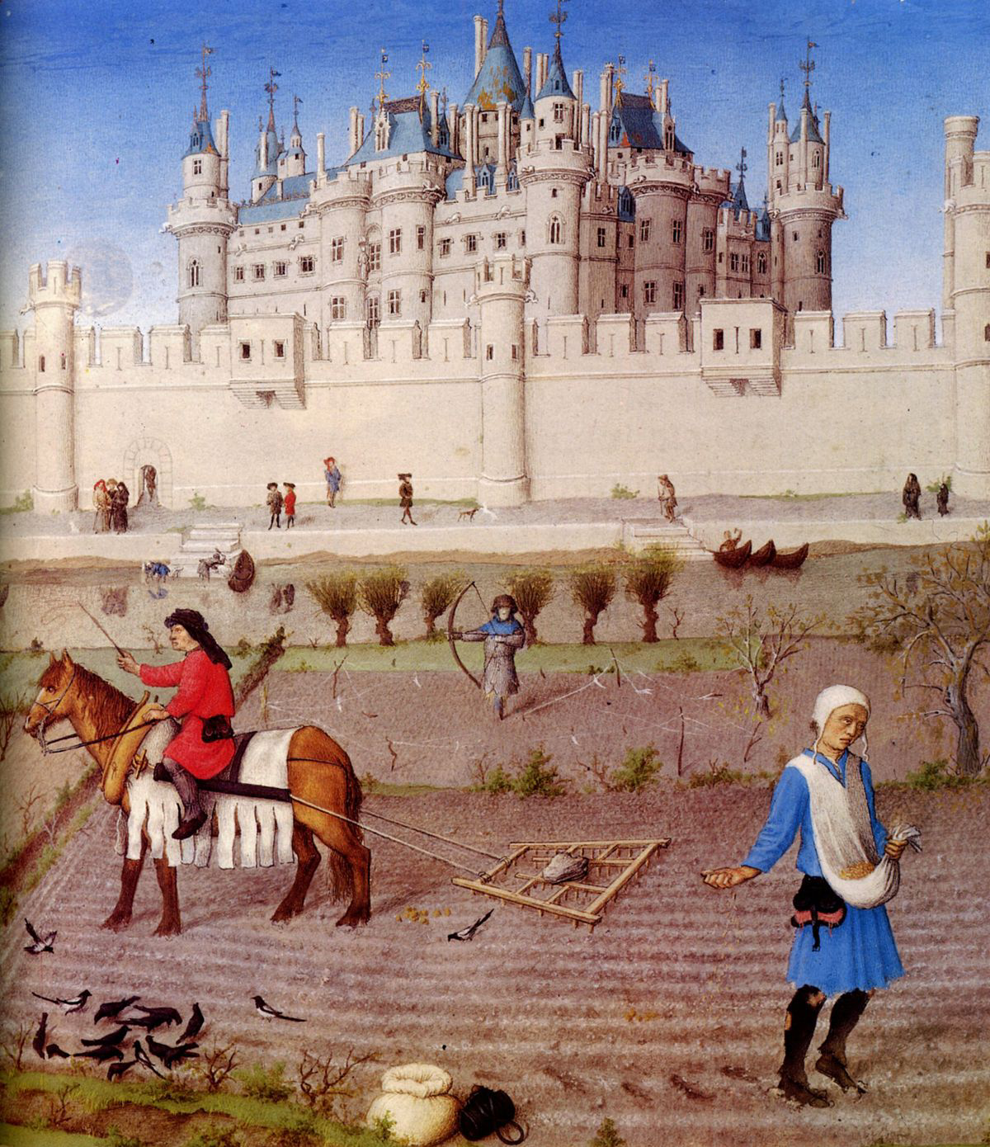
The Medieval Period

A set point in the historical time line stands as the medieval period. The medieval period in history was the era in European history – from around the 5th to the 15th century, coming after the fall of the Western Roman Empire, and preceding the start of the early modern era. This historical time period has been long since been the victim of film directors and romantic novelists, which has lead to the common, but false, idea of the medieval period consisting of knights and damsels in distress, wizards and dragons, and castles and battles. Although mainly wrong in most parts and being highly historically inaccurate – some aspects of the dramatic works do play true to the original time period. Certainly within British/English history we have a huge heritage in the medieval world and so it is quite easy to look for how aspects of this period develop through time but still retain relevance for people today. New technologies came to light during the medieval period, which are still in place today – new trade routes meant trade with the east was possible and items such as spices and silk were introduced to the western world, however with great possibilities and explorations, came dark times. Populations soared and this often led to poor sanitation and illness – such as the Black Death, the disease which killed half of Europe’s population. One aspect of the medieval society was the feudal system was also introduced during this period by William the conqueror; this set the basis for a governmental structure. The feudal system bound people together under one superior – it allowed the use of a standing army and offered protection to those lower in the ranks, in return of service. This use of constitutional government has a great exampl... ... middle of paper ... ...st of histories sources tell us about the rich or those of influence, similarly women were not often written about, therefore when looking at the social aspects of medieval history these problems can make it very difficult to find information on those of the lower classes or women. A further problem we find when looking at the medieval period is that historians often rely on non-written sources – carrying problems of interpretation, for example Bayeaux Tapestry or stained glass windows. Stain glass windows hold a lot of information, for example the image of Eleanor of Aquitaine and Henry II, which is used in the debate of whether Eleanor was important in the Angevin empire.

