Digital Humanities for History of Philosophy:
A Case Study on Nietzsche

Mark Alfano, Delft University of Technology & Australian Catholic University

Abstract: Nietzsche promises to “translate man back into nature,” but it remains unclear what he meant by this and to what extent he succeeded at it. To help come to grips with Nietzsche’s conceptions of drive (Trieb), instinct (Instinkt) and virtue (Tugend and/or Keuschheit), I develop novel digital humanities methods to systematically track his use of these terms, constructing a near-comprehensive catalogue of what he takes these dispositions to be and how he thinks they are related. Nietzsche individuate drives and instincts by the type of actions they motivate. One way in which the “translation” of man back into nature might succeed is through naturalistic explanation and reduction of moral notions such as virtue in terms of amoral, naturalistic notions, such as drives and instincts. I go on to show that this is indeed Nietzsche’s project: for him, a virtue is a well-calibrated drive. Such calibration relates both to the rest of the agent’s psychic economy (her other drives) and to her social context (what’s considered praiseworthy and blameworthy in her community).

Introduction
Nietzsche scholars have developed an interest in his conceptions of moral psychological phenomena, such as drives and instincts (Alfano 2010, 2013b; Katsafanas 2013a, 2015), as well as virtue(s) (Alfano 2013a, 2015a, 2015b, 2016; Annas 2017; Daigle 2006; Hurka 2007; May 1999; Railton 2012; Reginster 2006; Robertson 2012; Thomas 2012; White 2001). However, the quality and systematicity of engagement in this area leave much to be desired. In this chapter, I explain and recommend a synoptic digital humanities approach to Nietzsche interpretation by demonstrating the explanatory value that comes from following it.
This methodology integrates and extends both close-reading and distant-reading techniques developed by philosophers and other humanists (Moretti 2013). The latter have been available for years, but despite promising to lead to new insights and complement existing approaches, they have made almost no inroads in philosophy. Of the two million articles, chapters, and books housed at www.philpapers.org, only twenty-one unique publications (approximately 0.001%) are returned when one searches for ‘digital humanities’, and I am an author or co-author of three of them.
Here is the plan for this chapter: first, I explain my methodology. Next, I present the results of applying the methodology to the study of Nietzsche’s discussion of drives, instincts, and virtues. In the interpretive section of the paper, I marshal the resources developed in the previous section to argue that, for Nietzsche, instincts and virtues are (partially overlapping) subsets of drives. Instincts are innate drives, whereas virtues are well-calibrated drives. A well-calibrated instinct is therefore also a virtue. What it takes for a drive to be calibrated involves both internal synergy and social harmony (or at least non-interference). In the final section, I make a few observations and recommendations for future research in Nietzsche scholarship and history of philosophy more generally.

Methodology
Philosophers – especially those who favor a hermeneutic approach to “great figures” – may be prejudiced against digital humanities and distant reading, but they should rest assured that this approach complements and contextualizes the methods with which they are familiar. Since there is no single method associated with digital humanities, in this section I explain my approach, which can be reproduced by anyone with a deep acquaintance with Nietzsche’s texts, knowledge of German, and an internet connection. These are:
- select core concepts;
- operationalize for searching on the Nietzsche Source;
- conduct searches;
- clean data;
- analyze and visualize data; and
- close read relevant passages.
The first and most important step is to select the core concepts for the study. This can only be done effectively by someone who is deeply familiar with Nietzsche’s texts, has good intuitions about which concepts are associated in which ways, and is aware of prominent and promising interpretations and suggestions already in the secondary literature. For this study, I selected the concepts of virtue, drive, and instinct. As Katsafanas (2013a) remarks, Nietzsche sometimes seems to use the latter two equivalently. In addition, some interpretations in the secondary literature (Alfano 2013a, 2015b) claim based on passages such as D 30, GS 21, BGE 10, and GM III.8 that virtues are a subset of drives. For these reasons, it’s worthwhile to ask whether Nietzsche does in fact refer to drives and instincts interchangeably and which sorts of drives or instincts he grants the honorific ‘virtue’.
Once these questions have been formulated, a methodological challenge immediately arises. There is no reliable, valid catalogue of which concepts Nietzsche deploys (and whether he does so ironically) in which passages. The closest thing we have is the Nietzsche Source (www.nietzschesource.org), a digital repository of all of his writings that includes published works (e.g., HH, D, GS, BGE), private publications (e.g., NCW), authorized manuscripts (e.g., A, EH), posthumous writings (e.g., PTAG), posthumous fragments, and letters. This brings us to step 2: we need to operationalize the concepts under study by developing a list of words that Nietzsche characteristically uses to express them. This list will be neither comprehensive (there will be some false negatives) nor complete (there will be some false positives). Nevertheless, if the researcher is sufficiently familiar with Nietzsche’s corpus, it should have high validity and reliability. Such searching is aided by the query functionality of the Nietzsche Source: it is possible to return all passages containing words that begin with a given text string if one appends an asterisk at the end of the string (e.g., ‘tugend*’). Of course, it is possible to discuss curiosity in German without using one of these words, and it is also possible for one of these words to turn up without the author discussing virtue in a serious way. Despite these drawbacks, operationalizing in this way is the best, most reproducible method we currently have for systematically studying Nietzsche’s texts, and the texts are the best evidence we have for what he thought. In addition, because it makes explicit what the inclusion and exclusion criteria are, this method is criticizable and corrigible in a way that most other interpretive methods are not. For the present study, I operationalized drive by searching for ‘trieb*’. Likewise, I operationalized instinct with both ‘instinkt*’ and ‘instinct*’ (Nietzsche uses both until 1882, at which point he stops using the spelling with ‘c’). I operationalized virtue with ‘tugend*’ and ‘keusch*’. These are both typically translated as some variant of ‘virtue’ in English, though the latter is more gendered and often refers specifically to chastity. The same ambiguity exists in English of the nineteenth century, as we see in Austen’s Pride and Prejudice (1813/2002, p. 75).
The next methodological hurdle is to determine which of Nietzsche’s writings to include in the search. In keeping with standard interpretive practices, I refrain from using the unpublished works or the poems. That leaves me with the published works, private publications, and authorized manuscripts. Future work can easily supplement this chapter by including the letters, the poetry, and the kitchen sink.
Given these constraints, the next choice is to determine what researchers in the field of natural language processing call the ‘window’. The basic idea is that if an author tends to use word W near word V, then the author probably associates the concepts expressed by W and V (whether positively or negatively). However, there is no hard-and-fast rule for determining what counts as nearness. One appealing window is co-sententiality: if W and V are used in the same sentence, they are probably associated. Another is co-paragraphicality: if W and V are used in the same paragraph, they are probably associated. Alternatively, one can determine a window of length n, where n is the number of words between W and V. For instance, a window of 3 around W would include all words up to three before or after W (including words that occur across sentence and paragraph breaks). As you might imagine, choosing a window size is a dark art. Fortunately for Nietzsche scholars, he wrote in sections that – at least after the Untimely Meditations – tend to be of roughly the same brief length. These are standardly used in Nietzsche scholarship, making it straightforward to link this methodology to the existing secondary literature. In addition, the Nietzsche Source returns separate results for each such section, which makes it a simple task to reproduce results. For these reasons, I set the window at the level of the section for this study. As before, this may not be ideal, but it is documentable and therefore both criticizable and corrigible.
I now describe my method for preparing or “cleaning” the data. In order to clean the data for optimal use in the visual analytics platform Tableau Public, one must arrange them in a very particular yet simple tabular format. The rows in this table represent individual query results from the Nietzsche Source. The columns represent every datum of interest about the query result in question. When querying this database, one chooses a subset of writings to search and inputs a search term. For instance, in Figure 1, you can see the initial results when searching the published writings for ‘trieb*’.

Figure 1: results from querying the Nietzsche Source for ‘trieb*’ in the published works
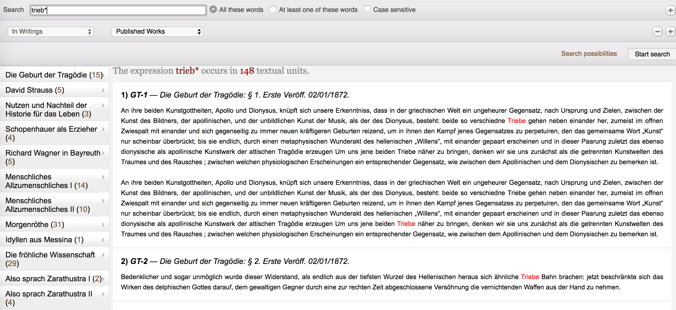

This query returned 148 passages: 15 from The Birth of Tragedy, 5 from David Strauss, the Confessor and the Writer, 3 from The Uses and Disadvantages of History for Life, and so on. The results include ‘Trieb’ (drive), ‘Triebe’ (drives), ‘Triebfedern’ (driving forces), and ‘trieblos’ (impotent). Some of the surrounding text for the first two passages is also returned. For each passage, I recorded five items in separate columns: the book in which it occurs, the passage within that book in which it occurs, the year of publication of the book, which search term I used, and which concept the term operationalizes. For details see Figure 2, which shows how some of the data for Daybreak is represented.

Figure 2: data structure for cleaning queries at the Nietzsche Source
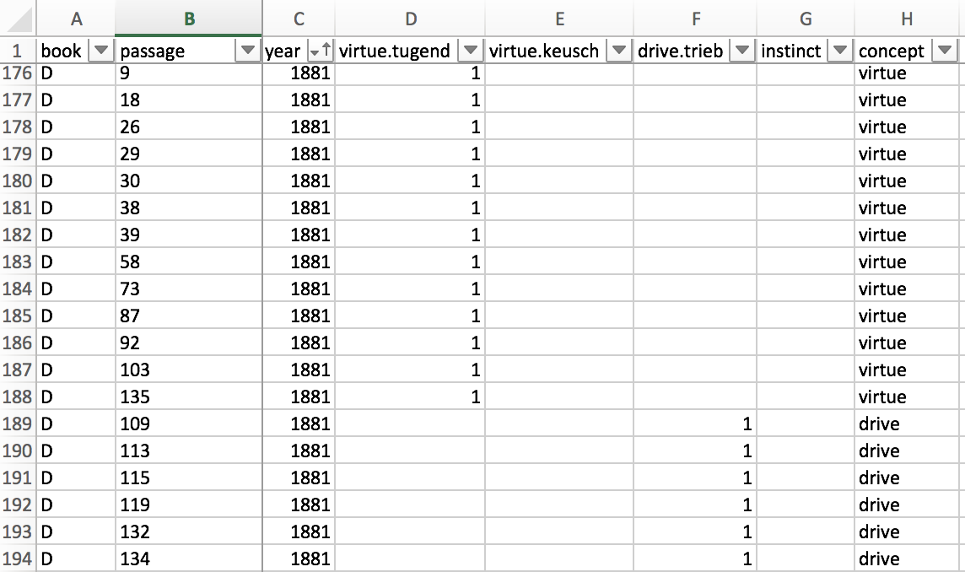

Once the data have been cleaned, they can be analyzed and vizualized. Perhaps the simplest analytic technique is to count the number of passages per concept in each book. For instance, in BT, virtue is referred to in five passages, chastity in none, drive in fifteen, and instinct in nine. We can also look for overlaps: passages in which more than one relevant concept is referred to. More sophisticated analyses involve various descriptive and inferential statistics. In this chapter, I focus primarily on visualization as a defeasible guide to close-reading. The idea is to achieve a synoptic view of both the books and the sections within each book in order to identify the most important passages and steer a systematic reading of those passages. To accomplish this, I fed the cleaned data into Tableau Public.
After reading the data into Tableau Public, I created three interactive visualizations:
- a timeline indexed to books and concepts,
- a treemap of all concepts of interest indexed to books, and
- a section-by-section map of each book, indexed to concepts of interest.

To create the timeline, I placed the year of publication and the book title in the Columns shelf (in that order), Number of Records in the Rows shelf, and Concept in both the Filters card and the Color card, as in Figure 3.

Figure 3: method for creating timeline
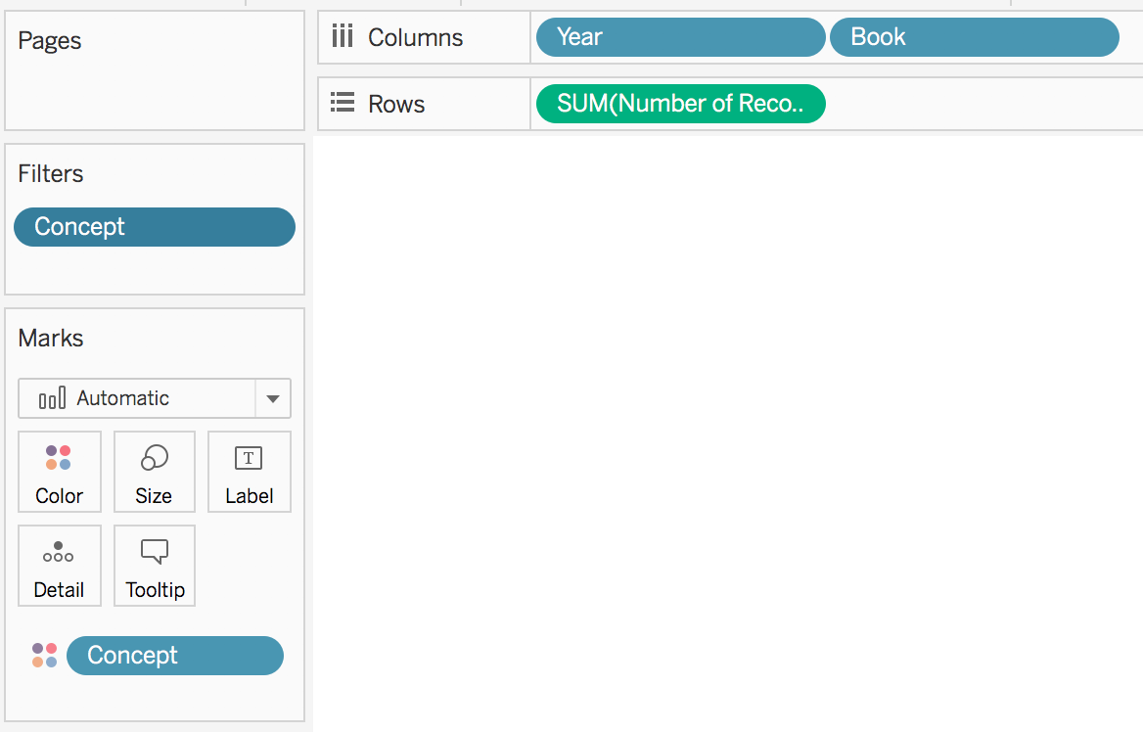

To create the treemap, I placed Number of Records in the Size card, Book in the Label card, and Concept in both the Color card and the Filters card, as in Figure 4.

Figure 4: method for creating treemap
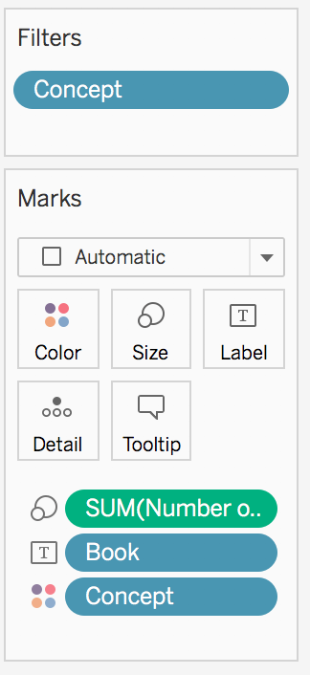

Finally, to create the section-by-section map, I placed Passage in the Columns shelf, Number of Records in the Rows shelf, Concept in the Color card, and Book in the Filters card, as in Figure 5.

Figure 5: method for creating section-by-section map
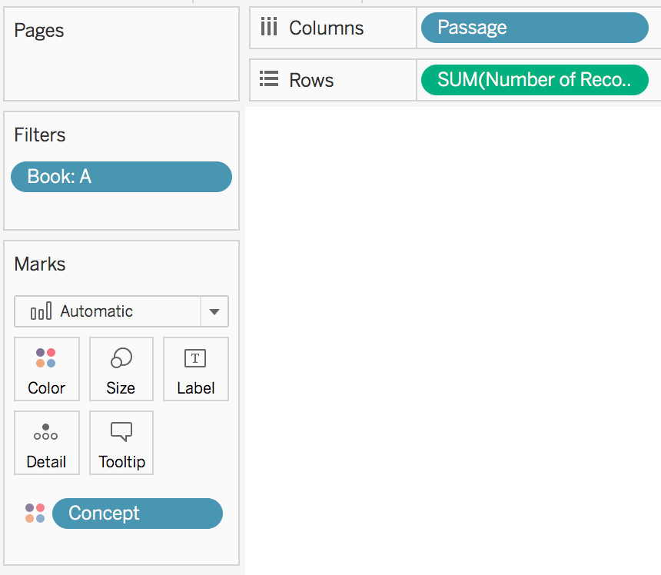

Results
In this section I present the results of the visual analytics exercise described above. These are here shown in the form of static figures, but at the website associated with this chapter, all visualizations are dynamic and interactive, with functionalities associated with mousing-over, clicking, and various filters. I first showcase the single-concept timelines and treemaps. Next, I display the timeline and treemap for all concepts together. Then I walk through an example of section-by-section results. Finally, I present a Venn diagram of all of the section-wise overlaps.
Using the filter functionality to select one concept at a time, Tableau Public automatically visualizes the data from Figure 3 as a histogram (Figure 6) with two horizontal axes (year and book) and one vertical axis (number of passages per book in which the concept of interest occurs at least once). We can quickly see in this visualization that Daybreak is the only book in which there are over 30 passages that refer to drives.

Figure 6: drive timeline
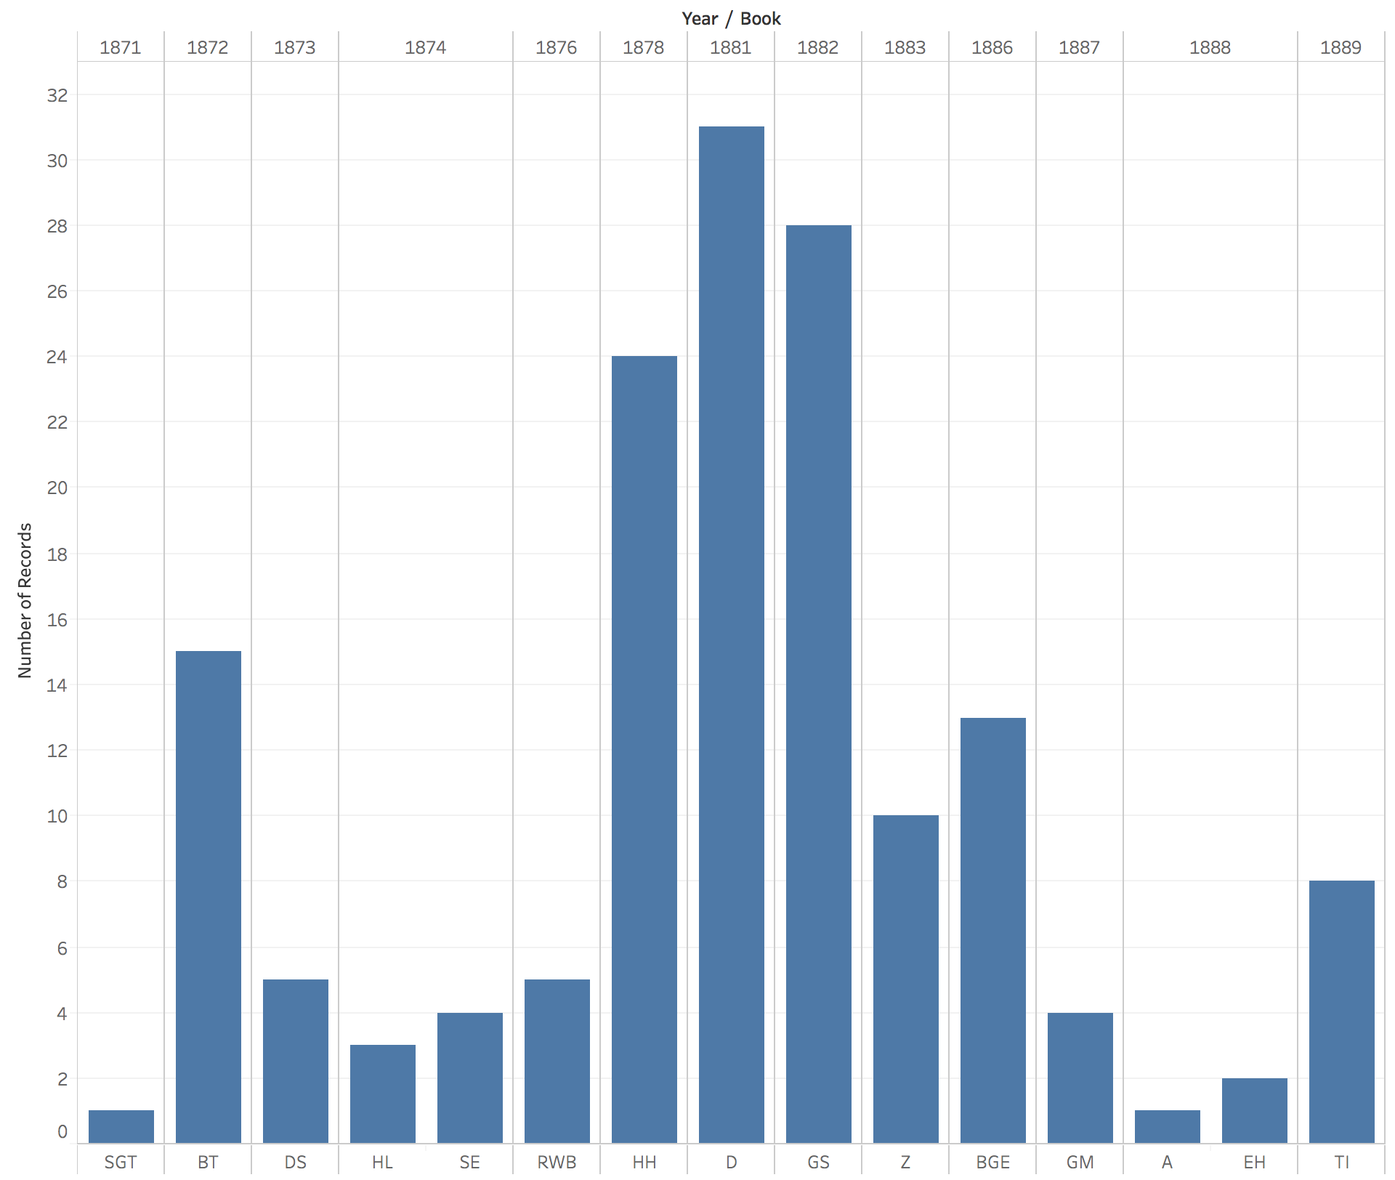

Likewise, Tableau Public automatically visualizes the data from Figure 4 as a treemap (Figure 7) in which the books with the most passages in which one of the concepts of interest crops up are represented by larger rectangles while the books with the least such passages are represented by smaller rectangles.

Figure 7: drive treemap

Figure 6 shows that, as Nietzsche moved beyond the Untimely Meditations (DS, HL, SE, and RWB), he began to speak more and more frequently of drives. However, after Beyond Good and Evil, his engagement with drive-talk dropped off precipitously. Thus, scholars interested in Nietzsche’s conception of drives would benefit from looking to the works associated with his so-called “free spirit” period (D, GS, and HH).
Next, consider the timeline and treemap for instinct:

Figure 8: instinct timeline
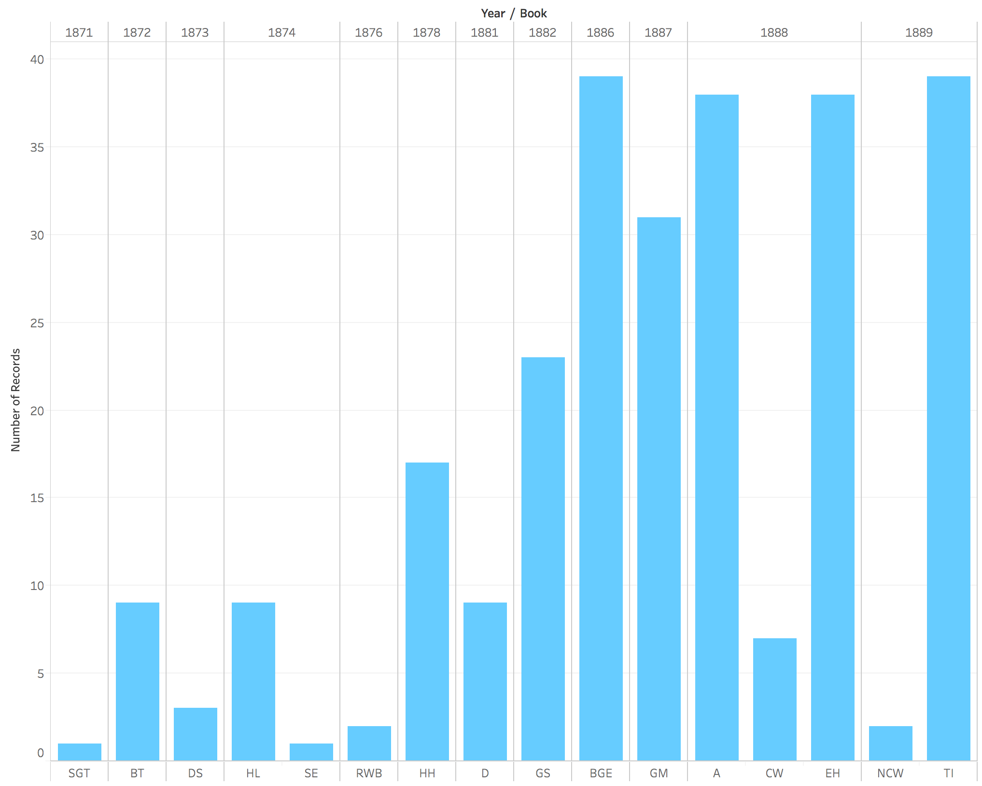

Figure 9: instinct treemap

The patterns in Figures 8 and 9 are very different from those in Figures 6 and 7. As Figure 8 shows, Nietzsche barely used the language of instinct until the 1880s. Indeed, the passages from GS in which Nietzsche uses instinct-talk are mostly from sections in the re-release that included book 5. Thus, unlike drives, instincts receive little attention from Nietzsche until his mature works (which I count as everything from BGE onwards). And, with the exception of the anti-Wagner works (CW and NCW), his use of instinct never drops off. Scholars interested in Nietzsche’s conception of instincts would benefit from looking less to the free spirit works and more to the mature works (TI, BGE, A, EH, and GM).
Next consider the timeline and treemap for virtue:

Figure 10: virtue timeline
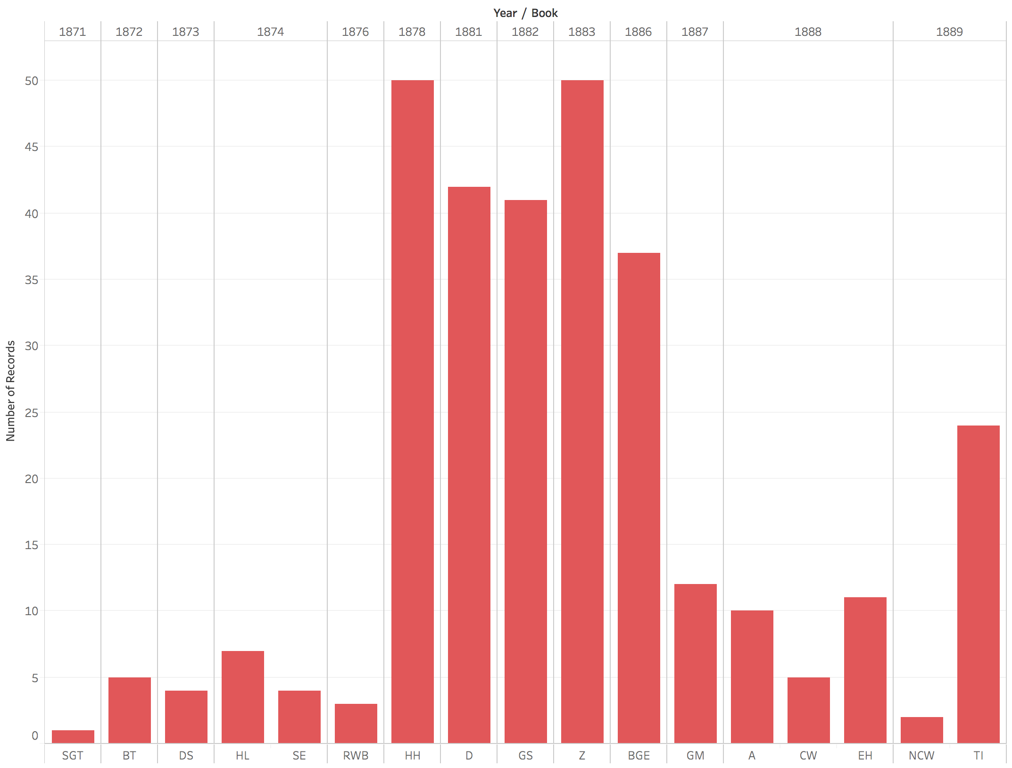

Figure 11: virtue treemap
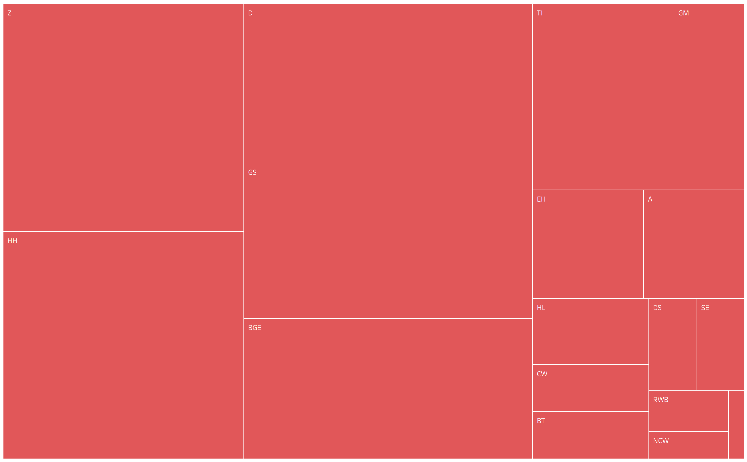

The patterns in Figures 10 and 11 are once again different from those that came before. As Figure 10 shows, Nietzsche started talking of virtue in the free spirit works and continued to do so until 1886 (plus TI in 1889). The discussions of virtue occur during the transition from an emphasis on drives to an emphasis on instincts. Thus, as Figure 11 shows, scholars interested in Nietzsche’s conception of virtue should look to both the free spirit works and the mature works.
Next, consider the timeline and treemap for chastity:

Figure 12: chastity timeline
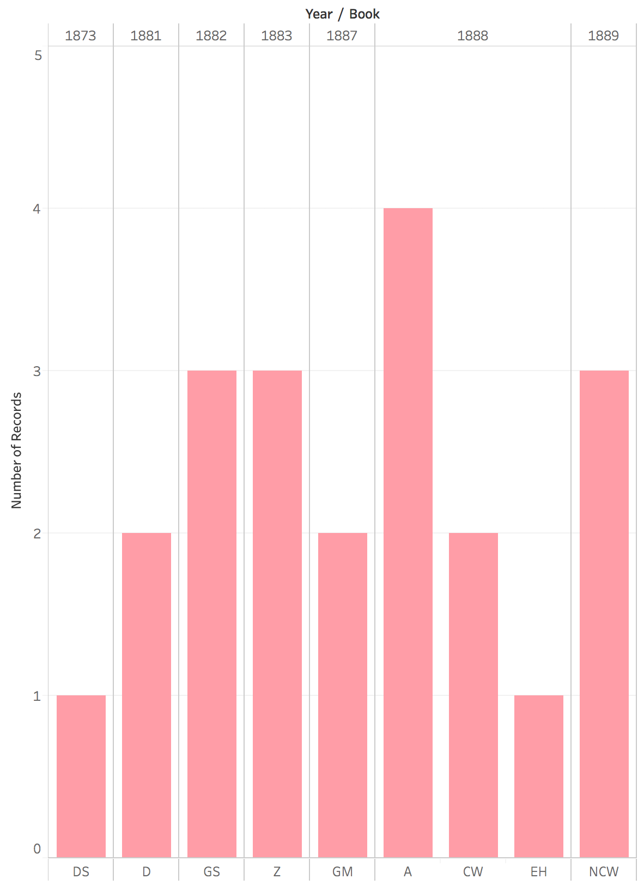

Figure 13: chastity treemap
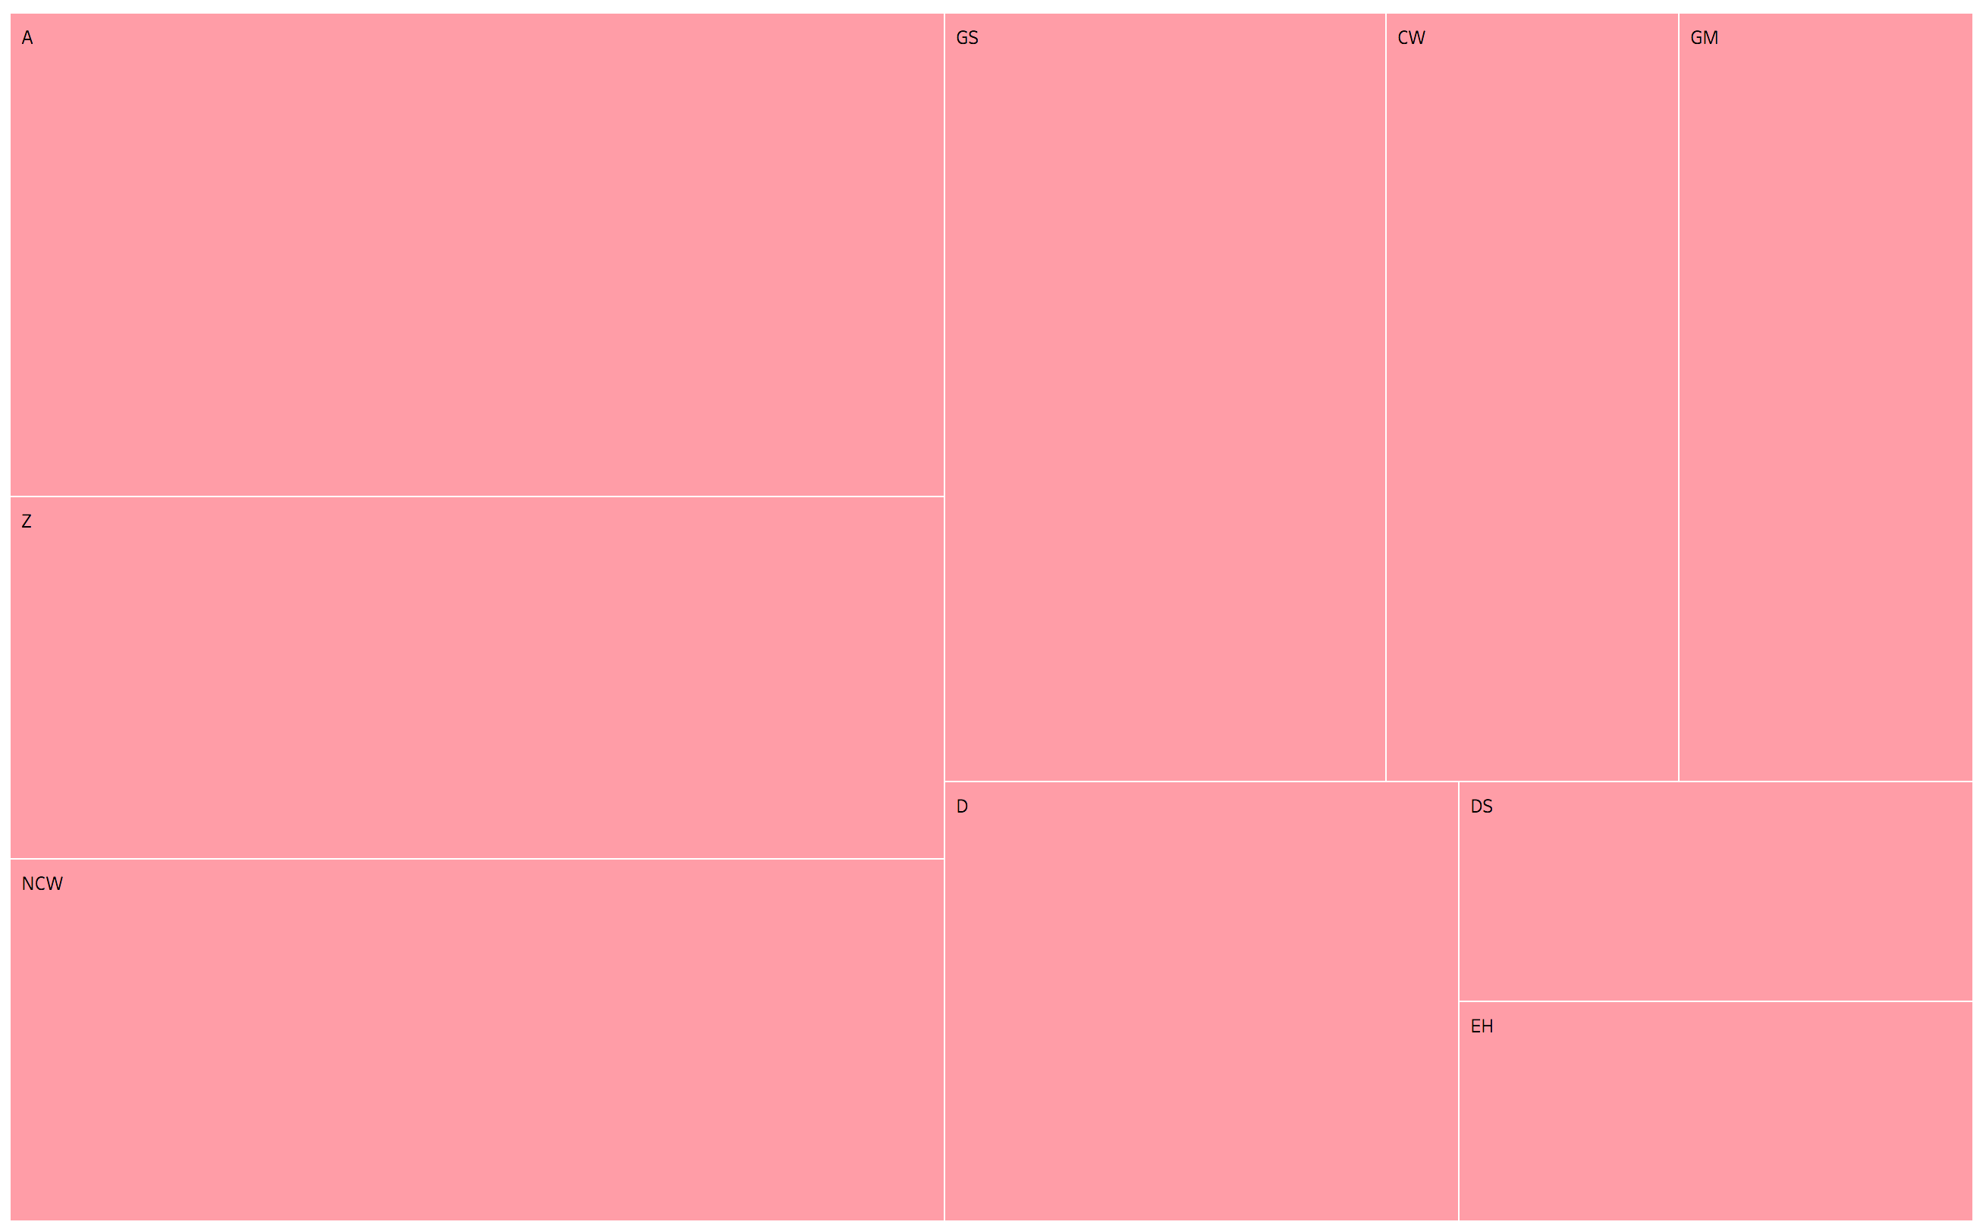

This final pair of single-concept Figures (12 and 13) shows still another pattern. Nietzsche talks of chastity less frequently than the other concepts. Several books have no passages in which it crops up. The Antichrist has the most relevant passages, and there are only four of them. By contrast, virtue proper is referenced at least five times in almost every book, and in many books there are over thirty-five relevant passages (HH, D, GS, Z, and BGE). Moreover, whereas virtue is barely discussed in the anti-Wagner books, chastity comes up in them multiple times. Scholars interested in Nietzsche’s differentiation between virtue proper and chastity should therefore look to the anti-Wagner books as well as to A, Z, and GS.
Next, I present visualizations of all concepts together in both timeline (Figure 14) and treemap (figure 15) visualizations. These visualizations allow us to see everything at once. In addition, they make it possible to see what proportion of the relevant passages in a given text refer to a particular concept. This is important because the number of sections in a given book is highly variable. For example, HL is arranged in ten long sections, whereas A has sixty-two numbered sections plus a preface and a concluding “Law against Christianity.” In addition, not every passage in each book – regardless of the total number of passages – contains a section that refers to drive, instinct, virtue, or chastity. Some books demonstrate relatively little engagement with the concepts under study, others much more. Graphing everything together enables us to see this.

Figure 14: all concepts timeline
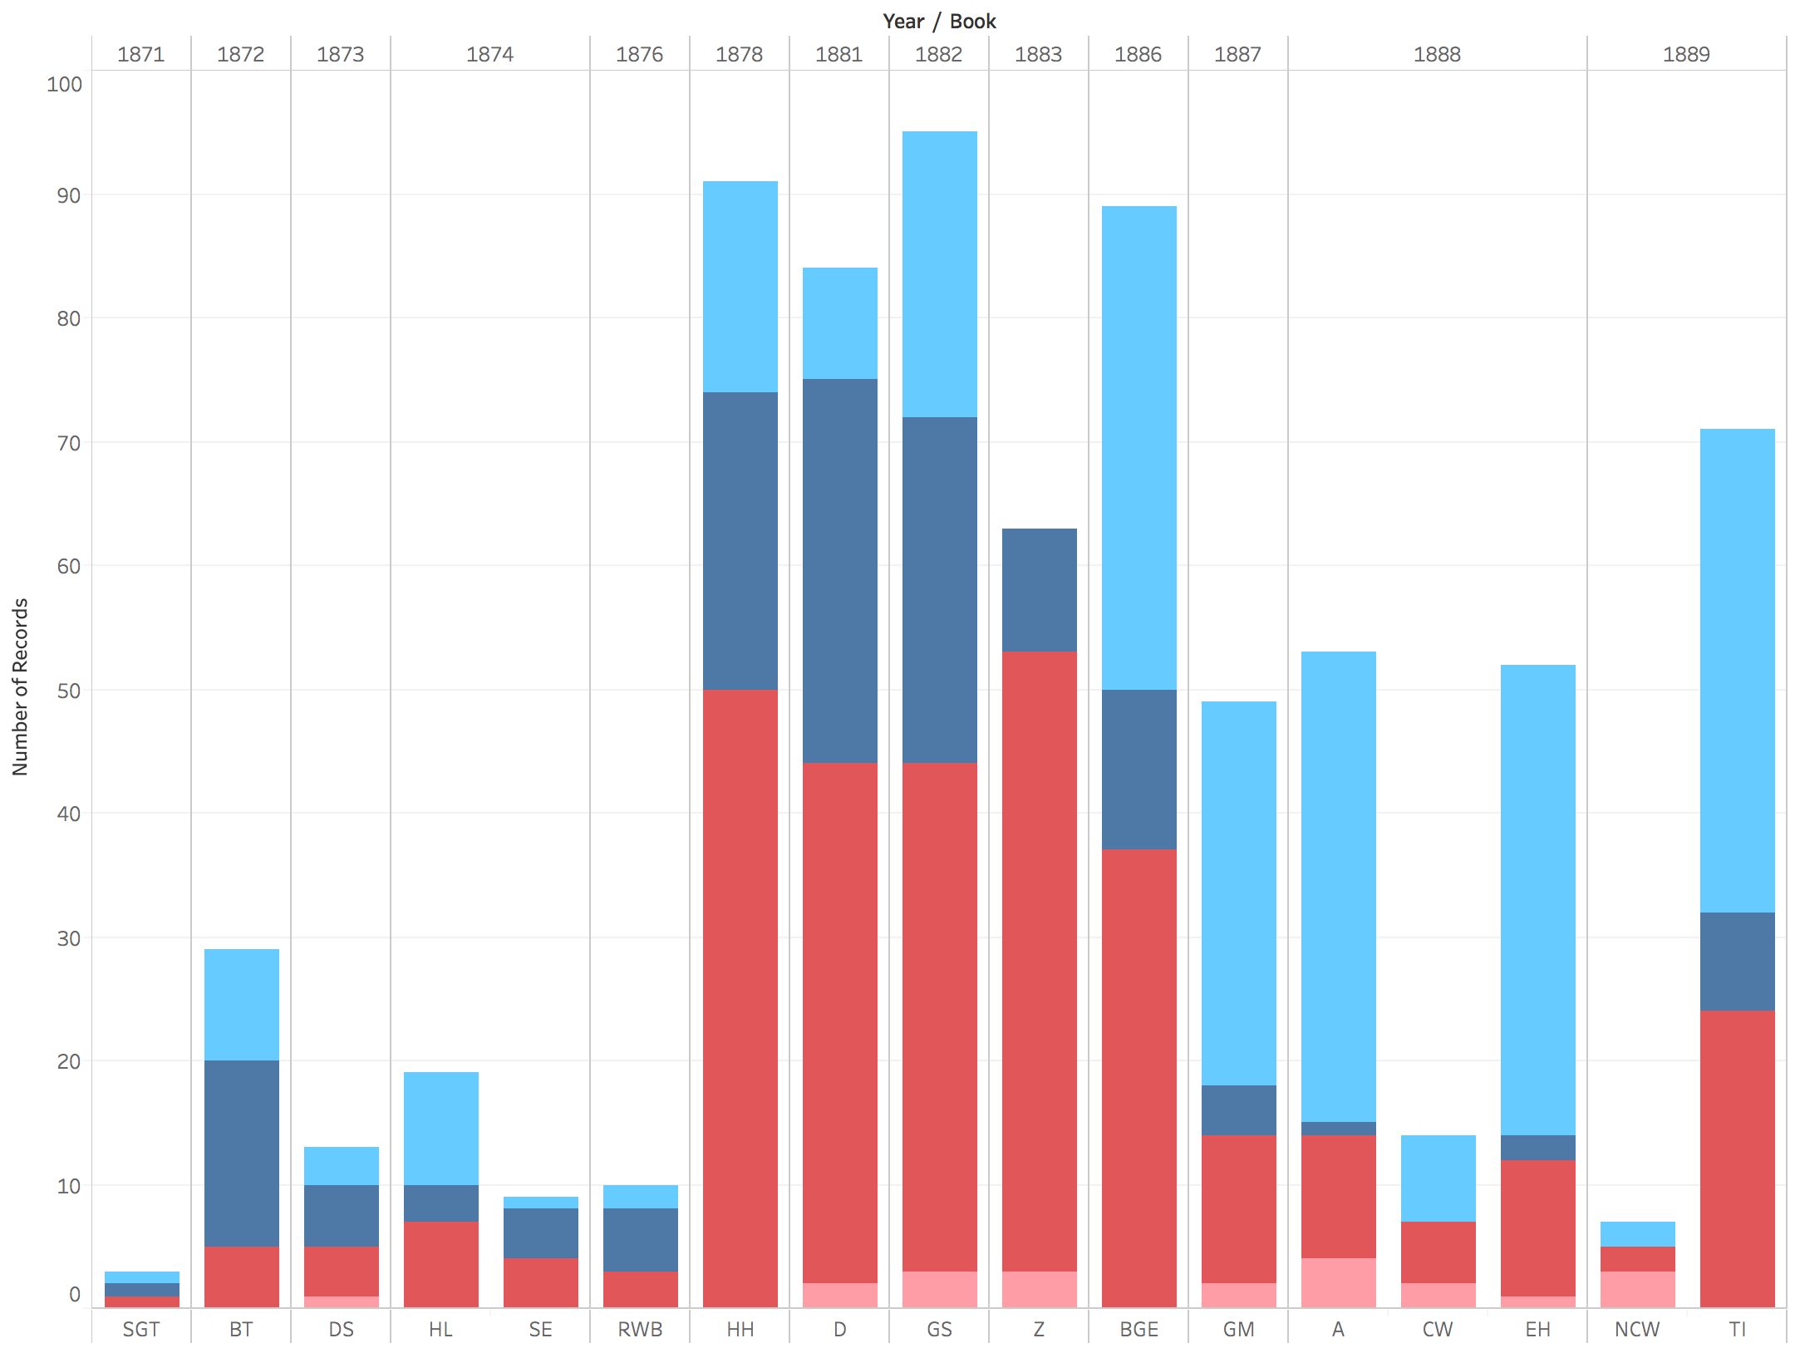

Figure 15: all concepts treemap
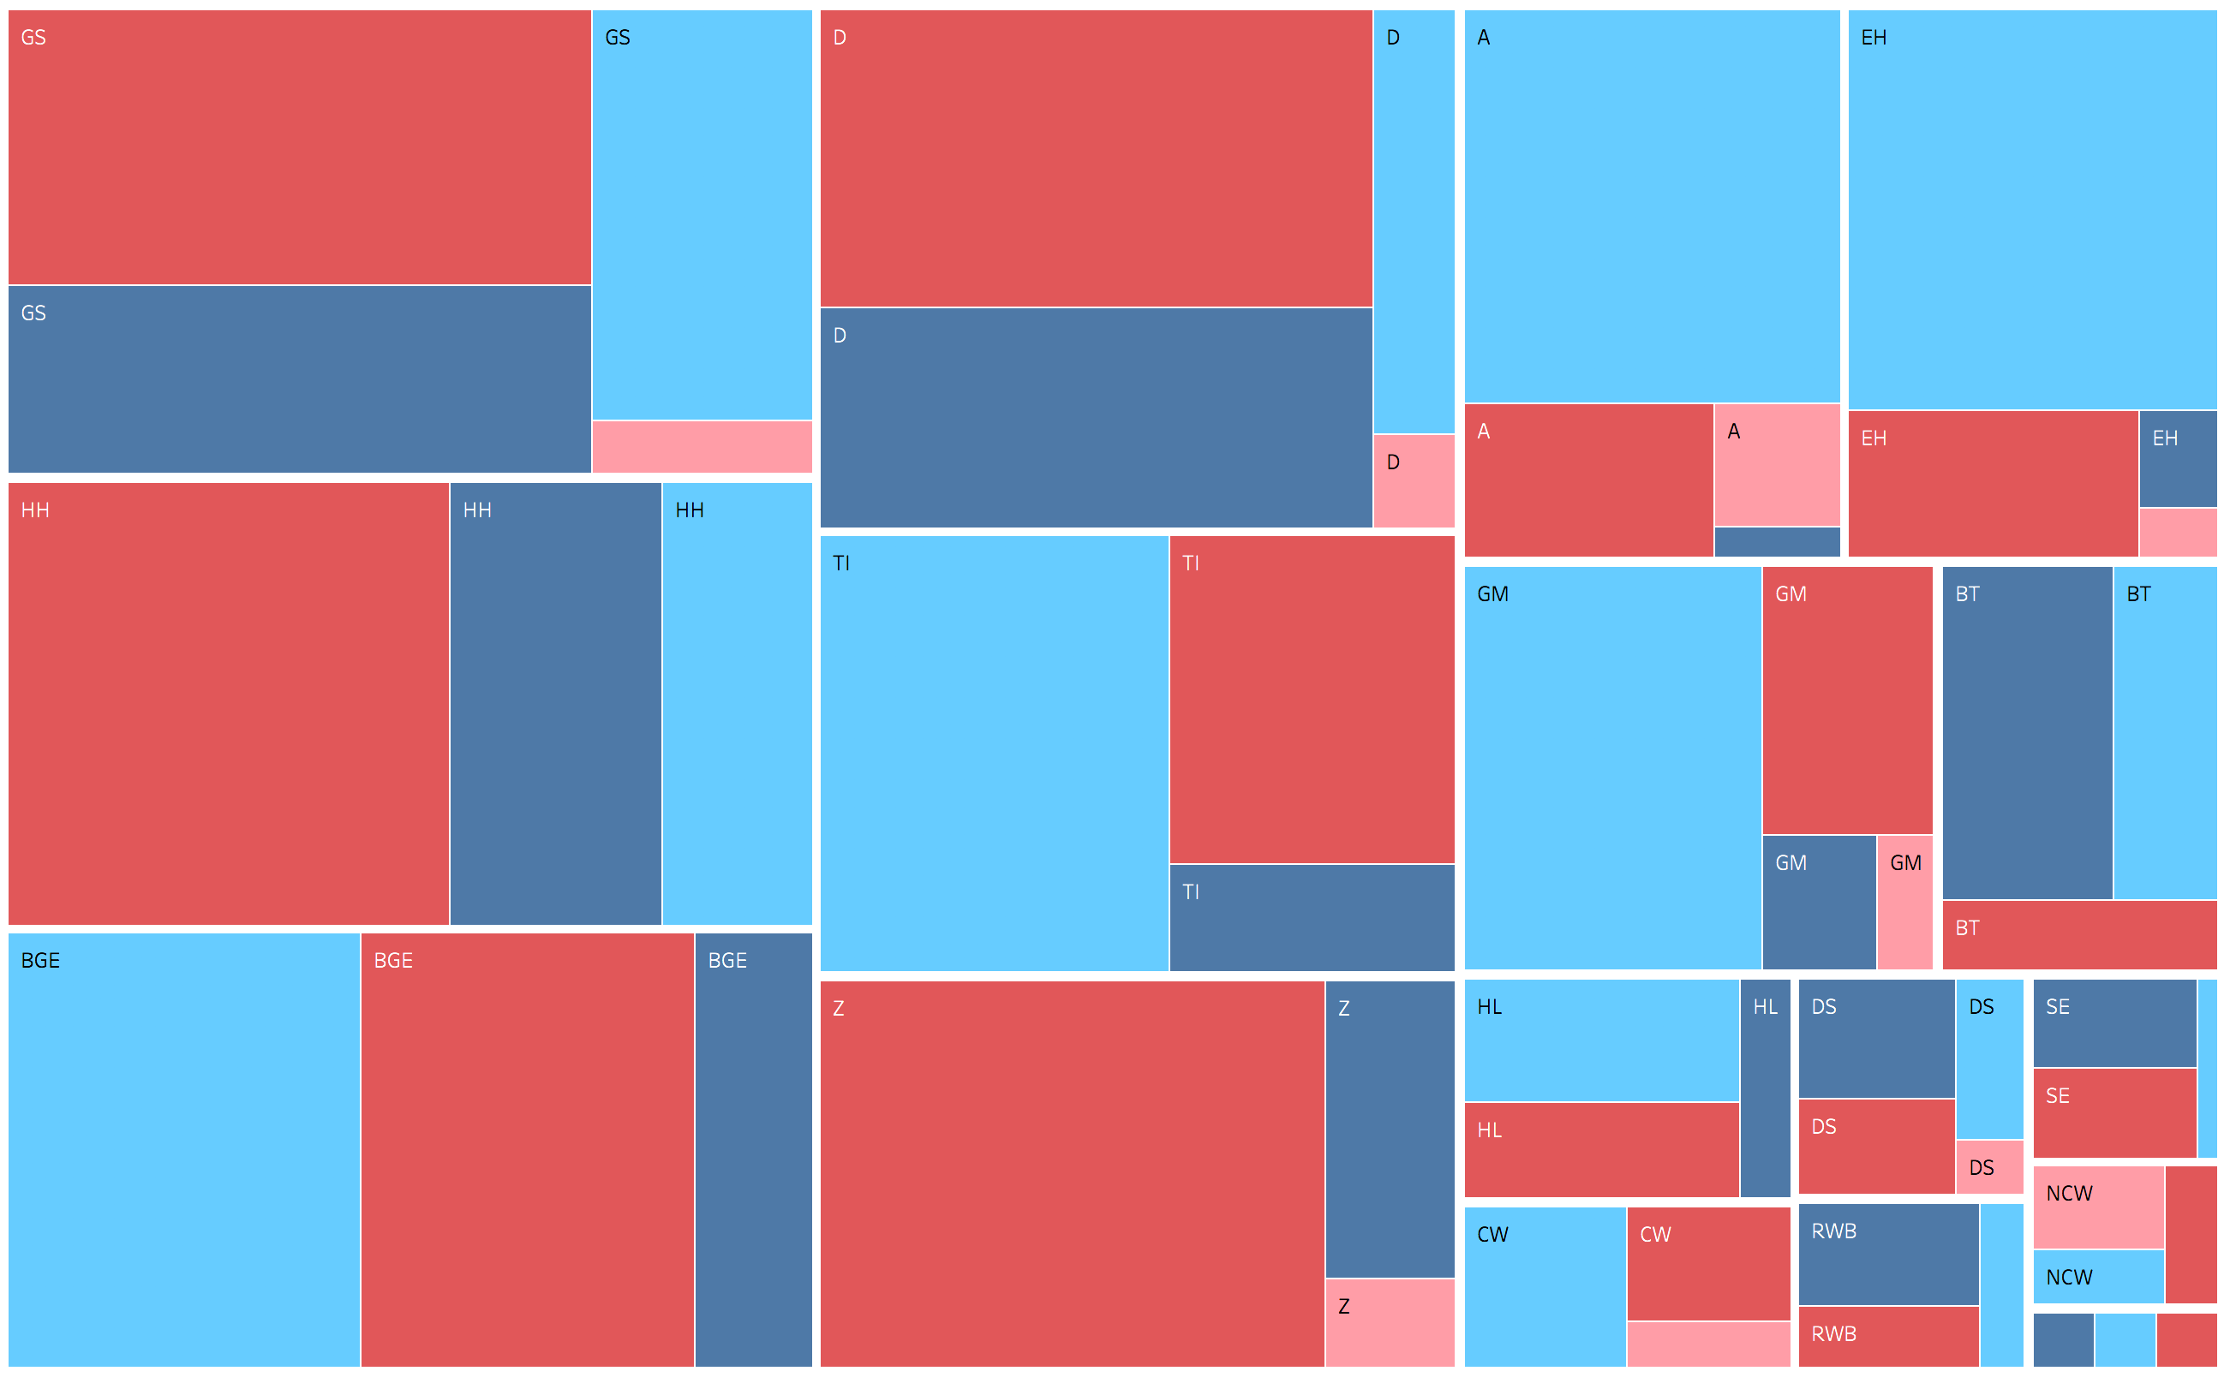

As Figure 14 shows, Nietzsche’s engagement with concepts of interests begins in earnest with HH and continues – with the exception of the anti-Wagner books – to the end of his writing career. The replacement of drives with instincts is even clearer in this figure, which shows that the sum total of passages that refer either to drives or to instincts remains relatively stable while the proportion shifts decisively from drives to instincts. The treemap in Figure 15 also makes it easy to see the relevant proportions of engagement on a book-by-book basis. For example, BGE engages most with instincts, virtues, and drives (in that order) without once mentioning chastity. By contrast, GS engages most with virtues, followed by drives, instincts, and chastity. The only books in which drives receive the most engagement are BT, DS, and RWB (SE is a tie), and the only book in which references to chastity predominate is NCW.
Next, I present an example of a section-by-section visualization (Figure 16) of relevant concepts within a single book (A).

Figure 16: all relevant passages from A
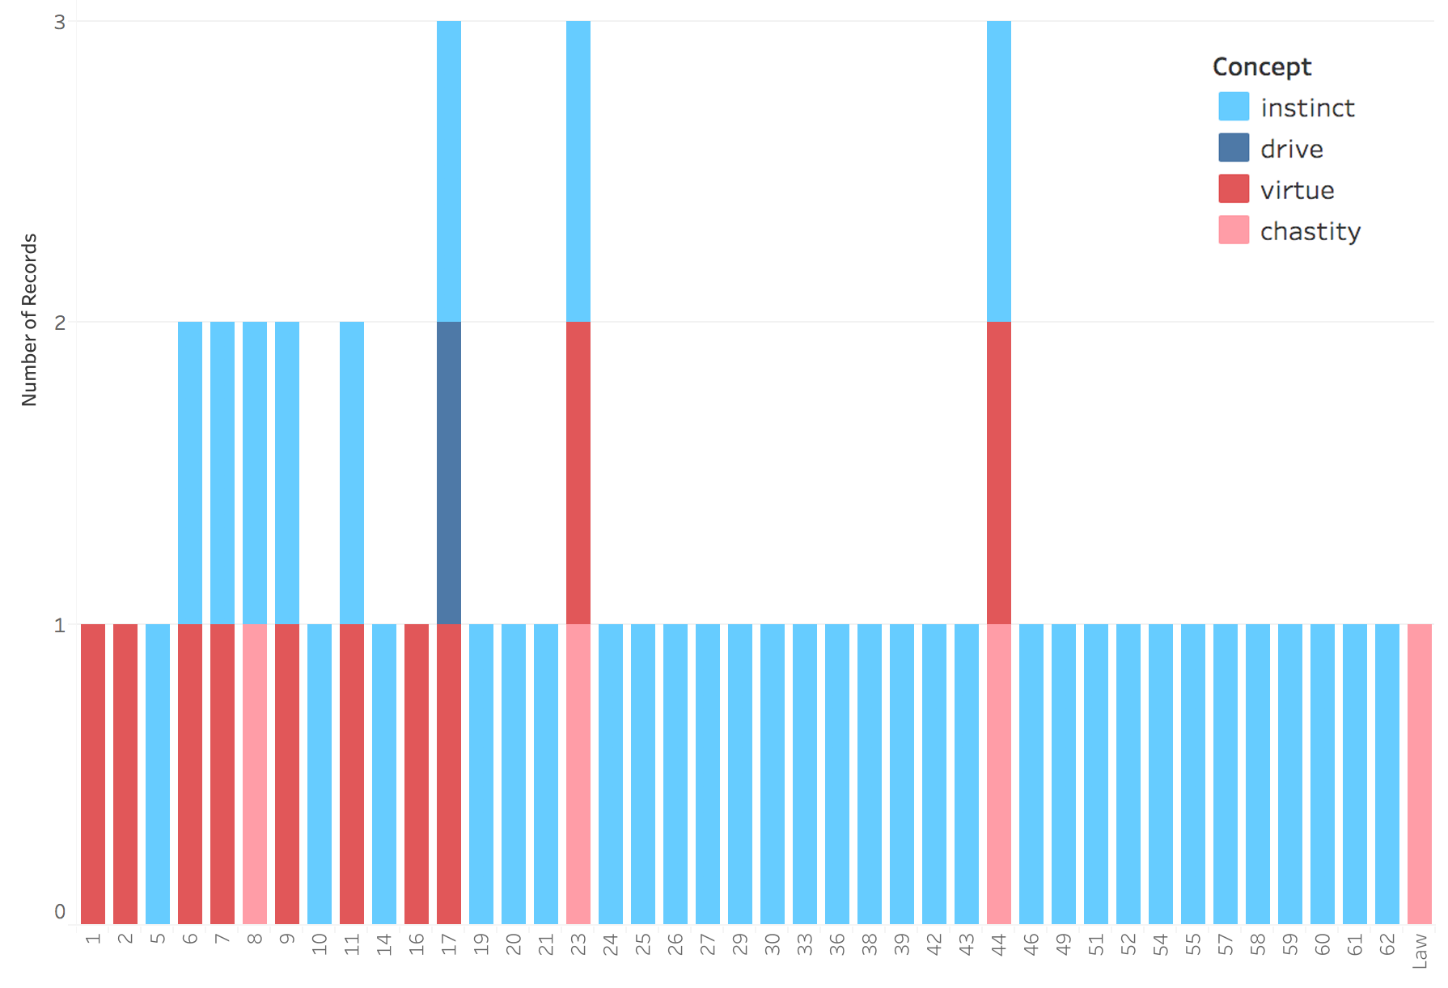

In the interactive version of this visualization online, it is possible to see a similar graph for each book under study. This figure shows that, in A, Nietzsche engages with instinct throughout, whereas he addresses virtue primarily in the first seventeen sections. Drives are mentioned only once (section 17), and chastity crops up three times in the same passage as instinct (sections 8, 23, and 44), two of which also refer to virtue (23 and 44). This sort of analysis allows us to see both the order in which various concepts crop up within a book and what Nietzsche also talks about when he talks about one of the concepts under study.
Finally, consider Figure 17, which maps the overlaps among the concepts under study.

Figure 17: Venn diagram of Nietzsche’s use of drive, instinct, virtue, and chastity. Numbers represent the number of passages in which a combination of concepts is discussed.
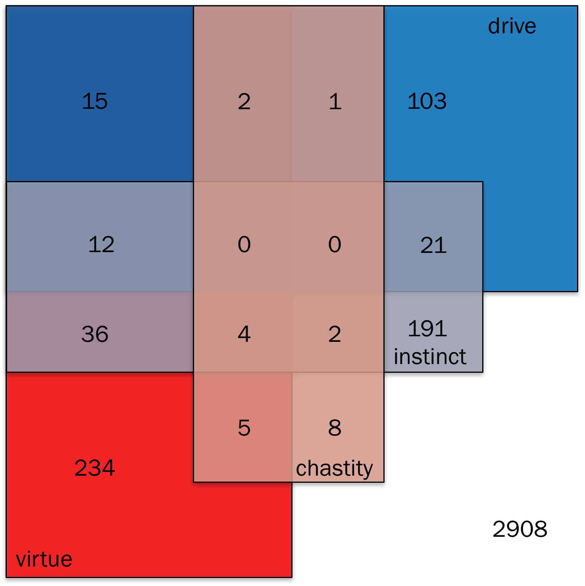

Tableau Public does not support Venn diagrams, so I constructed Figure 17 manually. In addition, this Venn diagram represents four sets, which makes it tricky to read. I’ll therefore walk through it starting with the cells with the least overlap and moving to those with the greatest overlap. There are 2908 passages in which none of the concepts under study occurs. There are 234 passages in which virtue but none of the other concepts is referenced. Along the same lines, there are 8 chastity-only passages, 191 instinct-only passages, and 103 drive-only passages. Next, consider the “doubles” – passages in which exactly two concepts are referenced. Virtue and chastity occur together in 5 passages, virtue and instinct in 36, virtue and drive in 15, chastity and instinct in 2, chastity and drive in 1, and instinct and drive in 21. Finally, consider the “triples” (there are no quadruples): virtue, chastity, and instinct in 4; virtue, instinct, and drive in 12; virtue, chastity, and drive in 2; and chastity, instinct, and drive in 0. In the next section, I will focus on the doubles and triples, since these are the passages most likely to indicate how the concepts under study are related in Nietzsche’s thinking.

Interpretation
Visualizations are food for thought. They do not do the interpretive work themselves. Nevertheless, by providing a synoptic view of the texts to be interpreted, they can guide our reading. For example, I should emphasize a point that is already clear from Figure 17: Nietzsche is significantly more likely to refer to one of the concepts under study if he also refers to at least one of the other three. Consider virtue by way of example. There are 3542 total passages in the works under consideration, of which 308 refer to virtue. The probability that a randomly selected passage will refer to virtue is therefore 308/3542 = 8.696%. There are 400 passages that refer to drives, instincts, or chastity, of which 74 also refer to virtue. The conditional probability that a randomly selected passage that refers to at least one of the other concepts will also refer to virtue is therefore 74/400= 18.500%. The discrepancies are similar for the other concepts. The prior probability of a passage referring to chastity is 22/3542 = .621%, while the conditional probability of a passage referring to chastity given that it refers to at least one of the other three concepts is 2.234%. The prior probability of drive is 4.348%, while the conditional probability is 9.605%. And the prior probability of instinct is 7.510%, while the conditional probability is 16.930%. Generalizing, the probability of one of these terms occurring in a passage is more than doubled if at least one of the other terms occurs in the same passage. Not to put too fine a point on it: these concepts are strongly related in Nietzsche’s thinking.
Determining more precisely how they are related, however, demands close-reading that is attentive to the possibility of changes in Nietzsche’s view from the free spirit works to the mature works, alertness to his use of irony and sarcasm, and an eye to the linguistic context in which a term crops up. Because this chapter must be brief, I here offer the conclusions of my close-readings along with the main passages on which they are based. In other work (Alfano forthcoming), I walk through the passages in more detail and connect my interpretation to the secondary literature.
My first claim is that, in Nietzsche’s framework, both instincts and virtues are subsets of drives: instincts are innate, whereas drives can be either innate or acquired; virtues are well-calibrated, whereas drives can be either well- or poorly calibrated. This claim is based primarily on HH I.99, D 26, D 30, GS 1, GS 8, GS 21, GS 116 GS 123, BGE 199, A 2, EH Clever 1, A 9, and TI Skirmishes 37. My second main interpretive claim is that drives are standing motivational dispositions to token actions of a particular type. When they are also instincts, such drives are biologically given (because innate); when they are not instincts, they are part of what Nietzsche sometimes calls “second nature” (zweite Natur, cf. HL 3, HL 4, D 38, D 455). This claim is based primarily on D 38, GS 21, GS 296 BGE 189, BGE 201, GM II.2, GM II.16, and TI Socrates. My third main interpretive claim is that, while drives can be modified and modulated both by the agent who possesses them and by others, drives are resistant to change and cannot be modified without limit. As early as HL, Nietzsche insists that people have types (Jensen 2016), and that a person’s type constrains the psychology that she can develop. To make sense of this idea, I here borrow and modify the capabilities approach (Sen 1985). Sen develops this approach by starting with the notion of a functioning, which is a way of doing or being, such as reading. He then defines a functioning vector as the set of functionings a person actually achieves (e.g., not just reading but also eating, walking, not being sick, etc.) and a capability as the power to exercise a functioning (e.g., literacy). A person’s capability set is then the set of functioning vectors within that person’s reach. Sen emphasizes that a person’s capability set is constrained both by their current psychology and by their material and social environment. We can build a Nietzschean version of this framework starting from the notion of an action-type. As I argued above, a drive is a standing motivational disposition to token actions of a given type; for example, all tokens of aggressing are associated with the aggressive drive, and all tokens of inflicting suffering are associated with the cruel drive. We can then define a drive vector as the set of drives a person actually embodies. Finally, define a drive set as the set of drive vectors within a person’s reach. This, I claim, is what Nietzsche means by a type: a type is just a drive set. And, just like a capability set, a person’s drive set is constrained both by their current psychology and by their material and social environment.
This brings us to what I’ve elsewhere (Alfano 2015a) called Nietzsche’s person-type-relative unity of virtue thesis, according to which a person’s flourishing is a matter of developing and acting from particular drives that fit both the type she embodies and the material and social environment in which she finds herself. This is what I meant above by a drive’s being “well-calibrated.” If someone attempts to embody drives that result in catastrophe, are outside her drive set (incompatible with her type), or meet with intense social and moral disapproval, she will not turn out well. Different people have different types, which means that some people will find it easier to embody virtue in one social context while others will find it easier to do so in another context. Thus, both internal (type-dependent) and external (social) factors conspire to determine whether someone’s drives are or count as virtues. I suggest that, for Nietzsche, a drive merely counts as a virtue if it meets with approbation from the agent’s community, whereas a drive is a virtue if it not only is approved but also fits the agent’s type. This view is supported by many passages, including D 202, D 204, Z Tree, Z Chastity, BGE 206, BGE 224, GM III.8, A 11, TI Socrates 11, TI Skirmishes 45, and TI Errors 2

Conclusion
In this brief section, I articulate some of the limitations of the digital humanities method employed in this chapter. Next, I point to future directions in Nietzsche scholarship that could benefit from this method. I conclude with a few broader remarks about the use of digital humanities methods in history of philosophy.
As I mentioned in the methodology section, my approach is liable to miss some relevant passages and tag as relevant passages that are actually irrelevant. For example, while I captured all passages that contain a word starting with ‘trieb’, I missed passages that contain a word starting with ‘antrieb’. Prefixes are trickier than suffixes. More generally, I ended up ignoring many passages that contain words that express concepts that arguably should have been included in the analysis, such as affect [Affekt], will [Wille], power [Macht], vice [Laster], and character [Charakter]. This is why I pointed out from the start that the first and perhaps most important step is to select the core concepts to study, and to do so explicitly so that the results are criticizable and corrigible. Future research can and should expand on the work in this chapter to include these and probably other concepts. What it should not do is engage in reckless and overblown readings of Nietzsche’s entire corpus that depend on a single, idiosyncratically-chosen passage (e.g., HH 95 for Swanton 2015, BGE Preface for Clark & Dudrick 2012). There are 3542 passages in Nietzsche’s entire published and authorized corpus. If Nietzsche scholarship is to advance, we need to read and relate these passages systematically.
Because he wrote in short, numbered sections, Nietzsche’s works are especially amendable to the kind of visual analytics employed in this chapter. That said, similar methods could be adapted to the textual structures used by other philosophers. For instance, Plato and Aristotle could easily be visualized in this way based on Stephanus pagination and Bekker numbering, and Aquinas helpfully organized the Summa Theologiae into parts, questions, and articles. When such standardized numbering is unavailable, it is of course possible just to divide the text in question into paragraphs or sentences – or to use a “window” of n words as explained above. Contemporary psychology and medical science face crises of replication. For digital humanities of the history of philosophy to avoid such a crisis, it must use rigorous, criticizable, corrigible, and reproducible methods.

References:
Alfano, M. (2010). The tenacity of the intentional prior to the Genealogy. Journal of Nietzsche Studies, 40: 123-40.
Alfano, M. (2013a). The most agreeable of all vices: Nietzsche as virtue epistemologist. British Journal for the History of Philosophy, 21(4): 767-90.
Alfano, M. (2013b). Nietzsche, naturalism, and the tenacity of the intentional. Journal of Nietzsche Studies, 44(3): 457-64.
Alfano, M. (2015a). An enchanting abundance of types: Nietzsche’s modest unity of virtue thesis. Journal of Value Inquiry, 49(3): 417-35.
Alfano, M. (2015b). How one becomes what one is called: On the relation between traits and trait-terms in Nietzsche. Journal of Nietzsche Studies, 46(1): 261-9.
Alfano, M. (2016). Review of Christine Swanton’s The Virtue Ethics of Hume and Nietzsche. Ethics, 126(4): 1120-4.
Alfano, M. (2017). A schooling in contempt: Emotions and the pathos of distance. In P. Katsfanas (ed.), Routledge Philosophy Minds: Nietzsche. Routledge.
Alfano, M. (forthcoming). Virtue in Nietzsche’s drive psychology. In T. Stern (ed.), The New Cambridge Companion to Nietzsche. Cambridge University Press.
Annas, J. (2017). Which variety of virtue ethics. In D. Carr, J. Arthur, & K Kristjánsson (eds.), Varieties of Virtue Ethics. Palgrave.
Austen, J. (1813/2002). Pride and Prejudice. Penguin Classics.
Clark, M. & Dudrick, D. (2012). The Soul of Nietzsche’s Beyond Good and Evil. Cambridge University Press.
Daigle, C. (2006). Nietzsche: Virtue ethics… virtue politics? The Journal of Nietzsche Studies, 32: 1-21.
D’Iorio, P. (2010). The digital critical edition of the works and letters of Nietzsche. Journal of Nietzsche Studies, 40: 70-80.
Gemes, K. (2001). Postmodernism’s use and abuse of Nietzsche. Philosophy and Phenomenological Research, 62(2): 337-60.
Gemes, K. (2008). Nihilism and the affirmation of life: A review of and dialogue with Bernard Reginster. European Journal of Philosophy, 16(3): 459-66.
Hurka, T. (2007). Nietzsche: Perfectionist. In B. Leiter & N. Sinhababu (eds.), Nietzsche and Morality, pp. 9-31. Oxford University Press
Jensen, A. (2016). An Interpretation of Nietzsche’s On the Uses and Disadvantages of History for Life. Routledge.
Katsafanas, P. (2013a). Nietzsche’s philosophical psychology. In J. Richardson & K. Gemes (eds.), Oxford Handbook of Nietzsche, pp 727-55. Oxford University Press.
Katsafanas, P. (2013b). Agency and the Foundations of Ethics: Nietzschean Constitutivism. Oxford University Press.
Katsafanas, P. (2015). Value, affect, and drive. In P. Kail & M. Dries (eds.), Nietzsche on Mind and Nature. Oxford University Press.
Katsafanas, P. (2016). The Nietzschean Self: Moral Psychology, Agency, and the Unconscious. Oxford University Press.
Knobe, J. & Leiter, B. (2007). The case for Nietzschean moral psychology. In B. Leiter & N. Sinhababu (eds.), Nietzsche and Morality. Oxford University Press.
Leiter, B. (2002). Nietzsche on Morality. Routledge.
Leiter, B. (2007). Nietzsche’s theory of the will. Philosophers’ Imprint, 7(7): 1-15.
Leiter, B. (2013). Moralities are a sign-language of the affects. Social Philosophy and Policy, 30(1-2): 237-58.
May, S. (1999). Nietzsche’s Ethics and His War on ‘Morality’. Oxford University Press.
Moretti, F. (2013). Distant Reading. Verso.
Railton, P. (2012). Nietzsche’s normative theory? The art and skill of living well. In C. Janaway & S. Robertson (eds.), Nietzsche, Naturalism, & Normativity, pp. 20-51. Oxford University Press.
Reginster, B. (2006). The Affirmation of Life. Cambridge University Press.
Reginster, B. (2013). Honesty and curiosity in Nietzsche’s free spirit. Journal of the History of Philosophy, (3): 441-63.
Robertson, S. (2012). The scope problem – Nietzsche, the moral, ethical, and quasi-aesthetic. In C. Janaway & S. Robertson (eds.), Nietzsche, Naturalism, & Normativity, pp. 81-110. Oxford University Press.
Sen, A. (1985). Well-being, agency and freedom. The Journal of Philosophy, 82(4): 169-221.
Swanton, C. (2015). The Virtue Ethics of Hume and Nietzsche. Wiley-Blackwell.
Thomas, A. (2012). Nietzsche and moral fictionalism. In C. Janaway & S. Robertson (eds.), Nietzsche, Naturalism, & Normativity, pp. 133-59. Oxford University Press.
White, A. (2001). The youngest virtue. In R. Schacht (ed.), Nietzsche’s Post-Moralism, pp. 63-78. Cambridge University Press.

Search conducted 23 January 2017. Gemes (2001; 2008) makes brief forays into the sort of word-counting that grounds the analysis in this paper, but he does not monitor overlaps. In addition, his papers were written before the Nietzsche Source was available as a resource.
I use the standard abbreviations for the titles of Nietzsche’s texts (http://www.hunter.cuny.edu/jns/style-guide). All translations are Cambridge University Press critical editions, with a few minor emendations for clarity.
For a full introduction, see D’Iorio (2010). To my knowledge, the only papers to use the Nietzsche Source to comprehensively study Nietzsche’s use of particular words are Alfano (2013a) and Alfano (2017). The complete data-sets for these study as well as the present study are freely available at http://www.alfanophilosophy.com/dh-nietzsche/.
Available at https://public.tableau.com/en-us/s/download. Tableau Public is a highly intuitive interface that automatically employs best practices in visual analytics.
All data, methods, and visualizations (including section-by-section visualizations for the other books) are freely available for perusal and download at https://public.tableau.com/profile/mark.alfano#!/vizhome/Virtuedriveinstinct/Story1.

