Title: Mapping Human Values: Enhancing Social Marketing through Obituary Data-Mining

Abstract: Obituaries are an especially rich resource for identifying people’s values. Because obituaries are succinct and explicitly intended to summarize their subjects’ lives, they may be expected to include only the features that the author(s) find most salient, not only for themselves as relatives or friends of the deceased, but also to signal to others in the community the socially-recognized aspects of the deceased’s character. We report three approaches to the scientific study of virtue and value through obituaries. We begin by reviewing studies 1 and 2, in which obituaries were carefully read and labeled. We then report study 3, which further develops these results with a semi-automated, large-scale semantic analysis of several thousand obituaries. Finally, we present the results of study 4 in which individuals were asked to write prospective obituaries. Geography, gender, and elite status all turn out to influence the virtues and values associated with the deceased.

Keywords: values, data-mining, network maps, obituaries, social marketing

1. Preliminaries
Traditionally, marketers have sought to influence behavior and choice with the ultimate end of promoting the interests of employers or clients. The domain of marketing was convincing individuals and groups to purchase certain products over others, to spend rather than save, and to upgrade after deciding to buy. Starting in the 1970s, marketing researchers began to recognize that these persuasive techniques could be harnessed for other purposes as well. This was already obvious in the case of political advertising, in which platforms and policies could be linked with consumers’ interests and self-concepts; relatedly, Kotler and Zaltman (1971) argued that marketing techniques could be used to promote the social good, with marketers’ own material interests taking a back seat. In this approach, Kotler and Zaltman stated, ideas, ideals, and causes can be “sold” just like “cigarettes, soap, and steel.” Andreason & Kotler (2008) later defined this type of “social” marketing as indistinguishable from traditional marketing except insofar as social marketers seek, as an ultimate end, to benefit their target audience and society more generally.
In this paper, we approach this social goal by linking two concepts from the field of marketing (means-end theory and laddering) with one from the philosophical field (virtue theory). Means-end theory has precedents in Aristotle’s Nicomachean Ethics (2000) and John Stuart Mill’s Utilitarianism (1861 / 1998) but has been developed in richer empirical detail by Reynolds & Olson (2001). According to this view, individuals’ desires, goals, and values are organized in a relatively stable hierarchy with more specific, concrete, local, and instrumental preferences (e.g., wanting sports team A to prevail over sports team B) at the bottom and more general, abstract, global, and intrinsic values (e.g., pride in one’s community) at the top. Between the maximally abstract and the maximally concrete are various mixed states that might be valued both instrumentally and intrinsically (e.g., the vicarious feeling of triumph).
Laddering is a technique for exploring individuals’ value-hierarchies. In a common interview-based version of laddering (Reynolds & Olson 2001), the marketer asks a consumer why she, for instance, purchased a product. Typically, the answer to this question identifies some concrete feature of the product at one end of the hierarchy, such as its ingredients or immediate effects on the consumer. The interviewer then iterates the “why”-question until a fundamental, intrinsic value is identified. Repeated further, this process generates a chain of increasingly global values. To the extent that the interviewed consumer is typical of the group the marketer wants to target, her value-hierarchy can be used as a model of the group’s values. Once the model is formed, it can be harnessed as a rhetorical tool. One standard way of doing this is to point to the features of a product that can be expected to engage people’s mid-level values, explicitly or implicitly draw the connection to such values, then point in the direction of the relevant intrinsic values. For instance, the marketer of a chocolate product draws the target audience’s attention to the fact that the ingredients are from Brazil and Ethiopia. This concrete feature is then connected with the mid-level value of exoticism. Exoticism is in turn connected with the intrinsic value of originality. The basic idea behind this strategy is that persuasive messages are likely to fall flat if they are (perceived as) irrelevant to what consumers care about. Though it may be possible, to some extent, to change what people care about, it is easier and more effective to establish the relevance of one’s product or service to what they already value.
As we have described it thus far, laddering seems to generate only linear networks between local preferences and global values. Common sense, reflection, and empirical research all suggest otherwise. For instance, in the Schwartz Values circumplex model (1992), the degree to which individuals value benevolence is positively correlated with the degree to which they value universalism and tradition but negatively correlated with the degree to which they value achievement, power, and pleasure. This suggests that values are embodied in complex, non-linear networks, and that marketing messages will be more effective to the extent that they utilize more routes towards the same higher-level value.
For this reason, we believe it is worthwhile to pursue means-end research not just through linear laddering but also with explicitly network-theoretic methods. One way to employ this method would be to data-mine existing corpora that may be rich in expressions of both communal and individual values. It remains an open question how to most accurately measure the distribution of values in a population. Several approaches have been developed, including the Schwartz circumplex mentioned above, as well as the models of Kahle et al. (1986), Rokeach (1973), and Graham et al. (2011). Graham et al. (2009) counted the number of value-laden words in sermons from politically liberal and conservative churches in order to make inferences about relative value structures within liberal and conservative groups more generally (while sermons from liberal churches focused relatively more on issues of group loyalty and concerns about harm and caring, sermons from conservative churches focused relatively more on issues of spiritual or physical purity and obedience to authority). Graham et al. (2009) thus utilized a lexical approach to understanding evaluative language, according to which everyday language reflects folk conceptions about the nature of morals and values more generally. This approach predicts that ideas that are particularly important to a community will naturally gain expression in that community’s language, often as discrete descriptors (e.g., “loyal,” “authoritarian,” “nature-loving,” etc. – see Christen et al., 2014). This type of lexical approach has a well-established history in the study of personality traits, a field that is also beginning to re-introduce evaluative terms (e.g., “wicked”) to what it considers descriptors of traits (Saucier, 2009). Graham et al. (2009) focused specifically on popular words in religio-political discourse, and actively filtered out words unrelated to Moral Foundations Theory (Haidt and Joseph, 2004). With a similar lexical approach, we sought to examine the extent to which virtues, values, and constituents of well-being are carried in the language of different communities in the general (theory-agnostic) person-descriptors they use. Thus, unlike Haidt and Joseph, we planned to only filter out non-person-descriptors rather than applying a pre-determined value framework.
This brings us to our perhaps surprising choice of corpora: we believe that obituaries are an especially rich resource for identifying people’s values. Because obituaries are succinct and explicitly intended to summarize their subjects’ lives, they may be expected to include only the features that the author or authors find most salient, not only for themselves as relatives or friends of the deceased, but also to signal to others in the community the socially-recognized aspects of the deceased’s character. Linda Zagzebski, a philosopher who specializes in virtue theory, proposed that “one way to express the depth required for a trait to be a virtue or a vice is to think of it as a quality we would ascribe to a person if asked to describe her after her death” (1996, emphasis ours). Such posthumous descriptions have a summative character to them, so positive or negative valence in them is presumably meant to evaluate the deceased’s moral identity as a whole. In a similar vein, in Acceptance and Commitment Therapy (ACT), a popular form of clinical psychiatry, one of the primary interventions employed to help patients clarify and connect their values is to ask them to write their own obituary or eulogy (Hayes et al., 2011). Additionally, because social marketing typically aims to promote moral or social ends, the values relevant to social marketers are especially likely to crop up in these documents.
Beyond these essential connections, extracting values is also potentially useful to social marketers for several pragmatic reasons. First, obituaries, unlike other value-laden corpera such as sermons, diaries, and letters, are published in newspapers and readily available online. Second, it is fairly straightforward to use metadata to segment obituaries (and therefore markets) based on potentially moderating variables such as age, race, socio-economic status, location, gender, and so on. Third, obituaries tend to focus primarily on moral values and virtues, which are typically the virtues and values social marketers wish to engage.
We expect the values expressed in these records to be diverse but also interconnected. Different communities and individuals are unlikely to unanimously agree on a single set of norms or ideals, but it would be equally surprising to find no significant overlap. Thus, the ideal approach to analyzing these texts will be sensitive to the typical (lack of) correlations between the various ways that we praise the dead. This sort of analysis could be conducted by developing an extensive list of positive and negative correlations between each term or phrase, but human observers have little to gain from a sprawling list of correlations between hundreds of variables. Thus, where we aim to present a holistic picture of the virtues expressed by each community, we will do so in the form of network graphs that represent hundreds or thousands of correlations in a single, easily digestible representation of the data.
In what follows, we begin by reviewing studies 1 and 2, in which obituaries were carefully read and labeled. We then report study 3, which further develops these results with a semi-automated, large-scale semantic analysis of several thousand obituaries. Next, we turn to study 4, in which participants wrote prospective obituaries. We conclude with a general discussion and suggestions for further research.

Study 1: Local Obituaries
Given our goal of using obituaries to further our understanding of ordinary people’s values, it was important to select sets of obituaries that are representative of the general public’s values, insofar as this is possible. To this end, we selected local newspapers with obituaries of people from all walks of life instead of targeting obituaries of larger newspapers that selectively write about famous individuals. We anticipated that obituaries from newspapers such as The New York Times would be both more selective (only covering a few famous or infamous individuals) and more comprehensive (written with the goal of telling a rich and captivating story of those few individuals whose lives were deemed worthy of note). We also found that, while Times obituaries are authored by professional writers, the obituaries of ordinary folks in local newspapers are typically composed by laypeople. The stories of (in)famous individuals in the Times, while more interesting, include a full range of virtues, vices, and value-neutral descriptions. Our initial goal, though, was to target obituaries as a means of developing a better understanding of positively (or at worst neutrally) valenced terms and phrases (see Study 2 for a brief discussion of obituaries from The New York Times).

Methods
Obituaries published between November 2013 and January 2014 were collected from newspapers in four cities: The Register Guard (Eugene, Oregon), The Mat-Su Valley Frontiersman (Wasilla, Alaska), The Flint Journal (Flint, Michigan), and The Hampshire Gazette (Amherst, Massachusetts). These were read with an eye to agent-level descriptions of the deceased (e.g. ‘hard-working’, ‘honest’, ‘generous’). General categories of traits were developed inductively as obituaries were read, with additional categories added as new types of descriptions were found that did not match previously added labels.

Results
We collected and analyzed 928 obituaries (52% female) in total across the four cities, with 708 containing agent-level descriptions of the deceased (51% female) as summarized in Table 1.
City | Male | Female | Total
Amherst, MA | 266 (215) | 299 (240) | 565 (455)
Eugene, OR | 91 (75) | 76 (43) | 167 (118)
Flint, MI | 66 (44) | 81 (59) | 147 (103)
Wasilla, AK | 21 (13) | 28 (19) | 49 (32)
Total | 444 (347) | 484 (361) | 928 (708)
Table 1: Total number of obituaries collected from four newspapers, broken down by gender; number in parentheses reports how many obituaries contained agent-level descriptions of the deceased.

We were particularly interested in investigating trends in the co-occurrence of descriptions of the deceased within obituaries. To see this, the co-occurrence of traits X and Y was treated as an undirected edge in a network, with the weight of each edge equal to the total number of obituaries in which the deceased was described as both X and Y. The resulting networks for each city and the combined network of traits are represented visually below. The graphs below were generated with Gephi, using a standard ForceAtlas layout with heightened stabilization, attraction distribution, and label adjust.
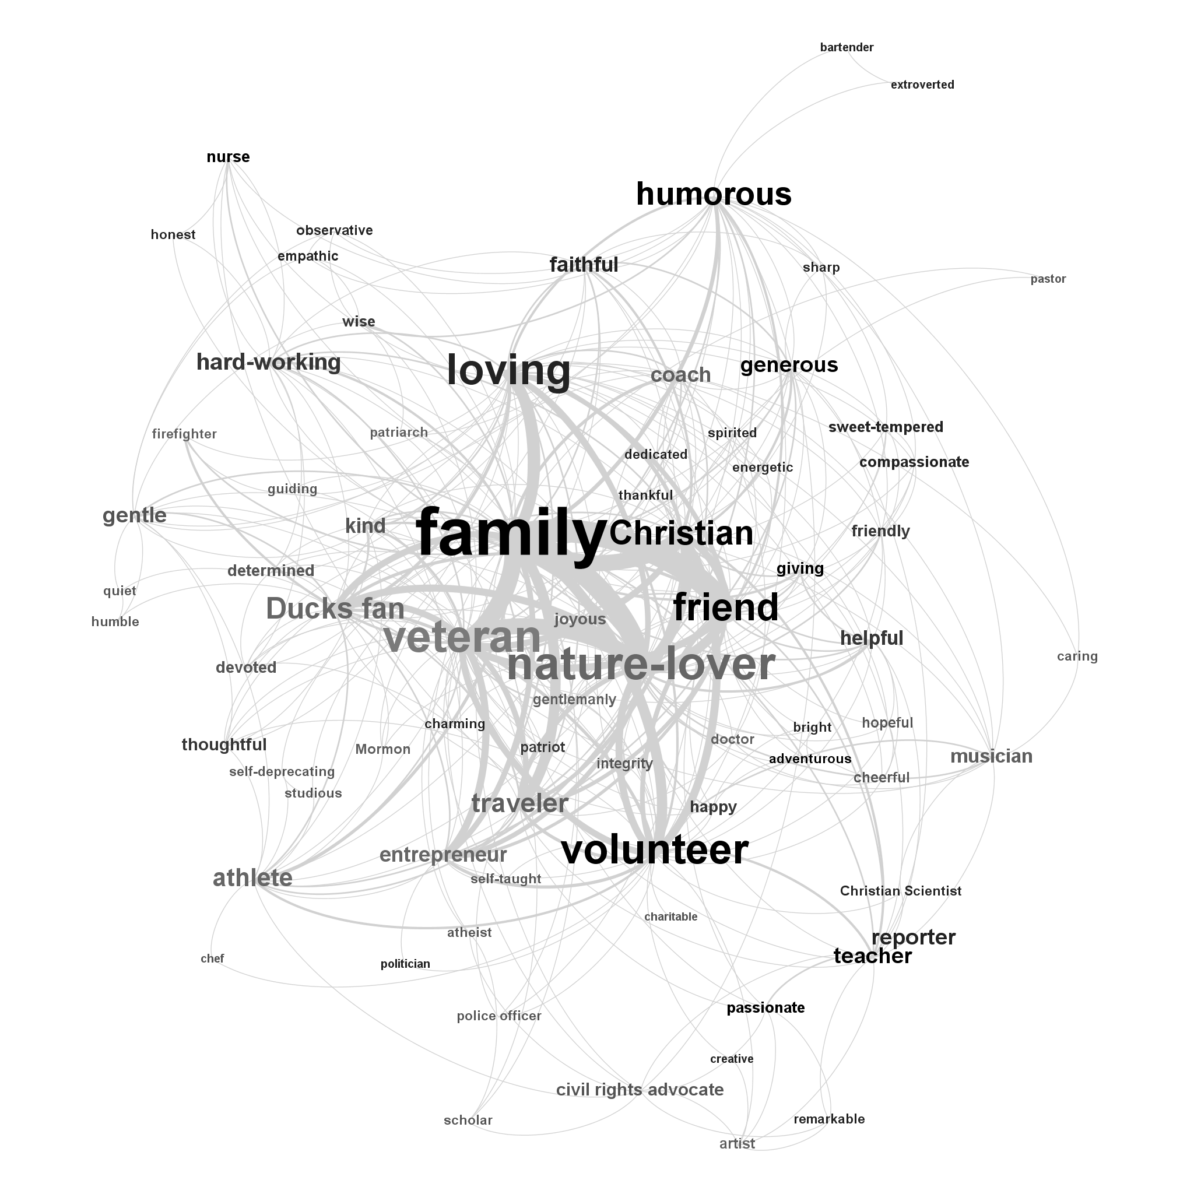
Figure 1: Co-occurrence of traits in Eugene obituaries. Label size was determined by total occurrences, edge width by total co-occurrences, and label color by gender differences (black = more female, light gray = more male, dark gray = mixed, continuous scale)

Figure 1 displays the traits ascribed to the deceased in Eugene. This graph depicts trait frequency with size (e.g., obituary writers highlighted volunteering more often than integrity, represented by the fact that “volunteer” is larger than “integrity” in the graph). Gender differences are represented with label coloring on a continuous scale between black and light gray, with terms colored black to the extent that they tended to be ascribed to women, light gray to the extent that they tended to be ascribed to men, and dark gray for terms that were roughly equal in frequency after adjusting for total word count of male and female obituaries. Finally, line thickness represents the frequency of co-occurrence of traits, with thick lines indicating pairs of terms that were frequently ascribed to the same individual. A label’s position is not meaningful on its own, but positions carry meaning in relation to the positions of every other node. In graphs such as this, node positions are determined by an iterated application of three forces: (1) gravity, pulling all nodes to the center, (2) attraction, pulling nodes together if they are connected by an edge, with the strength of the attraction determined by the weight of the edge, and (3) repulsion, whereby all nodes are pushed away from all other nodes.
Similar analyses were conducted using the trait-terms gathered from obituaries from Wasilla, Alaska (Figure 2), Amherst, Massachusetts (Figure 3), and Flint, Michigan (Figure 4).
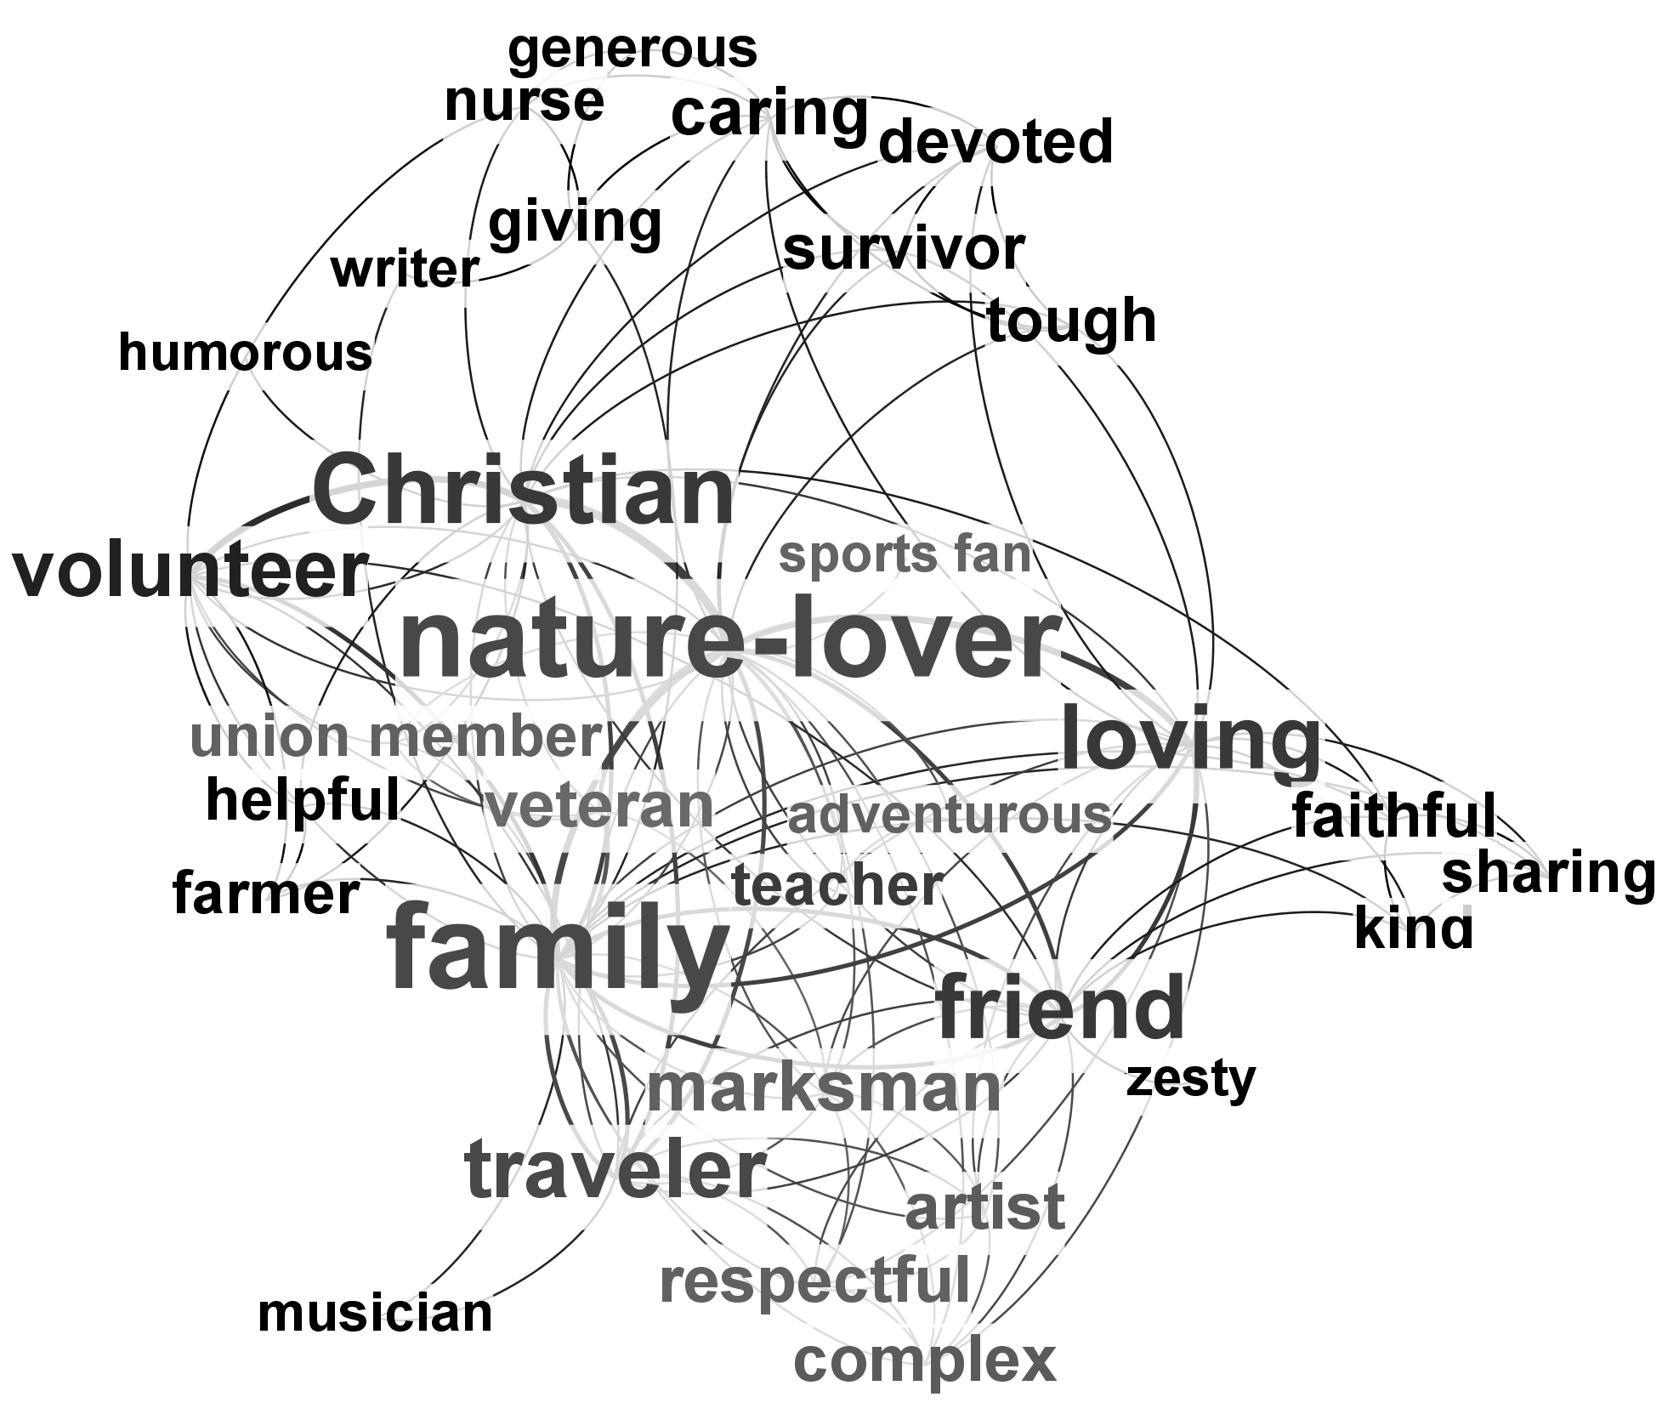
Figure 2: Co-occurrence of traits in Wasilla obituaries. See Fig. 1 for details on graph layout.
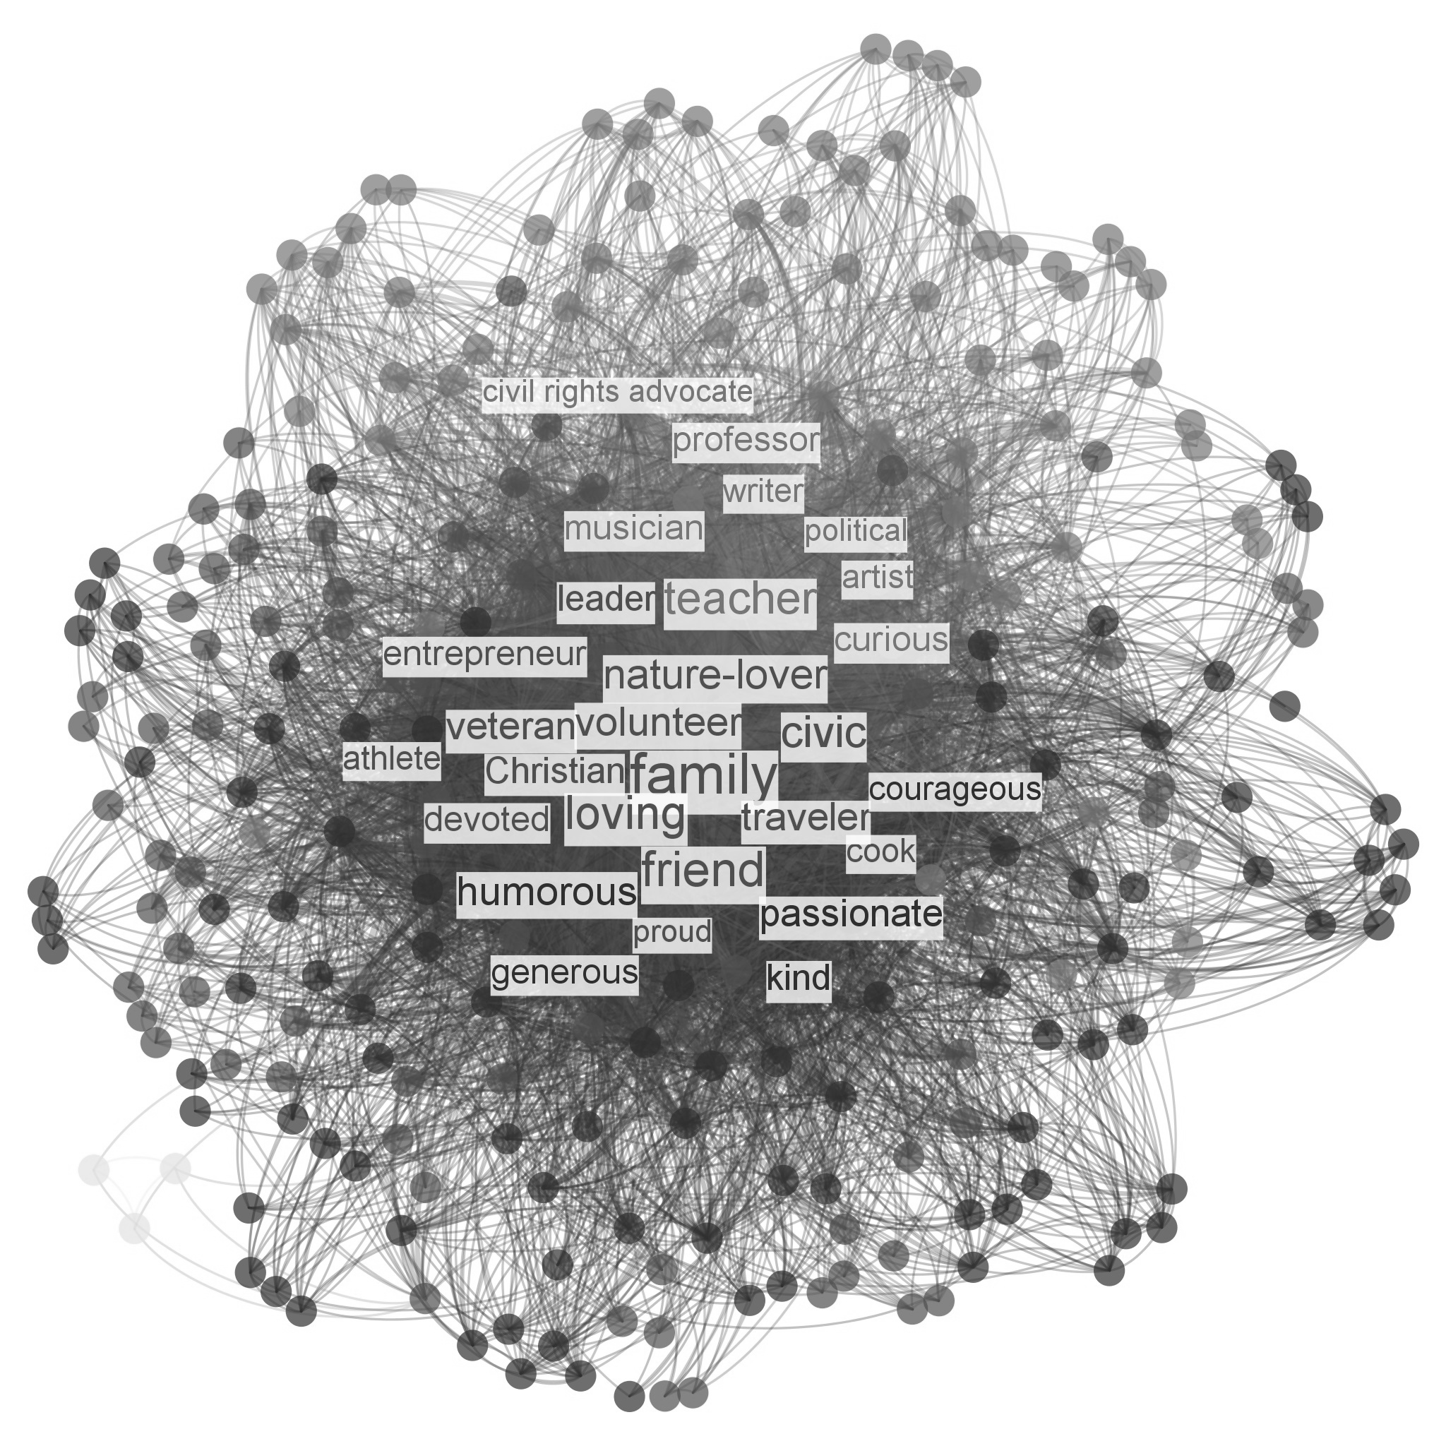
Figure 3: Co-occurrence of traits in Amherst obituaries; to reduce clutter, only the most prominent traits are labeled (as measured by PageRank). See Fig. 1 for details on graph layout.

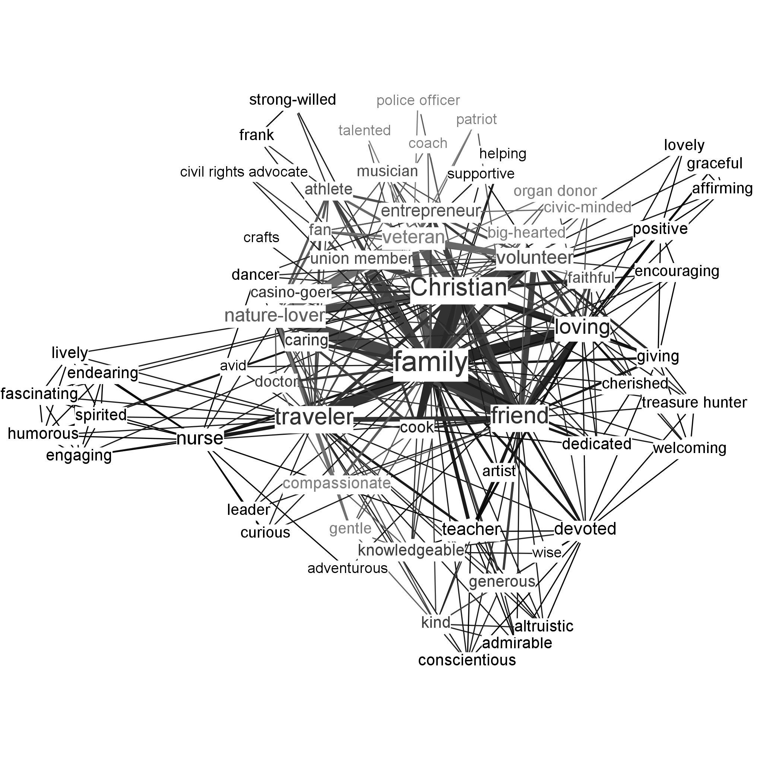
Figure 4: Co-occurrence of traits in Flint obituaries. See Fig. 1 for details on graph layout.

In addition, we combined the data for all four towns, then split it to create maps of the values and virtues associated with women (figure 5) and with men (figure 6)

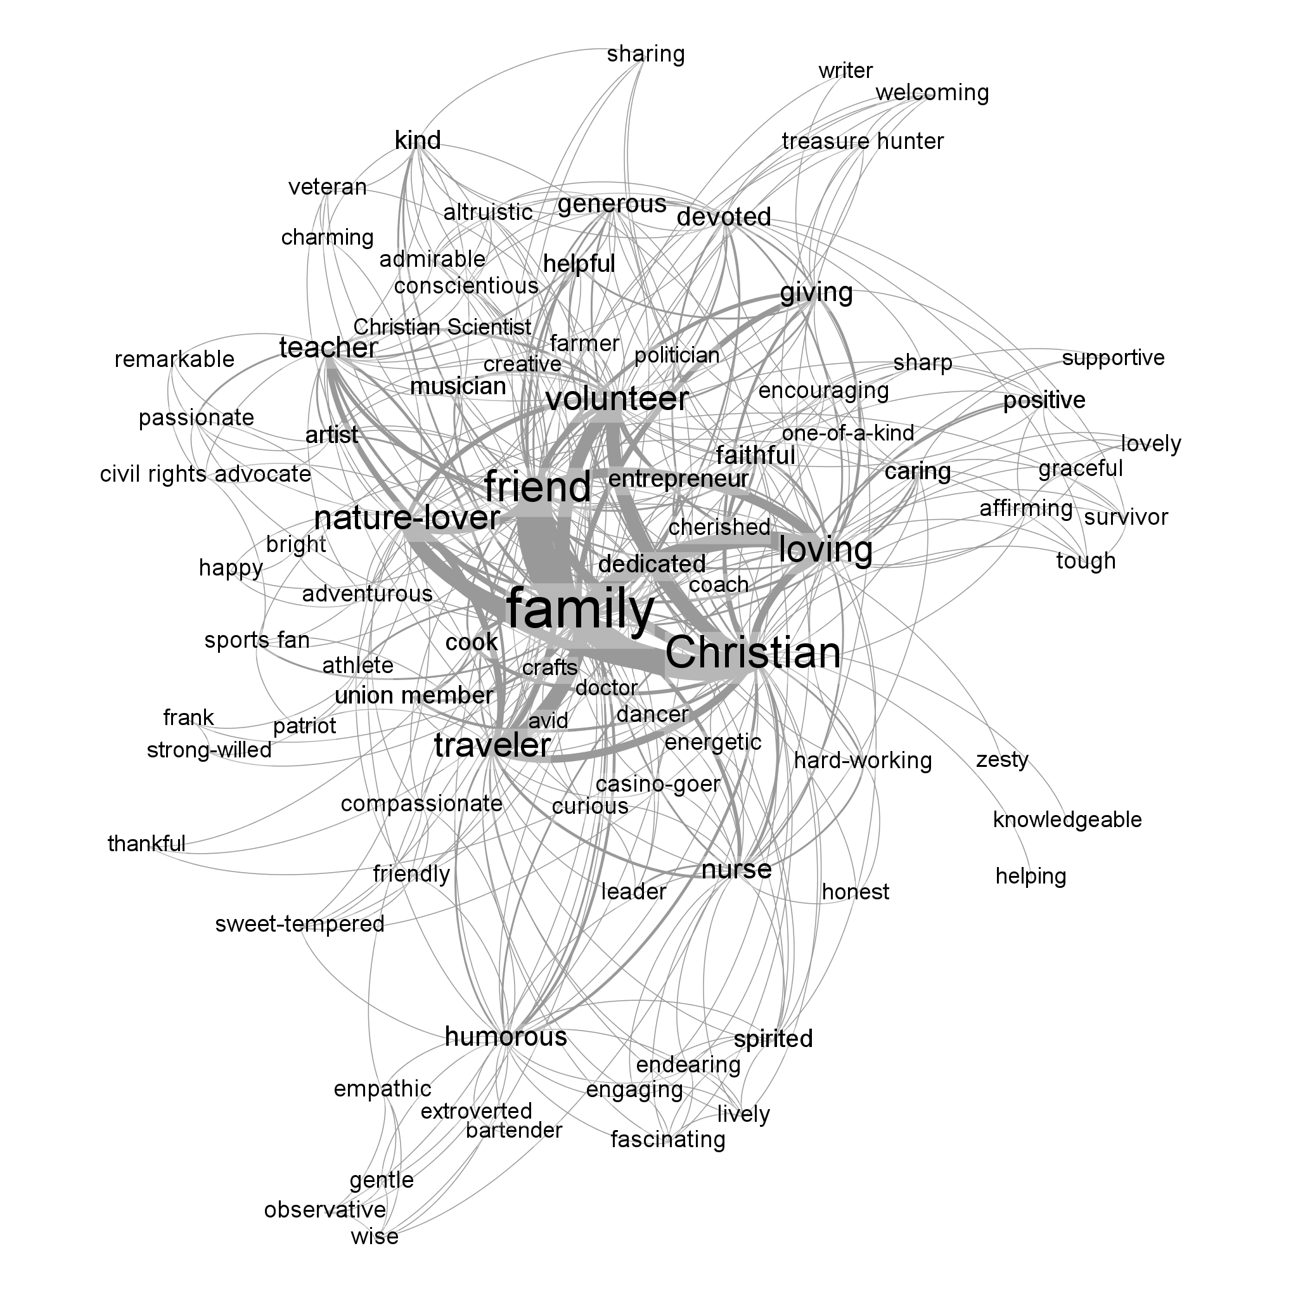
Figure 5: Co-occurrence of traits in female obituaries in Amherst, Eugene, Flint, and Wasilla. See Fig. 1 for details on graph layout.

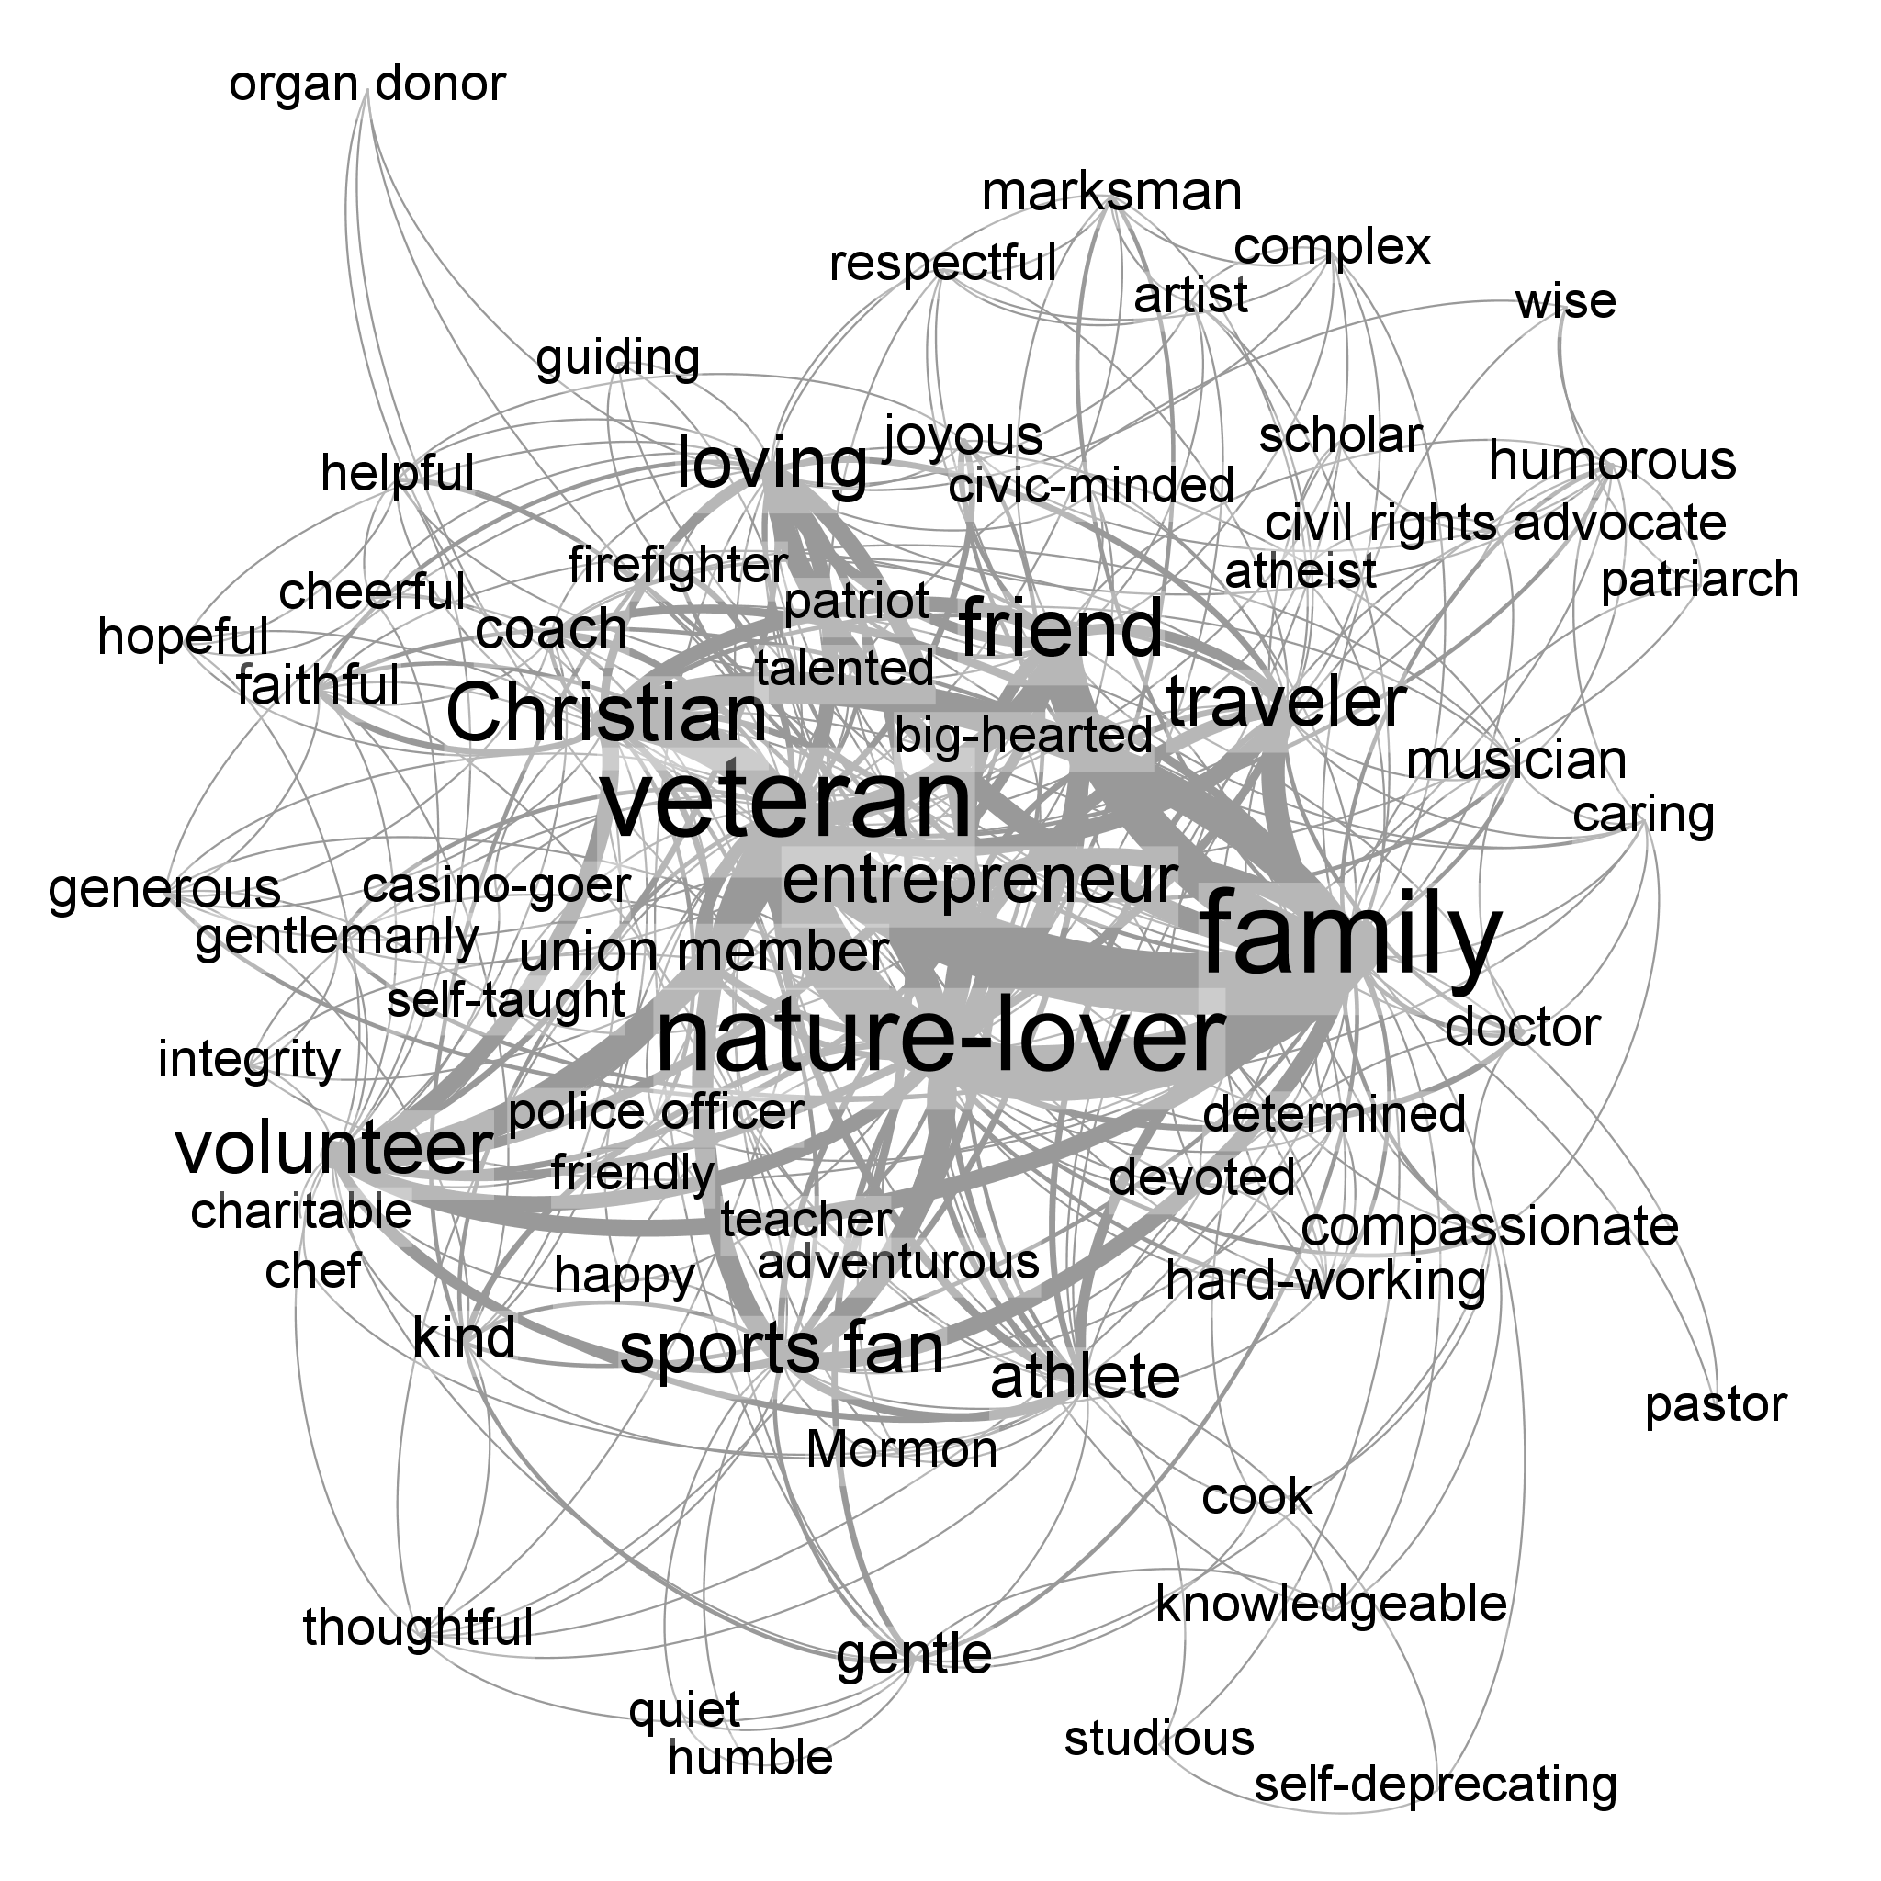
Figure 6: Co-occurrence of traits in male obituaries in Amherst, Eugene, Flint, and Wasilla. See Fig. 1 for details on graph layout.

Discussion
Naturally, these maps are only one perspective on the value-networks of the communities they represent. We believe, though, that they point to underutilized approaches to social marketing. For instance, suppose the Sierra Club, a non-profit public interest organization, were designing a social marketing campaign. They would of course want to connect with people whose identity as a nature-lover. One straightforward way to do this would be to call attention to the direct environmental impacts of the Sierra Club, connect those with mid-level values, then connect those to the valued identity of being a nature-lover. In addition, however, a social marketer might try to connect through closely-related identities, such as being athletic or being a veteran. Instead of or in addition to saying, “Support the Sierra Club! We help save the coastal redwoods, a unique forest that any nature-lover would hold dear,” they could say, “Support the Sierra Club! We maintain trails through the coastal redwoods, a beautiful hiking trail that any athlete would want to traverse,” or “Support the Sierra Club! We help save the coastal redwoods, a national landmark dear to any patriot.”

Study 2: New York Times Obituaries
We anticipated that local newspapers would be a useful place to look for variability in expressions of commonly shared values. However, we also wished to investigate the obituaries of significant figures because these might give us a better picture of the character traits of people who are commonly seen as great and noteworthy. It might be that people generally take certain traits to be virtuous for friends and loved ones, such as honesty and dedication, while evaluating famous individuals in a different light, perhaps differentially valuing traits such as leadership and decisiveness. To explore this possibility, we read and coded obituaries from The New York Times, following a similar set of methods as in study 1.

Methods
All obituaries published by The New York Times from 1 October 2013 to 1 February 2014 were read and analyzed. As with study 1, information was gathered on the age at death, gender, and traits of the deceased.

Results
A total of 74 obituaries (13% female, an eye-popping statistic) from The New York Times were read and labeled based on trait-ascriptions found in the obituaries. Three-hundred thirty-seven trait types were included in the sample, with an average of 8.5 traits per obituary. As in study 1, the resulting sets of traits were analyzed from a network perspective. Where someone was described as both X and Y, an undirected edge was created linking X to Y, with edge weight based on the total number of people described as both X and Y, resulting in 3,939 edges. This network is displayed in Figure 7.
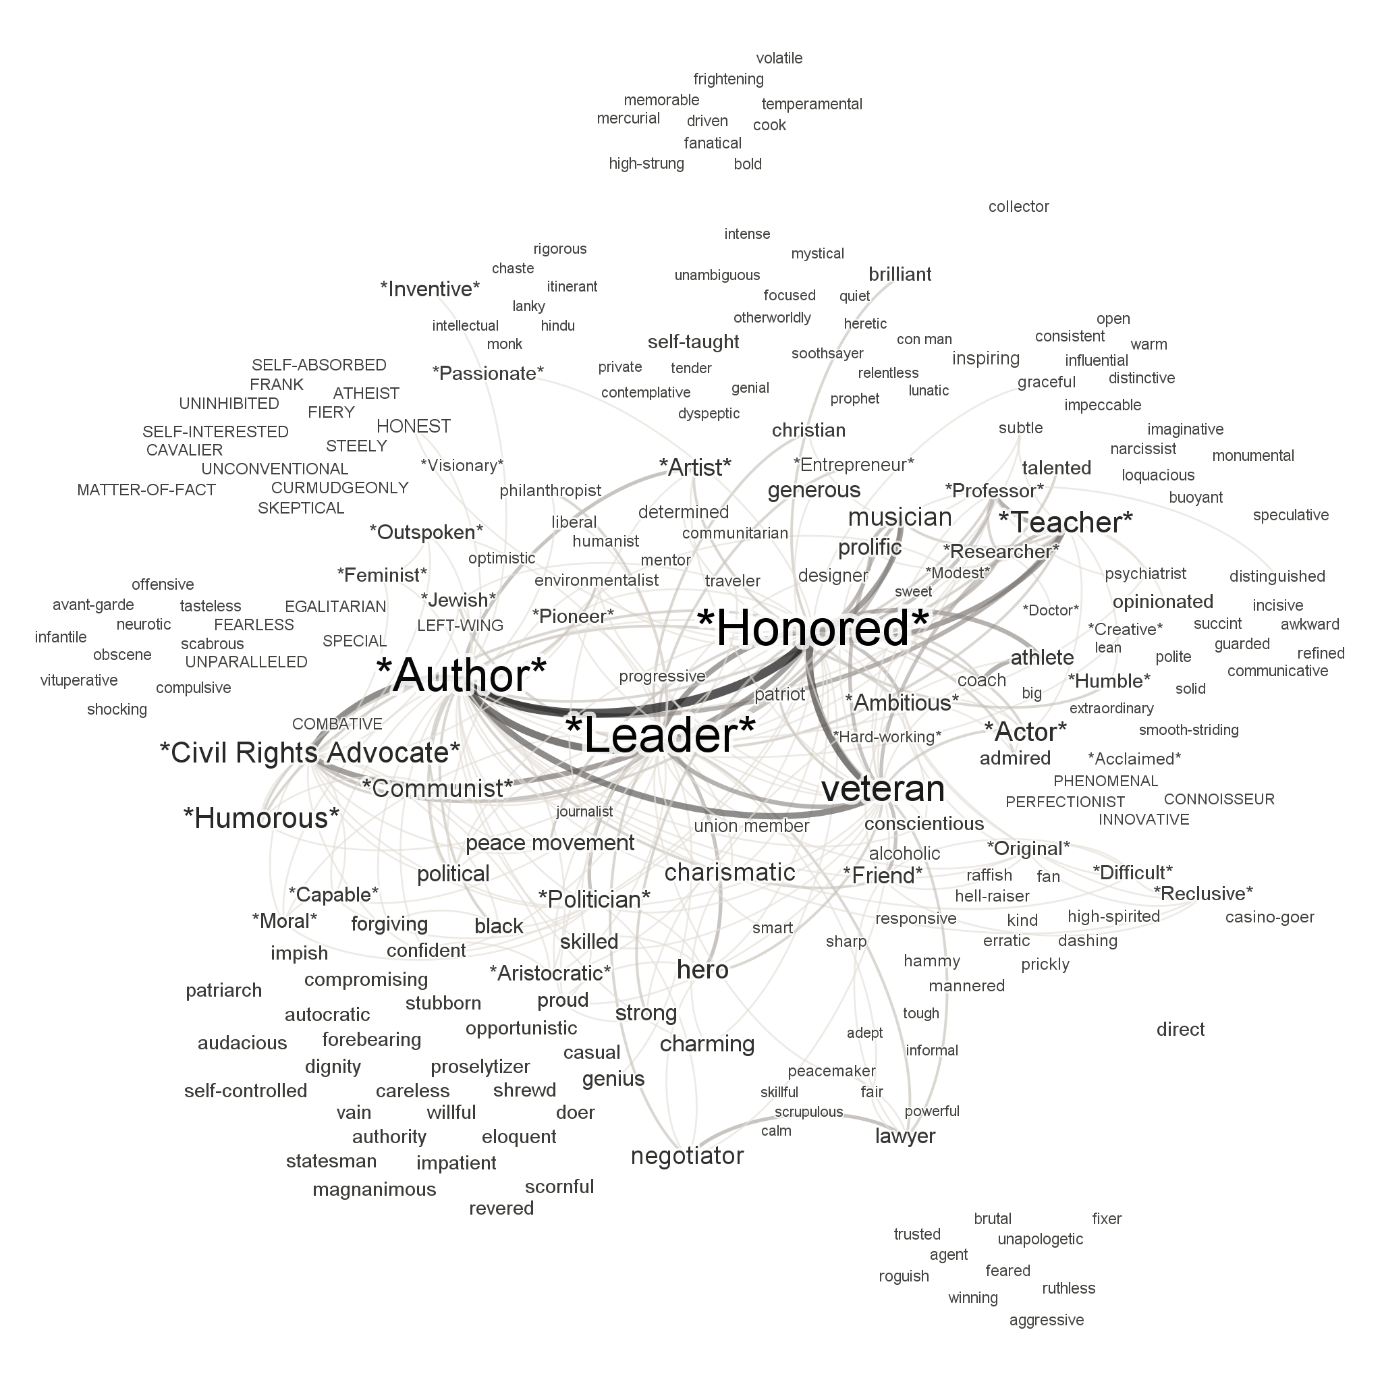
Figure 7: Character traits ascribed in New York Times obituaries. Trait are labeled based on the gender of the deceased (male only = lowercase; female only = UPPERCASE; both male and female = *Proper*). Label sizes reflect PageRank, and edge width reflects edge weight. Edges with edge weight <2 and nodes with weighted degree <10 were hidden to reduce clutter.

Discussion
Value-maps like the one in Figure 7 represent a complex social structure of valuation. They show what ordinary or somewhat-well-placed people consider important about praiseworthy and noteworthy individuals – not necessarily what those individuals were really like, nor what they aspired to be like. Nevertheless, since people, especially famous people, tend to be extremely concerned with how they’re perceived, even such maps of second-order values can be useful. For instance, suppose a lobbyist for the Nuclear Age Peace Foundation, an NGO committed to the abolition of nuclear weapons, were appealing to heads of state in hopes of persuading them to support nuclear disarmament. They would of course want to connect with the desire to be seen as good leaders. One straightforward way to do this would be to call attention to the direct societal impacts of disarmament, connect those with mid-level values, then connect those to the valued identity of being a good leader. In addition, however, a social marketer might try to connect through closely-related identities, such as being honored. Instead of or in addition to saying, “Support disarmament! It protects innocent lives, an intrinsically valuable resource that any leader would hold dear,” they could say, “Support disarmament! It will lead citizens and foreigners alike to honor and esteem you.”

Study 3: Large-Scale Data-Mining of Local Obituaries
After manually reading, coding, and analyzing over one thousand obituaries in studies 1 and 2, we were interested in developing methods for automatically encoding the traits ascribed in obituaries on a significantly larger scale. Hand-coding has clear advantages, especially with regards to our confidence that sampled obituaries are correctly parsed as ascribing traits to the deceased (rather than, say, commending caretakers for their devotion to the deceased). However, if an automated or semi-automated process should turn out to give similar results to the results of manual reading, we could be reasonably confident that the automated processes are not too compromised by misapplications of terms to the deceased (false positives) or missing content (false negatives) to render their results suspect. To gather more data and to test general reliability of a semi-automated data-mining process, we sought to test new methods on a batch of several thousand obituaries.

Methods
Obituaries were collected from ObituaryData.com in collaboration with the Alumni Office of the University of Oregon. ObituaryData.com is a data-warehousing company that maintains a subscription to the United States’ Social Security Death Master File, allowing a wide and nearly complete sample of deaths and respective obituaries within the US. The University Alumni Office’s account included permission to search the full text of all archived obituaries for keywords including the university’s name and most common abbreviation, U. of Oregon . We conducted automated acquisition of the entire collection of obituaries matching these terms, totaling 13,209 records from March 2000 to May 2014 and containing over 3.9 million words.
Gathered records comprised the following information about the deceased: name, city and state of residence, date of birth, date of death (or, lacking this, date of obituary publication), and full-text obituary content. Age in years at death was calculated from date of birth and date of death. In addition, forenames of the deceased were used to guess gender (Female, Male, or Unknown). To accomplish this, we compiled the most popular 4,275 female and 1,219 male names in the US as of 2005, based on 1990 US Census Bureau Data and other sources in 2005. The female and male name-lists were each ordered by decreasing popularity of name. The forename of the deceased in each gathered obituary record was then compared with both lists and assigned the gender of whichever list in which it appeared higher (e.g., if the name of the deceased was given as “Bobby” in the obituary record, the record was listed as “Male,” because “Bobby” was listed as a more popular male than female name in the Census Bureau name lists).
Using ConText, a program developed for semantic network analysis, we performed the following manipulations of the text: (1) changed all letters to lowercase, (2) applied a generic stoplist to the texts, (3) identified bigrams, and (4) merged near-synonyms. After steps (1) and (2), the resulting text, comprising two million words, was used to generate a full list of terms used in all obituaries; two of the three authors then independently read through this full word list and selected each unigram or bigram that could serve as a description of the deceased. The remaining author then reviewed all terms in cases where the first two authors disagreed. Terms selected by at least two of the three authors were retained; all other words from the original texts were deleted. We then reviewed the list of terms again and identified cases of synonyms or near-synonyms. Synonyms were retained based on the following general rules:
- Adjectives (e.g., “Honorable”) were preferable to past participles (e.g., “Honored”), which were preferable to Gerunds (e.g., “Honoring”), which were preferable to nouns (e.g., “Honor”).
- Words (e.g., “Adventist”) were preferable to phrases (e.g., “Adventist Church”)
- Singular nouns (e.g., “Airplane,” to describe a theme of a pilot’s life) were preferable to plural nouns (e.g., “Airplanes”)
- Person-descriptors (e.g., “Pilot”) were preferable to “themes” (e.g., “Airplane”)
After two members of the research team had made independent judgments on conflicting terms, the openNLP (open Natural Language Processing) package in R was used to automatically tag each judgement suggestion by Part of Speech (POS), including its singular vs. plural status for count nouns. Conflicting judgments were then automatically resolved using the rules above. Conflicts unresolved in this automated way were then resolved manually by the remaining research team member. Through this process, for example, “accomplish,” “accomplished,” “accomplishing,” “accomplishment,” and “accomplishments“ were all replaced with “accomplishment.” In doing so, we ran the risk of conflating semantically distinct terms in some contexts; however, this approach was preferable to not identifying the semantic similarity of these terms in the majority of contexts where they might be used more or less interchangeably.
With the texts filtered and cleaned, we then constructed a semantic map of the obituaries, treating co-occurrence of terms X and Y within the same obituary as an undirected edge in a network. This resulted in a network of 910 nodes and 19,034 edges. Given the scale of this network, it would not be informative to present a visual representation of it in its entirety; thus, we developed a summary visualization. This visualization, shown in Figure 8, simplified the network by collapsing closely-connected nodes into a single group node. Using Gephi’s modularity measure (resolution = 1.0), nodes were assigned to groups based on which terms tended to be clustered together. Groups of nodes were then treated as individual nodes.

Results
In Figure 8, nodes represent large sets of trait terms.
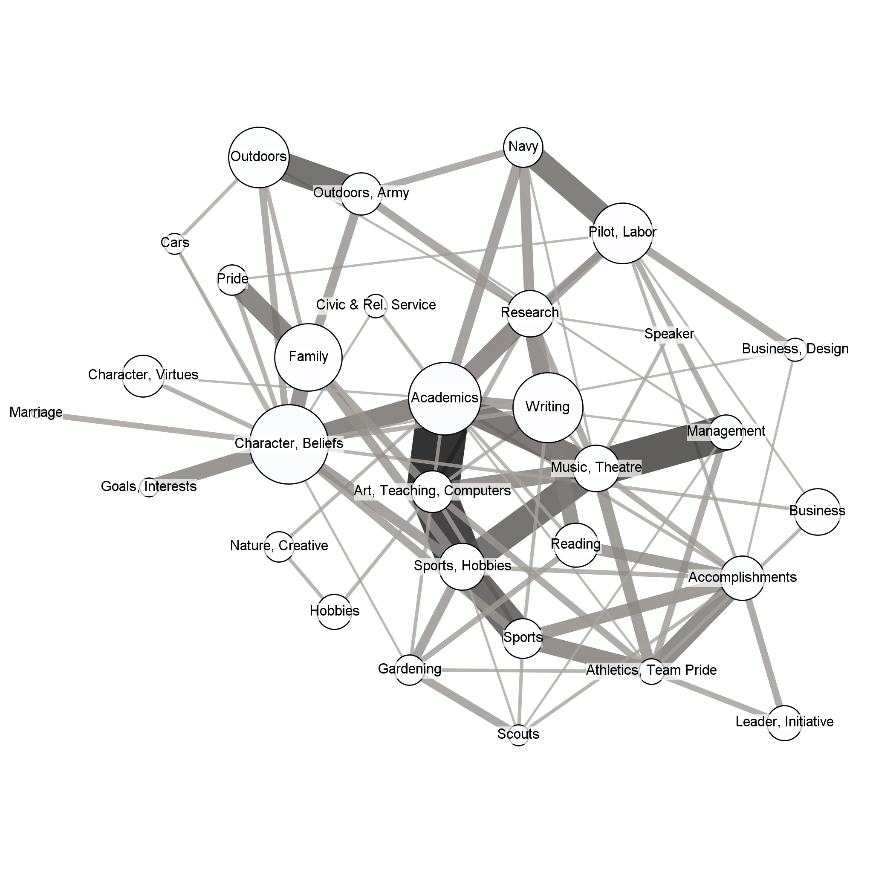
Figure 8: Groups of traits ascribed to 13,209 deceased University of Oregon alumni. Trait terms were grouped based on modularity measure and groups were labeled manually based on the judged common theme among the traits in each group. Node circle size indicates the number of traits subsumed in each group, and edge width and color reflect the number of between-group connections.

Labels were assigned manually based on the common theme we identified in each cluster. Node size was determined by the number of terms subsumed within each group. Edge width was determined by edge weight between nodes, which in turn was based on the co-occurrence of traits in each group. Node positions were determined by an iterated application of the ForceAtlas algorithm with heightened attraction distribution and repulsion strength.

Discussion
Before we initiated this semi-automated analysis, it was an open question whether this process would produce results similar to those of manual reading. The results suggest that semi-automated data processing results in a network of trait-terms similar to those identified by the authors in carefully reading individual obituaries, but the results diverge from the results of study 1 in some important respects.
First, we observed a substantially higher frequency of scholarly traits. Far more people were described as writers, scientists, researchers, students, teachers, etc. In the obituaries analyzed in study 1, family, friendship and faith were consistently at the core of the network; in the current study, these traits were still frequently mentioned but were less central to the network than academic attributes .This difference is naturally explained by differences in the original data. The obituaries used for study 1 came from local newspapers where friends or relatives of any deceased person may write about the deceased, but for the present study, obituaries were filtered to include only those mentioning University of Oregon. Thus, most people described in these obituaries were either students or university employees, and obituary writers took their university affiliation to be sufficiently important to the deceased to include this in their obituary, so it is no surprise that they tend to be described with more academic language.
Second, we observed higher modularity and more distinct patterns in the clustering of traits in the present study. This is best explained by the larger sample size. With over 13,000 obituaries to draw from, we could more easily identify the real patterns of connections and disregard less frequent or accidental connections.
Third, in addition to virtues and values, which were explicitly coded for in the manual studies, this automated study turned up many constituents of well-being. While it does not seem correct to say that accomplishments, athletics, gardening, or hobbies are virtues or values, they do seem to be part of what makes some lives enjoyable or worthwhile. If this is on the right track, it suggests that obituaries may be especially good resources for positive psychologists and marketers who are interested in what people enjoy for its own sake.
In the wake of federal and state divestment, public universities face serious budget problems that they’ve attempted to solve by, among other things, soliciting donations from alumni. We believe that the kind of network we’ve developed for the University of Oregon could be used to guide their outreach to alumni. In addition to connecting with former students’ commitment to academics, social marketers working on behalf of the university could connect to closely-related values, such as moral character, sports, music, theatre, and dance. Instead of or in addition to saying, “Support the University of Oregon! We educate students and perform valuable research,” they could say, “Support the University of Oregon! We cultivate the moral character of our students, and we engage the community through extracurricular activities like sports, music, theatre, and dance.”

Study 4: Prospective Obituary Writing
One limitation of using obituaries to inform social marketing is that this information concerns the values ascribed to the deceased, and it remains an open question whether, or to what extent, these values are shared by the living. It’s not unreasonable to guess that these values are shared with the living obituary writers and their intended readers in the community, but it would be better if the method of extracting values from obituaries were calibrated with other measures of the values of individuals and communities. For example, while the gender discrepancies observed in professional and lay-written obituaries probably reflect sexist attitudes in our society, these gender-based differences may have been more or less pronounced in the lives of the deceased. By calibrating obituary data with other sources, we can identify relevant cohort effects, and social marketers targeting specific age groups may better understand the unique constellation of values embraced by each cohort in a community.
The present study considers prospective obituaries written by study participants instead of actual obituaries. We aimed to test the following hypotheses:
(1) Prospective obituaries written by younger participants will have less pronounced gender-based differences.
(2) In writing obituaries for themselves, older participants will focus more on career, organizational affiliation, family, and character traits related to hard work and loyalty, while younger participants will focus more on friends and social personality traits such as being humorous, kind, or fun.
(3) Prospective obituaries concerning friends will focus more on personality traits related to benevolence and generosity while those for family members will focus more on loyalty and commitment.
(4) Descriptions that participants hope will be in their obituary will be more uniformly positive than those that they expect will be in their obituary.
(5) Prospective obituaries will only rarely include hobbies, personal preferences, and facts regarding their life history.
(6) All four types of hypothetical obituaries will be more similar to obituaries written by and for laypeople than those written about famous individuals by professional authors.

Methods
1,022 participant workers were recruited using Amazon Mechanical Turk and compensated with $0.50. The mean age was 33.5, with ages ranging from 18-75, and 56% were male. Participants were randomly assigned to one of four conditions: Self-Hoped (259), Self-Expected (252), Close Friend (247), or Family Member (252). In each condition, participants were asked to provide five words or phrases that will appear in a hypothetical obituary. For example, in Self-Hoped, participants read:
We’d now like to ask you to reflect for a few moments on your own values and life, then answer the following question:
Which five words or phrases do you hope will be used to describe you in your own obituary?

In Self-Expected, “hope” was replaced with “expected,” and in Close Friend and Family Member “your own values and life” was replaced with “the values and life of one of your close friends / a close living family member”. Participants also provided demographic information (age, gender, and location).

Results
In each condition participants identified sets of values highly similar to those identified in actual obituaries, as seen in table 2.
term | frequency | term | frequency | term | frequency
loving | 396 | intelligent | 82 | fun | 55
caring | 377 | good | 81 | father | 52
kind | 321 | giving | 75 | compassionate | 51
funny | 175 | mother | 73 | selfless | 51
loyal | 123 | hard | 71 | thoughtful | 51
honest | 116 | friendly | 64 | creative | 48
friend | 101 | strong | 61 | life | 48
generous | 99 | helpful | 60 | working | 46
loved | 93 | family | 57 | wife | 43
smart | 92 | happy | 57 | great | 40
Table 2: Most frequent traits ascribed across all four conditions.
In general, the traits highlighted in these hypothetical obituaries mirror those of actual obituaries. “Loving,” “caring,” and “kind” are central virtues in both, and both sets emphasize a range of familial, friendship, and personal virtues. Some notable differences were found, however. Local obituaries frequently mention being a veteran, nature lover, volunteer, traveler, and adherent of a particular religion, and obituaries from the New York Times most frequently emphasized being honored, an author, a leader, or a veteran. These words rarely appear in this set of prospective obituaries, even after combining nearby terms (e.g., treating “honor,” “honorable,” and “respected” as “honored”), with the following frequencies: religious (49), nature-lover (34), honored (22), volunteer (28), sports fan (8), leader (6), author (4), traveler (3), and veteran (1).
Some of these differences have natural explanations. Since the Mturk workers were limited to just five words or phrases, we would expect them to pass over life activities such as hiking or traveling and instead focus on paradigmatic virtues such as honesty and generosity. The decreased emphasis on religiosity may be due to younger people being less religious, but it may also be explained by the salience of religion, God, and the afterlife while writing an actual obituary. The most common virtues ascribed to notable, famous individuals are almost entirely absent in the prospective obituaries, perhaps suggesting that what we deem virtuous for ourselves and our loved ones more closely approximates the virtues ascribed to the dead in local death notices. Veteran status, however, is frequently highlighted in both types of actual obituaries while being virtually non-existent in those written by these Mturk workers. This may be due to the demographics of the Mturk workforce; however, even if Mturk workers are less likely to be veterans, this would not explain why only one participant in the Family or Friend conditions characterized their loved one as a veteran. This may be due to their friend or family member status being most salient; or perhaps military service, like other careers, was not as noteworthy as other traits when participants were limited to just five descriptions
We anticipated significant age-based differences in these hypothetical obituaries. Specifically, we hypothesized that older participants would more frequently highlight career, organizational affiliation, family, hard work, and loyalty, while younger participants would identify the virtues of being fun, humorous, and kind. We also expected more gender-based differences in the traits identified by older participants. Results were divided into three roughly equal groups based on age: Young (18-27), Middle (28-35), and Old (36-75). In comparing these groups, we did not find strong support for our predictions. Young and old alike frequently mentioned “fun,” “kind,” and “humorous,” with young participants doing so only slightly more frequently. Career and organizational affiliations were rarely mentioned by any group. While each age group identified important familial relations, older participants identified these relations slightly more. The virtues of loyalty and working hard were frequently mentioned by each age group. The hypothetical obituaries of older participants differed more along gender lines than those of younger participants, but the difference was very small (only 4% higher in Old) after replacing gendered terms with gender-neutral variants (e.g., ‘mother’ and ‘father’ each changed to ‘parent’).
Two unexpected patterns were identified, however. First, as should have been expected, older participants mentioned God and religion more frequently than younger people. Second, younger participants more frequently identified a constellation of affective traits, including Nice, Warm, and Passionate. Overall, though, the results in each age group were strikingly similar. This suggests that information provided by actual obituaries may be highly valuable for social marketing insofar as the values and virtues ascribed to the deceased are recognized as values and virtues by many adults of all ages.
We next compared traits provided in the Self-Expected and Self-Hoped conditions. Generally, the most prominent traits expected to appear in the obituary were also those traits participants hoped to see, except that the core values of being honest, loving, humorous, and generous were emphasized more by those imagining their ideal obituary while social relations like being a friend, mother, or husband were identified more frequently by participants imagining their expected obituaries. Combining the results from these two conditions, a list of 5,090 undirected edges between 438 nodes was generated identifying the most prominent patterns of co-occurrence. Traits tended to cluster into three major groups within this network. The ten most cited traits in each group are noted below in order of PageRank in the network.
Cluster #1: friend, loved, family, mother, father, wife, husband, missed, dedicated, daughter
Cluster #2: caring, loving, humorous, honest, loyal, hard worker, helpful, smart, friendly, happy
Cluster #3: kind, intelligent, generous, creative, quiet, thoughtful, curious, nice, good, wise
The first group stands out as focusing on social relations, while the second highlights social virtues, and the third group generally focuses more on personal virtues, including not only paradigmatic moral virtues (e.g., kindness and generosity) but also epistemic virtues (e.g., intelligence, creativity, curiosity, and wisdom).
Prospective obituaries for friends and family members were compared with an eye to the virtues of benevolence and loyalty. Terms such as ‘compassionate,’ ‘generous,’ ‘giving,’ and ‘loving’ were coded as benevolence traits while terms such as ‘dedicated,’ ‘loyal’ and ‘thoughtful’ were coded as loyalty traits. Our expectations were wrong. Loyalty was highlighted slightly more in descriptions of friends (13% vs. 11% of all words used in each condition condition), and benevolence was highlighted significantly more in describing family members (40% vs. 33%).
Finally, we compared responses in the Self-Expected and Self-Hoped conditions with the anticipation of finding that hopeful hypothetical obituaries would be more uniformly positive. Terms were categorized as virtues, vices, affiliations, or neutral. Traits were categorized as virtues or vices just in case they would be judged as virtues or vices almost unanimously. “Affiliation” terms included social roles (e.g., friend, mother), hobbies (e.g., artist, writer), and affiliations (e.g., Christian). All of these terms were probably viewed positively by our participants, but they were separated from the virtues to give a more impartial analysis. Neutral terms (e.g., decent, silent, stubborn) may have been intended by their authors as virtues but were categorized as neutral because, we believe, one could reasonably see these as vices. The results do not show any marked difference between hopeful and expected hypothetical obituaries. In each condition, less than one percent of terms were neutral or vices. However, expected obituaries did include more affiliation or hobby-related traits (15% in expected vs. 11% in hopeful), perhaps suggesting that idealized obituaries focus more on paradigmatic virtues. The lesson to learn is that the contents of obituaries are expected to be uniformly positive, and that our participants share the norm of only speaking well of the dead.

Discussion

An advantage of drawing from actual obituaries is that we avoid the possibility of obituary writers’ being influenced by researcher expectations and the distorting influence of survey participants’ apathy, carelessness, or desire to give witty responses. While a small number of our Mturk responders included (presumably) insincere virtues such as “shaman,” “pirate,” and “blah”, almost all participants seemed to take their work seriously. From this study we learn that the traits typically identified in actual obituaries mirror the constellation of virtues provided by living participants to describe themselves and their loved ones, and that what we hope people will say about us postmortem resembles what we expect them to say. Both observations provide further support for relying on obituaries as a measure of individual and communal values, and that the virtues ascribed to the recently deceased are also treated as virtues of the living, both young and old.

General Discussion and Future Directions
The methods used in the present studies could easily be extended to consider other public records of value. Using online tools such as Lexis Advance, one could scour newspapers or court opinions for specific terms. One could then visualize a term’s position in the larger semantic network, and, using sentiment analysis, identify the relative positive or negative valence surrounding the term. Alternatively, researchers could analyze large collections of text from social media sites such as Twitter and Facebook to identify general trends in positive or negative trait-ascriptions, though “#RIP” and related Twitter searches did not produce useful results. Unlike obituaries, these data will certainly include large proportions of negative judgments, but tools such as sentiment analysis could help in distinguishing positive, negative, and neutral descriptions.
Obituaries aim to broadcast to readers facts about the deceased and to convey intimate, summative portraits. Nonetheless, it is worth consideration that, especially for obituaries authored by friends and family with the intent to publish in a local newspaper, the work of “morality mining” (Christen et al. 2013) could be interpreted as intrusive. Such concerns are especially salient when researchers are neither members of authors’ local communities (as in the non-Eugene samples in Study 1) nor manually reading and interpreting each obituary as a document of a once-living person (as in Study 3). Aggregating public records that were likely originally intended by their authors to be read singly, while legally unproblematic, could be ethically suspect if authors feel that their words are being taken out of context or used for purposes that they did not intend and to which they were not afforded an opportunity to consent.
The potential for this type of emotional reaction reveals an ethical weight associated with this class of data, and also points to the value of intent in interacting with these records. This ethical weight indicates the value of these data for research and marketing undertaken with the intent of promoting the social good. It is striking, for example, that religion, personal relations, and community service are emphasized in four geographically and culturally distinct cities. For professionally-commissioned obituaries such as many in The New York Times (study 2), we saw a very different set of values expressed, with virtues such as being a loving father taking a backseat to leadership qualities such as charisma and entrepreneurial ambition. Although this type of research could be undertaken to manipulate a ritual of public grieving into an abstract data-generating mechanism divorced from its original context, those wishing to understand the moral language of local communities, especially to perform value-relevant work within or translating across those author communities, may find valuable insight in this approach.
There are several enticing prospects for applying this research beyond straightforward social marketing. First, if researchers could acquire a comprehensive dataset of obituaries from the Anglophone world, they could compare and contrast values across international geographic lines (e.g., the United States vs. Scotland vs. Singapore vs. New Zealand). Such research could be useful to international negotiators. Second, software developers could team up with clinical psychologists and psychiatrists to develop a smartphone or tablet app that guided someone through the Acceptance and Commitment Therapy obituary intervention mentioned above. This could help to partially automate psychological therapy. Finally, software developers could team up with geographers to develop a map of the Anglophone world’s values that could be used by people deciding where to live, somewhat like the www.walkscore.com mapping software.

References
Andreason, A. & Kotler, P. (2008). Strategic Marketing for Non-Profit Organizations, 7th edition. Upper Saddle River, NJ: Prentice Hall.
Aristotle. (2000). Nicomachean Ethics. Trans. R. Crisp. Cambridge University Press.
Christen, M., Alfano, M., Bangerter, E., & Lapsley, D. (2013). Ethical issues of ‘morality mining’: When the moral identity of individuals becomes a focus of data-mining. In H. Rahman & I. Ramos (eds.), Ethical Data Mining Applications for Socio-Economic Development. 1-21. IGI Global.
Christen, M., Robinson, B., & Alfano, M. (2014). The semantic neighborhood of intellectual humility. In A. Herzig & E. Lorini (eds.), Proceedings of the European Conference on Social Intelligence, 40-9.
Diesner, J., Pak, S., Kim, J., Soltani, K., & Aleyasen, A. (2014). Computational assessment of the impact of social justice documentaries. In iConference 2014 Proceedings. 462-483. iSchools.
Graham, J., Haidt, J., & Nosek, B. (2009). Liberals and conservatives rely on different sets of moral foundations. Journal of Personality and Social Psychology, 96(5): 1029-46.
Graham, J., Nosek, B., Haidt, J., Iyer, R., Koleva, S., & Ditto, P. (2011). Mapping the moral domain. Journal of Personality and Social Psychology, 101(2): 366-85.
Haidt, J., & Joseph, C. (2004). Intuitive ethics: How innately prepared intuitions generate culturally variable virtues. Daedalus, Fall, 55-66.
Hayes, S., Strosahl, K., Wilson, K. (2011). Acceptance and Commitment Therapy: The Process and Practice of Mindful Change. Guilford Press.
Kahle, L., Beatty, S., & Homer, P. (1986). Alternative measurement approaches to consumer values: The list of values (LOV) and values and life style (VALS). Journal of Consumer Research, 12(1): 405-9.
Kotler, P. & Zaltman, G. (1971). Social marketing: An approach to planned social change. Journal of Marketing, 35(3): 3-12.
Kramer, A., Guillory, J., & Hancock, J. (2014). Experimental evidence of massive-scale emotional contagion through social networks. Proceedings of the National Academy of Sciences, 111(24): 8788-8790.
Mill, J. S. (1861/1998). Utilitarianism, edited with an introduction by Roger Crisp. New York: Oxford University Press.
Reynolds, T. & Olson, J. (2001). Understanding Consumer Decision Making: The Means-End Approach to Marketing and Advertising Strategy. Lawrence Erlbaum Associates.
Rokeach, M. (1973). The Nature of Human Values. New York: The Free Press.
Saucier, G. (2009). Recurrent personality dimensions in inclusive lexical studies: indications for a big six structure. Journal of Personality, 77(5): 1577–1614.
Schwartz, S. (1992). Universals in the content and structure of values: Theoretical advances and empirical tests in 20 countries. In M. Zanna (ed.), Advances in Experimental Social Psychology (v. 25, pp. 1-65). New York: Academic Press.
Zagzebski, L. (1996). Virtues of the Mind. Cambridge: Cambridge University Press.

Notes

Eugene was chosen as a representative of the Pacific Northwest that is less influenced by in-migration than Portland and Seattle. Wasilla was chosen for potential cultural differences between Eugene – a somewhat large, left-leaning university town – and Wasilla – a small, right-leaning suburb adjacent to a major military base. Flint represents a rust belt city with a substantially lower median income. Finally, we chose Amherst as it is one of the most liberal, highly-educated cities in the United States.
The spatial proximity of two nodes may indicate an important connection between the two, but this need not be the case. If there is an edge with high edge weight connecting the two, this will pull them closer together. However, the position of any two given nodes is also the product of the aggregated movement and forces of every other node in the network. Node positions only perfectly reflect edge weights in an N-dimensional graphical representation where N = the total number of nodes.
ObituaryData.com’s “About” page claims that their records are 95%+ complete.
These name lists were compiled by MongaBay, who made them available at http://names.mongabay.com/male_names.htm and http://names.mongabay.com/female_names.htm.
A stoplist is a list of generic words that carry little semantic content (e.g., “the,” “and,” “or,” “an,” etc.) and are typically removed when analyzing large corpora of texts. Bigrams are pairs of words (e.g., “Eagle Scout”).
Twelve participants were removed from our analysis for failing to complete the study.
Gendered titles were made gender neutral to more clearly focus on gender differences indicating real differences in social norms, values, or expectations.
The work of Diesner et al. (2014) in analyzing the impact of social justice documentaries is especially useful for seeing how the tools of web data-mining and network analysis could be used for social marketing.
For a recent study that caused the kind of uproar we envision, see Kramer et al. (2014).
The NYT obituary for Yvonne Brill is a good case study for this difference between local and big paper obituaries. Brill’s obituary originally began with this sentence: “She made a mean beef stroganoff, followed her husband from job to job and took eight years off from work to raise three children.” The author was criticized for leading with family values rather than professional accomplishments. The obituary was quickly changed to begin with “She was a brilliant rocket scientist,” and no later mention of beef stroganoff.

