Natural Language Processing and Semantic Network Visualization for Philosophers

Mark Alfano is Associate Professor of Ethics & Philosophy of Technology at Delft University of Technology and Professor of Philosophy at Australian Catholic University.

Andrew Higgins is an Instructional Assistant Professor at Illinois State University.

Abstract
Progress in philosophy is difficult to achieve because our methods are evidentially and rhetorically weak. In the last two decades, experimental philosophers have begun to employ the methods of the social sciences to address philosophical questions. However, the adequacy of these methods has been called into question by repeated failures of replication. Experimental philosophers need to incorporate more robust methods to achieve a multi-modal perspective. In this chapter, we describe and showcase cutting-edge methods for data-mining and visualization. Big data is a useful investigatory tool for moral psychology, and it fits well with the Ramsification method the first author advances in a series of recent papers. The guiding insight of these papers is that we can infer the meaning and structure of concepts from patterns of assertions and inferential associations in natural language.

Keywords: network, visualization, semantics, axiology, virtue theory

Introducing big data and semantic networks to philosophy
Progress in philosophy is difficult to achieve because our methods are evidentially and rhetorically weak (Chalmers 2015). In the last two decades, experimental philosophers have begun to employ the methods of the social sciences to address philosophical questions. However, the adequacy of these methods has been called into question by repeated failures of replication (Open Science Collaboration 2015). In the next decade, experimental philosophers need to incorporate more robust methods to achieve a multi-modal perspective. In this chapter, we explain and showcase exemplars of a promising methodology for experimental and empirical philosophy: network analysis and visualization.
Networks dominate contemporary technologies such as the Internet, social media, so-called “smart” cities and ports, blockchain cryptocurrencies, and many others. In psychological science, constructs as diverse as the neuronal structure of the brain (Raichle 2015), pathologies and disorders (Borsboom & Cramer 2013), personality factors (Epskamp et al. 2012), and belief systems have been successfully modeled as networks (Brandt et al. 2018). In humanistic studies of novels and other literature, researchers employing digital humanities methods have analyzed texts and whole corpora (Moretti 2013; Alfano & Stauffer 2015). Yet these methodological tools have been employed sparingly in philosophy. A recent search of www.philpapers.com -- the most comprehensive archive of philosophical publications in the world, with over two million entries -- returned 28 results for ‘semantic network’, 189 for ‘social network’, and 0 for ‘psychological network’. And most of those results were published in inter- or trans-disciplinary venues such as MedInfo, Minds and Machines, Frontiers in Psychology, Library Trends, Behavioral and Brain Sciences, and Journal of Intelligent Systems. Despite their interest in empirical methods, experimental philosophers have -- with few exceptions such as Alfano, Higgins, & Levernier (2017), Chen & Floridi (2013), and Rathkopf (2018) -- demonstrated almost no interest in network analytics.
This state of affairs is unfortunate, as there are strong theoretical reasons for philosophers to take an interest in semantic, social, and psychological networks. Using semantic networks, it should be possible to shed light on word- and sentence-meaning beyond what can be revealed through introspection and conceptual analysis. After all, even for non-Wittgensteinians, it is generally uncontroversial that the meaning of a term is constitutively related to its use in natural language. More specifically, as Alfano (2015) argues, network analytics are presupposed by David Lewis’s (1966, 1970, 1972) development of Frank Framsey’s (1931) approach to the implicit definition of theoretical terms. The basic principle underlying the Ramsey-Lewis approach to implicit definition (often referred to as ‘Ramsification’) can be illustrated with a well-known story:
And the Lord sent Nathan unto David. And he came unto him, and said unto him, “there were two men in one city; the one rich, and the other poor. The rich man had exceeding many flocks and herds:” But the poor man had nothing, save one little ewe lamb, which he had bought and nourished up: and it grew up together with him, and with his children; it did eat of his own meat, and drank of his own cup, and lay in his bosom, and was unto him as a daughter. And there came a traveler unto the rich man, and he spared to take of his own flock and of his own herd, to dress for the wayfaring man that was come unto him; but took the poor man’s lamb, and dressed it for the man that was come unto him.” And David’s anger was greatly kindled against the man; and he said unto Nathan, “As the Lord liveth, the man that hath done this thing shall surely die: And he shall restore the lamb fourfold, because he did this thing, and because he had no pity.” And Nathan said to David, “Thou art the man.”

Nathan uses Ramsification to drive home a point. He tells a story about an ordered triple of objects (two human and one non-human animal) that are interrelated in various ways. Some of the first object’s properties (e.g., wealth) are monadic; some of the second object’s properties (e.g., poverty) are monadic; some of the first object’s properties are relational (e.g., he steals the third object from the second object); some of the second object’s properties are relational (e.g., the third object is stolen from him by the first object); and so on. Even though the first object is not explicitly defined as the X such that…, it is nevertheless implicitly defined as the first element of the ordered triple such that…. The big reveal happens when Nathan announces that the first element of the ordered triple is the very person he’s addressing (the other two, for those unfamiliar with 2 Samuel 12, are Uriah and Bathsheba).
The story is biblical, but the method has a modern incarnation. To implicitly define a set of theoretical terms (henceforth ‘T-terms’), one formulates a theory T in those terms and any other terms (henceforth ‘O-terms’) one already understands or has an independent theory of. Next, one writes T as a single sentence, such as a long conjunction, in which the T-terms t1,..., tn occur (henceforth ‘the postulate of T’). The T-terms are replaced by unbound variables x1,..., xn, then existentially quantified over to generate the Ramsey sentence of T, ∃x1,...,xn T[x1,..., xn], which states that T is realized, i.e., that there are objects x1 through xn that satisfy the Ramsey sentence. An ordered n-tuple that satisfies the Ramsey sentence is then said to be a realizer of the theory.
Lewis (1966) famously employed this method to argue for the mind-brain identity theory. He identified the postulate of folk psychology as the conjunction of all folk-psychological platitudes. The Ramsey sentence of folk psychology is formed by replacing all mental state-terms (e.g., ‘belief’, ‘desire’, ‘pain’, etc.) with variables and existentially quantifying over those variables. Finally, one goes on to determine what, in the actual world, satisfies the Ramsey sentence; that is, one investigates what, if anything, is a realizer of the Ramsey sentence. If there is a realizer, then that’s what the T-terms refer to; if there is no realizer, then the T-terms do not refer. Using this method ensures that we don’t simply change the topic when we try to give a philosophical account of some phenomenon. If your account of the mind is inconsistent with the postulate of folk psychology, then -- while you may be giving an account of something -- you’re not doing what you set out to do.
Notably, Lewis never compiled all the platitudes of folk psychology. He just asserted that it was obvious that the realizer of the Ramsey sentence of folk psychology was the brain. But he never wrote down the Ramsey sentence. This was for at least two reasons. First, there are a lot of folk psychological platitudes, and they’re all (by design) extremely boring. So the Ramsey sentence of folk psychology would probably fill many stultifying books, making it difficult to assemble and even more difficult to audit. Second, in Lewis’s time there was no systematic way to collate the platitudes.
Using contemporary natural language processing tools, we now have the opportunity to implement (a slightly modified form of) the method of Ramsification with semantic networks. To do so, we need access to a large corpus of platitudes. We then parse this corpus using ConText (Diesner 2014) or Python packages such as nltk (Bird, Loper, & Klein 2009) and gensim (Radim & Sojka 2010). After cleaning raw text, we select the T-terms from the parsed corpus. These are modeled as nodes in a semantic network. Edges (i.e., pairwise connections or binary relations) between the nodes represent semantic relations between the T-terms they represent. The resulting network can then be analyzed and visualized to assess whether it has any realizers.
Networks can be used to map trade, semantics, friendships, heredity, ecosystems, and much more. The simplest type of network represents nothing beyond the bare presence of nodes and whether, for each pair of nodes, there exists a connection between them. Network-analytics are valuable for highlighting and analyzing the extrinsic, relational properties of objects rather than focusing on intrinsic, atomistic traits. Such an approach enables us to move from Aristotelian explanatory models (the rock falls because its essence is heavy) to Newtonian explanatory models (the rock falls because the gravitational attraction between it and the center of mass of the Earth pulls it in that direction).
A network is an abstract structure. In what follows, we will sometimes express such abstract structures using visualizations. A visualization is not the same thing as a network, just as a drawing of a circle or square is not the same thing as a circle or a square. But just as it is often pedagogically, cognitively, or communicatively helpful to do geometry with drawings on paper, chalkboards, or computer screens, so it is often pedagogically, cognitively, or communicatively helpful to do network analysis with visualizations on paper, chalkboards, or computer screens. As Andy Clark (2002) has argued, human minds operate best when they are able to iteratively alternate between cognitive processes such as imagining, inferring, and evaluating and perceptual and agential processes such as seeing, feeling, and manipulating. Shifting back and forth between an abstract network and its visual representation enables us to take advantages of both our cognitive powers and our pattern-recognizing visual acuity.

Workflow
In this section, we elaborate a recommended workflow for semantic network analysis (Figure 1). Much of the approach will be familiar to experimental philosophers, but there are some important differences.

Figure 1: Workflow for semantic network analysis.
conceptualize
collect
operationalize
clean & preprocess
visualize
analyze
interpret

Conceptualization
As with any scientific research, we begin by conceptualizing the research question and all variables involved. This step is essential to ensure face validity. Inadequate, imprecise, and ambiguous conceptualization is arguably one of the root causes of the replication crisis currently racking social psychology (Lurquin & Miyake 2017). It might at first blush seem that a bottom-up, big data approach that harnesses the power of visual analytics would make it unnecessary to worry about conceptualization issues, but recent developments have shown that perspective to be overly sanguine (Lynch 2016, chapter 8). As Nobel economist Paul Krugman (2014) put it on his blog, you can’t just “let the data speak for itself -- because it never does. [...] If you think the data are speaking for themselves, what you’re really doing is implicit theorizing, which is a really bad idea (because you can’t test your assumptions if you don’t even know what you’re assuming).” For our main use case -- mining natural language for patterns of virtues, values, and constituents of wellbeing (VVC) -- the conceptualization step involves reflection on the philosophical literature on these constructs, as shown in Table 1.

Table 1: definitions of key terms.
virtue | admirable trait of personality or character (Zagzebski 2017)
value | stable attitude (or the object of such an attitude) that motivates behavior and furnishes a standard for evaluation (Tiberius 2008)
wellbeing | pleasurable, desirable, valuable, or otherwise good state of being (Parfit 1984)
cardinal VVC | VVC on which others turn; ‘cardinal’ derives from the Latin cardo meaning ‘hinge’ (Alfano 2012)
VVC conduit | high-traffic edge between VVC on measures like betweenness centrality (Van Norden 2008)

Since the current chapter is illustrative rather than argumentative, we will not spend time here justifying our conceptualizations of virtues, values, and constituents of wellbeing. Interested readers should refer to Alfano, Higgins, & Levernier (2017) for details.

Operationalization
The second step in the workflow is to operationalize the constructs of interest. There is no way to directly observe and measure properties like virtue. We must instead measure proxies for these phenomena. In the context of natural language processing and semantic network analysis, this means identifying accessible corpora that we expect to contain a large and diverse range of expressions that refer to virtues, values, and constituents of wellbeing. Given norms enjoining people to only speak well of the dead -- especially in public announcements -- we believe that obituaries are a good place to find proxies for virtues, values, and constituents of wellbeing. Other researchers interested in employing this workflow will need to think carefully about which corpora would best operationalize the constructs that interest them. For instance, research on lust and romantic love might use profiles from online dating apps, such as the OKCupid dataset (Kirkegaard & Bjerrekær 2014). By contrast, researchers interested in children’s development and acquisition of concepts may prefer to consult the CHILDES database (MacWhinney 2000). Researchers interested in cross-cultural comparisons may wish to consult the Human Relations Area Files (HRAF 1967). And researchers interested in social epistemology may use the Twitter application programming interface.

Data collection
This brings us to step three: collecting data. In more familiar experimental philosophy research, this step typically involves surveying live human participants with a questionnaire. Less commonly, live human participants may be invited to contribute other sorts of data, such as physiology, choice behaviors (indicated revealed preferences), or brain scan data. In all cases, the data structure is a database in which the rows represent distinct participants and the columns record data (e.g., survey responses) provided by those participants. Our method diverges from the industry standard at this point. Instead of representing live participants, the rows in our database represent documents.
This approach affords several advantages over traditional questionnaire methods, though it also comes with drawbacks they lack. First, if one is analyzing documents in the public domain, one needn’t bother with IRB approval. Second, documents in the public domain are free and in many cases plentiful, making it possible to have a very large sample size at zero or little cost. Third, documents in the public domain do not suffer concerns about ecological validity that often plague laboratory and questionnaire studies. Fourth, it is often possible to ensure a diverse, intersectional (Crenshaw 1989) sample using public domain documents. Fifth, documents in the public domain are also available to other researchers, meaning that they automatically satisfy one of the desiderata of the open science: namely, open data. One significant drawback of relying on this methodology is that it is hostage to the archivists. If there is no collection of suitable documents, the method cannot be employed.

Cleaning and preprocessing the data
The fourth step is to clean the collected data. Experimental philosophers will be familiar with the fact that raw data needs to be processed and regimented in various ways before it can be analyzed. The same holds for natural language processing. The main difference here is that cleaning data is often at least as time-consuming and onerous as collecting it in the first place. The basic idea is to extract the constructs operationalized in step 2 from each of the documents, appending them as columns in the database. For instance, in our work on obituaries, we are interested in demographic variables such as date of birth, date of death, age at death, gender, religious affiliation, veteran status, killed-in-action status, education attained, and marital status, among others. There are various natural language processing tools and software packages available for this kind of extraction, including ConText (Diesner 2014) and Python packages such as nltk (Bird, Loper, & Klein 2009) and gensim (Radim & Sojka 2010).
In addition to demographic variables, we are interested in the virtues, values, and constituents of wellbeing celebrated in people’s obituaries. There are three main approaches available for extracting these variables: supervised, semi-supervised, and unsupervised. In a supervised approach, the researchers establish in advance a codebook or set of principles for what to count as a textual expression of a virtue, value, or constituent of wellbeing. This would be part of the operationalization step. The researchers then independently read through all of the obituaries and annotate them (putting a 1 in the column if the trait is represented, 0 otherwise) using the codebook. A measure such as Cohen’s (1968) kappa can then be calculated to ensure adequate interrater agreement. Assuming an acceptable level of agreement is reached, it’s possible to move to the double-barrelled next stage: analysis and visualization. However, if the number of obituaries (or other documents, in a different use case) is very large, hand-coding all of them may be daunting. This brings us to the other two approaches. In a semi-supervised approach, the researchers hand-code a subset (say, 10%) of the documents, then use machine learning to automatically code the remainder (Hastie et al. 2008). This can be done all at once, then spot-checked for validity. However, it’s worth bearing in mind that machine learning suffers a recall/precision tradeoff (Powers 2011). Essentially, the further out on a limb you force the machine learning algorithm to go, the more documents it will label, but the less accurate those labels will be. To handle this problem, it is often best to “bootstrap” iteratively (Carlson et al. 2010). To illustrate, the researchers could hand-label 10% of the documents, then use machine learning to automatically label an additional 20% of them. The researchers then spot-check 10% of the automatically labeled documents for accuracy, correcting any biases they find. Next, the researchers again use machine learning on the 30% of labeled documents to label an additional 30% of them. After spot-checking again, they use machine learning one last time to label the remainder. The third approach throws out the codebook altogether, relying entirely on machine learning to unearth patterns that human coders might overlook or ignore because of bias. While unsupervised learning is a fascinating new methodology, we believe that researchers who have done a good job conceptualizing and operationalizing will enjoy more success using a codebook to support a supervised or semi-supervised approach. Even if unsupervised learning unearths patterns, it’s often impossible to give any meaning to those patterns. Unsupervised learning is therefore akin to looking for a needle in a haystack but not knowing what a needle is or how to use one.
The resulting database should now be ready to transform into a network format. The nodes of this network will be the column names, and the edges will be the frequencies of pairwise co-occurrence. To illustrate with the obituary use case, three of the traits often celebrated in obituaries are being a friend, being a volunteer, and having a good sense of humor. In our data, people who are described as being a friend are more likely to also be described as being a volunteer than as having a good sense of humor. We encode each of these traits as a node and treat the frequency of co-occurrence as the weight (explained in more detail below) of the edge between them. There are multiple file formats for representing such a co-occurrence network. Perhaps the most common is an edge list, which is a comma separated values (.csv) format in which the first column represents origin nodes, the second column represents target nodes, and the third column (if any) represents edge weights. Table 2 below is an edge list. A format we sometimes prefer to the edge list is called an adjacency matrix. You can generate an adjacency matrix from the row/column format described in this section by multiplying the database by its own transpose. To do this in R, just use this script:
data <- read.csv("data.csv")
M <- data.matrix(data)
T <- t(M)
adjacency <- (T %*% M)
write.csv(adjacency, file="adjacency.csv")

We should also note that experimental philosophers may wish to reanalyze their existing datasets as networks. If your data is already formatted as a correlation matrix, you can use that just like an adjacency matrix, in which the variables are the nodes and the edge weights are the correlations between the variables. In any event, once you have either an edge list or an adjacency matrix, you are ready to proceed with analysis.

Analysis
For analytical purposes, it’s helpful to associate various properties with the nodes and edges of a network. As such, the measures used to analyze networks will be derived from the relational properties of nodes. The basic relational property is a node’s degree, or the number of edges it has (i.e., the number of other nodes it is connected to). This is a local property of nodes: a node with three connections could exist at the periphery of a network or function as a significant bottleneck in the network, depending on how the rest of the network is structured. In order to better understand the role played by different nodes, it’s therefore helpful to employ more holistic properties. For example, the betweenness of a node is the sum of the number of geodesics that run through that node, where a geodesic is the shortest path through the network from one node to another. Nodes with high betweennness control the flow of information through the network. They are the way, truth, and life of the network: no information cometh to the other side of the network, but by them. Another key property of a node is its closeness, defined as the average (or normalized average) of the lengths of all its geodesics to all other nodes in the network.
We have thus far been dealing solely with undirected, unweighted networks. Directedness and weight are in the first instance properties of edges. Whether edges are directed depends on whether the relation modeled by the network is symmetric or (at least potentially) asymmetric. For example, the “is a sibling of” relation is symmetric, while the “is a sister of” relation is (potentially) asymmetric. If x is the sibling of y, y is the sibling of x, but if x is the sister of y, y may or may not be the sister of x. When the relation modelled in a network is symmetric, we can rest content representing it as an undirected network. However, when the relation is asymmetric, it may be useful to represent it as a directed network. Doing so adds complexity to the representation and makes visualizations more onerous on the eye. Sometimes, though, it’s worth the effort to represent networks in a directed way (and visualize them that way too). When we do so, the measures mentioned above need to be refined. Instead of simply degree, we can distinguish between out-degree (the sum of the number of edges directed from the node in question to another node) and in-degree (the sum of the number of edges directed from another node to a given node). In a directed network, a node’s betweenness will also be affected because the number and length of geodesics through the network will typically decrease and increase, respectively. Likewise, a node’s closeness will tend to increase as the length of paths increases.
A second way to complicate a network is to associate with each edge a weight. Whether edges are weighted depends on whether the relation modeled by the network is categorical or (at least potentially) scalar. For example, the “cites n times” relation scales, while the “cites” relation does not scale. If x cites y n times, then there is some whole number n characterizing the relationship. If x cites y (at all), there is no further question to ask. Likewise, the “is correlated with strength n with” relation ranges from -1 to 1, whereas the “is correlated with” relation is categorical. When the relation modelled in a network is not scalar, we can rest content representing it as an unweighted network. However, when the relation is scalar, it may be useful to represent it as a weighted network. As before, doing so adds complexity to the representation and makes visualizations more onerous on the eye, but may be worth the effort. When we do so, the measures mentioned above again need to be refined. Instead of simply degree, we can speak of the strength of a node (the sum of the weights of each of its edges). Mutatis mutandis for both betweenness and closeness.
It’s often tempting to gussy up networks by making them both directed and weighted -- and to try to represent both of these features visually -- but researchers should always bear in mind the costs associated with additional complexity. As we argue in more detail below, without a commitment to careful pruning and asceticism about the number and variety of variables one aims to visualize, one is liable to produce visually illegible network visualizations that could fairly be described as Christmas trees or hairballs. One may find it useful to consider weight and directedness when calculating network and node metrics while hiding these features in the visualization of the network.
That said, we here illustrate various network measures further using a (small) visualized network that is both directed and weighted (Figure 2). Table 2 gives the abstract, mathematical characterization of the network.

Table 2: Network with ten nodes and seventeen edges. The first letter indicates the origin of the directed edge; the second letter indicates the target of the directed edge. For example, A-G indicates that there is an edge from node A to node G with a weight of 3.
Directed Edges | Weights | Directed Edges | Weights | Directed Edges | Weights
A-E | 1 | C-D | 4 | F-E | 2
A-F | 1 | D-E | 1 | F-G | 1
A-G | 3 | D-G | 2 | G-C | 3
B-A | 2 | D-H | 3 | H-J | 5
B-C | 4 | E-F | 4 | J-K | 1
B-G | 2 | E-H | 2

While nothing in our analysis depends on what this network represents, we can imagine it as a business network where nodes are individual companies and edges are financial transactions. Those transactions are represented with varying weights, indicating the monetary value of the transactions, and with arrows, designating which company paid which.

Figure 2: Visualized network with ten nodes and seventeen edges. Each letter represents a node. Each line represents an edge. Arrowheads indicate the direction of edges.
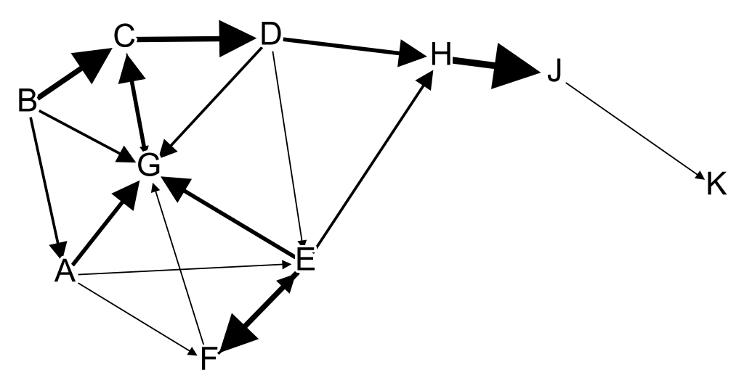
In Figure 2, the nodes are represented by letters and the edges are represented by lines connecting those entities. Not all edges are equal. If, for example, we represented a friendship network, it would be useful to distinguish between close friends and acquaintances. To track the strength of friendship ties, we could give distinct edge weights to each (e.g., two for close friends and one for acquaintances). In Figure 2, edge weight is represented by the thickness of the edge, with wider lines representing strong ties and thin lines representing weak ties. If the edges were undirected, input and output would be interchangeable, but when working with a directed graph these matter. In a network of citations, for instance, where X cited Y 8 times but Y never cited X, it matters who cited whom.
As a quick visual inspection of the figure below will confirm, H paid J a lot more than J paid K, but it’s quite difficult to see exactly how much more. Is it twice as much? Three times as much? Ten times as much? Table 2 indicates that the weight of H-J is five times the weight of J-K, but someone looking at Figure 2 would be hard-pressed to see this. In the next section, we expand on the difficulty of visually representing multiple features in the same network visualization and discuss best practices for informative visualizations.
As we explained above, the most significant properties of nodes are their relational properties. In our example, J has a degree of two because it is related to two other nodes. Degree is a limited measure because it only considers nodes in relation to their nearest neighbors and is insensitive to the significance of the connection. In an international trade network, for example, it would be important to know not just which countries trade with which, but also the quantity of goods traded. To track this information, we can sum up the weights of edges to assign strengths to nodes. J has a strength of six because J- K has a weight of one and H-J has a weight of five. This helps us to appreciate that, while A has more connections than C (i.e., a higher degree), C has more significant connections than A, giving it a weighted degree of 12 compared to A’s weighted degree of 7, as seen in Table 3.
This information is still highly limited. In analyzing a criminal or terrorist network, for example, we can learn something from the fact that A communicated with B, but we learn far more about A if we also know that B worked with C, D, and E, where these are high level figures in the illicit organization. To track such indirect connections, we can use measures of network centrality. Different algorithms define centrality in importantly distinct ways. Betweenness centrality, as mentioned above, measures how often a node occurs in the geodesics between other nodes. Nodes with higher betweenness centrality are more likely to play an essential bridge or filter role in connecting two otherwise separate groups of nodes. As seen in Table 2, H has the highest betweenness because any connections between J or K and all the other nodes must pass through H. Similarly, in analyzing the entities involved in criminal activity, bottlenecks (people who bridge the gap between two otherwise disconnected clusters) play an especially significant role (Diesner & Carley 2010).

Table 3: properties of nodes in Table 1. In-D refers to in-degree, Out-D refers to out-degree, Weighted refers to weighted degree, Clustering refers to clustering coefficient, Eigenvect refers to Eigenvector centrality, and Between refers to betweenness centrality.
Node | In-D | Out-D | Degree | Weighted | PageRank | Clustering | Eigenvect | Between
A | 1 | 3 | 4 | 7 | 0.03035 | 0.41667 | 0.00599 | 3.5
B | 0 | 3 | 3 | 8 | 0.02365 | 0.5 | 0 | 0
C | 2 | 2 | 4 | 12 | 0.20708 | 0.33333 | 0.60526 | 11.5
D | 1 | 3 | 4 | 10 | 0.11165 | 0.33333 | 0.35043 | 11.5
E | 3 | 3 | 6 | 13 | 0.08819 | 0.25 | 0.39409 | 10.5
F | 2 | 2 | 4 | 8 | 0.05725 | 0.5 | 0.26836 | 0
G | 6 | 1 | 7 | 15 | 0.20790 | 0.26667 | 1 | 7
H | 2 | 1 | 3 | 10 | 0.08029 | 0.16667 | 0.44308 | 14
J | 1 | 1 | 2 | 6 | 0.09187 | 0 | 0.25800 | 8
K | 1 | 0 | 1 | 1 | 0.10178 | 0 | 0.14887 | 0

Eigenvector centrality, by contrast, is a measure of the importance of a node in the network as measured by its connectedness to other nodes with high Eigenvector centrality (Newman 2008). This metric is similar to another measure of centrality, Google’s PageRank metric for determining the relevance of websites in a search. The PageRank for website W is determined by considering the number of other websites with links to W, with greater weight given to linking websites that are themselves frequently linked. In a citations-based network, Eigenvector centrality is a measure for the relative centrality of an author to the discussion in their area of specialty. G has the highest Eigenvector centrality and PageRank because it has several connections with nodes that themselves have several connections. PageRank weights hubs and bottlenecks higher while Eigenvector centrality gives more weight to nodes at the geometric center of the network. So, while PageRank ranks C as a close second (.207 compared to G’s .208), by the standard of Eigenvector Centrality G is in a league of its own (1.0, compared to C’s .6).
Clustering coefficient, intuitively, is a measure of how insulated a node in from the wider network. More specifically, to measure the clustering coefficient for node N, we consider the connections between all of N’s neighbors (the nodes directly connected to N), with more connections within the local neighborhood generating higher scores. Nodes that are mostly only connected to nodes which are connected to each other will have higher clustering coefficient scores. This is the inverse of a bottleneck. In the sample network above, B and F have high scores by this measure because, for each of them, their neighbors tend to also be neighbors of each other. In our earlier work studying the semantic networks in obituaries (Alfano, Higgins, & Levernier 2017), this measure was useful for identifying groups of traits that frequently co-occurred. For example, it allowed us to see a natural cluster involving the traits of being a traveler, camper, cyclist, backpacking, and hunter. A priori, there is no one right centrality metric. Instead, researchers should choose the metric that best answers to their research questions, as articulated in the conceptualization stage.
A limitation of clustering coefficient is that it measures individual nodes only in relation to their immediate neighborhood, and it’s more useful in some cases to step back and see larger communities. Modularity serves this role by identifying natural groups of nodes on multiple scales of analysis. As a quick first pass, modularity parcels out the nodes into a network into different groups using an algorithm that aims to ensure that there are more intra-group connections than inter-group connections. The threshold for group inclusion is the resolution, which needs to be fine-tuned for the particular network under analysis. Lower resolution will result in a higher threshold for group inclusion, and thus more communities, while a higher resolution will lead to fewer, larger groups. This measure is similar to clustering coefficient in that it identifies groups of highly interconnected nodes, but is better for seeing the larger picture. In the graph above, one would likely see two modules with a standard revolution, one including K, J, and H, and the other containing all other nodes. Going back to the example of obituaries, in Alfano, Higgins, & Levernier (2017) we showed that being a traveler is directly related to being a hunter and a camper, but also indirectly associated with enjoying boating and mountaineering, as well as being in the military. As we will show below, modularity is also useful in visualizing results because nodes can be marked to indicate group membership (e.g., with different colors), and this allows viewers to see connections that might have otherwise been obscured.
Thus far, we have been describing the sorts of metrics that can be extracted from networks and how to use them for network analysis. Experimental philosophers are likely to be wondering: what about significance tests? Suppose node X has a higher PageRank or betweenness than node Y. Is the difference significant? Familiar calculations in the null hypothesis significance testing paradigm cannot easily be employed for network metrics. In general, computer scientists seem uninterested in such metrics. That said, analytical tools that support inferential statistics on networks are just now being developed. Examples include the adaptive LASSO (Krämer et al. 2009), the IsingFit R package (Borkulo & Epskamp 2016), the bootstrapped difference test (Epskamp et al. 2016), the NetworkComparisonTest R package (Borkulo 2016), and network dynamics simulations (Costantini et al. 2015). We expect that further tools continue to be developed in the coming years.

Visualization
As we pointed out above, a network and its visualization are distinct. The former is an abstract structure, while the latter is an expression of that structure in visually perceivable form. In principle, everything that can be learned from a visualization could also be learned by analyzing the bare mathematics of the network itself. However, given the relative strengths and weaknesses of human cognition and perception, it is sometimes (though by no means always) advantageous to employ visualizations. In his seminal work on the principles of visual analytics, Schneiderman (1996) argues that good visualizations typically work in the following way. First, they provide an overview of all the data. Second, they allow the user to zoom in on items of interest. Third, they allow the user to filter out uninteresting items. Fourth, they provide details on demand (rather than not providing them at all, or trying to provide all of them at once in the initial overview). All the while, they should enable users to view the relationships between items.
When building an interactive (preferably, online) tool, it is helpful to follow Schneiderman’s prescriptions. However, when the research output is a journal article or book chapter that will be printed on dead trees, compromises need to be made. Essentially, the goal becomes to provide an overview that also contains enough details and visual cues to be interesting without overloading viewers’ perceptual capacities. Tamara Munzner’s (2014) Visualization Analysis and Design is a one-stop-shop for best practices. Among the many things this book covers is a comprehensive ranking of so-called “visual channels,” which carry information about either categorical or ordered (e.g., cardinal, ordinal) attributes (Munzner 2014, chapter 5). Information about categorical attributes is communicated with decreasing effectiveness using spatial region > color hue > motion > shape. In other words, if you want to convey that x and y belong to the same category as each other but a different category from z, the most effective way to do so is to put x and y in the same region, with z in a different region. Next most effective is using different colors of the rainbow. And so on. We should note that most red-green contrasts are strongly discouraged because many people are red-green deficient. The prevalence of red-green deficiency in men ranges from approximately 3% (for African and Native American men) to 8% (for European men), while the prevalence in women is between .5% and 2% around the world (Birch 2012). Given that spatial region is a stronger signal than hue, that red-green deficiency affects such a large portion of the population, and that color printing is often prohibitively expensive, we recommend using spatial location rather than (or in addition to) hue whenever possible to convey categorical information. If you do use hue, we strongly recommend consulting www.colorbrewer2.org for a printer-friendly, colorblind-safe palette. One set of three hues we endorse is, in HEX format, #e41a1c (a bright red), #377eb8 (a medium blue), and #4daf4a (a kelly green).
For ordered attributes, Munzner (2014) recommends the following visual channels, again in decreasing order of effectiveness: position > length > angle > area > three-dimensional depth > color luminance ≈ color saturation. This ranking provides theoretical background for our observation above that it is difficult to tell exactly how much bigger the arrowhead representing the weight of H-J is than the arrowhead representing J-K. This is because the information is being conveyed through the fourth most effective visual channel: area (and, what’s more, areas of arrowheads with different angles, rather than circles). To take advantage of the more effective visual channels of position, length, or angle, we could instead have represented edge weight using, respectively, a scatterplot, a histogram, or a pie chart. However, doing so would have made it impossible to show the structure of the network in a way that provides an adequate overview (Scheiderman’s first principle). These tradeoffs constantly crop up in data visualization, so researchers should, like the Desert Fathers, cleave to asceticism. Doing so will help them to avoid producing illegible network visualizations that resemble hairballs or Christmas trees.
This brings us to the topic of layouts: methods for visually organizing network graphs, some of which can be used together. The visual structure of the network can be determined manually or through the application of various algorithms. Algorithms are often preferred for their sensitivity to the purely mathematical properties of the network, helping to avoid bias and creating more elegant visual patterns that match the symmetries and asymmetries present in the data. Each algorithm has distinct (dis)advantages depending on the type and amount data, as well as which features researchers want to highlight. Most of our preferred algorithms are force directed, meaning the positions of nodes are determined by the iterated exertion of multiple forces. We’ll explain this option in detail, but it’s worth noting a few alternatives first. For ease of introduction for the uninitiated, the focus will be on layouts available with Gephi (gephi.org), user-friendly software for network analysis and visualization.
In very small networks (less than twenty nodes), circular layouts effectively communicate node connections, but edges in circular graphs are difficult to perceive in larger networks because of their high density, length, and crisscrossing. In addition, the one-dimensional rim of the circle, where all the nodes reside, carries less visually salient information about the clustering of nodes into categorical groups. Arc diagrams suffer from the same shortcomings because all nodes exist along a single dimension. The visualization of a network with n nodes is the transformation of an n-dimensional space into a representational format with one, two, or three dimensions. Where n is several orders of magnitude greater than the dimensions of the layout, this distorts or loses potentially important information. As such, we discourage using one dimensional layouts for all but the smallest networks. Instead, we use force directed and layered graph algorithms as starting points in visualizing networks.
The Sugiyama algorithm is a good example of a layered graph algorithm (Sugiyama et al. 1981). This is a good choice if your nodes form a hierarchy (e.g., business organizational structures or river systems). Sugiyama is most accurate with directed, acyclic graphs, though it will run with any edge list by forcing that structure onto your data and then reversing the alterations after computing positions. The result is a rigidly defined hierarchical structure. If your goal is not to create a purely hierarchical structure, we recommend force directed algorithms.
Force directed layout algorithms differ substantially, but, for simplicity, we can think of them as operating with three basic forces: gravity, attraction, and repulsion. Gravity draws all nodes closer to the center of the graph, attraction pulls nodes together if and only if they are connected by an edge (with the strength of attraction based on edge weight), and, to prevent all nodes collapsing into the center, repulsion pushes all nodes away from each other. For each layout, users can turn the dials on each force. The ideal force directed algorithm depends primarily on the size of the network. In order from largest (200,000+ edges) to smallest (less than 100), we recommend OpenOrd (Martin et al. 2011), Yifan Hu (Hu 2005), ForceAtlas2 (Jacomy et al. 2014), Force Atlas (Jacomy 2009), and Fruchterman-Reingold (Fruchterman & Reingold 1991).
Starting on the low end of the scale, Fruchterman-Reingold produces visually pleasing and accurate circular graphs for networks of up to 200 nodes. The only notable shortcoming, beyond size restrictions, is that the forced circular design can obscure the real distances between clusters. ForceAtlas, by contrast, produces less elegant graphs that are more true to the distances between clusters in the network, as can be seen in Figure 3 below. ForceAtlas is more informative for graphs of this size, but processing speed limits its functionality with significantly larger networks.

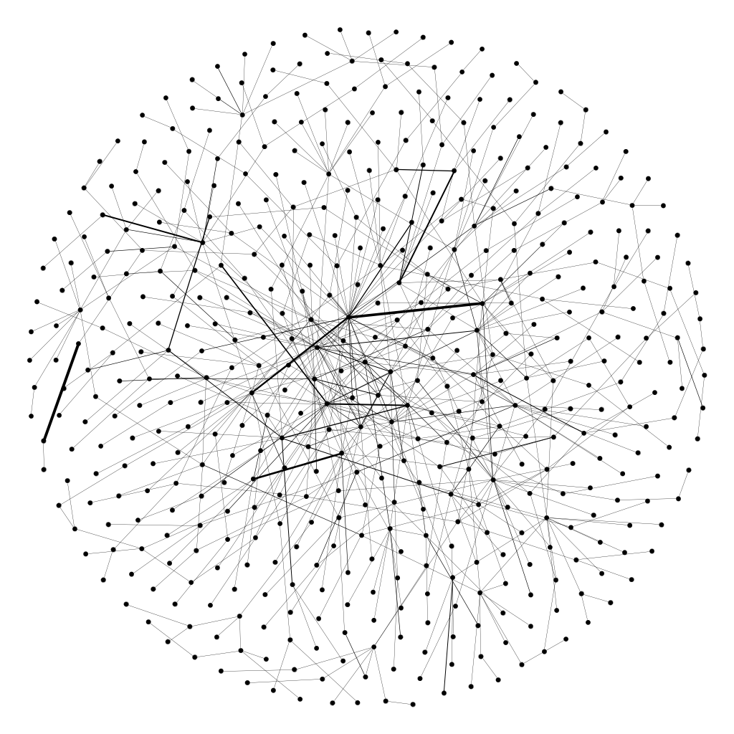
Figure 3: A network with 493 nodes and 612 undirected edges with the ForceAtlas layout (left) and Fruchterman-Reingold layout (right). The underlying mathematics are identical.
Many algorithms that are well-suited to small and medium networks break down when applied to larger networks: taking several hours to compute, creating hairballs with little visual structure, or converging on structures that do not truly represent the patterns in the data. ForceAtlas2, Yifan Hu, and OpenOrd overcome these problems with greater computational efficiency. This is done with parallel processing, only measuring local forces, combining forces, and cutting long edges. ForceAtlas2 will give similar results to ForceAtlas, but with less accuracy for networks with fewer than 50,000 edges. In addition, ForceAtlas2 provides the option of dissuading hubs, pushing the most central nodes to the periphery. The Yifan Hu multilevel algorithm cuts even more corners, so if ForceAtlas2 is too slow this is the next step in trading accuracy for speed. With the largest graphs, OpenOrd is the best option. For example, in attempting to visualize a network of philosophy topics based on 6.3 million data points, we ran ForceAtlas2 for days without success, but OpenOrd finished in two hours (results shown in Figure 4, left). However, OpenOrd cuts edges, so it should only be used if the more detail-oriented algorithms are inadequate.
Another challenge when representing especially large networks is finding ways to add semantic content to the syntactic structure of the representation. While OpenOrd created a clearly meaningful structure in the graph below, nothing in that image indicates what it is about, and adding hundreds of thousands of labels would not make the image more intelligible. One solution is to filter the edges or nodes by criteria such as edge weight, weighted degree, or component membership. For example, to better represent the network of philosophy topics, we cut all edges with weight less than twenty, along with any nodes no longer connected to the main component. Whereas ForceAtlas2 previously produced a meaningless hairball, when we applied it to the pared-down network it generated a meaningful structure where the remaining nodes could be given readable labels (if the image were bigger and zooming in were possible). Alternatively, one can simplify an overwhelming amount of data by treating natural clusters of nodes as individual nodes, as seen at the bottom of Figure 4, where groups -- as defined by modularity measure -- were represented as nodes, and then labeled based on the general trend within each cluster.

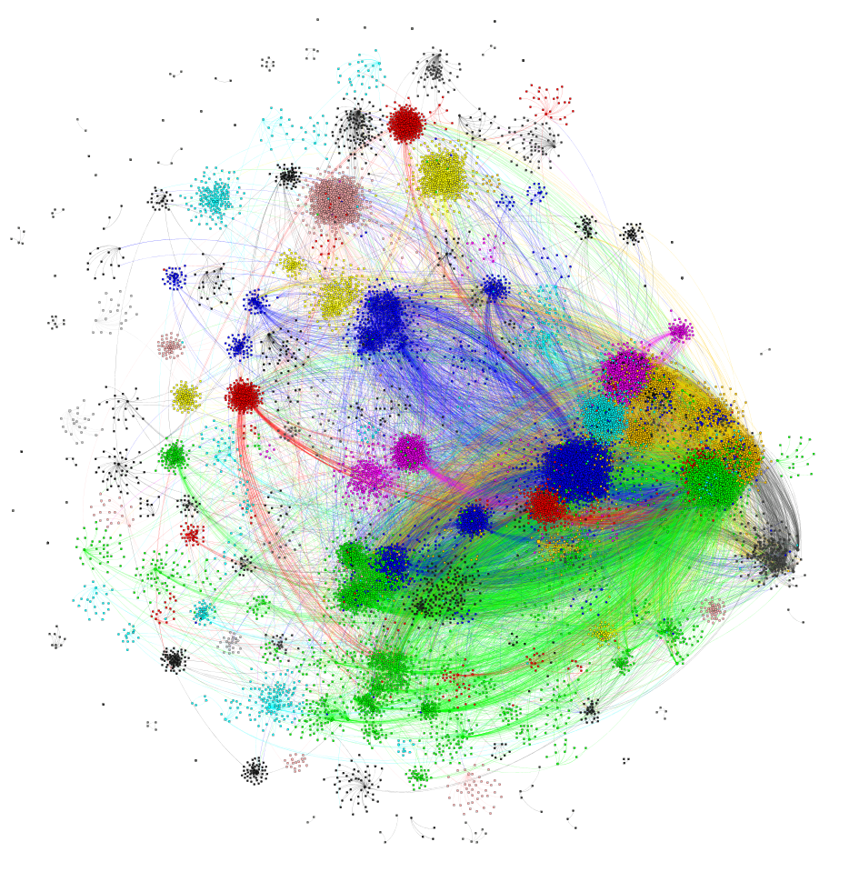
Figure 4: Publications in philosophy organized by OpenOrd without data editing (left), ForceAtlas2 with edges trimmed (right) and ForceAtlas2 with clusters grouped (bottom). The original data used to design these visualizations are identical.
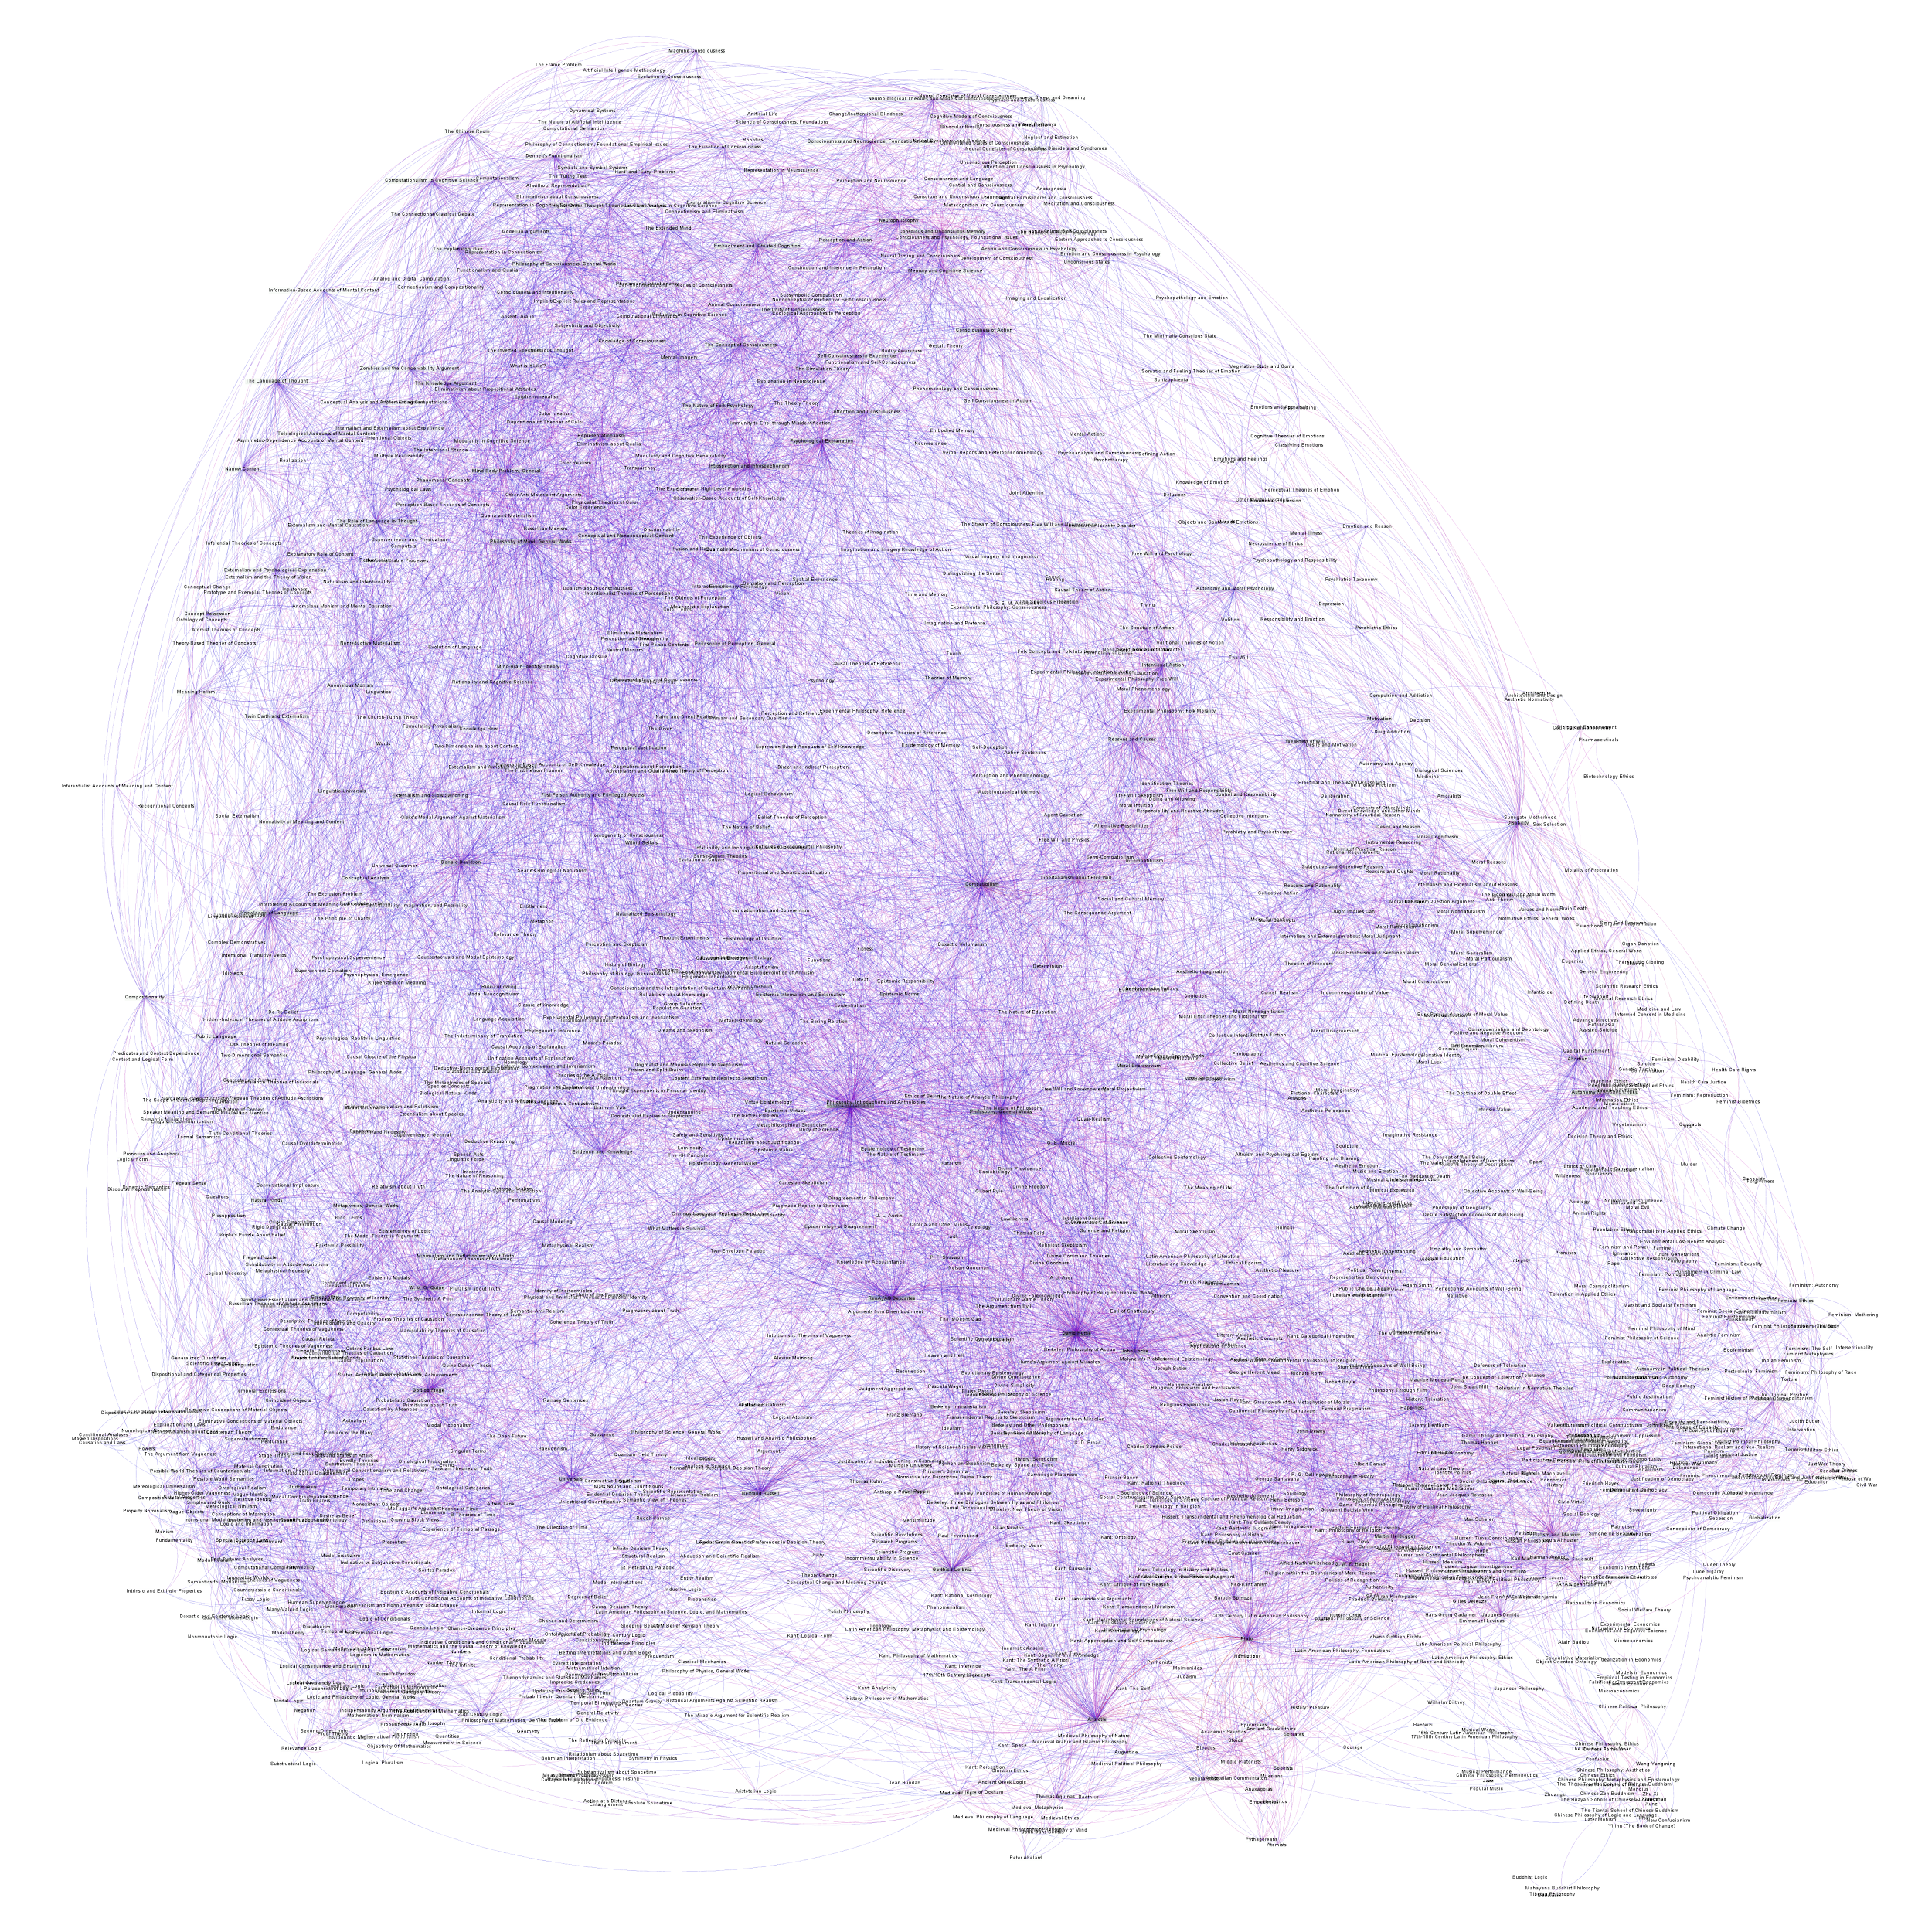

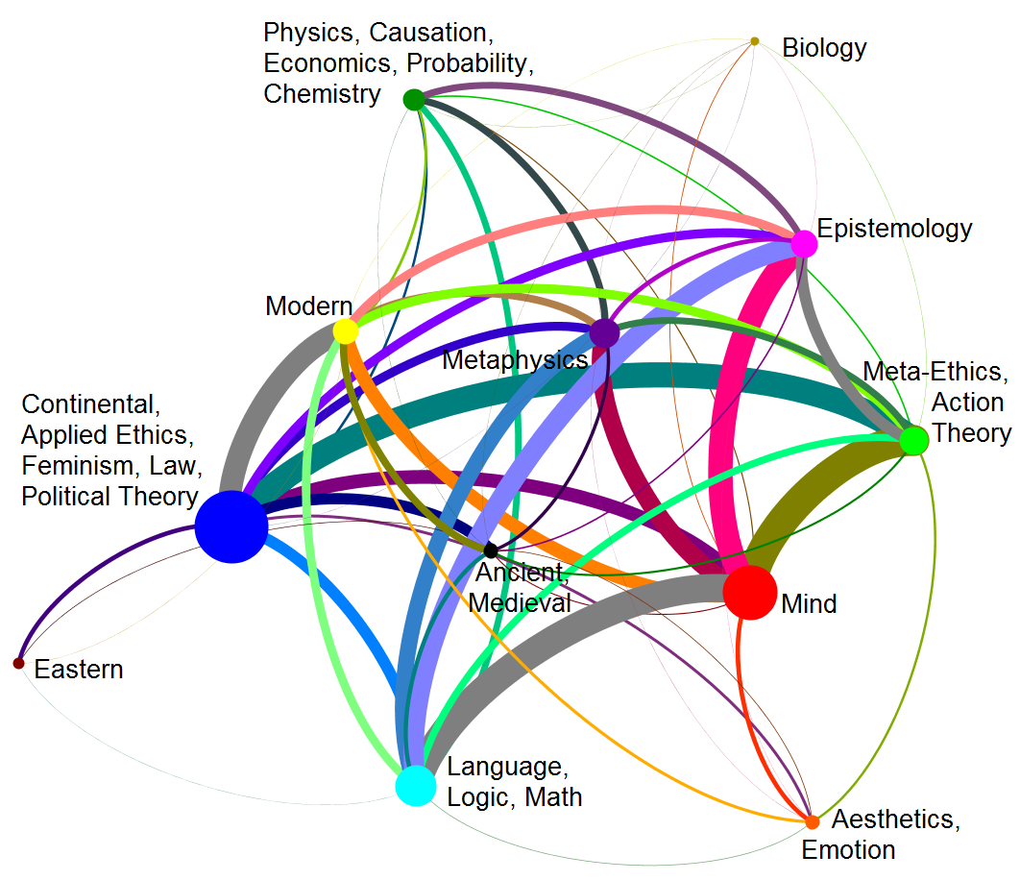

After using one of the algorithms above to generate the structure of the graph, one may wish to apply a few tweaks to the network to enhance its appearance. If the nodes are too spread out or too close together the graph can be expanded or contracted using the Expansion, Contraction, or Noverlap layouts. If the nodes or edges are labeled, the Label Adjust layout will move nodes to avoid overlapping labels (since labels are horizontally-aligned text, this can result in serious distortions). One can also manually adjust the positions of nodes, but this is discouraged since it potentially biases the results. All of these layouts are available in Gephi.
Once you feel satisfied with the general layout, the next step is to work on sizes and colors with the Appearance box. We typically use a centrality measure as the standard for node size, but one can base size on many other measures or determine size manually for each individual node. Colors for nodes, edges, and labels can be based on group membership (modularity), various network measures (bearing in mind the caveats about color mentioned above), or determined manually on a one-off basis.
The final adjustments are made in the Preview tab. Here, one should fine-tune the parameters determining sizes and colors. For our obituaries project, most graphs were developed by having 0% opacity on the nodes, showing labels with 12 point font (but with most nodes being larger due to their ranking-based size increases), showing edges with between 0.3 and 1 thickness, and turning off edge arrows (since these would be meaningless in an undirected network). The proportional size option is a way of making node labels larger based on their degree. We recommend turning this off and instead determining relative node sizes yourself in the Overview. Node labels can be easier to see if one applies an outline or box around the label. Edges can be either straight or curved, and their color can be determined by a metric (e.g., weight), by their input/output node, or manually. Hit Refresh to visualize the network, and select Export to save the image as a file.

Interpretation
Interpreting networks proceeds along two tracks. First, the researchers can make inferences from the mathematical properties of the network. Regarding nodes, the various centrality and clustering properties can be used to make inferences about both which nodes are more or less important (in particular ways). They can also be used to make inferences about subsets of the nodes in the network: to what extent they cleave into communities, as well as which nodes play important roles in connecting communities. To illustrate with our obituary case, we can use PageRank to identify cardinal virtues, vices, and constituents of wellbeing. Alternatively, in a citation network, researchers could use betweenness to identify authors who connect communities or modularity to identify the communities themselves. Which measure one uses and how one interprets it depends on the research question, which should inform the conceptualization, operationalization, and cleaning and preprocessing steps.
Second, the researchers can make inferences from the visualizations of the network. As we mentioned above, in principle visualizations add nothing new. However, because they primarily engage perception rather than cognition, they may make it easier for human minds to notice and understand patterns in the data that would be difficult to comprehend with just the bare mathematics. If nodes have been sized based on their PageRank or betweenness, it may be obvious at first glance which ones are most important (assuming that PageRank or betweenness matter for the network in question). If modularity has been encoded categorically using hue, commonalities may pop out among neighbors in a community and differences between communities may seem obvious on inspection. We recommend allowing the conceptualization, operationalization, and type of data to guide choices for visualization. In general, visualizations should be used for exploratory purposes, and researchers should rely on mathematical details for a more precise understanding of the results.
To illustrate this process with a final case study, consider the workflow involved in understanding the social structure of the community of philosophers working in ontology. The raw data -- 142,493 citations -- recommended visualizing with an emphasis on the structure of clusters instead of highlighting each individual node. This points towards OpenOrd or Yifan Hu. However, another relevant mathematical feature was the exceptional contrast between high and low degree nodes. Only 5% of the 30,808 authors had been cited at all, and the 40 most cited were cited more than the other 30,768 combined. Taking this observation to heart would have helped avoid many failures to produce meaningful visualizations. A related mathematical feature was symmetry and asymmetry. Most citers are not cited, but almost all cited authors cite. This motivated a new approach to visualizing, focusing on co-citation. Because this network was substantially smaller, ForceAtlas could be used to generate the picture seen in Figure 5. That visualization was made more informative, in turn, by using the mathematical properties of PageRank and modularity to further illuminate the information.

Figure 5: Co-citation among authors writing on objects and the topics most closely related (ontology, persons, realism/anti-realism, interlevel metaphysics, math ontology, metaontology, space, and time) as categorized by PhilPapers on 9/12/12. Betweenness centrality was used to determine which nodes were labeled, the size of the labels (bigger = higher), and node coloring (10 highest ranked nodes in red).
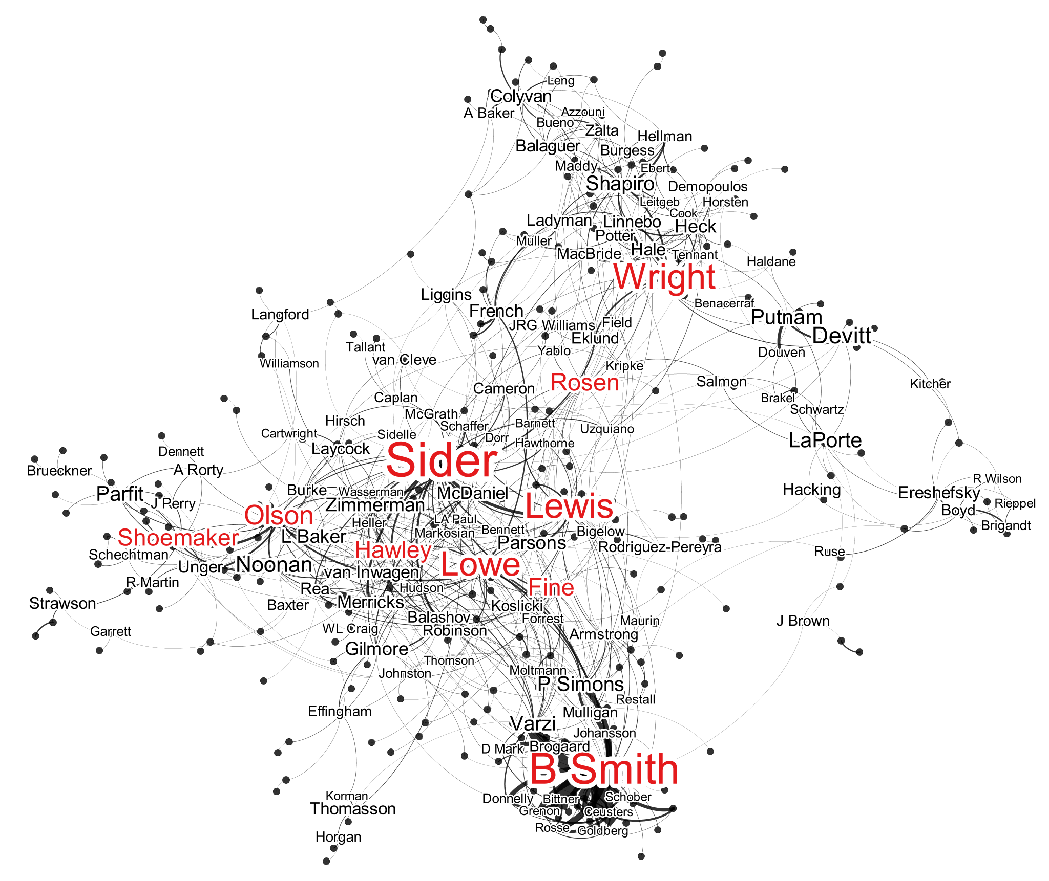
This picture is interesting in its own right, but its greatest use for researchers is to better understand what various metrics are really about. For example, Ted Sider and Barry Smith are both highly cited and have the highest betweenness centrality, but without the visualization it would be difficult to discern that Sider is highly cited and at the center of the material objects conversation while Smith is at the periphery of that conversation (while being at the center of another). It also helps to identify the bridges between conversations, those authors who play an especially strong role in communicating insights from one sub-field to another. Betweenness centrality informs us that Eric Olson and Crispin Wright are important, but without visualizing the community it would be difficult to discern that Olson connects analytic metaphysics to personal identity or that Wright bridges discussions of abstract and concrete object ontologies. With this new knowledge in hand, we could return to the original, full list of citations to more carefully investigate the neighborhoods on each side of the bridge to understand how information flows through the system. Visualizations are valuable for quickly communicating results to the broader academic community, but researchers should also use them to further their own investigations.

Final recommendations
The methods outlined here are promising for those employing the Ramsey-Lewis method for grounding conceptual meaning in natural language because the meanings of terms in natural language are embedded in deeper webs of semantic content. More broadly, we see this as a valuable resource for experimental philosophers and empirically-minded philosophers of all stripes. Network-based analysis and representation will not be ideal for all empirical projects. In particular, if the best translation of data into a network format results in less than ten nodes, or if the edges in the constructed network do not carry valuable information, this format is unlikely to generate new insights. Nonetheless, we see this as a great asset to add to the philosopher’s toolbox, especially when used in conjunction with other statistical methods and representational formats.

Suggested reading
Alfano, M. (2015). Ramsifying virtue theory. In M. Alfano (ed.), Current Controversies in Virtue Theory. 123-35. Routledge.
Alfano, M., Higgins, A., & Levernier, J. (2017). Identifying virtues and values through obituary data-mining. Journal of Value Inquiry.
Brandt, M., Sibley, C., & Osborne, D. (2018). What is central to belief system networks? PsyArXiv Preprints. DOI = < 10.17605/OSF.IO/TYR64>. URL = < https://psyarxiv.com/tyr64 >.
Munzner, T. (2014). Visualization Analysis and Design. AK Peters.
Moretti, F. (2013). Distant Reading. Verso.

References
Alfano, M. (2012). The most agreeable of all vices: Nietzsche as virtue epistemologist. British Journal for the History of Philosophy, 21(4): 767-90.
Alfano, M. (2015). Ramsifying virtue theory. In M. Alfano (ed.), Current Controversies in Virtue Theory. 123-35. Routledge.
Alfano, M., Higgins, A., & Levernier, J. (2017). Identifying virtues and values through obituary data-mining. Journal of Value Inquiry.
Alfano, V. & Stauffer, A. (2015). Virtual Victorians: Networks, Connections, Technologies. Palgrave.
Birch, J. (2012). Worldwide prevalence of red-green color deficiency. Journal of the Optical Society of America A, 29(3): 313-20.
Bird, S., Loper, E., & Klein, E. (2009). Natural Language Processing with Python. O’Reilly Media.
Borkulo, C. (2016). Statistical comparison of two networks based on three invariance measures. URL = < https://cran.r-project.org/web/packages/NetworkComparisonTest/NetworkComparisonTest.pdf>. Accessed 3 October 2016.
Borkulo, C. & Epskamp, S. (2016). Fitting Ising models using the ELasso method. URL = < https://cran.r-project.org/web/packages/IsingFit/IsingFit.pdf>. Accessed 3 October 2016.
Borsboom, D. & Cramer, A. (2013). Network analysis: An integrative approach to the structure of psychopathology. Annual Review of Clinical Psychology, 9: 91-121.
Brandt, M., Sibley, C., & Osborne, D. (2018). What is central to belief system networks? PsyArXiv Preprints. DOI = < 10.17605/OSF.IO/TYR64>. URL = < https://psyarxiv.com/tyr64 >.
Brin, S. & Page, L (1998). The anatomy of a large-scale hypertextual Web search engine. Computer Networks and ISDN Systems, 30: 107-17.
Carlson, A., Betteridge, J., Kisiel, B., Settles, B, Hruschka, E., & Mitchell, T. (2010). Towards an architecture for never-ending language learning. Proceedings of the Twenty-Fourth AAAI Conference on Artificial Intelligence (AAAI-10): 1306-13.
Chalmers, D. (2015). Why isn’t there more progress in philosophy? Philosophy, 90(1): 3-31.
Chen, M. & Floridi, L. (2013). An analysis of information visualization. Synthese 190(16): 3421-38.
Christen, M., Alfano, M., Bangerter, E., & Lapsley, D. (2013). Ethical issues of ‘morality mining’: When the moral identity of individuals becomes a focus of data-mining. In H. Rahman & I. Ramos (eds.), Ethical Data Mining Applications for Socio-Economic Development. 1-21. IGI Global.
Christen, M., Robinson, B., & Alfano, M. (2014). The semantic neighborhood of intellectual humility. In Herzig & E. Lorini (eds.), Proceedings of the European Conference on Social Intelligence. 40-9.
Clark, A. (2002). Towards a science of the bio-technological mind. International Journal of Cognition and Technology, 1(1): 21-33.
Cohen, J. (1968). Weighted kappa: Nominal scale agreement with provision for scaled disagreement or partial credit. Psychological Bulletin, 70(4): 213-20.
Costantini, G., Epskamp, S., Borsboom, D., Perugini, M., Mõttus, R., Waldorp, L., & Cramer, A. (2014). State of the aRt personality research: A tutorial on network analysis of personality data in R. Journal of Research in Personality, 54: 13-29.
Crenshaw, K. (1989). Demarginalizing the intersection of race and sex: A black feminist critique of antidiscrimination doctrine, feminist theory and antiracist politics. University of Chicago Legal Forum, 1989(1): 139-67.
Diesner, J. (2014). ConText: Software for the integrated analysis of text data and network data, Social and Semantic Networks in Communication Research: Conference of International Communication Association, Seattle, WA, 2014.
Diesner, J. & Carley, K. (2010). Relational methods for analyzing and preventing crime (German: Relationale Methoden in der Erforschung, Ermittlung und Prävention von Kriminalität). In C. Stegbauer, R. Häußling (eds.), Handbook of Network Research (pp. 725-738). VS Verlag.
Epskamp, S., Borsboom, D., & Fried, E. (2016). Estimating psychological networks and their accuracy: A tutorial paper. arXiv:1604.08462v3.
Epskamp, S., Cramer, A., Waldorp, L., Schmittmann, V., Borsboom, D. (2012). Qgraph: Network visualizations of relationships in psychometric data. Journal of Statistical Software, 48(4): 1-18.
Fruchterman, T. & Reingold, E. (1991). Graph drawing by force-directed placement. Software: Practice and Experience, 21(11): 1129-1164.
Hastie, T., Tibshirani, R., & Friedman, J. (2008). The Elements of Statistical Learning: Data Mining, Inference, and Prediction, 2nd edition. Springer.
HRAF. (1967). The HRAF quality control sample universe. Cross-Cultural Research, 2(2): 81-88.
Hu, Y. (2005). Efficient and high quality force-directed graph drawing. The Mathematica Journal, 10: 37-71.
Jacomy, M. (2009). Force-atlas graph layout algorithm. URL: http://gephi. org/2011/forceatlas2-the-new-version-of-our-home-brew-layout.
Jacomy, M., Venturini, T., Heymann, S., & Bastian, M. (2014). ForceAtlas2, a continuous graph layout algorithm for handy network visualization design for the Gephi software. PLoS ONE, 9(6): e98679. https://doi.org/10.1371/journal.pone.0098679
Kirkegaard, E. & Bjerrekær, J. (2014). The OKCupid dataset: A very large public dataset of dating site users. Open Differential Psychology. URL = < https://openpsych.net/forum/showthread.php?tid=279 >.
Krämer, N., Schäfer, J., & Boulesteix, A.-L. (2009). Regularized estimation of large-scale gene association networks using graphical Gaussian models. BMC Bioinformatics, 10: 38.
Krugman, P. (2014, March 18). “Sergeant Friday was not a fox.” The New York Times. URL = < https://krugman.blogs.nytimes.com/2014/03/18/sergeant-friday-was-not-a-fox/ >. Accessed 17 January 2018.
Lewis, D. (1966). An argument for the identity theory. The Journal of Philosophy, 61(1): 17-25.
Lewis, D. (1970). How to define theoretical terms. The Journal of Philosophy, 67(13): 427-46.
Lewis, D. (1972). Psychophysical and theoretical identifications. Australasian Journal of Philosophy, 50: 249-58.
Lurquin, J. & Miyake, A. (2017). Challenges to ego-depletion research go beyond the replication crisis: A need for tackling the conceptual crisis. Frontiers in Psychology, 8: 586.
Lynch, M. (2016). The Internet of Us: Knowing More and Understanding Less in the Age of Big Data. Liveright.
MacWhinney, B. (2000). The CHILDES Project: Tools for Analyzing Talk, 3rd edition. Lawrence Erlbaum.
Martin, S., Brown, M., Klavans, R., & Boyack, K. (2011). OpenOrd: An Open-Source Tollbox for Large Graph Layout. SPIE Conference on Visualization and Data Analysis.
Munzner, T. (2014). Visualization Analysis and Design. AK Peters.
Moretti, F. (2013). Distant Reading. Verso.
Newman, M. (2008). The mathematics of networks. In New Palgrave Encyclopedia of Economics. Palgrave.
Open Science Collaboration. (2015). Estimating the reproducibility of psychology science. Science, 349(6251): 943.
Parfit, D. (1984). Reasons and Persons. Oxford University Press.
Powers, D. (2011). Evaluation: From precision, recall and F-measure to ROC, informedness, markedness, and correlation. Journal of Machine Learning Technologies, 2(1): 37-63.
Radim, R. & Sojka, P. (2010). Software framework for topic modelling with large corpora. Proceedings of the LREC 2010 Workshop on New Challenges for NLP Frameworks, 45-50. ELRA.
Raichle, M. (2015). The brain’s default mode network. Annual Review of Neuroscience, 38: 433-447.
Ramsey, F. (1931). Theories. In R. B. Braithwaite (ed.), The Foundations of Mathematics. London: Routledge & Kegan Paul.
Rathkopf, C. (2018). Network representation and complex systems. Synthese.
Schneiderman, B. (1996). The eyes have it: A task by data type taxonomy for information visualizations. Proceedings of the 1996 IEE Symposium on Visual Analytics, 336-43.
Stevens, G., White, R., Flaxman, S., Price, H., Jonas, J., Keeffe, J., Leasher, J., Naidoo, K., Pesudovs, K., Resnikoff, S., Taylor, H., Bourne, R., & Visual Loss Expert Group. (2013). Global prevalence of vision impairment and blindness: Magnitude and temporal trends, 1990-2010. Ophthalmology, 120(12): 2377-84.
Sugiyama, K., Tagawa, S., Toda, M. (1981). Methods for visual understanding of hierarchical system structures. IEEE Transactions on Systems, Man, and Cybernetics, 11(2): 109-125.
Tiberius, V. (2008). The Reflective Life. Oxford University Press.
Van Norden, B. (2008). Mengzi: With Selections from Traditional Commentaries. Hackett.
Vie, L., Griffith, K., Scheier, L., Lester, P., & Seligman, M. (2014). The person-event data environment (PDE): Leveraging big data for studies of psychological strengths in soldiers. Frontiers in Psychology. Technology Report, 4: 1-7.
Zagzebski, L. (2017). Exemplarist Moral Theory. Oxford University Press.

Search conducted 12 January 2018 in The Netherlands.
Available at url = < https://developer.twitter.com/en/docs >.
We should also point out that, in 2010, approximately 32,400,000 people were blind and 191,000,000 people suffered from moderate or severe visual impairment (Stevens et al. 2013). This points to an inherent drawback of visualizations and the need to develop additional tools that can be used effectively by people with visual disabilities.

