Virtue in Nietzsche’s Drive Psychology

Mark Alfano, Delft University of Technology

**Abstract:** Nietzsche promises to “translate man back into nature,” but it remains unclear what he meant by this and to what extent he succeeded at it. To help come to grips with Nietzsche’s conceptions of drive (*Trieb*), instinct (*Instinkt*) and virtue (*Tugend* and/or *Keuschheit*), I develop novel digital humanities methods to systematically track his use of these terms, constructing a near-comprehensive catalogue of what he takes these dispositions to be and how he thinks they are related. Nietzsche individuate drives and instincts by the type of actions they motivate. One way in which the “translation” of man back into nature might succeed is through naturalistic explanation and reduction of moral notions such as virtue in terms of amoral, naturalistic notions, such as drives and instincts. I go on to show that this is indeed Nietzsche’s project: for him, a virtue is a well-calibrated drive. Such calibration relates both to the rest of the agent’s psychic economy (her other drives) and to her social context (what’s considered praiseworthy and blameworthy in her culture).

**Introduction**

Nietzsche scholars have developed an interest in his conceptions of moral psychological phenomena, such as drives and instincts (Alfano 2010, 2013b; Katsafanas 2013a, 2015), as well as virtue(s) (Alfano 2013a, 2015a, 2015b, 2016; Annas 2017; Daigle 2006; Hurka 2007; May 1999; Railton 2012; Reginster 2006; Robertson 2012; Thomas 2012; White 2001). However, the quality and systematicity of engagement in this area leave much to be desired. Perhaps the worst recent offender is Christine Swanton (2015), who fabricates a version of Nietzsche’s conception of virtue that is equal parts Ayn Rand, Alfred Adler, and 21st-century common sense (Alfano 2016). Clark & Dudrick (2012) are a close second, given that they fabricate whole cloth a Nietzschean “will to value.” In this chapter, I explain and recommend a synoptic digital humanities approach to Nietzsche interpretation by demonstrating the explanatory value that comes from following it.

This methodology integrates and extends both close-reading and distant-reading techniques developed by philosophers and other humanists (Moretti 2013). The latter have been available for years, but despite promising to lead to new insights and complement existing approaches, they have made almost no inroads in philosophy. Of the two million articles, chapters, and books housed at [www.philpapers.org](http://www.philpapers.org), only twenty-one unique publications (approximately 0.001%) are returned when one searches for ‘digital humanities’, and I am an author or co-author of three of them.[1]

Here is the plan for this chapter: first, I explain my methodology. Next, I present the results of applying the methodology to the study of Nietzsche’s discussion of drives, instincts, and virtues. In the main interpretive section of the paper, I marshal the resources developed in the previous section to argue that, for Nietzsche, instincts and virtues are (partially overlapping) subsets of drives. Instincts are innate drives, whereas virtues are well-calibrated drives. A well-calibrated instinct is therefore also a virtue. What it takes for a drive to be calibrated is complicated, involving both internal synergy and social harmony (or at least non-interference). In the final section, I make a few observations and recommendations for future research in Nietzsche scholarship and history of philosophy more generally.

**Methodology**

Philosophers – especially those who favor a hermeneutic approach to “great figures” – may be prejudiced against digital humanities and distant reading, but they should rest assured that this approach complements and contextualizes the methods with which they are familiar. Since there is no single method associated with digital humanities, in this section I explain my approach, which can be reproduced by anyone with a deep acquaintance with Nietzsche’s texts, knowledge of German, and an internet connection. It follows six steps:

1. select core concepts;
2. operationalize for searching on the Nietzsche Source;
3. conduct searches;
4. clean data;
5. analyze and visualize data; and
6. close read relevant passages.

The first and perhaps most important step is to select the core concepts for the study. This can only be done effectively by someone who is deeply familiar with Nietzsche’s texts, has good intuitions about which concepts are associated in which ways, and is aware of prominent and promising interpretations and suggestions already in the secondary literature. For this study, I selected the concepts of *virtue*, *drive*, and *instinct*. As Katsafanas (2013a) remarks, Nietzsche sometimes seems to use the latter two equivalently. In addition, some interpretations in the secondary literature (Alfano 2013a, 2015b) claim based on passages such as D 30, GS 21, BGE 10, and GM III.8 that virtues are a subset of drives. For these reasons, it’s worthwhile to ask whether Nietzsche does in fact refer to drives and instincts interchangeably and which sorts of drives or instincts he grants the honorific ‘virtue’.

Once these questions have been formulated, a methodological challenge immediately arises. There is no reliable, valid catalogue of which concepts Nietzsche deploys (and whether he does so ironically) in which passages. The closest thing we have is the Nietzsche Source ([www.nietzschesource.org)](http://www.nietzschesource.org)), a digital repository of all of his writings that includes published works (e.g., HH, D, GS, BGE), private publications (e.g., NCW), authorized manuscripts (e.g., A, EH), posthumous writings (e.g., PTAG), posthumous fragments, and letters.[2] This brings us to step 2: we need to operationalize the concepts under study by developing a list of words that Nietzsche characteristically uses to express them. This list will be neither comprehensive (there will be some false negatives) nor complete (there will be some false positives). Nevertheless, if the researcher is sufficiently familiar with Nietzsche’s corpus, it should have high validity and reliability. In my first foray into this methodology (Alfano 2013a), I was interested in Nietzsche’s conception of curiosity. I therefore searched the Nietzsche Source for all forms of ‘*Neugier*’ and ‘*Wissbegier*’. Such searching is aided by the query functionality of the Nietzsche Source: it is possible to return all passages containing words that begin with a given text string if one appends an asterisk at the end of the string (e.g., ‘neugier*’). Of course, it is possible to discuss or express curiosity in German without using one of these words, and it is also possible for one of these words to turn up without the author discussing or expressing curiosity. Despite these drawbacks, operationalizing in this way is the best, most reproducible method we currently have for systematically studying Nietzsche’s texts, and the texts are the best evidence we have for what he thought. In addition, because it makes explicit what the inclusion and exclusion criteria are, this method is criticizable and corrigible in a way that most other interpretive methods are not. For the present study, I operationalized *drive* by searching for ‘trieb*’. Likewise, I operationalized *instinct* with both ‘instinkt*’ and ‘instinct*’ (Nietzsche uses both until 1882, at which point he stops using the spelling with ‘c’). I operationalized *virtue* with both ‘tugend*’ and ‘keusch*’. These are both typically translated as some variant of ‘virtue’ in English, though the latter is more gendered and often refers specifically to chastity. The same ambiguity exists in English of the nineteenth century, as we see in Austen’s *Pride and Prejudice* (1813/2002, p. 75).

The next methodological hurdle is to determine which of Nietzsche’s writings to include in the search. Heidegger notwithstanding, I have no stomach for the unpublished and unauthorized writings. In addition, I confess to finding Nietzsche’s poetry unreadable and uninterpretable, so I excluded those writings as well. That left me with the published works, private publications, and authorized manuscripts. Future work can easily supplement this chapter by including the letters, the poetry, and the kitchen sink.

Given these constraints, the next choice is to determine what researchers in the field of natural language processing call the ‘window’. The basic idea is this: if an author tends to use word W near word V, then the author probably associates the concepts expressed by W and V (whether positively or negatively). However, there is no hard-and-fast rule for determining what counts as nearness. One appealing window is co-sententiality: if W and V are used in the same sentence, they are probably associated. Another is co-paragraphicality: if W and V are used in the same paragraph, they are probably associated. Alternatively, one can determine a window of length *n*, where *n* is the number of words between W and V. For instance, a window of 3 around W would include all words up to three before or after W (including words that occur across sentence and paragraph breaks). As you might imagine, choosing a window size is a dark art. Fortunately for Nietzsche scholars, he wrote in sections that – at least after the *Untimely Meditations* – tend to be of roughly the same brief length. These are standardly used in Nietzsche scholarship, making it straightforward to link this methodology to the existing secondary literature. In addition, the Nietzsche Source returns separate results for each such section, which makes it a simple task to reproduce results. For these reasons, I set the window at the level of the section for this study. As before, this may not be ideal, but it is documentable and therefore both criticizable and corrigible.

I now describe my method for preparing or “cleaning” the data. In order to clean the data for optimal use in the visual analytics platform Tableau Public, one must arrange them in a very particular yet simple tabular format. The rows in this table represent individual query results from the Nietzsche Source. The columns represent every datum of interest about the query result in question. When querying this database, one chooses a subset of writings to search and inputs a search term. For instance, in Figure 1, you can see the initial results when searching the published writings for ‘trieb*’.

**Figure 1:** results from querying the Nietzsche Source for ‘trieb*’ in the published works

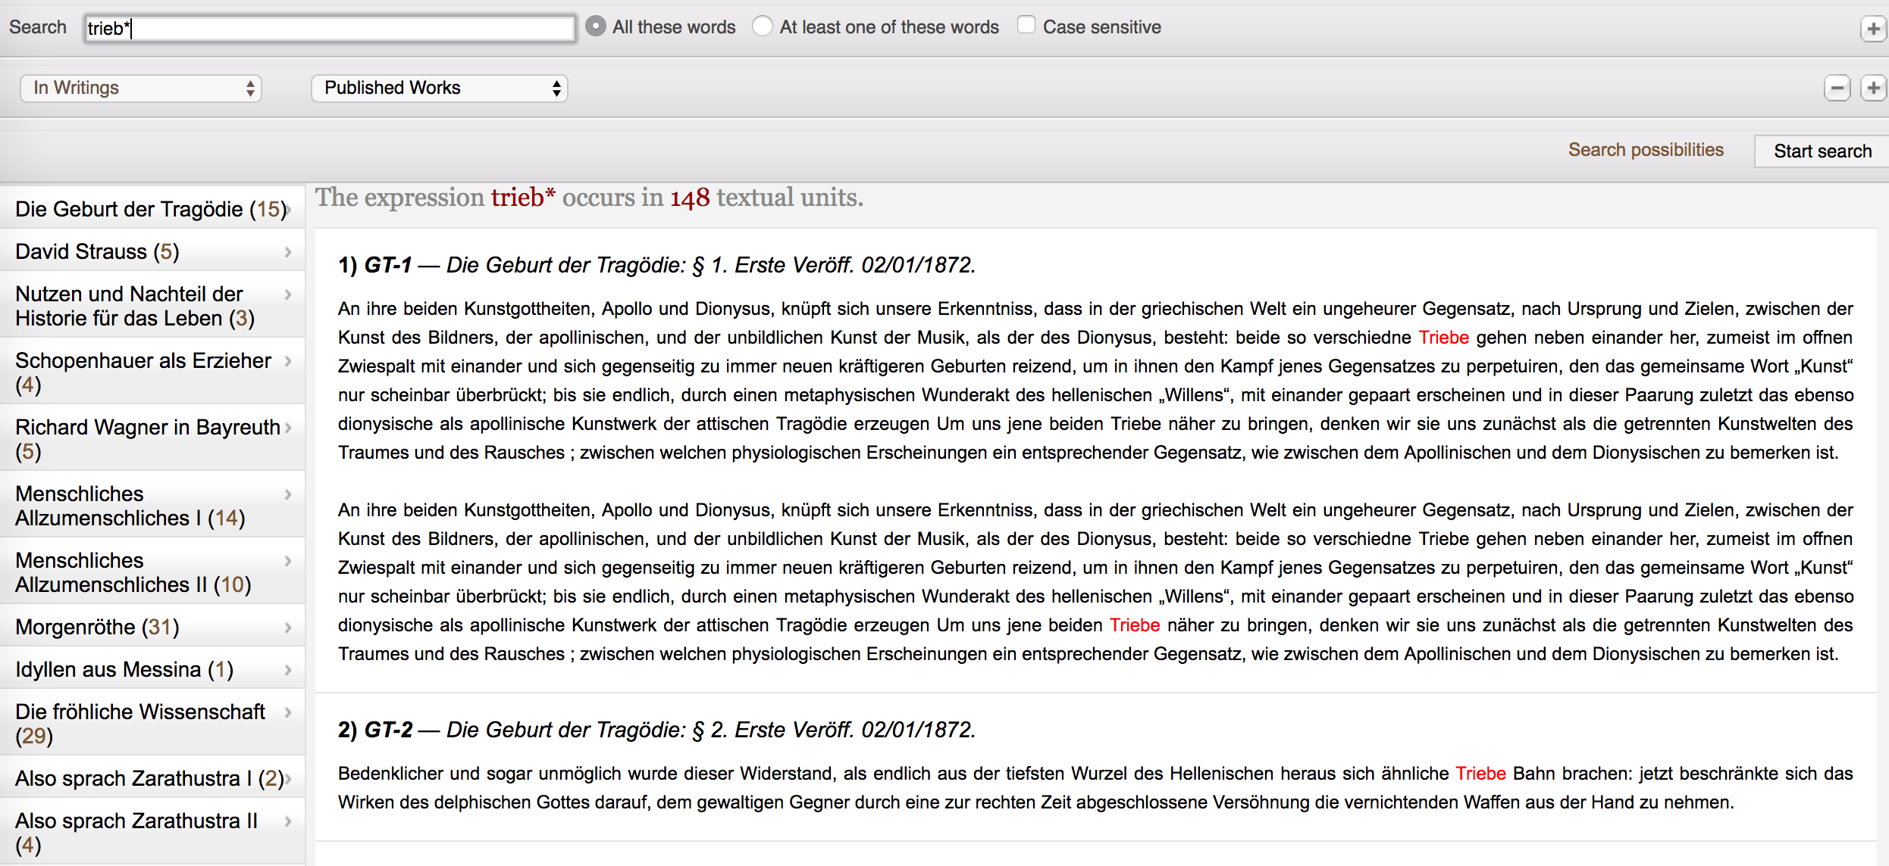

This query returned 148 passages: 15 from *The Birth of Tragedy*, 5 from *David Strauss, the Confessor and the Writer*, 3 from *The Uses and Disadvantages of History for Life*, and so on. The results include ‘Trieb’ (drive), ‘Triebe’ (drives), ‘Triebfedern’ (driving force), and ‘trieblos’ (impotent). Some of the surrounding text for the first two passages is also returned. For each passage, I recorded five items in separate columns: the book in which it occurs, the passage within that book in which it occurs, the year of publication of the book, which search term I used, and which concept the term operationalizes. For details see Figure 2, which shows how some of the data for *Daybreak* is represented.

**Figure 2:** data structure for cleaning queries at the Nietzsche Source

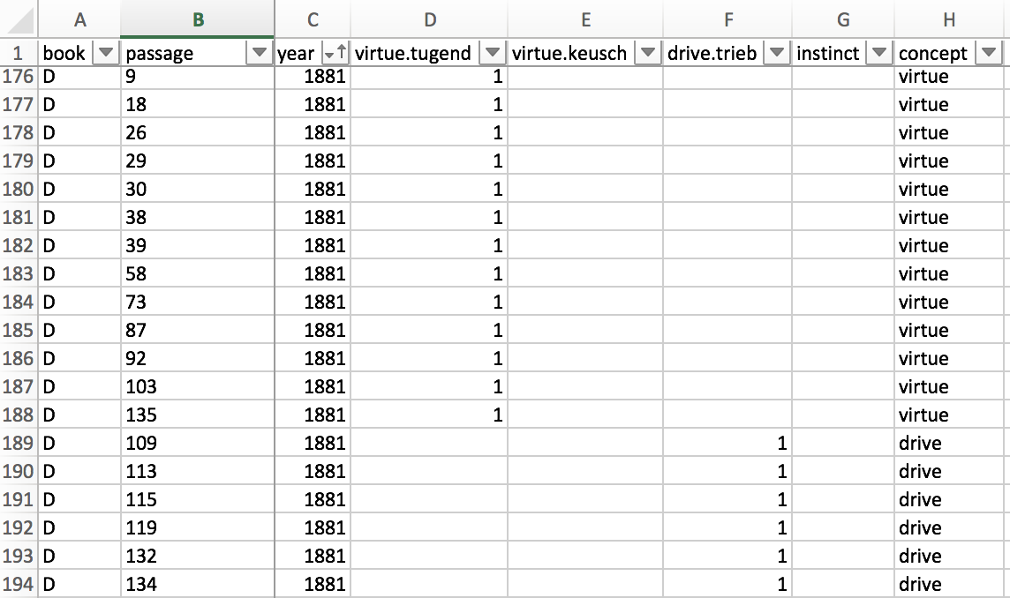

Once the data have been cleaned, they can be analyzed and vizualized. Perhaps the simplest analytic technique is to count the number of passages per concept in each book. For instance, in BT, virtue is referred to in five passages, chastity in none, drive in fifteen, and instinct in nine. We can also look for overlaps: passages in which more than one relevant concept is referred to. More sophisticated analyses involve various descriptive and inferential statistics. In this chapter, I focus primarily on visualization as a defeasible guide to close-reading. The idea is to achieve a synoptic view of both the books and the sections within each book in order to identify the most important passages and steer a systematic reading of those passages. To achieve this, I fed the cleaned data into a free software program called Tableau Public.[3]

After reading the data into Tableau Public, I created three interactive visualizations:

1. a timeline indexed to books and concepts,
2. a treemap of all concepts of interest indexed to books, and
3. a section-by-section map of each book, indexed to concepts of interest.

To create the timeline for a single concept, I placed the year of publication and the book title in the Columns shelf (in that order), Number of Records in the Rows shelf, and Concept in both the Filters card and the Color card, as in Figure 3.

**Figure 3:** method for creating timeline

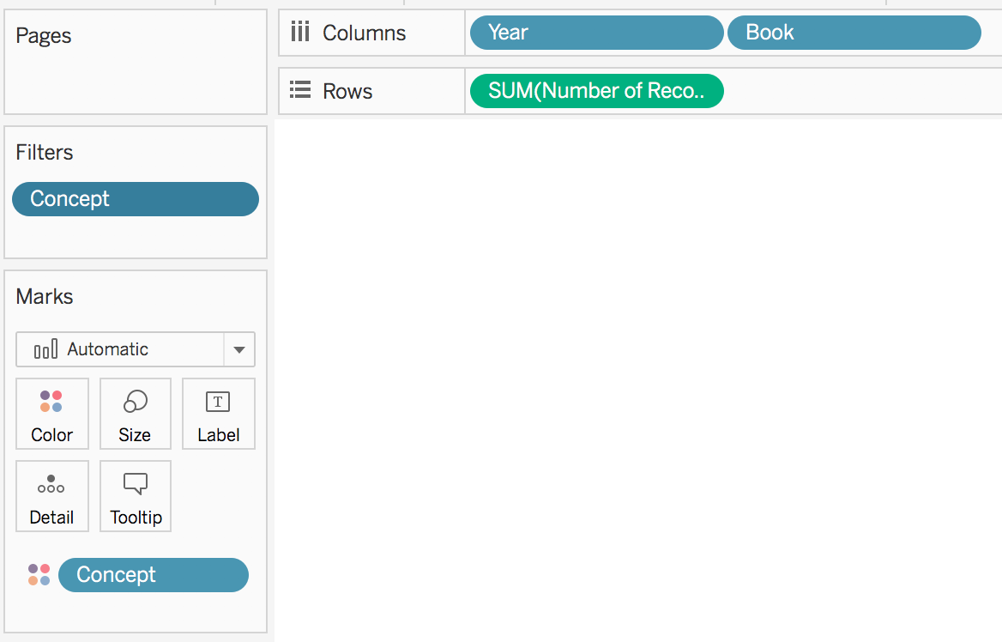

To create the treemap, I placed Number of Records in the Size card, Book in the Label card, and Concept in both the Color card and the Filters card, as in Figure 4.

**Figure 4:** method for creating treemap



Finally, to create the section-by-section map, I placed Passage in the Columns shelf, Number of Records in the Rows shelf, Concept in the Color card, and Book in the Filters card, as in Figure 5.

**Figure 5:** method for creating section-by-section map



**Results**

In this section I present the results of the visual analytics exercise described above. These are here shown in the form of static figures, but at the website associated with this chapter, all visualizations are dynamic and interactive, with functionalities associated with mousing-over, clicking, and various filters. I first showcase the single-concept timelines and treemaps. Next, I display the timeline and treemap for all concepts together. Finally, I walk through an example of section-by-section results.

Using the filter functionality to select one concept at a time, Tableau Public automatically visualizes the data from Figure 3 as a histogram (Figure 6) with two horizontal axes (year and book) and one vertical axis (number of passages per book in which the concept of interest occurs at least once). We can quickly see in this visualization that *Daybreak* is the only book in which there are over 30 passages that refer to drives.

**Figure 6:** drive timeline

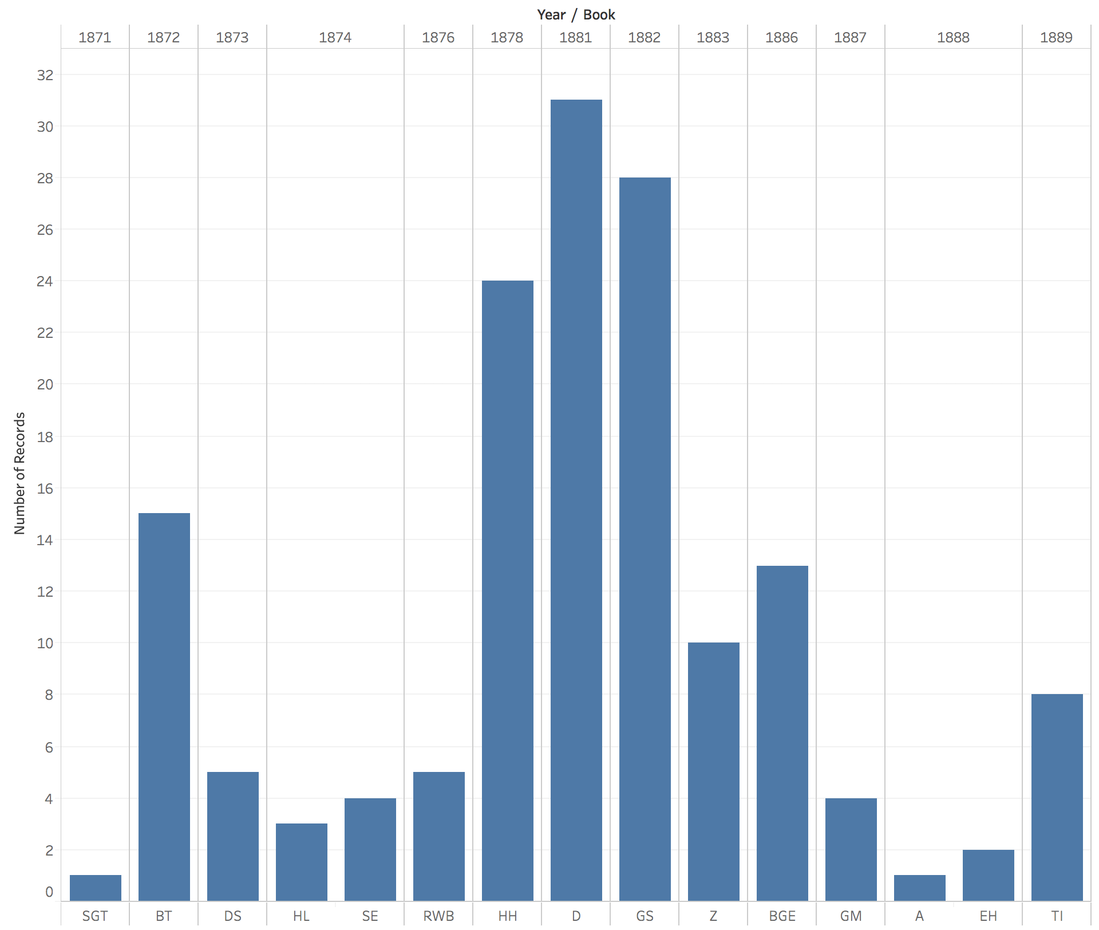

Likewise, Tableau Public automatically visualizes the data from Figure 4 as a treemap (Figure 7) in which the books with the most passages in which one of the concepts of interest crops up are represented by larger rectangles while the books with the least such passages are represented by smaller rectangles.

**Figure 7:** drive treemap



Figure 6 shows that, as Nietzsche moved beyond the *Untimely Meditations* (DS, HL, SE, and RWB), he began to speak more and more frequently of drives. However, after *Beyond Good and Evil*, his engagement with drive-talk dropped off precipitously. Thus, scholars interested in Nietzsche’s conception of drives would benefit from looking to the works associated with his so-called “free spirit” period (D, GS, and HH).

Next, consider the timeline and treemap for instinct:

**Figure 8:** instinct timeline

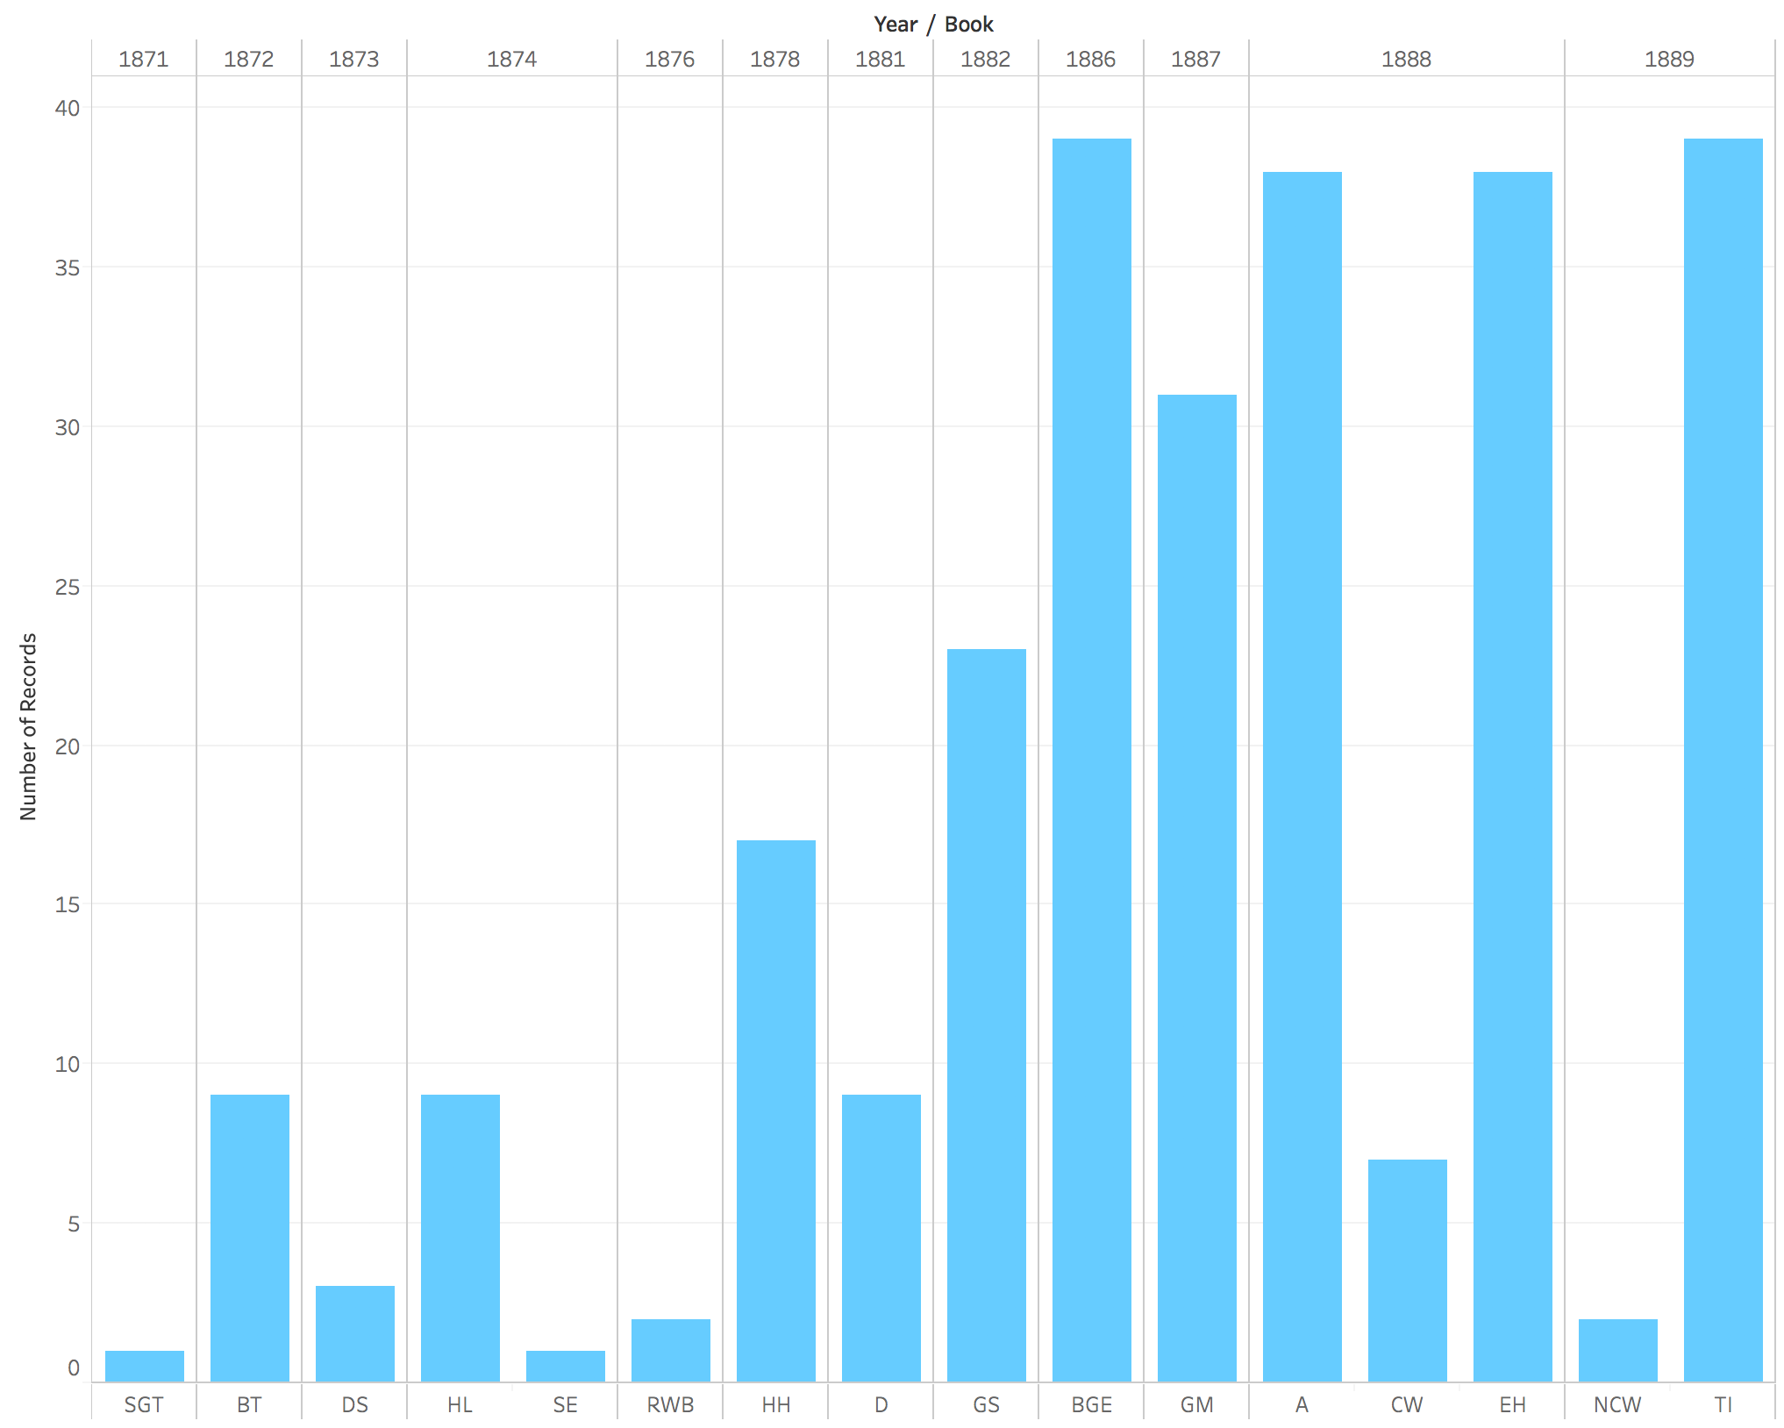

**Figure 9:** instinct treemap



The patterns in Figures 8 and 9 are very different from those in Figures 6 and 7. As Figure 8 shows, Nietzsche barely used the language of instinct until the 1880s. Indeed, the passages from GS in which Nietzsche uses instinct-talk are mostly from sections in the re-release that included book 5. Thus, unlike drives, instincts receive little attention from Nietzsche until his mature works (which I count as everything from BGE onwards). And, with the exception of the anti-Wagner works (CW and NCW), his use of instinct never drops off. Scholars interested in Nietzsche’s conception of instincts would benefit from looking less to the free spirit works and more to the mature works (TI, BGE, A, EH, and GM).

Next consider the timeline and treemap for virtue:

**Figure 10:** virtue timeline

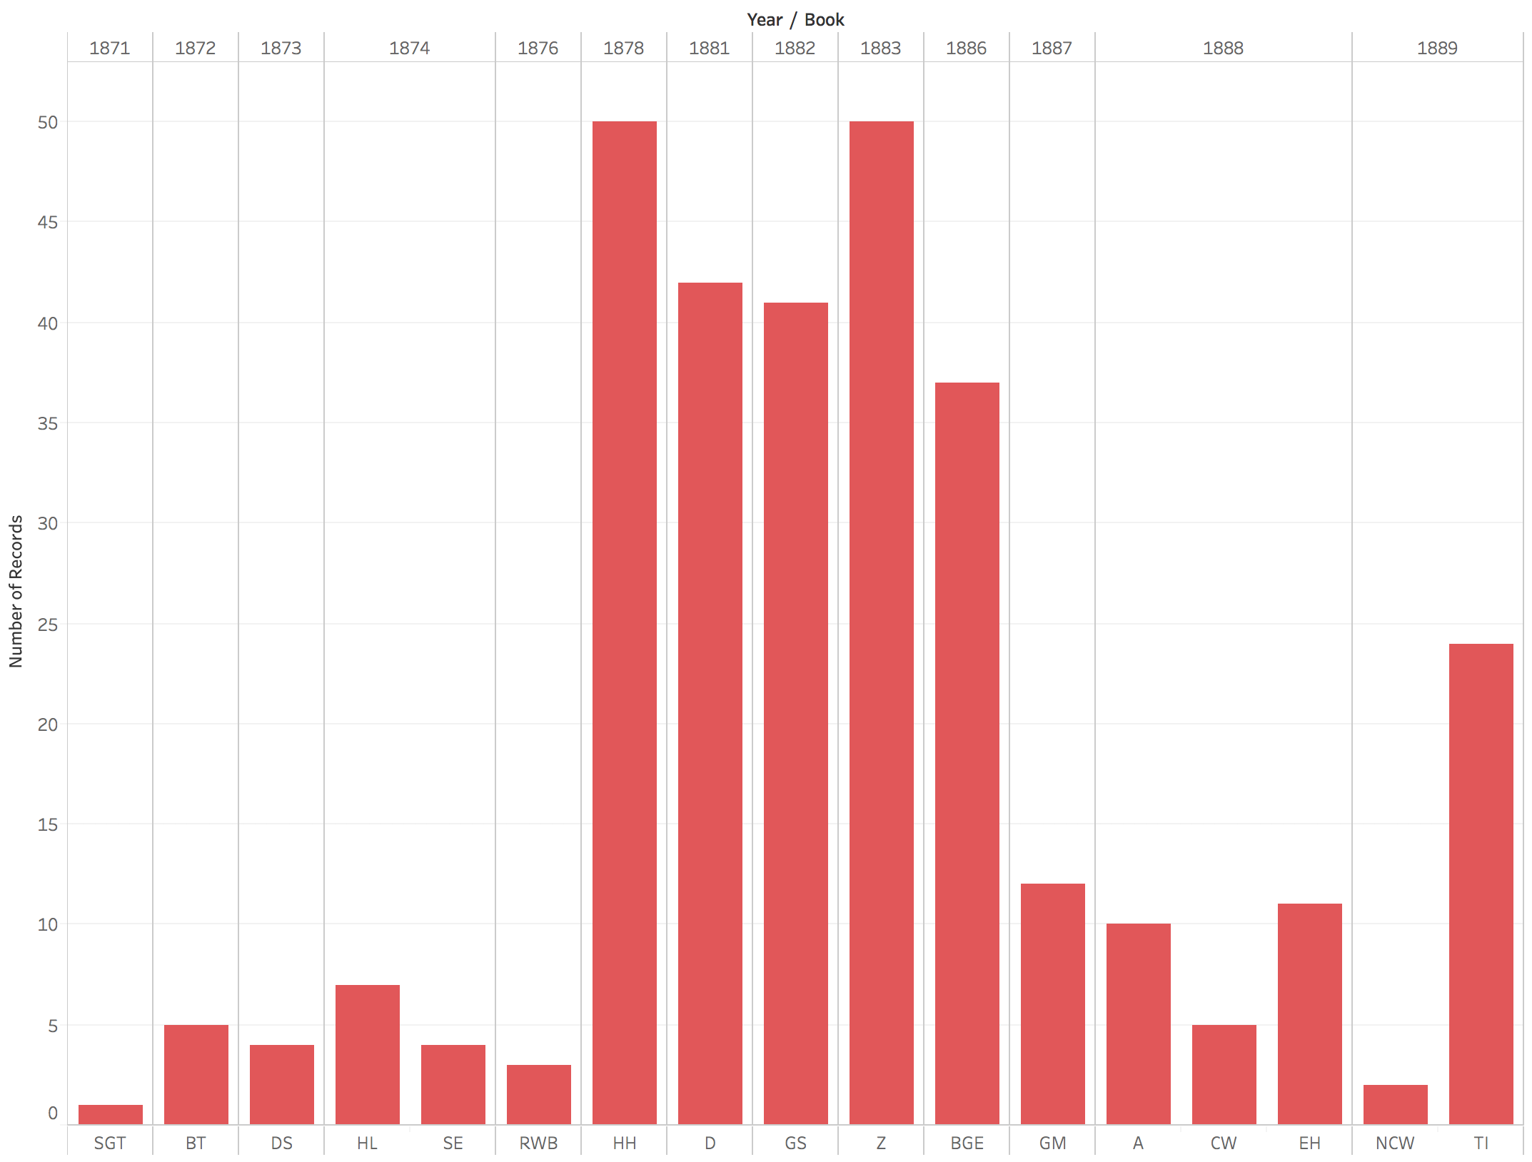

**Figure 11:** virtue treemap



The patterns in Figures 10 and 11 are once again different from those that came before. As Figure 10 shows, Nietzsche started talking of virtue in the free spirit works and continued to do so until 1886 (plus TI in 1889). The discussions of virtue occur during the transition from an emphasis on drives to an emphasis on instincts. Thus, as Figure 11 shows, scholars interested in Nietzsche’s conception of virtue should look to both the free spirit works and the mature works.

Next, consider the timeline and treemap for chastity:

**Figure 12:** chastity timeline

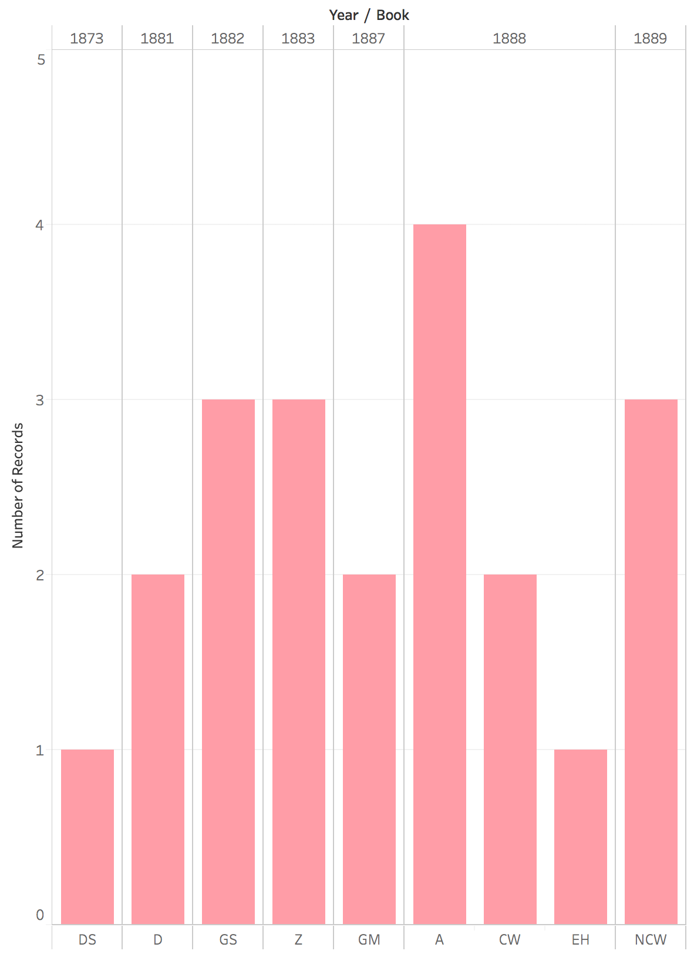

**Figure 13:** chastity treemap



This final pair of single-concept Figures (12 and 13) shows still another pattern. Nietzsche talks of chastity less frequently than the other concepts. Several books have no passages in which it crops up. *The Antichrist* has the most relevant passages, and there are only four of them. By contrast, virtue proper is referenced at least five times in almost every book, and in many books there are over thirty-five relevant passages (HH, D, GS, Z, and BGE). Moreover, whereas virtue is barely discussed in the anti-Wagner books, chastity comes up in them multiple times. Scholars interested in Nietzsche’s differentiation between virtue proper and chastity should therefore look to the anti-Wagner books as well as to A, Z, and GS.

Next, I present visualizations of all concepts together in both timeline (Figure 14) and treemap (figure 15) visualizations. These visualizations allow us to see everything at once. In addition, they make it possible to see what proportion of the relevant passages in a given text refer to a particular concept. This is important because the number of sections in a given book is highly variable. For example, HL is arranged in ten long sections, whereas A has sixty-two numbered sections plus a preface and a concluding “Law against Christianity.” In addition, not every passage in each book – regardless of the total number of passages – contains a section that refers to drive, instinct, virtue, or chastity. Some books demonstrate relatively little engagement with the concepts under study, others much more. Graphing everything together enables us to see this.

**Figure 14:** all concepts timeline

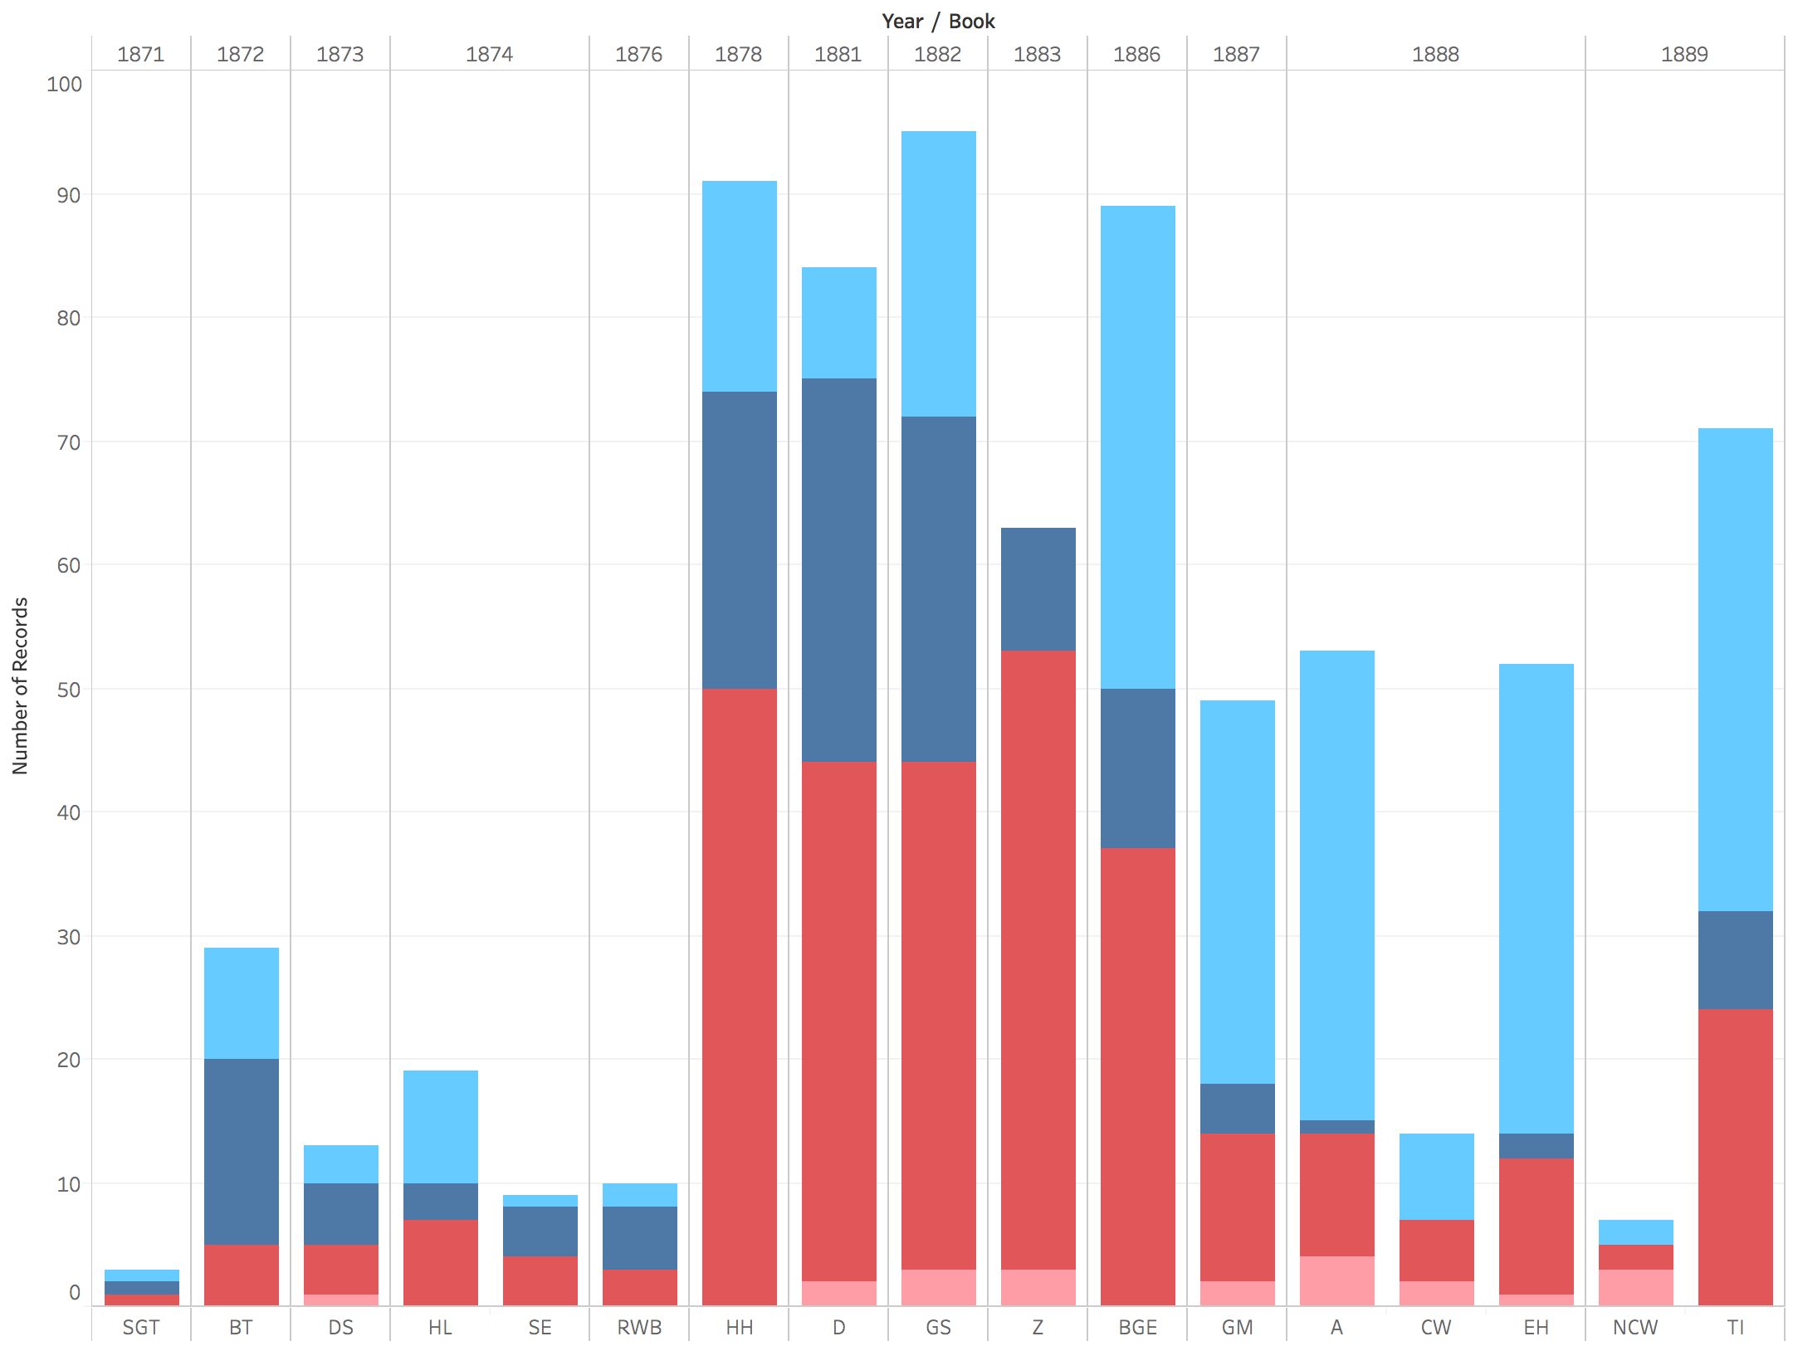

**Figure 15:** all concepts treemap

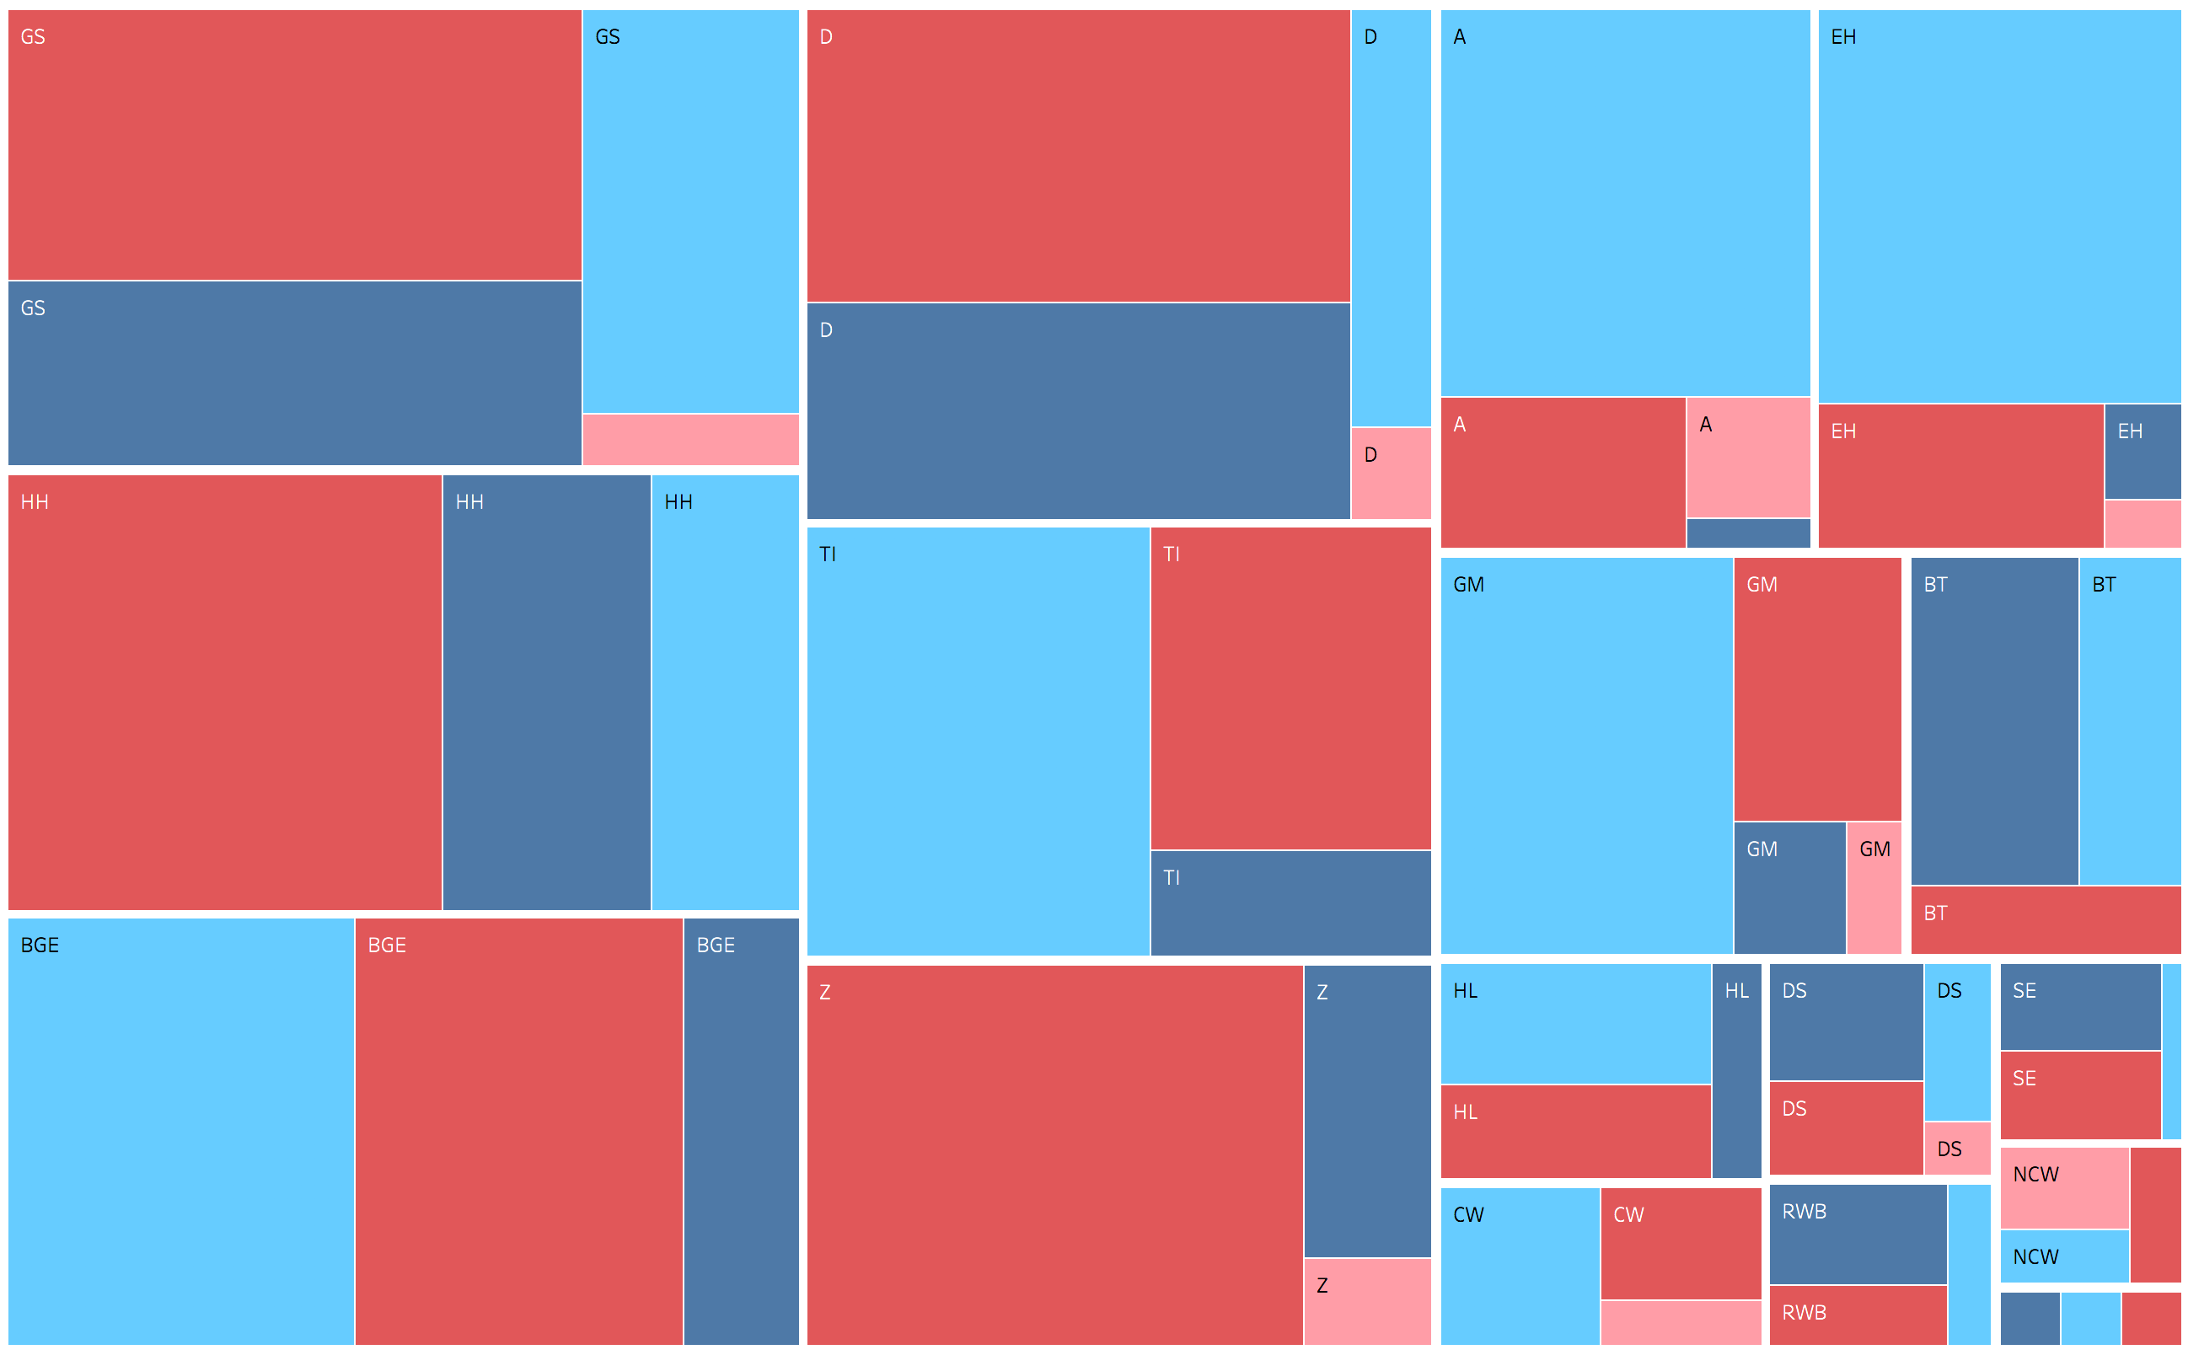

As Figure 14 shows, Nietzsche’s engagement with concepts of interests begins in earnest with HH and continues – with the exception of the anti-Wagner books – to the end of his career. The replacement of drives with instincts is even clearer in this figure, which shows that the sum total of passages that refer *either* to drives or to instincts remains relatively stable while the proportion shifts decisively from drives to instincts. The treemap in Figure 15 also makes it easy to see the relevant proportions of engagement on a book by book basis. For example, BGE engages most with instincts, virtues, and drives (in that order) without once mentioning chastity. By contrast, GS engages most with virtues, followed by drives, instincts, and chastity. The only books in which drives receive the most engagement are BT, DS, and RWB (SE is a tie), and the only book in which references to chastity predominate is NCW.

Next, I present an example of a section-by-section visualization (Figure 16) of relevant concepts within a single book (A).[4]

**Figure 16:** all relevant passages from A

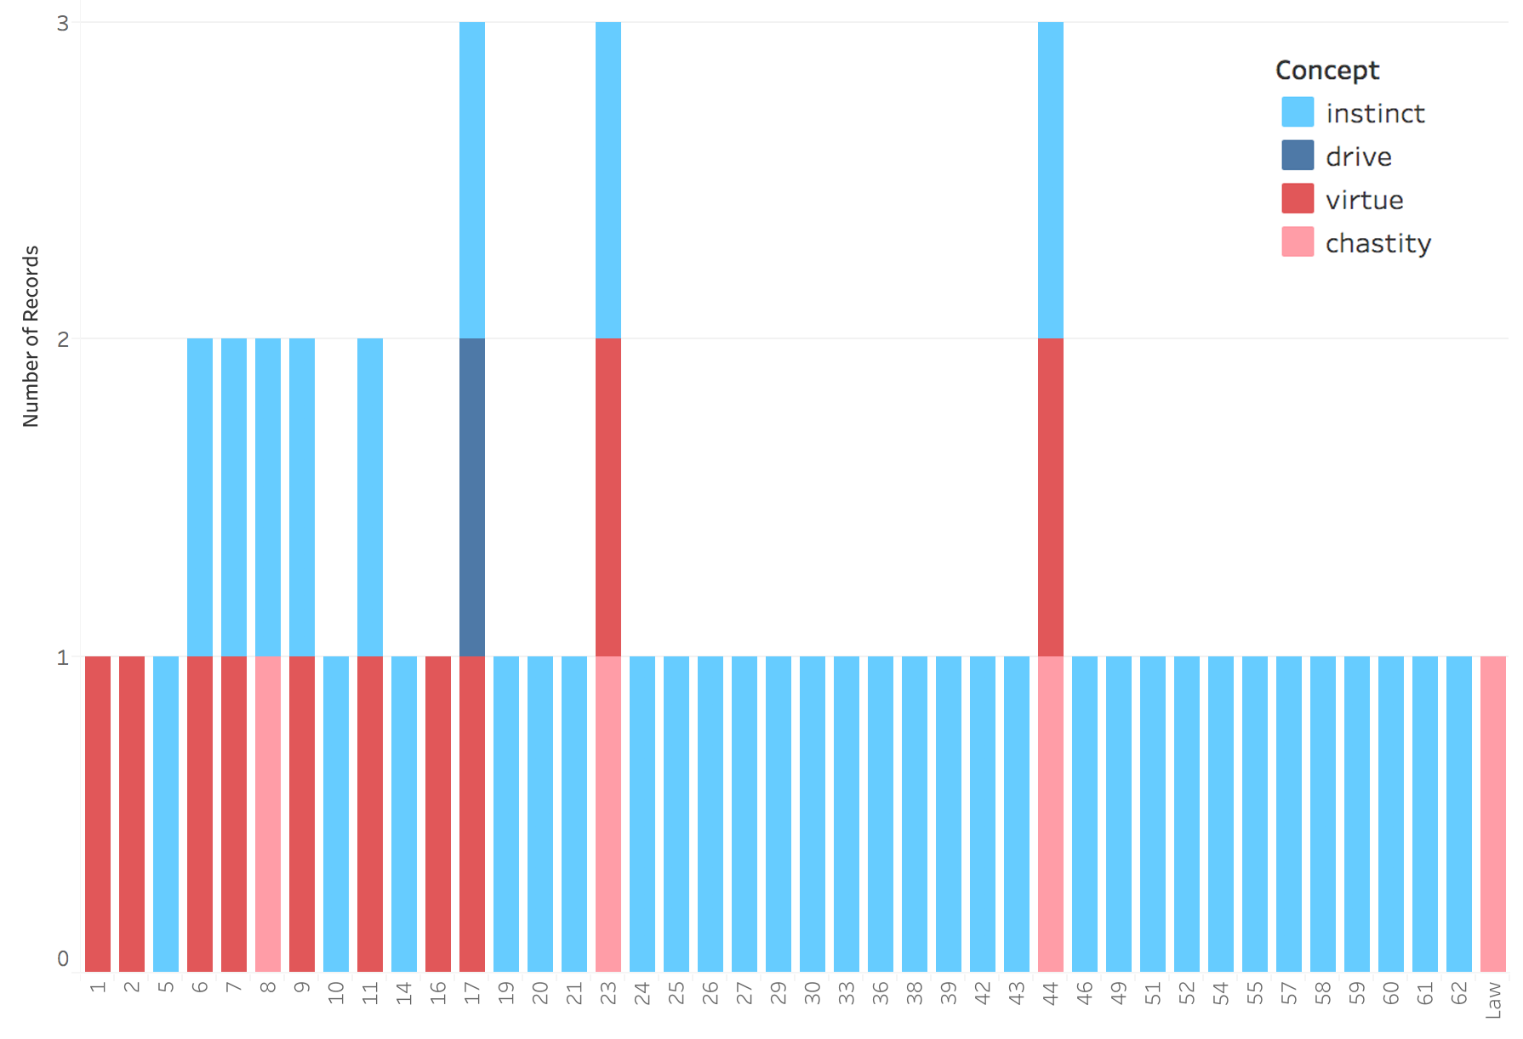

In the interactive version of this visualization online, it is possible to see a similar graph for each book under study. This figure shows that, in A, Nietzsche engages with instinct throughout, whereas he addresses virtue primarily in the first seventeen sections. Drives are mentioned only once (section 17), and chastity crops up three times in the same passage as instinct (sections 8, 23, and 44), two of which also refer to virtue (23 and 44). This sort of analysis allows us to see both the order in which various concepts crop up within a book and what Nietzsche also talks about when he talks about one of the concepts under study.

Finally, consider Figure 17, which maps the overlaps among the concepts under study.

**Figure 17:** Venn diagram of Nietzsche’s use of drive, instinct, virtue, and chastity. Numbers represent the number of passages in which a combination of concepts is discussed.

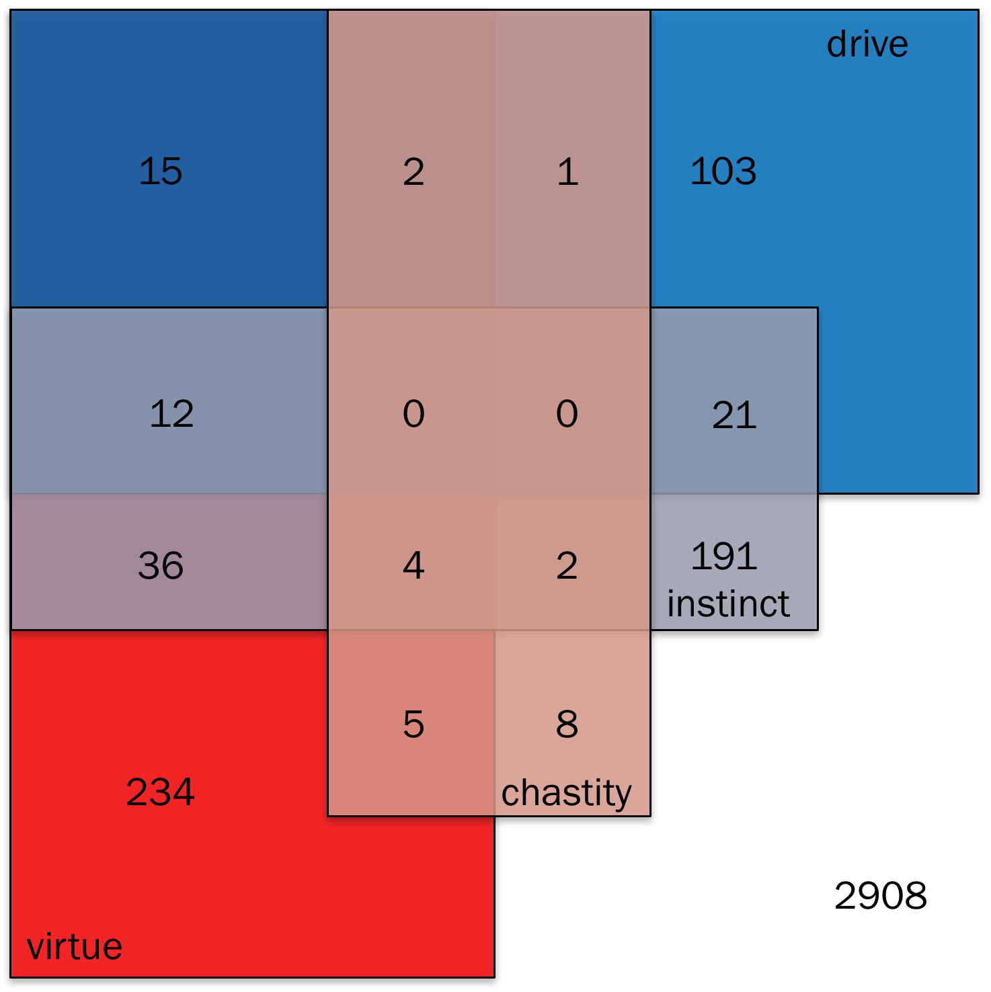

Figure 17 is a Venn diagram, which Tableau Public does not support, so I constructed it manually. In addition, this Venn diagram represents four sets, which makes it tricky to read. I’ll therefore walk through it starting with the cells with the least overlap and moving to those with the greatest overlap. There are 2908 passages in which none of the concepts under study occurs. There are 234 passages in which virtue but none of the other concepts is referenced. Along the same lines, there are 8 chastity-only passages, 191 instinct-only passages, and 103 drive-only passages. Next, consider the “doubles” – passages in which exactly two concepts are referenced. Virtue and chastity occur together in 5 passages, virtue and instinct in 36, virtue and drive in 15, chastity and instinct in 2, chastity and drive in 1, and instinct and drive in 21. Finally, consider the “triples” (there are no quadruples): virtue, chastity, and instinct in 4; virtue, instinct, and drive in 12; virtue, chastity, and drive in 2; and chastity, instinct, and drive in 0. In the next section, I will focus on the doubles and triples, since these are the passages most likely to indicate how the concepts under study are related in Nietzsche’s thinking.

**Interpretation**

Visualizations are food for thought. They do not do the interpretive work themselves. Nevertheless, by providing a synoptic view of the texts to be interpreted, they can guide our reading. In this section, I offer an interpretation of the “double” and “triple” passages in HH through TI (excluding the anti-Wagner works).

Before that, however, I should emphasize a point that is already clear from Figure 17: Nietzsche is significantly more likely to refer to one of the concepts under study if he also refers to at least one of the other three. Consider virtue by way of example. There are 3542 total passages in the works under consideration, of which 308 refer to virtue. The probability that a randomly selected passage will refer to virtue is therefore 308/3542 = 8.696%. There are 400 passages that refer to drives, instincts, or chastity, of which 74 also refer to virtue. The conditional probability that a randomly selected passage that refers to at least one of the other concepts will also refer to virtue is therefore 74/400= 18.500%. The discrepancies are similar for the other concepts. The prior probability of a passage referring to chastity is 22/3542 = .621%, while the conditional probability of a passage referring to chastity given that it refers to at least one of the other three concepts is 2.234%. The prior probability of drive is 4.348%, while the conditional probability is 9.605%. And the prior probability of instinct is 7.510%, while the conditional probability is 16.930%. Generalizing, the probability of one of these terms occurring in a passage is more than doubled if at least one of the other terms occurs in the same passage. Not to put too fine a point on it: these concepts are strongly related in Nietzsche’s thinking.

Determining more precisely how they are related, however, demands close-reading that is attentive to the possibility of changes in Nietzsche’s view from the free spirit works to the mature works, alertness to his use of irony and sarcasm, and an eye to the linguistic context in which a term crops up. As we will see below, in his late works Nietzsche sometimes puts ‘virtue’ in derisive scare quotes and distinguishes it from *virtú*, which enjoys his approbation. In the same vein, he sometimes simply says that something *is* a virtue; other times, he says it *counts as* a virtue or *is called* a virtue.

With these caveats in mind, I present my interpretation of the double- and triple-concept passages. My first claim is that, in Nietzsche’s framework, *both instincts and virtues are subsets of drives: instincts are innate, whereas drives can be either innate or acquired; virtues are well-calibrated, whereas drives can be either well- or poorly calibrated*. (What exactly calibration amounts to will emerge in the following pages.) I begin with HH I.99, which suggests that instincts overlap with both drives and virtues: “Morality is preceded by *compulsion*, indeed it is for a time itself still compulsion [….] Later it becomes custom, later still voluntary obedience, finally almost instinct: then, like all that has for a long time been habitual and natural, it is associated with pleasure – and is now called *virtue*.” Note that Nietzsche here says that morality becomes “almost” instinct. I suggest that this is because, at least according to this passage, it is acquired rather than innate.

Turning to *Daybreak*: in D 26 Nietzsche argues that, “The beginnings of justice, as of prudence, moderation, bravery – in short, of all we designate as the *Socratic virtues*, are *animal*: a consequence of that drive which teaches us to seek food and elude enemies.” Virtues are here consequences of drives. Their adaptiveness (in pursuit of nutrition and security) makes them virtues. Such adaptiveness is one aspect of what I mean by a drive’s being well-calibrated. Next, in D 30, which is titled “*Refined cruelty as virtue*,” Nietzsche argues that many virtues, including chastity, are expressions of a drive to distinction. People try to distinguish themselves, he argues, as superior on some dimension valued by others in their community. Humility, kindness to animals, artistry, and chastity are all interpreted as “variations” on the “theme” of aiming to incite envy in others, but this aim is not consciously available to those who manage to distinguish themselves in this way because it is inherited – “thoughts are not hereditary, only feelings.” Thus, a biologically inherited drive (an instinct) can manifest or express itself as a virtue, and which virtue it manifests or expresses as depends in part both on the agent and on the social context (which dimensions one can be seen as excelling at, thereby inciting envy).

Next, in GS 1, Nietzsche claims that all action is ultimately guided by the instinct (he also calls it a drive) to preserve the species.[5] This makes it clear that some instincts are also drives. In addition, he says that drives that “*might* have harmed the species” have probably “become extinct many thousands of years ago,” suggesting that he considers at least some drives (the ones he calls instincts) biologically heritable. Just a few sections later, in GS 8, Nietzsche half-jokingly equates “unconscious virtues” with “instinctive morality.” This passage suggests that some dispositions that count as virtues are also instincts. Later (GS 123), he says that in antiquity the dignity of scientific inquiry, which he glosses as the “scientific drive” was “diminished by the fact that even among [science’s] most zealous disciples the striving for *virtue* took first place, and that one thought one had given knowledge one’s highest praise when one celebrated it as the best means to virtue. It is something new in history that knowledge wants to be more than a means.” As I argue in Alfano (2013a; see also Reginster 2013), what Nietzsche has in mind here is that the scientific drive that unites curiosity, intellectual courage, and honesty has come to be considered an end in its own right, at least for and by certain types of people.

Moving on to BGE 199, Nietzsche here says that the “herd man” glorifies his own herd-instinct and related “attributes, which make him tame, easy to get along with, and useful to the herd, as if they were the truly human virtues: namely, public spirit, benevolence, consideration, industriousness, moderation, modesty, indulgence, and pity.” Once again, an instinct is counted or treated as a virtue, at least by and for certain types of people. The hint in this passage, of course, is that other instincts which would suit someone to commanding rather than obeying might also be virtues (for and by other types – a point to which I return below). Just two sections later, Nietzsche refers to dispositions to “consideration, pity, fairness, mildness, reciprocity” as drives that, starting with Christianity, “receive the honorary designation of ‘virtues’.” It is especially clear in this passage that what counts as a virtue simply is a drive that possesses or is taken to possess certain special properties (in this case and several others, such as GS 21 and GS 116, serving and protecting the herd).

Turn next to *The Antichrist* and *Twilight of the Idols*. In the former, Nietzsche asks, “What is happiness?” and answers his own question with, “The feeling that power is *growing*, that some resistance has been overcome. *Not* contentedness, but more power; *not* peace, but war; *not* virtue, but prowess (virtue in the style of the Renaissance, *virtú*, moraline-free virtue)” (A 2; see also EH Clever 1). As I mentioned above, Nietzsche here distinguishes between virtue and *virtú*, and he associates the latter with the expression of the drive he calls “will to power” (Reginster 2006, p. 127). The implication is that what have been considered virtues in the Christian tradition are somehow counterfeit because they, unlike *virtú*, do not adequately express will to power. In A 9, Nietzsche goes on to declare “war” on the “theologian instinct” that, through a “faulty optic” is “made into a morality, a virtue, a holiness.” Finally, in TI Skirmishes 37, Nietzsche equates the “loss of any hostile instincts” with “modern ‘virtues’,” which are “conditioned and *prompted* by weakness” – that is, by atrophied drives and instincts.

I hope that the foregoing has established that, for Nietzsche, instincts and virtues are subsets of drives. But what exactly is a drive? This brings me to my second main interpretive claim: *drives are standing motivational dispositions to token actions of a particular type*. When they are also instincts, such drives are biologically given (because innate); when they are not instincts, they are part of what Nietzsche sometimes calls “second nature” (*zweite Natur*, cf. HL 3, HL 4, D 38, D 455). If this is right, then drives are importantly different from desires. Desires are individuated by the goals towards which they motivate us; they are teleological. If I want to eat chocolate ice-cream, then no matter what other actions I take, if I haven’t eaten the ice-cream I won’t be satisfied. Drives are not teleological in this way. As long as the agent performs an action of the relevant type, the drive is satisfied (for now), even if no goal is attained. Drives are also importantly different from preferences: preferences construct a rank ordering of states of affairs. To have a preference, someone must prefer state of affairs X to state of affairs Y. Someone’s preferences are satisfied, then, to the extent that the actual state of affairs ranks high in her preference ordering. This could happen through an exercise of her agency, but it needn’t (unless she specifically prefers to exercise agency). Drives are not even potentially passive in this way: they motivate the tokening of actions of a particular type, the exercise of agency.

In this view, I am largely in agreement with Katsafanas (2013b, 2016) and Reginster (2006); I have also argued for a related position in Alfano (2010, 2013b). I will therefore support this interpretation only with a few passages that turn up as either double- or triple-concept passages in the analysis conducted specially for this chapter. In BGE 189, Nietzsche claims that temporarily starving a drive purifies and sharpens it. What do these metaphors of starving, purifying, and sharpening amount to? Starving seems to refer to blocking or forbidding the most natural way of expressing the drive (the path of least resistance), whereas purification and sharpening refer to the ways in which the drive nevertheless finds expression in some other, less easily-recognized and/or -accomplished way. According to Nietzsche, this explains the paradox of “why it was precisely during the most Christian period of Europe and altogether under the pressure of Christian value judgments that the sex drive sublimated itself into love (*amour-passion*).” The idea seems to be that, forbidden expression through carnal intercourse, the sex drive did not disappear or dissipate, but instead found a new way to express itself as passionate love. If the sex drive were a desire, then *amour-passion* would not satisfy it. Likewise, if it were a preference for worlds in which the agent has sex over those that are otherwise similar but in which the agent does not have sex, then *amour-passion* would not satisfy it. But if, as I contend, it is a standing motivational disposition to token actions of a particular type, then Nietzsche’s solution to the paradox begins to make sense.

In both BGE and GM, Nietzsche makes the same kind argument about aggressive drives – in both cases referring to the way in which their expression changes after the shift from a Hobbesian state of nature to society and the “straitjacket” of norms and rules it imposes on people (GM II.2). “After the structure of society is fixed on the whole and seems secure against external dangers,” he claims, “strong and dangerous drives, like an enterprising spirit, foolhardiness, vengefulness, craftiness, rapacity, and the lust to rule, which had so far not merely been honored insofar as they were socially useful […] but had to be trained and cultivated […] are now experienced as dangers” (BGE 201). Indeed, they are “doubly dangerous, since the channels to divert them are lacking.” The supposition here is that aggressive drives, lacking an opportunity for discharge in action against an external enemy, will be “diverted” from their usual “channels” onto members of the society. This is what I mean by a drive’s finding expression in alternative ways when the most natural manner of expression is no longer available. Nietzsche makes a similar claim about aggressive drives in GM II.16: with the establishment of society, he says,

suddenly all [people’s] instincts were disvalued and ‘suspended.’ […] in this new world they no longer possessed their former guides, their regulating, unconscious and infallible drives: […] at the same time the old instincts had not suddenly ceased to make their usual demands! Only it was hardly or rarely possible to humor them: as a rule they had to seek new and, as it were, subterranean gratifications.

This susceptibility to displacement from usual “channels” is one of the main reasons why drive-motivated actions sometime seem irrational from a consequentialist point of view. Consequentialist analysis – at least the simple-minded variety available in Nietzsche’s day – treats the exercise of agency as irrelevant: as long as my preferences are satisfied, I should be happy.[6] Nietzsche’s insight is that human animals aren’t accurately characterized by simple-minded consequentialism because we embody drives that sometimes lead us to act in ways that undermine the satisfaction of our own preferences.

Nietzsche is aware that such actions can be disastrous and criticized as unreasonable (GS 21, TI Socrates). But why not, when faced with such unreasonableness, just modify one’s drives? At first blush, it might seem that someone with a catastrophe-prone drive could just redirect it (modifying the extension of the type of actions to which it motivates her), down-regulate it (making it require fewer or less extreme expressions), or expunge it (eliminating it altogether). People seem to be able to modify their desires and preferences in light of information and feedback – why not drives?

This brings us to my dispute with Brian Leiter about what he calls the “Doctrine of Types,” according to which, “Each person has a fixed psycho-physical constitution, which defines him as a particular *type* of person” (Knobe & Leiter 2007; Leiter 2002, 2007, 2013), where drives and instincts are key determinants of this psycho-physical constitution. As I show in Alfano (2015a), Leiter’s interpretation of Nietzsche is hopeless. Nietzsche recognizes over and over again that a person’s drives can and do change. In D 38, he says that drives “evolve.” In D 109, he catalogues six methods for modulating one’s own drives. In GS 296, he argues that “it is still today most expedient for everyone to *act* as if his character and occupation are unchangeable, even if basically they are not,” then goes on to make it clear that character comprises the agent’s drives, including both their virtues and their vices. In A 6, he says that animals (very much including human animals) can lose their instincts; he labels such a loss corruption and decadence (see also EH Wise 4; TI Socrates 4-11), and it occupies his attention throughout the book (e.g., A 7, A 17, A Skirmishes 39).

So, if someone’s drives can and do change over the course of their lifetime – sometimes even in response to their own intentional intervention on their psychic economy – what is the problem? The problem is that Leiter is half-right: drives do change in all of the ways mentioned above, but not easily and not without limit. As early as HL, Nietzsche insists that people have types (Jensen 2016), and that a person’s type constrains the psychology that she can develop. To make sense of this idea, I here borrow and modify the capabilities approach (Sen 1985). Sen develops this approach by starting with the notion of a *functioning*, which is a way of doing or being, such as reading. He then defines a *functioning vector* as the set of functionings a person actually achieves (e.g., not just reading but also eating, walking, not being sick, etc.) and a *capability* as the power to exercise a functioning (e.g., literacy). A person’s *capability set* is then the set of functioning vectors within that person’s reach. Sen emphasizes that a person’s capability set is constrained both by their current psychology and by their material and social environment. We can build a Nietzschean version of this framework starting from the notion of an *action-type*. As I argued above, a *drive* is a standing motivational disposition to token actions of a given type; for example, all tokens of aggressing are associated with the aggressive drive, and all tokens of inflicting suffering are associated with the cruel drive. We can then define a *drive vector* as the set of drives a person actually embodies. Finally, define a *drive set* as the set of drive vectors within a person’s reach. This, I claim, is what Nietzsche means by a *type*: a type is just a drive set. And, just like a capability set, a person’s drive set is constrained both by their current psychology and by their material and social environment.

If this is right, then Leiter is correct to insist that a person’s type limits the kind of person she can become but wrong to insist that every element of the type is immutable. Here are some passages that support my interpretation: in D 38, Nietzsche says,

The same drive evolves into the painful feeling of *cowardice* under the impress of the reproach custom has imposed upon this drive: or into the pleasant feeling of *humility* if it happens that a custom such as the Christian has taken it to its heart and called it *good*. That is to say, it is attended by either a good or a bad conscience!”

He goes on to say that drives develop differently, as “second nature,” depending both on internal psychological pressures (“it enters into relations” with other “drives”) and on social pressures (it is associated with “a quality of beings the people has already evaluated and determined in a moral sense”). Likewise, in GS 296, Nietzsche claims that society esteems the pretense that character is unchangeable, and that

Such esteem, which blooms and has bloomed everywhere alongside the morality of custom, fosters ‘character’ and brings all change, re-learning, and self-transformation into *ill repute*. […] How hard living is when one feels the judgments of many millennia against and around oneself!”

It is difficulty to embody drives that meet with sanction from one’s community, and even more difficult to flourish while doing so.[7] In GS 359 (see also A Skirmishes 34), Nietzsche writes, “Fear of spirit [Geist], revenge of spirit – oh how often have these powerful [*triebkräftigen*] vices become the roots of virtues! Indeed, *become* virtues!” In the passage, it is clear that the development of virtues from vices (both of which are characterized as expressions of the same drive or instinct) is determined by both social influence and the internal psychic economy of the agent’s drives. In GM III.9, Nietzsche urges his reader to

Draw up a list of the various drives and virtues of the philosopher – his drive to doubt, his drive to deny, his drive to suspend judgment (his ‘ephectic’ drive), his drive to analyze, his drive to investigate, seek, dare, his drive to compare and balance, his will to neutrality and objectivity, his will to every ‘*sine ira et studio*’.

Doing so should make it “clear that for the longest time all of them contravened the basic demands of morality and conscience [… and] that if a philosopher *had* been conscious of what he was, he would have been compelled to feel himself the embodiment of ‘*nitimur in vetitum*’ – and consequently *guarded* against ‘feeling himself, ‘against becoming conscious of himself? […] All good things were formerly bad things; every original sin has turned into an original virtue.” Once again, the drives associated with a type develop and express themselves differently depending on the social context – especially the evaluative and moral attitudes of the community – of the agent who embodies them.

This brings us to what I’ve elsewhere (Alfano 2015a) called Nietzsche’s *person-type-relative unity of virtue* thesis, according to which a person’s flourishing is a matter of developing and acting from particular drives that fit both the type she embodies and the material and social environment in which she finds herself. This is what I meant above by a drive’s being “well-calibrated.” If someone attempts to embody drives that result in catastrophe, are outside her drive set (incompatible with her type), or meet with intense social and moral disapproval, she will not turn out well. Different people have different types, which means that some people will find it easier to embody virtue in one social context while others will find it easier to do so in another context. Thus, both internal (type-dependent) and external (social) factors conspire to determine whether someone’s drives are or count as virtues. I suggest that, for Nietzsche, a drive merely counts as a virtue if it meets with approbation from the agent’s community, whereas a drive is a virtue if it not only is approved but also fits the agent’s type.

This view is supported by many passages. For instance, in Z Chastity, we read “In some people chastity is a virtue, but in many it is almost a vice,” and what determines this is the agent’s drive set. In BGE 206, Nietzsche asks, “what is the scientific man?” and answers,

a type of man that is not noble, with the virtues of a type of man that is not noble, which is to say, a type that does not dominate and is neither authoritative nor self-sufficient: he has industriousness, patient acceptance of his place in rank and file, evenness and moderation in his abilities and needs, an instinct for his equals and for what they need.

Leave aside the question of nobility: the point here is that Nietzsche identifies a type (“the scientific man”) and catalogues a set of drives and instincts that fit the type and therefore are virtues for someone of that type. In the next section, he says, “*ideal* scholar in whom the scientific instinct […] blossoms and blooms […] has to pay for these virtues,” which include “meeting every thing and experience halfway, the sunny and impartial hospitality with which he accepts everything that comes his way, his type of unscrupulous benevolence, of dangerous unconcern about Yes and No.” Once again, Nietzsche identifies a type (the “ideal scholar”) and catalogues a set of drives and instincts that fit the type and therefore count as virtues for someone of that type. Later, in BGE 224, he does the same thing for “men of the ‘historical sense’,” which he equates with historical *instinct*: “we also have our virtues; that cannot be denied: we are unpretentious, selfless, modest, courageous, full of self-overcoming, full of devotion, very grateful, very patient, very accommodating.” Next, in GM III.8, Nietzsche distinguishes between cases in which poverty, humility, and chastity are ‘virtues’ (in derisive scare quotes) and cases in which they are “the most appropriate and natural conditions of [their bearers’] *best* existence, their *fairest* fruitfulness.” In the latter cases, the “dominating instinct” of the agent is a kind of “spirituality” which overrules other instincts and drives such as pride, sensuality, and liberality. The chastity of such people is not motivated by “ascetic scruple or hatred of the senses” but rather by a kind of spiritual “fruitfulness.” In A 11, Nietzsche again uses derisive scare quotes to distinguish between type-appropriate and type-inappropriate dispositions:

A virtue needs to be our *own* invention, our *own* most personal need and self-defense: in any other sense, a virtue is just dangerous. Whatever is not a condition for life *harms* it: a virtue that comes exclusively from a feeling of respect for the concept of ‘virtue’, as Kant would have it, is harmful.

Finally, inTI Socrates 11, he claims that, “as long as life is *ascending*, happiness is equal to instinct,” and in TI Errors 2, he says, “someone who has turned out well, a ‘happy one’, *has to* perform certain acts and will instinctively avoid others, he is the physiological representative of the system he uses in dealing with people and things. In a word: his virtue is the *effect* of his happiness [rather than vice versa].”

It’s not entirely clear what social conditions are needed for a drive that fits a person’s type to constitute a virtue. Broadly speaking, Nietzsche seems to think that the possession and expression of the drive must not meet with intense social and moral disapproval and sanction from the agent’s community, especially when such disapproval is liable to be internalized as bad conscience. His interpretation or diagnosis of the type of the criminal (*Verbrecher*) demonstrates this much. For instance, in D 202 (see also 204), Nietzsche says that the criminal suffers from “a burdensome *tyrannical drive*” which could potentially be cured via “extinction, transformation, [or] sublimation.” Likewise, in Z Tree, the young man feels like a criminal because his drives are condemned by his community. Most decisively, in TI Skirmishes 45, we read:

The criminal type, this is a strong type of person under unfavourable conditions, a strong person made ill. He needs a wilderness, a nature and form of existence that is somehow freer and more dangerous; this is where all the arms and armour of a strong person’s instincts *rightfully belong*. His *virtues* are ostracized by society; his liveliest drives quickly fuse with depressive affects, with suspicion, fear, dishonor. If we generalize from the case of the criminal: we can imagine beings who, for some reason, lack public approval, who know that they are not seen as beneficial or useful, – that Chandala feeling that you are not seen as equal but as excluded, unworthy, polluted. All creatures like this have a subterranean hue to their thoughts and actions. […] All innovators of the spirit have at some point had that pale and fatalistic sign of the Chandala on their foreheads: *not* because they were seen this way, but rather because they themselves felt a terrible gap separating them from everything conventional and honourable.”

As I mentioned above, it is not clear whether, for a drive to be a candidate virtue, it must meet with a specific form of social approval or just *not* meet with disapproval that is liable to be internalized. Nietzsche is certainly committed to the latter position, but he may also be committed to the former.

I conclude this section by briefly comparing the conception of virtue elaborated here to other well-known conceptions. According to Aristotle, virtues are acquired dispositions; for Nietzsche they can be either innate (instincts) or acquired (other drives). In this way, Nietzsche is closer to Mengzi, who held that each human is born with four “sprouts” that naturally grow, under suitable conditions, into virtues. However, unlike Mencius, Nietzsche’s view is not about sprouts but about drives, and he does not think that everyone has the same drive set or type. Finally, according to Hume, virtues are dispositions that meet with approbation from the general point of view; for Nietzsche, virtues must meet with approbation (or at least not disapprobation that gets internalized) from a smaller actual community, and they must also fit the agent’s type (her drive set).

**Conclusion**

In this brief section, I articulate some of the limitations of the digital humanities method employed in this chapter. Next, I point to future directions in Nietzsche scholarship that could benefit from this method. I conclude with a few broader remarks about the use of digital humanities methods in history of philosophy.

As I mentioned in the methodology section, my approach is liable to miss some relevant passages and tag as relevant passages that are actually irrelevant. For example, while I captured all passages that contain a word starting with ‘trieb’, I missed passages that contain a word starting with ‘antrieb’. Prefixes are trickier than suffixes. More generally, I ended up ignoring many passages that contain words that express concepts that arguably should have been included in the analysis, such as affect [*Affekt*], will [*Wille*], power [*Macht*], vice [*Laster*], and character [*Charakter*]. This is why I pointed out from the start that the first and perhaps most important step is to select the core concepts to study, and to do so explicitly so that the results are criticizable and corrigible. Future research can and should expand on the work in this chapter to include these and probably other concepts. What it should not do is engage in reckless and overblown readings of Nietzsche’s entire corpus that depend on a single, idiosyncratically-chosen passage (e.g., HH 95 for Swanton 2015, BGE Preface for Clark & Dudrick 2012). There are 3542 passages in Nietzsche’s entire published and authorized corpus. If Nietzsche scholarship is to advance, we need to read and relate these passages systematically.

Because he wrote in short, numbered sections, Nietzsche’s works are especially amendable to the kind of visual analytics employed in this chapter. That said, similar methods could be adapted to the textual structures used by other philosophers. For instance, Plato and Aristotle could easily be visualized in this way based on Stephanus pagination and Bekker numbering, and Aquinas helpfully organized the *Summa Theologiae* into parts, questions, and articles. When such standardized numbering is unavailable, it is of course possible just to divide the text in question into paragraphs or sentences – or to use a “window” of *n* words as explained above. Contemporary psychology and medical science face crises of replication. For digital humanities of the history of philosophy to avoid such a crisis, it must use rigorous, criticizable, corrigible, and reproducible methods.

**References:**

Alfano, M. (2010). The tenacity of the intentional prior to the *Genealogy*. *Journal of Nietzsche Studies*, 40: 123-40.

Alfano, M. (2013a). The most agreeable of all vices: Nietzsche as virtue epistemologist. *British Journal for the History of Philosophy*, 21(4): 767-90.

Alfano, M. (2013b). Nietzsche, naturalism, and the tenacity of the intentional. *Journal of Nietzsche Studies*, 44(3): 457-64.

Alfano, M. (2015a). An enchanting abundance of types: Nietzsche’s modest unity of virtue thesis. *Journal of Value Inquiry*, 49(3): 417-35.

Alfano, M. (2015b). How one becomes what one is called: On the relation between traits and trait-terms in Nietzsche. *Journal of Nietzsche Studies*, 46(1): 261-9.

Alfano, M. (2016). Review of Christine Swanton’s *The Virtue Ethics of Hume and Nietzsche*. *Ethics*, 126(4): 1120-4.

Alfano, M. (2017). A schooling in contempt: Emotions and the *pathos of distance*. In P. Katsfanas (ed.), *Routledge Philosophy Minds: Nietzsche*. Routledge.

Annas, J. (2017). Which variety of virtue ethics. In D. Carr, J. Arthur, & K Kristjánsson (eds.), *Varieties of Virtue Ethics*. Palgrave.

Austen, J. (1813/2002). *Pride and Prejudice*. Penguin Classics.

Clark, M. & Dudrick, D. (2012). *The Soul of Nietzsche’s* Beyond Good and Evil*.* Cambridge University Press.

Daigle, C. (2006). Nietzsche: Virtue ethics… virtue politics? *The Journal of Nietzsche Studies*, 32: 1-21.

D’Iorio, P. (2010). The digital critical edition of the works and letters of Nietzsche. *Journal of Nietzsche Studies*, 40: 70-80.

Hurka, T. (2007). Nietzsche: Perfectionist. In B. Leiter & N. Sinhababu (eds.), *Nietzsche and Morality*, pp. 9-31. Oxford University Press

Jensen, A. (2016). *An Interpretation of Nietzsche’s* On the Uses and Disadvantages of History for Life*.* Routledge.

Katsafanas, P. (2013a). Nietzsche’s philosophical psychology. In J. Richardson & K. Gemes (eds.), *Oxford Handbook of Nietzsche*, pp 727-55. Oxford University Press.

Katsafanas, P. (2013b). *Agency and the Foundations of Ethics: Nietzschean Constitutivism*. Oxford University Press*.*

Katsafanas, P. (2015). Value, affect, and drive. In P. Kail & M. Dries (eds.), *Nietzsche on Mind and Nature*. Oxford University Press.

Katsafanas, P. (2016). *The Nietzschean Self: Moral Psychology, Agency, and the Unconscious*. Oxford University Press.

Knobe, J. & Leiter, B. (2007). The case for Nietzschean moral psychology. In B. Leiter & N. Sinhababu (eds.), *Nietzsche and Morality*. Oxford University Press.

Leiter, B. (2002). *Nietzsche on Morality*. Routledge.

Leiter, B. (2007). Nietzsche’s theory of the will. *Philosophers’ Imprint*, 7(7): 1-15.

Leiter, B. (2013). Moralities are a sign-language of the affects. *Social Philosophy and Policy*, 30(1-2): 237-58.

May, S. (1999). *Nietzsche’s Ethics and His War on ‘Morality’*. Oxford University Press.

Moretti, F. (2013). *Distant Reading*. Verso.

Railton, P. (2012). Nietzsche’s normative theory? The art and skill of living well. In C. Janaway & S. Robertson (eds.), *Nietzsche, Naturalism, & Normativity*, pp. 20-51. Oxford University Press.

Reginster, B. (2006). *The Affirmation of Life*. Cambridge University Press.

Reginster, B. (2013). Honesty and curiosity in Nietzsche’s free spirit. *Journal of the History of Philosophy*, (3): 441-63.

Robertson, S. (2012). The scope problem – Nietzsche, the moral, ethical, and quasi-aesthetic. In C. Janaway & S. Robertson (eds.), *Nietzsche, Naturalism, & Normativity*, pp. 81-110. Oxford University Press.

Sen, A. (1985). Well-being, agency and freedom. *The Journal of Philosophy*, 82(4): 169-221.

Swanton, C. (2015). *The Virtue Ethics of Hume and Nietzsche*. Wiley-Blackwell.

Thomas, A. (2012). Nietzsche and moral fictionalism. In C. Janaway & S. Robertson (eds.), *Nietzsche, Naturalism, & Normativity*, pp. 133-59. Oxford University Press.

White, A. (2001). The youngest virtue. In R. Schacht (ed.), *Nietzsche’s Post-Moralism*, pp. 63-78. Cambridge University Press.

1. Search conducted 23 January 2017.
2. For a full introduction, see D’Iorio (2010). To my knowledge, the only papers to use the Nietzsche Source to comprehensively study Nietzsche’s use of particular words are Alfano (2013a) and Alfano (2017). The complete data-sets for these study as well as the present study are freely available at http://www.alfanophilosophy.com/dh-nietzsche/.
3. Available at <https://public.tableau.com/en-us/s/download>. Tableau Public is a highly intuitive interface that automatically employs best practices in visual analytics.
4. All data, methods, and visualizations (including section-by-section visualizations for the other books) are freely available for perusal and download at <https://public.tableau.com/profile/mark.alfano#!/vizhome/Virtuedriveinstinct/Story1>.
5. This is a view he later rejects, though that does not undermine the association between drives and instincts.
6. More sophisticated consequentialisms, especially Amartya Sen’s (1985) capabilities approach, make it possible to give normative significance to the exercise of agency. Below, I sketch a Nietzschean variant of Sen’s conception of a capability set.
7. This is why Nietzsche sometimes celebrates solitude and getting away from society. Doing so makes life easier for someone whose drives do not meet with social approval and helps them to develop *sperneri se sperni* (HH 137, D 56; cf. Alfano 2017).