Blindsight in monkeys, lost and (perhaps) found
Cowey and Stoerig’s (1995) discovery that Rhesus macaques with visual cortex lesions exhibit reduced visual capabilities strikingly comparable to those of human blindsight patients has been widely interpreted as of great significance for investigations into animal consciousness. One reason blindsight was initially thought to be important to the study of consciousness was because it might help with so-called ‘easy’ problems, such as how visual stimuli are processed, and where in the brain those processes are localized. However, Cowey and Stoerig’s research has also been taken to establish a difference between conscious and unconscious visual awareness in primates. If correct, this finding might offer progress when it comes to puzzlement about the distribution of consciousness in other non-humans, or what Carruthers (1998) calls the “demarcation problem,” and what Tye (2000) calls the “problem of simple minds.” The study of blindsight in monkeys might lead to a general criterion for distinguishing phenomenal experience from non-conscious modes of sensory processing. The idea is that the anatomical and behavioral profile of blindsight could be compared to the neurophysiology of various animals’ visual (and perhaps other perceptual) systems. This could support claims about whether there is something it is like for an animal to be consciously perceiving. There is a case to be made for thinking that a visual system which looks and acts very much like the damaged system of a blindsight subject is probably phenomenally blind as well. We may even find that some animals are “naturally blindsighted” in the broader sense that all of their sensing goes on “in the dark.” (Allen-Hermanson, 2008). However, this ambition must first answer those skeptics who have questioned whether blindsight occurs in non-humans.
Cowey and Stoerig’s method and the common interpretation of their work have been challenged by Mole and Kelly (2006) who contend that the monkeys’ reduced visual capacities are better explained in terms of deficits in visual attention and working memory, not the absence of visual consciousness. Hence, they suggest the results do not support the hypothesis that lesioned monkeys have blindsight. The central aim of this paper is to answer Mole and Kelly’s critique and defend the blindsight hypothesis. Though Cowey and Stoerig’s method is flawed, blindsight nevertheless offers the best explanation of the monkeys’ residual abilities. Mole and Kelly’s hypothesis positing a deficit in attention and working memory is not well-supported by what is known about primate neuroanatomy. However, Cowey and Stoerig’s experimental design can be revised to accommodate their criticism, so that the matter can be resolved empirically.
1. Why Blindsight is Important to the Study of Consciousness
To put this discussion in context, first consider how blindsight might play a role in furthering our understanding of consciousness:
In the case of blindsight, we have a clear difference between conscious vision and unconscious information processing. It seems that if we could discover the physiological and anatomical difference between regular sight and blindsight, we might have the key to analyzing consciousness because we would have a clear neurological distinction between the conscious and unconscious cases” (Searle, 2000, p.571).

Here, Searle is not thinking of the problem of other (non-human) minds, but rather of using blindsight as a tool to help us discover the Neural Correlate of Consciousness (NCC) in humans. He is ultimately skeptical about this strategy’s prospects for contributing to a general theory of (human) consciousness. The problem is that both kinds of persons – the ones with blindsight and the ones with regular sight – are fully conscious in the sense of being “creature conscious,” that is, they are the sort of beings which can lose and regain consciousness, and are consciousness of things being a certain way (Dretske, 1997). Searle concludes: “we cannot investigate consciousness in general by studying the difference between the blindsight patient and the normally sighted patient” (Searle 2000, p.572). I disagree. Such an investigation is possible since we need not assume, as Searle seems to, that creature consciousness is something distinct from the aggregate of the various conscious mental functions including, conscious vision, hearing, conscious pain, conscious planning, among others. It is possible that many – perhaps all – of these has a non-conscious (functionally degraded) analogue to blindsight. If this is so then consciousness “in general” may well yield to conquest-by-division.
This is not idle speculation. Analogues to blindsight have been discovered in other modalities, including “blindtouch” or “numbsense” (Paillard et al., 1983, Rossetti, 2001), blindsmell (Schwartz et al., 1994), and deafhearing (Engelien et al., 2000). Maybe there are phenomenally blind counterparts to all sense modalities. There is even an emotional analogue -- Alexithymia – in which anxiety or fear is provoked by visual threats not consciously apprehended (Lane et al. 1997a, b). Additionally, Searle is begging empirical questions by assuming we will not discover a common explanatory factor showing why any species of mental functioning is conscious, or not. Certainly, a more circumspect interpretation of Searle’s claim is agreeable, insofar as the study of blindsight is only one piece of a larger and ongoing project. So far the possibility that blindsight could be used to develop criteria for solving the demarcation problem remains open.
2. Stoerig and Cowey’s Influence
But now follows a pessimistic thought. While researchers can depend on verbal report in order to establish the presence or absence of consciousness in human subjects, the case with non-humans is obviously much trickier. The investigation of animal consciousness cannot blithely assume the efficacy of communicated instructions and replies. So, the hope that the distinction between blindsight and regular sight can advance our understanding of the distribution of visual consciousness in non-humans faces a difficulty. A routine response is to cite research conducted by Stoerig and Cowey (1995, 1997), which many have taken to show that macaque monkeys with lesions in the striate cortex (this is the area known as V1) have blindsight.
Stoerig and Cowey’s experiments have been influential, and are a primary source for claims about the presence of blindsight in non-humans. Their work has been cited by many authors, including Baars (2001), Carruthers (2005, p.92), Clark (2000, p.31), Crick and Koch (1998), Searle (2000, p.571), Edelman et al. (2005, p.171), and Griffin (2004, p.4). Less well known is that their results are not at all conclusive, as persuasively argued by Mole and Kelly (2006). Mole and Kelly contend that Stoerig and Cowey’s procedure is defective, in that they have only shown that hemianopic monkeys respond differently to different stimuli -- this hardly clinches the case that they are using blindsight to locate visual stimuli – for that, it would have to be shown that there is a dissociation between blind and conscious processing in response to one and the same stimulus within a common experimental context. Perhaps instead the monkeys’ failure to respond in certain cases is because they have failed to notice a stimulus, not because they have blindsight. Mole and Kelly’s critique has important ramifications for investigations into consciousness, blindsight, and the extent of human-primate homologies.
I accept that Mole and Kelly show that Stoerig and Cowey’s experiments do not, by themselves, support the conclusion that their partially destriated monkeys have blindsight. On the other hand, Mole and Kelly’s hypothesis is implausible on anatomical and other grounds. It is, for example, doubtful that damage to the striate cortex is the right place to locate a deficit in working memory, as I will explain further on. The neurophysiological and behavioral similarities between human blindsight subjects and destriated monkeys suggest that Stoerig and Cowey are on the right track. But their procedure needs to absorb Mole and Kelly’s criticism. In order to show that the monkeys are using blindsight, a revised paradigm requiring subjects to perform two tasks in response to one and the same stimulus is needed. This is, in effect, how the presence of blindsight is established in humans: the patient verbally reports subjective blindness in the scotoma, but her visuo-motor behavior indicates some kind of awareness of the stimulus. I will offer a revised experimental paradigm that is sensitive to Mole and Kelly’s concerns which can distinguish between the blindsight-hypothesis and their conjecture that there might instead be a deficit in working memory and visual attention.
Before describing the revised procedure, I will first give an outline of Stoerig and Cowey’s experiments. Then, I will present Mole and Kelly’s criticisms and their alternative interpretation of Stoerig and Cowey’s data. Next, I will discuss the revised paradigm, which can, I suggest, empirically resolve the outstanding issues identified by Mole and Kelly. Following that will be some reasons for thinking that the blindsight hypothesis will probably prevail, and then some implications for other kinds of investigations into animal consciousness will be provided.
3. Stoerig and Cowey’s Experimental Design
Stoerig and Cowey’s conclusion that the brain-damaged monkeys have blindsight is supported by two experimental procedures. The first procedure, known as the “localization paradigm,” measures residual vision after lesioning of V1 in one cerebral hemisphere of a macaque monkey (hence, a “hemi-lesion,” which in a human would result in blindsight only on one side of the visual field, namely, the one contralateral to the damaged hemisphere). The second procedure, known as the “signal detection” or “categorization” paradigm is assumed to indicate the presence or absence of conscious awareness.
In the localization task (fig.1) the subject elects to begin a trial by pushing a square in the center of a touch sensitive screen (visible from the normal visual field). This causes a target to be briefly illuminated in one of the four corners. The monkey is rewarded for localizing, by touch, the part the screen where the flash of light appeared. Not surprisingly, normal monkeys quickly master this task. Half-ablated monkeys are also highly successful (>90%) even when responding to targets presented on the right-side of the visual field – this is where a human patient with a left side V1 lesion would report subjective blindness, despite reliable visuomotor localizing.
The second, signal detection/categorization paradigm (fig.2) is similar to the first in that the subject is again required to initiate a trial, and is rewarded for localizing visual stimuli by touch. However, here, initiating a trial will occasionally produce no visual target. The correct response in this case is to touch a large white square (persisting on the left side, i.e. within the normal field) indicating “null response” or “blank field.” In their earliest experiments, most flashes occurred on the left (normal) side, possibly introducing a distorting effect. However, their later work distributed the flashes more evenly.
The results of the signal-detection experiment reveal a difference in the responses of lesioned versus non-lesioned subjects. The normal monkeys, as expected, reliably locate the flash on the right side, and touch the white square when no stimulus is present. However, the lesioned monkeys differ in that they respond to a right-side flash by ignoring it, instead touching the white square, thus behaving as if no stimulus was present. This leads Stoerig and Cowey (with many others following) to conclude that the destriated monkeys have blindsight. Together the two experiments might seem to suggest that the brain-damaged monkeys are not conscious of flashes that occur on the right side, despite an ability to localize them by touch. As they say, “we interpret their indicating ‘blank trial’ in the hemianopic field as evidence for phenomenal blindness, another incidence of species similarity” (Stoerig and Cowey 1997, p.552). In short, since hemianopic monkeys successfully locate stimuli in the first task that they classify as “blank field” in the second, this may seem to indicate that they are using their blindsight (in the first task) to find targets of which they are not consciously aware.
4. Mole and Kelly’s Critique
As Mole and Kelly point out, this interpretation is hastily made and rests on an unfounded assumption:
The case to be made for the existence of blindsight in monkeys on the basis of these experiments depends on the assumption that stimuli that aren’t seen consciously in the second experiment couldn’t have been seen consciously in the first…The two experiments may very well differ in respect of what the lesioned monkeys are likely to be conscious of (Mole and Kelly 2006, p.476).

Mole and Kelly point out that Stoerig and Cowey’s study draws on two quite different experimental procedures. The problem is that this is compatible with saying the hemianopic monkeys enjoy phenomenally rich (i.e. conscious) vision in both visual fields. Mole and Kelly are suggesting that since the experimental contexts differ, it is conceivable that one presents stimuli that the monkeys tend to notice, while the other does not. In fact they give reasons for thinking that the lesioned monkeys’ failure to respond to right-side targets in the second experiment is not due to a blindsight-induced absence of visual consciousness. Allow me to explain.
Mole and Kelly’s argument has two, empirically minded, steps. They start with the claim that attention increases as demands on working memory devoted to processing what is attended to increase; concomitantly, peripheral stimuli are processed less. The second step claims that an increase in attention towards a given stimulus will decrease the likelihood of consciously noticing the presence of peripheral stimuli. The link between working memory and attention is comparable to a teenager so engrossed with a complex videogame that the rest of his surroundings are tuned out. Mole and Kelly give several reasons for thinking that the performance of the destriated monkeys in the second task is attributable to a failure to pay attention to goings-on in the damaged field, and hence it did not notice the rare instance of a right-side stimulus “probe.” First of all, in their earlier experiments, stimuli occur on the right side much less often in the signal detection paradigm, and it is natural to expect that this might lead the monkey to attend more to the left side; likewise the white square indicating “blank field” lies on the left and might also be distracting. Then again, Mole and Kelly concede (2006, p.478) that these worries have been accounted for in subsequent experiments. Nevertheless, they contend that a difference in the demands on working memory could still account for the difference in performance between the two paradigms. They note that, in humans, attention is affected by differences in working memory load, e.g. they mention that viewing pictures of faces is more likely to distract one from the task of reading names if a subject is also trying to keep a “hard” series of numbers in mind (Ibid. pp.478-9). When the working memory devoted to a given task is relatively small, attention is less focused, peripheral stimuli are processed more, and are more distracting. However, the converse is true when lots of working memory is devoted to a task: attention is more focused, peripheral stimuli are processed less, and are less distracting. The critical point is that in the first, localization, task the smaller demands on working memory might result in smaller demands on attention, making peripheral stimuli more salient. However, in the second task, i.e. signal detection, the greater demand on working memory leads to a greater fixation of attention, and the resulting “tunnel vision” causes peripheral stimuli to be ignored (as in rare probes on the right side of the screen) – that is, for monkeys suffering from visual cortex lesions. The second step in their argument – from diminished attention to diminished conscious awareness – is also empirically supported by experiments demonstrating inattentional and change blindness in humans, as in the amusing, and slightly scandalous, example of “Gorillas in our midst” (Simons and Chabris, 1999). But being more susceptible to something like change blindness in the second task is compatible with saying that, in the first, the monkey is consciously aware of a stimuli probe which it successfully localizes in its damaged visual field.
The difference between the localization and signal detection procedures can be summarized in terms of the rules that the subject needs to act in accordance with. In the first, the monkey is only required to remember to touch what flashes. The second requires the monkey to remember the more demanding procedure: touch what flashes, but if nothing flashes, then touch the white area. Mole and Kelly also propose that the greater memory demands of the more complicated second task might focus the attention of the lesioned monkey on the left side, hindering its tendency to notice rare, right-side, flashes:
and so the fact that the stimuli are unnoticed in the second experiment doesn’t show that they were unnoticed in the first. If this is right then it follows that there is no reason to think that performance in the first paradigm was blindsight…Since, due to working memory differences, the monkeys in the signal detection paradigm might very well have focused attention more than the monkeys in the localization paradigm, they might very well be conscious of fewer things” (Mole and Kelly 2006, pp.479-80, emphasis in original).

Mole and Kelly then offer a suggestion about how Stoerig and Cowey might strengthen their case empirically. The second step in the argument (from a decrease in attention to a decrease in conscious awareness) could be challenged by showing that focusing attention only makes it more likely that the monkey will fail to consciously notice stimuli that are not perceptually salient because they are not relevant to the task at hand. However, they are doubtful about this possibility, since we do not know for certain whether task-relevant stimuli might also go unnoticed if the attention of a brain-damaged monkey is focused elsewhere. Mole and Kelly also point out the hypothesis that lesioned monkeys have blindsight seems to depend on the assumption of strong continuity between monkey and human visual systems (Mole and Kelly, p.483). However, it is conceivable that the differences, such as the massive encephalization of the human brain, matter when it comes to consciousness. The case for blindsight in monkeys depends on rejecting this sort of assumption, though this might be incorrect.
This completes my summary of Mole and Kelly’s critique. In what follows I will further discuss Stoerig and Cowey’s experiment, and then offer a suggestion for how to empirically strengthen their case. This will prepare the way for some general remarks about distinguishing between conscious and non-conscious perception in non-humans.
5. Why Mole and Kelly Have a Point
There is certainly something odd about the results obtained by Stoerig and Cowey, even on the assumption that the blindsight hypothesis is correct. In both paradigms there are similar flashes of light within the scotoma of the lesioned monkey, yet, in the signal detection case, the stimulus fails to elicit a localization response. Why? After all, the monkey has already demonstrated (in the first paradigm) that it is capable of localizing similar stimuli, and successful completion of this task in the second is still rewarded. Obviously, if the blindsight hypothesis is correct, the monkey does not need to be consciously aware in order to succeed at touching the screen where the stimulus occurred. So, their results are actually quite perplexing, for one might have expected the lesioned monkey in the signal detection/categorization task to do something else. For instance, maybe it should have done two things: it might have touched the point on the screen where the stimulus just appeared (using its blindsight), but then, as it was not consciously aware of the flash, it might have followed this by touching the white square, (incoherently) also indicating that the field is blank. Of course, this is not what happens, so what is going on? Perhaps the monkey is simply confused about which task it ought to perform. However, if this were the case would it not occasionally perform the localization task, instead of reliably failing to do so? Notice also that since the monkey would feel its arm moving, even if not consciously aware of the target, such a stimulus situation would differ from one where there really is no target – and so the monkey might be able to tell that this differs from a blank trial after all. Perhaps this is why the monkey does not first touch the target, and then touch the white square – it senses the motor impulse about to command its arm to move towards the right side, and so knows there is something different about this situation. But this cannot be correct either, since it touches the white square instead of touching the target. The destriated monkey is creature-conscious in both regular and probe trials, so what accounts for the seemingly spontaneous exercise of blindsight in the first case, but not the second?
Why is its blindsight “turned off” in the second experiment? Is it because there is something about the deployment of “categorical” judgment that is influencing visuomotor response? If so, there may be a clue here about the oft-reported absence of spontaneity in the exercise of blindsight in humans. These considerations drive me towards conjecturing that the failed attempt to exercise its conscious visual perception somehow suppresses its blindsight.
Human patients have to be cajoled into offering their uncannily accurate “guesses” – but perhaps there is a spontaneous mode of blindsight in primates after all. This suggestion at least squares with fact that a stimulus falling within the scotoma in the second experiment demands a conflicted response: i.e. touch the stimulus, but at the same time, also touch the white square. Motor control of a single limb requires a unified command vector, so perhaps conscious control is designed to override unconscious motor commands when both systems are online, but opposed (touch that, hang on, there’s nothing there!) – indeed, this account also fits nicely with the neuroarchitectural picture of two visual processing systems in normal primate vision, as argued by Milner and Goodale (1995).
According to Milner and Goodale, primate vision is anatomically separated into two processing steams with quite different cognitive functions. The “ventral” stream projecting into the temporal lobe specializes in recognitional abilities, such as identifying everyday objects. Meanwhile, the “dorsal” stream projecting to the parietal lobe is devoted to solving problems pertaining to the coordination of vision and movement. This includes the detection and localization of motion, and the guidance of limbs, as in touching or grabbing something. Usually the two systems work together, however Milner and Goodale argue that they become dissociated when damage to the primary visual cortex disables ventral stream functioning. Both streams project from V1, and although visual consciousness is lost when V1 is damaged, the dorsal steam, which also receives massive input from an alternative “tecto-pulvinar” pathway, continues to function. The result is blindsight.
What does this have to do with proving that destriated monkeys have blindsight? The point to keep in mind is that it ought to be possible to elicit a pair of responses to one and the same stimulus corresponding to a dissociation between dorsal and ventral stream processing, much as blindsight is detected in human beings. The new paradigm should be sensitive to Mole and Kelly’s key criticisms: the perceptual load on the macaques should be relatively high, and the working memory load on each hemifield should be evenly distributed (and it must be kept in mind that adding a task could lead to more focused attention, given the higher demands on memory resources). Most importantly, the monkey should be required to respond in every trial in two ways by combining responses for a given stimulus.
Before continuing, it is worth reflecting that Mole and Kelly’s criticism can be used to motivate a general worry about how to distinguish conscious and non-conscious awareness in non-humans: the condition they propose, that the animal must give distinct, indeed, conflicting responses to one and the same stimulus, might seem impossible to satisfy. An animal can only be entrained by applying a system of reward contingencies – meaning that the acquisition of two responses will require distinct training stages. But then if the stimulus remains the same, does not a change in the reward contingencies at a later stage seem doomed to interfere with what was previously inculcated? To see this problem more clearly, consider an lesioned animal that is conditioned to, say, pull a lever, using its blindsight when a flash occurs. Supposing the researchers also want it to, say, push a button, in order to indicate it classifies a situation as “no stimulus,” how is this to be done? If it is later rewarded for button-pushing, under that same stimulus condition, this will tend to weaken its acquired tendency to pull the lever, and vice versa. So, as a practical point, it may seem very difficult to train an animal in the required way. How is the animal in the second stage of training supposed to distinguish what the researchers have in mind from a different game – one in which button pushing, and not lever pulling, has become the one and only correct response? The general worry, then, exceeding even Searle’s pessimism, is that we cannot ever use behavioral techniques to establish that an animal has blindsight! As an empirical approach to animal consciousness, the project has met a major obstacle.
This raises the stakes of the discussion, but I suggest that the situation is not hopeless. Maybe training can proceed by requiring the animal to produce responses that are distinct motions, but physically and psychologically compatible with each other. This is easiest to explain by describing how a revised experiment might work: One task needs to elicit a subject’s residual visuomotor abilities, while the other must (presumably) draw on its ability to consciously categorize a stimulus situation as either “stimulus present” or “blank field.”
6. The Revised Paradigm: The Combined Task
The revised paradigm is a combined task which comes in distinct training stages (1 & 2), where the second stage builds on what the experimental subject has previously learned. In the second, the monkey is rewarded for giving distinct, indeed, conflicting, responses, and in such a way that does not make their acquisition impossible. An animal can learn to chain together behaviors, but asking it to give conflicting responses to one and the same stimulus risks asking it to unlearn a prior round of conditioning. In the case of blindsight, something like this may seem necessary. The animal needs to simultaneously respond to a stimulus as well as indicate that there is nothing there, and the trouble is finding a way to combine the two tasks. Regardless of the order in which they are learned, the acquisition of one response may seem to undermine the acquisition of the other: if it already knows it should localize a stimulus, then a later adjustment in the reward contingences in the hopes of adding a second style of movement may only lead to confusion and frustration. However, perhaps this problem can be avoided by incorporating further changes to the original paradigm.
The order in which the tasks are learned should be reversed – categorization must be mastered first. In stage-1 of the revised paradigm (fig.3) the animal is required to touch the green square when a stimulus is present, and red when there is a blank trial. As before, it is assumed that the left side of the screen falls within the normal visual field of the hemianopic subject, and the right side belongs to the one that is damaged. Once more a touch-sensitive screen is used to present a stimulus in the form of a momentary flash in one of the corners. This time, to emphasize, a correct response must take the form of touching one of two ever-present colored squares (green for “stimulus present” and red for “blank field”). Note that touching the targets themselves is not permitted.
The second stage of the combined task (fig.4) builds on this by keeping the red/green categorization task and adding a shape discrimination -- note that the localization task is being abandoned, and the targets now take the form of either Xs or Os (blindsight patients can reliably discriminate these). Here the monkey (already trained to discriminate stimulus/no stimulus from the first stage) needs to learn to touch the appropriate region of the green square thus simultaneously indicating both whether there is a target, and if there is, what type (e.g. it must learn to touch green-X for an X that flashes in the normal field). Note that the reversal of Storeig and Cowey’s procedure is needed for training to occur – otherwise the monkey would have to miraculously know in advance whether to choose green or red when it discriminates a shape. The shift to a shape-discrimination, instead of a flash-localization, allows a secondary visuomotor response to be added to an existing categorization response, e.g. now the monkey need only select a sub-region of the green square – and so the physical motion required is “contained” within a movement already being performed, rather than an altogether different motion. This double-task, in other words, consists in a discrimination within another discrimination. This is helpful because it means we might be able to dissociate responses in a non-linguistic subject after all.
This variation on Stoerig and Cowey’s procedure should be able to answer the skeptical challenge posed by Mole and Kelly. The crucial situation to consider is when a right-side probe occurs in the damaged hemifield. Given Stoerig and Cowey’s prior results, it is reasonable to expect that in this case a damaged monkey in stage-1 would successfully select red over green. Of course, regarding stage-1, it is still possible for Mole and Kelly to argue that the monkey is only distracted and ignoring the probe. So, next, consider a monkey at stage-2, which has been trained to choose the correct shape within the correct color. What might it do in the crucial situation of a right-side probe? Would the hemianope have a statistically significant tendency to select the region of the red square corresponding to whether the probe was either an X or an O (e.g. in fig.4 would it select red-X in response to an X in the presumed blindfield)? If it did, then consider what this would show. It could not merely be suffering from a deficit in right side attention, for, if it were, it could not perform a successful shape-discrimination at all. And yet, touching any part of red means that it thinks there was no target! (Recall that the training demanded touching the green square for perceived targets.) If the monkey has blindsight, then it should be possible to elicit such a conflict between its dorsal and ventral visual systems. I suggest that a correct red-response in stage-2 would be best explained by such a conflict: the damaged ventral stream makes a conscious judgment that there is a blank field, while its intact dorsal stream successfully processes the type of shape. This would be proof of blindsight.
But now, supposing it was successful in the case of a right side probe, what if one argued that this is because it is conscious of it after all? For that matter, how do we know that the red square even corresponds to the “meta” (categorization) task – e.g. might not red be associated with right-side targets, and green with left-side targets? However, this worry can be answered by including a final change in the procedure. First normal monkeys would have to be trained under the new paradigm, and then they could be tested after half the visual cortex has been surgically ablated. This is necessary because, otherwise, it would not be certain that a damaged monkey rewarded for selecting red in trial sets encompassing right side targets or no targets is learning the categorization task (since it might instead be learning the rule – “press green if there is a left side target, otherwise red” – this would be counterproductive). However, a normal monkey could first be rewarded for associating green with something on either side, and red with nothing, after which it could be trained to add the shape discrimination. Finally, after surgery, it could be determined how it responds to right side probes. Whereas a normal monkey in stage-2 will choose the X in the green square in response to a right-side X, what will it do after surgery? Consider what the different hypotheses have to say. Mole and Kelly’s theory predicts that the hemianope would be distracted, ignore the right-side stimulus, and, at best, select red-X or red-O at random. The blindsight hypothesis differs. It says that the hemianope would (as suggested above) tend to select the corresponding shape contained within the red square. This result would indicate a dissociation in the hemianope’s visual processing consistent with blindsight, and not a deficit in working memory: the monkey would be categorizing the situation as “blank field,” despite its successful discrimination of a visual target.
Let it be acknowledged that speculation about empirical results is of limited value. One worry is that it seems necessary to assume that prior conditioning with X/O discriminations for the green square will transfer over when it is time to select a region of red in response to the probe (i.e. it cannot be explicitly trained to discriminate red X/O). Another is that it might be confused in stage-2 probe trials. Nevertheless, the expectation that monkeys are capable of performing the new double-task is reasonable. The load on working memory is not heavy, and is comparable to tasks we already know they can perform (the rule is: if there is a flash, touch the appropriate region of the green square; but if there is no flash, then touch the red square). Given Stoerig and Cowey’s prior results with their categorization experiment, it is unlikely that the damaged monkey would touch the green region in the crucial scenario where a right-side probe occurs in the damaged hemifield. The tantalizing, but uncertain, question is whether it would have an inclination to successfully select the correct region of the red square. The damaged monkey might not, as it has not been explicitly trained to discriminate between regions of the red square. Then again, if it does have blindsight, the information necessary to guide such a discrimination ought to make a cognitive impact, just as it does with human patients, who are surprised to find themselves able to do so, despite no training, or conscious intention. If it did succeed in the crucial portion of the experiment, this would be a good thing, and not just because it would help researchers prove whether a monkey has blindsight; perhaps there are dividends when it comes to overcoming conceptual and practical obstacles in distinguishing conscious from non-conscious perception in animals generally. I will return to this thought in a moment.
A second version of the revised paradigm might attempt to elicit a dissociated pair of responses by calling on distinct motor faculties. For example, perhaps macaques could be trained to emit characteristic vocalizations corresponding to situations where a stimulus is or is not present. Simultaneity of response might be important, and would make the experiment closer to the case with humans. But this probably will not work for the same reason as before – a change in the reward contingencies intended to elicit a vocalization would have a tendency to weaken an appropriate touching response, and vice versa.
7. Grounds for rejecting Mole and Kelly’s Hypothesis
Before moving on, it is time to consider some reasons for thinking that the blindsight hypothesis is favored over Mole and Kelly’s proposal. Concern that monkey perceptual processing differs greatly in virtue of the massive encephalization of the human brain is probably unwarranted. It is only fair to point out that Mole and Kelly’s argument heavily depends on interspecies comparisons: both steps in their argument draw conclusions about cognition in macaques given results obtained from humans. The links they assume between a monkey’s attention, working memory, and awareness of peripheral stimuli are established by citing studies of human subjects (op. cit. pp.478-9).
Further comparisons can be made, to the disadvantage of their hypothesis. The visual systems of both macaque and human brains feature a separation of ventral and dorsal systems (Standage and Benvenuto 1983, Ungerleider and Mishkin 1982, Ungerleider and Desimone 1986) subserving a division of cognitive labor between ‘what’ and ‘how’ tasks (Goodale and Humphrey 1998). This similarity extends to the properties exhibited by individual cells in the respective streams (Milner and Goodale 1998, p.3). Sensitivity to visual stimuli in destriated monkeys resembles the characteristic “diminution in detection and discrimination sensitivity,” of humans with blindsight, not those with attentional deficits (for some discussion see Stoerig and Cowey 1997, p.542, and Stoerig and Cowey 1996, p.266).
An attentional deficit should also present itself in ways that are inconsistent with the behavior of destriated monkeys. Drawing on the work of Farah, Tye (1999, pp.212ff.) agrees with Mole and Kelly that visual attention deficits typically involve some form of tunnel vision. Sufferers of dorsal simultanagnosia, for instance, have what Farah calls “sticky” attention: although they can recognize, and are conscious of, everyday objects, such as faces, or the human form, (Farah 2004, pp.29-30), they can attend to them only individually. The limitation is attentional – they can recognize a single object (even one with a complex shape or “visual gestalt”), but they cannot shift rapidly between objects. Since attention is not easily “unstuck,” the perception of a complex visual scene is slow and fragmentary (e.g. as in seeing only the rider in a picture depicting a man riding a camel with a mountain in the background). Despite the ability to recognize single objects, they cannot localize them by touch, or describe their locations (Farah, 2004, p.31). This is quite unlike blindsight, where at least localization by touch is expected. In addition, visual stimuli that would normally be highly salient (such as a sudden threatening movement) are ignored when the subject’s limited attention is engrossed and the movement occurs in the periphery of the visual field (Tye 1999, pp.211-2). Human blindsight preserves visuomotor response, and is not associated with tunnel vision, so a threatening movement will be ignored regardless of whether the subject is attending to that part of the visual field (blindsight patients can consciously direct their attention to the scotoma).
Dorsal simultanagnosia corresponds to damage in the parietal lobe where lesions would affect the dorsal, not ventral pathway of the two-systems. Farah reports that “most authors have described dorsal simultanagnosia as one of visual attention” (p.31), and her work is plausibly seen as supporting the thesis of an attention system located in the parietal lobe, distinct from an object-recognition system located within the ventral stream.
Meanwhile, other forms of agnosia produced by damage in the temporo-occipital region, such as apperceptive and ventral simultanagnosia, do not seem to correspond to attention deficits. Ventral stream damage generally seems to lead to recognitional deficits, not sticky attention. A patient with apperceptive simultanagnosia, for instance, will ignore a threatening movement regardless of where attention is directed (since there is such a severe impairment of recognitional abilities, everyday shapes and objects are not recognized at all). Nevertheless, elements of a visual scene, that is, the “ingredients” of shapes, such as contours, and edges, are consciously perceived, and can be rapidly localized, or engaged by touch, including those on the periphery of the subject’s field of vision. Ventral agnosics can recognize everyday shapes and objects individually, but also have difficulty processing a visual gestalt. However, unlike dorsal simultanagnosics, they can point at, and grab, multiple objects, including those lying in peripheral regions of the visual field.
A consideration of these disorders suggests that if Mole and Kelly are correct, then the destriated monkeys ought to show signs of “sticky attention,” and associated visuomotor deficits, and yet this is not observed. The macaques do not seem to be merely distracted when they ignore right-side stimuli, rather they are completely incapable of discriminating complex shapes, including everyday objects, even when attention is apparently focused on the damaged side of the visual field. Stoerig and Cowey’s monkeys cannot recognize fruits, or model snakes, presented within the scotoma (Op. cit. p.542), which is very odd, relative to Mole and Kelly’s hypothesis, for why should a monkey be able to notice a flash of light, but not, say, a snake, which is a prime target for its attention-system? This suggests the affliction is not one of limited attention. As faces are also prime targets for a primate’s attention (Goodale and Milner 2004, p.95) would a destriated monkey ignore face-like stimuli presented in the damaged hemi-field? The blindsight hypothesis predicts it would.
Or might the monkeys be suffering from some quirky recognitional defect, or perhaps some combination of conditions, which falls short of blindsight, in the crucial respect that phenomenal consciousness remains? Almost anything is possible, all the same, the claim that Mole and Kelly’s hypothesis is favored over Stoerig and Cowey’s is not well supported. Even a severe recognitional deficit, such as apperceptive agnosia, is expected to leave the subject at least capable of pointing and grabbing at multiple targets – however, recall that this is inconsistent with the results from Stoerig and Cowey’s categorization paradigm, where ablated monkeys ignored right side probes and selected the white square.
Or might spatial attention in monkeys depend on cortical regions differing from those in humans? There is little to justify this suggestion. Tye’s (1999, pp.215-6) claim that the spatial-attention system is located within the primate parietal area is empirically well-supported. The parietal cortex, and its lateral intraparietal area (LIP), in particular, has been strongly implicated in the neural processes underlying visual attention (e.g. Bisley and Goldberg 2003). Researchers report that LIP “has been extensively studied over the past two decades, defining its important role in spatial attention and spatial short-term memory” (Sereno and Amador 2006, p.1078). Electrophysiological recording and neuroimaging studies using fMRI identify LIP as a “crucial area integrating motivation, attention, and saccade planning” (Bendiksby and Platt 2006, p.2419) in macaques, and it appears to be “homologous to areas of human parietal cortex activated by both attention and eye movements” (Ibid.). Monkeys with parietal damage seem to have spatial attention deficits, just like humans. Meanwhile, those with damage in the geniculo-striate pathway do not – they act more like ventral agnosics or blindsight subjects.
Given what is known about neuroanatomy, the visual attention system in macaques is probably in the parietal-occiptal region, just as it is with humans. Mole and Kelly’s hypothesis is therefore doubtful in light of the fact that the macaque’s damaged ventral stream is not the right place to locate a deficit in spatial attention.
8. Closing Remarks
The central aim of this paper has been met. Despite its influence, Stoerig and Cowey’s method is flawed. However, Mole and Kelly’s alternative hypothesis is implausible, and, besides, there is an improved experimental design which avoids their criticism. Before closing, a few words about the implications of the revised paradigm for the problem of other (animal) minds are in order.
The new procedure could be adapted for use with non-primate species, mammals especially, since they are also thought to share a ventral/dorsal visual processing architecture (Ungerlider and Mishkin 1982, Goodale and Carey 1990). The possibility of eliciting visuomotor dissociations from birds, lower vertebrates (including amphibians and fish), cephalopods, and perhaps others, could also be explored (cf. Edelman et al. 2005). Space does not permit more than the briefest outline. Almost anything with a nervous system can learn to perform localization and discrimination tasks (e.g. advancing on a conditioned stimulus). It is interesting to consider how various animals might be tested to see if they can also perform something analogous to the categorization task. For example, can a fish learn (by striking targets) to categorize stimulus situations as “no stimulus present,” (as in stage-1 of the combined task), or perhaps even perform categorization and discrimination simultaneously (as in stage-2)? Some non-mammals might have dual visual systems corresponding to the dorsal and ventral processing stream distinction, in which case, surgical ablation should result in a processing dissociations consistent with human blindsight. Finally, it should not go unnoticed that a creature might be conscious in some respects, but not others. As with humans, an organism with blindsight might smell or feel consciously -- various combinations of conscious and unconscious perceptual modes are easily conceived of. This leads to the thought that the experimental paradigm I have described could be applied to test for categorization abilities in other sense modalities—for example, can a bat in conditions similar to stage-1 of the revised procedure issue something analogous to a “blank field” response if the stimulus is, say, olfactory (or visual, and so on)? It is a familiar point amongst psychologists that the boundaries of animal learning often heavily depend on what sensory modality is in play; I am suggesting this can give us clues about conscious differences.
Given a background of creature consciousness, an organism might be manipulated into revealing other kinds of non-conscious perception by way of dissociated responses (i.e. localize or discriminate, versus, categorize). It is also conceivable that some organisms naturally possesses only the sensory equivalent of “blindsight” for each of their modalities. Perhaps some species, still extant, never developed beyond action-oriented visuo-spatial processing – they are “natural zombies,” or beings which perceive somewhat intelligently, albeit without conscious awareness. This is even expected given that the “blind” dorsal system is phylogenetically older than the ventral stream (Milner and Goodale, 1995). A behavioral and neurophysiological profile could be used to help make judgments about which animals do or do not enjoy conscious experience, and in what sensory respect. If a perceptual profile is much more strongly analogous to blindsight than regular sight, then, I argue, that is a good reason to think the creature is not phenomenally conscious. If insects and “lower” vertebrates are not creature conscious, for instance, then they should not succeed at either stage of the revised paradigm. However, this is compatible with their utilization of visually guided behavior conforming to the profile of blindsight (e.g. being capable of detecting and locating moving visual targets, and simple discriminations, but having difficulty recognizing complex shapes and objects and with “categorical” judgments about the presence of stimuli). Certainly a spontaneous form of non-conscious vision could confer a selection advantage over unsighted rivals. And “natural blindsight” might also be coupled to stereotyped or “sphexish” behavioral programs for prey capture, predator avoidance, and so on, as found in many animals, including frogs, fish, snakes, and other non-mammalian vertebrates.
Consider, for instance, the common toad whose elaborate stereotyped prey-catching sequence is mediated by very simple discriminations: small moving horizontal targets elicit predatory behavior, while larger stimuli will elicit a “freeze” response (Goodenough et al. 1993, p.185). The absence of complex object discriminations (e.g. frogs do not care if the target looks like a real insect – even a black rectangle will do), the anatomical layout of the frog’s visual system (which includes an optic tectum – this is analogous to the tecto-pulvinar pathway in humans, which, recall, continues to function after V1 lesions – however, frog brains have nothing comparable to the primate ventral stream), its mode of response to visual targets, even the features that its neurons are sensitive to, are reminiscent of the processing style of blindsight: there is sensitivity to contrast, changes in illumination, spatial relationships between lines and surfaces, and, especially, movement, and these are used to orient and guide the organism with respect to a single visual target. The crude forms of associative learning in toads are also comparable to the under-noticed trainability of blindsight (see Stoerig and Cowey 1997). I concede that these concluding thoughts about frogs and insects are merely suggestive; more work is needed. But there is reason to think empirically informed theorizing about animal blindsight might help solve the demarcation problem.

References
Allen-Hermanson, S. (2008). “Insects and the Problem of Simple Minds: Are
bees natural zombies?” The Journal of Philosophy 105 (8): 389-415.

Baars, B.J. (2001). “There Are No Known Differences in Fundamental Brain
Mechanisms of Consciousness Between Humans and Other Mammals.” Animal Welfare 10: 31-40.

Bisley, J.W. & Goldberg, M.E. (2003). “Neuronal Activity in the Lateral
Intraparietal Area and Spatial Attention,” Science 299 (5603): 81-6.

Bendiksby, M.S. & Platt, M.L. (2006). “Neural Correlates of Reward and Attention
in Macaque Area LIP,” Neuropsychologia 44(12): 2411-20.

Carruthers, P. (1998). “Animal Subjectivity.” Psyche 4(3),
<psyche.cs.monash.edu.au>.

Carruthers, P. (2005). “Why the Question of Animal Consciousness Might Not
Matter Very Much.” Philosophical Psychology 18: 83-102.

Churchland, P.S. & Sejnowski, T.J. (1992). The Computational Brain.
Cambridge: The MIT Press.

Clark, A. (2000). “A Case Where Access Implies Qualia?” Analysis 60: 30-8.

Cowey, A. & Stoerig, P. (1995). “Blindsight in Monkeys.” Nature 373: 195.

Crick, F. & Koch, C. (1998) “Consciousness and Neuroscience.” Cerebral Cortex 8: 97-107.

Dretske, F. (1997). “What Good is Consciousness?” Canadian Journal of
Philosophy. 27(1): 1-15.

Edelman, D.B., Baars, B.J. & Seth, A.K. (2005). “Identifying Hallmarks of
Consciousness in Non-mammalian Species.” Consciousness and
Cognition 14: 169-87.

Engelien, A., Huber, W., Silbersweig, D., Stern E., Frith, C.D., Döring, W., Thron,
A. & Frackowiak, R.S.J. (2000). “The Neural Correlates of ‘Deaf-hearing’ in Man: Conscious sensory awareness enabled by attentional modulation.” Brain 123: 532-45.

Farah, M.J. (1994). “Visual Perception and Visual Awareness After Braindamage:
A tutorial overview.” In C. Umilta & M. Moscovitch (Eds.). Attention and performance XV: Conscious and nonconscious information processing (37-76). New York: New York Academy of Sciences.

Farah, M.J. (2004). Visual Agnosia (2nd edition). Cambridge: The MIT Press.

Gazzaniga, M.S., Fendrich, R. & Wessinger, C.M. (1994). “Blindsight

Reconsidered.” Current Directions in Psychological Science 3: 93-6.

Goodale, M.A. & Carey, D.P. (1990). “The Role of Cerebral Cortex in Visuomotor
Control. In B. Kolb, R.C. Tees (Eds.). The Cerebral Cortex of the Rat (309-40). Norwood, New Jersey: Ablex.

Goodale, M.A. & Humphrey, G.K. (1998). “The Objects of Action and
Perception,” Cognition 67: 181-207.

Goodale, M.A. & Milner, A.D. (2004). Sight Unseen: An exploration of conscious
and unconscious vision. New York: Oxford University Press.

Goodenough, J., McGuire, B., & Wallace, R. (1993). Perspectives on Animal
Behavior. New York: John Wiley & Sons, Inc.

Griffin, D.R. & Speck, G.B. (2004). “New Evidence of Animal Consciousness.”
Animal Cognition 7: 5-18.

Humphrey, N. (2000). “In reply.” [Reply to Commentaries on “How to solve the
mind-body problem.”] Journal of Consciousness Studies 7(4): 98-112.

Jacob, P. & Jeannerod, M. (2003). Ways of Seeing. Oxford: Oxford University
Press.

Lane, R.D., Ahern, G.L., Schwartz, G.E., & Kaszniak, A.W. (1997a) “Alexithymia:
A new neurological model based on a hypothesized deficit in the conscious experience of emotion.” In A. Vingerhoets, F. van Bussel, & J. Boelhouwer (Eds.). The (Non)expression of Emotions in Health and Disease (131-8). Tilburg: Tilburg University Press.

Lane, R.D., Ahern, G.L., Schwartz, G.E., & Kaszniak, A.W. (1997b) “Is
Alexithymia the Emotional Equivalent of Blindsight?” Biological Psychiatry 42: 834-44.

Milner, A.D. & Goodale, M.A. (1996). The Visual Brain in Action. Oxford: Oxford
University Press.

Milner, A.D. & Goodale, M.A. (1998). Précis of The Visual Brain in Action.
Psyche 4 (12) <http://psyche.cs.monash.edu.au/v4/psyche-4-12-milner.html>.

Mole, C. & Kelly, S. (2006). “On the demonstration of blindsight in monkeys.”
Mind and Language 21(4): 475-83.

Paillard, J., Michel, F. & Stelmach, G. (1983). “Localization Without Content: A
tactile analogue of ‘blindsight’.” Archives of Neurology 40: 548-51.

Ro, T., Shelton, D., Lee, O.L. & Chang, E. (2004). “Extrageniculate Mediation of
Unconscious Vision in Transcranial Magnetic Stimulation-induced Blindsight.” Proceedings of the National Academy of Sciences 101(26): 9933-5.

Rossetti, Y., Rode, G. & Boisson, D. (2001). “Numbsense: A case study and
implications.” In B. Gelder, E. Haan, & C. Heywood (Eds.). Out of mind: Varieties of unconscious processes (265-92). Oxford: Oxford University Press.

Searle, J. (2000). “Consciousness.” Annual Review of Neuroscience 23: 557-78.

Schwartz, G.E., Bell, I.R., Dikman, Z.V., Fernandez, M., Kline, J.P., Peterson,
J.M. & Wright, K.P. (1994). “EEG Responses to Low-level Chemicals in Normals and Cacosmics.” Toxicology and Industrial Health 10: 633-43.

Sereno, Anne B. & and Amador Silvia C. (2006). “Attention and Memory-Related
Responses of Neurons in the Lateral Intraparietal Area During Spatial and Shape-Delayed Match-to-Sample Tasks,” Journal of Neurophysiology 95: 1078-98.

Simons, D. & Chabris, C. (1999). “Gorillas in Our Midst: Sustained inattentional
blindness for dynamic events.” Perception 28: 1059-74.

Sorenson, Kristy M. & Rodman, Hillary R. (1999). “A Transient Geniculo-
Extrastriate Pathway in Macaques: Implications for ‘blindsight’?” Neuroreport 10(16): 3295-99.

Standage, G. P., & Benevento, L.A. (1983). “The Organization of Connections
Between the Pulvinar and Visual area MT in the Macaque Monkey.” Brain Research 262: 288-94.

Stoerig, P. & Cowey, A. (1996). “Visual Perception and Phenomenal
Consciousness,” Stuart R. Hameroff, Alfred W. Kaszniak, & Alwyn C. Scott Towards a Science of Consciousness. Cambridge: The MIT Press, pp.259-78.

Stoerig, P. & Cowey, A. (1997). “Blindsight in Man and Monkey.” Brain 120: 535-
59.

Tye, M. (1999). Ten Problems of Consciousness. Cambridge: The MIT press.

Tye, M. (2000). Consciousness, Color, and Content. Cambridge: The MIT Press.

Ungerlider, L.G. & Mishkin, M. (1982). “Two Cortical Visual Systems.” In D.J. Ingle, Goodale, M.A. & R.J.W. Mansfield (Eds.). Analysis of visual behavior (549-86). Cambridge: The MIT Press.

Ungerleider, L.G. & Desimone, R. (1986). “Cortical Connections of Visual Area
MT in the Macaque.” The Journal of Comparative Neurology. 248: 190-222.

Weiskrantz, L. (1986). Blindsight: A Case Study and Implications. Oxford: Clarendon Press.

Weiskrantz, L., Warrington, E.K., Sanders, M.D. & Marshall, J. (1974). “Visual Capacity in the Hemianopic Field Following a Restricted Occipital Ablation.” Brain 97: 709-28.

Appendix

FIGURE 1

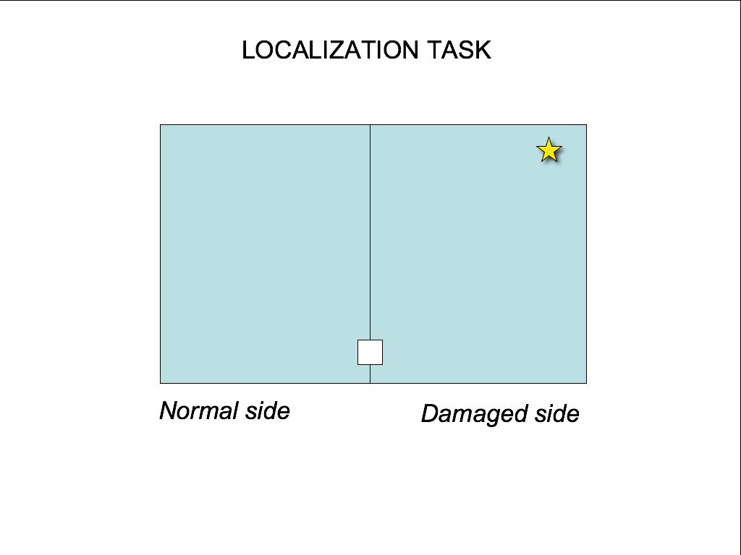

Legend

touch to start trial

stimulus (one target briefly flashes per trial; various left and right side locations); successful localization consists in touching approximate location

FIGURE 2

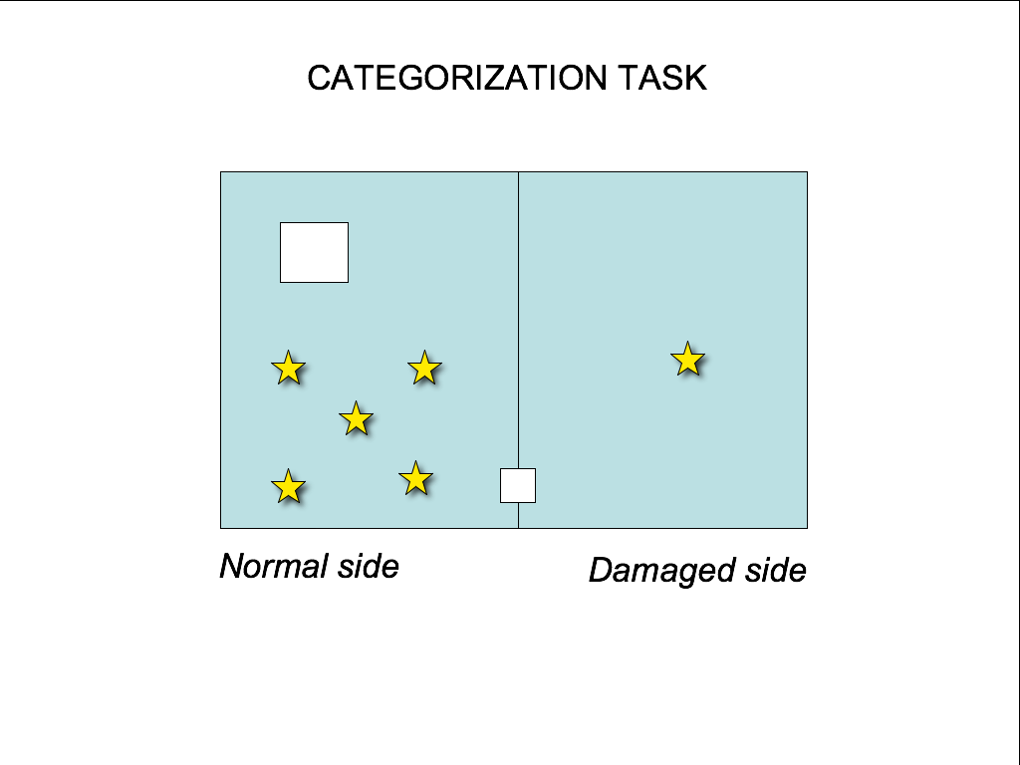

Legend

touch to start trial

stimulus (one target briefly flashes per trial; five possible left side locations; one right-side location); localization by touch is required if there is a target

in trials where no target appears, successful categorization consists in touching the ever-present large white square (i.e. indicating blank field)

FIGURE 3

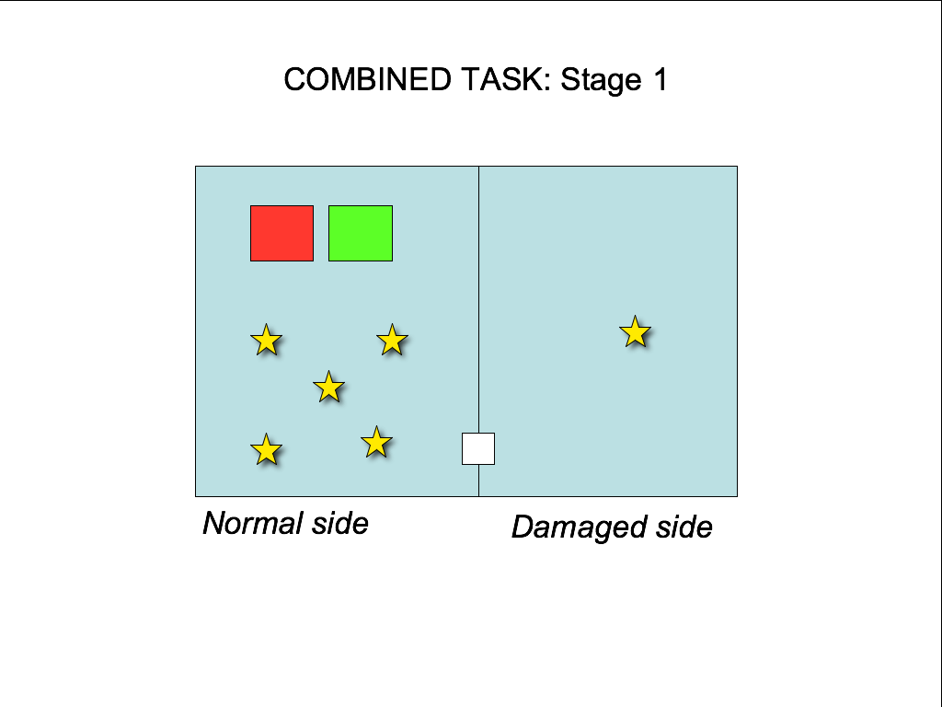

Legend

touch to start trial

stimulus (one target briefly flashes per trial; various locations; one right-side “probe” is indicated in the figure). N.b. It must not touch these.

touch to indicate no stimulus for that trial (blank field)

touch to indicate stimulus present
=

FIGURE 4

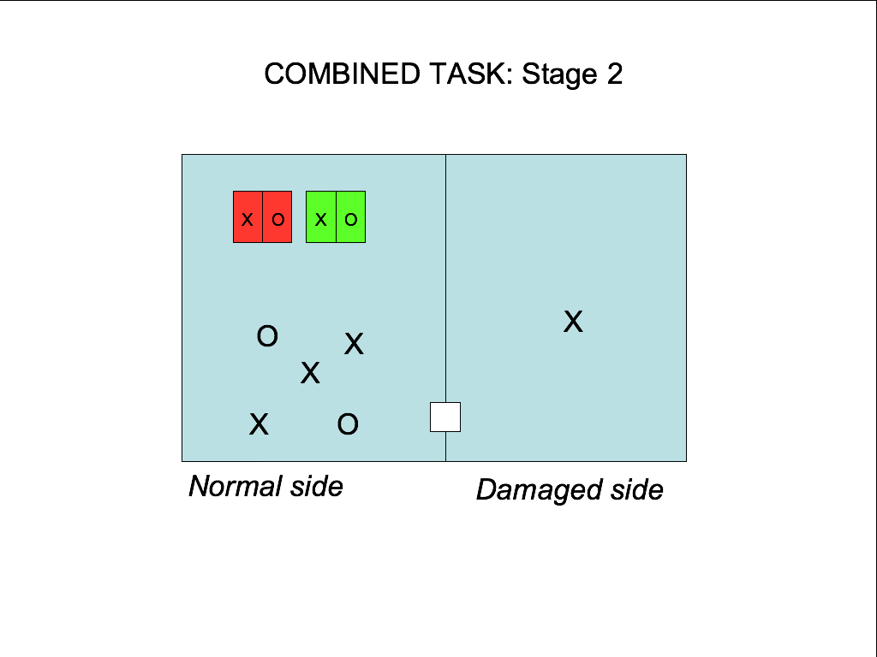

Legend

touch to start trial

X, O two types of flash targets (one per trial; various locations; one right-side probe is indicated in the figure). N.b. it must not touch these.
X O
touch green if there’s a target BUT only the part with the matching shape

X O
1. touch any part of the red square to indicate no target (i.e. blank field)
2. a lesioned monkey which always selects the red X when the stimulus is an X on the damaged side would be indicating non-conscious awareness (blindsight)

I am grateful to Petra Stoerig, Teed Rockwell, and two anonymous referees for their insightful suggestions and criticism.
‘Blindsight’ refers to residual visual functions in patients suffering from phenomenal blindness due to destruction of area V1 (the primary visual cortex). Blindsight is an “implicit,” non-reflexive cognitive process that, under forced choice conditions, allows a patient to detect visual targets, discriminate location, orientation, movement, and coordinate visuomotor response (as in adjusting grip size, or locating an object by touch) in areas of the visual field where subjective blindness is reported (Farah, 1994; Gazzaniga et al. 1994; Weiskrantz, 1986).
Christopher Mole and Sean Kelly “On the Demonstration of Blindsight in Monkeys,” Mind and Language 21 (4), 2006: 475-83.
Humphrey – one of the pioneers of blindsight research – remarks that anyone struck by the lack of spontaneity in human blindsight patients should consider his work with a blindsighted monkey, Helen: “Helen’s visually guided behaviour recovered to such a degree that anyone who observed her freely using her eyes to navigate through her environment would have assumed (quite rightly in my view) that her visual perception was almost back to normal.” (Humphrey, 2000).
The intact tectal-pulvinary pathway in blindsight patients uses a “vector averaging” mechanism which computes a single representation of direction from numerous components in order to guide motor response, as when orienting the eyes towards a visual target. (Churchland and Sejnowski 1992, pp.234-5).
See also Jacob and Jeannerod (2003).
I am grateful to Petra Stoerig for pointing this out to me.
Since blindsight subjects can perform both discriminations and localizations, this should not make an important difference (if, however, this is thought to be a significant alteration, a localization task could be used instead, e.g. by dividing the everpresent colored squares into quadrants).
Or could the desired effect be achieved without violence by using right-side probes just below the threshold of conscious awareness of undamaged monkeys? There is reason to think that dorsal and ventral processing can be dissociated in normal human subjects under similar conditions. Another option might be Transcranial Magnetic Stimulation – this technique has been used to safely induce reversible blindsight-like effects in human subjects through electromagnetic stimulation of V1 (Ro et al., 2004). Ethical concerns about the treatment of experimental subjects might also be accommodated by using pharmaceuticals to temporarily disrupt cognition (Churchland and Sejnowski 1992, p.235; Milner and Goodale 1998, p.3).
Worries about dis-homologies in neural architecture and function become more pressing as the discussion moves further away from primates. For example, although the gross behavior of mammals with V1 lesions is reminiscent of blindsight, the neural pathway mediating residual vision in our cousins, cats, is apparently unlike that of primates. The significance of these differences is unclear (see Sorenson, et al. 1999).

