Physicists Don’t Yet Understand Color Qualities
Brent Allsop
September 30, 2023

Abstract
You can demonstrate a subjective quality like redness is different from red light. If you add a device that converts a red signal into a green one, between the retina and the optic nerve, the strawberry will seem green. It’s not about light hitting the retina, it’s about how the signal is processed. In this case, the greenness must be a quality of our conscious knowledge of the strawberry, not of the red light landing on the retina. If you use sufficient, well-defined terminology, you can objectively communicate the nature of subjective qualities. For example, even though you know what it is like to see something that is red you cannot know that what happens inside my brain is the same as yours. It may be that “My redness is like your greenness, both of which we call red.” The properties of the red light are the same, but the experience the light produces could be different. What we lack is a universal dictionary to define what “redness” is, and how it differs from “red.” This is because physicists can’t yet answer: “Which of all our descriptions of stuff in the brain, including possible descriptions of yet unknown processes, is a description of redness?” Consciousness isn’t a ‘hard problem’ it is a color quality problem. Because if you understand color, that model of computation can extend to the rest of consciousness.
Key Words: objective consciousness, subjective consciousness, color vs. colorness, colorness, consciousness, hard problem

A new vocabulary to understand consciousness.
When physicists talk about “color”, they are talking about light. Perception of “color” is a chain of causal events, of which light is just one intermediate link. At the end of this causal chain is the resulting conscious knowledge of one of the properties of a ripe strawberry. It is our knowledge of the strawberry that has the redness quality, not the strawberry nor the light, and we will illustrate why this must be the case.
If something like colored glasses or a camera inverts the red light to green in this link of the chain, the strawberry then seems to have a greenness quality. To the physicist, this greenness is the result of green light being focused on the retina. But the retina is not the last link in the chain of events. Imagine the inversion happening immediately after the retina that turns the signals normally associated with red light into a green signal. This would demonstrate that the nature of this red light landing on the retina has nothing to do with the physical fact that your knowledge of the strawberry might have a greenness quality. The abstract notion of red can be represented by any set of physical properties in the chain of perception. The only thing that matters is the final interpretation where the brain decides what quality to render into conscious knowledge. People that suffer from Achromatopsia (who see everything as black and white) are going to use very different qualities to represent visual knowledge.
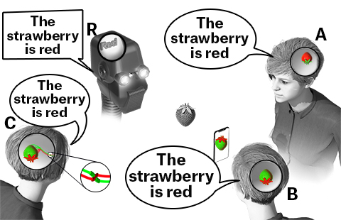
Figure 1. The difference between phenomenal and abstract systems, represented by three humans and a robot. A, B, and C represent red information with different subjective qualities. The R system represents red with a word. It needs a dictionary to know what red means.

Our current color terminology does not distinguish between the color of things, and our conscious knowledge of those things. The strawberry, the light, and our conscious knowledge of the strawberry all have different properties. When someone says something is red, you can’t tell which of those properties they are talking about. Any language that only has one word for all these qualities can be said to be “qualia blind,” as it is unable to represent the different qualities that “red” induces. If we are going to distinguish between reality and knowledge of reality we need different words with different physical definitions. For example, we could enhance our definitions to be something like this:
- Red: The intrinsic property of objects that are the target of our observation, the initial cause of the perception process (i.e. when the strawberry reflects 650 nm (red) light). A label for anything that reflects or emits ‘red’ light.
II. RedNESS: The intrinsic property of our knowledge of red things, the final result of our perception of red.
With current terminology, the title of this article: “Physicists Don’t Understand Color” is ambiguous at best, and we can’t communicate what we want to express in this paper. This problem with language creates qualia blindness, which is characterized by a deficiency in our language in describing subjective experience. If you interpret the word color to be the color of light something reflects, physicists know that. But all that tells you is the colorness things seem to be, or a particular wavelength of light. Once you have these new definitions, you can communicate relevant information without being misinterpreted. With non-qualia-blind terminology you can say something like: Physicists don’t know the intrinsic colorness quality of anything. They know about color, but not colorness.
A big part of Joseph Levine’s “explanatory gap” (Levine, 1983) has to do with the ineffability of the qualities of one’s conscious knowledge. Once we have sufficiently terminology that is well defined, effing the ineffable nature of the qualities of our knowledge becomes possible. Here is an example of an effing statement that would enable the first two systems in Figure 1 to communicate the nature of their different red qualities: “My redness is like your greenness, both of which we call red.”
The reason physicists use light as the physical definition of color is simply because this is the one link in the chain of perception that is easy to measure before the chain enters the skull on its way to be rendered into our conscious knowledge. The physical properties of light only represent ‘red’ information. Since it does not have a redness quality, you need a dictionary (or some other independent reference) to define what it may represent. While we are primarily focusing on the colorness qualities of redness and greenness, these are just two examples standing in for all physical qualities that can be computationally bound into consciousness including warmth, smells, tastes, emotions, and complex combinations of these things.

Why do we not see color qualities in our brain?
If all these colorness qualities are in our brain, why doesn’t a surgeon see them while operating on the optic lobe of the brain? Telling someone something reflects 700 nanometer light tells you nothing about what that is like unless that person has studied light wavelengths and associates “700 nm” with some prior experience. Similarly, describing whatever it is in our brain you can directly apprehend as redness, will tell you nothing about what it is like. The only way to know what the word red means, is to point to an example of a red quality, like the red knowledge of the first person in Figure 1 and say: “That is red.”
We tend to naively think the strawberry reflects red light, because of its redness quality. This is the right way to think about the physics of colorness, it’s just the wrong set of physics. It certainly isn’t red light being detected by a retina. Take a description of the neurotransmitter glutamate, reacting in a synapse, for example. For all we know, glutamate behaves the way it does, because of some physical quality, which could be your subjective redness. If neuroscientists demonstrated that conscious minds always experienced the same redness when glutamate was computationally bound into any conscious mind, this would provide the necessary physical definition to connect our objective descriptions of reality with what we can subjectively directly experience. We could then say effing of the ineffable statements using both objective and subjective synonyms for the same thing, such as:
My redness is like your greenness, both of which we call red.
Red elicits glutamate in my brain
Red elicits glycine in your brain
Glutamate and glycine have different colorness qualities
Redness can be caused by red or green light.
The idea that glutamate behaves the way it does, because of its redness quality is probably an overly simplistic hypothesis, at least for the simple reason that there are so many shades of red. We use this example because of its simplicity and ease of falsifiability. If the hypothesis is that glutamate is redness, and someone experiences redness without glutamate, then the hypothesis would then be falsified. But it must be the case that something in the brain is behaving the way it is, because of the redness quality we can directly apprehend in subjective consciousness.
Until we make that connection between abstract descriptions, and what we can subjectively directly apprehend, we can’t know the qualitative meaning of any of the physics we are describing. Just because something seems red (we represent visual knowledge of it with a redness quality), doesn’t mean it really has that quality.
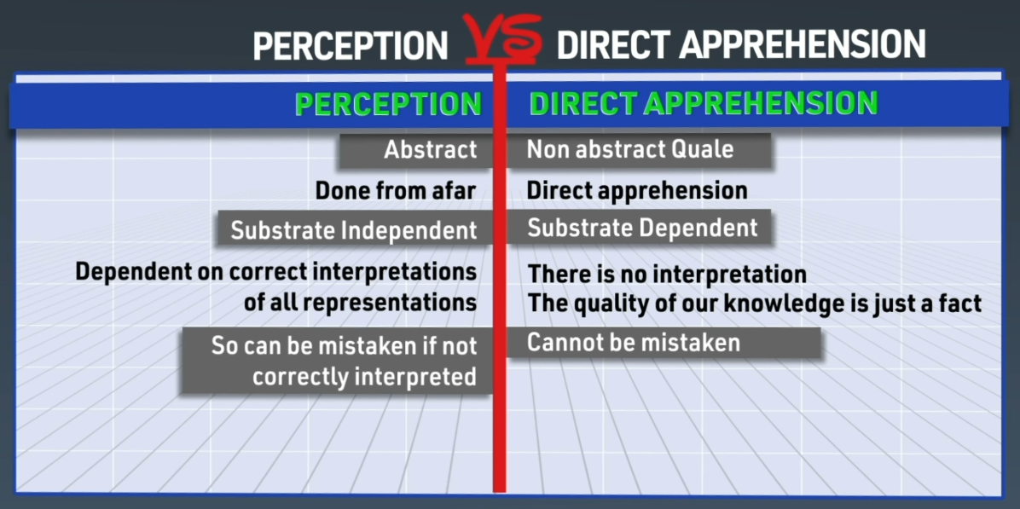
Figure 2. Two ways of gaining physical knowledge.
There are two different ways to consider our physical knowledge.
1. Abstract objective perception through our senses and
2. Direct apprehension of the physical knowledge that is the final result of perception. Abstract perception is not consciousness and “red” and “redness” are distinct concepts.

Colorness qualities are a key part of how brains compute differently
Computational binding in today’s abstract computers is done by complex discrete logic in the CPU. The information being compared is binary and abstracted away from whatever physics may be representing it. Since this kind of complex discrete logic takes so much hardware, there are only a few registers in the CPU that can do this kind of computational binding at any one time. Speed is the saving grace of this kind of computation, where you can iterate through every single pixel on the surface of a strawberry sequentially, to achieve the same kind of situational awareness about things like whether the strawberry is ready to pick or not.
We do the same computational binding directly on intrinsic qualities like redness and greenness. All of this qualitative knowledge is computationally bound into one unified experience, that is our situational awareness. For each spot of color we are aware of, we know how it compares to, and its spatial relationship with all the rest of our knowledge, including what objects those spots are part of, and their names. Just as you need transistors to do abstract computational binding, some mechanism in the brain must be doing the unification of knowledge into one unified Gestalt experience.
All computational binding in a system, whether mechanical or biological, is done in a Central Processing Unit. Any piece of knowledge we have that isn’t computationally bound, including our perception systems and long-term memory is subconscious. Until long term memories are recalled into our CPU where they can be computationally bound, we can not be consciously aware of them. Consciousness is what it is like for a massively parallel CPU to do computation directly on physical qualities.
Thomas Nagal famously asked: “What is it Like to Be a Bat? (Nagal, 1974). If you engineered a bat to compute with conscious knowledge of echolocated flying bugs using your redness quality, you would at least know what that part of that bat’s conscious knowledge was like.

Qualia Blind Observation of the Brain
There are brilliant examples of experimentalists demonstrating abilities to observe colored knowledge in the brain Anwar, 2021; Çelik et al., 2021; Dado et al., 2022). The problem is, they map brain responses “back to sensory stimuli.” They use different maps for different subjects. So, if they were observing two different brains, one engineered to represent red things with greenness, their maps need to “correct” for any physical difference detected, so it can be mapped back to the same red-light stimuli. Experimentalists simply need to start observing the brain in a non-qualia blind way. Discovering the connection between the subjective and objective isn’t going to be easy. But just like the Rosetta stone enabled us to figure out how different languages were saying the same thing, after enough observations of the actual physics in different brains, especially when including subjects from various forms of color blindness, they would eventually start to find ways to see overlapping consistent patterns in the physics in the different brains. For example, observing brains processing red shiny things and green shiny things could reveal commonalities for shiny, and differences for colors. Once a consistent physical map is found between the right physics, and subjective experiences like redness, only then would they finally be able to discover how much diversity there is, or isn't, between different subjective qualities people use to represent red knowledge with. We simply need to connect our objective knowledge to our subjective experiences, to understand what color things really are. The fact that so few people question or even wonder about this issue, illustrates how qualia blind we are.

Ways to Eff the Ineffable
Discovering what physical stuff behaves the way it does, because of its redness quality as described above, would only allow a weak form of effing the ineffable. We need to make the assumption that the same stuff, behaving that same way, would have the same quality in someone else's mind. However, there are stronger forms that don’t rely on such assumptions.
- Weak Form
Once we connect the qualitative subjective with the abstract objective, or discover which of all our descriptions of stuff in the brain is a description of redness, we will then have the required dictionary enabling effing communication. Here is an example of a sufficiently well defined effing statement: “My redness is like your greenness, both of which we call red.”
- Stronger Form
If you find something in nature with an intrinsic quality nobody has ever experienced before, you can give it a name. Let’s call it “Grue.” Then you can computationally bind this into your consciousness, throw the switch, then say: “That is what grue is like” providing the required dictionary between the abstract objective we already understand and the newly discovered qualitative subjective.
- Strongest Form
Half of our visual knowledge is in our left hemisphere, the other half, in the right. The Corpus Callosum computationally binds these into one unified conscious awareness of everything around us. If we achieved the ability to engineer a neural ponytail as portrayed in the movie Avatar (20th Century Studios, 2009), which could computationally bind like the corpus callosum, this would enable us to experience all of the experiences, not just half, when we hug someone. If the first two inverted systems in figure 1 were computationally bound with a neural ponytail, they would both directly (infallibly) experience the other's inverted knowledge of the world. You’d be aware of what is behind you, as seen through your partner’s eyes, that knowledge being red green inverted from your knowledge of what is in front of you. Direct awareness of computationally bound qualities in another brain hemisphere cannot be mistaken.

Building and tracking consensus representational qualia theory
We are currently using the theoretical science consensus building and tracking system on Canonizer.com (Canonizer, 2023a) to track how much consensus there is for competing Theories of Consciousness (Canonizer, 2023b). As of this writing the sample size is still small. Despite this, evidence is emerging indicating there may be more consensus on some key doctrine than anyone realizes. If anyone disagrees with any part of this emerging consensus, they are encouraged to “fix it.” If some of the current supporters don’t agree you can then put the “fix” in a competing camp. May the best theories achieve the most consensus. At the time of this writing, of the 69 total participants, more than 43 (63%) are supporting the Representational Qualia Theory camp (Canonizer, 2023c). Surprisingly, even supporters of Dennett's current Predictive Bayesian Coding Theory (Canonizer, 2023d) camp place it in a supporting sub camp position to Representational Qualia Theory (Canonizer, 2023c; D. Dennett, pers. comm. with B. Allsop). Since consciousness is composed of elemental intrinsic qualities like redness and greenness the supporters of Representational Qualia Theory all agree on this definition of consciousness:

Computationally bound elemental intrinsic qualities like redness and greenness
The majority of disagreement seems to just be around the nature of qualia. All the competing camps are making diverse falsifiable predictions about the nature of qualia. Once experimentalists demonstrate which of all our descriptions of stuff in the brain is a description of redness, this will falsify all but THE ONE camp making the correct predictions. All the supporters of the falsified camps will then be compelled to join THE ONE consensus camp. The goal is to use this theoretical science tool to enable rigorous tracking of how much scientific consensus has been achieved around a solution to the so-called “hard problem” of consciousness. We seem to have already been able to build some amount of consensus. We need to get this message out to the experimentalists. The more participation we have, the more valuable and compelling the theoretical information will be. The consensus camps are kind of like a dynamic petition. Once we get enough support, eventually experimentalists will finally get the message. Only once they understand these claims will they finally start to seek experimental ways to discover which of all our descriptions of stuff in the brain is a description of redness.

Conclusion
Phenomenal joys like redness, greenness, warmth and all that are what give meaning to life. The abstract system depicted on the right in figure 1 provides no purpose to life. We’ve demonstrated how redness cannot be a quality of the strawberry, it must be a quality of our knowledge of the strawberry. Redness is a quality of something in our brain. In other words, something in our brain is behaving the way it does, because of its redness quality. But an objective description of redness behavior would tell us nothing of what that behavior is like. That is, unless we have the dictionary required to connect our abstract objective knowledge with our qualitative subjective knowledge. 100% of our abstract physical descriptions of reality are completely devoid of any subjective qualitative information. Only once neuroscientists start to observe the brain in non-qualia blind ways will they be able to discover things like which of all our descriptions of stuff in the brain is a description of redness. Only when we finally connect our abstract objective information with the qualitative subjective will we then finally know the true colorness qualities of things.
Once we have the required dictionary connecting abstract objective to the qualitative subjective will we then be able to objectively determine not only what other systems are and are not phenomenally conscious. We will also know what they are like. Consciousness: Not a ‘hard problem’ just a color problem.

Acknowledgements
I am grateful to Karl Kjer for helpful feedback and discussion on drafts of this paper. I would also like to thank the reviewers for their detailed and constructive comments.

References
Anwar Y. Scientists use brain imaging to reveal the movies in our mind. https://news.berkeley.edu/2011/09/22/brain-movies/
Accessed date: January 10, 2023.
Canonizer a. Canonizer. https://canonizer.com/
Accessed date: January 10, 2023.
Canonizer b. Theories of Consciousness. https://canonizer.com/topic/88-Theories-of-Consciousness/1-Agreement
Accessed date: January 10, 2023.
Canonizer c. Representational-Qualia. https://canonizer.com/topic/88-Theories-of-Consciousness/6-Representational-Qualia
Accessed date: January 10, 2023.
Canonizer d. Dennett’s PBC theory. https://canonizer.com/topic/88-Theories-of-Consciousness/21-Dennett-s-PBC-Theory
Accessed date: January 10, 2023.
Çelik E, Keles U, Kiremitçi I, Gallant JL, Çukur T. Cortical networks of dynamic scene category representation in the human brain. Cortex 2021; 143:127-147. https://doi.org/10.1016/j.cortex.2021.07.008.
Accessed date: January 10, 2023.
Dado T, Güçlütürk Y, Ambrogioni L, Ras G, Bosch S, van Gerven M, Güclü U. Hyperrealistic neural decoding for reconstructing faces from fMRI activations via the GAN latent space. Sci Rep 2022; 12:141 https://doi.org/10.1038/s41598-021-03938-w
Accessed date: January 10, 2023.
Levine J. Materialism and Qualia: The Explanatory Gap, Pacific Philosophical Quarterly, 64, 354-361.Nagel, Thomas (1974). What Is It Like to Be a Bat? The Philosophical Review 1983; 83(4): 435-450.
Twentieth Century Studios. Avatar (film). 2009

