The very idea of art

Paper delivered at Australian National University, 28/7/2022. The illustrations are chosen from those used to accompany the paper.

Derek Allan

I should begin with two very brief, explanatory remarks. First, my paper will make frequent use of the word “art”. When I use it, I mostly mean art generally, including literature, music and so on; I don’t mean visual art exclusively. But I usually choose my examples from visual art because they allow me to illustrate my points more clearly.
Second, I often refer to André Malraux, who has been a strong influence on my thinking. Malraux is well known in France but less so in English-speaking countries. That won’t matter much today because I’m not going to assume any prior knowledge of his works; but I thought, nevertheless, that a few brief biographical remarks might be useful. Malraux was born in 1901 and first came to notice as a novelist, his third novel La Condition humaine winning him the prestigious Prix Goncourt in 1933. In the late 1930s, he fought with the

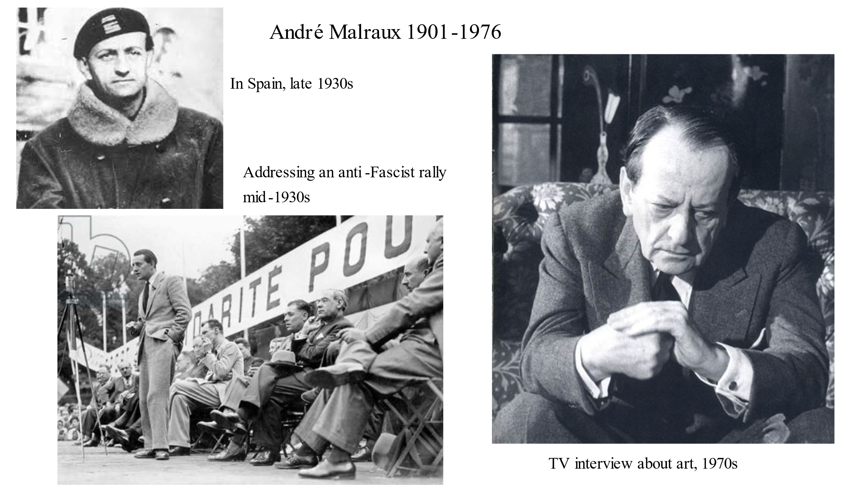
Republicans against Franco in the Spanish Civil War and subsequently saw action against the Nazi invasion of France, both in the French army and later in the Resistance. After the war, Malraux’s publications included a series of major works on visual art, which is the aspect of his writing I’ll be referring to today. From 1959 to 1969, he served as a very active Minister for Cultural Affairs in de Gaulle’s government. He died in 1976.
And with those preliminary points, I’ll pass to the substance of my paper.
Donald Preziosi, an influential contemporary figure in art history, tells us in his Introduction to the Oxford History of Art, that the discipline of art history has proved “particularly effective in naturalizing and validating the very idea of art as a ‘universal’ human phenomenon.” Now, personally, I would question whether art history has played such a significant role but if it has, then in my view it has done a serious disservice to our modern understanding of art. For as André Malraux often points out, the “very idea of art” is definitely not a universal human phenomenon, there being ample evidence that the vast majority of cultures throughout human history, have not regarded their music, poetry, painting, and sculpture as “art”. Those that have done so are: European civilisation from the Renaissance onwards and the many cultures around the world that have been influenced by Western ideas over the past century or so. So today, in other words, the notion of “art” is more or less universal because there is scarcely a corner of the world now that has not been affected by Western culture. But these exceptions aside, the concept “art” and everything that goes with it – the institution of the art museum, for example – was universally unknown. This is not of course to suggest that the cultures concerned – such as medieval Europe, ancient Egypt, India, the Pacific Islands, and precolonial Africa – were without painting, sculpture, music, and poetry. On the contrary, activities such as these typically played an important role, and when, today, we see the works of non-European cultures from the past in our art museums, we are often impressed by their quality and power. But in all such cultures, “the very idea of art” to use Preziosi’s words was quite alien, and the artefacts concerned originally performed functions, often associated with religious practices, that were quite unlike those the West has associated with the word art over the past five centuries or so. Today, we welcome many objects from non-European and early cultures into art museums and we willingly regard them as “art”; but that is a recent development, barely more than a century old – which we’ll discuss shortly. As a general rule, the cultures concerned were quite oblivious of the concept “art” and had no use for it.

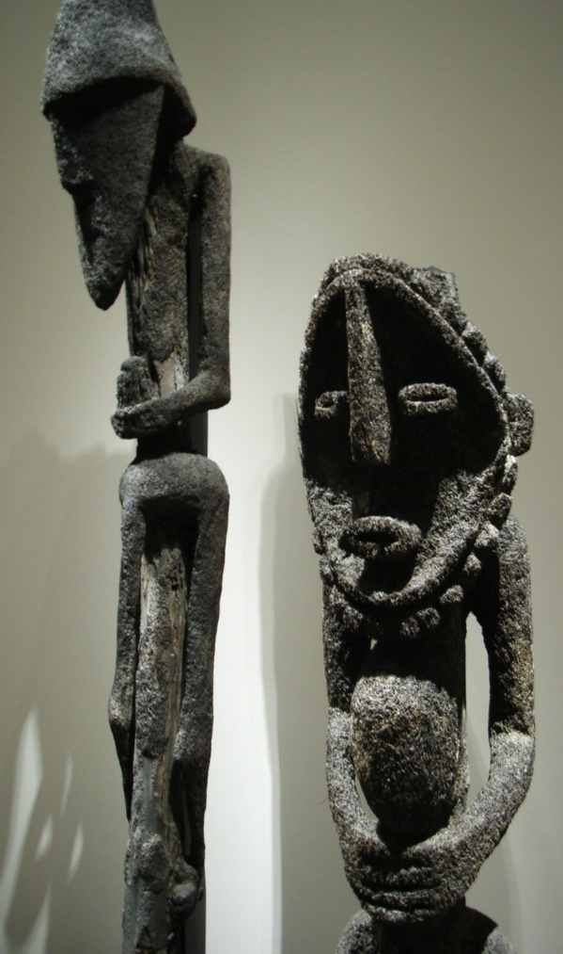
Ancestor figures, Vanuatu. Louvre
I don’t know if this proposition is surprising to those listening to me now, but in my experience, it often meets with resistance; and, strangely enough, the fiercest resistance usually comes from the directions one would least expect: the philosophy of art and the history of art. The dominant view in these disciplines is that, no matter what terminology they may have used, all non-European cultures, no matter how ancient, regarded their sculpture, painting, poetry and music as “art” in the European senses of the term; and this is true, they add, even if, as is usually the case, the languages of these cultures possessed no word equivalent in meaning to “art”, and if their associated customs and beliefs bore no resemblance to those of Europe. Paradoxically, art historians and philosophers of art normally concede that, in general, cultural differences should be recognised and respected; indeed, not to do so, they argue, leads to the kinds of “cultural appropriation” that Western culture has been guilty of far too often. But art, for no clear reason, is treated as an exception, and despite all contrary evidence, art historians and philosophers of art typically believe that, in Preziozi’s words, “the very idea of art [is] a ‘universal’ human phenomenon”.
Now, this belief has one convenient advantage, of course: if the very idea of art has been common to all cultures no matter how ancient or unlike Europe, no one is under any obligation to explain when and why the word and concept “art” arose. Since the idea is, and has always been, universal, there’s obviously nothing to explain. And neither, presumably, would there be any need to explain any radical change that might have occurred in the meaning of the word since it appeared. What has always been, will doubtless always be, and there’s an end to the matter.
Malraux, however, is not in this comfortable position. Dissenting from the majority view and arguing that the idea of art emerged at a particular time and place, he is, at a minimum, obliged to tell us where and when it emerged, and why. Which, I’m happy to say, is precisely what he does. Time will permit only an abbreviated account of his argument, but in essence it is this: The notion of art, based on a new and quite specific notion of beauty, first emerged in Italy, the principal initiator being Giotto who lived from 1267 to 1337. Why did it happen? Malraux responds with a fascinating analysis. He reminds us that the images that had dominated Mediterranean civilization for many centuries prior to this time – as exemplified by Byzantine mosaics – were part of a strongly dualist Christian faith. He writes:

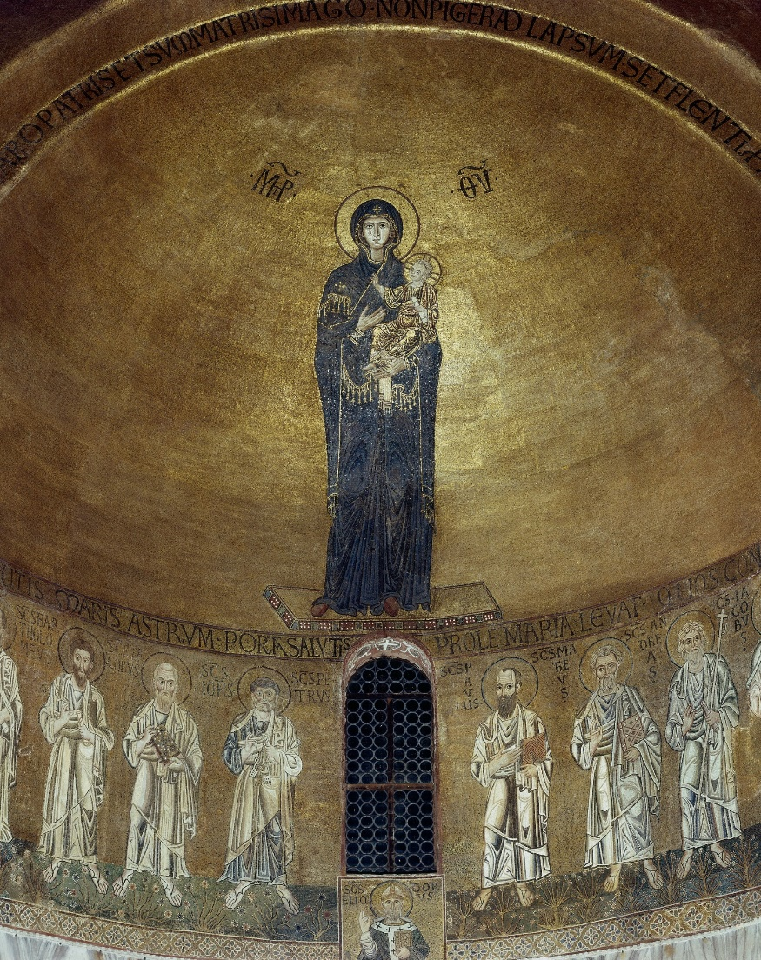
Madonna and Child with Apostles, Torcello Cathedral, Venice

God’s love was sacred love and partook of the central mystery of the Eternal. … Although God was love, and although man had access to Him through love, the ultimate mystery of his being remained inviolate
Thus, Byzantine images, Malraux continues,
never sought to depict Jesus and Mary as individuals … Yet in one respect – their otherworldliness –these figures all have a striking similarity… For [they] do not depict events that once took place on earth, but episodes of the sacred.
Giotto, however, initiated a rapprochement between man and God. Malraux comments: Giotto discovered, a new “power of painting”. No longer exclusively a vision of otherworldliness, his frescos depict sacred scenes that are “becoming scenes in the life of Jesus” – events that did once “take place on earth”. Malraux writes:
[Giotto] discovered a power of painting previously unknown in Christian art: the power of locating a sacred scene, without sacrilege, in a world resembling that of everyday life … For the first time, sacred scenes related as much to the world of God’s creatures as to the world of God.
This discovery opened the door to a new world of painting that Malraux terms “pictorial fiction” or “the imaginary”, or, as Malraux often prefers, the irréel. Giotto’s painting, Malraux writes, “[brought] the divine onto a plane nearer to man” by replacing the hieratic forms of Byzantine art with a “solemn expression of the Christian drama”. A degree of naturalism played a necessary part because the drama was now taking place in “a world resembling that of everyday life”. But the central objective was not “nature imitation,” as histories of art have so often told us, but the creation of a world that, for the first time, “related no less to the world of man than to the world of God”.
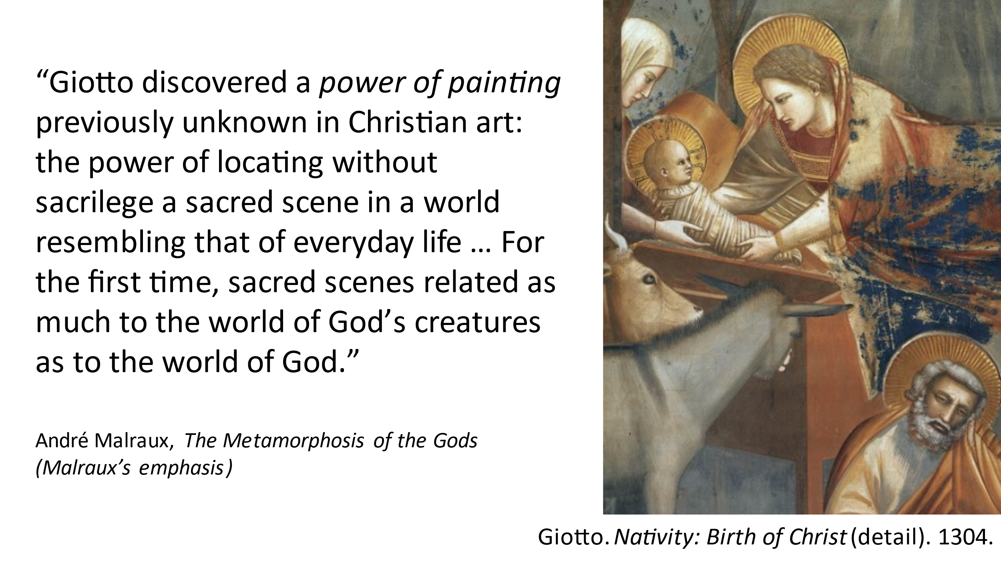These were the origins in the field of painting of what we now call the Renaissance, and they triggered an enthusiastic exploration of the possibilities Giotto had opened up. Religious feelings did not disappear, Malraux writes, but they were complemented by the discovery of an imaginary realm conveyed to the spectator by a power of the artist distinct from his power of representing scenes from Scripture in that it no longer called forth veneration, but admiration. And a century later, by the time of Botticelli, a further step had been taken. In exploring the newly discovered realm of the imaginary, painting began to call on the mythology of Antiquity whose heroes, gods and goddesses seemed to represent a transcendent world of the imaginary and to offer a “repertoire of exalted acts” befitting such a world. For Botticelli, especially in his non-religious works such as this one (below), it was no longer just a question, as it had been for Giotto, of “locating a sacred scene, without sacrilege, in a world resembling that of everyday life” but of creating an earthly realm that rivalled that of the sacred. Thus, Malraux writes, the admiration inspired by a painting such as the Primavera, gives exalted expression, for the first time, to a fiction drawn solely from the realms of the profane. Malraux is not of course suggesting that the works of Giotto and those who followed were somehow superior to those of Byzantium (a claim made by later writers such as Vasari, and even by writers as late as the nineteenth and twentieth century). There is no question of artistic “progress” as art historians have often suggested. But the function of painting had changed. Previously venerated as part of a sacred world, it was now the incarnation of a splendid fictional domain in which men and women themselves seemed touched by a spark of the divine.
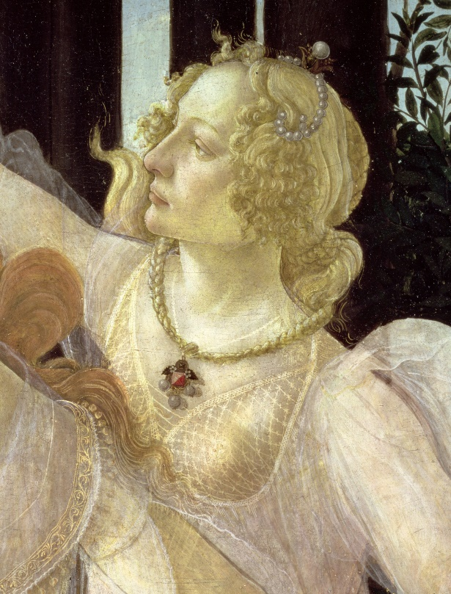
Botticelli. Primavera (detail). Late 1470s
This was a decisive moment in European art and its key words are “‘art” and “beauty”. The word art had already existed in medieval Europe but with quite different meanings. From this time on, it began to designate the new fictional world bodied forth by Renaissance painters such as Botticelli, Raphael, Michelangelo, Veronese and Tintoretto – a
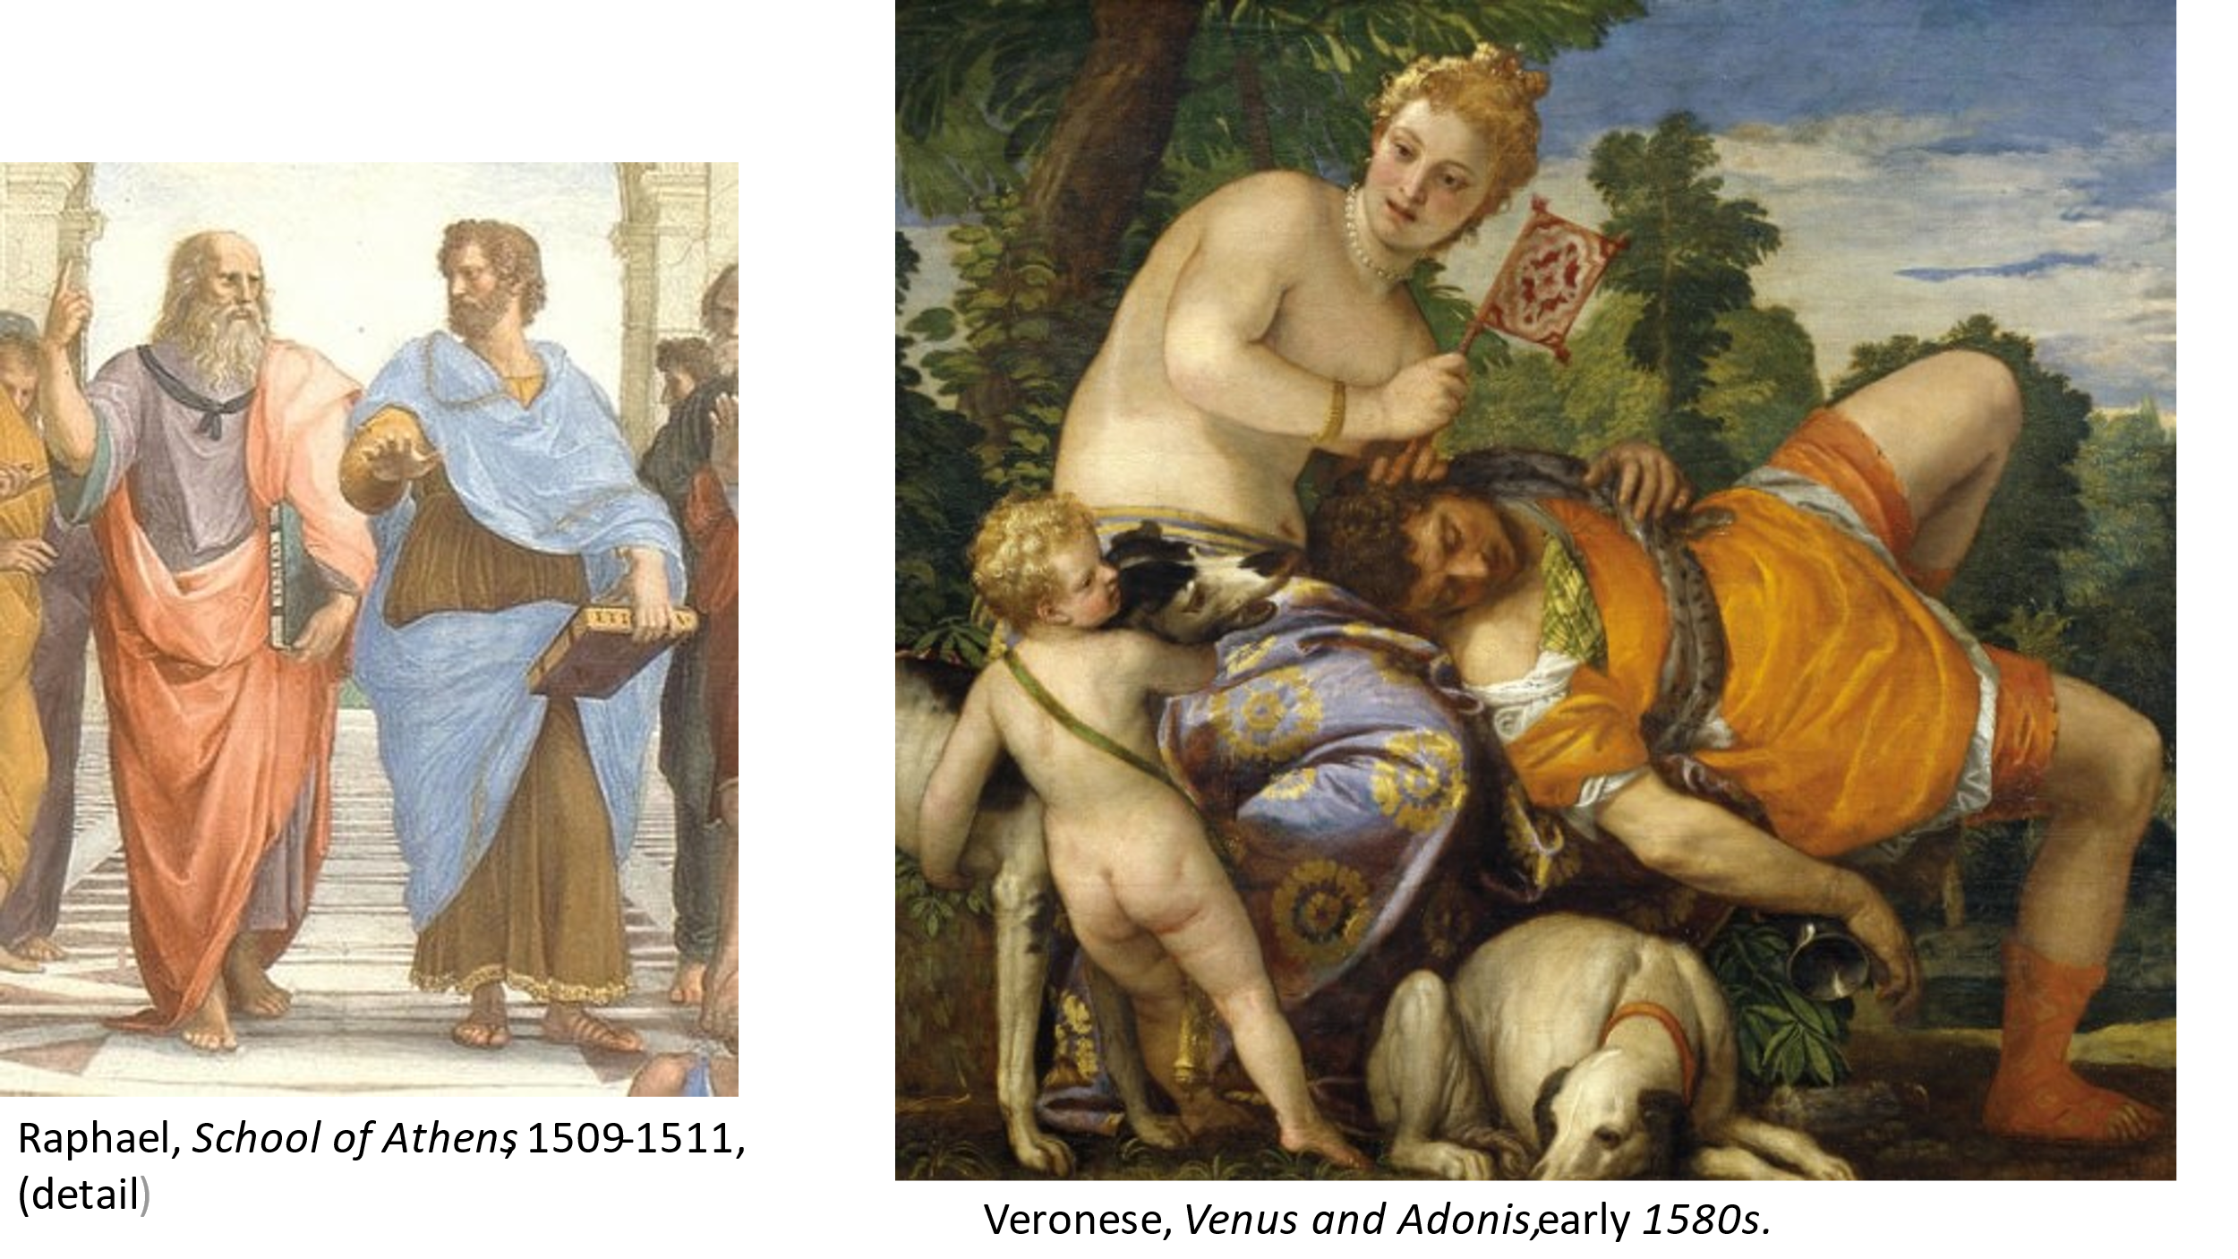
new exemplary world, Malraux writes, “outside of which man did not fully merit the name man”. And the quality common to all these works was a compound of nobility, harmony, and beauty – usually summed up in the single word “beauty” which, from then on, was taken to be the hallmark of any work that achieved the status of “art”. And as Byzantine and medieval works quickly lost prestige, these ideas provided the basis of Western thinking about art as, for some philosophers of art, they still do today.
There is more to say about the Renaissance idea of art, but I must move on quickly because I want to look briefly at the very different idea that supplanted it from the late nineteenth century onwards. Let us begin by asking ourselves how well the Renaissance conception of art fits the world of art we know today. Do we honestly believe that art’s fundamental goal is still to depict a world of nobility, harmony, and beauty? The answer is surely no. To begin with, our world of art today is far more varied and extensive than that of the Renaissance, and even if we exclude modern Western painters whose works typically seem to have little to do with nobility, harmony, and beauty – Picasso or Francis Bacon, for example – there is now a wide range of works from non-European sources such as Pre-Columbian civilizations, pre-colonial Africa, and the cultures of the Pacific that seem quite remote from anything expressing those values. In other words, given that the domain of art today extends well beyond the tradition of artists such as Botticelli, Raphaël, Titian and Poussin, can we seriously believe that the word “art” still carries the same meaning it carried

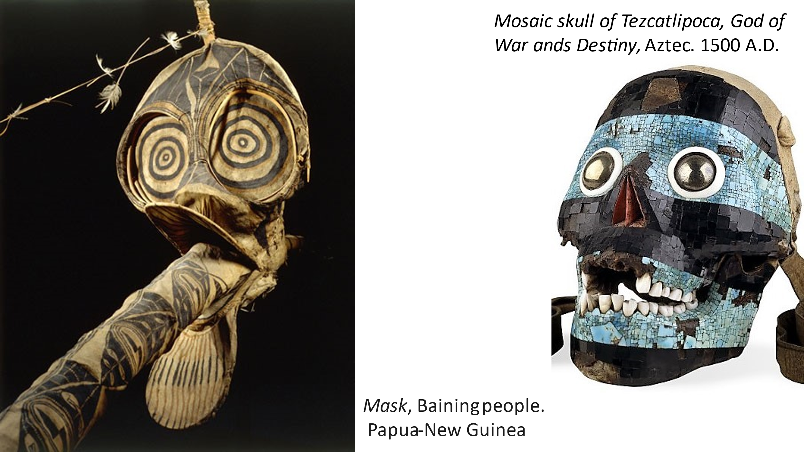
for artists such as these? Malraux’s response is clear: we still retain the word “art”, and it has lost none of its importance or prestige, but the meaning of the word has changed radically. A cultural transformation has taken place with implications no less profound than those triggered by Giotto; and the consequences have included a decisive change in the meaning of the term “art”, and the range of works it encompasses.
What is this new concept of art, and what caused it to emerge? The key factor, Malraux argues, was the Enlightenment’s relentless attacks on religious belief – its insistence, driven by the triumphs of science, that the path to truth lay solely through the empirical, observable fact, which in turn implied scepticism about transcendence in all its forms. This event was decisive, and Malraux writes in The Voices of Silence: “Something unprecedented was happening; something that would transform both art and culture.” Now, for the first time, he argues
a religion was being threatened otherwise than by the birth of another. In its various manifestations, ranging from veneration to sacred dread, to love, religious feeling had changed many times. Science and Reason were not another metamorphosis of this feeling; they were its negation.
“What was disappearing from the Western world,” Malraux continues, “was the absolute”. And despite the persistence of conventional forms of religious piety, “our civilization became as unresponsive to the voice of Christianity as to the stellar myths and Druid trees.”
The result today is an agnostic culture, and one conspicuous causality has been the Renaissance concept of art. Across the millennia, in cultures as various as Egypt, India, Pre-Columbian Mexico and medieval Europe, the function of painting and sculpture had always been inseparable from an absolute, usually a religion; and this remained the case when, from the Renaissance onwards, the absolute – in this case, the exemplary world “outside of which man did not fully merit the name man”– was created by art itself. But what might the function of art be in an agnostic culture? How could artists go on creating visions of humanity touched by a spark of the divine when belief in all things divine had turned to dust?
This question signalled the death knell of art as a transcendent, fictional world – the idea of art born with the Renaissance. But art, it turned out, could be reborn in a different form, and in 1865, with European painting sinking more and more deeply into academic futility, Manet’s Olympia made its startling appearance. Manet, in Malraux’s eyes, occupies a place in the history of Western art no less important than that of Giotto. Giotto, as we saw, discovered a “power of painting previously unknown in Christian art” which led to the emergence of “art” in its first incarnation. Manet, who recognized that an art of this kind was no longer possible, and who rejected the vacuity of academic painting, also discovered a new power of painting, but in his case, a power that abandoned the pursuit of a transcendent fictional world and simply became its own value. Manet, writes Malraux, discovered “the autonomy of painting,”– painting that relies exclusively on its power to create a rival world, and at this point a long chapter in the history of Western art, dating from the Renaissance, came to a close. Gone was any attempt to conjure up an exalted world of nobility and ideal beauty. Divorced from any absolute and left to its own devices in an agnostic culture, art fell

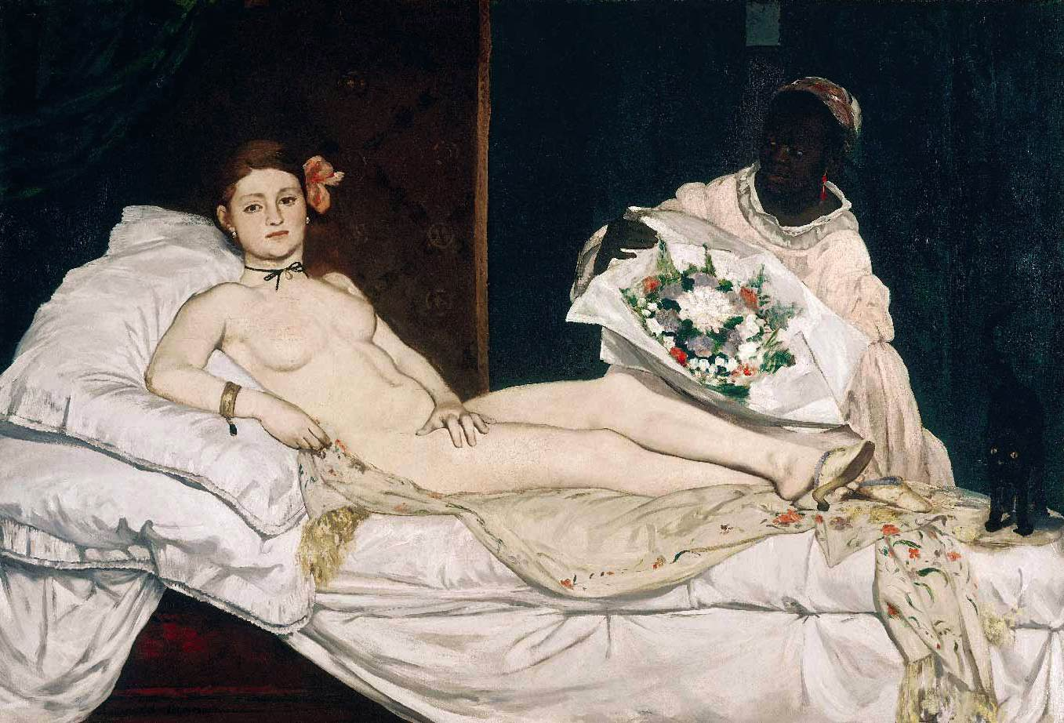
Manet, Olympia. 1863
back on what Malraux terms “its invincible element” (“sa part invincible”) – the irreducible power without which it would not even be a possibility: the capacity to create a rival, unified world. Cut off from any other value, art discovers a fundamental value in itself which, Malraux writes, “is much deeper than a desire to please the eye.” It is “the age-old urge to create an autonomous world, which, for the first time, has become the artist’s sole aim.”
I don’t want to dwell on this issue too long because it raises certain fundamental aspects of Malraux’s thinking that I don’t have time to pursue today. But I do want to point to certain major consequences of the event in question.
The Renaissance, as we know, was accompanied by a strong enthusiasm for ancient Greek and Roman sculpture – a renaissance of this sculpture, after a millennium of indifference. This fact is familiar to all of us and has been written about innumerable times. What is far less familiar, however, is that another renaissance has taken place in our own times, much broader in scope, and triggered by the new concept of art initiated by Manet. To see the importance of this event we need only think about the collections of works we encounter in any large art museum today – in our own National Gallery of Australia here in Canberra, for instance. The permanent collection in the NGA, like those in many other major galleries around the world, is not limited to Renaissance and post Renaissance art. It has a number of striking examples of Hindu and Buddhist sculpture, of African ceremonial objects, Indigenous Australian artefacts, Central American and other non-European works. Now, although we seldom reflect on it, and modern aesthetics rarely encourages us to reflect on it, no works of this kind were admitted into any art museum anywhere in the world before about 1900. They were excluded because they were regarded simply as “not art”, as the word was then understood, that is, with its moribund Renaissance meaning. Moreover, to hark back to a point discussed earlier, although we now refer to these works as works of art, all of them came from cultures in which the concept of art was non-existent.
How do we explain this puzzling situation? Public art museums have existed since the early 1800s but artefacts from other cultures such as ancient Egypt, Hindu India, and pre-colonial Africa were known to Europeans well before that, through trade and exploration. So why did these objects not begin to enter art museums until the early twentieth century, and why do we now regard them to be as much “works of art” as a Picasso, a Titian, or a Giotto?
Very few philosophers or historians of art have written discussed these issues, let alone offered answers. But this apparent indifference to the topic surely reveals a very superficial, incurious approach to the history of art. It is true that the process occurred bit by bit over a period of about 50 years from about 1900, when public attention was probably distracted by more “newsworthy” events such as surrealism, abstract art, and items of shock value like Duchamp’s Fountain. But the event I’m describing is at least as astonishing as any of these. Never before had objects from non-European cultures, or European works of pre-Renaissance times, been admitted to the world of art. Never before had these objects,
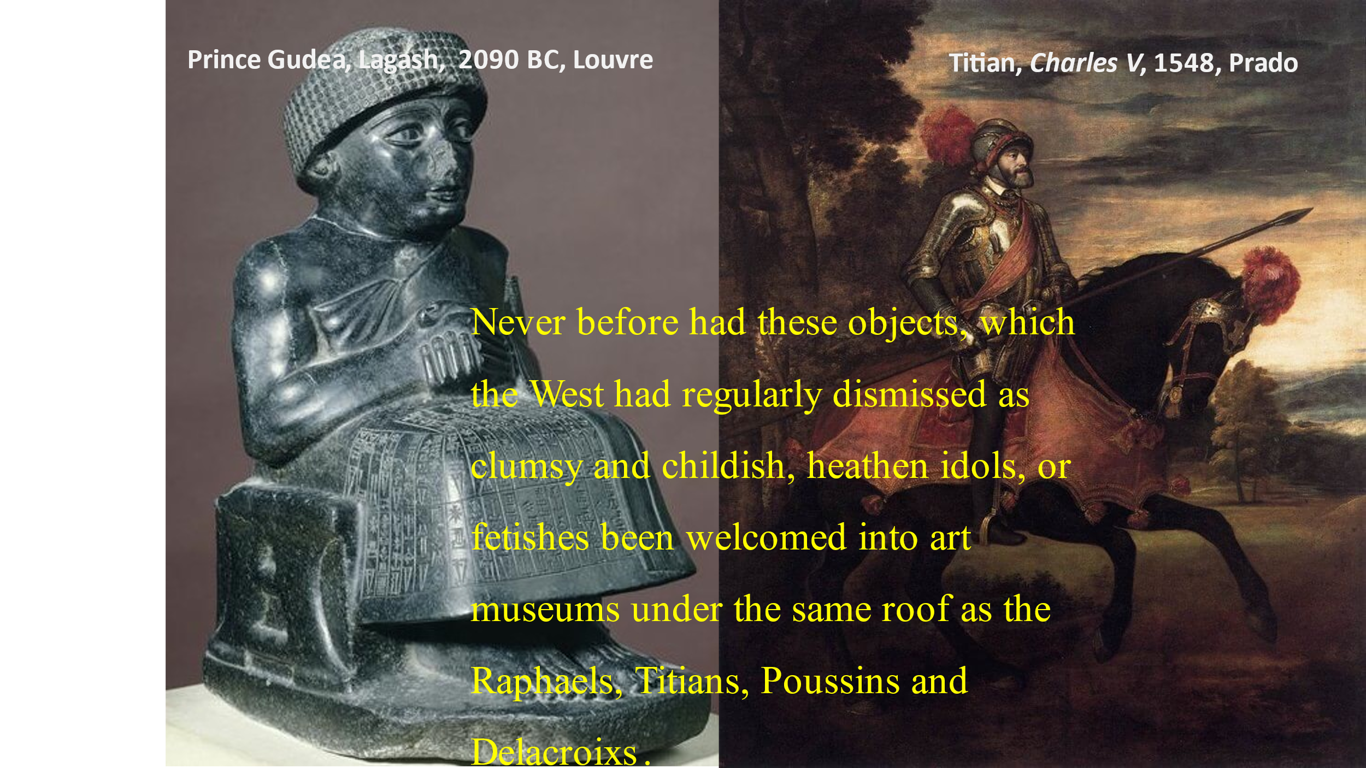

which the West had regularly dismissed as clumsy, childish, heathen idols, or fetishes been welcomed into art museums under the same roof as the cherished Raphaels, Titians, Poussins and Delacroixs. The event was a sea-change in the world of art, involving a radical transformation in what Preziosi calls “the very idea of art.”
Why did it occur? It occurred, Malraux argues, as the direct consequence of the discovery by Manet and subsequent painters of an art no longer linked to any value outside itself – an art that was now dependent solely on “the age-old urge to create an autonomous world, which, for the first time, has become the artist’s sole aim”. This revolutionary step revealed a new, vastly expanded world of art, made possible because “in ceasing to subordinate creative power to any supreme value, Malraux writes “modern art was revealing the presence of that same creative power throughout the whole history of art” – the phrase “whole history of art” now including the works of all cultures. The result has been “another Renaissance”, this time of much larger proportions and no longer limited to the works of two Mediterranean cultures. In an unprecedented development, we today, Malraux writes, have discovered “the first universal world of art”, a world in which, in his words, “a Mexican god becomes a statue, not a mere fetish, and Chardin’s still-lifes join the Chartres Kings and the gods of Elephanta in a common presence”.

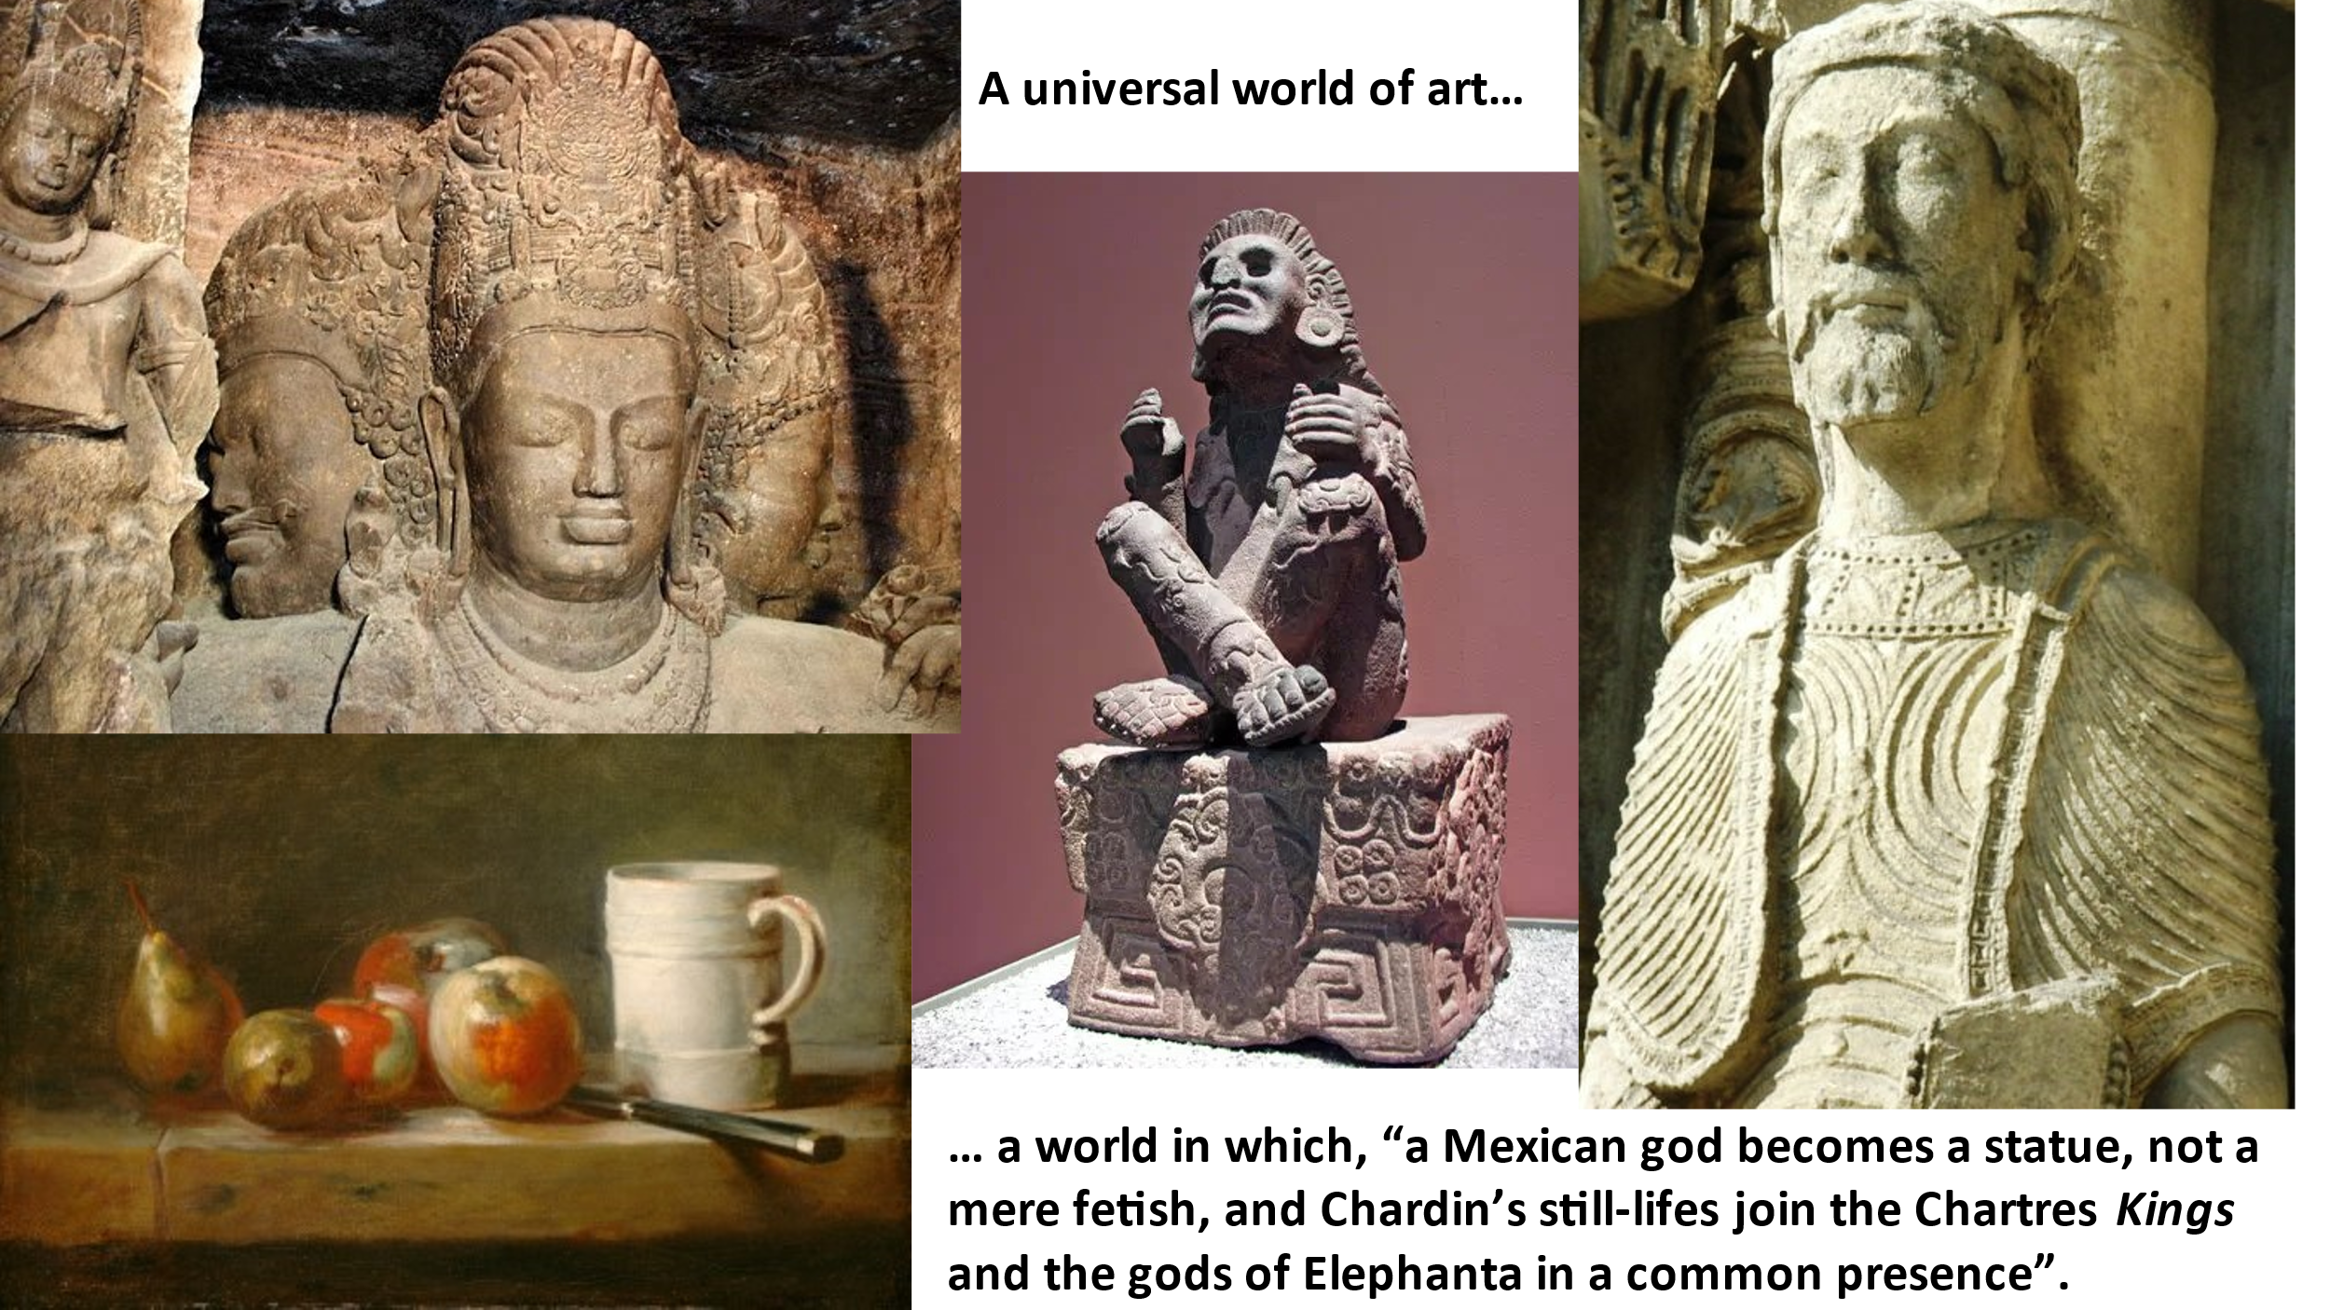

I’ve covered a lot of ground in this talk and done so much more rapidly and superficially than I would have wished. But I’d like to finish with a brief comment on certain implications of what I’ve said.
It seems obvious, surely, that Preziosi’s proposition is unsustainable. It is simply not the case that the very idea of art is a ‘universal’ human phenomenon. It is now, of course, as a result of the immense change we have just considered; but apart from the debatable case of Greece and Rome, we look in vain for any culture prior to the Renaissance in which the idea of art existed. And it is not even the case, as we have seen, that once the idea emerged in the West, it always remained the same. To ignore these basic facts is simply to distort the history of art – indeed, one might say, it is to trivialise that history.
The issue here is fundamental, so why has so little attention been paid to it? Answering that question adequately would require more time than I have left, but I will make one brief comment. Both art history and the philosophy of art are steeped in their own, long-standing academic traditions – much too steeped I would say. Both emerged in the eighteenth and nineteenth centuries when art still meant European art exclusively. Today, it is true, art historians and philosophers of art, generally accept that our modern world of art encompasses the works of all cultures. But so far, no art historian or philosopher of art has, to my knowledge, seriously confronted the fact that works from other cultures (prior to modern times), as well as from Europe itself prior to the Renaissance, were never created as “art”; and in addition, they have frequently ignored the fact that these works were, until relatively recently, excluded from Western art museums. We search in vain among modern writers in the history or philosophy of art for a clear recognition that most cultures had no use for the concept of art; and we look equally vainly for a persuasive explanation, such as that provided by Malraux, of when and why the concept emerged – or an account of why and how that concept changed so radically in the late nineteenth century, ushering in our unprecedented, universal world of art. The “history” in the history of art, in short, seems a decidedly superficial affair; and the “philosophy” in the philosophy of art appears equally determined to gloss over anything that challenges the traditional Enlightenment belief that art is a universal category, common to all cultures, past and present.
This suggests to me that the philosophy of art and the history of art have a lot of ground to make up. Both disciplines seem implicitly to accept that the world of art has expanded enormously over the past century or so, and now includes large numbers of works that, not so long ago, would have been unceremoniously shown the door. But the enormous implications of this development and the fundamental questions it raises are simply not being addressed. A major reason for this failure, I believe, is that, in many respects, the disciplines concerned – especially the philosophy of art – remain fettered to eighteenth and nineteenth century thought, such as that of Hume, Kant, and Hegel, which is of very little relevance in tackling issues such as these. It is high time, in my view, that these fetters were loosened and that “the very idea of art” in Preziosi’s phrase was approached with a little more intellectual rigour and adventurousness.

La Métamorphose des dieux, p. 133.
Ibid., p. 316.
Ibid., p. 318.
Ibid., p. 320.
L’Intemporel, p. 657.
Les Voix du silence, p. 720-722. Malraux’s emphasis.
Malraux, L’Intemporel, p. 669, 670.
Malraux, Les Voix du silence, p. 737.
Ibid., 871.
La Métamorphose des dieux, p. 25. In French: “le premier monde de l’art universel.” Stuart Gilbert renders this as “the first world of a truly universal art”. André Malraux, The Metamorphosis of the Gods trans. Stuart Gilbert (London: Secker and Warburg, 1960), 21. This is misleading, as the context indicates. It is not a question of a new form of art – a “universal art”. Malraux’s claim is that, for the first time, the category “art” encompasses the works of all cultures.

