Breast Cancer Knowledge Based System

**Suheir H. Almurshidi, Samy S. Abu-Naser**

Department of Information Technology,

Faculty of Engineering and Information Technology,

Al-Azhar University - Gaza, Palestine

***Abstract:*** *The Knowledge Based System* *for Diagnosing Breast Cancer is used to assist medical students to improve their education on diagnosis and counseling the process of analyzing the biopsy image of the microscope, determining the type of tumor and the treatment method for each case and identifying the disease related questions. According to the Ministry of Health in its annual report in Gaza, between 2009 and 2014 there are 7069 cases of breast cancer, and in 2014 there are 1502 cases of breast cancer . We are now in the age of visual information where 65% of the populations are visual learners; the Knowledge Based System is the easiest way to ensure students remember the information in the long term, using visual and textual information. The Knowledge Based System has an easy-to-use interface to help students diagnose the disease and enhance their information about the disease; the system can be used on smart phones. This Knowledge Based System can be divided into three main parts: The first part is specific questions for the patient, to help student to know questions type. The second part is the process of analyzing the biopsy sample image, to see if the biopsy image is intact or infected. The last part is the video shows ways to treat breast cancer in the form of animation.*

**Keywords:** Knowledge Based System, Breast Cancer, Artificial Intelligence, Expert Systems.

# **Introduction**

Nowadays, science is discovering more and more critical diseases and trying to figure out the causes, also in the same time giving a guideline for treatment and diagnosis.

There are huge information and databases about deferent diseases. To manage these resources, we have to systematic the information to be reachable for researchers, doctors and patients. The needing of a computerize systems is increasing day by day to create a suitable environment between doctors and patients by exploring the disease and its causes with treatment, so it will be easy to persuade the patient about the disease level and the growth of it.

Cancer: An abnormal growth of cells which tend to proliferate in an uncontrolled way and, in some cases, to metastasize [1].

There are many types of cancers divided into several groups and classifications, one of these breast cancers, the second known cancer [2], so it is very important to know how the cancer appeared for this patient and in which level.

A previous study agreed that diagnosing a disease in the first disease is easier for the healing process. So the researcher decided to build a new system with a clear interface for doctors and medical students to help them in the treatment process.

The new system includes three parts each part that contains information that is stored in the database.

The system can be used with mobile. This Knowledge Based System can be divided into 3 main parts:

* The first part is the questions to be answered and the percentage of each question to give the degree of infection to teach the student
* The second part deals with the diagnosis of the sample by the microscope and gives an analysis of the degree of infection of each image
* Finally the last part deals with treatment. Through the animated film in order to give clear information about the ways of treating the disease.

Intelligent Educational Systems (IES) are gaining importance in education. A lot of exams have been conducted to demonstrate and model students' knowledge perfectly, design effective programs and improve teaching methods. The system provided by the researcher gives students who study medicine an opportunity to learn about breast cancer effectively. Therefore, the researcher collected data on diseases from specialists such as a doctor in the field of breast cancer.

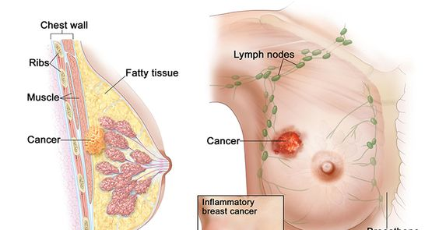

Figure 1**: Inflammatory Brest Censer**

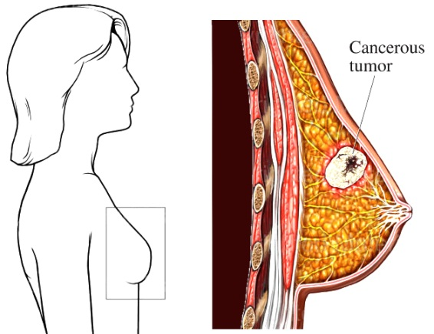

Figure 2: **A cancerous tumor within the female breast**.

Figure 1 and Figure 2 show cancerous tumor within the female breast. The first graphic provides a line orientation to the female breast in a lateral (side) view. A separate enlarged image identifies and illustrates the tumor within the breast tissue.

* 1. **Motivation For the Research**

The motivation behind the research is the need to further understand the diagnosis and treatment of breast cancer, so that students can review patients' questions and methods of treatment, diagnosis and review of microscopy experiments of breast tissue at any time without restriction.

* 1. **Problem Statement**

There are many types of cancers divided into several clusters and classifications, one of these breast cancers, which is the second common known cancer. Nowadays breast cancer is the most common cancer for women [3], the most important things in the process of treatment when is discover the disease early, in which stage the women they are The previous study has shown when discover the breast cancer early is easier in the process of treatment [4].

There are some difficulties for medical students to understand the process of treatment meaning and its levels so this will make misunderstanding, or there are no enough understandable easy resources about the disease. In addition, when medical students need to know about treatment methods and how operations are performed.

Thus, we need Knowledge Based System, which helps students to have a clear view about the disease and treatments. System will be available for researchers at any time without limitation.

* 1. **Research Questions**

With regard to the statement of the problem, this research aims to investigate the following:

1. What applications should I use for the Knowledge Based System?
2. How can Knowledge Based System be used for learning by medical students?
3. How can doctor benefit from the application of the Knowledge Based System?
   1. **Research Objectives**

The objective of this research is to:

* Know what each patient level of the disease.
* Save doctors time when he explains treatments he wants to give.
* Easier way for students for getting more information about disease especially some of them are new students.
* Educational program with a clear and interesting interface.
* To review the literature on diagnosis, staging, treatment, and prognosis.
  1. **Significance of the Research**

This is the first study of people living in Gaza to help them understand the disease, because it will help medical students in particular to give them a clear idea of ​​the disease, in one Knowledge Based System that can be clearly explained to students through pictures and animations to help them understand it easily. The application to diagnose the disease based on the analysis of data entered into the system and also learns the symptoms of the disease by the question of which the patient is directed

* 1. **Scope of the Research**

Knowledge Based System for Diagnosing Breast Cancer designed for medical students in Gaza strip by using some tools in multimedia like (graphics, sound, animation, and interaction etc.).

The application runs on mobile devices with android operating system.

# **LITERATURE REVIEW**

**2.1 Introduction**

This section will discuss the concepts of the Knowledge Based System, Knowledge Based Systems evolution, and application areas of Knowledge Based Systems, simulation, levels of details, and other concepts and after that will discuss the main reason for selecting the medical students in Gaza strip.

**2.2 Knowledge Based Systems**

**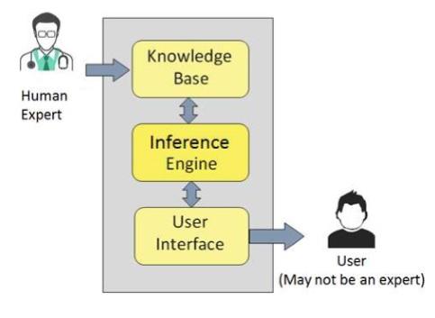**

**Figure 3**: Knowledge Based System Architecture [51-53].

Knowledge Based System (ES) comprises a set of rules that operate information to solve problems in a particular domain that usually require human expertise. The rule takes the form of:

IF Condition1

AND Condition 2

AND Condition 3

AND Condition 4

THEN

Result 1

AND Result2

AND Result 3

ELSE

Result 4

AND Result5

AND Result 6

Knowledge Based System’s information is obtained from expert sources and coded in a form suitable for the system to use in its suggestion for reasoning process. The Knowledge Based System information should be obtained from professional or other sources of expertise, such as journal article, textbook and database. Whenever, human expert needed to solve problems. Knowledge Based System is expected to candidate for application [54-94].

Knowledge Based Systems can be developed for diagnosis breast cancer disease. It can solve the problem about lacking of expert in field of breast cancer disease. Knowledge Based System can solve complex problem, poorly understood and cannot be handled efficiently by conventional systems.

**2.3 Knowledge Based Systems Evolution**

Knowledge Based Systems emerged as a division of Artificial Intelligence (AI) - an amalgamation of disciplines such as computer science, engineering, mathematics, philosophy and psychology. From the labors and effort of AI researchers, computer programs are developed that can reason as humans [6].

**2.4 The Application Areas of Knowledge Based Systems**

From its early days of infancy when MYCIN was earliest pioneer, Knowledge Based System (ES) have been developed in broad walks of life, in different areas and disciplines range from statistics, geology, and electronics to medicine. In fact, the sky has no limit! To highlight on this issue, a kaleidoscope of the Knowledge Based Systems developed in their particular fields is mentioned here. Williams recommended a prototype Knowledge Based System for the propose of complex statistical experiments. GEOPLAY is information based Knowledge Based System developed by the U.S. Geological Survey that is obtainable for explorations in the oil and gas manufacturing [7].

Craker & Coenen proposed Knowledge Bazaar, the concept of which a model for the development of ES and knowledge basis are produced dynamically using knowledge supplied by self-appointed internet community. The philosophy supporting the Knowledge Bazaar is the examination that knowledge can be accumulating, not from a limited number of experts or expert sources, but dynamically from internet users as they solve problems and suggest advice [8].

Perhaps, all the related studies are best encapsulate in the paper by Liao where ES methodologies in almost all applications have been reviewed by the author for a span of a decade starting from the year 1995 [9].

**2.5 Knowledge Based Systems in Medicine and Medical Application Areas**

Expert based systems are the mainly common category of artificial intelligence in medicine (AIM) system in routine clinical use. In fact, it was in the medical part that Knowledge Based Systems have made their existence felt in the former place. AIMs include medical knowledge, usually as regards a very particularly defined task and are capable to reason with data from individual patients to finally appear with logical conclusions. Although there are a lot of variations, the knowledge within Knowledge Based System is normally represented in the form of a set of rules [10].

Other areas of particular medical applications of Knowledge Based Systems are in Obstetrics and Gynaecology [11], for leukemia management [12], for estimate the diagnosis of head injured patients in unit of intensive [13] for heart valve diseases [14] practical to brain MRI [15], even as early as the 1980’s to establish the permanent refraining of every functions of the entire brain before any other organ transplantation [16].

Developed a medical diagnosis system, obtained by combine the expertise of a medical doctor specialized in isokinetic and data mining techniques where patients may do exercises one of their knee joints using essentially a physical support machine according to special ranges of association and at a constant speed [17].

**2.6 The Necessity for This Work**

During the recent decades, using Knowledge Based Systems has been developed in a high level in all sectors of human being life, in particular in the field of medicine. The main objective of this research was to design Knowledge Based System for diagnosis all breast cancer disease.

In the early period of a doctor's professional activity, Knowledge Based System would confirm helpful in minimizing the troubles that he or she may face due to inexperience. The survival of such facilities can be useful especially for students and doctors who are not expert on this field. In other words the inexperience staffs need the guide from the experience staffs to improve their skill in handling the diagnosis. It also to reduce the time required to come to a decision particularly in an emergency case.

**2.7 Artificial Intelligence in Breast Cancer Research**

The initial study encountered was by Cook & Fox [18], where mammographic image analysis was investigated via a decision table to characterize all the parameters and potential in 41 rules that were produced, all centered on masses and lesions.

Also it applied (Artificial Neural Network (ANN) on mammography for decision making in the diagnosis of breast cancer. A network that used image features performs well in distinguishing between malignant and benign lesions [19].

Predicted breast cancer malignancy tumor using an ANN on a retrospective set of data of patients scheduled for biopsy, i.e. breast biopsy decisions. Results of biopsies were taken as the truth in diagnosis of the malignancies [20].

A study of Baker is to determine if an ANN to categorize malignant and benign breast lesions can be uniform for use by all radiologists, using a subset of the database used by Floyd, using 10 BI-RADS descriptors and 8 input values from patient medical history as inputs [21].

**2.8 Simulation**

Is the [imitation](https://en.wikipedia.org/wiki/Imitation) of the operation of a real-world process or scheme over [time](https://en.wikipedia.org/wiki/Time). The work of simulating something first requires that a model be developed; this model represents the key characteristics, behaviors and [functions](https://en.wikipedia.org/wiki/Function_(engineering)) of the selected physical or abstract system or process. The model represents the system itself, whereas the simulation represents the operation of the system over time [22].

Simulation is used in various contexts, such as simulation of technology for act optimization, testing, education, safety engineering, video games, and training. Training simulators consist of flight simulators for training aircraft pilots. Simulation is also used for 11 scientific modeling of natural systems or human systems in order to expand insight into their operation. As well as Simulation can be used to show the eventual real effects of another courses and conditions of action. Simulation is also used when the real system cannot be available, because it may not be reachable, or it may be risky or unacceptable to engage, or it is being planned but not yet built, or it may simply not exist [23].

**2.9 Mobile Applications**

A mobile app is a software application developed specifically for use on small, wireless computing devices, such as smartphones and tablets, rather than desktop or laptop computers.

Mobile apps are designed with consideration for the demands and constraints of the devices and also to take advantage of any specialized capabilities they have. A gaming app, for example, might take advantage of the iPhone's accelerometer [24].

# **RESEARCH METHODOLOGY**

* 1. **Introduction**

This section describes the methodology phases, knowledge flows and the outputs during the application life cycle, we will follow custom Agile methodology consist of five phases as following:

Phase 1: Project Planning

Phase 2: Analysis and Risk Management

Phase 3: Design

Phase 4: Implementation

Phase 5: Testing

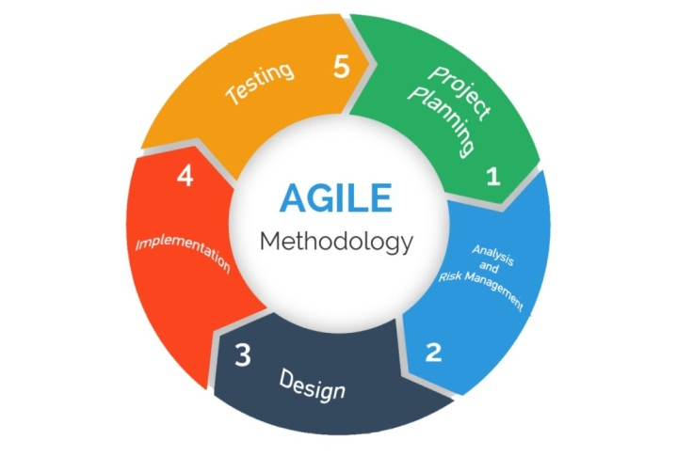

Figure 4: Agile Methodology Phases.

* 1. **Design Research Methodology**

This section is for the background of the chosen methodology. You may talk about the important of it, why did you choose it, to introduce about your methodology and its steps.

**3.2.1 Phase 1: Project Planning**

* **User Stories**

User stories capture what a user does or needs to do as part of his or her job function and here we present some of user stories:

1. As a user, I want to answer breast cancer questions.
2. As a user, I want to see the percentage of answered questions.
3. As a user, I want to compare the biopsy case if it is intact or infected
4. As a user, I want to present an animation video for breast cancer treatment methods.

* **Scenarios**

**Here we present some of scenarios for user stories.**

**Feature**: specific questions for the patient.

**Given you**: to help student to know questions type.

**Feature**: The process of analyzing the biopsy sample image.

**Given you**: To see if the biopsy image is intact or infected.

**Feature**: Video of breast cancer treatment methods.

**Given you:** To clarify ways of breast cancer treatment and learning for student.

**3.2.2 Phase 2: Analysis and Risk Management**

In our system we are trying to maximize the benefits of our smartphones and its powerful features to make every day of our life easier and healthier, we provide monitoring of the user health and make the following features available to him:

* 1. Specific questions for disease.
  2. Display the percentage result after answer the questions.
  3. Compare the biopsy case if it is intact or infected.
  4. Present an animation video for breast cancer treatment methods.

**System Specifications:**

* **Use Case**

Under this header we will present the use cases for the whole system, the use cases have been derived from the system requirements. We present the main use case and follow it each use case separately.

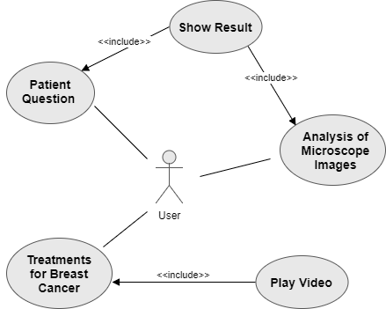

Figure 5: **Main Use Case**

* **Use Case Template**

The following Figure 3 shows the use case template.

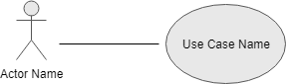

Figure 6: **Use Case Template**

Table 1: **Table shows general use case template details.**

|  |  |
| --- | --- |
| ID | Use Case ID |
| Name | Use Case Name |
| Description | A brief description about Use Case. |
| Priority | 1,2,3 and removed. |
| Status | High Level Description, Detailed Description, Scenarios, Complete, Coded, Tested, Incomplete Pates, etc. |
| Actors | Actors names which are involved in Use Case. |
| Pre-Conditions | Conditions required before the start of the use case. |
| Inputs | The inputs that enter to Use Case. |
| Normal Flow of Events | Steps to reach the Post-Conditions. |
| Otherwise Flow | The other flow if occur errors or exceptions |
| Post-Conditions | Conditions that will be achieved after executing use case. |
| Outputs | The outputs that out from Use Case. |
| Constraints | List of constraints for this requirement. |
| Exceptions | Wrong behavior appears in normal flow. |

**Patient Question Use Case**

Figure 7: shows Patient Question use case.

pQ

Figure 7: **Patient Question use case**.

Table 2: **Patient Question use case details.**

|  |  |
| --- | --- |
| ID | 1 |
| Name | Patient Question |
| Description | The user can answer to the Patient Question |
| Priority | 2 |
| Status | High Level Description |
| Actors | User |
| Pre-Conditions | Choose patient question screen |
| Inputs | Choose the question answer |
| Normal Flow of Events | Click on Patient Question button |
| Otherwise Flow | None |
| Post-Conditions | View question and result of answer |
| Outputs | Show result |
| Constraints | Answer all questions |
| Exceptions | None |

**Analysis of Microscope Images Use Case**

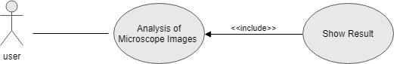

Figure 8: **Analysis of Microscope Images use case**.

Table 3: **Analysis of Microscope Images use case details**.

|  |  |
| --- | --- |
| ID | 2 |
| Name | Analysis of Microscope Images |
| Description | Comparison between the actual images in the system with the captured image |
| Priority | 1 |
| Status | High Level Description. |
| Actors | User |
| Pre-Conditions | Choose the Analysis of Microscope Images |
| Inputs | Captured image |
| Normal Flow of Events | Click on Analysis of Microscope Images |
| Otherwise Flow | None |
| Post-Conditions | capture image |
| Outputs | Show result |
| Constraints | The smart phone must have a camera |
| Exceptions | None |

t

Figure 9: **Treatments for Breast Cancer use case**.

Table 4: **Treatments for Breast Cancer use case details**.

|  |  |
| --- | --- |
| ID | 3 |
| Name | Treatments for Breast Cancer |
| Description | This screen shows list of Treatments for Breast Cancer |
| Priority | 1 |
| Status | High Level Description. |
| Actors | User |
| Pre-Conditions | Choose the Treatments for Breast Cancer |
| Inputs | None |
| Normal Flow of Events | Click on play video |
| Otherwise Flow | None |
| Post-Conditions | Open list video |
| Outputs | play video |
| Constraints | None |
| Exceptions | None |

**Sequence Diagram:**

1. **Patient Question Sequence Diagram.**

The Patient Question Sequence diagram presents the interactions that happened in the Patient question; the user first answer question in the Patient Question screen, then the result will change depending on the answer of the questions as Figure 10.

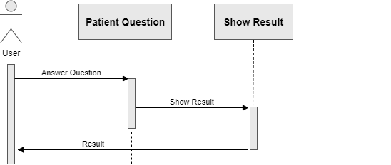

Figure 10: **Patient Question Sequence Diagram**.

1. **Analysis of Microscope Images Sequence Diagram**

Analysis of Microscope Images Sequence diagram presents the interactions that happened in the Analysis of Microscope Images, the user first Capture Image in the Analysis of Microscope screen, then the result will be the output of the comparison between captured image and actual images in the system as Figure 8.

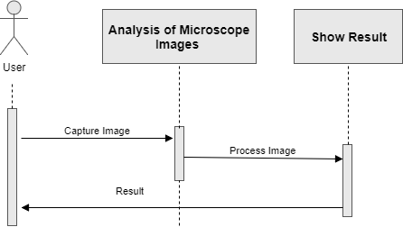

Figure 11: **Analysis of Microscope Images Sequence Diagram**.

1. **Treatments for Breast Cancer Sequence Diagram**

Treatments for Breast Cancer Sequence diagram presents the interactions that happened in the Treatments for Breast Cancer, the user first show video list in the Analysis of Treatments for Breast Cancer screen, then start playing video as Figure9 .

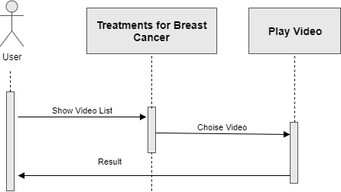

Figure 12: **Treatments for Breast Cancer Sequence Diagram**.

* **Risk Management**

Risk analysis and management is a crucial stage in system development, it involves looking at every problem that may occur during development and forming a plan of action when any of these problems arise as in Table 5.

Table **5: Risk Management for Problems May Occurs.**

|  |  |  |  |  |  |  |
| --- | --- | --- | --- | --- | --- | --- |
| **Solution** | **Rank** | **Measurement of effective** | **Possible of occurrence** | **Type** | **Risks** | **ID** |
| Get another phone or use other member phone | Very High | High | Low | Technology | Mobile phone lost or broken | **1** |
| Laptop repair or change | Moderate | Moderate | Low | Technology | Laptop with project's crashes | **2** |
| Postpone action for another time | Low | Low | Low | People | Trouble occurred and work can't be completed at the specific time | **3** |
| Adapt the new technology as fast as possible | Low | Low | Low | Technology | Technology change | **4** |

**3.2.3 Phase 3: Design**

The following Figure 10 presents the system architecture design; it shows the system as a whole and specifies the communication between components.

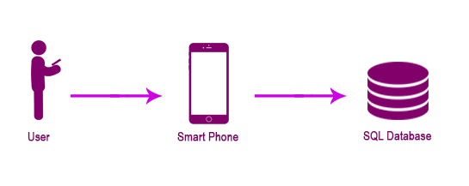

**Figure 13:** System Architecture Design.

* **Algorithms Description:**

ORB is an algorithm brought up by Ethan Rublee, Vincent Rabaud, Kurt Konolige and Gary R. Bradski in their paper ORB: An efficient alternative to SIFT or SURF in 2011 and they are working in OpenCV Labs

ORB is the alternative to SIFT and SURF in computation cost, matching performance and mainly the patents.

ORB is basically a fusion of FAST keypoint detector and BRIEF descriptor with many modifications to enhance the performance.

First it uses FAST to find keypoints, then apply Harris corner measure to find top N points among them. It also uses pyramid to produce multiscale-features.

It computes the intensity weighted centroid of the patch with located corner at center. The direction of the vector from this corner point to centroid gives the orientation.

Now for descriptors, ORB use “steer” BRIEF descriptors according to the orientation of keypoints. For any feature set of n binary tests at location (x_i, y_i), define a 2 \times n matrix, S which contains the coordinates of these pixels. Then using the orientation of patch, \theta, its rotation matrix is found and rotates the S to get steered(rotated) version S_\theta.

ORB discretize the angle to increments of 2 \pi /30 (12 degrees), and construct a lookup table of precomputed BRIEF patterns. As long as the keypoint orientation \theta is consistent across views, the correct set of points S_\theta will be used to compute its descriptor.

BRIEF has an important property that each bit feature has a large variance and a mean near 0.5. But once it is oriented along keypoint direction, it loses this property and become more distributed. High variance makes a feature more discriminative, since it responds differentially to inputs. Another desirable property is to have the tests uncorrelated, since then each test will contribute to the result. To resolve all these, ORB runs a greedy search among all possible binary tests to find the ones that have both high variance and means close to 0.5, as well as being uncorrelated. The result is called **rBRIEF** [25].

Figure 14 shows application of ORB to the analysis of a sample of breast tissue.

**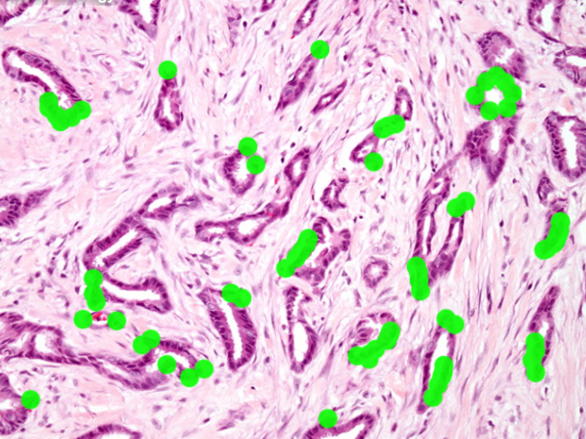**

Figure 14: **Application of ORB to the analysis of a sample of breast tissue**

* **Interfaces**



Figure 15 : **Starting screen of the application**.

**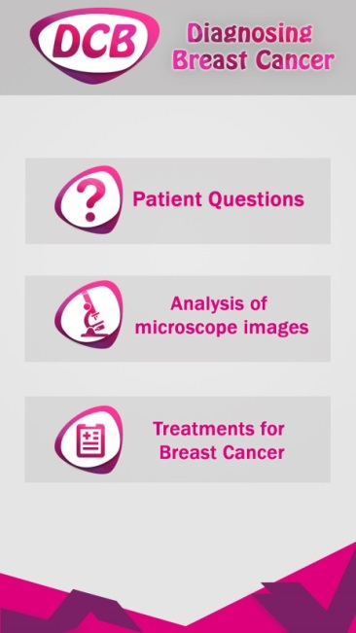**

Figure 16: **Main screen of the application**

**3.2.4 Phase 4: Implementation**

Implementation phase is a critical phase because it represents the project’s transition from virtual to real world, this system divided into three main parts:

1. Patient Questions
2. Analysis of microscope images
3. Treatments for Breast Cancer

**3.2.5 Phase 5: Testing**

Extreme program integrates testing with the implementation phase rather than at the end of the implementation phase. All codes have unit tests to eliminate bugs, and the code passes all such unit tests before release. Another key test is customer acceptance tests, based on the customer specifications. Acceptance test run at the completion of the coding and the developers provide the customer with the results of the acceptance tests along with demonstrations.

# **System Design Development**

**4.1 Introduction**

This section will discuss design and develop of diagnosis breast cancer application.

This application called (DCB). It is walk through many stages like gathering the information for the application and analysis it.

**4.2 Requirement Planning**

In this stage, establishing an initial plan depend on user’s opinions, suggestions and requirements.

**4.2.1 Data source and sample**

In this application, random samples of breast cancer and healthy samples are selected with a review by a specialist to diagnose and classify the condition of the sample so that the process of image analysis and results can be performed. The specialist determines the questions that the patient is asked to learn and determines the type of treatment needed for the patient and explain how to use it to the student.

**4.2.2 Hardware**

In this study, the application will be developed using:

1. **Laptop** : TOSHIBA , Intel (R) Core (i) i7-4700MQ @ 2.40GHz Bo, 1 TB hard, 12 GB of RAM [26].
2. **Mobil:** LG G4, Versions: H815 (EMEA) \ NETWORK: Technology (GSM / HSPA / LTE) \ LAUNCH: Announced 2015 \ April – Status: Available. Released 2015, April \ BODY: Dimensions: 148.9 x 76.1 x 6.3 - 9.8 mm [27].

**4.2.3 Software**

Software that will use for developing this application is:

1. **Android Studio:** Android studio is the official Integrated Development Environment (IDE) for Android application development .based on IntelliJ IDEA [28].
2. **OpenCV:** The Opencv Library is used to assist with algorithms that facilitate work [29].
3. **3D Maya \ MAX:** The program is designed to simulate breast cancer in animation [30].
4. **Photoshop:** Use the program to design application interfaces and logo[31].
5. **Backburner Network Rendering:** The network plays a key role in connecting computers and using their resources, using the network to handle multiple tasks, it uses multiple computers connected across a network to perform the task of exporting animations faster [32].
6. **Microsoft Office Word 2017**

Microsoft Office Word is a word processor developed by Microsoft, it offers enhanced features to create professional-quality documents, easier ways to work together with people, and almost-anywhere access to your files [33].

**4.2.4 Designing of Interface**

The interface is the application or system that is used to interact with the user. It is used by the user to interface between one interface and another interface. It consists of one main interface with many panels inside the interface they are:

* Patient Questions.
* Analysis of microscope images.
* Treatments for Breast Cancer.
* **Patient Questions:**



**Figure 17**: Questions answered by the user

This facade consists of a learning group that the student learns in order to determine the rate of breast cancer for the patient and the results are shown based on the patient's response. Where the rate of injury is determined for each question and the final outcome determines the likelihood of injury to the patient.

Table 6 : **Questions answered by the user**

|  |  |  |  |
| --- | --- | --- | --- |
|  | **Questions** | **Ratio %** | |
| **Yes** | **No** |
| **1.** | **Do you have any family history of breast cancer.** | **10 %** | **2 %** |
| **2.** | **Do you have any breast problem** | **12 %** | **2 %** |
| **3.** | **High fat diet.** | **4 %** | **1 %** |
| **4.** | **First child at late age.** | **5 %** | **1 %** |
| **5.** | **Late menopause.** | **6 %** | **1 %** |
| **6.** | **Alcohol consumption** | **4 %** | **1 %** |
| **7.** | **Are you using cosmetics heavily.** | **8 %** | **2 %** |
| **8.** | **Gender (Male \ Female)** | **Male** | **1%** |
| **Female** | **12 %** |
| **9.** | **Your skin color degree ( Black \ Blond \ Brown \ White)** | **Black** | **8 %** |
| **Blond** | **6 %** |
| **Brown** | **4 %** |
| **White** | **2 %** |

1. **Do you have any family history of breast cancer:**

Women with close relatives who've been diagnosed with breast cancer have a higher risk of developing the disease. If you've had one first-degree female relative (sister, mother, daughter) diagnosed with breast cancer, your risk is doubled [34].

1. **Do you have any breast problem:**

If you've been diagnosed with certain benign (not cancer) breast conditions, you may have a higher risk of breast cancer [35].

1. **High fat diet:**

Overweight and obese women -- defined as having a [BMI (body mass index)](http://www.breastcancer.org/tips/nutrition/after_treat/lose_weight/assess)over 25 -- have a higher risk of being diagnosed with breast cancer compared to women who maintain a healthy weight, especially after menopause. Being overweight also can increase the risk of the breast cancer coming back (recurrence) in women who have had the disease.

This higher risk is because fat cells make estrogen; extra fat cells mean more estrogen in the body and estrogen can make hormone-receptor-positive breast cancers develop and grow [36].

1. **First child at late age:**

Women who haven't had a full-term pregnancy or have their first child after age 30 have a higher risk of breast cancer compared to women who gave birth before age 30 [37].

1. **Late menopause:**

Women who started menstruating (having periods) younger than age 12 have a higher risk of breast cancer later in life. The same is true for women who go through menopause when they're older than 55. Over the past 15 years, girls have been starting puberty at younger ages. Breast development has started even earlier than menstrual periods. This unexpected shift has been attributed to the obesity epidemic and broad exposure to hormone disruptors, since a rise in hormones triggers the onset of breast development and puberty. The age when women go through menopause, however, has stayed about the same [38].

1. **Alcohol consumption:**

Research consistently shows that drinking alcoholic beverages -- beer, wine, and liquor -- increases a woman's risk of hormone-receptor-positive breast cancer. Alcohol can increase levels of estrogen and other hormones associated with hormone-receptor-positive breast cancer. Alcohol also may increase breast cancer risk by damaging DNA in cells [39].

1. **Are you using cosmetics heavily:**

While the chemicals in cosmetics make us look, feel, and smell better, research strongly suggests that at certain exposure levels, some of these chemicals may contribute to the development of cancer in people. But because personal care products contain a diverse combination of chemicals, it's nearly impossible to show a definite cause and effect for any specific chemical on its own [40].

1. **Gender (Male \ Female)**

**The biggest reasons for the difference in breast cancer rates between men and women are:**

* Women's breast development takes 3 to 4 years and is usually complete by age 14. It's uncommon for men's breasts to fully form -- most of the male breasts you see are fat, not formed glands.
* Once fully formed, breast cells are very immature and highly active until a woman's first full-term pregnancy. While they are immature, women’s breast cells are very responsive to estrogen and other hormones, including hormone disrupters in the environment.
* Men's breast cells are inactive and most men have extremely low levels of estrogen [41].

1. **Your skin color degree ( Black \ Blond \ Brown \ White)**

White women are slightly more likely to develop breast cancer than African American, Hispanic, and Asian women. But African American women are more likely to develop more aggressive, more advanced-stage breast cancer that is diagnosed at a young age. African American women are also more likely to die from breast cancer. Some of these differences in outcomes may be due to less access to mammography and lower quality medical care, as well as various lifestyle patterns (eating habits and weight issues for example) that are more common in some ethnic groups than in others. These factors can be changed and improved [42].

* **Analysis of microscope images:**

****

Figure 18: **Analysis of the tissue sample entered by the user**.

**This facade consists of comparisons of the samples of the breast tissue that the user enters into the application with the conventional samples and determines the result if the sample owner is infected or correct and a brief explanation of the nature of the infection.**

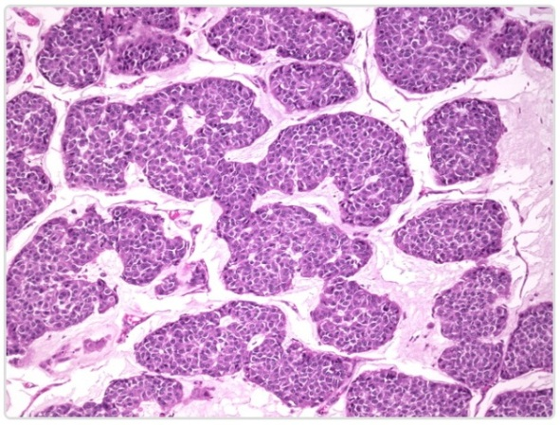

Figure 19: **Sample Mucinous Carcinoma of Breast [34].**

**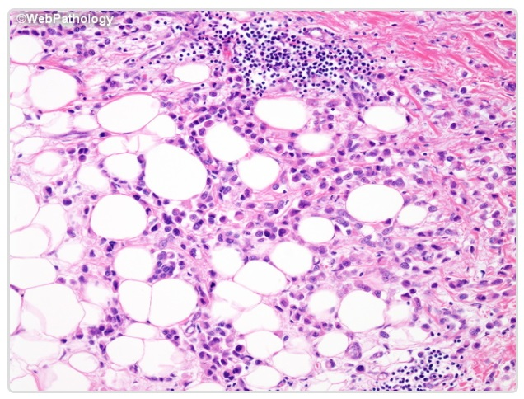**

Figure 20: **Sample Infiltrating Lobular Carcinoma [34].**

Figure 19 and Figure 20 shows a biopsy sample was taken from the microscope and analyzed in the program to show if it was infected or healthy.

* **Treatments for Breast Cancer:**



Figure 21: **Ways to treat breast cancer**.

The interface is designed to explain ways of treating breast cancer in an animation film, because the use of animation increases student interest and the ability to call medical information. Studies show that 40 percent of people respond better to visual information rather than text [43].

Animation helps capture the information students need because it is a highly specialized visual content. Students can use animation to help learn. Studies show that animation increases student interest and memory, and help improve comprehension and motivate learners On learning and transmit messages faster [44].

Figure 22: **On average, people remember**.

Based on Edgar Dale (Cone of Learning), on average, people remember: 10% of what they read; 20% of what they hear; 30% of what they see; 50% of what they hear and see.

Mazuryk and Gervaultz (1996) show the percentages of information that goes to human brain through human senses [45].

* **The animation was used to illustrate breast cancer treatments:**

1. Surgery
2. Chemotherapy
3. Radiation therapy
4. Hormone therapy
5. Targeted therapy

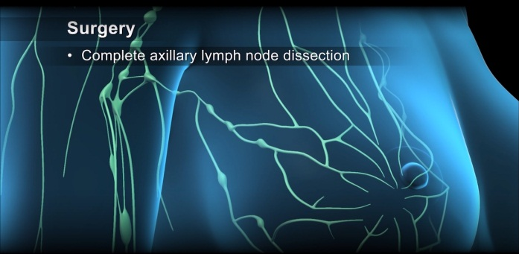

Figure 23**: Surgery - breast cancer treatments**.

1. **Surgery**: there are several surgical options depending on the severity of the cancer [46]:

* Lumpectomy: remove the tumor and a clear margin of surrounding tissue.
* Radiation therapy: treatment to kill unseen cancer cells.
* Mastectomy: removing the entire breast
* Breast reconstruction: a new breast is created using emplace or skin flaps.
* Sentinel Lymph node removal: remove one or more of the first lymph node draining the breast
* Complete axillary lymph node dissection: removal of most or all of the lymph nodes in the armpit area

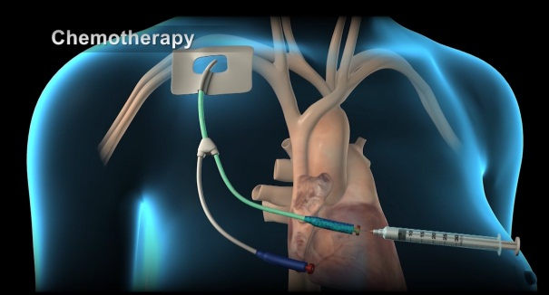

Figure 24: **Chemotherapy - breast cancer treatments**.

1. **Chemotherapy:**

Is a treatment that uses drugs to stop the growth of cancer cells [47].

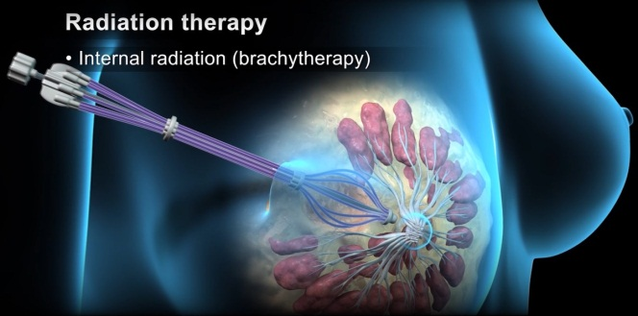

Figure 25: **Radiation therapy - breast cancer treatments**.

1. **Radiation therapy:** uses high energy radiation beams or particles to kill the remaining cancer cells or keep them from growing [48].

The main types of radiation therapy are:

* External beam radiation: It treats the breast from different angles while precisely targeting the tumor.
* Internal radiation (brachytherapy): It treats cancer from inside the breast using hollow applicated tubes with a radiation source passed through them.
* Intraoperative radiation: radiation is delivered during a breast sparing surgery such as a lumpectomy after the tumor is removed.

1. **Hormone therapy:** blocking the cancer cells from receiving the nature hormone that they need [49].

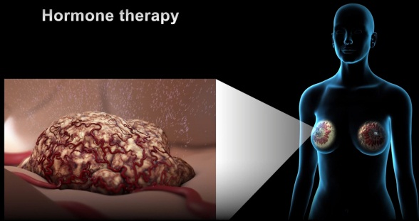

Figure 26: **Hormone therapy - breast cancer treatments**.

1. **Targeted therapy:** Uses specially designed drugs such as monoclonal antibodies that act on specific molecules inside or outside the cancer cells [50].

**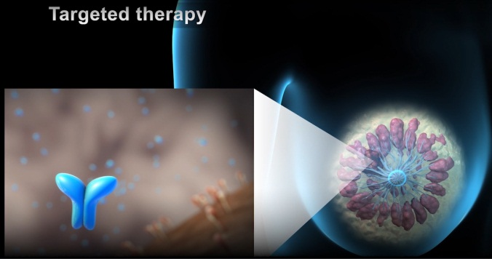**

Figure 27: **Targeted therapy - breast cancer treatments**.

# **System Evaluation**

System evaluation is a measure of the quality of the application that indicates the effectiveness, efficiency and satisfaction that users can perform tasks using the application. The usability assessment is now an essential part of the system development process, and a variety of questions have been developed to assess the system by the doctor and the student.

We have introduced this system to a few medical students and a few doctors who are specialist in the field. We asked both groups to evaluate the system and answer the following questions about the system. The results of both groups are shown in Figure 28 and Figure 29; furthermore a comparison of both groups is shown in Figure 30.

**Questions about the system for the doctor and the student:**

1. I am satisfied with how easy it is to use this system Comment.
2. It was simple to use this system.
3. Can effectively complete (work\study) using this system.
4. I am able to complete (work\study) quickly using this system.
5. I feel comfortable using this system.
6. The organization of information on the system screens is clear.
7. It was easy to learn to use this system.
8. The interface of this system is pleasant.

Figure 28: **The results were obtained by the doctor**

**Figure 29:** The results were obtained by the student

**Figure 30:** Comparison of results by doctor and student

# **Conclusion and Future Work**

* 1. **Conclusion**

The number of Knowledge Based Systems has increased in recent years and has proved to be of significant importance in the diagnostic process. Most of these systems focus on specific areas of disease in order to improve the accuracy of results. However, our system focuses on helping to diagnose breast cancer so that it can help students to understand and analyze the diagnosis of breast cancer.

Our Knowledge Based System is not intended to replace doctors or educational books, but it helps to encourage students' creative thinking skills, allowing students to know the consequences of decisions taken from diagnosis, because the experiment can be repeated several times without material or human loss.

* 1. **Future Work**

We have many plans for the future work and we will continue improving and adding new functions for the current application in addition improve the project as a whole by adding new features and ideas.

The application can be improved by adding the following features:

1. Develop and design to support and diagnosis other diseases.
2. Develop system to store patient historical information, retrieve this information when needed and keep it safe.
3. The application could be a tool to transfer the information between doctors and students.
4. Knowledge for everyone by adding a new part for non-specialist people to teach and keep them away from wrong behavior.

# **REFERENCES**

1. Zeichner, S. B., Herna, S., Mani, A., Ambros, T., Montero, A. J., Mahtani, R. L., Vogel, C. L. (2015). Survival of patients with de-novo metastatic breast cancer: analysis of data from a large breast cancer-specific private practice, a university-based cancer center and review of the literature. Breast Cancer Research and Treatment,153(3), 617-624. doi:10.1007/s10549-015-3564-3
2. Minicozzi, P., Bella, F., Toss, A., Giacomin, A., Fusco, M., Zarcone, M., Sant, M. (2013). Relative and disease-free survival for breast cancer in relation to subtype: a population-based study. Journal of Cancer Research and Clinical Oncology, 139(9), 1569-1577. doi:10.1007/s00432-013-1478-1
3. Collins LC, Tamimi RM, Baer HJ, Connolly JL, Colditz GA, Schnitt SJ. Outcome of patients with ductal carcinoma in situ untreated after diagnostic biopsy: results from the Nurses’ Health Study. Cancer. 2005;103:1778-1784.
4. Edge SB, Byrd DR, Compton CC, Fritz AG, Greene FG, Trotti A. AJCC Cancer Staging Manual. New York: Springer, 2010.
5. Abu Naser, S. S., & ALmursheidi, S. H. (2016). A Knowledge Based System for Neck Pain Diagnosis. World Wide Journal of Multidisciplinary Research and Development (WWJMRD), 2(4), 12-18.
6. Dahhaghchi, I., et al. “AI application areas in power systems.” IEEE Expert, vol. 12, no. 1, 1997, pp. 58–66., doi:10.1109/64.577416.
7. Stempfle, Hans-Ulrich. “The Role of Hypogonadism in the Evolution of Bone Loss before and after Cardiac Transplantation.” Bone Disease of Organ Transplantation, 2005, pp. 193–208., doi:10.1016/b978-012183502-6/50011-0.
8. Roberts, L. M. “MammoNet: a Bayesian Network Diagnosing Breast Cancer.” Series in Machine Perception and Artificial Intelligence Artificial Intelligence Techniques in Breast Cancer Diagnosis and Prognosis, 2000, pp. 101–148., doi:10.1142/9789812792488\_0004.
9. Wu, Qiu, and Mia Markey. “Computer-Aided Diagnosis of Breast Cancer on MR Imaging.” Recent Advances in Breast Imaging, Mammography, and Computer-Aided Diagnosis of Breast Cancer, pp. 739–762., doi:10.1117/3.651880.ch22.
10. Brocklehurst, Paul R., et al. “Factors which determine the referral of potentially malignant disorders by primary care dentists.” Journal of Dentistry, vol. 38, no. 7, 2010, pp. 569–578., doi:10.1016/j.jdent.2010.04.008.
11. Rosé, Helge. “M3-Simulation Multidisciplinary Simulation of Sustainability Strategies.” Systems Analysis Modelling Simulation, vol. 43, no. 9, 2003, pp. 1243–1247., doi:10.1080/02329290310001600291.
12. OpenCV library. (n.d.). Retrieved December 22, 2017, from https://opencv.org/
13. Autodesk | 3D Design, Engineering & Entertainment Software. (n.d.). Retrieved December 22, 2017, from https://www.autodesk.com/
14. T. Mazuryk, M. Gervautz: Two-Step Prediction and Image Deflection for Exact  
    Head-Tracking in Virtual Environments. Proceedings of EUROGRAPHICS’95,  
    pp. 29-41 (1995)
15. Bayraktar, Soley, and Banu Arun. “Dose-Dense Chemotherapy for Breast Cancer.” The Breast Journal, vol. 18, no. 3, 2012, pp. 261–266., doi:10.1111/j.1524-4741.2012.01236.x.
16. Pritchard, Kathleen I. “Hormone Replacement Therapy After Breast Cancer.” Breast Cancer and Molecular Medicine, pp. 879–902., doi:10.1007/978-3-540-28266-2\_41.
17. Burstein, Harold J. “Targeted Therapy for Breast Cancer.” Targeted Therapy in Translational Cancer Research, 2015, pp. 190–192., doi:10.1002/9781118468678.ch19.
18. Abu Ghali, M. J., Mukhaimer, M. N., Abu Yousef, M. K., & Abu Naser, S. S. (2017). Knowledge Based System for Problems of Teeth and Gums. International Journal of Engineering and Information Systems (IJEAIS), 1(4), 198-206.
19. Abu Naser, S. S., & Akkila, A. N. (2008). A Proposed Expert System for Skin Diseases Diagnosis. Journal of Applied Sciences Research; www.aensiweb.com/JASR/, 4(12), 1682-1693.
20. Abu-Naser, S. S., Kashkash, K. A., & Fayyad, M. (2010). Developing Knowledge Based System for plant disease diagnosis. Journal of Artificial Intelligence ; Scialert, 3(4), 269-276.
21. Al Rekhawi, H. A., Ayyad, A. A., & Abu Naser, S. S. (2017). Rickets Knowledge Based System Diagnoses and Treatment. International Journal of Engineering and Information Systems (IJEAIS), 1(4), 149-159.
22. Abu Naser, S., Al-Dahdooh, R., Mushtaha, A., & El-Naffar, M. (2010). Knowledge management in ESMDA: Knowledge Based System for medical diagnostic assistance. AIML Journal, 10(1), 31-40.
23. Azaab, S., Abu Naser, S., & Sulisel, O. (2000). A proposed expert system for selecting exploratory factor analysis procedures. Journal of the College of Education, 4(2), 9-26.
24. Abu Naser, S. S., & El Haddad, I. A. (2016). An Expert System for Genital Problems in Infants. EUROPEAN ACADEMIC RESEARCH, 4(10).
25. Bakeer, H., & Abu Naser, S. S. (2017). Photo Copier Maintenance Expert System V. 01 Using SL5 Object Language. International Journal of Engineering and Information Systems (IJEAIS), 1(4), 116-124.
26. Abu Naser, S. S. (1993). A methodology for expert systems testing and debugging. North Dakota State University, USA.
27. El Agha, M., Jarghon, A., & Abu Naser, S. S. (2017). Polymyalgia Rheumatic Expert System. International Journal of Engineering and Information Systems (IJEAIS), 1(4), 125-137.
28. Abu Naser, S. S. (1999). Big O Notation for Measuring Knowledge Based Systems complexity. Islamic University Journal Gaza, 7(1), 57-70.
29. Hilles, M. M., & Abu Naser, S. S. (2017). Knowledge-based Intelligent Tutoring System for Teaching Mongo Database. EUROPEAN ACADEMIC RESEARCH, 6(10), 8783-8794.
30. Khella, A. R., & Abu Naser, S. S. (2017). Expert System for Chest Pain in Infants and Children. International Journal of Engineering and Information Systems (IJEAIS), 1(4), 138-148.
31. AbuEl-Reesh, J. Y., & Abu Naser, S. S. (2017). Knowledge Based System for Diagnosing Shortness of Breath in Infants and Children. International Journal of Engineering and Information Systems (IJEAIS), 1(4), 102-115.
32. Mrouf, A., Albatish, I., Mosa, M., & Abu Naser, S. S. (2017). Knowledge Based System for Long-term Abdominal Pain (Stomach Pain) Diagnosis and Treatment. International Journal of Engineering and Information Systems (IJEAIS), 1(4), 71-88.
33. Abu Naser, S. S. (2015). Sl5 Object: Simpler Level 5 Object Expert System Language. International Journal of Soft Computing, Mathematics and Control (IJSCMC), 4(4), 25-37.
34. Nabahin, A., Abou Eloun, A., & Abu Naser, S. S. (2017). Expert System for Hair Loss Diagnosis and Treatment. International Journal of Engineering and Information Systems (IJEAIS), 1(4), 160-169.
35. Abu-Naser, S., El-Hissi, H., & Abu-Rass, M. (2010). Knowledge Based System for Endocrine Diadnosis and Treatment using JESS. Journal Of Artificial Intelligence, 4, 239-251.
36. Abu Naser, S. S., & Al-Bayed, M. H. (2016). Detecting Health Problems Related to Addiction of Video Game Playing Using Knowledge Based System. World Wide Journal of Multidisciplinary Research and Development, 2(9), 7-12.
37. Naser, S. S. A., & Al-Nakhal, M. A. (2016). A Ruled Based System for Ear Problem Diagnosis and Treatment. World Wide Journal of Multidisciplinary Research and Development, 2(4), 25-31.
38. Qwaider, S. R., & Abu Naser, S. S. (2017). Expert System for Diagnosing Ankle Diseases. International Journal of Engineering and Information Systems (IJEAIS), 1(4), 89-101.
39. Abu Naser, S. S., Baraka, M. H., & Baraka, A. (2008). A Proposed Expert System For Guiding Freshman Students In Selecting A Major In Al-Azhar University, Gaza. Journal of Theoretical & Applied Information Technology, 4(9).
40. Abu Naser, S. S., & Abu Hasanein, H. A. (2016). Ear Diseases Diagnosis Expert System Using SL5 Object. World Wide Journal of Multidisciplinary Research and Development, 2(4), 41-47.
41. Almurshidi, S. H., & Abu Naser, S. S. (2017). Design and Development of Diabetes Intelligent Tutoring System. EUROPEAN ACADEMIC RESEARCH, 6(9), 8117-8128.
42. Abu Naser, S. S., & Mahdi, A. O. (2016). A proposed Expert System for Foot Diseases Diagnosis. American Journal of Innovative Research and Applied Sciences, 2(4), 155-168.
43. Abu Naser, S. S., & Hilles, M. M. (2016). An expert system for shoulder problems using CLIPS. World Wide Journal of Multidisciplinary Research and Development, 2(5), 1-8.
44. Al-Bayed, M. H., & Abu Naser, S. S. (2017). An intelligent tutoring system for health problems related to addiction of video game playing. International Journal of Advanced Scientific Research, 2(1), 4-10.
45. Abu-Nasser, B. S. (2017). Medical Knowledge Based Systems Survey. International Journal of Engineering and Information Systems, 1(7), 218-224.
46. Abu Naser, S. S., & Hamed, M. A. (2016). An Expert System for Mouth Problems in Infants and Children. Journal of Multidisciplinary Engineering Science Studies (JMESS), 2(4), 468-476.
47. Almurshidi, S. H., & Abu Naser, S. S. (2017). Stomach disease intelligent tutoring system. International Journal of Advanced Research and Development, 2(1), 26-30.
48. Abdulla, A., Aziz, A., Al Shobaki, M., & Abu Naser, S. S. (2017). The Reality of Integrating the Dimensions of Computerized Health Information Systems in Dar Al-Shifa Medical Complex. International Journal of Engineering and Information Systems (IJEAIS), 1(9), 80-104.
49. Abu Naser, S. S., Alamawi, W. W., & Alfarra, M. F. (2016). Rule Based System for Diagnosing Wireless Connection Problems Using SL5 Object. International Journal of Information Technology and Electrical Engineering, 5(6), 26-33.
50. Abu Naser, S. S., & Alawar, M. W. (2016). [An expert system for feeding problems in infants and children](https://scholar.google.com/citations?view_op=view_citation&hl=en&user=-AgiPYoAAAAJ&cstart=20&pagesize=80&sortby=pubdate&citation_for_view=-AgiPYoAAAAJ:8gBurD7jEYQC). International Journal of Medicine Research, 1(2), 79-82.
51. Abu Naser, S. S., & AlDahdooh, R. M. (2016). Lower Back Pain Expert System Diagnosis And Treatment. Journal of Multidisciplinary Engineering Science Studies (JMESS), 2(4), 441-446.
52. Abu Naser, S. S., & Alhabbash, M. I. (2016). Male Infertility Expert system Diagnoses and Treatment. American Journal of Innovative Research and Applied Sciences, 2(4).
53. Abu Naser, S. S., & Al-Hanjori, M. M. (2016). An expert system for men genital problems diagnosis and treatment. International Journal of Medicine Research, 1(2), 83-86.
54. Abu Naser, S. S., & Bastami, B. G. (2016). A proposed rule based system for breasts cancer diagnosis. World Wide Journal of Multidisciplinary Research and Development, 2(5), 27-33.
55. Abu Naser, S. S., & El-Najjar, A. E. A. (2016). An expert system for nausea and vomiting problems in infants and children. International Journal of Medicine Research, 1(2), 114-117.
56. Abu Naser, S. S., & Abu Zaiter, O. A. (2008). An Expert System For Diagnosing Eye Diseases Using Clips. Journal of Theoretical & Applied Information Technology, 4(10).
57. Abu Naser, S. S., & Shaath, M. Z. (2016). Expert system urination problems diagnosis. World Wide Journal of Multidisciplinary Research and Development, 2(5), 9-19.
58. Abu Naser, S. S., & Zaqout, I. S. (2016). Knowledge-based systems that determine the appropriate students major: In the faculty of engineering and information technology. World Wide Journal of Multidisciplinary Research and Development, 2(10), 26-34.
59. Barhoom, A. M., & Abu-Naser, S. S. (2018). Black Pepper Expert System. International Journal of Academic Information Systems Research (IJAISR), 2(8), 9-16.
60. Almadhoun, H. R., & Abu Naser, S. S. (2018). Banana Knowledge Based System Diagnosis and Treatment. International Journal of Academic Pedagogical Research (IJAPR), 2(7), 1-11.
61. Alajrami, M. A., & Abu-Naser, S. S. (2018). Onion Rule Based System for Disorders Diagnosis and Treatment. International Journal of Academic Pedagogical Research (IJAPR), 2(8), 1-9.
62. Almurshidi, S. H., & Abu-Naser, S. S. (2018). EXPERT SYSTEM FOR DIAGNOSING BREAST CANCER. Al-Azhar University, Gaza, Palestine.
63. Khella, R., & Abu Naser, S. S. (2017). Rule Based System for Chest Pain in Infants and Children. International Journal of Engineering and Information Systems, 1(4), 138-148.
64. Dahouk, A. W., & Abu-Naser, S. S. (2018). A Proposed Knowledge Based System for Desktop PC Troubleshooting. International Journal of Academic Pedagogical Research (IJAPR), 2(6), 1-8.
65. Musleh, M. M., & Abu-Naser, S. S. (2018). Rule Based System for Diagnosing and Treating Potatoes Problems. International Journal of Academic Engineering Research (IJAER), 2(8), 1-9.
66. AlZamily, J. Y., & Abu-Naser, S. S. (2018). A Cognitive System for Diagnosing Musa Acuminata Disorders. International Journal of Academic Information Systems Research (IJAISR), 2(8), 1-8.
67. Nassr, M. S., & Abu Naser, S. S. (2018). Knowledge Based System for Diagnosing Pineapple Diseases. International Journal of Academic Pedagogical Research (IJAPR), 2(7), 12-19.
68. Abu-Nasser, B. S., & Abu-Naser, S. S. (2018). Cognitive System for Helping Farmers in Diagnosing Watermelon Diseases. International Journal of Academic Information Systems Research (IJAISR), 2(7), 1-7.
69. Abu Naser, S., & Aead, A. M. (2013). Variable Floor for Swimming Pool Using an Expert System. International Journal of Modern Engineering Research (IJMER), 3(6), 3751-3755.
70. El\_Jerjawi, N. S., & Abu-Naser, S. S. (2018). Diabetes Prediction Using Artificial Neural Network. International Journal of Advanced Science and Technology, 121, 55-64.
71. Elqassas, R., & Abu-Naser, S. S. (2018). Expert System for the Diagnosis of Mango Diseases. International Journal of Academic Engineering Research (IJAER), 2(8), 10-18.
72. AbuEl-Reesh, J. Y., & Abu Naser S. S. (2017). An Expert System for Diagnosing Shortness of Breath in Infants and Children. International Journal of Engineering and Information Systems (IJEAIS), 1(4), 102-115.
73. Abu-Naser, S., El-Hissi, H., Abu-Rass, M., & El-Khozondar, N. (2010). An expert system for endocrine diagnosis and treatments using JESS. Journal of Artificial Intelligence; Scialert, 3(4), 239-251.
74. Abu-Nasser, B. (2017). [Medical Expert Systems Survey](https://papers.ssrn.com/sol3/papers.cfm?abstract_id=3082734). International Journal of Engineering and Information Systems (IJEAIS), 1(7), 218-224