Predicting Birth Weight Using Artificial Neural Network
Mohammed Al-Shawwa, Samy S. Abu-Naser
Department of Information Technology,
Faculty of Engineering and Information Technology,
Al-Azhar University - Gaza, Palestine

Abstract: In this research, an Artificial Neural Network (ANN) model was developed and tested to predict Birth Weight. A number of factors were identified that may affect birth weight. Factors such as smoke, race, age, weight (lbs) at last menstrual period, hypertension, uterine irritability, number of physician visits in 1st trimester, among others, as input variables for the ANN model. A model based on multi-layer concept topology was developed and trained using the data from some birth cases in hospitals.
The evaluation of testing the dataset shows that the ANN model is capable of correctly predicting the birth weight with 100% accuracy.

Keywords: Artificial Neural Networks, Birth Weight, ANN, Predictive Model.

Introduction
The main objective of a birth weight prediction system is to identify and the weight of the baby, Do you a normal weight or a low weight, and baby's low weight affects her life, such as injury squint.

This study seeks to explore the possibility of using the artificial neural network model to predict the birth weight, at the lowest possible time and high accuracy in the results.
Of course one would expect the birth weight to be associated with several influential factors as mentioned earlier. On the other hand it is clear that it will be very difficult to find a mathematical model that may be an appropriate model for this relationship between performance/factors. However, one realistic method of the weight prediction may be to study data on the background of the some factors.

The practical approach to this type of problem is to apply a regression analysis in which data is better integrated into some functions. The result is an equation in which both input x_{j} is multiplied by w_{j}; the sum of all these products is constant,, and then an output of y = Σ w_{j} x_{j} +, is given, where j = 0.n.
The problem here is that it is difficult to choose a suitable function to capture all data collection as well as automatically adjust the output in the case of more information, because prediction is controlled by a number of factors, and this control will not be any clear and known regression model.
The artificial neural network, which simulates the human brain in solving a problem, is a more common approach that can address this type of problem. Thus, attempting to develop an adaptive system such as artificial neural network to predict the temperature based on the results of these factors [1].

1.1 The objectives of this study are:
- To identify some appropriate factors that affect the low birth weight.
- To convert these factors into appropriate models for adaptive system coding.
- Designing an artificial neural network that can be used to predict weight based on some predefined data.

The Artificial Neural Networks
An Artificial Neural Network (ANN) is an application of Artificial Intelligence [4-58]. ANN is an arithmetical model that is motivated by the organization and/or functional feature of biological neural networks. A neural network contains an interrelated set of artificial neurons, and it processes information using a connectionist form to computation. As a general rule an ANN is an adaptive system that adjusts its structure based on external or internal information that runs through the network during the learning process. Recent neural networks are non-linear numerical data modeling tools. They are usually used to model intricate relationships among inputs and outputs or to uncover patterns in data. ANN has been applied in numerous applications with considerable attainment [4-5]. For example, ANN has been effectively applied in the area of prediction, handwritten character recognition, evaluating prices of lodging [6-7].

Neurons are often grouped into layers. Layers are groups of neurons that perform similar functions. There are three types of layers. The input layer is the layer of neurons that receive input from the user program. The layer of neurons that send data to the user program is the output layer. Between the input layer and output layer are hidden layers. Hidden layer neurons are only connected only to other neurons and never directly interact with the user program. The input and output layers are not just there as interface points. Every neuron in a neural network has the opportunity to affect processing. Processing can occur at any layer in the neural network. Not every neural network has this many layers. The hidden layer is optional. The input and output layers are required, but it is possible to have on layer act as both an input and output layer [7].

ANN learning can be either supervised or unsupervised. Supervised training is accomplished by giving the neural network a set of sample data along with the anticipated outputs from each of these samples. Supervised training is the most common form of neural network training. As supervised training proceeds the neural network is taken through several iterations, or epochs, until the actual output of the neural network matches the anticipated output, with a reasonably small error. Each epoch is one pass through the training samples. Unsupervised training is similar to supervised training except that no anticipated outputs are provided. Unsupervised training usually occurs when the neural network is to classify the inputs into several groups. The training progresses through many epochs, just as in supervised training. As training progresses the classification groups are “discovered” by the neural network [6].

Training is the process by which these connection weights are assigned. Most training algorithms begin by assigning random numbers to the weight matrix. Then the validity of the neural network is examined. Next the weights are adjusted based on how valid the neural network performed. This process is repeated until the validation error is within an acceptable limit [5].

Validation of the system is done once a neural network has been trained and it must be evaluated to see if it is ready for actual use. This final step is important so that it can be determined if additional training is required. To correctly validate a neural network validation data must be set aside that is completely separate from the training data [7].
About 60% of the total sample data was used for network training in this paper. About 30% of the total sample data served as test and the remaining 10% used for validation of the system.

Methodology
By looking deeply through literature and soliciting the experience of human experts on birth children, a number of factors have been identified that have an impact on the low birth weight. These factors were carefully studied and synchronized in an appropriate number to encode the computer in the ANN environment. These factors were classified as input variables. Configurations variables reflect some possible levels of know birth weight by values and factors.

  - The Input Variable
The input variables specified are those that can be obtained simply from the hospitals. Input variables are:
Table 1: Attributes of the Data set
No. | Attributes
 | smoke
 | race
 | age
 | lwt
 | ptl
 | History of hypertension
 | uterine irritability
 | ftv
 | birth weight in grams

  - The Output Variable
The output variable represents the performance of the hospitals. The output variable depends on the input.

Table 2: Output variables
S/N | Output | Represent
1. | 1 | low weight
2. | 0 | Normal weight

  - Design of the Neural Networks

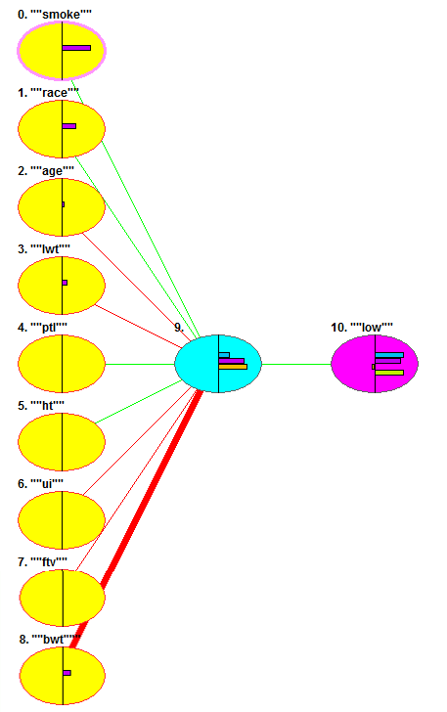

Figure 1: Shows the Design of the Neural Networks

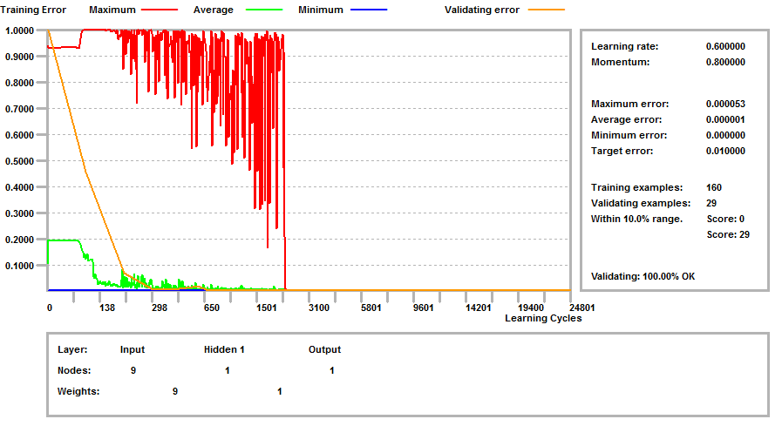
Figure 2: Shows the Training, error, and validation of the data set.

  - The Back-propagation Training Algorithm
- Initialize each wi to some small random value
- Until the termination condition is met, Do
- For each training example <(x1,…xn),t> Do
- Input the instance (x1,…,xn) to the network and compute the network outputs o_{k}
- For each output unit k: δk=ok(1-ok)(tk-ok)
- For each hidden unit h: δh=oh(1-oh) Σk wh,k δk
- For each network weight wj Do wi,j=wi,j+Δwi,j,where Δwi,j= η δj xi,j and ηis the learning rate.

Evaluation of The Neural Network
As mentioned previously, the purpose of this experiment was to predict the weight newborn child. Where we used data, which provides the possibility to implement and test the neural network and its learning algorithm. Our neural network is a sensor expression designed to detect the presence of one of two sets of materials. Alternatively, human reading may be wrong.
After training and validation, the network was tested using the test data set and the following results were obtained. This involves inputting variable input data into the grid without output variable results. The output from the grid is then compared with the actual variable data.
The neural network was able to accurately forecast 100% of the excellent data (representing 8 inputs and based on the inputs.) We have two outputs represented in values and each value is as follows: (0)100% , (1) 100%.

Conclusion
The artificial neural network model was presented to predict the weight of the newborn baby based on specific inputs.
The model was tested and the total score was 100%. Thus, the potential of the artificial neural network to predict the weight of the newborn baby was reviewed.

REFERENCES
- Salah, M., Altalla, K., Salah, A., & Abu-Naser, S. S. (2018). Predicting Medical Expenses Using Artificial Neural Network. International Journal of Engineering and Information Systems (IJEAIS), 2(20), 11-17.
- Marouf, A., & Abu-Naser, S. S. (2018). Predicting Antibiotic Susceptibility Using Artificial Neural Network. International Journal of Academic Pedagogical Research (IJAPR), 2(10), 1-5.
- Jamala, M. N., & Abu-Naser, S. S. (2018). Predicting MPG for Automobile Using Artificial Neural Network Analysis. International Journal of Academic Information Systems Research (IJAISR), 2(10), 5-21.
- Kashf, D. W. A., Okasha, A. N., Sahyoun, N. A., El-Rabi, R. E., & Abu-Naser, S. S. (2018). Predicting DNA Lung Cancer using Artificial Neural Network. International Journal of Academic Pedagogical Research (IJAPR), 2(10), 6-13.
- Al-Massri, R. Y., Al-Astel, Y., Ziadia, H., Mousa, D. K., & Abu-Naser, S. S. (2018). Classification Prediction of SBRCTs Cancers Using Artificial Neural Network. International Journal of Academic Engineering Research (IJAER), 2(11), 1-7.
- Alghoul, A., Al Ajrami, S., Al Jarousha, G., Harb, G., & Abu-Naser, S. S. (2018). Email Classification Using Artificial Neural Network. International Journal of Academic Engineering Research (IJAER), 2(11), 8-14.
- Metwally, N. F., AbuSharekh, E. K., & Abu-Naser, S. S. (2018). Diagnosis of Hepatitis Virus Using Artificial Neural Network. International Journal of Academic Pedagogical Research (IJAPR), 2(11), 1-7.
- Heriz, H. H., Salah, H. M., Abu Abdu, S. B., El Sbihi, M. M., & Abu-Naser, S. S. (2018). English Alphabet Prediction Using Artificial Neural Networks. International Journal of Academic Pedagogical Research (IJAPR), 2(11), 8-14.
- El_Jerjawi, N. S., & Abu-Naser, S. S. (2018). Diabetes Prediction Using Artificial Neural Network. International Journal of Advanced Science and Technology,124, 1-10.
- Abu-Naser, S., Al-Masri, A., Sultan, Y. A., & Zaqout, I. (2011). A prototype decision support system for optimizing the effectiveness of elearning in educational institutions. International Journal of Data Mining & Knowledge Management Process (IJDKP), 1, 1-13.
- Abu Naser, S., Zaqout, I., Ghosh, M. A., Atallah, R., & Alajrami, E. (2015). Predicting Student Performance Using Artificial Neural Network: in the Faculty of Engineering and Information Technology. International Journal of Hybrid Information Technology, 8(2), 221-228.
- Elzamly, A., Abu Naser, S. S., Hussin, B., & Doheir, M. (2015). Predicting Software Analysis Process Risks Using Linear Stepwise Discriminant Analysis: Statistical Methods. Int. J. Adv. Inf. Sci. Technol, 38(38), 108-115.
- Abu Naser, S. S. (2012). Predicting learners performance using artificial neural networks in linear programming intelligent tutoring system. International Journal of Artificial Intelligence & Applications, 3(2), 65.
- Elzamly, A., Hussin, B., Abu Naser, S. S., Shibutani, T., & Doheir, M. (2017). Predicting Critical Cloud Computing Security Issues using Artificial Neural Network (ANNs) Algorithms in Banking Organizations. International Journal of Information Technology and Electrical Engineering, 6(2), 40-45.
- Abu Naser, S. S., & Al-Bayed, M. H. (2016). Detecting Health Problems Related to Addiction of Video Game Playing Using an Expert System. World Wide Journal of Multidisciplinary Research and Development, 2(9), 7-12.
- Abu Ghali, M. J., Mukhaimer, M. N., Abu Yousef, M. K., & Abu Naser, S. S. (2017). Expert System for Problems of Teeth and Gums. International Journal of Engineering and Information Systems (IJEAIS), 1(4), 198-206.
- Abu Naser, S., & Akkila, A. N. (2008). A Proposed Expert System for Skin Diseases Diagnosis. INSInet Publication. Journal of Applied Sciences Research, 4(12), 1682-1693.
- El Agha, M., Jarghon, A., & Abu Naser, S. S. (2017). Polymyalgia Rheumatic Expert System. International Journal of Engineering and Information Systems (IJEAIS), 1(4), 125-137.
- Abu Naser, S., Al-Dahdooh, R., Mushtaha, A., & El-Naffar, M. (2010). Knowledge management in ESMDA: expert system for medical diagnostic assistance. AIML Journal, 10(1), 31-40.
- Almurshidi, S. H., & Abu-Naser, S. S. (2018). EXPERT SYSTEM FOR DIAGNOSING BREAST CANCER. Al-Azhar University, Gaza, Palestine.
- Abu Naser, S. S., & Alawar, M. W. (2016). An expert system for feeding problems in infants and children. International Journal of Medicine Research, 1(2), 79-82.
- Al Rekhawi, H. A., Ayyad, A. A., & Abu Naser, S. S. (2017). Rickets Expert System Diagnoses and Treatment. International Journal of Engineering and Information Systems (IJEAIS), 1(4), 149-159.
- Abu Naser, S. S., & AlDahdooh, R. M. (2016). Lower Back Pain Expert System Diagnosis and Treatment. Journal of Multidisciplinary Engineering Science Studies (JMESS), 2(4), 441-446.
- Nabahin, A., Abou Eloun, A., & Abu Naser, S. S. (2017). Expert System for Hair Loss Diagnosis and Treatment. International Journal of Engineering and Information Systems (IJEAIS), 1(4), 160-169.
- Abu Naser, S. S., & Alhabbash, M. I. (2016). Male Infertility Expert system Diagnoses and Treatment. American Journal of Innovative Research and Applied Sciences, 2(4).
- Qwaider, S. R., & Abu Naser, S. S. (2017). Expert System for Diagnosing Ankle Diseases. International Journal of Engineering and Information Systems (IJEAIS), 1(4), 89-101.
- Abu Naser, S. S., & Al-Hanjori, M. M. (2016). An expert system for men genital problems diagnosis and treatment. International Journal of Medicine Research, 1(2), 83-86.
- Naser, S. S. A., & Hasanein, H. A. A. (2016). Ear Diseases Diagnosis Expert System Using SL5 Object. World Wide Journal of Multidisciplinary Research and Development, 2(4), 41-47.
- Nassr, M. S., & Abu Naser, S. S. (2018). Knowledge Based System for Diagnosing Pineapple Diseases. International Journal of Academic Pedagogical Research (IJAPR), 2(7), 12-19.
- Abu Naser, S. S., & El-Najjar, A. E. A. (2016). An expert system for nausea and vomiting problems in infants and children. International Journal of Medicine Research, 1(2), 114-117.
- Elqassas, R.,& Abu-Naser, S. S. (2018). Expert System for the Diagnosis of Mango Diseases. International Journal of Academic Engineering Research (IJAER) 2 (8), 10-18.
- Naser, S. S. A., & Hilles, M. M. (2016). An expert system for shoulder problems using CLIPS. World Wide Journal of Multidisciplinary Research and Development, 2(5), 1-8.
- Musleh, M. M., & Abu-Naser, S. S. (2018). Rule Based System for Diagnosing and Treating Potatoes Problems. International Journal of Academic Engineering Research (IJAER) 2 (8), 1-9.
- Abu Naser, S. S., & Hamed, M. A. (2016). An Expert System for Mouth Problems in Infants and Children. Journal of Multidisciplinary Engineering Science Studies (JMESS), 2(4), 468-476.
- Almadhoun, H., & Abu-Naser, S. (2017). Banana Knowledge Based System Diagnosis and Treatment. International Journal of Academic Pedagogical Research (IJAPR), 2(7), 1-11.
- Abu Naser, S. S., & Mahdi, A. O. (2016). A proposed Expert System for Foot Diseases Diagnosis. American Journal of Innovative Research and Applied Sciences, 2(4), 155-168.
- Dahouk, A. W., & Abu-Naser, S. S. (2018). A Proposed Knowledge Based System for Desktop PC Troubleshooting. International Journal of Academic Pedagogical Research (IJAPR) 2 (6), 1-8
- Abu Naser, S. S., & Ola, A. Z. A. (2008). AN EXPERT SYSTEM FOR DIAGNOSING EYE DISEASES USING CLIPS. Journal of Theoretical & Applied Information Technology, 4(10).
- Bakeer, H., & Abu-Naser, S. S. (2017). Photo Copier Maintenance Expert System V. 01 Using SL5 Object Language. International Journal of Engineering and Information Systems (IJEAIS) 1 (4), 116-124.
- Abu Naser, S. S., & Shaath, M. Z. (2016). Expert system urination problems diagnosis. World Wide Journal of Multidisciplinary Research and Development, 2(5), 9-19.
- Khella, R., & Abu-Naser, S. S. (2017). Rule Based System for Chest Pain in Infants and Children. International Journal of Engineering and Information Systems 1 (4), 138-148.
- Abu-Naser, S. S., El-Hissi, H., Abu-Rass, M., & El-Khozondar, N. (2010). An expert system for endocrine diagnosis and treatments using JESS. Journal of Artificial Intelligence; Scialert, 3(4), 239-251.
- Mrouf, A., Albatish, I., Mosa, M., & Abu Naser, S. S. (2017). Knowledge Based System for Long-term Abdominal Pain (Stomach Pain) Diagnosis and Treatment. International Journal of Engineering and Information Systems (IJEAIS) 1 (4), 71-88.
- Abu Naser, S. S., Baraka, M. H.,& Baraka, A. R. (2008). A Proposed Expert System For Guiding Freshman Students In Selecting A Major In Al-Azhar University, Gaza.Journal of Theoretical & Applied Information Technology 4(9).
- Abu-Nasser, B. S., & Abu-Naser, S. S. (2018). Cognitive System for Helping Farmers in Diagnosing Watermelon Diseases. International Journal of Academic Information Systems Research (IJAISR) 2 (7), 1-7.
- Abu Naser, S. S., Alamawi, W. W., & Alfarra, M. F. (2016). Rule Based System for Diagnosing Wireless Connection Problems Using SL5 Object. International Journal of Information Technology and Electrical Engineering 5(6), 26-33.
- Akkila, A. N., & Abu Naser, S. S. (2016). Proposed Expert System for Calculating Inheritance in Islam. World Wide Journal of Multidisciplinary Research and Development 2 (9), 38-48.
- Abu Naser, S. S., & Zaqout, I. S. (2016). Knowledge-based systems that determine the appropriate students major: In the faculty of engineering and information technology, World Wide Journal of Multidisciplinary Research and Development 2 (10), 26-34.
- AbuEl-Reesh, J. Y., & Abu Naser, S. S. (2017). A Knowledge Based System for Diagnosing Shortness of Breath in Infants and Children. International Journal of Engineering and Information Systems (IJEAIS) 1 (4), 102-115.
- Abu Naser, S. S., & Bastami, B. G. (2016). A proposed rule based system for breasts cancer diagnosis. World Wide Journal of Multidisciplinary Research and Development 2 (5), 27-33.
- Abu-Nasser, B. S. (2017). Medical Expert Systems Survey. International Journal of Engineering and Information Systems, 1(7), 218-224.
- Abu Naser, S. S., & ALmursheidi, S. H. (2016). A Knowledge Based System for Neck Pain Diagnosis. World Wide Journal of Multidisciplinary Research and Development (WWJMRD), 2(4), 12-18.
- Azaab, S., Abu Naser, S., & Sulisel, O. (2000). A proposed expert system for selecting exploratory factor analysis procedures. Journal of the College of Education 4 (2), 9-26.
- Abu-Naser, S. S., Kashkash, K. A., & Fayyad, M. (2010). Developing an expert system for plant disease diagnosis. Journal of Artificial Intelligence, 3 (4), 269-276.
- Barhoom, A. M., & Abu-Naser, S. S. (2018). Black Pepper Expert System. International Journal of Academic Information Systems Research, (IJAISR) 2 (8), 9-16.
- AlZamily, J. Y., & Abu-Naser, S. S. (2018). A Cognitive System for Diagnosing Musa Acuminata Disorders. International Journal of Academic Information Systems Research, (IJAISR) 2 (8), 1-8.
- Alajrami, M. A., & Abu-Naser, S. S. (2018). Onion Rule Based System for Disorders Diagnosis and Treatment. International Journal of Academic Pedagogical Research (IJAPR), 2 (8), 1-9.
- Al-Shawwa, M., Al-Absi, A., Abu Hassanein, S., Abu Baraka, K., & Abu-Naser, S. S. (2018). Predicting Temperature and Humidity in the Surrounding Environment Using Artificial Neural Network. International Journal of Academic Pedagogical Research (IJAPR), 2(9), 1-6.

