Treatise on Morality

John Altmann

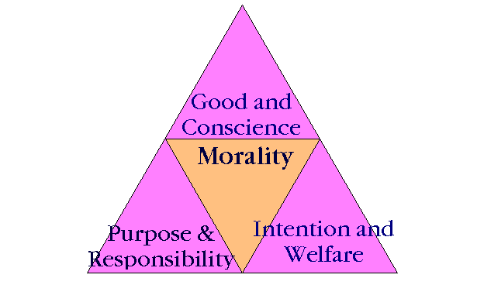

1.1 There is no such thing as morality or moral philosophy.
1.2 There does not exist a set of moral laws by which an individual governs themselves.
1.3 There does not exist a singular moral law by which man as a whole universally wills themselves.
1.4 The concept of good and evil is nonexistent.
1.5 The concept of right and wrong is nonexistent.
1.6 There exists only the forces of action and consequence
1.7 There can be no consequence without action nor can there be actions without consequence.
1.8 Actions have no charge
1.9 Consequences can be positively charged (+) or negatively charged (-)
2.0 A consequence's charge is determined based on the equation intent = reality or (I = R)
2.1 This equation basically states that a consequence is positive if the reasoned intent of the action plays out in reality. If the intent of the action conflicts with the nature of reality the consequence is said to be negatively charged.
2.2 To give a very elementary example, say a boy wishes to use his five dollars from selling lemonade to buy a cheeseburger so I is illustrated as cheeseburger and R is represented by the boy actually buying said cheeseburger. As a result (I = R) or (Wants to buy a cheeseburger = Cheeseburger bought) is a positively charged Consequence.
2.3 Now to look at a negatively charged Consequence, let us again return to the boy with the five dollars in his pocket. He still intends to buy a cheeseburger with his money, so the I variable remains the same. Now let us assert that just as the boy enters a local Burger King his mother calls him on his cell phone and requests that he bring home some potted petunias for the family garden. The boy not wanting to disappoint his mother agrees and he leaves the Burger King. The equation then becomes (Wants to buy a cheeseburger ≠ Needs to make flower purchases) which is a negatively charged consequence and is in turn replaced by the equation (Needs to make flower purchases = Flowers purchased) which carries a positive charge.
2.4 Neutral charges are only possible when intents clash and thus give rise to conflicting realities
2.5 This is illustrated by the equation (I = R + I² ≠ R²) = N
2.6 Consider if you will the nature of a game engaged between two parties. Both parties wish to win the game so we see that I and I² are identical. However only one person can win the game so while I=R is fulfilled on the one side of the equation for the victor (the victor achieves a positive consequence) The loser of the game has achieved a negative consequence through I² ≠ R² being fulfilled. Thus the consequence for the game as a whole carries a neutral charge.
2.7 The world in itself is a neutrally charged atmosphere.
2.8 The terminology of good and evil and right and wrong carries no weight except that of the beliefs of the speaker. There are no means by which to quantify these terms objectively. These terms are mere linguistic tools used to express displeasure at intents that conflict with their own. For instance, the person whose intent is to promote peace might use the term evil to describe their reality and those who indulge in war as being “wrong” The person is communicating displeasure on being subjected to a negatively charged consequence. Conversely, those who share our ideals and intents and who help us achieve positive consequence are “right” and “good” In the end, such terms are mere expressions with no real bearing on how our world is governed.
  - Actions are derived from our capacity to reason. For instance, our stomach growls, we reason that we are hungry, this prompts us to commit the action of going to the refrigerator for food.
3.0 Reason does not always take a logical form for sometimes the logical form is in itself a consequence. To illustrate further, a child who is only a year old touches a hot object and burns their hand. The child was incapable of reasoning prior to touching the object that it would be hot so as a consequence the child's hand is not only burned, the experience itself has taken the logical form of the object is hot so to touch the object is to be burned by the object.
3.1 Reason then, is a composition of logical forms that formulate our actions.
3.2 It goes against reason to attribute consequences for actions to “omnipotent forces” (God) Therefore, it also goes against reason to attribute our actions to said omnipotent force.
3.3 In regards to consequences, consequences are things that we as individuals brought forth with our actions. Consequences can be quantified by action and vise verse.
3.4 God has no justification of any kind and is in the same category as good and evil in the sense that it cannot be quantified. If one cannot justify it, it cannot derive any consequence from it nor can any acts perpetrated be attributed to it.
3.5 Furthermore, let it be known that it goes against reason to derive our actions or attribute our consequences to anything other than our own subjective reasoning capacities and the environment in which that reasoning was implemented.
3.6 To delve into the statement further, it is like saying we act in accordance with the rabbit. Though the rabbit can be quantified and thus justified, it is illogical to say we understand how it acts and have a knowledge of the consequences a rabbit endures. Our streams of consciousness differ and thus, so do our logical capacities.
3.7 Thoughts alone carry absolutely no charge.
3.8 Thoughts and actions are two separate entities. Unlike actions, thoughts bear no consequence. If a man thinks about cheating on his wife, that thought is incapable of being measured until acted upon.
3.9 A person is the totality of their consequences.
4.0 There is no positively charged being (a being whose intentions always harmonized with reality) nor is there a negatively charged being (a being whose intentions always clashed with reality.) Such a being can never exist for it is illogical. Environmental conditions are not always ripe for what we reason and it is because of this conflict between mind and environment that we are all neutrally charged beings. However it should be stated for the record, that if a person consistently sees their intentions fulfilled (in other words always proves the equation I = R) or vise verse, that being is the next step in human evolution and has proven, that one's actions and consequences can be contained within their own personal environment and away from the influence of conflicting intents.

