Article
Anti-Hedonism: Analysis Marxist Economic Theory of the Debt-to-Income
Angga Pratama ¹
¹ Universitas Terbuka & Ruangan Filsafat; angga3pratama@gmail.com
Abstract: Hedonism is a basic problem in society, especially in Indonesia. There are several negative impacts produced by hedonism such as poverty, debt problems, and social conflict. With an income level that does not match one's level of spending, this can cause an imbalance in one's financial condition. The economic theory of Marxism—which was pioneered by Karl Marx through one of his books entitledThe capital—helps us to understand more about logical considerations when consuming and maximizing utility to fulfill the collective interest. Capitalism creates a quite radical push in one's consumption activity, where by analysisLaw Diminishing Marginal Utility, capitalists will easily make new innovations so that they can produce new commodities that are deliberately positioned as commodities needed by society.Debt to Income Ratio which is one of the ratios to measure the liability and income of entities can be used as a step to prevent or slow down the development of a culture of hedonism and raise collective awareness in the midst of a fairly chaotic capitalist system.
Keywords: Economics, Marxism, Debt to Income Ratio, Asimetri, Hedonism

1. Introduction
Philosophically, hedonism is a concept that correlates with the pursuit of pleasure and avoid pain as the goal in life. The main principle of hedonism is to achieve the highest good by maximizing individual/subjective happiness and well-being—term Researchers use "subjective" because it is not uncommon for efforts to achieve pleasure and well-being to occur in accordance with personal interests and there is the potential to harm others-which focus on worldly satisfaction and enjoyment.
At first glance, we can see that there is nothing wrong with hedonism, but we need to realize that the pleasure and prosperity to be achieved are only based on the desires, interests, and encouragement of the capitalist system. Hedonism is one of the concepts used by the capitalist system or capitalists to gain profit. This can happen through encouragement based on social and economic status, where capitalist society, especially some of the upper middle-class live-in conditions that are quite affluent and affluent. That the life of the upper middle class usually encourages the lower classes to follow the lifestyle of the upper middle class. There is nothing wrong with the lifestyle of the upper middle class because they have sufficient economic capacity to fulfill their lifestyle. However, we need to realize that through the financial capabilities possessed by the upper middle class, this is used by capitalists to encourage public consumption through lifestyle, fashion, and food.
By creating new (non-substantial) needs, capitalists encourage the lower classes to follow (consciously or unconsciously) the lifestyle of the upper middle class. Thus, leading to criticism arising from hedonism, namely the neglect of long-term goals, personal growth, and collective well-being. The relentless pursuit of gratification can lead to a shallow and selfish existence that encourages disregard for consequences and their impact on others. Not only does it damage a person's financial system, but it also damages a person's physical and mental health. This can happen becauseLaw Diminishing Marginal Utility, which occurs when the pleasure derived from each experience decreases and results in a more extreme cycle of pleasure-seeking or gratification.
Marxism is a socio-economic theory that provides a critical analysis of capitalism and is an alternative for economic and social organizing. In this case, Marxism can take a position as a critical opposition to hedonism which is one of the products of capitalism to perpetuate exploitation and oppression. In theory, the economic concept of Marxism reveals the exploitative nature of capitalism and the fundamental need to transform the economic structure. In practice, we can see that Marxism identifies that capitalism inherently produces inequality, alienation, and instability. And collective power or class struggle is considered as the most important driving force of social change. With hedonism, we can see that there are efforts made by capitalism to maintain its domination and control over collective economic equality.
Debt to Income Ratio (DTI) is a measuring tool that can be used to measure the level of debt of the entity against income they. This is a substantial indicator in finance, especially used as a material consideration for measuring the quality and ability of an entity to manage debt and make repayments of previous obligations.DTI will provide insight into the financial health of entities and their capacity to take on additional debt or over-transact in their economic cycles. DTI we can use to measure a person's ability to buy or consume a commodity. Although not an absolute measure, we can see that DTI can be used to re-consume or take additional financing through credit so that the entity can buy or get the commodity it wants. However, with these actions, we need to see that the potential for default or critical unconsciousness of the entity can grow rapidly, and this can be detrimental to the entity and have an impact on social problems. Size generated byDTI it can be used with the help of the asymmetry of economic materialism as a secondary tool to eliminate non-substantial interests to reduce the harmful effects of capitalism.

2. Method
The approach used in this research is a qualitative research approach. The method used includes literature study and analysis SWOT. Qualitative data is information obtained from various sources and presented in the form of narratives or process schemes. This data is then analyzed to obtain comprehensive theoretical conclusions and provide a meaningful contribution to further research.
The data used in writing this research are the results of literature studies obtained from related research journals and relevant books. Researchers carry out the development and theoretical analysis of the problems that are the object of research to produce an up-to-date understanding of the relationship between the economic concept of Marxism andDebt to Income Ratio on the stability of debt management, stability, and financing of an entity. The sources of data used are sources that are recognized in the fields of economics and related social sciences. In addition, in data analysis, researchers also use an analytical approach SWOT (Strengths, Weaknesses, Opportunities, and Threats). SWOT analysis is used to identify the strengths, weaknesses, opportunities, and threats related to the application of the concept of Marxist economics in this era post-capitalism. This approach assists researchers in understanding the existing problems holistically and evaluating the potential and challenges associated with applying the concept to overcome the cycle of hedonism and consumerism which has the potential to cause structural poverty and oppression.
By using a qualitative research approach, literature study, and analysis SWOT, this study aims to present an in-depth and evidence-based understanding related to the economic concept of Marxism, the philosophical asymmetry of economic materialism, Debt to Income Ratio, and adaptability in the era post-capitalism. Through this research, it is hoped that relevant thoughts and recommendations will be generated to promote community financial stability and face complex social and economic challenges in the future.

3. Result and Discussion
3.1 The Picture of Anti-Hedonism
Anti-hedonism is a philosophical idea that contradicts the idea of hedonism. This idea of anti-hedonism aims to provide another alternative to what is offered by the idea of hedonism. Movement or human action that arbitrarily pursues pleasure, satisfaction, and individual welfare is a wrong concept and can be detrimental to the welfare of society. We realize that pleasure and satisfaction have no limits. Each additional unit obtained by everyone can cause "boredom" to be seen through Law Diminishing Marginal Utility. As a result, it will create an addictive effect that does not have a strong and meaningful basis, everything that is obtained by someone will not find a final limit or will continue to do so.exploitation and manipulation to satisfy themselves, this is not only binding on society who acts as a consumer, but also becomes a law that binds producers to continue to create new needs so that their commodities can be sold. We will understand when a need is naturally formed, for example the need for food staples. Of course, this is very natural, but what we need to criticize is the need which is basically not substantial and tends to sacrifice a lot of costs which, if allocated to other aspects, will provide more individual and even collective benefits (for example: by reducing the poverty rate, the crime rate will increase. the road will go down).
If we look at the correlation of anti-hedonism andLaw Diminishing Marginal Utility (LDMU)—we have seen one of the concepts in economics which states that any increase in the consumption of a good or service will provide diminishing satisfaction for the individual as a tool that is important enough to assess and determine the re-planning of consumption motives—that accumulation or equality an entity's boredom level will support sufficient analytical steps to support financial improvement. The equation is:

Subject = G + S = SN (normal assumption), Subject = G + S = SN + N – (1.n) = UN (LDMU assumption).

Notation: G (goods) and S (services), each additional (N = G + S) obtained will provide significant satisfaction, SN (satisfaction), UN (dissatisfaction), and (1.n) for each repetition, as the basic assumption of any decline in consumption interest. However, as consumption increases, the additional satisfaction obtained tends to decrease.
The numbers obtained from the equation LDMU can describe that however the amount of consumption of an entity will not be compared with the satisfaction or sacrifice that must be issued to get long-term benefits, that in some way, particularly in the future. The benefits of hedonistic behavior will not provide healthy financial change and development. And, through analysis carried out, we can see that the amount of money or effort put into obtaining non-substantial commodities is basically not commensurate with the risks that will appear in DTI when an entity makes sacrifices beyond its gross income capacity.

3.2 Overview of the Ethics of Utilitarianism
Philosophical asymmetry of Economic Materialism is an asymmetrical approach or condition that can be applied by individuals, companies, or organizations in emphasizing or eliminating existence goodwill. This asymmetry involves analysis goodwill in two conditions, namely presence (X) and absence (Y), which impact on policies and entities to disclose gains and losses associated with maintaining goodwill. This asymmetrical approach aims to reject and criticize subjective judgments that are not based on a firm foundation, and tend to causeBottleneck Fallacy, where the arguments in favor of goodwill are only as strong as its weakest point. Problems Goodwill has become a complex intellectual debate. This debate can cause confusion in presenting financial statements, making decisions, and disrupting the management control system. Impairment Goodwill in financial reports is often a loophole that can be exploited by management to commit fraud or manipulate data in order to maintain the professional image of a company or organization.
In this context, an understanding of the philosophical asymmetry of economic materialism becomes important. This approach tries to reveal that subjective judgments are related to goodwill can lead to distortions in decision making and presentation of financial information. Indirectly we can see that the philosophical asymmetry of economic materialism is only limited to larger entities or have structured economic and financial power, but this does not indicate that the philosophical asymmetry of economic materialism is not useful for smaller entities (individuals or a person). We need to realize that the philosophical asymmetry of economic materialism indirectly indicates that abstract values derived from economic activity can be comprehensively or partially reduced to ensure that subjects or individuals are not trapped in cycles of hedonism and consumerism. To clarify the philosophical asymmetry of economic materialism, we can see in table 1 below (David Benatar, 2008):
Presence (X) | Absence (Y)
Constantly increasing expenses (bad) | Not increasing expenses continuously (good)
Provide regular satisfaction (good) | Not always satisfying (not bad)

3.3 Framework of Thinking
Apart from discussing goodwill which is criticized by the philosophical asymmetry of economic materialism. Basically, the concept of philosophical asymmetry of economic materialism does not only serve to criticize goodwill—Of course this is limited within the framework of a company or corporation—however, it can be implemented within a more subjective and reducing framework of economic activity ineffectiveness in consumption activity. With the equation we get, namely Subject = G + S = SN (normal assumption), Subject = G + S = SN + N – (1.n) = UN (LDMU assumption). So, to clarify this equation, we can see scheme 1 below:
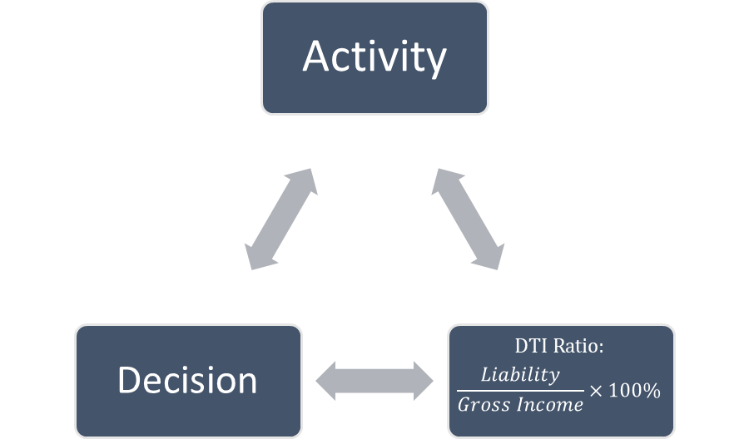
Note:
(≤35% ideal, 36% − 49% can be considered, ≥ 50% not ideal)
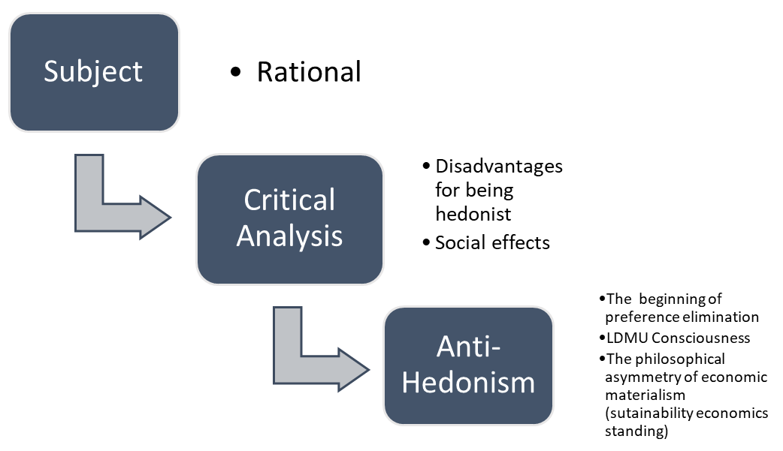
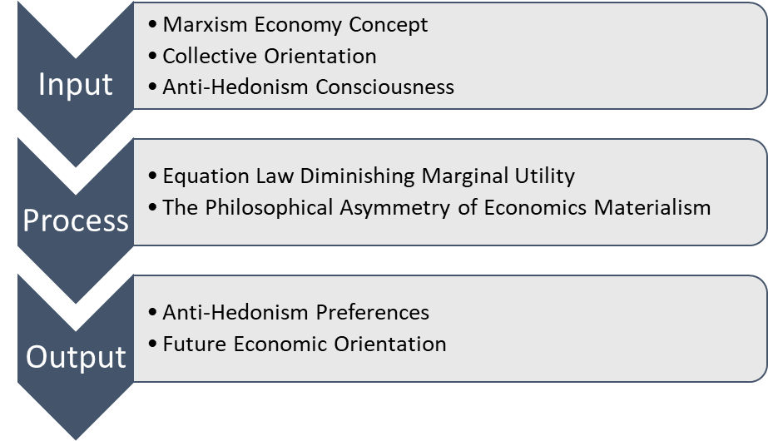
3.4 Anti-Hedonism Interpretation and Implications for Several Elements of Critical Financial Analysis
By looking at the scheme identified earlier, inherently the economic concept of Marxism, LDMU, DTI, and the philosophical asymmetry of economic materialism can be implemented without reducing the potential for economic development—basically, economic development is not fully characterized by high levels of consumption but is also followed by various variables that must be appropriate to form an optimal average rating in accordance with the applicable scheme. Based on the structure, we can see the following case assumptions:
If the price of an apple is 1$ and a dishwashing service is 2$, then the total of all spending or one's consumption if accumulated will result in an amount of 3$ (under normal assumptions) with that amount the level of satisfaction felt from consumption is large or very high satisfied, however when it happened reps or repetition, then this does not apply. If the subject buys one apple and enjoys additional dishwashing services, it will be seen that the fruit and additional services will then result in the accumulation of two consecutive transactions (Subject = 1$ + 2$ = 3$ + 1$ + 2$ = 6$). From these activities, occurredLaw Diminishing Marginal Utility occurred due to several repetitions (Subject = 1$ + 2$ = 3$ + 1$ + 2$ = 6$ - (1.n) = 5$).
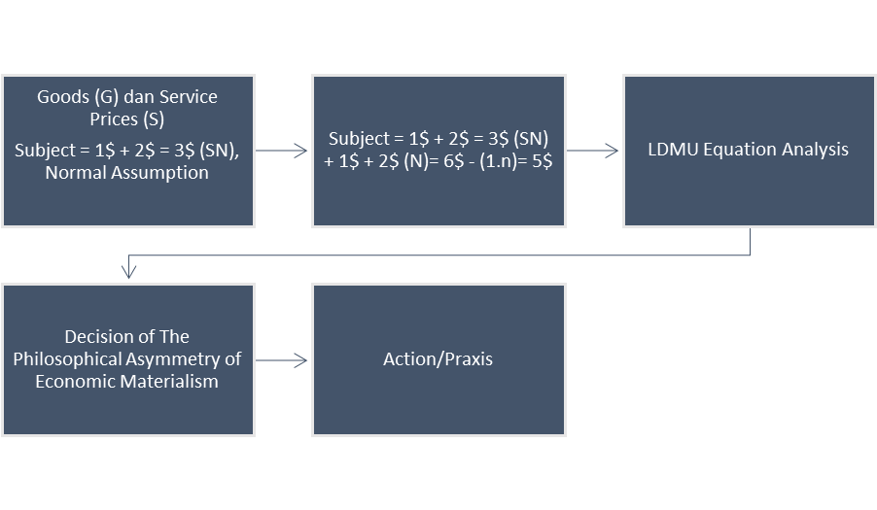
Furthermore, by looking at the activity framework above, once someone realizes that the activity is to seek satisfaction through non-substantial items provide no long-term benefits long and tend to be seen as compulsive actions, then we can carry out through the results of the LDMU equation, and enter these results to decide the concrete values that we can get from a consumption activity compared to abstract activities that are only attached to non-substantial. Thus, we can practice more efficient and effective activities to form a more humane collective consciousness.
3.5 Analysis SWOT (Strength, Weakness, Opportunity, and Threat)
Table 2. Theoretical review of LDMU's, Marxist Economics Theory, and Hedonism implications for economic stability:
No | Research journal | Researcher | Year | Abstract Summary
1. | The role of diminishing marginal utility in the ordinal and cardinal utility theories | Lin, C. C., & Peng, S. S | 2019 | We illustrate the role of the law of diminishing marginal utility in the two main modern utility theories, ordinal and cardinal utility theories, by using a generalized total utility function. In short, ordinal utility theory, where utility is immeasurable, must abandon the law of diminishing marginal utility; cardinal utility theory, while capable of defending this law, suffers from maintaining an unrealistic view of measurability of utility, which Samuelson criticizes as "absolutely improbable". A new utility theory with the advantages of the two theories mentioned (i.e. the ideas of diminishing marginal utility and unmeasured utility) but without the disadvantages (i.e. the law of diminishing marginal utility is negated and utility can be measured) therefore still appears to be a theory. The Holy Grail is worth seeking out and developing for economists.
2. | Diminishing Marginal Utility and the Teaching of Economics: A Note | Tamara Todorova | 2021 | This paper discusses how utility can be taught in an undergraduate course in microeconomics so as to describe total and marginal utility, the law of diminishing marginal utility, and consumer rationality. Diminishing marginal utility is very important in describing rational consumer behavior, overconsumption, and satiation for students of economics.
3. | Capitalism and alienation: Towards a Marxist theory of alienation for the 21st century | Emil Øversveen | 2021 | Alienation is one of the most influential terms in Marxist theory, but also one of the most ambiguous and controversial. Unlike earlier literature, which tended to focus on Marx's early philosophical writings, this offers a novel reinterpretation of the theory of alienation found in Marx's later works. Instead of understanding alienation as a subjective experience or an inherent feature of social organization, I argue that alienation in the Marxist sense can be understood as an objective process arising from the appropriation of the output of production and its transformation into capital. This interpretation resolves the main theoretical problems conventionally associated with alienation theory, such as the tendency towards essentialism and moral paternalism. In particular, Marxist alienation theory explains the paradox of social power and isolation that characterizes contemporary capitalist society, in which feelings of powerlessness and loneliness increase despite objectively increasing social power and interdependence.
4. | Hedonism, hedonistic shopping experiences and compulsive buying tendency: a demographics-based model approach | Richard J. Harnish  & Jasurbek Babaev | 2022 | Although consumer and marketing research focuses on identifying the various precursors of compulsive buying behavior, little attention has been paid to the more complex relationships examined from the perspectives of hedonism as personal values, hedonic shopping experiences, and consumer demographics. Thus, this study postulates a mediation model in which the degree of hedonism-related compulsive buying through diagnosed hedonistic shopping experiences, and produces a moderating effect based on the consumer's demographic characteristics (i.e. gender, age, education). Using data (N = 1,245) from a representative survey, and based on a structural equation model, the results show that hedonism significantly influences compulsive buying through the hedonistic shopping experience, whereas the moderating effect indicates that this relationship is stronger in younger individuals, mostly women. In contrast, this effect is not significantly related to consumer education level. The findings of this study are discussed in terms of theoretical and practical insights to better understand and prevent contemporary consumerism trends related to hedonism, hedonistic shopping, and compulsive buying tendencies. This research also offers important public policy and retail implications.
5. | Hedonism on the behavior of consumer society as a global cultural transformation | Subawa , N.S. , Widhiasthini , N.W. , Pika , P.A.T.P. , & Suryawati , P.I | 2020 | This study discusses changes in consumer behavior based on hedonic desires. The shift from consumption to consumerism. This is done on the purchase of four-wheeled vehicles (cars). This research is expected to provide awareness and critical understanding to the public to buy products according to their abilities, not to be trapped in a capitalist trap. This study uses descriptive qualitative and interpretive, involving consumers, car marketers, and financial agents as informants. The results of the study show that there has been a transformation in the behavior of a consumer society based on the desire for hedonism which is influenced by global cultural imperialism, such as instant culture and consumerism behavior.
● Strength:
- Helping entities to carry out selection and critical analysis of consumption motives when faced with a plurality of goods and services in the market;
- Increase financial capacity for future preparation to minimize uncertain conditions in economic activity;
- Optimizing the stability of the entity's or individual's financial condition through a consideration process that is relatively accurate and easy to implement;
- Helping entities to resist and reduce the influence of the marketing psychological attacks of capitalism.
● Weakness:
- There is a weakness in the human psychological element to determine influence comprehensive policies and steps to get rid of hedonistic spending schemes and anti-hedonism preferences;
- Doubts about the existence of entities attached to social phenomena or fashion which causes consumption to become undirected;
- There is a lack of principles centralized in individual economic thinking and policies to ensure stability in the medium- or long-term economy. Thus, worsening the condition of financial management to the most basic point.
● Opportunities:
- Reconstructing an economic motive for sustainability that is more optimal than the maximization of unfounded consumption in a capitalistic cycle that leads to the failure of rational economic decisions;
- Providing opportunities for each entity to maximize financial distribution into investment instruments compared to the satisfaction of pseudo-consumption that traps entities in the era post-capitalism;
- Providing opportunities for the creation of a more even distribution of wealth through maximizing work according to the needs of the community. And stopping the cycle of wasted commodities.
● Threat:
- The transition from the old to the new consumption motive will cause ambiguity in preferences so that the entity must notice fundamental aspects of their preferences before making decisions;
- There is no guarantee for everyone to overcome the problem of value and satisfaction which encourages the wrong formulation of individual consumption preferences to the point of "addiction" to pseudo-consumption.

4. Conclusions
This research seeks to investigate the availability of human resources owned by a community to be able to prepare themselves to face various unexpected conditions from various economic activities, especially the phenomenon black swan which often makes economic cycles fall apart. Hedonism, which is a classic problem in society, can hinder the creation of the awareness expected through this research, so that anti-hedonism is a way to critically analyze several consumption decisions. ThroughDebt to Income Ratio and the philosophical asymmetry of economic materialism—these two tools in particular—can provide a critical assessment of preferences to consumption decisions of an entity. Through this research, it was found that hedonism cannot guarantee maximum satisfaction and instead causes pointless sacrifices made by an entity only to experience temporary satisfaction or pleasure. The integration of human consciousness with its economic environment is influenced by only a few variables and thus, DTI, LDMU, and the philosophical asymmetries of economic materialism seek to re-measure some variable available to create economic decisions based collectively.

References
- Angga Pratama, & Endang Kartini Panggiarti. The Philosophical Asymmetry of Economic Materialism and the Negation of Goodwill: A Theoretical Review. Journal of Economic and Business Analysis, 2023, 1(1), 28-35.
- Hayek, Friedrich A. Individualism and Economic Order. The University of Chicago Press, 2012.
- Lin, C. C., & Peng, S. S. The role of diminishing marginal utility in the ordinal and cardinal utility theories. Australian Economic Papers, 2019, 58(3), 233-246. https://doi.org/10.1111/1467-8454.12151.
- Lorens, Bagus. Kamus Filsafat. Gramedia Pustaka Utama, 2005.
- Mandel, Ernest. An Introduction to Marxist Economic Theory. Resistance Books, 2008.
- Mandel, Ernest. Marxist Economic Theory Vol. 1. The Merlin Press, 1968.
- Mulyani, Sri. Sistem Pengendalian Manajemen. Universitas Terbuka, 2022.
- Øversveen, E. Capitalism and alienation: Towards a Marxist theory of alienation for the 21st century. European Journal of Social Theory, 2022, 25(3), 440-457.
- Sagoff, Mark. The Economy of the Earth Philosophy, Law, and the Environment. Cambridge University Press, 2007.
- Subawa, N. S., Widhiasthini, N. W., Pika, P. A. T. P., & Suryawati, P. I. Hedonism on the behavior of consumer society as a global cultural transformation. International research journal of management, IT and social sciences, 2020, 7(2), 59-70.
- Suryajaya, Martin. (Ed). Teks-Teks Kunci Filsafat Marx. Resist Book, 2016.
- Suryajaya, Martin. Materialisme Dialektif Kajian tentang Marxisme dan Filsafat Kontemporer. Resist Book, 2016.
- Suseno, Franz Magnis. Dari Mao ke Marcuse Percika Filsafat Marxis Pasca-Lenin. PT Gramedia Pustaka Utama, 2013.
- Tarka, P., Harnish, R. J., & Babaev, J. Hedonism, hedonistic shopping experiences and compulsive buying tendency: a demographics-based model approach. Journal of marketing theory and practice, 2023, 31(2), 197-222.
- Todorova, T. Diminishing marginal utility and the teaching of economics: A note. Journal of Research in Educational Sciences (JRES), 2021, 12(14), 25-31.

