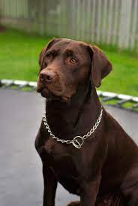
My favorite animals are dogs. I like big dogs. I have a 4-year-old dog, he is very funny but he is very rude
I don't like cats because they are very ugly
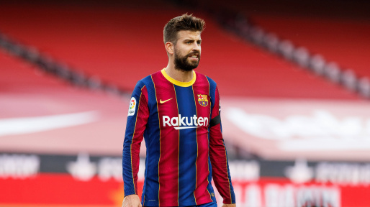
my favorite sport is soccer, I like to play and watch the uefa champions league. I really like FC Barcelona and Deportivo Pereira.
my position is defender and I don't like to play goalkeeper.
I don't like basketball because it's so boring

