ANYONS, MOBIUS STRIPS, and IMAGINARY COMPUTERS

by Rodney Bartlett

Unaffiliated with Institution – Lives in Australia, Member of ResearchGate and ORCID, Certificates in Astrophysics from ANU (Australian National University), Certificates in Robotics from QUT (Queensland University of Technology, Australia)

INTRODUCTION
In 1982, MIT physicist Frank Wilczek predicted and named ANYONS, quasiparticles (particle-like formations) that are confined to 2 dimensions. The name might come from Prof. Wilczek's lighthearted comment "anything goes". This article's main goal is to show that anyons could be another name for 1) virtual particles, 2) Mobius strips, and 3) figure-8 Klein bottles. Along the way, we'll see the picture painted by the article confirm that Einstein's dream of gravitational-electromagnetic unity fits in with anyons being Mobius strips. We'll also have encounters with intergalactic travel and imaginary computers. They really could exist but are imaginary in the sense that they use imaginary time (as well as space-time warping).

GRAVITATIONAL-ELECTROMAGNETIC UNIFICATION

What's a method that suggests the unifying of gravitation and electromagnetism? Electronics' binary digits can be used to draw a two-dimensional computer image of a Mobius strip. Two united Mobius strips create a three-dimensional figure-8 Klein bottle
(Polthier, K. Imaging maths - Inside the Klein bottle". http://plus.maths.org/content/os (2003).
that acts as a building block of space, time, forces’ bosons and matter’s fermions. This creates a supersymmetry (linkage) between fermions and bosons. A recent paper
(Afshordi, N. & Corianò, C. & Delle Rose, L. & Gould, E. & Skenderis, K. From Planck Data to Planck Era: Observational Tests of Holographic Cosmology. Phys. Rev. Lett. 118, 041301. https://journals.aps.org/prl/abstract/10.1103/PhysRevLett.118.04130 (2017).
says that in a holographic universe, all of the information in the universe is contained in two-dimensional packages trillions of times smaller than an atom (in this case, the 2D package is the Mobius Strip). Therefore, trillions of Mobius strips could form a photon and trillions of more complex figure-8 Klein bottles could form a more complex graviton (suggesting union of electromagnetism and gravitation).
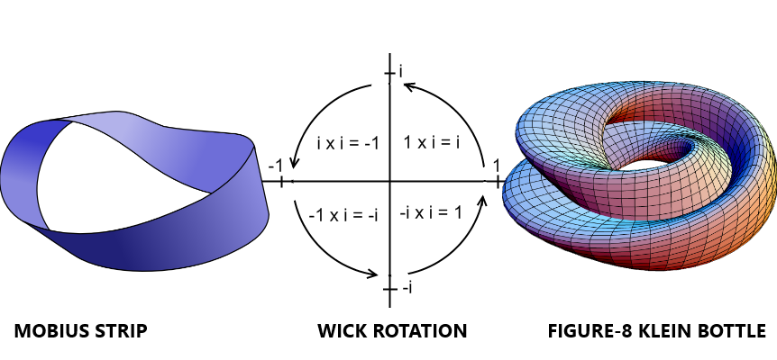
Diagram 1 - Mobius/Wick/Klein

The physicist and science historian Abraham Pais wrote that “In 1924 the scientist Wolfgang Pauli was the first to propose a doubling of electron states due to a two-valued non-classical "hidden rotation".
(Pais, A. Niels Bohr's Times. Oxford: Clarendon Press, p. 201 (1991).
Extending the ideas of “doubling”, “two-valued” and “hidden rotation” to the Mobius strip being a basic, fundamental unit of reality; it can be seen that Pauli’s proposal has an analogy to this article. The doubled Mobius strips (doubled to form a figure-8 Klein bottle) could be produced by the two-valued binary-digit system used in electronics. The bottles possess a hidden rotation, now identified as adaptive Wick rotation, which gives a fourth dimension to space-time.

The above paragraphs suggest we should follow Einstein's example and not be in favor of a 4 dimensional model but concede to its use to help mathematicians address the calculations necessary to explain general or special relativity.

(Luca Rajabi, https://www.researchgate.net/messages/53816668)

Also, they imply that the universe we live in needn't be described as 3 spatial dimensions plus one temporal dimension (3+1 space-time) but, in keeping with the theory of a holographic universe's 3 spatial dimensions being a projection from 2 dimensional information, as 2+1 space-time. The universe's foundation wouldn't rest on particles then but on what physics calls quasiparticles: particle-like objects which exhibit exotic behaviours and may, according to this article's next paragraphs, be identified as Mobius strips and figure-8 Klein bottles (see diagram 1).

According to physics, the electric repulsive force between 2 electrons is due to the exchange of "virtual" photons (undetectable particles which nevertheless have measurable effects on "real", detectable particles). When 2 electrons move past each other, real photons may be emitted. Logically, the real photons must be composed of the pre-existing virtual photons. If it's recalled that photons were described as being composed of trillions of Mobius strips (just before Diagram 1), we conclude that virtual particles are Mobius strips. Or they're more complex figure-8 Klein bottles, when 2 Strips combine to form a more complex Bottle. Trillions of Bottles form the complicated, elusive graviton.

You need to journey round a Mobius twice (make 2 revolutions) to return to the starting point. So if 1 anyon (a virtual particle aka a Mobius strip) moves round another, return to the original quantum state can only occur after 3 revolutions - the 2 required to return a Mobius to its start plus the complete revolution of one moving around the other. If the particle under study is a figure-8 Klein bottle, then the revolution of one about the other is supplemented by 4 revs (you go round each of the 2 combined Strips twice), and 5 revs must be completed before return to the original quantum state is achieved.

About time and the property called distance between 3 dimensional objects (assuming the universe is holographic and actually resides in 2+1 space-time) -

As stated in a robotics lesson,
(Corke, P. & Queensland University of Technology. MATLAB: Interpolation of a scalar. https://www.futurelearn.com/courses/making-robots-move/6/steps/570340 (2019).
"the time variable t varies from 0 to 1, that is, 0 ≤ t ≤ 1". Therefore, this article’s logic states that 0 may be equal to 1 (division by 1 is accepted, so why isn't division by 0?) Since time is permanently united with space in physics, 0=1 in space-time too. This is consistent with a proposed future theory of physics called Quantum Gravity; where Quantum Mechanics is united with General Relativity, Einstein's theory of gravity. A possible path to attainment of quantum gravity is realizing that all objects and events on Earth and in space-time are just one thing - like 0 equalling 1, and like the objects in a computer image seeming to be a lot of separate objects but really just being one thing (strings of the binary digits 1 and 0, which can represent electrical pulses being "on" or "off"). A spacecraft sitting on its launchpad can be assigned t=0, and its destination t=1. Since 0=1, reaching the destination takes the same time as reaching the launchpad from the craft’s position on the launchpad (travel is instant).

(The distance to the ship's destination and the time to arrive both equal zero.)
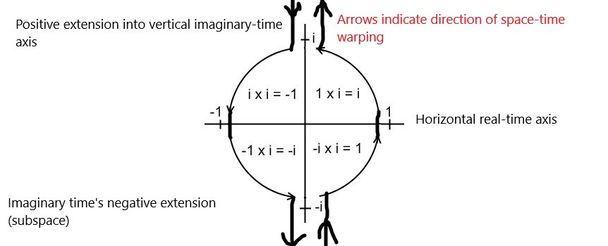
Diagram 2 -
GOING BEYOND QUANTUM COMPUTERS WITH IMAGINARY TIME AND SPACETIME WARPING

Our present approach to developing computers has gone about as far it can. The problems of chips generating too much heat - and of quantum uncertainties making transistors hopelessly unreliable at the scale of atoms - demand a new approach. I'm proposing that the successor to today's silicon technology (and tomorrow's quantum computers) lies in new concepts of time. An "imaginary" computer using the Complex Number Plane's vertical axis of imaginary time can perform calculations at the familiar rate of time's passing while the horizontal axis of "real" time sees absolutely no elapsed time (the possibility of no time passing in the normal sense is hinted at by Special Relativity's time dilation or slowing of time). Referring to diagram 2, space-time is warped and the computer's processing is performed in imaginary time (possibly for trillions of years) - but space-time is warped again so the results can be retrieved in real time where no time at all has elapsed.

For a hundred and ten years, science has accepted the concept of space-time which was formulated by Russian-German mathematician Hermann Minkowski and unites one time dimension with three space dimensions. Today, so-called imaginary numbers (such as i, which equals √-1) describe so-called imaginary time. Imaginary time is a concept derived from special relativity and quantum mechanics. Geometrically, imaginary numbers are found on the vertical axis of the Complex Number Plane, allowing them to be presented perpendicular to the real axis of space-time as we know it. One way of viewing imaginary numbers is to consider a standard number line, positively increasing in magnitude to the right, and negatively increasing in magnitude to the left. At 0 on this x-axis (the so-called real axis), a y-axis (the so-called imaginary axis) can be drawn with "positive" direction going up - "positive" imaginary numbers then increase in magnitude upwards, and "negative" imaginary numbers increase in magnitude downwards.

The ultraviolet catastrophe, also called the Rayleigh–Jeans catastrophe, is a failure of classical physics to predict observed phenomena: it can be shown that a blackbody - a hypothetical perfect absorber and radiator of energy - would release an infinite amount of energy, contradicting the principles of conservation of energy and indicating that a new model for the behaviour of blackbodies was needed. At the start of the 20th century, physicist Max Planck derived the correct solution by making some strange (for the time) assumptions. In particular, Planck assumed that electromagnetic radiation can only be emitted or absorbed in discrete packets, called quanta. Albert Einstein postulated that Planck's quanta were real physical particles (what we now call photons), not just a mathematical fiction. From there, Einstein developed his explanation of the photoelectric effect (when quanta or photons of light shine on certain metals, electrons are released and can form an electric current). So it appears entirely possible that another supposed mathematical trickery (imaginary time) will find practical application in the future in the form of Imaginary Computers.

To introduce you to the idea of extra dimensions, consider this – Professor Itzhak Bars of the University of Southern California in Los Angeles says, one whole dimension of time and another of space have until now gone entirely unnoticed by us.
(Tom Siegfried, 'A Two-Time Universe? Physicist Explores How Second Dimension of Time Could Unify Physics Laws', May 15 2007 https://m.phys.org/news/2007-05-two-time-universe-physicist-explores-dimension.html)
The temporal dimension would be "imaginary" time and the spatial dimension would be "imaginary" space, which must exist since time cannot exist apart from space (just as there is space-time, there would be imaginary space-time). Now suppose engineers warp space-time so the functioning of a computer's processor takes place in so-called imaginary time. If warping is looped so results emerge in so-called real time, its calculations would be retrieved instantly after they were entered into the computer because billions of years might pass in imaginary time yet no period at all could elapse in our real time. These warps and loops are viable because they're inspired by Einstein's Special Relativity – and propose the use of space-time warping which, though in its infancy, is a technology being worked on today by places like NASA.

USA theoretical physicist Ronald Mallett is also doing experimental work on space-time warping (gravitational warping, since General Relativity defines gravity as the warps and curves in space-time) for the purpose of developing scientific time travel. He describes his work - called the Space-time Twisting by Light (STL) project - in:

Mallett, R. L. (2000). "Weak gravitational field of the electromagnetic radiation in a ring laser". Phys. Lett. A. 269: 214. doi: 10.1016/s0375-9601(00)00260-7.

"In Einstein's General Theory of Relativity, both matter and energy can create a gravitational field. This means that the energy of a light beam can produce a gravitational field. My current research considers both the weak and strong gravitational fields produced by a single continuously circulating unidirectional beam of light. In the weak gravitational field of an unidirectional ring laser, it is predicted that a spinning neutral particle, when placed in the ring, is dragged around by the resulting gravitational field."

