Is Endurantism the Folk Friendly View of Persistence?

Abstract

Many philosophers have thought that our folk, or pre-reflective, view of persistence is one on which objects endure. This assumption not only plays a role in disputes about the nature of persistence itself, but is also put to use in several other areas of metaphysics, including debates about the nature of change and temporal passage. In this paper, we empirically test three broad claims. First, that most people (i.e. most non-philosophers) believe that, and it seems to them as though, objects persist by enduring rather than perduring. Second, that most people have a view of change on which enduring but not perduring objects count as changing. Third, that one reason why the folk represent time as dynamical is because it seems to them, and they believe that, they endure through time. We found no evidence to support these claims. While there are certainly plenty of ‘folk’ endurantists in the population we tested, there are also plenty of ‘folk’ perdurantists. We did not find robust evidence that a majority of people believed that, or it seemed to them as though, objects endure rather than perdure. We conclude that many arguments in favour of endurantism that appeal to folk beliefs about, or experiences of, persisting objects and change rest on views about those beliefs and experiences that are empirically unsupported. There is no evidence to suggest that endurantism is the folk friendly view of persistence, and so we should stop treating it as such without argument.

1. Introduction

While there are various accounts of persistence, the two most common views are endurantism and perdurantism. Roughly speaking, endurantism is the view that objects persist through time by being ‘wholly’ or ‘entirely’ located at one time, and then wholly located at another time, and then wholly located at a third time (and so on). On this view persisting objects are three-dimensional and are multiply located throughout time. By contrast, according to perdurantists objects are four-dimensional, having three spatial dimensions and one temporal dimension. They are extended along the temporal dimension by being composed of various short-lived objects, the temporal parts of the four-dimensional object in question. So while all of an enduring object is located at each time at which it exists, only some (a proper part) of a perduring object is located at each time at which it exists.

Much ink has been spilled debating which of these views is correct. The aim of this paper is not to adjudicate that question. Rather, our aim is to investigate a particular claim that has emerged from that debate: namely, that endurantism is the ‘folk friendly’ account of persistence (we will return, shortly, to say more about how to understand that claim).

Whatever exactly the claim amounts to, something like it has been made by a variety of authors. Benovsky (2015 p 689) notes that endurantism is often claimed to be “the ‘intuitive’ or the’ common sense’ view, contrary to perdurantism” And likewise, Daniels (2017, p 269) holds that ‘endurantism is often taken to be the intuitive theory of persistence.” Carrol (2011 p 359) takes the view to be “just so much common sense” and Paul (p 586) says that it is “the more natural view, capturing at least some of the content of our pre-theoretic intuitions.” In turn, Crane (2012 p 313) says that endurantism provides “a more natural and intuitive picture of how objects persist through time, a picture worth retaining if possible.” Scholl says that endurance “may strike many readers as much more natural and compelling than perdurance [because it is] more closely matched to the actual way in which we experience the world” (2007 p 583).

These quotes suggest two ways we might spell out the idea that endurantism is the folk friendly view of persistence. The first of these is in terms of a claim about belief:

Belief Claim: The folk believe (perhaps tacitly) that persisting objects endure.

If so, we’ll say that endurantism is the doxastically folk friendly view of persistence.

A second way in which endurantism could be the folk friendly view of persistence is hinted at by Scholl. It is the idea that the world seems to us, in experience, to be one in which objects endure. This is a claim about experience:

Phenomenal Claim: We have a phenomenology as of objects enduring.

As we will understand it, this is to say that it seems to us, in perceptual experience, as though persisting objects endure. We take this to be a claim about the content (rather than just the character, if you think the latter is not simply a function of the former) of the mental state in question: namely that its perceptual content represents (persisting) objects as enduring. The idea, then, is that we have perceptual experiences of persisting objects, and in having those experiences we not only represent that some object—say Annie—persists, i.e. that she exists at multiple times, but as part of that representation we represent that Annie, who we perceive at one time, is the very same object as Annie, who we perceive at another time. So, for instance, imagine tracking a moving object. Suppose you are tracking a dog running across a park. According to the phenomenal claim, it is part of the content of your perceptual experience, as you track the dog, that you are tracking a single thing; or, if you will, that you perceiving the same thing at these different locations (where, in turn ‘a single thing’ and ‘the same thing’ are to be understood in terms of numerical identity). Furthermore, it is part of your experience that all of Annie is located at each location where she is perceived. There is no sense in which Annie is perceived to be apparently incomplete, in the way that a biscuit with a bite out of it is perceived as being incomplete. If this claim is true, we will say that endurantism is the phenomenologically folk friendly view of persistence.

The claim that endurantism is the folk friendly view of persistence has played a role in theorising about persistence, insofar as many philosophers suppose that it is a mark in favour of a view that it is folk friendly. As Traynor (2014) puts it, the fact that endurantism is seen as the more common-sense view is taken by many to be justification for resisting perdurantist accounts. Given this, there is reason to try to determine whether in fact endurantism is the folk friendly view of persistence it is claimed to be.

There are also other reasons to be interested in this question. The claim that endurantism is the folk friendly view of persistence (or something very much like it) has played a pivotal role in a number of other debates in metaphysics. We will focus on two of these. Consider, first, change. Hales and Johnson (p. 498) put matters as follows. Since endurantism “as a general theory of persistence is intuitively plausible…any account of change must derive from the endurantist model.” An even stronger claim that is sometimes made is that change requires endurance. The idea, here, is that mere variation across a dimension is not genuine change. One reason to accept this would be if it were part of our (folk) concept of change that endurance is necessary for change. According to this view our concept of change is a concept of enduring things that have different properties at different times. Call this the Conceptual Connection Claim. The Conceptual Connection Claim draws a strong connection between our concept of change and our concept of persistence.

Conceptual Connection Claim: It is a conceptual truth that an object, O, changes only if O endures.

If the Conceptual Connection claim is true, then this would give us further reason to reject perdurantism. The plausibility of the Conceptual Connection claim, however, clearly rests on the plausibility of the Belief Claim. After all, we surely do believe that objects change, and if the Conceptual Connection claim were true, this could only be so if we believe that ordinary objects endure. So, whether or not the Conceptual Connection claim is true is hostage to the Belief Claim. This paper aims to investigate the status of both the Belief Claim and the Conceptual Connection claim.

There is also another claim, in the vicinity of the Conceptual Connection claim, that bears consideration. One might wonder whether there is a phenomenological connection between our experience of change and persistence. It could be, for instance, that in experiencing change, it seems to us as though we are experiencing endurance. There are various ways we could spell out this connection (again depending on how you think about the connection between character and content). But we will take this claim to be the following:

Phenomenal Connection Claim: Any perceptual experience that represents that some object O changes, thereby represents that O endures.

Again, the truth of the Phenomenal Connection Claim rests on the truth of the Phenomenal Claim. We do have perceptual experiences that represent that objects change. But according to the Phenomenal Connection claim this can be so only if we also have perceptual experiences that represent that objects endure. So, whether or not the Phenomenal Connection claim is true is hostage to the truth of the Phenomenal Claim. In this paper we investigate the status of both the Phenomenal Claim and the Phenomenal Connection claim.

There is one final way in which the claim that endurance is the folk friendly view has been put to work in debates within metaphysics. Many have thought that it seems to us, in experience as though time is dynamical. We will suppose that time is dynamical just in case some events are objectively (as opposed to merely subjectively) present, and which events those are, changes. Hence any version of the A-theory is a view on which time is dynamical, while the B-theory or C-theory are both views on which it is not. If a world is dynamical we will say that it is one in which time robustly passes.

Dynamists have appealed to this apparent feature of our experience---that time seems dynamical---to argue in favour of dynamism, while non-dynamists have sometimes attempted to explain why we have experiences that are like this even though time does not robustly pass. Still others have argued that we don’t have experiences like this at all. Prosser (2007; 2012; 2016) falls into this latter camp. He argues that we are tempted to think that time seems to us to be dynamical (even though it does not seem this way at all) and to believe that time is in fact dynamical, because we have experiences as of an enduring self. There are two related ideas here. First, there is the idea that people who judge that they have perceptual experiences as of time robustly passing mistake a perceptual experience as of the self enduring, for a perceptual experience as of time robustly passing. Call this the temporal phenomenology claim:

Temporal Phenomenology Claim: People judge that they have perceptual experiences as of time robustly passing because they have perceptual experiences as of the self enduring.

Second, there is the idea that people come to represent time as dynamical because they mistake a perceptual experience as of the self enduring, for a perceptual experience as of time robustly passing.

Passage Explanation Claim: People represent time as dynamical because they have perceptual experiences as of an enduring self.

Both the Temporal Phenomenology and Passage Explanation Claims rest on the Phenomenal Connection Claim. If it does not seem to us, in perceptual experience, as though we endure, then it cannot be that this seeming explains why we judge that time is dynamical (Passage Explanation Claim) or why we judge that our perceptual experiences are as of time robustly passing (Temporal Phenomenology Claim). We aim to probe both the status of the Phenomenal Claim as well as (more directly) the status of the Temporal Phenomenology and Passage Explanation Claims.

In all, then, we aim to test three classes of claims. The first class of claims focuses on the question of whether endurantism is either doxastically or phenomenologically the folk friendly view of persistence. Here, we aim to determine whether there is any empirical basis for the Belief Claim or the Phenomenal Claim. The examination of both claims has implications for several of the other connections that have been posited between, on the one hand change and persistence and, on the other hand, persistence and temporal phenomenology. If there is no empirical support for the Belief Claim or the Phenomenal Claim, then this in turn weakens the empirical basis for the Conceptual Connection and Phenomenal Connection claims, as well as the Temporal Phenomenology and Passage Explanation claims.

Notably though, even if support is found for the Belief Claim or the Phenomenal Claim, this does not show that the relevant connections do in fact obtain between our beliefs/experiences of persistence, and either our concept/experiences of change or our beliefs about, or experiences of, time. Moreover, even if no support is found for the Belief Claim or the Phenomenal Claim because most people do not believe that objects endure, nor does it seem to them, in perceptual experience, as though they endure, it could still be that a minority of people have these beliefs or experiences. If so, it would still be interesting to see whether, amongst these people, the posited connection between these beliefs/experiences of persistence on the one hand, and concepts/experiences of change or beliefs about/experiences of time obtain.

Our second two classes of claims that we aim to test explore the connection between our belief/experience of persistence and our concept/experience of change, on the one hand, and the connection between our belief/experience of persistence and our beliefs about/experiences of time, on the other hand. The first of these we call the change claims, the second we call the time claims. In the class of change claims, we test the Conceptual Connection Claim and the Phenomenal Connection Claim. In the class of time claims, we test the Temporal Phenomenology Claim and the Passage Explanation Claim.

We outline the hypotheses used to test these claims, along with our experimental methodology and results, in Section 2, and turn to discussion of these results in Section 3.

2. Methodology and Results
2.1 Experiment 1 Methodology

Experiment 1 tests the phenomenal and belief claims, and the temporal phenomenology and passage explanation claims.

2.2.1 Participants
1084 people participated in the study. Participants were recruited and tested online using Amazon Mechanical Turk and compensated $2.50 for their time. 895 participants had to be excluded from the analyses. That is because they failed one of the attentional check questions, or failed to answer 3 out of 4 comprehension questions correctly for both persistence vignettes or 3 out of 4 comprehension questions correctly for both time vignettes. The remaining sample was composed of 189 participants (70 female, 2 trans/non-binary; aged 21-71 mean age 39.30 (SD = 10.92)). Ethics approval for these studies was obtained from the [blanked] Human Research Ethics Committee. Informed consent was obtained from all participants prior to testing. The survey was conducted online using Qualtrics.

2.1.2 Materials and Procedure

Participants first saw two persistence vignettes with accompanying diagrams. The first vignette describes a world in which objects endure—which we will call an endurance universe—which is followed by a diagram of endurance. The second vignette describes a world in which objects perdure—which we will call a perdurance universe—and is followed by a diagram of perdurance. The vignettes are below.

Endurance Universe: Universe A

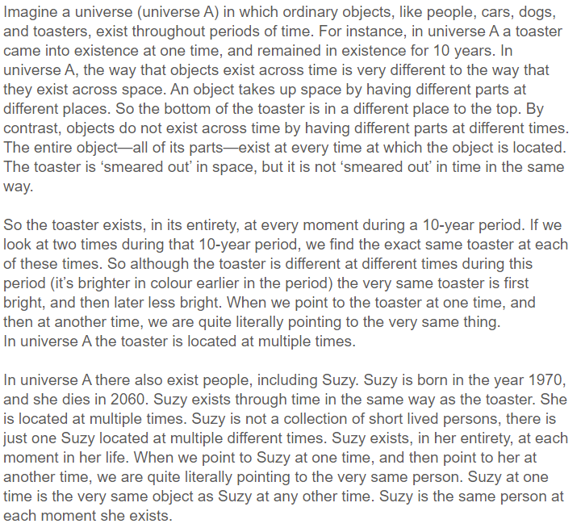

Perdurance Universe: Universe B
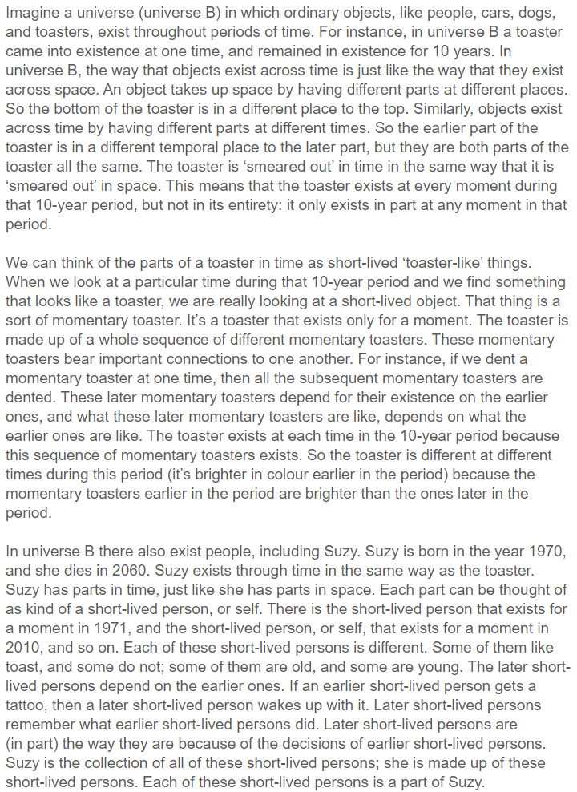

In order to maximise comprehension of the difference between these vignettes, participants were then presented with two diagrams, one that depicted Suzy as enduring, and one that depicted Suzy as perduring. These diagrams are below:
Figure 1: Endurance Universe
Figure 2: Perdurance Universe

After reading both persistence vignettes, participants responded to four comprehension questions to which they could either respond (a) true or (b) false. Participants who did not correctly answer 3 out of 4 of these questions for each vignette were excluded from the analyses.

- In Universe [A/B] people are collections of short-lived persons.
- In Universe [A/B] if a person exists for some period of time, then the person who exists at one time is literally the same person as the person that exists at some other time.
- In Universe [A/B] when we look at the toaster at different times, it always looks the same.
- In Universe [A/B] people exist through time in a different manner to all other objects.

Participants were then told:

We can distinguish what you believe about the way our universe is, from how the universe seems to you to be, as you experience it. For instance, it can seem to you, in your experiences, as though the two lines below are different lengths, even though (if you’ve met this illusion before) you don’t believe that they are.

Participants are then told, “Bearing this in mind, which universe do you think is most like our universe?” and given two options (a) universe A or (b) universe B.

Participants are then asked, “Which universe do you think seems more like our universe?” and given three options (a) universe A or (b) universe B or (c) both universe A and universe B seem equally like as though they could be like our universe.

Participants then proceed to a new page where they see two time vignettes. The first describes a non-dynamical world, and the second a dynamical world. The vignettes are amended versions of those used in Latham, Miller and Norton (2019) and in Everett, Latham and Miller (ms).

Dynamical (Moving spotlight)
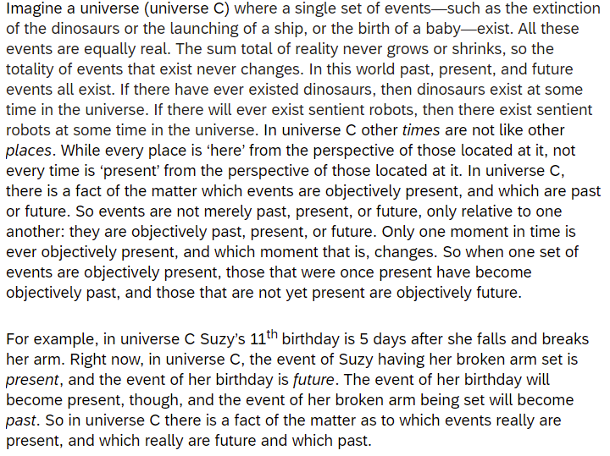

Non-dynamical (B-theory)

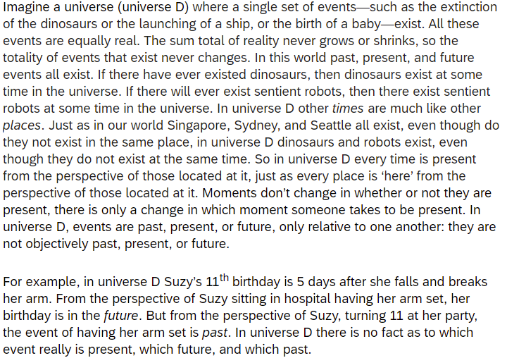

After reading both time vignettes, participants responded to four comprehension questions to which they could either respond (a) true or (b) false. Participants who did not correctly answer 3 out of 4 of these questions for each vignette were excluded from the analyses.

- In Universe [C/D] the past and present exist, but the future does not.
- In Universe [C/D] the past, present, and future exist.
- In Universe [C/D] there is an objective fact as to which events are present.
- In Universe [C/D] events are always only past or future relative to other events.

Participants were then asked, “Which universe, C or D do you think is most like our universe” and given two options (a) Universe C and (b) Universe D.

Participants were then shown one of the original two persistence vignettes again, and asked, “Imagine Suzy is in Universe A/B. Do you think she is more likely to be in a universe that is just like universe C, or just like universe D? and given two options (a) Universe C or (b) Universe D.

Finally, all participants moved to a new screen and read the following description:

Temporal Passage Description
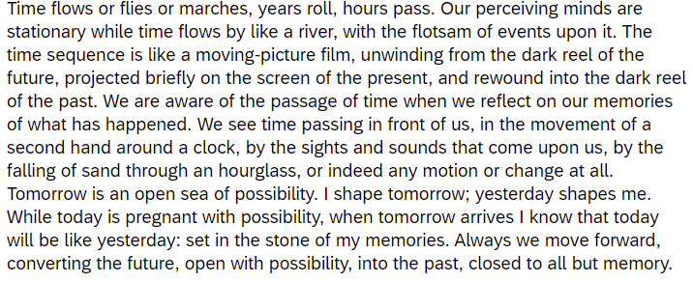

They were also provided with both earlier persistence diagrams.

After reading the temporal passage description they then responded to the final following statement: “If you are told that this description is a description of Universe [A/B], how likely do you think it is that what you are told is true?” and responded on a Likert scale that ran from (1) very unlikely through to (7) very likely.

2.1.3 Hypotheses for Experiment 1

Experiment 1 tested the following hypotheses. If the phenomenal claim is true, then we should find:

H1: More people will judge that our universe seems like the endurance universe than the perdurance universe.

If the belief claim is true, then we should find:

H2: More people will judge that our universe is like the endurance universe than the perdurance universe.

If the passage explanation claim is true, then we should find:

H3: There will be an association between believing the endurance universe is most like our universe and believing that the dynamical universe is most like our universe.

H4: There will be an association between its seeming as though the endurance universe is most like our universe and believing that the dynamical universe is most like our universe.

H5: People who are told that Suzy is in the perdurance universe will be more likely to judge that she is in the non-dynamical universe than the dynamical universe and people who are told that Suzy is in the endurance universe will be more likely to judge that she is in the dynamical universe than the non-dynamical universe.

If the temporal phenomenology claim is true, then we should find:

H6: People who are told that the passage vignette is a description of the endurance universe will judge that what they are told is more likely to be true (i.e. the description is a description of the endurance universe) than people who are told that it is a description of the perdurance universe.

After all, if people are in fact mistaking one kind of perceptual content—experiencing the universe as containing an enduring self—for another—experiencing the universe as containing robust passage—we would expect people to judge that a universe in which it seems as though there is robust passage will be a universe in which things endure.

Our hypotheses were preregistered at https://osf.io/fjx9p/.

2.2 Experiment 2 Methodology

In Experiment 2 we tested the phenomenal and belief hypotheses and the conceptual connection and phenomenal connection hypotheses.

2.2.1 Participants
710 people participated in the study. Participants were recruited and tested online using Amazon Mechanical Turk and compensated $2 for their time. 554 participants had to be excluded from the analyses. That is because they failed one of the attentional check questions, or failed to answer 3 out of 4 comprehension questions correctly for both persistence vignettes. The remaining sample was composed of 156 participants (52 female, 2 trans/non-binary; aged 20-70 mean age 37.70 (SD = 10.51)). Ethics approval for these studies was obtained from the [blanked] Human Research Ethics Committee. Informed consent was obtained from all participants prior to testing. The survey was conducted online using Qualtrics.

    - Materials and Procedure

The first part of Experiment 2 is the same as Experiment 1 up until after participants are asked the first probe questions: “Which universe do you think is most like our universe?” and “Which universe do you think seems more like our universe?”.

Participants then proceed to a new page where they are divided into two conditions: endurance and perdurance. Those in the endurance condition see the endurance vignette and accompanying diagram again and those in the perdurance condition see the perdurance vignette and accompanying diagram again. All participants then respond to the relevant version of the following statements to which they could either respond (a) yes or (b) no:

“In universe A/B do objects, including objects like Suzy, change”
“In universe A/B do objects, including objects like Suzy, seem to change.”

Finally, participants then proceeded to a new page and see the following vignette along with the endurance and perdurance persistence diagrams.

Change Description

Participants are then asked: “If you are told that the written description above the diagrams is a description of universe A/B, how likely do you think it is that what you are told is true?” and responded on a Likert scale that ran from (1) very unlikely through to (7) very likely. They are also asked, “Which universe do you think that Suzy is more likely to be in?” to which they could respond (a) Universe A or (b) Universe B, and “Do you think that it is more likely that it will seem to Suzy, in her experience of the world, as though she is in”, to which they could respond (a) Universe A, (b) Universe B or (c) It will seem equally likely, to Suzy, in her experience of the world, as though she is in universe A or universe B.

The first two hypotheses that Experiment 2 tests are the same as Experiment 1.

H1: More people will judge that our universe seems like the endurance universe than the perdurance universe.

H2: More people will judge that our universe is like the endurance universe than the perdurance universe.

The remainder of hypotheses tested in Experiment 2 focus on the Conceptual Connection Claim and the Phenomenal Connection Claim.

If the Conceptual Connection Claim is true we should find that:

H7: More people will judge that objects change in the endurance condition compared to the perdurance condition.

H8: People who are told that the change description is a description of the endurance universe will judge that what they are told is more likely true (i.e. the description is a description of the endurance universe), than people who are told that it is a description of the perdurance universe.

H9: More people will judge that Suzy is in the endurance universe than the perdurance universe.

If the Phenomenal Connection Claim is true, we should find that:

H10 More people will judge that it seems that objects change in the endurance condition compared to the perdurance condition.

H11 More people will judge that it seems to Suzy in her experience that she is in the endurance universe rather than the perdurance universe.

Our hypotheses were preregistered at https://osf.io/fjx9p/.

2.3 Results

2.3.1 Experiment 1

Before reporting the results, we will first summarize our findings in light of our hypotheses. H1 was supported. We found evidence that people are more likely to judge that our universe seems like the endurance universe, and less likely to judge that endurance and perdurance both seem equally likely. H2 was not supported; we did not find evidence that more people judge that our universe is more like an endurance universe than a perdurance universe. H3 and H4 were also not supported. We did not find evidence of an association between people believing (H3) or its seeming as though (H4) the endurance universe is most like our universe, and believing that the dynamical universe is more like our universe.

H5 was partially supported. We predicted that people who are told that Suzy is in the perdurance universe will be more likely to judge that she is in the non-dynamical universe than the dynamical universe, and that people who are told that Suzy is in the endurance universe will be more likely to judge that Suzy is in the dynamical universe than the non-dynamical universe. While people’s judgements regarding whether Suzy is in the dynamical or non-dynamical universe did not differ when they were told that she was in the endurance universe, more people judged that she was more likely to be in the non-dynamical universe than the dynamical universe when they were told that she was in the perdurance universe.

Finally, H6 was not supported. We did not find that people judged that the temporal passage description was more likely to be true when they were told the passage description was a description of the endurance universe as opposed to the perdurance universe.

Table 1 and Table 2 below summarize the descriptive data regarding which persistence vignette people think seems most like our universe (endurance, perdurance, both equally likely) and believe is most like our universe (endurance, perdurance). We also include the results of separate one-way χ² tests which test whether more people judged that our world seems, or is, more like the endurance universe. The results of those tests show there is no significant difference in the numbers of people that judge our universe to be more like the endurance or the perdurance universe. However, there is a significant difference in the numbers of people regarding how our universe seems. To identify where the difference lies in people’s seeming judgments we calculated the standardised residuals. Using a Bonferroni correction, we found that the significant result was due to more people judging that the universe seems like an endurance universe (z = 3.240, p = .001) and fewer people responding that both endurance and perdurance seem equally likely (z = -4.012, p < .001).

Table 1. Descriptive data of participants’ judgments regarding which persistence vignette seems most like our universe.
Persistence | Endurance | Perdurance | Equally Likely | χ² | p-value
Seem | 84 (44.4%) | 68 (36.0%) | 37 (19.6%) | 18.127 | <.001

Table 2. Descriptive data of participants’ judgments regarding which persistence vignette they believe is most like our universe.
Persistence | Endurance | Perdurance | χ² | p-value
Believe | 99 (52.4%) | 90 (47.6%) | 0.429 | .513

Table 3 below summarises the descriptive data of participants’ judgments regarding which time vignette (dynamical, non-dynamical) is most like our universe. Once again we include the results of a one-way χ² test, which this time tests whether most people judge that our universe is like the dynamical universe. This is indeed what we found, which is consistent with previous research. Next, to test whether there was an association between people’s responses to the persistence vignettes and responses to the time vignettes, we performed separate χ² tests of independence. If there is an association between its seeming that, or believing that, the endurance universe is more like our universe and believing that the dynamical universe is more like our universe, then we should find a statically significant result. We found no evidence for either association (Persistence Believe: χ²(1, N = 189) = .663, p = .416; Persistence Seem: χ²(2, N = 189) = .002, p = .999).

Table 3. Descriptive data of participants’ judgments on which persistence vignette is, or seems more like, our universe, and which time vignette is more like our universe.
Time | Dynamical | Non-Dynamical | χ² | p-value
Believe | 117 (61.9%) | 72 (38.1%) | 10.714 | .001

Table 4 below summarises the descriptive data of participants’ judgments regarding whether Suzy is in the dynamical or non-dynamical universe, depending on whether they were told that she is in the endurance or perdurance universe. To test whether there is an association between which persistence universe participants were told that Suzy is in, and their judgments of which time universe she is likely to be in, we performed a χ² test of homogeneity. There was a significant association. People who were told that Suzy is in the endurance universe were divided between judging that she is in the dynamical or non-dynamical universe. However, people who were told that Suzy is in a perdurance universe were much more likely to judge that she is in a non-dynamical universe than a dynamical universe (χ²(1, N = 189) = 8.088, p = .004).

Table 4. Descriptive data of participants’ judgments to which time universe Suzy is in, depending on which persistence universe they were told she is in
Condition | Dynamical | Non-Dynamical
Endurance | 52 (55.3%) | 42 (44.7%)
Perdurance | 33 (34.7%) | 62 (65.3%)

Table 5 below summarises the descriptive data of participants’ responses regarding whether they think that what they were told is likely true when told that the passage description is a description of either the endurance universe or perdurance universe. The “Yes” column represents the proportion of participants who reported that it is likely (5, 6, 7). The “No” column represents the proportion of participants who reported that it is unlikely (1, 2, 3). The “4” column represents the proportion of participants who reported being indifferent between these two options. We also include the results of separate one-sample t-tests for each condition which test whether the mean response is significantly different from 4. Overall, people judge that what they were told was true, regardless of whether they were told that the passage description was a description of the endurance universe or the perdurance universe.

Table 5. Descriptive data of participants’ responses regarding whether what they told was true in each condition
Condition | Yes% | No% | 4% | Mean | SD | t-value | p-value
Endurance | 53.8 | 36.3 | 9.9 | 4.40 | 1.72 | 2.188 | .031
Perdurance | 66.3 | 25.5 | 8.2 | 4.73 | 1.60 | 4.539 | <.001

Finally, we performed a between-subjects t-test to examine whether there was a difference between how likely people thought the passage description was to be true between persistence conditions. If people thought that the passage description was more likely to be true when they are told that it was a description of the endurance universe than the perdurance universe, then we should find a significant test result. We found no evidence of such a difference (t(187) = -1.401, p = .163).

2.3.1 Experiment 2

Again, we will first summarize our results before reporting the statistics. Support was found for both H1 and H2. We found that more people judge that our universe seemed more like an endurance universe than a perdurance universe (H1), and was in fact more like an endurance universe than a perdurance universe (H2). No support was found for H7 or H10 We did not find that more people judged that objects change in the endurance condition compared to the perdurance condition (H7) or that more people judged that it seems that objects change in the endurance condition compared to the perdurance condition (H10). In fact, we found that more people judged the objects seem to change in a perdurance universe.

No support was found for H8. We found that most people judged that what they were told was true when they were told that the change description is the description of an endurance universe. However, we also found that most people judged that what they were told was true when they were told that the change description is the description of a perdurance universe. Accordingly, no difference between endurance and perdurance universes was found that would support the asymmetry between them specified by H8.

Support was found for H9. We found that people judged that Suzy was more likely to be in the endurance universe than the perdurance universe after reading the change description. Finally, no support was found for H11. We did not find evidence that more people judged that it seemed to Suzy that she was in the endurance universe.

Tables 6 and Table 7 below summarize the descriptive data regarding which persistence vignette people think seems most like our universe and which persistence vignette people believe is most like our universe. We also include the results of separate one-way χ² tests which test whether more people judged our universe seems, or is, more like the endurance universe. The results of those tests show that significantly more people judge our universe to be more like the endurance universe than the perdurance universe. The results also show that there is a significant difference in the numbers of people regarding how our universe seems. To identify where the difference lies in people’s seeming judgments we calculated the standardised residuals. Using a Bonferroni correction, we found that the significant results was due to more people judging that the universe seems like an endurance universe (z = 3.397, p < .001) and fewer people responding that both endurance and perdurance seem equally likely (z = -3.057, p = .002).

Table 6. Descriptive data of participants’ judgments regarding which persistence vignette seems most like our universe.
Persistence | Endurance | Perdurance | Equally Likely | χ² | p-value
Seem | 72 (45.9%) | 50 (31.8%) | 34 (21.7%) | 14.000 | <.001

Table 7. Descriptive data of participants’ judgments regarding which persistence vignette they believe is most like our universe.
Persistence | Endurance | Perdurance | χ² | p-value
Believe | 95 (60.9%) | 61 (39.1%) | 7.410 | .006

Table 8 below summarizes the descriptive data of participants’ judgments regarding whether objects change, or seem to change, in each persistence condition. The “Yes” column represents the number (and proportions) of participants who responded that the objects change or seem to change. The “No” column represents the number (and proportions) of participants who responded that the objects do not change or do not seem to change. We also include the results of separate χ² tests of homogeneity, which test whether there is an association between the persistence condition and judging that objects change (top pair in Table 8) or seem to change (bottom pair in Table 8). In fact, we found that more participants judge the objects seem to change in the perdurance condition.

Table 8. Descriptive data of participants’ judgments of whether objects change or seem to change in each of the persistence conditions.
Condition | Yes | No | χ² | p-value
Change
Endurance Universe | 45 (54.2%) | 38 (45.8%)
Perdurance Universe | 48 (65.8%) | 25 (34.2%) | 2.147 | .143
Seem to change
Endurance Universe | 58 (69.9%) | 25 (30.1%)
Perdurance Universe | 63 (86.3%) | 10 (13.7%) | 6.019 | .014

Table 9 below summarises the descriptive data of participants’ responses regarding whether they think what they were told was true when they were told that the change description was the description of either the endurance universe or perdurance universe. The “Yes” column represents the proportion of participants who reported that it is likely (5, 6, 7). The “No” column represents the proportion of participants who reported that it is unlikely (1, 2, 3). The “4” column represents the proportion of participants who reported being indifferent between these two options. We also include the results of separate one-sample t-tests for each condition which test whether the mean response is significantly different from 4. Overall, people judged that what they were told was true, regardless of whether they were told that the change description was a description of the endurance universe or the perdurance universe.

Table 9. Descriptive data of participants’ responses of whether what they were told was true in each condition.
Condition | Yes% | No% | 4% | Mean | SD | t-value | p-value
Endurance | 63.8 | 20.3 | 15.9 | 4.67 | 1.85 | 2.990 | .004
Perdurance | 50.6 | 31.0 | 18.4 | 4.40 | 1.79 | 2.099 | .039

Finally, Table 10 and Table 11 below summarises the descriptive data of participants’ judgments regarding whether Suzy is in, or it seems to Suzy that she is in, an endurance or perdurance universe. We also include the results of separate one-way χ² tests, which test whether more people judged Suzy to be in, or to seem to be in, the endurance universe than the perdurance universe. The results show that majority of people judged Suzy to be in the endurance universe. However, people were divided regarding how things seem to Suzy.

Table 10. Descriptive data of participants’ judgments regarding which persistence universe they believe Suzy to be in.
Persistence | Endurance | Perdurance | χ² | p-value
Believe | 95 (60.9%) | 61 (39.1%) | 7.410 | .006

Table 11. Descriptive data of participants’ judgments regarding which persistence universe it seems to Suzy in her experience that she is in.
Persistence | Endurance | Perdurance | Equally Likely | χ² | p-value
Seem | 56 (35.9%) | 47 (30.1%) | 53 (34.0%) | .808 | .668

3. Discussion

Across our two experiments we investigated six key claims:

Belief Claim: The folk believe (perhaps tacitly) that persisting objects endure.
Phenomenal Claim: We have a phenomenology as of objects enduring.
Conceptual Connection: It is a conceptual truth that an object, O, changes only if O endures.
Phenomenal Connection: Any perceptual experience that represents that some object O changes, thereby represents that O endures.
Temporal Phenomenology Claim: People judge that they have perceptual experiences as of time robustly passing because they have perceptual experiences as of the self enduring.
Passage Explanation Claim: People represent time as dynamical because they have perceptual experiences as of an enduring self.

The belief and phenomenal claims capture the idea that endurantism is the more folk friendly view either because the folk believe that persisting objects endure rather than perdure, or because it seems to them as though things persist this way. Consider, first the phenomenal claim. We found evidence that people are more likely to judge that our universe seems like the endurance universe, and less likely to judge that endurance and perdurance both seem equally likely. Having said that, it would be misleading to suggest that most people judged that it seems as though objects endure. In Experiment 1 only ~44% of people made this judgement, while ~36% of people judged that it seems as though objects perdure, and ~20% judged that things seems equally likely to be either way. Experiment 2 replicated these results, with ~46% of people judging that our universe is one in which objects seem to endure, ~32% judging that it’s a universe where things seem to perdure and ~22% judging that things seem equally likely to be either way. Overall then, most people do not judge that it seems as though objects endure and do not perdure. We found it particularly interesting that across both experiments a substantial minority of people (~20%) judged that things seem equally likely to be such that they endure or perdure. This, in conjunction with the almost 50/50 split between those who judge that it seems as though things endure and those who judge it seems as though they perdure, suggests that people’s phenomenology of persistence might not have content that strongly inclines them in either direction. This suggests to us that the phenomenal claim is likely false.

Next, consider the belief claim. In Experiment 1 we found that people were evenly split between judging our universe to be an endurance universe and a perdurance universe (~52% and ~48% respectively). In Experiment 2, by contrast, we found that more people judged that our world is most like an endurance rather than a perdurance world (~60% versus ~40%). Thus, while Experiment 1 provided no support for the belief claim, Experiment 2 provided some support for that claim. Having said that, even in Experiment 2 there was a very substantial minority of people (~40%) that judged that our universe is most like the perdurance universe. Taken jointly, we don’t think this provides strong support for the idea that most people believe that objects endure rather than perdure.

In all then, our results did not find clear support for the claim that endurantism is the folk friendly view of the way that things do, and seem to, persist, contra what many philosophers have supposed to be the case. At best, we can say that the population contains somewhat more (probably tacit) endurantists than perdurantists.

Based on these results, it seems to us that any argument in favour of endurantism that proceeds via the idea that it is preferable to perdurantism because it is the more doxastically or experientially folk friendly view should be dismissed even if one is inclined to think that were endurantism the folk friendly view, that this would be a reason to prefer it to perdurantism.

Next, consider the conceptual connection and phenomenal connection claims. It could be that people who judge that objects endure, and seem to endure, will judge that perduring objects do not change. So, it could still be that we find an association between judging that objects endure, and judging that change requires endurance (as per the conceptual connection claim). In fact, though, we found no such thing.

H7 through H11 tested the conceptual and phenomenal connection claims. We found no evidence in favour of these hypotheses. Most people judged that objects both changed, and seemed to change, in the perdurance universe (H7 and H10), nor was it the case that more people judged that objects changed in the endurance universe compared to the perdurance universe (H8). Indeed, somewhat surprisingly, we found that more people judged the objects seem to change in a perdurance universe compared to the endurance universe. We also found that most people who were asked whether the change description was true of a perdurance universe judged that it was, and most people who were asked where the change description was true of an endurance universe also judged that it was. That is, it made no difference to people’s judgements about whether the change description was true of a universe or not, whether the universe in question was a perdurance universe or an endurance universe. There is thus no evidence that people take endurance to be conceptually necessary for change, nor that people believe that what it is to have an experience of change is to experience objects as enduring.

Interestingly, we did find that participants judged that Suzy, as described in the change description, was more likely be in an endurance universe than a perdurance universe. One potential explanation for this is that enduring changing objects slightly better satisfy some people’s concept of a changing object than do perduring changing objects. If this were so, it could explain why there’s no difference between whether people judge that the change description can be a true description of an enduring universe or a perduring universe: namely because both enduring and perduring objects satisfy people’s concept of a changing object. It could also explain why if all people know about a universe is that the change vignette is true of it, they are more inclined to judge that the universe is one in which objects endure rather than perdure: namely because enduring objects are slightly better satisfiers of that concept.

Another possibility, though, is simply that people’s concept of change is equally well satisfied by enduring or perduring objects, but that more people judge that the universe that is described in the change description, is more likely to be a universe where objects endure rather than perdure because (as per Experiment 2) somewhat more people think that our universe is one in which objects endure rather than perdure. Perhaps simply faced with the change description people have no grounds on which to decide whether that description is a description of a universe in which objects endure or perdure, and so they might suppose that the universe described in the change description is like the actual universe. Thus, those who think our universe is one in which objects endure will judge that the change description is a description of a universe in which objects endure and mutatis mutandis for those who judge that our universe is one in which objects perdure Since somewhat more people judge, in that experiment, that our universe is one in which objects endure, we would predict that more people would judge that the change description is a description of a universe in which objects endure. If this explanation is right, however, then we don’t have reason to think that perduring objects are less good satisfiers of people’s concept of change.

At any rate, whichever of these potential explanations is the case, there is no evidence to support the view that people have a concept of change on which only enduring objects change. Thus, arguments in favour of endurantism that proceed via some claim to the effect that perduring objects do not really change should be seen as suspect, at least if that claim about change is intended to be a claim about change as people ordinarily conceive of it. Of course, philosophers could still ague that there is some important metaphysical sense of change in which perduring objects do not change, and that this is a reason to dis-prefer the view.

The two studies conducted here may have broader implications for views about the nature of change. So called ‘at-at’ theories of change hold that what it is to for something to change, is for it to have different features or properties at different times. This is to be contrasted with dynamical theories of change, on which change is characterised by the universe itself being different at different times (either by a difference in total ontology, or in specific temporal properties of pastness, presentness and futurity). We did not explicitly test people’s views about ‘at-at’ versus dynamical change. However, the fact that people clearly judge that perduring objects change, and that they do so in non-dynamical worlds, provides evidence that people take ‘at-at’ change to be a respectable kind of change. This is contrary to certain philosophers’ views on the matter (or their views on ordinary people’s views on the matter) according to which ‘at-at’ change is not really change at all, since it’s really just a kind of variation, but across time rather than space. Our results suggest that, insofar as such views are motivated by the idea that our ordinary concept of change would only be satisfied by something different from mere variation, such views are not well motivated.

The current studies may also inform arguments in favour of dynamical theories of time over static theories of time. McTaggart (1908) for instance, argues that time must be dynamical since if it were not, there would be no real change precisely because there would only be mere variation along the “temporal” dimension. Without change, he thinks, there would not really be time at all. Perhaps McTaggart has a particularly metaphysically loaded sense of change in mind here, and clearly nothing we have said here establishes that such a notion is not required if there is to be time. But insofar as he can be interpreted as holding that our ordinary notion of change is one that is not compatible with ‘at-at’ change, his argument for temporal dynamism founders on a mistaken view about the ordinary notion.

Before we turn to the passage explanation and temporal phenomenology claims, it’s worth briefly considering what our results, in concert with earlier studies, tell us about people’s (folk) representation of time. After all, the passage explanation claim assumes that people do in fact represent our universe as dynamical, and seeks to explain why this is so given that, according to deflationists, it does not seem to us to be this way in perceptual experience. If people do not, in fact, represent time as dynamical, then there would be no reason to hypothesise that the passage explanation claim is true.

In fact, though, the results of the current study alongside others, suggest that people (not all of them but many of them) do represent time as dynamical. Latham Miller and Norton (2021a, 2020a, 2020b) used detailed vignettes that described a variety of different dynamical and non-dynamical models of time, and asked participants which they think is most like our universe. While they found that which kind of dynamical or static view people thought was most like our universe was not very stable across experiments, whether people judged our universe to be dynamical or not was stable. They found robust findings of ~70% of people judging that some kind of dynamical universe is most like our universe.

More recently, Hodroj, Latham and Miller (ms), replicated something very close to that finding using a pair of more general vignettes that only focussed on whether a universe is dynamical or static, rather than on which kind of dynamical/static universe it is. They found that ~65% of people judge that our world is dynamical as opposed to static. A further recent study by Baron, Everett, Latham, Miller, Tierney and Oh (ms), probed people’s representations of time using animated diagrams rather than vignettes. They found that ~75% of people thought that a dynamical diagram was most like our universe, and ~25% thought that a static diagram was most like our universe.

In our study we found that ~62% of people judged that a dynamical universe was most like ours, and ~38% judged that a non-dynamical universe was most like ours. Taken jointly, we think these studies should give us some confidence that roughly 60-70% of people have a representation of time that is closer to a dynamical view than a static view, and 30-40% have a representation of time that is closer to a static view than a dynamical view. This suggests that some explanation of why a substantial proportion of people represent time as dynamical is indeed called for.

Those who think that time is dynamical and that we experience it as such have a straightforward explanation for why we represent time as dynamical: namely that it seems that way to us. Those who deny that time is dynamical, but think that it seems to us to be dynamical (passage illusionists) can appeal to the same explanation. Deflationists, however, who deny that we are subject to any such illusion, need an alternative explanation. Prosser (2016) suggests that (in part) what explains why we represent time as dynamical is that we experience ourselves as enduring trough time, and we come to mistake this experience for an experience of temporal passage, and hence come to believe that time robustly passes. If that is right, then we should find support for the passage explanation claim.

We tested the passage explanation claim in H3 through H5. We found no association between people judging that our universe is an endurance universe and judging it to be dynamical, nor between people judging that our universe seems like an endurance universe and judging that it is dynamical. Nor did we find any difference in people’s judgements regarding whether Suzy is in the dynamical or non-dynamical universe when they were told that she is in an endurance universe. Taken jointly, these results suggest that there is no empirical basis for the passage explanation claim.

Interestingly, we did find that more people judged Suzy to be in the non-dynamical universe when they were told that she was in the perdurance universe. This is an interesting finding, which suggests that people find perdurantism to be a more natural fit with non-dynamical views of time than they do endurantism. Even if that is so, however, it gives us no reason to endorse the passage explanation claim. For we are not aiming to explain why people endorse a non-dynamical view of time. Rather, we are attempting to explain why they endorse a dynamical view of time.

We also found no evidence in favour of the temporal phenomenology claim: the claim that people mistake a phenomenology as of the self enduring for a phenomenology as of time robustly passing. We did not find that people who are told that the passage vignette (which describes the experience as of robust passage) is a description of an endurance universe will judge that what they are told is true, compared to those who are told it is a description of a perdurance universe.

Our study is, however, limited in the way in which the temporal phenomenology claim was tested. This, recall, is the claim, that we mistake one content of experience (an enduring self) for another (robust passage). This, however, is difficult to test, and it was not the principal focus of the current study. We assumed that if this claim were true, then if people were told that a description of an experience of robust passage were true of a universe, they would be inclined to judge that the universe is an endurance rather than perdurance universe. Our reasoning was that if people are mistaking experiences of endurance for experiences of robust passage, then when presented with a description of an experience of robust passage this should tend to elicit in them an experience of endurance and they should therefore tend to judge that a universe containing that experience is more likely to be an endurance rather than a perdurance world.

But defenders of the temporal phenomenology claim might argue that is not a good way to test this hypothesis. Even if we do mistake an experience of endurance for one of robust passage, so that we are inclined to describe our experiences (as of) endurance as being as of robust passage, it doesn’t follow that when presented with a description of an experience of robust passage that we will infer that the description is of an endurance universe. Our methodology requires that reading the temporal passage vignette does indeed summon up the endurance phenomenology, and that having done so, people are able to read off its content in such a way that they can infer that the content is as of an endurance universe. But if the temporal phenomenology claim were true, then this is called into doubt. If people interpret the endurance content as content as of passage, then they may not infer that the universe in in which there are such experiences will be an endurance rather than a perdurance universe, precisely because they are misinterpreting/misdescribing the content of that experience.

So, we think that some caution is required in interpreting our results as they pertain to the temporal phenomenology claim. It may still be that people do mistake a phenomenology as of an enduring self for one as of robust passage. Even if they do, though, there is no evidence that this is what explains why they represent time as robustly passing, since we found no evidence in favour of the passage explanation claim and if the temporal phenomenology claim were true, then we would expect there to be support for the passage explanation claim. After all, if we do mistake a phenomenology as of an enduring self for one as of robust passage and come to describe that phenomenology as being as of robust passage, then we would expect this to at least partly explain why we represent time as dynamical. So, we would expect to find an association between people judging that it seems to them as though objects endure, and judging that our universe is dynamical. That, however, is an association we failed to find. So, despite the limitations in our methodology in testing the temporal phenomenology claim, we think that the lack of evidence for the passage explanation claim is additional reason to be cautious about endorsing the temporal phenomenology claim.

If our findings in this regard are right, then this means that some other explanation is required of why people represent time as dynamical. This, perhaps, puts some pressure on the deflationist, since all other parties to the debate already have an explanation ready to hand. Having said that, of course, there are other potential explanations to which the deflationist could appeal, so nothing we have said here shows that deflationism is not a viable view. Moreover, it is not so obvious that the deflationist is ‘worse off’ explanatorily speaking. After all, roughly ~40% of people (or thereabouts) represent time as static. This, too, requires explanation. If it seems to us as though time robustly passes then some explanation is required of why so many people represent time to be other than it seems to them to be, something that neither dynamists nor passage illusionists have, so far, attempted to explain.

Of course, studies like the one conducted here have their limitations. The concepts are difficult, and in this study we not only have temporal dynamism vs non-dynamism, but also endurance vs perdurance. We did several things to try to mitigate this risk. First, we included a number of comprehension checks and eliminated participants who did not pass these checks. This also had the effect of weeding out bots, and people selecting answers at random and without thought to quickly receive payment (Ahler, Roush, and Sood 2020). This is something that needs to be especially guarded against when running online studies.
Second, we used diagrams as well as vignettes, which we thought would significantly aid in comprehension.

However, there are several risks remaining. Eliminating participants who do not pass comprehension checks often results in large number of participant exclusions when using online platforms. Indeed, in our study we had a high elimination rate. On this: it is worth noting that the numbers of participants excluded by our studies are roughly comparable to those of many other online studies across a range of areas including personal identity (Bruno and Nichols (2010); Latham, Miller, West and Yu forthcoming) and time (Latham, Miller, Tarsney and Tierney (2021a, 2021b).

Although this high exclusion rate is to be found in a lot of recent experimental work as a result of attempts to eliminate poor quality participants, it is possible that this impacts whether the sample is representative. Perhaps those who comprehend the various vignettes and diagrams are more thoughtful, reflective, or intelligent, than those who did not, and perhaps those people are more likely to represent time, or persisting objects in a certain way. We see no good reason to suppose this to be so, but we cannot rule it out, and so some caution is required in interpreting these results. It also remains possible that despite the comprehension checks, some people still did not understand the target notions properly, and that that partly explains our results. Understanding temporal dynamism vs static views of time is also challenging, although as we have already noted above, several studies using different vignettes and different methodologies have achieved very similar results to the current one, and so that gives us some reason to be confident that people are correctly understanding the distinction between these two views. In all then, we think that further research could profitably be undertaken in this regard. Nevertheless, we take these results to be interesting, and a good place to begin such work.

4. Conclusion

Overall, we take there to be three key upshots of our studies. First, while there are likely more ‘folk’ endurantists than perdurantists, it is not the case that most people believe that objects endure, nor that it seems to most people as though objects endure. It is certainly not the case that people are, overwhelmingly, folk endurantists. So, any arguments that presuppose that founder on a false assumption. Second, most people have a concept of change on which both and enduring perduring objects equally count as changing. This suggests that arguments that presuppose that the ordinary concept of change requires ‘robust’ change likely founder on a false assumption. Third, while a (small) majority of people represent time as dynamical, we found no evidence to support the idea that this can be explained by people mistaking an experience as of an enduring self for an experience as of dynamical time.

References
Balashov, Y. (2000a). “Persistence and Space-time: Philosophical Lessons of the Pole and Barn.” The Monist. 83(3): 321—240.
Balashov, Y. (2000b). “Relativity and Persistence.” Philosophy of Science. 67(3): 549—562.
Balashov, Y. (2000c). “Enduring and Perduring Objects in Minkowski Space- Time.” Philosophical Studies 99: 129—166.
Balashov, Y. (2002). “On Stages, Worms and Relativity.” Philosophy 50: 223—252.
Cameron, R. (2015). The Moving Spotlight: An Essay on Time and Ontology (Oxford; Oxford University Press).
Cleland, C. (1990). “The Difference Between Real Change and Mere Cambridge Change.” Philosophical Studies 60: 257-280.
Costa, D. (2017). “The Transcendentist Theory of Persistence.” Journal of Philosophy 114 (2):57-75
Costa, D. and Giordani, A. (2016). “In defence of transcendentism.” Acta Analytica 31 (2):225-234
Dainton, B. (2011). “Time, Passage and Immediate Experience.” In C. Callender (ed.), Oxford Handbook of Philosophy of Time. (Oxford: Oxford University Press), pp 382-419.
Dainton, B. (2012). “Time and Temporal Experience.” In A. Bardon (ed.), The Future
of the Philosophy of Time. (New York: Routledge), pp. 123-148.
Deng, N. (2013). “Our Experience of Passage on the B-theory.” Erkenntnis lxxviii(4): 713-726.
Daniels, P. (2019). “Persistence, temporal extension, and transdurantism”. Metaphysica, 20, 83- 627 102.
Giordani, A. and Costa, D. (2013). “From Times to Worlds and Back Again: A Transcendentist Theory of Persistence.” Thought: A Journal of Philosophy 2 (1): 210-220.
Haslanger, S. (1989). “Endurance and Temporary Intrinsics”. Analysis, 49: 119–25.
Hawley, K. (2001). How things persist. Oxford: Oxford University Press.
Hawley, K. (2020). “Temporal parts.” In E. Zalta (Ed.). The Stanford Encyclopedia of Philosophy, Summer 2020 edition.
Heller, M. (1984). Hunks: An Ontology of Physical Objects. Dissertation, Syracuse University.
Heller, M. (1990). The ontology of physical objects. Cambridge: Cambridge University Press.
Hinchliff, Mark. (1996). “The puzzle of change.” In Philosophical Perspectives 10: 119-136. Hoerl, C. (2014). “Do we (seem to) perceive passage?” Philosophical Explorations, xvii: 188–202.
Hudson, Hud. (2001). A materialist metaphysics of the human person. Ithaca: Cornell University Press.
Johnson, T. A. (2007). “Time for Change.” Southern Journal of Philosophy 45 (4):497-513
Johnston, M. (1987). “Is there a Problem about Persistence?” Proceedings of the Aristotelian Society 61: 107–35.
Kelly, Thomas. (2005). “Moorean Facts and Belief Revision, or Can the Skeptic Win?” Philosophical Perspectives 19(1): 179–209.
Klein, Charles J. (1999). “Change and Temporal Movement.” American Philosophical Quarterly 36 (3): 225–39.
Latham, A. J., Miller, K and Norton, J. (2021) “Is Our Naïve Theory of Time Dynamical?”. Synthese 198: 4251-4271
Le Poidevin, R. (2007). The images of time: an essay on temporal representation. Oxford: Oxford University Press.
Lewis, D. (1976). “Survival and identity.” In A. O. Rorty (Ed.), The identities of persons. Berkeley: University of California Press, pp. 17-40.
Lewis, D. (1984). “Putnam’s Paradox.” Australasian Journal of Philosophy 62: 221-236.
Lewis, D. (1986). On the plurality of worlds. Oxford: Wiley-Blackwell.
Lewis, D. (1999). Papers in Metaphysics and Epistemology, Cambridge: Cambridge University Press.
Lowe, E. J. (2005). “Vagueness and Endurance.” Analysis 65: 104–112.
McCall, S. and Lowe, D. J. (2002). “3D/4D Equivalence, the Twins Paradox and Absolute Time.” Analysis 63 (2): 114–123.
McTaggart, J. E. (1908). “The Unreality of Time.” Mind 17 (68): 454-474.
Merricks, T. (1994). “Endurance and Indiscernibility.” Journal of Philosophy 91 (4): 165-184.
Merricks, T. (1999a). “Persistence, Parts, and Presentism.” Noûs 33 (3): 421-438.
Miller, K. (2004). “Enduring Special Relativity.” Southern Journal of Philosophy 42 (3): 349-370.
Miller, K. (2005a). “The Metaphysical Equivalence of Three and Four Dimensionalism.” Erkenntnis 62 (1): 91-117.
Miller, K (2008). “Endurantism, Diachronic Vagueness and the Problem of the Many.” - Pacific Philosophical Quarterly 89 (2): 242-253.
Miller, K. (2009). “Ought a four-dimensionalist to believe in temporal parts?” Canadian Journal of Philosophy, 39: 619-646.

Miller, K., Holcombe, A., & Latham, A. J. (2020). “Temporal phenomenology: phenomenological illusion versus cognitive error.” Synthese, 197: 751-771.
Norton, J. (2010). “Time Really Passes.” Humana.Menta Journal of Philosophical Studies 13: 23-24
Odeberg, David S. (2004). “Temporal parts and the possibility of change.” Philosophy and Phenomenological Research 69 (3): 686–708.
Parsons, J. (2000). “Must a four-dimensionalist Believe in Temporal Parts?” The Monist 83 (3): 399-418.
Parsons, J. (2007). “Theories of Location.” In D. Zimmerman (ed.), Oxford Studies in Metaphysics Volume 3 (Oxford: Oxford University Press), pp. 201–232.
Parsons, J. (2015). “A Phenomenological Argument for Stage Theory.” Analysis 75 (2):237-242.
Paul, L. A. (2010). “Temporal Experience.” Journal of Philosophy cvii (7): 333–359.
Prosser, S. (2007). “Could we experience the passage of time?” Ratio, xx: 75–90.
Prosser, S. (2012). “Why does time seem to pass?” Philosophy and Phenomenological Research, lxxxv: 92–116.
Prosser, S. (2016). Experiencing Time. (Oxford: Oxford University Press).
Rea, M. (1998). “Temporal Parts Unmotivated.” Philosophical Review 107 (2): 225-260
Rychter, P. (2012). “Stage Theory and Proper Names.” Philosophical Studies 161 (3): 367-379.
Rychter, P. (1996) “All the World’s a Stage” Australasian Journal of Philosophy. 74(3): 433-453.
Sattig, T. (2019a) “The flow of time in experience.” Proceedings of the Aristotelian Society, 119(3): 275–293
Sattig, T. (2019b) “The sense of temporal flow: a higher order account.” Philosophical Studies 176: 3041–3059
Sider, T. (2000). “The Stage View and Temporary Intrinsics.” Analysis 60 (1): 84-88
Sider, T. (2001) Four Dimensionalism. Oxford: Clarendon Press.
Schlesinger, G. N. (1994). Timely Topics. New York: St Martin’s Press.
Schuster, M. M. (1986). “Is the Flow of Time Subjective?”, The Review of Metaphysics, xxxix: 695–714.
Smith, Q. (1994). “The Phenomenology of a-Time.” in L. Nathan Oaklander and Quentin Smith (eds.) The New Theory of Time. (New Haven London: Yale University Press), pp. 351–59.
Thompson, J.J. (1983) “Parthood and Identity Across Time”, Journal of Philosophy 80: 201–20.
van Inwagen, P. (1990) ‘Four-Dimensional Objects’, Nous 24: 245–55.
Velleman, J. David. (2006). “So it Goes”. Amherst Lecture in Philosophy, 2006. Available at SSRN: http://ssrn.com/abstract=1006901
Wahlberg, T. H (2014). “The Endurance/Perdurance Controversy is No Storm in a Teacup.” Axiomathes 24 (4): 463-482
Wasserman, R. (2016). “Theories of persistence.” Philosophical Studies, 173: 243-250.

Defences of endurantism (not all of them by endurantists) can be found in Lowe (1987); van Inwagen (1990) Thompson (1983); Daniels (2013); Miller (2008; 2004); Merricks (1994; 1999a); Klein (1999); Hinchliff (1996); Oderberg (2004) and Rea (1998).
Other views include exdurantism (defended by, inter alia, Sider (1996; 2000); Rychter (2012); Parsons (2015) and Hawley (2001)) and transdurantism (see Parsons (2000) Miller (2009), and Daniels (2019)) and transcendentism (see Costa and Giordani (2016) and Costa (2017)).
At least in our world: in worlds with more spatial dimensions than three, they have the same number of dimensions as there are spatial dimensions in that world.
At least, if there are multiple times at which to be located. Enduring objects are not multiply located if presentism is true (and only present things exist).
Perdurantists, or those who have defended perdurantism in various ways, include Lewis (1976; 1986), Armstrong (1980), Heller (1984; 1990), Hudson (2001), Sider (2001), Miller (2009), Wasserman (2016); and Balashov (2000).
Similar claims have been made by Lowe (2005), Almeida (2017), Traynor (2014) Faller (2021), and Butterfield (2005).
The phenomenal claim has been defended by, inter alia, Velleman (2006).
Whether being a piece of common-sense is, indeed, a reason to favour a view, is not an issue we discuss here. Though one popular way of justifying this idea is via an appeal to so-called Moorean facts (see Kelly (2005) for discussion).
Arguments of this kind have been offered by Hinchliff (1996, 120), Oderberg (2004) and to some extent Klein (1999) (though Klein also thinks that endurance is incompatible with change over time).
Paul (2010), Dainton (2011) Le Poidevin (2007) Smith (1994) and Schlesinger (1994) Norton (2010) Sattig (2019a 2019b) (though Sattig’s view is not one on which it seems to us as though time passes in an A-theoretic sense).
Smith (1994), Schlesinger (1994) and Schuster (1986). For discussion see Baron, Cusbert, Farr, Kon and Miller (2015).
Le Poidevin (2007) Paul (2010), Dainton (2011) Prosser (2007; 2012)
Miller, Holcombe and Latham (2018); Miller (2019) Hoerl (2014); Deng (2013); Sattig (2019b)
Prosser thinks that the experience of an enduring self is itself illusory, but that is irrelevant to our current purposes.
Since the vignettes are quite difficult for non-philosophers to understand, we deliberately had fairly taxing comprehension questions to make sure our sample understood the vignettes. As a result, we expected that many participants would be eliminated from that sample.
20% of the remaining sample got all the comprehension questions correct.
This link is disabled while the paper is under blind review.
44% of the remaining sample got all the comprehension questions correct.
This link is disabled while the paper is under blind review.
For a useful overview, see Cleland (1990). See also Sider (2001), pp. 212-215.
McTaggart is not the only philosopher to have motivated endorsing dynamical theories via change. Others include but are not limited to, Cameron (2015) p. 5, Effingham and Miller (forthcoming) and Tooley (1997), p. 14.
Paul (2010), Dainton (2011) Le Poidevin (2007)

