Beyond Civility & Incivility
Brian C. Barnett
SUNY Geneseo & St. John Fisher University
December 2024

We have all heard the well-worn complaint that we live in a divided world. It is worse than that: we are divided over whether we should remain divided. This meta-division problem is nowhere more apparent than in the flamethrowing arena of political rhetoric, especially on social media. On the one hand, some call for civility as a step toward unity. Many universities, for example, organized campus civil engagement initiatives leading up to and following the 2024 U.S. presidential election. A quick online search returns countless articles, books, blog posts and podcasts defending civility. And organizations such as the Constructive Dialogue Institute make it their mission to promote civil discourse in the face of disagreement. On the other hand, some call for incivility as a means of resistance. The political right, for example, often dismisses charges of incivility as “political correctness,” whereas the political left is more likely to respond with a defiant “Fuck Civility”— a trendy social justice slogan printed on buttons, bumper stickers, and tee shirts. This self-instantiating imperative is also the title of several articles and a 2018 song by The Mad Libs. Ironically, I have even witnessed defenders of civility descend into incivility during debates over civility! Before anyone panics, note that, according to polls, most Americans still prefer civility. This leaves one in five people who approve of incivility (among many more who employ it, contrary to their own reflectively endorsed standards)—enough of a divide, I think, to justify the National Review’s declaration of “The Civility Wars.”
Following Martin Luther King’s loosely “Hegelian” approach to debate and conflict, we can advance the discussion by seeking to identify both the virtues and vices of each position (what Hegel called the “thesis” and its “antithesis”), using that information to construct a “synthesis” that improves upon both (which then becomes the new thesis with its own antithesis, and so on). There is indeed utility in both civility and incivility: civility eases social friction, enables cooperative work, and promotes stability despite differences, whereas incivility offers an outlet for righteous anger, a way to express solidarity with victims, and a means of resistance against travesties of justice. Each of these is critical for the flourishing of any diverse society.
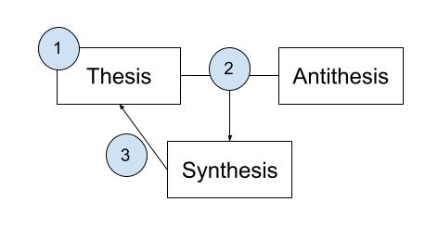
However, there are also serious vices. In this first installment of a three-part series, I focus on the critique of civility. In so doing, I do not defend incivility. In fact, part of my critique of civility extends equally to incivility. My position is that we must move our normative discourse beyond both the thesis of civility and the antithesis of incivility to a synthesis that reframes the terms of discussion. In the second installment, I develop this alternative framework—namely, ahimsic (nonviolent) communication. In the third installment, I explore the strategic and moral advantages of this framework.
Let’s now consider the case against civility. I will argue that it faces five fatal flaws: (1) “civility” (hence “incivility”) is radically ambiguous, (2) “civility” carries too much historical baggage, (3) civility functions as a double-standard, (4) civility is practically unpromotable, and (5) civility (hence incivility) misses the moral mark, drawing the normative boundary in the wrong place.

- “Civility” and “Incivility” Are Radically Ambiguous
My first objection to the term “civility” is that its meaning is problematically unclear. I say “problematically,” since lack of clarity is not necessarily a serious problem. Consider, for example, Patricia Roberts-Miller’s objection that “civility” is vague—i.e., has imprecise boundaries (5). I agree with William Keith and Robert Danisch that “civility is no more (and no less) vague than any other important moral concept; it does not have sharp edges and clear applications” (41). My objection is not that “civility” is vague, but that it is multiply ambiguous—i.e., has various distinct meanings—some of which are in strong tension with each other (akin to the word “peruse,” which can mean either of two opposite things: “to read carefully” or “to skim”). If so, then “incivility” inherits this radical ambiguity, since it is defined in terms of civility.
For a real-world example, let’s examine the 2018 Red Hen affair, in which White House Press Secretary Sarah Huckabee Sanders was asked to leave the Red Hen restaurant mid-meal by the owner, Stephanie Wilkinson. According to Wilkinson, she was contacted at her nearby home by her waitstaff, several of whom were LGBTQ individuals, who were distraught about serving Sanders due to her defense of President Donald Trump’s homophobic rhetoric and policies. The next day, Sanders Tweeted:

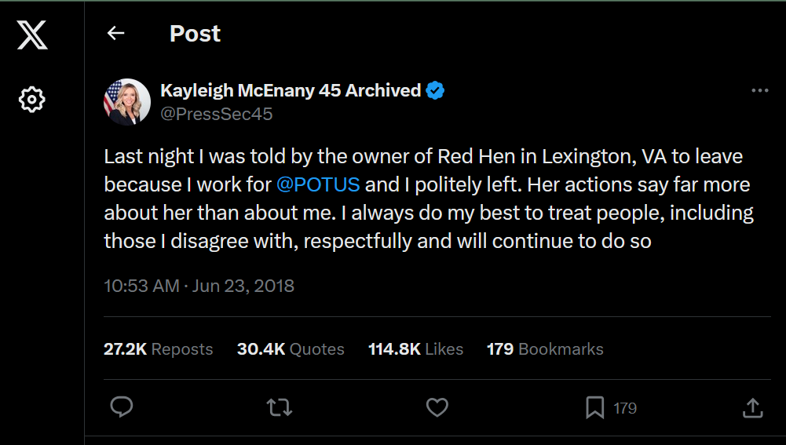
Two days later, Trump entered the dispute:
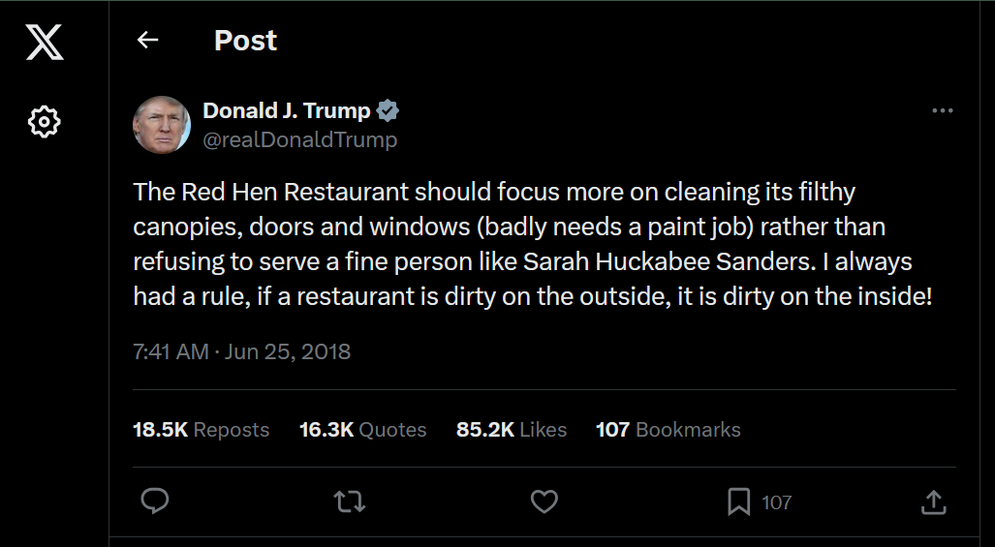
Fox News then issued a headline reading: “Left Setting New Standard of Civility, Critics Say: ‘This Is Very Dangerous.’” In their book, Beyond Civility: The Competing Obligations of Citizenship, William Keith and Robert Danisch point out that commentators on both sides assumed that Wilkinson’s act was uncivil, disagreeing instead over the norm of civility (33). Those on the left would characterize it as righteous incivility, while those on the right would characterize it as unrighteous incivility. Keith and Danisch take a different tack: they suggest that Wilkinson was civil (33).
This raises the question: What, exactly, is civility, anyway? One would think that asking this question would help clarify matters. As it turns out, it makes matters worse. Way worse! In this case, clarity exposes a hidden mess.
Most modern popular sources define civility in terms of politeness. For example, Cambridge Dictionary defines civility as “politeness or a polite remark.” So, was Wilkinson polite? By her lights, yes. It follows that she was civil on the popular definition, contrary to what most commentators thought. Was she correct in characterizing herself as polite? Well, on the one hand, asking Sanders to leave clearly broke some rules of decorum, even if the violation was justified. On the other hand, Wilkinson went out of her way to proceed as politely as possible: she spoke to Sanders in private instead of humiliating her in public, patiently explained the situation, asked rather than demanded that Sanders leave, and told Sanders that her food and drink were on the house (though Sanders paid anyway). Perhaps we should say, then, that Wilkinson was polite in some respects but impolite in others, or polite to a certain degree. If so, she was civil in some respects but uncivil in others, or civil to a certain degree.
Following the older association of “civility” with “civilization,” Merriam-Webster defines civility as “civilized conduct.” “Civilized” is in turn defined as “characteristic of a state of civilization—especially: characterized by taste, refinement, or restraint.” It seems to me that we can say nearly the same thing here as above: Wilkinson’s behavior was civilized in some ways but not others, or civilized to a degree. But given that “taste” and “refinement” go far beyond “polite,” our verdict on civility must be much weaker than on the previous definition—inching a bit closer toward the verdict of the commentators.
Not all definitions of civility imply a “yes and no” or “somewhat” answer. Michael Walzer, inspired by the original notion of civility as good citizenship, identifies civility with law-abidingness (597). Clearly, Wilkinson obeyed the law. So, on this definition, she was civil full stop. Assuming “civil” is univocal in “civil disobedience,” Walzer’s definition would also make “civil disobedience” impossible, since by definition it involves breaking an unjust law. It would also make it civil to be rude or mean (since rudeness and meanness are legal)—quite the opposite of politeness.
Or consider John Rawls, in his Political Liberalism, where he takes reasonableness to be the litmus test for civility. It is clear that Wilkinson aimed to be reasonable: to avoid a hasty decision, she went to the restaurant to examine the situation firsthand, consulted with her staff, carefully weighed the reasons, came to what she saw as a reasonable conclusion, and patiently explained those reasons to Sanders, who had the opportunity to respond or resist but freely and quietly left. Wilkinson’s proponents would presumably maintain that she weighed the reasons correctly and came to a reasonable conclusion. Yet again, this doesn’t fit the media’s view that Wilkinson was uncivil, nor does it make sense of the rejection of the civility standard.
The above definitions are one-dimensional: they identify civility with a single attribute (politeness, being civilized, law-abidingness, or reasonableness). There are also “list definitions” that define civility in terms of a mix of attributes. I will mention two. First, expanding on politeness, Britannica Dictionary defines civility as “polite, reasonable, and respectful behavior”—a conjunction. Second, in his essay “The Virtue of Civility,” Cheshire Calhoun maintains that “Civility always involves a display of respect, tolerance, or considerateness”—a disjunction (259). Here we have three new attributes tied to civility (via two different logical connectives, which raises additional complications that cannot be pursued here). My remarks on tolerance and considerateness would be similar to my remarks on politeness and being civilized. So let me focus on respect. This one in particular raises a new issue altogether: some attributes commonly tied to civility raise serious interpretation issues of their own.
In everyday uses of the word, we can say that Wilkinson “respected” her staff, but did not “respect” what Sanders represented, even though she was “respectful” in how she asked Sanders to leave. Furthermore, in the Kantian tradition, respect is understood to require just deserts. On this view, if Sanders deserved what she got, Wilkinson was fully respectful, contradicting the everyday notion of respect. However, it is unclear whether the Kantian understanding is compatible with respect as a condition for civility. For Kant, murderers deserve capital punishment. This would render executions civil. Whether morally right or wrong, I doubt most people would characterize executions as “civil.”
Notice that Calhoun’s definition uses the word “display.” His point is that one might have respect, tolerance, or considerateness without displaying those qualities to others, or one might display them to others without having them. For Calhoun, civility is a distinct “virtue” precisely because it refers to the display itself (“virtue” in scare quotes because his definition focuses on the display behavior rather than on the underlying character traits that drive behavior). This illuminates why it is possible (albeit barely) to get two political candidates who hate each other’s guts to “keep things civil” during a public debate. The emphasis on display seems to fit contemporary and much historical usage of the term. But it does conflict with definitions of civility that do not require display. This is yet another point of contention.
As we can see, “civility” is used in a wide variety of ways. There is no single correct way to use the term. Yet people continue to use the word unflinchingly with adamant pronouncements, and even get into fights over it with others—without attempting to clarify what they mean, as if it is obvious. After 2400 years, we have still not learned the Socratic lesson: if we wish to use an unclear term, we should clarify it to avoid talking past one another.
How to proceed from here? One option is to abandon the term “civility.” Let’s treat this as a last resort. Alternatively, we might encourage everyone to stipulate what they mean by “civility” whenever they use the term. As the preceding discussion shows, this would be difficult, and I doubt most people would bother. A different approach, taken by Keith and Danisch, is to make a three-way distinction that captures most meanings of “civility”:
Weak civility: A network of behaviors and norms intended to maintain the appearance of comity, ease, comfort, and belonging. Often equivalent to politeness, it may accomplish its goal by strategically ignoring or effacing uncomfortable differences of belief or practice (18).
Strong civility: A network of behaviors and norms that can be used to engage differences in a way that will deepen a sense of community and over time help communities move toward nonviolent systemic change. Strong civility may include deliberations, deep listening, dialogue, confrontation, protest, and civil disobedience (18).
Pseudocivility: The invocation of weak civility norms against strong civility behaviors, resulting in a refusal to engage on the grounds that engaging some difference is always uncivil, even if the difference is arguably of great public and moral importance (18).
By introducing a distinction between weak and strong civility, Keith and Danisch implicitly recognize that the term is ambiguous. However, the term “pseudocivility” confusingly suggests that there is something such as “real” civility. This would be like arguing that, while “peruse” can refer to skimming or reading thoroughly, only one of them is the “real” meaning. In truth, there is simply no single right way to use the term. Perhaps, though, we shouldn’t take “pseudo” so seriously. Strictly following the definition, pseudocivility is a type of civility, namely weak.
Keith and Danisch also apply the weak/strong distinction to incivility (126), which leads to cases that are weakly civil but strongly uncivil (e.g., Sanders and her advocates), and cases that are strongly civil but weakly uncivil (e.g., Wilkinson and her champions). Theoretically, this is helpful in untangling disagreements over civility. It could even temper disagreements in public discourse—if only people would use it. But unfortunately, a jargon-laden distinction that enables a single act to be simultaneously civil in some sense and uncivil in another will probably never catch on there, where it matters most. Moreover, any use of “civility,” including in “weak civility” and “strong civility,” will be subject to my remaining critiques.

- “Civility” Carries Too Much Historical Baggage
Meanings evolve over time, and multiple meanings exist simultaneously. For our usage, present meanings matter most. But in this particular case, present meanings are often imbued with echoes of problematic past meanings: “civility” is understood by many today as carrying racist, elitist, or sexist undertones. Let’s take an etymological tour.
We can trace the origins of the English term “civility” to the Roman Republic. The Latin term civilis originally referred to the duties and behaviors that constitute good citizenship. In his book Civil Disagreement: Personal Integrity in a Pluralistic Society, Edward Langerak points out that citizens originally were those who belonged to the civitas (city), “the place where we meet strangers and cannot rely on friendship or familiarity to get things done” (20). To borrow a metaphor from Clifford Orwin, civility is about respecting the “fences” of one’s “neighbors” (560). It is more about restraint than a positive prescription, a mere moral minimum. This is echoed in modern definitions that define civility in terms of tolerance, law-abidingness, reasonableness, and respect—qualities that promote good citizenship, but not necessarily the additional social niceties such as politeness, taste, or refinement.
Roman citizenship was limited to free white adult male property owners. As citizenship gradually became more inclusive, so did the idea of civility. This process began with the collapse of Rome, marking the beginning of the Middle Ages. In Medieval Europe, there were no citizens in the Roman (or earlier Greek) sense. Instead, “Civility became the proper conduct between lords and free men who served them—deference, cooperation, service, reciprocal rights and duties, and proper speech and dress. Civility became a social, political, that is, courtly word” (Schaefer 104). This is echoed in modern definitions that define civility in terms of “courtesy,” which refers to the display of certain attributes such as respect (recall Calhoun’s account).
With the rise of humanism and the reemergence of citizenship during the Italian Renaissance, civility came to refer to the best in humanity, epitomized by educated European gentlemen (105). By the mid-16th century, according to Oxford Languages, we see the emergence of the modern identification of civility with politeness, the mark of a gentleman. By now we have proceeded far beyond the neighborly fence idea.
Due to shifting economic tides, as historian Michael Curtin argues, the 18th century sees the feminization of etiquette with the rise of the modern etiquette manual, which was primarily aimed at nouveau riche women who needed to learn to act the part. In her book The Wrong of Rudeness: Learning Modern Civility from Ancient Chinese Philosophy, Amy Olberding argues that this marks the unhelpful separation of civility from good manners, a division reflected in the fact that the two topics are found in different sections of today’s bookstores (5-8). Civility was therefore associated with public life and considered masculine, whereas good manners and etiquette was associated with domestic life and considered feminine. But as Confucius, Mencius, Xunzi and the other Confucians have emphasized, the distinction between public civility and personal manners is deeply problematic: even our most quotidian “rituals” (the exchange of pleasant greetings, addressing others with respect, saying “please” and “thank you,” maintaining a pleasant tone, expressing modesty and humility, waiting one’s turn in line, offering apologies, engaging in mourning rites, etc.) help us develop and communicate the pro-social traits and behaviors at the heart of healthy public life.
Picking up on a different strand of historical development, “civility” also shares its root with “civilization” and “civilizing,” which today are often associated with gentlemanly qualities. This sense is retained in the Merriam-Webster definition discussed earlier. The same qualities are associated with elitism. As Keith Thomas explains in his 2018 book The Pursuit of Civility: Manners and Civilization in Early Modern England, “civilization,” “civilized,” and “civilizing” historically carry connotations of ethnocentrism, specifically Eurocentrism, and was used to justify colonization, exploitation, slavery, and murder (5-6). As detailed in Roberts-Miller’s 2010 book Fanatical Schemes: Preslavery Rhetoric and the Tragedy of Consensus, antebellum proslavery Americans found abolitionist discourse offensive and therefore dismissed it as uncivil (an example of pseudocivility).
This “civil silencing” continued a century later during the American Civil Rights Movement, when “law and order” (another phrase commonly associated with civility) was wielded as a weapon against peaceful protestors. Even today, “civility” is often associated with silencing, hence the protest slogan “Civility = Silence, Silence = Death”. Relatedly, civility is sometimes associated with cowardice and complicity: New Yorker columnist Jelani Cobb tweeted “Civility is the coward’s favorite virtue” to which Doug Gordon added that “Civility in the face of tyranny is just another form of complicity” (Keith and Danisch 32). In a similar vein, Hillary Clinton remarked in her interview with Christiane Amanpour, “you cannot be civil with a political party that wants to destroy what you stand for, what you care about.” And in response to Michelle Obama’s aphorism “When they go low, we go high,” former Attorney General Eric Holder suggested a new approach for the Democratic Party: “When they go low, we kick them.”
The Age of Enlightenment set us on the path toward universal human rights. As rights gradually expanded, our notion of citizenship and civility also expanded to include traditionally marginalized groups (Schaefer 105-6). We’re still not there yet—far from it. But even if we were, would it mean we can simply excise the historical baggage from our current usage of “civil” and happily proceed? Some maintain that we should generally abandon terms that carry problematic historical baggage. I need not quite defend that view here. Instead, I merely suggest that when a term is still associated with that baggage by present members of our linguistic community, continued usage perpetuates some harm, and unnecessarily so when there is a less problematic term that would serve just as well. And as we have seen, there are many today who still hear “civility” as code for “silencing.” As Ibram X. Kendi notes in his book Stamped from the Beginning, “Civility as a democratic good and social ideal cannot be divorced from its historical usage and meaning. Its etymological and ideological ties to ‘civilization’ and ‘civil society,’ its demarcation of the white ‘civil citizen’ from the nonwhite ‘savage’ and ‘slave,’ and its tie to citizenship and belonging render civility and civilizing discourses racialized technologies of the flesh” (334). Keith and Danisch want to “save civility from racists” (7). Perhaps it can be done via linguistic reappropriation or amelioration, but this would require the group primarily impacted by the negative term in question to take on that initiative.

- Civility Functions as a Double-Standard
Ambiguity and historical baggage help render civility a double-standard. Everyone wants the other side to be civil, but when the self or one’s in-group is charged with incivility, it is heard as a criticism (which it is). And when we hear criticism, we tend to react defensively, rejecting the charge. However, the double-standard is often masked by language. This is enabled partly by the radical ambiguity of the terms “civil” and “uncivil.” Given how unclear the term is, it is often possible to find a sense in which what’s “uncivil” in one sense is “civil” in another, and vice versa. Hence, motivated reasoning can subconsciously lead us to latch onto whichever meaning suits our purposes at the moment. And when a claim to civility or incivility fails to fit this meaning, the label will be rejected and possibly replaced.
This plays out differently for different people, since language encodes group identity: the political left and the political right each express defensiveness with their own preferred phrasing. On the right, the charge of incivility in the mouths of liberals will likely be heard as “political correctness” and dismissed as such. On the left, the charge of incivility in the mouths of conservatives is more likely to be embraced while rejecting the norm of civility. This is partly because the left is more likely to associate “civility” in those cases with historic injustices, which they associate with the political right. But when calling for civility from the other side, they associate civility with something more positive, such as reasonableness.

- Civility Is Practically Unpromotable
Either way, the call for civility often backfires. But issuing a call for civility is merely one way of promoting civility. Here I wish to consider more generally the extent to which promoting civility is useful.
Let’s distinguish civil engagement from the promotion of civility. One engages in civility when one follows the norms of civility. One promotes civility when one acts with the intention of getting others to be more civil. These categories can overlap: one might promote civility by engaging in it to set an example for others. One might also promote civility by teaching the skills associated with civility, or in a host of other ways. Such methods are indirect. Another way to promote civility is to issue a direct call for civility: an explicit written or spoken request or command for others to be civil. A targeted call for civility is one directed toward—and delivered to—a specific person or group; a general call for civility is one that is not targeted. A targeted call for civility is confrontational when it calls out the intended recipient for being uncivil; it is nonconfrontational when directed toward a person or group that the issuer already perceives as civil, perhaps with hope of maintaining civility.
Confrontational calls for civility tend to be self-defeating. First, on some meanings of “civil,” a confrontational call for civility is itself uncivil, hence violates its own standard. Second, confrontational calls for civility aim to increase civility or deescalate conflict, but often backfire for the reasons articulated in the previous section.
General calls for civility can be harmful, such as when someone promotes “pseudocivility” to a receptive audience. In other cases, general calls for civility do no harm but do little good (except for pure emotional release), such as when I yell at the debaters to be more civil through the television (although in some sense I direct it toward them, it counts as general since I do not deliver the message to the targets). Similarly, we might preach to the choir by exclaiming “We should have more civility in politics!” when among friends who already agree.
Nonconfrontational calls for civility stand the best chance at successful promotion, since they can help prevent outbreaks of incivility in the first place. On the first day of the semester, I might ask students in my Philosophy of Nonviolence class to remain civil during class conversations throughout the semester. They tend to welcome the suggestion, and it makes them more comfortable about the discussions to come. But even then, its utility is limited for two reasons.
First, even if we consciously approve of civility, we all know how easy it is to subconsciously slip up in the heat of the moment, regretting it later. Second, even upon reflection, many people actively disapprove of civility and approve of incivility.
Consider some recent actions by conservatives that many liberals deem uncivil:
- The inflammatory rhetoric of conservative media personalities such as Rush Limbaugh, Alex Jones, and Erick Erickson
- Derogatory labels for liberals like “libtard,” “femoid,” and “snowflake”
- Refusal to recognize preferred pronouns
- The use of gay and trans slurs
- The burning of an effigy of President Barack Obama in Wisconsin
- Trump’s birther movement against Barack Obama
- Trump’s comparison of President Joe Biden to Hitler
- Trump’s comment about a nonviolent Black Lives Matter protestor at a campaign rally: “Maybe he should have been roughed up”
- Trump appears to mock reporter with disability
- The “89 Things Donald Trump Has Said About Women”
- “All the Times Donald Trump Insulted Mexicans” as “drug dealers” and “rapists”
- Trump’s allegation of “Haitians Stealing and Eating Pets in Ohio”
- Tee shirts worn at Trump rallies that read “Fuck your feelings. Trump 2016.”
And consider some recent actions by liberals that many conservatives deem uncivil:
- Media personality Tucker Carlson gets called a “pig fornicator” on social media (Keith and Danisch 147)
- Trump is routinely characterized as a fat, ugly, stupid, orange man who wears a hairpiece
- Barack Obama roasts Trump at the 2011 White House Correspondents’ Dinner, the event that many speculate solidified Trump’s decision to run for president
- Trump images defaced with Hitler mustache and other Nazi imagery
- Minnesota Vikings kicker Chris Kluwe issues the ultimate takedown of right-wing bigotry in his widely circulated “Open Letter to Emmett Burns”
- Joe Biden tells Trump: “Will you shut up, man?” during their 2020 presidential debate
- Vice President Kamala Harris wields facial expressions as a weapon during her 2024 Presidential Debate with Donald Trump—an example of what Marshall B. Rosenberg calls “nonverbal condemnation” (29)
- Expressing disappointment that the 2024 Trump assassination attempts failed
- Unfriending Trump voters on social media after the 2024 election
Clearly, some of these are way worse than others, but for better or worse, many endorse this sort of behavior and do not later regret it. They view themselves as rhetorical “warriors,” to use a term from Keith and Danisch (117), viewing civility as weak and ineffective—akin to bringing a knife to a gun fight. It is often dismissed as political correctness, both-sidesing (the false claim that both sides are equal), silencing, or whitewashing. Incivility on the other hand serves multiple functions, as earlier noted. But mostly, it just feels too damn good!
When all of these factors combine—when one believes that one is on the right side (as most do), and is fueled by strong emotions—motivated reasoning and groupthink take over, enabling one’s claims to detach and float free from truth. This is why, in the midst of rhetorical warfare, few seem to consider or care whether fighting fire with fire will burn the whole world down.
Aristotle was right that logos (facts, evidence, reasoning) is not enough to persuade. Persuasion also requires the audience to be receptive, which depends on ethos (one’s character or credibility) and pathos (the audience’s frame of mind and emotional state). Promoting pure civility amidst incivility fails at the pathos level because the emotions driving incivility are stronger, hijacking rational control. This in turn impacts the perception of ethos and logos. I will argue in the next installment of this series that promoting incivility won’t stop incivility either.

The most effective way to promote civility when emotions run high—where we most need it—is to employ methods and principles that move the whole person, not just the mind but the entire heart-mind (xin in Chinese philosophy).

- (In)civility Misses the Moral Mark
This brings me to my final point: civility misses the moral mark. It draws the normative boundary in the wrong place. And if civility draws the boundary in the wrong place, so does incivility.
To see this, note first that civility is a derivative norm: those who promote civility, if they are genuine, presumably do so because they believe that incivility is harmful. Non-harming is the underlying norm. The attributes commonly associated with civility (politeness, respect, tolerance, considerateness, courtesy, reasonableness, law-abidingness, refined taste, etc.) are in some way intended to address harm. But they do not fully succeed. For this reason, civility doesn’t hit the nail on the head, so to speak.
The fact that civility dances around the underlying norm is part of the reason it is so difficult to promote. Again, we need methods that move the heart-mind. There are methods in the civility literature, such as Rapoport’s Rules, that help. But they help precisely because such methods go beyond mere civility. Such methods are, in fact, methods of nonviolence (ahimsa in Indian philosophy), albeit a mere fraction of the broader set of methods in the practice of ahimsa. I will argue that this broader framework is what we need for an ethic of communication (as well as for action more broadly). If I am right, we should abandon the narrow focus on civility and promote ahimsic communication directly.

Acknowledgments:
Many thanks to Linda Mills Boyd, Alexis Flint, Loren Manchester, and Jelena Markovic for their feedback on earlier drafts of this piece.

Please cite the published version of this essay, which can be accessed at the Blog of the APA. It is part of the Current Events in Public Philosophy series.

