TIME ITERATION FOR REPEATEDLY SAME ORBITAL MOTION OF OBJECTS IN SPACE
Areena bhatti, BS third semester, department of space science, University of Punjab.
Abstract
This theory aims to describe what time iteration is. That is the property of time that it repeats itself. This paper focuses on the repetition of orbital motions of objects in space and gives us three postulates that describe what time will be with different relations of objects and their surroundings. This paper will help to make us understand how everything in our universe which is orbiting something if repeats its orbital motion again and again no matter in what time it completes its one rotation, time do exists for that orbital motion but the motion of that time for the motion of that object is moving in both directions. So I conclude that repetition of orbital motion of objects is in time equilibrium position that we shall discuss in this paper.
Keywords Time; repetition; orbital motion; space; space time; vacuum
Image
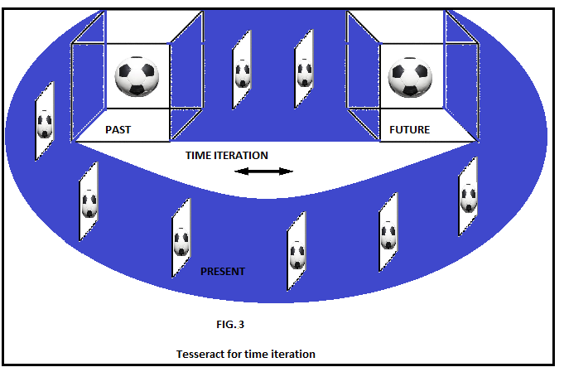

Presenting author details
Areena bhatti
University of Punjab
Pakistan
areenabhatti14@hotmail.com
03064378557
Oral presentation
Research interest: astronomy

