SUBMITTED ARTICLE

Aphantasia: In search of a theory
Andrea Blomkvist, Department of Philosophy, University of Sheffield

Correspondence
Andrea Blomkvist
Department of Philosophy
University of Sheffield
45 Victoria Street
Sheffield S3 7QB
UK
Email: a.blomkvist@sheffield.ac.uk

Funding information
This research was funded by AHRC White Rose College of the Arts and Humanities, grant number 169547374

Though researchers working on congenital aphantasia (henceforth “aphantasia”) agree that this condition involves an impairment in the ability to voluntarily generate visual imagery, disagreement looms large as to which other impairments are exhibited by aphantasic subjects. This article offers the first extensive review of studies on aphantasia, and proposes that aphantasic subjects exhibit a cluster of impairments. It puts forward a novel cognitive theory of aphantasia, building on the constructive episodic simulation hypothesis of memory and imagination. It argues that aphantasia is best explained as a malfunction of processes in the episodic system, and is therefore an episodic system condition.

KEYWORDS
aphantasia, mental imagery, episodic memory, cognitive architecture, imagination, episodic system

1. Introduction

Until recently, it has been commonplace to assume that everybody has the capacity to voluntarily generate mental imagery. But an increasing number of people who are unable to do so have been identified—this condition has become known as congenital aphantasia. Despite the attention it has received from researchers and media, we still do not know much about this condition. Not only have very few explanatory theories of aphantasia been proposed (Pearson, 2019; Nanay, 2021), but it even remains unclear which cluster of impairments characterise the condition in the first place.
Some claim aphantasia primarily involves a visual imagery impairment, selectively impairing the generation of visual imagery (Greenberg & Knowlton, 2014; Keogh & Pearson, 2018; Fulford et al., 2018; Milton et al., 2020; Zeman et al., 2020; Bainbridge et al., 2020), while others claim that there are further impairments associated with the condition, which affect other forms of imagery too, as well as other impairments related to episodic memory (Zeman, Dewar, & Della Sala, 2015; Jacobs, Schwarzkopf, & Silvanto, 2018; Pearson, 2019; Dawes et al., 2020; Nanay, 2021). There is also disagreement about whether aphantasia only affects the production of voluntary imagery, as when intentionally imagining, or if it also affects involuntary imagery, such as imagery generated when dreaming. Most importantly, it remains unclear whether aphantasia is a condition resulting from a malfunction in a system producing visual imagery, or if it results from a malfunction in a different system.
The lack of significant progress towards a theory of aphantasia, I contend, is the result of a piecemeal approach: So far, there has been no overarching project of drawing the available data together into a theory of aphantasia. This has hampered the possibility of giving an explanation of the impairments as resulting from a malfunctioning of a cognitive system. In this article, I seek to provide a better understanding of aphantasia by offering such a cognitive explanation of the condition (Newell, 1990; Nichols & Stich, 2004).
First, after illustrating the current confusion of tongues in aphantasia research (Section 1), I examine the data from recent studies on aphantasia and show that they cluster neatly into six robust data points (see just below) (Section 2). I propose that a theory of aphantasia ought to explain the following findings:

(1) The impairment in generating voluntary visual imagery.
(2) The differential impairment in generating mental imagery with respect to different sensory systems.
(3) The differential impairment in producing voluntary imagery and involuntary imagery.
(4) The impairment in recalling episodic memory details.
(5) The impairment in generating episodic details for both atemporal events and future events.
(6) The retained ability to solve spatial imagery tasks and score averagely on spatial imagery questionnaires.

Secondly, I discuss two recent accounts of aphantasia, namely, Nanay’s (2021) account involving unconscious imagery, and Pearson’s (2019) account based on the cognitive architecture of visual imagery, and I show that neither of them can explain (1) to (6) (Section 4). Finally, I put forward a novel theory of aphantasia (Section 5). My theory builds on the cognitive architecture of CESH (Schacter & Addis, 2007, 2020), adding three features to the model: (i) memory indices, (ii) episodic retrieval processes dedicated to particular sensory systems, and (iii) spatial retrieval processes. I call the modified version, “CESH+”. With this architecture of memory and imagination, I show that the cluster of impairments in aphantasia can be explained by the malfunctioning of different episodic retrieval processes, making aphantasia an episodic system condition.
This article makes three important contributions to the research. Firstly, it provides the first comprehensive review of data on aphantasia, identifying a cluster of impairments; secondly, it makes important modifications to the constructive episodic simulation hypothesis (CESH) thus contributing to the research on episodic memory; and thirdly, it proposes that the impairments in aphantasia result from the malfunctioning of episodic retrieval processes.

2. Definitions of Congenital Aphantasia

Let us begin by taking a look at what definitions of “aphantasia” are currently used in the literature (see Table 1):

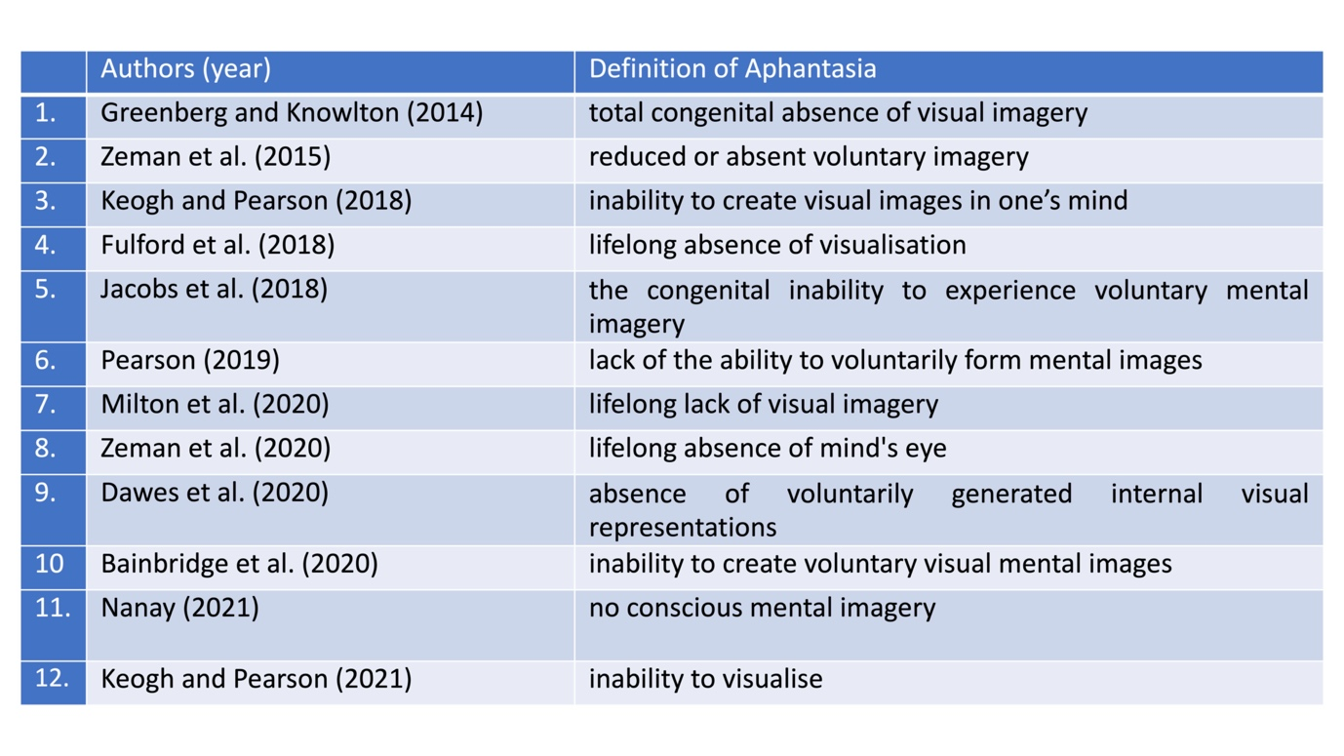
TABLE 1. Definitions of “aphantasia”.

A first point of disagreement is whether people with aphantasia are impaired with respect to visual imagery only. There are many kinds of imagery other than visual imagery, such as auditory imagery (Okada & Matsuoka, 1992; Herholz, Halpern, & Zatorre, 2012) and olfactory imagery (Bensafi & Rouby, 2007). Stating that aphantasia is a condition where only visual imagery is impaired (as definitions 1, 3, 4, and 7–10, and 12 do) implies that aphantasics could perhaps generate all other kinds of mental imagery. This conflicts with what is stated in definitions 2, 5, 6, and 11, which use the all-encompassing term “mental imagery”. It thus appears that there is no consensus about whether people with aphantasia are only impaired with respect to visual imagery, or if this impairment clusters with other mental imagery impairments.
Secondly, while it is common to make a distinction between the generation of voluntary and involuntary imagery (Dorsch, 2015; Pearson, 2020), the above definitions often do not specify which of these two abilities aphantasics supposedly lack. For example, definitions 1, 4, 7, 8, and 11 do not make this explicit, thus allowing for both involuntary and voluntary imagery to be affected, while definitions 2, 3, 4, 5, 6, 9, 10, and 12 explicitly state an impairment in only voluntary imagery. Again, we lack a precise description of the type of impairment involved in aphantasia.
Finally, all these definitions tacitly assume that aphantasia is mainly, if not exclusively, a problem of generating imagery. That is, they presuppose that the core impairment in aphantasia, if not the only impairment, is an impairment in producing imagery (visual or otherwise, voluntary or otherwise). This, as I will show, goes against a large body of data indicating that aphantasic subjects exhibit a cluster of cognitive impairments, which are not limited to impairments involving imagery. It would be a mistake to assume from the outset that these impairments are not central to aphantasia.
These problems are symptomatic of a more serious issue: The research on aphantasia has so far been piecemeal, with each study providing a new definition based only on its own data. If we want to provide an adequate explanation of aphantasia, we ought to instead review the available data from multiple studies, which is what I do next.

3. Empirical Data on Congenital Aphantasia

Below, I present the data from studies on aphantasia. My review follows the common practice of operationalising aphantasia in terms of scoring below a certain threshold on the vividness of visual imagery questionnaire (VVIQ) (Marks, 1973). This questionnaire asks subjects to form a voluntary visual image, and aphantasia is thus operationalised in the literature in terms of an impairment in voluntary visual imagery.

3.1 Voluntary visual imagery
All studies on aphantasia have administered the VVIQ and established that subjects are impaired with respect to voluntary visual imagery (see Table 1). Recently, there have also been some experimental findings pointing in the same direction.
Three experiments (Keogh & Pearson, 2018, 2021, experiment 3 and 4) (n = 15, n = 10, n = 15, respectively) have used a binocular rivalry paradigm, showing that aphantasics demonstrate no priming effect following a visual imagery condition, whereas controls did (see Section 4.1.1). For now, it suffices to say that the three experiments provided support that aphantasics are impaired in generating voluntary visual imagery.
One study also carried out a further experiment on voluntary visual imagery (Keogh & Pearson, 2021, experiment 4). This experiment tested whether participants could form so-called attentional templates—templates based on visual imagery, which include spatial and object information, and are thought to aid our attentional performance (Treisman, 2006; Battistoni, Stein, & Peelen, 2017). Aphantasics showed no evidence of being able to form attentional templates, confirming their inability to form voluntary visual imagery.
Based on the results from the VVIQ and these experimental results, we need to explain the following:

(1) The impairment in generating voluntary visual imagery.

3.2 Non-visual imagery
In Zeman et al.’s (2015) study, 10/21 aphantasics reported that all their sensory systems were affected, such that they could not voluntarily produce mental imagery in any of them, and results were replicated in Zeman et al. (2020), with a sample size of 2000 participants. 54.2% of aphantasics reported that all their sensory systems were seriously affected. “Extreme aphantasics” were also more likely than “moderate aphantasics” to report all their sensory systems affected.
Dawes et al. (2020) reported similar results based on the questionnaire upon mental imagery, in which 267 participants are asked to rate the vividness and clarity of voluntary imagery in different sensory systems. Results showed that 26.2% reported a complete lack of imagery for all sensory systems, and 73.8% reported overall significantly reduced imagery in all sensory systems compared to controls, but still some degree of non-visual imagery.
Thus, more than half of aphantasics report reduced mental imagery in all sensory systems; and up to 26.2% report a total absence of mental imagery in all sensory systems. The second data point to be explained is thus:

(2) The differential impairment in generating mental imagery with respect to different sensory systems.

3.3 Involuntary imagery
A few studies have reported that aphantasics can form involuntary mental imagery. In particular, studies have asked about “flashes of visual imagery” (Zeman, Dewar, & Della Sala, 2015), daydreaming (Dawes et al. 2020), or night-time dreams (Zeman et al., 2020; Dawes et al., 2020).
Zeman et al. (2015, 2020) administered a set of questions to aphantasics (n = 21; n = 2000). In the 2015 study, they found that about 50% reported involuntary flashes of imagery and 80% reported visual dreaming. In the 2020 study, participants were further divided aphantasics into “extreme aphantasics” and “moderate aphantasics” (fn. 2). 63.4% of all aphantasics reported dreaming, but “extreme aphantasics” were significantly less likely to report this than “moderate aphantasics”, and 30% of all aphantasics reported brief flashes of visual imagery, with a similar significant difference between “extreme aphantasics” and “moderate aphantasics”.
Finally, these findings were replicated by Dawes et al.’s (2020) study of 267 aphantasics. They used the imaginal process inventory (IPI) with 24 items assessing the frequency of daydreams and night dreams; as well as the subjective experiences rating scale (SERS) comprising of 39 questions assessing participants’ night dreams. Aphantasics reported experiencing significantly fewer night dreams than control participants, and that the dreams were also of qualitative difference. Aphantasics’ dreams were impaired across all sensory aspects, with a lower sense of awareness and control over their dreams, and a less clear dreamer-perspective, but they did not differ on within-dream cognition or spatial features of the dream. There was no significant difference between the frequency of daydreams between aphantasics and control participants, but a comparison with a second non-age matched control group did show a significant difference, such that aphantasics experienced significantly fewer daydreams than controls.
This indicates that we need to explain the following:

(3) the differential impairment in producing voluntary imagery and involuntary imagery.

3.4 Memory
A wide range of findings have been made relating to autobiographical memory, episodic memory, semantic memory, and working memory in aphantasia. I discuss the two first ones in turn.
In two studies (Zeman, Dewar, & Della Sala, 2015; Zeman, 2020), aphantasics were asked if they think their autobiographical memory is “normal”. In the 2015 study, results showed that 14/21 aphantasics answered negatively, and in the 2020 study aphantasics reported having significantly worse memory than both the control groups. There was no in-group difference between “moderate aphantasics” and “extreme aphantasics”.
In Dawes et al.’s (2020) study (n = 267), two questionnaires were used to assess their episodic and semantic memory. The episodic memory imagery questionnaire (EMIQ) assessed the vividness of episodic memories, with items based on the VVIQ, and the survey of autobiographical memory (SAM) assessed episodic, semantic, spatial memory. SAM contains questions about recalling specific details, recalling facts, and one’s perceived competence at spatial navigation (however, see Setton, 2021, for reliability issues of SAM). Aphantasics reported almost no ability to generate visual sensory details when recalling past events, and scored significantly lower than controls for providing details of episodic memories. For semantic memory, aphantasics scored significantly lower than control group 1, but not significantly lower than control group 2.
These findings are echoed in Milton et al.’s (2020) study (n = 69). Here, participants took the logical memory test (immediate, and 30-minute delayed recall of a prose passage), the Rey-Osterrieth complex figure (copy a figure immediately, and after a 30-minute delay), the Warrington recognition memory test (word and facial recognition), and the autobiographical interview (recall as much information as possible about an event). Results showed that there was a small significant difference on the logical memory test, aphantasics performing slightly worse than controls. The interesting findings relate to the autobiographical interview, where details provided by participants were coded as episodic details (location, people, etc.) or semantic details (information, narrative, etc.), and results showed that aphantasics produced significantly fewer episodic details, but not significantly fewer semantic details, than controls. The remaining tests showed no significant differences.
A drawing paradigm has also been used to investigate how many details aphantasics (n = 61) can reproduce from memory (Bainbridge et al., 2020). Here, aphantasics and controls were presented with photographs of rooms to study for an unlimited time, and later asked to reproduce these in as much detail as possible, using their mouse to draw in a simple paint program. They produce significantly fewer than controls, and these details are particularly to do with memory of objects, rather than spatial memory. This study also found that aphantasics had significantly fewer memory errors than controls, where this was not due to drawing fewer details than controls (this possibility was adjusted for).
From this discussion, we can see that another result that has been replicated across many studies is that aphantasics have a memory impairment; they produce fewer episodic details than controls when retrieving episodic memories, and report having problems recalling autobiographical memories. Thus, this is the fourth data point that a theory of aphantasia should be able to explain:

(4) The impairment in recalling episodic memory details.

3.5 Atemporal and future imagination
Atemporal and future imagination relate to voluntarily imagining general events (e.g., going to the market) and future events (e.g., going to the market tomorrow) (Rendell et al., 2012). In Milton et al.’s (2020) study, aphantasics engaged in one future and one atemporal imaginative task. In the atemporal task, they were provided with three different scenarios which they were to elaborate on (e.g., imagining standing in a street market). In the future task, they were asked to imagine three possible future events (e.g., a possible Christmas event). They described these events in as much detail as possible, and the information was coded and scored for different components, including spatial reference, entity presence, sensory description, thought/emotion/action. Results showed that aphantasics scored significantly lower than the control group on both tasks.
Similarly, Dawes et al. (2020) studied aphantasics’ ability to voluntarily imagine the future using SAM. Subjects rated their agreement on a 1-5 point scale for six statements such as: “When I imagine an event in the future, the event generates vivid mental images that are specific in time and place”. Aphantasics reported a near inability to imagine future events in any sensory detail.
These findings suggest that our theory needs to account for:

(5) The impairment in generating episodic details for both atemporal events and future events.

3.6 Spatial imagery
Studies have investigated whether aphantasics’ ability to use spatial imagery is intact. Spatial imagery, as opposed to object imagery, roughly codes for where, rather than what something is. Dawes et al. (2020), Keogh and Pearson (2018), and Bainbridge et al. (2020) used the object and spatial imagery questionnaire, consisting of 25 items which participants rate on a 5-point agreement scale (e.g., “I am a good Tetris player”). Aphantasics had significantly lower scores than controls for object imagery, but not spatial imagery. Keogh and Pearson also used a questionnaire about the spontaneous use of spatial imagery—the spontaneous use of imagery scale (SUIS)—and found that aphantasics did not perform differently from controls here. Similarly, aphantasics performed well on spatial imagery tests administrated by Milton et al. (2020), which used Manikin’s test (a mental rotation task), the curved segments test, and the animal tails test. Finally, Bainbridge et al.’s experiment also tested spatial imagery accuracy through their drawing paradigm (see Section 3.4 for further details of methods). While they found that aphantasics drew significantly fewer objects than controls, there was no significant difference between the groups when it came to the spatial location or size of these objects. We thus need to explain:

(6) The retained ability to solve spatial imagery tasks and score averagely on spatial imagery questionnaires.

4. Objections to Current Theories

Here, I examine Nanay’s (2021) account of aphantasics as lacking conscious mental imagery, and Pearson’s (2019) theory based on the visual/dorsal architecture of visual imagery. I first identify which impairments they attempt to explain, before evaluating the explanation and considering whether they could be extended to explain (1) to (6). I find that neither account can satisfactorily explain everything.

4.1 Nanay’s no conscious imagery account

4.1.1 The Account
Nanay (2021) argues that there is unconscious visual imagery and he maintains that this unconscious visual imagery can be voluntarily or involuntarily generated, just like how a subject can voluntarily generate visual imagery of a holiday, or involuntarily have a traumatic visual flashback. He suggests that aphantasics lack all forms of conscious visual imagery (voluntary and involuntary), but (some) aphantasics retain involuntary unconscious visual imagery. I first motivate his claim that some aphantasics have unconscious visual imagery, and then why he thinks that this spared imagery is also involuntary. I call the first claim the unrestricted view, and the second claim the restricted view.
Firstly, Nanay argues for the unrestricted view—that some aphantasics have unconscious visual imagery—to explain the performance of one aphantasic subject in an experiment by Jacobs et al. (2018). The subject was shown a geometrical shape (e.g., a triangle), and was then either instructed to imagine the triangle (imagination condition) or was shown placeholders for the triangle (placeholder condition), before being shown a single dot and asked whether this was within the boundaries of the original shape. It was expected that the aphantasic subject would not be able to solve the task in the imagination condition, since this presumably requires visual imagery. Surprisingly, the subject did not perform differently from controls in either condition, and performed well above chance levels (around 90%). Nanay argues that the explanation for the results is the following: Controls used conscious visual imagery in the imagination condition, whereas the aphantasic subject used unconscious visual imagery.
But this hypothesis faces a potent objection, which Nanay himself raises, and which leads him to instead assert the restricted view. Keogh and Pearson (2018) tested 15 aphantasics and found that aphantasics seem to have no visual imagery at all—neither conscious, nor unconscious. This experiment used a binocular rivalry paradigm, where average subjects normally exhibit a priming effect after imagining a stimulus. Participants were sat in front of a screen, and instructed to imagine either a red horizontal Gabor patch or a green vertical Gabor patch, before being presented with a binocular rivalry test where the different Gabor patches were independently presented to each eye (see Figure 1). They were then asked whether the pictures appeared to be overlapping or not. In controls, having first imagined one of the Gabor patches primed the visual system to be more likely to perceive this patch when the patches were presented simultaneously. However, no such priming effect was found in aphantasics. Nanay admits that this finding appears out of line with the predictions of his own account, since his account predicts that there should still be a priming effect. After all, if retaining unconscious visual imagery allowed the aphantasic in Jacobs et al.’s experiment to solve the task in the imagination condition, it would be strange if unconscious visual imagery did not give rise to a priming effect here.

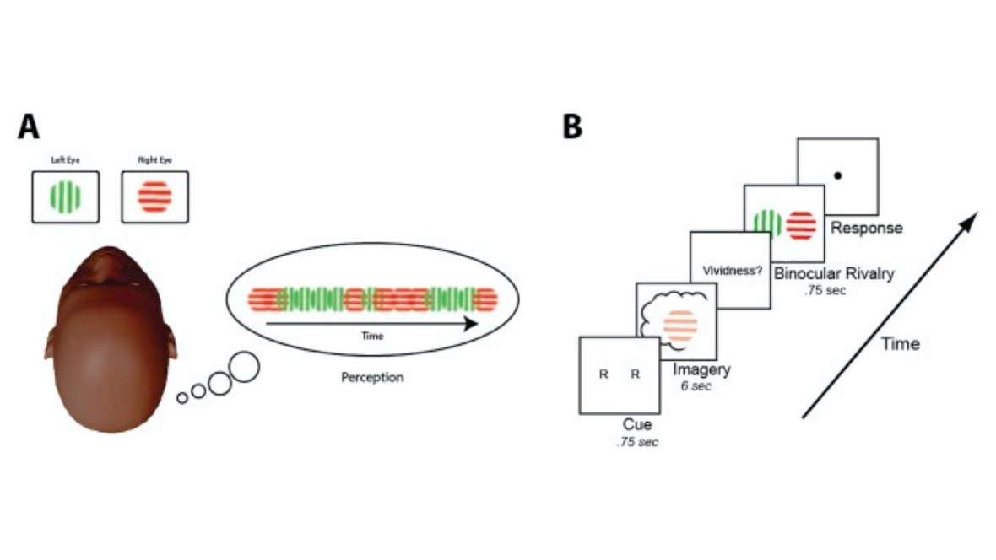
FIGURE 1. Binocular rivalry and experimental timeline. Reprinted with permission from Keogh and Pearson (2018).

To rebut this objection, Nanay adopts the restricted view and points to the distinction between voluntary and involuntary unconscious visual imagery. Keogh and Pearson’s experiment involved the former as it was a voluntary task. Hence, Nanay argues that their finding is consistent with the claim that aphantasics have involuntary unconscious visual imagery, arriving at his conclusion that some aphantasics retain involuntary unconscious visual imagery.
Nanay’s account looks promising as a theory of aphantasia. It can explain the impairment in voluntary visual imagery (1): Aphantasics lack voluntary conscious visual imagery, and hence they report not experiencing any visual imagery on the VVIQ. Given that Nanay (2018) holds that there are different kinds of mental imagery, the account can also explain differential impairment across sensory systems (2), by positing differential impairments in different kinds of mental imagery. It could also explain the retention of spatial imagery (6), since this is also a kind of imagery, that might never be impaired in aphantasics. Since Nanay posits a distinction between voluntary and involuntary imagery, it could also account for the differential impairment in these and thus explain (3).

4.1.2 Problems for the account
There are two serious problems with the account. Firstly, Nanay’s attempt to avoid the objection from Keogh and Pearson (2018) leads to a contradiction in his own proposal; secondly, his theory cannot explain the episodic memory impairment (4) or the impairment in future/atemporal imagination (5).
Nanay explains Keogh and Pearson’s finding by hypothesising that aphantasics lack voluntary unconscious visual imagery, but retain involuntary unconscious visual imagery. This undermines his own explanation of Jacobs et al.’s experiment in terms of unconscious imagery, and hence undermines the account. How so? As the subject was instructed to imagine something in Jacobs et al.’s experiment, it was a voluntary task. So, Nanay should say that the aphantasic subject used voluntary unconscious visual imagery to solve the task—it would make no sense to claim that the subject used involuntary imagery in a voluntary task. But this is inconsistent with interpreting Keogh and Pearson’s finding as aphantasics lacking this very type of unconscious imagery.
Aphantasics cannot both retain and not retain voluntary unconscious visual imagery. Now, Nanay could either stand by the explanation of Jacobs et al.’s finding, or stand by Keogh and Pearson’s explanation of their finding. Choose the former, and his account would predict the opposite of what was found by Keogh and Pearson, rendering his account disconfirmed by the data. Choose the latter, and he would now lack support for the very claim that aphantasics retain unconscious visual imagery in the first place, as there is now no viable way of positing unconscious visual imagery to explain the Jacobs et al. finding. Either route undermines the account.
Even if the hypothesis that aphantasics retain involuntary unconscious visual imagery were backed up by data, both the restricted and unrestricted view still struggle to account for other impairments. Particularly, they cannot explain why aphantasics have problems with recalling episodic memory details (4) or imagining future and atemporal events (5), as the accounts offers no connection between mental imagery and the episodic processes involved in episodic memory and episodic imagination. Let us consider a possible way for Nanay to explain (4) and (5). It could be the case that episodic memory and future/atemporal imagination both depend on conscious visual imagery. Hence, an impairment in the former leads to impairments in the latter. However, I think that this proposal puts thing exactly backwards. Let me explain why.
In the case of visual perception, we form conscious visual experiences based on input from the eyes, but when we form visual imagery, the input comes from elsewhere. The most likely place where the input comes from is of course episodic memory, as this is where visual information is stored—indeed, numerous studies show the involvement of the hippocampus in forming conscious visual imagery (Addis, Schacter, & Szpunar, 2017; Lee, Kravitz, & Baker, 2019). But if conscious visual imagery takes input from episodic memory, it cannot be the case that the former underwrites the latter and hence this does not suffice as an explanation of (4) and (5). In fact, in Section 4, I will argue that the relationship is rather the reverse. For now, it suffices to say that Nanay’s account fails both on its own terms and in accounting for the whole set of data concerning aphantasia.

4.2 Ventral and dorsal streams of visual imagery

4.2.1 The account
Pearson (2019) focuses on accounting for (1) and (6)—the impairment in voluntary visual imagery, and the retained ability to solve spatial tasks. His proposal starts from the distinction between the ventral and dorsal pathways of vision (Goodale & Milner, 1992): the first one provides information about what an object looks like; the second one provides information about where an object is spatially located. Importantly, these pathways can dissociate, as can be seen in the patient DF (Servos & Goodale, 1995), who has been found to be unable to report on what objects look like, but nevertheless is able to interact with these objects in a normal way.
Pearson claims that there is both ventral and dorsal visual imagery, and that these two types of visual imagery also dissociate. In aphantasics, the ventral pathway is damaged, but the dorsal pathway is unimpaired. This can explain both (1) and (6), since spatial imagery produced by the dorsal pathway is retained, but visual imagery produced by the ventral pathway is damaged. Pearson also maintains that there is a dissociation between the processing of external information (seeing a tree) and the processing of internal information (a mental representation of a tree) in the ventral stream. Hence, aphantasics only have a damaged ventral stream when it comes to internal processing, as their vision is unimpaired.
By tweaking Pearson’s account, we could extend its explanatory benefits even further. The differential impairment in voluntary and involuntary imagery (3) could be explained by adding a distinction between top-down and bottom-up processing to the model. Top-down processing involves the process being triggered by a subject’s intention, whereas bottom-up processing is triggered in the absence of intention. With this distinction, Pearson could explain why some aphantasics experience involuntary imagery whereas others do not: Both groups are impaired with respect to internal top-down processing in the ventral stream, but the ones who experience involuntary imagery retain bottom-up processing.
The theory could also explain (4)—that is, the impairment in episodic memory. Pearson holds that visual imagery is produced by the ventral stream and it enables other functions, such as mind-wandering and episodic memory (see Figure 2). Therefore, if aphantasics have a ventral stream impairment, and the ventral stream underwrites episodic memory and mind wandering, we should expect to see an impairment there too. Presumably, this is not an exhaustive list of functions that visual imagery supports, and Pearson could hold that visual imagery could also enable atemporal and future imagination too (5). It thus looks like this account explain the majority of the data points.

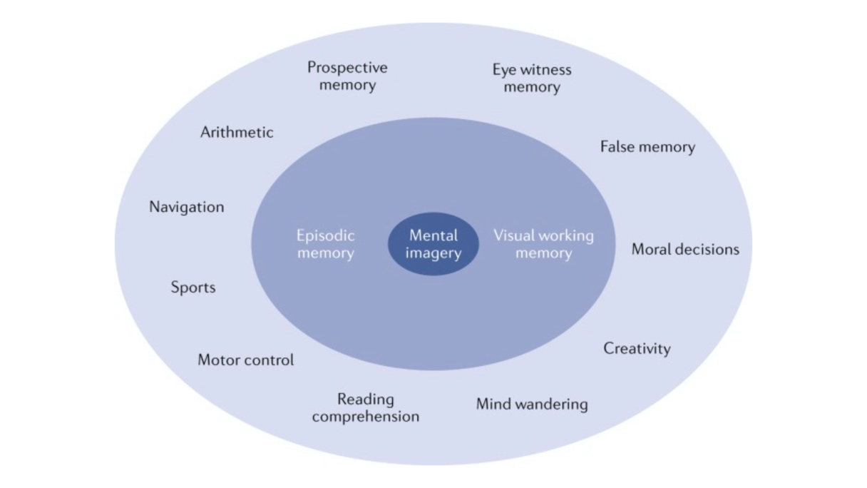
FIGURE 2. Graphical depiction of the cognitive processes related to mental imagery in non-aphantasic individuals. Reprinted with permission from Pearson (2019).

4.2.2 Problems for the account
But Pearson’s narrow focus on the cognitive architecture of visual imagery leaves him with insufficient elements to explain the whole set of data on aphantasia. In particular, it seems practically impossible to explain impairments in non-visual imagery (2) in terms of impairments to visual imagery. (2) cannot be directly explained by appealing to the mechanism involved in generating visual imagery, and it is unlikely that an impairment in visual imagery could indirectly explain such impairments. That is, it looks unlikely that the generation of non-visual imagery would be dependent on the generation of visual imagery, since, for example, we know that visual imagery is not realised where olfactory imagery is realised (Flohr et al., 2014; Winlove et al., 2018).
This shortcoming of Pearson’s model is unsurprising, since he characterises aphantasia as a visual imagery condition from the start. This is a mistake, and we ought to revise our starting point, which is what I do in the next section.

5. A New Theory

Researchers have accumulated evidence in support of a cognitive architecture of the episodic system—CESH—whereby the same three key processes are, to different extents, responsible for the generation of both rememberings (including episodic and semantic memories) and imaginings (including episodic and semantic imaginings) (Schacter & Addis 2007, 2020; Perrin & Michaelian, 2017). These processes are: the semantic retrieval process, the episodic retrieval process, and the (re)combination process. Only some parts of the model are relevant to my project here, and I will therefore not discuss semantic rememberings/imaginings.
Section 5.1 explains the basic tenets of CESH, and adds three features to this model: (i) memory indices which store the addresses of the locations where information is stored; (ii) different episodic retrieval processes for each type of sensory information; (iii) spatial retrieval processes for different kinds of spatial information. Section 5.2 defends the new model, CESH+, by providing empirical evidence for my modifications. Section 5.3 develops a new theory of aphantasia, which can successfully explain (1) to (6). This explanation shows that aphantasia results from the malfunctioning of a mechanism in the episodic system.

5.1 Two stories
CESH concerns how episodic rememberings and imaginings, as well as semantic rememberings and imaginings, are produced (see Figure 3), where these are constructive and simulative processes. Let us unpack these claims. Firstly, these processes are constructive (Schacter & Addis, 2007, 2020), since, when a memory is retrieved, we actually retrieve independent elements (e.g., who, what, where), which need to be (re)constructed into a representation of a past experience. Similarly, when an imagining is produced, we first retrieve independent elements, which are then constructed into a (novel) representation. The database of elements which are drawn on when we remember or imagine is the same.
Secondly, memory and imagination are simulative when it comes to neural re-use (Hurley, 2008), whereby the processes rely on many of the same neural areas. But the theory goes even further than this, and claims that all processes involved in memory are also involved in imagination, only to different extents. To elaborate on how, I will give two toy examples that show CESH in action, and also illustrate my modifications to the theory: Matilda episodically remembering riding a horse at her old riding school; and Isela episodically imagining riding an elephant.
What happens in the first case? The first step is that Matilda intends to remember riding a horse in her old riding school. On the basis of this intention, multiple commands are issued. These are commands to retrieve particular elements needed to reconstruct the memory, such as a visual representation of a horse, and a representation of what horses smell like. Retrieving these is the responsibility of the episodic retrieval process (Folville et al., 2020; Madore, Jing, & Schacter, 2016). But in order to do its job, the episodic retrieval process needs to know where to find these elements.
This is where I make the first addition to CESH: Memory indices implemented in the hippocampus (Teyler & DiScenna, 1986; Langille & Gallistel, 2020). The episodic retrieval process needs to retrieve the element from a particular location, and the address of this location has to be stored somewhere – much like how the address of a person is stored in an official register. A memory index stores the addresses (or “pointers”) to the actual locations of particular elements. Depending on what kind of information is requested, the command to retrieve information gets sent to a different memory index. That is to say, different indices hold different addresses. The index for episodic memory holds addresses for episodic elements; the index for semantic memory holds addresses for semantic elements; and the index for spatial memory holds addresses for spatial elements (Moscovitch et al., 2005). In the case of Matilda, the first command was to retrieve a visual representation of a horse. This is an episodic detail, so the address of this representation is found in the index for episodic memory. The second was to retrieve the smell of a horse—an olfactory detail—so this is also sent to the same index. However, the third command was to retrieve spatial information about the location of the riding school, and this command is sent to the index for spatial memory. Let us put aside the spatial elements for a while, and focus on the episodic.
Here is the second addition: A modification of the episodic retrieval process. Depending on what kind of episodic information is requested (i.e., visual, auditory, olfactory, etc.), a different episodic retrieval process is recruited to retrieve it. That is, whereas CESH posits one episodic retrieval process, I posit six: visual, auditory, gustatory, tactile, olfactory, and affective (Smith et al., 2004; Gottfried et al., 2004; Barrós-Loscertales et al., 2012). In Matilda’s case, the first two commands were to retrieve a visual representation of a horse and an olfactory representation of a horse, meaning that the visual episodic retrieval process and the olfactory episodic retrieval process are activated.
To explain how spatial information is retrieved, I make my final addition: There are two spatial retrieval process—one semantic and one episodic—which are independent from all other retrieval processes (Rosenbaum et al., 2005; Moscovitch et al., 2005). The spatial episodic retrieval process retrieves allocentric and egocentric information about locations, including landmarks and typography, and supports re-experiencing the location. The spatial semantic retrieval process retrieves schematic representations of environments, and does not support re-experiencing the location. In Matilda’s case, the spatial episodic retrieval process is activated to retrieve allocentric and egocentric information about her former riding school.
Call this modified version, “CESH+”. Finally, the recombination process recombines the three into Matilda’s memory of riding a horse at her old riding school. Evidence for the recombination process comes for example from experiments where the generation of memory errors is best explained by positing a recombination process, and this has been tested in a number of memory experiments, such as experiments involving associative inference (Carpenter & Schacter, 2017), and value memory (Carpenter & Schacter, 2018). In the study of imagination, further support for the recombination process comes from experiments using false recognition tasks in future planning (Dewhurst et al., 2016). Due to the recombination process recombining retrieved information, Matilda now experiences this as an episodic memory.
Now we can also make sense of how constructing an episodic imagining works. Consider Isela episodically imagining riding an elephant, which is not something they have done before. Isela intends to imagine riding an elephant, and this sends out multiple commands to retrieve elements needed to construct the imagining. The first command is to retrieve a visual representation of an elephant, where the address again is found in the index for episodic memory, and the visual retrieval process is recruited to retrieve the representation. But Isela has no episodic representation of riding. Instead, a command is sent to retrieve semantic knowledge of riding. Though Isela has not ridden before, they are still aware of the concept of riding, and have some knowledge of it, but this is stored in their semantic memory. The sematic retrieval process, which retrieves semantic information, has been demonstrated to be distinct from the episodic retrieval process, as evidence from semantic dementia and episodic amnesia show that the episodic and semantic retrieval processes doubly dissociate. In cases of semantic dementia, episodic memory can remain intact whilst semantic memory is severely impaired (Irish et al., 2012; Madore et al., 2019), and in cases of episodic amnesia due to trauma, semantic memory remains intact whilst episodic memory is severely impaired (Rosenbaum et al. 2005). Coming back to the toy example, the command to retrieve information relevant to riding goes through the index for semantic memory, where the address of the representation is stored, and the semantic retrieval process is recruited to retrieve it. Finally, the (re)combination process combines the representations into an imagining of riding an elephant, containing both semantic and episodic information (Addis et al., 2009; Carpenter & Schacter, 2017).
Finally, both the cases I have discussed are cases of voluntary memory/imagination, where a subject forms an intention to remember/imagine something. But we know that there are involuntary cases too, as people also experience traumatic flashbacks, daydreams, and nocturnal dreams. This tells us that the commands to retrieve elements can be issued in the absence of an intention, or bottom-up. That is, a subject’s having an intention is not necessary for details to be retrieved. A study by Spanò et al. (2020) suggests that involuntary imagery also relies on the episodic system, and in particular that the hippocampus is necessary for retrieving details to form content in dreams. Thus, CESH+ can explain both how voluntary and involuntary episodes are generated, as it is not a requirement that commands be issued by an intention.

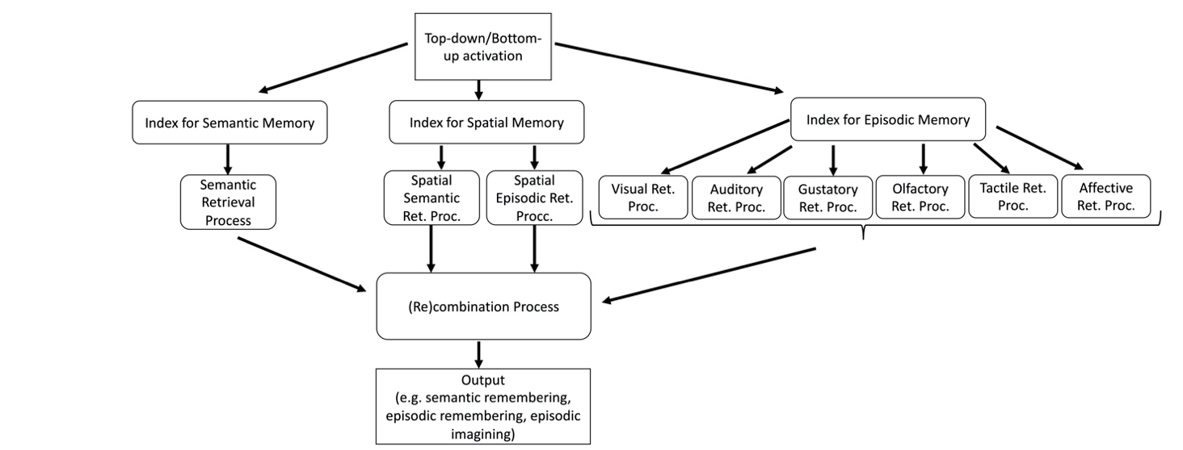
FIGURE 3. A boxological depiction of the cognitive architecture of memory and imagination suggested by the constructive episodic simulation hypothesis+ (CESH+). “Ret. Proc.” is short for “retrieval process”.

5.2 The empirical evidence
This section provides empirical support for CESH+, focusing first on the memory indices, then the episodic retrieval processes, and finally the spatial retrieval processes.
Firstly, though memory indices are a new addition to CESH, it is an idea that has been prevalent in memory research since the late 1980s (Teyler & DiScenna, 1986). Memory indices were introduced to explain the role of the hippocampus in memory, positing that the hippocampus serves as an index which stores the addresses of sensory information. The theory specifies ﻿the intrinsic organisation of the hippocampus, its synaptic physiology as well as its anatomical relationship to other regions of the brain (Langille & Gallistel, 2020), and supporting studies have carried out predictions of the theory, such as the prediction that cued recall should trigger the reactivation of the memory ﻿index, which will then reactivate the entire pattern of neocortical activity related to the episode (Rudy & O’Reilly, 2001). Evidence also indicates that the hippocampus is activated both when retrieving a memory and when forming and imagining, indicating that accessing the index is necessary for both (Zeidman & Maguire, 2016). For example, in a task where subjects were instructed to elaborate on past events and future imagined events, results showed that the anterior hippocampus was activated in both cases (Addis, Wong, & Schacter, 2007), and this was also the case when subjects in another study recalled episodic memories and imagined fictitious events set in the past or future based on recombined elements from episodic memories (Addis et al., 2009).
Secondly, research supports the existence of a different episodic retrieval processes dedicated to retrieving different sensory details. Studies indicate that brain regions involved in encoding an episodic memory are partially reactivated when that content is later remembered, and according to Danker and Anderson (2010), many PET and fMRI studies show the reactivation of sensory regions when retrieving an episodic memory. Studies have used an associative paradigm, where a word (“dog”) is either coupled with hearing a sound (woof!) or a picture (of a dog) (Wheeler & Buckner, 2004; Wheeler et al., 2006). Upon seeing the word “dog” again, activity in the visual association cortex is reinstantiated during retrieval of visual information (picture of dog), and activity in the auditory association cortex is reinstantiated during retrieval of auditory information (woof!). Retrieval of olfactory and gustatory memories has been studied in a similar way, where activity in the olfactory cortex, or gustatory cortices, respectively, was reinstantiated upon re-experiencing a stimulus (Gottfried et al., 2004; Barrós-Loscertales et al., 2012). When it comes to generating imagery, we see a similar reliance on sensory areas, where for example, visual imagery activates high-level visual areas. Support from this claim comes from fMRI experiments where participants were instructed to either imagine an object (imagery condition), or were visually presented with the object (perception condition). Results showed that both conditions activate visual areas. Indeed, visual information can even be decoded from the perception condition using multivariate pattern analysis, and used to reliably predict the content in the imagery condition, suggesting that not only are the same neural areas involved, but they might share a common code (Johnson & Johnson, 2014; for a recent review, see Dijkstra, Bosch, & van Gerven, 2019).
There is a similar story for auditory imagery, where Zatorre and Halpern (2005) have demonstrated that it relies on the auditory cortex through fMRI experiments which focus on musical imagery. Here, participants either hear a real tune, or are instructed to imagine the same tune. Results indicate that both the primary auditory cortex (Zatorre & Halpern, 2005) and the secondary auditory cortex (Kleber et al., 2007) are involved in both hearing a tune and imagining the same tune. Though research in the area is limited, a similar paradigm has been used to study olfactory imagery, where PET studies show that both actually smelling a scent and imagining smelling it activates the same neural areas in subjects (Djordjevic et al., 2004, 2005). Interestingly, both olfactory perception and olfactory imagery are also modified by sniffing behaviour (Bensafi, Pouliot, & Sobel, 2005). Taken together, we see that both episodic memory and sensory imagery rely on sensory areas in the brain, supporting the claim that there are different episodic retrieval processes dedicated to retrieving different kinds of sensory details.
Thirdly, the existence of two dedicated spatial retrieval processes has been defended by Moscovitch et al. (2005), one of which retrieves semantic information and one which retrieves episodic information. There is dissociative evidence for positing these two processes. Two patients, K.C. and E.P., who both had extensive bilateral damage to the hippocampus and related medial temporal lobe structures, were tested on tasks related to semantic spatial information (distance judgements, proximity judgements, sequencing landmarks along routes, recognising gross features on world maps) and episodic spatial information (identifying smaller neighbourhood landmarks and smaller features on maps). Whilst they were not impaired on the former, they were severely impaired on the latter. This points to that schematic information as involved in the former task is retrieved differently to the more detailed information involved in the second task (Rosenbaum et al., 2000).

5.3 Aphantasia explained
Having defended CESH+, I can now demonstrate how this cognitive architecture can explain (1) to (6). I start with (1): Why can aphantasics not voluntarily generate visual imagery? To explain this, we need to consider the mechanisms that generate voluntary imagery. Generating voluntary imagery involves a subject’s intention to trigger commands to retrieve elements from storage, the addresses of which are provided by the relevant index. When a subject is unable to voluntarily generate mental imagery, the top-down command fails to trigger the relevant retrieval process. That is, a command is issued, but the relevant episodic retrieval processes are not activated. This in turns means that no elements can be retrieved, and there is nothing to forward to the (re)combination process to recombine, resulting in no experience of visual imagery.
What goes wrong here? We are not yet in a position to know exactly why the retrieval processes are not activated. There are three possibilities: Either there is a problem with the memory index itself, or with the retrieval processes downstream from the memory index, or with the recombination process. The last option is unlikely as we know that the recombination process is also vital to recombining elements when forming semantic imaginings/rememberings, and we know that semantic memory is not impaired in aphantasics (Milton et al., 2020; Bainbridge et al., 2020). So we are left with two viable options. fMRI imaging could shed some light on this by telling us whether hippocampal areas are activated as normal as this is where the index for episodic memory is realised (Moscovitch et al., 2005). If so, it would indicate that the memory index works as normal, and hence it is more likely that aphantasics have a particular problem with the retrieval processes. fMRI has already shown that visual areas are abnormally activated in aphantasics, lending support to the second option (Fulford et al., 2018).
Secondly, there are aphantasics who cannot involuntarily generate mental imagery (3), where no intention is involved. My theory explains data point (3) by appealing to different ways in which the episodic system can be activated. The system can be activated in a top-down or a bottom-up way (Schacter & Addis, 2020; Spanò et al., 2020), and it is triggered in a top-down way when an agent intends to generate imagery, and in a bottom-up way when there is an absence of intention but the system is still triggered (e.g., when dreaming). Accordingly, I propose that those aphantasics who are only impaired with respect to generating voluntary imagery manifest a deficit with respect to top-down activation only. In contrast, I maintain that those aphantasics who are impaired when it comes to generating both voluntary and involuntary imagery might have: (i) either a deficit with respect to both the top-down and bottom-up generation of imagery; or (ii) an impaired episodic system. The difference between (i) and (ii) is important: In the former case, the episodic system itself is intact; it is the “activation routes” that are impaired; in the latter case, it is the system itself which is impaired. We currently lack evidence to point us in either of these directions, but importantly, my theory is flexible enough to account for both possibilities.
Interestingly, this account makes a novel prediction with respect to voluntary and involuntary impairments. As we have seen from the data, some subjects are impaired with respect to both the top-down and bottom-up processing, resulting in no voluntary imagery and no involuntary imagery. But not all subjects lack both voluntary and involuntary imagery—many retain involuntary imagery. This points to a dissociation between these two processes, where one can be retained in the absence of the other. It is possible that this is a double dissociation, such that we would find also find subjects who retain voluntary imagery, but lack involuntary imagery. This intriguing hypothesis remains to be tested.

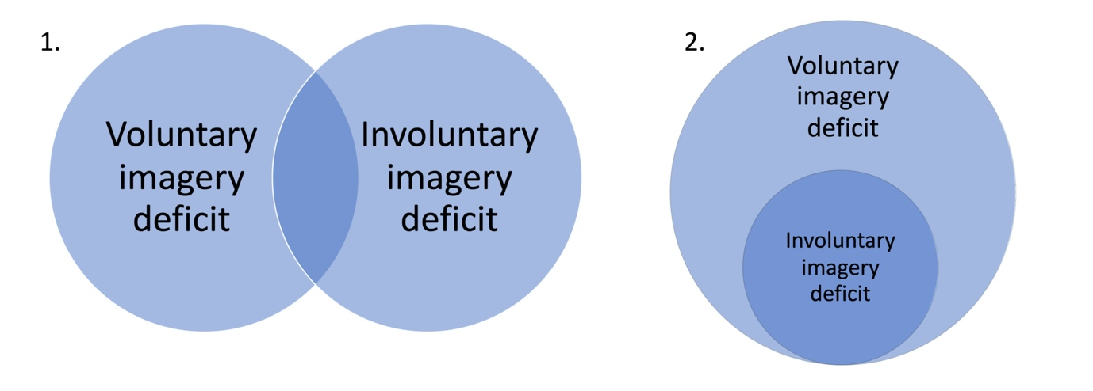
FIGURE 4. Graphical depictions of possible relations of the voluntary imagery impairment and the involuntary imagery impairment.

Thirdly, this theory is well-equipped to explain (4) and (5)—the impairments in retrieving episodic memory details and generating future/atemporal imaginings. If the activation of the episodic retrieval processes is impaired, we should expect fewer details reported in episodic remembering, as well as in future/atemporal imaginings, since the output depends on the episodic retrieval processes. But note that the output also depends on other processes, such as the semantic retrieval process, which is not impaired. We know that the semantic retrieval process also contributes to the output of episodic memories and episodic imaginings (Schacter & Addis, 2020), and so this account predicts that aphantasics should rely more heavily on these than what other people do, resulting in some memory details being retrieved. Sensory details could be stored in semantic memory as semanticised content which has been rehearsed (Bainbridge et al., 2020), though retrieving these is not accompanied by the sense of reliving that episodic memories are, as suggested by Greenberg and Knowlton (2014). Thus, my account can explain how aphantasics can still recall episodes in less detail by using different coping strategies, and it predicts that we should find that aphantasics rely more heavily on semantic memory.
Fourthly, we ought to account for why aphantasics can be differentially impaired across sensory systems (2), which Pearson’s theory had trouble with. In contrast, positing different retrieval processes can explain why it is the case that a person could be impaired with respect to one kind of sensory imagery but not another. The retrieval processes operate independently from each other, so it is possible for one to be impaired whilst others are not. For example, when a person is impaired with respect to visual imagery, the retrieval process that is responsible for retrieving visual information is impaired, whilst the other ones are not. That is, when a command is issued to activate the visual retrieval process, this fails, whereas commands to activate other retrieval processes succeed. Neurological data should bear this out, by showing differential activity in the visual cortex when a person with a visual imagery impairment tries to visually imagine, compared to when a neurotypical person visually imagines (Fulford et al. 2018). Neurological activation for other impairments, such as auditory or olfactory impairments, are yet to be tested, but we should expect similar results of differential activity there. CESH+ is thus able to explain the data that Pearson’s struggled with.
Finally, my theory can also account for the fact that aphantasics score highly on spatial imagery questionnaires (6), and are able to solve tasks involving spatial imagery. There are two possible explanations for these results, and further research needs to adjudicate between them. Recall that there is a semantic spatial retrieval process and an episodic spatial retrieval process. One possibility is that aphantasics retain the functionality of both of these processes, even though the episodic retrieval processes are impaired. Another possibility is that at least one of the spatial retrieval processes always remains functional. It is likely that only the spatial semantic retrieval process needs to work in order to solve spatial imagery tasks and navigate, so this would be sufficient to produce the results discussed in Section 3.6 (Moscovitch et al., 2005). If this is the case, it is unlikely that the subjects could experience conscious spatial mental imagery. Currently, we do not have data which can adjudicate between these explanations, as no experiments focusing on spatial imagery have been conducted. Crucially, my theory has the resources to explain both possibilities.
I highlight two particularly noteworthy points to finish. Firstly, aphantasia is best characterised as an episodic system condition, rather than a mental imagery condition. Though earlier accounts of aphantasia have characterised the condition as a (visual) imagery condition, the data on aphantasics does not in fact tally with this interpretation. We have no reason to think that the inability to form voluntary visual imagery should take precedence over the other impairments in defining the condition, even though the condition was first identified in this way. Aphantasia is characterised by a cluster of impairments, of which one is the inability to form voluntary visual imagery. But as I have shown here, aphantasia cannot be a visual imagery condition as argued by Pearson, but it is instead a condition which can be wholly explained by the cognitive architecture of the episodic system.
One might object to this claim by pointing to that more empirical evidence is needed to establish the link between the imagery and memory impairments in aphantasia. While I agree that further research needs to be conducted into this issue, it remains the case that all extant studies on aphantasia which have investigated both imagery and memory impairments support the existence of a positive correlation between these two impairments (Bainbridge et al., 2020; Dawes et al., 2020; Milton et al., 2021; Zeman, 2020; Zeman et al., 2015), which is what my theory predicts. To be clear, if aphantasia is an episodic system condition, where the episodic system is responsible for generating both imagery and episodic memory, we should expect both imagery and episodic memory to typically be impaired at the same time—we should not expect a double dissociation between them such that one is impaired and the other is not. This is instead what a theory posting two different systems would predict. Now, it might be further objected that many studies have actually not found a correlation between an episodic memory impairment and an imagery impairment, as they only have found an imagery impairment in aphantasia (e.g., Keogh & Pearson, 2018; Keogh, Wicken, & Pearson, 2021). This objection, however, would rest on a mistake: It is true that many studies only detail an imagery impairment in aphantasia, but this is simply because these studies did not investigate episodic memory and its neural substrates at all. In other words, the fact that we do not have many studies indicating a joint imagery-episodic memory impairment simply reflects the fact that many prominent studies have neglected episodic memory entirely. If my theory is on the right track, this should be rectified, and the relation between imagery and episodic memory in aphantasia should be extensively investigated.
Secondly, it should also be pointed out that aphantasia seems to manifest differently in different individuals, where not all individuals have all the impairments that I have discussed. There is thus a heterogeneity in the sample, which might potentially indicate different sub-types of aphantasia. Does the heterogeneity of the condition pose a problem for my attempt to give a unified account of aphantasia? An alternative possibility is that aphantasia is not a unified condition with different sub-types at all, but that we are instead currently studying several different conditions. But conditions are not identified by their varying manifestations or symptoms, but rather by the underlying factors that cause these manifestations or symptoms (Murphy & Stich, 2000). The heterogeneity of aphantasia is hence not problematic for my account, as it is unified in that there is one underlying system which causes all the impairments we see in aphantasic subjects. This system is complex and is subject to (at least partially) independent breakdowns, and this explains why aphantasia can manifest itself in different ways despite being one condition.
Going forward, we ought to develop a new sampling method for aphantasia to reflect the insight that aphantasia is an episodic system condition which manifests in different ways. Given what we now know of aphantasia, we can see that the VVIQ focuses too narrowly on visual imagery. In fact, using it will treacherously skew our research sample towards people with a visual imagery impairment, and completely leave other aphantasics out of the sample. We ought to develop new methods which focus on various aspects of the condition, such as the generation of voluntary and involuntary imagery, the generation of mental imagery with respect to different sensory systems, and the generation of episodic memory details.

6. Conclusion

I have laid the groundwork for a theory of aphantasia. I have argued that aphantasia is a condition which results from a malfunction in the episodic retrieval process—an episodic system condition. To argue my case, I considered currently available data on aphantasia, and identified six data points for which a theory ought to be able to provide a cognitive explanation. Examining Nanay’s and Pearson’s accounts, I found that these were unable to do so satisfactorily, and I therefore developed a new theory, which can account for all the impairments. Our next goal should be to test the predictions of this theory. The research on aphantasia is still in its infancy and there are many avenues left to explore, but I believe that this theory can guide us in the right direction.

ACKNOWLEDGEMENTS
Thanks to two anonymous reviewers, the cognitive science research group at the University of Sheffield, especially Luca Barlassina, Ryan Doran, Will Hornett, Dominic Gregory, and James Lloyd, and audiences and commentators at the Society of Philosophy and Psychology, Issues in Philosophy of Memory 2.5, the Second Annual C.O.V.I.D. Conference, and the Grießen Lecture Series on Imagination.

REFERENCES

Addis, D. R., Pan, L., Vu, M. A., Laiser, N., & Schacter, D. L. (2009). Constructive episodic simulation of the future and the past: Distinct subsystems of a core brain network mediate imagining and remembering. Neuropsychologia, 47(11), 2222–2238.
Addis, D. R., Schacter, D. L., & Szpunar, K. K. (2017). Escaping the Past: Contributions of the hippocampus to future thinking and imagination. In Hannula, D. E., & Duff, M. C., (Eds.), The hippocampus from cells to systems: Structure, connectivity, and functional contributions to memory and flexible cognition (pp. 1–589). Cham: Springer International Publishing.
Addis, D. R., Wong, A. T., & Schacter, D. L. (2007). Remembering the past and imagining the future: Common and distinct neural substrates during event construction and elaboration. Neuropsychologia, 45(7), 1363–1377.
Bainbridge, W. A., Hall, E. H., & Baker, C. I. (2021). Distinct representational structure and localization for visual encoding and recall during visual imagery. Cerebral Cortex, 31(4), 1898–1913.
Bainbridge, W. A., Pounder, Z., Eardley, A. F., & Baker, C. I. (2020). Quantifying aphantasia through drawing: Those without visual imagery show deficits in object but not spatial memory. Cortex, 135, 159–172.
Barrós-Loscertales, A., González, J., Pulvermüller, F., Ventura-Campos, N., Bustamante, J. C., Costumero, V., Parcet, M. A., & Ávila, C. (2012). Reading salt activates gustatory brain regions: FMRI evidence for semantic grounding in a novel sensory modality. Cerebral Cortex, 22(11), 2554–2563.
Battistoni, E., Stein, T., & Peelen, M. (2017). Preparatory attention in visual cortex. Annals of the New York Academy of Sciences, 1396, 92–107.
Bensafi, M., Pouliot, S., & Sobel, N. (2005). Odorant-specific patterns of sniffing during imagery distinguish “Bad” and “Good” Olfactory Imagers. Chemical Senses, 30(6), 521–529.
Bensafi, M., & Rouby, C. (2007). Individual differences in odor imaging ability reflect differences in olfactory and emotional perception. Chemical Senses, 32(3), 237–244.
Carpenter, A. C., & Schacter, D. L. (2017). Flexible retrieval: When true inferences produce false memories. Journal of Experimental Psychology: Learning Memory and Cognition, 43(3), 335–349.
Carpenter, A. C., & Schacter, D. L. (2018). False memories, false preferences: Flexible retrieval mechanisms supporting successful inference bias novel decisions. Journal of Experimental Psychology: General, 147(7), 988–1004.
Danker, J., & Anderson, J. R. (2010). The ghosts of brain states past: Remembering reactivates the brain regions engaged during encoding. Psychological Bulletin, 136(1), 87–102.
Dawes, A. J., Keogh, R., Andrillon, T., & Pearson, J. (2020). A cognitive profile of multi-sensory imagery, memory and dreaming in aphantasia. Scientific Reports, 10(1), 1–10.
Dewhurst, S. A., Anderson, R. J., Grace, L., & van Esch, L. (2016). Adaptive false memory: Imagining future scenarios increases false memories in the DRM paradigm. Memory and Cognition, 44(7), 1076–1084.
Dijkstra, N., Bosch, S. E., & van Gerven, M. A. J. (2019). Shared neural mechanisms of visual perception and imagery. Trends in Cognitive Sciences, 23(5), 423–434.
Djordjevic, J., Zatorre, R. J., Petrides, M., Boyle, J. A., & Jones-Gotman, M. (2005). Functional neuroimaging of odor imagery. NeuroImage, 24(3), 791–801.
Djordjevic, J., Zatorre, R. J., Petrides, M., & Jones-Gotman, M. (2004). The mind’s nose. Psychological Science, 15(3), 143–148.
Dorsch, F. (2015). Focused daydreaming and mind-wandering. Review of Philosophy and Psychology, 6(4), 791–813.
Flohr, E. L. R., Arshamian, A., Wieser, M. J., Hummel, C., Larsson, M., Mühlberger, A., & Hummel, T. (2014). The fate of the inner nose: Odor imagery in patients with olfactory loss. Neuroscience, 268, 118–127.
Folville, A., Bahri, M. A., Delhaye, E., Salmon, E., D’Argembeau, A., & Bastin, C. (2020). Age-related differences in the neural correlates of vivid remembering. NeuroImage, 206, 1-9.
Fulford, J., Milton, F., Salas, D., Smith, A., Simler, A., Winlove, C., & Zeman, A. (2018). The neural correlates of visual imagery vividness: An fMRI study and literature review. Cortex, 105, 26–40.
Galton, E. (1883). Inquiries into human faculty and its development. London: ﻿Macmillan.
Goodale, M. A., & Milner, A. D. (1992). Separate visual pathways for perception and action. Trends in Neurosciences, 15(1), 20–25.
Gottfried, J., Smith, A., Rugg, M., & Dolan, R. (2004). Remembrance of odors past: Human olfactory cortex in cross-modal recognition memory. Neuron, 42(4), 687–695.
Greenberg, D. L., & Knowlton, B. J. (2014). The role of visual imagery in autobiographical memory. Memory and Cognition, 42(6), 922–934.
Herholz, S. C., Halpern, A. R., & Zatorre, R. J. (2012). Neuronal correlates of perception, imagery, and memory for familiar tunes. Journal of Cognitive Neuroscience, 24(6), 1382–1397.
Hurley, S. (2008). Understanding simulation. Philosophy and Phenomenological Research, 77(3), 755–774.
Irish, M., Addis, D. R., Hodges, J. R., & Piguet, O. (2012). Considering the role of semantic memory in episodic future thinking: Evidence from semantic dementia. Brain, 135(7), 2178–2191.
Jacobs, C., Schwarzkopf, D. S., & Silvanto, J. (2018). Visual working memory performance in aphantasia. Cortex, 105, 61–73.
Johnson, M. R., & Johnson, M. K. (2014). Decoding individual natural scene representations during perception and imagery. Frontiers in Human Neuroscience, 8, 1–14.
Keogh, R., & Pearson, J. (2018). The blind mind: No sensory visual imagery in aphantasia. Cortex, 105, 53–60.
Keogh, R., & Pearson, J. (2021). Attention driven phantom vision: Measuring the sensory strength of attentional templates and their relation to visual mental imagery and aphantasia: Measuring attentional templates. Philosophical Transactions of the Royal Society B: Biological Sciences, 376(1817), 1-10.
Keogh, R., Wicken, M., & Pearson, J. (2021). Visual working memory in aphantasia: Retained accuracy and capacity with a different strategy. Cortex, 143, 237–253.
Kleber, B., Birbaumer, N., Veit, R., Trevorrow, T., & Lotze, M. (2007). Overt and imagined singing of an Italian aria. NeuroImage, 36(3), 889-900.
Langille, J. J., & Gallistel, C. R. (2020). Locating the engram: Should we look for plastic synapses or information-storing molecules? Neurobiology of Learning and Memory, 169, 1–15.
Lee, S. H., Kravitz, D. J., & Baker, C. I. (2019). Differential representations of perceived and retrieved visual information in hippocampus and cortex. Cerebral Cortex, 29(10), 4452–4461.
Madore, K. P., Jing, H. G., & Schacter, D. L. (2016). Divergent creative thinking in young and older adults: Extending the effects of an episodic specificity induction. Memory and Cognition, 44(6), 974–988.
Madore, K. P., Thakral, P. P., Beaty, R. E., Addis, D. R., & Schacter, D. L. (2019). Neural mechanisms of episodic retrieval support divergent creative thinking. Cerebral Cortex, 29(1), 150–166.
Marks, D. F. (1973). Visual imagery differences in the recall of pictures. British Journal of Psychology, 64(1), 17–24.
Milton, F., Fulford, J., Dance, C., Gaddum, J., Heuerman-Williamson, B., Jones, K., Knight, K. F., MacKisack, M., Winlove, C., & Zeman, A. (2020). Behavioral and neural signatures of visual imagery vividness extremes: aphantasia vs. hyperphantasia. PsyArXiv.
Moscovitch, M., Rosenbaum, R. S., Gilboa, A., Addis, D. R., Westmacott, R., Grady, C., McAndrews, M. P., Levine, B., Black, S., Winocur, G., & Nadel, L. (2005). Functional neuroanatomy of remote episodic, semantic and spatial memory: A unified account based on multiple trace theory. Journal of Anatomy, 207(1), 35–66.
Murphy, D., & Stich, S. (2000). Darwin in the madhouse: evolutionary psychology and the classification of mental disorders. In Carruthers, P., & Chamberlain, A., (Eds.), Evolution and the human mind: Modularity, language and meta-cognition. Cambridge: Cambridge University Press.
Nanay, B. (2018). Multimodal mental imagery. Cortex, 105, 125–134.
Nanay, B. (2021). Unconscious mental imagery. Philosophical Transactions of the Royal Society B, 376, 1-9.
Newell, A. (1990). Unified theories of cognition. Cambridge, MA: Harvard University Press.
Nichols, S., & Stich, S. P. (2004). Mindreading: An Integrated account of pretence, self-awareness, and understanding other minds. Oxford: Cleardon Press.
Okada, H., & Matsuoka, K. (1992). Effects of auditory imagery on the detection of a pure tone in white noise: Experimental evidence of the auditory perky effect. Perceptual and Motor Skills, 74(2), 443–448.
Pearson, J. (2019). The human imagination: the cognitive neuroscience of visual mental imagery. Nature Reviews Neuroscience, 20(10), 624–634.
Pearson, J. (2020). The visual imagination. In Abraham, A. (Ed.), The Cambridge handbook of the imagination (pp. 175–186). Cambridge: Cambridge University Press.
Perrin, D., & Michaelian, K. (2017). Memory as mental time travel. In Bernecker, S., & Michaelian, K., (Eds.), The Routledge handbook of philosophy of memory (pp. 228–239). London: Routledge.
Rendell, P. G., Bailey, P. E., Henry, J. D., Phillips, L. H., Gaskin, S., & Kliegel, M. (2012). Older adults have greater difficulty imagining future rather than atemporal experiences. Psychology and Aging, 27(4), 1089–1098.
Renoult, L., & Rugg, M. D. (2020). An historical perspective on Endel Tulving’s episodic-semantic distinction. Neuropsychologia, 139, 1–11.
Rosenbaum, R. S., Köhler, S., Schacter, D. L., Moscovitch, M., Westmacott, R., Black, S. E., Gao, F., & Tulving, E. (2005). The case of K.C.: Contributions of a memory-impaired person to memory theory. Neuropsychologia, 43(7), 989–1021.
Rosenbaum, R. S., Priselac, S., Köhler, S., Black, S. E., Gao, F., Nadel, L., & Moscovitch, M. (2000). Remote spatial memory in an amnesic person with extensive bilateral hippocampal lesions. Nature Neuroscience, 3(10), 1044–1048.
Rudy, Jerry W., & O’Reilly, R. C. (2001). Conjunctive representations, the hippocampus, and contextual fear conditioning. Cognitive, Affective and Behavioral Neuroscience, 1(1), 66-82.
Schacter, D. L., & Addis, D. R. (2007). The cognitive neuroscience of constructive memory: Remembering the past and imagining the future. Philosophical Transactions of the Royal Society B: Biological Sciences, 362(1481), 773–786.
Schacter, D. L., & Addis, D. R. (2020). Memory and Imagination: Perspectives on constructive episodic simulation. In Abraham, A., (Ed.), The Cambridge handbook of the imagination (pp. 111–131). Cambridge: Cambridge University Press.
Servos, P., & Goodale, M. A. (1995). Preserved visual imagery in visual form agnosia. Neuropsychologia, 33(11), 1383–1394.
Setton, R., Lockrow, A. W., Turner, G. R., & Spreng, R. N. (2021). Troubled past: A critical psychometric assessment of the self-report survey of autobiographical memory (SAM). Behavior Research Methods, 54(1), 261–286.
Smith, A., Henson, R., Dolan, R., & Rugg, M. (2004). fMRI correlates of the episodic retrieval of emotional contexts. NeuroImage, 22(2), 868–878.
Spanò, G., Pizzamiglio, G., McCormick, C., Clark, I. A., De Felice, S., Miller, T. D., Edgin, J. O., Rosenthal, C. R., & Maguire, E. A. (2020). Dreaming with hippocampal damage. Elife, 9, 1–15.
Teyler, T. J., & DiScenna, P. (1986). The hippocampal memory indexing theory. Behavioral Neuroscience, 100(2), 147–154
Treisman, A. (2006). How the deployment of attention determines what we see. Visual Cognition, 14, 411–443.
Wheeler, M. E., & Buckner, R. L. (2004). Functional-anatomic correlates of remembering and knowing. NeuroImage, 21(4), 1337-4.
Wheeler, M. E., Shulman, G. L., Buckner, R. L., Miezin, F. M., Velanova, K., & Petersen, S. E. (2006). Evidence for separate perceptual reactivation and search processes during remembering. Cerebral Cortex, 16(7), 949–959.
Whiteley, C. M. K. (2020). Aphantasia, imagination and dreaming. Philosophical Studies, 178, 2111–2132.
Winlove, C. I. P., Milton, F., Ranson, J., Fulford, J., MacKisack, M., Macpherson, F., & Zeman, A. (2018). The neural correlates of visual imagery: A co-ordinate-based meta-analysis. Cortex, 105, 4–25.
Zatorre, R. J., & Halpern, A. R. (2005). Mental concerts: Musical imagery and auditory cortex. In Neuron, 47(1), 9–12.
Zeidman, P., & Maguire, E. A. (2016). Anterior hippocampus: The anatomy of perception, imagination and episodic memory. In Nature Reviews Neuroscience, 17(3), 173-82
Zeman, A. (2020). Phantasia: The psychological significance of lifelong visual imagery vividness extremes. Supplementary material.
Zeman, A., Della Sala, S., Torrens, L. A., Gountouna, V. E., McGonigle, D. J., & Logie, R. H. (2010). Loss of imagery phenomenology with intact visuo-spatial task performance: A case of “blind imagination.” Neuropsychologia, 48(1), 145–155.
Zeman, A., Dewar, M., & Della Sala, S. (2015). Lives without imagery: Congenital aphantasia. Cortex, 73, 378–380.
Zeman, A., Milton, F., Della Sala, S., Dewar, M., Frayling, T., Gaddum, J., Hattersley, A., Heuerman-Williamson, B., Jones, K., MacKisack, M., & Winlove, C. (2020). Phantasia: The psychological significance of lifelong visual imagery vividness extremes. Cortex, 130, 426–440.

Galton (1883) first documented the condition in 1883, but no modern research was conducted until 2010. A distinction is made between acquired aphantasia (Zeman et al., 2010) and congenital (lifelong) aphantasia (Zeman, Dewar, & Della Sala, 2015; Zeman et al., 2020; Milton et al., 2020; Fulford et al., 2018). I limit my discussion to congenital aphantasia, since acquired aphantasia is extremely rare.
The VVIQ asks subjects to form a voluntary visual image. The maximum score on the VVIQ is 80/80, and the minimum is 16/80, where a subject would have answered “no image at all” on all questions. The threshold for counting as aphantasic varies. Some studies use 16/80 (Fulford et al., 2018; Zeman et al., 2015), other studies use ranges, such as 17-30 (Zeman, Dewar, & Della Sala, 2015), or 16-23 (Zeman et al., 2020; Milton et al., 2020), or 16-25 (Bainbridge et al., 2020). Some studies also make further distinctions between groups of aphantasics—notably Zeman et al. (2015) distinguishes between subjects who score 16 (“no imagery”), and subjects who score between 17-30 (“limited imagery”), and Zeman et al. (2020) distinguishes between subjects who scored 16 (“extreme aphantasia”), and subjects who scored between 17-23 (“moderate aphantasia”). Some studies do not report what operationalised definition was used (Keogh & Pearson, 2018; Greenberg & Knowlton, 2014; Dawes et al., 2020). Keogh and Pearson (2021) used self-ascribed aphantasics, though the VVIQ was also administered.
This is plausibly an underestimation of how many people have impairments to non-visual imagery, since the data reported here is taken from a subset of those who have a visual imagery impairment, indicated by the VVIQ. A person with only an impairment in, say, olfactory imagery would be excluded from the sample. Independent evidence shows that there are people who have only this impairment, without any impairment in visual imagery, as demonstrated by Bensafi and Rouby (2007) who developed the vividness of olfactory imagery questionnaire (VOIQ). They found that some subjects scored normally on the VVIQ, but below average on the VOIQ. Thus, current data plausibly underestimates the cases of non-visual imagery impairments.
For aphantasia and dreaming, see Whiteley (2020).
Jacobs et al. (2018) and Greenberg and Knowlton (2014) investigated working memory, but due to small sample sizes and generalisability issues, I do not report findings here.
The questionnaire used was the same as for Zeman et al. (2015), and the question pertaining to memory only asked subjects to report on phenomenology of memory. That is, accuracy of memory was not tested. Taken together with data from Bainbridge et al. (2020), evidence indicates that aphantasics perform worse when it comes to accuracy of episodic memory details too.
This study tested only one aphantasic, so we cannot say whether the findings would generalise.
Nanay could potentially respond to the objection from Keogh and Pearson in a different way and maintain the Unrestricted View. As pointed out by an anonymous reviewer, visual imagery and binocular rivalry might rely on difference neural mechanisms, hence, aphantasics might fail to be primed as a result of a deficit in the mechanism responsible for binocular rivalry, but still retain visual imagery.
Whether and to what extent there is a distinction between episodic and semantic memory is controversial (Renoult & Rugg, 2020).
Note that a reliance on many of the same neural areas does not entail that recall is merely a reactivation of encoding patterns. In fact, a recent study by Bainbridge et al. (2021) suggests that this is not the case for encoding an recalling visual imagery, indicating instead that recall displays a different representational structure from encoding. My theory is compatible with these results, as it does not pronounce on the processes instantiated during encoding vis-à-vis recalling.
To the best of my knowledge, the neural substrates of affective and gustatory imagery have not yet been investigated.
Thank you to an anonymous reviewer.
Thanks to an anonymous reviewer.
Thanks to an anonymous reviewer.

