About Gravity, Antigravity and Vacuum!
Understanding Gravity has been one of the most challenging tasks of humankind so far. Despite having some ideas about what it is and how it works, we can say with very high certainty that it still is a mystery or at least that some things about it are still a mystery. Without understating Gravity, we cannot understand the concept of Antigravity and whether it is possible to start with.
In this article I will be using simple philosophical arguments and logic along with some real-life observations to explain what the true reason for the phenomena which we call Gravity could be. These arguments of mine, as a final result, will challenge Newton’s and Einstein’s ideas about Gravity. But let’s the facts and results of tests determine what is more likely to be true.
All arguments used here will be fully consistent with down-to-Earth science or facts that we are well familiar with. Also, I will put forward suggestion for experiments to test my proposals or hypothesis. For my hypothesis to work, there is a need for a completely different understanding of the essence of Vacuum too. Therefore, I will also put forward another suggestion for another test which would prove or disprove my hypothesis about the Vacuum. Yes, in this article I will challenge the current understanding of this concept too. But let the facts speak for themselves, as no statement has any value if that cannot be tested or proved factually. After all, facts are the only language science should be using.
The short answer to question “What Is Causing Gravity?” is this – physical items (the non-magnetic ones!) are attracted to Earth or any other Cosmic Object because of Magnetism, BUT NOT BY THE MAGNETISM. The mechanism of it is truly very simple but, as I already stated, it requires reconsideration of our understanding of Vacuum as a substances-free areas for which, as I also said, I am going to provide an idea for experiment to test it.
THE MOST IMPORTANT PART OF THIS ARTICLE!
The realisation of how and why Gravity or Attraction of Physical Objects towards Earth (in this case) might be working came from observing candle flames and science experiment called Cartesian Diver. First of all, we all say that flames prove that Anti-gravity exist. But this so-called Anti-gravity here is caused simply by the flow of air around the flames moving upwards. So, I was thinking, if it indeed was showing the Effect of Anti-gravity, and we know that it is caused by the flow of air around the flame and caused by the properties of the flame itself then, maybe, the same is true with the actual Gravity, only the flow of air would be moving in opposite direction to flames, namely, downwards. But what would be causing this movement of air in this direction, which should be measurable by the way, is still to be explored! So, the Cartesian Diver Experiment provided another clue towards it. Namely, a lesser density causes things in certain circumstances to descend.
What is Cartesian Diver Experiment? If you fill a bottle fully with water, and if you put inside of it an object, preferably some kind of small and soft tube which is partly filled with air, but only as much to make it hardly float at the top of the water, then you are ready for the experiment. All you have to do now is to close the bottle so that nothing goes out or in of it. Then you slightly squeeze it, and the small tube that you prepared and put inside of it previously, the one that was hardly floating at the top of the water, will start to sink. And you can even regulate how far it will be sinking by applying a certain pressure on the bottle. You can also make it levitate at certain level, proving that pressure changes very rapidly with every single millimetre. This, in my view, proved that higher density leads to objects going down.
And this is where I was thinking - what if a lesser density is what causes the Effect of Gravity/Weight? The only difference between objects in atmosphere and the Cartesian Diver would be that the higher density is outside these objects while in case of that tube it is inside of it. After all, if the Anti-gravity of flames is caused by lesser density of air around the flames, then a higher density around physical bodies might be the key to unlock the mystery of Gravity too. And the best part of this hypothesis is, it can be verifiably tested…
So, in short, in my hypothesis, everything with respect to Gravity is to do with higher density or, rather, different densities of air around different bodies compared to density of air on its own in the given area. We only have to establish what could be causing this higher density around objects. And the Magnetic Field of Earth, or its strength in particular, along with the Magnetic Properties of our Atmosphere, are very important too for the existence of what I call “the Effect of Gravity”.
The last thing I would like to mention right now is that this hypothesis explains everything we have observed with respect to the Effect of Gravity, one of which is this dilemma - why is Gravity such a weak force? Answer – because it isn’t even a force. It is a phenomenon caused by Electromagnetism and the properties of Anti-magnetic substances in certain conditions… Some others of those observations, along with explanations for the given facts, I will also address in this very article.
After studying magnetism and magnetic field, I realised that magnetic properties of our atmosphere could be the key factor that causes Gravity. After all, if the air is magnetic, and Earth has enormous magnetic field, then it is only logical to assume that the air is being attracted by this magnetic field of Earth, and the same would be true with all other magnetic objects. But clearly, that would be only true with substances that are magnetic. Most substances, however, aren’t magnetic! So, what is attracting them?
Turns out that being non-magnetic doesn’t mean our bodies do not affect the magnetic field (or effects created by it) in substances surrounding us. It well might be that our bodies are indeed Non-magnetic and not in a passive way. But that would make them Anti-magnetic instead… Namely, it might be that the so-called Non-magnetic substances suppress the magnetism in particles of substances surrounding them at certain vicinity from them. But that would have some very specific consequences. So, we better explore this possibility of Anti-magnetism, if that is possible.
As it turns out, there are lots of experiments even on YouTube that point into this direction of this Anti-magnetism. Needless to say, that it would perfectly explain why completely Non-magnetic objects are attracted to Earth through the effects created by Magnetism. One of the best of such experiments have been carried out by a YouTube channel called “Brainiac75”. The owner of this channel is heavily involved into Magnetism, and anyone can learn a lot about it from his videos. Only that no YouTuber ever tries to understand and interpret the results of their experiments. In this case, when experimenting with large Magnet and its impact on Ferrofluid, at some point he also dropped a piece of plastic inside of it. And, as it appears, the effects of Magnetic Field there indeed appeared to be weaker than in surrounding areas. See the next few images from his experiment.
Anyone is free to visit his channel and the title of this particular video is as follows: “Monster Magnet Meets Magnetic Fluid…”. Next are two screenshots from it.
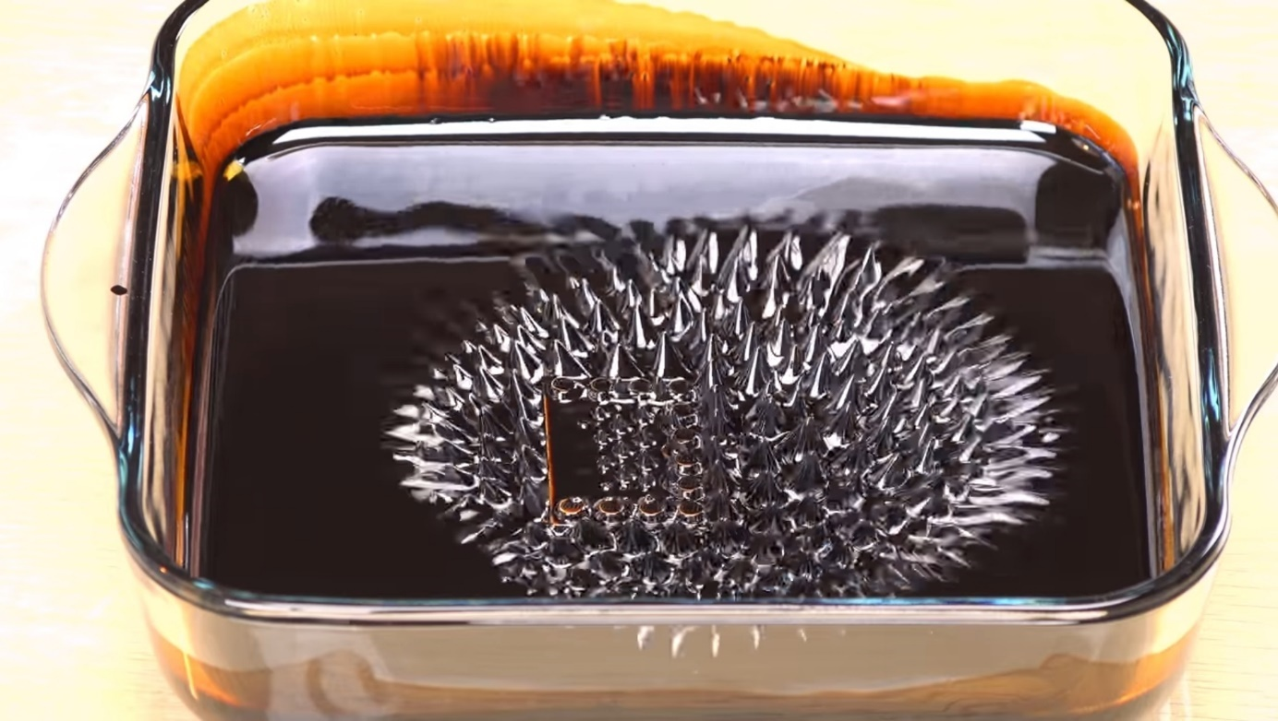
Here you see how magnet creates spikes in ferrofluid. A phenomenon that cannot be explained with the currently accepted pattern of magnetic field. Somewhere at the middle of it you can see a piece of plastic. Next image has it enlarged.
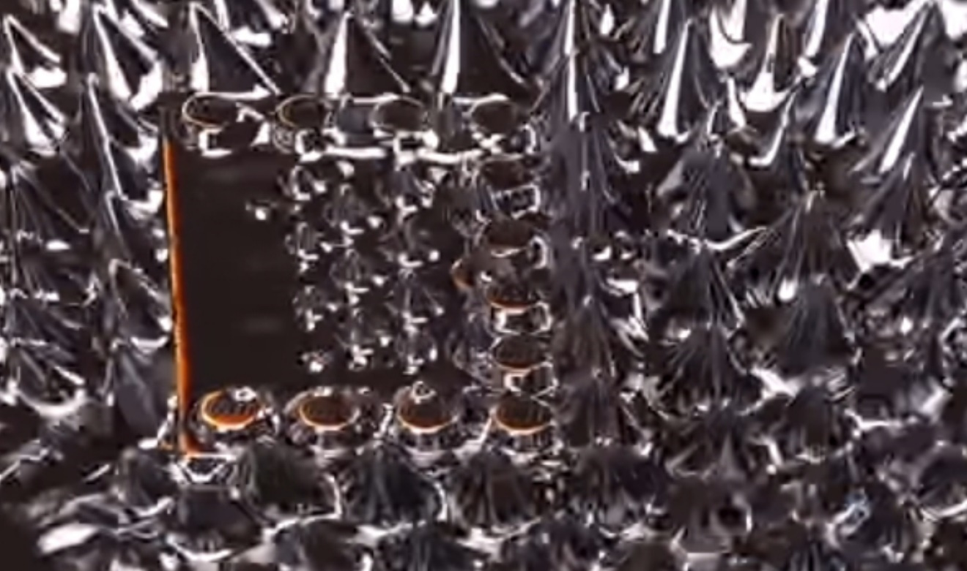
So, here you see that the spikes on this piece of plastic are significantly smaller than in other areas around of it. Of course, partly it might be because there is less ferrofluid on it. However, you can see that there still is some Ferrofluid on it that is doing nothing at all. So, in my view, it is a good indication that Magnetic Field could have been oppressed by this piece of plastic. Based on this we can also say that the so-called insulators of electricity actually are Anti-magnetic and are suppressing the Electromagnetism. But that can only lead to increased loss of energy especially over larger distances.
Electromagnetic energy, famously, also leads to increase of temperatures, which leads to increased activity of particles in the affected area and ends up with the expansion of these particles. We also know this effect as lower density. That is true either with Light or with electricity. And magnetism is another expression of Electromagnetic Phenomenon. So, the magnetic field of Earth would be attracting the substances of air (as they are magnetic) and providing them with a certain magnetic charge. But that would lead to two and opposite effects working at the same time – the Attraction leads to increased density, but magnetic charge leads to expansion of the affected magnetic substances and to reduced density. These two forces would find a perfect balance between them for the given conditions and lead to a certain density of air in the given place.
Now, since the Non-magnetic objects reject Magnetic Charge, they might be even affecting it in a direction of reducing it. As you can remember, I previously said that Non-magnetic substances might be actively Non-magnetic, meaning, they might be supressing the Magnetic Charge around them. But since the compression of air due to large masses of it being attracted by the magnetism of Earth is still present at all times, it might result in higher density of air around those bodies that are Anti-magnetic. It would be like a field of slightly denser air around these bodies caused by the Anti-magnetic energy of the given bodies compared to density of it elsewhere. Clearly, denser air would be sinking… And that might be the true reason for why all Non-magnetic substances are being attracted to Earth. As I said, they aren’t attracted by Magnetism, but they are attracted because of the effects created by Magnetism.
This hypothesis can be scientifically tested and would solve large number of problems with respect to this phenomenon of Gravity and answer all questions that are still baffling scientists.
Some of those questions are these:
- Why is Gravity such a weak force? (It isn’t even a force, as it is only an effect caused by Electromagnetic processes around us. This is similar to why shadow isn’t energy. After all, shadow is a side effect of energy of Light in areas where laws of physics cause the effect of Energy of Light to reduce. So, shadow is fully dependent on the existence of Light, and so might be Gravity fully dependent on the effects of Magnetism.)
- Why Gravity only attracts and never repels? (Actually, at least theoretically, this phenomenon can be used to cause the repulsion (in a different way than Magnetic Repulsion…) and even used to create a balanced and controlled hovering of Non-magnetic bodies at any chosen altitude. But that would be possible only when this phenomenon will be fully explored and understood.)
- What is the possible connection between Magnetism and Gravity if any? (Obviously, there is a connection between the two, as Gravity might be impossible without Magnetism.)
Let me explain the idea of Gravitation Attraction of Non-magnetic objects visually. First, let us remember how “anti-gravity of flames of fire” work… Famously, the heat from flames of fire expands the particles of air and, through this, it makes certain areas of air around the flames less dense. And that air is quickly being pushed upwards by other parts of air which are far denser. During this process flame is being dragged upwards with the flow of air moving upwards. This flaw is fairly strong and even lifts up some large pieces of ash and other small parts from the fire. For this reason, we can call it Anti-gravity Effect. It is important to recognise the fact that all those particles that are flying upwards are still being attracted and pulled back to Earth by the magnetic field of Earth at all times.
So, in short, my proposal is that Gravity is caused exactly because of the same mechanism as it is around the fire, only that it causes the flow of air to move in opposite direction. Namely, the air around physical substances is flowing downwards. (Deeper explanations and suggestions for experiments to test it will follow!)
Note! - Before we move any further it is important to mention that there are magnetic substances and there are non-magnetic substances. And magnetic substances are being attracted because of magnetism, while non-magnetic substances are attracted because of principles and mechanisms explained in this article.
So, if I am right and if particles of physical substances create around them a field with increased density, then this denser air would be moving downwards pulling along all items that cause this increased density around them. And, clearly, if I am right, there should be experiments that could prove it. So, I am putting forward two ideas for two different experiments that would help us test it and understand and, potentially, lead to solving of this dilemma of What is Gravity.
Interesting note! – During strong winds or at great speeds we have the feeling that we have become lighter. If my hypothesis is correct, it actually might turn out to be true, as the wind would keep blowing away the denser and downwards moving air around us and even change the direction of its flaw altogether making it easier for the wind to send us (anything, really) flying up in the air. This would be true if this possible anti-magnetic effect of non-magnetic substances would affect the air around the given bodies at similar speeds to how temperatures work. As we know, if a strong wind is blowing at a very hot oven, we wouldn’t feel heat coming from the oven as the wind would be blowing away most of this effect of heat. And something very similar might be happening with this Anti-magnetic Effect around our bodies, which would be (at least partly) blown away by strong winds. And the stronger the wind, the weaker the effect of Gravity. In other words, the stronger the wind the less weight we have making it easier for the same wind to make us fly in the air…
Next - Visual depiction of anti-gravity of flames and the possible actual Gravity of solid, Anti-magnetic objects/substances if it is caused by the flaw of air around of them in a certain direction.
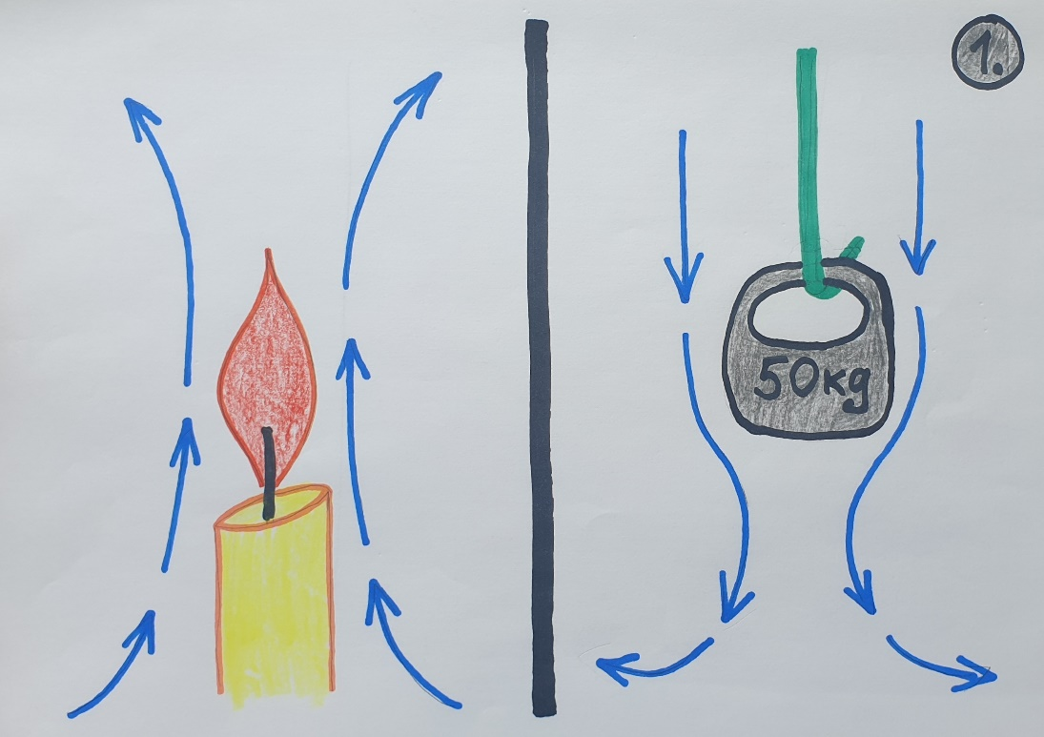
In this image I tried to depict the flows of air as they are/could be around flames and Non-magnetic bodies! There would be a certain vicinity at which effects from both bodies would be affecting the air around them. And the closer to the bodies, the stronger the given effect.
Interesting facts!
For those of us who are leaving our houses at least sometimes in order to explore the broader neighbourhood, we must have experienced this strange phenomenon when the smoke from the fire keeps coming at us. And not simply at us, but somehow at our head and even tends to wrap around it and stay there, as if trying to suffocate us. No matter where we go, the smoke will soon follow as if we are under some kind of a spell… Of course, this is only true within certain conditions.
Please, see the next image!
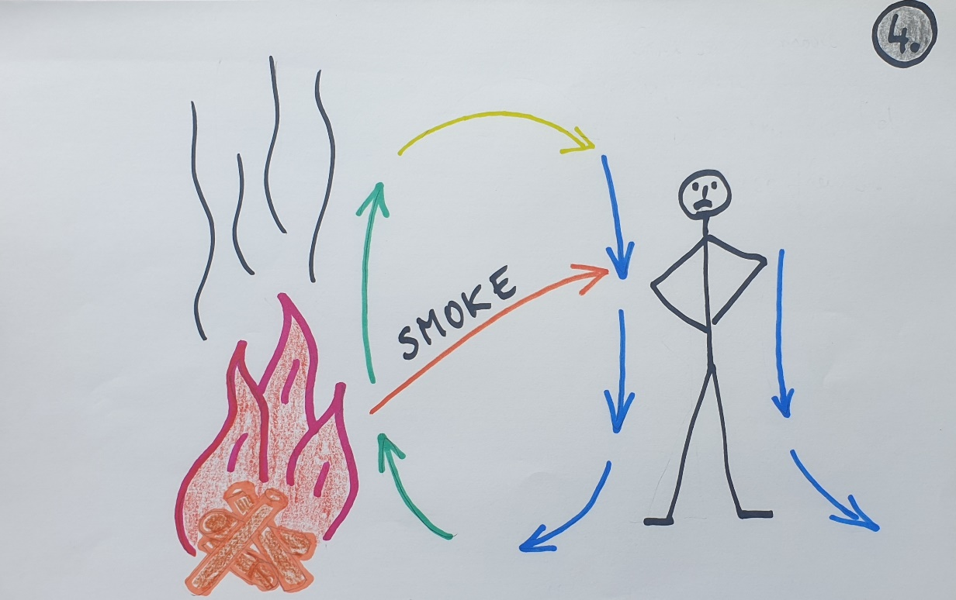
Of course, this only happens when the fire is small and low and there is a lot of smoke. Also, the wind should be very, very weak for this effect to work. And in this image, I tried to explain why I think it is happening and how my hypothesis of Gravity and the flows of air would explain this phenomenon.
So, if the fire is small and smoky, meaning – it doesn’t create too much heat, the smoke still would be hotter and would be rising upwards, even though slower than in case of a high heat. But the air around us still would be moving downwards as usual. If we are at a certain distance from such fire, both circulations of air would create a united flow of air as it is shown in this drawing. In real life though, because smoke still tends to go up but is slightly affected by the flow of air around us, which goes downwards, we end up observing a movement of smoke that appears to be coming directly from the fire at us, as the red arrow is showing.
And since the smoke tends to move upwards, but the air around us is moving downwards, sometimes the two speeds turn out to be very close. So, we end up with all that smoke having reached us, our heads mainly, and, as if, wrap around our heads and bodies… I have experienced it first hand and been annoyed with this effect myself. No matter where you go, the smoke would be following you in few seconds. So annoying… It only happens at a distance at which you can get some heat from fire. If you move further, the smoke stops bothering you, but you also lose the warmth of the fire… The solution is in larger and/or hotter fire. Then the heat takes the smoke up and far way very quickly and it doesn’t come back.
Another effect of denser air flow caused by the Effect of Gravity can be observed in houses which use local fireplace for heating. Once again, I have experienced this first hand. Unfortunately, it is hard to prove that in this case it is caused by Non-magnetic objects causing lower density and, therefore, a certain air flow, as different temperatures are involved in this case too. But temperatures alone cannot explain everything here.
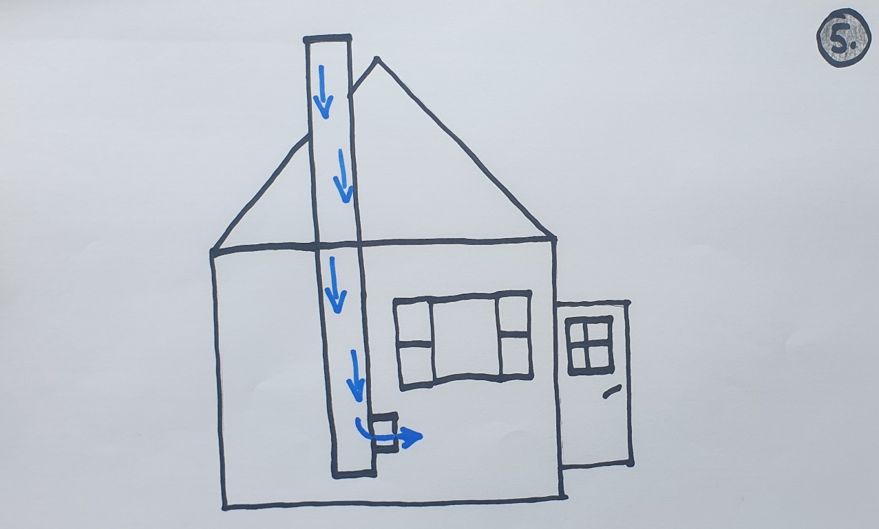
So, what could be happening! When you are trying to start a fire in the fireplace in the house, especially in summer, you might end up with your house being filled with smoke as the smoke is refusing to go out through the chimney. The biggest mistake people are making is to keep the doors or windows open when trying to start the fire exactly because of the smoke coming into the room. As it turns out, keeping anything open causes most of the smoke ending up inside the room.
Chimney is made of heavy substances. Namely, of clay bricks. If my hypothesis is correct, then they must have a strong Anti-magnetic effect resulting in denser air close to it and ending up with air flow that is coming down the chimney and inside the room. Lower temperatures in the chimney, which would also result in higher density, do not explain why this problem with smoke in the room is nearly completely fixed when all the windows and doors are fully closed. After all, when that is done, the whole room ends up being filled with denser air from the chimney, and the flow of air downwards reduces to minimum or, maybe, even stops. It is at this point when you can start your fire as even slightly higher temperatures of freshly started fire will cause the air flow to move out through the only opening left – through the chimney. Some smoke, at first, still will end up in the room. But nothing compared to how it was with the doors or windows open.
If the flow of air were only down to temperatures, then open doors would cause the air flow through the chimney which would heat the chimney up with the hotter air from outside and, eventually, balance the temperatures out and stop the flow of air. But that isn’t happening. The temperatures there stay cooler. It can be explained with the air being denser near Non-magnetic bodies, as denser air always has lower temperatures too. Think about the compressed nitrogen. The more it is compressed, the colder it gets. And our atmosphere mainly (over 70% in fact) consists of nitrogen…
So, what tests would prove that Gravity is caused by lesser density caused by anti-magnetic energy of things? I have several proposals to test this idea.
First of all, the one that I am going to show you first is the experiment of a lesser importance. Secondly, it would be very sensitive to many other effects, so the room in which the experiment would be carried out should be fairly large and undisturbed. Also, the movements of air flows should be carefully explored before the actual experiment takes place and before the given items are brought into the room, which should be large in order to avoid effects from walls and free from any other physical bodies, including the ones of the examiner. Nowadays we have some great cameras to do the observations from afar anyway.
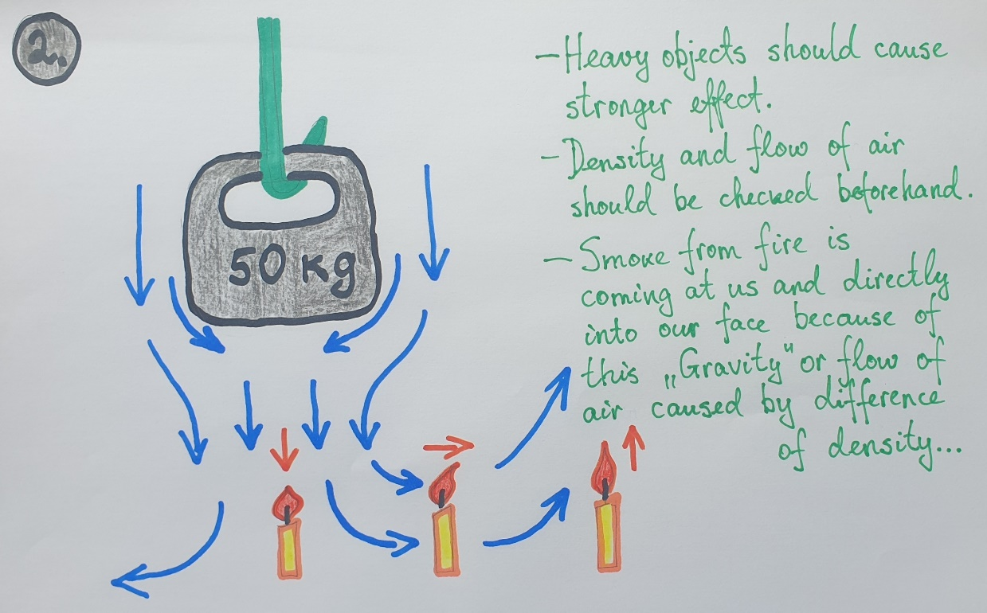
For the experiment we should use some objects that have heavy mass. Ideally, those would be Non-magnetic objects. The idea is that heavy objects are heavy because they are causing higher density around of them. But that should result in stronger air flows as well, which would be easier to spot in tests.
In this experiment we would be using a heavy item that is hang to the ceiling somewhere at the middle of a large room, like a sports hall. We would be examining the flame of the candle at different places from the item we are examining. The candles should be used one by one, not all at once, as their individual air flows could affect each other. Also, the distance between the candle and objects should be carefully established in order to avoid wrong side effects. For instance, if the candle that is under the object is too close, its flame might be affected by the closeness of the observed object as the air flow created by it would be hitting the bottom of the object. Probably, the aerodynamic shape of the observed object might be important too… Namely, it might be made in the form of a cone at the bottom, so that the flow of air around the flame is not affected by the shape of the observed object.
In short, the flame of the candle somewhere under this object in question would be slightly shorter and, possibly, broader compared to it without an object above it.
The flame of the second candle (the one at the middle in this drawing) could tend to point sideways and away from the object, if the object is causing the air flow that I think it would.
The third flame would be farther away from the object in question and have the longest and narrowest flame of the three as it wouldn’t be affected by air flows from the object.
Clearly, as interesting as this experiment is, it still might be inconclusive to prove the point. For this reason, we can use other experiments to test this hypothesis of mine. But for these experiments we would need some sensitive instruments of other facilities to measure it.
Before me move on to this idea of another experiment, I would like to explain a few things about how this possible Anti-magnetism would be affecting the substance around the given object by creating a certain field of them and leading to the “Gravity Effect”. Also, I would like to explain that the flow of air around these bodies might be very slow actually.
So, Magnetism moves at the speed of Light. That is an established fact as these two are one or another side of the same phenomenon. That means this - the same must be true with Anti-magnetic Effect. Namely, Anti-magnetic impact also must be moving at the Speed of Light. Also, it could be that this field is descending very slowly actually, as it could be as if attached to our bodies in a way. That would mean that even if we would be moving downwards exactly because of the mechanics of descending air around us, it still would be that we and the field around us, to certain extent, are working like a united system. Namely, we simply would be right at the middle of this field and would be moving downwards along with it, as part of it. That would make it difficult to measure its movement.
And even though the Anti-Magnetic Effect would be as fast as the Speed of Light, it still would need a longer time to reach full effect of maximum density. That would be similar to how source of light affects substances surrounding it (at a certain distance) by heating them up. The effect of temperature isn’t near-to-instant even though the initial effect of Light itself is. And the same could be true with the Anti-magnetic Effect. It might start to work nearly instantly, but the full effect is reached with slight delay. This would perfectly explain why during strong winds or when on a fast-moving bike we feel lighter. Possibly, we become lighter in literal sense of this concept simply because the density and the direction of the air around us is partly replaced by atmospheric density (which is lower) in one or another way.
Now, let us take a look at the image that is meant to explain visually the higher density around Anti-magnetic bodies of different sizes at certain distance or field from them.

Image
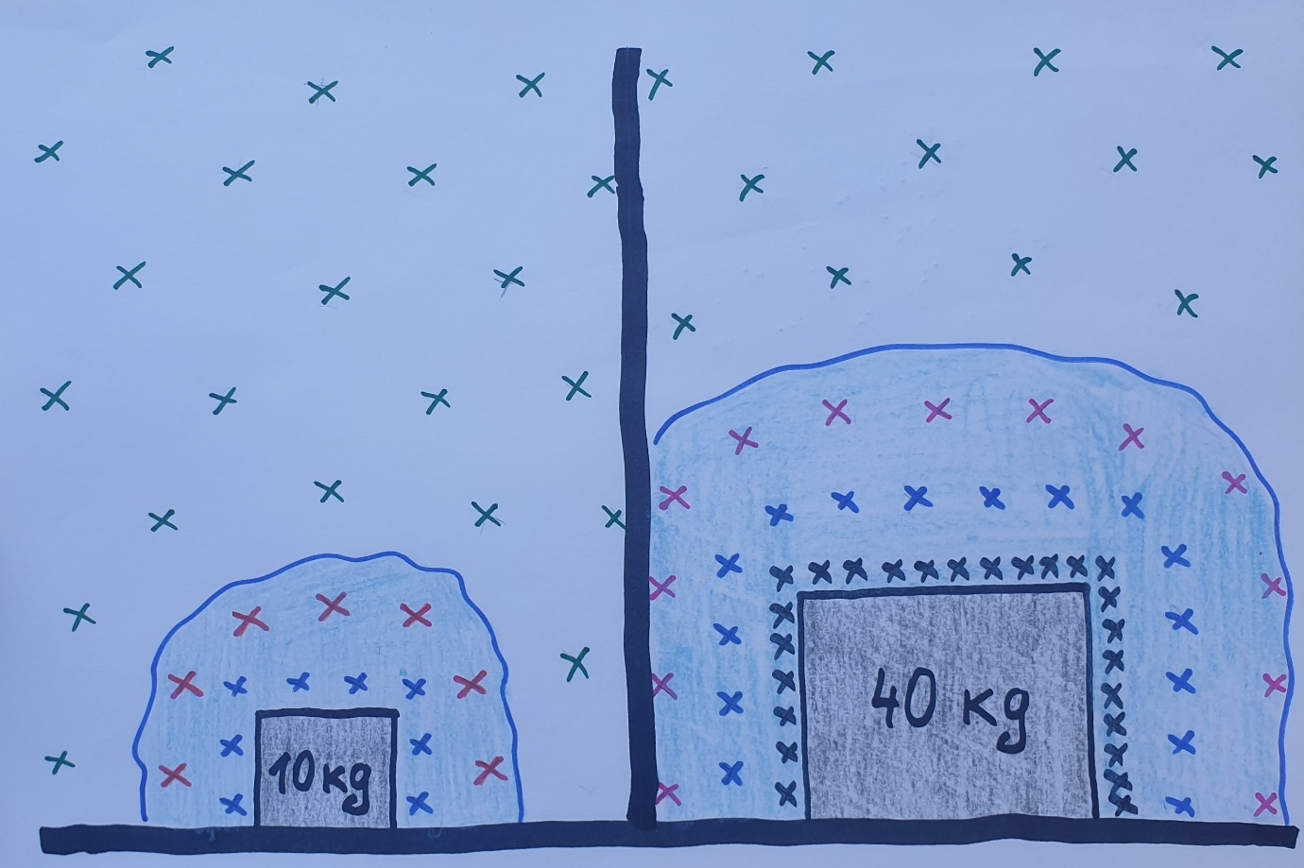

In this image I tried to depict how I imagine the field of higher density surrounding bodies. The crosses are meant to depict the particles. So, the closer are the crosses to each other, the higher density they depict. Also, I tried to show that density levels change with the distance from the body.
As you can see, the field around the larger object (and both these objects are meant to represent the same material) not only is larger, but also much denser right next to it. But the denser the substance is, the faster and stronger it is descending. And, as I have said it previously, this field could be descending together with the object as one system, as one object.
It could be that the level of density might have a certain limit after which it cannot become higher. However, the size of the field created by the given object still would be growing if the object becomes larger, providing what we call weight or Gravity to become larger too and directly because of these mechanisms.
Next suggestions for further experiments.
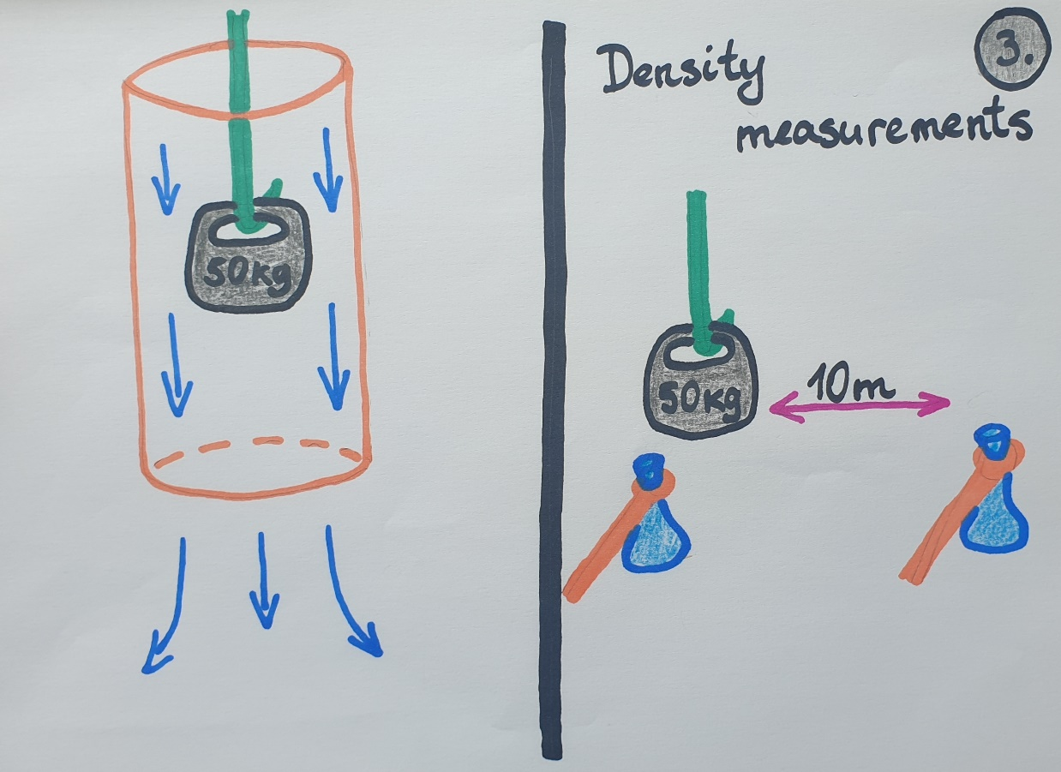
On the left side of this drawing, you can see a heavy object around which a plastic cylinder with open ends has been put. Possibly, this could result in improved air flow that could be measured better than in previous examples. There should be some instruments or ways that can be used to detect even very weak movements of air. In this case the effect of air flow would be similar to how it works inside the chimney, only that here it would be caused by a heavy body at the middle of the cylinder. Another difference would be that here there is no effect caused by the difference of temperatures between outside and inside of the cylinder. So, if it still causes a measurable flow of air, it will prove the point. But, as I said, the flow might be very weak. But, in case it cannot be measured, I am suggesting the next experiment.
On the right side of this drawing, I tried to depict the possible measurement of density. Once again, the experiment would be carried out in a large hall in order to avoid some false readings. For this we would need some very sensitive devices on sticks which can be used to detect the density of air at the given place. Another way to test the density would be as follows - If we can make some small containers from a very elastic plastic, and if we have some remotely controlled systems to close these containers remotely, then we could take the same amount of air example from certain areas and seal them. After that, we could put both of these bags into a strong vacuum chamber and pump all the air out of it.
The idea is this – in one of these elastic bags the air would be denser. In normal conditions the difference between the two bags wouldn’t be visible. But in vacuum chamber the one with even slightly higher density would expand visibly more than the other. And, in this way, we could establish whether there is higher density around Non-magnetic/Anti-magnetic objects or not. Clearly, the higher density should be right under the observed object.
Interesting fact! – When we are descending in the lift, at the first moment we feel as if we have lost our weight. But that normalises very quickly, and we feel as heavy as normal apart from that very last moment when the lift is stopping, as then we feel slightly heavier. Of course, some of the modern lifts are so efficient at starting and ending the movement that we no longer feel anything…
If I am correct about the Gravity being caused by the flow which is caused by the denser air around us, then this experience of us being lighter for a short moment at the beginning of downward moving lift with consequent stabilization of the feeling of weight would explain it just perfectly. After all, when the lift starts to move, the air follows with a slight dely. And that means, for a brief moment the density of air moves upwards from the bottom to top. Clearly, that would have affected the flow of air around us that would be moving downwards and make us feel lighter. Later, however, the air would catch up with the direction and speed of the lift and all processes would go back to normal inside the lift despite it moving downwards, as the inside of the lift would become like a separated unit from the broader system.
In the current understanding of Gravity this shouldn’t be the case. With the current understanding of Gravity, we should be experiencing the lesser weight all the way down inside of the lift. And the idea of Gravity as acceleration would change little to nothing with respect to this feel of lighter weight.
Also, after considering all things said here, I recently tried to stand with my bare hands stretched sideways. Trust me, you can really feel the air moving from above downwards like a very light wind. And even though it cannot be used as a proof for anything, I recommend everyone to try it out by themselves.
Another interesting thing to consider with this hypothesis for Gravity is about how planes fly. Of course, there are those aerodynamic properties and everything that cause the lift. At the same time, moving fast through the air reduces the effect of downward pull too, making it lighter and easier for it to go upwards and stay there. Possibly, even the so-called turbulence or air-holes when the plane seems to be suddenly falling might be caused by different directions of atmosphere. If the atmosphere moves in the same direction as does the plane, and, possibly, at similar speed to it, then the downward pull of Gravity Effect returns, and the plane instantly starts to fall even though for a short while. But falling itself cancels the Effect of Gravity, so, everything goes back to normal right after.
As you can see, I no longer use the concept Gravity, but have replaced it with the Gravity Effect instead…
Before we move on to the question about the true essence of Vacuum, I would like to suggest one more experiment that could prove that my theory is indeed correct. It is experiment with a heavy object in a water. Famously, everything feels lighter in the water. Scientists have dismissed the chance that things indeed become less heavy in the water, as that only appears to be true according to them. I haven’t seen any experimental evidence for that though… However, if I am right with my hypothesis about what causes the Effect of Gravity, and that being because of higher density, and water is famously much less elastic than air is, then all things indeed in water might become less heavy as they aren’t pulled downwards that strong anymore. And there is a simple and easy to perform idea of an experiment to confirm just that or prove the opposite. Please, see the next image.
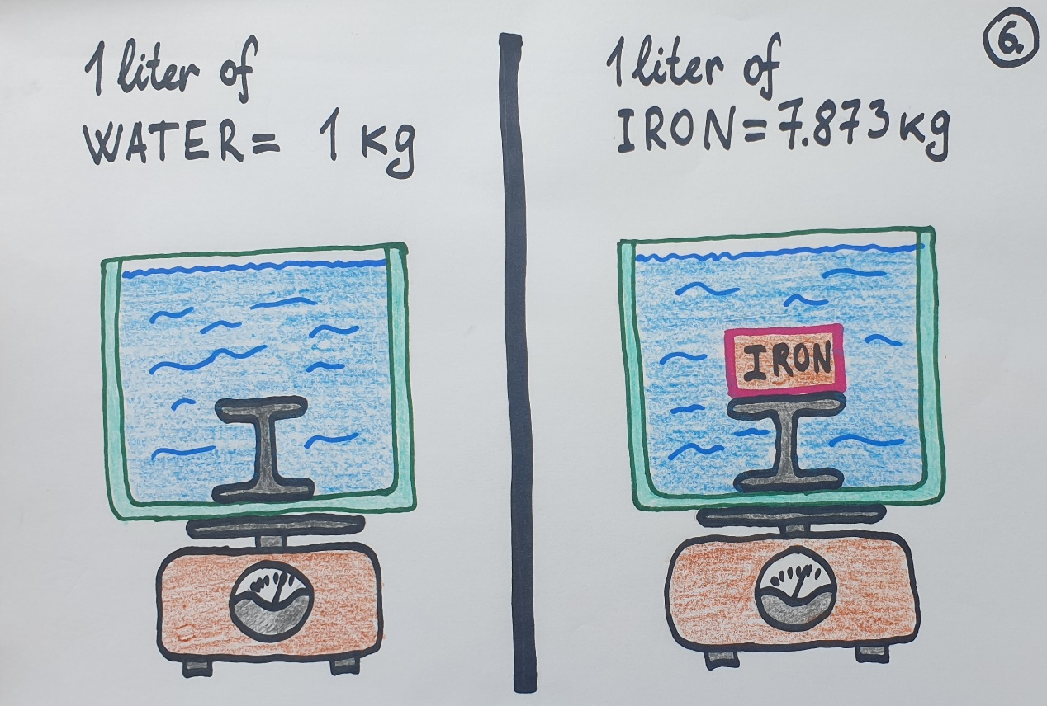
The core idea of such experiment is very simple. On the left side you see a tank of water. It should be fairly large for better results. On the right side you see the same tank of water, but this time one litre of water has been replaced by one litre of iron. One litre of water weighs 1 kilogram. One litre of iron weighs 7.9 kilograms. So, if these volumes were swapped in the second situation, then the total weight on the scales should be 7.9 kg (of iron) minus 1 kg (of water), if the currently accepted ideas are correct. That would mean that in total the second result should be 6.9 kg heavier compared to the first one. On the other hand, if I am correct, it might be significantly lighter, at least in certain conditions. How much I cannot tell. But it should be clear that the total weight might be smaller than it should be by simply adding or subtracting these two. There is a chance though that even if I am right about the Gravity, the iron in water still might give its Anti-magnetic Energy to water and result in total weight that would be exactly of fairly close to 6.9 kg. Unfortunately, in experiments that I carried out to test it, the weights combined and didn’t cause any discrepancies. Reasons for that and what conditions could still change that I am providing slightly later in this article.
Note! – It is interesting that scientists have measured the change of weight of heavy objects in water only in one way. They were weighing only the item itself by using “luggage-scales” with weight hanging from them. Such experiment doesn’t give you even a hint that the total weight of water and item might not add up to the same when they are calculated separately. To the best of my knowledge, I can say that nobody so far has measured the impact of water on heavy things in the way shown in my experiment in previous image.
When talking about the properties of water (with respect to Gravity) we have to keep in mind that water consists of two Hydrogen atoms and one Oxygen atom. We write them as H₂O. As it turns out, two Hydrogen atoms together are diamagnetic (Anti-magnetic in scope of this article, as it is repelled by magnetism), while Oxygen is paramagnetic or attracted by Magnets. So, it might be that Hydrogen (in the molecule of water) makes its Oxygen atom more compressed (a.k.a. denser), and that leads to water molecule being heavier than air and able to push it out, making it move upwards.
About my experiment with objects in water that showed that the total mass of object and water sum up and stay the same as they were when weighed and summed up separately and why it still doesn’t disprove my theory.
So, I decided to test my theory in practice. I took ordinary kitchen scales, a small bolt, and a jar of water. I weighed the bolt and jar separately, and right after that I weighed them with the bolt being submerged in the water. But let the images speak for themselves.
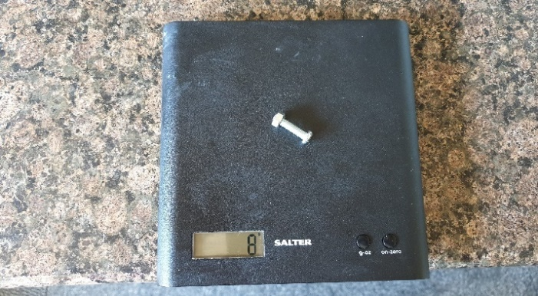
The weight of the bolt with a nut turned out to be 8 grams or 0.008 kg.
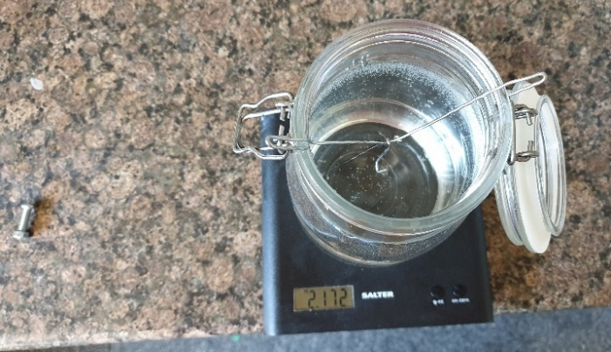
The weight of the jar of water and a wire inside of it turned out to be 2.172 kg. That means, this jar together with that bolt, when weighed separately, would be 2.180 kg.
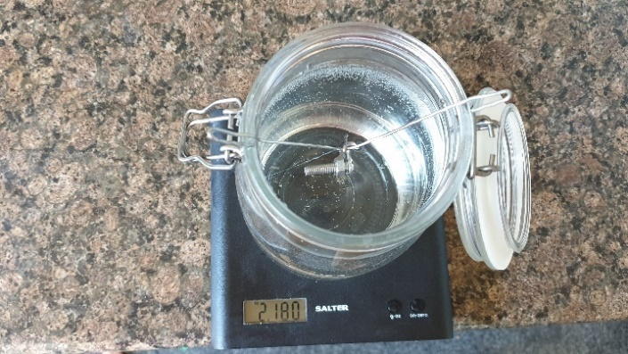
And, together with the bolt submerged at the middle of the water the total weight was indeed 2.180 kg. So, that (kind of) proves, that water doesn’t make things lighter, right?! Turns out, there still is a room for my claim as these results still can be explained in a different way. Firstly, the effect of weight loss at this scale might be too small to be measurable with smallest units being full grams. Secondly, possibly, the layer of water around the bolt should be larger to have a measurable effect.
Right now, I would like you to look at the next image in which I tried to explain the possible process leading to the failure of this experiment.
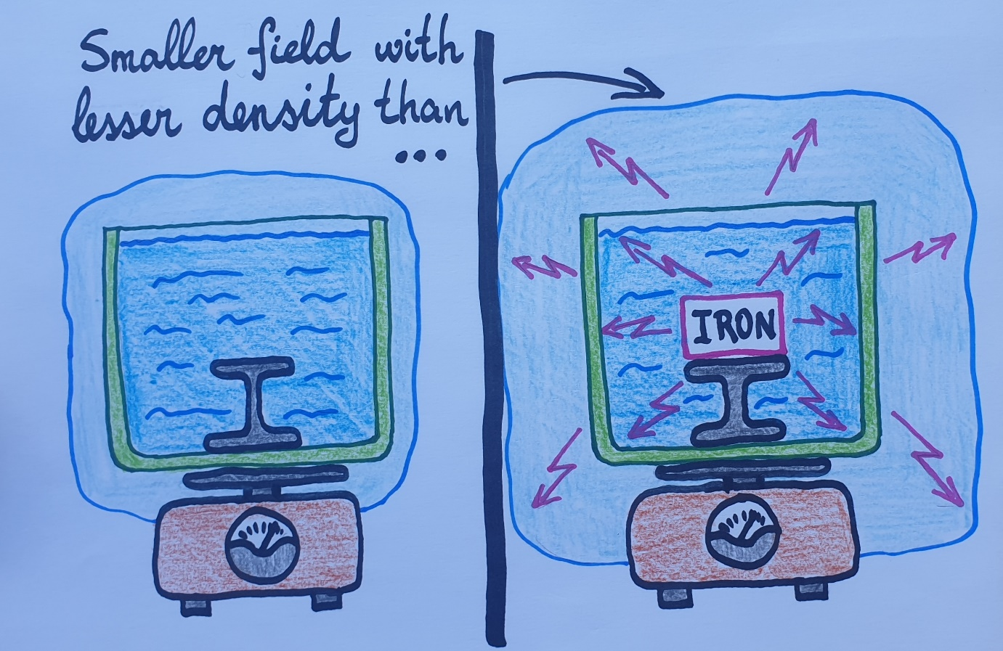
So, here in this image you can see depicted a field around the water tank when there is only water inside of it. Within the borders of this field the air would be denser. The second image shows the same tank of water but with the piece of iron right at the middle of it. The total volume of substances there in the tank is the same as in previous one, as the water that would match the volume of iron has been taken out of it. So, this piece of iron might be affecting the water by transferring its Anti-magnetic charge to the water, making it possess a stronger Anti-magnetic energy in general. But that would result in a larger field created around the tank and this field would be denser at closer distance to the tank. It all could be resulting in total weight of both substances being identical or close to the sum of their weights summed up when weighed separately.
As I said, this problem, if everything works indeed as described here, would be eliminated if there was a much larger layer of water all around the object in the water. The thing is - water is very inelastic. So, all Electromagnetic effects imposed on it (compared to how it would be in atmosphere) would decrease faster with the distance from the source increasing. In this case, the bolt would be the source of Anti-magnetic Effect.
When I was testing magnets, I learned that magnetic field of even small neodymium magnets stretches more than 25 to 30 centimetres from them. Next images confirm that. So, it might be that the same is true with Anti-magnetic Effect. Of course, those 30 centimetres apply to our air. In water this distance would be shorter. But even with that in mind we have to admit that in my experiment the depth of the layer of water around the bolt was only few centimetres in all directions. And the bolt itself was some 10 times larger than those magnets I was experimenting with. So, we definitely cannot exclude the possibility that it was the bolt that affected the strength of Anti-magnetism of water itself and led to a total weight of water and bolt (when the bolt was in the water) to appear as not having lost any weight at all.
Here the compass points to the Earth’s Northern Pole or to its Magnetic South.
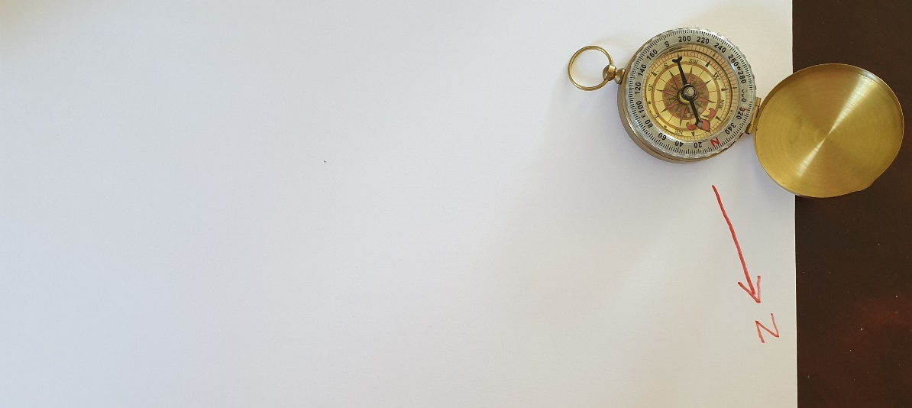
In the next image you can see how a small magnet starts to pull the needle of compass towards itself when the distance between the compass and magnet is around 25 cm. It still is competing with Earth’s magnetic field.
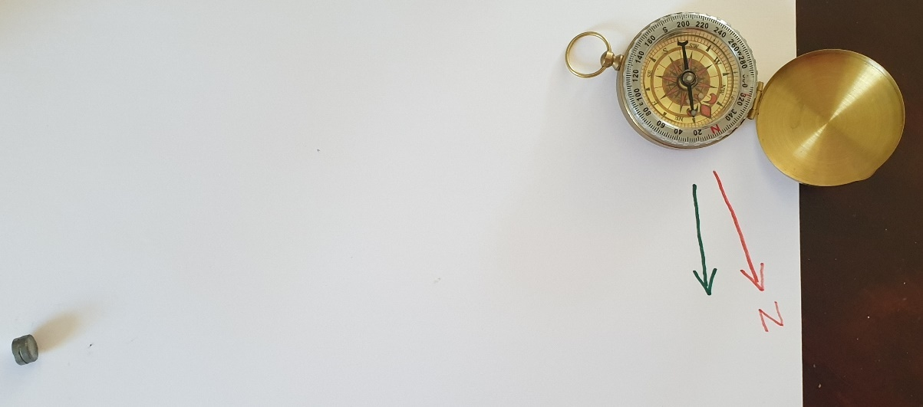
So, both magnetic fields here are trying to attract the needle of compass and at these distances from the sources of magnetism they both are exercising a similar force on it. Possibly, this magnet is having effect on the compass at twice the distance than it is now. It can be tested in space, where magnetic field of Earth is much weaker. Here the magnetic energy of magnet is too week to compete with the strength of Earth’s magnetic field at distances larger than 25 centimetres. Nevertheless, the effect from it still will be reaching the compass. And the same or something very similar would be with Anti-magnetic force.
Why are objects lighter in water to start with?
We are being told that this is because of buoyancy and the Gravitational Weight of the object. If, however, my theory is correct, this happens because water is less dense, and it has higher viscosity/thickness. Water, famously, is nearly non-elastic. For this reason, any Anti-magnetic Effects would make a very slim impact on it. That means, the difference of densities between areas surrounding the object compared to the rest of the water would be much smaller than they are in air. The higher viscosity of water would only affect the speed of downward movement, not the weight as such. For this reason, we can fairly confidently state that items indeed become lighter in water. Now all we have to do is to confirm that experimentally. And one experiment, as you saw it, already failed to prove it.
And with that in mind we can move on to the “Problem of Vacuum”!
What about the problem of Vacuum?!
On thing that would appear to be controversial in this story is caused by what I call the ”Problem of Vacuum”. At this moment our science strictly believes that Vacuum is substances-free areas. And that would mean that Gravity (as it is described in my hypothesis) would be impossible in conditions of Vacuum as there are no particles of substances to interact with. Clearly, the same problem would be true with Magnetism. For this reason, I have come up with idea for another experiment to test the true essence of Vacuum.
The following is a very simple experiment with a bottle that is fully filled with a liquid. Results of this experiment have been always violating everything we currently think about the true nature of Vacuum… But nobody is paying a due attention to this dilemma.
To understand the problem, I encourage everyone to carry out by themselves this experiment with a bottle fully filled with a liquid and then with only air in it. What one has to to do is this: we have to put the opening of the bottle to our lips so tightly that air isn’t getting inside of it at all. Then we can start the experiment by trying to suck the water out of the bottle still not allowing the air inside. Trust me, you will fail as only a tiny bit of water will get out. And the more you will have managed to suck anything out, the stronger one force will be sucking it back in. And, if there is no air in the bottle at all, then you will get out no more than few droplets.
According to currently accepted theories, this happens because our atmosphere is under a huge pressure as absolutely nothing is holding that water inside from inside. The problem, however, is in the fact that there is a Vacuum in our mouth at the moment of experiment, and that Vacuum is growing as we keep trying to suck the water out from the upside-down bottle. Inner part of our mouth has no access to the air of atmosphere at this moment of experiment.
While doing this experiment with only air inside of the bottle we will succeed for a certain time as something will appear to be coming out. Water will be refusing to come out at all. As I said, this is due to different properties of these two substances. One is very elastic, and the other is opposite of what one would call elastic. So, the more air will be sucked out, the stronger will be the pull back. One can also try out this experiment with an ordinary glass. He will end up with his lips being sucked inside of it quite aggressively. Since the pressure of air has no access to inside area of this glass, then, according to current understanding, we are supposed to believe that nothing is pulling it back inside of these containers. But that is complete opposite of what we experience. So, the only thing that would explain the observations of this experiment is the possibility that it is our lips that are desperately trying to squeeze inside the glass filled with Vacuum and expand there with terrible force… And the bigger Vacuum we create in the given container, the more our lips want to explode inside of it… But it doesn’t even make any sense. It is as if saying that our bodies are desperately trying to swell and even blow up, and the only thing that keeps us intact is an enormous atmospheric pressure. But that is insane. There is nothing scientific in these claims. In my view, this small experiment alone should be enough to start questioning our current understanding of Vacuum, but nobody in science community seems to have a desire to challenge the existing theories, as if these theories should be protected as some kind of religious creeds.
Since nobody has been willing to look at this dilemma scientifically and explore it deeper (apart from me), I have a proposal for a ‘cosmic experiment’ that will settle the argument beyond any doubt. But before we move to that, let me explain how I see what the true nature of Vacuum is, as that is what my experiment is going to prove.
In my hypothesis, there is no such thing as substance-free areas as that is physically impossible. After all, such emptiness is as good as stating that there is absolutely nothing that exists physically in the given place. Science cannot even describe such state as that is the same as Nothing or Nothingness. And Nothingness has all the properties of things that don’t even exist. Nothingness cannot be described as it doesn’t have any properties. To say that somewhere is Nothing is to say that that place doesn’t exist.
Instead, it is more likely that Vacuum is where particles of the given liquid substances are in full touch with each other and with all other items they are in touch with, they are highly stretched and, also, they fully fill the given area. When the air is being sucked out of a container, then the container is simply left with highly stretched and extremely scattered particles in it. And this causes the opposite process of what we observe when we are compressing things. The stronger we compress them, the stronger they push back. So, when we expand things, and creating Vacuum is simply expanding or stretching the given substance in the given compartment, then this substance starts to pull back. The more we expand it (the stronger Vacuum we create), the stronger it pulls back. That would perfectly explain the collapse of all those huge railroad tanks when strong Vacuum is created inside of them. And that would also perfectly explain why the water isn’t coming out of the bottle even if there is a Vacuum between the bottle and atmosphere (in our mouth). You will also never pump out water from the bottom of any large container even with the strongest Vacuum pumps, if you will not let the air inside. That completely contradicts the existing theories, and I have an idea of how to test it with a very simple experiment that can only be carried out in Space. The reason for that is that Vacuum in Space is said to be around 10 times stronger than the best we can achieve on Earth.
Please, see the next image which shows how I imagine Vacuum.
Here you see what Vacuum actually might be. This would solve many problems in science, first of which would be the return of the medium for Light, Magnetism and Gravity. But not only those problems would be solved. Also, one can perfectly explain everything we know about Vacuum if it is as described in this theory of mine, including and especially the lack of sound in it. A fully filled with a substance space doesn’t mean the sound is possible. There are other conditions for the sound to travel.
So, here in this next drawing you can see two containers. One is meant to have the same density of air as it is outside in atmosphere. The other shows Vacuum inside of the container. Since Water isn’t elastic, it stays where it is at both stages of experiment. The air, on the other hand, has extremely low density in the second stage and yet its particles are in full contact with each other and with everything around them leaving no place that would be empty. And they are pulling back inwards with a great force.
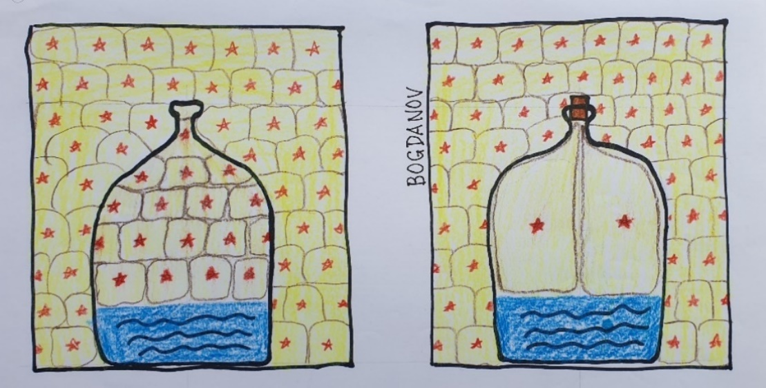
Now let us move to the experiment that would prove that Substance—free areas are impossible and do not exist to start with. Please, take a look at the next images.

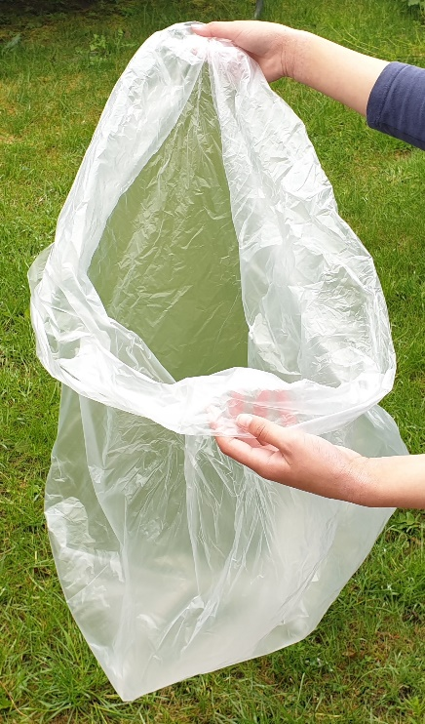 | 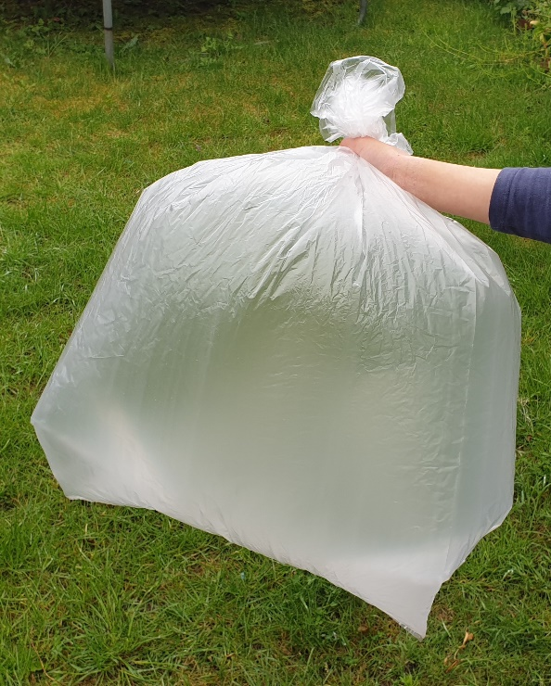

These images show a bag that has been closed right after it was fully opened. As you can see, it feels full and there is a good reason for that. Now, according to science, nothing of this is possible in Vacuum, especially in the Vacuum of Space. According to contemporary science, if you will try to repeat in Space what these images show, then you will fail to see a full bag, as there are no substances in Space. In fact, science claims that this bag will fully collapse. Yet, when challenged with this simple experiment, all scientists turn around. We live in sad times for curiosity…
Clearly, this is a very simple and yet, very decisive experiment which would make it abundantly clear that one of the hypotheses meant to explain the true nature of Vacuum is true while the other would instantly be false.
I strongly believe that substances-free space is impossible. Unfortunately, I cannot go to Space and carry out this experiment by myself. So, my prediction for this experiment is that if you close a bag in Space in the same manner, it also will feel fully full. Not partly, but fully full.
The reason for that is as I already described but let us look at the idea one more time.
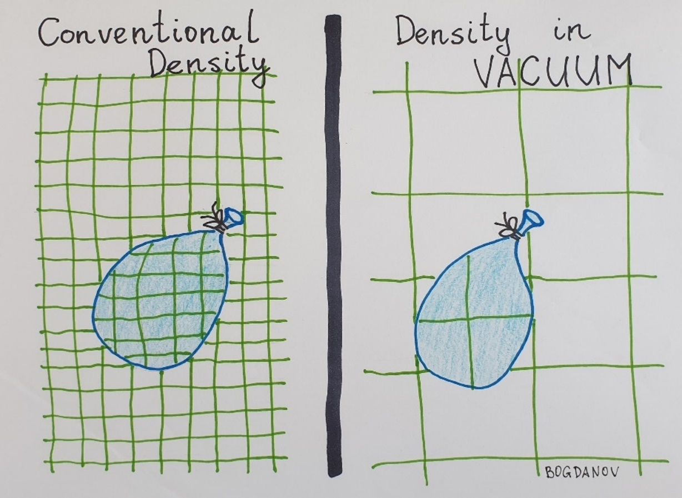
Since there is always the same density all around the given area, and all particles of the surrounding area are always in full contact with each other and with everything else they come in contact with, then they will make the bag feel fully full in any Vacuum.
The implications of discovery of the true essence of Vacuum would be enormous. I already said that it would allow us to revisit our ideas about what is and how works Light, Magnetism, Gravity. We could easily describe Black Holes and why all dependent Cosmic Objects are floating around their hosts at their Equator and nowhere else… Such Vacuum would forbid the Expansion of the Universe as well. We could easily explain the mystery of the Double Slit Experiment… So, yes, this could be a small revolution in science, and for that reason I strongly believe that we have to carry out this experiment in the name of science. And even if my hypothesis is wrong (which I don’t believe is possible), it still would give something to science as failed results are also results that can be used somewhere. After all, that would take of the table my hypothesis about the Vacuum altogether.
Obviously, this is a very simple and cheap to do experiment. In my view, it is very important to keep challenging ourselves with everything in science. After all, this is how science is meant to work.
Now a bit about the so-called Anti-gravity.
From what you should have learned so far in this article, it should be clear that phenomenon which we call Gravity is caused either by Magnetism, if the given substance is magnetic, or by a denser air around the physical objects caused by Anti-magnetism, or by both. But in that case the Anti-gravity would be caused by an opposite mechanism. Namely, it would be caused by a lesser density around the given object. The problems is, however, how to achieve that. And even though it seems near too impossible right now, it will be figured out at some point in the future. I myself have plans to work on it too.
A lesser density would cause the possible large objects float in the air in the same way as ships or submarines do in the water. The only difference would be that with ships the lesser density is on the inside of the ship, while on Anti-gravity ships it would be on the outside of them. And humans would be steering these Anti-gravity ships by using magnetic fields generated inside of their hovering ships.
As I said, many things that seemed impossible some time ago, like flying, one day became reality. The only thing that stops us from achieving it is in our own approach to things, our denial of facts and refusal to carry out tests that would challenge some long-established theories about quite a few things. And Anti-gravity can only be done if my theory about the Effect of Gravity is correct. It is impossible with Einstein’s description of it.
What importance discovery of true causes of Gravity and true essence of Vacuum would have for the science in general!
Antigravity is only one and right now the most obvious thing that could be worked at, achieved and made useful for humankind if anything about Gravity and Vacuum as described in this article is correct. Some of the other topics that would be affected and perfectly explainable within the existing Laws of Physics are as follows: Dark Matter, Dark Energy, Black Holes, nature and essence of Light, Double Slit Experiment, Big Bang theory, Newton’s Laws of Gravitation, and many, many other things.
It truly would be the new revolution in science that starts another Golden Age of it, if only science officials were interested to unlock this by exploring this hypothesis. In reality though, it seems that science officials are the ones that put-on brakes any attempts of true facts to come out. This happened to my theory about the true Pattern of Magnetic Field too. Despite multiple solid facts, direct and indirect, no scientist is interested in these facts. And no scientist has ever challenged my claims let alone proven them wrong. When I presented those facts, all I received back was a complete silence. The great Michael Faraday would be ashamed of this. Contemporary scientists are so absorbed with exploring incredibly mysterious and impractical things that would have no practical use whatsoever, even if they were right, that they have completely abandoned simple and down-to Earth research of things that are still heavily underexplored, like Magnetism, Gravity and Vacuum. And here I am providing very interesting and undeniable facts, and not a single scientist seems to be interested. It is as if the spirit of Faraday (the true spirit of science) is dead in science communities…

So, how these questions would affect the science?! They would give a completely new perspective to the following topics! And the list of topics affected doesn’t stop with these ones…
Dark Matter and Newton’s Lows of Gravity.
These are based on assumption that Gravity, even though in somewhat mysterious way, is caused by a mere mass of the given object which would be bending the Space-Time Fabric and Magnetism has no role between any of these objects or in the mechanisms causing the Effect of Gravity. And idea of Dark Matter is based on and derives from just this understanding of what is and how works Gravity according to Einstein’s interpretation. If, however, my hypothesis is correct, then the Effect of Gravity and relationships between Cosmic Objects, which all appear to have Magnetic Fields around them, would be caused by completely different mechanisms. So, it would change our approach to both of these ideas and interstellar relationships too. But in that case, we would have a good reason to abandon this idea of Gravity being caused by a mass of a body simply bending Space-Time Fabric, regardless of whether this fabric even exists or not, and the question of the Dark Matter would be off the table for good. That would free loads of financial and intellectual resources and make them available for research of down-to-Earth questions.
Dark Energy and the Big Bang theory.
Both of them are based on the idea that the Universe has been expanding. If, however, I am correct, all things are connected through certain substances (like tied up with strings…), and they can only stretch for a certain amount. Namely, eternal expansion would be impossible. And that, clearly, would end the idea of Dark Energy and Big Bang theory instantly as it would be impossible for the Universe to expand beyond a certain level. And yes, there is already another explanation that would and already can explain the Redshift, and there are even reasonably good indications that this idea might be the correct one instead. All it needed is the medium for Light to propagate which would be provided by proving that substance-free Vacuum doesn’t exist and is impossible altogether.
Nature and essence of Light, Black Holes and the Double Slit Experiment.
All of the above-named concepts in their current form emerged from the idea that Vacuum is a substance-free Space. If, however, my theory is correct, then any Vacuum is instead fully filled with certain liquid substances and particles of them are in full contact with each other at all times. And, in my article, I provided an idea for a simple and effective experiment to test it. But, if I am right, that would mean that Light, Magnetism, Information and Gravity have a medium through which they propagate forward, which I believe is the case. For that reason, there would never be any non-local interactions ever… With that in mind explaining the above-mentioned observations is a very simple thing to do. For instance - if Light is simply like an increase of energy of some kind, then it forces the particles that it propagates through to expand. But particles of any substance would have a resistance. So, while the energy is trying to expand them, they themselves will be trying to pull back inwards. It creates a fight between two of these forces where they each take upper hand or lose it at certain moments. And that creates phenomenon which we call ‘waves’… Waves are only possible in a substance. Of course, explaining Black Holes and Double Slit Experiment need a more elaborated explanation which is not a goal of this article.
As you can see, the implications from this hypothesis would be huge. But without tearing down the existing theories there is no moving forward. One has to admit that science has been stuck with the existing ideas for at least 50 years now. Of course, we are stuck with some of them for more than a century already. Possibly, we could be flying to other solar systems if we had these basics correct from the beginning.

