Can there be conflict between Conscience and Self-love?

This paper rests upon several substantial assumptions. For instance, it assumes that there are such things as Conscience and Self-love. That is to say, it assumes a kind of dualism in regard to ethics. The idea is that there are at least two distinct rational aims in life, namely our own happiness, or the maximal satisfaction of our various desires, on the one hand, and on the other, moral rightness in our motivation and behavior. Furthermore, there are, it assumes, two modules within us that urge the pursuit of these apparently distinct goals.
The controversial conclusion of the paper is that (1) at least for people who do not believe in God, karma, life after death, etc. it looks as though there can be clashes between the two, and (2) under these conditions, it seems, at least sometimes, equally reasonable and rational (in any ordinary everyday sense of these terms) to comply with Conscience as opposed to Self-love or with Self-love as opposed to Conscience. So far as reason is concerned, it’s a toss-up. [My impression is that this last claim would be deigned by most present-day ethicists.]
There is a ‘clash’ between Conscience and Self-love, when Self-love urges an agent to do some particular deed D and Conscience forbids it, or the clash goes the other way. Self-love forbids the doing of D; but Conscience demands, or at least urges, it.
Many Christians have welcomed the idea of such conflict. The idea was that it provided a powerful motive for believing (or trying to believe) in God and a life after death since, as they saw it, only that context made full-scale commitment to morality reasonable and rational.
The paper is divided into two parts. Part One contains a discussion of Butler’s view of the relation between Conscience and Self love and a discussion of a claim Rawls makes about that view. With Sidgwick’s help, it is agued that the claim Rawls ascribes to Butler is implausible. Part One also contains a long stretch devoted to Anselm. Apparently, Anselm was the discoverer (or inventor) of the sort of ‘dualism’ under discussion.
Part Two deals with David Sussman’s recent attempt to construct a Kantian proof that Self-love and Conscience cannot clash. Here it is argued that Sussman’s ‘proof’ is unsound.
Part One

History provides many respectable thinkers in support of ethical dualism - Duns Scotus, for instance, and Thomas Reid. Nevertheless, this paper relies mostly on Anselm, Joseph Butler, Kant (a quasi dualist), and Henry Sidgwick (a reluctant dualist). Appearances to the contrary not withstanding, the paper is not primarily intended as an exposition of their views. These views are explored only because they strengthen and/or clarify the line of thought.

Butler and Rawls
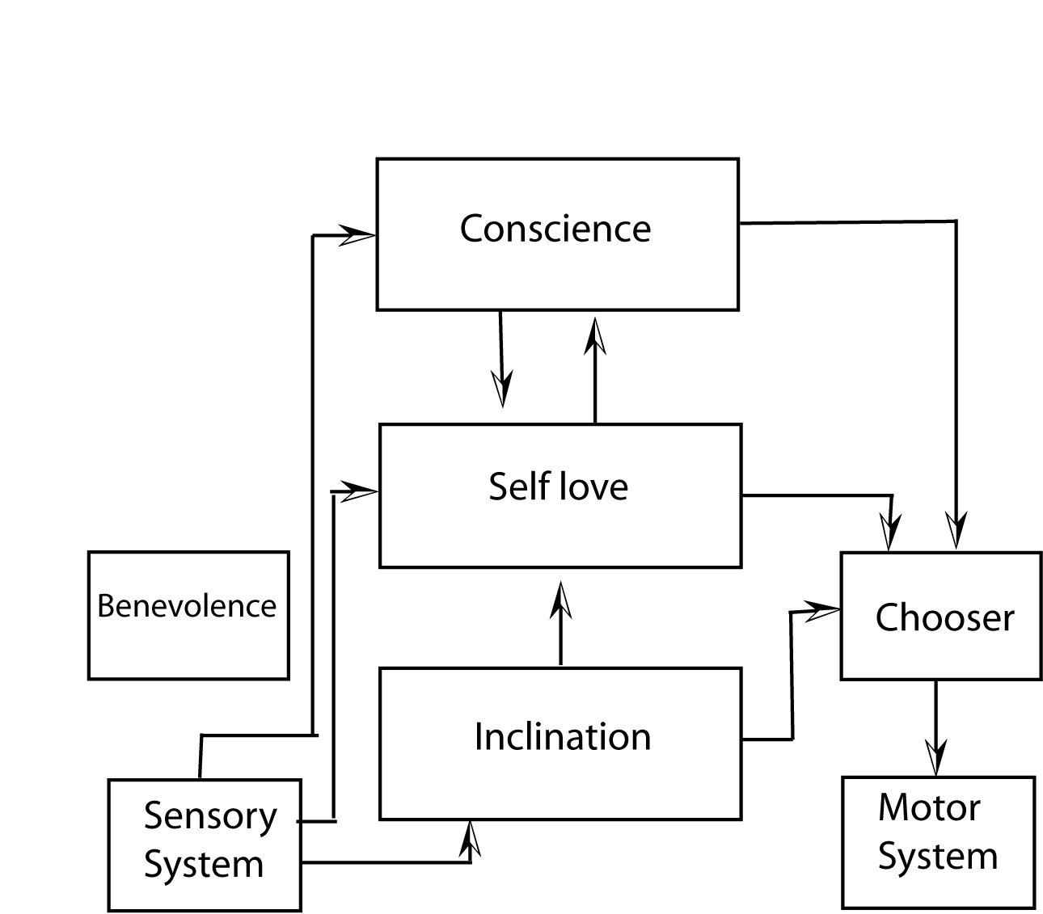
Figure 1, drawn by the author

This is a wiring diagram of a ‘Butleroid.’ Benevolence is floating out there to the left, unattached to anything, because it is not clear where Butler would put it. Is Benevolence, more or less, on a par with Self-love, or is it a special batch of particular inclinations, appetites, etc.?
The Chooser isn’t anything ever mentioned by Butler. It is introduced to add a Kantian touch, and because it seems to be needed to make the system work properly.
In his wonderful Lectures on the History of Political Philosophy John Rawls discusses an apparent conflict or inconsistency in Butler’s account of the relations between Conscience and Self-love. It’s not entirely clear what the apparent conflict or inconsistency is supposed to be. Nevertheless, good candidates can be found in Butler’s sermons and in Rawls’ discussion of those sermons.
In Lecture V on Butler, Rawls says that, for Butler “.. given our nature and our place in the world, there can be no conflict or inconsistency between conscience, the deliverances of which we are always to follow, and Self Love.” [p. 447] Apparently Rawls’ Butler is willing to make this bold claim even given the supposition that there is no God and no life after death.
Taken as it stands, this cannot be true. In the preface to his sermons Butler points out “a material deficiency or omission in Lord Shaftesbury’s Inquiry concerning Virtue.” Shaftesbury has not considered the authority of Conscience.
He has shown, beyond all contradiction, that virtue is naturally the interest or happiness, and vice the misery of such a creature as man, placed in the circumstances which we are in this world. But suppose there are particular exceptions; a case which this author was unwilling to put, and yet surely it is to be put. Or suppose a case which he has put and determined, that of a skeptic not convinced of this happy tendency of virtue, or being of a contrary opinion: his determination is, that it would be without remedy. One may say more explicitly, that, leaving out the authority of reflex approbation or disapprobation [that is Conscience], such a one would be under an obligation to act viciously; since interest, one’s own happiness, is a manifest obligation, and there is not supposed to be any other obligation in the case.
Let’s elaborate. Here is Bertrand Russell wondering whether to invite T. S. Elliot’s wife out for tea. He would very much like to do so, and his Self-love module has given its approval, but his Conscience tells him it would be wrong. In regard to God and life after death Russell is, to put it mildly, skeptical. Furthermore, (let’s pretend) he believes that a bit of wickedness now and then can make one’s life as a whole more satisfying than it would otherwise be.
Butler’s claim is that in a case like this, if Conscience had no moral authority, Russell would have an obligation to take Elliot’s wife out for tea.
Of course this is ridiculous. So Conscience must have some authority. That’s Butler’s argument. But where does this leave us? What is Russell supposed to do? Butler’s imaginary opponent presses the point:
“… does it much mend the matter, to take in that natural authority of reflection [i.e. Conscience]? There indeed would be an obligation to virtue; but would not the obligation from supposed interest on the side of vice remain?”
In response Butler says that in cases of conflict our obligation to comply with Conscience always entirely supersedes our obligation to comply with Self-love because the natural authority of Conscience is definite and obvious, whereas our obligation to comply with Self-love is never more than probable. We don’t know for sure how things will turn out for us in the remainder of our lives, let alone in some sort of life-after-death.
In effect, Butler thinks that Russell’s actual Self-love at time t, could urge a course of action that his Conscience opposes. Furthermore, these two seem to impose conflicting prima fascia obligations. In addition, Butler thinks (correctly, but perhaps for the wrong reason) that Conscience should be the winner when there is such a clash. Should this bother Rawls? One point he definitely wants to make is that, for Butler, Self-love and Conscience, in their fully developed, reason-guided state would be ‘integrated’ via Benevolence, and thus unable clash.
…self-love differs according to its scope, that is, upon whether it is limited in its concerns to our temporal and imperfect state, or whether it also considers our state of possible perfection in the hereafter. If we introduce the notion of reasonable self-love as a settled affection to the proper good of our person as a reasonable creature (with the moral constitution as described in Sermons I-III), and if we take in the full scope of self-love, which includes the state of our possible perfection, then Butler believes that a life guided by the love of virtue – by an affection to right and justice and moved by real benevolence – is that way of life which best advances our good. It provides for the greatest happiness we can reasonably have faith in and hope for.
When Rawls speaks of ‘the full scope of self-love’ he seems to include our possible future life in heaven (or in Hell). But then if, say, Alice, firmly believes that death is equivalent to obliteration, her actual present Self-love may be in flat-out conflict with her Conscience.
[In regard to Rawls’ use of ‘rational’ and ‘reasonable,’ Rawls writes: “In my own work, and in this discussion, the reasonable involves fair terms of cooperation; while the rational involves furthering the good or advantage of oneself, or of each person cooperating.”]
There are at least two reasons for rejecting Rawls’ claim that for Butler there can be no conflict between Conscience and Self Love. First, the textual evidence for it is far from compelling. Second, it ascribes to Butler a view that is pretty clearly false, and for this reason we should be reluctant to ascribe it to him. The case that Henry Sidgwick makes for a contrary view seems much more persuasive. Here is a part of Sidgwick’s discussion of the issue:
It may be held that the pleasurable emotions attendant upon such virtuous or quasi-virtuous habits as are compatible with adhesion to egoistic principles are so inferior to the raptures that attend the unreserved and passionate surrender of the soul to virtue, that it is really a man’s interest – even with a view to the present life only – to obtain, if he can, the convictions that render this surrender possible; although under certain circumstances it must necessarily lead him to act in a manner which, considered by itself, would be undoubtedly imprudent. This is certainly a tenable position, and I am quite disposed to think it true of persons with specially refined moral sensibilities. But – though from the imperfections of the hedonistic calculus the proposition cannot in any case be conclusively disproved – it seems, as I have said, to be opposed to the broad results of experience, so far as the great majority of mankind are concerned. Observation would lead me to suupose that most men are so constituted as to feel far more keenly pleasures (and pains) arising from some other source than the conscience;…

This looks like an appropriate response to Rawls’ Butler; but this may be a misunderstanding of Rawls. Perhaps Rawls thinks Butler’s point is that it is always in our long-term interest to move ourselves towards the happy end state in which Self-love and Conscience are in perfect agreement, and that this movement is always best maintained by compliance with Conscience, as even Self-love must admit.
Well, perhaps. But again, the theory being ascribed to Butler looks false. Imagine a wicked old man (he’s 93) who doesn’t believe in God or an after life and really enjoys tormenting cats. Isn’t it fairly obvious that his over-all happiness during his few remaining months or years might well be better served by persistence in his vile behavior than by a constant struggle against his evil inclination, even though by this persistence he moves himself further and further away from the ideal harmony recommended by Rawls and Butler?
In any case, if Butler really believed that it is always in our interest in this life and assuming no God to comply with the dictates of Conscience, why did he claim that under those conditions, Conscience and Self-love can clash?
Before we move on, perhaps we ought to notice something rather odd. Butler holds that Self-love has some sort of (ethical?) authority. Presumably, in the absence of conflicting demands from Conscience, its demands generate a ‘manifest obligation.’

Anselm

In three interesting investigations Anselm explores first the idea of an angel that is given a ‘will for happiness’ but no ‘will for rectitude,’ then the supposition that the angel is given a ‘will for rectitude’ but no ‘will for happiness,’ and finally he considers the angel that committed the first wicked deed – the devil – a creature who, like us, had both a ‘will for happiness’ and a ‘will for rectitude.’

The Angel in Situation One

As it turns out, in this state the angel must will to be as happy as God is (this, of course, is unobtainable). But is he morally wrong (unjust) in this willing?
Teacher: Then he wills to be like God.
Student: Nothing is clearer.
Teacher: So what do you think, can the will to be like God be unjust?
Student: I cannot call it just, because he would want what does not befit him, nor unjust, because he would will it necessarily.
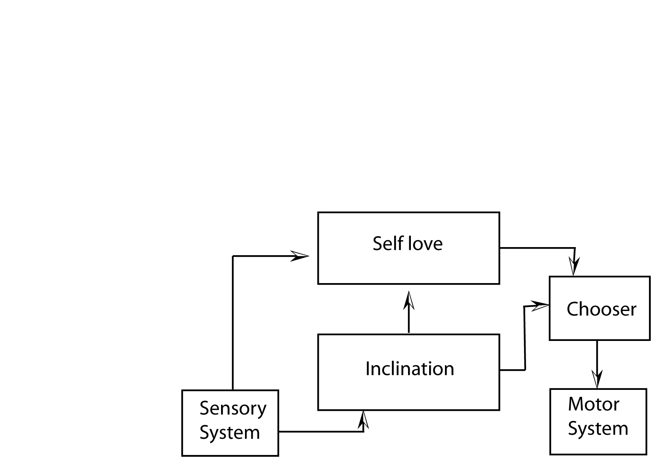
Figure 2, drawn by the author

This sort of creature might be called a “Hobbot” – that is to say, a Hobbsian Robot.
There are several things one would like to know about Anselm’s first maimed angel. For instance, does he have ‘free will?’ In Anselm’s sense of the term, he certainly does not. By ‘free will’ Anselm means the ability to do what is morally right simply because it is morally right. Morality has no meaning at all for the angel in the first situation. He has no capacity for it. Hence, he lacks Anselmian free will.
On the other hand, at least in this Hobbot diagram, he has a ‘Chooser.’ This means that when Self-love urges the Chooser to disregard some inclination, the Chooser has to decide whether to go with Self-love or turn a deaf ear and go with the inclination. We might describe this as a conflict between reason and a particular passion. More generally, the Chooser can work out some over-all policy in regard to the demands of those two modules. It can, for instance, decide to favor inclinations over Self-love every Saturday night, but go with Self-love the rest of the time. In this sense, the angel in this situation has a substantial degree of freedom. He can decide to be rational and governed by Self-love, or, so to speak, go a bit crazy and be governed by his appetites, passions, and so on. [If he takes the latter course, he may well feel embarrassed, and a bit ashamed of himself, on Sunday mornings. These are proto-moral feelings, so to speak.]

Situation Two

Teacher: Let us now consider the will for justice and see if the same angel to whom is given to will only what befits his nature, could will something else or could of himself not will what he has been given to will.
Student: It must be exactly the same here as it was with the will for happiness.
Teacher: Then this angel would have a will that is neither moral nor immoral. For just as above there could not be an unjust will if he willed something unfitting, since he could not not will it, so if he should will what is fitting, his will would not be just, since it was so given him that he could not will otherwise.

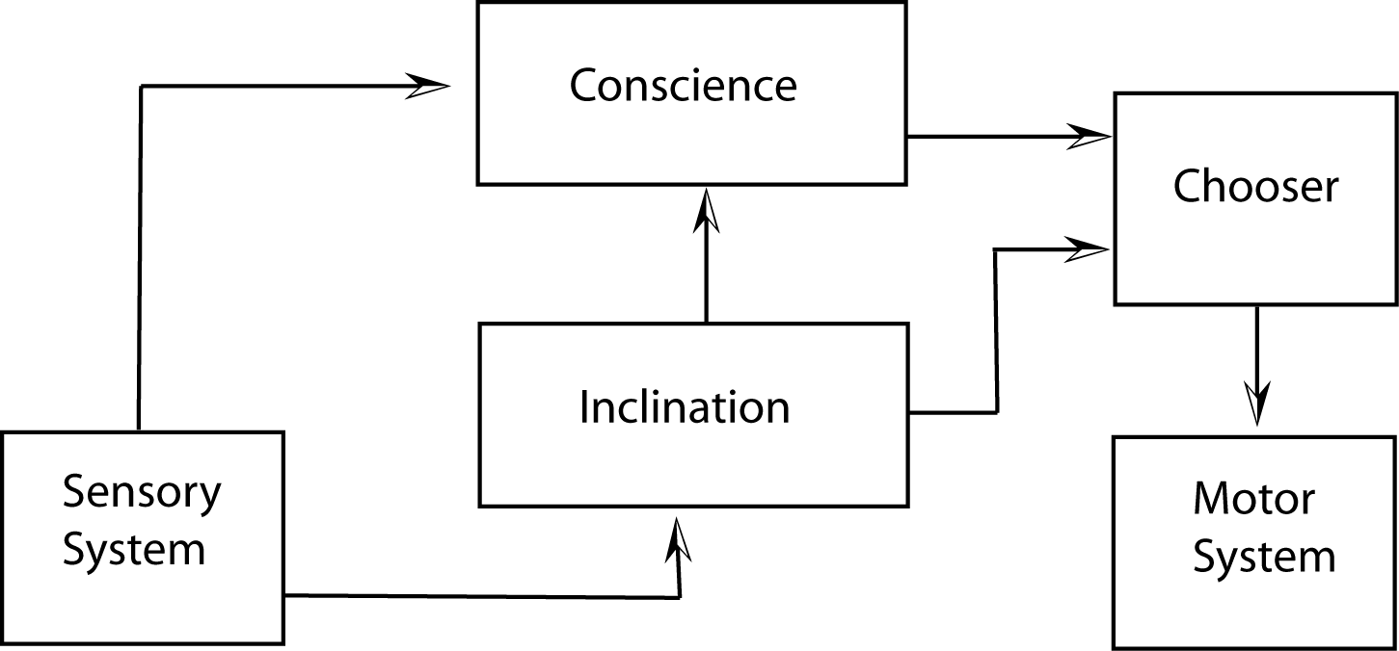
Figure three, drawn by the author

Anselm says that, in this second situation, the angel has no choice. Given the wiring diagram above it would seem that the Angel does have a choice. It could obey its Conscience or let itself be governed by some particular appetite, passion, or affection. [Of course there is no reason at all to suppose that Anselm has this diagram in mind. Why should he?]
On the other hand, looking at the diagram, an Anselmian might point out that the only rational course available to the angel is to do whatever it’s Conscience urges it to do.
Another option would be to remove the wire that connects the Inclination module to the Chooser. In that case, the Chooser has no real job at all. We might as well let the Motor System be run by Conscience. Surely, in that situation it would be plausible to claim that the angel has no choice. Perhaps it is a ‘moral’ being, in some sense; but it definitely lacks what Sidgwick calls ‘neutral’ or ‘moral’ freedom – the freedom to choose between right and wrong.

Anselm flat-out refuses to call neutral freedom ‘free will.’

“Teacher: I do not think free will is the power to sin or not to sin. Indeed if this were its definition, neither God nor the angels, who are unable to sin, would have free will, which it is impious to say.” [On Free Will, Anselm of Canterbury, The Major Works, Oxford University Press, 1998, p. 176]
In spite of this, it is clear that, as Anselm tells the story, the devil exercised neutral freedom when he made the decision that brought about his fall.

The Devil’s Fall

In “On the Fall of the Devil’ the Student, among other things, wants to know what it was that the devil lacked but wanted, and thus brought about his own fall.

Teacher: You do not doubt that he sinned, because he could not be unjustly condemned by a just God, but you are asking how he sinned?
Student: Yes.
Teacher: If he had served justice with perseverance, he would neither sin nor be unhappy.
Student: So we believe.
Teacher No one serves justice except by willing what he ought, nor abandons it save by willing what he ought not.
Student: No one doubts that.
Teacher: Therefore by willing something that at the time he ought not to will, he abandoned justice and thus sinned.

Anselm goes to considerable lengths to show that there was nothing irrational or stupid in this behavior. It was not a slip-up, or a miscalculation. The devil had good reason to do what he did. [On this view, it would seem, reason itself does not resolve the conflict between Conscience and Self-love.]

Teacher: Because he was rational, he could understand that he would be justly punished if he sinned, but since God’s judgments are a deep abyss and his ways inaccessible to us [Rom. ii: 33], he was unable to know whether God would do what he justly could do. But, even if one should say that he could not believe that God would have condemned the creature he had made with so much goodness because of his guilt, he would not in fact express something impossible, since no example of justice punishing injustice would have preceded, and the angel was certain that the number that were created to enjoy God had been established with so much wisdom as to have nothing superfluous and to be unable to be lessened without leaving something incomplete, and that God’s wonderful work could not remain partially incomplete. On the other hand, he could in no way know, if man had already been created man, that God would put human nature in place of the angelic and the angelic in the place of the human should he fall. Rather he had to think God would reconstitute every nature in the way it had been made for itself and not for another; much less could he have thought, if man had not yet been created, that God would have created him to take the place of another. What is absurd about any of that?
Prior to his fall the devil presumably had both good (Anselmian) freedom and neutral freedom. He exercises his neutral freedom in deliberately choosing to do what Self-love urges and Conscience forbids. But, we suppose, he could have obeyed his conscience and done what was morally right simply because that was the morally right thing to do. That is to say, he had good freedom, but chose not to employ it.
Anselm holds that the devil gives up (and thereby looses) his good freedom by choosing happiness over virtue. Why is this so? Perhaps there is no direct connection – God takes away the devil’s freedom (both kinds?) as part of his punishment. On the other hand, perhaps we are to suppose that the devil really did renounce both kinds of freedom and became some sort of Hobbot.
According to Anselm, the will for happiness and the will for justice are sometimes in conflict. Even with God in the picture, there can, as Anselm might now put it, be a clash between Conscience and Self-love.
Has it been proved that there can be such clashes, and that reason, on its own so to speak, cannot resolve them? Of course not. It has been shown that Butler and Anselm believed these clashes can occur. Along the way, cases have been provided that seem to make both claims plausible.

Part Two

Now we take a quick look at David Sussman’s subtle and illuminating reconstruction of what he takes to be Kant’s attempt to prove that Conscience cannot find a real rival in Self-love. Sussman does not say whether he accepts this argument or not, and it isn’t perfectly clear whether it really is Kant’s view or not. Consequently, let’s ascribe it to someone named ‘Skant’.

According to Skant, in finite creatures:

- There are only two forms of self-love:
  - “Basic self-love (Eigenliebe) is our ordinary interest in the satisfaction of our inclinations and natural needs. Such self-love aims at overall satisfaction with our condition in life without any concern for the self beyond the instrumental value of our abilities and talents.” … “Eigenliebe locates happiness in the gratification of our needs and desires.”
  - Self-conceit (Eigendunkel). Here “…we strive to be satisfied not with how we are living, but with what we are. Eigendunkel seeks the self-satisfaction that comes from esteem, admiration and honor. '’ [Sussman again]

- Basic self-love “…makes no claim to practical authority (Kp V 5:74).” [Sussman] (Presumably, then, it is not in the running as a possible competitor for Conscience.)
- “Self-conceit … implicitly subordinates itself to the principles of pure practical reason, whatever they might turn out to be.”
- Hence, “…there turns out to be no form of self-love that is both truly distinct from morality and yet capable of making a coherent bid for practical authority.”

Sussman says that this is not an attempt to show that Self-love (more specifically ‘basic self-love’, Eigenliebe) and Conscience cannot “…come into conflict in particular cases.” But how is that possible? How could Eigenliebe come into real conflict with morality? Doesn’t it just quit when it sees the possibility of conflict? Given that Skant’s argument is sound, why can’t it, or a properly modified version of it, be applied to a particular case?
Apparently we are simply disregarding something that Kant calls ‘physical self-love.’
The predisposition to animality in the human being may be brought under the general title of physical or merely mechanical self-love, i.e. a love for which reason is not required. It is threefold: first, for self-preservation; second, for the propagation of the species, through the sexual drive, and for the preservation of the offspring thereby begotten thorough breeding, third, for community with other human beings, i.e. the social drive. [6:26]
Here is the distinction between self-love and self-conceit offered in the critique of practical reason:
…we find our nature as sensible beings so constituted that the matter of the faculty of desire (objects of inclination, whether of hope or fear) first forces itself upon us, and we find our pathologically determinable self, even though it is quite unfit to give universal law through its maxims, nevertheless striving antecedently to make its claims primary and originally valid, just as if it constituted our entire self. This propensity to make oneself as having subjective determining grounds of choice into the objective determining groound of the will in general can be called self-love; and if self-love makes itself lawgiving and the unconditional practical principal, it can be called self-conceit. [5:74]
The description of human self-love in Religion within the Boundaries of Mere Reason is, in part, as follows:
The predispositions to humanity can be brought under the general title of a self-love which is physical and yet involves comparison (for which reason is required); that is, only in comparison with others does one judge oneself happy or unhappy. Out of this self-love originates the inclination to gain worth in the opinion of others, originally, of course, merely equal worth: not allowing anyone superiority over onself, bound up with the constant anxiety that others might be striving for ascendancy; but from this arises gradually an unjust desire to acquire superiority for oneself over others. [6:27]
Let’s call the kind of self-love that doesn’t (try to?) make itself “…into the objective determining ground of the will” ‘unassertive self-love.’ By definition unassertive self-love cannot conflict with Conscience. As soon as Conscience makes a demand, unassertive self-love withdraws any conflicting suggestion it might have made, or been about to make. No conflict.
The really tricky part of the argument lies in showing that the other kind of self-love (or all the other kinds of self-love) cannot offer coherent opposition to Conscience.
Consider self- conceit.

Sussman writes:
From self-conceit I want to be pleased with myself as a whole person, just as in basic self-love I desire to be happy with the way I am living. …
In striving to be satisfied with myself as a good or worthy person, I am implicitly committed to there being objective standards for the assessment of persons that properly command the assent of others. For Kant, such standards would have to be norms of pure practical reason, insofar as they would have to sustain demands on the agent independent of her actual attitudes and feelings. Self-conceit thus implicity subordinates itself to the principles of pure practical reason.
Self-conceit is vulnerable to this sequence because of its desire “to gain worth in the opinion of others.”
Note the following supplementary argument:
- If Self-conceit seeks the good opinion of others then Self-conceit is committed to compliance with the principles of pure practical reason.
- Self-conceit does seek the good opinion of others.
- Hence self-conceit is committed to compliance with the principles of pure practical reason.

It is difficult to see in either of these ‘Self-loves’ something equivalent to the kind of thing Butler (and Anselm) had in mind, or equivalent to the ‘Self-love’ ascribed to Hobbots and Butleroids. There is nothing in Butler & Co about ‘Self-love’ wanting its person to have worth in the opinion of others or wanting its person to be satisfied with herself or himself as a good and worthy person. Of course, if the person happened to have such desires, then Butlereian Self-love would be interested in finding a way of fulfilling them. Those desires are not intrinsic to Butlerian Self-love itself.
Given that Butlerian Self-love is different from Self-conceit in this way, we have no reason to think that it too is committed to compliance with Kantian pure practical reason (i.e. conscience).
People who take Hobbot rationality and Self-love seriously can hold that Hobbots should comply with Butlerian Self-love when some particular passion, appetite, or whatever is in conflict with it. That is to say Butlerian Self-love should dominate inclinations. Presumably, Hobbots themselves recognize this fact. They often feel shame when they recall having been ‘overcome’ by some appetite. This is not necessarily a matter of embarrassment at being caught in the act. It may have nothing to do with other Hobbots. They are ashamed of themselves. Doesn’t this show that their Self-love ‘claims authority’ over their particular passions (to put it in that peculiar Kantian way)?
In Sermon II Butler discusses conflict between Self-love and particular passions. He imagines a man going against cool Self-love and rushing into certain ruin in order to gratify an appetite of some sort. The claim is that this sort of behavior is ‘unnatural’ in human beings. There is an important difference in rank (so to speak) between passions and Self-love.

…there must be some other difference or distinction to be made between these two principles, passion and cool self-love, than what I have yet taken notice of. And this difference, not being a difference in strength or degree, I call a difference in nature and kind. And since, in the instance still before us, if passion prevails over self-love, the consequent action is unnatural; but if self-love prevails over passion the action is natural; it is manifest, that self-love is in human nature a superior principle to passion. This may be contradicted without violating that nature, but the former cannot. So that, if we will act conformably to the economy of man’s nature, reasonable self-love must govern. Thus, without particular consideration of conscience, we may have a clear conception of the superior nature of one inward principle to another; and see that there really is this natural superiority, quite distinct from degrees of strength and prevalency.
In addition, Butlerian Self-love seems to claim a kind of equality with Conscience:
Let it be allowed, though virtue or moral rectitude does indeed consist in affection to and pursuit of what is right and good, as such: yet that, when we sit down in a cool hour, we can neither justify to ourselves this or any other pusuit, till we are convinced that it will be for our happiness, or at least not contrary to it. [Sermon XI , next to last paragraph]
Butlerian Self-love is by nature ‘superior’ to the passions, etc. or, as Kant would say, it ‘claims authority’ over them. Isn’t this ‘practical authority’? Furthermore, it seems to demand something like veto power in regard to voting.
OK, that may have been cheating. Perhaps what is meant by ‘practical authority’ is more like long-term governance of the decision making process. Presumably, Butlerian Self-love does make some such claim in regard to Hobbots; but does it do so in regard to Butleroids and ordinary human beings? It does seem likely that, under some circumstances, Self-love would be glad to take permanent full control into its own hands. Given no God and no afterlife, Self-love might well be a better guide to long-term happiness than is Conscience, and might well know that this was the case. When Conscience in a non-believer persistently demands painful self-sacrifice, Butlerian Self-love might well urge some such arraignment.
Here is a more specific version of Butlerian Self-love. Let’s call it ‘Assertive Self-love.’ Assertive Self-love thinks (so to speak) that the Chooser ought to be guided by either Assertive Self-love or by Conscience. The choice is up to the Chooser. Following Kant, it may well be prepared to admit that, in principle, Conscience is in some way more noble, more admirable. Nevertheless, Assertive Self-love does not subordinate itself to Conscience, nor, for that matter, does it regard itself as superior. It regards itself as an equal in its degree of authority, and, since only one of them can be the principle guide, it recommends itself on the grounds that it can do a better job as a guide to happiness. “Remember,” it says to it’s person, “that you are not an angel flying around in heaven. You are a rational animal, with an animal’s wants and needs. I take into account all of your desires, good as well as bad – the whole person, whereas Conscience …… Well, you know.”
If the person cares about other people’s judgments, then Assertive Self-love will urge behavior conducive to their esteem. This does not mean that Assertive Self-love itself must somehow acknowledge the claims of ‘pure practical reason.’
Assertive Self-love appears to be something other than Kant’s “Self-conceit.” If this is the case, (1) is false. [It’s certainly not a form of Basic self-love – less of a wimp.] If it’s a form of ‘Self-conceit,’ then (3) is false. Assertive Self-love does not subordinate itself to the principles of pure practical reason.
Skant has not shown that conscience (i.e. ‘pure practical reason’) cannot collide with self-love. Butler (and Anselm) held that they can collide. This view seems very plausible. That is to say it looks as though Conscience and self-love sometimes collide, and, when they do, conscience should be the winner.

‘Self-love’ in this paper usually means what Butler calls reasonable or cool Self-love. Unreasonable or heated Self-love has no part to play here.
Anselm would probably say he got the idea from Augustine; but I don’t see it there. Is the idea platonic? Plato (and Freud) offer us a three-part psyche; but the parts do not seem to be Anselmian. For instance, the ‘Thumos’ (id) often urges a rationally indefensible course of action.
Butler’s Sermons, preface, par. 26.
This shows, or at least suggests, that Sephen Darwall’s account of the situation is mistaken. Darwall holds that (for Butler) it is Conscience alone that makes it possible for us to have reasons for doing what we do. It would seem to follow that Butler ought to think that if Conscience had no authority, or was missing altogether, we would have no reason to do what Self-love tells us to do. See Darwall’s, The British moralists and the internal ‘ought’, (Cambridge University Press, 1995, p. 247).
Butler, Sermons, preface, par. 26
Why should Conscience be the winner? That is to say, why should we do what is morally right rather than what is (probably) most conducive to our happiness (when these two are in conflict)? H. A. Prichard (and Anselm) may well have been right about this. We should do what is morally right simply because it is morally right. See Prichard’s ‘Does Moral Philosophy Rest on a Mistake?’ (Mind, N. S., Vol. 21, 1912). Butler, however, tries to provide rational grounds for holding that Conscience should always win in this kind of case. He may well go wrong here. Reason may fall scilent. [One might, for instance, be a bit uncertain about the existence of absolute moral principals.] The issue may require a moral decision.
Op cit. pp. 446-447.
Ibid. p. 54.
“the raptures that attend the unreserved and passionate surrender of the soul to virtue.” [This appears to be a Sidgwickian joke.]
Henry Sidgwick, The Methods of Ethics, (Macmillan and Co. London, 1913, Book ii, ch. v, pp. 174-175.)
In her beautiful little book, Natural Goodness, Philippa Foot reluctantly admits that a vile Nazi commandant could be (deeply?) happy; but holds, never the less, that there is a kind of deep happness that only goodness can achieve, although it may be unobtainable by any actual human being. (See pp. 90-97)
Anselm of Canterbury The Major Works, Edited with an Introduction by Brian Davies and G. R. Evans, Oxford University Press, 1998, p. 215.
Perhaps the Self-Love modual aims at maximal pleasure and minimal pain without excessive risk, taking the long view. Alternatively, it aims at maximal satisfaction of one’s various actual desires, wants, and needs, without exessive risk, taking the long view.
Ibid. p. 201.
See H. Sidgwick, ‘The Kantian Conception of Free Will,’ Mind, Vol. 13, No. 51. (July, 1888), pp. 405-412.]
Anselm, Ob.cit, p. 201.
Ibid. ch. 23.
David Sussman, ‘From Deduction to Deed: Kant's Grounding of the Moral Law.’ (section 7, Kantian Review, 13:1, pp. 52-81.)
Sussman,’From Deduction…’, p. 71.
Kant writes: All the inclinations together (which can be brought into a tolerable system and the satisfaction of which is then called one’s own happiness) constitute regard for oneself (solipsismus). This is either the self-regard of love for oneself, a predominant benevolence toward oneself (Philautia), or that of satisfaction with oneself (Arrogantia). The former is called, in particular, self-love; the latter self-conceit.” [5:73]
Sussman, pp. 72-73.
The Cambridge Texts edition of Religion has a footnote here showing how close Kant is to J. J. Rousseau (in Emile ou de l’education) in this passage.
Sussman, p. 74
Presumably, this would be Sidgwick’s view.
Butler, Sermon II, sec. iii.
Incidentally, Assertive Self-love vehemently denies that Conscience resides in the numenal realm while it (Assertive Self-love) is forced to make its living here in the material world.

