From: rituparna ray chaudhuri in front of my canvas on british literature, as white academy logo:

My topic of discussion
IN BRIEF…

HOW I TEACH MY STUDENTS IN MAJORITY…WHEN THERE IS A QUESTION ON ME , AS BEHIND MY EYES-

I am thinking only majority of students, might can acquire knowledge on my topic of discussion. I was turning the pages of History of English litereature. It appeared to me a huge’ landmark to complete the whole syllabus of such PASTORAL literature TO ME, within a short span of time in English Honours. It is deadly to finish up the enlarged topics and subtopics ”in enormous” within such a brief time.
I thought let me make the matter, fore on a such a way that a pictorial description should alert as a chart form, infront of STUDEnTS’ eyes, SUCH TO ACQUIRE THE KNOWLEDGE ON MATTER WITH EASE.
So what I do to my students too…(IN FACT, IT COMFORTS ME…). THESE ARE:
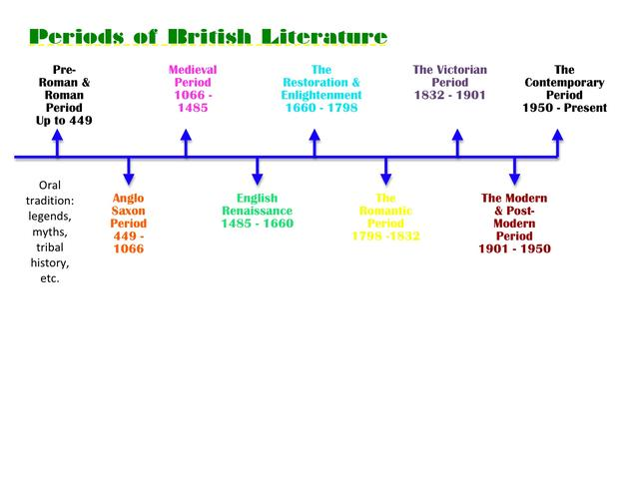

- I ask my students to make separate copies for different ages.
~~~~~~~~~~~~~~~~~~~~~~~
- I start to write notes along with them taking any of a student’s copy. Rest of the students they are copying exactly in the same way I have written notes on an age , with its divisions and subdivisions, in detail but only what is required.

~~~~~~~~~~~~~~~~~~~~~~~~~~~~

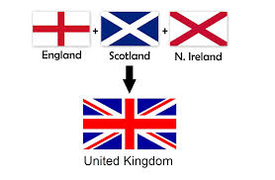

[Images are from different sources, the web-source.]

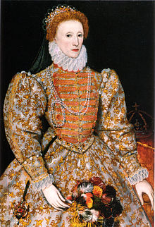

- In this way I continue with old age, middle age…with constant revision of timeline’ they are reading in. ^^^^^^^^^^^
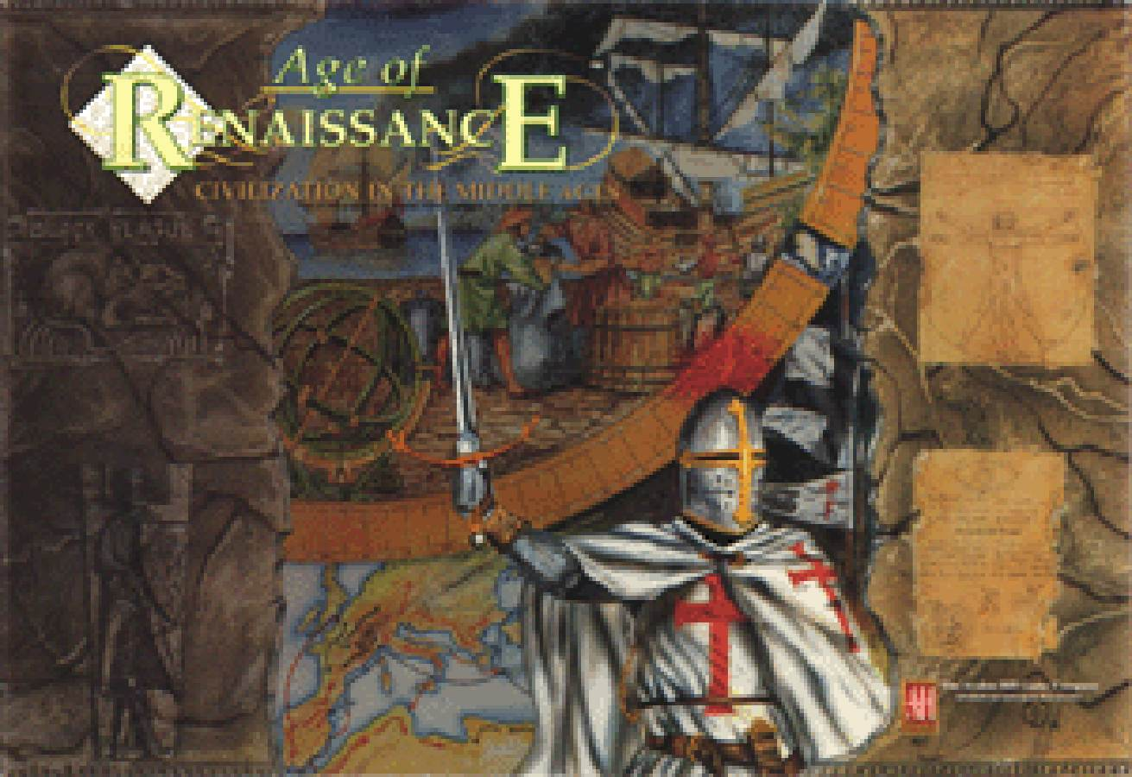
- First I start, with Elizabethan age: from the core of its meaning. I sharE to them the tudor literature and stuart literature showing different images of what and on whom they are
learning.

- With it ,I also start with age of renaissance.
- Once with age of renaissance, I tAKE another copy to start with old english and middle English TO WRITE MY NOTES ON THESE AGES.
^^^^^^^^
- ConsTantly, I start to share with students centralise the image of Queen Elizabeth and the-cause the Age as it is called ,the Golden Age.
- Remembering of years and cause’ oN flourish’ ,THE HISTORY OF ENGLISH literature together is an utmost thing.
……………………………………………..
- So, my first question to them is what was the span of ruling , Queen Elizabeth in the Age. Then I proceed with Tudor literature AS MAKING THEM TO LEARN, WHEN I ALSO BECOME A STUDENT AMONG WITH THEM.
- On a next day, I start to ask them with Middle English and the Age of Renaissance in particular.
~~~~~~~~~~~~~~~
- Then I DIRECTLY COME with THE Stuart literature.
- Next comes AT BACK, the topic of Old English literature, a little later.
- After a WIDE-gap, I start with Augustan Age in suggestive way though IN-details, as I suppose everything is not possible for them to go through. IT CAN, HOWEVER BE SHORTENED.
- Next AWAITS my suggestions to Romantic period with contribution’ of poets’ legendary- work, as whole ..
- Then comes the ADVANCEMENT’ in detail of Victorian Age.
~~~~~~~~~~~~~~~~~
- Suggestive notes after a time, act to my students while teaching Modern Literature ..

~~~~~~~~~~~~~~~~~~~~~~~~
RITuPARNA RAY CHAUDHURI…
(GOOGLE…IS MY IDENTITY, WEB-SOURCE)

