(DIED ON 06.06.2015).

“Rhythm of Literature- And My Impulse -

WRITING HAS BECOME MY PASSION, SETTING OF MY IDEA ON TOPIC IS NOW MY IMPULSE, ANALYSIS IS MY RHYTHM AND, LITERATURE IS IN MY BLOOD....'’
-RITUPARNA RAY CHAUDHURI.

“No sooner had the Almighty ceased, but all
The multitude of angels, with a shout
Loud as from numbers without number, sweet
As from blest voices, uttering joy, Heaven rung
With jubilee, and loud hosannas filled
The eternal regions. Lowly reverent
Towards either throne they bow, and to the ground,
With solemn adoration, down they cast
Their crowns inwove with amaranth and gold-
Immortal amaranth, a flower which once
In Paradise, fast by the tree of life,
Began to bloom; but soon for man’s offence
To Heaven removed, when first it grew, there grows,
And flowers aloft, shading the fount of life,
And where the river of bliss, through midst of Heaven,
Rolls o’er Elysian flowers her amber stream.”

THE ENGLISH LANGUAGE: LET ME TALK.
;

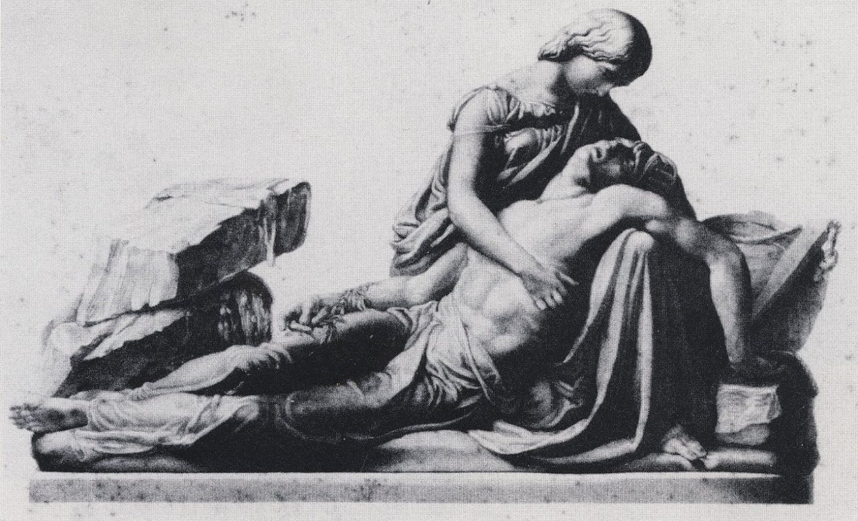
Engraving by George Stodart after a monument of Mary and Percy Shelley by Henry Weekes (1853).

“BARDS OF PASSION AND OF MIRTH”..

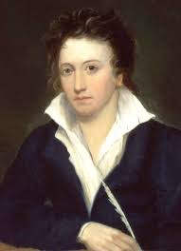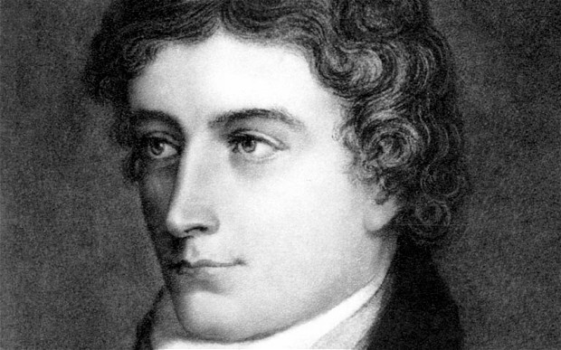

Percy Bysshe Shelley John Keats

In Switzerland, Byron writes:
“I live not in myself, but I become
Portion of that around me, and to me
High mountains are a feeling, but the hum
Of human cities torture….”

JOHN KEATS, A THINKER IN RELATION TO THE CRITICAL APPRECIATION OF HIS VERSE ‘ODE TO A NIGHTINGALE’.
Keats’s friend and roommate, Charles Brown, described the composition of this beautiful work as follows:
‘In the spring of 1819 a nightingale had built her nest near my house. Keats felt a tranquil and continual joy in her song; and one morning he took his chair from the breakfast-table to the grass plot under a plum-tree, where he sat for two or three hours. When he came into the house, I perceived he had some scraps of paper in his hand, and these he was quietly thrusting behind the books. On inquiry, I found these scraps, four or five in number, contained his poetic feeling on the song of our nightingale. The writing was not well legible; and it was difficult to arrange the stanzas on so many scraps. With his assistance I succeeded, and this was his ‘Ode to a Nightingale’, a poem which has been the delight of everyone.’- WEB-SOURCE

THE WAY I HAVE BUILT THIS ANSWER:

Ans. “Here are sweet peas, on tip-toe for a flight
With wings of gentle flush o’er delicate white,
And taper finger catching at all things
To bind them all with tiny rings;”
Keats’s attitude towards nature developed as he grew up. In the early poems, it was a temper of merely sensuous delight, an unanalyzed pleasure in the beauty of nature. “He had away”, says Stopford Brooke, “of fluttering butterfly-fashion, from one object to another, touching for a moment the momentary charm of each thing… he would let things flit in and out of the brain not caring to ask anyone to stay and keep him company, but pleased with them and his game of life.” His attitude was one of unthinking pleasures and enjoyments without thought.
…..“To laugh a while at her so proud array;
Her waving streamers loosely she lets play,
And flagging colours shine as bright as smiling day.”
Sensuousness is the key to Keats’s attitude towards nature. He looked with child-like delight at the objects of nature and his whole being was thrilled by what he saw and heard. The earth lay before him tilled, spread out with beauties and wonders, and all his senses reached to them with delight and rapture. Everything in nature for him was full of wonder and mystery-the rising sun, the moving clouds, the growing bud and even swimming fish.
“Adieu! the fancy cannot cheat so well
As she is famed to do, deceiving elf!”
The lines also reveal Keats’s idea that our imperfect nature is not framed to enjoy the eternal joy and beauty for long. In Ode to a Nightingale Keats in his attempt to share the eternal joy and happiness of the nightingale, escapes into the idyllic woodland where the bird sings. The escape brings him the bliss he ever longs for, but he cannot enjoy the imaginative reverie in which state alone he can enjoy this bliss. When Keats is recalled from the world of the nightingale’s song to the actual world, he realizes that fancy cannot make a man forget the realities of life so thoroughly as it is believed to do. In other words, the illusion produced by fancy or imagination is after all, evanescent.
“Was it a vision, or a waking dream?
Fled is that music:-Do I wake or sleep?”
As a poet Keats is enchantingly and abundantly sensuous. His poetry has rarely been equaled in descriptions of the beauties perceptible to the senses. Ode to a Nightingale amply illustrates Keats’s sensuousness -his delight in the sights, sounds, colours, smell and touch. He will ‘taste’ wine “cooled a long age in the deep-delved earth”, he will ‘see’ the beaker “with beaded bubbles winking at the brim” and “purple-stained mouth”, he ‘hears’ the nightingale singing in “verdurous glooms”, and the flies buzzing “on summer eves”, while his ‘smell’ is gratified by the “soft incense” that “hangs upon the boughs” and the fragrant flowers at his feet. In other words, the poem offers a rich feast for all the senses.
“There is a place beyond that flaming hill,
From whence the stars their thin appearance shed;
A place beyond all place, where never ill
Nor impure thought was ever harboured;”
Keats says, “We hate poetry that has a palpable design upon us. Poetry should be great and unobtrusive - a thing which enters into one’s soul and does not startle it” to make beauty, says Bradley, is his (poet’s) philanthropy. He must be unselfish; by refusing, that is, to be diverted from his poetic way of helping by his desire to help in another way. Hence there is no didacticism in Keats as there is in Wordsworth. There is no moralizing in The Eve of St. Agnes as there is none in King Lear; in both, the poets leave their works to speak for themselves.
“Ite domum impasti,domino iam non vacat, agni,
Go home unfed, my lambs, your master now has no time for you,”
Keats often says that the poet must not live for himself, but must feel for others, and must do good but he must do so by being a poet- not by being a teacher or moralist. He must have a purpose of doing well by his poetry, but he must not obtrude it in his poetry-that is, he must not show, that he has palpable design upon us. One of the most striking notes of romantic poetry is that of supernaturalism. Just as the romantic poet looks backward from the present to the distant past, so he looks beyond the seen to the unseen. His imagination is lured by the remote, shadowy and the mysterious among the romantic poets. Coleridge felt the spell of the supernatural the most, and his Ancient Mariner and Christabel are two of his important poems which dealt with ‘supernatural’. Keats dealt with the supernatural in his La Belle Dame Sans Merci, and in that little poem he has condensed a whole world of supernatural mystery.
“Darkling I listen; and, for many a time
I have been half in love with easeful Death.
Call’d him soft names in many a mused rhyme,
To take into the air my quiet breath;”……
Ode to a Nightingale is an escape into the dreamland cast up by Keats’s romantic imagination. The poet hears their song of a nightingale. The song fills his mind with intense joy which borders on pain. Drunk with the delight the nightingale brings him he longs to escape to the cloudland of the nightingale’s song to forget the anguish caused him by “the weariness, the fever and the fret” and the evanescence of youth, beauty and love. At first he seeks the aid of wine to escape from reality, but the next moment he gives up the idea of taking wine as a means of escape into his dream world, and mounts on the viewless wings of poesy to land on the nightingale’s romantic bower. The song of the nightingale perches him on the height of his happiness and he wants to “cease upon the midnight” painlessly with the nightingale still singing to him. The paradox gets resolved when he says that Melancholy
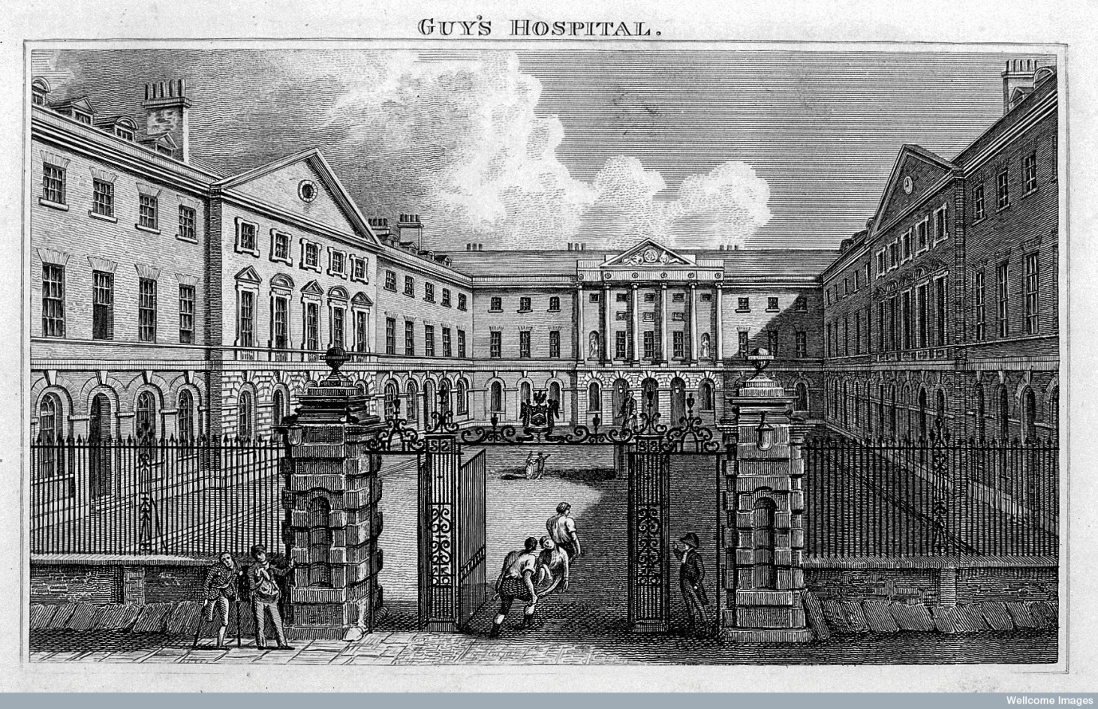
[Engraving of Guy's Hospital, where John Keats trained as a doctor. –WEB-SOURCE.]
“Dwells with Beauty, Beauty that must die;
And Joy whose hand is ever at his lips
Bidding adieu.”
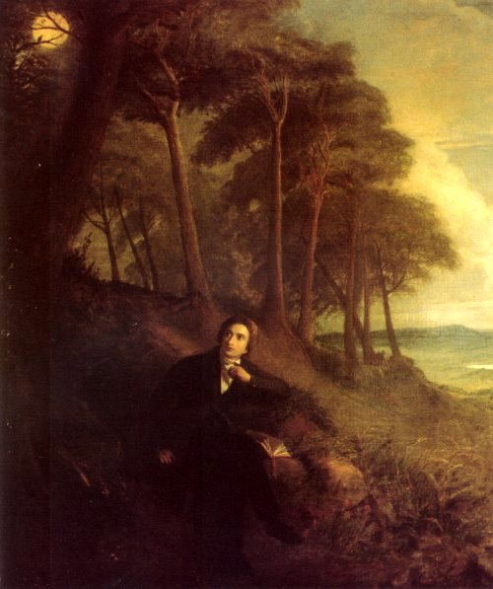
[Joseph Severn's depiction of Keats listening to the nightingale (c. 1845) - WEB-SOURCE.]
There are, thus, a variety of topics introduced in the flow of thoughts that constitute the related-poem, but to think that it has no central theme or unifying motif is to betray indifference to the wonderful power of poetic imagination that sustains the entire ode and the unique artistic design that gives an undeniable coherence to its structure. It is true that Ode on a Grecian Urn concentrates only on the pictures of the urn, their effects and significance; and Ode to Autumn is dedicated on the opulence and beauty of Autumn, without much philosophic reflexion, but Ode to a Nightingale, in spite of being more passionate in mood, more complex in psychological probe and more full of sudden twists and turns of thought by way of dramatic reactions to what may follow, does not in any way forfeit its unity of appeal…But of, his escape to the dreamland of his own doesn’t endure long - Reality soon asserts itself and sets his excursion to the cloud land of the nightingale’s song at naught. He is stranded on the hard shores of reality and left to lament. Ode on Melancholy dwells primarily on two fundamental experiences of human life, the experience of joy and the experience of pain. Paradoxically enough he says that real melancholy is there in all that is joyful and beautiful.
“Save what from heaven is with the breezes blown
Through verdurous glooms and winding mossy ways.”
Though Ode to a Nightingale should be read as a poem of escape, we cannot ignore the reflection of human experience in it. Indeed the poet escapes to the romantic bower of the nightingale to quite forget the ills and evils of life which the bird “among the leaves hast never known”. The poem reflects the tragic human experience that human life is a tedious tale of sorrow, of hopes baffled and efforts disappointed. In this world few men live up to old age, and even those who are fortunate to live up to that age are struck with paralysis agitans, and with a few grey hair on their heads , they hobble along trembling and tottering. Youth is transient and repeated shocks to premature death. The world is so full of miseries that no thinking man can reflect on human life, even for a single moment, without being filled with despair. The lot of man is misery even for the best and fairest. The charms of a loveliest woman fade away very soon, and the love of a woman for her lover does not last longer than a single day.
“Swelter in quiet waves of immortality”
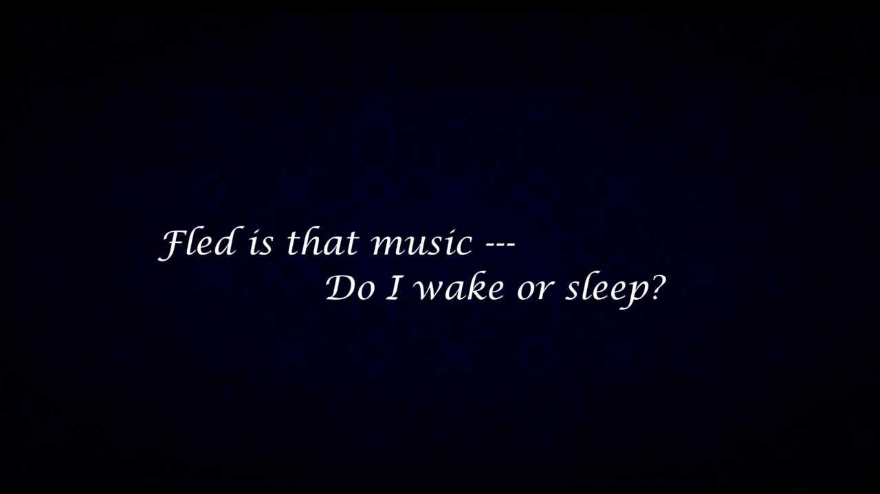
[WEB-SOURCE.]
The realization that happiness in this world is but an occasional episode in the general drama of pain is too much for them to bear. So to forget their own painful experience and that of others they escape to the ideal land of their imagination. Thus Wordsworth escapes to Nature, the vast world of flowers, trees, mountains, valleys etc; Coleridge to the mysterious world of the supernatural and the Middle Ages; and Shelley to the Golden Millennium of the future.
“Think what a present thou to God has sent,
And render him with patience what he lent;
This if thou do, he will an offspring give
That till the world’s last end shall make thy name to live.”
We read Ode to a Nightingale primarily as a poem of escape, Ode to a Nightingale is a glory of Romantic poetry, and escapism is the distinctive feature of Romantic poetry. The Romantic poets are all fed up with the hard stern realities of life – “its din and bustle, fever and fret”.
“… the fancy cannot cheat so well
As she is famed to do, deceiving elf.”
The allegory in Endymion relates the ‘divine essence’ with concrete, sensuous loveliness but by the time we reach Hyperion his conception of beauty has widened. In the first place, beauty has become the symbol of power born of perfection, which explains the victory of the new creation of Gods over the old one; secondly, beauty has become blended with sorrow in the picture of Thea.
“But saintly heroes are for ever said
To keep an everlasting sabbath’s rest,
Still wishing that, of what they’re still possessed,
Enjoying but one joy-but one of all joys blest.”
The treatment of Keats’s poetic growth will be only half-sided if we omit to trace the influence of other poets on the development of his poetic genius. Keats was educated almost exclusively by the English poets. In the early part of his poetic career the influence of Spenser was immense. “It was the Faerie Queene” says Brown a friend of Keats’s later years, “that first awakened his genius.”
“Better than all measures
Of delightful sound,
Better than all treasures
That in books are found,
Thy skill to poet were, thou scorner of the ground!”
Now his imagination invests the nightingale with immortality with the result that it ceases to be a bird to flesh and blood and becomes a thing of beauty, a voice of romance, regaling the ears of kings and clowns, and women in distress and captivity from time out of mind.
“But Oh: how unlike marble was that face,
How beautiful, if sorrow had not made
Sorrow more beautiful than Beauty’s self.”
In Spenser’s fairyland, he was enchanted, breathed in a new world and became a new being. It is significant that Keats’s earliest composition is the Imitations of Spenser, written probably in 1813; and Spenser never lost hold upon his imagination. There was indeed an essential kinship between the two poets, and that brooding love of sensuous beauty, that frank response to charm of nature and romance, that luxuriance of fancy and that felicity of expression to which the Faerie Queene owes its irresistible fascination, were soon to be re-echoed in the poems of Keats. He also came under the influence of Chatterton. Early in 1815, he came under the influence of Chapman’s translation of Homer. The early works of Milton, and of the poems of Fletcher and of William Browne, while his delight in the seventeenth-century Spenserians remained inextricably blended with his admiration for the most prominent of Spenser’s living disciples, the charming and versatile Leigh Hunt. Spenser and Hunt gave a great impetus to his spirit of romanticism. “Keats was introduced by Leigh Hunt,” says Elton, “to the enchanted gardens of romantic poetry.” -He saw “beautiful things made new.”~~………………..
A marvel of English lyrical poetry, Ode to a Nightingale is one of the greatest odes Keats wrote. It illustrates all main features of Keats’s poetry, namely, his concept of Beauty, his Sensuousness, his Meditation, his Hellenism and his Verbal magic. The Odes of Keats are not only sensuous, but also deeply meditative. Ode to a Nightingale turns on the thought of the conflict between the ideal and the real -between the joy, beauty and apparent permanence of the nightingale’s song, and the sorrow and the transience of joy and beauty in human life, which lends a deep philosophic interest to it. It embodies the thought that however distressful the human condition is, man still possesses the capacity to respond to immortal beauty and thus to establish communion with the unchanging world beyond flux and mutability.
“Qual in colle aspro,al imbrunir di sera
L’avvezza giovinetta pastorella
Va bagnando I’herbetta strana e bella
Che mal si spande a disusata spera
Fuor di sua natia alma primavera,…”
(As, on a rugged hill, when twilight darkens,
The young shepherdess, familiar with the place,
Keeps watering a strange and beautiful little plant
Which feebly spreads its leaves in the unfamiliar clime,
Far from its native fostering springtime….)
Thus in different ages men of different classes and social positions - “emperor and clown”, Ruth, captive princess -had, in certain fleeting moments, glimpses of this unchanging world of beauty. The poem also contains the reflection that death means the denial of sensory experience. In the Ode the poet is still sensuous, but his sensuousness is now touched with “the still, sad music of humanity” and shot through and through with the stirrings of an awakening intellect.
“The same that oft-time hath
Charmed magic casements opening on the foam
Of perilous seas, in faery lands forlorn.”
It is true that his poetry does not express the revolutionary ideas of his time, as Shelley’s poetry does. But for, Keats was not a revolutionary idealist like Shelley, nor had he Shelley’s reforming zeal. Keats was a pure poet, who expressed in his poetry the most worth-while part of himself and this worst—while part of great poet must follow the bent of his genius:-he has his own vision of life, and he expresses it in his own way. Wordsworth has a spiritual vision and he expresses it in simple style; Shelley has an idealistic vision and he expresses it in musical verse; Keats had the artist’s vision of beauty everywhere in nature, in art, in the deeds of chivalry, and truth were identical………~~
“…the sweet buds which with a modest pride
Pull droopingly, in slanting curve aside
Their scantily-leaved and finely tapering stems.”
This was the profoundest and innermost experience of Keats’s soul, and he expressed it most emphatically: “Where swarms of minnow show the little heads/Staying their wavy bodies against the stream.” The very idea of joy and beauty make one melancholic because the duration of joy and beauty is very short. They must die one moment or the other. Thus we see that in Ode on Melancholy, Keats is purely realistic and there is no question of making an escape into a different world. The poem deals with purely human emotions of pain and joy.
For Keats, therefore, senses were creative as they set Imagination into play and what the imagination gasped as beauty was also Truth. Thus the Ideal was only a sublimation of the real. He sums up the whole matter in one of his letters: “Adam’s dream will do here and seems to be a conviction that Imagination and its empyreal reflection is the same as human life and its spiritual reflection…The Prototype must be hereafter.” Shelley soared above the earth in search for the light that never fades but Keats contemplated the dark earth against the polar light of heaven, the two being the opposite sides of the same coin.
The Nightingale also embodies the age-old human experiences that however distressful the human condition is, man still possess the capacity to respond to immortal beauty and thus to establish communion with the unchanging world beyond flux and mutability. Thus in different ages men of different classes and social positions-“emperor and clown”, distressed women, captive princesses-had, in certain fleeting moments, glimpses of this unchanging world of beauty. The poem also contains the reflections that death means the denial of sensory experience.
“Like as a ship, in which no balance lies,
Without a pilot, on the sleeping waves,
Fairly along wieth wind and water flies,
And painted masts with silken sails embraves,
That Neptune’s self the bagging vessel saves,”
To conclude, though we should read Ode to a Nightingale as a poem of escape, we should not neglect the reflection of human experience in it.
“When old age shall this generation waste,
Thou shall remain in midst of other woe
Than ours, a friend to man, to whom thou say’st,
“Beauty is truth, truth beauty?’ that is all
Ye know on earth, and all ye need to know.” “
The tale of Keats’s development from his feeble poetic beginnings to the magnificent odes is open of the great stories of literary history. It is remarkable that this achievement is contained in four years. The development, by necessity because of the short period of time, may be incomplete. In Keats’s work, beginning from 1816 and culminating in1821, we see the growth of a high poetic intelligence.
“Now comes the pain of truth, to whom ‘tis pain;
O folly! For to bear all naked truths,
And to envisage circumstances all calm,
This is the top of sovereignty.”
Like Wordsworth’s lark he is -“Type of the wise who soar but never roam/True to the kindred points of Heaven and Home.”But of, this instinctive or sensuous and intuitional perception of the feelings, joys and sorrows of theirs must be balanced and steadied by an intellectual self-awareness.
“Blinded alike from sunshine and from rain
As though a rose should shut and be a bud again.”
In the last book of the fragmentary epic Keats presents the transformation of Apollo through the sudden rushing in of knowledge into his impulsive heart.
“Where we such clusters had
As made us nobly wild, not mad;
And yet each verse of thine
Outside the meat, outdid the frolic wine-“
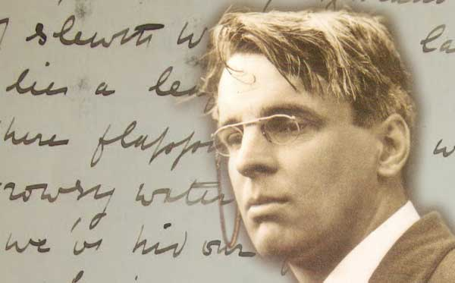
[W.B. Yeats-WEB-SOURCE.]
Keats’s concern for Man simultaneously brings in mind. T.S. Eliot and W.B. Yeats have got to say about the chaotic state of affairs in the world around us, in their famous poems The Waste Land and Sailing to Byzantium respectively. Unfolding deeper mysteries of life, finding the truth of being and the meaning of existence are as much a rhyme of Keats’s poetry as recurrently we see them finding place in the poetry of modern poets. He has in him Wordsworth’s fundamental goodness of human-heart and it is this basic goodness of heart that generates in us a sense of oneness with Keats. He feels for us and in return we feel for him and this accounts for his ever-continuing appeal to his readers. His poetry shows a deep concern for Man, the problems of Man and his pains and joys. We find much of the same thing in the poets of our times. Another feature of Keats’s poetry which has also been employed to a much greater degree by modern poets is Symbolism. Keats has made use of the Nightingale as a symbol of permanence and immortality and the Grecian Urn as a symbol of artistic perfection. There are inspired moments when the present beauty of nature with all its sensuous appeal gives him a fleeting vision of deeper reality. He then in his imagination passes from the world of time to the world of eternity. These mystic experiences are indicated in his Ode to a Nightingale. As Keats hears the song of the nightingale, the barriers of time and space seem to vanish away. He has imaginatively passed through death, flown on the wings of imagination to the nightingale, the barriers of time and space seem to vanish away. He has imaginatively passed through death,- “flown on the wings of imagination to the nightingale’s immortality”. The nightingale will be singing on while he will become a sod. “Then”, says Middleton Murry, “with a magnificent sweep of the imagination, he sees the song and the bird as one. The bird becomes pure song, and inherits the eternity of beauty.”
Keats often asked himself the question, “Where are the songs of spring?” Indeed, the songs of spring do not stay; beauty does not keep her lustrous eyes for long. So beauty is transitory, fleeting -it remains for a time and passes away. It is experience of his senses, but his imagination revealed to him the essential truth about beauty. Though poetry came naturally and spontaneously to him,” as leaves to a tree”, yet he felt that poetic composition needed application, study and thought, and with regard to many passages of his works he took considerable pains to shape his verse. The observation that Ode to a Nightingale, unlike Keats’s other odes, has no single central theme is neither true nor desirable. Keats was a conscious artist and his poetry, apart from its other qualities, is marked by its artistic workmanship. He wrote rapidly and many of his happiest phrases came to him in the flush of inspiration; still he carefully reviewed his work, and made alternations, where necessary, to give his conceptions the desired shape. “Keats’s sureness of touch in the corrections of his verse reveals is sense of consummate artist.”
“What men or gods are these? What maidens loath?
What mad pursuit? What struggle to escape?
What pipes and timbrels? What wild ecstasy?”
This is why Keats laid so much emphasis on the ‘negative capability’ of the poet: ‘A poet is the most unpoetical thing in the world because he has no identity he is continually filling some other body…it enjoys light and shade; it lives in gusto, be it foul or fair, high or low, rich or poor, mean or elevated…capable of being in uncertainties, mysteries, doubts, without any irritable reaching after fact and reason.’ Again, he is with his fellow human beings to sit with them and hear their groans. He always has a warm corner in his heart for those sufferings from “the fever, and the fret” and palsy.
“Sitting careless on a granary floor,
Her hair soft-lifted by the winnowing wind,
Or on a half reaped furrow sound asleep
Drowsed with the fume of poppies, while her hook
Spares the next swath and all its twined flowers.”
In Ode to a Nightingale, we find that Keats has been deeply grieved by the mental strains of humanity at large. These strains have resulted from the intricate complexities of human life. Some are suffering from palsy, the others are dying young. Everyone has one problem or the other so much so that “Men sit and hear each other groan.” In nutshell, man is suffering from so many that the world has become a place, “Where but to think is to be full of Sorrow”. In order to find relief from the heavy burden of human worries, Keats wants to fly far away into the world of the Nightingale who, “Among the leaves hast never known” as to how miserable is the life of man in the world of reality. The natural beauty of the world of Nightingale also subdues Keats’s mental strain to a large extent. The happy lot of the Nightingale also generates a death wish in Keats and he puts it very clearly, “Now more than ever seems it rich to die”, but finally Keats comes back into the world of reality with the sound of just one word, ‘Forlorn’, a word that reminds him of the human lot.
“In the very temple of Delight,
Veiled Melancholy has her sovereign shrine.”
So, imagination reveals a new aspect of beauty, which is; sweeter’ than beauty which is perceptible to the senses. The senses perceive only external aspect of beauty, but imagination apprehends its essence, and “what the imagination seizes as beauty (Keats says) is truth’’.
“Thou wast not born for death, immortal bird,
No hungry generations tread thee down.”
In so far as they fail to do this, in so far as they are thoughts and reasoning, they are no more than a means to an end, which end is beauty-that beauty which is also truth. This alone is the poet’s end and therefore his law (Bradley). Keats was led to this conviction by the poetic instinct in him. He was more than Wordsworth or Coleridge or Shelley, a poet and simple.
“Follow thy fair sun, unhappy shadow,
Though thou be black as night,
And she made all of light,
Yet follow thy fair sun, unhappy shadow.”
But of, Keats’s aestheticism was not only sensuous -it had an intellectual element. He was constantly endeavouring to reach truth through beauty; he had a conviction that “for his progress towards truth, thought, knowledge and philosophy were indispensible, but he felt also that “a poet will never be able to rest in thoughts and reasoning, which do not also satisfy imagination and give a truth which is also beauty.”
“And ask no questions but the price of votes. “
The ode is an exquisite example of the imaginative adventure of Keats. Nature takes him away from’ the weariness, the fever and the fret of the present world to the eternity of beauty represented by the song of the nightingale. Here is the highest nature poetry of Keats, where the inspired imagination of the poet gives him a fleeting glimpse of eternal beauty.
“Hear melodies are sweet, but those unheard
Are sweeter; therefore ye soft pipes, play on;
Not to the sensual ear, but more endeared,
Pipe to the spirit ditties of no tone.”
Keats was a conscious artist in the matter of producing musical effects in his verse. He consciously used language as Spenser, the Elizabethan poets, and Milton had used it, employing all its resources to make his verse musical. He frequently uses alliteration, but it is used with the sure tact of an artist, so that it contributes to the music of his verse:” the marble men and maidens”, “the winnowing wind”, “fast fading violets covered up in leaves”. In his Odes, vowels are artistically arranged so that they do not clash with one another; they bear the burden of the melody, and are interchanged, like the different notes of music, to prevent monotony. Many are the devices employed by the poet to make his verse musical, one of them being to make the sound echo the sense.
“But as I raved and grew more fierce and wild
At every word,
Methought I heard one calling, Child:
And I replied, My Lord.”
The focus is predominately on the ephemeral character of all that is valuable and desirable in life. Human sorrow and suffering and loss are mainly due to the decay and fickleness of youth, health, beauty and love. The quickly perishable charms of life under the ruthless domination of devouring time only leaves an inevitable sense of inconsolable gloom and despair. The destructive process in the life of reality is also expedited by ‘hungry generations’ treading on the existing beings and things.
“…for heaven’s smiling brow
Half insolent for joy began to show:
And the brag lambs ran wantonly about,
That heaven and earth might seem in triumph both to shout.”
The Middle Ages have been said to be a vast storehouse of romance, and some of the romantics freely drew upon this storehouse for their inspiration. Distance lends enhancement to the view, and so the distant days of the medieval past made a strange appeal to the romantics. Pater says that the romantic quality in literature is addition of strangeness to beauty, and this strangeness, the romantic poets-Coleridge, Scott and Keats, is one of those, who reveled in the past, in which his imagination, loved to dwell are the Middle Ages and the days of ancient Greece, with its beautiful mythology.
“A! fredome is a noble thing.
Fredome maiss man to have liking:
Fredome all solace to man gives:
He livis at ease that freely livis.”
In Ode on a Nightingale, there is sorrow, but Keats, an untiring worshipper of beauty, would not allow his personal sorrow to interfere with his pursuit of beauty. In one of his letters Keats writes: “The setting sun will always set me to rights, or if a sparrow were before my window I take part in its existence and pick about the gravel.”
“Knowledge enormous make a god of me
Names, deeds, grey legends, agonies etc.
Pour into the wide hollows of my brain
And deify me.”………
Every poet is a lover of beauty-but he may have, and often has, other interests and affections. Shakespeare was interested in the drama of human life and in the play of human passions. Milton’s dominant interest was religion, though he was passionate lover beauty. Wordsworth and Shelley had other interests than mere beauty, but to Keats passion “with a great poet, the sense of beauty overcame every other consideration”. Beauty was, for Keats, the moving principle of life; infact, beauty was his religion. He loved beauty in all its forms and shapes-in the flower and in the cloud, in the song of a bird and in the face of a workman, in a work of art and in tales of romance and mythology. And all his poetry from Endymion to Hyperion has one dominant theme- viz. Beauty.
“O cheeks! Beds of chaste loves
By your showers seasonably dashed;
Eyes! nests of milky doves
In your own wells decently washed;
O wit of love! that thus could place
Fountain and garden in one place.”
Like the ancient Greeks, Keats often presents the objects of nature as living beings with a life of their own. As Leigh Hunt said of him, “he never beheld the oak tree without seeing the Dryad.” The moon is Cynthia, the sun Apollo. Keats’s observation of Nature is characterized by minuteness and vividness. Keats’s eye observes every detail, and presents it with a mature touch. He has the knack of capturing the most essential detail and compelling our attention. His descriptions of nature are thus marked by a fine pictorial quality.
Keats remained untouched by the idea of the Revolution which filled the atmosphere of Europe at the time; at least from his poetry we do not find any indication of his interest in the Revolution. Though the contemporary facts of history have not left any impression on his poetry, he deeply realized and expressed in his poetry the fundamental truths of life. Keats was a pure poet, and would not allow any extraneous things like politics or morality to disturb the pure waters of poetry. And poetry is the expression of the poet’s own experience of life. Keats as he developed mentally and spiritually- and his development was very rapid- was searching for truth in his soul. The earlier hankering for the world of Flora and Pan- for unreflecting enjoyment of sensuous delights- is past; he now subjected himself persistently and unflinchingly to life. He faced life with all uncertainties and contradictions, its sorrows and joys.
“Eheu quid volui mihil floribus austrum
Perditus…”
(Alas, what wretchedness have I brought upon myself!
I have let loose the south wind upon my flowers….)
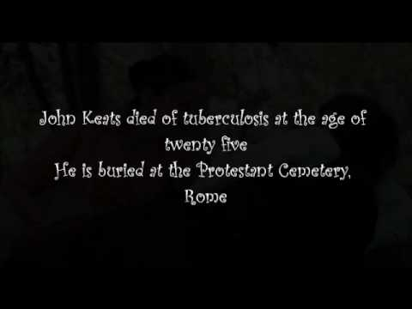
[IMAGE FROM WEB-SOURCE.]
Ode to a Nightingale begins by pitting the poet’s heart-ache against the ‘full-throated ease’ of the nightingale’s song whose joyous melody is symbolic of the undying beauty of art; and by suggesting a reconciliation of the contraries by ‘being too happy in thine happiness.’, but nevertheless the intensity of the contrast between the nightingale’s forest world and the painful, troubled and decaying human world is brought into sharp focus in Stanza Third: the nightingale ‘among the leaves’ is completely free from ~~
“What is love?’ tis not hereafter.
Present mirth hath present laughter;
What‘s to come is still unsure.
In delay there lies no plenty;
(…..Then come kiss me, sweet and twenty,
Yoth’s a stuff will not endure.”)!

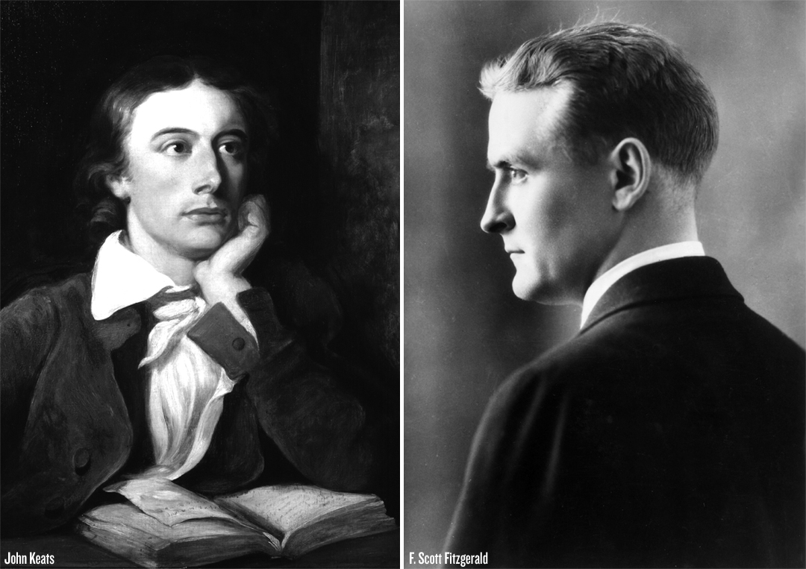

[To F. Scott Fitzgerald Read Keats’s 1819 Classic Poem “Ode To A Nightingale”- WEB-SOURCE]
The contrast between the imperishability of the world of art or the emblem of imagination and the transience of life, is a common theme in romantic poetry and analogies are frequent in Shelley and Yeats, but what gives greater depth to, and accounts for the subtler effect of Keats’s presentation of those contrast is his ironical and paradoxical awareness of the other side of things. The moment, when Keats listens to the superb spell of the nightingale and glorifies its song as well as the singer as ‘immortal’, is not measured in terms of clock-time or calendar-time, it is an ‘eternal moment’ as Foster calls it; and once ‘eternal’, it remains so even after the fading away of the ‘plaintive anthem’, with the flying away of the bird to the other side of the hill.
“The weariness, the fever, and the fret,
Here, where men sit and hear each other groan;
Where palsy shakes of few, sad, last grey hairs,
Where but to think is to be full of sorrow.”
Melancholy arises from transience of joy is transient by its nature. Therefore, Keats accepts life as a whole-with its joy and beauty as well as its pain and despair. It is this alternation of joy and pain, light and shadow, that gives life its harmony, his is the truth of life- and truth is beauty. The poet is wholly in the time and with the things of which he wrote. He lives wholly in the present, and does not look back to the past or forward into the future.
The Greeks were lovers of beauty, and so is Keats. To him, as to the Greeks, the expression of beauty is the aim of all art, and beauty for Keats and Greeks is not exclusively physical or intellectual or spiritual bur represents the fullest development of all that makes for human perfection. It was the perfection of loveliness in Greek art that fascinated Keats, and it was the beauty and shapeliness of the figures on the Grecian Urn that started the imaginative impulse which created the great Ode. The instinctive Greekness of Keats’s mind lies in his passionate pursuit of beauty, which is the very soul of his poetry. It is a temper of unruffled pleasure, of keen sensuous joy in beauty. To him a thing of beauty is a joy forever. Keats enters fully into the life of nature, and does not impute his own feelings to her. He is completely absorbed in the momentary joy and movement of things in nature. He enters into-
“Who hath not seen thee oft amid thy store?
Sometimes whoever seeks abroad may find
Thee sitting careless on a granary floor
Thy hair soft-lifted by the winnowing wind;”
The Greeks did not burden their poetry with philosophy or spiritual message. Their poetry was incarnation of beauty, and existed for itself. Similarly Keats was a pure poet. He enjoyed unalloyed pleasure in nature, which for him did not carry any philosophical or spiritual message. Keats did not know anything of Shelley’s enthusiasm for humanity, or his passion for reforming the world. Keats’s poetry had no palpable design; it existed by its right of beauty. For Keats the sense of beauty overcame every other consideration.
“Go, soul, the body’s guest,
Upon a thankless arrant
Fear not to touch the best;
The truth shall be thy warrant.
Go since I needs must die,
And give the world the lie.”…
Graham Hough perceived that Keats’s major odes ‘are closely bound up this theme of transience and permanence.’ It is his romantic urge that forces him, after acutely feeling the tragic loss of all that is lovable and precious in life in the inevitable flux of the world of reality, to discover an imaginative resource of permanent beauty and happiness, which would defy the decaying power of time. And in his poetry he continually makes an ‘attempt to reconcile the contradiction’ between mutability of human life and permanence of art.
The four major odes of Keats, ‘Ode on a Grecian Urn’, ‘Ode to a Nightingale’, ‘Ode to Autumn’ and ‘Ode On Melancholy’ yield a very interesting study if they are read one after the other. The total impression of these Odes constitutes a very solid and compact whole. There is an element of unity in the final impression that they leave upon the reader and this unity springs primarily from the oneness of themes in these odes. The basic theme, underlying all these Odes can be summed up very briefly like this: The Odes deal with the fundamental human problems of finding a solace from the naked and merciless realities of life. The solace can be found in the objects and beauties of nature, in the world of art, in the world of imagination and in a wish for death but with Keats the solace is always temporary in character and a final come back into the world of realities is very important and essential. In the Ode to Autumn, he asks, the past or forward into the future. The acceptance of life- this triumph over despair attained through deep spiritual experience is expressed most forcibly in his Ode on a Grecian Urn.
“Beauty is but a flower
Which wrinkles will devour:
Brightness falls from the air,
Queens have died young and fair,
Dust hath closed Helen’s eye.
I am sick, I must die.
Lord, have mercy on us!”…………………….
The ode begins and ends in real time and is in a very profound way bound by time. Living in real time and is in a very profound way bound by time. Living in real time, the nightingale provides the plot by impinging on the poet’s consciousness, so provoking the reflections that make up the poem, before flying away…’. This is the fact, as observed by John Barnard in his John Keats that accounts for the thematic unity of the ode. The thought of soporific drug in the first stanza leads to the thought of wine in second stanza and the thought of flight from reality. The reason for this desire to escape is given in third stanza. The escape is achieved through imagination in fourth stanza and this and the next stanza dwell on a peaceful, relaxed enjoyment of the sensuous beauty of nature. The topic of death in six stanzas is allied to the desire to escape already mooted in the earlier stanza. Robert Bridges has complained of an unexpected shift of thought in seventh stanza., but of the key-line, ‘ Thou wast not born for death, immortal Bird!’ has own and of man’s , mortality, a contrast, which is very much the central theme. It is a moment which is timeless, this impression is created by the magical voice of the nightingale and the same spell is conveyed on us by the wonderful song of the poet. So, it is idle to complain that the poem lacks a definite central theme. Rather the unity of the basic inspiration is felt again and again in the depth of our hearts and it is clearly betrayed in the diction as well. The ‘fade away’ of second stanza is echoed by ‘Fade for away’ in third stanza, and ‘Away! away! for I will fly with thee’ in fourth stanza. The ‘hungry generations’ in seventh stanza recalls the sordid picture of life in third stanza. It is the last word, ‘forlorn’ in sixth stanza which is repeated like a refrain at the beginning of seventh stanza to mark a bridge between the land of fancy and the solid ground of reality. What more could be expected by way of thematic unity in a genuine romantic poetry where passion and imagination enjoy the right to blossom fully?
“Sweet Spenser, moving through his clouded heaven
With the moon’s beauty and the moon’s soft place.”
In his Ode to Nightingale, the luxuriance of his fancy carries him far away from the fever and fret of the world to a faery land, where the song of the nightingale can be heard through “charmed magic casements opening on the seas”. He is carried away by his imaginative impulse, but his artistic sense soon prevails. The exuberance of his fancy does not blind him to his classical sense of form and order. He realizes that “fancy cannot cheat so well as she is famed to do,” and he comes back to the world of realities.
“A little lowly Hermitage it was,
Down in a dale, hard by a forest’s side.”
All romantic poets except Keats see in nature a deep meaning, ethical, moral, intellectual or spiritual. For Wordsworth, Nature is a mother, a nurse, an educating influence. He regards it as a living spirit. He sees in it the presence of God. Shelley, too, finds in Nature Intellectual Beauty, but while Shelley intellectualizes nature and Wordsworth spiritualises it, “Keats is content to express her through the senses; the colour, the touch, the scent, the pulsing music; these are the things that stir him to his depths; there is not a mood of Earth he doesnot love, not a season that will not cheer or inspire him.”
“Forlorn; the very word is like a bell
That dolls me back from thee to my sole self”,
Thus we find here a happy blending of the romantic ardour with Greek restraint of romantic freedom with classical severity. Thus “there was in Keats the keenest sense and enjoyment of beauty, and this gave him a fellow-feeling with the Greek masters”, but of it was one side of Greek art he saw. He saw its beauty, but he did not see its purity, its self-restraint and its severe refinement. His poems-barring La Belle, the Odes and the Hyperion fragments are characterized by over-refinement and looseness. They have romantic ardour, but lack classical severity. It is in the Odes that we find a fusion of romantic impulse with classical severity. Here we notice Keats’s sense of form, purity and orderliness. The Odes show an amazing sense of proportion in the Greek manner and present well-designed evolution of thought. They have a close texture and are marked by severe restraint, but at the same time they have all the spontaneity and freedom of imagination that characterizes romantic poetry.
“Mori mihi contingat, non enim alia
Liberatio ab aerumnis fuerit ullo pacto istis.”
(Would I were dead,for nought, God knows,
But death can rid me of these woes.)
The poem ends by admitting in a very sensible manner the impossibility of achieving freedom from the tethers of the struggles and pains and frustration of life through imagination forever, because ‘the fancy cannot cheat so well/As she is fam’d to do, deceiving elf’. The implication in ‘so well’ includes a stress on ‘so long’ too, but the quality and intensity of this joy and freedom achieved through artistic fancy has an eternal value. John Barnard has rightly observed: ‘The paradox of the poem is that by admitting failure it, as if inadvertently, demonstrates the grandeurs of the human singer, who within his limits, gives the bird immortality-an immortality that exists only in the human mind.’ It is our capacity of thought which makes our mortality so palpable to us and makes us ‘full of sorrow’. But for, the nightingale is unthinking, so it cannot possible comprehend the advantage of immortality and accompanying feeling of superiority.
“For Love is lord of truth and loyalty,
Lifting himself out of the lowly dust
On golden plumes up to the purest sky
Above the reach of loathly, sinful lust
Whose base affect through cowardly distrust
Of his weak wings dare not to heaven fly.
But like a moldwarp in the earth doth lie.”
Same is true of the Ode on a Grecian Urn, Keats is acutely aware that in real life everything is short-lived and fleeting, but when he looks at a beautiful pieces of art, the Urn, he is all praise for its artistic worth which has lent a torch of immortality, not only to the Urn itself, but also to all that has been carved upon it, the piper, the trees, the lover and the maidens. Even earthly objects have been immortalized just because they are there on a piece of art that has been very beautifully named by Keats as the “Still unravish’d bride of quietness” and the “Sylvan historian.” Analysing the contents of Keats’s Ode to a Nightingale according to prosaic logic, one may naturally think that the poem is full of diverse thoughts. It begins with an expression of dull pain suffered by the poet which seeks a relief in the joyous song of the nightingale. It draws a contrast between his deep drowsiness and the bird’s full-throated song and Dryad like charm in the beech-green forest. The second stanza records a picture of Dance, and Provencial song, and sunburnt mirth in summer in Southern France, born out of the poet’s desire for a beaker full of wine which he needs to drink in order to forget the world of reality and escape from it to the nightingale’s world. The third stanza concentrates on the misery and plight of human beings on earth, where suffering and death are the only certainty, and youth, beauty and love are constantly facing extinction. The fourth and fifth stanzas contain the poet’s imaginative experience of sitting on the leafy tree with the nightingale in the embalmed darkness and anticipating the beauty of the moonlit sky above and the charm of the fragrant flowery garden below. The sixth stanza brings back his focus on the nightingale’s song itself and triggers off his constitutional desire for death, which flares up at this opportune moment, when the bird’s song can serve as a requiem. The seventh stanza contains an emphatic assertion of the nightingale’s immortality, and the poet, flying on the wings of imagination, traverses an unending amount of space and time to affirm that the same nightingale sang from days immemorial to persons of all kinds, in life and in fiction. Finally, in the last stanza the poet wakes up from his dream, at the fading away of the nightingale’s song, as the bird flies across the hills. He is faced with stark reality and realizes that fancy cannot prolong its spell on human mind.
The beautiful sensuous lines on the Queen Moon, ‘Starry Fays’ and the scented flowers of the season, bear eloquent testimony to his love for and intense appreciation of the gifts of nature which he wanted to explore and cherish. The spirit and attitude betrayed here is positively youthful and enthusiastic. His whole being is involved in this eternal celebration of life. No idle escapist has the capacity to think, as Keats has done in this ode, about the relation of ideal art, represented by the nightingale’s song and transient, ever-changing life of reality. The nightingale was ‘not born for death’, he asserts and immediately re-asserts his conviction by calling it ‘immortal Bird!’, but man is simply mortal and in his world of mortality nothing lasts long, being devoured by time and treaded down by ‘hungry generation.’ Moreover, if the escapist mood had become dominant for some moments due to frustrations and vexations of life, Keats finally does not fail to realize that escape from reality is absurd and realistically he can feel that the nightingale’s song is nothing as joyous as it pretended to be, but a ‘plaintive anthem’. At the end of the poem he wakes up from his indolent dream to face actual life on its terms.
“Love, the delight of all well-thinking minds;
Delight, the fruit of virtue dearly loved;
Virtue, the highest good that reason finds;
Reason, the fire wherein men’s thoughts be proved;
Are from one world by Nature’s power bereft,
And in one creature, for her glory, left.”
Moreover, it is the bard, a human creator, who invests the nightingale with immortality by glorifying its song in his song that hopes to attain immortality. In reality a nightingale’s life-span is much shorter than a man’s and its song survives only in the sense of a kind of song by successive generations of nightingales; whereas in case of a great poet like Keats, his individual song endures.
“Ecce novo campos Zephyritis gramine vesit
Fertilis, et vitreo rore madescit humus.”
(See, the bountiful daughter of Zephyr dresses the fields in new grass, and the earth is moist with glistering dew.)
In Ode to a Nightingale Keats shows his deep sense of awareness for “the fever, and the fret” of men and women of the world of reality. The poet thinks of forgetting his personal loss and suffering in life by drinking and sleeping under the influence of the liquor. He thinks that the sweet song of the nightingale is a sure testimony of the absolutely happy world of the bird. The poet, therefore, eagerly wants to escape from the life of reality, which has given him a surfeit of torment and misery in the forms of ill health, unsuccess in poetic career and in love and bereavement of a younger brother and seek refuge in the forest world of the nightingale. His personal afflictions are also seen as part of the sad lot of humanity as a whole. The general picture of malady is undeniably moving in its pitiful starkness. Thus, Ode to a Nightingale may truly be described as a wonderful poetic record of the poet’s reflection of human experience.
“The Lord thy God I am,
That Johne dois thee call;
Johne representit man,
By grace celestiall.”
The pattern of thought in the Ode is apparently complex and not smoothly linked in parts, but the occasion as well as the basic impulse and atmospheric effect, externally spelt through the music and the imagery , secure unity and solidarity of this creative artistic production. It starts with a feeling of drowsiness and ends with the final clearing of that smokiness of the brain. The entire period in between was a spell cast by the nightingale’s melody on the highly sensitive and imaginative mind of the poet. One of the main ideas in this romantic poem is a sincere yearning to get away from the miseries and frustrations of life, to escape ‘the weariness, the fever and the fret’, which the poet experienced from his failure to achieve fame, love and health. What he generalizes as the lot of humanity is authentically based on his personal afflictions. It is therefore impossible to escape from inevitable pain in life. Shelley says of the dead Adonias:
“He lives, he wakes-his Death is dead, not he.”
It is the thought of death or mortality that naturally leads to its opposite thought, that of immortality. It enables the poet to highlight the contrast between the world of man and that of the nightingale in a climactic manner. With a philosophical imagination Keats calls the nightingale ‘Immortal Bird’. The phrase has been variously interpreted, the most common of them being that the poet is called not a particular bird, but the nightingale as a species, immortal. Some think that it is not the bird, but its song which is immortal in its appeal, but it is more reasonable to agree with Farrod who points out that the particular nightingale is addressed as ‘Immortal’ because Keats has called it ‘light winged Dryad of the trees’ at the outset , a creature of myth, like nymphs and fairies, which being purely imaginary, are not subject to death.
“Who brought me hither
Will bring me hence, no other guide I seek.”
Ode to a Nightingale has a note of searching melancholy and is inspired by the poet’s personal sufferings and disappointments in life, the latest of which was the death of his brother, Thomas Keats. Not only does he want to escape to the nightingale’s forest, but he also yearns for death. Life’s torture has taught him to love Death and call him ‘soft names’. The wish ‘to cease upon the midnight with no pain’ and with the nightingale’s song in his ears, is a purely romantic wish. The beginning of the next stanza, contrary to the opinion of some critics, is not at all abrupt.
“Now more than ever seems it rich to die
To cease upon the midnight with no pain
While thou art pouring forth thy soul abroad.”
The thirst for wine brings in the beautiful sensuous image of a ‘beaker full of the true, the blushful Hippocrene/With beaded bubbles winking at the brim/ And purple-stained mouth’. Allusions and concrete imagery reinforce each other to produce the whole sensuous impact as unforgettable. We not only have the rich colour of the wine, but also the emphatic suggestion of its poetic efficacy. The small bubbles with their bead-like shapes and restless movement are compared to curious children peeping at the outside world from the rim of the container and winking. It will be difficult to find in the whole range of English poetry a more truly romantic lyric and a better penetration into the mysteries of life and death in a mood of complete absorption in beauty. The ode is intensely lyrical, yet its thoughts are elaborate enough to form a comprehensive philosophy in combination with imagination and sensuous experience. Keats’s poetic genius attains maturity to find its most perfect expression in a few wonderful odes, and Ode to a Nightingale is undoubtedly at the centre of the selected band. The nightingale’s song, heard by the poet in the Hampstead Garden, triggers a series of sensations and thoughts and builds up imaginative situations, in the mind of the poet. It produces myths, gorgeous imagery, subtle psychological perception and takes us through momentous experience of personal memory and historical imagination.
Still the fundamental fact remains that Keats must not escape to the world of the Urn or the world of the Nightingale for long. In the fourth stanza of the poem he realizes that with all its immortality with it, the Urn will remain speechless. It will remain empty and desolate and the desolation of the Urn, once again brings back on the hard crust of earth on which average man lives. This vivid depiction of the negative side of life makes all readers acutely feel a desire to escape from here. And the poet passionately and emphatically cries out: He decides to fly on the wings of poetic imagination and stays in the company of the nightingale on the shady branch of a leafy tree. He indulges in the contemplation of nature’s beauty and pleasures. “Or new love pine at them beyond to-morrow”, are “thrilled with aching hopelessness”, but this hopelessness, this despair, Keats met squarely. In Ode to Melancholy, he points out how sadness inevitably accompanies joy and beauty. The rose is beautiful indeed, but we cannot think of the rose without its thorn.
“Open the temple gates unto my love,
Open them wide that she may enter in,…”
The nightingale, the source of the purely joyous music, is a symbol of perfect happiness and beauty; and is world amidst the forest is the ideal world offering a total contrast to the sordid, painful and morbid world of man. This purely romantic conception of aspiring for the ideal and bewailing the fact that it cannot be achieved by mortal man, is comparable to the attitude of Shelley in To a Skylark and of Yeats in The Stolen Child. Keats calls the nightingale ‘light- winged Dryad of the trees’, who sings of the joyous summer and whose song is imaginatively associated with the warm Southern countries of ‘Dance and Provencal song’ and ‘sunburnt mirth’.
“So every spirit, as it is most pure,
And hath in it the more of heavenly light,
So it the fairer body doth procure
To habit in, and it more fairly dight
With cheerful grace and amiable sight.
For of the soul the body form doth take:
For soul is form and doth the body make.”
All through the poem, we are keenly alive to Keats’s sensitive study of nature’s charm and beauties, while a poignant sense of melancholy pervades the atmosphere, but above all and, superintending other elements, is the astonishing flight and magical power of imagination. “This joy in present, this absorption in the beauty of the hour, this making of it a divine possession and losing in its loveliness, the pain of life is one of the chief makes of his genuine.”The richly sensuous stanza on flowers where the sense of smell is most exhaustively exercised is justly famous. The poet at once takes us into the enchantingly fragrant atmosphere of the dark garden, where we inhale and identify white hawthorns, eglantines, violets and the musk-rose, astonishingly mythed as ‘Mid-May’s eldest child’. At the same time a unique melodious effect is achieved by the ultimate verse of this stanza: ‘The murmurous haunt of flies on summer eves.’
“her pure and eloquent blood
Spoke in her cheeks, and so distinctly wrought
That one might almost say, her body thought.”
Since the bird is immortal its song is literally timeless and defies the barrier of space. The poet imagines that the same nightingale which is singing to him now had gladdened the hearts of monarchs as well as fools in ancient days, relieved the gloom of Ruth’s mind in the biblical times and even had consoled the captive princess of the fairy tales. The powerful imagination thus sweeps all over the universe and blends together the real and the imaginary. The drab world of reality is linked by its aerial ray with the ‘faery lands forlorn.’ But of, though the wings of imagination float the poet wherever he wishes to fly Keats retains artistic control over his creation. The quick succession of thoughts, spontaneous, rich and colourful, is beautifully stranded together as the colours in a rainbow. The whole effusion is occasioned by the nightingale’s song and at the end, the poet is waked up to reality from his ‘vision’ or reverie when the bird files away and its song fades into silence. Meanwhile his mind has ranged from the garden bench to the farthest ‘charmed casements, opening on the foam of periluous seas’, only to return to the starting point, after completing a circle. Structurally the poetic frame-work, containing the feelings, thoughts and fancies, is admirably sound.
“I envy no man’s nightingale or spring;
Nor let them punish me with loss of rhyme
Who plainly say, My God, My king.”
In sharp contrast to this, the nightingale is called ‘immortal’, ‘not born for death’ and its song, which represents ideal beauty of art, has an eternal and universal appeal. It is omnipresent in all times and places and casts its spell unfailingly on John Keats as well as on kings and Ruth and the captive princes of the medieval Romances and fairy tales. The romantic imagination has lifted the poet far away from the nightingale whose song is the theme of the poem.
“The same that oft-times hath
Charmed magic casements, openings on the foam
Of perilous seas, in faery lands forlorn.”
Here there is romantic suggestiveness and mystery. The nightingale’s song is the voice of eternity, and the poet longs to die in the hope of merging with eternity. There is, behind the expressed words, a world of mystery. This is a romantic style. The word ‘rich’ is infinitely suggestive-suggestive of the sensuous delight of the poet, his physical comfort as well as the soul’s ardent longing to escape the fever and fret this world.
“And my soul from out that shadow that lies floating on the floor
Shall be lifted-nevermore!”
The beginning of the next stanza, contrary to the opinion of some critics, is not at all abrupt. It is the thought of death or mortality that naturally leads to its opposite thought, that of immortality. It enables the poet to highlight the contrast between the world of man and that of the nightingale in a climactic manner. With a philosophical imagination Keats calls the nightingale ‘Immortal Bird’. The phrase has been variously interpreted the most common of them being that the poet is calling is not particular bird, but the nightingale as a species, immortal. Some think that it is not the bird, but its song which is immortal in its appeal, but it is more reasonable to agree with Garrod who points out that the particular nightingale is addressed as ‘Immortal’ because Keats has called it ‘light winged Dryad of the trees’ at the outset, a creature of myth like nymphs and fairies, which, being purely imaginary are not subject to death.
“Where are the songs of spring?
Ay, where are they?”
He answers, “Why talk of spring? We are in autumn.”
From this stark and gruesome reality the poet wants to escape on the ‘viewless wings’ of imagination to the world of the nightingale. By virtue of his unfettered romantic fancy he can lose himself in the midst of the dark foliage of the trees and sit beside the nightingale. It has a miraculous power to deport him through time and space anywhere in the universe. It is this imagination which immediately leads to the creation of a mythical image of Spenserian sweetness. The note of escapism asserts more strongly in the death-wish of the poet. The soothing darkness brings up his desire for dark death.
“With beaded bubbles winking at the brim,
And purple-stained mouth;
That I might drink, and leave the world unseen,
And with thee fade away into the forest dim.”
A drowsiness steals over him as if he has drunk an opiate. He wishes for a draught of vintage, which would carry him out of the world into the abode of the nightingale. He would thus leave behind him the sorrows of the world. He thinks of the universal, sorrows of man, and his own particular and personal griefs. The youth that grows pale and spectre-thin and dies, is his own, dearly loved brother Tom who had died few months before, and beauty’s lustrous eyes are according to Middleton Murray, the eyes of Fanny Brawne, whom Keats loved. “This stanza is tense with the emotion of personal suffering controlled by poetic genius.”
“..for many a time
I have been half in love with easeful Death,
Call’d him soft names in many a mused rhyme,
To take into the air my quiet breath;
Now more than ever seems it rich to die,
To cease upon the midnight with no pain…”
A highly imaginative and purely romantic poet like Shelley or Keats cannot be reconciled with the real life which they feel as oppressive and restrictive in every way. In all their representative creations an urge for getting rid of the tyranny and bondage of social life must be inevitably betrayed. Ode to a Nightingale being one of Keats’s most significant poetical utterances, does illustrate an escapist trend of the poet. However before making any final appraisal of this feature in the poem, we have to consider what the term ‘escapism’ implies and whether in Keats’s poetry it is a passing mood or a permanent obsession. ’Escapism’ is usually a pejorative term; it is used to denote a strong reproof, a criticism of the habit of shrinking or avoiding duties, a failure to face life’s trials. Escapists run away from harsh, unpleasant acts and duties and try to hide themselves in their idle world of dream and peace, like an ostrich hiding its head in the sands during storms on the desert. It implies cowardice and spinelessness.
The first and foremost quality of his odes is their unity of impression. The major odes of Keats-Ode to a Nightingale, Ode on a Grecian Urn and Ode on Melancholy have a common subject and theme. They have a common mood to depict and last but not the least in all these odes the development of mood is more or less similar and the mood develops , in the shape of a drama, i.e. first the mood takes birth, it develops, reaches a climax and finally the anti –climax takes place. Thus when we read Keats’s odes, we feel that we are reading an abridged drama, and in this lay the secret of their success. In so short a form of writing, Keats been able to give an impression of the kind that plays of Shakespeare produce, but for it shall be an over-simplification of facts if this statements of ours is taken to mean that Keats has reached the Shakespearean heights of literature’s perfection. No doubt it was Keats’s most cherished desire to be remembered with Shakespeare in the rank of men of letters, but unfortunately Keats could not perform this feat. Might be, if he had not died young, he could have had been able to probe better into his poetic wealth.
“She found me roots of relish sweet
Of honey wild and manna dew.”
Yes, a note of escapism is sounded clearly in Ode to a Nightingale because the poet wants passionately to ‘leave the world unseen’ and with the nightingale ‘fade away into the forest dim.” The setting of the poem, La Belle Dame Sans Merci is medieval. We have here also medieval accessories-the knight-at-arms, the cruel mysterious, lady, ‘a faery’s child’, the elfin grot, and the spell and enchantment and general supernatural atmosphere. La Belle is one of Keats’s great achievements. It is medieval in its setting and atmosphere and has the simplicity of the medieval ballad. The Eve of St. Agnes, on the other hand, is overloaded with excessive details and is marked by gorgeous, high-flown style. La Belle is in the simple style of a ballad, and tells a supernatural story with a medieval atmosphere.
“Since then ‘tis centuries; and yet each
Feels shorter than the day
I first surmised the horses’ heads
Were toward eternity.” …………
The other element of drama to be found in the odes of Keats is their drama-like development. A mood takes birth, it develops and reaches its point of pinnacle and finally it drops from that high point to its lowest position. The climax is reached when the mood of escape goes to the extent of a wish for death and at that moment Keats finds it richer than ever to die but the word ‘forlorn’ reverts the whole process and the anti-climax takes place with Keats’s return to the world of reality.
“Sleep after toil, port after stormy seas,
Ease after war, death after life does greatly please.”
This temper of spontaneous joy changes with the coming of pain and sorrow in the poet’s life. He has his brother die and his love doomed to disappointment. The temper of the poet becomes grave and imaginative, and his note towards nature is mixed with sorrow, which seeks to lose itself in joy. Now there is deep spiritual union between the soul of the poet and the soul of nature. Nature does not merely gratify his senses -she now goes deep into his soul. In the joy of nature, Keats forgets his sorrow. This is the spirit that informs the Ode to Nightingale. The poet has felt the burden of sorrow in his own personal life and the whole world of full of sorrow, but of then there is the nightingale also in the world, and the nightingale is the very symbol of joy. The imagination of the poet is set aglow by the song of the bird, and he forgets his sorrow and joins the nightingale in spirit. This is the moment when nature, with her moon and stars and flowers, enters into his soul, and his soul is merged in nature. Keats and nightingale are one; it is his soul that sings in the bird, and he sings.
In one of his lad poems- Ode to Autumn, he describes the sensuous beauty of the season-but here the tone is one of joy mixed with the sadness of thought. The poet is and to think of the passing away of beauty, though he soon overcomes the feeling of sadness.
“Season of mists and mellow fruitfulness,
Close bosom-Friend of the maturing sun.”
The most characteristic quality of Keats’s poetic art is power to paint pictures by means of words. His poems may be said to have been painted with words. His words and epithets call up vivid pictures to the mind: “beaded bubbles winking at the brim; anguish moist; full throated ease; soft conched hushed, cool-rooted flowers fragrant eyed.” The abstract ideas in Keats’s poetry assume a concrete, corporeal form; for instance, he gives a concrete living image to express the idea of earthly joy which is transitory;
“Think not of them, thou hast thy music too.”
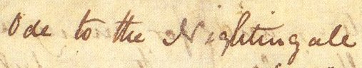
[WEB-SOURCE.]
Keats was extraordinarily endowed with a native gift- viz. that of feeling acutely with his senses. All his five senses reacted quickly to the beauties of the external world, and these sense-impressions are transmitted into poetry by his imagination. The first line of Endymion strikes the keynote of Keats’ poetry..
Even in the midst of his pains of disease and his sufferings and disappointments of life, this joy of beauty came to him through his senses. In one of his early poems-Sleep and Poetry, he wrote-
“First the realm I’ll pass
Of Flora and of Pan, sleep in the grass,
Feed upon apples, and strawberries
And choose each pleasure that my fancy sees.”
So Keats drank in the beauty of the external world with all his senses, and his whole being was excited by it and he sang out with wonder and delight,
“The Ocean with its vastness, its blue green,
Its ships, its rocks, its caves, its hopes, its fears
Its voice mysterious.”
Thus throughout his brief career, Keats’s poetry reveal sensuousness aspect of his love of beauty.
“How sould I rewill me or in quhat wys,
I wad sum wyse man wald devys;
Sen I can leif in no degree,
Bot sum my maneris will dis pys.
Lord God, how sould I governe me?”
The poetic genius transports him. Not with the help of wine but on the wings of poetic imagination, he flies to the realm of forgetfulness-viz, the romantic world of the nightingale. This world is “a heaven of joy”, where the poet listens to the song of the nightingale. Now more than ever it seems to him rich to die, and cease upon the midnight with no pain. But if, he was indeed to die, he would not hear the song. Thus, morality has its poor advantage, in that he, while living, can hear the enchanting song of the bird. “Morality is re-asserted against the immortality of which the bird’s song is at once the symbol and the elixir.”
“Joy whose hand is ever at his lips
Bidding adieu.”
The poetic equivalent for an emotion with Keats is commonly a picture; he hardly expresses a thought or feeling in abstract terms; his thought leaps into visual forms the chill of winter is thus expressed by means of picturesque images.
“A dram of sweet is worth a pound of sour.”
Keats is a Greek in his manner of personifying the powers of nature. The attitude of the ancient Greeks in the presence of nature was one of childlike wonder and joy, and they defined the powers of nature. This imaginative attitude of the Greek created their “beautiful mythology”. They felt the presence of Proteus in the sea, of Dryads in the trees and of Naiads in the brooks. Keats’s instinctive delight in the presence of nature led him to the heart of Greek mythology. What Greeks felt, Keats also felt. The rising sun for Keats is not a ball of fire, but Apollo riding his chariot. He sees the moon as the goddess with a silver bow coming down to kiss Endymion. Infact, the world of Greek paganism lives again in the poetry of Keats, with all its sensuousness and joy of life, and with all the wonder and mysticism of the natural world, Autumn to Keats is not only a season of mists and mellow fruitfulness, but a divinity in hun shape. Autumn sometimes appears as a thresher.
“St. Agnes’ Eve- Ah, bitter chill was:
The Owl for all his feathers was a cold,
The hare limp’d trembling through the frozen grass
And silent was the flock in woolly fold.”
The imagination of Keats came to be elevated by his sense perception and sense –impressions. His poetry is not a mere record of sense-impressions. It is a spontaneous overflow of his imagination kindled by the senses. He hears the song of nightingale and is filled with deep joy which at once kindles his imagination. He has been hearing the actual song of a nightingale, but when his imagination is excited, he hears the eternal voice of the nightingale singing from the beginning of time. He sees the beauty of the Grecian Urn and of the figures carved upon in. His imagination is stirred, and he hears in his imagination the music of the piper.
“Because I could not stop for Death,
He kindly stopped for me;
The carriage held but just ourselves
And Immortality.”
Indirect contrast to this is the world of the Nightingale who, “Among the leaves has never known” what it is to sad and unhappy. The nightingale is singing the happy and melodious songs of summer “in full-throated ease.” She is an immortal bird as compared to man who is ever prone to death. It is here that the real drama takes place. The poet, already quite tired of the worries of the real world, wants to fly away to the world of the Nightingale “on the viewless Wings of Poesy.” He wants to make an escape to the care-free surroundings of the Nightingale, but the drama does not end with the escape. It touches their heights of climax with the sound of a single word; and that word is “forlorn!”, the very word is like a bell. “To toll me back from thee to my sole self” with this the poet is back on the hard crust of earth. He accepts the world of his fellow beings with all its pains and worries. In nutshell, he does not allow the deceiving elf, and fancy to cheat him. The ode presents a living picture of Keats’s state of mind. It shall, therefore be in fitness of things to say that the ode takes birth from the inner conflicts of Keats’s mind.
Sometimes, as a reaper, sound asleep on a half reaped furrow, or as a gleaner, steadying the laden head across a brook. This is the typical attitude of the Greeks, who attributed human qualities and shapes to gods and demi-gods. The Pan of Greek myth was half human - any one wandering in the lovely woods, may expect to meet him playing on his pipe. The Pan of Keats’s ode is also half human, and he sits by the riverside, wanders in the evening in the fields and meadows.
“Heard melodies are sweet, those unheard
Are sweeter; therefore, ye soft pipes, play on
Not to the sensual ear, but more endeared,
Pipe to the spirit, ditties of no tone.”
Keats’s greatest achievement, however, is in his presentation of pure beauty. Beauty itself was his interest, not beauty to point a moral or to carry a message. Keats had no lesson to teach. He did not want to call his readers’ attentions to social wrongs as Shelley did; to the corrupt state of society as Byron did, to nature as a great moral teacher as Wordsworth did. Because of this lack of bias, his poems have an objective beauty which is especially attractive to young people. But for, to readers of all ages Keats sings enduring music.
“I cannot see what flowers are at my feet,
Nor what soft incense hangs upon the boughs,
But, in embalmed darkness, guess each sweet
Wherewith the seasonable month endows…”
Keats’s influence has been very strong from Tennyson to the present time. His emphasis upon craftsmanship has had excellent following. Many a poet has been led through the example of Keats to perfect verse that might otherwise have been carelessly written. Keats also turned attention to richness of verse, unlike the simplicity of Wordsworth. Again, he taught a new use of the classics. Instead of finding in the classics models for restraint he found a highly coloured romanticism. Restraint of form he did emphasize, but for his material he chose the legends of Endymion and Lamia rather than the tales of Greeks and Romans of inspiring deeds.
“Where Beauty cannot keep her lustrous eyes,
Or new Love pine at them beyond to-morrow.”
The underlying principle of all Keats’s poetic thought is this: ‘’Beauty is Truth, Truth Beauty”. In one of his letters he says: “I have loved the principle of beauty in all things”. But of, his “passion for the beautiful “was not that of the sensuous or sentimental man, it was an intellectual and spiritual passion. There was a deep melancholy about him, too; pain and beauty were the two intense experiences of his mind. “Do you not see”, he writes, “how necessary a world of pains and troubles is to school intelligence and make it a soul?” Keats studied the Elizabethans, and “caught their turn of thought, and really saw things with their sovereign eye.. He rediscovered the delight and wonder that lay enchanted in a dictionary” (Lowell). “There is something innermost soul of poetry in almost everything he wrote.” (Tennyson).
“Away! away! for I will fly to thee,”…
The English Romantic Movement was the movement in literature which started towards the end of the 18th century and continued till the thirties of the 19th century. It can be roughly dated from 1780 and it ended round about 1830. Of course, there were poets of 18th century who showed romantic tendencies in their writings before 1780. Thomson, Dyer, Akenside etc. wrote in a manner which anticipated some features of romantic poetry. But of, true romanticism, though it sometimes flings our imagination far into the remote and the unseen, is essentially based on truth- the truth of emotion and the truth of imagination. Keats was a true romantic-not a romantic in the hackneyed sense of dealing with the unrealities of life. He loved not merely beauty but truth as well, and not merely the world of imagination but that of reality; and he saw beauty in truth and truth in beauty. He never escaped from the realities of life in pursuit of the beautiful visions of his imagination; in fact, the visions of his imagination are based on reality. He persistently endeavoured to reconcile the world of imagination with the world of reality. Therefore, Middleton Murray calls Keats “a true romantic.”
Shakespeare and Wordsworth developed his intellect and style though in different ways. The vocabulary and phraseology of Endymion differ from that of the 1817 volume in the influx of Shakespearian words, allusions and reminiscences, drawn from a large number of plays while the influence of Shakespeare’s poems is shown in the fact that though the large number of Keats’s sonnets are in Italian form, all the best, with the exception of the Chapman’s sonnet which belongs to an earlier date, are written upon the model of Shakespeare. At the same time that he was finding in Shakespeare the greatest examples of the imaginative presentation of life, he was turning to Wordsworth whose teaching had seemed to Wordsworth a pretty piece of paganism, yet it was Wordsworth’s interpretation of Greek mythology which revealed to Keats the spirit which informed the poem. Furthermore, Keats owed much to the spirit and vocabulary of the old English poets especially those of the Renaissance. The influence of Paradise Lost is visible in Hyperion.
“Thou wast not born of death, immortal bird.
No hungry generations; tread thee down.”……………..~~~

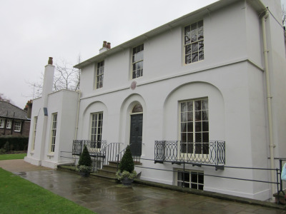
[Where Keats lived, on the edge of Hampstead Heath-now the Keats House museum.
WEB-SOURCE. ]
Written in the spring of 1819, this Ode “was inspired by a song of a nightingale that had built its nest close to the house” of a friend in Hampstead. The bird’s song, we are told often threw Keats into a sort of trance of tranquil pleasure. The proper subject of the poem is not so much the bird itself as the poet’s “aspiration towards a life of beauty away from the oppressing world”- a beauty revealed to him for a moment by listening to the bird’s song. This glimpse of the Infinite, revealed to Keats for a moment by the song of the nightingale, is also suggested in that bold line, Then with a magnificent sweep of the imagination he sees the bird and the song as one. “The bird becomes pure song and inherits the eternity of beauty.
“A thing of beauty is a joy forever.”
Like all romantic poets, Keats seeks an escape in the past. His imagination is attracted by the ancient Greeks as well as the glory and splendor of the Middle Ages. Most of his poetry is inspired by the past. It is rarely that he devotes himself to the pressing problems of the present. Endymion, Hyperion and Lamia are all classical in theme, though romantic in style. The eve of St. Agnes, Isabella and La Belle Dame Sans Merci are medieval in origin. Keats thus finds an escape to the past from the oppressive realities of the present. The poetry of Keats shows a process of gradual development. His earlier experiments in verse are products of youthful imagination, immature and overcharged with imagery. The youthful poet has abnormal sensibility, but lacks experience of life. Endymion opens with the famous line-‘A thing of beauty is a joy for ever’, it is full of glorious promise, but it is lost in shadows and uncertainties, because it is not based upon experience of real life. In the tale that follow-Isabella, Lamia and The Eve of St. Agnes, the poet has not come to grips with real life: his imagination plays with the romance of love. In the Odes, Keats’s poetry assumes a deeper tone. There he faces the sorrows and sufferings of life. He would wish for a life of joy and happiness, like that of nightingale.
“My heart aches, and a drowsy numbness pains
My sense, as though of hemlock I had drunk,
Or emptied some dull opiate to the drains
One minute past, and Lethe-wards had sunk:”
The effect of listening to the song of the nightingale is that the poet’s heart is full of aching pain and his senses are dulled, owing to the very happy participation in the happiness of the bird. The pain is the outcome of excessive joy of the poet to think that the nightingale should thus sing in full throated ease in the care-free manner. The poet longs to lose himself into the happy spirit of the bird, and leave the world unseen and fade away into the dim forest. At first proposes to do with the help of a cup of wink that has been cooled a long age in the deep-delved earth, and is rich with all the associations of the songs and dances of Provence, its country of origin. If he can do so, he will leave behind him all the woes of the world, the weariness, the fever and the fret of the world where we sit and hear each other groan, where youth grows pale all too soon, and beauty fades in no time. But in, on second thought he understands, wine is not potent enough to transport him into the ideal region. Poetry alone shall transport him. For a moment he mistrusts his own power, but the next moment he finds himself in imagination by the side of the bird, listening to the bird’s song in the wwoodland.The poet describes the romantic forest into which he has flown on the viewless wings of poetry. In the darkness he cannot see the flowers, but can guess each of them by its peculiar fragrance-the hawthorn, the eglantine, the violet and the musk rose. The illusion is broken; the poet comes back to his daily consciousness and regrets that imagination has not the power to beguile him for ever. In this beautiful romantic scene the poet thinks of many associations of the bird’s song as he listens to it. “In his joy he remembers how often the thought of death has seemed welcome to him, and thinks it would be more welcome now than ever.” The nightingale would not cease her song- the poet will die but the bird will sing on-the contrasts the transitoriness of the individual human life with the permanence of the song-bird’s life, meaning the life of this type. The bird was not born or to die; the voice that the poet hears was heard in ancient times by damsel kept captive in some medieval castle. The Ode to a Nightingale is “a poem of midnight, and sorrow and beauty”. The poet hears the song of a nightingale when the night is tender.
“That leaves a heart high sorrowful and cloy’d,
A burning forehead and a parching tongue,
Thou, silent form: doth lease us out of thought
As doth eternity; Cold Pastoral:”
The stanza-form, with its intricate rhyme-plan is a beautiful invention of the poet. It has a sustained melody the rolling music of the lines being variegated by the introduction of a short line in each verse. The rhyme scheme of each stanza is a b a b c d e c d e. There is a Shakespearian felicity of expression in the telling epithets and picturesque compounds throughout the poem.
“Where palsy shakes a few, sand last grey hairs,
Where youth grows pale and spectre-thin and dies,
Where but to think if to be full of sorrows
And leaden-eyed despairs.”
To Wordsworth, the cuckoo becomes a wandering voice, which turns, this world into a faery unsubstantial place. In the Immortality Ode, Wordsworth passes from the finite to infinite when he says:
“Hence in a season of calm weather
Though inland far we be,
Our souls have sight of that immortal sea
Which brought us hither.”
The nightingale whose song the poet hears is suddenly transported in a flash from the world of time to the world of eternity; it has been singing for ages and ages. Thus to the poet in that moment of imaginative ecstasy the nightingale is not a solitary bird swinging from its hiding place in the tree; the bird is turned into song; the bird and the song are one- therefore the bird is immortal, “not born finite, from the world of the time to the world of eternity is a marked feature of the greatest romantic poetry. Blake expresses his imaginative vision of eternity in a wonderful manner:
“To see a world in a grain of sand
And a heaven in a wild flower,
Hold Infinity in the palm of your hand
And Eternity in an hour.”……………
Some superficial critics have complained of the logical fallacy involved in the contrast between the transitory life of the individual man with the permanent life of the nightingale, conceived not as an individual but as a type of the race; but such critics, led by their prosaic method of criticism, have missed the real significance of the great line-“ Thou wast not born for death, immortal bird.“
“And haply the Queen Moon is on her throne,
Clustered around by her starry rays.”
“I could not name”, says Bridges, “an English poem of the same length which contains so much beauty as this Ode.” Middleton Murray says: “For sheer loveliness this poem is unsurpassed in the English language.” It reaches the peak of romantic poetry in the lines……………..
The poetic style of Keats reaches its peak of glory in the Ode to a Nightingale. As an example of almost perfect execution, the ode is one of the very greatest that has been written in the English language. It shows a perfect blending of classical balance and romantic inspiration. Every word is in its place, and there is a restraint of expression from the beginning to the end; yet it grows with emotion, which is romantic to the extreme. Starting in a mood of despondent contemplation of life, in which beauty perishes, the poet has a fleeting glimpse of a world- the world of eternity- where beauty does not perish. Behind the seen world, he has a vision of the unseen-and this is the verb quintessence of romance.
“Provencal song and sunburnt mirth,
With beaded bubbles winking at the brim,
Where but to think is to be full of sorrow
And leaden –eyed despair.
Now more than ever seems it rich to die.”
The poem represents the fleeting experience of the poet- an intense imaginative experience in which sorrow is fused into joy, and the world of time merges into the world of eternity. It is a romantic poem, but it denies nothing of human experience; it tells of the sorrows of life and it reveals also that the bitterest human experience can be transmuted into beauty, which is truth. The Ode to Nightingale is one of the greatest lyrics in the English language.
“So hand in hand they pass’d, the loveliest pair
That ever since in love’s embrace met,…”
Keats is pre-eminently a poet of sensations, whose very thought is clothed in sensuous images. The epithets he uses are rich in sensuous quality- watery clearness, delicious face, melodious plot, azure-lidded sleep, sunburnt mirth, embalmed darkness, anguish moist. Not only were the sense perceptions of Keats quick and alert, but he had the rare gift of communicating these perceptions by concrete and sensuous imagery. How vivid and enchanting is the description of wine-bubbles in the line:
“With beaded bubbles winking at the brim.”~~~……………
He contemplates the sorrows of the world to which all mankind is subject, and longs to get away from them. How? By means of his imagination which reveals to him the truth of beauty, he at once passes from this physical world –the world of time-to the world of eternity. The song of the nightingale represents beauty- ideal beauty that never fades. It is the eternal spirit of beauty; it is the voice of eternity that transcends the bounds’ of space and time:
“Thou wast not born of death, immortal bird.”……………….~~
[IMAGE FROM WEB-SOURCE.]
Keats was passionate lover of Greek literature, mythology, sculpture and almost anything Greek. It has influenced his attitude to nature and life immensely. The temper of the soul with which he has looked on nature betrays all the simplicity, the same feeling of joy and worship wrought together, which a young Greek might have had before Socrates. In his world of poetry the sun is not a mere ball of fire, but Apollo himself burning in with ardour; the moon is the sweet love of Endymion. Pan’s sweet pipings are heard among the oaks and olives, along with choirs of fauns. Trees and brooks are full of dryads and naiads. The immortal knit relation with the mortal. This Hellenism accounts for the charm of concrete beauty and mythical loveliness of his lyrics, narrative poems and odes alike.
“Insuffishaunce of cunnyng & of wyt
Defaut of language & of eloquence,
This work fro me schuld have withholden yit…” (!....)
This delight in pure sensation was, however, but a passing phase with Keats. As his mind mature, his sympathies broadened, and he felt at one with the human heart in travail. Sensuousness is still there, weaving its fairy tissues as before but the colouring is different. In his maturerer poems, it is gradually manifested with the stirrings of an awakening intellect, and is found charged with pain, charged with the very religion of pain. His yearning for passing for the beautiful is transformed into an intellectual and a spiritual passion. He sees things, not only in their beauty, but also in their truth. And it is partly by reason of his perception of truth in sensuous beauty that Keats has become the, “inheritor of unfulfill’d renown.”
This mood of serenity is expressed in the Ode to Autumn which according to Middleton Murry, is “the perfect and unforced utterance of the truth contained in the magic words (of Shakespeare): ‘Ripeness is all.’ The Ode to a Nightingale is a vivid portrayal of the drama of pulls and strains, taking place in Keats’s mind. On the one hand, like Shelley he is bleeding after having a fall on thorns of life.”The fever, and the fret” of the world of Man are making him feel uneasy. His dissatisfaction with the world of reality is clearly reflected in what he has got to say about it.
“Songe and prison han noon accordaunce;
Trowest thou I wol synge in prisoun?
Songe procedith of ioye and of pleasaunce
And prison causith deth and distructioun…”~~~
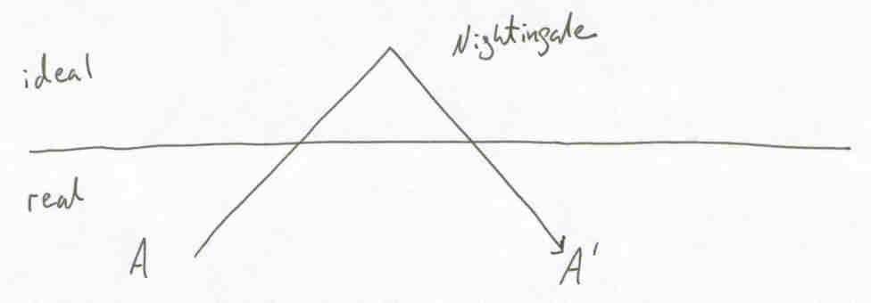
[IMAGE FROM WEB-SOURCE.]
That “sensuousness is a paramount bias” in Keats’s poetry is largely true; even as it is true that he is more a poet of sensuousness than of contemplation.” Yet, like all generalized statements, these remarks are only partly true. Keats’s mind is mainly sensuous by direct action but it also works by reflex action, passing from sensuousness into sentiment. Certainly, some of his works are merely, extremely sensuous; but this is the work in which the poet was trying his material and his powers, and rising towards mastery of his powers, and rising towards mastery of his real faculty……….. In his mature performances in the Odes, for example, and in Hyperion, sensuousness is penetrated by sentiment, voluptuousness is permeated by vitality, and aestheticism is tempered by intellectualism. In Keats’s palace of poetry, the nucleus is sensuousness; but the superstructure has chambers of more abiding things and more permanent colours.
“The voice I hear this passing night was heard
In ancient days by emperor and clown”~~~………………….
The other predominant feature of Keats’s poetry that holds our attention is its masterly handling of the world of reality and the world of escape. He does not remain uninfluenced by the delights of the world of the Nightingale. He relishes in the carefree life of the bird. At the same time he enjoys the pleasant and beautiful natural surroundings in which the Nightingale has her abode. The sweet fragrance of the white hawthorn, the fast fading violets and the musk-rose fascinates his sense of smell. So he makes an escape into the Nightingale’s world. He fades far away flying “on the viewless wings of poesy, but right after a very brief escape, the anti-climax follows. The very sound of the word ‘Forlorn’ falls heavily upon Keats’s ears. It is really terrible for Keats to stand the sound and he cannot afford to remain in the world of escape any longer though the world continues to remain as beautiful as ever. He tossed back into the world of naked truth. In a sonnet he wrote: “How fevered that man who cannot look upon his mortal days with temperate blood.” Keats was trying to attain serenity of mood in the midst of all the sufferings which he was undergoing in his own life and which he saw all around him in life. Further Shelley passes beyond the bounds of space and time, and expresses his poetic vision of the Infinite when he says:
“The one remains, the many change and pass:
Heaven’s light for ever shines, earthy’s shadows fly.”…………………..~~~
–RITUPARNA RAY CHAUDHURI.
When Robinson Crusoe gets back to his wrecked ship,

“first I found that all the ship’s provisions were dry and untouched by the water, and being very well disposed to eat, I went to the bread-room and filled my pockets with biscuit, and ate it as I went about other things, for I had not time to lose; I also found some rum in the great cabin, of which I took a large dram, and which I had indeed need enough of to spirit me for what was before me.”

When I have Fears That I May Cease to Be
By John Keats

When I have fears that I may cease to be
Before my pen has gleaned my teeming brain,
Before high-pilèd books, in charactery,
Hold like rich garners the full ripened grain;
When I behold, upon the night’s starred face,
Huge cloudy symbols of a high romance,
And think that I may never live to trace
Their shadows with the magic hand of chance;
And when I feel, fair creature of an hour,
That I shall never look upon thee more,
Never have relish in the faery power
Of unreflecting love—then on the shore
Of the wide world I stand alone, and think
Till love and fame to nothingness do sink.
(WEB-SOURCE)
: WEB-LANGUAGE: MY IDENTITY: WEB SOURCES:

Country: Worldwide; (BRITISH LITERATURE,Rituparna Ray Chaudhuri, http ...
scholar.google.co.in/citations?user=0wtg748AAAAJ&hl=en
W Shakespeare.Cambridge University Press, 2003.1142, 2003. Regional innovation systems: the integration of local 'sticky' and global 'ubiquitous' knowledge. (WEB-LANGUAGE)

Rituparna Ray Chaudhuri | LinkedIn
https://in.linkedin.com/pub/rituparna-ray-chaudhuri/73/9b0/2b2
India - ‎SELF -THOUGHT at SELF
- View Rituparna Ray Chaudhuri's (India) professional profile on LinkedIn. ... "Education Reform and Disruption": DISCUSSION- ... More I am thankful to academia.edu and also as Google scholar that are helping me constantly to convince..... White academia logo · Log In · Sign Up. Type to. ... Certifications...

…..BRITISH LITERATURE, GRAVATAR Rituparna Ray ...
scholar.google.co.in/citations?user=0wtg748AAAAJ&hl=en
BRITISH LITERATURE, GRAVATAR Rituparna Ray Chaudhuri, http://scholar.google.co.in/citations?user. EPAPER.TIMESOFINDIA.COM , Times Now ...

User talk:Rituparna Ray Chaudhuri - Wikimedia Commons
commons.wikimedia.org/wiki/User_talk:Rituparna_Ray_Chaudhuri- ... Wikimedia Commons, the free media repository. Jump to: navigation, search. Welcome to Wikimedia Commons, Rituparna Ray Chaudhuri! (WEB -LANGUAGE)…

SOME ASPECTS ON THE ENGLISH LANGUAGE

"ENGLISH LANGUAGE AND ME:LET WE TALK.”"
Feb 2, 2015
“DO, I KNOW ENGLISH LANGUAGE WELL? LET ME JUDGE MYSELF: WHO, SHALL ANSWER ME!
“Have you a pen? (British Usage)
Do you have a pen? (American usage)
Have you got a pen? (British colloquial style) ...."
Along with writing over in Web, I thought on a time on the given topic. Many where, I am getting of the problem over and over when I find English pronunciation, is in a hedge of a dilemma. Rather, to speak with correct usages on knowledge of philology is another utmost problem. Children, in my country they are reading in English Medium Schools. My question is how far they are been on the successive -stage to face boldly and confidently on the language....!
Creativity, in true sense a rare thing, readily does not come to everyone… It does not mean that life has, or had stopped. Yet, I am talking ''from'' the shakiness I have found among many persons, when to speak on the language. I think, it must have some, or a- root cause for this "traditional” suffocation. What therefore, can be done for this? How do the feelings of “perhaps -getting -to -be humiliated” within many beings be rooted out? How to give the correct sense of usage among the seeds? …and so on alike questions fogged my mind. Who shall answer?”

Rituparna Ray Chaudhuri (GRAVATAR SELF -THOUGHT at SELF)

Romantic poetry changed priorities in English Literature. Poetry is henceforth about personal experience rather than the public and moral concerns of a classical/Christian Augustanism. In this general cultural shift to finding meaning in personal rather than collective experience, poetry showed the way. And whereas the 18th-century novel of Fielding focussed on moral action, the 19th-century novel chronicles the emotional development of characters-or of a leading character with whom we are expected to identify. The first-person narrator is no longer an ironist.

A REMARKABLY FINE BLENDING OF IDEALISTIC MESSAGE:
ODE TO THE WEST WIND- - Percy Bysshe Shelley…
“Thunder is good; thunder is impressive. But it is lightening that does the work.”
The poem ‘’Ode to the West Wind’’ was written in the autumn of 1819, in the beautiful Cascine Gardens outside Florence and was published with ‘‘Prometheus Unbound’’ in 1820. The poet is himself in a mood of despondency and misery and says that he falls upon the thorns of life and is bleeding. He is seeking reawakening also through the poem and wants the wind to carry his dead thoughts and ideas like it has taken the leaves and wants fresh ideas to take birth. This is possible only if he first gets rid of stale ideas and thoughts and learns to replace them with new ones. In that sense even the poet is feeling a sort of intellectual deaths and is desirous of being given a new lease of life. “This poem was conceived and chiefly written in a wood that skirts the Arno, near Florence, and on a day when that tempestuous wind, whose temperature is at once wild and animating, was collecting the vapours which pour down the autumnal rains. They began, as I foresaw, at sunset with a violent tempest of hail and rain, attended by that magnificent thunder and lightning peculiar to the Cisalpine regions.”
Nothing can surpass Shelley’s poetic description of himself in ‘Adonais’, as a ‘frail form’, ‘a phantom among men’, ‘companionless’ as ‘the last cloud of an expiring storm’-
“The weight of the superincumbent hour,
It is a dying lamp, a falling shower;
A breaking billow;”
The life of Shelley lays worlds apart from that of Byron. His treatment of Harriet apart, his private life was not vicious, but on the contrary in many respects exemplary. As far as the ideas, which he sang, were capable of application to life, he applied them in his own conduct. He preached the equality of man and he proved that he was willing to practice it. He was generous and benevolent to a fault.
“Life is either a daring adventure or nothing.”
Shelley holds a unique place in English literature by virtue of his power of making myths out of the objects and forces of Nature. Clutton-Brock has discussed in detail Shelley’s myth-making power as revealed in the Ode to the West Wind: “It has been said that Shelley was a myth-maker. His myths were not to him mere caprices of fancy. They expressed by the only means which human language provides for the expression of such things, that sense which he possessed, of a more intense real.ity in nature than is felt by other men. To most of us, the forces of nature have little meanings. But for Shelley, these forces had as much reality as human beings. Have for most of us, and he found the same kind of intense significance in their manifestations of beauty that we find in the beauty of human belongs or of great works of art. The nature of this significance, he could not explain; but he could express it with enormous power in his art, and with a precision of statement which seems miraculous where the nature of the subject matter is considered… to Shelley, the West Wind was still a wind, and the cloud a cloud, however intense a reality they might have for him. …we are not wrought upon to feel anything human in the wind’s power; but if we are susceptible to Shelley’ magic, we are filled with a new sense of the life and significance and reality of nature.”
Shelley started writing very early, but his first major work came in 1811. This was Queen Mab, along poem. It is a revolutionary poem, but there is much confusion in the development of the story. The next great poem ‘Alastor’ came in 1815. In the same year he produced Mount Blanc and Hymn to Intellectual Beauty. These poems expressed the poet’s idealism. In the latter of the two poems, the poet expresses his feeling of the presence of a spirit in nature. In 1818-19, came the great drama, Prometheus Unbound. This is a major poem. As a drama it is not much of a success, but both in theme and in its individual songs it achieves greatness. In 1819, came another great play, The Cenci. This play portrays absolute evil as Prometheus Unbound portrays absolute goodness. This was followed by ‘The Witch of Atlas ‘and ‘Epipsychidion’. In the same year published ‘Adonais’, a lament on the death of the poet Keats. In the last year of his life (1822) Shelley wrote Hellas. Shelley left an unfinished poem, Triumph of Life. In addition to these long poems, Shelley wrote a large number of lyrics. The most well-known of these are ‘Ode to the West WinD’, ‘To a Skylark’ and ‘The Cloud’. It is in these lyrics that we often find Shelley at his best. ‘Ode to the West Wind’ is a great achievement-a poem in which great thought is combined with great art. Most of his lyrics are love poems. Many of them express the poet’s deep joy in life as well as his deep sorrow.
Shelley sets up a humanity glorified through love; he worships in the sanctuary left vacant by “the great absence of God” (His youthful atheism lacked warmth and in the end he turned to a type of pantheism). Love, as exemplified in his personal life, is a passionate kind of sensuality which becomes his simple moral code with no duty, blame, or obligation attached. The reign of love when no authority was necessary was his millennium. Most of Shelley’s poems are sad in tone and as such he is regarded as “the singer of endless sorrows”, but this is not true of all his poems. Whenever he writes of the future of mankind, he turns ecstatically optimistic.
“A wave to pant beneath thy power, and share
The impulse of thy strength, only less free
Than thou, O uncontrollable!-“
Shelley believed in a soul of the Universe, a Spirit in which all things live and move and have their being. His most passionate desire was for the mystical fusion of his own personality with his spirit. Spontaneity and fluidity are the proof of his wealth of imagination. There is no effect of laborious artistry about Shelley’s style at any time. According to Bradley,” The language is poetical through and through, not, as sometimes with Wordsworth, only half-poetical, and yet it seems to drop from Shelley’s lips. It is not wrought and kneaded; it flows.”
In ‘Ode to West Wind’, the poet begins his invocation in a buoyant mood. He looks upon the Wind as the destroyer of the present order and usherer of a new one. In the course of the poem, Shelley’s pessimism reaches its peak. He suddenly remembers his own plight:
“I fall upon the thorns of life! I bleed!”
The subsequent thought of the future at once turns his melancholy into ecstatic rapture and he ends the poem with one of the most optimistic and memorable prophecies about the future of mankind. The ecstasy arises out of his ardent belief in the imminent regeneration of mankind and the end of all evils. He hopes that all forms of tyranny and oppression will be replaced, in the millennium to come, by all-round happiness. The joyous rapture is born of an intense feeling of optimism:
“Be thou, Spirit fierce,
My spirit!be thou me,impetuous one!
Drive my dead thoughts over the universe,
Like wither’d leaves, to quicken a new birth;”
Most of Shelley’s poetry is symbolic. Shelley makes use of symbolism by means of his normal use of images including the personified forces of life and nature. He looks upon the West Wind as a personified force of nature and finds in it various symbolic meanings to suit the purpose of the poem. The West Wind drives the last signs of life from the trees and also scatters the seeds which will come to life in spring. In this way the Wind appears to the poet as a destroyer of the old order and a preserver of the new, i.e., a symbol of change. The Wind also symbolizes Shelley’s own personality. When he was a boy he was one like the Wind: “tameless, and swift, and proud.” He still possesses these qualities but they lie suppressed under “a heavy weight of hours.”
“Ideals are like stars. We never reach them but, like mariners on the sea, we chart our course by them.”
Shelley’s sky-lyrics-‘’Ode to the West Wind’’, ‘’The Cloud’’ and ‘’To A Skylark’’-have all been interpreted as having symbolic significance. The West Wind drives away the old, pale; hectic-red leaves and scatters fresh seeds over the ground. Shelley thus looks upon the Wind as a destroyer of the old order and the usherer of a new one i.e., as a symbol of the forces that will end all evil and bring about the golden millennium in which there will be nothing but peace and happiness for mankind. In the poem The Cloud, the brief life of a Cloud has also been constructed by such critics as a symbol of the immortality of the soul. However, there is no doubt that his concept of the Skylark is entirely symbolic. Shelley’s Skylark, is not just a bird but an embodiment of this ideal, the poet can hear its song but the bird ever remains invisible. The skylark, by its very nature, also symbolizes Shelley’s own poetic spirit.
“Poetry is like a perfume which on evaporation leaves in our soul essence of beauty.”
Among the Romantic poets, Shelley is marveled for his inimitable abstract ideas, but he is less of an artist .He was aiming not at the poetry of art, but at the poetry of rapture. Keats advised him to be “more an artist” and to “load every rift with ore”, but Shelley was aiming at a different effect from that of Keats’s richly decorated and highly finished poetry. The poem” Ode to the West Wind” is universally accepted as one of the best poems in English Literature. The poem is remarkable for its theme, range of thought, spontaneity, poetic beauty, lyrical quality, and quick movement similar to that of the wind itself. This poem along with the “The Cloud” and “The Skylark”, mark an abiding monument to Shelley’s passion for the sky. Shelley himself writes:
“I take great delight in watching the change in the atmosphere.”
The west wind wakes the Mediterranean up from its summer dreams and even manages to shake up the otherwise quite calm Atlantic Ocean. For its path the ocean starts to create cracks and the might of the west wind is so great that even the moss and flowers under the sea begin to tremble with fear. Thus, the west wind acquires the quality of being fearful and creating terror. The clouds are carried by the wind to a tomb and are locked there. During this season, the strong wind does not let the clouds gather easily since it blows them away. Shelley imagines that the wind gathers the clouds in a sepulcher till they have enough strength to burst forth and bring rain. Again the idea of destroyer and preserver is implicit. The clouds are destroyed and without rain the earth becomes barren but then clouds burst bringing rain which brings earth back to life. There is greenery everywhere and earth is rejuvenated.
“The difference between ordinary and extraordinary is that little extra.”
Shelley calls the west wind the ‘dirge of the dying year’ and in these words is hidden the idea of rebirth. The west wind once again brings winter and December but the end of the year implies the birth of a new one since December is followed by January and the new year with new hopes and resolutions. The poet is himself in a mood of despondency and misery and says that he falls upon the thorns of life and is bleeding. He is seeking reawakening also through the poem and wants the wind to carry his dead thoughts and ideas like it has taken the leaves and wants fresh ideas to take birth. This is possible only if he first gets rid of stale ideas and thoughts and learns to replace them with new ones. In that sense even the poet is feeling a sort of intellectual deaths and is desirous of being given a new lease of life.
”Wild Spirit,which art moving everywhere-
Destroyer and Preserver-hear, O hear!”
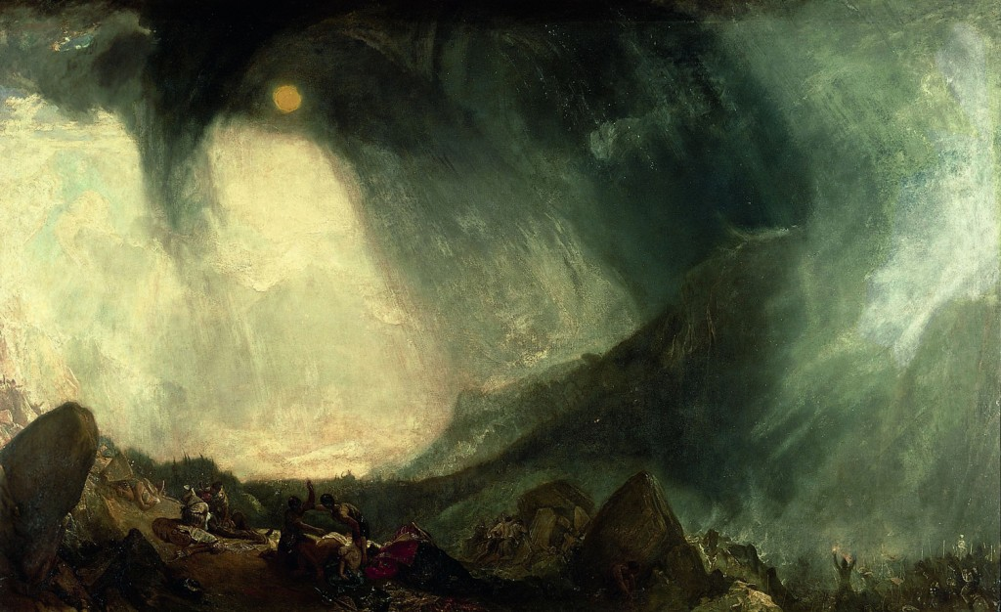
A Man of Action, A Man About the World, A Man of the World
[English Poetry LX - Percy Bysshe Shelley - Ode to the West Wind –WEB-SOURCE. ]
Shelley’s idea of the Islands of Delight as expressed in ‘Lines Written among the Euganean Hills’, is merely a product of an unfounded optimism and has no logical bearing. Shelley’s faith is no doubt genuine and intense, but it comes from his abstract visions, not from sound logical reasoning. He is ever haunted by the Eternal Mind. He constantly endeavours to look beyond the evil of life and chases the invisible and impalpable. He gives various names to this unattainable thing. In his Hymn To Intellectual Beauty, he describes it as the spirit of Beauty pervading the universe. He speaks of it as an “unseen power” that rarely visits human hearts as an ‘awful loveliness’ that can free this world from tyranny and oppression. Thus, a profound note of yearning for the unattainable is another feature of Shelley’s poetry. According to Cazamian,”The tone of Shelley’s poetry is that of a keen aspiration, in which mystical desire, with its anguished pangs and spiritual raptures, transcends the joys and sufferings of ordinary mankind.”
Shelley is pessimistic about the present but optimistic about the future. He believes that regeneration always follows destruction and that a new and utopian order is certain to come when the present degenerate system is ended. His optimism about the imminent dawn of a golden age is genuine and firm and his prophecy of that millennium underlies most of his poems. In Ode to West Wind also this prophetic note is present and present with the greatest intensity of expression.
“And, by the incarnation of this verse,
Scatter, as from an unextinguished hearth
Ashes and sparks, my words among mankind!”
Shelley had a deep interest in ancient Greeks. His enthusiasm for the wisdom of the Greek philosophers is implicit in many of his poems. This gives Shelley a sharper appreciation of natural forms and the theory that artists and poets must try to remove the worldly cover from objects and expose the underlying ideal prototype. Platonism appeals to him most because the guiding power behind the ideal forms serves him in lieu of a religion. In ‘Adonais’, Shelley’s Platonism has found the most elaborate expression.
Like the other Romantic poets, Shelley too was an ardent lover of Nature. Like Wordsworth, Shelley conceives of Nature as one spirit, the Supreme Power working through all things “The one spirit’s plastic distress/ Sweeps through the dull dense world.” Again he personifies each object of nature as an individual life, a part of that Supreme Power, Nature. He celebrates nature in most of his poems as his main theme such as ‘’The Cloud’’, ‘’To a Skylark’’, and ‘’To the Moon’’. ‘’Ode to the West Wind’’, ‘’A Dream of the Unknown’’. The tone of pessimism set in the beginning with ‘dead’ ,’ghosts’, ’corpse in grave’ reaches its climax with ‘ I fall upon the thorns of life, I bleed’. In the last stanzas the poet moves from the natural to the human misery and the mention of the hearth combines the two because hearth is seen as the centre of the earth where the natural world and the human one merge. The poet is seeking transcendence into the sublime as did Wordsworth in Tintern Abbey. The affinity of temper between them prompts the poet to appeal to the Wind to save him from his present plight. At this hour of distress the poet can look upon the Wind as a competent savior, a symbol of aid and relief. Finally, the West Wind is treated by the poet as representing the forces that can help bring about the golden millennium, when the miseries and agonies of mankind will be replaced by all round happiness.
“The tumult of thy mighty harmonies
Will take from both a deep autumnal tone,
Sweet though in sadness.”
Shelley shows no sense of history and cannot put forth the cause and remedies of the evils he finds in human society. He has an intense belief that regeneration of mankind is imminent but cannot tell us why and how it is coming. His West Wind is a symbol of the forces that will bring about this regeneration: it is nothing more. He has never told us what these forces symbolized by the wind are in reality. Shelley belongs to the younger generation of Romantic poets. Like the other two poets of his generation, he died young. His poetry divided itself into two distinct moods. In one he is the violent reformer seeking to overthrow the present institutions’ in order to bring about the Golden Age.
“Vaulted with all thy congregated might
Of vapours, from whose solid atmosphere
Black rain, and fire, and hail will burst:-O hear!”
Sometimes Shelley becomes pantheistic in his concept of nature when he seems to believe that every aspect of nature is a manifestation of only one and invisible soul or spirit and that after the end of the earthly existence, everything is reunited with that one soul.
“…that sustaining love
Which through the web of being blindly wove
By man and beast and earth and air and sea.”
Shelley’s lyrics are surpassingly musical and sweet. Swinburne was ecstatic in his tribute to this aspect of Shelley’s lyricism. Shelley out sang all poets on record, but some two or three throughout all time; his depths and heights of inner and outer music are as diverse as nature’s and not sooner exhaustible. He was alone the perfect singing God; his thoughts words and deeds all sang together. Arnold, one of the worst critics of Shelley, admired his music and remarked: “the right sphere of Shelley’s genius was the sphere of music.” Shelley’s careful handling of diction fitting into the sense of his lines enhances the musical quality keeping with the swift, of his lyrics. The rhythm of Ode to the West Wind is thus exactly in gusty march of the wind itself: “O wild West Wind, thou breathe of Autumn’s being.” Shelley never allows morbidity to overcome the enjoyment in his lyrics. Self-pity is no doubt his favorite theme, but in his lyrics, he presents this self-pity, not as something to be feared, but as an essential part of life. Shelley’s readers are never depressed because they are constantly reminded that sufferings lie only in the present and that in future all sufferings will be replaced by pure happiness. His despondency is soon replaced by an ecstatic rapture of joy when he comes to think of the future happiness of mankind, of the millennium to come:
“If Winter comes, can Spring be far behind?”
Shelley calls the west wind a destroyer and a preserver at the same time. It is a destroyer because it makes the trees shed their leaves making them bare. The west wind is called a preserver since it carries the seeds to places where they lie in hibernation during the winter and when the sister of west wind, the east wind blows in spring time, they start to germinate and blossom into many different colored flowers. Winter is often seen as death since plants die and many animals hide themselves for the season. The earth looks barren and appears lifeless but spring is a time of rejuvenation, flowers blossom and insects and animals begin to start life again. The poet gives the credit of carrying the seeds to a safer place in winter to the west wind. This way it becomes the destroyer and the preserver.
“(Driving sweet buds like flocks to feed in the air)
With living hues and odours plain and hill-
Wild Spirit, which art moving everywhere-
Destroyer and Preserver –hear,O hear!”
This co-existence of pessimism and optimism-the swift replacement of one by the other-is a major attractive feature of Shelley’s lyric poetry. This poem is considered to be one of the finest lyrics in English poetry because of its sentiments and the perfect technical construction. The poet touches on the four elements- earth, sky, weather and fire and the transition from the wind to himself is very smooth one and does not feel enforced. It is a complex poem because of the number of similes and they do not appear to be enforced or excessive in any way. The movement of the wind from earth to sky and water is observed minutely by the poet keeping scientific facts in mind. The symbolism of destroyer and preserver is carried through the poem; first with the wind driving the dead leaves away to make place for new ones, secondly with the mention of pumice isle which was built with the lava from a volcano. Volcano is both a destroyer and a preserver since while it erupts it pours forth fire but once it subsides it leaves behind valuable minerals and fertile material. Finally, the poet’s own thoughts are dead leaves to be driven away so that new ones can take their place. The theme of rebirth is thus an integral part of the poem.
“A deep resolute mind rises above all difficulties”
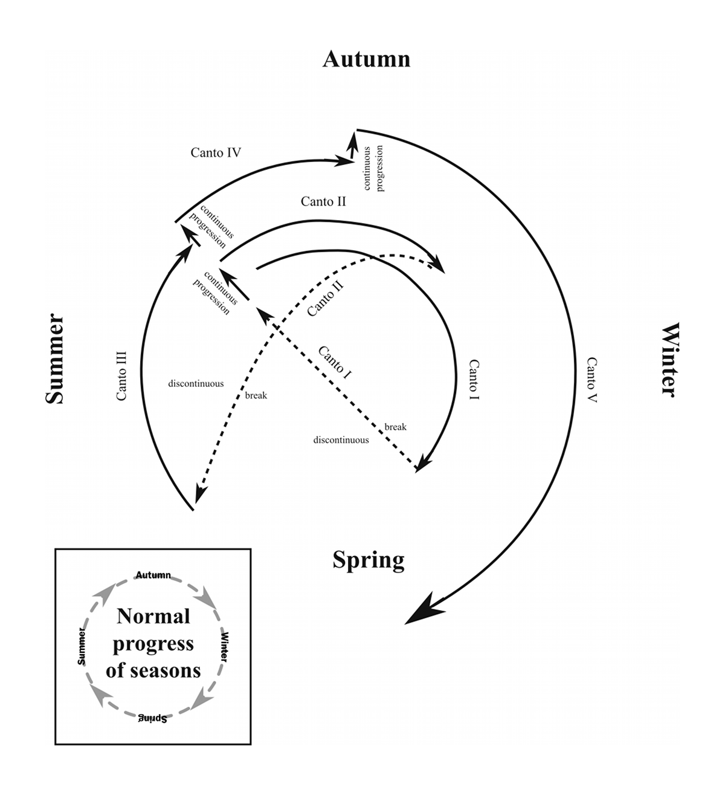
[IMAGE FROM WEB-SOURCE.]
The poet then describes how the wind carries loose clouds on its stream and spreads them from horizon to the height of the skies. The wind is the funeral song of the passing year because soon after autumn comes winter when the year ends and a new one begins. Winter is often seen as death since plants die and many animals hide themselves for the season. The earth looks barren and appears lifeless but spring is a time of rejuvenation, flowers blossom and insects and animals begin to start life again. The poet gives the credit of carrying the seeds to a safer place in winter to the west wind. This way it becomes the destroyer and the preserver.
“Each like a corpse, within its grave, until
Thine azure sister of the Spring shall blow
Her clarion o’er the dreaming earth,”
In his treatment of nature, he describes the things in nature as they are and never colours it. It is true, he gives them human life through his personifications, but he does it unintentionally for he felt they are living beings capable of doing the work of human beings. His mythopoeia power had made him the best romanticist of his age. In Ode to the West Wind, he personifies Nature as the Destroyer and the Preserver, and in ‘‘The Cloud’’, the cloud is a possessor of mighty powers.
“Thou on whose stream, ‘mid the steep sky’s commotion,
Loose clouds like earth’s decaying leaves are shed,
Shook from the tangled boughs of Heaven and Ocean,
Angels of rain and lightening!”
Shelley holds a unique place in English literature by virtue of his power of making myths out of the objects and forces of Nature. Beauty, to Shelley, is an ideal in itself and a microcosm of the beauty of Nature and he calls it ‘Intellectual Beauty’. He celebrates Beauty as a mysterious power. In the Hymn to Intellectual Beauty, he says that when Intellectual Beauty departs, this world becomes a “dim vast vale of tears, vacant and desolate” and if human heart is its temple, then man would become immortal and omnipotent:
“Man were immortal and omnipotent
Did’st thou, unknown and awful as thou art
Keep with thy glorious train firm state
Within his heart.”
The West Wind is the breath of Autumn. Dead leaves, black, yellow and red in colour, fly before the wind, as the ghosts fly before a magician. The West Wind scatters the flying seeds. The seeds lie under the ground and when Spring comes, they grow into flowers of different colours and fragrance. The West Wind destroys dead leaves and preserves useful seeds.
“Make me thy lyre, ev’n as the forest is:
What if my leaves are falling like its own!”
The spirit of the west wind is described as ‘uncontrollable’. The west wind is unstoppable and it affects everything that falls in its path. It affects the earth, the water in the oceans and the clouds of the sky. It is responsible for carrying them and locking them up in a sepulcher till they burst forth in fury of rain and hail. The poet thinks that the west wind has a free spirit and wanders as and where it pleases. He admires it for its freedom and wishes the wind would carry him along like a leaf or a cloud. Shelley then sums up the spirit of the west wind as ‘tameless, swift and proud.’ It cannot be kept in check so it is ‘tameless’, the speed of the west wind is formidable and it is proud because it would not listen to any one. Finally, the poet refers the west wind as ‘Spirit fierce’ and ‘impetuous one’ that acts on the impulse of the moment.
“The sea-blooms and the oozy woods which wear
The sapless foliage of the ocean, know
Thy voice, and suddenly grow gray with fear
And tremble and despoil themselves: -------- O hear!”
The Wind blows through the jungle and produces music out of the dead leaves. Shelley requests it to create music out of his heart and to inspire him to write great poetry, which may create a revolution in the hearts of men. He wants the Wind to scatter his revolutionary message in the world, just as it scatters ashes and sparks from a burning fire. His thoughts may not be as fiery as they once were, but they still have the power to inspire men. He tells the Wind to take the message to the sleeping world that if winter comes, spring cannot be far behind. In optimistic note he declares that bad days are followed by good days.
“Thou who didst waken from his summer-dreams
The blue Mediterranean, where he lay,
Lull’d by the coil of his crystalline streams,
Beside a pumice isle in Baiae’s bay,
And saw in sleep old palaces and towers,”
Idealism is a part and parcel of Shelley’s temperament. He is a rebel, like Byron, against the age –old customs, traditions, conventions and institutions, sanctioned only by practice and not by reason. Unlike Byron, but, he is not only a rebel but also a reformer. He wants to reconstitute society in keeping with his ideals of good, truth and beauty. According to Compton- Rickett, “To renovate the world, to bring about utopia, is his constant aim, and for this reason we may regard Shelley as emphatically the poet of eager, sensitive youth; not the animal youth of Byron, but the spiritual youth of the visionary and reformer.”
Poetry is the expression of the poet’s mind. This is absolutely true of Shelley’s poetry. A study of Shelley’s poetry is the easiest and shortest way to his mind and personality. The fourth Stanza of Ode to the West Wind is entirely personal and autobiographical. An analogy with the West Wind helps the poet describe his own spirit: ‘’tameless, and swift, and proud.” The poet narrates the change, he has undergone in the course of his life. He was full of energy, enthusiasm and speed in his boyhood, but the agonies and bitterness of life-“A heavy weight of hours”-has repressed his qualities and has put him in an unbearable state. The expression of his sufferings “I fall upon the thorns of life! I bleed!” is intensely genuine, heart-rending, and possibly the most spontaneous of Shelley’s emotional outbursts through his poems.
The calm Mediterranean was sleeping. The music of the glassy waves lulled the ocean to sleep. It was dreaming of towers and palaces reflected in its water. The West Wind creates furrows on the smooth waters of the Atlantic Ocean. At the bottom of the Atlantic grow plants and vegetation. These plants are dry, without sap though they live in water. When the West Wind blows in autumn, the plants on the land wither; the plants at the bottom of the ocean also fade and die.
“Quivering within the wave’s intenser day,”
Shelley is describing the approach of the terrible West Wind. In the regions of the sky. Shelley’s emotional ecstasy fires his brain to that kind of superb conception which made the ancient Greeks fill the earth, the air sand the water with gods and goddesses who were but personifications of the forces of nature.
“Flowers always make people better, happier and more helpful; they are sunshine, food and medicine to the soul.”
The cloud form on the horizon, gather up in the sky and then darken the space. The sky is at first blue, but it assumes a dark appearance on the approach of the vaporous clouds. From the distant and dim horizon to the highest point in the sky, the whole visible space is filled by the movements of the air. The clouds are up and spread themselves. The scattered and disorderly clouds look like the locks of the mighty West Wind personified, as seen approaching through the sky; these locks resemble the dishevelled and erect hair on the heads of intoxicated and frenzied female worshippers of the wine-god who used to dance madly about.
“The comrade of thy wanderings over heaven,
As then, when to outstrip thy skiey speed
Scarce seem’d a vision,-“
These lines are very touching and highly characteristic of Shelley. Shelley was a rebel and a revolutionary. He had a restless temperament which was even at war with something. In the West Wind, Shelley finds a kindred spirit. Looking at it, he is reminded of his youth when he too was free and uncontrollable. At that time, he did not think it an impossibility to vie with the West Wind in its speed, but the worries and mysteries of this life have proved too much for him and have made him tame and weak. He had lost his old vigour and force, and he appeals to the West Wind to lend him some strength and lift his dejected spirit as it lifts a cloud, wave or a leaf. He was very much oppressed by the hardships of the world and he wants somebody to support him through his struggle for existence in this world. He was indeed tameless and wild like the West Wind at one time, but now he is bowed down by the worries and care, and calls for help. Next, Shelley describes the agitated surface of the ocean cuts a thousand deep passages on itself for the march of the terrific wind; while the rush and tumult on the surface reach the vegetable world at the bottom of the ocean, the leaves, the flowers, the sapless forests there tremble with fear and are shaken loose pell-mell at the awful roar of the mighty wind.
Desmond king-Hele remarks: “The verse technique and structure of the Ode to West Wind could scarcely be improved: it is the most fully orchesterd of Shelley‘s poems, and consequently the most difficult to read aloud. The ever fluctuating tempo and he artfully random pauses in the long lines reflect the lawless surging of the wind and its uneasy silences. This device is not overworked: the wonder is that Shelley could use it at all when grappling with the problems of the terza rima and operating within a rigid structural framework. In conformity with this framework, which seemed to be in the Style of Calderon, the first three Stanzas are designed to show the wind’s power in three spheres of Nature, in preparation for the prayer to the Wind, as pseudo-god, in Stanzas 4 and 5.
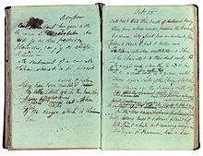
[Percy Bysshe Shelley's fair draft of lines 1–42, 1819, Bodleian Library - WEB-SOURCE.]
The keynote of the first three Stanzas is balanced. Their settings, land, sky and sea, give equal emphasis to the three states of matter, solid, gaseous and liquid. Each of the four seasons has its appointed place, and there is a full range of colours- red, yellow, blue, grey and black explicitly, white and green implicitly. Turmoil is balanced against calm, life against death, detail against generalization, cold against calm, life against death, detail against generalization, cold against warmth, plain against hill, and so on. The varied evidence of Stanzas1-3 is assembled in support of the narrow, one-track theme in the last two stanzas: the plan is sound, but in points of detail it falls short of perfection. For Shelley harps on his prayer rather too long. His defeatism becomes a trifle depressing, unless when reading the poem we happen to be in the same mood as he was…the note of self-pity is overplayed in the last two Stanzas; and this must be counted a blemish in what is otherwise a nearly faultless poem.”
“Of the dying year, to which this closing night
Will be the dome of a vast sepulcher,
Vaulted with all thy congregated might
Of vapours, from whose solid atmosphere
Black rain, and fire, and hail will burst:-O hear!”~~
-Rituparna Ray Chaudhuri.
MY IDENTITY: Rituparna Ray Chaudhuri - Academia.edu http://independent.academia.edu/RituparnaRayChaudhuri/Posts Location; Kolkata, West Bengal, India. Profiles ... ... The believing was in Anglo Saxon times….. (WEB-SOURCE)

RAY CHAUDHURI (BRITISH LITERATURE) RITUPARNA
Asia Pacific's...EPAPER.TIMESOFINDIA.COM,GoogleScholarship White Academia logo,Shakespeare Birthplace Trust Logo .. at Websites, Self-tuition centre at home (WEB-SOURCE) Follow

“‘I am’ is reportedly the shortest sentence in the English language. Could it be that ‘I do’ is the longest sentence? “
–George Carlin.

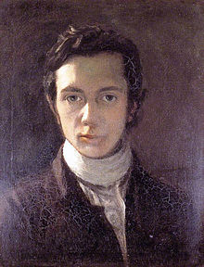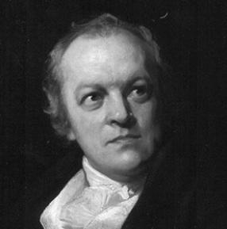
William Hazlitt William Blake.
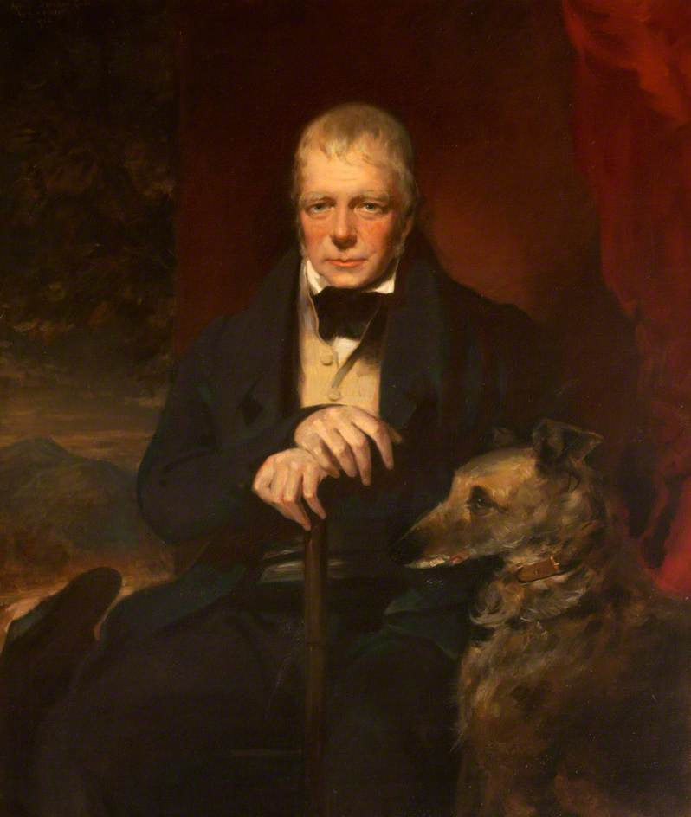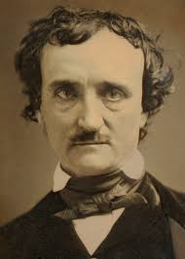
Sir Walter Scott Edgar Allan Poe
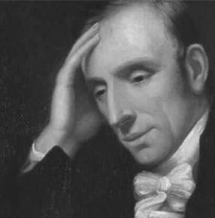William Wordsworth
"MEETING TO GREAT, GREAT GRANDSON OF WILLIAM WORDSWORTH"- (ONLY WEB RELATED: https://t.co/6djskBW3bw)
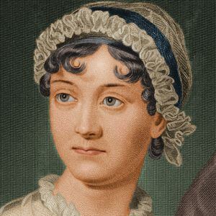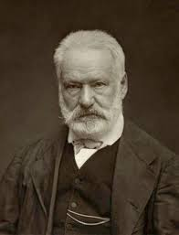
Jane Austen Victor Hugo

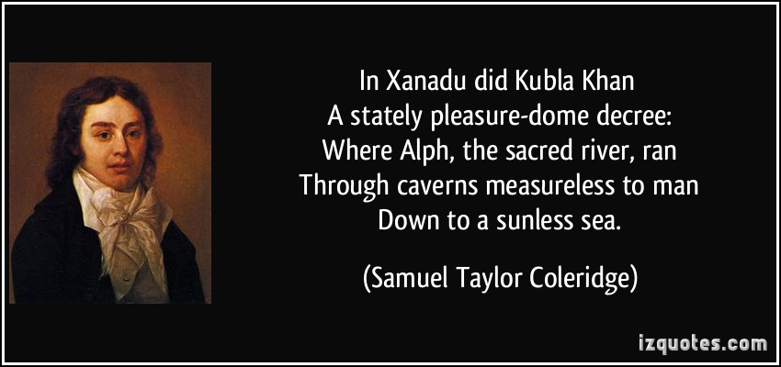Samuel Taylor Coleridge

The image of a fountain recurs in Kubla Khan, and in Wordsworth’s commemoration of STC’s death, when ‘every mortal power of Coleridge/Was frozen at its marvellous source’. Coleridge conceived the mind as active, not as in Locke’s passive model in which ideas derive from sense-impressions on a blank mental plate. Coleridge also went beyond the physiological turn given to Locke’s theory of the association of ideas by David Hartley (1705-57). Coleridge called his first child Hartley, but his second after the idealist philosopher Berkeley, who placed the source of knowledge in the divinely-inspired human mind. For Coleridge, association of ideas could only lead to the combinatory power of Fancy, as he defined it in Biographia Literaria, whereas the poet imitates the divine creativity by the power of Imagination. This is the centre of Coleridge’s critical thinking, in which literature is less a work of art than a natural product of the imagination.

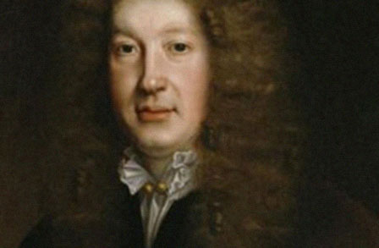John Dryden

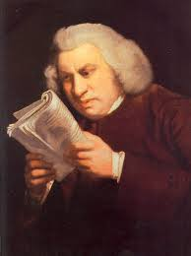 Dr.SamuelJohnson ……
MY-TRIBUTE
(RITUPARNA RAY CHAUDHURI-…..)

“ON RESPECT TO SOUL OF AMMA,
MY GRANDMOTHER”

Media & Web: The Web has met with its History and Historical Names-the Historians/Archaeologists are still meeting with its history , whom the newspapers had met in vast- when, I am talking of Glorious Origin Of ROY CHOWDHURY FAMILY, OF KARPARA IN NOAKHALI, district of present day Bangladesh, more known in historical sites “Chowdhury-bari”(House of Chowdhury)...
……….
Most Recent Letter(s) to the Editor - Publish A Letter .com www.publishaletter.com/recentletters.jspDear Editor, This is with regards to the Times of India website. ... Noakhali Riots: As Published In Wikipedia by Rituparna Ray Chaudhuri. Dear Editor: I. Rituparna Ray Chaudhuri, recently gone through different writings as published in diffe ..
(INSPIRED MORE WITH WORDS FROM Madhusraba Dasgupta (Author) ON TIMELINE. )

‘HISTORY ON MEMORIOUM’

: “Meeting the Ancient lady of more than 92 years old, I had returned home. I said my father on what I had been blessed through her words. History has its own History. I don’t know how much I deserve to have my completion upon the old lady’s words, but the rustling memories capitulates me to have constant pace of my summation to run through in life.

Having the day I met with her, Late (Mrs.) Smt. Bina Roy Choudhury, (wife of RENOWNED Late (Prof.) Dr. Makhanlal Roy Choudhury(Sastri), specialised on Muslim History), after joining Presidency College of Kolkata she blessed me with words, “Remember that our family is attached with that college since 1905 through Rajendralal (the HISTORICAL name as the then Advocate RAJENDRALAL ROY CHOWDHURY). You must keep dignity of that.”

I recall here, the moment of many words I PERSONALLY, also been aspired from one of the daughters of Late Bina Devi and Late Dr. Makhanlal Roy Choudhury, whom (LATE Prof.) the family respects as still, ‘Mithu Pishi’.
At present, I am fortunate enough to been blessed by Madhusraba Dasgupta (Author)
and Mandakranta Bose
who are other two daughters, of Historian Late Dr. Makhanlal Roy Choudhury and Late Bina Devi.

After meeting the respected old- lady, I came home and, wanted to know from father about the renounce of the family. Father, recalled the history when heard from his father, Late Narayan Roy Choudhury and from Dr. Makhanlal. Herein, once Dr. Makhanlal Roy Choudhury had visited Birnagar village of Nadia District, West Bengal during Durga Puja (the festive) held in the house of Late Narayan Roy Chowdhury. There the Late Professor, Dr. Roy Choudhury narrated the history left in the family not only as a descendant of Noakhali Roy Choudhury family, but also out of his historical research.

My father found out an old diary, and told the REPUTED ORIGIN OF ROY CHOWDHURY FAMILY, HISTORY HAS HIDDEN ITSELF ANOTHER HISTORY.

He continues...

OUR KNOWN ROOT (in brief)

Yogeswar Guha, first known root of the family resided in Murshidabad of present day West Bengal. His grandson Barahiprasad worked in the court of Nawab of Bengal, Alivardi khan (1740-1756). Nawab decided to send young Barahiprasad to Bahula (earlier name of Noakhali of present Bangladesh) to collect tax and administer that isolated, undeveloped, surrounded by rivers area far off from Murshidabad.

Barahiprasad dared to go there and settled as a ‘tahasilder’ (tax-collector) on behalf of the Nawab. After the short lived rule of Siraj-ud-Dowla with his defeat to British in 1757, the depositing of tax collected at far off places was stopped to the Nawab treasure and the British rule was still unorganised. Barahiprasad and his son Durlav Ram took the chance and expanded their holdings and properties in that area. Raghab Ram, son of Durlav Ram died young leaving behind Iswar Chandra, son of 8/9 years. He was intelligent and decided to live peacefully with the British.

It was around 1820, more than 50 years after beginning of the British rule in India, Iswar Chandra was given title ‘ROY CHOUDHURY’ by the British and became a trusted man to the British. Durlav Ram started family Durga Puja and other Hindu Festivals which lasted up to the year of riot in Noakhali in 1946. Mahim Chandra, grandson of Iswar Chandra was educated, kind hearted and intelligent enough like his grandfather. He was a lawyer, died in 1937.

TURNING HISTORY ON FIELD OF ACADEMIC: “HISTORY HAS CARRIED OUT ANOTHER HISTORY”

Mahim Chandra, younger son of Madhab Chandra and a famous lawyer of Noakhali at his time had educated and qualified sons- his first son Chinta Haran was a lawyer, second son Rajendralal was scholar of Presidency College and University of Calcutta. He was President of Lawyers’ Bar Council of Noakhali district, President of Hindu Mahasabha, social worker and politician influenced by Dr. Shyama Prasad Mukherjee, ex-Vice Chancellor of University of Calcutta. He was declared hero of Noakhali riot in 1946 by different politicians of that time. 3rd son (Satish Chandra) & 4th son Priyolal were in business. 5th son Prof. Dr. Makhanlal (Sastri) was known by himself in his days being authority in Muslim History and was acquainted with Pali & Sanskrit. He was an educationist, Dean in University of Calcutta, B.L. and a social worker...

Chinta Haran, Rajendralal, Satish Chandra and Monilal the elder son of Chinta Haran along with several relatives had died in Noakhali Riot, 1946.

………….
……………..
- I, the descendent of the family, recall all along words of my grandmother Late Niva Roy Choudhury, [demised , morning on 6th June, 2015 whom too, Late Rajendralal called as ‘Beti’ (daughter) for her knowledge and acquisition on merit], the daughter-in-law of Late Chinta Haran Roy Chowdhury, and wife of Late Narayan Roy Choudhury, had a role to play on my steady confidence to do something for people, for country, for world….Her words to me, “Presidency is not new to us”…”
…………...
-RITUPARNA RAY CHAUDHURI

-----

(VERSION: A History of English Literature
and Science of language) ---

“Sobriety is a characteristic mark of the English expression. Exaggerated or hyperbolic expressions are hardly entertained in a happy English style. Sobriety is always a test of masculinity, as fickleness is often a kind of weakness! “

T. S. Eliot Wordsworth Lord Byron
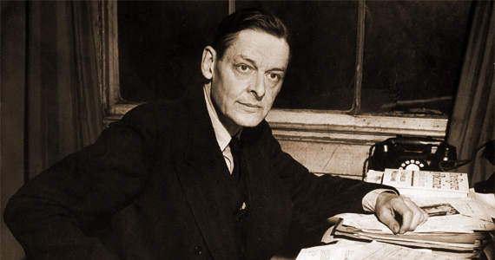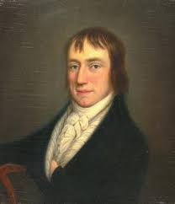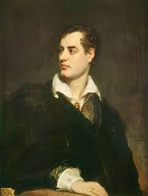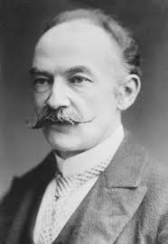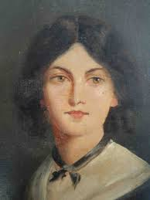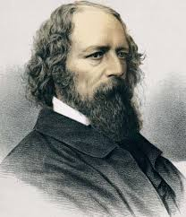 Thomas Hardy Emily Bronte Alfred Lord Tennyson …….

“Into my heart an air that kills
From yon far country blows:
What are those blue remembered hills?
What spires, what farms are those?”
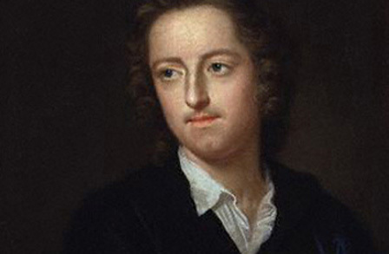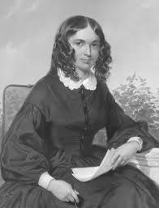
Thomas Gray Elizabeth Barrett Browning

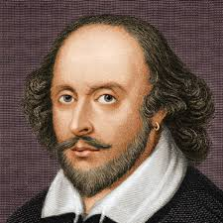 Shakespeare

AN ETERNAL SLEEP

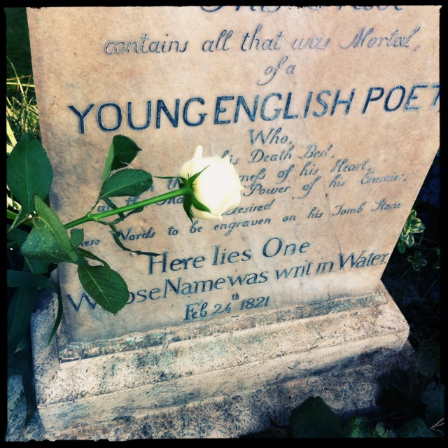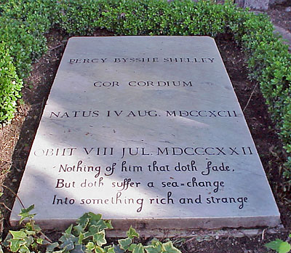

“The Grave of Keats” “Heart of Hearts”

“Both poets rest in the "Non-Catholic Cemetery" of Rome.”……….
‘HISTORY ON MEMORIOUM’

“The historian of a literature tries to do justice to the great things in its tradition, while knowing better than most that classical status is acquired and can fade. As for literary status itself, it is clear from Beowulf that poetry had a high place in the earliest English world that we can know about. The first formal assertion of the classical potential of writing in a modern European vernacular was made about 1307 by the Italian poet Dante. Such a claim was made for English by Philip Sidney in his Defence of Poetry (1579), answering an attack on the theatre. Puritans closed the public theatres in 1642. After they were reopened in 1660, literature came to take a central role in English civilization. From 1880, Romantic poets made very great claims for the value of poetry. Eventually the Victorians came to study English literature alongside that of Greece or Rome.
Literature has also had its enemies. The early Greek wrier-philosopher Plato (c.429-347BC), in banning poets from his imaginary ideal Republic, had acknowledged their power. The English Puritans of the 17th century, when they closed the theatres, made a similar acknowledgment. After 1968, some French theorists claimed that critics were more important than writers. Some Californian students protested, at about the same time, that dead white European males were over-represented in the canon.”

Keats-Shelley Memorial House, Spanish Steps, Rome

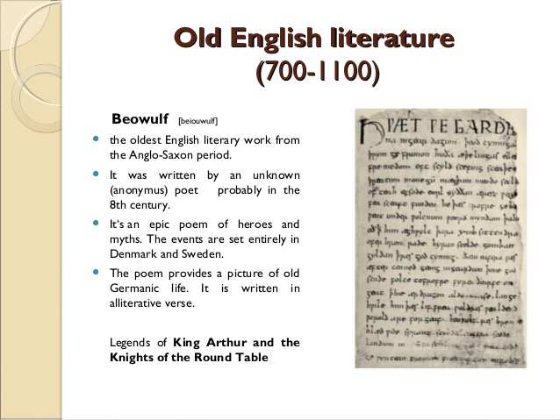
(WEB SOURCE-DIRECT IMAGES and INFORMATION)

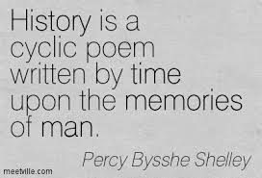
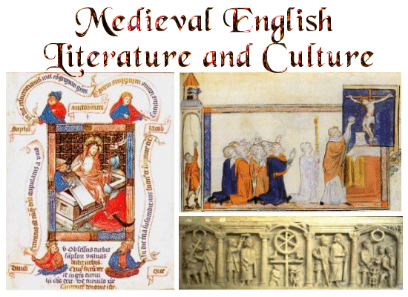
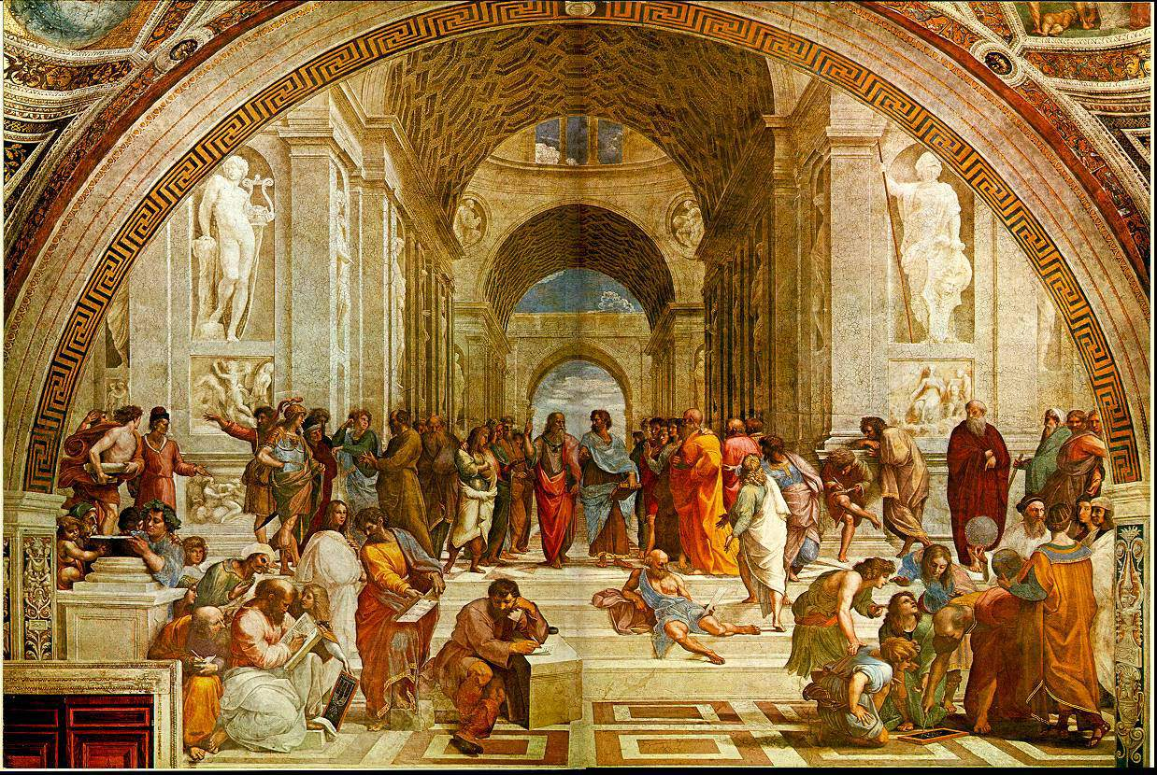”Shakespeare's time: The Renaissance, Elizabethan Era, and the Age of Discovery.”
(WEB-INFORMATION)
“And did those feet in ancient time
Walk upon England’s mountains green?
And was the holy Lamb of God
On England’s pleasant pastures seen?”

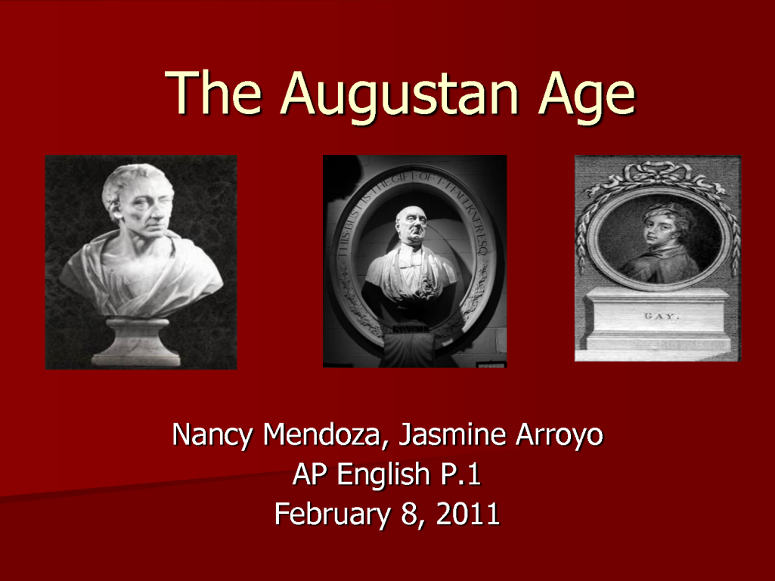

(WEB SOURCE-DIRECT IMAGES)

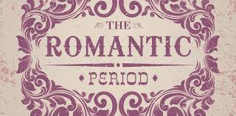

Scott’s initial approach is oblique, establishing Edward Waverley as a decent young English gentleman who has spent his youth, like Cervantes’ Don Quixote, reading romances of chivalry. He is an innocent blank page. Finding himself in Scotland with his detachment of Dragoons, he is charmed by Scottish hospitality and manners, and by Rose Bradwardine. He is then captivated by Highland life, and smitten with Flora Maclvor, whom he sees in the glen in a scene of ‘romantic wildness.’:

“Here, like one of these lovely forms which decorate the landscapes of Poussin, Waverley found Flora gazing at the waterfall. Two paces further back stood Cathleen, holding a small Scottish harp, the use of which had been taught to Flora by Rory Dall, one of the last harpers in the Western Highlands. The sun now stooping in the west, gave a rich and varied tinge…”
“I live not in myself, but I become
Portion of that around me, and to me
High mountains are a feeling, but the hum
Of human cities torture….”

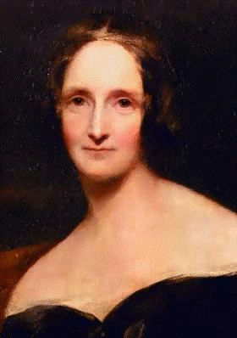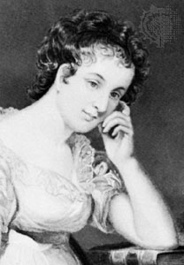
Mary Shelley Maria Edgeworth

‘And what are you reading Miss-?’’Oh, it is only a novel’, replies the young lady; while she lays down her book with affected indifference, or momentary shame.-‘It is only Cecilia, or Camilla, or Belinda’; or, in short, only some work in which the greatest powers of the mind are displayed, in which the most thorough knowledge of human nature, the happiest delineation of its varieties, the liveliest effusion of wit and humour are conveyed to the world in the best-chosen language.’

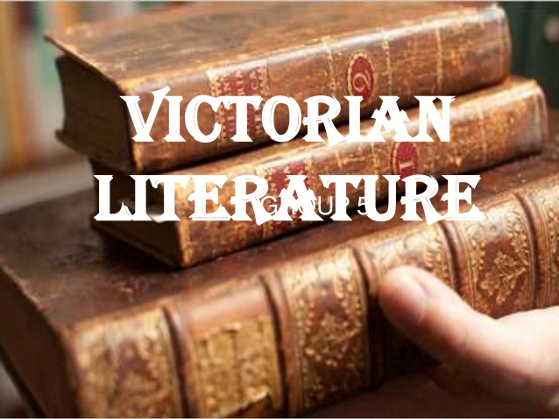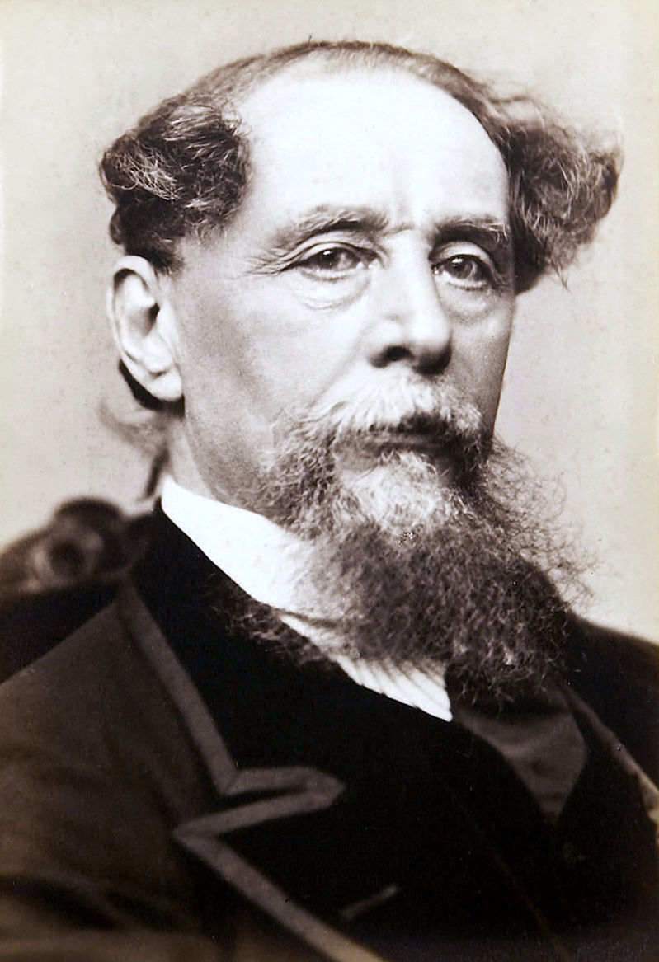
Charles John Huffam Dickens
(WEB SOURCE-DIRECT IMAGES) ………………

The literary lull that followed the early deaths of Keats, Shelley and Byron is a true age of transition, the period of Great Reform Bill of 1832. Features of the Victorian age began to appear: liberal legislation, a triumphant middle class, industrial advance, proletarian unrest, religious renewal. When Victoria came to the throne, the warning voices of Keble and Carlyle were audible. Among the young writers were Tennyson, the Brownings, Thackeray and Dickens.

“She lived unknown, and few could know
When Lucy ceased to be;
But she is in her grave, and oh!
The difference to me.”

Modern-English Period is dated from A.D. 1500 to the present (WEB SOURCE-DIRECT INFORMATION)

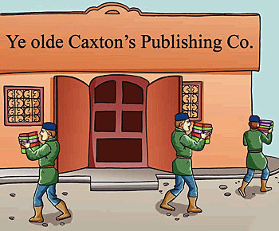

—Word Info image © ALL rights reserved.

The communication and the awareness of social problems which resulted in a new epoch of universal knowledge and interests. Invention of the printing press expanded education.
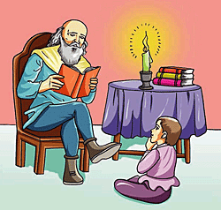
—Word Info image © ALL rights reserved. —Word Info image © ALL rights reserved.

—Word Info image © ALL rights reserved.

The Renaissance was a revival of classical literature; the purifying of Latin diction and grammar, the revival of Greek, and a return from Middle Age compilation to the old classical texts.
Italian humanists from 1393 onward went to Constantinople to learn Greek and brought Greek manuscripts back with them.
—Word Info image © ALL rights reserved.
Here are various versions of a familiar text to see the differences between Old, Middle, and Modern English. (WEB SOURCE-DIRECT)
Take for example, this Old English (c.1000) sample:
Fæder ure þuþe eart on heofonum
si þin nama gehalgod tobecume þin rice gewurþe þin willa on eorðan swa swa on heofonum
urne gedæghwamlican hlaf syle us to dæg
and forgyf us ure gyltas swa swa we forgyfað urum gyltendum
and ne gelæd þu us on costnunge ac alys us of yfele soþlice.
Rendered in Middle English (Wyclif, 1384), the same text is recognizable to the modern eye:
Oure fadir þat art in heuenes halwid be þi name;
þi reume or kyngdom come to be. Be þi wille don in herþe as it is dounin heuene.
yeue to us today oure eche dayes bred.
And foryeue to us oure dettis þat is oure synnys as we foryeuen to oure dettouris þat is to men þat han synned in us.
And lede us not into temptacion but delyuere us from euyl.
Finally, in Early Modern English (King James Version, 1611) the same text is completely intelligible:
Our father which art in heauen, hallowed be thy name.
Thy kingdom come. Thy will be done in earth as it is in heauen.
Giue us this day our daily bread.
And forgiue us our debts as we forgiue our debters.
And lead us not into temptation, but deliuer us from euill. Amen.

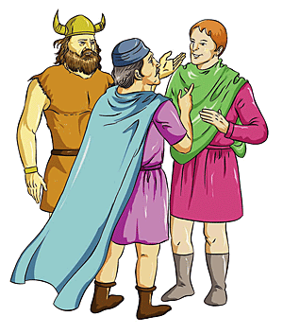
—Word Info image © ALL rights reserved. (WEB SOURCE-DIRECT IMAGE AND INFORMATION)

As a result of the many translated books, Greek and Latin were assimilated into English through writing, not by conversation as were the Scandinavian and French languages.

There was a strong opposition to something called "inkhorn terms"
Another great invasion of England was accomplished by Greek and Latin words which have become a permanent part of the English language. Some English "purists" called this classical invasion "Inkhorn Terms". In fact, some of them strongly expressed: "Down with inkhorn terms, up with good old Anglo-Saxon English!"
The phrase “inkhorn term” came into English in the early to middle sixteenth century, with the first attested usage dating from 1543 and referred to "invented words" almost exclusively from classical Latin and Greek origins.
It was from the beginning a term of "gentlemanly abuse", referring to words which were being used by scholarly writers but which were unknown or uncommon in ordinary speech.
The word derives from the then standard name for the container in which ink was stored, originally made from a real horn; later, when this term had itself become obsolete, it was sometimes rendered as "inkpot term".
The objection to inkhorn terms was primarily against the sudden increase in English vocabulary derived from classical sources which was taking place at this time.
Writers were experimenting with the language, importing and inventing terms to meet their needs; especially, because of the need for terms to describe new technologies.
The greater number of these new words were borrowed from Latin, but they were not exclusively drawn from that source. Some were taken from Greek, a great many from French, and not a few from Italian and Spanish.
Although many of their inventions and adaptations proved unsuccessful, large numbers of others did gain a permanent place and are still in use today.
Whatever the reason for the success or failure of new words, the period of inventiveness and adaptation enriched English with thousands of new terms and the process continues in our modern-English era. (FROM WEB-SOURCE –DIRECT WRITING)
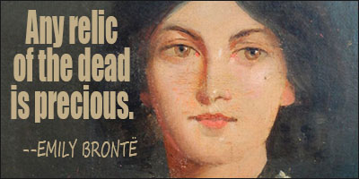
[IMAGE FROM WEB-SOURCE.]
“Professor Wrenn’s study is far better than any of its predecessors…It would be an impertinence for an indolent reviewer to comment on the scholarship of the Rawlinson and Bosworth Professor of Anglo-Saxon at Oxford, but one may perhaps venture to admire the vivacity and seriousness of his interest in modern English, and his conviction that the language should be studied historically in order that we may use it more intelligently today.”
- The Cambridge Review.

“Let observation with extended view
Survey mankind from China to Peru-“

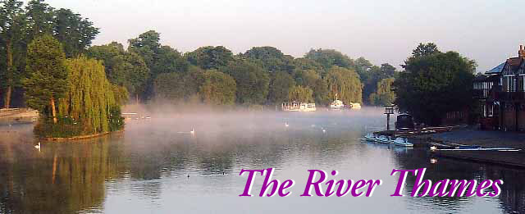

“When the English language gets in my way, I walk over it.” - Billy Sunday.

“The plinth of prosody is based on two elements-quantity and accent. Time is expressed by quantity, and tone or tune is embodied in accent.”

(NEEDS CAPABLE TEACHERS OR EXPERTS TO MAKE WHOLE PROCESS TO UNDERSTAND):

- To find out
------------
Syllables
- To mark
------------
Accented syllables

- To separate
------------
Different feet

4. To determine
------------
Metre and
Prosodic name

5. To indicate
----------
Variations, if any.
:

Ri`ch the/ tre`a-sure
Swe`et the /plea`-sure

Each foot in each line each line is disyllabic. The first syllable is accented and the second is unaccented.

Grow o`ld /a-lo`ng /with me`.
The be`st/ is ye`t /to be`.

The feet are iambic (from iambus), for an unaccented syllable is followed by an accented one in all cases.

Me`-rri-ly/ sha`ll I live/ no`w .

The verse is dactylic. The last foot has one accented syllable.

Ha`teful/ i`s the /da`rk blue/ sky`
Va`ul-ted o`er the/ da`rk blue/ se`a.

The lines have become trochaic with catalectic variations at the end.

They a` l-/so se`rve/ who o`n-/ly sta`nd /and wa`it.

The line, it is evident, is iambic pentameter.
Ho`n-our/ and sha`me/ from no`/ con-di`-tion ri`se
Act we`ll/ your pa`rt,/ there a`ll/ the ho`n-/our li`es
Fo`r-tune/ in me`n/ has so`me/ small di`ffe-/rence ma`de
One fla`unts/ in ra`gs/ one flu`tt-/er i`n/ bro-ca`de.

This is written in iambic pentameter with the following variations:
The first foot of the first line is a trochee.
The first foot of the third line is a trochee.

--------“I-a`m/bus ma`rch /from sho`rt/ to lo`ng
Tro`chee/ tri`ps from/ long to short.”

Phonetic symbols for English
AIM OF PHILOLOGY, PRONUNCIATION AND PHONETICS.
This is the standard set of phonemic symbols for English (RP and similar accents).
Consonants  p pen, copy, happen  b back, baby, job  t tea, tight, button  d day, ladder, odd  k key, clock, school  g get, giggle, ghost  tʃ church, match, nature  dʒ judge, age, soldier  f fat, coffee, rough, photo  v view, heavy, move  θ thing, author, path  ð this, other, smooth  s soon, cease, sister  z zero, music, roses, buzz  ʃ ship, sure, national  ʒ pleasure, vision  h hot, whole, ahead  m more, hammer, sum  n nice, know, funny, sun  ŋ ring, anger, thanks, sung  l light, valley, feel  r right, wrong, sorry, arrange  j yet, use, beauty, few  w wet, one, w en, queen  ʔ (glottal stop) department, football | Vowels  ɪ kit, bid, hymn, minute  e dress, bed, head, many  æ trap, bad  ɒ lot, odd, wash  ʌ strut, mud, love, blood  ʊ foot, good, put  iː fleece, sea, machine  eɪ face, day, break  aɪ price, high, try  ɔ choice, boy  uː goose, two, blue, group  əʊ goat, show, no  aʊ mouth, now  ɪə near, here, weary  eə square. fair, various  ɑː start, father  ɔː thought, law, north, war  ʊə poor, jury, cure  ɜː nurse, stir, learn, refer  ə about, common, standard  i happy, radiate. glorious  u thank you, influence, situation  n̩ suddenly, cotton  l̩ middle, metal  ˈ (stress mark)
(FROM WEB: EDIT: -THE CHART)
“The science of phonetics treats of the noises we make in speech quite independently of the manner of writing them in ordinary books. It is therefore found it necessary to invent such a ‘phonetic’ writing, by which the actual noises of any language or dialect can be written accurately without regard to conventions of spelling.”

WHY I HAD,ON PARTICULAR WRITING THE DOCUMENT:
: A VISION IN A DREAM, A FRAGMENT- THE ENGLISH LANGUAGE, LET ME TALK..(http://www.slideshare.net/RituparnaRayChaudhur/respecting-every-decision-i-visioned-my-thought)

Read Letters to the Editor sent to Times of India, The - On ...
www.publishaletter.com/readletter.jsp?plid=59169
Apr 19, 2015 - Letter to the Editor Sent to: Times of India, The. Country: India ... Rituparna Ray Chaudhuri, It is to hope the constant foregoing views will.....
“When a man perfectly understands himself, appropriate diction will generally be at his command either in writing or in speaking. He who thinks loosely will also write loosely.” (Coleridge)

COMMUNICATION
One of the chief characteristics of the human being is his ability to communicate to his fellows’ complicated messages concerning every aspect of his activity. A man possessing the normal human faculties achieves this exchange of information mainly by means of two types of Sensory Stimulation, Auditory and Visual. The child will learn from a very early age to respond to the sounds and tunes which his elders habitually use in talking to him; and, in due course, from a need to communicate, he will himself begin to imitate the recurrent sound patterns with which he has become familiar. In other words, he begins to make use of Speech; and his constant exposure to the spoken form of his own language, together with his need to convey increasingly subtle types of information, leads to a rapid acquisition of the frame work of his spoken language. Nevertheless, with all the conditions in the sound system used in his community but also has at his disposal a vocabulary of any extent or is entirely familiar with the syntactical arrangements in force in his language system. It is no wonder, therefore, that the learning of another language later in life, acquired artificially in brief and sporadic spells of activity and without the stimulus arising from an immediate need for communication, will tend to be tedious and rarely more than partially successful. In addition, the more firmly consolidated the basis of a first language becomes or, in other words, the later in life that a second language is begun, the more the learner will be subject to resistances and prejudices deriving from the framework of his original language. It may be said that, as we grow older, the acquisition of a new language will normally entail a great deal of conscious, analytical effort, instead of the child’s ready and facile imitation.
Speech
“I'm very sensitive to the English language. I studied the dictionary obsessively when I was a kid and collect old dictionaries. Words, I think, are very powerful and they convey an intention.”
–Drew Barrymore
WRITING :

: Later in life the child will be taught the conventional visual representation of speech-he will learn to use Writing. To-day, in considering those languages which have long possessed a written form, we are apt to forget that the written form is originally an attempt at reflecting the spoken language and that the latter precedes the former for both the individual and community. Indeed, in many languages, so parallel are the two forms felt to be that the written form may be responsible for changes in Pronunciation or may at least tend to impose restraints upon its development.
If your language separates the future and the present in its grammar, that seems to lead you to slightly disassociate the future from the present. Keith Chen, Yale University .
(WEB-SOURCE)
In case of English, this sense of parallelism, rather than of derivation, may be encouraged by the obvious lack of consistent relationship between sound and spelling. A written form of English, based on the Latin alphabet, has existed for more than 1,000 years and, though the Pronunciation of English has been constantly changing during this time, few basic changes of spelling have been made since the fifteenth century. The Result is that written English is often an inadequate and misleading representation of the Spoken language to-day. Clearly it would be unwise, to say the least, to base our judgements concerning the spoken language on prejudices derived from the orthography. Moreover, if we are to examine the essence of the English language, we must take our approach through the spoken rather than the written form. Our primary concern will be the Production, Transmission, and Reception of the Sounds of English- in other words, the phonetics of English.
Language
: From the moment that we abandon orthography as our starting point, it is clear that the analysis of the spoken form of English is by no means
simple. Each of us uses an infinite number of different speech sounds when we speak English. Indeed, it is true to say that it is difficult to produce two sounds which are precisely identical from the point of view of instrumental measurement: two utterances by the same person of the word cat may well show quite marked difference when measured instrumentally. Yet we are likely to say that the same sound sequence has been repeated. In fact we may hear clear and considerable differences of quality in the vowel of cat as, for instance, in the London and Manchester Pronunciations of the word; yet, though we recognize differences of Vowel Quality, we are likely to feel that we are dealing with a ‘variant’ of the ‘same’ vowel. It seems, then, that we are concerned with two kinds of reality: the concrete, measurable reality of the sounds uttered, and another kind of reality, an abstraction in our minds, which appears to reduce this infinite number of different sounds to a ‘manageable’ number of categories. In the first, concrete, approach, we are dealing with sounds in relation to Speech; at the second, abstract level, our concern is the behaviour of sounds in a particular language. A language is a system of conventional signals used for communication by a whole community. This Pattern of conventions covers a system of significant sound units (the phonetics), the inflexion and arrangement of ‘words’, and the association of meaning with words. An utterance, an act of speech, is a single concrete manifestation of the system at work. As we have seen, several utterances which are plainly different on the concrete, phonetic level may fulfil the same function, i.e. are the ‘same’, on the systematic language level.
It is not, however, always possible or desirable to keep the two levels
of analysis entirely separate: thus, we will draw upon our knowledge of the linguistically significant units to help us in determining how Redundancy the speech continuum shall be divided up on the concrete, phonetic level; and again, our classification of linguistic units will be helped by our knowledge of their phonetic features.: Finally, it is well to remember that, although the sound system of our spoken language serves us primarily as a medium of communication, its efficiency as such an instrument of communication does not depend upon the perfect production and reception of every single element of speech. A speaker will, in almost any utterance, provide the listener with far more cues that he needs for easy comprehension. In the first place, the situation, or context, will itself delimit very largely the purport of an utterance. Thus, in any discussion about a zoo, involving a statement such as ‘We saw the lions and tigers’, we are predisposed by the context to understand lions, and even though the ‘n’ is omitted and the word actually said is ‘liars’. Or again, we are conditioned by grammatical probabilities, so that a particular sound may lose much of its significance, e.g. in the phrase ‘These men are working’, the quality of the vowel in ‘men’ is not as vitally important for deciding whether it is a question of men or man as it would be if the word said in isolation, since here the plurality is determined in addition by the demonstrative adjective preceding ‘men’ and the verb form following. Then again, there are particular probabilities in every language as to the different combinations of sounds which will occur. Thus in English, if we hear an initial th sound [ð], we expect a vowel to follow, and of the vowels some are much more likely than the others. We distinguish such sequences as –gl and –dl in final positions, e.g. in beagle and beadle; but this distinction is not relevant initially, so that even though dloves is said, we understand gloves. Or again, the total rhythmic shape of a word may provide an important cue to its recognition: thus, in a word such as become, the general rhythmic pattern may be said to contribute as much as to the recognition of the word as the precise quality of the vowel in the first, weakly accented syllable. Indeed, we may come to doubt the relative importance of vowels as a help to intelligibility, since we can replace our twenty English vowels by the single vowel [Ə] in any utterance and still, if the rhythmic pattern is kept, retain a high degree of intelligibility. An utterance, therefore, will provide a large complex of cues for the listener to interpret, but a great deal of this information will be unnecessary, or redundant, as far as the listener’s needs are concerned.
“After I'd been in college for a couple years I'd read Shakespeare and Frost and Chaucer and the poets of the Harlem Renaissance. I'd come to appreciate how gorgeous the English language could be. But most fantasy novels didn't seem to make the effort.” –
Patrick Rothfuss.
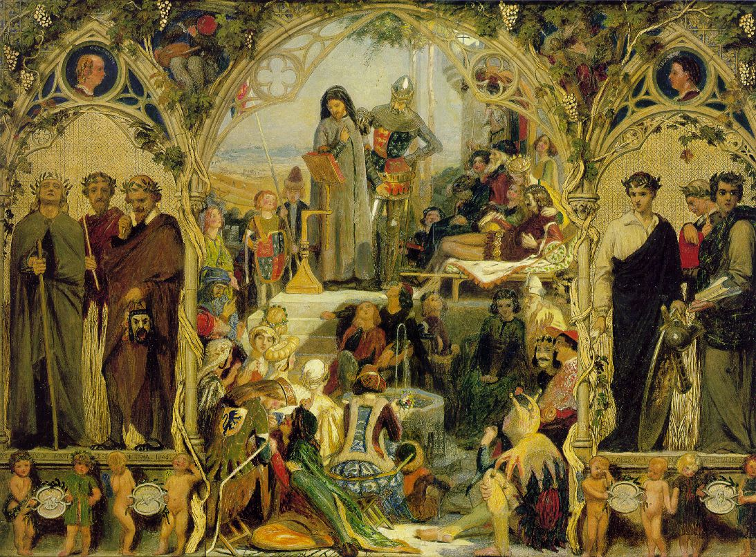
[English poetry – WEB-SOURCE.]
On the other hand, such an over-proliferation of cues will serve to offset any disturbance such as noise or to counteract the sound quality divergences which may exist between speakers of two dialects of the same language. But of, to insist, for instance, upon exaggerated articulation in order to achieve clarity may well be to go beyond the requirements of speech as a means of communication; indeed, certain obscurations of quality are, and have been for many centuries, characteristics of English. Aesthetic judgements on speech, such as those which deplore the use of the ‘intrusive’ r, taken into account social consideration of a somewhat different order from those involved in a study of speech as communication.
Phonetics and Linguistics: A complete description of the current state of a language must provide information on several interrelated levels:
- Phonology- the concrete phonetic characteristics (articulatory, auditory and acoustic) of the sounds used in the language; the functional, phonemic behaviour of these words for distinctive purposes; the combinatory possibilities (syllabic structure) of the phonemes; the nature and use of such prosodic features as pitch, stress and length. A study of the language may be accompanied by a description of the written form of the language (graphology).
- Lexis- The total number of word forms which exist.
- Grammar- The system of rules governing the structure of phrases, clauses and sentences consisting of words contained in the lexicon.
- Semantics- the relation of meaning to the signs and symbols of language.
Under both (2) and (3), it will be necessary to study the structure of words-morphemics. In addition, a statement may be made which combines phonemic and morphemic features (morpho-phonemics), e.g. the phonemes /s/ and /z/ in cats and dogs are exponents of the same morpheme of plurality which might be symbolized as |s|.
Other aspects of language which would require investigation include the variation of the same language in different regions and social classes (dialectology); the influence of context and style upon the form and substance of the language; the behaviour of human beings in their production and perception of the language (psycholinguistics); the interaction of the language and society in which it is spoken (sociolinguistics).
Finally, it is clear that phonology, lexis, grammar and semantics of a language are always undergoing change in time.
The state of a language at any (synchronic) moment must be seen against a background of its historical (diachronic) evolution ...
7^{TH.} JUNE, 2015-

“The science of phonetics has a prominence in the determination of pronunciation in the study of language, which signifies philology. The pronunciation of an expression is the first stage in the manifestation of language. There is perceived also, particularly in English, the scrupulous effort to make spelling adequately representative of pronunciation, though this is seldom seem sufficiently successful. This is because, with the change of time, and culture, language changes and so, do its spellings and pronunciation. Yet, pronunciation is found to change much quicker than spelling. After all, language, in written form, is a much later development. Of course, now-a-days, spelling, thanks to the convention and codes of printing, is much standardised, leaving pronunciation to pursue its natural course of change. This trend to constant changes in the pronunciation has created confusion regarding the speech-sound, particularly to foreign ears. A sort of system in the sound –speech is naturally considered necessary.
This has evolved the science of phonetics that treats this sound-speech quite independently, of the manner of writing down the same.”

“Theoretical theories theory theorizes theorists

- Efforts to solve global problems often require broad understanding of cultural systems, as well as detailed understanding of specific local cultures.

- Many now believe that vocabulary development is even more important than grammar study for second language learners.”
(WEB-THOUGHTS AND IMAGE)

“The English language is nobody's special property. It is the property of the imagination: it is the property of the language itself.”
-Derek Walcott

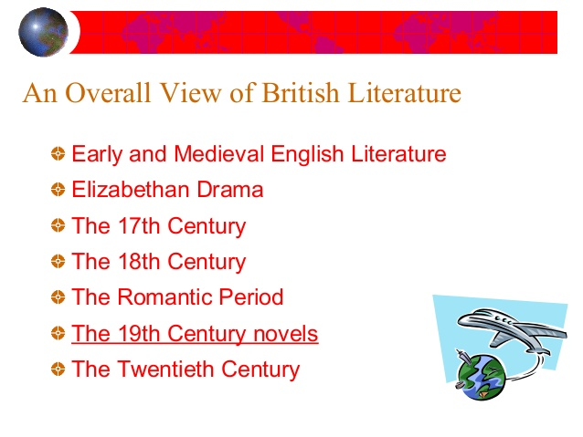
“MY HIGHER AND EX-STUDENTS UNDER MY SUPERVISION AND THOUGHTS HAD A VENTURE WITH MANY OF MY SCHOLASTIC STUDENTS AS WELL AS AVERAGE STUDENTS TO UNDERGO THE DISCUSSION ON DILEMMATIC CHORES OF THE ENGLISH LANGUAGE, THESE STUDENTS SOMETIMES ARE FACING.

THE MODERN GENERATION ANSWERED ON VARIOUS THOROUGHFARES ON USAGE OF SOME ASPECTS ON THE LANGUAGE. THEY HAD NOT ONLY VISUALIZED ON DISCUSSION OF TODAY BUT ALSO THEIR THOUGHTS WENT TOO FAR TO PERCEIVE THE KNOWLEDGE OF THIS VERSATILE LANGUAGE. THEY DREAM OF ABROAD, WITH CONTINUOUS EMPHASIS ON OWN PLACE. A VIDEO WAS UPLIFTED.”
-RITUPARNA RAY CHAUDHURI.

THE ETHNIC OF THE LANGUAGE

ACTIVE PARTICIPANTS AND THEIR EFFORTS TO EXPRESS THEMSELVES ON THE ENGLISH LANGUAGE: (EDITED)

NAVONIL SAHA (IMO, APPRECIATION ON DILIGENCE, ENGLISH WIZARD, STATE HOLDER)-TALKS ABOUT THE ENGLISH LANGUAGE IN BENGAL, THE LANGUAGE SYSTEM PREVAILS IN INDIA AS WELL AS ENGLISH, A GLOBAL LANGUAGE. He talks to me with a far-sight on following paper-article, TIMES OF INDIA...he says on,

“My mother is a teacher. On discussion to topic with my known, I am worried of my place; still there is deficiency to speak the English language fluently as well as of not being a proper well-exposure, even in case of many teachers am coming across. Thinking from different points of conventional chores, thus whom should I blame?

Perhaps, I might myself not able to articulate properly at far extent! Considering many others in majority on my knowledge, I should say I am disturbed on undergo situations of English Medium Schools too... Are students there or in majority, well-comfortable to speak fluently on this language? What is about creativity? I stammer to have my own answer. My knowledge on speaking and confidence together goes against my academic-result I dream in on the language, for me and for others!”

KOHILI CHAKRABARTY (EXCELLENCE ON ACADEMIC; SCHOLAR.)- TALKS ON BEST BENEFITS OF THE LANGUAGE TO BE PROVIDED BOTH FOR CAPABLE AS WELL AS AVERAGE STUDENTS, WITH EQUIPPED EDUCATIONAL RESOURCES, SYSTEM AND CONVENTIONALISM.

“English language is not at all a problem to me. Though a pure student of Science, the English to me is ‘Gift of Divinity’. Dictionary, different sorts of books on the language, sometimes on poems or different books on vocabulary, alike and many other norms on the language as well as Philosophy together is my individual-core.

On the contrary however, getting to be learnt on the language should be highly equalised among both for common as well as scholastic students from the very ground. However, scholars … well, in midst or later in qualification(s) are proved to be A-Scholar... that is not most important to me. We want educational resources, I suppose, to know what the English language is, we are instead ‘studying’.

The gift of exposing self, through language is present in all individuals in form of an ore, I think. The person who can just rub it out in ‘’whetstone” and bring it out from its crude form (i.e. the ore) is the one who comes out shining brightly. He becomes the winner among us with the golden treasury. His casket of diamond (i.e. his honour of creativity) reflects his global glory. We are not the legends, but we the mob should try in field of learning.”

NILANJANA THAKUR (ACADEMIC BENEFITS, TELEGRAPH, APPRECIATION ON DILIGENCE.) - TALKS ON CLEAR AND PERFECT PRONUNCIATION WITH BEST EXPECTANT BENEFITS ON THE LANGUAGE.

“Correct Pronunciation and Self-Exposing are main ingredients to me. We are hearing of American Influence as well as British accents. Yet now, talking on my place we have not been taught of any on such difference…I, therefore feel myself to be much declined when speaking to a foreign mouth or while perceiving from a GOOD level, however. We have to have, thereby, a good guide or an expert on the language. We want, therefore proper resources of the acquired language that to be learnt.”

SOHAM SIDDHANTA (ACADEMIC BENEFITS, TELEGRAPH)

“I am not at all been satisfied with educational resources regarding the language. To me at least, it is a fuss on acquiring properly the fluency of English language as well as a complete incompetence in English Grammar on teaching to a moderate student on the subject. I think myself moderate, ONLY on the subject. My mother tongue is Bengali. I only … study the subject on acquisition to get marks unlike Science.”

TAULIK PAUL (ACADEMIC BENEFITS)

“There is no scope of proper development on Creativity of a student from own on the language. Rather, we are only being imposed upon to be under mechanical regulars of the subject on language. Hence, sometimes we lack interest.”

PRATITI SEN (ACADEMIC EXCELLENCE,SCHOLAR)
“Acquisition of knowledge on the language, more to develop creativity and to learn a matter rather than only to study is my altogether choice.”

KUNTAL SARKAR (ACADEMIC EXCELLENCE AND BENEFITS)

‘“I think group discussion IN proper English accent- and- dialect on guidance is an individual form to introduce in nearly all schools or alike, as one of the most important steps to create the power of communication.”
My Ex-student versed, “I joined the session on discussion only with motive after reading with English Honours, if possible, turn The English Language in Dilemma in case of many, on many aspects concerning my place also, to The English Language in Debonair.”- SUBARNA CHAKRABARTY (STUDENT OF ENGLISH HONOURS).

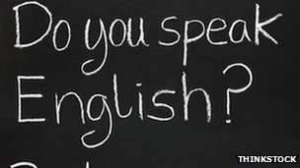

[Disassociating the future-WEB-SOURCE.]

“With Latin, French is one of the great fundamental formative influences on the English vocabulary.” ----------

Causes Of Entry of Loan Words
Loan words form essential elements in a language. The question that comes here is the factors which lead to the introduction of loan words into a particular language. These factors are generally two.

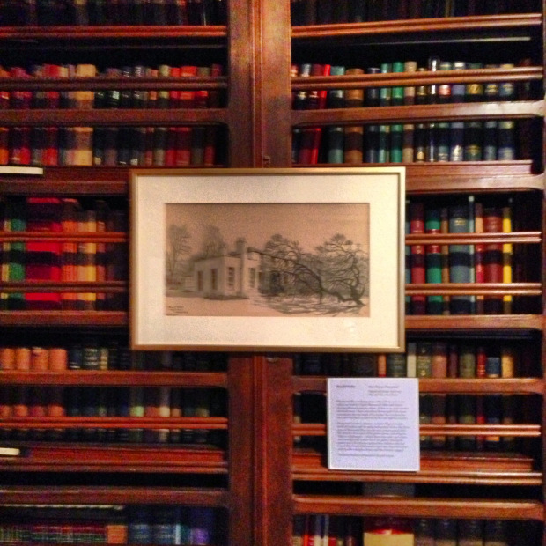
[Making it the largest Romantic literature collection in the world.-WEB-SOURCE.]
In the first place, during its intercourse with another nation, a nation may learn some new idea, thought, or element. If there is no ready native word to express the same, a ready-made foreign word has to be taken. Thus, when Christianity was introduced, the English had to borrow certain Latin and Greek terms to express their new, religious beliefs and ideas.
In the second place, there are certain technical elements which cannot be learnt without the help of foreign loans, and naturally, such loans are taken. The introduction of feudalism by the Normans invariably led to the import of certain technical words, connected with it, from French.
It is to be also noted that linguistic laziness often leads a people to borrow words from another language freely.

The contention of Jespersen that the loan words are the milestones of philology may well be corroborated by referring to the influence of loan words on the English Language. There are several stages of the penetration of loan words into the English language, and these may well be designated as the milestones of its philological growth.
:
Before their conversion to Christianity, the savage Anglo-Saxons came in contact with the superior civilization of Rome. The impact of high Roman culture and of the magnificence of the Latin language was immense on their language.
In fact, the adoption of Latin loans into the English language started before the settlement of the Angles and the Saxons in England. Several Latin terms, connected with that civilisation, had an easy access to English. One such loan was Latin ‘strata’ (mod. ’street’).as a result, the Anglo-Saxon people learned a number of Latin terms in course of their intercourses with the Roman people and adopted them in their own language. Even some early Christian terms found their way into the native English words, such as, ‘devil’, ‘church’ and ‘bishop’.
Again the Anglo-saxons were connected with the cultivation of vine and drinking of wine, and they had recourse to Latin loans in order to express their ideas. One of the earliest loan words was ‘wine’ (from Latin ‘vinum’). Other such loan words include ‘cup’ (O.E. ‘calic’ from Latin ‘calicem’.
Again, the Anglo-Saxon had intercourses with the Roman merchants who were mostly wine-dealers. Consequently, there is found the loan ‘cheap’ (the old meaning was ‘bargain’ or ‘price’) from O.E. ‘ceapin’ which had come from Latin ‘caupones’, meaning ‘wine dealers’ or ‘keepers of taverns’. Another commercial term, borrowed from Rome, is ‘monger’ (O.E. ‘mangere’) from Latin ‘mango’, meaning ‘retailer’.
Such Latin loans are usually termed as he Latin Loans of the Zero Period and belong to the phase of the continental borrowing by the Anglo-saxon people from Rome. This forms the first milestone of the foreign loan
:
When the English settled in Britain, they learned a few other Latin words from the Romanised people of the land. Thus, the Latin ‘castra’ (a fortified town) was adopted in Old English, under the form ‘ceaster’, and it survives today in the place-name of ‘Chester’, and in the ending of many other place-names, such as Winchester, Leicester, and so on.
The English also learned from Roman certain commercial terms, relating to value and measurement. One such term is ‘mint’ (O.E. ‘mynet’) from Latin ‘moneta’, meaning ‘money’. Similarly, there are ‘pound’ (O.E. ‘pund’) from Latin ‘pondo’, meaning a weight, and ‘inch’ (O.E. ‘ynce’) from Latin ‘unica’, a measurement.
The English similarly borrowed the Latin words, connected with travel and sea-voyage, such as ‘mile’, ‘anchor’ ‘punt’. The borrowed words, connected with food and cooking, also indicate the influence of Rome on the savage Anglo-Saxons. Thus, there are ‘cook’ (O.E. ‘coc’) from Latin ‘conquus’, ‘kitchen’ (O.E.’plume’) from Latin ‘prunus’, ‘pea’ (O.E. ‘pise’) from Latin ‘pisum’, and so on. Instances may be multiplied here. This stage of borrowing, after the settlement of the Anglo-Saxon people in Britain, generally goes by the designation-Latin Loans of the First Period.
Such loan words, adopted from Latin in the Pre-Christian period (prior to the conversion of the Anglo-Saxon people to Christianity), may be taken to form the second milestone on the long road of the growth of the English language.
It may be noted in this connection that the savage Anglo-Saxons, with their lower strata of civilization, could hardly appreciate the high Roman philosophy or culture. They were not ripe for the purpose, and in their barbaric ignorance and simplicity, they imitated and adopted a good many Latin words which they found necessary to their practical and material everyday life. It may need be noted also that those loan words are mostly short, as compared with the bulk of the later Latin loans, because such short foreign words could be better grasped and managed by the ignorant and backward Anglo-Saxons.

The introduction of Christianity into England about 600A.D. led to the import of a great number of loan words, known as the Latin Loans of the Second Period. The conversion had far reaching linguistic consequences. The Anglo-Saxons had to find out new words to understand and express their new religious ideas and thoughts. They borrowed a good many words from Latin and Greek. One of the earliest loan words, belonging to this sphere and already mentioned ,is ‘church’ (O.E. ‘cirice’ or ‘cyrice’), from Greek ‘kuriakon’ (house of tyhe Lord) or ‘kuriaka’. Similarly, there came from Greek ‘devil’ (Lat. ‘diabolus’ from Gk. ‘diaboles’), and ‘angel’ (O.E. ‘engel’ from ‘angelus’). From Latin, came a good many words connected with Christianity, such as ‘minster’ (O.E. ‘mynster’) from Latin ‘monasterium’. Other such loan words are ‘Pope’, (O.E. ‘papa’), ‘bishop’ (O.E. - biscop), ‘abbot’ (O.E.-‘abbod’), and so on. Some more Latin loans are found in ‘nun ’, ‘pall ’, ‘masses, etc. In addition to these loan words, new words were also formed from native sources to express Christian ideas and practices, such as ‘gospel’, ‘Easter’, ‘handbook’, and so on. All this constitutes the third milestone.
It is to be remembered that, in the third phase of borrowing, the Anglo-Saxon people could adopt learned words, connected with Christianity, and exhibited their intellectuals’ resourcefulness to frame new words from their own sources to express their new faith. That was a definite mark of their cultural and intellectual advancement.

The Scandinavian invasion and settlement brought a good number of loan words, like ‘hence’, ‘thence’, ‘whence’, ‘gift’, ‘dream’, ‘they’, ‘them’, ‘their’, ‘same’ , and so on. The Scandinavian loan words were not uncommon, nor too learned for the average Englishman. Some such common Scandinavian loan words include ‘law’ (O.N. ‘lagu’), fellow (O.N. felagi), wrong (O.N. wrang), egg, skin etc. they had a purely democratic character with their everyday uses in common-place matters by him. The Scandinavian contribution to the growth of the English language is immense and constitutes the fourth milestone in the philological growth.
The democratic nature of the Scandinavian influence is indicative of the closeness of the cultural relation between the English and the Danes.

The Norman Conquest of 1066 brought about another stage of the philological expansion in the English language. The Normans, as conquerors and rulers, introduced a good many new ideas and institutions in social, religious and political matters. Their own words, the French loan words, were automatically introduced by them to impose and express the same. Such French loans are ‘reign’, ‘sovereign’, ‘chancellor’, ‘minister’, ‘exchequer’ , ‘plaintiff’, ‘jury’, ‘abbey’, ‘cloister’, ‘beef’, ‘mutton’, ‘bacon’, ‘dress’, ‘costume’, ‘adieu’, ‘alas’, etc.
The Normans, with their French culture and language, were much more advanced than the conquered nation English. Naturally, the impact of this French language on English was tremendous, establishes in the force of a superior culture on an inferior, and marked another milestone in English philology.

The Renaissance brought forth some further Latin loans such as ‘enormous’, ‘premise’, ‘climax’, ‘bathos’, ‘sonnet’, ‘epistolary’, ‘insomnia’, ‘phenomenon’ and ‘parricide’. This is the third stratum of Latin loans and styled as Latin loaned of the Third Period.
The classical words, borrowed in the third phase, are, however, found much richer, more learned and intellectual and rather abstract. They are meant for educated, intellectual people. The enrichment of the English vocabulary from the rich store-house of Latin and Greek seem to testify to the growth of English culture and taste under the impact of the Renaissance, which served to indicate the sixth milestone.

The expansion of the British empire, the new contact with distant lands, advancement in trade and commercial transactions and scientific inventions are all found to have distinctly affected and enlarged much the potential scope for the inclusion of loan words from different languages. In fact, loan words have found their entry into the English Language from different countries, from Europe, Asia, Africa, and even America, at different times, under different forces social, commercial, ethical or cultural.
Moreover, numerous words have coined in English to give expressions to new matters and issues, including war, internationalism and so on.
The seventh milestone indicates the extension of the cultural ties or political or social relations of the English people with various people’, is belonging both to the orient and to the occident.
INTRODUCTION TO PHONETIC SYMBOLS ……
philology, pronunciation AND PHONETICS
NEEDS A PROPER GUIDANCE

“DERIVATION’ MEANS THE MAKING OF A NEW WORD OUT OF AN OLD ONE. IT IS ONE OF THE RICHEST SOURCES OF FORMING WORDS IN ENGLISH.

PHILOLOGY- It is the science of language. It is the study of the origin, growth and expansion, different features and factors of a language. But of, language depends on expressions-not merely on sound, but on a meaningful sound. This meaningful sound in language in language is PRONUNCIATION. The pronunciation of an expression is the first stage in the manifestation of language. After all, language in written form is a much later development.
PRONUNCIATION- It is a key element in language. But of, it is again an effect of the spelling of a word. This is because with the change of time and culture, language changes and so do its spellings and pronunciation. Yet, pronunciation is found to change much quicker than spelling.
This tend to constant changes in pronunciation has created confusion regarding the speech-sound, particularly to foreign ears. A sort of system in SOUND –SPEECH is naturally considered necessary. This has evolved the SCIENCE OF PHONETICS that treats this sound-speech quite independently of the manner of writing down the same.
So the SCIENCE OF PHONETICS has a prominence in the DETERMINATION OF PRONUNCIATION in the STUDY OF LANGUAGE that signifies PHILOLOGY.
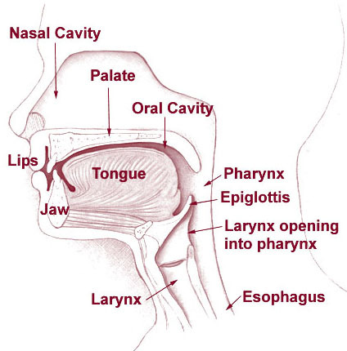
[IMAGE FROM WEB-SOURCE.]
The oral matter of language or what constitutes sound brings in the issue of phonetics. The tem PHONETICS HAS COME FROM GREEK PHONETIKOS (PHONEO-‘SPEAK’ ETIC- ‘SEE’), and represents a vocal sound, and is used always in the ‘same symbol’ for the same sound.
Phonetics is the scientific study of the functions of the speech sound. THE THREE –FOLD FUNCTION OF PRODUCTION, TRANSMISSION AND RECEPTION OF THE SPEECH FORM THE LINGUISTIC PROCESS.
As is the case with other languages, English spelling is not logical. Words which are spelled in a similar manner may be pronunced differently. It is, therefore, essential to have some knowledge of phonetics.
Phonetic symbols are a great help when it comes to learning to pronunce English words correctly. Though we can find the correct pronunciation of words in the dictionary by looking at the phonetic pronunciation that follows the word, if we do not know the symbols, we will not be able to master the pronunciation. Unfortunately, learning the phonetic alphabet is not always the easiest thing to do.
In English, many words can have the same pronunciation but must be written differently with different meanings. For example ‘to, two, and too’ all have the phonetic transcription/tu/. Sometimes, words can be written similarly but have different pronunciations as in the ‘ough’ combinations thought, though, bough, and through. Another factor in pronunciation is the how the word is stressed.
Study the following chart showing phonetic symbols
- ni as tree/trı/
- ı as in insect /ınsekt/
- Ɛ as in bet /bƐt/
- æ as in cat /kæt/
- a as in car /ka/ British, /kar/ American
- ɒ in bought /bɒt/
- ɔ in saw /sɔ/
- Ʊ as in foot /fƱt/
- u as in boot /but/
- Λ as in up /Λp/
- ɜ as in fur /fɜ/ British, /fɜr/ American
- ə as in ago /ə’gəƱ/
- eᴵ as in play /plɵᴵ/
- əƱ as in know /nəƱ/
- aᴵ as in sky /skaᴵ/
- aƱ as in how /haƱ/
- ɔᴵ as in boy /bɔᴵ/
- ᴵə as in near /nᴵə/ British, /nᴵər/ American
- eə as in where/weə/ British , /weər/ American
- Ʊə as in pure /pȷƱə/ British, /pȷƱər/ American

Consonants

p as in play /pleᴵ/
b as in boy /bɔᴵ/
t as in tree /tri/
d as in dog /dɒg/
k as in cat /kӕt/
g as in got /gɒt/
tʃ as in chin /tʃᴵn/
dʒ as in judge/ dʒƱdʒ/
f as in fine / faᴵn/
v as in visit /vᴵzət/
Ɵ as in thin /Ɵᴵn/
Ǒ as in then /ǒɛn/
s in sick /sᴵk/
z in zoo /zu/
ʃ as in shine /ʃaᴵn/
ʒ as in vision /viʒn/
h as in how /haƱ/
m as in much /mΛtʃ/
n as in now /naƱ/
ŋ as in sing /siŋ/
l as in leg /lɛg/
r as in read /rid/ or /rɛd/
j as in yes /jɛs/
w as in wet /wɛt

The growth of language, reposes both on the words, borrowed from other tongues, and on its capacity for forming new words from native sources.
Such native formation in English are found made in diverse processes, and these are discussed below:

A compound word or simply a compound is formed by joining two or more base or root words. The new word, thus formed, is used to express a meaning that could be rendered by the phrase of which the simple words form parts. Of course, the new words formed may or may not have any link or relation with the sense of each base word. In English language, compound words are formed freely, and this has enriched, to a very extent, the native vocabulary.
In the English language, the compound may be made by joining two or more parts of speech. There may be the compounds of two or more nouns, nouns and pronouns, nouns and verbs, nouns and adjectives, adjectives and verbs, adverbs and verbs, adjectives and adverbs, and so on.
N+N > Compounds < N +Adj
N +Adj > Compounds < Adv+ N
Adj +N > Compounds < V +Adj
N+V > Compounds <V +Adv
V+N > Compounds < P+N
^ ^ ^
Adj+v Adv+V Adj+Adv
The English compounds are, thus, found formed in different ways, as illustrated below:
Parts of Speech Root Words Compounds
N+N gold +smith goldsmith
N+N sun +rise sunrise
N+N home +work homework P+N he +goat he-goat
P+N she +cat she-cat
P+N she +wolf she-wolf
A+N green +house greenhouse
A+N noble +man nobleman
A+N public +house public house
N +Adj duty +free duty free
N +Adj world +wide worldwide
N +Adj knee +deep knee deep
V+N hang +man hangman
V+N search +light searchlight

V+N break-fast breakfast
N+V sight +see sightsee
N+V house +hunt house hunt
N+V sleep +walk sleepwalk
Adv +V over +look overlook
Adv +V under +mine undermine
Adv+V out +do outdo
Adj +V white +wash whitewash
Adj +V clear +cut clear cut
V +Adv run +away runaway
V +Adv blow +out blowout
V +Adv knock +out knockout
Adj +Adj dark +blue dark blue
Adj +Adj red +hot red hot
Adj +Adj serio +comic serio-comic
Adv +Adj under +ripe under-ripe
Adv +Adj ever +green evergreen

Noun+ ‘ing’
Participle man +eating man-eating
Law +abiding law-abiding
Noun+’ed’
Participle hand +made handmade
Blood +stained blood stained
Adj/Adv+’ing’/
‘ed’ participle easy +going easy going
Far +fetched far-fetched

Miscellaneous
Compounds: my +self myself
No +body nobody
Walkie +talkie walkie-talkie

Lastly, there are several rich poetical compounds, freely invented and employed by such poets, as Spenser, Shakespeare and Keats. Some such instances are:
‘rosy-fingered Morn’, ‘Silver-dropping tears’, ‘self-consuming care’, (all from Spenser).
‘proud-pied April’, ‘heaven-kissing hill’, ‘word-without end hours’, (from Shakespeare).
‘light-winged Dryad’, ‘mid-May’s eldest child’, ‘purple-stained mouth (from Keats), and so on.
In all the above cases, the literal meaning of the compounds depends, more or less, on the last elements. Thus ‘garden-flower’ is a kind of flower, while ‘flower-garden’ is a class of garden. Similarly, there are night-guard, Head-master, and so on.
There are, however, other compounds in which this principle is not exactly applicable, as in ‘bare-foot’, ‘lion-hearted’, and so on. Here the ‘sense’ is carried by both the elements.
Again, there are also some compounds, in which the meaning is mostly dependent on the ‘first element’ as in ‘break-fast’, ‘save-all’ and ‘spendthrift’.
There are some improper or spurious compounds which are formed by combining the words which might have existed in a regular, syntactical relation, as father –in-law, man-of-war, matter-of-fact.
In this connection, it needs to be noted there are some compound words which carry a ‘sense’, completely different from the meaning of their constituent elements. Thus ‘dayes eye’ is now ‘daisy’, but there is no relation of this word with its component words. Similarly, ‘holy’ and ‘day’ have formed ‘holiday’, as also ‘Christ’ and ‘mass’ have become ‘Christmas’. But in, in both the cases, the compound words bear meaning distinctly different from the sense of each constituent element.

The true life-blood of a language lies in its power to make new words by derivation. However numerous the foreign loan words may be, it is the process of forming new words from native resources that constitutes the genius of a language.
Thus ‘laugh’ is the original verb, and from this the noun ‘laughter’ is derived. It needs to be noted, that the ending ‘-ter’ is no longer a living suffix, but the word ‘laughter’ has become an original term.
The formation of words by means ‘derivation’ has taken place in the English language in a ‘number of ways’, and all these indicate the great potency as well as the flexibility of the English language.
If a paragraph is unduly long, it tires out the attention of the reader and makes it difficult to grasp the main idea.

In the first place, a large number of derivative verbs has come from nouns, adjectives, or other verbs by the alteration of the vowels. Thus the verb ‘tell’ has come from the noun ‘tale’. Similarly, ‘sell’ has come from ‘sale’, ‘bleed’ from ‘blood’, and so on.
Of course, there is no such alteration in some cases. The verb ‘cool’ is formed from the adjective ‘cool’ and there are many such instances. The verb ‘welcome’ has been formed from the adjective ‘welcome’ (a welcome guest), without any alternation.
In some cases, however, a verb, formed of a noun, has given rise to a new noun. Thus from the noun ‘smoke’ is derived the verb ‘smoke’, (‘to smoke a pipe’), and from that has come a new noun ‘smoke’ with a different sense (as in ‘let us have a smoke’). Of course, in some cases, the derivative verb differs in pronunciation from the noun as ‘bathe’. Again such a verb and such a noun, a corresponding verb and a noun are also derived respectively. Thus there are ‘bath’ as a verb and ‘bathe’ as a noun.
The test of unity of a paragraph is that it should be capable of being summed up in a single sentence.
An excessive attention to sound must not also lead us to neglect the more important qualities of style of creative skill

In the second place, derivations are found made, on a rapid scale, in English by the use of prefixes and suffixes. In fact, a very common process of word-formation in English is to add a prefix in front of or a suffix at the end of a root-word or base-word.
Thus ‘author’ is the root or main word. The syllable ‘co’- is added before it. This is the prefix and it serves to make a new word ‘co-author’- co+author=co-author.
Again, the word ‘drive’ (a verb) is the ‘root’ or main word. The letter ‘r’ is added after it to form a new word ‘driver’. Hence ‘-r’ is a suffix.
Drive+r=driver.
The new word, formed by means of the prefix or suffix, may or may not have any change in the word-class. Of course, the new word thus formed, has a new meaning.

A prefix or suffix may be added to the same root/base word to form different words. Thus the prefix ‘a’-+root word ‘lone’ forms a new word ‘alone’. But in, by adding the suffix ‘-ly’ to this word, another word may be formed –lone+ly= lonely.
Similarly, asleep [prefix ‘a’ + sleep], sleepless [sleep + suffix ‘-less’], friendly [friend + suffix ‘-ly’], unfriendly [prefix ‘un’ + friend + suffix ‘-ly’]. Happiness [happy +suffix’-ness’], happily [happy+ suffix ‘-ly’], blindly [blind + suffix ‘-ly’], blindness [blind+ suffix ‘-ness’]
The existence of prefixes and suffixes has been a common and constant feature since the days of Old English. The prefix ‘un-‘or ‘be-‘, used to form verbs like unfasten, uncover or be-fog, be-night, be-muddle’ has a long past. The most potential force in forming derivatives is the suffixes which are found existing plentifully even in Old English. Of such old suffixes mention may be made of : ‘-ly’, ‘-ness’, ‘-ship’, ‘-dom’, ‘-en’, ‘-isc’ (modern’-ish’), and so on.
Of course, all these prefixes and suffixes are not native. Foreign prefixes and suffixes have too, contributed immensely to the enlargement of the English vocabulary.
Such ‘foreign’ prefixes, used commonly, include-
FRENCH- ‘-en’: endanger, enlarge, enlist, enlighten.
‘demi’ : demi-god, demi-official.
LATIN-‘re-‘: recover, regain, reconstruct.
‘de’ :decontrol,de-nationalise, de-centralization, decompose.
‘pre’: pre-planned, pre-war,
pre-arrange, pre-conquest.
‘pro-‘: pro-Vice-Chancellor, pro-British.
‘post-‘ : post-war, ‘post-date, postgraduate.
‘extra-‘: extra-curricular, extra-work.
‘dis’- disobedient, discontent.
‘Foreign suffixes’ too are found freely adopted in the formation of words:
FRENCH- ‘-ment’: amazement, merriment.
‘-esque’ : picturesque, picaresque.
‘-ess’: authoress, poetess, hostess.
‘ette’ : kitchenette.
‘-age’: shortage, bondage.
‘-ee’: addressee, payee.
LATIN- ‘-al’: arrival, refusal.
‘-ous’: virtuous.
‘-eous’, ‘-ious’ : courteous, vivacious.
‘-ese’: Chinese.
‘-ation’: estimation, starvation.
‘-ative’: talkative.
‘-al’: withdrawal, upheaval.
GREEK- ‘-ism’: heathenism.
‘-ite’: Raphaelite, Irvingite.
However, now the further formation of words by different prefixes and suffixes is shown below:

Prefix +Root/Base word= New Word
- (at, in, engaged) +boil (verb) aboil
+drift adrift
+shore (noun) ashore

a (without, absence
of a quality) +moral (adj.) amoral

ante- (before) +room (noun) anteroom
anti (against)+social (adj.) antisocial
arch (chief) +bishop (noun) arch-bishop
auto- (self)+biography (noun) autobiography
demi- (semi, half) +god (noun) demi-god
extra- +curricular(adj.) extra-curricular.

Similarly,

‘be’> belittle. ‘bi’> biweekly.
‘co’= together> co-education.
‘counter= against > counter-attack.
‘de = to/remove> debunk
‘dis- =in the negative sense >dishonour, disbelief.
‘em/’en = to make verbs> embitter, enslave.
‘ex =former> ex-minister.
‘extra = outside> extra-curricular.
‘fore = before, infront> fore-father, foreground
‘in/’un =in the negative sense =undigested, indiscipline.
‘inter =between, among> inter-marriage, international.
Mal =bad> malpractice
Mini =little> minibus
Mis =wrongly> misconduct.
Multi=many> multinational.
Non-not >non-smoker, non-stop.
Vice=deputy >Vice-president. …

Now some examples of word formation by means of suffixes are given. An important difference between the prefix and the suffix is that the former has mostly a meaning of its own, but the latter rarely has any such meaning. The suffix mainly serves to modify the meaning of the root or base word.

Root/base Word +Suffix New Words
Hunt +er hunter
Poet +ess poetess
Churl +ish churlish
America +an American
Ideal +ism idealism

The existence of such prefixes and suffixes has been a common and constant feature since the days of old English. The prefix ‘un’- or ‘be-‘, used to form verbs like unfasten, uncover or be-fog, be-night, be-muddle, has a long past.

One of the resourceful means in word-formation is the process of back-formation. This is a process to form new words by subtracting something from some old existing words. It owes its origin to the mistaken idea about a particular part of a word which is generally taken as a derivative suffix.
Indeed, a good many English words have a fallacious appearance by having some well-known derivative suffix. A word of this kind is popularly supposed to imply the existence of a primary word from which this has been unconscious creation of a new word, made out of the old one, by depriving it of what is thought to be a suffix or sometimes by the substitution of the old supposed suffix by a different prefix.

Thus, the verb ‘beg’ is supposed to have been formed from ‘beggar’ which probably came from French ‘begar’, a member of a religious order, who lived by begging. The ‘ar’, taken as a suffix, was removed and the verb ‘beg’ came. The foundation of the new word here was made from the back.

Similarly, the noun ‘butcher’ has come from the French word ‘boucher’. The ending ‘-er’ here is not the usual English suffix to form agent nouns. But in, that was taken as a suffix and eliminated to form the verb’ to butch’. Similar dialectical back-formations include ‘buttle’ (to pour out liquor) from ‘butler’ and ‘cuttle’ (to make knives) from ‘cutler’. The same process of back-formation is marked in the origin of the verb ’edit’ from ‘editor’. In all these cases, it is obvious, new words are found formed from the back.

Again, the adverbs, like ‘sideling’ ‘grovelling’ ‘darkling’ were originally formed by means of the adverbial ending ‘-ling’. Subsequently, it was thought that those adverbs were formed by means of the participle ‘-ing’. So, by subtracting ‘-ing’, new verbs like ‘slide’, ‘grovel’, ‘darkle’ were formed respectively.
The words in all these cases were formed from the back, and so the process is called ‘back formation’.

Some more examples of ‘back –formation’ are ‘greed’ from ‘greedy’, ‘laze’ from ‘lazy’, ‘gloom’ from ‘gloomy’, ‘cose’ from ‘cosy’, ‘jeopard’ from ‘jeopardy’, ‘pup’ from ‘puuppy’, ‘bant’ from ‘banting’, ‘burgle’ from ‘burglar’, ‘hawk’ from ‘hawker’ and so on.

Hybridism is the process of forming composite words from the stems of different languages. When a prefix or suffix is added from one language to an original word of another language, the new word, thus formed, is called a hybrid.
In the English language, the principle of hybridism is found operative in the formation of new words by the combination of English and French, English and Latin and English, French and Scandinavian and so on. A hybrid in the English language is generally found to have been formed in the following ways:
First, an English inflexional ending is added to a French word, as seen in ‘Duke’s children’, ‘noblest’, and so on. Similar hybrids, formed by the English ending added to the French words, are also found, as illustrated below:

French word+ Native ending= New Word

Beauty + full beautiful
Art + less artless

Second, some hybrids are formed by native word and a French ending. Such hybrids are:
Native word + French ending =New Word

Shepherd + ess shepherdess (New Word)
Mile + age mileage
Endear + ment endearment

Third, the native prefix and the French word are found to combine to form a new word as:

Native prefix + French Word = New Word

Un + just unjust
Over + power overpower

Fourth, the French prefix is also added to the native word to form a new word:
French prefix + Native Word = New Word

Dis + believe disbelieve
Re + birth rebirth
Fifth, hybrids are also found to contain French and English endings, added to Scandinavian words.

Scand. Word +French ending + English ending= New Word

Trust + ‘-ee’ + ‘-ship’ = Trusteeship

Sixth, there are the formations of hybrids by means of Latin and Greek suffixes, added to English words:

Native words + Latin/Gk. Suffix = New Word
Talk + -ative talkative

Heathen + -ism heathenism

Starve + -ation starvation
Seventh, some Latin or Greek prefixes are found to form new words with native terms.

Latin/Gk. Prefix + Native Word = New Word
Anti- + slavery anti-slavery
Pro + English pro-English
Ex + king ex-king

There is a general tendency to mono-syllabism in the English language. This has led to the numerous popular clippings of long foreign words. These clippings have been done in different ways.
In the first place, this clipping is made at the end , and the beginning only subsists, as in ‘pop’ (popular concert), ‘sov’ (sovereign), ‘gov’(governor), ‘pub’ (public house), ‘vet’ (veterinary surgeon), ‘bike’ (bicycle), ‘exam’ (examination), ‘cab ( cabriolet), ‘mob’ (mobile vulgus), ‘Jap’ (Japanese), ‘caps’(capital letters), and so on. Such clippings, at the end, are generally popular, but some of them are used as slangs.
In the second place, the clipping is made in the beginning, leaving the end only, as in-

‘bus’ (omnibus), ‘phone’ ( telephone), ‘baccy’ (tobacco), ‘wig’ (periwig) , ‘photo’ (photograph), ‘gram’ (telegram).
In the third place, in some very rare cases, the middle is only retained as ‘teck’ (detective).

Some of the clipped words have become so popular that their original forms have passed completely into oblivion. In this respect, ‘bus’, ‘cab’, ‘mob’ ,‘pop’ etc., may be specifically mentioned. In fact mob, cub, bus and pop have almost an independent existence, apart from their original words. Even the shortened form is found to assume a slight different sense, as in the case cab and cabriolet, for these are today not the same kind of vehicles at all.

The general trend of the English language to mono-syllabism has resulted in the shortening of some words of more than one syllable. This process of shortening has been made by a regular ohonetical development in which the pronunciation shifts to mono-syllabism. Thus ‘lord’ is shortened from O.E. ‘hlaford’. Similarly, there are ‘hawk’ (O.E. ‘hafoc’), miss (O.E. missies), ‘pence’ (O.E. ‘penigas’). Of course, ‘Mrs’ and ‘Miss’ are both derived by means of shortening from ‘mistress’.
In some cases, this shortening is done with a derogatory implication ‘Gent’ and ‘cit’ are the familiar abbreviations for ‘gentlemen’ and ‘citizens’ respectively. But in, the shortened forms are used contemptuously. Again, ‘Mrs’ and ‘Miss’ differ from the original word ‘mistress’.
The formation of words by shortening has arisen also of the abbreviations as M.P. (Member of Parliament), M.L.A. (member of the Legislative Assembly), M.A. (Master of Arts), and B.Com (Bachelor of Commerce), percent (Lat. Centum) and so on. The most peculiar of this is ‘culprit’ (from ‘culpable prest’)
Shortening is also found effected by dropping the initial vowel which immediately preceded the stressed syllable of a word. As a result, many words, beginning with a vowel, have come to take an alternative form, without the initial syllable. Both the forms, however, have survived with a slight difference in the sense:
Alone shortened to ‘lone’
Amend shortened to ‘mend’
‘Despite’ shortened to ‘spite’ and so on.
Of course, word clipping is also a process of shortening.

Of the process of word-formation, the principle of root creation need be mentioned. Of course, it is not easily definable or founded on any exactly logical method. In fact, the term is applied, somewhat vaguely, to the process of the formation of those words which owe their origin neither to native resources nor to foreign influences.
There are really a good many words in English which do not belong to old English or to any foreign language. These are not also formed out of the linguistic process of word-composition and derivation. The method of the formation of such words is characterized as root-creation.
Word –making by means of root-creation has several forms.
One of the principal forms of root-creation is onomatopoeia, which is a Greek word, meaning ‘name making’. In onomatopoeia, the sound of a word echoes its sense. The word is formed here to imitate its sound. The number of such ‘echoic’ words is quite considerable in English and include bang, boo, whirr, ding-dong, hiss-him, and so on.
Another important form of root-creation is phonetic symbolism. Sometime the sound of a word seems to suggest symbolically a particular kind of movement or a particular shape or appearance. It produces a mental effect that finds the meaning, imitated and expressed in the very sound. Of course, it is not possible to explain definitely why such a mental effect is created. A few instances of the words, thus formed-
Chap, chip, chop, joggle, flap, flip, flop, flash,
Flush, hung, hump, lump, throb, thump, twiddle, wobble, etc.
This phonetic symbolism accounts for this sort of root-creation, on a large scale, in Middle as well as Modern English. Many of the words, so invented, are generally found to occur in the group of two or three, in which the consonants are alike, although the vowel is varied to emphasize the differences of mental effects. Thus ‘bleb’, ‘blob’, ‘blub-checked’ have the same pronunciation of consonants, although the vowel sound is not the same at all.
As a matter of fact, a good many words are found to owe their origin to the suggestion, made by the combination of sound, such as bob, brob, hugger-mugger, fiddle-faddle and so on.
Again, there is the process of intentional root-creation which comprises the clever coinages of words. Such coinages derive their effects partly from their obscure resemblance to some existing words and partly from their phonetic expressiveness. 'Galumphing' and ‘chortle’ (verb) are two such popular coinages.

“Some lovers in this world
Live dear to each other, lie warm together
At day’s beginning; I go by myself
About these earth caves under the oak tree.
Here I must sit the summer day through,
Here weep out the woes of exile…”

A language, like a living organism, grows and develops decays and dies away, although this is no animate being. It is, however, the weapon, not martial, but intellectual and cultural of the most rational animate being. Naturally it has, like a living being, growth and decay. Its advancement and development depend, of course, on a number of factors, external as well as internal. An individual requires external aids in the form of food, drink, even medicines and the like for his or her health and growth. At the same time, he or she must have the internal power of the appropriate assimilation of external elements. In the same way, a language needs foreign elements, along with its own assimilative resourcefulness, to grow adequately. This is borne out solidly by the linguistic history of the English language that has risen today from a tiny local dialect to the status of an international language.
Indeed, the English language occupies today a very significant status in the world. It is the chief claimant for the dignified position of the international language, and this is hardly refutable. In vigour and vastness, in affluence and applicability, the language stands formidable and almost unassailable.
With its rich vocabulary, orderly grammatical and phonetical systems and easily accessible and liberal masculinity, it has attained a height, seldom to be rivalled by any other existing language.
This stupendous growth of the English language is, however, the inevitable effect of the regular processes which have been constantly at a work for its enrichment in diverse directions. As already indicated, both the external aids and inner strength work together harmoniously in great making of the language. The native element and the foreign borrowing (foreign loans) are to be equally reckoned with in this respect.
In the first place, the English language is found much enriched by the direct borrowing from other languages, old and new. Of course, the native Teutonic tongue of the Anglo-Saxon people was not strong enough and naturally easily influenced by the foreign tongue from time to time. The foreign borrowing started actually even while the Anglo-Saxons were still on the continent. Before they got to and settled in Britain, they adopted some loan words, for their own convenience, in course of their communication with other people’, in the matter of trade, warfare and domesticity. They borrowed even from the Roman people their words and expressions. Some such early classical (Greek and Latin) words are- street, cup, kitchen, chalk, cheese and so on. They also learnt some church-words even before their conversion, such as church, devil, bishop, and so on.
When they settled in Britain, they had another layer of borrowing from the Celtic people who had lived therein before them. Of course, the number of Celtic words in the English language is very few and include-
‘bin’ (a compartment or storage), ‘crag’ (a rock), ‘coomb’ (a deep valley),tor’ (a steep hill), ‘ambet’ (servant), and a few more.
Apart from the borrowing from classical languages- Latin, Greek and French and also Celtic-words from other foreign languages- Scandinavian, Italian, German, Spanish, Russian, Indian, Arabic, Persian etc. - are found freely accommodated in English. Such an importation of foreign words, rather on such a large scale, has immensely added to the English vocabulary. No list of such borrowed words can be exhaustive and as such only some specimens are cited below:
[From] Latin- Pope, monk, abbot, mass, pall, pea, candle, celestial, erroneous, appendix, epistolary, insomnia, phenomenon, sonnet, premises, series, bathos.
Greek- church, devil, angel, logic, ecstasy, pathos.
French- beef, venison, banquet, assize, sovereign, parliament, duke, council, chauffeur, ensign, standard.
Scandinavian- sister, law, crave, thrall, skin, skirt.
But at, this is not all. The English language has also freely borrowed and assimilated words from many other European languages as also Asiatic and African languages:
German: zinc, kindergarten, hinterland.
Spanish: don, grandee, canoe, embargo, plaza.
Italian: opera, piano, balcony.
Russian: steppe, vodka, rouble.
Indian: swaraj, durbar, coolie, gherao.
Chinese: chowmen, chopsuey.
Japanese: rickshaw.
It is clearly evident that the foreign borrowing has been extensive. Yet, such foreign loans are, in most cases, so distinctly assimilated with the native tongue that there is rarely perceived anything foreign or unusual about them. This power to assimilate perfectly and turn the foreign element into the native is definitely an innate strength of the English language.
In the second place, there is the formation of words, from native sources. This has taken place as a result of a number of linguistic processes, such as word composition, back formation, hybridism, word-clipping, shortening, and so on.
Some examples from those processes are given below:

Bare-foot, pick-pocket, white wash.

Greed (from greedy), darkle (darkling)

Oddity, talkative, starvation, anti-slavery.

Phone (telephone), bus (omnibus), cab (cabriolet)

Lord(hlaford), gent.( gentlemen), exam (examination)

Tell (v) (from tale), sell (sale), bleed (blood).
Again, the English vocabulary and its uses are largely extended by the change of significance or meaning of different words from time to time. Existing words are found used in several cases in derivations from their ordinary or original sense. Such changes in meaning or significance are seen, in several cases:
Sad (original meaning’ satiated’), glad (original meaning ‘bright’) tide (time), keen (cleverness), deer (wild animal), silly (blessed), and so on.
Moreover, recent coinages, the use of slangs (common colloquial terms), and the degeneration as well as regeneration of meaning have added to the sources of the language.

In the English language, compounds or compound words are very common and formed in different ways. These compounds are formed by joining two or more words. The component words may be of different parts of speech and they may form some compounds or compound words also of different parts of speech.
Such compounds, again, are generally classed as Fixed Compounds and Free Compounds.
There are some compounds in which the component parts are thoroughly integrated to convey a sense that has nothing to do with the sense of each part. Here one part is inseparable from the whole, and as the compound is fixed, this is called the fixed compound. Thus ‘daisy’ was originally formed by joining together two words ‘dayes’ and ‘eye’. The compound ‘daisy’, meaning ‘a particular flower’, has nothing to do with ‘dayes’ and ‘eyes’.
Similarly, ‘cupboard’ is an instance of the fixed compounds. The two constituent parts of the word ‘cup’ and ‘board’. The word is now used in the sense ‘a side board or keeping cups, plates etc.’, and has nothing to do with the component parts ‘cup’ and ‘board’. Other instances include, ‘Christmas’ (Christ + mass), holiday (holi+ day), nostril (nose+ thyrel). In each case, the component parts have nothing to do with the compound word in sense.
Some compounds are, again, found to have independent component parts. Each part exists separately in the compound and beats its own individual sense. The meaning of the compound is modified, intensified, or limited by each component part. As such a compound has independent or free component parts it is called a free compound. Thus in the compound, ‘barefoot’ both the parts ‘bared’ and ‘fost’ retain their individual entity and the sense of the compound (having the foot bare) is modified either of them. Such free compounds include breakfast, pocket money, dark blue etc.
‘I cannot see what flowers are at my feet,
Nor what soft incense hangs upon the boughs
But, in embalme’d darkness, guess each sweet
Wherewith the seasonable month endows
The grass, the thicket, and the fruit-tree wild;
White hawthorn, and the pastoral eglantine;
Fast fading violets cover’d up in leaves;
And mid-May’s eldest child,
The coming musk-rose, full of dewy wine,
The murmurous haunt of flies on summer eves.’

(ODE TO A NIGHTINGALE: JOHN KEATS.)

My students (RIDDHI NANDY AND MONANI BOSE: STUDENTS OF ENGLISH HONOURS) quote: “…shocking! Today’s generation is only been burdened with particular books to grab the rules and to have a self-career, as usual. What are they learning instead! Talking on this language, proper guidance is immediately to require on the subject for creativity, clear pronunciation; more shameful to be like majority, we think too, ourselves being an English Honours Student respectively we cannot expose ourselves properly with proper accent, or a proper dialect! We feel hence, part of rhetoric and prosody if possible and, are introduced to pupils at very secondary level... we can think, it should be benefitted.” (EDITED)

DEVELOPMENT OF MY THOUGHT ON TOPIC OF DISCUSSION WITH LITERATURE:

My intense thought on the language paralysed:

Kubla Khan orders a pleasure house to be built at Xanadu. Alph River ran through underground caves to the dark sea. So ten miles of land are enclosed by walls. There were gardens with zig-zag streams; there are trees with flowers having sweet perfume. There are ancient forests as old as the hills. Also there are sunny spots of greenery.
There is a romantic chasm full of cedar trees. It seems a magical place, where in moon light, a woman might come weeping over her ghost-lover who has broken her heart.
From this valley, a fountain of water has gushed out of the ground every moment. This burst of water throw up stones, which looks like hail or chaff being scattered around. This fountain is the source of River Alph, which for some miles ran underground and then fell into silent sea.
In the midst of this noise of water and waves, Kubla heard from far, ancestral voices prophesying war.
The shadow of the pleasure-house fell mid-way on the waves of the river. It is a strange miracle-a sunny pleasure dome with caves of ice.
Once the poet saw in a dream an Abyssinian girl playing on her dulcimer (musical instrument), and singing a song of Mount Abora. If the poet could recall that song, he with the power of music create the sunny pleasure-dome with caves of ice. People will think him to be a magician, who has eaten honey dew and drunk the milk of Paradise. (Heaven)

‘’But’ oh! that deep romantic chasm which slanted
Down the green hill athwart a cedarn cover!
A savage place! as holy and enchanted
As e’er beneath a waning moon was haunted”…
A RESOURCE OF THE LANGUAGE

The term ‘Philology’ originally meant, as used by classical and medieval writers, the study of literature, including the technical study of such linguistic matters as were needed for the understanding of texts. For the ‘Word’ properly means ‘love of Logos’: and logos, implied both thought and language. Today in England though not in Europe generally, ‘philology’ has been narrowed till it covers only more technical study of language apart from literature.

PHILOLOGY AND LITERATURE
Yet this distinction between ‘language’ and ‘literature’ in the approach to English, is clearly artificial as well as misleading and harmful. For there is no separating the two disciplines or studies. Only by understanding the meaning of an author’s language, with the historical knowledge that this will imply for older literature , can any full aesthetic satisfaction be obtained. Without knowing something of the history of the language and of the meanings , words and idioms have had at different periods of our literature, it will be impossible to appreciate Shakespeare, Milton or Pope; not to mention more obvious examples such as Chaucer. It is, on the other hand, only in its written monuments that we can study the development of the English language: we must cultivate a feeling for the imaginative qualities in the use of words and a sensetiveness to their finer nuances of connotations, especially in poetry, if we are to know genuinely and intimately our mother tongue as employed by its best writers and speakers. The study of what is termed Semantics or Semasiology, that is of the meanings of words, is of particular importance to the student of literature. So many words have retained something like the same recognizable form throughout their history, while the meaning has continued to change through different periods. When William Morris rendered a line of the Old English poem ‘Beowulf’, as
‘The foamy-necked floater, most like to fowl,’
He caused a somewhat comic and incongruous image to appear in frivolous minds, because the word fowl, which formerly meant any kind of bird, has long been limited in ordinary usage to a particular species. We must beware of thinking of the language as static-assuming unconsciously that a word in Shakespeare which is still in common use, must have had our present significance to him. The famous line in Hamlet describing King Hamlet as
‘Unhousel’d, disappointed unaneal’d,’
Has the terms unhousel’d (from Old English hứsel= ‘Sacrifice’) meaning ‘not having had the housel or last Sacrament’, disappointed in the sense of ‘without the proper appointments or rites of the Church’, and unaneal’d meaning ‘lacking the Sacrament of anointing (annealing) or Extreme Unction’. All this is clear to the student of the history of the language. But of, a teacher is said once to have explained the line as referring to the restlessness of the ghost lacking his housel or ‘little house’ (coffin) , while another is alleged to have regarded housel as referring to the bread of the Sacrament as a ‘little house’. Clearly either view would lead to distortion of the meaning of the whole line and its context in the play, and hence to a false view of Shakespeare.
But at, enough has been said to emphasize that one of the values of the study of the history of a language is that it constantly reminds the student that language is by its nature fluid, never static, a living organism which can only be fully appreciated in relation to thought and feeling as well as form.
(C.L.WRENN)

romantic poem-Kubla Khan as an example ……….
Ans: Kubla Khan is a concentration of romantic features. Content and style together evoke an atmosphere of wonder and romance and enchantment.
A basic feature of Coleridge’s poetic art is his ability to render supernatural phenomena with artistry. This is also a characteristic of Romantic poetry. While Kubla Khan is not a supernatural poem in the conventional sense, some phrases in the poem collectively give it an atmosphere of other –worldly enchantment. The “caverns measureless to a man “, a “sunless sea”, a “woman wailing for her demon lover”, “the mighty fountain forced momently from that romantic chasm”- these are all touches, which create an atmosphere of mystery and arouse awe. But of, the description is so precise and vivid that no sense of unreality is created.
Romantic poetry is also characterized by sensuousness. Like Keats, Colerdge exhibits a keen observation. There are sensuous phrases and pictures in Kubla Khan. The bright gardens, the incense-bearing trees with sweet blossoms, the sunny spots of greenery, rocks vaulting like rebounding hail, the sunless caverns these are highly sensuous images. Equally sensuous is the vision of the Abyssinian maid playing on a dulcimer and singing a sweet song.
References to distant lands and far-off places emphasise the romantic character of Kubla Khan. Xanadu, Alph, Mount Abora belong to the geography of romance and contribute to the romantic atmosphere. There are highly suggestive lines in the poem and they too, are romantic in character. For instance, the picture of a woman wailing for her demon-lover under a waning moon, is very suggestive-“a savage place…holy and enchanted” Coleridge calls it. Equally suggestive are the lines: “And mid this tumult Kubla heard from far/ Ancestral voices prophesying war.”
The picture of the divinely has inspired poet closing lines is typically romantic. No writer imbued with the classical spirit have written these lines where the poet is presented as a divinely inspired creator. The poet achieves an awesome personality of whom the ordinary persons must “Beware”.
Kubla Khan is a work of pure fancy, the result of sheer imagination. The dream-like atmosphere of the poem is purely romantic.
‘In Xanadu did Kubla Khan’ is an incantation; each name says backwards the vowels of the other. The magic mounts as the rhythm rises. Then (as his headnote tells), STC was interrupted in writing down this vision he had in a dream by the call of ‘a person on business from Porlock.’ The breaking-off improves the mystery. If Coleridge had never touched opium, this symbolic account of poetic possession shows that he had ‘drunk the milk of Paradise’- and that such intense experience was a burden. This is the first supra-rational poem in Modern English, what De Quiency called a poem of power rather than a poem of Knowledge, though its fuel is STC’s extraordinary reading.

ONE OF MY EX-STUDENTS speaks-
“This conversation on topic with the students of primary as well as secondary system of education is perhaps a reality check which has put forth some of the crucial questions which need to be taken into consideration for improving the quality of education. Penetrating deep into the matter has cultivated me new questions whose answers are hidden in the bits and pieces of this very question answer session with the pupils regarding on the topic. Lack of COURAGE ON THE LANGUAGE, STRENGTH, SELF ESTEEM and CONFIDENCE are of particular area IN MANY CASES TOGETHER ‘draws our attention’.

Dynamism is the very law of nature, thus it also implies towards our educational structure .A union of practical knowledge with interactive sessions will however, help also the students to accommodate themselves, with the flexible job oriented environment benefitting them to opt for suitable career options in future.” – AGNIMITA MUKHERJEE (STUDENT OF JOURNALISM) (EDITED)

One of my students messaged me,” Our second language is English…We love the dialect and accent that it is spoken out. Without blaming, as per my opinion, on the topic of discussion we are deprived of teaching on pronunciation exactly and proper insufficient acquire on vocabulary words of the language. We should be too cared on our creativity and to be initiated with a complete self-exposed method on the fluency of the language, instead of caging ourselves in reading the books only…” (Vedant Bagchi, Academic Thoughts.) (EDITED)

The melody of a sentence depends, in a great measure, on the arrangement of its words. The alternate stress and relief of the voice being absolutely necessary for the cause of pronunciation, words should be so arranged as to admit to the rise and fall of the voice at regular intervals. The accumulation of unaccented syllables is never melodious; as felicitously, peremptorily, incompatibility, indefatigably etc.; and so also is an unvarying succession whether of long or short syllables.

English and the speech of the United States are one language: but in the more than three centuries that have passed since the first settlements, each has developed in divergent ways- both in its generally accepted ‘standard’ forms and in dialects. While it will be obvious to anyone that American speech and written language have developed new elements-in vocabulary, phrasing structure and pronunciation- it is not so well known that many older usages of English have been preserved in America which have disappeared from Britain. There are in America use, archaisms such as the preservation of gotten as the past participle of ger fall for ‘autumn’, aim to for the later English use of aim at, and faucet for tap. Many seventeenth–century usages have survived in standard America; and far more in some of the dialects: and some of these, like fall for ‘autumn’, may well seem more attractive than their English equivalents. American has developed new ways of speech partly through differing conditions of life, partly through its having received many influences from other languages in the process of its absorption of large bodies of immigrants from many lands. The primary difference between English and American is in the rhythm and intonation of speech: but there are many differences in shade of meaning in the common shared stock of English vocabulary, as well as new words and new metaphorical usages found first in America and only now beginning to take root in Britain. For example, politician has a disparaging sense in America which it doesnot carry in England; solicitor means a canvasser or visiting agent or beggar in American and clerk more often means shop-assistant than anyone else. The English of educated standard American then, is just as much a ‘good English’ as that of educated London: but the ‘clipped syllables’ which the American hears in Englishmen’s pronunciation as against the ‘drawl’ and ‘nasal tone’ which the Englishman notices in American, are in reality differences in rhythm and intonation which shew the development of two types of English. Such differences are enhanced by changes of meaning in the same words, new words in both forms of English, etc. But at, it is too soon to say whether these divergent developments will later produce two distinct languages, whether they will draw nearer together with the increased freedom of intercourse, or whether (as some Americans incline to think) American English win absorb that of Britain. Each has its formal and its slovenly types of speech, as each has its archaic and its rapidly changing features.

WHY I AM WRITING THE DOCUMENT:
It is, however, that American English has very considerably influenced British English- especially in the last quarter of a century: and this has been due to a far wider set of circumstances than the mere fact of America’s leading position in commerce, the films and finance- though these have produced a body of slang in England some of which has already penetrated to good colloquial usage. The word caucus, for instance, came to England as a political term from America, and has now developed a slightly different meaning. The use of cut as a word for reduction was originally American, but became fixed in good English largely through the financial slump of 1931 in Britain and its consequences. Sense as a verb, which has been in use in the British written language for nearly a century was an importation from America, and even to-day is frowned upon as a poor substitute for perceive or feel by some old-fashioned scholars.
But of, far the most marked American influence- and one which still seems to be increasing- is in the slang of the younger generation in Britain and in the colloquial English which springs from a selection of this. The films, naturally are a prolific source of this kind of language: but one cannot guess how much of it may turn out to be only a passing fashion of speech. Vividness and force in metaphorical expression are characteristic of much American English; and its natural , therefore, that a selection of these should be taken up into spoken English ,especially by the young who are most eager for new linguistic experience. But in, there are metaphors from America far older than the cinema which are now part of colloquial good English, such as the phrase to get down to brass tacks. Among , colloquial expressions in English from America may be mentioned the use of the verb to fix for a far wider number of senses than is current in written English or was known before the American influence, such as ‘I’ll fix it for you’ or ‘Try and fix it so that he escapes.’ Again, at least in newspapers and commercial works, the word executives has become a noun in English under American influences, as in ‘business executives are very highly paid’. No ‘one is conscious now in Britain of using a American expression when speaking of the party machine; yet this was till lately a pure American use of machine.
Among slang expressions which have not yet- and may never-reach the good colloquial stage, are dumb for ‘stupid’, ‘frame-up for ‘trumped-up charge’ , blue ‘depressed’, pass out ‘die’ or ‘fain’, O.K ‘all right’, and the noun pull in the sense of special individual influence (though this last may be thought by some already to have reached good colloquial status). The horde of slang terms from the film industry and from American ‘gangster’ and low life (real or supposed), needs no recording here.
In some ways it will appear that the recent American influence has done something to revitalize and invigorate British English- especially in vivid metaphor. On the other hand, vivid expressions if used as mere stereotyped phrases, when they were intended first in America, for occasions of special emphasis and strength of language, may seem an impoverishment rather than an enrichment of speech. Perhaps it is in the language of British journalism of the more popular newspaper variety , that this superfluous use of American expressions where British English was already well provided with appropriate words, shews the weakness or the disadvantage of the cheaper American influences and is most to be deplored. But at, journalism is a special profession which has practiced on a far vaster scale in the United States than anywhere else in the world. It is significant that Mr. Churchill , with his talent for simple beauty of phrase, has shewn at one and the same time the influence of American English and of Shakespeare by beginning a speech with the words ‘Before the fall of the autumn leaves’ .
BIBLE TRANSLATIONS
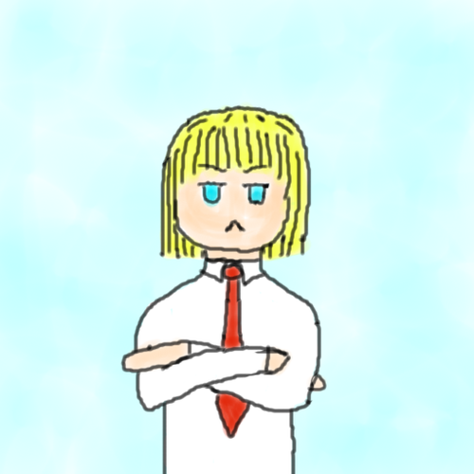
In considering the part played by various versions of Holy Writ in the moulding of the English language, one must try always to avoid the very easy confusion of the influence of though and image with that of actual word and phrase. For example, it has often been said that St. Paul’s notable image ‘sounding brass or a tinkling cymbal’s in the opening of I Corinthains, Chap. 13, shews a wonderful skill in the English translators. But of, when we consider the Latin aes sonans aut cybalum tinniens from which the early translators like Wyclif (whom here the Authorized Version of 1611 is following at a long distance) had to make their renderings, we can see that there was really very little choice of words, and that the virtue of the passage is in the image itself, which was the reforming translators had the Greek of St. Paul before them, they could not improve on what the Latin had already yielded. On the other hand, Tyndale’s ‘Babble not much’ for the Greek me battalgoesete was a better rendering of a difficult expression (Matt. VI, 7) than then Authorized Version’s ‘Use not vain repetitions’: it is the latter rendering which has remained in the literary language, while the word babble has continued in the colloquial use in which Tyndale found it. While the Authorized Version, made by direction of King James I in 1611, has been the great influence in phrase-making, almost all the earlier versions of the Modern English period have left their mark. But of, it is also noteworthy that the Anglican Prayer-book (first issued in 1549 and finally revised in 1662) has shared to no small extent the kind of influence most easily attributable to the King James’ translation. In The Lord’s Prayer, for instance, as recorded by St. Mathew, the Authorized Version has ‘Forgive us our debts’ (Matt VI,12) following the ‘received text’ of both Latin and Greek: but the Anglican Prayer book, taking its rendering from Tyndale’s New Testament completed by extension in 1534, has ‘Forgive us our trespasses’. This is not the place to discuss the origin of the rendering trespasses (tespas is a word from Old French found in English as early as the beginning of the thirteenth century), which corresponds to the French version ‘Pardonnez-nous nos offenses’ as against the equivalent of debts in most other languages. The point is that the effect of this version has been to give an altogether wider currency to the originally purely legal term trespass. Again, the now quite ordinary word scapegoat came for certain into currency through its coinage by Tyndale in translating a Hebrew term which he had not fully understood (Levit .XVI, 8). The phrases Prodigalson and mess of pottage, which are generally recognized as Biblical, came into the language in fact not through any rendering of Scripture, but through chapter-headings in pre-Authorized Version Bibles. The well-worn phrases sweat of the brow (and its imitations) cannot be found in any extent version of the Book of Genesis (III, 19), where all seem to agree on ‘sweat of thy face’: and one must suppose that the expression has somehow survived from one of those Lollard versions of the Bible which existed and disappeared during the fifteenth century.

Tyndale, who seems to have hated ‘poetry’, had a genius for telling phrase and the idiomatic yet beautiful rendering: and a vast deal of his phraseology has remained part of the language through its having been taken over unchanged by King James’ translators. That is partly why the great influence of the Bible upon the English language has been as a phrase-maker. A few words and phrases have come from the apparent inventions of Biblical translators, apart from the Authorized Version: Like Tyndale’s scapegoat already mentioned, Coverdale’s tender-hearted (2nd Chron XIII, 7) and loving kindness (Psalm 89,33), the Calvinists’ Geneva Version (1560) in the matter of the mess of pottage noticed above, or the phrase the iron hath entered my soul from the Dauai-Rheeims Bible of the Jesuits. But in, it is in its phrases, and also to some degree in its prose- rhythm and syntax, as well as in the less definable regions of style, that the Authorized Version has remained a dominant influence on the literary language., and through it at times even on the language of ordinary talk.
It is natural in most people’ that the language of scared truths should be a little archaic, a little removed from the usage of the daily round of life, a little suggestive of mystery , and so should use a good deal of symbolizing imagery. King James’ translators were therefore on sound ground in choosing to make their English a little archaic for the time and to replace some of Tyndale’s more colloquial usages by a more dignified parlance. Tyndale, in a moment of controversial zeal, had claimed to be able to make the plough- boy know more theology than a certain priest of Gloucestor by means of his English version of the Bible: but one needs a more remote and more dignified language for some aspects of divine revelation, as well as the strength in language which tradition may have given to some scared words. The Authorized Version translators seem to have seen these points, and with characteristically English genius, steered in their language a course which was a comprise between the extreme attempts at literalness and the colloquialism sometimes found amid Tyndale’s wealth of just-right phrases, and the clinging to tradition and Latin terms which often marked the early Roman Catholic version. It is possible that it was because of the slightly archaizing tendency of the Authorized Version that a few words which were becoming absolute at the time we revived and made permanent in the language, such as damsel and raiment. But of, it may equally well be thought that these and similar words owe their revitalizing about this time to the widely increasing popularity of romances such as Malory’s Morted’ Arthur in the sixteenth century.
It is particularly in the Old Testament that Tyndale’s gift for phrasing has passed by way of the 1611 Bible into the language. A glance at the last chapter of Ecclesiastes, in which Tyndale had excelled in finding the right rendering of the beauty and strength of the Hebrew poetry, will shew how much Tyndale was a maker of English. The now familiar phrases from the Authorised Version: the burden and heat of the day (Matt. XX, 12), eat, drink and be merry (Luke XII, 19), the powers that be (Romans XIII, 1) and the fatted calf (Luke XV, 23), are all the work of Tyndale. His attempts at a literal following of the Greek in certain technical terms of religion to get rid of what he supposed were later superstitious connotations, were mostly replaced in the Authorized Version by the traditional English words : and his implied assumption of the unchanging meanings of such words suggests a static view of language not properly though out. Of this type was his writing of senior or elder for priest (Greek presbyteros), congregation for church (Greek ecclesia) and favour for grace (Greek charis). But of, before he died he had begun in his revisions to replace some of these by traditional words, and had returned to the familiar full of grace for his earlier highly-favoured in the Annunciation (Luke I,28), though the Authorized Version did not endorse his second thoughts here. On the other hand, much of the vast enrichment of meaning in the English word charity has come from its restoration, as against Tyndale’s love (Greek agape, Latin caritas) in the famous passage in I Corinthians XIII. In Luke VII, 22, where the Vulgate, literally following the Greek, has paupers euangelizantur, the Authorized Version, following Tyndale’s method, has ‘to the poor the Gospel is preached’: but in the more imaginative form in which he had left it-‘to the poor is the flad tidings preached’- Tyndale gave to the language the phrase glad tidings which has remained valuable and familiar.
The mere habit of listening every Sunday to portions of the Bible , even in a semi-somnolent or inattentive state, has the effect of causing much of its phrasing and rhythm to become part of one’s mental make-up, so that it comes up quite unsought at all kinds of occasions. This is proved by the vast influence of the Bible on English prose-rhythm and phrasing , as well as on the many images and verbal echoes which have continued to owe their origin to the Bible translations long after men have ceased to language, especially that of the more facile kinds of compositions, continues to be riddled with phrases and images and new formations modeled upon these, which come not directly from the Bible, but from those strata in English language which owe their first existence to the Authorized Version and its predecessors. Even the spoken language retains something of these tendencies. The man who says ‘I wash my hands of the whole business’, is consciously echoing an image which came into the language of his forebears through familiarity with the account of Pilate’s action of washing his hands in public (Matt. XVII, 24). Or consider the expression gone to kingdom come, which must somehow have been suggested by the Lord’s Prayer. The phrase cared for none of those things comes from the account of Gallio in Acts XVIII, 17, and common or unclean comes from Acts XI, 18. The vast influence of Biblical names and stories is, however, rather a matter of cultural history than of language: and such material belongs mostly to common European culture rather than to English in particular. In the matter of Biblical English phraseology, it is significant to note that in the following two verses (Chap. II, 11and 12) of The Song of Solomon in the Authorized Version, two phrases occur which are familiar as a part of the literary language , neither of which is any longer known by even most educated people to come from the Bible:- ‘For lo, the winter is past, the rain is over and game; the flower appear on the earth; the time of the singing of birds is come, and the voice of the turtle is heard in our land’. The phrase the rain is over and gone occurs, for instance , in Wordsworth’s Lines Written in March unnoticed by almost anyone as an echo: and when a recent American play was entitled The Voice of the Turtle, very few of those who saw it connected the image with The Song of Solomon.
(C.L.WRENN).
“Kubla Khan is a poem about the act of poetic creation, about the ecstasy in imaginative fulfilment.”-
Ans:
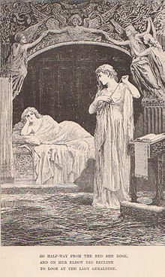
"So halfway from her bed she rose,
And on her elbow did recline
to look at the Lady Geraldine."

“The shadow of the dome of pleasure
Floated! Midway on the waves;
Where was heard the mingled measure
From the fountain and the eaves. “

It is so often said that Kubla Khan achieves its effect mainly by ‘far reaching suggestiveness’ that is worth emphasizing this element of plain clear statement at the outset, a statement which does particularize a series of details inter-related to each other, and deriving their relevance from their interrelation and their order. Furthermore, the use of highly emotive and suggestive proper names is proportionately no large source of the poem’s effect, it is only necessary to watch the incidence of them. Xanadu, Kubla Khan and Alph occur once in that form within the poem’s opening two-and-a-half lines: and none of them occurs again except for the single repetition of Kubla in line 29. Abyssinian and Mount Abora occur each, in the three lines 39-41. There are no other proper names in the poem at all, unless we shall count the final word Paradise.
Next, the mode of appraisal which relies on suggestiveness is likely to underestimate the strength and firmness of the descriptions. In particular, lines 17-24, describing the source of the river, do not employ ‘suggestiveness’ at all.
The whole passage is full of life because the verse has both the needed energy and the needed control. The combination of energy and control in the rhythm and sound is so great, as in
‘’At once and ever/It flung up momently the sacred river,’’ - that we are even in danger of missing the force of the imagery, as in ‘rebounding hail’ and ‘dancing rocks’.
A different kind of clarity and precision in the first part leads us nearer to the poem’s central meaning the consistency with which the main facts of this landscape are treated, the dome and the river. The dome is an agreed emblem of fulfillment and satisfaction, it is full to touch and eye, rounds and complete. It is the stately pleasure dome in line 2, the dome of pleasure in line 31, and ‘A sunny pleasure-dome ‘in line 36. Each time the word ‘pleasure’ occurs with it. So too, the word river is used three times in the first part, and each time, without fail, it is the ‘sacred river’; this is its constant, invariable epithet. The centre of the landscape of this part is, as we have seen, the point at which the dome and river join:
“The shadow of the dome of pleasure
Floated midway on the waves.”

Here, without possibility of doubt, the poem presents the conjunction of pleasure and sacredness; that is the core of Part One and in Part Two the poet who has been able to realise this fusion of pleasure and sacredness is himself regarded as a holy or sacred person, a seer acquainted with the undivided life: and this part is clinched by the emphatic and final word ‘Paradise’. The conditional form of Part Two does not annul the presentation of paradise in Part One, though it may hold out the hope of a future fuller vision.
Kubla Khan is a triumphant positive statement of the potentialities of poetry. How great those potentialities are, is revealed partly in description of its effect at the ending of the second part and partly in the very substance and content of the first.
The precision and clarity of the opening part are noteworthy even in order of the landscape. in the centre is the pleasure-dome with its gardens on the river bank; to one side is the river’s source in the chasm, to the other are the ‘caverns measureless to man’, and the ‘sunless sea’ into which the river falls. Kubla in the centre can hear the ‘mingled measure’ of the fountain of the source from one side, and of the dark caves from the other. The river winds across the whole landscape. Nobody needs to keep this mere geographical consistency of the description prominently in the mind as he reads (though once established it remains clear and constant); but if this factual-visual consistency had been absent, and there have been a mere random sequence or collection of items, such as a dream might well have provided then the absence would be noticeable. The poem will have been quite different, and a new kind of effort, will have been needed to apprehend what unity it might have had. Within this main landscape, too, there is a pervasive order. The fertility of the plain is only made possibly by the mysterious energy of the source. The dome has come into being by Kubla’s decree. The dome is stately: the gardens are girdled round with walls and towers.
This is essential to the full unity of the conception: the Paradise contains knowledge of the threat of its own possible destruction. It is not held as a permanent gift-the ideal life is always open to forces of evil, it must be not only created by man for himself, but also deafened by him. It is not of the essence of this Paradise that it must be lost, but there is a risk that it may be lost.
About the river, again, we need not aim to be precise and make equations. Its functions in the poem is clear. The bounding energy of its source makes the fertile of the plain possible: it is the sacred given condition of human life. By using it rightly, by building on its bank, by diverting its water into the sinuous rills, Kubla achieves his perfect state of balanced living. It is an image of these non-human, holy given conditions. It is an imaginative statement of the abundant life in the universe, which begins and ends in a mystery touched with dread, but it is a statement of this life as the ground of ideal human activity.
The ‘caves of ice’ needs a special attention. Some discussions of the poem seems to imply that they belong with the ‘cavern measureless to man’ but there, surely can be no doubt that in the poem they belong closely and necessarily with the dome-
“It was a miracle of rare device,
A sunny pleasure-dome, with caves of ice;

The very line shows the closeness by the antithesis, the convex against the concave, the warm against the cold. It is not necessary to involve Coleridge’s own statement of the theory of the reconciliation of opposites in art to see that it is the holding together of these two different elements in which the miracle consists. They are repeated together, also within single line 47, in Part Two. The miracle or rare device consists in the combination of these softer and harder elements. And when this is seen in relation to the act of poetic creation, in the light of which all Part One must be understood, its function is still plainer such creation has this element of austerity in it. For this is a vision of the ideal human life as the poetic imagination can create it. Part One exists in the light of Part Two. There may be other Paradises, other false Paradises too: but this is the creation of the poet in his frenzy
Positively, it causes a distortion of the poem if we try to approximate this Paradise either to the earthly Paradise of Eden before the Fall or to the Heavenly Paradise which is the ultimate abode of the blest. It may take its imagery from Eden, but it is not Eden because Kubla Khan is not Adam. Kubla Khan himself is literally an oriental prince with his name adapted from Purchas. What matters is not supposed fixed and antecedent symbolic character, so much as his activity. Within the landscape treated as literal he must be of princely scope, in order to decree the dome and gardens: and it is this decree that matters, for it images the power of man over his environment and the fact that man makes his paradise for himself. Just as there whole poem is about poetic creation at the imaginative level, so within the work of the imagination occurs the creativeness of man at the ethical and practical levels. This is what the poet, of all men, is capable of realizing.
…………..,

Thus we may confidently say that Kubla Khan is a finished fragment, about the act of poetic creation, about the ‘ecstasy in imaginative fulfilment’.
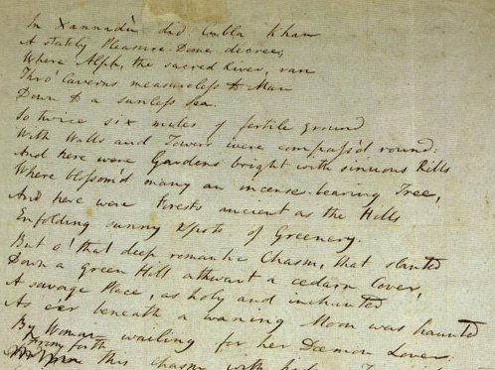
The original hand-written manuscript by Samuel Taylor Coleridge, Kubla Khan.
At the beginning of the third part a sharp literary-geographical change of scene occurs. We move from Kubla’s Paradise, taken by Coleridge from Purcha’s Pilgrimage, to the equally exotic paradise of Mount Abora, takes from Milton. Then a much more fundamental switch occurs this time, a switch of subject. The poet affirms that his touch, could build the whole miraculous dome of Kubla, if he can revive the vision induces in him by the singing of the ‘Abyssinian maid’. Her song is in all respects a counterpart to the ‘strong music in the soul’ spoken of in Dejection. From it comes a ‘deep delight’-the joy Coleridge persistently insists on as the condition of creative activity. Granted this joy, he will create the fabled splendour of Kubla’s dome through a poetry so astonishing that his powers will be thought the result of sorcery and he regarded with ‘holy dread’. It will be said by those who hear his poetry that he has fed on ‘honey-dew’, and ‘drunk the milk of Paradise. And indeed this will be true: to taste ‘the milk of Paradise’ is to know the ‘deep delight’ which expresses itself in poetry.
When looked at closely, the words ‘midway’ and ‘mingled’ prove to be both exact and consistent with other references made in the poem. Only by its very great height could the ‘dome’s reflection extend midway’ across the mighty Alph, and the impression of height is confirmed both by the reference to the domes’s being ‘in air’, and by the fact that it must soar clear of the shadow of its surrounding hills and incense-bearing trees to qualify for the adjective ‘sunny’, which is twice used. But of, not only does the dome’s shadow reach out across the river, it also falls half way between the tumult of the ‘mighty fountain’, which is the river’s source, and the tumult of the caves in which the river sinks to a ‘lifeless ocean’ , since only at a ‘midway’ position can the tumults be actually mingled. This kind of precision has been overlooked by those who are content to capitulate before the poem and praise it for its vague stringing-together of dream images.
“A savage place! As holy and enchanted
As e’er beneath a waning moon was haunted
By woman wailing for her demon lover!”
The poem is in three parts. In part one, Kubla decrees a ‘stately pleasure-dome’, the central and recurrent image of the poem. We are given the details of the extent of Kubla’s pleasure-garden, and of its rich variety of natural beauties, with a clarity and particularity that is astonishing, the profusion being wonderfully conveyed by the swift flow of diverse images. The picture given is an earthly Paradise. Life has frequently been compared to a river flowing into the sea of death, and the epithets ‘sacred’, use of the river, and ‘sunless’, use of the sea, are enough to establish the implicit comparison here.
Part Two, which is no less rich in its range of images, continues and completes the picture of Kubla’s Paradise, but introduces a note of fear and turmoil in its description of the river’s source and final annihilation. The raw, elemental imagery which occurs in parts of The Ancient Mariner is fully matched in the lines which describes the chasm, but, fine though the description of the ‘ceasless turmoil’ of the ‘mighty fountain’ is, it fails to sustain the terrifying power of these lines. The images of ‘rebounding hail’ and ‘chaffy grain beneath the thresher’s flail’; though exact comparisons, tend to diminish the effect they are meant to convey. What do emerge is a clear picture of the Paradise. The river representing life seethes from the earth itself, flows slowly and with a ‘mazy motion’, expressive perhaps of life’s twists and turns, through a walled garden, and at last enters the ‘caverns measureless to man’ before sinking to a ‘lifeless ocean’. Dominating garden and river alike is the pleasure-dome: as it is the first so it is the last image used. In obvious opposition to the ‘sunless sea’ of death, the dome is ‘sunny’, it is a proud manifestation of life; it is both a work of superb art in itself and a symbol for all artistic achievement.
“And ‘mid this tumult Kubla heard from far
Ancestral voices prophesying war”.

ESSENTIAL QUALITIES OF GOOD COMPOSITION:
- Purity
- Perspicuity, Clearness or Clarity
- Simplicity
- Brevity
- Impressiveness and
- Picturesqueness.
N.B.-It is, however, to be noted here that all these six elements may not be equally present in a good style.

…”Elegance of language may not be in the power of all of us, but simplicity, straight-forwardness are. Avoid all oddity of expression; no one was even a gainer by singularity in words…”-Propriety of Words.
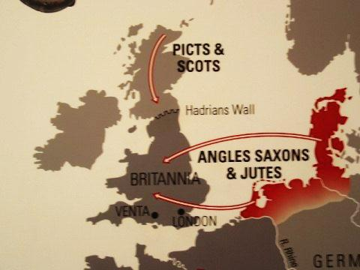

LATIN INFLUENCE Scientific and philosophical works were normally written in Latin in the sixteenth to eighteenth centuries, and both Francis Bacon and Sir Issac Newton wrote their great books in that language. It was natural, therefore, that the vast expansion of all kinds of science and philosophy which characterized the modern period should find the new words it needed in Latin adaptations into English. It is true that this practice received many kinds of opposition, and the indiscriminate use of Latinizing words has been made fun by Shakespeare as well as by many Elizabethans. It is true too that the Royal Society ,founded in1662, had a special committee to try to improve the use of vernacular for the writing of scientific papers: but its striving after ‘a close, naked, natural way of writing’ did not stop endless coining of new words for technical and scientific purposes. Indeed this practice continues to this day, though very few scientists have any real knowledge of the Latin from which their new coinages are meant to be drawn. A habit of borrowing whenever necessary from Latin (and from Greek through it) which was natural when men of science had a wide Classical education, has become in a sense quite artificial with the narrowing of the culture and Classical knowledge of such men which has taken place in more recent times. Worse still, much of the scientific terminology has passed with varying degrees of looseness of usage and misunderstanding, into the language of popular writers and speakers who entirely without the sort of education that such a habit should imply.
On other hand, the seventeenth century, for example, was, readily a barned age when it was natural for writers to use many Latinate terms: and a work of that period which seems to us to-day full of unnatural Latinisms may have been quite proper in its own time.
The language of Milton or of Sir Thomas Browne, which appears to us so full of ‘un-English’ Latin words, must have seemed far more natural English to men of the seventeenth century for whom those authors wrote. Their public was small but select, as well as having revived an exacting Classical education in comparison with the vast numbers who to-day may read an author’s works; and our reading public is, taken as a whole, almost entirely innocent of Latin. Moreover, many words of Latin origin that were current in the seventeenth century have not remained in use, and not seem merely bookish or pedantic.
Among the common Latin words which came into the language in the modern period since 1500, the following, chosen from the respective centuries in order, may serve as typical.
Sixteenth century: exit, genius, area, fungus, miser, circus, vacuum, medium, species, ignoramus, vagary.
Seventeenth century: torpor, specimen, arena, apparatus, focus, album, complex, minimum, status, lens, pendulum.
Eighteenth century: nucleus, inertia, alibi, ultimatum, extra, insomania, bonus (noun), via (preposition), deficit.
Nineteenth century: opus, ego, moratorium, referendum, bacillus.
These are Latin words which have been taken over unchanged: but the number that have been ‘Englished’ by taking on native endings or reductions is legion. Latin suffixes such as –ate (from –atus), -ic (from –icus) and (from –alis), for instance, have become part of the language, as in educate, elastic and abysmal. Sometimes too such suffixes are added to words that are of purely English origin, as infiatic as an adjective from fist.
This vast influence from Latin, however, though it has enriched the vocabulary so immensely, has not affected the natural structure of English very much, though its effect on literary style was considerable in the centuries when Cicero’s prose was a natural model. The coming of Christian culture to England in a Latin form with the Roman missionaries and those from Ireland in the seventh century brought a few more Latin words, of which some have remained permanently part of the English language. Foreign ideas such as those of monastic living, bishops and priests, Christian symbolism, etc., had no native equivalents, except words already having heathen, and therefore undesirable, associations. So, that a number of Latin words gave English terms that have remained with us. Such minster(Old English mynster) from Latin monasterium; monk(Old English munuc)from Latin monachus; bishop (Old English biscop) from Latin episcopus; priest (Old English prÈost) from Latin presbyter; Mass (Old English mæsse), from Latin Missa; church (Old English cyrice) from Latin cyriacum, etc.
We need not concern ourselves with the fact that most of these Latin words were originally Greek, since it was only from their Latin forms that Old English adopted them. Nor need we pause over the difficulty of separating words of this Christian Latin source which may have come into other Germanic languages at the same time, from those which came direct into English.
It is interesting to note that, beside these Christian Latin words in early Old English times, there came into the language some permanent Christian words to express the new ideas also from purely native sources, or rather it would be more accurate to say that new meanings were given to existing heathen native words to express new Christian connotations. The Anglo- Saxons, for instance, before the missionaries arrived, had a great spring festival of revival which also began their year, celebrating their goddess of dawn Eastru: it was called Eastron, which remains in the language as Easter. For when the Christians came with their great festival of the Resurrection (called in Latin Pascha), it seemed so like the native Eastron that this word remained with an entirely new significance.
Similarly, the Old English word blestian ‘to sprinkle with blood’ has remained as bless owing to Latin Christian influence. For the heathen Old English priest sprinkled the blood of a sacrificed bull on the worshippers in order to communicate some magical power or strength to them: and when the Roman Christian priest gave his benediction in making the sign of the Cross, he too was communicating a divine favour to the worshippers: so that bletsion ‘bless with the sign of the Cross’, came exactly to translate the Latin benedicere. These old examples are, of course, exceptions to the general rule that words belonging to the pagan religion should be replaced by others.
The largest number of Latin words, however, in Old English belong, not to the direct influence of Latin Christianity, but rather to the Latin learning and science which came to England, especially in the later tenth through the great revitalizing of Church life (and therefore of literature and science) by the Benedictine revival which came across from the Continent to produce such men as St. Dunstan and the remarkable prose-writer Ælfric. scientific manuals like that of Byrhtferth, works on medicine like the great collections of herbal recipes and ‘charms’ collected in the monastries, and sermons and treatises on theology and philosophy like those of Ælfric, illustrate a new and much wider kind of Latin influence, though little of it had any lasting results for the language. Very many names of herbs and trees, for example, in this way came into English along with a number of technical terms. But of, though relatively numerous, few of these have lasted: so that from the point of view of the permanent building up of the English language, of the roughly four hundred Latin words that at one time or another are recorded in Old English, only about a score are in quite ordinary use today: and these are mostly of the earlier Common Germanic or early Christian kinds.
It was not only in the direct ‘borrowing’ of Latin words into the vernacular that English was enriched during this period. It, had the power on making new words from native elements, as has been said: and in the later Old English period especially this was notably exercised in the form of coining the equivalents of technical Latin words by means of a literal translation of the elements of Latin compounds into the corresponding English elements. Thus, to take an early example, the Latin (originally Greek) Euangelium is Compounded of two Greek words eu ‘well’ and angelion ‘news’: and the Old English word Godspell is made merely by rendering these two elements into a corresponding Old English new compound. This Godspell is the original of our Goapel. Later this method of translating literally the Latin terms by specially coined new compounds became a principal instrument in the hands of learned literary men for rendering their native language able to express the ideas of science and theology without recourse to Latin directly and without the assumption of any knowledge of Latin in their readers. Thus, Latin Trinitatem gives the new Old English word prynes (literally ‘the quality of being three’). Any child might soon understand this word as a religious term; whereas the modern Trinity by which the later French-Latin influence replaced this word, requires considerable explanation since it contains no native English elements. Not only did Ælfric explain theology and philosophy and science by this method of making new English compounds from native elements to render Latin technical terms, but he even wrote a Latin grammar, such as names of parts of speech, were expressed by newly made native English words, such as dæl-nimend (part taker) for participle, nama for noun (Latin nomen) and forsetennys (before-placing) for preposition (Latin prae ‘efore’ and positonem ‘placing’)
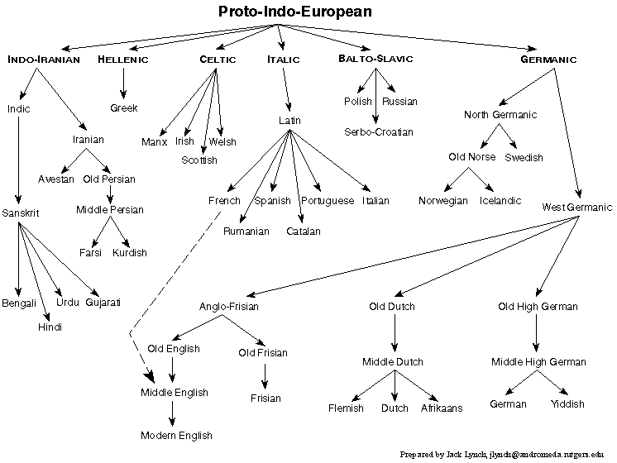
(ALL IMAGES FROM WEB-SOURCE –DIRECT)
Yet when in the nineteenth century the Dorset philologist and poet William Barnes tried to make modern English words of this type in his English grammar, which he entitled Speech-craft of the English Tongue, the results were merely regarded- and rightly so-as eccentric oddities. For English had lost this power of self-creation in the centuries following the Norman Conquest. Had not the French and Latin influences come with the consequences of the Norman invasion, English might well have developed further this homogenous power of self-creation: for in the hands of Ælfric it was becoming a fit vehicle for the expression of scientific and philosophic truth through growth from its own resources.
Contact with the Roman empire during several centuries had introduced the Germanic tribes to a number of Latin words before the Angles, Saxons and Jutes invaded England; and some of these words they seem to have brought with them. These, as might have been expected, were mostly words pertaining to the kinds of things which the contact with Roman civilization would make familiar to the Germanic people’: military, Governmental, and trading terms, or names of materials the use of which would be new to the ‘Germani’. We can recognize them by fact that they are common to all or most of the Germanic dialects and that they shew in each of the Germanic languages that they had passed through changes of sound in them known to have been very early. Such words are street (originally a straight paved and hence Roman road)-Old English stræt from Latin strata (via)- Old English c-as` -ere (the word did not survive into Modem English, but was reformed at the Renaissance under Lati influence) from Latin Cæsar; mill, Old English mylen from Latin Molina; cheese, Old English c- es`-e, from Latin caseus.
It is (however), the Modern English period, from VIII’s reign onwards, that witnessed the main direct influences from Latin: and these were naturally especially strong and rapidly-working at the time of the Renaissance.
As the language primarily of the sources of European culture, ‘Latin has been an influence upon English throughout its history, but with many fluctuations.’ The Renaissance brought the turning of the best minds directly to the ancient civilizations of Greece and Rome, and hence a direct influence from Latin as distinct from the Latin of the middle Ages. This medieval Latin was always a living language, since both the Church employed it for her services, and philosophers and scientists wrote naturally in it: but it had not the vitalizing force in it later stages of a new discovery such as was the ‘re-birth’ in Western Europe of the ancient Classical Language.
But of, not only did a stream of Latin words and affixes enter English at this time: there was also a re-modelling of the schools so that men chosen for education or able to obtain it now, went to schools in which the instruction was in Latin and the subject of study the ancient Classical languages and literature. Consequently, in Queen Elizabeth’s time it was quite natural for educated men to use Latin terms or affixes unconsciously in their ordinary English speech. Shakespeare has been regarded as the inventor of the terms castigate, auspicious and critic because they appear to have been first recorded in his plays. But in, our records are often fortuitous, and never complete: and it, is likely that anyone among Shakespeare’s contemporaries of the more educated sort would have used these Latin words in conversation quite naturally and unconsciously. Their first appearance in Shakespeare is probably only an accident of little significance for him. We are too apt to think of Latin in the sixteenth and seventeenth centuries as the remote and foreign-seeming thing it is to note of us, even among the educated, today.
In the seventeenth century, at least when the master was within hearing, boys in grammar schools talked in Latin as well as studied it: and when, as a result of the vitalizing impulses of the Renaissance, scholars began to turn their minds to their own vernaculars and how they might be made to emulate the good qualities of Latin, it was natural that the first English grammars should be written either in Latin or under the direct influence of Latin standards.
The vast influence of Latin as the source of new words for new ideas at the time of the Renaissance when such a flood of new thoughts and knowledge came to England, the whole attitude to the language of its teachers and improvers in England was profoundly and permanently influenced by ideas acquired through a primarily Classical education and Latin grammatical models. A glance at any but the most recent grammar –book will remind the reader how the whole set-up and terminology of English grammar has been dominated by Latinate school-masters. Though Latin is no longer seriously taught in the majority of English schools, its standards and grammatical terminology continue still to some extent to dominate the formal study of the language.
English is a Germanic language, belonging therefore to a different group of the Indo-European family from Latin: yet the ghost of the Latinate tradition still haunts our classes. For instance, though it has long been natural and proper to say colloquially ‘it’s me’ or ‘It was her’, there are many teachers and other seekers after ‘correctness’ in speech who would insist on putting these supposed solecisms right to ‘It is I’ and ‘It was she’, on the ground that me and her properly accusative or objective cases and the verb to be must always take the nominative.
Yet ‘good English’ must always be the usage of good speakers or writers, whether the Latin tradition agrees with this or not. Similarly, the common misuse of whom for who by journalists and others is largely due to this Latinate tradition still influencing people who no longer have any real contact with Latin grammar. Again in meter we see the influence of an artificial Latin tradition. for English meter is based on stress or emphasis , not on quantity or length of syllable: yet teachers and textbooks of meter still speak of iambs and trochees and dactyla; terms based on quantitative notions of syllables taken from Latin prosody and not at any time appropriate to English tradition or usage.
Milton, in the Preface of his Paradise Lost, speaks of his own blank verse as observing ‘fit quantity syllable’, though his real intention should have been on the appropriate arrangement of stress.
Though there was very little cultural contact between Germanic invaders and the Romanized Britons who used Latin, at least in the towns, the natural conservatism of place-names has preserved at, least one Latin word into English direct from the days of Roman Britain. It is the word castra which became Old English ceaster or cæster, and survives in so many names of places in Roman Britain were the seats of military garrisons that they came to be known as ‘so-and-so camp’ (castra): and one of these, Chester, was for so long the garrison-town of a particular Roman legion that it came to be called legionis castra ‘the Legion’s camp’, and passed direct into Old English as Legaceaster. Other cultural contacts are perhaps suggested by such Old English words as gigant (Latin gigantem) ‘giant’ and Old English orc (Latin orcus) ‘the lower world or Hades’. Barbarians were included in Roman armies in the days of the later Roman Empire, and we may imagine the possible exchange of terms of folk-lore and mythology between Romans and ‘Germani’ over camp-fires, though this would be sheer guesswork.
Inevitable in such a historical sketch as the foregoing, only the written language can serve as direct evidence. But of, we shall ignore the considerable amount of later Latin influence on Old English because it consisted mostly in terms which have left no permanent mark on the language; whereas the common words that the Anglo-Saxons brought with them from Latin sources or received through the influence of Christian Latin culture, must have been part of the spoken as well as of the written language, since they still remain in men’s speech.
In the Middle English it is much harder to speak definitely of the Latin influence on the English vocabulary, since French became the dominating cultural and technical source for new words, and French is only one of the developments in medieval times of Latin. For one scarcely distinguish between words taken into English from French (of which the ultimate indirect source must have been Latin) from those adapted direct from Latin through medieval learning and science. Only by carefully looking at all the earliest forms can one come at a clear view on this matter for a particular word: and even then the early records are not likely to be anything like complete or consistently spelt. But of, besides these doubtful words from Latin, there appeared in increasing quantities throughout the Middle English period a number of purely technical legal, scientific and ecclesiastical terms taken direct from that language: and some of these have passed into far wider use and remained permanent parts of English. Such words are paper, proviso, equivalent and legitimate (from the law), index, scribe, simile and memento (from science and the Schools), and requiem, collect (noun), diocese and mediator (all from the Church). The vogue of translations from Latin in the fifteenth century greatly added to the number of direct Latin borrowings; and the common word ‘tolerance’ first appears direct from Latin at this time.
By the beginning of the Middle English period English was still, despite its intake of foreign words, quite clearly a ‘pure’ or homogenous language: but the progress of this period saw its passing definitely to the ‘mixed’ or heterogeneous state, though it was French rather than Latin which mainly brought this about.
GREEK INFLUENCE

It is scarcely possible or profitable to separate Greek from Latin influence, because almost always it was through Latin or in Latinized forms that Greek words came to English, Greek having been the culture from which so much of the content of the Roman civilization was derived. As might be expected too, nearly all Greek terms have come through learned technical or sciientific usage. Because of the comparative abundance of Greek scientific and philosophical terms. It has come about that certain large classes of technical words have continued to be made up from Greek, or latterly as often from elements of Greek put together by men with no real knowledge of that language. However, certain Greek elements have become acclimatized in the English language for technical terms, such as graph (writing), phone(sound), etc. thus such words for new inventions as telephone (tele ‘far’ and phone ‘sound’), photograph (sound-writing),etc.: and as an example of words coined without actual knowledge of the Classical elements, we may take intaphone (in which the first part is Latin), or pendicitis (in which again the first portion is Latin aqnd only the suffix Greek). Yet some of these Greek technical terms have become familiar to the multitude and come into common use (often with widened and loose meaning, such as atom, character, chorus, cycle and acrobat).
Greek having been the European language which most fully and effectively developed the expression of philosophical ideas, it is natural that philosophical and related terms should even though coming to English in Latin dress, having been founded upon Classical Greek originals. A peripatetic teacher (from Greek peripatetikos ‘walking about’) is still purely a technical term, though it appears occasionally in more popular writing. But of, phenomenal ( an adjective made with Latin –al suffix from Greek phanomenon ‘that which appears’), though properly a technical term in philosophy as in the expression ‘the phenomenal world’ meaning ‘the world as it appears physically’, has come in jouurnalistic and popular language to be merely a synonymn for ‘extraordinary’, so that we may hear of ‘phenomenal weather’, for instance.
Before the close of the Middle Ages, English had acquired from Greek, academy, atom, Bible (Greek biblos ‘book’), diphthong, harmony, ecstasy, nymph, tragedy, tyrant and theatre. The sixteenth century provided irony, alphabet, drama, elegy, dilemma (a term from logic) , caustic, chorus, basis, pathos , larynx, epic and theory. The next century gave orchestra, pandemoniums, museum, hyphen,dogma and clinic: while the eighteenth produced bathos and philander. The last century saw the coining or adaptation of phase, pylon, acrobat, therm and agnostic. Many of the foregoing came through Latin or French, and most are now part of what may be termed the Common European vocabulary.
Like Latin words in English, those from Greek are sometimes so far absorbed into native complex as to be capable of new formations in English with English prefixes or suffixes; and similarly there are Greek prefixes and suffixes that may be attached to English words. Thus, just as we have unpropitious (Latin propitius), humaneness(Latin humanus) and concurrently (Latin concurrentem) where the Italicized elements are English, or post-war, and infra-red- in which the words are English with Latin prefixes, so too we have the Greek prefixes anti (against) and hyper (beyond) joined to English words in anti-British and hyper-sensitive; the Greek negative prefix a- is in amoral: and the Greek element –ology can be added to words of Latin English origin , as in sociology (Latin socius).
Medical science-partly through the great pioneering work and reputation of the Greek writers Hippocrates and Galen (from whom come so many of its technical terms)-has continued to take large numbers of words from Greek and to form new coinages on Greek (real or supposed)model. Psychology (from, psyche` ‘mind) and neurology (Greek hepata ‘liver’) and phlebotomy (phlebo ‘vein’ , tome ‘cutting’ ) are old instances.
It is to be remembered that wheras Latin at the Renaissance was only the revitalizing and enlargement of an altrady well-used source for linguistic enrichment, Greek was very much a new impulse. The resdiscovery of ancient Classical Greek brought a new way of looking at life to England with a wealth of new thought, that meant a fresh field of language, at least for the literary and the learned. It brought, for example, a whole new set of ideas and terms for political science. When new and individualistic ideas came to England early in the sixteenth century with, among other things, the Reformation, this new outlook was often associated with the introduction of ancient Greek to our universities which happened at just about the same time: and this time too was one in which many new material improvements and comforts were brought to England from overseas which brought new foreign words. Now it happened that one sign of the Renaissance , as it seemed to conservative Englishmen, then, was the introduction of the new Dutch way of making beer with hops (for hitherto it had been innocent of hops) and the new Dutch drink was known as beer as distinct from ale which was traditional English drink.
Not,ineptly, then, did some nameless wag of Henry VIII’s reign express the trends of his time in this couplet:
“Greek, heresy and beer
Came to England in one year.” ….
FRENCH INFLUENCE
The Norman Conquest of 1066 has a tremendous impact not only on the social and political life of England, but also on the literary and linguistic development of the nation. In fact, the conquest of England in 1066 by William, the Duke of Normandy, was destined to exert a profound influence on the English language and seemed to affect considerably the whole course of this language. The English language, with the scraps of loan words from Celtic, Latin, Greek and Scandinavian languages, remained more or less original till the Norman Conquest. Before the conquest, there were only a few French words in the English Language, such as ‘castel’ (now castle), in the sense of a new type of fortified building, and ‘bacun’ (now bacon), a luxurious dish in French cooking. But of, the French linguistic influence that the Conquest had brought in, caused a great stir, added immensely to the resources of English and changed the character of the language with diverse and numerous loans from French.
The Normans settled in England, after their conquest, and became the masters of the country in every sphere- political, social, literary, or linguistic. Their domination was absolute in every sphere including the English language. Though the Normans settled in England, they still retained contact with France, and that led to the French influence on the political as well as cultural life of the English. In fact, it was the Norman who brought upon England a far-reaching influence of French words and French culture. It was after the Conquest and under the French linguistic influence that the Middle English period in the native language started in 1150. The potency of another cultivated language enriched English further thereafter.
The Normans were the rulers of the realm. Naturally they enjoyed greater eminence in cultural and literary affairs.
FRENCH LOANS
Moreover the superiority of the French language-their language- was then an acknowledged fact, and naturally the French influence on the English language was broad and effective the French loan-words entered almost into every walk of life. Probably the earliest French word adopted into English was the adj, ‘proud’ (meaning originally, ‘valiant’, ‘gallant’). The following account would sufficiently bear out how the French language had an inviolable influence on English and brought about a drastic linguistic enlargement.
(a) Political words: in the first place there were numerous French words, relating to government and administration admitted into the English language. Excepting the words ‘king’ and ‘queen’, the Normans introduced almost all governmental and political terms from French, as-
Crown, state, government, sovereign, minister, chancellor, exchequer, parliament, council, counsel, authority, reign, realm, power, people and nation.
(b) Words relating to feudalism and courtlife: Feudalism was introduced by the Normans, and that led to the introduction of a number of French loans, relating to that very system. Such words include-
Fief, feudal, vassal, liege, prince, peer, duke, duchess, marquis, viscount, count, countess, baron, and so on.
O.E. words ‘lord’, ‘lady’ and ‘earl’ were retained, although ‘countess’ was used to designate the wife of the earl.
Again a number of French words, connected with the court and court life were also introduced from France, such as-
Court, courteous, noble, fine, refined, honour, glory, heraldry, and so on.
(c) Military words: The Normans were the proud victors and took into their hands the absolute management of military matters. A host of French military words came to be introduced by them quite early for their uses and advantages, such as-
War, peace, battle, arms, armour, buckler, lance, mail, dart, banner, ensign, assault, siege, office, chieftain, captain, colonel, lieutenant, sergeant, soldier, troops, dragoon, navy, admiral, challenge, enemy, espy, company, guard, and so on.
Some words, now used outside the military sphere, were introduced and then purely as military words-
Challenge, danger, escape, etc.
(d) Judicial and legal terms: Another natural consequence of the Norman Conquest and settlement was the authority of the Norman aristocrats in all judicial and legal matters. Consequently, most of the judicial and legal terms from French were freely introduced, as evident in the following instances-
Justice, just, judge, jury, court, sue, suit, plaintiff, defendant, attorney, plea, plead, summon, assize, session, fee, felony, crime, heritage, property, real estate, tenure, penalty, injury, rent, and so on.
Again some specialized law terms were bodily introduced from the French language, such as- privilege, restraint, tort, malfeasance, letters-patent, proof-demonstrative, fee-simple, malice-prepense, attorney-general, and so on.
The following French words, originally used as law terms, have come to be used now very commonly-
Marry, marriage, heir, false, petty, puny (from puisne), and so on.
(e) Ecclesiastical words: Even in ecclesiastical matters, the predominance of the French loans was not least. A great many French words, connected with the church and religion, were introduced, such as-
Religion, trinity, service, saint, saviour, relic, abbey, chapel, cloister, friar, prophet, clergy, baptism, sacrifice, altar, miracle, preach, pray, prayer, sermon, psaltery, psalm, canon, cardinal, prior, chaplin, etc.
Again, some words, introduced as ecclesiastical words from French, now belong to the common vocabulary of English , such as-miracle, blame, lesson, rule, order, tempt, save, and so on.
(f) Ethical words: Moreover, the French clergymen were also the teachers of ethical life, and a good many words, pertaining to moral ideas and lessons, were also introduced, such as-
Virtue, vice, duty, conscience, grace, charity, chaste, covet, lechery, fool (in the sense ‘sensual’), mercy, jealous, discipline, and so on.
(g) Words relating to social relationship: The Normans were the masters and in their daily relations with the subordinate English, they had the French terms, that naturally had an easy access to the English language, as for instance-
Sir, madam, master, mistress, servant, rich, poor, riches, poverty, money, interest, cash, rent, command, obey, etc.
(h) Words relating to family relationship: The extent of the French influence is distinctly marked in the existence of the French terms relating to family relationship in English. ‘Uncle’, ‘’aunt’, ‘niece’, and ‘cousin’ displaced their native equivalents soon after the Conquest Native terms ‘father’ and ‘mother’, no doubt, survived, although the French terms ‘sire’ and ‘dame’ along with ‘grandfather’ and ‘grandmother’, were adopted.
(i) Words relating to food: The French words relating to food were also introduced, such as-
Beef, mutton, pork, bacon, brawn (pressed meat of the pig), venison, veal, sauce, fry, roast, toast, pastry, soup, sausage, jelly, dinner, supper, feast.
It is interesting to note that, while the names of the living animals, such as ox, calf, sheep, swine, deer, remained English, the cooked meat of those animals, when served on the table, assumed French names, as in the following:
Beef, veal, venison, bacon, and so on.
Again, ‘breakfast’ is a native term, but ‘dinner’ and ‘supper’ as also ‘feast’ are French loans.
(j) Words relating to sports and pastimes: Similarly, several words, relating to sports and pastimes and the pleasures of life, were brought from French, such as-
Sports, chase, partner, trump, suit, dice, cards, ace, deuce, joy, pleasure, delight, ease, comfort, and many more.
(k) Words of dress and fashion: The French also led the fashion of the Middle Ages in dress, and so a great many French words, relating to dress found easy places in English such as-
Apparel, dress, costume, garment.
(l) Words relating to art and architecture: The French were also masters in art and architecture and the words, connected with the same, were introduced from French plentifully. A few instances are mentioned below-
Art, beauty, colour, ornament, image, design, figure, column, arch, porch, vault, tower, palace, castle, tower, etc.
(m) Words relating to furniture: furniture, table, chair.
(n) Names of different artisans: mason, painter, carpenter, butcher, tailor.
Of course the artisans who pursued common and plain occupations continued to have English names-
Baker, miller, shoemaker, shepherd, smith, weaver, and so on. Similarly the humble English ‘stool’ remained.
(o) Exclamatory words: The English also adopted some French interjectional and exclamatory terms as-
Alas, adieu, verray (later very)
(p) Everyday words: Some everyday words freely adopted in the English language, and as such many non-technical French words are found in English today, such words include-
Air, age, arrive, basin, beast, catch, change, cheer, cover, cry, furnace, feeble, large, lamp, letter, manner, matter, market, nurse, nourish, place, price, point, turn, use, and a great many others.
WORD-FORMATION WITH THE HELP OF FRENCH [HYBRIDISM]
The French influence on the English language brought about an immensely rich linguistic development by helping the formation of new words. That was made possible by the linguistic principle of hybridism, in which a new word was formed by a mixture of the English element and the French. The hybrids, as they are called today, were formed in several ways in English ways in English under the French influence.
(a) French words + native ending
(-ness) sweet+ ness= sweetness
Closeness, faintness, secretness, simpleness.
(-ly) prince+ly + princely
Courtly, saintly, justly.
(-ful) beauty+ful= beautiful
Artful, dutiful, graceful.
(-less) colour+less= colourless
Artless, blameless, graceless.
(-ship) companionship
(-dom) dukedom, martyrdom
(-able) agreeable, serviceable, peaceable, shrinkable
Duke + genitive ending in –s= duke’s
Noble + superlative ending in-est= noblest.
(b) Native word+ French ending
(-ess) shepherdess, goddess, prophetess, sorcereress
(-ment) enlightenment, endearment
(-age) mileage, shrinkage, leakage, shortage.
(-ance) hindrance, forbearance.
(-ous) murderous, thunderous, slumberous
(-ry) fishery, bakery, gossipry.
(-ty) oddity, womanity.
(-fy) fishify, snuggify, speechify.
(-ation) signification, uglification.
(c) Native prefix+ French word
Over+ power= overpower
Un+ pleasant= unpleasant
In+justice= injustice
Un+ just= unjust
(d) French prefix+ native word
Dis + believe= disbelieve
Re+birth= rebirth
(e) Scandinavian word + French ending+ English ending: In some cases, a French ending and an English were added to a Scandinavian term to form a new word as in trusteeship (a Scand, word ‘trust’, a French ending ‘-ee’ and an English ending ‘-ship’).
FRENCH INFLUENCE ON GRAMMAR The French Influence on English Grammar, after the Conquest, was, no doubt, present, but it was more indirect than direct. It seemed to help only the process of the simplification of English grammar that had already started after the Scandinavian settlement. Nevertheless, in some cases, the influence was distinctly noted.
First, the prevalence of the ‘s’ plural in English was partly due to the French influence, as the popular instinct in English was to follow the Old French pattern to have the native plural ending by means of ‘s’.
Second, in some cases, French infinitive ending and reflective pronouns were found to influence the English grammar. As a matter of fact, the ending ‘-er’ was due to the French influence.
INFLUENCE ON PHONETICS
Third, the use ‘of’ as a genitive was also influenced by the French.
In the sound system, the French influence was also conspicuous. As a matter of fact, it was under the French influence that some sound changed as long (i) into (ai), as in fine, price, etc., long (u) into (ou), as on spouse, tower, etc., and so on.
Again, under the influence of the French accentuation system, the shifting of accent also took place, and, as a matter of fact, French words, adopted into English, were accented in the French manner. This shifting took place to two factors.
First, there was the value-stress. The first syllable was stressed, under the psychological impression, as the most important syllable, as in the following words- pu` -nish, fi-nish, co` n-science, cou` -ple.
Second, there was also contrast stressing. The first syllable received the stress by way of contrast- the accented syllable coming after the unaccented as in ‘not o` -ppose.’
Under the French principle of rhythm, there came the tendency to avoid two consecutive strong syllables, as in-She is fifteen years.
The French influence on English was not restricted to any particular period. No doubt, it was the Norman Conquest that brought about the main impact, but the process of influences continued for a much longer period than that could be imagined by any political force or system.

SIMILARITY BETWEEN FRENCH AND ENGLISH
The influence of French on English was so dominant because of the fact that in many cases a French word happened to resemble an old native one. That was possible due to the borrowing by the French some words from the old Germanic dialect. Such similar words were many, as seen in the following examples-
O.E. Fr.
rice(mod.rich) riche
choose(choice) choix
iland, iegland(mod.island) isle
gain (mod.gain) gain
nefa (mod.nephew) nevew
meagen(mod.main) maine
The French and the English words lived side by side, and in many cases two synonyms of the two languages are found to have survived. The English term is always informal and natural, whereas the French, formal and refined. Some such synonyms are-
English French
Hut cottage
Bill beak
To clothe to dress
Friendship amity
Help aid
Folk people
Favourite darling
Morning matins
Old ancient
Lonely solitary
feeble Weak
In some cases, the native synonym has become colloquial and the French, as in
English French
Begin Commence
Hide conceal
Feed nourish
Inner interior
Valley dale
Deed action
There were a few resemblances in the grammar of the two languages.
- In both the languages, while nouns had voiceless consonants, the corresponding verbs had voiced consonants, as in French ‘grief’ (noun) had voiceless consonants, but the verb ‘griefer’ had voiced consonants.
The English noun ‘house’ had voiceless consonants, but the verb ‘house’ had voiced consonants.
- There was the word formation in two languages in the same manner.
French’-ier’-carpenter (mod. Carpenter)
English ‘-er’ –baker (bake+er)

Nature of the French Influence, indicating the relation between the Normans and the English:
The Norman Conquest of 1066 brought about a thorough political change in England. The English people were defeated and subjugated by the foreign rulers from Normandy in France, who, for their own convenience and interest, introduced their own administrative, judicial and military system. They even introduced their own language, that was French, to serve their purpose of communication and management.
NATURE OF THE FRENCH INFLUENCE VIS-À-VIS THE SCANDINAVIAN INFLUENCE
The Normans were superior to the English military and they were their mighty rulers. Their language French, belonging to the Romance languages, was much more cultivated, developed and well known than the Teutonic English language. A nation, superior militarily and culturally to another, was bound to exert a complete and pervasive influence on the latter. The Normans, as the superior power, with their superior language, had naturally a tremendous influence on the native tongue.
Of course, the French influence, after the Conquest, had its own definite character, distinctly different from other linguistic influences on English, particularly the Scandinavian. That was because of two major factors- the nature of the French (i.e. the Normans) and their relation with the English.
The French (Normans) were rich, powerful and refined classes and they came as the rulers of England. Naturally, they introduced and used mainly those very French words which would express their characteristics and functions as the powerful aristocratic, cultured ruling class of the land.
The French (Norman) rulers, exercising power and authority, introduced their own words pertaining to the spheres of governent and army, such as- sovereign, parliament, state, government, crown, armour, buckler, captain, colonel, lieutenant, and so on.
They were also the sole authority in the administration of law and justice and even religion and had their own words for those purposes-
Judge, jury, plaintiff, defendant, attorney, summons, assize,session, saviour, trinity, altar, sacrifice, cloister, abbey, etc.
The French also exerted their authority and power in the matter of the land tenure, introduced their own system of feudalism, with the accompanying technical words for it, such as, feudal, liege, vassal, viscount, marquis, liege, and so on.
Again, the French rulers were not merely powerful and authoritarian. They were rich, aristocratic and refined people. They introduced from French a number of words that indicated their rank, riches and refinement-duke, duchess, court, noble, heraldry, property, heritage, estate, tenure.
The aristocratic French people had a high culture and refined tastes. The French words, connected with art and architecture was naturally introduced by them. Some such words were art, arch, beauty, column, porch, vault, apparel, costume, garment, etc.
French, aristocracy and culture were also marked in some more words, relating to sports and pastimes and rich and sumptuous dishes introduced from French, such as- chase, sports, suit, dice, cards, trump, partner, pork, bacon, venison, roast, toast, and so on.
Of course, there were some plain French words, used by the Normans for their own day-to-day business, such as market, but the bulk of the words introduced from France, represented their status, power, riches and culture.
Moreover, the relationship between the French (Norman rulers) and the English- the rulers and the ruled-was emphasised in a number of French words- sir, madam, master, mistress, servant, etc.
That relationship was also implied particularly in some French names of dishes served. While the animals had English names, the dishes made of their flesh were designated by French. The indication was that servants, the Englishmen, looked after the animals and prepared and served the dishes, made of their flesh, for the enjoyment of their masters, the Normans. Thus ‘sheep’ was English, while the dish ‘mutton’ French. Similarly there were English ‘ox’ anf French ‘beef’, English ‘deer’ and French ‘venison’, English ‘pig’ and French ‘bacon’ , and so on.
That was the nature of the French influence on the English lanuage after the Conquest. It indicated the domination of a superior language of a superior power over an inferior language of a conquered people. The French power, authority, riches, dignity, refinement and outlook on life were all manifested in the bulk of French words, introduced by the Norman Conquerors and Rulers.
THE FRENCH INFLUENCE AND THE SCANDINAVIAN
But in, the nature of the linguistic influence from Scandinavia was altogether different. The Danes, too, were aggressors, defeated defeated the English and settled their rule in England, but they never imposed their superiority, militarily or culturally, on the English. In fact, the English an the Danes had a mutual co-existence, as equal partners, despite their initial hostility.
As a result, the influence of the Scandinavian language, after the Danish invasion and rule, on English was democratic, not authorative. As a matter of fact, both the Danes and the English belonged to the same Teutonic race, with much commonness in their culture and linguistic pattern. Naturally, there was the smooth and harmonious relation between the two languages and the Scandinavian words never appeared foreign, belonging to a superior, powerful and rich people, to an English man.
In fact, the Scandinavian loans, adopted in the English language, were common-place, belonging to the communication or transaction of daily life. They became even indispensable to the way of living of the English people.
The Scandinavian words have become intimately fused with English life and activities, and proved to be the very part and parcel of the English common vocabulary. This is, however, not so with the French linguistic influence. Such Scandinavian words , as husband, fellow, sister, knife, they, them, take, get, give, ill, ugly, are very commonly used and have never appeared alien or aggressive. To the conquered English, French words remained imposed by the superior foreign conquerors, and that was not in harmony with the native tongue.
FRENCH LAW AND MILITARY TERMS
- LAW TERMS: The linguistic impact of the Norman Conquest was profound. The Norman Conquerors and rulers, for their own convenience, imposed a large number of French terms in the judicial as well as military matters. Such imposed foreign words have mostly remained in the English language and need to be mentioned disytinctly.

The Normans had the complete authority over legal and judicial matters. Naturally , to have everything at their command, they introduced and imposed a good many legal and judicial term. As a matter of fact, most of the judicial and legal term, originated in French, freely used and fully adopted in course of time , as evident in the following instances-
Justice, just, judge, court, sue, suit, plaintiff, defendant , attorney, plea, plead, summon, assize, seesion, fee, felcony, crime, heritage, property, real, estate, tenure, penalty, injury etc.

- MILITARY TERMS: As the proud victors of the land, the Normanintroduced a host of French military words to have in their hands an absolute management of military matters. Such words of their own convenience, imposed by the Norman masters include-War (Fr. Were), peace, battle, arms, armour, buckler, banner, lance, mail, dart, ensign, assault, siege, office, chieftain, captain, colonel, lieutenant, sergeant, soldier, troops, dragoon, navy, admiral, (originally amiral in French as in English).
Some words now used extensively outside the military sphere were originally purely military, such as- Challenge, enemy, danger, escape, espy(spy) , aid, prison, company, guard, march, gallant, force, hardy and so on.

THE CHARACTER OF MIDDLE ENGLISH

The Norman Conquest brought about drastic changes in the English language and widened its frontiers. What is more, the middle English period actually began with it. Middle English was distinctly different from Old English and marked the further advancement of the English language. As a matter of fact, middle English was much more advanced both in vocabulary and in grammar. Both enlargement and simplicity were effected immensely thereby.
In the first place, there was an immense enlargement of the vocabulary with the addition of a large number of words from French and Latinised French. That immense linguistic enlargement was a part of the influence of the French language, as discussed already.In the second place, there was also a general reduction of inflections. That levelling of inflectional endlings was mainly due to phonetical changes.
Moreover, there was the simplification in the application of grammar in the matter of Verbs, Tenses and Gender.
TWO DIFFERENT FRENCH DIALECTS
It is quite interesting to note that the French words which were introduced into English belonged to two different dialects. There was the northern dialect- the speech of Normandy and Picardy- that obtained the initial currency in England immediately after the Conquest. But for, later on, in the middle of the twelfth century, the central dialect-the dialect of Central France- became popular and grew prominent as the language of the court and of the fashionable society.
Those two dialects differed considerably in the matter of pronunciation. Whereas the northern dialect had ‘k’ the central ‘ch’ is in the northern dialect and ‘s’ , in the central. In a good many words, the northern dialect had ‘g’ which changed in the central into ‘j’. Similarly, ‘w’ in the northern dialect had the form of ‘g’ in course of time.
As a result of such an adoption of French words from two dialects, the same French words entered into English twice in two different forms and with meanings more or less slightly different.
A few examples of such dialectical diversities are given below:
Nortern Dialect: catch, warden, launch, wage, goal
Central Dialect: chase, guardian, lance, gage, jail.
[Thus c (k) > ch, w>g, ch>ce(s), w>(g), g>j.]
FRENCH INFLUENCES IN SUBSEQUENT CENTURIES
The Norman Conquest of 1066 brought about tremendous linguistic changes as well as developments in the English language. In fact, the importation of the French words, as a result of the Conquest, in the middle ages,
was prolific. There was, perhaps, no sphere of activity, where the borrowing of French words was not made.

Yet, the process of borrowing from the French language, as an inevitable effect of the Norman rule, did not end in the middle English period. It continued in subsequent centuries, long after the merger of the Norman conquerorsd in the flow of the national life of England. This may well be substantiated from the following analysis.
The adoption of the French words, as already stated, continued after the Conquest almost all through the post-middle ages. Such an adoption of the French loan words was well evident in the Elizabethan age as well as the Jacobean. Some of the words, introduced during the period and used generally, included-

Brigade, moustache, promenade, liaison, parole, pilot, partisan, piquenty, rendezvous, sally, portmanteau and volley.

The Restoration (in 1660) brought a fresh flow of the French words. The new King (Charles II), who had lived long in the French court, when restored to the English throne, brought with him French followers; French culture and even the French linguistic influence. Some of the French words, mainly used by the intellectual and aristocratic people of the time, were- ballet, belle, beau, burlesque, connoisseur, coquette, cruisine, dragoon, etiquette, forte, morale, rapport, route, salon, suite, souveneir, tableau, liaison, champagn, pleateau and so on.

The eighteenth century was equally rich in French loan words. Such borrowed words were of all kinds, including military and diplomatic terms. Moreover, towards the close of the century, a few special French words came through the French Revolution. Of the important French words, adopted in the century, mention may be made of the following:Depot, cotorie, bureau, picnic, guillotine, regime, tricolour, corps, manoeuvre, espionage, ennui, fusillade, brochure, coup, rouge, critique and so on.

According to Wrenn, ‘The nineteenth century was the richest of all periods in French loans since Middle English times’’. Different words, relating to art and literature, dress and furnishing , food and cooking, along with the usual military, political and diplomatic terms, were then freely borrowed and adopted, as listed below:
MARKS OF DIFFERENCE IN THE NATURE OF BORROWINGS

- Literature and art: litterateur, resume, cliché, matinee, premiere, motif, macabre, etc.
- Dress and furnishing: blouse, rosette, crepe, profile, lorgnette etc.
- Food and cooking: café, restaurant, menu, saute, chef, souffle, fondant and so on.
- Military and politics: barrage, attache, communique, chasis, impasse, charge de affair, and so on.
- General life: soiree, financee, chancery, debutante, elite, debacle, chauffeur, and so on.

The process of borrowing from French is found continued in the twentieth century. This has been particularly aided by two world wars in which England and France were allies. Among the borrowings of that century, the following words may be particularly mentioned-
Garage, camouflage, hanger, limousine, fuselage, and so on.

There is, however, a tendency , as noted by Wrenn, among recent borrowings from French ‘to take in whole phrases either as they stand in French or by a literal translation’. Such borrowings include-
Comme il faut (as it should be), de trop (too much/ too many), enfant terrible(precocious child), en masse (in a body), cup d’etat (a vilent or supervise political activity) as also such literal translations as ‘goes without saying’, ‘jumps to the eyes’, ‘make a gaffe’ and so on.
First, after the Conquest, the French words were rather imposed by the Norman rulers for their own convenience. But of, in subsequent centuries, there was no questions of any imposition of the French words by anybody. The English actually borrowed such words at their own will for their own uses and advantages, for the sake of fashion or variety, as the case may be.

Second, the French words, imported and adopted after the Conquest by the Norman rulers, were for the practical purposes of administration, judiciary, clergy and even of daily life. Naturally, those words became quite common and came to be used , in course of time, alike by the Norman and the English. The words, like ‘parliament’, ‘people’, ‘justice’, ‘jury’, ‘conscience’, ‘grace’,’beef’, ‘mutton’, etc., formed the integral part of the language.

But at ,the French words were borrowed, after the sixteenth century , not out of any practical necessity, but, as implied already, for the purpose of variety and sophistication. Naturally, such words as ‘parole’, ‘liaison’, ‘litterateur’, ‘attache’, ‘profile’, and so on, could never be commonplace and essential to an Englishman in his usual life. They were special or technical terms, not meant for all, but restricted to the use of the educated, intellectual class for embellishment and sophistication in discourses.

Third, the French words , introduced after the Conquest , were Anlicized in course of time and easily fused with the English language. But of, the post middle ages French loan words entered into the English language and have remained till now with their actual French pronunciation. Such words have never been Anglicized, and seemed foreign always. But of, the French loan words entered into the English language and have remained till now with their actual French pronunciation. Such words have never been Anglicized, and seemed foreign always. But in, the French loan words of the middle ages were so much assimilated with the native tongue that they seldom appear foreign. Thus, except scholars and philologists, nobody would feel the words like peace, art, beauty, table, pillar, mutton and dress French or foreign. But at, no philolological knowledge would , perhaps, be needed to take burlesque, fusillade, bureau, moustache, promenade, rendezvous, connoisseur as of the foreign origin.
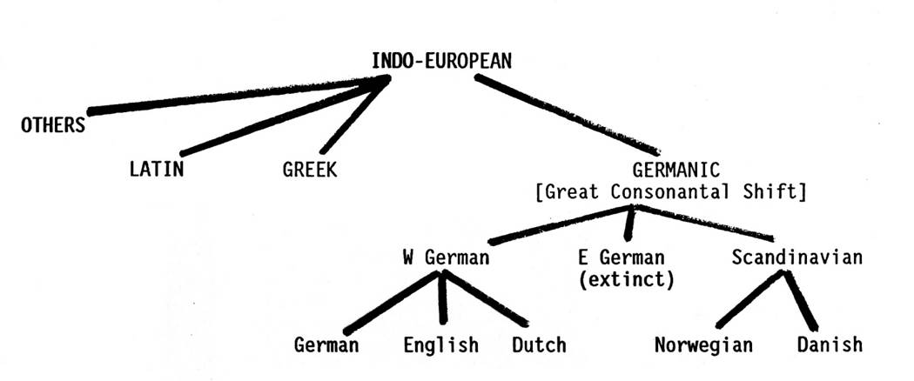
[IMAGE FROM WEB-SOURCE]
SCANDINAVIAN ELEMENTS The Old English language, was essentially self-sufficing, its foreign elements were few and did not modify the character of the language as a whole. It was almost a purely Teutonic tongue, but practically from the close of the Old English period the foreign elements that began to enter into the language gradually modified its character to a great extent. The Scandinavian element is one of the three that have really changed the character of the Old English language as no other element has done. The other two are French and Latin. These were, according to Jespersen, “Three super structures, as it were, that came to be erected on the Anglo-Saxon foundation, each of them modifying the character of the language, and each preparing the ground for its successor.”
The Danish influence is of considerable importance from the point of view of the development of the language. The contribution of the Danish settlers in the growth of British civilization and the permanent effects on English language have been very wide and deep and intimate, as is seen from the permanent place in English of purely Scandinavian words that are primarily grammatical elements in the language, such as the pronouns they, them and their. The early linguistic influence of the Danes can be felt in the use of the Scandinavian loan-word ‘to call’ in a glorious patriotic war-poem written shortly after the Battle of Maldon (993).
Scandinavian influence on place-names and proper names
A great number of Scandinavian families settled in England, specially in Norfolk, Suffolk, Lincolnshire, Northumbria, etc. Names of places ending in –by- thorp,-back and names of persons testify to the predominance of the invaders in great parts of England. Certain names of places ending in –by,-thorp,-beck,-dale,-thwaite,-toft etc show Scandinavian influence. These suffixes are not found in English proper, e.g. - Whitby, Goldthorp, Braithwaite, Lowestoft, etc.
All these suffixes have the meaning ‘village’ or ‘hamlet’. This preponderance of the Scandinavian place-names shows that a great number of Scandinavian families settled in England. It is apparent that these families entered intimately into the speech of the people of the Danelaw. Quite a large number of such place-names are found in Yorkshire, Lincolnshire, Cumberland, Westmoreland, Norfolk etc. Personal names ending in-son as Gibson, Jonson, and Thomson also show Scandinavian preponderance.
The similarity between Old English and Old Norse was very great as both the English and Scandinavians were descended from the same Germanic stock. On account of the almost identical vocabulary of these two languages, it seems rather difficult to indicate the extent of the Scandinavian element in English. And say definitely whether some words which are used in English today originally belonged to the native English or they were borrowed from Scandinavians, though they could be distinguished from one another by a few sound tests.
However, number of words were then identical in two languages, as even now there is some correspondence between two languages, like man, wife, father, mother, wise, well, ill, over, under, come, sit, etc. Among the settlers there were Norwegians too, and it is difficult to say to which nation England owed most. Some words as ‘bound’, ‘busk’, ‘boon’ are Norwegian.
--------------- “And though the forms of grammar were very different, much of the vocabulary was shared between Old English and Old Norse dialects, with differences of pronunciation. Moreover, among the aristocracy of England and Scandinavia there was a common Germanic heroic tradition and many commonly inherited cultural features which Christianity in England had not obliterated‘’ (Wrenn). “The most important and the most far-reaching influence of the Danish, however, was not so much upon the vocabulary as upon the pronunciation, grammar and syntax, and to some extent upon the development of dialect.”(F.T.Wood)
“Words are like leaves; and where they most abound.”
The influence of the Scandinavian conquest thus, manifests itself in three directions. They are-
(a) In certain place names and proper names
(b) In the introduction of new words of Danish origin and,
Scandinavian influence in respect of law terms and war-terms

(c) In modification in respect of grammar and syntax, but more often pronunciation of the existing language. The attempt of the Scandinavians to impose on the English is clearly seen in a certain number of Scandinavian law-terms to some extent which have entered the language, though a great number of Scandinavian law-terms have gone out of use after the conquest of England by the Normans who took charge of legal affairs. Mention may be, however made of few of these Scandinavian terms which are in common use in Modern English like law, by-law, thrall, crave etc.
As the Scandinavians were superior in land and sea fight, the English borrowed from them a few words in this sphere like orrest (battle),fylcian(to marshall),lith (fleet),barda (kind of warship),etc. These words, however soon disappeared.
Scandinavian influence on Architecture and Cooking
Though the Scandinavians were not very superior in these spheres, still a few words from them were borrowed like-
Window (< Scandinavian word ‘vindauga’> ‘vinde’ is ‘wind’ +’auga’ is ‘eye’. So Scandinavian word literally meant ‘wind-eye’, i.e. an eye or hole for the admission of light and air), Steak (< Scandinavian word ‘steik’), Knife (< Scandinavian word knif) etc.
Obsolete native words revitalized through Scandinavian influence-
Some words which had existed in Old English but had gone out of use, gained back the vitality and currency through Scandinavian influence.
The preposition ‘till’ is found only once or twice in Old English texts belonging to the pre-Scandinavian period, but after the Danish conquest it begins to be exceedingly common in English. Other words were blend, rim, run were very rare in old English but later their use was strengthened by the Scandinavian influence.
Survival of Scandinavian words due to agreement with other native words
Here, the English took Scandinavian words for conveying ideas which could adequately be expressed with words of their own language. E.g. - The word ‘Die’-
The Scandinavian verb was ‘deya’ (die). This Scandinavian word was more easily associated with Old English ‘death’ and ‘dead’, probably because of the similarity of the initial sound than Old English ‘steorfan’ and ‘sweltan’. Old English noun and adjective ‘death’ and ‘dead’ had corresponding Old English verbs ‘steorfan’ and ‘sweltan’.
The Scandinavian word ‘deya’ replaced the Old English verbs ‘steorfan’ and ‘sweltan’, and survives in Mod. English as ‘die’.
‘Sweltan’ was totally discarded but ‘steorfan’ was retained and it attained a specialised sense ‘to starve’.
Similarly, the word ‘seat’ comes from the Scandinavian word ‘saete’. In Old English the verbs were ‘to sit’ and ‘to seat’. The Scandinavian, ‘saete’ was adopted in English as noun because it agreed so well with the existing Old English verbs ‘to sit’ and ‘to seat’.
The Scandinavian word ‘want’ survived because of its agreement with Old English ‘wan’ means ‘wanting’ and ‘wana’ means ‘to want’.
The Scandinavian word ‘ill’ was retained because it agreed so well with Old English ‘evil’.
The Scandinavian word ‘same’ survived because it was easily associated with the Old English ‘swa’ means ‘so’.
The Scandinavian pronouns, they, them, their survived and supplanted the Old English plural pronouns hie, heom, heora.
It is because of two reasons-
1) The Scandinavian pronouns with initial’th’ sound were readily associated with the Old English forms beginning with ‘th’sound in ‘the’, ‘that’,’this’ (Native Words)
2) These Scandinavian words were felt to be more distinct forms than the Old English forms hie,heom,heora which were supplanted.
Otherwise, after the vowel sounds had become obscured, it would no longer have been possible to keep easily apart ‘he’ and ‘hie’,’him’ and heom. Her (hire) and heora, so that we would always have got confusion between Old English singular and plural forms:
(i) He (singular) and hie (plural)
(ii) Him (singular) and heom (plural)
(iii) Her (singular) and heora (plural).
It took a long time before the Old English forms were finally discarded. The Old English dative ‘hem’ (heom) still survives in the form ‘em as take’,’em’which is ignorantly taken as the shortened form of ‘them’.
Thus, the Scandinavian words not only made their way into English confined to nouns and adjectives and verbs, but also extended to pronouns, prepositions, adverbs and even a part of the verb to be. Such parts of speech are not often transferred from one language to another.
Scandinavian influence on form words
(i) Pronouns- The pronouns they,them,there are Scandinavian,but they are not the only Scandinavian pronouns to be found in English. ‘Both’ and ‘same’, though not primarily pronouns,have pronominal uses and are of Scandinavian origin.
(ii) Prepositions-The preposition’till’ was at one time widely used in the sense of ‘to’, besides having its present meaning. The word ‘fro’, likewise in common use formerly as the equivalent of ‘from’,survives in the phrase ‘to and fro’. Both words are from Scandinavian.
The Conjunction ‘though’,the Old Norse equivalent of Old English ‘theah’. The scandanavian use of ‘at’ as a sign of the infinitive ,is to see in the English ‘ado’(at-do) and was widely used in this construction in Middle English.
(iii) Adverbs- The adverbs aloft,athwart,aye(ever) and seemly and the earlier hethen(hence) and whethen (whence) are all derived from the Scandinavian.
(iv) Verbs- While ‘we aron’ was the Old English form in the North, the West Saxon plural was ‘syndon’ and the form ‘are’ in Modern English undoubtedly owes its extension to the influence of the Danes.
Cases where Scandinavian forms survive in dialects, native in literary language: There are cases where the old English forms belong to the literary language, while the Scandinavian forms occur only in some dialects. In the following pairs, the English word is given first.
Leap-loup,church-kirk,yard-garth, mouth-mun, chest-kist,dew-dog.
Cases where native form has survived, Scandinavian form has disappeared
There are cases where the native form has remained and has ousted the Scandinavian form in course of time. E.g.-
Old English that has ousted the Scandinavian forms-(These Scandinavian (Sc.) forms have disappeared from the English Language.)
Loathe (Old English) > laithe (Sc.)
Few (Old English) >fo (Sc.)
Fish (Old English) >fisk (Sc.)
Bench (Old English) > bennk (Sc.)
Yarn (Old English) > garn (Sc.)
Naked (Old English) > naken (Sc.)
Origin of thence, hence, whence-
Thanon (Old English)> has ousted >thethen (Sc.) and has become >‘thence’,--- when at a later stage adverbial ‘s’ was added to the Old English form, and this ‘s’ gradually became ‘c’ that ultimately the Old English form became ‘thence’. Here we find that the Scandinavian ‘e’ has been retained, while the Old English vowel ‘o’ has disappeared.
Heonan (Old English)> has ousted >hethen (Sc.) and has become >‘hence’,--- when at a later stage adverbial ‘s’ was added to the Old English form, and this ‘s’ gradually became ‘c’ that ultimately the Old English form became ‘hence’. Here we find that the Scandinavian ‘e’ has been retained, while the Old English vowel ‘eo’ has disappeared.
Hwanon (Old English)> has ousted >hwethen (Sc.) and has become >‘whence’,--- when at a later stage adverbial ‘s’ was added to the Old English form, and this ‘s’ gradually became ‘c’ that ultimately the Old English form became ‘whence’<( hwanon +c). Here again, we find that the Scandinavian ‘e’ has been retained, while the Old English vowel ‘o’ has disappeared.
Collateral existence of the Old English and the Scandinavian forms of the same word with slightly different shades of meaning
As a result of the Scandinavian influence we come across a class of words, having two forms- one the Old English and the other the Scandinavian influence. Both of these forms are retained with slightly different shades of meaning, as in the following pairs where the first word is and the second Scandinavian, e.g.-whole -hale, no-nay, from-fro, shirt-skirt, edge-egg(incite),shriek-screech, rear-raise. All these forms are used in standard speech.
Cases where Scandinavian form has survived, native form has disappeared
In these cases the Scandinavian forms have survived and have ousted the legitimate native forms, e.g.-
Sister> comes from > syster (Old Norse) has ousted sweoster (Old English)
They (Sc.) > yete (Native)
Get (Sc.) > yelde (Native)
Guild (Sc.) > yive (Native)
Gift (Sc.) > yift (Native) -- In this word, not only initial ‘g’ due to Scandinavian influence, but also has the modern meaning. The Old English word ‘yift’ meant ‘the price paid by a suitor in consideration of receiving a woman to wife.’
Kettle (Sc.) > chetel (Native)
The Scandinavian verb ‘take’ replaced Old English ‘niman’, ‘cut’ took the place of Old English ‘smithan’, ‘window’ drove out the equally appropriate English word ‘eagthyrel’ means eye-thirl, i.e. eyehole, ‘sky’ took the place of Old English ‘wolcen’ is now being preserved only in poetical word ‘welkin’. All these native forms have disappeared from the English language.
Sense-Shifting
In some cases where, native form has survived but the meaning adopted is that of the corresponding Scandinavian word.
E.g. - The word ‘Dream’-
Old English Word Meaning in Mid. English and Modern English<Scandinavian influence
Dream ,(which originally meant ‘joy’) but, in Mid. English, it is assumed modern meaning ‘vision of the night < taken over from the corresponding Old Norse ‘draumr’, Danish word as ‘drom’ which had also the meaning ‘vision of the night’.
Analogous cases are-
‘Bread’, an Old English word meant ‘fragment’. The word had survived but adopted in Mid. English the modern meaning ‘loaf’< taken over from the meaning of Danish ‘brod’.
‘Bloom’ (bloma), an Old English word meant ‘mass of metal’. The word had survived but adopted in Mid. English the modern meaning ‘shine’ taken over from the corresponding Scandinavian word.
‘Dwell’, an Old English word meant ‘to lead astray’. The word had survived but adopted the modern meaning ‘to remain in a place’ taken over from the corresponding Scandinavian word.
‘Gift’ (yift), an Old English word meant ‘the price paid by a suitor in consideration of receiving a woman to wife.’ The word had survived but adopted the modern meaning which is general, not specific, taken over from the meaning of Scandinavian word.
‘Earl’, an Old English word meant ‘nobleman’. The modern meaning is something specific (nobleman ranking between marquis and viscount) < has been taken over from the meaning of Old Norse ‘jarl’.
Scandinavian influence on pronunciation
Thus, the hard pronunciation of ‘g’ in give and get is due to the Scandinavian influence. In Old English these were ‘yive’ and ‘yete’.
A certain number of inflectional elements peculiar to the Northumbrian dialect have been attributed to Scandinavian influence-
Scandinavian influence on
Grammar (i) The ‘-s’ of the third person singular, present indicative of verbs and the participial ending-and, corresponding to’-end’ and ‘-ind’ in the Midlands and South, and now replaced by ‘-ing’ are said to be due to Scandinavian influence.
(ii) The final ‘t’which is the neuter adjective ending of Old Norse is preserved in and forms an inseparable part of words like scant, want, athwart.
(iii) Except a few verbs like take, thrive, etc. which are strongly inflected as in Scandinavian, almost all Scandinavian strong verbs have been made weak in conjugation in English. ‘Die’, was a strong verb in Scandinavian but in English conjugation it has become a weak verb ‘died’.
(iv) Scandinavian nominative ending ‘-r’ in nouns was dropped in English, e.g. Scandinavian word ‘byr’ became ‘by’ in Native.
(v) There is at least one interesting word with the Scandinavian passive voice in ‘-sk’ as ‘busk’, but in English it is treated like an active form.
(vi) As the result of the influence, admixture was the leveling of the terminations in English, that is, the simplicity of declension and conjugation.
(vii) Certain prominal forms like ‘they, them, their’ ,adverbial forms ‘thence, hence, whence, present plural ‘are’ of the verb ‘to be’ and the prepositions like ‘till’ and ‘fro’ are all due to Scandinavian influence.
The bulk of Scandinavian words are of a purely democratic character. The French words introduced in the following centuries represent the rich and the refined. The Scandinavian influence is felt in the English grammar and syntax. The ‘-s’ of the third person singular in the present indicative tense of verbs is said to have been due to Scandinavian influence.
“To the Danes and Northmen the English vocabulary owes a great deal.”- Bradely
Scandinavian influence on Syntax
(i)Relative clauses without any pronoun were very rare in Old English, but they became very common in Mid. English due to Scandinavian influence. E.g.-
The man whom I know. The man I know.
This is the book which I lost. This is the book I lost.
(In these second cases the relative pronouns whom and which are omitted.)
(ii) According to Jespersen the omission of the relative pronoun in relative clauses (This is the book I lost, in the example given in syntax) – the relative pronoun ‘which’ is omitted here, and the retention and omission of the conjunction ‘that’ are also due to the Scandinavian influence.
(iiii) The use of shall and will in Mid. English corresponds well Scandinavian.
Other points in syntax might perhaps ascribed to Scandinavian influence, such as the universal position of the genitive case before its noun (where Old English like German placed it very often after it),but in these delicate matters it is not safe to assert too much, as in fact many similarities may have been independently developed in both languages
…”The latest influence from the classical languages is something between a hindrance and a help”- Jespersen.
THE DEVELOPMENT OF DICTIONARIES

“Rats and mice and such small deer
Have been Tom’s food for seven long year.”
In the ancient classical world and in the Middle Ages there were often made collections of ‘hard words’ and foreign words with their meanings. These are termed glossaries or collections of glosses (a gloss, from Latin of the Greek glossa ‘rare word needing special explanation’, is a translation or explanation of a word). Until the Renaissance such glossaries were only selected groups of explanations and in no sense aimed at the completeness we associate with a dictionary. The Renaissance brought the need for Latin and Greek dictionaries, and the impulse given by the new attitude caused the thoughts of scholars to turn also to the improvement and clarification of the vernacular. So it was that crude and incomplete dictionaries began to appear in the sixteenth century. Such in part was Thomas Cooper’s Thesaurus Linguae Romanae Britannicae of 1565, in which a number of difficult or obsolete words are treated. In 1604 Robert Cawdrey produced a slim volume entitled A Table of Alphaebiticall English Wordes; and in 1658 Edward Phillips, Milton’s nephew and pupil, published his New World of English Words in which are contained, he tells us, ‘the interpretations of all the words derived from foreign languages’. The first two stages of the history of dictionaries, then, were the glossary first and secondly the merely selective dictionary which dealt only with ‘hard words’ or those of foreign derivation.
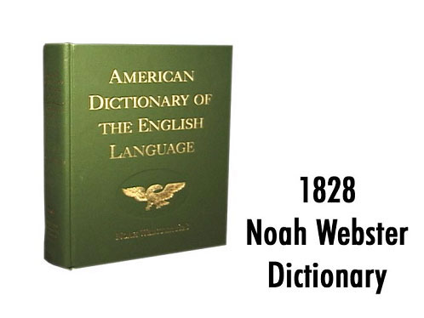
The third step was the addition of etymologies to the meanings of words: for to know the history of a word before it entered the language is of value for the understanding of its exact shade of meaning. Stephen Skinner in 1667 with his Etymologicon Linguae Anglicanae, and the Dutch scholar Francis Junius (who first printed the oldest poem of the Old English Caedmon) with his Etymologicon Anglicanum in 1677, were the pioneers in providing etymological dictionaries for English though both wrote in the then usual Latin.
All the foregoing were but preliminary stages; the first dictionary in anything like the proper sense of the word appeared in 1708. This was John Kersey’s Dictionarium Anglo-Britannicum or A General English Dictionary. This embodies a fourth development, namely the attempt to set out the whole of the literary language. It was followed in 1730 by a much more scholarly work, Nathan Bailey’s Dictinarium Britannicum or A More Comleat Universal English Dictionary, which included all the advances hitherto made in the science of lexicography or dictionary-making , but with greater fullness. Moreover it introduced slightly a fifth feature, the illustration of definitions and meanings by quotations from select contemporary authors so as to make much clearer than before exact shades of meaning by enabling the reader to see the words used words in given contexts.
But of, the greatest landmark in the development of lexicography was Dr. Sam. Johnson’s Dictionary of the English Language, completed in 1755.For this employed much more fully and effectively the method of illustrating by quotations which Bailey had only occasionally used. Moreover its definitions, despite some humorous or individual vagaries, were the first to be really clear, scholarly and effective. At once it became the standard work, for long the arbiter of English usage and the standard for English spelling. All good dictionaries have benefitted by its pioneering steps; and it set the model for the next hundred years, and also first set up the habit which has now become well-nigh universal, of treating dictionaries are always inevitably somewhat out of date, in view of the constantly changing nature of language.
It was Charles Richardson who, in his A New Dictionary of the English Language (1836), widened the scope of his illustrative quotations and first indicated a sixth development the inclusion of quotations to shew the historical uses of words (the meanings they had in older times as well as their contemporary sense).
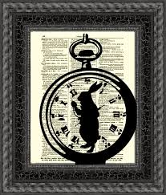
[IMAGE FROM WEB-SOURCE.]
In 1928, as the result of seventy years of work and fifty of actual carrying out of an established plan, there appeared the final volumes of The Philological Society’s A New English Dictionary on Historical Principles published by the Clarendon Press of Oxford. This, the work of a number of editors and thousands of helpers all over the world, is the greatest scientific achievement in lexicography so far completed. It adds to the foregoing developments, the complete setting forth of the whole history and semantic development of every word known to have been used since the twelfth century. This it does by means of a series of definitions for each word, with a past history of its several different meanings which show its exact development; and these are each illustrated chronologically by appropriate quotations from various periods. In addition, every known spelling the word may have had at any time in its history is recorded, together with a full indication of the current British pronunciation in a phonetic script. It is thus, for the scholar, the most complete record of the whole of the English Language, with all the material the student could want for the study of any and every aspect of its history. It occupies ten large volumes or twenty half-volumes: but for ordinary working purposes its material is summarized in two volumes in The Shorter Oxford English Dictionary, and still further reduced and adapted to speedier consultation in The Oxford Concise English Dictionary.
In America, Noah Webster was the pioneer with his Compendious English Dictionary of 1806, which follows well on the great work of Johnson: and in 1828 was published his American Dictionary, which was the foundation of the great Webster’s International Dictionary, which is the universal working tool in America after successive revisions. The Century Dictionary (1889-91) is the great American example of a scholarly compendious English dictionary, in six volumes, which is largely an encyclopaedia as well. A Dictionary of American English, on the same lines (but reduced somewhat) as The New English Dictionary, embodying all of the English language that is recorded in America from the days of the earliest settlements treated historically, has lately been published.
Locke defines Rhetoric as the ‘art of speaking with propriety, elegance and force.
INFLUENCES ON ENGLISH
“And for ther is so greet diversitee
In English and in writing of our tonge,
So preye I God that noon miswryte thee,
Ne thee mismetre for defaute of tonge.
And red wher-so thou be, or ells songe,
That thou be understonde, I God beseche.’’

One effect of universal schooling is the wreaking of regional dialect and the growth of ‘modified’ Standard English in imitation of teachers and through their efforts after producing the ‘received standard’. Many children now shew a sort of ‘bilingualism’, speaking one form of English at home and another at school. Some teachers, instead of concentrating on training clarity and grace of speech and sensitive linguistic observation together with understanding of and administration for the best models, tend to expand energy on eradicating dialectal sounds and intonation, giving children the impression that a local dialect is necessarily ‘inferior’ or ‘unculturaled’. This may result in unnatural types of speech, linguistic snobbishness and a seeking after artificial refinement which has no foundation in the personality of the speaker. ‘Good English’ must be talked naturally, or it is not good.
The necessarily of acquiring a form of ‘received’ English for the sake of convenience when mixing in society or working in different area, is something quite distinct from any question of the ‘superiority’ of one dialect over another. With the decay of direct understanding of the ancient classical languages and the knowledge that English could not fully and exactly be explained or described in the terms and within the rules traditionally set out for Latin, there came a desire to cast aside the restraints of grammatical teaching altogether. Grammar is only the attempt exactly to describe the facts, of a given language, and formulates rules and definitions to clarify the understanding and application by users of the language, of these facts. Without this knowledge which has been laboriously put together by others with more leisure, the disciplined use of the language to its full capacity becomes impossible to most people. On coming to realize the growing ill-effects of this loss of linguistic discipline, most authorities have lately been insisting once more on some teaching of English grammar. This merely replaces the traditional terms, which were, like all human efforts, inaccurate, by new descriptions which lack the convenience of tradition without avoiding inaccuracies.
It is natural that, in an age of some psychological advance and much consequent superficial talk and writing about psychology, there should be a growth of self-consciousness in linguistic usage, side by side with the growth of a more introspective mental habit. Hence perhaps the increased seeking after ‘correctness’ in English and the looking after a ‘received standard’. Yet just in so far as a speaker becomes exactly conscious of the sounds of his speech, that speech will become less natural- less truly the expression of his own personality. Let the reader try for himself the experiment of listening to his own voice while making a speech, and the truth of this statement will become clear. Broadly speaking, it may be said there are three types of spoken English in England: ‘received standard, regional dialects, and modified standard. To these three types of English might be added the always mixed or heterogeneous speech of large industries; towns where the population is mobile and from varied localities; and many dialects have influenced one another and become blurred and blended into a common speech. There are, too, small occupational dialects, such as that of Yorkshire West Riding textile- workers, which have their own specialized vocabulary within a regional dialect. While, on one hand, the needs of modern life require a universally clear and comprehensible form of English and therefore suggest a received standard of pronunciation to be learned and used by all, there is nothing necessarily superior in this ‘good English’ as against regional dialects. Nor is exact uniformity of pronunciation to be aimed at, even if it were possible. For it is for sake of being universally understood that we should cultivate a generally received kind of English: but within that requirement there is a good deal of room for variety of dialect –produced pronunciation and intonation.
Indeed to many the ‘correct’ pronunciation of professional broadcasters may sound flat and lifeless, lacking colour and musical quality. We can scarcely expect even now to attain to that objectiveness which it is fashionable to seek, in viewing the English of to-day. We can notice the effects of the many changes in social life on speech, and the linguistic results, it may be, of the widening of school education and the reduced influence of a more traditional and Classical education which had been a brake upon change and a conserver of usage. No orator or rhetorical writer has had any marked influence on the language as a whole that can be demonstrated, in the same sense in which Shakespeare or the Bible, or even Dr. Johnson, have influenced it. But of, great speakers and writers of rhetorical prose have left examples which have had their effect on the general development of the language; and occasionally the phrases, allusions or tricks of style of such persons have become part of English.
English is a stressed language, and the Old English verse line is a balance of two stress phrases linked by alliteration: the first or second stress, or both, must alliterate with the third; the fourth must not. Old English verse is often printed with a mid-line space to point the metre. Free oral improvisation in a set form requires a repertory of formulaic units. The style is rich in formulas, often noun-phrases. Thus in the nine lines of his ‘Hymn’ Caedmon has six different formulae for God, a feature known as variation. The image of heaven as a roof and of the Lord as protector is characteristically Anglo-Saxon.
Language , lacks the quality of conciseness of brevity is said to be diffuse. A diffuse style is almost always tiresome. It is certainly not pleasing to anybody to be obliged to go through a multitude of words conveying only a small amount of sense. Such a style, therefore, can never command much interest and attention.
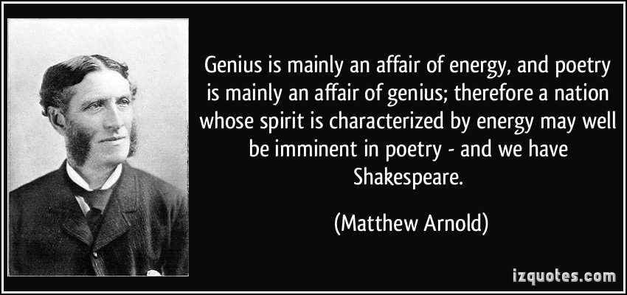
[WEB-SOURCE.]
Literature is written language. Human settlement, in Britain as elsewhere, preceded recorded history by some millennia, and English poetry preceded writing by some generations. The first poems that could conceivably be called ‘English’ were the songs that might have been heard from the boats crossing the narrow seas to the ‘Saxon Shore’ to conquer Britannia. ‘Thus sung they in the English boat’, Andrew Marvell was to write.
The cliffs at Dover were often the first of Britain seen by early incomers, and have become a familiar symbol of England, and of the fact that England is on an island. These cliffs are part of what the Romans, perhaps from as early as the 2nd century, had called the Saxon Shore: the south-eastern shores of Britain often raided by Saxons. The Romans left Britain, after four centuries of occupation, early in the 5th century. Later in that century the Angles and Saxons took over the lion’s share of the island of Britain. By 700, they had occupied the parts of Great Britain which the Romans had made part of their empire. This part later became known as Engla-land, the land of the Angles, and its language was to become English.
The language that I use must be transparent i.e., the images I want to present, the ideas I intend to express, must be clearly and distinctly presented. If there be any flaw in this, I shall see them but dimly. Perspicuity must not be sacrificed to any other quality of composition; the want of it is the greatest defect that language can have.
The people eventually called the English were once separate people’: Angles, Saxons and Jutes. St. Bede recounts in his Latin Historia Ecclesiastica Gentis Anglorum (Ecclesiastical History of the English People, 731) that the Jutes were invited into Kent in 449 to save the British Kingdom from the Saxons and Picts. The Jutes liked what they saw, and by about 600 the lion’s share of Britannia had fallen to them, and to Saxons and Angles. The Celic Britons who did not accept this went west, to Cornwall and Wales. The new masters of Britain spoke a Germanic language, in which ‘Wales’ is a word for ‘foreigners’. Other Britons, says Bede, lived beyond the northern moors, in what is now Strathclyde, and beyond them lived the Picts, in northern and eastern Scotland. English was first written about the year 600 when King Æthelred of Kent was persuaded by St Augustine of Canterbury that he needed a written law-code; it was written with the Roman alphabet.
The simplicity of language consists in its being easily understood. The criterion of the perspicuity of language is not that it should be intelligible without any effort, but that its meaning, when understood, should be unambiguous and unmistable.
Language is graphic,when it calls up some image to the mind by dwelling on the particular rather than on the general, on the concrete rather than on the abstract.
Amongst the offences against simplicity of style, euphimism and mannerism deserve special mention. Impressiveness is a very desirable and very important quality of a personality.
The accumulation of unaccented syllables is never melodious; as felicitously, peremptorily, incompatibility, indefatigably etc; and so also is an unvarying succession of long or short syllables. The words of a sentence should flow on naturally and gracefully, and there should be regular pauses in it, clearly indicated by punctuation marks. An excessive use of parentheses, it should be noted, is likely to render a sentence harsh and unmusical.
English literature is both literature in English and the literature of England. In the 16th century, England became a state with its own national church. Before this, English was not always the most important of the languages spoken by the educated, and loyalty went to the local lord and church rather than to the state. Art historians use the term ‘Insular’ to characterize British art of this period. Insular art, the art of the islands, is distinctive, but of mixed origins: Celtic, Mediterranean and Germanic. The blended quality of early English art holds true for the culture as a whole: it is an Anglo-Celtic- Roman culture.
When applied to language, the word signifies that quality of beauty, derived from the agreement of sound and sense, which is naturally fitted to give pleasure to the mind. Violent emotions, on the other hand, impassioned reasonings or familiar addresses require brisk and abrupt turns of expression. The Angles and Saxons conquered what is now called England in the 5th and 6th centuries. In the 7th century, Christian missionaries taught the English to write. The English wrote down law-codes, and later their poems. Northumbria soon produced Caedmon and Bede. Heroic poetry, of a Christian kind, is the chief legacy of Old English literature, notably Beowulf and the Elegies. A considerable prose literature grew up after Alfred (d.899). There were four centuries of writing in English before the Norman Conquest.
This hybrid culture found literary expression in an unmixed language. Although Britannia was now their home, the English took few words from the languages of Roman Britain; among the exceptions are the Celtic names for rivers, such as Avon, Dee and Severn, and the Roman words ‘wall’ (vallum) and ‘street’ (strata). Arriving as the Roman Empire faded, the Saxons did not have to exchange their Germanic tongue for Latin, unlike their cousins the Franks, but Latin was the language of those who taught them to read and write. As they completed their conquest of Britain, the Saxons were transformed by their conversion to Catholicism. Gregory’s mission rejoined Britain to the Judaeo-Christian world of the Latin West.
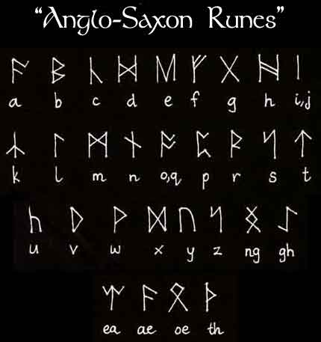
LITERATURE:
CRITICAL APPRECIATION OF KUBLA KHAN.
Ans:
Kubla Khan is one of the three great poems of Coleridge.it is the shortest but in some ways the most remarkable of the three. It differs from the other two in that it does not relate a story. It is a piece of description. The first part describes a mighty river and a rare pleasure-dome constructed on it by a mighty conqueror, Kubla Khan. The later part describes the power of poetry and inspiration as well as a poet in the frenzy of creation.
The poem is described by Coleridge himself as a fragment. According to him it is only a part of the poem of two to three hundred lines which has come to him in a dream. Not only he actually see the picture that he paints in the poem; even the lines and the words came to him, just as they are. But of, he cannot complete the poem as he was interrupted by a visitor and the vision faded.
Ever since, then, critics have regarded this poem as a fragment. Not all critics, however, are of this view. For example, George Saintsbury disbelieves Coleridge’s statement. He remarks, the prose rigmarole in which Coleridge tells the story of the coming and going of the vision called Kubla Khan is “a characteristic piece of self –description.” It is his view that the poem is not a fragment. Says he, “Far from being an opium dream, Kubla Khan is the product of one unexpected lucid interval before the fumes closes up once more the expression of the spirit; moreover, it is complete. It is pure poetry, it is perfect.” A modern critic named Humphrey House also holds that the poem is complete. He regards it a poem about the process of poetic creation, about the ecstasy of imaginative fulfilment.
At first reading, the poem gives the impression of being “airy and unsubstantial”. It gives us the feeling that it has no coherence and that the two parts of the poem do not hang together. The first part describes the river Alph. The second part describes a vision and then a poet in frenzy. Even in the first part, the description does not follow an even course. It wanders and wanders like the river Alph. There seems to be no connection between the river Alph and the Abyssinian maiden.
A closer study, however, convinces us that the poem is not as innocent as it seems to be. It cannot be explained in rational terms, but when we follow the course of the associations and suggestions that runs through the poem, it does yields a coherent meaning.
The poet’s imagination is much aroused by the river Alph and its subterranean course. The measureless caverns, the panting earth, the dancing rocks, sunless and lifeless sea, the tumult of the mighty waves as they rush into the silent ocean, the scene where a woman wails for her demon lover -all these excites his imagination. A feeling of awe and mystery is upon him, and he is lifted into a mood of poetic creation.
This suggests him the power of creation in man. It arouses in him the desire to capture the weird beauty of the entire scene, and reminds him that this can be built in colours, strains and words. The symbol of this creative power is the maiden whom he see in a vision.
The poet, therefore, glides into his new theme through suggestion. The two parts are connected by the poet’s desire to build a pleasure dome with the help of his imagination. He then describes the poet when the fit of creation is upon him.
Such an interpretation is possible and so the poem can be shown to be complete. But of, the coherence and the completeness of this poem is the coherence and the completeness of a dream, not of walking life. In fact, the whole poem follows the course of a dream. Even the description of the river Alph has this dream-like quality. The pictures are repeated, and it is not easy to follow the course of the river exactly. It is also difficult to conclude whether the river has an entire course of ten miles or whether this is only a part of the course. Again, it is not at all possible to say with confidence how the wild and fertile parts of the course of the river are related to each other. Again the transition from the description of the river to the description of the vision is abrupt, and the connection between the first and the second part tenuous. In vividness as well as lack of smooth transitions, the poem is like a dream.
This poem is a master-piece of descriptive art. It has a pictorial quality about it. In fact, the poem is nothing but a series of pictures that follow each other in quick succession. After announcing that Kubla Khan decreed a pleasure-dome, the poet describes the course of river Alph. Then he builds up the picture of a romantic chasm-a scene of vast desolation in the dim light of the moon. Then follows the picture of the mighty fountain. The picture of the course of the river is repeated, and is followed by a picture of the pleasure-dome. Then comes a description of the vision, and finally the description of the poet in frenzy.
These pictures are at once vivid and yet vague. This is exactly what happens in a dream. The impressions of a dream have clear outline, and yet they concentrate only on a few details, the rest being left vague. In other words, the description on leaves much to the imagination of the reader they are suggestive, not explicit. For example, what exactly do we know, about the pleasure-dome, that it was situated on the bank of the river Alph, that it had a sunny dome and caves of ice, that its shadow fell on the floating waves and that it was haunts by the tumult of the mighty river.
Equally vague and yet vivid is the picture of the river. We cannot answer a definite question about it. How far, we ask, was the sunless sea from the pleasure-dome? How far is the fountain head of the river? Was the entire course of the river only ten miles? And these questions have no answer because the entire description has the indefiniteness of a dream.
This vagueness, however, is the greatest strength of the description. It leaves so much to suggestion that every reader with a little imagination will build a vast scene of his own. The mystery becomes more effective because of this vast vision of vagueness which surrounds the vivid picture of the poem.
Several touches in the poem raises from the region of everyday realities to that of a supernatural world. The details are realistic, and each detail has an actual counterpart somewhere. The total impression, however, is of an unearthly rather than earthly scene.
This is achieved with the help of deft touches scattered in the poem. The very mention of Xanadu, Kubla Khan, Alph, Abora and the Abyssinian maid evokes associations of remoteness, mystery and strangeness. “The woman wailing for her demon-lover,” the chasm “seething with ceaseless turmoil”, “the earth breathing in thick pants”, “the huge fragments”, thrown up by the waves “the caverns measureless to man”, “the sunless, lifeless ocean”, “the ancestral voices prophesying war”, “the caves of ice”, the poet with “his flashing eyes, his floating hair”, fed on honey-dew and milk of Paradise, the circle woven around him thrice- all these are touches which make the poem of a supernatural world .
Basically, the history of the English language is divided into three periods called Old English or Anglo Saxon, Middle English and Modern English. Old English came into being in the 5th century A.D., when the Germanic tribes migrated to England from what are now northern Germany and Denmark.

The English language belonged to the Teutonic or German branch of the Indo-European family of languages. “The English language of to-day reflects many centuries of development. The political and social events that have in the course of English history so profoundly affected the English people in their national life have generally had a recognizable effect on their language. The Christenizing of Britain in 597 brought England into contact with Latin civilization and made significant additions to the English vocabulary. The Scandinavian invasions resulted in a conservable mixture of the two races and their languages. The Norman Conquest made English for two centuries the language mainly of the lower classes, while the nobles and those associated with them used French on all occasions. And, when English once more regained supremacy as the language of all elements of the population it was an English greatly changed in both form and vocabulary from what it had been in 1066.
In a similar way the Hundred Years’ War, the rise of an important middle class, The Renaissance, the development, of England as a maritime power, the expansion of the British Empire, and the growth of commerce and industry, of science and literature have, each in its way, contributed to make the English language what it is today.
In a word, the English language reflects in its entire development the political, social, and cultural history of the English people.”
THE MAKING OF ENGLISH LANGUAGE
“Most weary seemed the sea!weary the oar,
Weary the wandering fields of barren foam.”
Different factors were at work at different times in the making of the English language, as it is known today. Those factors were political as well as social, religious, as well as cultural. IN FACT, IT IS THE TOTAL AND COLLECTIVE RESULT OF THE WORKING OF DIFFERENT MATERIALS THAT HAS GONE TO THE MAKING OF THE MIGHTY EDIFICE OF THE MODERN ENGLISH LANGUAGE.
(1) THE ROMAN CONQUEST OF BRITAIN
(2) THE CONQUEST AND SETTLEMENT OF THE GERMANIC TRIBES IN BRITAIN
(3) THE CONVERSION OF THE ENGLISH PEOPLE TO CHRISTIANITY
(4) THE SCANDINAVIAN INVASION AND SETTLEMENT IN ENGLAND
(5) THE NORMAN CONQUEST
(6) THE REVIAL LEARNING
(7) THE EXPANSION OF THE BRITISH EMPIRE
(8) THE EXTENSIVE GROWTH OF SCIENCE, TECHNOLOGY AND COMMERCE
(9) THE WORLD WARS.
The Roman Conquest, of course, took place before the beginning of the actual English Language on the soil of Britain. Still it had a tremendous impact whole cultural and linguistic life of the old Britons. Eve, after the departure of the great Roman and the settlement of the Teutonic people that impact persisted in some ways. The old Roman words came to be incorporated in some cases with the new language of England.
It is to be noted here that, even while the Anglo-Saxon people were yet on the continent and did not settle in Britain, they adopted some loan words from Rome in course of their trade or commercial transactions. Some early Christian terms (mostly Greek), found introduced into English, such as ‘devil’ (deofol), ‘Church’ (Cirice) and ‘bishop’ (biscop). Some Latin terms , related to trade and commerce were borrowed, too, such as ‘chalk’, ‘cheese’ , ‘cup’ ‘dish’ ‘pillow’, ‘pound’ ,‘street’, ‘wine’, and so on.
Ri`ch the |trea`sure,
Swee`t the |pleas`sure. (Dryden)
Of course, borrowings from the Celtic Language, the language of the Celtic people , who had lived originally in Britain , took place , as seen in the words like ‘bin’, ‘crag’, ‘tor’, ‘coomb’, and so on.
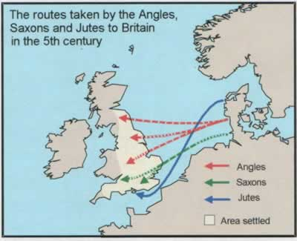
The conquest and settlement of the Teutonic people’- Angles, Saxons and Jutes- actually set the ground for the growth of the English Language. It was after the name of the language of the Angles that the English language came to be known. Of course there were distinct stages in the growth of the language in O.E. period and M.E. period.
The Christianizing of the Teutonic settlers of England by the Church of Rome in 597 A.D. brought the country into an intimate contact with Latin civilization and made significant additions to the English vocabulary from Latin and Greek languages. A large number of church words and other words in connection with religious practices and rites came to be introduced.
The Scandinavian invasion from the eighth century and ultimate settlement resulted in the further expansion of the language by fusing harmoniously the two races- the English and the Danes-and their languages, English and Scandinavian. Many Scandinavian words recognized by the hard ‘k’ or ’g’ sound, had a smooth passage into English- dank, keel, skirt, sky, egg, girth, guess, etc.
The Norman Conquest of 1066 had a majestic effect on the development of the English language. The Normans brought with them the French culture as well as language of the time and thereby affected the English language as well as life in a very significant way. The resources of another highly cultivated language enriched immensely the English Language.
The impact of the Renaissance that had brought about the Revival of Learning too, had no mean contribution to the expansion of the English language. The renewed contact with the classical languages of Rome and Greece strengthened and extended the scope of English and enlarged the frontiers of the language to a very great extent. As the language of learning and scholarship, Latin was used as a rich reservoir to draw newly made-up English words.
The expansion of the British empire brought the English nation in contact with other people’ and different countries. As a result of linguistic intercourses with different nations, European and Asiatic, there was the further enrichment of the English language. Many alien and queer words were, too, drawn upon. From modern Germany, Hungary, India, Malay and many other places, words flowed in. even from other continents, from the aborigines of Australia and America, a large number of words came to be adopted.
The extensive growth of the English language is well recorded today with the all-pervasive march of science, technology and commerce. There are numerous remarkable scientific and technological terms as also commercial coinages.
The English therefore is not static or stationary. It is a dynamic, living and growing language. It has a wonderful flexibility ensures for it a persistent growth and a prospective future and all this is made possible by the inner strength of the language to harmonize all forces and assimilate diverse elements with utmost spontaneity.
INFLUENCES ON MAKERS OF THE LANGUAGE
Shakespeare’s influence on the English language is stupendous. There is no other author, either before or after him, who comes equal to him on this plane. In the making of English, however, three other great poets- Chaucer, Spenser and Milton- are important names. Their influences are to be carefully estimated too.
-Chaucer is a great man as a literary maker of the English language. There is no doubt about the powerful influence of his writings on this language. A long list of words and expressions, supposed to have been used first by Chaucer in literature, may well be furnished. Again, he is also found to have given new and felicitous applications to many words, already current. Chaucer’s role requires really a respectful review in the matter of the enrichment of the English tongue.
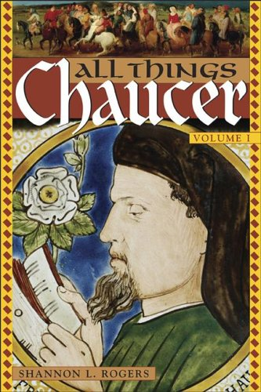
Yet, it is difficult to assess Chaucer’s influence by definite examples. There is, as a matter of fact, no distinct proof that, in the use of a particular word or words, he had no predecessor. The indebtedness of the modern poetical vocabulary to him is undeniable, but there again, it is hard to find particular instances that are not open to doubt about his originality.
In fact, Chaucer’s words and expressions can hardly be taken to have become the part of the familiar language, like Shakespeare’s. It is actually not possible to discuss his share in the making of English with detailed illustrations.
-It is much easier to measure Spenser’s role in the making of the English language. He is found to have used deliberately an artificial dialect, comprising archaic words and expressions, provincial speeches and newly invented terms.
Spenser’s poetical diction is generally deemed as artificial, but it should not be dismissed as a sort of pure affectation. As a matter of fact, it seems the most befitting vehicle for his thoughts, feelings and fancies. Of course, most of the words, invented or revived by him, have now become obsolete.
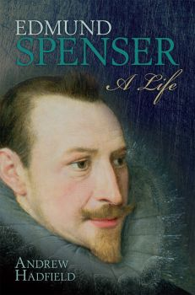
Nevertheless, the modern English vocabulary has retained some distinct traces of his literary influence. A few instances may be cited here to show the same. ‘Elfin’, a quite common word today, is due to Spenser. The adjective ‘blatant’ was first used by him in poetry, and it is now so current. Braggadocio refers to the vain-glorious knight in The Faerie Queene. It is now commonly used in the sense ‘empty boaster’. Similarly, ‘derring-do’, used by him, is found quite current in chivalric romances, including Scott’s historical novels.
-as a literary master, Milton’s eminence is without any questions, yet the extent of his influence on the English Language is nothing in comparison with Shakespeare’s. “While Shakespeare has contributed innumerable phrases to the common treasury of English diction, the Miltonic expressions that have really become the part become the part of the language are extremely few.” (Bradley)
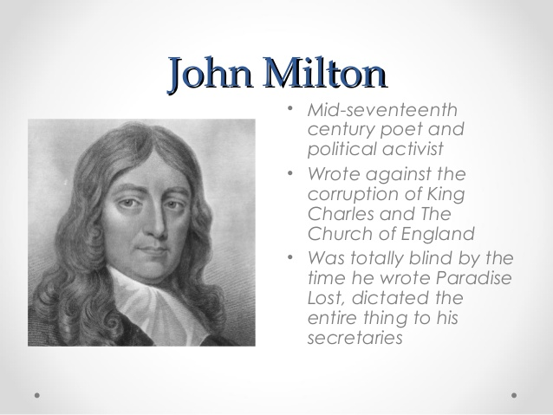
Certain expressions and passages from Milton are, however, freely quoted and becoming quite familiar. Such terms and expressions include ‘men of light and leading’, ‘darkness visible’, ‘the human face divine’ , ‘the last infirmity of noble minds’, ‘writ large’, ‘justify the way of God to men’, ‘can make a Heaven of Hell’, ‘who overcomes by force hath overcome but half his foe’, and so on. Again, the word ‘Pandemonium’, invented by Milton as the place or the assembly of the fallen angels in ‘Paradise Lost’ is now freely used, without any literary allusion, to indicate ‘utter confusion’ or ‘an abode of lawless violence’. The word ‘anarch’, as a designation for the personified chaos, is also his invention. ‘Gloom’, in the modern sense of ‘darkness’, is probably due to him.
Some words of Latin origin appear to have been introduced first by Milton. ‘Horrent’, ‘impassive’ and ‘irresponsible’, may be cited as instances.
Milton’s poetic vocabulary seems to have pressed much subsequent English poets. Pope, Byron and Shelley are found definitely influenced by the Miltonic diction.

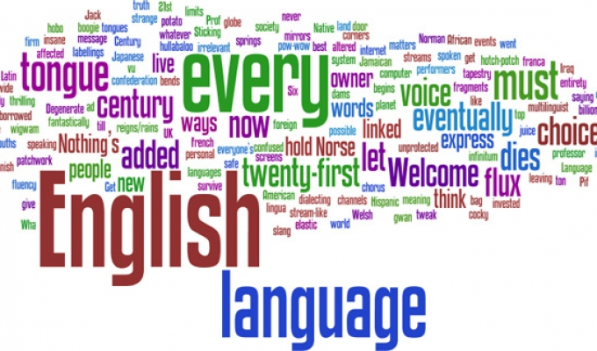
[Importance of English Language- WEB-SOURCE.]

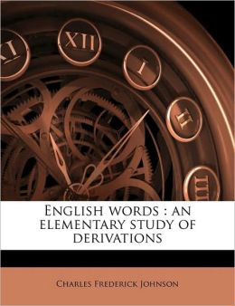
[IMAGE FROM WEB-SOURCE.]
The English language is not only the language of England and the United States but it is spoken and read by the largest number of people and has recognized as a second language throughout the world. It may be true that historical, political and economic factors have contributed to the wide expansion of English; but it is also true that it owes something of its wide appeal to certain qualities and characteristics inherent in itself.”
The following are some of the characteristic features which have made the English language what it is today, has put a stamp of individuality on it and has contributed to its world-wide significance:
- Receptiveness and heterogeneousness of the language.

- Inflectional Simplification.

- Relatively Fixed Word-Order.

- Use of Periphrases and Prepositions.

- Development of New Varieties of Intonation.

- Natural Gender.

- Masculinity.

- Conclusion.

English Grammar is the detailed knowledge of the structure and usage of -English language.

With wonderful ease and readiness it has taken to itself materials from almost everywhere in the world. With extra-ordinary receptivity it has assimilated these heterogeneous elements so successfully that only the professional student of language is aware of their origin.
When England was first conquered by the Anglo-Saxons in the fifth and sixth centuries, English was almost a ‘pure’ or unmixed language which could frame new words for new ideas from its own native resources and hardly borrowed any foreign words, “but now it has become the most ‘mixed’ of language s having received throughout its history all kinds of foreign elements with ease and assimilated them” with thoroughness. The richness of its vocabulary is outstanding no doubt, but more striking is its amazing variety and heterogeneousness.
And this general receptiveness of new elements from all parts of the world has been of great help in making the English language a suitable and attractive vehicle in so many parts of the world.

A second characteristic which English possesses to a preeminent degree is the simplicity of its inflections- “the ease with which it indicates the relationship of words in a sentence with only the minimum change in their shapes or variations of endings.”(Wrenn).
“In this process of simplification English has gone further than any other language of Europe. Inflections in the noun have been reduced to a sign of the plural and a form for the possessive case.
The elaborate Teutonic inflection of the adjective has been completely eliminated except for the simple indication of the comparative and the superlative degrees.
The verb has been simplified by the loss of practically all the personal endings, the almost complete abandonment of any distinction between the singular and plural and the gradual discard of the subjunctive mood. These complications which are present in German are absent from English, and such a reduction of inflections can hardly be considered anything but an advantage.” As a result of this simplifying of inflections the relationship of words to each other is no longer made clear by their endings.

English maintains regular, clear and consistent word-order. The normal word-order is subject, predicate and object. If, for instance, in a sentence like “John killed a tiger” the position of the nouns is changed as “A tiger killed John”, the meaning is entirely changed; the subject and the object which were denoted in Old English by endings or inflections to the words or which are denoted by such inflections in Greek or Latin or in modern German, are not denoted by such inflections now. They are denoted by their position before and after the verb. The normal word-order in English as follows:
The subject is before the verb; the object is after the transitive verb; the adjective stands almost always before the noun it qualifies; the auxiliary verb stands nearest to its principal verb.
“A third quality of English, therefore, is its relatively fixed word-order. An inflected language like Latin or Russian can afford to be fairly free in the arrangement of its words, since the inflections show clearly the properly relationship in the sentence, and ambiguity is unlikely. But in a language which does not change the forms of its words according to their relationship in the sentence significance (by adding inflections), the order of the words is likely to be relatively fixed; and a fixed word-order in relation to meaning in the sentence takes the place of freedom made possible by the system of inflections.”(Wrenn)
Do all we know a minimum of Scandinavian influence on English Vocabulary? - --The amalgamation of the two races facilitated the infusion of Scandinavian elements into English the vocabulary of which owes a great deal to the Scandinavians.

The relation of words in a sentence is now expressed by the use of auxiliaries for the tenses of the verbs. “Another consequence, fourthly, of the loss or reduction to the minimum of the inflections which English once had, is the growth of the use of periphrases or roundabout ways of saying things, and of the use of prepositions to take the place of lost inflections. The English simplified verb uses, periphrases and compound tenses made with auxiliary verbs to replace the more elaborate system of tenses that once existed.”
“Similarly, English which once had nearly as many case endings as Latin, has come to use prepositions instead of these” (Wrenn) and the relation of words in a sentence which was formerly denoted by means of endings in nouns is now expressed by prepositions for the case of nouns. Almost every shade of thought which was expressed in Old English by inflectional endings in nouns and verbs is now indicated by means of prepositions and auxiliary verbs.

“A fifth quality of English…is the development of new varieties of intonation to express shaded of meaning which were formerly indicated by varying the shapes of words. This is perhaps somewhat comparable (though only in a small way) to the vast use of intonation in Chinese as a method of expressing meaning in sentences which would otherwise seem like series of unvarying monosyllabic roots. Consider, for instance, the wonderful variety of shades of meaning we may put into the use of the word “do” merely by varying the intonation- that is, the pitch and intensity, the tone of the voices.”
(Wrenn).

A sixth quality of English is that it “enjoys an exceptional advantage over all other major European languages in having adopted natural in place of grammatical gender. In studying other European languages the students labours under the heavy burden of memorizing along with the meaning of every noun, its gender. Thus in German Sonne (Sun) is feminine, Mond (Moon) is masculine, but Kind (child), Madche (maiden), and Weib (wife) are neuter…But gender in English is determined by meaning. All nouns naming living creatures are masculine or feminine according to the sex of the individual, and all other nouns are neuter.”

A seventh quality of the English language is its masculinity. “It seems to me“says Jespersen, “positively and expressly masculine, it is the language of a grown-up man and has very little childish or feminine about it.”
Some of the qualities discussed above as simplicity of inflections and fixed word-order are features which speak of the masculinity of the language. But of, there are other features like the sound system, sobriety and business-like brevity of expression, monosyllabism, logical consistency in using tense forms and freedom from pedantry which also signs of the masculinity of the language.
“Not all the above qualities are in themselves necessarily good, nor have they all contributed to the general success of English. But it seems probable that of them all it is the adaptable receptiveness and the simplicity of inflection that have done most in this regard.”(Wrenn). The cosmopolitan vocabulary of the English language is an undoubted asset that seeks to attain international use.

In fact, the English language has readily adopted a good many words from different modern European languages. This has already been much strengthened and enriched by the great languages of old Europe- Greek, Latin, French and Scandinavian. In recent centuries, the developing languages of modern Europe have, in some way or other, contributed to the English language that has ever accepted and assimilated words from such languages. Of course, there are found some strong grounds to make the English language easily accessible to those European words.
WORDS FROM MODERN EUROPEAN LANGUAGES
Italian: Modern Italy is well reputed as the teacher of Europe in music and fine arts. The English, too, have learnt from this country, and this is well evident in the inclusion of a large number of Italian words, relating to fine art and music in modern English. Such Italian words include-aria (solo in music), basso, busto, cantabile, da capo, dado, fantasia, finale, fesco, gamut, graffito, impasto, intermezzo, maetoso, Madonna, mezzotint, opera, piano, pizzicato, rallentando, replica, staccato, terra cotta, and many more.
In fashions and dress, the Italian influence is distinctly borne out too, in the words like –attitude, fiasco, motto, umbrella, casino, carnival, etc.
Some other Italian words, found in the common use are-volcano, gondola, inferno, pizza and pilaster.
Dutch Words: Again ,England has its cultural obligation to Netherlands, though not much known , as illustrated in such words of art and painting- easel, etch, landscape, maulstick , sketch , etc.
In nautical matters, the influence of the Dutch is amply borne out by such terms as-
Aloof, avast, bullwork, boom, buoy, dock, deck, euphroe, flyboat, hull, hoist, rover, skipper, yatcht and many others.
Some commonly used Dutch words include- loiter, groove, hop, luck, booze, splint, drill (bore a nole), coy (cage) and so on.
Spanish: similarly, the English, in course of their communications with the Spaniards on different manner, learnt a number of Spanish words. Some such Spanish words have remained in the current use as the part of modern English:
Ambuscade, armada, embargo, desperado, grandee, negro, peccadillo, plaza, punctilio, renegade, spade, tobacco, dago, stevedore, esplanade, olesta etc.
German: the advancement of modern Germany in Science and particularly mineralogy have led to the inclusion of some Germanic terms, relating to mineralogy in particular in modern English- - bismuth, blende, cobalt, grey-wacke, quartz, nickel, shale, zinc, zeitgeist, wolfram, yodel, kindergarten, plunder etc.
Portuguese: from the Portuguese language, too, English has incorporated such terms as ayah, auto-da-fe, albatross, caste, verandah and other terms, which are mostly technical. ‘Molasses’ and ‘marmalade’ are also Portuguese words relating to food.
Russian: the modern Russian language has contributed drosky, knout, verst, steppe, mammoth from Russian mamont, Soviet, Balshevik, intelligentsia, robot originally Czeck.
Turkish: Modern Turkish has bey, caftan, coffee, effendi, horde and ottoman in the English Language.
Scandinavian: English has also adopted certain words from the modern Scandinavian language as eides, geyser, kraken and tungsten and coach, paprika, goulash from Hungary.

Different Asiatic languages, too, are found readily accommodated in the English Language.
WORDS FROM OTHER REGIONS
Malay: the number of Malay words is surprisingly large in the English language, although only a few of them are used commonly. Of the familiar Malayan words may be mentioned- amuk, bamboo, gong, gingham, gutta-percha, ketchup, lagoon, lorry, orangoutan, sarong, sampan, juragan, sumpitan, paddy and sago.
Words adopted from Persian, Arabic, Syriac and Hebrew are listed below:
Persian- bazaar, chess, caravan, dervish, hazard, jasmine, shawl, azure, lashkar, etc.
Arabic: alchemy, alcohol, algebra, alcove, alkali, elixir, harem, mufti, sofa, sash, zero, zenith, Allah, hookah, Syrop, fakir, imam, madrasaha, cipher, safforon etc.
Syriac- damask, muslin.
Hebrew- amen, balsam, cherub, cider, Hebrew, rabbi.
Words from China and Japan are also found included in modern English- (tea, kowtow and chow from Chinese)
Kimono, rickshaw, Japanese, hara-kiri, geisha, jujitsu etc. from Japan.
Indian- the long British rule in India derived a good many Indian words to enrich English. Such words,
baboo, bungalow, bandh, begum, chutney, coolie, durbar, dharna, divan, gherao, gunny, Himalayan, khaki, loot, pundit, purdah, rupee, sahib, swaraj, shampoo, zenana, sepoy, jungle, thug, verandah, nawab, Juggernaut, chit, bangle, and so on.
Polynessian- From Polynessian dialects have come two very familiar words- taboo, and tattoo.
Australian- Similarly three familiar Australian words, commonly used in English, are boomerang, kangaroo and wombat.
Africa- popular African words in English are banana, Boe, boorish, indaba, gorilla, chimpanzee, guinea, zebra, etc.
America- As asserted by Henrey Bradley, the languages of the New World have contributed some hundred words. All of them are, of course, not very commonly used, but a good many such American words are found intimately blent with the English language and never appear foreign at all. A list of such words are given below:
Potato, tobacco, hurricane, maize, moccasin, chocolate, tomato, cannibal, cocoa, cafeteria, wigwam, totem and many more.
Of course, some of these words have come from Spanish and Portuguese, as the early European settlers in the new world belonged mostly to Spain and Portugal.
Foreign tongues, belonging even to the remoter parts of the world, have had, thus, a useful role in the enrichment of the English language and its claim on the status of the world language. Such foreign elements constitute the bulk of immensely rich English vocabulary. That is why Henry Bradley has so rightly observed- “The increase of the English vocabulary by additions from foreign sources has been so enormous that the words of native etymology bear a very small proportion to the whole number of words, given in our modern dictionaries.”

“Love’s not Times’s fools, though rosy lips and cheeks
Within his bending sickle’s compass come,
Love alters not with his brief hours and weeks,
But bears it out even to the edge of doom.”

The SHAPES AND END OF WORDS
Old English (as used between A.D. 700 and 1100) was never a highly inflected language, judged from the starting –point of the original Indo-European with its eight cases and its multitudinous verbal forms. Yet from the standpoint of the history of English and as compared with Modern English, it seems definitely to be a language of full inflexions. It distinguished four (sometimes five) cases of noun, adjective and pronoun by means of inflexional endings: it indicated whether the adjective was in the attributive or the predicative significance by means of separate sets of endings: it had in some of its personal pronouns a dual number, that is to say special forms to shew that only two persons were being spoken of : it distinguished the plural of its verb form the singular by endings, though without shewing in the plural the three persons separately. On the other hand, it had lost the separate expression of the passive voice which Latin, for instance, preserved from Indo-European, and this function had to be performed by means of auxiliary verbs much as in Modern English. Again it had only two tenses of the verb so far as simple form was concerned, making its others by mean of auxiliaries or contextual indications. But of, taken as a whole, it was relatively fully inflected. It even indicated four or five cases by the terminations or shape of its definite article. Prepositions, which may serve to shew the relationships of words in the sentence, were not nearly so much used as in Modern English, since they were not so much needed.
“If it were done, when ‘tis done, then ‘twer well,
Sit were done quickly: if th’ Assassination
Could trammel vp the Consequence, and catch
With his surcease, Successe; that but this blow
Might be the be all, and the end all. Here,
But here, vpon this Banke and Schoole of time,
Wee’ld iumpe the life to come.”
Like of many terms in the study of language which are convenient and traditional, but never quite exact, the word gender in grammar is well known, but difficult accurately to define or explain. In highly inflected Indo European languages such as Modern English, which has lost so many of those inflexional distinctions which formerly indicated gender (particularly in adjectives and pronouns), it has become natural. Grammatical gender depends on the form of a word and not primarily on its meaning. The three genders (from Latin genera, ‘kinds’ or ‘types’), Masculine, Feminine and Neuter (Latin neutrum ‘neither’) which are usually employed in treating of Indo-European inflected languages, are misleading in their names to a certain extent. For it is often the form and not the meaning of a noun, for instance, which determines its gender. Thus in Old English wif (woman), cild (child) and hus (house) are all neuter in gender , though wif could not have been thought of as anything but female in sex. This conception of gender, then, in which one comes to learn to recognize from the type or form of the word rather than from its sex or absence of sex, is conveniently termed grammatical: for it is a matter of grammatical forms rather than of meaning in the accepted sense. In Old English the gender was grammatical.
The passing from Old to Middle English brought with it the transition from grammatical to natural gender. By natural gender is meant the classification of gender, not according to any formal principle, but to the sex or absence of sex of the noun, adjective or pronoun concerned. Since, however, generally speaking, only animate parts of speech (those which are conceived as having life) have the notion of sex attached to them, inanimate words have properly, according to the conception of natural gender, no gender at all. Such words are often said to be of common gender, while others describe them as neuter. But of, in fact, natural gender really ignores words not having life in which the modern language gives no indication of gender whatever by inflexion or otherwise: and there is no need to pursue the matter. Personifications, of course, come under masculine or feminine according to their nature.
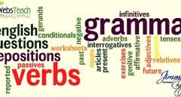
[IMAGE FROM WEB-SOURCE.]

Middle English preserved a few traces of the former grammatical gender, but these have almost entirely disappeared with the modern loss of inflexion. Grammatical gender can only remain a real distinction. So long as there are inflexions, as for instance the indicating by adjectival endings or the forms of the definite article of the gender of qualified nouns. The confusion which followed, in the early Middle English period, the reduction of English inflexions, together with the great intake of foreign influence at that time, inevitably brought the breakdown and disappearance of grammatical gender. In Modern English, for all practical purposes, the question of gender, since it has become entirely natural, scarcely arises.
Middle English is characterized by the reduction of the endings of words, or, as it has been conveniently called, the leveling of inflexions: and as a consequence of this, by the substitution of natural for grammatical gender. This process was rapid in some areas, like
the North (where it had become marked even before the end of the Old English period) and the East Midlands; but much more gradual in conservation regions like those of the Southern counties and the South-West Midlands. In certain stereotyped phrases inflexional forms lingered into the modern period: but in general it may fairly be said that English had reached the modern stage of the loss of those inflexional endings which had been levelled in Middle English by the time of Shakespeare.
MASCULINITY OF ENGLISH LANGUAGE
According to Jespersen, the English language is ‘positively and expressly masculine’. To be clearer, Jespersen refers to different aspects in the English language- Phonetics, Grammar and Lexicon.
Jespersen first speaks of the sound system in the English language. The English consonants are well defined. Voiced and voiceless consonants stand clearly together. They are, as a rule, distinctly and precisely pronounced. The indistinct or half-pronounced consonants, that are found in other Teutonic languages, are not to be found in the English language. In fact, the pronunciation of an English consonant is seldom affected by the vowels on its either side. Some samples are given below in this respect:
The Phonetic System
Jargon (j and g are distinctly pronounced), surety (s, r and t have distinct pronunciations).
There is only one exception in this respect. The English consonant ‘r’ is not pronounced distinctly, when it is followed by a vowel, as in the case ‘hurt’, ‘heart’.
English vowels, too, are comparatively independent of their surroundings. They are also clearly and distinctly pronounced. They are found mostly independent of the consonants that surround them. The long vowel sound, as in ‘ale’, ‘whole’, ‘eel’, and so on, testify to this aspect of the English pronunciation.
Again, in the English language, there are many words, ending in two or more consonants (here the pronunciation and not the spelling of the words is meant). Some such words are ‘tent’, ‘tempt’, ‘plinth’, ‘hence’, ‘wealth’, ‘feasts’, ‘beasts’, and so on. Such words require no mean energy on the part of the speaker to pronounce them.
The phonetic system in English, thus, indicates the masculine strength of the English words. Of course, the manly strength of the English language not be considered harsh or rough. Indeed, softness and sonority are not found missing in the English phonetical system. In fact, this language may be characterised as possessing a male energy, and not a brutal force, from the phonetically viewpoint.
Again, Jespersen refers to the English rhymes. The English rhymes are mainly male rhymes, in which there is the single stressed syllable at the end. Thus, there are ‘lai-d’, ‘se-t’, ‘be-t’, and so on. This requires a force in accentuation and is also a sign of masculinity.
The English language has also gained masculine vigour in pronunciation by its tendency to form mono-syllables, such as ‘thanks’ (single syllable), in place of ‘thank you’ (two syllables). Even there are many English proverbs and sayings which are extremely condensed in structure and tend to monosyllabism, as seen in the following examples:
Live and learn, haste make waste, first come, first served, waste not, want not, and so on.
GRAMMAR
Brevity
Brevity is an essential mark in English Grammar. English Grammar has got rid of many superfluous elements and achieved brevity in different ways.
First, it has done with the plural endings altogether. Thus in the expression- ‘All the good boys who study here’-the only plural mark is in the noun ‘boys’. This is a process of inflectional simplification, and it achieves brevity considerably.
Second, the English Grammar has also attained masculine conciseness by dropping definite articles in a good many cases, ‘dinner is ready’, ‘life is short’, ‘‘school is over’.
Third, there is the business-like shortness, permitted in English Grammar. Thus in the sentence- “While it was flying to Bangkok...”, the simplified expression is “While flying to Bangkok, the plane crashed. Such examples – “While he was addressing...” simplifies to “While addressing the meeting, he collapsed...” “Once he is out of..” simplifies to “Once out of his home, he feels shaky”.
Fourthly, abbreviated sentences and expressions abound in the English language. There are such forceful abbreviations as ‘phone’ (for telephone), ‘bus’ (omnibus), ‘photo’ (photograph), ‘cab’ (cabriolet) and so on.
LOGICALLY
The logical use of different tenses shows the difference between the past tense ‘he came’, the present perfect tense ‘he has come’ and the past perfect tense ‘he had come’. The use of progressive tenses, such as ‘I am going’, ‘we were going’ and ‘You will be going’ has furnished the language too with precision and logically.
The entire word-order in English is regular and vigorously systematic. An Adjective generally stands before the Noun, an Adverb stands always remains close to the Verb, Just as an Auxiliary verb is not far from the Main Verb. A Negative also stands very close to the Word it Negatives.
A fragrant rose not seldom delights all hearts.
In the third place, English Grammar allows broadness, along with flexibility and has liberality. The English Language has the freedom from the narrow-minded pedantry that insists on the austere adherence to the rules of grammar. This is clearly discernible in the use of numbers in English.
Some English words are grammatically singular in number, such as- government, cabinet, committee, club, family, clergy, and so on. These words are, however, have liberty to modify both as a singular and as a plural, according to the sense, as in-
- The committee is dissolved (the concept of oneness as a body is marked)
- The committee are not unanimous in the decision(a sense of plurality is conveyed, implying the members of the committee)
Again, a good many nouns are freely used as verbs and vice-versa:
We taxied back from the station. (taxi- noun-as a verb)
No control is found herein. (control- verb- as a noun)
LEXICON
Jespersen refers to rich vocabulary of English. There is hardly any other language, containing so many words, as English. The English dictionary contains a larger number of words than the dictionary of any other language. This sort of rich vocabulary is also a sign of the masculine vigour of English language, foe men, moving in a wider circle, command more words than women, usually confined to narrower circles.
The rich vocabulary of the English language is a product of its flexibility. Some such words include- balcony, canto, opera, piano, umbrella, volcano (from Italian), cargo , cork, contraband, mosquito, stampede (from Spanish) , acme, acrobat, anthology, catastrophe (from Greek), steppe, vodka, ruble (from Russian), and so on. The English dictionary reveals glaringly how English has borrowed from Hebrew, Arabic, Persian, Chinese, Hindustani, Bengali and even the aboriginal languages of Africa and South America.

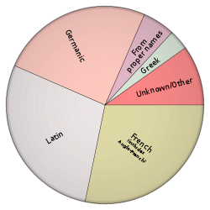
[Influences in English vocabulary- WEB-SOURCE.]
Again, sobriety is a characteristic mark of the English expression. Exaggerated or hyperbolic expressions are hardly entertained in a happy English style. Sobriety is always a test of masculinity, as fickleness is often a kind of weakness!
In conclusion, the English language may be characterised, in the light of Jespersen’s opinion, as Masculine. It is Masculine in its Energetic Phonetic, Logical yet Flexible Grammar, Methodical Word-Order, Sober Expression, Business-like Approach and Rich Vocabulary.
This is, therefore positively and expressly masculine.

The introduction of Christianity in 597A.D. brought about immense changes in England in social and religious matters. It had also far-reaching effects on the English Language.
Nevertheless, the great bulk of specially Christian terms entered into English Language only after the Christianizing of Britain. As a result, the English language is found immensely enriched and strengthened by borrowing many Latin (and Greek) terms, associated with Christian rites and practices, as also by finding out an exceedingly enlarged vocabulary from native stems with the aid of those terms. Such an expansion of the language took place in several ways.
- In the first place, the English borrowed certain Greek and Latin terms connected with their new faith. They did so in order to express their ideas about their new religion clearly and to answer to their definite need. Such a sort of borrowing happened in a six-fold way.
First, several Latin and Greek words, connected with Christianity, were readily adopted, together with their ideas, such as ‘apostle’, ‘disciple’, ‘martyr’, ‘psalm’.
Second, the titles of the entire ecclesiastical dignitaries were also readily introduced to the language. Thus there was the introduction of such titles as ‘Pope’, ‘arch-bishop’, bishop, ‘priest’, ‘monk ‘nun’ ‘provost’, ‘abbot’, and so on.
Third, a few terms , connected with Christian institutions, such as ‘shrine’, ‘pall’, ‘mass’ ‘hymen’, ‘candle’, ‘canon’ , ‘anthem’, ‘altar’, ‘shrive’, ‘relic’, ‘cowl’ (monk’s food), rule (monastic rule), ‘alms’ and so forth, were also introduced from Latin and Greek.
Fourth, the Catholic Church also exercised a profound influence on the domestic life of common people and that was evident in the adoption of many words, such as the names of the articles of clothing, household use and food- cap, sok, silk, box, crisp, chest, mat, lobster, plant, caul (cabbage), savory, oyster, lily, myrrh, etc.
Fifth, a certain number of words, connected with education and learning, came from Latin and Greek, under the influence of the Church as, - school, master, grammatical, verse, meter, gloss, notary, and so on.
Lastly, some words, ‘relating to the miscellaneous requirements of life’, were introduced- anchor, fan, circle, place, phoenix, giant, elephant, talent and so on.
- In the second place, the English did not blindly borrow Christian words from Latin and Greek to enlarge their native vocabulary. They also utilized fully the resources of their native language in the light of their new acquaintances with the Christian faith and terms. They did it, again, in three ways.
First, they formed new words from foreign loans by means of native affixes. Thus the native affix –‘had’ (modern ‘hood’) was extensively added after many Latin words to form new terms for the English language, such as, ‘priesthood and bishophood. Similarly, -ship and –dom were added to have such words as ‘provostship’, ‘Christendom’, and so on.

Second, the meaning of some existing native words was modified, more or less, to express Christian ideas and sentiments. Of words, foremost was ‘God’. Other words, belonging to the same class and surviving till today, are ‘sin’, ‘altar’, ‘easter’, etc. Third, some new words were framed from the existing materials of the native language to express newly introduced Christian ideas. Thus, the words ‘gospel’, from good-spell), ‘heathen’ (from ‘heath’) and trinity from ‘threeness’) were formed out of the native stems to serve the requirements of the new religion. There were many cases in which excellent words were derived by the English under the impulse of Christianity. Some of those words displayed no less ingenuity in forming. Thus the ‘scribes’ and ‘Pharisees’ of the New Testament were called ‘boceras’ [from ‘boc’ (book)] and ‘sunder-halgan’ (from sundor-apart) respectively. Such excellent words seemed to be quiet independent of foreign expressions, as evident in ‘sciencraft’ (phantom art), ‘handboc’ (a small handy book), and so on.
GRAMMAR IS ALWAYS A FUSS…... !
The English language has grown from a variety of roots over the ages. Even today it continues to grow and change.
Christianity also brought about intellectual occupations and interests. Scientific and medical terms, like leececraft (leechcraft for medicine), ‘tid’ (mod. ‘tide’), and ‘sunngihte’(for solstice) were formed from the native sources with a unique adroitness.
The native formations of the Christian words were done at a rapid pace, and fully bear out the vitality as well as flexibility of the English language that borrowed as well as created words under the influence of Christianity, and strengthened its own plinth, with the help of learned classical words.

“What though the field be lost?
All is not lost-the unconquerable will.”
The vocabulary of Modern English is immensely enriched and reveals distinctly the advancement that has already been achieved. This is, however, made possible by the wonderful resourcefulness of the English language to adopt, assimilate, apply newly and invent. Words from different continental and far remote regions are found readily adopted and assimilated in the language. A few rare words may only be instanced here:
When so many French words were introduced into the English language the question may probably arise in the mind as to how the people managed to learn so many foreign words and how they could assimilate them.
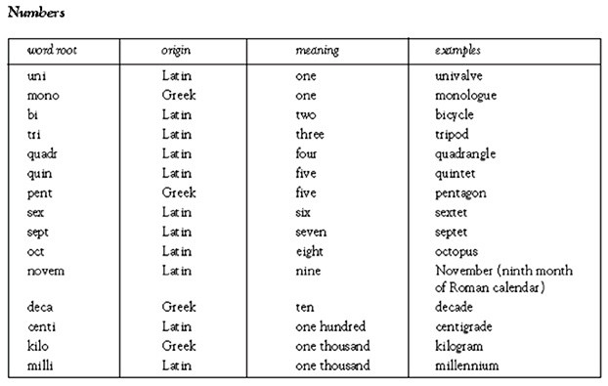
[IMAGE FROM WEB-SOURCE]
Chauffeur, garage, bohemian (from French), Confetti, vendetta (from Italian), Bonanza (from Spanish), Zeppelin (from German), Vodka (from Russian), Robot (from Czech),Dharna, loot, thug (from Indian languages),Bazaar, pyjamas (from Persian),Elixir, harem, mufti (from Arabic), Suey (from Chinese), Rickshaw (from Japanese), and so on. Moreover, from the New World, a good many words, belonging particularly to the Spanish, Portuguese and different native tongues, are found adopted, such as-canoe, hickory, moccasin, wampum, wigwaon and so on. The addition of such numerous words from so many lands has strengthened the cosmopolitan character of the English vocabulary in modern times.
Tense= Tempus (Latin) =time.
By the side of such additions of foreign elements, the process of derivation and formation of new words is found continued in modern English. There has been a considerable enlargement of the modern native vocabulary as a result of the deliberate invention of new words or coinage on a rapid scale. With utmost ingenuity and even imitative skill, words have been formed from various sources, native or foreign, for various purposes.
As a list of such coinages would be enormous, a few instances, as typical specimens , are given below:
Camera, Kodak (a trade name), film, focus, shutter, oil-fields, blue print, motorcycle, feminist, marathon, intelligentsia, aircraft, monoplane, Bolshevik (in the sense of revolutionary), nylon (a trade name), plastic, deep freeze, automaton, locomotive, photography, radar, television and many more.
Craving for coinages is further indicated in the practice of forming compounds. Such compounds, ingenious enough, are often quite novel and self-explanatory-
Finger-print, fire-extinguisher, newsprint, searchlight, spotlight, steamroller, streamline, lipstick, know-how, teen-age, speed-boat, and so on.
Compounds are too, found formed from classical elements-from Greek and Latin terms as in-Bronchoscope, stethoscope, panchromatic (from Greek), fluorine (from Latin), automobile (from Greek and Latin).
Another popular method for enlarging the modern vocabulary is seen in the application of familiar prefixes and suffixes to existing words. Some such words-
(With prefixes)- pre-natal, pre-school, pre-condition, post-operative, post-graduate, post-war, under-graduate, transformer, transplantation, counterattack, counteract, co-operative, devaluation, defrost, debunk, sub-title, sub-editor and many others.
(With suffixes)- filmdom, stardom, fandom, gangster, profiteer, racketeer.
The modern English vocabulary has also gained in strength and bulk by inventing and applying new sense to existing words. Many an old word is now found used in a special sense. Thus ‘park’ is used as a verb in the sense ‘to park a car’ and from that a new term ‘parking space’ has come. Similarly, the word ‘spare’ is used as a noun in the sense ‘some element that are additional or available’. ‘Smoke’ is also used as a verb as in the sentence-‘He smoked continuously’.
Again, ‘smoke’ as a noun, has also significance, as in the sentence- ‘Let us go out to have a smoke’. Finally, modern English has attained simplicity, as well as stability in grammatical matters. Modern English grammar has passed from intricacy to simplicity, from disorder to order ‘from chaos to cosmos’ (in the language of Jespersen). And with Grammar, the phonetical system in modern English is found sufficiently simplified and made more easily accessible and convincing.
Modern English is a link in the long chain of linguistic growth. This is no end by itself or the culminating point of perfection. English, as it is now, preludes a more vigorous and prosperous advancement in future to come.
“The modern English vocabulary includes words derived from every civilized language of Europe, and from innumerable languages of Asia, Africa, America and Australia.” – H.Bradley
PROCESSES IN THE MAKING OF ENGLISH
Riming Locutions: This refers to the process of word-formation through riming. Some words or expression are found formed rather ingeniously for the sake of rime. Such words or expressions are styled as riming locutions and include-
Highways and by-ways, fairly and squarely, toil and moil, hurdy-gurdy, hocus-pocus, and so on. Such riming locutions serve to enhance volume, as variety of the English vocabulary.
Some words are supposed to have a classical pedigree, but they are actually recent coinages, more or less on classical analogies, and belong to the ordinary vocabulary. As such words are not really classical, but coined on the classical pastern, they are called quassi-classical words. Some instances of such words-Eventual, annexation, realism, vocalic, dentist, tourist, affixation, and so on.
Quassi-Classical Words
This refers to certain words, imported from Latin, which are well understood by eyes, but which cause some sort of confusion when pronounced. These foreign words are pronounced in a number of ways, and actually it is by seeing or writing that their existence can be clearly identified. Thus ‘gaseous’ is pronounced in different scientists. Similarly, hegemony, phthisis, phonotype, photocromy are pronounced in different ways by different men and even in different dictionaries. As words can be distinguished only by looking at them, they are called eye-words.
Eye-Words
This refers to the language used in the press under the classical impact of Renaissance. It consists of the verbose expressions, used by the journalists, as the very trick of their style. The tendency is to use the learned, cumbrous and pedantic words by the press. The purpose is to make the writing uncommon extra-ordinary and thereby to attract a reader’s notice. Some examples of journalese are given below-
Journalese
‘A vast concourse assembled to witness the scene’.
‘A disastrous conflagration beset the whole population’.
‘The learned counsel commenced his re-joinder.’
‘The English king, by his devastating flaw, precipated his own fall.’
‘His spirit quitted its earthly habitation and winged its way to eternity.’
In all these examples, instead of using simple, straight forward expressions, a sort of stilted, ornamental language, full of circumlocutions and other clinches, is used. This is no case of a happy style, and better to be discarded.
One of the masculine traits of the English Language is its tendency to monosyllabism. Monosyllabic words are generally found popular in English, and the process of monosyllabism is also a source of the linguistic expansion. It is to be noted here that the word of a single syllable has always a greater force than that of two or more syllables.
Monosyllabism
Monosyllabism is found in operative in the English Language in different ways:
- An expression of two or more syllables is found turned into a monosyllabic word, as: ‘Thank you’ to ‘thanks’, ‘hlaford’ to ‘lord’.

- Monosyllabism is attained by means of abbreviations such as: photo for photograph, phone for telephoned, gram for telegram, teck for detective, caps for capital letters, pub for public house, and so on.
- The word-clipping, in which some big or long loanwords are clipped at the beginning, or at the end, is also a process to achieve monosyllabism. Some clipped words are- bus from omnibus, cab from cabriolet, mob from mobile vulgus, ‘sov’ from sovereign and so on.
- The number of mono-syllabic words in English is also found increased by forming new monosyllabic words from existing mono-syllabic words without any change. Thus mono-syllabic verbs are formed from monosyllabic nouns as in- glance (from glance), bleed (from blood), and so on.
- English monosyllabism is expressed also in a certain number of words, the etymology of which has hitherto remained unknown. Such words include: jam, slum, dad, chum, etc.
Some of these words might have come from children’s playful invectives, while others may be called ‘slangs’.

The notorious misuse of words and phrases by Mrs. Malaprop of Sheridan’s famous comedy ‘The Revival’ has brought into existence a new form of entertaining verbal felicity. The oddity of Mrs. Malaprop’s language is popularly known as Malapropism, and has passed into the rules of rhetoric.
Malapropism
The term ‘Malaprop’ has come from French ‘mal’ (ill) ‘aprops’ (to the purpose). Malapropism consists in the wrong use of a word to its purpose.
Examples are not few from Mrs. Malaprop’s mistakes. A list of some of her proverbial mistakes in the use and misapplications of words is given below:

Accommodation > recommendation
Allegory > alligator
Alacrity > affability
Anticipate > retrospect
Affluence> influence
Envoy > convoy
Epitaphs > epithets
Illiterate> obliterate
Illegible> ineligible
Exhort> escort
Enveloped> divulged
Antistrophe> catastrophe
Delusions> allusions
Dissolve> resolve
Illuminate> elucidate
Pineapple> pinnacle
Punctuation> punctiliousness
Precede> proceed
Analyzed> paralyzed
Perpendiculars> particulars
Felicity> velocity
Caparisons> comparisons
Preposition> proposition
Physiognomy> phraseology
Derangement> arrangement
Superfluous> superficial
Ingenuity > ingenuousness
Hydrostatics> hysterics
Oracular> vernacular
Reprehend> comprehend
Compilation> appellation
Parricide> parricide
Malapropism was an effect of the influence of Latin and Greek words after the Renaissance, as half-educated people were tampered to use big classical expressions, making ludicrous mistakes. The effect of Malapropism was of course, to evoke laughter and ridicule.
Of course, Sheridan was not the first literary man to invent this art of using words wrongly to their purpose. Shakespeare had anticipated Malapropism in his Dogberry and Verges (in Much Ado About Nothing) and Launcelet Gobbo (in The Merchant of Venice). Moreover, Malapropism, in some form, is also found in Fielding’s Joseph Andrews, Smollett’s Humphry Clinker, and so on.
The term refers to the ornamental and bombastic language, used by Dr. Johnson and his circle. The use of learned words became a fashion in the English prose style of the eighteenth century, was foremost among those who cultivated that style which was turgid, too stiff for ordinary readers. The whole style has come to be designated after the name of Dr. Johnson as Johnsonese.
Johnsonese
Johsonese was a direct result of the classical influence and of the tendency among literary men to express themselves in the verbose Latin Language than in the simple native tongue.
Johnsonese comprises the use of long and big words. Such words are generally Greek to average men, but strike them with their long and deep sound. Some examples of Johnsonese may be quoted here-
‘the proverbial oracles of our parsimonious ancestors.’
There is no denying of the fact, that such an inflated-turbid way of writing is complicated and undemocratic; and seldom convincing to common readers. This is clearly indicative of the derogatory effect of the classical language on English.
Of course, Johnsonese is also found used in a humorous sense, as in Charles Lamb- ‘I am by nature, destitute of those exterior twin appendages, hanging ornaments and handsome volutes to the human capital.’
Johnsonese is found to have exerted influences, more or less, on the writers of the nineteenth century. Both Macaulay and Newman are found influenced by it.
In the present century, a simple style of writing is much commended,
Synonyms
yet the habit of using big, learned words persists in the writing of some authors.
Synonyms are the words, identical and co-extensive in sense and usage. They denote the same thing or idea, but are sometime found suitable to different occasions.
The existence of synonyms makes a language rich and resourceful, and prevents monotony to a great extent. Such synonymous terms abound in the English language. The presence of a good many synonyms is marked even in old English poetry. Thus, in Beowulf, there are found at least thirty-six words for ‘hero’ or ‘prince’, twelve words for ‘battle’ or ‘fight’ and eleven for ‘ship’ or ‘boat’.
In the enrichment of the native vocabulary by foreign loanwords, synonymous terms are also found adopted. There are Scandinavian words, adopted in English, which appear almost synonymous to the corresponding English terms, such as:
English Scandinavian
No nay
Shirt skirt KNOWLEDGE ON DERIVATION
From fro
Rear raise
There are also French words which are synonymous to some English terms such as-
English French
Rice (O.E.) rich (M.E.) riche
Choice choix
Hearty cordial
Hut cottage
Hide conceal
Clothe (verb) cloth (noun) dress (verb) dress (noun)
Similarly, there are English and Latin synonymous as in-
English Latin
Fire conflagaration
Rise ascend
Ask interrogate
Sleeplessness insomnia
Manly masculine
Some general synonyms are given below-
Absolute-complete; absurd-silly; act-deed; allot-give; attempt-try; base-mean; big-large; foolish-silly; kill-slay; silent-dumb; vacant-empty.

This is actually the name of a figure of speech in which a thing or idea is expressed indirectly in order to spare one’s feeling. In fact, this consists in the use of words in a manner to expresses a harsh or hard matter or thing in a softening way to spare one from a sudden shock. Thus, the hard fact of a person’s hanging is expressed indirectly in a softening manner:
He perished on the scaffold.
Other examples-
The bank has stopped payment. The trader has regretted his inability to supply goods any more.

The double plural refers to the plural, formed for the second time. This is actually the second plural. Thus in O.E. ‘broc’ had its plural form in ‘brec’, which , again had a variant ‘breech’. In course of time, as ‘brec’ became obsolete, ‘breech’ was wrongly taken as a singular. A new plural ‘breeches’ has come with the ending ‘-es’. ‘Breeches’ is an instance of the second plural or double plural.
In trhe same way, ‘bodice’ (upper garment) was originally plural, with the plural ending‘s’, written as ‘ce’. Subsequently, under an erroneous presumption, ‘bodice’ was taken as a singular, and another plural ‘bodices’ was formed. This is, thus, also a case of double plural.
Some other instances of the double plural include children (children), kine (cy), brethren (brethre), clawses (claws).

Euphuism refers to an artificial or affected style of writing. The term has come from the extremely artificial, polished prose style of Lyly in his celebrated romance. Euphues, the Anatomy of Wit, published in 1580. This is a sort of linguistic artifice and marked with high flown, alliterative words. Shakespeare, however, is found to make a fun of this, style, in his play, like Hamlet and Love’s Labour Lost.
Value Stressing implies the practice to lay stress on a syllable on the basis of its value or importance. The syllable that is deemed most important in a word is usually stressed. Again, in the English language, words are usually found stressed on the first syllable, for the first syllable is generally considered the most important part of a word. This very practice is continued even in the case of foreign loans.

This means the copy of the ancients in the application of the language. The term has come from Greek, ‘arkhais’, meaning ‘ancient’.
Archaism denotes the deliberate retention, imitation, or use of the words that are very old or almost obsolete. This, however, constitutes a feature in the poetic style of some English poets. Edmund Spenser, the great Elizabethan master, is found to have adopted a good many words, long forgotten, such as behest, dight, elfin, hardiment, wend and so on.
In his poem, Christabel, with a medieval setting, Coleridge has used such archaic words, as ‘wis’, ‘sire’, ‘tairn’. The archaic spelling is also found used by him in Christabel and The Rime of the Ancient Mariner ‘countree’, ‘clomb’, etc. Sir Walter Scott, John Keats and William Morris are some other poets of note to resort to archaism in their poetical works, related to the medieval world.

Doublet is one of the two words (belonging to the same language), representing the same word in pronunciation. But in, the words are actually different in form and sense. This actually implies a pair of words, with the same pronunciation, but different senses. Thus ‘clock’ is a doublet of ‘cloak’. Similarly, ‘principle’ and ‘pricoipal’, ‘son’ and ‘sun’, ‘sole’ and ‘soul’ are doublets.

Haplology means saying once instead of twice. ‘Haplo’ implies ‘single’. Haplology actually signifies the single pronunciation in place of twice. This is found particularly in the genitive case. Thus ‘The Lords’ House’ is used instead of ‘The Lord’s House’. Similarly, ‘Pears’ soap’ and not ‘Pear’s soap’ is used. This has also led to the omission of the genitive sign before a word, beginning with‘s’ as in ‘fashion sake’ (not fashion’s sake).

This is the process of forming new words by combining two or more terms into one. It is actually an old process of word-making in the English language. Thus, out of the two word, ‘do’ and ‘on’ and ‘do’ and ‘off’, don (do+ on) and doff (do+ off) are formed. These are two simple instances of telescoping. Other instances include flurry (flaw+ hurry), lunch (lump+ hunch), flaunt (flout+ vaunt).

The names of different places form a fruitful source of new words. The word ‘canter’ has, thus, come from ‘Canterbury’, ’worsted’ from ‘Worstead’ and so on.

The names of persons are found to be also a happy process of word-making. This has been in vogue since the O.E. time. The Anglo-Saxon saint ‘Audrey’ was famous for his splendid dress. That name has given rise to the word ‘tawdry’ (in the sense ‘showy’, ‘gaudy’). The noun ‘sandwich’ has come from the name of the Earl of Sandwich’ who was supposed to eat the slices of bread and meat, pressed together, while hunting. Other such words , from the names of persons, are boycott, micawberism and quixotic from Captain Boycott, an Irish land agent, Mr. Micawber, a character in Dicken’s David Copperfield and Cervantez’s Don Quixote, respectively.

“Great as are differences between the grammar of Old English and that of Modern English, the one has been developed gradually out of the other.”
Modern English grammar is distinctly different from old English grammar, and this is mainly perceived in the orderliness of the former and the chaotic state of the later. This growth or making of English grammar is marked in a number of ways. The simplification of accidence which implies the gradual disappearance of inflectional forms is one of the key factors to bring the English languages, SIMPLIFICATION OF
ACCIDENCE particularly English Grammar, from chaos to cosmos. The existence of a great variety of conjugations and declensions makes a language intricate, and mistakes in the use of grammar are often found inevitable here. Naturally, as observed by Henry Bradley, ‘the progressive reduction of the number of inflexional forms is a phenomenon not at all peculiar to English.’ In fact, most of the languages which were inflected, like German, have undergone, in some way or other, this sort of change and attained inflectional simplicity. Nevertheless, an asset that has enriched the English language, to a pre-eminent degree, is inflectional simplicity. The classical languages of early dates, like Sanskrit, Greek and Latin, have different inflections, in the forms of nouns, adjectives, verbs and even pronouns. Such inflections are not common in modern English, Russian, French, or German.
In this process of inflectional simplicity, English has, however, advanced much more than any other language in Europe. Inflections in nouns have been reduced to the signed of plurals and forms for the possessive case. There were numerous Teutonic inflections of the adjective. But in, these are all completely eliminated, except for designating the comparative degree and the superlative. All inflectional endings in verbs are dropped. The inflectional distinction between the singular form and the plural of the verb is abandoned.
Thus, there is a remarkable reduction of inflections in almost all forms, and this, as remarked by Albert C. Baugh, ‘can hardly be considered anything but an advantage.’
SENTENCE STRUCTURE

The English language is extremely logical. This is evident in its sentence structure. The two aspects of a sentence-Subject and the Predicate-are well connected. And exist in a regular order.
In this connection, the three ranks-Primary, Secondary and Tertiary, and they indicate the rank or position of importance of a word in a sentence. E.g. - The weather is terribly cold and inclement, where ‘weather’ is primary,’ cold and inclement ‘taken together, are secondary and ‘terribly’ is tertiary. Generally, a primary is the subject of a sentence, ‘weather’ above in the sentence.
But in, a sentence contains more than one primary, connected with the same verb. But only one is the subject, as in the sentence-
“Prof. Bose purchased a ticket.” Here, the subject is ‘Prof. Bose’ and ‘a ticket’ is the object, but both of them constitute the primary, and are connected with the verb ‘purchased’. There may even be two objects, as: ‘Prof. Bose gave his wife a ticket.’
As a matter of fact, however, the English language has developed a tolerably fixed word-order, which, in the great majority of cases, shows, without fail, what are the subject, the object and their respective position in relation to the verb.
The normal word-order above is-
Subject-Verb-Object (symbolically written as S-V-O).
This order is found regularly followed in modern English, and the statistical investigation sufficiently indicates the gradual growth of regularity in the word-order in course of a thousand years. While the percentage of this word-order was nearly sixteen in the poetry of the age of Beowulf, nearly forty in the prose of King Alfred’s time, this is eighty two or ninety six in the representative authors of the nineteenth century. Of course, as noted by Otto Jespersen, ‘no grammatical rules of word-order can, however, be strictly observed in all cases.’ These are exceptions to it, and one such found in the system, is called inversion. In the inversion, the subject is placed after the verb, and the order is generally V-S-O. This occurs in the interrogatory sentence:
“Hath not a Jew eyes”?-Shakespeare, or in the exclamatory or optative sentence: “What a piece of work is man!’’ – Shakespeare.
There is also the poetical inversion (known as the figure of speech Hyperbaton) - “Much have I travelled in the realms of gold”-Keats.
Inversion may, however, take place in a number of ways, and the normal word-order S-V-O may have further variations here.
In this connection, amorphous sentences may also be referred to, they consist of only one member, and this may even be not more than one word. In a mood of impulsiveness, such sentences are given vent to and this is because a person hardly makes a logical analysis of his expression in his mood. Some such amorphous or one-member sentences are: Yes! Thanks! Silence! and so on. But in, the sentence-structure in English, in the ultimate analysis, appears complete, independent, orderly and regular. A sentence in English, as a vehicle of communication, is capable of standing by itself and remaining always intelligible to hearers, and demonstrates thereby the orderliness of the language.

IN THE MATTER OF NOUNS
The Genitive ‘S’ –Ending
Old English had many declensions of substantives. One popular declension was’-es’ used to form the genitive singular. There were also other declensions. ‘-a’, ‘-an’, ‘-e’ appearing as endings for the genitive singulars. Out of all such endings, ‘-es’ is the only form that has survived. Bradley finds in this the operation of the principle of ‘survival of the fittest’, for ‘amongst’ the Old English case endings ‘-es’ was the only one that never meant anything else than a genitive singular’.
It is not quite correct to think that the ‘-es’ as a declension, came to supersede all the rest because of the French influence after the Norman Conquest. Actually that suppression began to take place much earlier, particularly in the northern dialect. There were some reasons for the same.
Declensions in Old English were full of ambiguity. That was chiefly because of the drastic phonetical change which the inherited Germanic case endings had undergone. Moreover, the mixture of different local dialects had the effect of a general indistinctness and uncertainty in the pronunciation of those vowels which served as case-endings. In that state of confusion, some remedy was urgently needed for clarity and distinctness. Old declensions, of course, yet survived, but when a clear and more distinct expression was required, the ending ‘-es’ for the genitive, was substituted for other genitive endings, and that was done possibly for achieving uniformity and orderliness.
Again, confusions were found to prevail in the use of the genitive case which was employed for a variety of functions-possessive, subjective, objective, partitive, definitive, descriptive, and so on. It was also used not simply to connect two substantives. It was used after a great number of verbs and adjectives. Its positions, too, was not regular. It was placed before as well as after the governing word. In fact, genitives were at first formed and used in a highly complicated way.
In course of time, however, the formation as well as the employment of genitives came to be made in a much more simplified and regular way. There was the simplification of accidence, followed by the regularity in syntax, and that resulted gradually in the formulation of the following principles:
First, the s-genitive is more or less commonly based both to the singular number and to the plural. It is, however, the only genitive ending in the language. Thus, there are both ‘man’s feet’ and ‘men’s feet’, ‘dog’s bite’ and ‘dogs’ bite’ and so on.
Of course, in the plural, the ‘genitive’ is, in the great majority of cases, concealed in the ‘s’, which is used to indicate the plural number, as in the above instance, ‘dogs’ bite.’
Second, the position of the genitive is now always just before the governing word- ‘The elephant’s tusk’, ‘the monkey’s paws’.
Third, this regularity of the position has brought into existence the modern group-genitive. In this genitive, the ‘s’ is tacked on to the end of a word group, without any regard to the logic of the older grammar, as in the examples- ‘someone else’s book’, ‘the son and the daughter’s return.’
USE OF ‘OF-PHRASE’
The introduction of the ‘of-phrase’ into the genitive case is a useful piece of the grammatical machinery, and for that English certainly owes to the French influence. The genitive in Old English was formed mostly in ‘-es’ in most masculines and neuters. But of, there were other endings as ‘-e’, ‘-re’. ‘-an’. In course of time‘s’ has come to be regarded was the only genitive sign, and such expressions as ‘David’s son’ and ‘father’s purse’ have been quite common till today.
But in, the genitive form finds a different expression in the use of ‘of’, as seen in the sentence, ‘the son of David’ or ‘the purse of father’. This is now-a-days a very popular practice in the English language, although such a sort of use is grammatically not very apt. the correct principle , as advocated by the conservative grammarians, is to form the genitive with ‘s’ in the case of living beings, such as ‘Jacob’s ladder’ , and with ‘of’ in the case of inanimate and like elements, such as ‘The desert of Arabia’.
Of course, ‘of’ was used in Old English, but in the sense ‘from’ or ‘out’ of’. There are a very few instances of the use of ‘of’ in a genitival sense in Old English. The use of the preposition, as a regular sign of the genitive, is found prevalent in the language, only after the 12th century, under the French influence.
The use ‘of’, in a genitival sense, might also be occasioned by the complexity of the inflextioned genitives in Old English. Following the French pattern, the English achieved clarity as well as regularity by the use of ‘of’ for genitival purposes.
It need to be noted, that ‘of-phrase’ has never completely superseded the use of ‘s’ as the genitival ending. The latter is till retained, although on certain occasions, a difference in meaning and emphasis between the inflected genitive and the ‘-of’- phrase is evident. When ‘England’s history’ and ‘the history of England’ are used together, the former indicates an emphasis on the personification of England, while there is no such thing in the latter. Of course, the ultimate sense is not much affected, but the importance given to the nominative is somewhat different.
ATTRIBUTIVE USE OF SUBSTANTIVES
A remarkable feature in English grammar which has come to be developed since the Old English days is the use of a substantive as an attribute to another substantive; the substantive is made to express an attribute. In fact, this functions almost as an adjective. Thus in ‘milk dairy’ both are substantiates, but ‘milk’ acts as an attribute to ‘dairy’. Similarly, ‘birth day’, ‘death anniversary’ and so on.
THE NOMINATIVE PLURAL
There was, however, one declension that formed its genitive singular in ‘es’ and the nominative plural in ‘-as’. There were other declensions such as ‘-a’, ‘-an’, ‘-e’ in genitive singular and ‘-a’, ‘-an’,’-e’ and’-u’ in the nominative plural. Besides, in some cases, the genitive singular and the nominative plural were both like the nominative singular or different from it only in the change of the vowel of the root syllable. In course of time, in the process of the simplification of declensions, only ‘-es’ and ‘as’, however, came to survive. Excepting the case of a few irregular plurals, the English substantives have now the genitives or nominative plural in ‘-s’ and ‘-es’ which have all descended from the Old English forms ‘-es’ and ‘-as’, as in ‘the salary for two months’, ‘nine matches’ and so on.
In a few cases, in plural the ‘-n’ ending has survived, as in oxen (sing. Ox). Of course, in previous times, such plurals as ‘eyen’ (sing. ‘eye’) ‘shoon’ (sing. Shoe), and so on, were quite popular.
In some other cases, not much, the Mutation Plural, in which the vowel changes, has survived, as in teeth (sing. Tooth), mice (sing. Mouse), and so on.
Irregular Plurals are found to have survived still in some cases. In such plurals, there is some irregularity in the formation of the plural from the singular. Thus, the plurals, like children, brethren and kine were originally formed from the plurals childer, brether and ky respectively. Those plurals were given a second plural form in the inflection ‘-en’ to form ‘brethren’, ‘children’ and ‘kine’ (ky+en). They are actually double plurals. Such double plurals include breeches (O.E. plural ‘brec’), ‘bodices’ (O.E. plural ‘bodice’, from ‘body’).
In some other cases, there is found a wrong identity about the plural sign, and the words were wrongly formed therefrom. Thus ‘peas’ was the original English form of the Latin ‘pisum’. But of, subsequently ’s’ was taken as a sign of plural and ‘pea’ has come to be recognized as a singular. Similarly, there are ‘riddle’ (from riddles) and ‘Yankee’ (from Yankees, Dutch ‘Jankees’).
Sometimes the ‘s’ belonging to the stem of the original word, is taken as a plural ending , as in ‘alms’, ‘riches’, and so on. These are, however, actually singulars, although they are very rarely used as such.
Again, in some cases, the plural and the singular are found identical, such as ‘deer’, ‘sheep’ and so on.
There are also some cases, in which the ‘s’ is actually the sign of the plural, but it is taken as a part of the original word as in ‘ means’ summons, amends and so on, and such words are used as singulars.
GENDER AND SIMPLIFICATION IN ITS USE
In every cognate language- Latin, German, or English- each substantive has a definite gender, masculine, feminine or neuter. The distinction has some connection with the natural distinction between male, female and sexless. But of, in many cases, this is made arbitrarily, without any reference to natural conditions. In fact, the method usually followed was grammatical rather than natural.
In Old English, there were three genders, and a substantive belonged to any one of the three gender-classes. But of, there was no regular method or order in the designation of the gender of a substantive. Some masculine pronouns and endings were attributed to a great many substantives which had nothing to do with the male sex, such as horn, ende (end), ebba (ebb), and doeg (day). Similarly, there were feminine pronouns and endings for many words, without any relation to the female sex, such as sorh (sorrow), glof (glove), plume (plum) and pipe. In fact, the whole gender system was intricate in Old English, and it seemed to have no logical basis or method.
In Modern English, however, no traces of that old system have been left. English has immensely gained today in clarity and simplicity by discarding the old intricacies, adopting natural genders and applying ‘he’ only to male and ‘she’ only to female living beings. The distinction between animate and inanimate is also emphasized clearly. In this respect, one important creation is the form ‘its’, used now in the neuter gender only. Previously ‘his’ was applied to denote both neuter and masculine. Another important development is the restriction of the relative pronoun ‘which’ to inanimate things. It was alike or animate beings and inanimate things in the past.
The following factors are needed to be noted:
- There are some substantives, denoting animate beings, which have no particular reference to sex, e,g. fellow, friend, thief, nation, fool, foreigner, neighbour, and so on. Professional, people too have on reference to doctor, lawyer and so on.
- There are some pronouns, used of animate beings, without regard to any sex- who, somebody.
- Some pronouns exist to indicate animates as well as inanimate- each, some, they.
- There are some substantives, like ‘man’ and ‘youth’, which have some ambiguity in their gender. Though ‘man’ indicates a male being, it is often used in the general sense of human beings, without regard to any sex. The same comment holds good for ‘youth’. The same ambiguity has led to the substantivized adjective ‘human’ as in
How unfortunate we human’ are! ...
- Many substantives, derived from verbs, do not specifically indicate any sex: reader, teacher intruder and so on.
- There are some popular but peculiar uses of sexual pronouns, which are, perhaps, due to a strong literary tradition and the influence of the Latin gender. Thus, while the ‘sun’ has ‘he’, as the pronoun, the ‘moon’ has ‘she’. When a country is personified, the pronoun is feminine-
- “England mourns her Dead across the sea.”
Similarly, when Nature or Fortune is personified, the feminine pronoun is used- “Let Nature be your teacher.”
In the same way, ‘she’ is used of other abstract elements, as in: “I love wisdom more than she loves me.”
NEGATIVE SENTENCES

The earliest negative adverb is ‘ne’. It was placed before the verb, as in O.E., ‘’ic ne siege”. But at, ‘noht’ (nothing) was very often added after the verb. In course of time ‘noht’ was made into ‘not’ and the typical M.E. form was, thus- “I ne seye not”. But of, ‘ne’ was pronounced with little stress, and so it disappeared altogether, leaving the present form- “I say not.”
There is, however, a general tendency to place the negative before the verb, and this is done by the employment of the auxiliary verb ‘do’. ‘Not’ comes after the auxiliary, but goes before the important verb, and the expression takes the form-“I do not say”. Because of the less stressed pronunciation of ‘not’, the colloquial form ‘I don’t say’ has come into existence.
SPLIT INFINITIVE
Some important innovations have taken place in the syntax of the infinitive. Thus, in the expression- ‘It is healthy for every man to walk in the early morning’- the noun ‘man’, with ‘for’, was originally in the close connection with the adjective ‘healthy’. But at, by a natural shifting, ‘for a man’ was felt to be the subject to the infinitive. Such a manner of indicating the subject gradually came to be employed, where the original construction was excluded.
But at, ‘to’ is now often taken as belonging to the preceding verb, as in the example- “Will you go there?”
“Yes, I intend to”. This avoids the clumsy expression ‘to do so’. Such a splitting of the infinitive is mis-termed as split-infinitive.

USE OF GENDER
The gender is of two kinds-grammatical and natural. When the gender depends on the form of the word, it is called the word-gender, which is actually the grammatical gender. But at, when the gender is determined on the consideration of the sex of the object, this is the natural gender.
In Old English, the gender was based on the word, and had nothing to do with sex. Thus in O.E. ‘wif’ (Mod. Eng. ‘wife’), ‘cild’ (‘child’), ‘maegden’, (maiden), were all neuter. But of, ‘wifmann’ (woman), ‘ende’ (end), ‘ebba’ (ebb) and ‘dœg’ (day) were all masculine, though they had nothing to do with the male sex. Similarly, a good many words, that had no relation with the female sex, were classed as the feminine gender, such as ‘sorh’ (sorrow), ‘glof’ (glove), ‘plume’ (plum), ‘pipe’, and so on.
In all such cases, the form of the word determined its gender. Thus is the word-gender, and its use was often confusing and chaotic.
Modern English grammar, however, has gained immensely and achieved simplicity and regularity by doing away with the word- USE OF ‘-ING’ ENDING
gender and adopting the natural gender in its place. At present the gender is fixed on the basis of sex. Man, lion, boy, etc., are masculine in sex and so they belong to the feminine gender. Similarly there is the neuter gender for inanimate objects, like ‘book’, ‘tree’, ‘brook’, etc. In this respect, the English language has come to possess, in the language of A.C. Baugh, ‘an exceptional advantage over all other major European languages.’
The history of the ‘-ing’ form shows not the process of simplification, but rather than extension in the sphere of the employment of an inflexion that is found peculiarly adopted.
The words, ending in ‘-ing’ were at first nouns, that had been formed from nouns, such as ‘schooling’ from ‘school’.
In course of time, the ‘-ing’ formation came to be derived from verbs, too, such as ‘coming’, from ‘come’, doing from do, going from go and so on.
But of, syntactically, the ‘ing’ formation had the function of nouns, and was generally accompanied with articles (or example-‘the passing of Arthur’) and could enter into a sentence in a position occupied by a noun,
Gradually, however, in the Middle English period, the ‘-ing’ formation came to assume the function of verbs as in the sentence-
‘I am trying for the office of the President.’
In the following phrase of Chaucer, both the forms are perceptible –“In getting of your riches and using them.” ‘Getting is used in the noun sense whereas ‘using’ in the verb. Thus the ‘-ing’ form, like a verb, has come to take an object. It has also come to be modified by an adverb. Thus, in the example-‘He prosed our drinking a bottle immediately,’ both the object ‘’bottle’ and the adverb ‘immediately’ are present. The form has also developed, composing perfects, and so begun to express the distinction between the active voice and passive, and this has done away much with the ambiguity of many expressions. An example of the kind can be seen in the sentence- “I have no objection to a rogue being hung.”
When an Englishman says- “There is some probability of the place having been visited”,- he is making, as many as four departures from the linguistic practice of six hundred years ago, such as- place is uninflected, the ‘-ing’ formation is modified by an adverb ‘-ing’ formation takes part in forming the passive voice, and so on. The extension of the ‘-ing’ form has made the use of economic expressions possible. Without this, a sentence might have been often burdened with clumsy dependent clauses.
CLASSIFICATION AND CONJUGATION
IN THE MATTER OF VERBS
In English, verbs are classified as strong verbs and weak verbs for the purpose of conjugation. A strong verb forms its past tense and past participle by changing the vowel in it and without adding suffixes like ‘-d’, ‘-ed’, ‘-t’. a weak verb forms its past tense and past participle by adding ‘-d’ , ‘-ed’, or ‘-t’ to present tense with, or without changing inside vowel, by shortening the inside vowel of the present tense, ending with ‘-d’ or ‘-t’, or by making no change at all.
Some examples are given below:
Strong Verbs
Present Tense Past Tense Past Participle
Abide Abode Abode
Arise Arose Arisen
Blow Blew Blown
Choose Chose Chosen
Drink Drank Drunk
Eat Ate Eaten
Fight Fought Fought
Grind Ground Ground
Know Knew Known
Steal Stole Stolen
Tread Trod Trod,
trodden
Write Wrote Written
WEAK VERBS:
Present Tense Past Tense Past Participle
Burn Burnt Burnt
Creep crept Crept
Deal Dealt Dealt
Feed Fed Fed
Have Had Had
Kneel Knelt Knelt
Lead Led Led
Leap Leapt Leapt
Meet Met Met
Sweat Sweat Sweat
Teach Taught Taught
Weep Wept Wept
In Old English, there were about three hundred strong verbs, belonging to seven classes. In Modern English, strong verbs are less than one hundred. They are comparatively free from the irregularities or anomalies, found so considerably in Old English. They are also inflected regularly. A good many complicated inflections have disappeared altogether. Moreover, the number of distinct vowels has been remarkably reduced in many verbs. Lastly, the consonant change, so much prevalent in many old verbs, has been abolished altogether. The only exceptions here are ‘am-are’, ‘was-were’.
Weak verbs are broadly divided into two classes-regular and irregular. In Old English, the termination of the regular pretetrite (past tense) was ‘-ede’ or ‘-de’. The normal termination ‘-ed’ in the past tense has followed from the same.
In irregular weak verbs, the vowel in the stem varies and thus, resembles the strong, form as in ‘think-thought’, ‘tell-told’ and so on. The endings ‘-ed’, ‘-d’ or ‘-t’, however, indicates that such verbs belong to the weak conjugation.
In the use of the verb ‘do’, a gradual development is well perceived. In Old English as well as early Middle English, ‘do’ was used as a pro-verb to avoid the repetition of a verb, already used, and as a causative. Its use, in the latter seems, was replaced soon by the verb ‘make’. In Middle English, it came to be used more frequently as an auxiliary, as in the expression-“…daily do see it”. The use of this verb, as an auxiliary, was also indiscriminate, without any definite grammatical purpose or principle. Some poets, like Lydgate, even used to fill up a line and make a convenient rime. Of course, it was also employed to make the tense in respect of those verbs, which were alike in the present tense and preterit, as in the following- “We do set”- “We did set.”
USE OF ‘DO’
In the sixteenth century, ‘do’ was almost denied the character of a full verb and left only to serve lesser verbs, placed by its side. As matter of fact, down to the seventeenth, the use of ‘do’ is not found quite logical, as in such instances-
“We speak- We do speak.
She replied- She did reply.”
There is not perceived any clear distinction between these two forms. But of, the use of ‘do’ is emphasized and well regularized in modern English grammar. It is now used for certain fixed purposes. First, it is used for the sake of emphasis, especially in the case of a contrast, as in-“Others mourned, while he did laugh heartily”. Second, it is also used in earnest requests- “Do tell me the truth, my boy.” Third, it is employed in negative sentences with ‘not’- “Do not go there at all.” Fourth, it is found in the questions, which are not introduced by a Pronominal SUBJECT, such as-“Do you want to say anything?”
USE OF SOME SMALL VERBS, AS FOLLOWS
As “these verbs” cannot be used in all moods and tenses, they are called defective verbs.
CAN: the Old English form of ‘can’ is ‘cunnan’ used in the sense ‘know’. ‘Can’ was a past form of ‘cunnan’. ‘Could’ as the past tense of ‘can’ came much later.
In modern grammar ‘can’ is a transitive verb, used generally in three sense:
- Permission: You can co, whenever you like.
- Ability or Power: He can write fast.
- Sense of possibility: Accidents can happen any time.
In the Interrogative sentence ‘can’ is used to express politely a request or intension- Can you come to dinner?
‘can’ has the past form of ‘could’, but it has no use in the past participle form. Hence it is taken as a defective verb.
May: the Old English form mæg (past tense’ maehte’ has the sense of capability or power. This is the sense in which ‘can’ is now used.
‘May’ has now two different uses:
- As a Principal verb, in the sense ‘possibility’ or ‘permission’- The boy may go back.
- As an Auxiliary, in the sense sish, preayer, purpose etc. - May his soul rest in eternal peace.
In the interrogative sentence, ‘may’ is used in the sense of request, or to seek permission- May you grant me an interview? (Request). May has the occasional form of might in the past tense. But of, it has no use in normal senses and moods, and as such a defective verb.

Must: in Old English ‘must’, was the past tense of an old verb ‘motan’ (meaning –to be obliged). ‘Must’ now relates not to the past tense, but to the present or future. It is used in four different senses:
- Sense of necessity, compulsion or inevitability- All must die.
- Sense of very strong desire, intention or determination- I must go there, whatever may happen.
- Sense of certainty or a very strong inference- The old lady must be dead by this time.
- Sense of duty or a very strong obligation- We must be respectful to our constitution.
‘Must’ has only one form, and undergoes no change of form for the tense, person or number. As this has no form or use in all tenses, it is also a defective verb.

Ought: this verb was originally the past tense of the verb ‘owe’, as in the expression: “You ought him a thousand pounds.”
It is a transitive verb, used in the sense of duty: “You ought to do this.” It is used with an infinitive, has a ‘to’ after it.
SHOULD: it has generally a two-fold use-

- Sense of duty or obligation: Students should object their teachers.
- This is used as the past form of ‘shall’-He knew that I should go there.
Should has no change of form.

Would: it is used:
- Past form of ‘will’: His friends promised that they would give him money.
- To express request (generally in the interrogative sentence) - Would you open the window please?
- To express desire, willingness, liking- She would like to know many things about the place.
- To show a habitual action- Children would play during their leisure period.
Could: it is used-
- Sense of possibility- He could work out the sum easily.
- Sense of request (generally in the interrogative sentence) - Could you come to dinner?
- As the past form of ‘can’- He tried, but could not finish the work.
Used to: It is used in the past tense only. This is used to indicate what work is done regularly as a sort of habit, as-“The child in Wordsworth used to watch different natural elements intently.”

USE OF ‘S’ AND ‘TH’ FORMS
In Old English’-th’ (p) was the usual verbal ending in the third person singular, and in all persons, in plural of the present indicative. The vwel before it, however, varied, as shown below:

Infinitive 3rd person singular 3rdperson plural
Bindan bindeth, bint bindath
Lufian lufath lufiath

In the Northumbrian dialect of the tenth century‘s’ replaced ‘th’ as sing. Bindes, pl. bindas. As all unstressed vowels were leveled in course of time, both the forms became identical (bindes). The second person singular in the same dialect, too, had the verbal ending ‘s’ and as such all persons were made to sound alike, except the first singular.
The process of development did not, however, stop there. A difference was made in the verbal ending in the plural according as the verb ‘preceded’ ‘we’ or ’ye’ (ge), or not , as in following-

‘binde we’ ‘bind ye(ge)’, we bindath’ ‘ye(ge) bindath’. ‘This is the germ of the more radical difference now carried through consistently in the Scotch dialect, where the ‘s’ is only added when the verb is not accompanied by its proper pronoun, but in that case, it is used all persons,” (Jespersen).

Jespersen quotes Murray to illustrate his contention-
“aa cum first-yt’s mey at cums fyrzt
We gang theare-huz tweae quheyles gangs theare.
They cum an’ teake them-the burds cums an’ peacks them.”
(I come first-it is I that come first.
We go there-we two sometimes go there;

They come and take them –the birds come and pick them)

“My Student quotes, “Grammar, a rule based is a fuss, as such appears us to be in vogue. We need to learn to acquire such in everyday speech and communication competently. “-NILANJANA THAKUR (ACADEMIC BENEFITS.)”
Of course, the nature of development was different in the other parts of the land. In the Midland dialect, the ending ‘-en’ of the subjunctive and of the preterit (past tense) was transferred to the present tense of the indicative. The standard forms were-I falle, he falleth, we fallen (falle) and I fall, he fall (e) th, we fall-in the 14th century and the sixteenth respectively. That was the only dialect in which the third person singular was found distinctly different from other persons.
In the southern part of the country, the ‘-th’ verbal ending was preserved in the plural, and was even extended to the first person singular. But of, the ending ‘-s’ also came to be used in the southern dialect.

Caxton used the ‘-th’ ending exclusively in the fifteenth century, and it remained in vogue till the 16th century, when‘s’ began to be used in poetry. Marlowe used ‘s’ extensively, except after hissing consonants, as in ‘passeth’, ‘opposeth’, ‘pitcheth’, and so on (in Tamburlaine). Spenser and other Elizabethan poets preferred ‘s’, too. In Shakespeare, of course, both the forms-‘th’ and’s’ are found. While the earlier quartos have’s’ the folio of 1623 contains ‘th’ in a good many passages. Some principles seem to have been followed in his plays, although they are not applicable scrupulously to all cases. First, the ‘th’ form is used in solemn and dignified speeches, as in Macbeth- “He hath honour’d me of late…’’-or in The Merchant of Venice- “Hath not a Jew eye…” Second, ‘s’ is common, in plain matter-of-fact everyday talk, as in Hamlet-“Horatio says ’tis but our fantasy’’. Third, ‘s’ prevails in the prose parts of his play, as in As you like It-“Fortune reigns in thee gifts of the world.”

Elizabethan prose, in its higher form (i.e. in dignified and elevates expressions), has generally the ending ‘-th’. The ‘-s’ ending is not at all found in the Authorised Version of 1611 or in Bacon’s New Atlantis. Of course, in Bacon’s Essays, ‘s’ is found used in some cases.
In the first half of the 17th century,‘s’ was universally used in common conversation, and even ‘-th’ was read as ‘s’ in some books. The only exceptions were ‘hath’ and ‘doth’ which remained in force till about the middle of the 18th century. Of course, the ‘-th’ ending was yet prevalent in the church, but therein, too, the ‘s’ form began to creep.
Under the influence of the Biblical language, the ‘th’ form, again, began to be used by poets towards the end of the eighteenth century. Poets, in the nineteenth century, employed it to a greater extent. The revival of the old form was found more advantageous to their employment of syllables, rime and music. This is noticed in the poems of Wordsworth, Coleridge and even Shelley, as the following lines from The Rime of Ancient Mariner indicate-

“He prayeth best, who loveth best
All things, both great and small;
For the dear God who loveth us
He made and loveth all.”
Of course, the‘s’ form is also found in the poetry of the nineteenth century, and the individual fancy of different poets seems here the chief factor.
In the prose of nineteenth century, the ‘th’ form is found common, not merely in the Biblical quotations, but also in a solemn, dignified , style, as in Thackeray’s lines- “Not always doth the writer know whither the divine Muse leadeth him.”
The popularity of the ‘th’ form in the nineteenth century has led to the creation of the double form in the same verb- ‘doth’ (auxiliary) and ‘doeth’ (independent). Previously ‘doth’ and ‘doeth’ were used indiscriminately by the printers, in particular, according to their necessity. But at, the modern differentiation between them is clear, as in the following examples are- “She doeth little kindness.” “Her life doth rightly harmonize.”
TENSE SYSTEM
The tense system in Modern English is found organized on clear lines. There are three simple tenses: Present, Past and Future. Each of these tenses have four divisions- Indefinite, Continuous, Perfect and Perfect Continuous. Thus, to our knowledge there are altogether twelve clear tenses.
These forms may be illustrated from the verb ‘do’:

DIFFERENT FORMS OF TENSE-‘DO’ VERB
In Old English there were only present and past tenses. The present tense was also used to indicate a sort of vague future. The simple preterit (i.e. past tense) was often employed as a kind of pluperfect (tense to indicate an action completed prior to some past of time). There was none of perfect and continuous tenses.
Present Tense (i) Present Indefinite (ii) Present Continuous (iii) Present Perfect (iv) Present Perfect Continuous
Past Tense (i) Past Indefinite (ii) Past Continuous (iii) Past Perfect (iv) Past Perfect Continuous
Future Tense (i) Future Indefinite (ii) Future Continuous (iii) Future Perfect (iv) Future Perfect Continuous.
HISTORY OF SHALL AND WILL
Of course, in the past, there was the ambiguity in the employment of these two forms in relation to their different implications. But in, the clarity in the meaning of their expressions is now clearly achieved and ‘shall and will’ have precise and distinctive uses in the English language. The present rule, based on a very intelligible principle, revises future events into two classes- those which depend on the present wish or determination of the speaker and those which do not. In the former case, expressing a wish or determination, ‘I will’ or ‘you should’ or ‘shall’ is used. In the latter case, ‘I shall’ or ‘you will’ or ‘he will’ is the general form. Barring some exceptions, here and there, this rule, in the main, is accepted and followed commonly.
In the use of ‘will’, of course, there may be perceived even now some ambiguity, and such a statement, as ‘he will do it’ may either express a mere futurity or indicate the determination of the person to do the act. In interrogative sentences, ‘will’ is used to express a wish or intention or to request or enquire. This is done, in the second or third person-
(Intention) Will you ask him to attend the meeting?
(Enquiry) Will they go there?
(Request) Will you come to the tea party?
The two forms imply actually two different aspects of action- one futurity and the other obligation or determination. In the second case, ‘will’ is used for the first person, singular or plural, and ‘shall’ for the second or third person, singular or plural, as in the following cases:
We will sacrifice our all for this noble cause.
He shall do this without any delay.

‘Have’ and ‘Had’ were auxiliaries in Old English. They were used in the sense of the perfect tense and pluperfect. But of, their use was restricted to transitive verbs only. Moreover, there was not any actual conception of the perfect form at that time.
In the Middle English, ‘have’ came to be used extensively in the perfect tense, and its use was extended to intransitive verbs, too. The use of ‘have’ with ‘been’ came sometimes later (about 1200).
‘I am’ was commonly used then in the perfect with the verbs, like ‘go’ and ‘come’ and even after. ‘I have gone’ and ‘I have come’ belong rather to the subsequent development.
Like ‘have’, ‘had’ came to be used, in course of time, in the perfect and the perfect continuous tenses.
ADJECTIVES: NUMERALS The history of the English language denotes a slight change in the use of cardinal numerals. But of, the ordinals are found much changed. The principle from chaos to cosmos is seen applicable here, too. Previously, the ordinals were formed rather irregularly, but their formation is now completely regular, except the first three (i.e. first, second and third) .But of, from the fourth, the same ending ‘-th’ is is found added to the corresponding cardinals, as in the four-fourth, five-fifth, six-sixth and so on. Of course, a little modification is noted in fifth and twelfth. The slight modification in eighth and ninth is, however, simply orthographic. Again, the ending ‘-tieth’ corresponds to ‘-ty’: ninety- ninetieth.
The ending ‘-th’ is also applicable to dozen, hundred, thousand and to different mathematical symbols, like ‘n’-: the dozenth, the hundredth, the millionth, the ninth.
Ordinals are also applied to denote fractions- one-third, three-fourths.
There are a few cases in which cardinals are used instead of ordinals as in Book Three (Book III), Canto Four (Canto IV), Chapter Eleven (Chapter XI), in the year 1975. They are, however, always used after number, and this is a device to change a cardinal into an ordinal.
There are also indefinite numerals. They do not denote any exact number. Some such indefinite numerals are- all, many, few, some, no, any. They are also used in a regular meaningful way.
PRONOMINAL SYSTEM
In Old English, who and which, what were interrogative pronouns and indefinite pronouns. They were derived from O.E. interrogative pronouns ‘hwa’ and ‘hwite’. But in, now they are all used as relative pronouns. In Old English, the demonstrative pronoun ‘that’ served the purpose of the relative pronoun, and this is retained in modern English. But of, ‘that’ was applied only to the neuter singular, relative previously, but now it is used in all cases and genders. The function of the relative pronoun was also served in old English by joining ‘the’ to the personal pronoun. This is discontinued, and ‘as’ has got the force of a relative pronoun in modern English.
The use of ‘self’, as compounds, is also found much extended now. It is freely used in singular-‘myself’, ‘yourself’ and ‘himself’. But in, it is given a plural form, as in ‘ourselves’ and ‘themselves’. Of course, the frequency in the use of ‘self’ has considerably decreased in recent times. Thus ‘he dressed him’ became ‘he dressed himself’, but this has now given rise to the simple form ‘he dressed’.
The Pronoun ‘one’ has various uses. It is originally a numeral, but it is used as the indefinite pronoun too. Thus: One can never say what the child of today will be tomorrow”-‘one’ is an indefinite pronoun. This again, has led to the use of ‘one’ as a prop-word. As a prop-word, ‘one’ has the important purpose of serving as a primary on which a secondary depends.
In Old English, the forms of pronouns in the second person were:
Singular Plural
Nominative thou ye
Objective thee you.
In the Middle Ages, the plural forms were, however, popularly used in addressing an individual. That use was first applied respectfully to superiors, then politely to inferiors, and finally to everybody. The old singulars were continued to be used in some dialects, particularly for religious purposes. ‘Thee’ was used with the third person of the verb, as in, ‘thee has’ but thou had the use of the second person as in ‘thou hast’. The use of old forms is still found in the religious or poetic language, but in everyday life, only one form ‘you’ survives, without any number or case distinction.

………………………

“….from the east came
Angles and Saxons up to these shores.
Seeking Britain across the broad seas,
That overcame the Welsh, and won a homeland.”

RESULTANT OF PRONUNCIATION

Vowel Length
There are traditional relationships between short and long vowels in English…
Bid and bead /I – i: /
- A long vowel bears two dots( : ) after the symbol- i:
- (I)/ (i) (short vowel)> It is a close front vowel. It is produced with the front of tongue, raised to the nearly-closed position. The lips are loosely spread. This is actually a short pure vowel, as in : Sink- /sink/ , Pit-/pit/ , Sit-/sit/

- /i: / (long vowel) > This is a close front vowel. In the production of this vowel-sound, the lips are spread and the front of the tongue is raised to the highest position, slightly below and behind the close front position. This is a long and relatively pure vowel. Such as: tree-/tri:/ , Leaf- li:/f/
Good and food /u – u: /
(a) /u/ (short vowel): It is a centrally back vowel. This is produced when a part of the tongue goes nearer to the centre than to the back, raised just above the half-close position. It has a symmetrical back relationship with the front vowel /i/. The lips are closely but loosely rounded in the pronunciation of this sound: Wolf- /wulf/, Put- /put/
(b) /u:/(long vowel)- This is a long back-close vowel, with tongue is raised and relaxed from the closest position and somewhat advanced from the back and very close to the soft palate. The lips tend to be closely rounded. Such as- Food- /fu:d/ , Spoon- /spu:n/
Cad and card /æ – a: /
- /ӕ/ (short vowel): This is formed when the mouth is slightly more open than in the case of/e/. The front of the tongue is raised just below the half-open position. The lips remain in the neutral position. This is comparatively longer, as : Hand- /hӕnd/ , Cab-/kӕb/

(b) /a:/ (long vowel)- This is actually a back-vowel in which a part of the tongue, between the centre and the back, is in the fully opened position for the formation of sound. Lips are neutrally opened. Such as: Pass-/pa:s/, Car- /ka:r/
Cod and cord /ɒ - ɔ: /
- /ɒ/ (short vowel) - This is a short, pure vowel which is articulated with wide open jaws and slightly open lip-rounding. The back of the tongue is in fully open position. E.g.- Dog- /dɒg/ ,Want- /wɒnt/

- /ɔ: / (long vowel) - This sound is articulated with the medium lip-rounding of the back of the tongue is raised between the half-open and half-close position. E.g.-Cord- / κɔ:d/ , Saw- /sɔ:/
(for)ward and word /Ə – ȝ:/
- Vowels in unstressed syllables mostly become (Ə) – women –wƏmen.

- /Ə: / /ȝ:/ (long vowel)- This sound is articulated with the centre of the tongue, raised between half-close and half-open. The lips are neutrally spread. Girl- /gƏ:l/ ,Word-/wƏ:d.

“When I have seen by Time’s fell hand defaced.
The rich proud cost of out worn buried age,
When sometime lofty towers I see down raze
And brass eternal slave to mortal rage.”
The qualities that characterise English as a masculine language are generally the following:
1. Sound system
2. Simplification of endings
3. Monosyllabism
4. Business-like shortening of words and sentences
5. Sobriety of expression
6. Word-order
7. Logic
8. Freedom from pedantry.

The sound system of the English language is one of the proofs of its masculine quality. The reasons are as follows:-
- CONSONANTS WELL-DEFINED AND PRECISELY PRONOUNCED
The English consonants are well defined. They are, as a rule, clearly and precisely pronounced. Each English consonant belongs to its own type, e.g., a ‘t’ is always pronounced as ‘t’ as in ‘bat’, a ‘k’ is always a ‘k’ as in ‘kin’ and a ‘d’ is always a ‘d’ as in ‘den’, and there is an end. Each of these consonants is distinctly and precisely pronounced.
II) CONSONANTAL SOUNDS NOT AFFECTED BY VOWEL SOUNDS
These clear consonantal sounds are much less modified by the surrounding vowels than in some other languages, as in Russian.
III) VOWEL SOUNDS NOT USUALLY MODIFIED BY SURROOUNDINGS
Then, the vowel sounds in English, too, are comparatively independent of their surroundings and are not usually modified by them. They generally retain the distinctive separate qualities except in the ease of dipthongs (two vowels representing sound of a single vowel) where two separate vowels with separate sounds are combined into one sound. As for example, the vowel ‘a’ has a separate sound from the vowel ‘e’ but in dipthongs, these two separate sounds are combined into one sound which belongs neither to the sound of ‘a’ nor to the sound of ‘e’ as in ‘ale’ or whole’. This diphthongisation counteracts, to some extent, the impression of neatness and evenness.
IV) A LARGE NUMBER OF WORDS ENDING IN TWO OR MORE DISTINCT CONSONANTAL SOUNDS
In English a large number of words end in two or more consonantal sounds which are distinctly pronounced as ‘hence’, ‘wealth’, ‘tempts’, ‘feasts’ etc. each consonant is distinctly pronounced in these cases.
This distinct pronunciation of each consonant at the end of a word might make the language harsh or rough. But of, as against this probable charge of harshness it might be said, in the first place, that such examples of consonant groups are not very large in the English language.
And secondly, by way of compensation for this harsh pronunciation , as it were, some harder consonant groups like ‘ght’ in ‘night’ and ‘thought’ and the initial ‘kn’ in ‘know’ and the initial ‘gn’ in ‘gnaw’ which were originally distinctly pronounced became softened into the modern pronunciations. Similarly, in words like ‘alms’ and ‘folk’ the ‘I’ sound which was distinctly pronounced in the earlier stages has now disappeared. In a similar way ‘r’ sound in ‘hard’ and ‘court’ has now disappeared, and in words like ‘comb’ and other words in ‘mb’ with the exception of ‘timber’, the final consonant groups have been simplified in pronunciation.
A similar thing has also happened to the words in ‘ng’ group like ‘strong’ , ‘long’, etc., where originally the distinct pronunciation of the two consonants was maintained, but where now only one consonant is heard (partaking of the nature of ‘n’ and ‘g’ but identical with neither of them). But of, the word ‘stronger’ retains the old distinction of two consonants, so also ‘longer’ etc.
It must be admitted that this distinct and precise pronunciation of consonants brings a considerable energy to the language and, therefore, it is called masculine. Though English, phonetically speaking, possesses male energy, yet it has no unnecessary force.

In grammar, English has got rid of many superfluities found in earlier English. In Old English there were many endings in nouns, verbs and adjectives which made the language rather complicated. These endings were in the nature of feminine ornaments which lent a rather cumbersome appearance to the language.
In a sentence, e.g. , “all the wild animals that live there”, ‘all’ (adjective), ‘the’ (article), ‘wild’ (adjective), ‘that’ (relative pronoun) do not now receive any mark of the plural number as they used to do in earlier English where all these qualifying words received the mark of the plural qualified.
But of, in German, as in Old English, the plural idea is expressed in each word separately with the result that most German sentences are so drawling and move in a slow, lazy way. But at, with the progress of the language through years, English has freed itself from these superfluous endings in grammar and has become much more simplified. It has reduced endings etc. to the shortest forms possible, and often done away with the endings altogether. To give another example, the word ‘land’ had numerous endings in singular and plural and in various cases like the nominative, objective, dative, possessive etc. (e.g. land, lands, lande, landas, landa, landum). But in, the word has now two endings, one is plural (lands) and the other is possessive (land’s). So English has gained in masculine vigour by avoiding the use of too many inflectional endings. It has, as it were, put on a masculine robe marked by its manly simplicity by discarding the superfluous feminine ornaments.

A third masculine characteristic of the English language is that it has rendered many words of two syllables or more into words of one syllable. It is easily to be seen that there is always a greater force in uttering a word of two syllables or more. For, in a word of two syllables, one is bound to be an accented syllable, and the moment the unaccented syllable is uttered after the accented syllable., the force of the utterance loses its intensity and turns softer. That a monosyllabic word is generally more forceful than a two-syllabled word is borne out by the use of two expressions ‘thanks’ and ‘thank you’.
“Thanks’ , for example, is no doubt harsher and less polite, but it seems to possess greater force than the two-syllabled ‘thank you’ where the strongly stressed syllable ‘thank’ is followed by the weakly- stressed syllable ‘you’ and, therefore, the expression ‘thank you’, seems to have less force than one-syllabled word ‘thanks’.
The increased monosyllabism in Modern English leads to a general use of single rime. In English we get single rimes or rimes of one syllable in abundance like ‘bet’, ‘set’, ‘laid’, ‘shade’, etc., which sound better and more forceful than rimes of two syllables like ‘better’, ‘setter’, ‘lady’, ‘shady’ etc. the rimes of one syllable are generally called male or masculine rimes and the rimes of two syllables or more are generally called feminine or feminine rimes. There are few feminine rimes in English poetry but male rimes are found in abundance to-day.

This tendency towards monosyllabism has led to the condensing of bigger sentences into smaller ones in many cases. As an example we may say that the normal English expression would require a big sentence like ‘If there is no cure there will be no pay’. But of, manly power of English has rendered it easy for the language to make itself condensed by simply using brief expression ‘No cure, no pay’. Other examples of this kind are ‘First come, first served’, ‘Live and learn’, ‘Haste makes waste’, ‘Waste makes want’, etc.

In cases like the above we find that every word is a monosyllabic word. Only monosyllabic words have been retained by condensing fuller sentences which, if not condensed, might have contained words of more than one syllable. This power of condensation of an unnecessarily big sentence shows the masculine trait in the language.

A fourth masculine characteristic of the English language is its
Business-like shortening of words and sentences. An Englishman does not generally like to use more words or syllables than are strictly necessary. Hence, there is often a tendency in him to omit articles where they are not indispensible or to shorten sentences or words without disturbing the core meaning. Business-like shortening caused by convenient abbreviations is a marked feature of the English Language.

- BUSINESS-LIKE OMISSION OF THE DEFINITE ARTICLE
In the first place we find that there is a tendency to omit the definite article ‘the’ in a good, many cases where other languages think it indispensable., e.g., ‘Heaven and Earth’ in place of ‘The Heaven and the Earth’; ‘Dinner is over’ in place of ‘The dinner is over’; ‘He is absent from college’ in place of ‘He is absent from the college’; ‘Life is short’ in place of ‘The life is short’; ‘I saw him at church’ in place of ‘I saw him at the church ‘, etc.
This omission has its advantage in this that it frees the language from a good number of those short ‘empty words’ which make the style somewhat weak and monotonous if these words are accumulated in one sentence.
This idiomatic and business-like omission of the definite article, therefore, indirectly adds to the masculinity of the language.

II) BUSINESS-LIKE SHORTNESS FOUND IN SYNTACTICAL ABBREVIATIONS

Secondly, as a result of this business-like tendency to make sentences shorter we find, in English, that there are very frequent syntactical abbreviations (abbreviations in sentence-construction) that strike us as very convenient and business-like , e.g. ‘While fighting he was taken [prisoner’, (While he was fighting); ‘He would not answer when spoken to ‘ (he was spoken to); ‘We had no idea what to do’ (what we should do); ‘Did they work? Yes, I made them’ (made them work); ‘Dinner over he left the house’ (when the dinner was over).

III) BUSINESS-LIKE SHORTNESS FOUND IN MORPHOLOGICAL ABBREVIATIONS

Thirdly, the tendency towards business-like shortness also leads to morphological shortenings, reducing, in many cases, words of more than one syllable to monosyllables. These morphological shortenings are of frequent occurrence I English, e.g. ‘Cabriolet’ shortened into ‘cab’; ‘Omnibus’ shortened into ‘bus’; ‘Photograph ‘shortened into ‘photo’; ‘Telephone’ shortened into ‘phone’ etc.

This brevity in the use of words and sentences is one of the masculine characteristics of the English language. It makes the language concise and terse. (It should be remembered in this connection that monosyllabism is one of the characteristic features of the English Language.)

I) SOBRIETY IN EXPRESSING IDEAS INDICATIVE OF STRONG EMOTIONS
The shortening of words and sentences referred to above make it clear that in English language there is a demand for the economy of expression and these shortenings lead to a masculine sobriety in expressing ideas. As has been said before, an Englishman does not like to use more words or more syllables than are strictly necessary. To use emotional or sentimental or hyperbolic expressions is generally a feminine characteristic. But of, an Englishman dislikes strong or hyperbolic expressions of approval or admiration, and avoids exaggerated ejaculations and tries to bring sobriety or restraint in his expressions.
In other languages, however, expressions of approval, admiration or warmth of feeling tend to be hypothetical, formal and so often many-worded. Instead of using hyperbolical expressions an Englishman would often say ‘that isn’t half bad’ or ‘she is rather good looking’ and these are often the highest praises one can draw out of an Englishman, whereas a Frenchman who is more emotional would exclaim ‘Oh, she is so charming, she is ravishing!’ which are certainly hyperbolical. Where a German would use the world ‘colossal’ which is no doubt hyperbolical, an Englishman would use a sober word like ‘great’ or ‘biggish’. A Frenchman’s adverb ‘extremement’ (extremely) would be used by an Englishman as ‘very’ or ‘rather’ or ‘pretty’. An Englishman always tries to be not too enthusiastic or too distressed and is always afraid of appearing ridiculous by showing strong emotions either of joy or of sorrow, and his language tends, therefore, to be sober, even sometimes to the point of being barren. As this sober trait is certainly found more frequently in men than in women, so this sobriety is another sign of masculinity.
II) SOBRIETY IN INTONATIONS (AVOIDANCE OF VIOLENT CHANGES IN INTONATIONS)
Those who use many strong words to express their approval or disapproval have a genital tendency to make violent changes in intonations; “their voices will now suddenly rise to a very high pitch and then as suddenly fall to low tones.” But of, an Englishman would always try to avoid violent changes in intonation for expressing heights of emotion.
III) SOBRIETY IN THE USE OF DIMINUTIVES
The manly sobriety of the English language is further brought out by the extreme fewness of diminutive endings and in the rarity with which they are used in current spoken English. The language has very few diminutives and it sparingly uses them in contrast to Italian or German which has a larger number of such endings that are frequently used without any apparent necessity. The only diminutives of importance possessed by English are ‘-let’, ‘-kin’,’-ling’, ‘-y’ and ‘-ie’. Of these diminutives ‘let’ is the commonest and a comparatively modern ending, its extensive use in modern English being chiefly due to naturalists who use it to express in a short and precise manner certain small organs like ‘budlet’, ‘leaflet’, ‘featherlet’, etc. These are not terms of endearment as in Italian or German but have some specific connotations. The diminutive endings ‘kin’ and ‘ling’ as in ‘princekin’ ‘princeling’ are not very frequently used, and they generally express contempt or derision, and not fondness. There is, of course, one fondling diminutive in the English language, like ‘-‘ or ‘i.e.’ as in ‘Bill-Billy’, ‘Dick-Dicky’, ‘aunt-auntie’, ‘bird-birdie’ etc., but its application is restricted to the nursery, and it is hardly used by grown-up people except in speaking to children.
REGULARITY IN THE MATTER OF ORDER OF WORDS
The business-like virile qualities of English are further illustrated by the word-order in English which is ever the same. English shows more regularity and less caprice in the matter of word-order than most or probably all-cognate languages. For example,
An auxiliary verb does not stand far from its principal verb, e.g. I shall go.
The subject precedes the verb, e.g. The boy walks every day.
The transitive verb precedes its object, e.g. The sun gives light.
The adjective nearly always stands before its noun, e.g., He is a talented man.
EXCEPTIONS TO THE REGULARITY-INVERSION OF THE WORD-ORDER
But of, the normal word-order is inverted in a few cases, e.g.

(I) it is invented in case of adjectives when there are qualifications added to the adjective which draw the adjective after the noun, so that the whole complex is made to serve the purpose of a relative clause. That is to say, when an adjective is enlarged by some qualifying phrase, it must always be placed after the noun. For example, we normally say ‘He is a talented and prosperous man’ or ‘We have enough bread.’ Here the normal word-order is maintained, that is, the adjective stands before the noun. But of, when we add qualifications to the adjectives, that is, when the adjectives are enlarged by some qualifying phrases, these adjectives stand after the nouns. E.g. - if we add the qualifying adverb ‘everyway’ to the adjectives ‘talented’ and ‘prosperous’ or the qualifying phrase ‘and to spare’ to the adjective ‘enough’, then these qualifications (qualifying phrase or adverb) draw these adjectives after the nouns, and inverting the normal word-order we say ‘He is a man everyway talented and prosperous’ or ‘We have bread enough and to spare.’ This inverted word-order forms an exception to the normal order.
(II) The order of words is also inverted in cases where emphasis requires it, as ‘Go you must’ which indicates the firmness of the order.
Though English inverts the word-order when necessary, yet it makes a more sparing use of it than the German or Scandinavian languages, which , in most cases, try to put emphasis without any real necessity by inverting the word-order especially in a great many every day phrases as ‘that can do I not’ etc. This trait, that is, the normal word-order gradually developed since the composition of ‘Beowulf’ and modern English uses the normal word-order even after introductory adverb , though a few years back it was not so. The previous ‘there goes she’ has now been replaced by ‘there she goes’. We see, therefore, that English of all cognate languages has most attained this regularity without an unnecessary rigidity. ‘Thus order and consistency signalize the modern stage of the English language ‘and also are the signs of its masculinity.

Comparing different languages and judging them by the standard of logic one may say that with the sole exception of Chinese which has been described as pure applied logic, English is, by far, the most logical of all languages, and there is perhaps no other language in the civilized world that stands so high as English.
When we look at the tenses we find that the difference between the past tense ‘he saw’ and the present perfect ‘he has seen’ and the past perfect ‘he had seen’ is maintained with great consistency as compared with similarity formed tenses in Danish and German.
Secondly, the comparatively recent development of the expanded (or progressive) tenses has furnished the language with wonderfully precise and logically valuable distinction between ‘I write’ (which indicates a habitual action) and ‘I am writing’ (which indicates an action that began in the past and is still continuing and will terminate in the future), ‘I wrote’ ( which indicates an action wholly completed in the past and ‘I was writing’ (which indicates an action that was going on during a certain time in the past).
Similarly, English correctly maintain a distinction between ‘I wrote’ (a simple past tense) and ‘I have written’ (which carries a perfect signification and which indicates an action that was completed in the past but whose effect is continuing in the present), and ‘I had written’ (which carries a perfect signification and which indicates an action that was completed in the past but whose effect was continuing during a certain time in the past).

These expanded tenses (i.e. expansion of simple present tense and simple past tense into present continuous tense and past continuous tense and other composite perfect tenses) have enabled English to maintain subtle logical distinctions of time notes.

Thus we find that English stands perhaps the highest amongst the languages of the world except Chinese as to logical distinctions of time notes in verbs and other things in grammar. This logical consistency in using different tense forms is one of the signs of the masculinity of the English language.

- FREEDOM FROM OVER-VIGOROUS ADHERENCE TO RULES OF GRAMMAR

Freedom from pedantry is one of the masculine traits of the English language. Most languages are full of pedantry in this sense that they strictly follow the rules of grammar ignoring the logic of facts, it is on account of this pedantry that in most languages people are shy of saying or writing things which are not strictly grammatical.
It is due to freedom from pedantry that in English the logic of facts often overrides the logic of grammar, that is to say , the normal grammatical rules are not strictly and logically followed in a sentence if the sense conveyed requires the use of something else which is not in strict accordance with the established grammatical rules.
- PLURAL VERB USED WITH A SINGULAR NOUN TO INDICATE A PLURAL SENSE

This freedom from pedantry is particularly clear with regard to number. The logic of grammar says that the words ‘family’ and ‘clergy’, for example, are singular; and most languages would treat such words only as singular. But of, in reality, that is, the logic of facts says that these words indicate a plural sense, for ‘family’ connotes a group of persons who are related, and ‘clergy’ means all the priests, ministers and preachers of a church. Grammatically the words are in singular number but factually they convey a plural sense. So freedom from pedantry lies in the fact that –in English one is free to add a verb in the singular if the idea of unity is essential and then refer to this unity as ‘it’; but if the idea of plurality is predominant, one is free to put the verb in the plural and use the pronoun ‘they’.
E.g. - “The judge consulted the jury: it was unanimous in its verdict’ (it carries the sense of unity, so the verb is singular).
‘The judge consulted the jury; they were divided in their verdict (it conveys a sense of plurality, for the jury were divided into more than one group giving more than one opinion.)
So an Englishman can freely use the singular ‘family’ or ‘clergy’ or ‘jury’ in a plural sense which shows freedom from pedantry or strict and over-rigorous adherence to grammatical rules.
A few other examples are:
‘The whole race of man (singular) proctdim (plural) it lawful to drink wine.’
Here ‘the whole race of man’ has taken the verb in the plural because it is equivalent to ‘all men’.
‘There are no end of people here that I don’t know’. Here ‘no end’ which is singular has taken the verb in the plural because ‘no end of people’ conveys a plural sense and is equivalent to ‘many’.
- SINGULAR VERB OR THE ARTICLE ‘A’ USED WITH A PLURAL NOUN TO INDICATEA SENSE OFUNITY (SINGULAR SENSE)
Exactly in the reverse way there is in English a freedom in expressing grammatically a unit, that is, essentially one whole idea which consists of several parts, and so using a verb in the singular or the article ‘a’, e.g. , ‘I never spent a more delightful three weeks’ (one unit of three weeks); ‘Three years is but too short’ (one unit of three years).
In the above-cases we find several parts in ‘more delightful’ three weeks’, or ‘three years’-grammatically all in the plural number ‘Weeks’, ‘years’-all these words, when taken individually, are plurals, but when taken collectively and considered as conveying essentially one whole idea or unity, they carry a singular sense. So these several parts form one unit in each case, and therefore, the article ‘a’ or the singular verb ‘is’ is used to convey a singular sense.
A few other examples are:
‘For a quiet twenty minutes’ (one unit of twenty minutes)
‘Ten minutes is heaps of time’ (one unit of ten minutes)
‘A fortnight ‘(originally fourteen nights) (one unit of fourteen nights)
All these instances go to show that in English the logic of facts often overrides and gets a preference over the logic of grammar. This freedom is not, however, exercised to such an extent on other languages.
- FREEDOM IN THE UNWARRANTED USE OF CONSTRUCTION, PHRASES, WORDS AND SENTENCES:
The same freedom from pedantry is shown by other phenomenon in English. For example, English allows-
(I) unwarranted passive constructions like ‘He was taken no notice of by me’
The active voice of this passive construction is “I took no notice of him’. Now grammar warrants that as ‘I’ is the subject and the phrase ‘no notice of him’ is the object of the transitive verb ‘took’ , the active voice when changed into a passive construction should normally take the form ‘ No notice of him was taken by me’. This is warranted in grammar. But of, English has freed itself from strict adherence to grammatical rules, and instead of the normal passive construction as above, it has the freedom to use the passive construction like ‘He was taken no notice of by me’ which is not warranted by the normal rules of grammar. Similarly, ‘The Headmaster took particular care of the boy’ should, according to the rules of grammar, be ‘Particular care of the boy was taken by the Headmaster’ when changed into the passive voice. But at, English also allows a passive construction like ‘The boy was taken particular care of by the Headmaster.
(i) The Adjectival use of Adverbs
‘The then residence’ (the residence used then).
‘An almost reconciliation’ (the reconciliation which was almost effected).
(ii) The Adjectival use of Prepositions
‘I have invited my out-college friends’ (friends who have come out of the college)
‘He is smoking his before-breakfast pipe.’ (pipe smoked before breakfast).
(iii) The Adjectival use of Phrases
‘With a quite at home kind of air’ (here the phrase quite at home qualifies the noun ‘kind’, meaning ‘homely’).
(iv) The Adjectival use of a Whole Sentence
‘You seem to possess “I’ll contradict you sort of countenance” (where the whole sentence “I’ll contradict you” qualifies the noun ‘sort’).
“Mira is simply ‘self-willed’, a ‘she-will’ or ‘she won’t’ sort of little person” (where the sentence ‘she will’ or ‘she won’t’ qualifies the noun ‘sort’). The idea contained in the first sentence seems to be something like this- the countenance betrays an attitude of opposition which seems to indicate that the person referred to is ready to contradict whatever is said. The second sentence seems to contain the idea that Mira is rather arrogant; she is determined always either to do or not to do anything according to her sweet will. The last named combinations are generally found in more or less jocular style. But of, some expressions of a similar order, however, have permanently entered into the language like ‘would be artist’, ‘a stay at home man’ etc. Such expressions illustrate the English freedom from strict adherence to the rules of grammar and, therefore, show the immense possibilities of the language. ‘But such things are inconceivable in such a language as French, where everything is condemned that does not conform to a definite set of rules laid down by grammarians. It is worth quoting the imagery used by Jespersen in this connection.” The French language is like the stiff French Garden of Louis XIV, while the English is like an English park, which is laid out seemingly without any definite plan, and in which you are allowed to walk everywhere according to your own fancy without having to fear a stern keeper enforcing rigorous regulations.”‘
(II) FREEDOM IN BORROWING WORDS FROM ALL POSSIBLE SOURCES RESULTING IN ENORMOUS RICHNESS OF THE ENGLISH VOCABULARY
The enormous richness of the English vocabulary, again, is due to English love of liberty and freedom from pedantry. This love of liberty and freedom from pedantry is not to be found so much in other languages. This freedom in borrowing words from all sources adding to the richness of the vocabulary- whether from the ordinary stock of everyday words, or from native dialects or from old authors or from other languages dead or living- and also freedom in establishing new usages is another proof of the masculinity of the English language. Hence we may say that the English vocabulary is particularly rich and free from pedantic conformity to the rules of grammar. This characteristic of bolds individualism belongs only to the English language.

“The English Language has augmented its resources not only by the adoption of words from other tongues but also by the making of new words”- Bradley

The original tongue of different European as well as Asiatic settlers was the Aryan or Indo-European language. But of, the language, because of its complexity in inflection, grammar and lexicon, had to undergo radical changes in different countries to suit different exigencies. In course of time, thus, that language was split up into a variety of languages, spread over different lands. Each of those languages began to have its own phonetics, grammar and vocabulary, and the difference between those languages gradually widened to such as extent that the same source of their origin was almost forgotten.
TWO SHIFTS: CONSONANT SHIFT AND STRESS SHIFT
This drastic deviation in the formation of language is evident in modern English too. Modern English evolved from the Germanic language, as a part of the Teutonic tongue, which is a specific manifestation of the Indo-European language. But of, the Germanic language is found to differ considerably from the source language, and, as a result, it is too difficult to perceive the origin of a Germanic tongue. The original Aryan words now look strange and absolutely new to an average Englishman. The difference between the two languages- the Germanic and the Aryan-is almost incredible, rather too drastic.
Wherein lays the cause of such a drastic difference between the two languages? While discussing the beginning of the English Language, Jespersen observes that there are two main factors for the astounding change- The Consonant –Shift and The Stress-Shift.

The consonant shift, which was the result of a very long drawn process, remarkably affected the structure of the English language. Certain original Indo-European consonants tended to change into other consonants in the Teutonic or Germanic group of languages. The process of shifting was regular and continuous in different Teutonic languages. There were, of course, different causes behind such shifts in consonants. But of, the fact remains that the consonant-shift took place and revolutionized the character of the language to bring it to its present shape.
It is interesting to observe the shifting consonants. The table below indicates how one consonant changes into another (from I.E. to Germanic languages), whereas the consonant ‘p’ (pronunciation is only indicated) in the Indo-European language is found preserved in Latin, it shifted to ‘f’ in the Germanic languages. Similarly, the original consonants ‘t’ and ‘k’ changed to ‘th’ and ‘h’ (kh) respectively. In the same way other I.E. consonants (pronunciation) shifted in the Germanic languages.
Original Consonant >Changed to> Changed Consonant > Examples>
P > f pater
|
Father.
T > th tres
|
Three
K > kh (h) cormu
|
Horn
D > t pada
|
Knee
B > p lubricus
|
Slippery.
The proper use of Punctuation marks, capital letters and Indentations give more clarity and sense to the passage or speech. Punctuation is derived from the Latin word ‘Punctum’ a point.

In regard to the consonant shift in the English language, the philological principle, laid down by Grimm (called Grimm’s Law),may be mentioned for substantiation.
Jacob Grimm, a German scholar of the nineteenth century, after a good deal of linguistic investigations, has concluded that the certain series of consonant sounds shows regular shifting in the German (Teutonic) group of languages, as compared with classical or other Indo-European languages. He observes that while the Indo-European consonant system has remained steady, in the primitive Germanic languages, there is found a regular and continuous change or shift of consonants.
Thus the consonants ‘p’ in Latin has the consonant ‘f’ in the corresponding Germanic word. Similarly, ‘t’ , in the Latin has ‘th’ in the corresponding Germanic word, ‘d’ in Latin has ‘t’ and so on. Grimm contends that all this bears out the shift of consonants in the old Teutonic or Germanic group of languages.
Grimm’s Law points out that the Aryan sound, corresponding to each of the following symbols, is shifted to the sound corresponding to the symbol next succeeds it in Germanic languages.
This may be stated symbolically
|
‘dh’> d> t> ‘th’
‘bh’ > b > p > ‘ph’
‘gh’> ‘g’ > k> ‘kh’(h).
The main materials of Grimm’s Law in regard to the English language may be enunciated:
- The consonant sounds in Indo-European (I.E.) bh, dh and gh shifted to the consonant sounds in b, d, g respectively in Old English.
(ii) Similarly I.E. b, d and g > p, t and k respectively in O.E.
(iii) Also I.E. k, p ad t> kh, ph and th respectively in O.E.
Some examples may be cited to explain what Grimm’s Law indicates. Thus, te Aryan (Sans.) dhvara became ‘door’ and rudhira changed to ‘red’, ‘dh’ changed to ‘d’.
Again, I.E. ‘dingua’ (Lat.) became ‘tongue’ and ‘dant’ (Sans) changed to tooth and‘d’ here changed to‘t’.
I.E. ‘t’ is found to have changed to ‘th’ , as in the case of Lat. ‘tres’ changed to English ‘three’.
Similarly, I.E. ‘bh’ changed to ‘b’ in ‘bhandh’ (Sans.) to ‘bind’, ‘p’ is changed ‘ph’ in ‘padfa’ (Sans) to ‘foot’ (pronunciation is here only indicated), ‘gh’ changed to ‘g’ as in Sans. ‘hansa’ (Skt ‘h’= I.E. ‘gh’) to Eng. ‘goose’ and ‘g’ changed ‘k’ in ‘genu’ (Sans) to ‘knee’.
Again ‘k’ changed to ‘kh’ (h) as ‘centum’ changed to ‘hundred’. Some more examples in this respect are- bhardrami (Sans.): bear (Eng), dha (Sans): do (Eng), decem (Lat). ; ten (Eng) ,: hoslis (ghost in : Lat): guest (Eng), hortus (Lat):yard (Eng).

Perhaps, more interesting than the consonant shift is the stress shift which affected the general character of the language more thoroughly. In the Germanic group of languages, the stress was originally laid on any syllable-first, second, or third. There was actually neither any method nor any system in the matter of accentuation, and the accent was laid rather recklessly. Such a process of accentuation confounded the meaning as well as the character of different words.
But of, the subsequent philological revolution, however, simplified the whole process of accentuation to a very great extent and established a somewhat fixed system. The stress was laid generally on the first syllable, except in the case of prefixes on which it was not laid. The stress shift, according to Verner, depended on the position of the accent and took place much later than the consonant shift, although its influence was in no way less distinct.

The law, enunciated by Verner, a Danish philologist, in connection with the stress shift, deserves here particular mention. Verner’s Law tries to explain the way in which the shift in stress took place. This actually intended to supplement Grimm’s Law by accounting for the apparent exception to it and thereby serves to cover the deficiency in the operation of Grimm’s Law. Thus Latin, ‘centum’ is found to have correspondence with English ‘hundred’. The shift of ‘c’ (k) to ‘h’ is according to Grimm’s Law, but that of ‘t’ to ‘d’ is not.
But of, Verner has pointed out the accent in the Indo-European language was not on the vowel, immediately preceding voiceless consonants to become voiced in the Germanic language. ‘Hundred’ in that case was regularly formed.
As a matter of fact, Grimm’s Law has not accounted for all the changes that have taken place in the Germanic group of languages. Verner’s Law, however, has pointed out how the shift of the consonant sound depended on the position of the accent. Thus, in Sanskrit ‘pada’, ‘p’ occurred initially and it is found changed to ‘f’ (ph) in English ‘foot’, according to Grimm’s Law.
Verner points out that, when the Aryan ‘k’ , ‘t’ ,or ‘p’ followed immediately the position of the accent, it shifted , according to the operation of Grimm’s Law, regularly to the low German, ‘kh(h)’, ‘th’ , or ‘f’.
Thus the Aryan ‘bhrater’ had the stress before ‘t’, and the ‘t’, changed to ‘th’ in ‘brother’. Verner also points out that , if the accent had any other position, ‘k’ , ‘t’ , or ‘p’ changed , beyond the scope of Grimm’s Law, to ‘g’, ‘d’ or ‘b’.
Thus the Aryan, ‘pater’ had the accent after ‘t’ and ‘t’ changed to ‘d’ in German ‘fader’ (modern ‘father’).
Similarly, ‘mater’ changed into ‘mader’ (modern ‘mother’).
The different operations of these two laws may be illustrated from Sanskrit ‘antara’ and ‘antar’. In case of ‘antara’‘t’ was preceded by an accented vowel ‘a’ and as such‘t’ was changed into ‘th’ in the English word ‘other’. Here Grimm’s Law operated.
In ‘antar’, ‘t’ was followed by the accented vowel ‘a’. Naturally’ changed to‘d’ as in ‘under’. Here Verner’s Law was in operation.
There is also marked the interesting operation of Grimm’s law and Verner’s Law together. Thus in Sanskrit word ‘tritiya’, the first‘t’ occurs initially, and therefore , this is found changed , according to the former law, to ‘th’ . The second‘t’, however, is followed by the accented vowel ‘I’ and so, in accordance with the operation of the latter law, it has changed to ‘d’ and the word in English has become ‘third’.
Verner observes that the stress, falling upon the vowel of the accented syllable, preserved the consonant that followed it, from any further change. But of, the consonant, following an unaccented syllable, suffered from further changes.
The formation of ‘are’ (to be) is also explained in Verner’s Law. I.E.‘s’ became voiced –z- in the Germanic accent and then was changed into ‘r’. So, ‘as’ in O.E., in the sense ‘to be’, changed into ‘are’ for the use in the case of the Third Person, Plural. Similarly, ‘wes’ (wese) was changed into ‘were’.

In fact, the English language has a cosmopolitan character, and possesses an unusual capacity for assimilating outside elements. ‘And it has assimilated these heterogeneous elements so successfully that only the professional student of language is aware of their origin.” (A.C. Baugh).

Of the relative importance of the consonant shift and the stress shift, there is a good deal of controversy, no doubt. But of, to a modern philologist, the greater interest lies certainly in the former. It is quite clear that a word, with a shifted consonant, is Germanic, while one, with an upshifted consonant, must be a loan word. This sort of distinction is not possible in the case of the stress shift, as, in the Germanic languages, the stress might be laid on any syllable.
The stress shift, however, has a greater importance from the point of view of this phonetical development of the language and its pronunciation. The explanation offered by Verner; for the change in sounds, because of the shift in the stress, is of immense significance. This actually serves to vindicate the claim of regularity for the sound change which the Grimm’s Law seems to define and explain. What is most important for study in a language is not the shifting of the consonant, but a rational system of accentuation. The phonetical change of a language is a sign-post on its road to development. The stress shift gives rather an easy indication to find out how this phonetical change took place.
Indeed, the stress shift is of immense importance in the philological history of English. But of, why did this stress shift at all take place? Jespersen claims that there were two reasons for the stress shift:
In the first place, the shift might have been the result of a purely mechanical process that would lead one to lay stress on the first syllable, without any particular signification.
In the second place, there might be the psychological process which had led one to lay stress on the root syllable as the most important part of the word, and the root syllable was often deemed as the first syllable.

A Paragraph is a group of sentences forming an integral part of a whole composition. Sentences are the foundation of paragraphs and paragraphs are the foundation of composition.

The science of phonetics treats of the noises we make in speech quite independently of the manner of writing them in ordinary books. It has therefore found it necessary to invent such ‘a phonetic’ writing, by which the actual noises of any language or dialect can be written accurately without regard to conventions of spelling. Thus it is quite possible for a person with a trained ear to write down a foreign language as he hears it without understanding of its meaning, and then to have his ‘phonetic transcript’ translated by those who do not know the language. Or again, many unwritten languages, such as those of some American Indians, have been written down from mere hearing, so that their structure might later be reached and a suitable alphabet devised. It will be convenient then, to use when necessary in the following sketch, a simplified form of the phonetic writing authorized by the International Phonetic Association. It is as follows:
The other consonants are pronounced much as in English today.
In using the above phonetic method, the following points are to be remembered:
- The so-called ‘liquids’ l, r, and the nasal consonants m and n may be also pronounced as syllables, when a mark may be placed beneath them. Thus in table [teibl], the l is syllabic, as compared with tabloid [tæ blɔ id]. Similarly compare the m in prism [prizm] with prismatic [prizmætik], the n in nag [næg] with that in ration [ræfn], etc.
- All phonetic transcriptions are placed within square brackets to distinguish them from actual spellings.
- The syllable having the strong stress may be marked with an acute accent, as in bacon [beikn].
- There are no silent symbols. Every symbol represents a sound, and every sound must be represented by a symbol. Thus knife will be transcribed as [naïf], but its earlier form when its initial k was still sounded must be written as [kni:f]
- A long vowel is indicated by putting a colon after it as in boot [bu:t], and all vowels not so followed by the colon are to be read as short.
- The consonant symbols ð and p are taken from the Anglo-Saxon alphabet, though in Old English the p is often written for both these sounds which are now represented by th.
- The symbol Ə (reversed e) is used to represent the so-called ‘neutral’ vowel which is so common in English, as in river [rivƏ] where it is short, or bird [bƏ:d] in which it is long.

/i: / (long vowel): this is a close front vowel. In the production of this vowel-sound, the lips are spread and the front of the tongue is raised to the highest position, slightly below and behind the close front position. This is a long and relatively pure vowel. Such as: tree-/tri: /
DESCRIPTION OF DIFFERENT VOWEL SOUNDS
Leaf- li:/f/
Reason- ri:zƏn
Me-/mi: /
Cheese-/ tʃ:z/

(I)/ (i) (short vowel): it is a close front vowel. It is produced with the front of tongue, raised to the nearly-closed position. The lips are loosely spread. This is actually a short pure vowel, as in:

Sink- /sink/
City- /siti/
Pit-/pit/
Sit-/sit/

/e/ (short vowel): this is a half-close front vowel. It is formed in the neutral position of the lips. The front of the tongue is raised between the half –open and half-close position. The lips are, however slightly wide apart than in case of /i/. This is actually a short vowel as in words, like

Set-/set/
Went-/went/
Pen-/pen/
Dead-/ded/
Red- /red/

/ӕ/ (short vowel): this is formed when the mouth is slightly more open than in the case of/e/. The front of the tongue is raised just below the half-open position. The lips remain in the neutral position. This is comparatively longer, as:

Hand- /hӕnd/
Cab-/kӕb/
Sat- /sӕt/

/⩘/ (short vowel): the half –open central vowel, makes the lips neutrally open, while the centre of the tongue is raised just above the fully opened position. This is a short, pure vowel, as:

Some- /s/⩘m/
Blood- /bl⩘d/
Sun- /s⩘n/
Fun- /f⩘n/

/u/ (short vowel): it is a centrally back vowel. This is produced when a part of the tongue goes nearer to the centre than to the back, raised just above the half-close position. It has a symmetrical back relationship with the front vowel /i/. The lips are closely but loosely rounded in the pronunciation of this sound: Wolf- /wulf/

Put- /put/
Sugar- /ʃugƏ/

/u:/(long vowel)- this is a long back-close vowel, with tongue is raised and relaxed from the closest position and somewhat advanced from the back and very close to the soft palate. The lips tend to be closely rounded. Such as-

Food- /fu:d/
Spoon- /spu:n/
Who- /whu:/
Group- /gru:p/

/Ə:/ /ȝ:/ (long vowel)- This sound is articulated with the centre of the tongue, raised between half-close and half-open. The lips are neutrally spread.

Girl- /gƏ:l/
Word-/wƏ:d/
World-/wƏ:ld/
Bird- /bƏ:d/

/Ə/ /ȝ/ (very short vowel for faint pronunciation) - this may be used with most vowel letters and their combination with a half-close central vowel. This sound has a high frequency of occurrence in unaccented syllables. Its quality is that of a central vowel, with neutral lip position. The tongue is raised between half –close and half-open position.

Women- /wƏmen/
Doctor- /dɒκƏ/

/a:/ (long vowel)- This is actually a back-vowel in which a part of the tongue, between the centre and the back, is in the fully opened position for the formation of sound. Lips are neutrally opened.

Pass- /pa:s/
Car- /ka:r/
After- /a:ftƏ/
Heart- /ha:t/

/ɒ/ /ɔ/ (short vowel) - this is a short, pure vowel which is articulated with wide open jaws and slightly open lip-rounding. The back of the tongue is in fully open position.

Dog- /dɒg/
Want- /wɒnt/
Dock- /dɒκ/

/ɔ:/ (long vowel)- this sound is articulated with the medium lip-rounding of the back of the tongue is raised between the half-open and half-close position.

Cord- / κɔ:d/ , Saw- /sɔ:/ , Talk-/tɔ:k

INTRODUCTION TO ENGLISH LANGUAGE (IN SHORT)
The English language has grown from a variety of roots over the ages. Even today it continues to grow and change.

The history of English Language is usually divided into three major periods: Old English (or Anglo- Saxon); Middle English; and Modern English.

OLD ENGLISH
Until about A.D. 450, England was not called England nor, was English spoken there. Before that time, the country was called Britain and the people were known as Britons. The Britons spoke Celtic dialects, which included many Latin words because Roman troops occupied Britain from A.D. 43 until the mid-400’s.
Around 450, invading Germanic tribes called Angles, Saxons, Jutes, and Frisians conquered Britain. These conquerors all spoke similar dialects of Germanic. The Angles and Saxons occupied a large part of Britain, which took its new name, England, from the name of Angles. From 500’s to 1066, the Anglo-Saxon language, now usually called Old English, became firmly established.
Celtic made only a small contribution to the Old English vocabulary. Except for a few words such as crag and bin, most Celtic words that remain in English today are place names such as Avon, Kent, London and Thames.
Latin had a much stronger influence on early English. Even before the Germanic tribes invaded Britain, the Britons had borrowed many words such as camp and wine, from their Latin-speaking rulers. During the 500‘s, Latin-speaking Celt and Roman missionaries spread Christianity in England, and more Latin words entered in English vocabulary at that time. Most of these words were religious terms such as bishop and mass.
In the 800’s, Vikings from Denmark and Norway invaded England and many of these Scandinavians settled in England and intermarried with the English. Many English words have their origin in the Scandinavian languages, among them most words that begin with sk (for example-sky, skill and skirt).

MIDDLE ENGLISH
In 1066, the Normans invaded Britain, replacing the English people as the chief landholders and church officials. The invaders’ language-the Norman dialect of French- became the language of the ruling class. The common people, however, continued to speak English.
Norman-French and English existed side by side until political and social changes began to favour the use of English by all classes. By the end of the Middle English period (1100-1500), English had again established itself as the major language in Britain. But of, as a result of Norman Conquest, thousands of French words had entered the English vocabulary-words such as air, army, art, blue, chair, colour, dinner, government, jolly, judge, justice, mayor, paper, poet, prison and towel. Words from other languages also became part of English during this period, including words of Dutch origin such as deck, easel, etch, freight, furlong and stoop.

MODERN ENGLISH
The Modern English period, starting about 1500, witnessed the standardization of the language. Several factors contributed to establishing Standard English spelling and certain forms of usage. Among these factors are the introduction of the printing press into England in 1477, the revival of interest in literature, and the growth of popular education. Since printing allowed books to be created in much greater numbers than handwritten books of previous centuries ever could have been, the spelling and usage within those printed books gained a greater acceptance. The revival of interest in literature , especially in classical Greek and Latin literature, led to attempts to label grammar and some spelling as “ right” or “wrong”. The coincidental growth of popular education enabled this standardization brought to English through printing and the literary revival to be spread.
From the 1500’s through the 1700’s more than 10,000 new words entered the language. Many of these were taken from Latin and Greek by scholars who wanted to replace words earlier adopted from French. More than 25 percent of modern English words come almost directly from classical languages. These words include conduct, dexterity, extinguish, scientific and spurious.
Because of these and other borrowings (including borrowings from French, Italian, Spanish, Russian, German, American, Indian and Arabic), English today has a larger and more varied vocabulary than almost any other language.
LANDMARKS IN THE HISTORY OF ENGLISH (IN BRIEF)
Language is a natural human growth, partly mental and partly physical. It follows, therefore, that it never ceases to change, but is a continuing development in a constant state of flux. To divide the history of any language into ‘periods’ historically must, then, be only a somewhat artificial rough- and-ready expedient. Yet, provided it is remembered that such divisions are only approximate, the method has its advantages and is generally followed.
The history of English is divided into three main periods, each of which may be further subdivided. They are Old English, Middle English and Modern English (this last is sometimes called New English after the example of German scholars). The Old English period extends from the earliest written documents, about the close of the seventh century, to about 1100, by which time the effects of the Norman Conquest begin to be perceptible in the language. It is characterized by a homogenous Anglo-Saxon language, with only a small amount of Latin influence, followed by some from Norse, on the vocabulary of the written language. It is also characterized by having its inflexional system relatively full, with three or four case-endings for its nouns and adjectives and fuller verbal endings than existed at any time later. In pronunciation it had no ‘silent syllables’ and its spelling was a rough attempt at being phonetic, that is to say its letters represented its sounds fairly closely. Its word-order was relatively for, since its inflexions prevented ambiguity. It had a number of dialects, but only one of them, the language of King Alfred’s Wessex (West- Saxon), has left literary monuments on any large-scale. For the history of the country caused this West-Saxon to become by the tenth century the accepted language for most vernacular literary purposes. Even the literature of other dialects , such as was most of the poetry, was re-copied into the ‘standard’ West- Saxon which, with local modifications, had become a sort of common literary language all over the country. It is this West-Saxon which, with local modifications, had become a sort of common literary language all over the country. It is this West-Saxon which, because there are most materials in it, has become the basis of Old English grammars and dictionaries. But at, as has been already remarked, it is unfortunate that there is not a direct continuity between this literary West-Saxon and later English; since the direct ancestor of modern literary English was some kind of Midland ( Mercian as it is called for the Old English period), with an underlay of South-Eastern. The nearest direct descendants of West-Saxon are to be found in such countries as Gloucester, Somerset and Devon, as rural speech only.
Middle English extends from about A.D. 1100 to about 1450, and may be said to take in the medieval period more narrowly so called. It begins with the Norman Conquest and ends with a transitional period leading to the close of the Middle Ages. It is marked by the sweeping changes in vocabulary caused first by the Scandinavian invasions and then by the Norman Conquest. For though the Norse invasions must have caused a general Scandinavian-zing of the dialects in which they most operated, yet since the language of Northumbria and East Anglia and other lesser areas where Norsemen settled was scarcely written down in Old English times, it is only in Middle English documents that the real force of the Norse influence on the language becomes perceptible. The effects of the Norman Conquest and of consequent French cultural influences later, were to deprive English finally of its homogenous character. Norse, being fairly closely related to Old English, has left far less distinctive traces on the main stream of English than Norn French, which was not a Germanic language and had naturally far more ‘foreign’ ways with it. Inflexiolls, which had begun to weaken or become blurred in later Old English owing to the fixed stress already touched on (and perhaps helped by the mixing with the related Norse dialects of the earlier invaders), became definitely reduced in the Middle English period: and it is for this reason that it has been called the period of ‘levelled’ inflexions. This weakening of inflexions caused the word-order to become less free, as well as encouraging the growth of the use of prepositions and periphrases. Owing to the difficulties of the French scribes who became the chief copyists for a time in the twelfth and thirteenth centuries with the unfamiliar Old English spelling and some Anglo-Saxon letters not used on the Continent, there was in Middle English-especially in its earlier period-confusion in spelling and a loss of that phonetic habit with which Old English had begun. Some of the English letters had ceased adequately to represent a changing pronunciation in later Old English, and French scribes introduced some of their own Continental methods of spellings, so that uncertainty in orthography resulted. This confused spelling was further aggravated by the loss in the Middle English period of that idea of a kind of standard or common literary dialect which had been a feature of later Old English. The use of Latin for learned work, and of Norman French for aristocratic entertainment, reduced the English vernacular to set of spoken dialects with little common impetus towards a norm or standard, and West-Saxon had no successor as a common literary vehicle. But of, this diversity of dialects for literary purposes remained even when, in the fourteenth century, the vernacular once again, began to assert itself effectively as the language of English culture. It was only with the growth of London as the centre of commercial, political, legal and ecclesiastical life towards the end of this century that there began to emerge the dialect of educated Londoners as a widespread medium of written expression which was to become later the literary English we know. London’s very heterogeneous population, drawn from all over the country., developed a kind of mixed dialect of the educated and commercial classes distinct from the local tongue of the streets whose modern direct descendant is ‘Cockney’. The comparative nearness of the universities of Oxford and Cambridge (the only two in the country), with their similarly very mixed educated ‘foreign’ population, helped further to develop this new dialect of which London was the centre into something wider and more influential. But the East Anglian trade, especially that in wool and cloth, caused London to have particularly close connections with the East Midlands; and it is for this reason that the educated heterogeneous population of London developed a very mixed dialect, spreading out to take in educated Oxford and Cambridge, which became largely East Midland in character while retaining an under layer of the original South- Eastern of its geographical position. It will now be seen why it is that ‘received standard’ English is described as descending from a East Midland type of dialect rather than from King Alfred’s West-Saxon. It was in the later Middle English period, then, that England’s capital, as has happened in most countries, began to provide the whole country with its written language, though it was not till the late sixteenth century that this process may be said to have been completed, and not till two centuries later still that the same result was also achieved for the spoken language. This period ends with the introduction of printing to England by Caxton; and it is because so many rapid changes were going on in the language about that time as well as a corresponding transition from the Middle Ages to modern times in history generally, that it is convenient to regard the period from 1450 to about 1500 as one of transition from Middle to Modern English. This and the immediately preceding century were marked by a widening of the English vocabulary through technical Latin terms as well as through contacts with Continental European science and culture. Modern (or New) English runs from about 1500 (or say about the end of the reign of Henry VII) to the present day: but it is clearly necessary to subdivide it at 1700 (say Queen Anne’s accession) into Early and Later Modern English. For though there are common factors which make the term suitable for the whole period, the language has changed so greatly between Henry VIII’s time and now, that without such subdivision the expression ‘Modern’ for sixteenth-century works for instance, is likely to sound forced or misleading. Modern English covers the period conveniently, historically from the close of the Middle Ages and the completion of the Renaissance to the present age, which has all the appearances of being one of transition to another not yet clear. The division into Early and Later is made at about the point where spelling becomes more or less fixed in substantially its present form, and also the end of a period of exceptionally marked changes in pronunciation. Indeed it may be said that 1700, when Dryden died, is about the date from which we may fairly begin to think of English as having assumed the form which we still use. It might, however, in view of the considerable changes which seem to be taking place in English today, be a good thing to separate current usage from what history tells us about the language, and to speak of the tongue of our own generation as ‘Present-day’ English.
This Modern period is distinguished by a vast and varied increase in the Latin elements through the Renaissance influences, as well as by the loss of many of those inflexions which had been ‘levelled’ in Middle English. It is often called the period of ‘lost inflexions’ for this latter reason. Further fixation of word-order follows inflexional loss, as well as increased developments in prepositional usages and periphrases. But of, Modern English stands out from its predecessors markedly for the almost complete transformation in the pronunciation of its vowels, which took place between the beginning of the transition –period (1450)and the close of Early Modern English (1700). Especially between the fifteenth and seventeenth centuries English vowels, which had very roughly the sounds of Classical Latin came to assume their present sounds, some of which are peculiar to our language.
This relatively rapid change in the vowel-sounds happened to coincide with the increasing and inevitable tendency of the printers, with the popularizing of books about Queen Elizabeth’s time, to look for accepted conventions on what had been common a little earlier, lagged markedly behind the actual pronunciation by the time they had arrived at something like a common practice (about Dryden’s later period): so that a marked characteristic of English in modern times is that its spelling, while fixed, is largely based on a relation to pronunciation which historically belongs to Late Middle English and Early Modern English; and pronunciation has changed considerably without being at all phonetically reflected in the orthography. A notable feature of English, therefore, is now that its spelling is largely symbolical of thoughts and things rather than a phonetic representation of the actual sounds of the words.

The Speech Chain
Any manifestation of language by means of speech is the result of a highly complicated series of events. The communication in sound of such a simple concept as ‘It’s raining’ involves a number of activities on the part of the speaker.
In the first place, the formulation of the concept will take place at a linguistic level, i.e. in the brain; the first stage may, therefore, be said to be psychological. The nervous system transmits this message to the so-called ‘organs of speech’ and these in turn behave in a conventional manner, which, as we have learned by experience, will have the effect of producing a particular pattern of sound;
The second important stage for our purposes may thus be said to be articulatory or physiological. The movement of our organs of speech will create disturbances in the air, or whatever the medium may be through which we are talking;
These varying air pressures may be investigated and they constitute the third stage in our chain, the physical or acoustic.
Since communication generally requires a listener as well as a speaker, these stages will be reversed at the listening end:
The reception of the sound waves by hearing apparatus (physiological) and the transmission of the information along the nervous system to the brain, where the linguistic interpretation of the message takes place (psychological).
Phonetic analysis has often ignored the role of listener. But at, any investigation of speech as communication must ultimately be concerned with both the production and the reception ends. A number of phonetic features, e.g. stress, must be defined in different terms according to whether the emphasis is laid on the speaker’s feeling for his own speech activity or on the listener’s appreciation of significant features.
On concrete speech level, we must examine the speaker’s articulatory stage (his speech mechanism) to discover how the various organs behave in order to produce the sounds of speech.
“Sweet is the breath of morn, her rising sweet,
With charm of earliest birds.’’
We cannot concern ourselves here with the vast fields of new words that have been created or have grown up in every kind of specialized or technical department of every kind of specialized or technical department of language. Each occupational group has its cant vocabulary, each new science or entertainment-industry develops its own mass of technical terms. These are not part of the language thought of as ‘received standard’, though it sometimes happens that some words pass from a limited special vocabulary into general use.
HOMOPHONES AND HOMONYMS
‘’Make thee search thy coffers round
Until thou clothe my fancy in fit sound.”
Words spelt differently but pronounced alike are termed homophones (from Greek homos ‘same’ and phỐnệ ‘sound’. Those pronounced differently but spelt identically are called homonyms (from Greek homos ‘same’ and the adjectival onumos ‘name’). Homophones and homonyms are especially likely to arise in a relatively uninflected language like English; but as a rule the context makes the chances of real ambiguity or confusion very slight. The homonyms lead (name of the metal) and lead (verb) are distinguished by pronunciation; and the homophones red (name of colour) and read (past of verb to read) are kept apart by spelling as well as in any conceivable context. But of, it seems to be a general rule that if there is a real danger of serious confusion between a pair of homophones, one or other must disappear from the language, whereas any confounding of homonyms is prevented by their differences in pronunciation generally. When homophones become so confusable as to cause real difficulty, there arises what has been called the conflict of homophones. For instance, the two words queen and quean (used until the later eighteenth century for ‘a loose woman’) remained both in common use till the time came when both were pronounced alike, in the late eighteenth century. Queen (Old English cwÈn) was pronounced much as it is today from the late fifteenth century, but quean (Old English cwene) was sounded as [cwe: n] in the seventeenth to mid-eighteenth centuries. They were thus kept quite apart in pronunciation. But in, quean came then to be identical in sound with queen: and the serious misunderstanding which then became possible brought about the disappearance of queen except in such dialects as continued to keep its pronunciation separate from queen.
An Austin Count visiting London in the 1770’s is said to have abruptly ended his social career in the salons where he had played cards with the ladies, because he would persist in calling his queen a quean!
““Perennial of mispronunciations we are coming across every day!” –NILANJANA THAKUR, & KUNTAL SARKAR.”

SHAKESPEARE’S INFLUENCE

The influence of Shakespeare as a ‘maker of English’ is very much of the same kind as that of Bible translations, though naturally its incidence, despite undoubted colloquial usages and almost endless literary echoes and poetic assimilations, has not been, so fundamental or so widespread. We are not here concerned with the fact that ever since his own time, Shakespeare has been the master and the source, often not consciously used, of countless play-wrights, poets prose-writers and popular journalists. It is only with the Shakespearean sources of actual parts of the general literary and spoken language that we have to do here. Shakespeare was immensely interested like Chaucer, Milton, Wordsworth and many more poets, in the English language. He constantly criticizes or satirizes linguistic and stylish fashions among his contemporaries, while himself experimenting with all kinds of innovations, dialectal adaptations and archaisms. The ‘Italianate Englishman’ of his time is referred to in ‘As You Like It’, IV, I, 35ff:- Rosalind addresses Jaques, who had boasted of being a travel thus:
In ‘Love Labour’s Lost’ we find a pedantial Latinizing schoolmaster Holofernes, the Curate Sir Nathaniel and ‘fantastical Spaniard’ Don Armado, all exhibiting fashionable linguistic aspects to be ridiculed: and Berowne finally discovers the value of ‘plain honest words’ and addresses his love in the following terms of linguistic renunciation (V, 2, 403ff):-
“O Never will I trust to speeches penn’d,
Nor to the motion of a school-boy’s tongue,
………………………………………………………….
Nor woo in rhyme like a blind harper’s song,
Taffeta phrases, silken terms precise,
Three-pil’d hyperboles, spruce affection.’’
Affection here has the sense of ‘affectation’. In Henry IV Part I (II, 4) we find elaborate satire of the style of ‘Euphues’ and of some popular tragedies. In Hamlet (II, 2, 533ff) the apparently Warwickshire dialect-word mobled in the phrase mobled queen is commented upon by Polonius: and indeed the whole play abounds in references to all kinds of affectations in language. That Shakespeare was very language conscious is evidenced almost everywhere in his plays, as for instance by the many puns and equivocations which are found especially in his earlier works. Thus the pun in Hamlet (III, 2, 250) on the words trap and tropically depends entirely as an a, so that it easily connected in the mind with trap when heard.
As an experimenter with the dramatic use of dialect, Shakespeare was remarkable; and in so doing he made some permanent contributions to the English language. In early life he tried to suggest ‘local colour’ in The Taming of the Shrew (Induction) by making Christopher Sly use some provincialisms , notably the probably Warwickshire word pheeze ‘to drive away’ and hence ‘to settle the business of’.
The rustical rhymes of Touchstone in As You Like It and of the Fool in King Lear use some deliberate provincialisms very effectively to gain the required atmosphere. In later plays we occasionally find dialect words employed for poetic effect, like the blood-bolter’d Banquo of Macbeth (IV,1, 123) in the sense of ‘with blood in his matted hair’, in which the bolter’d looks like a definitely West Mildland word. In Henry V we find Shakespeare entertaining his audience with a very successful attempt at the dialects of Scots, Irish and Welsh soldiers of the English army, as well as an Englishman learning French. In The Merry Wives of Windsor we have the English of the Frenchman Dr. Caius as well as the masterly Welshman’s English of Sir Hugh Evans. But of, we find a more generally significant achievement in the rustical dialect of Edgar disguised as a peasant in King Lear. For here Shakespeare is using in an early example that convention, which became fairly widespread, of making the stage rustics speak a kind of modified South-Western. To be effective on a London audience, such a rustic must use a dialect not too remote for intelligibility, and odd enough to sound comic: and here there is a general air of provincialism , a few South- Western characteristics (with some other that come from provincial areas), but nothing in the vocabulary that a Londoner would not understand.
In short, it is a literary or stage dialect, not a real one. It is in a sense the ancestor of much both on the stage and in the novel, though not the first in its kind. Perhaps his native Warwickshire suggested the contemptuous for a Foreigner (still said to be heard in the Birmingham area in a slightly changed form) basimecu (Henry VIII part II, IV,7, 31) and the idiomatic phrase speak within door meaning ‘speak as quietly as possible’ (Othello, IV,2,144) . in all this dialect- material, the one word that seems to have come into both general literary and spoken use through Shakespeare is the probably West Midland dwindle already mentioned, in the phrase (Macbeth, I, 3,23) dwindle, peak and pine. Dwindle is a frequentative of dwine (Old English dwinan ‘pine’) which latter is still in use in Shropshire. Peak in this quotation in the sense ‘waste away’ is also probably Western, but it only survives in the form of the adjective of our colloquial language peaky.
Besides using a number of archaisms for poetic effect on occasion, as did many other Elizabethans, Shakespeare may have made a special effort to frame it to the suggestion of a time two centuries earlier in the Gower choruses in Pericles with its stylistic air of antiquity and a few archaic words: but this effort seems more like that of another hand in this only partially genuine Shakespearean play. Sometimes Shakespeare makes fun of the archaizing tendency of his time, as in Pistol’s speech to Bardolph on his wishing to become a tapster instead of a soldier:
‘O base Hungarian wight, wilt thou the spigot wield?’
(Merry Wives of Windsor, I, 3, 21) and in a number of passage the archaic eyne for eyes is used for the sake of rhyme or for comic effect, as in
‘If the scorn of your bright eyne
Have power to raise such love in mine’
As You Like It, (IV, 3, 51-2). But at, as Shakespeare is primarily a playwright, archaism, save for rare occasions, is not an important part of his style.
Mention has already been made of the fact that a number of words first seem to make their appearance in Shakespeare. But at, unless there is special reason to regard these as individual creations, it is better to take all colloquial terms, at any rate as more likely to have been lifted out of the spoken language for dramatic purposes. Similarly, Latin words found for the first time in Shakespeare, unless of special individual quality, are more likely to have accidentally first been recorded in his works. Thus bump from the spoken language, and castigate from Latin, are scarcely likely to have been coined in English by Shakespeare; nor are gloomy (found at about the same time in Marlowe’s Edward II and Shakespeare’s Titus Andronicus), auspicious and critic. Shakespeare has been shewn to have surpassed all other poets in the vastness and variety of his vocabulary: but this does not mean that the considerable number of words first recorded in his plays are all his coinages. On the other hand, in the following famous passage from Macbeth (II,2, 61-3) the word incarnadine seems so individual its context as to suggest (this being its first occurrence) a Shakespearean creation:-
“Will all great Neptune’s ocean wash this blood
Clean from my hand? No, this my hand will rather
The multitudinous seas incarnadine,
Making the green one red.”
But of, it is more in the making of new compounds and especially in the creation or adaptation of apt or beautiful phrases from the spoken idiom, Shakespeare can be looked upon properly as an individual contributor to the making of Modern English. With the French original prefix en (or .em) he made a number of new words, such as enact (which seems to derive its currency from his use of it), embattle ‘draw’ up in order of battle’, embay’d ‘locked in a bay’ empoison, enchafed ‘excited’, enchas’d ‘adorned’, endeared ‘increased in value’, enfree, engaol, engila ‘brighten with golden light’, engirt, enkindle (meta-phorically) , enlink, enmesh (perhaps current as enmesh because of Shakespeare), enrooted, enseamed ‘loaded with grease’, ensky and entame. By joining one adjective worth another he made new effective poetic compounds like daring-hardy and happy-valiant. He used some adjectives to make new verbs, such as happy ‘to make happy’ (Sonnet, VI, 6), and safe ‘to make safe’ (Antony and Cleopatra, I, 3, 55). From nouns he takes the verbs spaniel’d ‘followed like a spaniel’ (Antony and Cleopatra, IV, 10, 34, if Hanmer’s universally accepted emendation stands) and childed and father’d both in the one passage in King Lear (III, 6, 119). With the prefix un- he has the compounds unavoided ineviable’, unvalu’d ‘precious beyond valuation’, unless, unbody, uncharged ‘acquit’, uncolted, unexpressive ‘inexpressible’, unfather’d unfellow’d ‘without an equal’, ungot ‘unborn’, unhair, unkiss, unroosted ‘ousted from one’s place’ and many more.
But of, it is in a multitude of phrases above all else, and in imitations or misunderstandings of them, that Shakespeare’s language may be said still to live in the full sense of the word. It is here that his chief contribution to the language is to be found.
Like other dramatists of the period, Shakespeare used plenty of material from colloquial and ‘low’ parts of the language. But at, he stands out in his use of this for the individuality of his effects. It may be, too, that some of his transfers of words and phrases from the spoken to written language have kept alive usages that would otherwise have disappeared like so many ephemeral fashions in language. For example, the still familiar what the dickens first is recorded in The Merry Wives of Windsor (III,2,20) in a speech of Mrs. Page beginning ‘I cannot tell what the dickens his name is’. The likely connexion of dickens here with Dickon, a word for a boy mischief-maker recorded a little earlier in the play Gammer Gurton’s Needle, suggests that the phrase was one of that kind meaning ‘what the devil’ in which the name of the evil one is avoided in a euphemism which has lost its exact form. It is at least a permissible speculation that we may owe the survival of what the dickens to Shakespeare just as we do the word dwindle, and to set these beside the score of telling phrases of a more dignified kind which his genius has made or made lasting. Very few indeed outside the ranks of professional students are aware that in expression past praying for they are using a phrase first heard (as far as our knowledge goes) on the lips of Falstaff in Henry IV Part I (II,4, 215), or that patience on a monument is first known from Twelfth Night (II,4, 116) in Viola’s description of a girl pining away through unrevealed love:-

‘She sat like patience on a monument,
Smiling at grief’.
To the manner born, like a particularly large number of Shakespeare’s permanently English phrases, is from Hamlet (I, 4, 15), as is also hoist with his own petard (III, 4, 207) meaning ‘blown up by his own bomb’. Caviar to the general, where general means ‘the common multitude’ (II,2, 466), and to be or not to be , are again specimens of different types of now well-used phrases provided first in Hamlet. Indeed a film production of Hamlet in a shortened form struck some critics as something like a recitation of clinches: so full of phrases that have now become part of the machinery of literature and journalism is this play.
Some of Shakespeare’s phrases have remained in currency among those who are innocent of any knowledge of the playwright, and are found even in accepted parlance with a meaning other than that which Shakespeare had intended. The most startling of these is perhaps a foregone conclusion first found in Othello (III,3, 429), where the meaning is ‘an experience previously undergone’: for a fairly common sense of conclusion was then ‘experiment’ or ‘experience’, which does also survive in the Shakespearean phrase to try conclusions from Hamlet (III,4, 195). Another commonly misapplied phrase from Hamlet is more honour’d in the breach than the observance: for as employed by Hamlet (I,4, 15) it refers to the Danish custom of very heavy drinking , upon which he comments that the custom would be more honourably broken than observed.
Elizabethan and Jacobean English was characterized by a most marked increase of flexibility in its grammatical usages, as men came to feel that the freedom of the individual suggested by the Renaissance had its expression in the use of language. New collocations of words in which nouns or adjectives might perform the functions of verbs, came into use; so that some careless explorers have even been led into thinking that Elizabethan, and therefore Shakespearean English, had no grammar at all. This is an exaggeration and a misunderstanding; but it is true that the Elizabethans often seem to be able to interchange the functions of noun, adjective and verb in a way which seems logical rather than grammatical in forms where the loss of inflexions has removed the morphological differences. Shakespeare used this flexibility to the full. As he was the first great writer of the widest interest and influence after the loss of the English inflexions, it may be that his practice has had its effect in encouraging the extraordinary flexibility of Modern English grammar, as distinct from the relative fixity of its word.
“drive the night away;
For me thought it beter play
Than play either at ches or tables.
And in this bok were written fables
That clerkes had in olde tyme,
And other poets, put in rime….”

~~~~~~
MY EX-STUDENT HAS AN ARTICLE ON EXPRESSING HER VIEWS: (EDITED)
“Viewed freely the English language is the accretion and growth of every dialect, race and range of time and is both the free and compacted composition of all” – Walt Whitman
Different periods in a particular respective manner hold a different set of history to share; certain noteworthy events were: the Anglo Saxon, Celtic tongue, the epic poem Beowulf, the advent of the Latin tongue with the Norman conquest to the starting of the loanwords, Chaucer’s ascension of the literary throne with the Canterbury tales, advent of prose and drama with the miracle and the mystery plays, which farther enhanced the structure and growth of English history, includes the great vowel shift, inflectional, simplification and linguistic standardization: the vast sphere of English history takes in the work of the greatest writer of all time William Shakespeare, translation of the Bible, along with the hold of writers including Alfred Tennyson, Robert Browning, novelists like Jane Austen, Charles dickens, the various genres of novels, nature poets endowed Wordsworth, Keats, Coleridge, Shelley, Byron who contributed a huge part of their immortality to enhance and broaden the sphere of the English literature, and hence, instilled the upcoming writers with a new field of expedition to conquer, follow eternal works through Milton’s Paradise Lost, novelists inveigle D.H. Lawrence, James Joyce, Virginia Woolf with many other legendary pillars, can be named as some of other harbingers of the literary kingdom.
English literary history holds numerous expeditions, conquests, knowledge with the advent of the most treasured creative minds thus, their works have left the stage of literary craftsmanship permeated for the next group of creative minds to follow, and such has been the cycle of English literary world: though questions can be raised regarding the position of grammar in English history! What exactly is therefore, the English language? We had asked such questions to some of the secondary standard as well as higher students of different English based institutions. I report here, on steps of their answers were merely based upon books and rules emphasizing upon the different forms of the English language like verbs, adjectives, articles, prepositions, without providing a definite answer to the question. Grammar being a rule based subject, becomes a dilemma for the students as the traditional method of teaching at institutions makes it rather, a hamper to memorize the rules exposing the incompetence of applying such rules in our daily life resulting herein, to the inability of properly on keeping the grammatical errors at bay; doesn’t this lead us to a dilemma in learning English? Can this be shortly, therefore blamed upon the present education system of India? Or are the students wholly responsible for the lack of enthusiasm, interest, exposure which has resulted together upon the present condition of disillusionment concerning English learning! English grammar, to me is not only a problem among the students rather a stigma faced by plenty, even in abroad in vast…
“A tree without root is just a piece of wood”...
American influence and culture, none of us can regret the interest we have upon it, as far my experience goes when the younger generations are the most tempted, the interviewed students carried within themselves an aspiration, thirst and ambition to study abroad, keeping in mind their inability to communicate in fluent English. Pronunciation is another factor for the lack of correct fluency of the language throughout. Talking on Indian English which has well been popularized by different writers of the literary kingdom like R.K. Narayan, Nissim Ezekiel and many others, one noteworthy example can be pointed out in the work of Nissim Ezekiel’s poem ‘The Professor’, written as a monologue indulges in Indian talks and expressions on the language with use of such lines as, “Our progress is progressing”, “Old values are going, new values are coming” and so on, written in a colloquial tongue, the poem unveils certain qualms faced by the common Indians to grasp English and reveals the loopholes of the present education system.
The document has been incredibly helpful and educational for me where I got to study English on a polished global platform, understanding and minutely studying the motive, psychology, aspirations and interest of students presently on the situation. Interacting and discussing about the subject not only helped me more to be successful in my research but also helped the participants to open their own-mind obviously and lookout to different horizons. It was amazing to see their interest and constant support and confidence towards the project concerning too the Indian mode of academics. It can be concluded, however though we have been successful in bringing literacy and knowledge of English for plenty, as recent researchers have revealed that approximately 4% of the Indian population use English, though the figure stands insignificant yet out of the total population this represents 35 million speakers which makes it the largest English speaking community, outside UK and the USA. Hence, concerning my place why not introduce new approaches and advance the study of English into a much more grand scale? Why not try to shed lights upon the fluency and deeper aspects of English learning?
It is true that human mind is at constant dilemma with what we want and what we need. Keeping in mind with the topic of the document, it seems fair to conclude that we are awaiting for changes, if so, in the education system at the same time we need the system to remain the same as it might become a burden for certain students to get acquainted, too much depth regarding the origin and different ideas of the English language, yet it seems, unfair to stay a novice about the subject which today have become the part and parcel of our daily life- we can’t do without English. It has become an important language considering the fast changing world and the unlimited advancement and range of human minds. It doesn’t matter if one aspires to study engineering, chemistry, medical or anthropology we just can’t study it without English, even scholars with Sanskrit, Bengali as their course of interest have to know English with norms and vocabulary as a communicative source while aiming for abroad researches. “
Sources: Various sites with complete own views
-SUBARNA CHAKRABARTY (STUDENT OF ENGLISH HONOURS).
A note on Jespersen’s statement : “An Englishman cannot thrive or be ill or die without Scandinavian words; they are to the language what bread and eggs are to the daily fare.”

THE FULL DOCUMENT IS TAGGED WITH FOLLOWING LINKS:
“I submit my conglomerating thanks to The People of My Country, Abroad- ‘’The Human Angels’’, for whom I staged myself on Google Earth, Web and Media. Thank you -so much on fertile my name UNDER ALIKE PARTICULAR-CATEGORY of following links.”
–Rituparna Ray Chaudhuri.

The present document is , (also) tagged:

- Rituparna Ray Chaudhuri | LinkedIn
https://www.linkedin.com/pulse/discussion-rituparna-ray-chaudhuri
Feb 26, 2015 - World News Report retweeted you 2h:'Education Reform and Disruption': Let , If the System of Secondary Education on English be changed.
User:Rituparna Ray Chaudhuri/sandbox - Wikipedia, the free. What in me is dark Certain passages in Book II have a positive moral to those who have but need.

2. File:Google Scholar logo.png - Wikimedia Commons
https://commons.wikimedia.org/wiki/File:Google_Scholar_logo.png

User talk:Rituparna Ray Chaudhuri - Wikimedia Commons
commons.wikimedia.org/wiki/User_talk:Rituparna_Ray_Chaudhuri- ... Wikimedia Commons, the free media repository. Jump to: navigation, search. Welcome to Wikimedia Commons, Rituparna Ray Chaudhuri!
3. Datta, Michael Madhusudan - Search 24 news
www.search24news.com/wordpressblogs/search.php?qwery=Datta...
- User:Rituparna Ray Chaudhuri/sandbox - Wikipedia, the ...en.wikipedia.org/wiki/User:Rituparna_Ray_Chaudhuri/sandbox Rituparna Ray ...

4. Ray Chaudhuri BritishliteratureLogo Rituparna | Facebook
https://www.facebook.com/rituparna.raychaudhuri
Ray Bie Wil · Karl E. Ray · Ray McCarthy.. Contact Information Website. http://commons.wikimedia.org/wiki/User_t... http://social.britannica.com/wWVo2EW …

BRITISH LITERATURE, GRAVATAR Rituparna Ray ...
scholar.google.co.in/citations?user=0wtg748AAAAJ&hl=en
BRITISH LITERATURE, GRAVATAR Rituparna Ray Chaudhuri, http://scholar.google.co.in/citations?user. EPAPER.TIMESOFINDIA.COM , Times Now ...
………………..
My document could not be preceded without the following persons. I am grateful to THESE persons in having their COMPLETE conversation with modern generation clearly, and distinctly –
~~~~

SUBARNA CHAKRABARTY.

RIDDHY NANDI.
AGNIMITA MUKHERJEE.
MONANI BOSE.

SUBHADIP DAS.
“I like to have my obligatory thanks to my all such students along with their respective- guardian, who co-operated to me in barefoot of aspired dreams and acquisitions, on the session of the discussion performed on the Language as Dilemma or Approbation…”

Other than Active Participants, whose support to me also had a very vital role in knowing my students more closely are:

Debasmita Chakrabarty (Talks on System as well as own negligence being the second language), Abhishek Roy (Talks on Teaching Method and more co-operation from a teacher both together is needed..), Poushaly Ghosh, IMO and ACADEMIC BENEFITS (Talks on own negligence on the subject is the root cause of declination and insistence by self, to develop creativity with proper acquisition on vocabulary more intensely from basic are needed for higher study), Sneha Nandy (Talks only on fuss of grammar and as such problems are been faced by Mediocre Students), Antara Sarkar (Talks on Self –creativity, to be developed from basic root), Debanjana Majumder (Talks on to fulfil dreams for higher study but unfortunately is deprived of proper steps to climb upstairs more), Jayasree Roy (Talks on Self-improvement to avoid situation of humiliations in case of not being a fluent speaker), Soumyajit Palit, IMO (Talks on aspirations to fulfil dreams and holding teachers’ hands more gravely), Sreeja Choudhury, IMO (Talks on Self-improvement and ways to be shown by teachers), Deborshi Singha (Talks on Educational Resources such to take care on Mediocre Students), Sinjini Jana (Talks on Teaching System to have providence for mediocre students in the class), Riya Paul (Talks on humiliations sometimes to be faced on as an ordinary student) Tathagata Rout, Academic Benefits on Science (Writes me on failure of understanding the Artistic Language, as he calls ‘The English Language’ is) and Uttara Mazumdar ,Academic Benefits (Writes me about problems on fluency and self-exposing on the language with lack of knowledge in ‘derivatives’..) 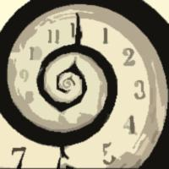

““Lack of Self-expression or Creativity on age with mispronunciations together sometimes, is really a major problem to us on the language, even though we are reading “English Rapid Literature or reading in English Medium Schools”…it feels me to be very difficult in certain circumstances in spite of resources on language are in front of us. Well, I think this is our problem as a student and, is leading a problem in future too!” (Navonil Saha, My Student.)” (EDITED)
Navonil Saha.
~~RITUPARNA RAY CHAUDHURI
Sources of the Document with quotes encouraged from various writing sites, web images, authenticate books with complete self-setting and self-thought and editing.

(Except setting, development and thoughts the words are completely followed up from Dr. S. Sen and other books both in case of Odes...)

~~RITUPARNA RAY CHAUDHURI

What inspired me on writing the document : -

American vs. British English - Vowel Sounds - Pronunciation differences https://youtu.be/LIZ78RwhSPc

Introduction to Perfect German Pronunciation https://youtu.be/p3kd2prpZJ4

Why Study Latin? https://youtu.be/HdjYBDD8b2I

“If it be true that good wine needs no bush, ’tis true that a good play needs no epilogue; yet to good wine they do use good bushes, and good plays prove the better by the help of good epilogues. What a case am I in then, that am neither a good epilogue, nor cannot insinuate with you in the behalf of a good play!”

“You are never too old to set another goal or to dream a new dream.” - C.S. Lewis.

~~RITUPARNA RAY CHAUDHURI.

