Leaf Extract of Eupatorium adenophorum negatively Regulates Growth of Alternanthera philoxeroides

Huabao Chen, Chunping Yang, Kai Shu, Wenming Wang, Zhaojun Li, Guoshu Gong, Min Zhang*

College of Agronomy, Sichuan Agricultural University, Chengdu 611130, China

Running title: Alligator Weed and Crofton Weed Antagonize Each Other

* Correspondence to:
Dr. Min Zhang, College of Agronomy, Sichuan Agricultural University,
Wenjiang District, Chengdu 611130, China
Tel: +86-0835-2882776
Fax: +86-0835-2882776
E-mail: shukai6603@aliyun.com

Abstract
Allelopathy is an important biological phenomenon in exotic plant invasions. Studies about this phenomenon can help us to understand how plant interactions influence plant colony and ecosystem functioning. Both alligator weed (Alternanthera philoxeroides, Ap) and crofton weed (Eupatorium adenophorum, Ea) are important destructive exotic species in China. Their allelopathic effects on native plant species are well documented. However, whether alligator weed and crofton weed antagonize each other regarding plant growth? There is largely unknown currently. Here we report that the leaf extract from crofton weed possesses the negative effect on the growth of alligator weed. The results showed that root growth of alligator weed could be seriously inhibited by aqueous extract from crofton weed, exhibited as no root or a few roots if only. Consistent with the inhibition of root growth, we observed changes of physiological and biochemical parameters in treated alligator weed. The chlorophyll content, the root activity and the acetolactate synthase (ALS) activity were significantly decreased; while the rate of superoxide anion (O₂⁻), the malondialdehyde (MDA) content, the peroxidase (POD) activity, and the shikimic acid content were remarkably increased in the treated alligator weed plants. These physiological analyzes suggested that the main allelopathic effects of crofton weed were mainly through affecting the integrity of cell membrane and the activity of the key enzymes. Further, these data also imply that one exotic species has the potential value to be used in bio-control of the other exotic species.
Key words: Allelopathy; Alternanthera philoxeroides; Eupatorium adenophorum
Introduction
Allelopathy is a biological phenomenon that allelo-chemicals synthesized by one organism affect on the other organisms nearby, which can be either inhibitory or stimulatory. Invasive exotic plant species displace native plant species by exuding the phytotoxin to inhibit the growth of native species. The allelochemical triggers a wave of reactive oxygen species (ROS) initiated at the root meristem, which leads to a Ca²⁺ signaling cascade triggering genome-wide changes in gene expression and, ultimately, death of the root system . Thus the allelopathy of invasive plants has caused unfavorable consequence on the native biodiversity and ecosystem. Alternanthera philoxeroides, commonly known as Alligator weed, is an immersed aquatic plant. It originated in South America, but has spread to many parts of the world and is considered an invasive species in Australia, China, New Zealand, Thailand and the United States . Alligator weed can grow in a variety of habitats, including dry land, but is usually found in wetland or in water, and very often form large interwoven mats over the water or along shorelines . When a waterway is invaded by alligator weed, the water flow and water quality are reduced because the weed prevents light penetration and oxygenation of the water. It can also reduce water bird and fish activity and cause the death of fish and native plants. In addition, alligator weed is also difficult to control. Neverthless, insects have been successfully released for the biological control of alligator weed. The most successful and widely used is Agasicles hygrophila commonly called the alligator weed flea beetle; it has been released for biocontrol in Australia, China, Thailand, New Zealand and the United States. Amynothrips andersoni, the alligator weed thrips, and Vogtia malloi, the alligator weed stem borer, have also been released in the United States .
Eupatorium adenophorum Spreng, commonly known as crofton weed, belonging to the Composite family, is an invasive perennial weed in China . It was reported that aqueous extract of E. adenophorum could generate significant allelopathy on many plants, such as wheat, maize, pea capitates flower velvetbean, Dactylis glamerata, Trifolium repens, Mariscus cyperinus. Also it was proved that allelopathy had some difference in different parts of E. adenophorum and leaf was the most significant part . Previous studies were mainly focused on the allelopathic effects of crofton weed on crops and herbages, so as to help for the rational distribution of these crops. Recently, studies on allelochemicals of E. adenophorum were shift to the effects on weeds such as amaranthus retroflexus and chenopodium glaucum. However, no report is available on allelopathy of E. adenophorum to Alternanthera philoxeroides.
It was reported that allelopathic chemicals could affect on membrane permeability, cell division, protein synthesis, and respiration. Yang et al. reported that allelochemicals of E. adenophorum could affect the growth and development of rice by changing structure of the cell and membrane. Zhang et al. found that allelochemicals of E. adenophorum could lead to membrane lipid peroxidation of Gynura and Macroptilium atropurpureum. These studies suggested that allelochemicals of E. adenophorum had significant effects on membrane permeability of plants. However, the effects of E. adenophorum on the key enzymes of amino acid biosynthesis remain to be studied.
Alternanthera philoxeroides is important invasive weed in China and very difficult to control for their strong flexibility . We hypothesis that crofton weed is so aggressive, it may also be useful to be exploited to control alligator weed. To this end, we tested the allopathic effects of leaf extract from crofton weed on alligator weed. As expected, we found that the leaf extract from crofton weed can obviously affect the growth of alligator weed by inhibiting root growth, reducing the chlorophyll content, the root activity and the acetolactate synthase activity.

MATERIALS AND METHODS

Plant materials
Eupatorium adenophorum (Ea) leaves were collected from cropland in Xichang, Sichuan Province. Then the leaves were dried, grinded and sieved at room temperature to generate dry powder for the experiments. Alternanthera philoxeroides plants were collected from the dry land during the vigorous growth period in Yaan, Sichuan Province. Then the plants were cut into 6-cm stems with the apical three nodes for test.

Preparation of aqueous extract from E. adenophorum leaves
Dry powder of the Ea leaves were extracted by soaking in water for 48h at 20℃ (100 g per 1000mL of distilled water). The solution was filtered through two layers of gauze and two layers of filter paper. Then the filtrate was stored as stock solution with the concentration of 0.1 g·mL⁻¹ (0.1g of dried power per 1mL of distilled water). For treatment of alligator weed, the stock solution was diluted into five objective concentrations of 0.005 g·mL⁻¹, 0.01 g·mL⁻¹, 0.02 g·mL⁻¹, 0.04 g·mL⁻¹, and 0.08 g·mL⁻¹.

Effects of aqueous extract from Ea leaves on the root growth of alligator weed
To obtain uniform plant materials without root, the stems of alligator weed with upper three nodes were snipped and inserted in culture beds; every culture bed had three stems. Culture beds were prepared by using culture substrates filled in petri dishes. Culture substrates were constituted by sand and nutrient soil with the volume ratio of 1:2. Then, 25 mL of aqueous extracts with 5 different concentrations of 0.005 g·mL⁻¹, 0.01 g·mL⁻¹, 0.02 g·mL⁻¹, 0.04 g·mL⁻¹, and 0.08 g·mL⁻¹ were poured into the culture beds, respectively. Distilled water was used as the control. After the stems of alligator weed were incubated at 25℃ for 7 d, the length of roots were measured. Triplicates were set in the experiment.

Measurement of physiological and biochemical parameters
The stems of alligator weed were cultivated in 100 culture beds with aqueous extract of Ea leaves at the concentration of 0.04 g·mL⁻¹ and 100 culture beds with water as control. The culture beds were irrigated 5 times with interval of 3 days with Ea leaf extract at the concentration of 0.04 g·mL⁻¹ or water, respectively. Samples were collected firstly at 3 days past the last irrigation (dpi) and then at 8, 13, 18, and 23 dpi, respectively. Seven physiological and biochemical parameters of the samples such as chlorophyll content, root activity, peroxidase (POD) activity, superoxide anion (O₂⁻) references, malondialdehyde (MDA) content, acetolactate synthase (ALS) activity and shikimic acid content were measured.
The content of chlorophyll was determined in 80% acetone extract of 0.1 g leaf tissues as described by Hegedüs et al. and expressed using mg·g⁻¹ FW. Root activity was measured using the triphenyl tetrazolium chloride (TTC) method and was expressed as the amount of triphenyl formazan (TF) deoxidized by TTC. POD activity was measured using guaiacol, The reactionmixture consisted of 1 ml of 40 mM guaiacol solution, 1 ml of McIlvaine buffer (pH 3.8), and 1 ml of 3mMH₂O₂ solution. Superoxide anion（O₂⁻）references was determined by the method of Hydrorylamine Oxidization; Malondialdehyde(MDA) content was determined by the colorimetric of thiobarbituric acid. The detailed steps were as described in reference . Acetolactate synthase (ALS) activity and shikimic acid content was determined as described before .

Statistical analyses
Data were analyzed with the software of DPS 6.55. Means data were compared by the multiple range tests of Duncan at P≤0.05.

RESULTS

Effect of aqueous extract from Ea leaves on root growth of alligator weed
The aerial growth of a plant relies on its root system. If the root growth is blocked or inhibited, the aerial part will more or less be affected. Our results showed that the root growth of alligator weed was obviously inhibited by the leaf extract of Ea at different concentrations and more severe inhibition was observed along with the increase of the concentration (Figure 1A). By measuring the root length, we found that significant inhibition of root growth could be observed at the concentration of as low as 0.02 g·mL⁻¹ (Figure 1B). Almost no new roots were observed at the concentration of 0.08 g·mL⁻¹. Thus, unknown allelochemicles in Ea leaf extract can significantly inhibits root growth of alligator weed.

Chlorophyll content of alligator weed was reduced by the Ea leaf extracts

Chlorophyll content is the first physiological factor reflecting photosynthesis and the aerial growth of a plant. Because the root growth of alligator weed was significantly inhibited by the Ea leaf extracts at the concentration of as low as 0.02 g·mL⁻¹ and the most severe inhibition was observed at the concentration of 0.08 g·mL⁻¹. To justify our data, we performed our experiment at the concentration of 0.04 g·mL⁻¹. As shown in Figure 2A, the chlorophyll content of alligator weed treated at this concentration of Ea leaf extract was significantly lower than that of control, especially after 18 dpi, the chlorophyll content was sharply reduced, implying the death of the plant. Thus these data suggests that the aerial growth of alligator weed could be inhibited by the Ea leaf extract.

Effect of Ea leaf extract on root activity of alligator weed
Root activity reflects the health status of a plant. As shown in Figure 2B, the root activity of alligator weed was steadily and steeply increased from 3 dpi to 18 dpi and remained at higher level in the control experiment. On the contrast, the root activity of alligator weed treated by Ea leaf extract was at higher level than that of control at 3 dpi and 8 dpi. Then significant lower root activity was observed at 13 dpi and 18 dpi. At 23 dpi, root activity was returned to the control level. Such relatively smooth increase of root activity in the treated sample imply that the inhibition of root growth could be due to the lower root activity of alligator weed treated by Ea leaf extract.

Acetolactate synthase activity of alligator weed was significantly reduced by the treatment of Ea leaf extract
Acetolactate synthase (ALS) is a critical enzyme in amino acid synthesis. Its activity is a hall marker to reflect the health status of a plant. Because both the root and aerial growth of alligator were inhibited by Ea leaf extract, we assumed that ALS activity should be affected too. To this end, we measured the ALS activity of alligator weed at five time points at 3, 8, 13, 18, and 23 dpi. As our expectation, while the ALS activity was slightly increased in a steady and high level in the control, the ALS activity in the samples treated by Ea leaf extraction was steeply decreased (Figure 2C), implying that the amino acid synthesis in alligator weed is significantly affected by the Ea leaf extract.

Effect of the Ea leaf extract on peroxidase activity of alligator weed

When a plant is in stressful environments, such as drought, too high or too low temperature, and pathogen infection, the activity of certain oxidoreductases will increase so as to buffer such stresses. Peroxidase (POD) is one typical oxidoreductase. To understand whether the treatment of Ea leaf extract generated a stressful environment for alligator weed, we measured the activity of POD according to the method of the colorimetric of guaiacol . The POD activity of alligator weed was obviously increased at 8 dpi and 13 dpi, the POD activity of treatment was 1.65 times more than that of the control at 13 dpi. However, there were no significant differences between the treatment and the control at 23 dpi (Figure 3A). These data suggests the existence of stressful environment in alligator weed plant after application of Ea leaf extract.

Effect of Ea leaf extract on the rate of superoxide anion in alligator weed
Superoxide is biologically quite toxic, usually generated during severe stressful conditions. To understand whether the treatment of Ea leaf extract generated a stressful environment for alligator weed, we measured the rate of superoxide anion in alligator weed. The results showed that the rate of superoxide anion in alligator weed treated by Ea leaf extract was significantly higher than that of control plant at the tested five time points (Figure 3B). From 8 dpi to 18 dpi, the rates of superoxide anion of treatment were 1.80 times, 2.13 times and 1.85 times higher than that of the control at 8 dpi, 13 dpi, and 18 dpi, respectively. The higher accumulation of free oxygen radical in alligator weed treated by Ea leaf extract is consistent with the higher POD activity. These data imply that alligator weed is indeed generates a stressful growth condition after the application of Ea leaf extract.

Effect of Ea leaf extract on malondialdehyde content of alligator weed
Plants injury in stressful environments is close relation to membrane lipid peroxidation led by accumulated active oxygen, malondialdehyde (MDA) is one of the most important products on membrane lipid peroxidation. The extent of damage of membrane systems can be indirect investigated through measure the content of MDA in plant. To understand whether the treatment of Ea leaf extract generated injury on membrane systems of alligator weed, we measured the content of MDA. As shown in Figure 3C, the MDA content of alligator weed had no significant change at 3 and 8 dpi, and the content was increased gradually and higher compared with the control from 8 dpi to 18 dpi, the difference was more and weaker. The results revealed that MDA could be accumulated for some times, then it would be recovered.

Effect of Ea leaf extract on shikimic acid content in alligator weed

Shikimate pathway is one of important amino acid biosynthesis pathway. Shikimic acid is an important medial product in shikimic acid synthesis pathway, and its accumulation replays 5-enolpyruvyl-shikimate-3-phosphate synthase is inhibited, because the synthase can decomposite shikimic acid. The accumulation of shikimic acid will inhibit further biosynthesis in the synthesis pathway, and then influence plant growth.

The shikimic acid content in alligator weed treated by Ea leaf extract maintained at significantly higher level compared with the control, but the difference was gradually reduced along with the time and became no different at 23 dpi (Fig 3d). These results showed that Ea leaf extract could induce the accumulation of shikimic acid of A. philoxeroides, which would affect the normal work of shikimate pathway and amino acid biosynthesis.

DISCUSSION

It has become a research focus on using natural products to control the weeds, allelochemicals are the important part of natural products, many studies proved that they can affect the germination and growth of the weeds. E. adenophorum contains abundant allelochemicals, so it will be significant to study the effects of allelochemicals from E. adenophorum on A. philoxeroides. In the present report, our results showed that the growth of A. philoxeroides could be inhibited seriously with the treatment of aqueous extract from E. adenophorum leaves in higher concentration. The main symptoms were presented as inhibition in root growth, lower chlorophyll content and lower root activity. The results will have potential value on the control of A. philoxeroides.

It has been proved that allelochemicals of E. adenophorum can affect normal work of cell membrane of plants. Ma et al. indicated that the main reasons was the injury of membrane system, and this injure was caused by the accumulation of malondialdehyde (MDA). The results in this article showed that aqueous extract from E. adenophorum leaves could increase the rate of superoxide anion, the malondialdehyde (MDA) content and peroxidase (POD) activity. Based on the investigation, it would speculated that more oxygen free radical and hyperoxide were produced in the A. philoxeroides, which caused the improvement of peroxidase (POD) activity to decrease the damage of harmful substance in the plant. The results confirmed that aqueous extract from E. adenophorum could lead to the membrane peroxidation, because oxygen free radical and hyperoxide are the products of it.

Acetolactate synthase inhibitors play important roles on controlling the weed for their low dosage and significant efficacy . However, they are easy to cause resistance of weed because of their single action mechanism . The allelochemicals of E. adenophorum can affect not only the acetolactate synthase, but also other targets such as membrane. So it may be valuable that using allelochemicals of E. adenophorum as potential botanical herbicide to control weeds, but the chemical compounds, whose target is acetolactate synthase, are still unknown and need further studies.

Acetolactate synthase is an impotrant synthase in amino acid biosynthesis, it will directly affect the biosynthesis of valine, isoleucine and leucine . Our results showed that acetolactate synthase activity of A. philoxeroides was significantly inhibited by the treatment of aqueous extract from E. adenophorum leaves, meanwhile, the shikimic acid content was increased. it may be a close relationship with the inhibition of 5-enolpyruvyl-shikimate-3-phosphate synthase, because the inhibition of this synthase can cause the accumulation of shikimic acid. According to the above results, allelochemicals of E. adenophorum could affect the key enzymes in amino acid biosynthesis, thus future research should focus on allelopathic mechanism of E. adenophorum .

Acknowledgments
This work was supported by application basic program of Sichuan provincial science and technology department (Grant No. 2012JY0117). We thank Deng Tingting, Fu Dongmei and Yu Jianhan for their works collecting and extracting Eupatorium adenophoruma.

Conflicts of Interests
No conflicts of interest are involved in this manuscript.

References
1. Bais HP, Vepachedu R, Gilroy S, Callaway RM and Vivanco JM: Allelopathy and Exotic Plant Invasion: From Molecules and Genes to Species Interactions. Science 301: 1377-1380, 2003.
2. Zhou J, Dong B-C, Alpert P, et al.: Effects of soil nutrient heterogeneity on intraspecific competition in the invasive, clonal plant Alternanthera philoxeroides. Annals of Botany 109: 813-818, 2012.
3. Longstreth DJ, Bolanos JA and Smith JE: Salinity Effects on Photosynthesis and Growth in Alternanthera philoxeroides (Mart.) Griseb. Plant physiology 75: 1044-1047, 1984.
4. Sanders NJ, Weltzin JF, Crutsinger GM, et al.: INSECTS MEDIATE THE EFFECTS OF PROPAGULE SUPPLY AND RESOURCE AVAILABILITY ON A PLANT INVASION. Ecology 88: 2383-2391, 2007.
5. Sang W, Zhu L and Axmacher J: Invasion pattern of Eupatorium adenophorum Spreng in southern China. Biol Invasions 12: 1721-1730, 2010.
6. Baruah N, Sarma J, Sarma S and Sharma R: Seed germination and growth inhibitory cadinenes fromEupatorium adenophorum spreng. J Chem Ecol 20: 1885-1892, 1994.
7. Yu X, Yu D and Ma K: Relationships between allelopathy and invasiveness by Eupatorium adenophorum at different sites. Chinsese Journal of Plant Ecology 28: 773-780, 2004.
8. Zhu X, Zhang J and Ma K: Soil Biota Reduce Allelopathic Effects of the Invasive <italic>Eupatorium adenophorum</italic>. PLoS ONE 6: e25393, 2011.
9. Yang G, Wan F, Liu W and Zhang X: Physiological effects of allelochemicals from leachates of Ageratina adenophora (Spreng.) on rice seedlings. Allelopathy Journal 18: 237-246, 2006.
10. Min Z, DongMei F, HuaBao C, TingTing D and Kai S: Preliminary study on allelopathic effects and mechanism of Eupatorium adenophorum to wheat and rape seedlings. Journal of Zhejiang University (Agriculture and Life Sciences) 36: 547-553, 2010.
11. Gao J, Xiao Q, Yin L and He G: Isolation of cDNA clones for genes up-regulated in drought-treated Alternanthera philoxeroides root. Mol Biol Rep 35: 485-488, 2008.
12. Hegedus A, Erdei S and Horvath G: Comparative studies of H(2)O(2) detoxifying enzymes in green and greening barley seedlings under cadmium stress. Plant science : an international journal of experimental plant biology 160: 1085-1093, 2001.
13. Ruf M and Brunner I: Vitality of tree fine roots: reevaluation of the tetrazolium test. Tree physiology 23: 257-263, 2003.
14. Fan H, Guo S, Jiao Y, Zhang R and Li J: Effects of exogenous nitric oxide on growth, active oxygen species metabolism, and photosynthetic characteristics in cucumber seedlings under NaCl stress. Front. Agric. China 1: 308-314, 2007.
15. Zhao J, Williams CC and Last RL: Induction of Arabidopsis tryptophan pathway enzymes and camalexin by amino acid starvation, oxidative stress, and an abiotic elicitor. The Plant cell 10: 359-370, 1998.
16. Jinhu M, Guofang X, Wenxiu Y, et al.: Inhibitory effects of leachate from Eupatorium adenophorum on germination and growth of Amaranthus retroflexus and Chenopodium glaucum. Acta Ecologica Sinica 32: 50-56, 2012.
17. Moreland DE: Mechanisms of Action of Herbicides. Annual Review of Plant Physiology 31: 597-638, 1980.
18. Whaley CM, Wilson HP and Westwood JH: A New Mutation in Plant Als Confers Resistance to Five Classes of Als-inhibiting Herbicides. Weed Science 55: 83-90, 2007.
19. Chipman DM, Duggleby RG and Tittmann K: Mechanisms of acetohydroxyacid synthases. Current opinion in chemical biology 9: 475-481, 2005.

Figure Legends

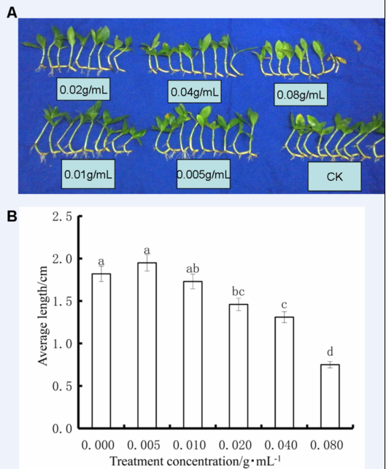
Figure 1. Aqueous leaf extract of E. adenophorum inhibits the growth of A. philoxeroides roots. Stems of A. philoxeroides were treated with the indicated concentration of aqueous extract from E. adenophorum leaves for 7 days.
- Representative images of treated alligator weed plants under the different concentrations.
(B) The quantitative analysis of root length of the alligator weed in (A). Percentages are the average of three repeats ± standard error. Bar chart with different letters indicate significantly different at P= 0.05 level.
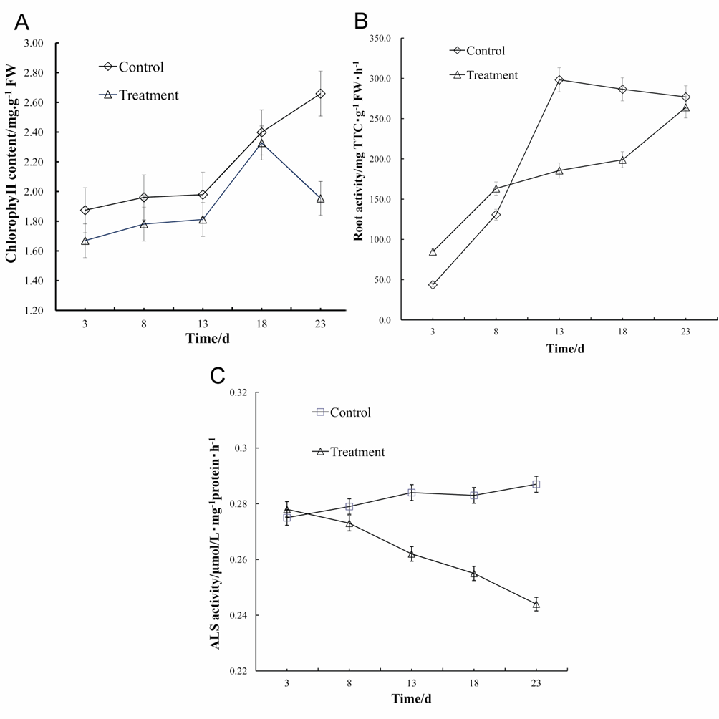
Figure 2. Physiological effects of the aqueous extract from E.adenophorum leaves on A. philoxeroides. (A) Chlorophyll content of A. philoxeroides was lower than that of the control at the indicated days after treatment of the aqueous extract from E.adenophorum leaves at the concentration of 0.04 g/mL.
(B) Root activity was affected by the treatment of the aqueous extract from E.adenophorum leaves at the concentration of 0.04 g/mL. Note that root activity was significantly lower than that of the control at 13 days and 18 days after treatment.
(C) Acetolactate synthase (ALS) activity of the A. philoxeroides was continually decreased after treatment with aqueous extract from E. adenophorum leaves at the concentration of 0.04g/mL.
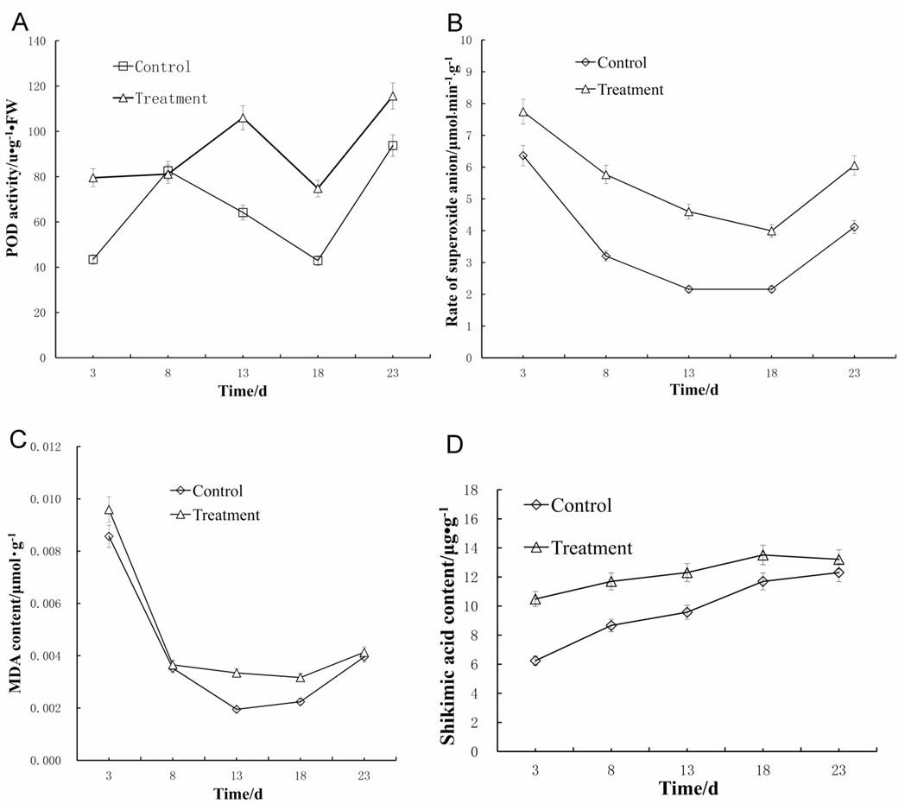
Figure 3. Stress responses of A. philoxeroides to the treatment of aqueous extract from E.adenophorum leaves. Peroxidase (POD) activities (A), free radicals of active Oxygen measured as superoxide anion (B), malondialdehyde (MDA) content (C), and shikimic acid content (D) were higher in at least three time points after treatment with aqueous extract from E. adenophorum leaves at the concentration of 0.04g/mL than that of the control.

