S.LUKASHOVA

HANDBOOK OF PSYCHOLOGY 154

READER FOR LECTURES 5-8:

- MEMORY AND ATTENTION
- INTELLIGENCE
- EMOTIONS
- MOTIVATION

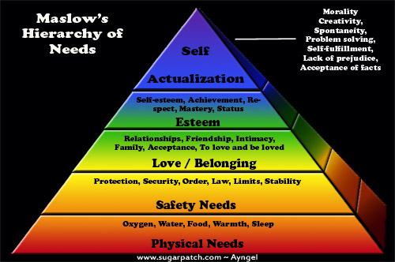

SDU 2019-2020
Chapter 5. Memory and attention

Memory is the faculty of the brain by which data or information is encoded, stored, and retrieved when needed. It is the retention of information over time for the purpose of influencing future action. If past events could not be remembered, it would be impossible for language, relationships, or personal identity to develop. Memory loss is usually described as forgetfulness or amnesia.

Memory is often understood as an informational processing system with explicit and implicit functioning that is made up of a sensory processor, short-term (or working) memory, and long-term memory. This can be related to the neuron. The sensory processor allows information from the outside world to be sensed in the form of chemical and physical stimuli and attended to various levels of focus and intent. Working memory serves as an encoding and retrieval processor. Information in the form of stimuli is encoded in accordance with explicit or implicit functions by the working memory processor. The working memory also retrieves information from previously stored material. Finally, the function of long-term memory is to store data through various categorical models or systems.

Declarative, or explicit, memory is the conscious storage and recollection of data. Under declarative memory resides semantic and episodic memory. Semantic memory refers to memory that is encoded with specific meaning, while episodic memory refers to information that is encoded along a spatial and temporal plane. Declarative memory is usually the primary process thought of when referencing memory. Non-declarative, or implicit, memory is the unconscious storage and recollection of information. An example of a non-declarative process would be the unconscious learning or retrieval of information by way of procedural memory, or a priming phenomenon. Priming is the process of subliminally arousing specific responses from memory and shows that not all memory is consciously activated, whereas procedural memory is the slow and gradual learning of skills that often occurs without conscious attention to learning.

Memory is not a perfect processor, and is affected by many factors. The ways by which information is encoded, stored, and retrieved can all be corrupted. The amount of attention given new stimuli can diminish the amount of information that becomes encoded for storage. Also, the storage process can become corrupted by physical damage to areas of the brain that are associated with memory storage, such as the hippocampus. Finally, the retrieval of information from long-term memory can be disrupted because of decay within long-term memory. Normal functioning, decay over time, and brain damage all affect the accuracy and capacity of the memory.

Memory Processes
Encoding (or registration): the process of receiving, processing, and combining information. Encoding allows information from the outside world to reach our senses in the forms of chemical and physical stimuli.
Storage: the creation of a permanent record of the encoded information. Storage is the second memory stage or process in which we maintain information over periods of time.
Retrieval (or recall, or recognition): the calling back of stored information in response to some cue for use in a process or activity. The third process is the retrieval of information that we have stored.

Memory Stores
Sensory memory
Sensory memory holds sensory information less than one second after an item is perceived. The ability to look at an item and remember what it looked like with just a split second of observation, or memorization, is the example of sensory memory. It is out of cognitive control and is an automatic response. With very short presentations, participants often report that they seem to "see" more than they can actually report. The first experiments exploring this form of sensory memory were precisely conducted by George Sperling (1963) using the "partial report paradigm". Subjects were presented with a grid of 12 letters, arranged into three rows of four. After a brief presentation, subjects were then played either a high, medium or low tone, cuing them which of the rows to report. Based on these partial report experiments, Sperling was able to show that the capacity of sensory memory was approximately 12 items, but that it degraded very quickly (within a few hundred milliseconds). Because this form of memory degrades so quickly, participants would see the display but be unable to report all of the items (12 in the "whole report" procedure) before they decayed. This type of memory cannot be prolonged via rehearsal.

Three types of sensory memories exist. Iconic memory is a fast decaying store of visual information; a type of sensory memory that briefly stores an image which has been perceived for a small duration. Echoic memory is a fast decaying store of auditory information, another type of sensory memory that briefly stores sounds that have been perceived for short durations. Haptic memory is a type of sensory memory that represents a database for touch stimuli.

Short-term memory
Short-term memory is also known as working memory. Short-term memory allows recall for a period of several seconds to a minute without rehearsal. Its capacity is also very limited: George A. Miller (1956), when working at Bell Laboratories, conducted experiments showing that the store of short-term memory was 7±2 items (the title of his famous paper, "The magical number 7±2"). Modern estimates of the capacity of short-term memory are lower, typically of the order of 4–5 items; however, memory capacity can be increased through a process called chunking. For example, in recalling a ten-digit telephone number, a person could chunk the digits into three groups: first, the area code (such as 123), then a three-digit chunk (456) and lastly a four-digit chunk (7890). This method of remembering telephone numbers is far more effective than attempting to remember a string of 10 digits; this is because we are able to chunk the information into meaningful groups of numbers. This may be reflected in some countries in the tendency to display telephone numbers as several chunks of two to four numbers.

Short-term memory is believed to rely mostly on an acoustic code for storing information, and to a lesser extent a visual code. Conrad (1964) found that test subjects had more difficulty recalling collections of letters that were acoustically similar (e.g. E, P, D). Confusion with recalling acoustically similar letters rather than visually similar letters implies that the letters were encoded acoustically. Conrad's (1964) study, however, deals with the encoding of written text; thus, while memory of written language may rely on acoustic components, generalisations to all forms of memory cannot be made.

Long-term memory
The storage in sensory memory and short-term memory generally has a strictly limited capacity and duration, which means that information is not retained indefinitely. By contrast, long-term memory can store much larger quantities of information for potentially unlimited duration (sometimes a whole life span). Its capacity is immeasurable. For example, given a random seven-digit number, one may remember it for only a few seconds before forgetting, suggesting it was stored in short-term memory. On the other hand, one can remember telephone numbers for many years through repetition; this information is said to be stored in long-term memory.

While short-term memory encodes information acoustically, long-term memory encodes it semantically: Baddeley (1966) discovered that, after 20 minutes, test subjects had the most difficulty recalling a collection of words that had similar meanings (e.g. big, large, great, huge) long-term. Another part of long-term memory is episodic memory, "which attempts to capture information such as 'what', 'when' and 'where'". With episodic memory, individuals are able to recall specific events such as birthday parties and weddings.

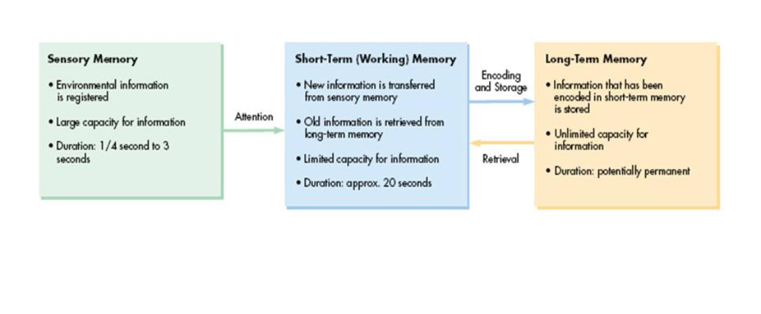
Attention.
Attention is the behavioral and cognitive process of selectively concentrating on a discrete aspect of information, whether deemed subjective or objective, while ignoring other perceivable information. It is a state of arousal. It is the taking possession by the mind in clear and vivid form of one out of what seem several simultaneous objects or trains of thought. Focalization, the concentration of consciousness, is of its essence. Attention has also been described as the allocation of limited cognitive processing resources.

Attention remains a major area of investigation within education, psychology, neuroscience, cognitive neuroscience, and neuropsychology. Areas of active investigation involve determining the source of the sensory cues and signals that generate attention, the effects of these sensory cues and signals on the tuning properties of sensory neurons, and the relationship between attention and other behavioral and cognitive processes like working memory and psychological vigilance. A relatively new body of research, which expands upon earlier research within psychopathology, is investigating the diagnostic symptoms associated with traumatic brain injury and its effects on attention. Attention also varies across cultures.

The relationships between attention and consciousness are complex enough that they have warranted perennial philosophical exploration. Such exploration is both ancient and continually relevant, as it can have effects in fields ranging from mental health and the study of disorders of consciousness to artificial intelligence and its domains of research.

Memory Improvement
Here are 10 great tips for making things stick in your brain.
1. Establish Routine
2. Go Against Habit
3. Eat More Brain Food
Lots of foods improve your memory because they are filled with special antioxidants and vitamins. Try adding more green tea, blueberries, salmon, cabbage, broccoli, cauliflower, dark chocolate and turmeric to your daily intake.
4. Get More Sleep
Your brain needs downtime to stay sharp. If you don't get enough sleep, you'll tax your memory and start forgetting things. Stay rested so you can keep your mind alert.
5. Have a Mental Workout
Mental challenges like studying complex concepts make simple tasks like remembering names at a party seem like a piece of cake.
6. Create Stories in Your Mind
Names and numbers by themselves can be easily forgotten if there is little or no context involved. As you are being introduced to new information, be aware of the surroundings and any possible details you can associate with the specific information. Recognize the order of events and then you can replay them in your mind to retrieve the answer.
7. Write Things Down
The actual act of physically writing something down helps to register text in your mind where you can recover it later.
8. Get Creative
Make up poems, songs and other mnemonics to lock important facts in my memory. They can be very powerful tools. I still use the 30 days has September poem from childhood to figure out the number of days in each month.
9. Pay Attention
Ultimately you want to shift important facts from your short-term memory to your long-term memory. Science dictates that this process takes about 8 seconds of focused attention on a specific item. So next time you need to encode something important, focus on it while counting to 8 alligators and lock it in.
10. Exercise
A healthy body provides for a healthy mind. Not only does exercise make the brain work better, getting the blood pumping actually makes it work harder.

PSYCHOLOGY JOURNAL
Assignment 5.
1) Describe the best ways you remember and learn;
2) recall a time in your life , when your behavior was influenced by reward and punishment .
Chapter 6. Intelligence

Intelligence has been defined in many ways, including: the capacity for logic, understanding, self-awareness, learning, emotional knowledge, reasoning, planning, creativity, critical thinking, and problem solving. More generally, it can be described as the ability to perceive or infer information, and to retain it as knowledge to be applied towards adaptive behaviors within an environment or context.

The characteristic that is most defining of human beings as a species is that our large cerebral cortexes make us very, very smart. In this chapter we consider how psychologists conceptualize and measure human intelligence—the ability to think, to learn from experience, to solve problems, and to adapt to new situations. We’ll consider whether intelligence involves a single ability or many different abilities, how we measure intelligence, what intelligence predicts, and how cultures and societies think about it. We’ll also consider intelligence in terms of nature versus nurture and in terms of similarities versus differences among people.

Intelligence is important because it has an impact on many human behaviors. Intelligence is more strongly related than any other individual difference variable to successful educational, occupational, economic, and social outcomes. Scores on intelligence tests predict academic and military performance, as well as success in a wide variety of jobs (Ones, Viswesvaran, & Dilchert, 2005; Schmidt & Hunter, 1998). Intelligence is also negatively correlated with criminal behaviors—the average intelligence quotient (IQ) of delinquent adolescents is about 7 points lower than that of other adolescents (Wilson & Herrnstein, 1985) —and positively correlated with health-related outcomes, including longevity (Gottfredson, 2004; Gottfredson & Deary, 2004). At least some of this latter relationship may be due to the fact that people who are more intelligent are better able to predict and avoid accidents and to understand and follow instructions from doctors or on drug labels. Simonton (2006) also found that among U.S. presidents, the ability to effectively lead was well predicted by ratings of the president’s intelligence.
Our vast intelligence also allows us to have language, a system of communication that uses symbols in a regular way to create meaning. Language gives us the ability communicate our intelligence to others by talking, reading, and writing.

Theories of Intelligence
In the early 1900s, the French psychologist Alfred Binet (1857–1914) and his colleague Henri Simon (1872–1961) began working in Paris to develop a measure that would differentiate students who were expected to be better learners from students who were expected to be slower learners. The goal was to help teachers better educate these two groups of students. Binet and Simon developed what most psychologists today regard as the first intelligence test, which consisted of a wide variety of questions that included the ability to name objects, define words, draw pictures, complete sentences, compare items, and construct sentences.
Binet and Simon (Binet, Simon, & Town, 1915; Siegler, 1992) believed that the questions they asked their students, even though they were on the surface dissimilar, all assessed the basic abilities to understand, reason, and make judgments. And it turned out that the correlations among these different types of measures were in fact all positive; students who got one item correct were more likely to also get other items correct, even though the questions themselves were very different.
On the basis of these results, the psychologist Charles Spearman (1863–1945) hypothesized that there must be a single underlying construct that all of these items measure. He called the construct that the different abilities and skills measured on intelligence tests have in common the general intelligence factor (g). Virtually all psychologists now believe that there is a generalized intelligence factor, g, that relates to abstract thinking and that includes the abilities to acquire knowledge, to reason abstractly, to adapt to novel situations, and to benefit from instruction and experience (Gottfredson, 1997; Sternberg, 2003). People with higher general intelligence learn faster.
Soon after Binet and Simon introduced their test, the American psychologist Lewis Terman (1877–1956) developed an American version of Binet’s test that became known as the Stanford-Binet Intelligence Test. The Stanford-Binet is a measure of general intelligence made up of a wide variety of tasks including vocabulary, memory for pictures, naming of familiar objects, repeating sentences, and following commands.
One advocate of the idea of multiple intelligences is the psychologist Robert Sternberg. Sternberg has proposed a triarchic (three-part) theory of intelligence that proposes that people may display more or less analytical intelligence, creative intelligence, and practical intelligence. Sternberg (1985, 2003) argued that traditional intelligence tests assess analytical intelligence, the ability to answer problems with a single right answer, but that they do not well assess creativity (the ability to adapt to new situations and create new ideas) or practicality (e.g., the ability to write good memos or to effectively delegate responsibility).
As Sternberg proposed, research has found that creativity is not highly correlated with analytical intelligence (Furnham & Bachtiar, 2008), and exceptionally creative scientists, artists, mathematicians, and engineers do not score higher on intelligence than do their less creative peers (Simonton, 2000). Furthermore, the brain areas that are associated with convergent thinking, thinking that is directed toward finding the correct answer to a given problem, are different from those associated with divergent thinking, the ability to generate many different ideas for or solutions to a single problem (Tarasova, Volf, & Razoumnikova, 2010). On the other hand, being creative often takes some of the basic abilities measured by g, including the abilities to learn from experience, to remember information, and to think abstractly (Bink & Marsh, 2000).
Another champion of the idea of multiple intelligences is the psychologist Howard Gardner (1983, 1999).

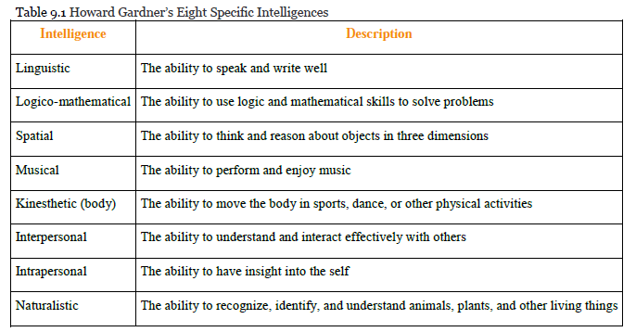
Creativity Development
Coming up with new or unusual responses to familiar circumstances (closely related to the ability to solve problems)
Guilford (1967) :
- Convergent thinking (coming up with single correct answer)
- Divergent thinking (with new unusual responses)
Studies of creative people suggest at least five components that are likely to be important for creativity:
Expertise. Creative people have carefully studied and know a lot about the topic that they are working in. Creativity comes with a lot of hard work (Ericsson, 1998; Weisberg, 2006).
Imaginative thinking. Creative people often view a problem in a visual way, allowing them to see it from a new and different point of view.
Risk taking. Creative people are willing to take on new but potentially risky approaches.
Intrinsic interest. Creative people tend to work on projects because they love doing them, not because they are paid for them. In fact, research has found that people who are paid to be creative are often less creative than those who are not (Hennessey & Amabile, 2010).
Working in a creative environment. Creativity is in part a social phenomenon. Simonton (1992) found that the most creative people were supported, aided, and challenged by other people working on similar projects.
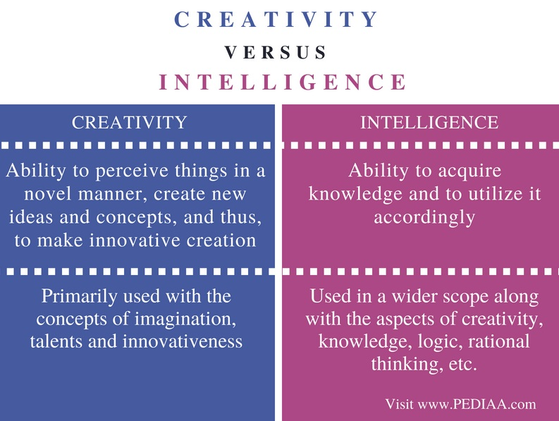

Measuring Intelligence: Standardization and the Intelligence Quotient
The goal of most intelligence tests is to measure g, the general intelligence factor. Good intelligence tests are reliable, meaning that they are consistent over time, and also demonstrate construct validity, meaning that they actually measure intelligence rather than something else. Because intelligence is such an important individual difference dimension, psychologists have invested substantial effort in creating and improving measures of intelligence, and these tests are now the most accurate of all psychological tests. In fact, the ability to accurately assess intelligence is one of the most important contributions of psychology to everyday public life.

PSYCHOLOGY JOURNAL
- Assign.6 . 1)Did your parents/teachers try to improve your intelligence? How? Do you think their efforts were successful?
- 2)Multiple Intelligence test

Chapter 7. Emotions

An emotion is a mental and physiological feeling state that directs our attention and guides our behavior. Whether it is the thrill of a roller-coaster ride that elicits an unexpected scream, the flush of embarrassment that follows a public mistake, or the horror of a potential plane crash that creates an exceptionally brilliant response in a pilot, emotions move our actions. Emotions normally serve an adaptive role: We care for infants because of the love we feel for them, we avoid making a left turn onto a crowded highway because we fear that a speeding truck may hit us, and we are particularly nice to Mandy because we are feeling guilty that we didn’t go to her party. But emotions may also be destructive, such as when a frustrating experience leads us to lash out at others who do not deserve it.

The most fundamental emotions, known as the basic emotions, are those of anger, disgust, fear, happiness, sadness, and surprise. The basic emotions have a long history in human evolution, and they have developed in large part to help us make rapid judgments about stimuli and to quickly guide appropriate behavior (LeDoux, 2000). The basic emotions are determined in large part by one of the oldest parts of our brain, the limbic system, including the amygdala, the hypothalamus, and the thalamus. Because they are primarily evolutionarily determined, the basic emotions are experienced and displayed in much the same way across cultures (Ekman, 1992; Elfenbein & Ambady, 2002, 2003; Fridland, Ekman, & Oster, 1987), and people are quite accurate at judging the facial expressions of people from different cultures. View Note 10.8 "Video Clip: The Basic Emotions" to see a demonstration of the basic emotions.
The cognitive interpretations that accompany emotions—known as cognitive appraisal—allow us to experience a much larger and more complex set of secondary emotions. The secondary emotions are those that have a major cognitive component. They are determined by both their level of arousal (low to high) and their valence (pleasant to unpleasant).
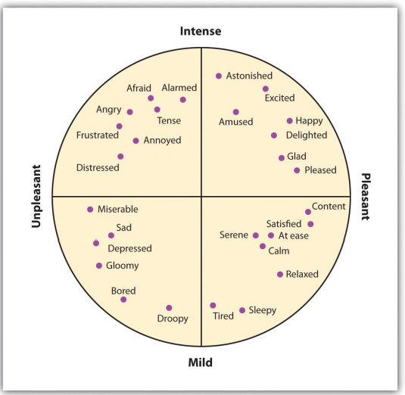

The Cannon-Bard and James-Lange Theories of Emotion
Psychologists have proposed three different theories of emotion, which differ in terms of the hypothesized role of arousal in emotion ("Three Theories of Emotion").
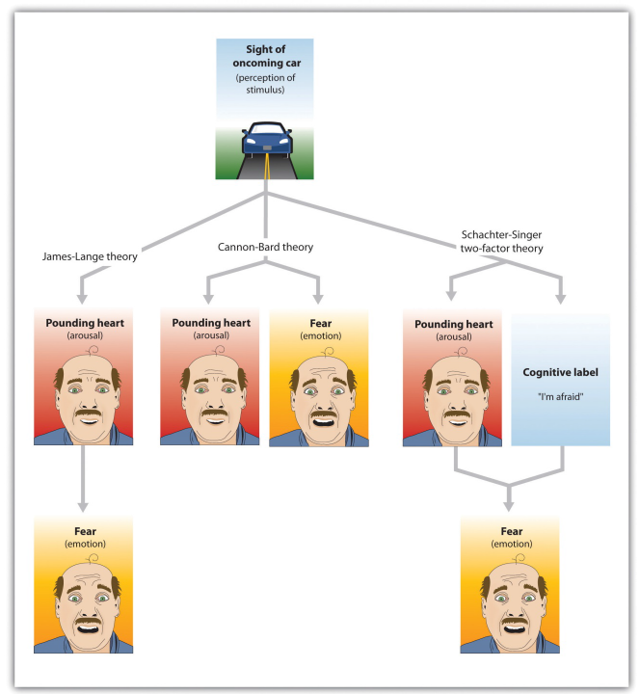
The Cannon-Bard theory proposes that emotions and arousal occur at the same time. The James-Lange theory proposes the emotion is the result of arousal. Schachter and Singer’s two-factor model proposes that arousal and cognition combine to create emotion.
The Two-Factor Theory of Emotion
Whereas the James-Lange theory proposes that each emotion has a different pattern of arousal, the two-factor theory of emotion takes the opposite approach, arguing that the arousal that we experience is basically the same in every emotion, and that all emotions (including the basic emotions) are differentiated only by our cognitive appraisal of the source of the arousal. The two-factor theory of emotion asserts that the experience of emotion is determined by the intensity of the arousal we are experiencing, but that the cognitive appraisal of the situation determines what the emotion will be. Because both arousal and appraisal are necessary, we can say that emotions have two factors: an arousal factor and a cognitive factor (Schachter & Singer, 1962):
emotion = arousal + cognition

Emotion Regulation
Emotional responses such as the stress reaction are useful in warning us about potential danger and in mobilizing our response to it, so it is a good thing that we have them. However, we also need to learn how to control our emotions, to prevent them from letting our behavior get out of control. The ability to successfully control our emotions is known as emotion regulation.
Emotion regulation has some important positive outcomes. Consider, for instance, research by Walter Mischel and his colleagues. In their studies, they had 4- and 5-year-old children sit at a table in front of a yummy snack, such as a chocolate chip cookie or a marshmallow. The children were told that they could eat the snack right away if they wanted. However, they were also told that if they could wait for just a couple of minutes, they’d be able to have two snacks—both the one in front of them and another just like it. However, if they ate the one that was in front of them before the time was up, they would not get a second.
Emotion regulation is influenced by body chemicals, particularly the neurotransmitter serotonin. Preferences for small, immediate rewards over large but later rewards have been linked to low levels of serotonin in animals and low levels of serotonin are tied to violence and impulsiveness in human suicides (Asberg, Traskman, & Thoren, 1976).
Although stress is an emotional response that can kill us, our emotions can also help us cope with and protect ourselves from it. The stress of the Monday through Friday grind can be offset by the fun that we can have on the weekend, and the concerns that we have about our upcoming chemistry exam can be offset by a positive attitude toward school, life, and other people. Put simply, the best antidote for stress is a happy one: Think positively, have fun, and enjoy the company of others.
The power of positive thinking comes in different forms, but they are all helpful. Some researchers have focused on optimism, a general tendency to expect positive outcomes, finding that optimists are happier and have less stress (Carver & Scheier, 2009). Others have focused self-efficacy, the belief in our ability to carry out actions that produce desired outcomes. People with high self-efficacy respond to environmental and other threats in an active, constructive way—by getting information, talking to friends, and attempting to face and reduce the difficulties they are experiencing. These people too are better able to ward off their stresses in comparison to people with less self-efficacy (Thompson, 2009).

The benefits of taking positive approaches to stress can last a lifetime. Christopher Peterson and his colleagues (Peterson, Seligman, Yurko, Martin, & Friedman, 1998) found that the level of optimism reported by people who had first been interviewed when they were in college during the years between 1936 and 1940 predicted their health over the next 50 years. Students who had a more positive outlook on life in college were less likely to have died up to 50 years later of all causes, and they were particularly likely to have experienced fewer accidental and violent deaths, in comparison to students who were less optimistic. Similar findings were found for older adults. After controlling for loneliness, marital status, economic status, and other correlates of health, Levy and Myers found that older adults with positive attitudes and higher self-efficacy had better health and lived on average almost 8 years longer than their more negative peers (Levy & Myers, 2005; Levy, Slade, & Kasl, 2002). And Diener, Nickerson, Lucas, and Sandvik (2002) found that people who had cheerier dispositions earlier in life had higher income levels and less unemployment when they were assessed 19 years later.

Emotional Intelligence
Emotional intelligence refers to the ability to accurately identify, assess, and understand emotions, as well as to effectively control one’s own emotions.
The idea of emotional intelligence is seen in Howard Gardner’s interpersonal intelligence (the capacity to understand the emotions, intentions, motivations, and desires of other people) and intrapersonal intelligence (the capacity to understand oneself, including one’s emotions).

EQ model To Succeed in Your LIFE
Self Awareness
- Awareness of Emotions
- Awareness of Self
- Awareness of Situation
- Self Confidence
Self Management
- Self control
- Positive Attitude
- Accountability
- Self Validation
- Trust
- Achievement
- Drive
Social Awareness
- Listening
- Empathy
- Awareness of Others
- Awareness of Organisations
Relationship Management
- Vision
- Communication Bonds
- Conflict Management
- Teamwork
- Mentoring

PSYCHOLOGY JOURNAL
Assign.7 Are you good at emotion regulation? Can you think of a time that your emotions got the better of you? How might you make better use of your emotions?
2)Emotional Intelligence test

Chapter 8. Motivation.

Motivation: The biological, emotional, cognitive or social forces that activate and direct behavior.
There are three basic characteristics associated with motivation • Activation (initiation of behavior) • Persistence (continual efforts or determination) • Intensity (strength of response)

Just as animals display instinctive behavioral patterns, such as migration or mating behaviors, human behavior is thought be motivated by innate instincts or genetic programming. Instinct theories say that people are motivated to engage in certain behaviors because of evolutionary programming.
• Instinct theory describes and labels behavior and relies on circular reasoning. • While instinct theories seem logical, these labels and descriptions do not explain behavior. In addition, we don’t have enough genes to account for every behavior and motivation. People try to use instincts to “explain” one’s behavior, but it rarely does.

Drive Theories
Behavior is motivated by the desire to reduce internal tension caused by unmet biological needs, such as hunger and thirst. These unmet biological needs “drive” us to behave in certain ways to ensure survival. Drives such as hunger and thirst arise from tissue deficits--when we are hungry, we are driven to eat. When we are thirsty, we are driven to drink.
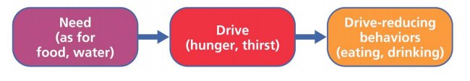

When a particular behavior reduces a drive, the behavior becomes reinforced when the same need state arises again. Our bodies biological systems are delicately balanced to ensure survival. Homeostasis is a state of internal physiological equilibrium that the body strives to maintain. For example, when you are hot, your body automatically tries to cool itself by perspiring, when you are cold, your body generates warmth by shivering. Physiological disruptions in homeostasis produce drives—states of internal tension that motivate an organism to reduce this tension.

Incentive Theories
Behavior is motivated by the “pull” of external goals and rewards such as rewards, money or recognition (page 331). This approach is based heavily on operant learning theory (behavior is based on the expectation of consequences such as reinforcements or punishments), and hence testable.
Reinforcements __________behavior
Punishments ____________ behavior
If we think we will be reinforced for the behavior, we are motivated to engage in that behavior. If we think we will be punished for the behavior, we are motivated to avoid that behavior.
Arousal Theories Arousal theories are based on the observation that people find both very high levels of arousal and very low levels of arousal quite unpleasant.
• When arousal is too low, we become motivated to increase arousal by seeking stimulating experiences • When arousal is too high, we become motivated to reduce arousal by seeking a less stimulating environment.
People are motivated to maintain an optimal level of arousal—one which is neither too high or too low.
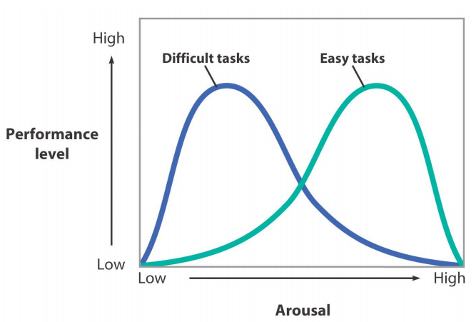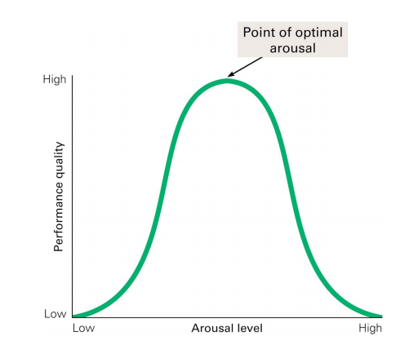
Humanistic Theories
Abraham Maslow, a humanistic theorist, proposed a broad motivational model. He proposed that psychology’s other perspectives ignored a key human motive—the desire to strive for personal growth.
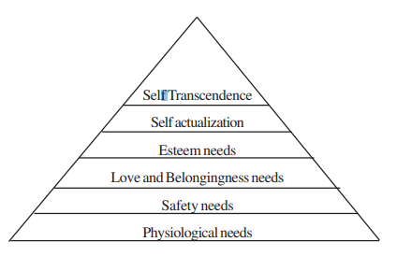
Safety needs: When the physiological needs are satisfied safety needs become the dominant force in life. Safety needs are mainly concerned with maintaining order and security, to feel secure, safe and out of danger.
Love and Belongingness needs: These are the needs of making intimate relationship with other members of the society. People want to become an accepted member of an organized group, need a familiar environment such as family. These needs are dependent on the fulfilment and satisfaction of physiological and safety needs.
The Esteem needs: Esteem needs are divided into the following two categories:
(a) Needs related to respect from others like reputation, status, social success and fame. The need of self-evaluation occurs in those persons who are comfortably situated and satisfied with the fulfilment of lower order needs. For example, a competent professional who has established a high reputation and does not have to worry about getting a job, may become quite choosy about what type of work he/she would accept.
(b) Self-esteem, self-respect and self-regard. The other type of esteem needs include need to achieve, to be competent, to gain approval and to get recognition. The need to feel superior to others also falls under this category. For fulfilling this, a person may buy good quality and costly clothes.
Self-actualization: Self-actualization refers to the desire to utilize one’s personal capacities, to develop one’s potentialities to the fullest and to engage in activities for which one is well suited. One should realize and be satisfied that he or she has achieved what one is capable of. Self-actualization is possible only when the needs of a person are met to the degree that they neither distract nor consume all available energy. When the person succeeds in satisfying his/her lower order needs, only then he can act upon his/her higher order needs.
Self-transcendence: This is the highest level of need where a person becomes conscious of broader reality. He transcends the boundaries of self and attends to the needs of collectivity and society. At this level one becomes aware of the entire humanity. At this level spiritual concerns become very important. In this hierarchy it is assumed that the lower order needs dominate people’s lives until that level is fairly satisfied; then comes the next one and so on. However, Maslow explains that every individual does not follow this hierarchy step by step; exceptions do arise. An individual sometimes risks his life to save someone or to save a valued object by defying his own safety needs. There are certain examples in Indian history when women sacrificed their lives to save their honor. There have been freedom fighters who starved themselves to death fighting for the cause of the freedom of the country. Here the higher order needs superseded the hunger and thirst needs. Sometimes individual rejects love, family, friends, etc. by committing suicide, thus defying the needs of love and sense of belongingness. It may be noted that the hierarchy, however, does not imply that lower order needs become dormant once they are satisfied and the higher order needs become active.

Cognitive Theory of Motivation.
- Emphasizes thinking and perceptual interpretation
- Certain behaviors certain goals, so we develop cognitive expectancies that motivate us to exhibit these behaviors
Example: Would you study for an exam or go to a movie?
Our behavior is the result of our expectations of achieving goals and the value that those goals have for us. We are motivated to maximize the value of our behavior and choices.

Biological motives.
- They have a definite psychological basis and biologically necessary for survival of the individual: hunger, thirst, body t regulation, avoidance of pain, sexual drive.
Examples:
1)Obese people are much more sensitive to external cues (time, the sight, smell, and taste of food) This conclusion has practical implication for people trying to lose weight.
2) Human sexuality is controlled by the higher brain centers that enables us to learn from experiences, sexual behavior in humans is learned, it is mostly in the head.

Motivation at Work
The healthy life, said Sigmund Freud, is filled by love and work.
People have different attitudes toward work. Some take it as a:
Job: Necessary way to make money.
Career: Opportunity to advance from one position to another.
Calling: Fulfilling a socially useful activity.

Learned Social Motives
Achievement | Power (personality trait) | Affiliation (personality  trait)
Desire to perform at some high standard of excellence.  Those who rank high in achievement good problem solvers, well-adjusted in personal and work life.  - With low achievement need have a high fear of failure | Desire to control and exert influence.  With high power motive problems with close relationship; take risks, drink more and behave recklessly;  Can be dictators, fight more. But women show socially responsible behavior. | Seeking out and  forming  attachments with  other people.  Need to be accepted  by groups,  it affects their  performance.

Seeking o Internals vs Externals
Rotter (1990) describes the internal locus of control as:
'the degree to which persons expect that a reinforcement or an outcome of their behavior is contingent on their own behavior or personal characteristics'
The studies concluded that students with an internal locus of control had higher academic achievement than students with an external locus of control (Uget, 2007). The reason for the internals performing better academically comes from their belief that if they work hard and study, they will receive good grades. Therefore, they tend to study longer and spend more time on their homework (Grantz, 2006).
People with a high internal locus of control believe in their own ability to control themselves and influence the world around them. They see their future as being in their own hands and that their own choices lead to success or failure.
Internals: tend to say things like,
“I succeeded because I tried.”
“I failed because I did not try hard enough.”
“I succeeded because I have ability to learn in that area.”
“I did well because I’m smart.”
Thus, they see self as responsible for both success and failure.
They attribute success and failure internally.
Effort and/or ability are the factors they see at work to produce outcomes.

Rotter (1990) describes the external locus of control as:
'the degree to which persons expect that the reinforcement or outcome is a function of chance, luck, or fate, is under the control o f powerful others, or is simply unpredictable.'
A person who has an external locus of control believes that rewards or outcomes in life are determined by "luck, chance, or powerful others" (Mearns, 2008). If they do not succeed at something they believe that their lack of success is due to forces beyond their control. For example, a student with an external locus of control doesn't receive a good grade on his exam. He concludes that the test was written poorly and the teacher was incompetent. He blames the grade on external factors that were out of his control and doesn't see the need to try harder (Grantz, 2006)."Males tend to be more internal than females"
On the other hand, externals believe they have no control over what grade they get. This belief may have been caused by many attempted school assignments that they failed, leading them to have low expectations of studying and school (Grantz, 2006). Any success that they might experience will be rationalized as luck or that the task was too easy. They have come to expect low success and whatever goals they do set are unrealistic (Uget, 2007).
Externals: tend to say things like,
“Everything is going my way this semester. That’s why I’m doing well.”
“I really lucked out on that last test.”
“I got a bad grade because the teacher didn’t like me.”
“The teacher threw us a curve. That was a hard test.”
Thus, they see outside, external factors as responsible for their successes and failures. They do not perceive themselves as being in charge. They believe luck, task difficulty, “powerful others” are the main factors determining their outcomes.

A student who blames teachers or other students for what is going wrong in their educational experience is seen as having an external locus of control and being at risk.
It is a wide held view that students with an internal locus of control fare better academically and socially within schools versus students with an external locus of control. Lebedina- Manzoni (2004) found in a study of students beliefs about academic success that, unsuccessful students compared to successful ones stated success depended on circumstances which are directed towards outside influences and were beyond their control. Luck, parents, and teachers were among the things unsuccessful students felt influenced their academic success. Externally orientated students were more likely to engage in passive and unsuccessful study strategies, cope poorly with course-induced stress, achieve lower grades, and blame others for poor performance relative to the internally orientated students (Grimes et al., 2004).nd forming attachments with other people.
Need to be accepted by groups, it affects their performance.

PSYCHOLOGY JOURNAL
Assign.8 Locus of Control Test - http://similarminds.com/cgi-bin/locus.pl

Topics for seminar projects ( lectures 5-8)
- Memory improvement strategies and techniques presentation with research analysis(20 min)
3-5 person team project:
- Study the lecture about memory; you may also use internet resources.
- Summarize and present general rules to improve memory and explain from psychological point of view.
- Collect at least 10-15 participants ‘ home assignment 5 , read and analyze some common techniques students use to learn better and which common rewards and punishments influenced their learning behavior . Present your findings.
(Assign.5.1) Describe the best ways you remember and learn; 2) recall a time in your life , when your behavior was influenced by reward and punishment).
- Study the test “ learning styles: visual, auditory, kinesthetic’ ; ask at least 15-20 students to do this test and analyze the results in graph and explain the strengths and weaknesses of each learning style in learning a foreign language.
For example:
- Intelligence development project presentation with research analysis (20 min)
3-5 person team project:
- Study the lecture about intelligence, you may also use internet resources.
- Summarize and present general rules to develop intelligence;
- Collect at least 10-15 participants ‘ home assignment 6 , read and analyze some common students’ intelligence improvement strategies their parents and teachers implemented in their childhood and school experience. Present your findings.
(Assign.6 . 1)Did your parents/teachers try to improve your intelligence? How? Do you think their efforts were successful? )
- Collect results of Multiple Intelligence test from at least 20 participants , make a research analysis in graph and present it with explanation . Which three most developed types of intelligence are common among teacher participants and what it means.
For example:

- Creativity development project with research analysis (15 min)
3-5person team project:
- Study the lecture about creativity /intelligence, you may also use internet resources.
- Summarize and present general rules to develop creativity;
- Make up 5 questions about creativity features and development and ask at least 20 students ; then summarize and present findings of most common features and strategies.
- Present at least 10 most creative tasks you decide can be for learning FL.

- Emotional Intelligence development project with research analysis (15min)
3-5 person team project:
- Study the lecture about emotions, you may also use internet resources;
- Summarize and present general rules to develop emotional intelligence;
- Collect at least 10-15 participants ‘ home assignment 7 , read and analyze some common students’ strategies to use and regulate their emotions wisely . Present your findings.
(Assign.7 Are you good at emotion regulation? Can you think of a time that your emotions got the better of you? How might you make better use of your emotions? )
- Collect results of Emotional Intelligence test from at least 20 participants , make a research analysis in graph and present it with explanation . Which two are found most developed ? Which is the least developed , what do we need to undertake to develop? Present your findings with explanation.
For example:

- Understanding people’s motives project with research analysis ( 15 min)
  - person team project:
a)Study the lecture about motivation ; you may also use internet resources;
b)Summarize and present different motives of people ;
c)Make up 5 “WHY” questions ( you may choose them from self-study questions in the presentation ) and ask at least 20 students ; then summarize and present findings of most common motives.
d)Collect results of Locus of control test from at least 30 participants , make a research analysis in graph and present it with explanation .
For example

