John Gorman, Le faune et Galatea. 20x15cm. Graphite, chalk on paper, 2021
The composition here shows two figures more or less taken from a frame from which they protrude on the right, while on the left the vertical line defining this frame deports them in a way, giving way to the written title of the work: "The Faun and Galatea", and the date of its execution, March 6, 2021. Inside this partial frame we see a crouching faun, but with his upper body raised so that his left arm can reach, without touching it, the female figure, which is therefore that of Galatea. The multiple lines that determine the faun's body are sometimes tenuous but double (the whole of the lower part of his body, his buttocks, his right thigh and the beginning of his left knee and leg), his torso, sometimes denser with more pigment, although they remain elliptical (his arms, especially the left, very muscular, stretched out in the effort, and his face, veiled, only his two horns being visible but separated by a strange oval. Galatea's body, for its part, seems to emerge from a block of ivory and to be brought back to life. Extremely rare in John Gorman's work is a very slender silhouette, with juvenile buttocks, a small breast, the only visible arm also thin, the delicate roundness of her left shoulder, her back barely arched. Situated a little higher than the fauna, her legs still buried in the block from which Pygmalion brought her up, she comes to life only slowly, and the fact that a mythical creature such as a faun accompanies her in her birth attests that she still belongs to the realm of dreams, and not yet fully to that of human beings. In contrast to the complex network of lines that define the faun's body, the line that circumscribes its silhouette is very fine and limpid, although it too is crossed by some discursive incursions. Her face is not only hidden, but even seems to be wearing a helmet, a wire mesh slit that perhaps allows her to see and breathe. A thick but measured length of hair falls on her back.
The dense mass of dark grey chalk that indicates the block from which she emerges resonates at the top of the composition in a series of thick, dense zigzags, while the entire interior of the frame is crisscrossed with enigmatic crosses of varying sizes, more or less precisely drawn, and which form the sole background to this scene. A background made of signs, again, therefore.

In Greek mythology, the story of Pygmalion and Galatea refers to a legend telling the story of the sculptor Pygmalion who falls in love with his creation, Galatea, a statue brought to life by Aphrodite, the goddess of love, who understands Pygmalion's wish. The names of the characters come from ancient Greek: Πυγμαλίων καὶ Γαλατεία (Pugmalíôn kaì Galateía). The legend is mainly told by Ovid in his Metamorphoses. Pygmalion is a sculptor from Cyprus descended from Athena and Hephaestus. Revolted against marriage because of the reprehensible conduct of the Propetides (women of Cyprus), he dedicated himself to celibacy. However, he falls in love with an ivory statue, the work of his chisel. Obtaining from Aphrodite that she gives life to the statue, he marries her in the presence of the goddess and, according to some versions, has two children of her own: Paphos and Matharmé.

Having denied Aphrodite's divinity, the Propetides are punished by the goddess who kindles the fire of fornication in their hearts. Having finally lost all shame, they are imperceptibly changed into hard rock.
The names Πυγμαλίων καὶ Γαλατεία (Pugmalíôn kaì Galateía) evoke respectively the fist / elbow / arm (πύγμα) of the sculptor working with the mallet and chisel, and milk (γάλα), the white colour of the statue, but also of the Propetides transformed into ivory.
It seems that Philostephanus of Cyrene (c. 222-206 BC) is one of Ovid's sources. Specialists rely on an extract from the Protreptic (IV, 57, 3) by Clement of Alexandria and on a text by Arnobius taken from his Adversus nationes libri. Without rejecting the probable influence of Philostephanos of Cyrene, Julien d'Huy situates the first emergence of the narrative in present-day Libya. The story would have appeared there more than 3000 years ago in North Africa, and would have been borrowed by the Greeks between the 7th and 1st century BC. This myth, linked to that of the Propetides, condemns the independence of women's morals, at the time already associated with prostitution or witchcraft, in contrast to the fidelity of the statue, the creation of the man who modelled it, the only one worthy of love and rewarded by taking life.

The legend of Pygmalion, recounted by Ovid in the Metamorphoses, inspired, among other things, the painting : Pygmalion voit sa statue animée, painting by François Lemoyne, 1729, Musée des Beaux-Arts de Tours; Pygmalion amoureux de sa statue, also known as Pygmalion et Galatée, painting by Girodet, 1819, Musée du Louvre, Paris ; Pygmalion and the Image (1870), painting by Edward Burne-Jones, Birmingham Museum & Art Gallery; Pygmalion and Galatea, painting by Jean-Léon Gérôme, 1890, Metropolitan Museum of Art, New York; Pygmalion (1939), painting by Paul Delvaux, Royal Museums of Fine Arts of Belgium. References in sculpture include: Galatée, by Robert Le Lorrain, 1701 (Washington, National Gallery of Art, inv. 1952.5.105); Pygmalion & Galatée, by Étienne Maurice Falconet, 1763; La Poupée, by Hans Bellmer, 1933-1936, Collection Centre Pompidou, Paris. Noteworthy in the cinema, in 1923: Monsieur de Pygmalion, adaptation of Jacinto Grau's play by Antonin Artaud.

However, going back to Greek sources, and to the names Πυγμαλίων καὶ Γαλατεία (Pugmalíôn kaì Galateía), which respectively evoke the fist / elbow / arm (πύγμα) of the sculptor working with the mallet and chisel, and milk (γάλα), the white colour of the statue, we see here a possible different interpretation of John Gorman's drawing. Could the faun, with his fist, elbow, arm, be the real author of this statue? Nothing in this would surprise us, as John Gorman's work is full of distorted references to ancient myths. He would thus replace Pygmalion. Hence a possible interpretation of the crosses and other discursive signs, which would indicate to the spectator that there is an enigma to be deciphered here. And that the title is not as innocuous as it seems, although it is deliberately inscribed in the work itself.

On the other hand, the link between this drawing and the sculpture is clearly established here. This brings us back to a technique employed by the absolute master of modern sculpture, Michelangelo, although he himself did not depict such a scene. It is interesting to note that John Gorman carefully wrote the date of his drawing in the work, the date corresponding to Michelangelo's birthday in 1475. We also know that the Divine Master is one of his major references, and we can see in this work an equivalence of the work he did on his marble statues.

Let us remember that Michelangelo was struck by the discovery of ancient statues, such as the Torso of the Belvedere - statues extracted from the earth, mutilated, with forms damaged by time. Michelangelo reproduced some of these characteristics on some of his statues; in his mind, the sculptor's work is that of a man who set out to discover forms hidden and buried in stone. Not to deform the marble, but to protect the shape it contains: this was Michelangelo's watchword. He sought to preserve the uniqueness of the block, using all the possibilities of the block he was working on: Condivi insisted on this Michelangelesque feat of always refusing to add anything to the block of marble; he even left a trace of unfinished work at the top of the head of David to show that he had used the whole block, which contained the entire statue. Michelangelo had to sculpt the David in a particularly narrow block of marble, already attacked and badly roughened by another sculptor. The finished statue shows how Michelangelo, by reducing the width of the basin, succeeded in extracting a shape from this difficult block that corresponds to him.

There is nothing obvious about sculpting a statue, or even a group of sculptures, in a single block, and Bernini did not hesitate to use four blocks of marble to make his Longin. Such a technique, limited to a single block, has important consequences, including those of containing movement within the ideal limits of the block of marble and of highlighting the compactness of the work, its undivided uniqueness: one can "feel, on the finished works, the large simple shapes of the block in which they were cut" and the work is ordered from "outside to inside". Michelangelo is therefore an exception in the history of sculpture, which is haunted by the temptation to go beyond the possibilities of its medium. Conversely, the Florentine sculptor valued the material's own qualities. Finally, the technique of relief, applied to the round-bump, involves working the block in depth. Michelangelo did not diminish the imposing and massive character of the marble blocks, but rather their aesthetic qualities: the weight of the marble accentuates the impression of imbalance of the Bacchus, and in the Medici Chapel, the statues of Julian and Lorenzo de Medici, which protrude from their niche and are set back from the other statues, have a depth greater than their width, so that, even seen from a distance, they impose themselves by their materiality. As Panofsky writes, Michelangelo's "relief technique" does not "sacrifice the power of volume to the harmony of two-dimensional drawing", but on the contrary enhances this volume in space. The form is not conquered by a struggle against the properties of the material: once completed, the work always reminds us of its material dimension through its depth and the impression of heaviness it gives off. This way of working implies a very precise conception of the form to be created: the statue's shapes were fixed on sketches, as can be seen in the preparatory drawings used to extract the statues from the Medici Chapel, or on scale models, bozzetti, which, according to Rudolf Wittkower, "enabled him to clarify or consolidate his ideas and served as a reference as the work on the marble progressed".

This preparatory work enabled Michelangelo to refine his disegno, his project and his idea, even before he started working in stone. Working on a model does not contradict the fact that the form is in the marble, since its sole purpose is to specify the shape that the sculptor guesses in the block; it has a role quite similar to drawing, as Vasari points out: "Some sculptors, not used to drawing lines and contours, cannot draw on paper: they therefore prefer to work in relief with clay or wax: shaping figures, animals and other subjects, they thus produce the equivalent of an excellent drawing on paper or any other support. "But unlike the mannerists, Bernini and later Rodin, the model was not for Michelangelo the place where the idea was discovered; it was found in the study of the block of marble. Hence the "extremism" of Michelangelo, who was one of those "sculptors who sought their ideas in the material itself, letting it take precedence over their desire to give form and almost putting themselves at its service". ''You cannot work," wrote Michelangelo in a letter of 1525, "with your hands busy with one thing and your brain with another, especially when it comes to marble.''

Drawing, the source of all future work for Michelangelo, who was such a fabulous master of drawing. Source of all future work for John Gorman, too, whose drawings, precisely, reveal so often that there is more of the sculptor in him than of the painter...

But there is also and above all, in John Gorman's universe, philosophy. Once again, and doubly so, the figures have their faces hidden, and Galatea still remains partially created. The event takes place before our eyes.

This brings us back to Heidegger's concept of the co-occurrence of veiling and unveiling.
The following points are successively highlighted by Marlène Zarader, commenting on Heidegger :
The alètheia, or unveiling, says the emergence out of the λήθη because it is an unveiling, alètheia also means "being true": it is as having appeared, as having emerged from latency that being, "is". What appears has left the occultation behind.
This exit from the 'occultation' is inscribed in the word alètheia.
The private "ἀ" of ἀλήθεια is not only a grammatical symbol, it indicates a "revealed" which is also and above all a "snatched from occultation". This is what happens before our eyes in John Gorman's drawing.
The Greek way of thinking is not based on the construction of the word, but on the thought that unveiling, in order to be what it is, needs veiling. Philippe Arjakovsky, for his part, underlines the dynamics of this: "For Heidegger it is the phenomenon that suspends its retreat, the phenomenon, in other words: what is. Heidegger believes that it is the phenomenon that suspends its withdrawal, the phenomenon, in other words: what is." He understands from alètheia "truth means: Unverborgenheit of being", "declosion" of being, "desabritement", suspension of withdrawal".

Martin Heidegger strives to make us think together veiled and unveiled. To this end, he uses the German translation, which authorises him to interpret the "hiding" of the Heraklian sentence as a "hiding place" as well; the Phusis, according to the thinker, would thus like to "take shelter" because, in the shelter of the veil, concealment, occultation, are for him the guarantee of "rising up" and "hatching". We are once again fully here, as thinking spectators, confronted with the work of John Gorman.

Meditating on this co-appropriation between "blossoming" and "occultation" is not a dialectical game, nor a simple apposition of opposites; but, as Heidegger points out, a dynamic of its own that forces us to think of occultation and non-being as an essential part of the Phusis (night of day, war of peace, scarcity of abundance), which alone guarantees it to be what it is. In this original thought non-being is constitutive of being, and this is what is thought in the enigmatic Heraclitus sentence, as well as in the status of saying and speech in archaic times. Archaic times to which the artist of the 21st century almost always refers in his work.

Even more enigmatic is Heidegger's insistence on presenting the alètheia not only as needing the occultation to shine (day needs night) what it would be if it were a simple opening but "as the unveiling of the occultation itself".

Finally, in his understanding of die Lichtung, usually translated as 'clearing', Heidegger appears innovative. The metaphor of light has been banal since Plato, to designate the condition of the possibility of "appearing" it, Heidegger also uses it in this sense, but he notes that this clarity, this free radiation, requires a dimension, a land where it can spread its radiance and where everything can appear. The enlightenment, die Lichtung, is therefore much more the opening that this clarity presupposes, it says not only what is revealed and this very unveiling, but also that other which is not revealed and which remains hidden. Marlène Zarader summarises in three points the essential lines of force for the understanding of the meaning of alètheia in Heidegger's thought:

The ἀλήθεια is thought as an unveiling of the being and not as a concordance.
It turns out that the being can only be unveiled because of a dimension that is not revealed. The ἀλήθεια needs the λήθη, what is concealed, which constitutes like a reserve is, the being.
What will finally be essential and enigmatic is that this occultation conceals itself.

The referential system used in his drawing by John Gorman is in fact extremely rich and complex, as usual, and could lead us to many more comparisons and analyses.
In order not to exhaust the reader or listener, we will leave it at that for today.

Too see John Gorman’s work: https://johngormansite.wordpress.com/2021/03/16/le-faune-et-galatea/
Or below.
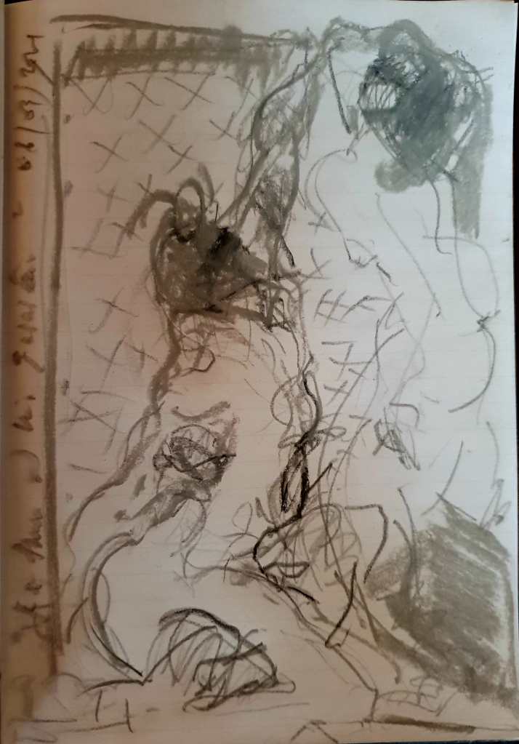

The legend is mainly told by Ovid in his Metamorphoses, Livre X, Fable 6: Pygmalion et Galatée (1st century AD)
Ascanio Condivi, Vita di Michelagnolo [sic] Buonarroti, 1553.
Regarding this passage and the following ones about Michelangelo, (except for the footnotes), read the remarkable work of Baptiste Tochon-Danguy, who condenses in a text present on this site the studies of Michelangelo's contemporaries, as well as others from art historians up to the 20th century. I have borrowed a few passages from him, for which I thank him warmly: Baptiste Tochon-Danguy, Per forza di levare : matière et création dans la sculpture de Michel-Ange, Édition électronique URL http://journals.openedition.org/appareil/2952 ISSN : 2101-0714 Éditeur MSH Paris Nord ; see also the best published study of Michelangelo to date: William Wallace, Michelangelo, The Complete sculpture, painting, architecture, Universe publishing, New York, 2009
Rudolf Wittkower, Qu’est-ce que la sculpture ? : principes et procédures, trad. Béatrice Bonne, Paris, Macula, coll. « Histoire de l’art », 1995, p. 124.
Marlène Zarader, Lire Être et temps de Heidegger, Paris, Vrin, 2012, réédition 2020
Le Dictionnaire de Martin Heidegger, Philippe Arjakovsky, François Fédier, Hadrien France-Lanord (dir.), Paris, éditions du Cerf, 2013.
The most extensive description of the meaning of φύσις [Phusis] among the ancient Greeks can be found in Martin Heidegger, Introduction à la métaphysique, Paris, Gallimard, 1987, coll. "Tel", pp. 26-29
Read about it Jean Beaufret, Dialogue avec Heidegger, Les éditions de Minuit, 1973.

