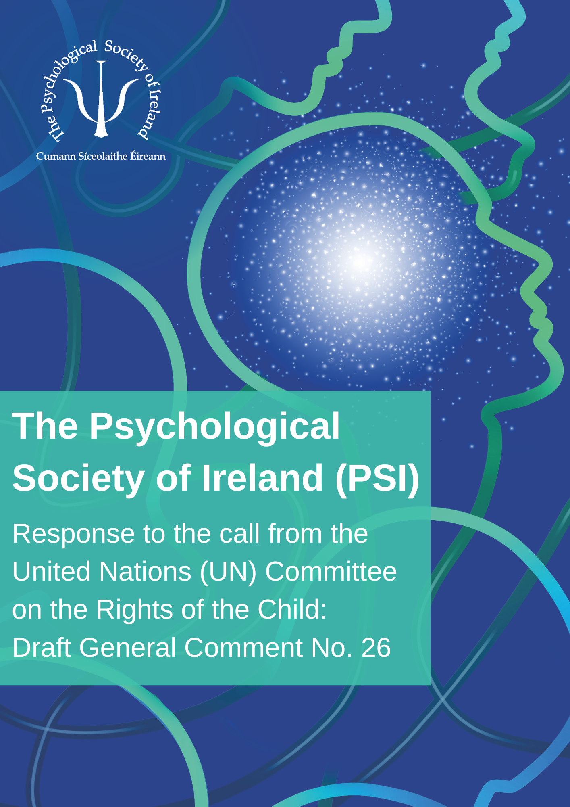

The Psychological Society of Ireland’s (PSI) response to the call from the United Nations (UN) Committee on the Rights of the Child:
Draft General Comment No. 26

Calls for comment on the draft general comment on children’s rights and the environment with a special focus on climate change

III. ‘Specific rights of the Convention as they relate to the environment’, B. The right to the highest attainable standard of health (art. 24), 27. … children’s current and anticipated psychosocial, emotional and mental health problems and suffering caused by environmental harm.

The PSI wishes to express sincere thanks to the Society’s Special Interest Group in Human Rights and Psychology, particularly Dr Michelle Cowley-Cunningham, Dr Elaine Rogers, and Ms Alexis Carey, who coordinated the following response on behalf of the Society.

- Environmental degradation, loss of biodiversity, and climate change impact children’s human rights and present a serious threat to future generations’ enjoyment of human rights. Distressingly, 1.7 million children lose their lives annually as a result of avoidable environmental impacts, while millions more are impacted by disease, displaced from their homes and miss out on receiving education. The PSI Special Interest Group in Human Rights and Psychology (SIGHRP) is grateful to the Committee on the Rights of the Child for this opportunity to submit a stakeholder comment in advance of the drafting of the Draft General Comment No. 26. SIGHRP is appreciative of the work of the Committee in monitoring the implementation of the Convention on the Rights of the Child (UNCRC) and welcomes the Committee's stakeholder call for ideas to aid the development of policies, both domestically and internationally, to address critical climate change issues. Specifically, SIGHRP welcomes the opportunity to comment on the connection between child and adolescent mental health and human rights obligations, and advocates for policies and initiatives to address this issue in the context of climate change.

- SIGHRP fully appreciates that human rights law instruments cannot replace any enforcement mechanism for instruments or principles of international environmental law, and that international human rights law and international environmental law are generally separate legal frameworks presenting different logic and limitations. Rather than present an exhaustive set of recommendations, SIGHRP is highlighting concerns in line with UNCRC Article 24 and how the issue of environmental degradation and children’s awareness of climate change present an important linkage to children’s mental health and well-being. Applying the definition of a child as defined in the UN Convention as a person under the age of 18 years, SIGHRP’s comment outlines potential elements of priority for consideration and advocacy from this perspective.

- Since the previous Draft General Comment No. 26, innovative medical and mental health research has discovered a potential relationship between climate anxiety and anxiety disorders. ‘Climate anxiety’ relates to how humans may perceive, fear, or dread the impacts of climate change via anxiety and apprehension over both immediate and future threats. Climate anxiety may be for oneself and one’s own family (egoistic), for future generations (social–altruistic), or for the environment and animals (biospheric). The Diagnostic and Statistical Manual of Mental Disorders (DSM-5, 5th Edition), categorises anxiety disorders as groups of symptoms that are chronic, severe, manifesting as clinically maladaptive behaviours including restlessness, irritability, panic, sleep and digestive disturbance. Symptoms diverge between individuals and across ages; however, they may include negative thoughts and chronic rumination, restlessness, panic attacks, sleep, and digestive disturbance. Climate anxiety has been associated with clinical behavioural clusters including excessive worrying, difficulty sleeping, and negative impacts on work, study, and family relationships.

- Globally, children experience increasing mental health distress as a result of climate change and its bleak narrative. Although mental health can be shaped by social determinants of health including poverty, food security/nutrition, neighbourhood/community, and trauma, environmental changes are compounding these influences in the lives of children. Climate anxiety diverges from anxiety disorders because it presents a rational response to a real, major, and global threat. Increasingly, we see children across a range of ages and maturity readily demonstrate their understanding of the threat climate change poses. In accordance with the UNCRC Article 12, children who are capable of forming their own opinions have a right to freely express their views in all matters affecting them. Given an opportunity, many children and adolescents readily express their climate empathy and climate distress, and may even be uniquely predisposed to climate anxiety. As psychologists, we understand that children and adolescents are cognisant of the peril climate change presents to their life and future. Similar to adults, they have the capacity to recognise the real psychological, physiological, and social threat to their environment and future it presents.

- Paradoxically, from a psychological perspective, climate anxious behaviour is on the one hand healthy because it presents the impetus for an adaptive psychological, physiological, or behavioural response to threats in the environment, but on the other hand recent research suggests experience of worry and distress in response to climate change may range from mild to clinical anxiety (e.g., excessive negative thought patterns that may result in distress accompanied by mild, or in rare cases, functional impairment)¹². That said, SIGHRP do not advocate for pathologising climate anxiety. Rather, that adaptations prompted by apprehension about climate change may facilitate pro-environmental behaviour and a sense of empowerment. Maladaptive climate anxiety may invoke feelings of helplessness or hopelessness that overwhelm and impact psycho-social health and well-being (or that in some cases climate anxiety presents a dimension of a pre-existing anxiety disorder)¹². SIGHRP support foregrounding climate justice, by centring power operations in the child’s personal sensemaking whilst recognising the need for change is at political, structural, systemic, and cultural levels. Much of the evidence comes from the Western countries. In line with other researchers, SIGHRP believes a research agenda reflecting a global perspective is required, to increase share of voice by non-Western countries. Indigenous peoples and children connected to the natural world are most impacted by climate anxiety – indeed climate trauma¹⁶, and are, therefore, identified as vulnerable. The unjust paradox of climate justice is that those who contribute least to climate change are most affected. This potentially holds true for health and mental health.

- Regardless of the severity of climate anxiety experienced (e.g., climate empathy, climate distress, clinical anxiety), SIGHRP advocates for climate change interventions and initiatives that seek to align with children and adolescent experience across the range. In particular, SIGHRP recommends initiatives that psychologically protect and empower children to be informed, expressive, family-centred, peer supported, and intervention-enabled to adapt and measurably contribute to the alleviation of the climate crisis in their lifetime.

Recommendations

- Promote parity of mental health and physical health with regard to the climate crisis context
Article 24 of the UNCRC recognises the right of the child to the highest attainable standard of health and to facilities for the treatment of illness and rehabilitation of health. While it is vital for States Parties to combat disease, provide adequate nutrition, clean drinking water, and intervene when the risk of environmental pollution presents, it is recommended States Parties should also endeavour to recognise mental health’s parity, with physical health and allocate resources appropriately, so as to prevent illness and loss of well-being (e.g., whether it be tackling air pollution risks posing neurodevelopmental skills, or enacting solutions to aid children and adolescents adapt to their climate anxiety concerns; see also Report of the First Children and Young People’s Consultation on the General Comment No. 26 documents, 2022).

- Allocate the resources of States Parties to climate change education and awareness raising
In the effort to help children and adolescents cope with the unavoidable impacts of climate change, best practice support requires systematic delivery, for example, by introducing climate change education and resources at primary and secondary school age (ensuring that the needs of children and adolescents with disabilities are also met). Included in this curriculum, whether it be supplementary, modular, optional, or mandatory form, are teaching methods (e.g., digitally enabled) that best enable active participation by children, their teachers or educators, their parents, and guardians. Moreover, States Parties should enable children and adolescents to contribute their views and experiences on the development, implementation, and monitoring of these education programme plans. It is proposed the central tenets of this curriculum:
- introduce child human rights and the UNRC.
- address the concept of climate anxiety and its relationship with child and adolescent mental health and well-being.
- action health and well-being strategies to children that foster their coping and adaptive behaviour change.
Research shows that children who are knowledgeable about the UNCRC, and have their views taken into account when decisions affecting them are made, rate measurably higher on subjective well-being indicators than those who do not.

- Promote consumer empowerment agendas to enable children to participate in environmentally-friendly and healthy consumer choices
UNCRC Article 12 affirms children who are capable of forming their own opinions have a right to freely express their views in all matters affecting them, in so much as the views of the child are given due weight in accordance with the age and maturity of the child. Consider that children tend to become brand aware from the age of 9-11 years and children’s influence on parental purchase decisions is well documented, whether it be positive or negative. The UN Convention acknowledges the family as the fundamental unit of society not only advocating for the role of parents as the primary caregivers with responsibility for the up-bringing of their children, but obliges governments to help parents fulfil their essential role. Moreover, the UNCRC’s Article 17 details children’s right to appropriate information and encourages States Parties to develop and adopt appropriate guidelines for the protection of the child from information and material injurious to their well-being,. For example, that States Parties promote and make mandatory an independently verified label for environmental excellence, with guaranteed low environmental impact (e.g., the use of the EU Ecolabel). Therefore, it is recommended that States Parties prioritise and support climate-change informed and family-centred purchasing aided by responsible public messaging to offset human rights abuses by third parties, including businesses. Improvements in education (see Recommendation II above) and responsible public messaging will in turn help children cope with the unavoidable impacts of climate change. It is proposed that enabling participatory and well-informed consumer decisions are likely to support children as non-complicit actors in the climate crisis, thereby countering climate anxiety and promoting climate-informed well-being.

- Establish an international ‘Climate Justice Safe Space Forum’ for children to raise product marketing concerns
In making these recommendations, the findings of the UN’s First Children and Young People’s Consultation (2022) regarding the UN Committee on the Rights of the Child Draft General Comment No. 26 calling on governments to take action on the environmental crisis, have been taken into account. Climate justice and just transition themes rank high on children’s climate agenda whether it be voiced in this call’s consultation, or by the National Youth Assembly on Climate in Ireland. It is recommended that an international forum with specific remit is established. This forum would highlight how intended, unintended, foreseen, and unforeseen consequences or side effects of product marketing or merchandise strategy targeted at children make their consumer choices complicit in damaging or exploiting the environment, their health and well-being, or the health and welfare of other children either locally or globally. This forum should be internationally resourced, be presided over by children for children, present a safe space to facilitate children’s voice and conjecture, and give due attention to testing the legitimacy of their concerns. Such a forum will better enable children’s collective voice, including seldom heard voices of minority children and those with disabilities to compel clear and transparent actions from corporations and campaign for climate justice on an international stage⁷. It is not intended this forum to be considered a replacement for expectations that States Parties address their general targets associated with the UN’s sustainable development goals (SDGs). States Parties should remain committed to fully implementing all actions required to meet national climate targets. That is, to remove and reduce the risks posed by climate change to children’s health and mental health, to complement and add constructively to progress successful implementation of general targets. Moreover, advocating for children’s rights in this way will encourage the development of appropriate guidelines for their protection from information and material injurious to their present and prospective health and well-being.

UN General Comment No. 26. Available at: https://childrightsenvironment.org/about/
Clayton, S. & Karazsia, B. T. Development and validation of a measure of climate change anxiety. J. Environ. Psychol. 69, 101434 (2020). https://doi.org/10.1016/j.jenvp.2020.101434
Helm, S. V., Pollitt, A., Barnett, M. A., Curran, M. A. & Craig, Z. R. Differentiating environmental concern in the context of psychological adaptation to climate change. Glob. Environ. Change 48, 158–167 (2018). https://doi.org/10.1016/j.gloenvcha.2017.11.012
Diagnostic and Statistical Manual of Mental Disorders: DSM-5 5th Edition (American Psychiatric Association, 2013).
Hickman, C. et al. Climate anxiety in children and young people and their beliefs about governmental responses to climate change: a global survey. Lancet Planet. Health 5, e863–e873 (2021). A global survey, conducted in 10 countries, of climate anxiety in 10,000 youth aged 16–25 years.
Obradovich, N. et al. Empirical evidence of mental health risks posed by climate change. The Proceedings of the National Academy of Sciences 115, 10953-10958 (2018). https://doi.org/10.1073/pnas.180152811
Kennedy, A. M., & Witham, S. M. The interplay between social and ecological determinants of mental health for children and youth in the climate crisis. Int. J. Environ. Res. & Public Health 18(9), 4573 (2021). https://doi.org/10.3390/ijerph18094573
Greta Thunberg (Teen Vogue Special Issue). Available at: www.teenvogue.com/story/greta-thunberg-climate-strike-teen-vogue-special-issue-cover
UNCRC www.gov.ie/en/publication/a1481d-united-nations-convention-on-the-rights-of-the-child/
UN Report of the first children and young people’s consultation on General comment No. 26 (September 2022). Available at: https://childrightsenvironment.org/wp-content/uploads/2022/09/Report-of-the-first-Children-and-Young-Peoples-Consultation.pdf
Thunberg, G. No One Is Too Small to Make a Difference: Illustrated Edition (2019). Penguin Books Ltd.
Crandon, T. J. et al. A social-ecological perspective on climate anxiety in children and adolescents. Nat. Climate Change 12, 123–131 (February 2022). https://doi.org/10.1038/s41558-021-01251-y
The Climate Crisis is a Child Rights Crisis: Introducing the Children’s Climate Risk Index (UNICEF, 2021). A report that identifies how children are exposed and vulnerable to the impacts of climate change, using the Children’s Climate Risk Index. Available at: www.unicef.org/press-releases/one-billion-children-extremely-high-risk-impacts-climate-crisis-unicef
Charlson, F. et al. Climate change and mental health: a scoping review. Int. J. Environ. Res. Public Health 18, 4486 (2021). https://doi.org/10.3390/ijerph18094486
Parkes, A. (2013). Children and international human rights law: The right of the child to be heard. Taylor & Francis.
Morgan, G., Barnwell, G., Johnstone, L., Shukla, K., & Mitchell, A. The Power Threat Meaning Framework and the climate and ecological crises, (2022). University of Leicester. https://doi.org/10.57157/pins2022Vol63iss1a5444
Coffey, Y., Bhullar, N., Durkin, J., Islam, S., & Usher, K. Understanding Eco-anxiety: A Systematic Scoping Review of Current Literature and Identified Knowledge Gaps. J. Climate Change & Health, 3, (2021). https://doi.org/10.1016/j.joclim.2021.100047
Castagna, A. et al. Air pollution and neurodevelopmental skills in pre-school and school-aged children: A systematic review. Neurosci. & Biobehavior.l Rev. 136, 104623 (2022). https://10.1016/j.neubiorev.2022.104623
OHCHR. General comment No. 20 on the implementation of the rights of the child during adolescence. Available at: https://www.ohchr.org/en/documents/general-comments-and-recommendations/general-comment-no-20-2016-implementation-rights
Casas, F., González-Carrasco, M., & Luna, X. Children's rights and their subjective well-being from a multinational perspective. Eur. J. Educ. 53, 336–350 (2018). https://doi.org/10.1111/ejed.12294
Wang, F., & Shu, L. When does product brand matter to children? Int. J. of Market Res 61(4), (2018). https://doi.org/10.1177/14707853188026.
Dikcius, V. et al. Children’s influence on parental purchase decisions: Scale development and validation. Int. J. of Market Res 62(4), 449–467 (2019). https://doi.org/10.1177/1470785319872377
Children’s Rights Alliance Ireland. The United Nations Convention on the Rights of the Child. Available at: www.childrensrights.ie/sites/default/files/submissions_reports/files/UNCRCEnglish_0.pdf
Office of the Children’s Ombudsman Ireland. Public Consultation on the Regulation of Harmful Content on Online Platforms and the Implementation of the Revised Audiovisual Media Services Directive. Available at: https://www.oco.ie/app/uploads/2019/04/OCO-Submission_DCCAEOnlineSafetyConsultation_April2019.pdf
EU Ecolabel. Available at: https://environment.ec.europa.eu/topics/circular-economy/eu-ecolabel-home_en
Fullerton, D. Report of the National Youth Assembly on Climate, (2022). Available at: www.gov.ie/pdf/?file=https://assets.gov.ie/240077/89733538-2da4-4a96-843d-0375db9e21b9.pdf#page=null
Clemens, V. et al. Report of the intergovernmental panel on climate change: implications for the mental health policy of children and adolescents in Europe—A scoping review. Eur. J. of Child & Adolescent Psych. 31, 701–713 (2022). https://doi.org/10.1007/s00787-020-01615-3
Hogan, L., et al. Creating our future: Expert Committee report, (2022). Available at: https://creatingourfuture.ie/wp-content/uploads/2022/07/Creating-Our-Future-EXPERT-Report.pdf

