A Proposed Knowledge Based System for Desktop PC Troubleshooting
Ahmed Wahib Dahouk, Samy S. Abu-Naser
Department of Information Technology,
Faculty of Engineering and Information Technology,
Al-Azhar University, Gaza, Palestine

Abstract: Background: In spite of the fact that computers continue to improve in speed and functions operation, they remain complex to use. Problems frequently happen, and it is hard to resolve or find solutions for them. This paper outlines the significance and feasibility of building a desktop PC problems diagnosis system. The system gathers problem symptoms from users’ desktops, rather than the user describes his/her problems to primary search engines. It automatically searches global databases of problem symptoms and solutions, and also allows ordinary users to contribute exact problem reports in a structured manner. Objectives: The main goal of this Knowledge Based System is to get the suitable problem desktop PC symptoms and the correct way to solve the errors. Methods: In this paper the design of the proposed Knowledge Based System which was produced to help users of desktop PC in knowing many of the problems and error such as : Power supply problems, CPU errors, RAM dumping error, hard disk errors and bad sectors and suddenly restarting PC. The proposed Knowledge Based System presents an overview about desktop PC hardware errors are given, the cause of fault are outlined and the solution to the problems whenever possible is given out. CLIPS Knowledge Based System language was used for designing and implementing the proposed expert system. Results: The proposed PC desktop troubleshooting Knowledge Based System was evaluated by IT students and they were satisfied with its performance.

Keywords: Knowledge Based System; Desktop PC; Troubleshooting.

Introduction
In spite of continuous advances in hardware and software technology, computers are still hard to use. They often behave in unexpected ways, and it is hard to find fixes for problems encountered.
The typical approach to solving a problem is to describe the symptoms (e.g. “keep restarting or blue screen dumping memory”) to the keyword search interface of a vendor-owned help database, a small number of public databases, and then finally a broad “Google”-like search of the entire web. With luck, the “right” choice of keywords may quickly produce an article or posting describing the problem, the cause, and hopefully a resolution. More likely, though, the user gets back too little, too much, or the wrong information. He may continue searching, contact customer support or a message board, or simply give up and hope the problem doesn’t come up again. This can be time consuming. Moreover, for a given problem, this diagnostic process is repeated for each user touched by the problem, leading to massive global costs as a single problem is diagnosed millions of times. In contrast, root cause analysis and repair is done relatively infrequently. Once a user has identified a problem’s symptoms and repair procedures.
This paper presents the flat vision in which computers diagnose their own problems, benefit prior analysis work done by others [1].
In line with this vision, we propose that problem reports, which today are unstructured text, follow a structured format and in particular that they express symptoms and causes in a machine-readable and machine-testable format. A structured representation simplifies diagnosis since an errant client machine can search for and test itself against symptoms in Knowledge Based System application with high precision. The structured representation, however, complicate the task of problem reporting. While true, we believe that finding and fixing a problem for the first time is where the hard work occurs, and that any incremental burden posed by representing that process in a structured format is small.
Expert systems are computer programs derived from computer science, it copes with concepts of inference process for computers and the knowledge that is used to represent those inferences in terms of a machine.

Expert systems are developed to provide problem solving solutions using knowledge of some specific domain that related to the problem like desktop PC diagnosis. It contains knowledge that used by human experts, even though the “thinking” process is not the same as that of a human expert. The system essentially is a type of information processing system, what makes it different from others is that Knowledge Based System processes knowledge while general information processing system handles information. Knowledge could be derived from various sources, such as textual instructions, databases or personal experience. Expert systems could be roughly divided into the following components(as seen in Figure 1):
- The knowledge base: knowledge base is the collection of domain knowledge required for solving a certain problem, including fundamental facts, rules and other information. The representation of knowledge could be shown in variety of ways such as framework, rules and semantic web, etc. The knowledge base is a major component in Knowledge Based System and it could be separated from other functions inside the Knowledge Based System which makes it easier to modify and improve the performance of the system.
- Inference engine: Inference engine is considered to be the core component inside the expert system, it takes the query of the user as input and make decisions based on preset logic reasoning mechanism, the expansion of knowledge base does not affect the inference engine, however, increasing the size of the knowledge base improves the inference precision as well as enlarges the extent of solvable problem.
- User interface: Users interact with Knowledge Based System through the user interface. User input their necessary information regarding to the specific problem, then the system output the result from inference engine, and provide explanations of that result if available
- Almost all expert systems also have an explanation subsystem, which allows the program to explain its reasoning to the user.
- knowledge base editor which help the expert or knowledge engineer to easily update and check the knowledge base.
- The case specific data includes both data provided by the user and partial conclusions (along with certainty measures) based on this data.

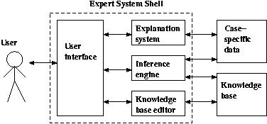
Figure 1: Architecture of an Expert System

MATERIALS AND METHODS
The proposed Knowledge Based System performs diagnosis for desktop PC problems by asking him/her to select the proper symptoms according to his/her problem. The proposed Knowledge Based System will ask the user to choose the correct options given to him/her on the screen. At the end of the dialogue session, the proposed Knowledge Based System provides the main error and recommendation of the solving problem. Figure 2 shows a sample dialogue between the Knowledge Based System and the user. Figure 3 shows how the users get the cause of problem and recommendation.

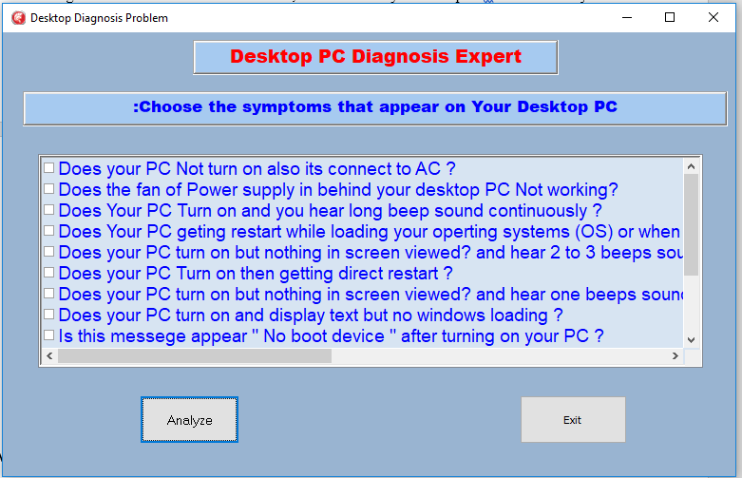
Figure 2: The figure presents shows common symptoms if PC problems.

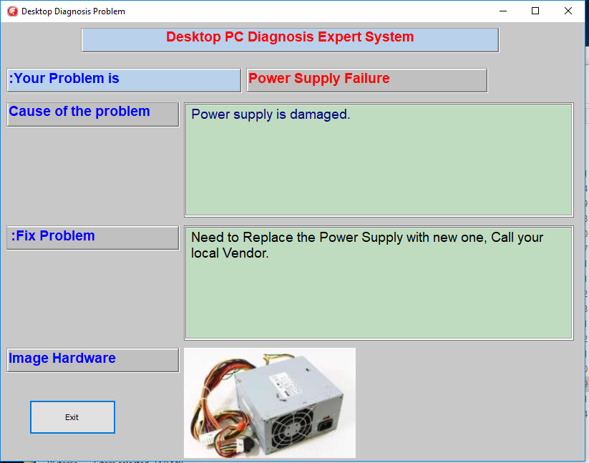
Figure 3: The figure shows Error cause and recommendation of the expert system.

LITERATURE REVIEW
There is a lot of Knowledge Based System that were designed to diagnose problems of humans, plants, and PC such as ESPCRM, but there is no specialized Knowledge Based System for diagnosis of hardware desktop PC available[9-60].
The current proposed Knowledge Based System is specialized in the diagnosis of seven hardware problems in desktop PC : Power Supply Failure, PROCESSOR CPU Error, RAM problems, Error VGA, Hard disk failure, Blue screen memory dump, and CMOS battery for motherboard.

KNOWLEDGE REPRESENTATION
The main sources of knowledge for expert systems either from an expert in the field of computer engineers or a website specialized in repair hardware desktop PC, these sources are transferred to Clips Knowledge Based System Shell with Delphi 10.2 as the interface language.
Currently the Knowledge Based System contains a number of rules that help to solve seven problems of desktop PC [5]:
- Power Supply Failure: The PC power supply is probably the most failure-prone item in a personal computer. It heats and cools each time it is used and receives the first in-rush of AC current when the PC is switched on. Typically, a stalled cooling fan is a predictor of a power supply failure due to subsequent overheated components. All devices in a PC receive their DC power via the power supply.
A typical failure of a PC power supply is often noticed as a burning smell just before the computer shuts down. Another problem could be the failure of the vital cooling fan, which allows components in the power supply to overheat. Failure symptoms include random rebooting or failure in turn on the desktop for no apparent reason.
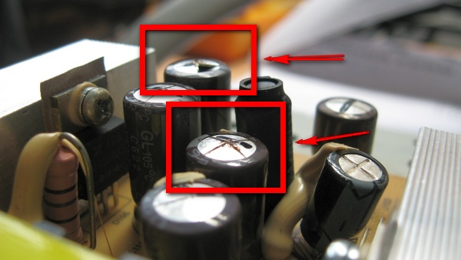
Figure 4: The figure shows the Power Supply Failure [3]

- PROCESSOR CPU Error: The CPU is the brains of your computer. When your computer's CPU is getting older, is used to do functions for which it wasn't intended, or overheats due to poor power flow, it could fail completely. Common reasons a CPU Goes Bad is Heat. Overheating CPU's lead to a dead CPU. This can happen when room temperature is often above 80 degrees Fahrenheit and if the computer has an ineffective cooling mechanism inside. And the second reason is age. Every machine has its limits. A computer that is five years old or older is considered to be in its grace years. They can just give up [4] .
CPU's often simply burn out. To determine that is your problem, consult this list of common processor failure symptoms: Computer turns on, no beeps, no screen. Does not POST (Power-On Self Test), Computer turns on, fans run at highest speeds, still no POST, and operating system not loading, Computer powers on, but turns off immediately.
- Random Access Memory, or RAM problems: RAM, is a way for your computer to store temporary data, rather than in a cache or permanent storage. Storage, often wrongly referred to as memory, is permanent data stored on a hard drive or solid state drive. A CPU cache is a small amount of often-needed memory that is stored on a CPU chip. Both the RAM and CPU cache are temporary data stores that are cleared when your computer is turned off.
Symptoms of a RAM Problem:
- When you first turn on your computer it runs fine, but as you go about your business you notice that its performance diminishes. By lunch time, websites take minutes to load and local programs run at a snail's pace.
- Your computer randomly restarts while you are in the middle of something or freeze sporadically. It may also reboot almost immediately upon opening the desktop. This could be a sign of faulty RAM.
Causes Memory Damage:
Power surges can damage most computer components, including RAM.
Excessive heat can cause RAM and other parts to wear out over time. Individual components can overheat, or heat from one component can cause damage to adjacent parts.
Your memory module may have some fault that passed through quality control and worsened over time. This is the most likely cause behind a damaged RAM.

- VGA Problems: When a display adapter is having problems it can have all kinds of symptoms: crashes, hangs, freezes, graphics artifacts (display corruption), and more. If your video card is displaying some things incorrectly then you may be able to identify the problem by comparing your screen errors with examples screenshots. [5]
Symptoms of a VGA Card Problem:
- Artifacting
When something is going wrong with the graphics card, you may notice this via bizarre visuals onscreen. This is because the graphics card is how the PC “draws” onto the monitor. Colors will look strange, 3D models will stretch for no reason, “digital snow” will appear, or the entire screen will be covered in visual garbage.
- Loud Fan Sounds
When you boot up software that uses 3D graphics (or even when you boot up the computer!), you might hear what sounds like a small jet aircraft taking off within the PC. This is the telltale sound of one of your system fans going into overtime. If this fan is the one on your graphics card, it might be a sign that something’s not quite well with it.
- Black Screens

Sometimes you won’t see any visual clues at all! A graphics card gone bad can simply decide to stop working and not display anything. You’ll have to resort to integrated graphics or a cheap “throwaway” graphics card to see if it’s your card or your monitor acting up. If it works with either of those, it’s most likely your graphics card at fault.

- Hard disk failure problem

The hard drive or hard disk drive is a large component in your computer that stores all your user software and all the files you create. There are two sizes predominantly - the 3½" size for desktop computers and the 2½" size for notebook computers. [6]
Unfortunately hard disk drives have a limited life span. Somewhere between 3-5 years is the normal life span of a hard drive, depending on how much work it does on a day to day basis. Environmental conditions also play a significant part in determining the life duration of the hard drive.
Principal causes of failure of hard drives include:
- Heat (a build up of excessive heat especially in notebook computers)
- Bumps and vibration (particular in regard to notebook computers)
- Wear and tear / metal fatigue / old age of components
- Electrical storm / power surge

You will know if it is a physical failure by the noise the drive will make. You will hear a clicking, clunking, grinding or whirring sound coming from the hard drive. Do not mistake the sounds for a malfunctioning cooling fan. Carefully open the case and listen close to the drive.

And you after you turn you desktop, your operating system will not loading and you well get this message “ No boot device ” .

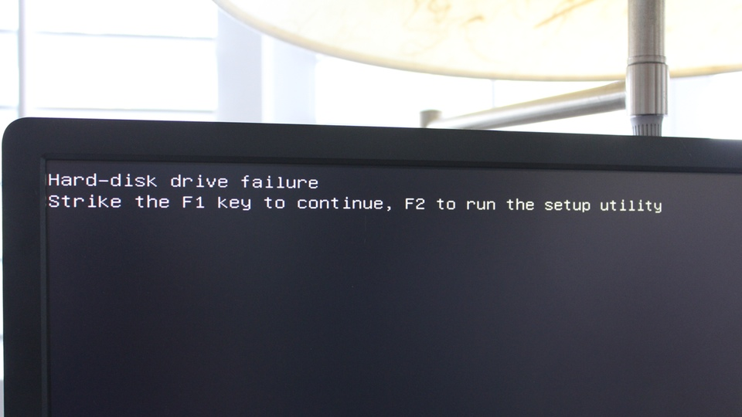
Figure 5: The figure shows the hard disk failure in desktop PC [6]

- A blue screen memory dump is an error screen that comes up just before the system gets rebooted, because the operating system is no longer able to function properly due to a variety of reasons, and the content of the RAM is dumped on to a data file. This is a frequent problem mainly encountered in various versions of Windows operating system and is also popularly called the Blue Screen of Death (BSoD). Fixing a blue screen memory dump will be specific to correcting the error which is displayed on the screen. Sometimes it is difficult to figure out the particular error from the info on the screen, and therefore a broad correction strategy is undertaken to solve the issue. Here are a few steps which address frequently encountered problems in BSoD [7].

Usually the main cause of this problem is a Damaged Hard Drive, Sometimes the cause of BSoD is a faulty hard disk. Most Windows operating systems have a diagnostic scan for the hard drive, and you need to run this to figure out the problem. Sometimes the operating system will encounter a problem where it is unable to read from the hard disk, and in such cases apart from the hard disk, you also need to check out the SCSI (Small Computer System Interface) terminator.

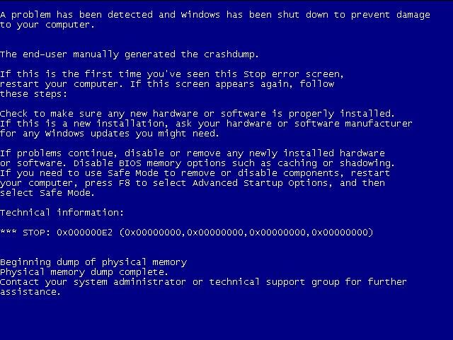
Figure 6: The figure shows the blue screen memory dump in desktop PC [7]

- CMOS battery Error in motherboard: CMOS (complementary metal-oxide-semiconductor) is the term usually used to describe the small amount of memory on a computer motherboard that stores the BIOS settings. Some of these BIOS settings include the system time and date as well as hardware settings. Most talk of CMOS involves clearing CMOS, which means to reset the BIOS settings to their default levels. This is a really easy task that's a great troubleshooting step for many types of computer problems. See How to Clear CMOS for several ways to do this on your computer.[8]
The CMOS battery is a small battery fitted on the motherboard of your computer. It has a life of around five years. You need to use the computer regularly to extend the life of the CMOS battery. The computer power supply increases the availability of a standby current and hence increases the life of the battery.

If the computer is not plugged in regularly, the life of the battery is normally 3 years. However, the life of the battery gets extended to 5 years when you use it regularly. The battery provides power to CMOS memory and the real-time clock.
If the CMOS battery failed, incorrect computer date and time settings. Also, the date/time keep getting reset even after you fix them in the BIOS. This is the most common CMOS battery failure sign. Your PC occasionally turns off or doesn’t start. Drivers stop working.
You may start to get errors while booting that say something like “CMOS checksum error” or “CMOS read error“. Some weird hardware issues such as your computer not being able to locate the mouse, keyboard, or printer.

LIMITATIONS
The current proposed Knowledge Based System is specialized in the diagnosis of Desktop PC hardware problems: Power Supply Failure, PROCESSOR CPU Error, Random Access Memory RAM problems, VGA Problems, Hard disk failure problem, blue screen memory dump problem and CMOS battery Error in motherboard problem.

SYSTEM EVALUATION
As a preliminary evolution, Group of IT users tested this proposed Knowledge Based System and they were satisfied with its performance, efficiency, user interface and ease of use.

CONCLUSION
Despite continuous advances in hardware and software, computers are still difficult to use and users frequently have problems. Computer usability is essentially an availability issue: if the user can’t get their job done, it is irrelevant that the computer is running. The correct metric of computer availability therefore is not the traditional uptime metric, but instead is the user’s ability to get work done (goodtime).
This paper argues that an important way to increase goodtime is to decrease the time spent diagnosing problems by automating the diagnosis process, when the user encounters a problem. This Knowledge Based System does not need intensive training to be used; it is easy to use and has user friendly interface. It was developed using Clips Knowledge Based System Shell with Delphi 10.2. as the interface language.

REFERENCES
- Using Computers to Diagnose Computer Problems Joshua A. Redstone, Michael M. Swift, Brian N. Bershad Department of Computer Science and Engineering University of Washington, Seattle
- (redstone, mikesw, bershad)@cs.washington.edu
- Abu-Nasser, B. S. (2017). Medical Expert Systems Survey. International Journal of Engineering and Information Systems, 1(7), 218-224.
- https://computer.howstuffworks.com/power-supply4.htm
- https://turbofuture.com/computers/What-a-CPU-Does-When-It-Goes-Bad-or-Fails
- http://www.playtool.com/pages/troubleshooting/intro.html
- http://www.leoisaac.com/tec/main030.htm
- http://www.steves-digicams.com/knowledge-center/how-tos/troubleshooting-repair/how-to-fix-a-blue-screen-memory-dump.html
- https://www.lifewire.com/what-is-cmos-2625826
- Abu Naser, S. S., & ALmursheidi, S. H. (2016). A Knowledge Based System for Neck Pain Diagnosis. World Wide Journal of Multidisciplinary Research and Development (WWJMRD), 2(4), 12-18.
- Abu Ghali, M. J., Mukhaimer, M. N., Abu Yousef, M. K., & Abu Naser, S. S. (2017). Expert System for Problems of Teeth and Gums. International Journal of Engineering and Information Systems (IJEAIS), 1(4), 198-206.
- Abu Naser, S., & Akkila, A. N. (2008). A Proposed Expert System for Skin Diseases Diagnosis. INSInet Publication. Journal of Applied Sciences Research, 4(12), 1682-1693.
- Akkila, A. N., & Abu Naser, S. S. (2016). Proposed Expert System for Calculating Inheritance in Islam. World Wide Journal of Multidisciplinary Research and Development, 2(9), 38-48.
- Abu-Naser, S. S., Kashkash, K. A., & Fayyad, M. (2010). Developing an expert system for plant disease diagnosis. Journal of Artificial Intelligence ; Scialert, 3(4), 269-276.
- Al Rekhawi, H. A., Ayyad, A. A., & Abu Naser, S. S. (2017). Rickets Expert System Diagnoses and Treatment. International Journal of Engineering and Information Systems (IJEAIS), 1(4), 149-159.
- Abu Naser, S., Al-Dahdooh, R., Mushtaha, A., & El-Naffar, M. (2010). Knowledge management in ESMDA: expert system for medical diagnostic assistance. AIML Journal, 10(1), 31-40.
- Azaab, S., Abu Naser, S., & Sulisel, O. (2000). A proposed expert system for selecting exploratory factor analysis procedures. Journal of the College of Education, 4(2), 9-26.
- Abu Naser, S., & El Haddad, I. (2016). An Expert System for Genital Problems in Infants. World Wide Journal of Multidisciplinary Research and Development (WWJMRD), 2(5).
- Bakeer, H. M. S., & Naser, S. S. A. (2017). Photo Copier Maintenance Expert System V. 01 Using SL5 Object Language. International Journal of Engineering and Information Systems (IJEAIS), 1(4), 116-124.
- Abu Naser, S. S. (1993). A methodology for expert systems testing and debugging. North Dakota State University, USA.
- El Agha, M., Jarghon, A., & Abu Naser, S. S. (2017). Polymyalgia Rheumatic Expert System. International Journal of Engineering and Information Systems (IJEAIS), 1(4), 125-137.
- Abu Naser, S. S. (1999). Big O Notation for Measuring Expert Systems complexity. Islamic University Journal Gaza, 7(1), 57-70.
- Hilles, M. M., & Abu Naser, S. S. (2017). Knowledge-based Intelligent Tutoring System for Teaching Mongo Database. EUROPEAN ACADEMIC RESEARCH, 6(10), 8783-8794.
- Khella, R. A., & Abu Naser, S. S. (2017). Expert System for Chest Pain in Infants and Children. International Journal of Engineering and Information Systems (IJEAIS), 1(4), 138-148.
- AbuEl-Reesh, J. Y., & Abu Naser, S. S. (2017). An Expert System for Diagnosing Shortness of Breath in Infants and Children. International Journal of Engineering and Information Systems (IJEAIS), 1(4), 102-115.
- Mrouf, A., Albatish, I., Mosa, M., & Abu Naser, S. S. (2017). Knowledge Based System for Long-term Abdominal Pain (Stomach Pain) Diagnosis and Treatment. International Journal of Engineering and Information Systems (IJEAIS), 1(4), 71-88.
- Abu Naser, S. S. (2015). Sl5 Object: Simpler Level 5 Object Expert System Language. International Journal of Soft Computing, Mathematics and Control (IJSCMC), 4(4), 25-37.
- Nabahin, A., Abou Eloun, A., & Abu Naser, S. S. (2017). Expert System for Hair Loss Diagnosis and Treatment. International Journal of Engineering and Information Systems (IJEAIS), 1(4), 160-169.
- Abu-Naser, S., El-Hissi, H., & Abu-Rass, M. (2010). An Expert System for Endocrine Diadnosis and Treatment using JESS. Journal Of Artificial Intelligence, 4, 239-251.
- Abu Naser, S. S., & Al-Bayed, M. H. (2016). Detecting Health Problems Related to Addiction of Video Game Playing Using an Expert System. World Wide Journal of Multidisciplinary Research and Development, 2(9), 7-12.
- Naser, S. S. A., & Al-Nakhal, M. A. (2016). A Ruled Based System for Ear Problem Diagnosis and Treatment. World Wide Journal of Multidisciplinary Research and Development, 2(4), 25-31.
- Qwaider, S. R., & Abu Naser, S. S. (2017). Expert System for Diagnosing Ankle Diseases. International Journal of Engineering and Information Systems (IJEAIS), 1(4), 89-101.
- Abu Naser, S. S., Baraka, M. H., & Baraka, A. (2008). A Proposed Expert System For Guiding Freshman Students In Selecting A Major In Al-Azhar University, Gaza. Journal of Theoretical & Applied Information Technology, 4(9).
- Naser, S. S. A., & Hasanein, H. A. A. (2016). Ear Diseases Diagnosis Expert System Using SL5 Object. World Wide Journal of Multidisciplinary Research and Development, 2(4), 41-47.
- Almurshidi, S. H., & Abu Naser, S. S. (2017). Design and Development of Diabetes Intelligent Tutoring System. EUROPEAN ACADEMIC RESEARCH, 6(9), 8117-8128.
- Abu Naser, S. S., & Mahdi, A. O. (2016). A proposed Expert System for Foot Diseases Diagnosis. American Journal of Innovative Research and Applied Sciences, 2(4), 155-168.
- Naser, S. S. A., & Hilles, M. M. (2016). An expert system for shoulder problems using CLIPS. World Wide Journal of Multidisciplinary Research and Development, 2(5), 1-8.
- Abu-Naser, S. S., El-Hissi, H., Abu-Rass, M., & El-Khozondar, N. (2010). An expert system for endocrine diagnosis and treatments using JESS. Journal of Artificial Intelligence; Scialert, 3(4), 239-251.
- Abu Naser, S. S., & Hamed, M. A. (2016). An Expert System for Mouth Problems in Infants and Children. Journal of Multidisciplinary Engineering Science Studies (JMESS), 2(4), 468-476.
- Abu Naser, S. S., & Al-Bayed, M. H. (2016). Detecting Health Problems Related to Addiction of Video Game Playing Using an Expert System. World Wide Journal of Multidisciplinary Research and Development, 2(9), 7-12.
- Abu Naser, S. S., Alamawi, W. W., & Alfarra, M. F. (2016). Rule Based System for Diagnosing Wireless Connection Problems Using SL5 Object. International Journal of Information Technology and Electrical Engineering, 5(6), 26-33.
- Abu Naser, S. S., & Alawar, M. W. (2016). An expert system for feeding problems in infants and children. International Journal of Medicine Research, 1(2), 79--82.
- Abu Naser, S. S., & AlDahdooh, R. M. (2016). Lower Back Pain Expert System Diagnosis and Treatment. Journal of Multidisciplinary Engineering Science Studies (JMESS), 2(4), 441-446.
- Abu Naser, S. S., & Alhabbash, M. I. (2016). Male Infertility Expert system Diagnoses and Treatment. American Journal of Innovative Research and Applied Sciences, 2(4).
- Abu Naser, S. S., & Al-Hanjori, M. M. (2016). An expert system for men genital problems diagnosis and treatment. International Journal of Medicine Research, 1(2), 83-86.
- Abu Naser, S. S., & Bastami, B. G. (2016). A proposed rule based system for breasts cancer diagnosis. World Wide Journal of Multidisciplinary Research and Development, 2(5), 27-33.
- Abu Naser, S. S., & El-Najjar, A. E. A. (2016). An expert system for nausea and vomiting problems in infants and children. International Journal of Medicine Research, 1(2), 114-117.
- Abu Naser, S. S., & Ola, A. Z. A. (2008). An Expert System For Diagnosing Eye Diseases Using CLIPS. Journal of Theoretical & Applied Information Technology, 4(10).
- Abu Naser, S. S., & Shaath, M. Z. (2016). Expert system urination problems diagnosis. World Wide Journal of Multidisciplinary Research and Development, 2(5), 9-19.
- Abu Naser, S. S., & Zaqout, I. S. (2016). Knowledge-based systems that determine the appropriate students major: In the faculty of engineering and information technology. World Wide Journal of Multidisciplinary Research and Development, 2(10), 26-34.
- Almurshidi, S. H., & Naser, S. S. A.(2018). Expert System For Diagnosing Breast Cancer. Al-Azhar University, Gaza, Palestine.
- Abu Naser, S., & Aead, A. M. (2013). Variable Floor for Swimming Pool Using an Expert System. International Journal of Modern Engineering Research (IJMER), 3(6), 3751-3755.
- Abu Naser, S. S., Al Shobaki, M. J., & Abu Amuna, Y. M. (2016). Promoting Knowledge Management Components in the Palestinian Higher Education Institutions-A Comparative Study. International Letters of Social and Humanistic Sciences, 73, 42-53.
- Abu Naser, S. S., Al Shobaki, M. J., & Amuna, Y. M. A. (2016). Knowledge Management Maturity in Universities and its Impact on Performance Excellence" Comparative study". Journal of scientific and Egineering research, 3(4), 4-14.
- Abu Naser, S. S., Al Shobaki, M. J., & Amuna, Y. M. A. (2016). Measuring knowledge management maturity at HEI to enhance performance-an empirical study at Al-Azhar University in Palestine. International Journal of Commerce and Management Research, 2(5), 55-62.
- Abu-Naser, S., Al-Masri, A., Sultan, Y. A., & Zaqout, I. (2011). A prototype decision support system for optimizing the effectiveness of elearning in educational institutions. International Journal of Data Mining & Knowledge Management Process (IJDKP), 1, 1-13.
- Hilles, M. M., & Abu Naser, S. S. (2017). Knowledge-based Intelligent Tutoring System for Teaching Mongo Database. EUROPEAN ACADEMIC RESEARCH, 6(10), 8783-8794.
- Abu Naser, S. S., Al Shobaki, M. J., & Abu Amuna, Y. M. (2016). KMM Factors Affecting High Performance in Universities' Case Study on Al-Quds Open University in Gaza-Strip'. International Journal of Information Technology and Electrical Engineering, 5(5), 46-56.
- Abu Naser, S. S., Al Shobaki, M. J., & Abu Amuna, Y. M. (2016). KM Factors Affecting High Performance in Intermediate Colleges and its Impact on High Performance-Comparative Study. Computational Research Progress in Applied Science & Engineering, 2(4), 158-167.
- Abu Naser, S. S., Al Shobaki, M. J., & Abu Amuna, Y. M. (2016). KMM Factors Affecting High Performance in Universities' Case Study on Al-Quds Open University in Gaza-Strip'. International Journal of Information Technology and Electrical Engineering, 5(5), 46-56.

