Chapter for Routledge Handbook of the Philosophy of Public Health
(Editors: S. Venkatapuram & A. Broadbent)

Explanation in Public Health

Olaf Dammann, Tufts University School of Medicine

Abstract
In this chapter, I first outline the public health workflow from assessment via goal definition and intervention to evaluation. Further, I discuss the types and subtypes of explanation used in public health research and practice: scientific, justificatory, methodological, and prospective. In doing this, I take the discussion far beyond the usual focus in philosophy of science as answers to “why?”-questions. The chapter ends with a few comments on my proposal.

1. Introduction
What are the things that call for an explanation in public health? What types of explanation are used to do the explaining and what are their functions in public health practice?

Let me begin with a brief note on explanation. There are of course many definitions of the term, both in general dictionaries and in the philosophical literature. For example, the Merriam-Webster Thesaurus states that explanation is “a statement that makes something clear” and the Encyclopedia Britannica defines the philosophical concept of explanation as a “set of statements that makes intelligible the existence or occurrence of an object, event, or state of affairs.” In the philosophical literature, however, the meaning of the term is frequently restricted to scientific explanation (Skow 2015). While there is no consensus on how scientific explanation should be defined, there seems to be agreement that many scientific explanations can be characterized as answers to why-questions which explain why facts come about and events occur. On this view, an explanation is sometimes seen as an outline of the etiology of a fact or event by reference to its causal history (Salmon 1984; Lewis 1986; Lipton 1991). More recently, non-causal explanation has received increased attention by philosophers (Lange 2017; Reutlinger and Saatsi 2018).

I will not delve any further into models of explanation in this chapter. Instead, my survey of explanations used in public health includes but is not restricted to “why-question-response” explanations. Activities like data interpretation, decision-making, planning, and policy development also involve explanations that are nonscientific. Most of these activities are based on scientific evidence, but they also require types of explanation that are not answers to why-questions. The main reason not to restrict myself to the usual pattern of how explanation is generally discussed in the philosophical literature is that my topic is explanation in public health practice in which other types of explanation play important roles.

The types of explanation given in public health vary according to what is being explained (explanandum), what kinds of data are used to do the explaining (explanans), and for what purpose the explanation is given. I propose to distinguish four types of explanation that are used for the purpose of knowledge generation (scientific explanation), justification of action (justificatory explanation), data design (methodological explanation), and planning (prospective explanation) (Table 1). I do not suggest this list exhausts all possible types of explanation.
Table 1. Characteristics of types and subtypes of explanation in public health.
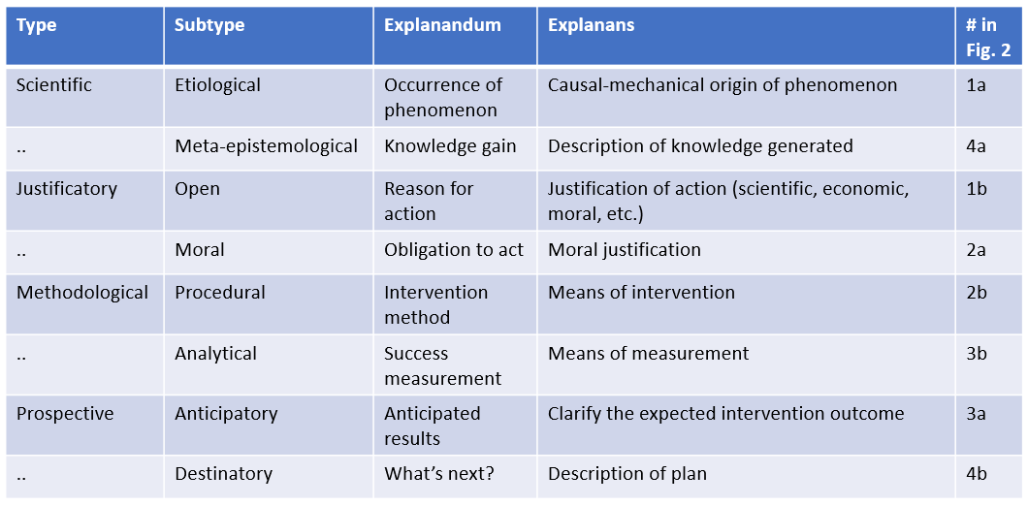

Of note, I will be flexible regarding the distinction between public health and population health but will attempt to be mindful of potential differences when it comes to issues of explanation. In broad terms, I suggest thinking of public health as the institutionalized effort to protect the public’s health and of population health as the health of populations, pragmatically defined by some as groups with >1 member (Keyes and Galea 2016).

In what follows I will first introduce a simple four-step schema (Figure 1) that illustrates the sequential relationship among the abovementioned tasks in public health (section 2), then turn to the types of explanation (Table 1) that play a role in connecting them (Figure 2) into a continuous workflow (section 3) and offer some comments in section 4.

2. Assessment, definition, intervention, and evaluation
For the purpose of this chapter, let us adopt the notion of public health proposed by the American Public Health Association as what “promotes and protects the health of people and the communities where they live, learn, work and play”. (ref to elsewhere in handbook?) This is obviously an extremely broad definition, including the activities of police, firefighters, teachers, and so forth. I propose the following list of main activities in order to outline how public health workers (researchers and practitioners) accomplish that mission (Figure 1): population health assessment; definition of goals; an appropriate intervention; and evaluation of success.
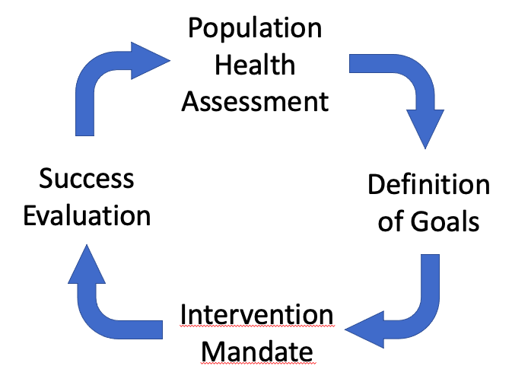
Figure 1. Four main activities in the cyclical public health research and practice workflow.

The following sections briefly touch on the four types of explanation, each one with two subtypes as specified in Table 1 and depicted in Figure 2, that are part of the transition from each one of these activities to the next. They will be discussed in more detail in section 3.

2.1 From assessment to definition
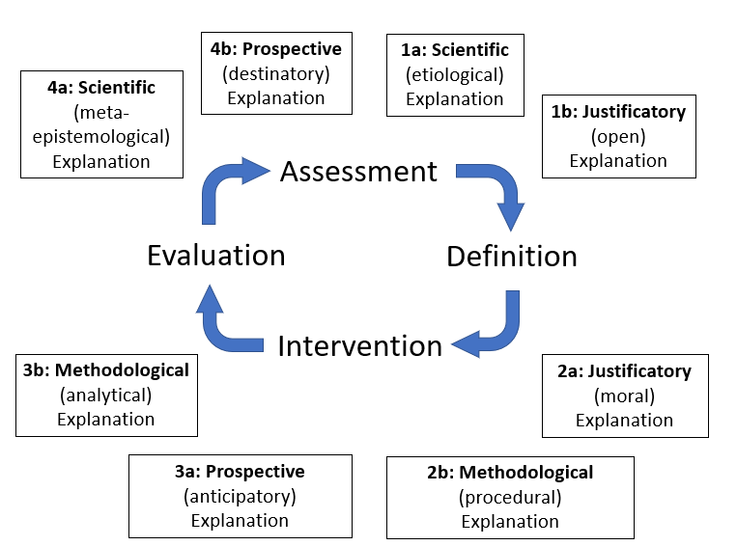
As a first step in the development of a public health program, public health workers must be able to assess the state of the health of their target population accurately. Usually, those in charge of public health activities work in municipal or regional (in the United States: county or state) departments of public health. They are charged with overseeing public health activities to support the population residing in their catchment area. In order for their work to be evidence-based, the department has to collect evidence, that is, valid information about the state of health in this population, which is a research activity guided by scientific principles. How is the occurrence of disease explained? A scientific/etiological explanation needs to be provided that tells decision-makers why and how a certain assessment result occurs (Figure 2, #1a). In the evidence-based public health framework (Brownson, Fielding, and Maylahn 2009), this explanation is based on type 1 scientific evidence, that is, data on the “size and strength of preventable risk—disease relationship (measures of burden, etiologic research)” (Brownson, Fielding, and Maylahn 2009: 179).
Figure 2. Types (and subtypes) of explanation in public health research and practice.
Before data from surveillance and epidemiological studies can be turned into a definition of public health action, an explanation needs to be given that specifies why the collected data justify a certain public health action (Figure 2, #1b). This justificatory/open explanation is called “open” because it needs to employ all kinds of justification (scientific, moral, economic, and so on). In the context of dangerous infectious diseases this seems trivial and is, obviously, done a long time in advance and not just when the need arises. With other health indicators, however, such as a novel clustering of cancer cases in a certain community, the justificatory explanation will be made only after the new data have become available.

2.2 From definition to intervention
Public health agencies like the Centers for Disease Control and Prevention (CDC) in the United States are mainly concerned with the definition of surveillance measures. They have developed a list of criteria that specify the scope of the public health problem, the ability to control it, and the public health system capacity needed to implement proper control measures (CDC 2012). In the United Kingdom, the Covid-19 pandemic has triggered the creation of a new agency in 2021, the UK Health Security Agency (UKHSA), which is charged with infectious disease surveillance, prevention, and response. It is government agencies like these that decide how threats to the public’s health are to be defined.

To declare a population health measure as an indicator of a health burden that requires amelioration, public health researchers, agencies, and politicians must offer a justificatory/moral explanation why an intervention is warranted (Figure 2, #2a). Of course, this also helps justifying the intervention plan and is, therefore, also a justificatory explanation. Next, a methodological/procedural explanation is needed to clarify what sort of intervention is likely to ameliorate the situation and how it is supposed to work (Figure 2, #2b).

2.3 From intervention to evaluation
The expected results will be explained by means of a prospective anticipatory explanation before the intervention is initiated and that explanation of expected results is sometimes refined while the intervention is implemented (Figure 2, #3a).

Concomitantly, it needs to be explained in what ways the outcome of the intervention will be evaluated. This is a methodological/analytical explanation that specifies the technical ways of outcome evaluation (Figure 2, #3b).

2.4 From evaluation to assessment
When the evaluation is completed, it is time to ask what has been learned. What exactly is the knowledge added by the project? This knowledge gain (if any) is explained in the form of a meta-epistemological explanation (Figure 2, #4a). Since this is an explanation that increases our knowledge about our knowledge, I count it as a scientific explanation.

One interesting topic in this context is the purported explanatory opacity of some artificial intelligence approaches used in health data analysis (Amann et al. 2020). What can we know about our knowledge gain if it comes from machine learning methods whose result are not interpretable? I have argued elsewhere that there might be ways to use computational models of illness occurrence as providers of etio-prognostic explanations (Dammann forthcoming).

The last type of explanation before the workflow cycle arrives back at the beginning is the prospective/destinatory explanation of what is to come next (Figure 2, #4b). In our current context, this will be an explanation of the next steps (changes to process, especially new forms of assessment, and so on).

Again, the way I use the term explanation in this chapter is very broad and goes deliberately beyond the definition of scientific explanation, because science is only one component of public health. The types of explanation used in public health I propose and discuss in the next sections include nonscientific explanations that are used for knowledge transfer, not in the process of knowledge generation.

3. Types of explanation in public health
As alluded to at the beginning of the previous section, part of my goal is to analyze the types of explanation given in public health. I propose, as summarized in Table 1, that four main types of explanation prevail: scientific, justificatory, methodological, and prospective. Each one of these categories has at least two, perhaps more, subcategories. In what follows I describe these in more detail, using examples from public health practice.

3.1 Scientific explanation

3.1.1. Evidence for public health
One of the main ways to collect the necessary evidence is public health surveillance (ref to elsewhere in handbook?). Public health surveillance is defined as “the ongoing, systematic collection, analysis, and interpretation of health data, essential to the planning, implementation and evaluation of public health practice, closely integrated with the dissemination of these data to those who need to know and linked to prevention and control” (Hall et al. 2012).

The CDC in the United States consider surveillance “the cornerstone of public health practice” (Richards, Iademarco, and Anderson 2014: 472). Surveillance provides data that help “detect and monitor diseases, injuries, and conditions; assess the impact of interventions; and assist in the management of large-scale disease incidents” (Richards, Iademarco, and Anderson 2014: 472). For the detection of occurrence, a target condition is defined, and surveillance staff and technology tools are prepared to detect the occurrence of that target condition to an extent higher than expected. Data are accumulated over a defined time period and compared to expected occurrence numbers. For example, if an infectious disease occurs more frequently than expected in a certain area over a certain period of time, this would be considered an outbreak.

However, this evidence is not provided by surveillance alone. Another important source of data is epidemiologic research, the branch of the health sciences that is charged with the design, conduct, and analysis of population-based studies to understand the distribution and determinants of health and disease in populations (Rothman et al. 2021). Contrary to popular belief, recently fueled by its prominent role in the media during the Covid-19 pandemic, epidemiology is not just the science of epidemics. Infectious disease epidemiology is only one branch among many in modern epidemiology. Epidemiologists study the occurrence (prevalence, incidence) of practically any health phenomenon in populations under the heading descriptive epidemiology and the statistical association (often mislabeled “correlation”) between purportedly causal risk factors (exposures) and any kind of illness (outcome) using analytical epidemiology methods. Modern epidemiological theory started with predominantly methodological considerations in the 1970s (MacMahon and Pugh 1970) and 1980s (Kleinbaum, Kupper, and Morgenstern 1982; Miettinen 1985; Rothman 1986) and has reached new heights with Nancy Krieger’s ecosocial theory of health (Krieger 2001, 2011), Miguel A. Hernán and James M. Robins’s framework for causal inference (2020), and Tyler VanderWeele’s explanatory approach (2015).

For VanderWeele, an explanation is putting a phenomenon “with a particular context so that the phenomenon is better understood” (VanderWeele 2015: 7), which dovetails with the Merriam-Webster definition of explanation referred to above. His main topic is epidemiological modelling tools for the analysis of mediation, which he briefly defines as “the phenomenon whereby a cause affects its intermediate and the change in the intermediate goes on to affect the outcome” (VanderWeele 2015: 7), and interaction, which “relate[s] to when, and for whom, a cause affects a particular outcome” (VanderWeele 2015: 9). On this view, a mediator is just that, an intermediate factor that provides the link between cause and effect. Interaction, on the other hand, is a somewhat more complex concept, but more important for population health science. In much simplified terms, interaction is a phenomenon of “mixed effects,” which results in different magnitudes of influence of cause C on effect E in strata defined by the presence or absence of a third factor F. In other words, the CE relationship R_{CE} among individuals with F differs appreciably from R_{CE} among individuals without F. Stated formally: (R_{CE}|F) ≠ (R_{CE} |¬F). In public health, the importance of this phenomenon is obvious, because one needs to know whether the effect of some intervention should be expected to be different in one subpopulation with F compared to one without F. Identifying factor F in this scenario would obviously have enormous impact on whether and how the intervention would be implemented. The same holds for clinical (medical) contexts as well, illustrating the general import of clinical epidemiological methods and findings as a basis for medical action. For example, Paul M. Ridker and colleagues conducted a randomized trial of low-dose aspirin in almost 40,000 women aged 45 or older and followed them for 10 years regarding cardiovascular events and stroke (Ridker et al. 2005). While the intervention was associated with a risk reduction for myocardial infarction by 34% among women 65 years or older, it did not affect this risk in younger women. This result has obvious consequences for physicians’ prescription decisions.

3.1.2 Etiological explanation
Etiological explanations (#1a in Figure 2) abound in public health because they unify explanations that refer to the causes of illness and to the mechanisms that provide the connection between causes and the illness they cause. Thus, causal explanations are etiological explanations that clarify the causal origin, while mechanical explanations clarify the mechanical origin of disease. Taken together, this is what is what Wesley C. Salmon called a causal-mechanical or etiological explanation (Salmon 1984; see also Dammann 2020). One simple example of an etiological explanation is the explanation of health disparities by reference to socioeconomic status (cause) and stress (mechanism) (Adler and Rehkopf 2008).

The causal-mechanical model represents only one of multiple philosophical accounts of scientific explanation (Woodward 2017). In brief, the earlier deductive-nomological (or “covering law”) model was proposed by Carl Hempel (Hempel 1962). The D-N model, as it is now often abbreviated, states that one or more accepted laws (such as those of thermodynamics) in addition to one or more particular contextual facts about a certain event (a metal lid is stuck on a glass jar, the jar is put in hot water) jointly explain the fact that the metal lid comes off the jar easily once the jar is taken out of the water. Another type of explanation, unificationist explanation, was introduced by Michael Friedman, who started his 1974 paper with the question of what connects explanation to scientific understanding (Friedman 1974), a question that Hempel (according to Friedman) shied away from for being psychological and, thus, not to be considered part of logic. Friedman argued that, in essence, providing a scientific explanation is to provide a comprehensive statement that unifies multiple less comprehensive statements. He further argued that since understanding is global, not limited to single instances of phenomena to be explained, we “genuinely increase our understanding of the world” by replacing one statement with a more comprehensive statement, which reduces the total number of accepted statements (Friedman 1974: 19). Friedman’s version of unificationist explanation was later modified by Philip Kitcher, who suggested that the number of types of premises accepted as underived can be minimized by reducing the number of argument patterns that derive many beliefs (Kitcher 1981).

3.1.3 Meta-epistemological explanation
In the above accounts of explanation, an increased intelligibility and, ultimately, understanding is part of the goal. In our framework of explanation in public health, a meta-epistemological explanation (#4a in Figure 2) is one that increases our knowledge about our knowledge; it increases the number of facts that we know about the number of facts we know. This sounds much more complicated than it is. In our context, a meta-epistemological explanation is nothing more than a clarification of what we have learned from a public health intervention project. This type of explanation would be any explanation that refers to the results of an intervention study that has yielded new knowledge. For example, a community intervention program with the goal to reduce smoking among women yielded results that suggest that community involvement improves the success rate of such program (Secker-Walker, Flynn et al. 2000). Here, the novel piece of information is the community participation bit and any explanation that refers to this bit would count as a meta-epistemological explanation.

3.2 Justificatory explanation
These explanations are given for the purpose of action justification. Whoever is in a decision-making position for a public health program will require a solid justification for an action to be taken. The response to the request What justifies this intervention? is an explanation that is given to justify or warrant the intervention. Ruth Faden and Sirine Shebaya have argued that the broad mission of public health to protect and improve the health of populations is too broad to appropriately justify some public health interventions (Faden and Shebaya 2019). They identify five justifications that may justify public health interventions: “(1) overall benefit, (2) collective action and efficiency, (3) fairness in the distribution of burdens, (4) prevention of harm (the harm principle), and (5) paternalism”.

I will now very briefly refer to three main ways to justify an action in public health: scientific, moral, and economic.

3.2.1 Scientific justification
Scientific justification requires explanations that refer to scientific reasons or desiderata. This type of explanation is not to be confused with scientific explanations (see section 3.1). Justificatory explanations of the scientific type simply cite scientific reasons in support of a justificatory statement. In other words, a scientific justificatory explanation refers to a scientific need as a justification for action. Perhaps the most frequently employed scientific justificatory explanation is the one given in the background section of scientific grant applications. This usually reads something like: “We want to study the phenomenon P. Previous research has revealed that P is caused by C, but the mechanism M remains to be elucidated. In this application, we propose a series of experiments designed to characterize M.”

3.2.2 Moral justification
Moral justification can be provided by offering moral reasons why an action is warranted. Ross Upshur has conveniently summarized the principles to be considered in the justification of public health intervention (Upshur 2002). He discusses the harm, least restrictive means, reciprocity, and transparency principles. These principles can be viewed, individually or together, as reference points for justificatory explanations. The harm principle, rooted in John Stuart Mill’s On Liberty, holds that personal freedom cannot be rightfully constrained unless such limitations are imposed in order to prevent others from harm. Upshur suggests that the harm principle is “perhaps the foundational principle for public health ethics in a democratic society” (Upshur 2002: 102). For example, mandatory face masks during the most serious phases of the Covid-19 pandemic can be justified by the argument that the mask-associated reduction of personal comfort is far outweighed by the beneficial population effect on disease incidence and mortality. The least restrictive means principle requires that public health policies should have implemented and exhausted less invasive interventions before more draconian measures are initiated. To stay with our previous example, mandatory face masks are considered less restrictive than mandatory sheltering in place. Reciprocity refers to the right of the individual to be compensated for losses due to public health interventions. Transparency covers the need to design decision-making processes in a fair manner that includes all stakeholders, free discourse among them, and the absence of political or financial interests, among others.

3.2.3 Economic justification
Economic justification is the purpose of explanations that cite expected economic gains or losses as reasons why some action should or should not be taken in public health. Comparative economic analysis techniques are involved, such as cost-effectiveness, cost-benefit, cost-utility analyses, and so on. A study from the United Kingdom revealed that decision-makers apparently prefer to base their decisions on more complex and detailed methods rather than on simpler ones (Phillips et al. 2011). The growing field of public health economics (Edwards, Charles, and Lloyd-Williams 2013) is complex and multifaceted, and represents a formidable target area for further philosophical inquiry.

3.3 Methodological explanation
At first glance, methodological explanations seem to be justifications of why certain methods are used. I think, however, that the primary motivation for this type of explanation is to simply describe methodology, just like etiological explanations describe the causal-mechanical genesis of a phenomenon. In public health, methodological explanations explain the details of intervention procedures and data analysis. To explain why a particular method is used is a scientific justificatory explanation that details scientific reasons for such usage.

3.3.1 Explaining intervention methodology
Any public health intervention will be implemented in a particular way. The creation and provision of an intervention methodology explanation (#2b in Figure 2) in the form of a detailed intervention implementation plan is necessary for stakeholders to understand what kind of intervention is planned and what its implementation will mean for them and their constituents.

Public health nursing is one of the areas of public health in which a considerable amount of work has been done to specify what kinds of interventions public health entails. Linda Olson Keller and colleagues have developed a framework for public health intervention known as the Intervention Wheel for population-based public health practice (Keller et al. 1998; Keller et al. 2004). The Wheel is a graphical depiction of its three equally important core aspects: interventions are population-based, they are implemented at the level of the individual/family, community, or system, and there are 17 different types of public health interventions that are further specified in the model.

3.3.2 Explanation of analytic methods
Once a public health program is implemented, its success (or failure) needs to be evaluated. An analysis plan is needed that explains the methods that are to be used in program evaluation (#3b in Figure 2). Bobby Milstein and Scott Wetterhall have proposed a framework for program evaluation that consists of six steps: stakeholder engagement, program description, focusing the evaluation design, evidence gathering, conclusion justification, ensure usage and lessons learned. Interestingly, the second item (program description) comes rather close to our aforementioned explanation of intervention methodology: “Before stakeholders can talk about evaluating a program, they should agree on what the program is. They must describe the program in enough detail to ensure a solid understanding of its mission, objectives, and strategies” (Milstein and Wetterhall 2016: 222). Part of the explanation of analysis methods should be whether the data to be analyzed are quantitative, qualitative, or mixed methods.

3.4 Prospective explanation
Prospective explanations are forward looking. They explain by reference to future events, not to things that have happened in the past. In other words, both the explanans and the explanandum of prospective explanations are yet to occur. We can offer anticipatory explanations in public health in the form of statements like, for example, “We expect this program to reduce the number of opioid overdoses by 10% over the next twelve months.” Destinatory explanations are visionary statements of what the plans are for the future development of affairs.

3.4.1 Anticipatory explanation
Anticipatory explanations (#3a in Figure 2) outline what one expects to be the case under defined circumstances and why. In the public health workflow, they simply explain the results that are expected if a defined intervention is implemented in a certain way. On a superficial level, anticipatory explanations are merely descriptive, serving the purpose of an outline for the uninformed. On a deeper level, they can also serve as a justificatory explanation, when used to mount an argument in support of the initiation of a program.

3.4.2 Destinatory explanation
The final kind of explanation, which we may call destinatory explanation, outlines the plan for moving forward after a public health project is completed (#4b in Figure 2). It is exemplified by the questions from the audience to the speaker after a presentation at a scientific conference like “Now that you are done with this project, what are your next steps?” or “What else needs to be done to achieve your long-term research goal?”

Destinatory explanations are not teleological explanations (Wright 1976; Stout 1996). The latter explain facts (mainly actions) by means of referring to the actor’s reasons to act. The former are explanations of where things are going or are expected to go in the future. While the latter always have a causal connotation (the reason being the cause of the action), the former do not.

4. Comments
In this chapter I have departed appreciably from the traditional philosophical concept of explanation as closely and perhaps exclusively related to causal inference. Instead, I have offered a smorgasbord of explanations employed for different purposes in public health practice.

One important objection to the framework of explanation types offered in Table 1 is that one may say that except for scientific explanations, the other types just are not explanations at all, but justifications, descriptions, predictions, outlines of plans, and so on. On my view, the components of these terms (for example, justification and explanation) are not mutually exclusive, but one specifies what the other does. In this regard, I propose to distinguish between models of explanation (for example, the D-N model, the causal-mechanical model, and unificationist models of explanation) and types of explanation as those listed in Table 1. While models of explanation are defined by how philosophers think explanation works, types of explanation are defined by what purpose they serve.

Of course, my proposed framework of explanation in public health offered in this chapter is just one possible view of public health workflow and the types of explanation used therein. I am certain that many others can be construed and some of these will probably be more helpful than the one presented here. Of note, the framework is not intended for usage in other contexts. Most certainly do I not intend to propose a framework for explanation in general. It may very well be that some of the classification of explanations depicted in Table 1 can be used in other contexts. However, such usage would need to be justified before the backdrop of that other context. There is just no one-size-fits-all solution.

Maël Lemoine begins his chapter on explanation in medicine in another handbook in this series with the statement that “the scientific part of medicine seeks explanations” (Lemoine 2017: 296). He continues with a call for inclusion of multiple types of explanation in medicine, such as “molecular, epidemiological, psychiatric, pathophysiological, social, …” explanations. Two comments, if I may. First, I do not think that there is such a thing as the scientific part of medicine. Medicine has no scientific part. At least, individuals working in medicine and science are the exception, not the rule. Indeed, the physician-scientist is a vanishing breed. The vast majority of medics care for patients, organize and optimize that care, and improve it. They use scientific data, but they do not generate them; they do not do the science. This is done by medical and health scientists like epidemiologists, who generate causal explanations, and bioscientists, who generate mechanical explanations (Dammann 2020). Second, Lemoine’s list of “types” of explanation is confused in terms of being derived from different classification systems. Molecules are biological entities, psychiatry is part of medicine, and epidemiology, pathophysiology, and sociology are branches of science, and thus activities outside clinical medicine. In the remainder of his chapter, Lemoine distinguishes between deductive-nomological, deductive statistical, and mechanistic models of explanation. While this is certainly a useful approach, I hope that the purpose-driven framework of explanation I propose in this chapter will be helpful in providing a purpose-driven roadmap for explanation in public health.

We have to keep in mind what kinds of stakeholders in public health offer the explanation and who are the ones supposed to benefit. Who is the explainer and who is the explainee? Assuming that it will most often be the public health professionals who do the explaining, while the recipients are policymakers and the general public, we may need to be considered whether different perceptions of truth and knowledge might affect the explanatory process and success. The attempt to successfully explain a planned public health program—for example, mask wearing in public—to a community whose members subscribe to the notion of “fake news” maybe futile. Public trust is of paramount importance in a healthy public discourse. One important example of philosophical work in this realm is Maya Goldenberg’s argument that vaccination hesitancy is not due to science illiteracy but lack of trust in science (Goldenberg 2021).

My discussion in this chapter comes from a western perspective (I trained as a medical doctor in Germany and as an epidemiologist in the United States). Alex Broadbent and Benjamin Smart have made a cogent argument that in public health policy, “ignoring local social and cultural factors is a mistake“ (Broadbent and Smart 2020: 405). On this view, it is objectionable if a public health intervention ignores the specific socio-cultural background of the population it serves. Initiatives such as the decolonization of global health (Büyüm et al. 2020), antiracism efforts in medicine (Paul et al. 2020), and declaring racism a public health crisis in the United States (Paine et al. 2021) will greatly benefit from implementing this insight.

References
Adler, N. E. and D. H. Rehkopf (2008). "U.S. Disparities in Health: Descriptions, Causes, and Mechanisms." Annual Review of Public Health 29(1): 235-252.

Amann, J., A. Blasimme, E. Vayena, D. Frey and V. I. Madai (2020). "Explainability for artificial intelligence in healthcare: a multidisciplinary perspective." BMC Medical Informatics and Decision Making 20(1).

Broadbent, A. and B. Smart (2020). Kinds of Explanation in Public Health Policy. Explaining Health Across the Sciences. J. Sholl and S. Rattan, Springer: 405-415.

Brownson, R. C., J. E. Fielding and C. M. Maylahn (2009). "Evidence-based public health: a fundamental concept for public health practice." Annu Rev Public Health 30: 175-201.

Büyüm, A. M., C. Kenney, A. Koris, L. Mkumba and Y. Raveendran (2020). "Decolonising global health: if not now, when?" BMJ Global Health 5(8).

CDC. (2012). "Public Health Surveillance: Preparing for the Future." from https://www.cdc.gov/surveillance/improving-surveillance/index.html.

Dammann, O. (2020). Etiological Explanations: Illness Causation Theory. Boca Raton, CRC Press.

Dammann , O. (forthcoming). "Agent-based models as etio-prognostic explanations." Argumenta.

Edwards, R. T., J. M. Charles and H. Lloyd-Williams (2013). "Public health economics: a systematic review of guidance for the economic evaluation of public health interventions and discussion of key methodological issues." BMC Public Health 13: 1001.

Faden, R. R. and S. Shebaya (2019). Public Health Programs and Policies: Ethical Justifications. The Oxford Handbook of Public Health Ethics. A. C. Mastroianni, J. P. Kahn and N. E. Kass: 20-32.

Friedman, M. (1974). "Explanation and scientific understanding." Journal of Philosophy 71(1): 5-19.

Goldenberg, M. (2021). Vaccine Hesitancy. Pittsburg, University of Pittsburg Press.

Hall, H. I., A. Correa, P. W. Yoon, C. R. Braden, C. Centers for Disease and Prevention (2012). "Lexicon, definitions, and conceptual framework for public health surveillance." MMWR Surveill Summ 61 Suppl: 10-14.

Hempel, C. G. (1962). Deductive-Nomological versus Statistical Explanation. Scientific Explanation, Space, and Time. H. Feigl and G. Maxwell. Minneapolis, University of Minnesota Press. III: 98-169.

Hernán, M. A. and J. M. Robins (2020). Causal inference: What if? Boca Raton, Chapman & Hall/CRC.

Keller, L. O., S. Strohschein, B. Lia-Hoagberg and M. Schaffer (1998). "Population-based public health nursing interventions: a model from practice." Public Health Nurs 15(3): 207-215.

Keller, L. O., S. Strohschein, B. Lia-Hoagberg and M. A. Schaffer (2004). "Population-based public health interventions: practice-based and evidence-supported. Part I." Public Health Nurs 21(5): 453-468.

Keyes, K. M. and S. Galea (2016). Population health science. Oxford ; New York, NY, Oxford University Press.

Kitcher, P. (1981). "Explanatory unification." Philosophy of Science 48(4): 507-531.

Kleinbaum, D. G., L. L. Kupper and H. Morgenstern (1982). Epidemiologic research : principles and quantitative methods. Belmont, Calif., Lifetime Learning Publications.

Krieger, N. (2001). "Theories for social epidemiology in the 21st century: an ecosocial perspective." Int J Epidemiol 30(4): 668-677.

Krieger, N. (2011). Epidemiology and the people's health : theory and context. New York, Oxford University Press.

Lange, M. (2017). Because without cause : non-causal explanation in science and mathematics. New York, NY, United States of America, Oxford University Press.

Lemoine, M. (2017). Explanation in Medicine. The Routledge Companion to Philosophy of Medicine. M. Solomon, J. R. Simon and H. Kincaid, Routledge: 296-309.

Lewis, D. (1986). Causal explanation. Philosophical Papers. Oxford, Oxford University Press. II: 214-240.

Lipton, P. (1991). Inference to the best explanation. London ; New York, Routledge.

MacMahon, B. and T. F. Pugh (1970). Epidemiology; principles and methods. Boston,, Little.

Miettinen, O. S. (1985). Theoretical Epidemiology. New York, John Wiley & Sons.

Milstein, B. and S. Wetterhall (2016). "A Framework Featuring Steps and Standards for Program Evaluation." Health Promotion Practice 1(3): 221-228.

Paine, L., P. de la Rocha, A. P. Eyssallenne, C. A. Andrews, L. Loo, C. P. Jones, A. M. Collins and M. Morse (2021). "Declaring Racism a Public Health Crisis in the United States: Cure, Poison, or Both?" Frontiers in Public Health 9.

Paul, D. W., K. R. Knight, A. Campbell and L. Aronson (2020). "Beyond a Moment — Reckoning with Our History and Embracing Antiracism in Medicine." New England Journal of Medicine 383(15): 1404-1406.

Phillips, C. J., R. Fordham, K. Marsh, E. Bertranou, S. Davies, J. Hale, M. Kingsley, S. Parke, C. Porteous, J. Rance and D. Warm (2011). "Exploring the role of economics in prioritization in public health: what do stakeholders think?" Eur J Public Health 21(5): 578-584.

Reutlinger, A. and J. Saatsi (2018). Explanation beyond causation : philosophical perspectives on non-causal explanations. Oxford, United Kingdom, Oxford University Press.

Richards, C. L., M. F. Iademarco and T. C. Anderson (2014). "A New Strategy for Public Health Surveillance at CDC: Improving National Surveillance Activities and Outcomes." Public Health Reports 129(6): 472-476.

Ridker, P. M., N. R. Cook, I. M. Lee, D. Gordon, J. M. Gaziano, J. E. Manson, C. H. Hennekens and J. E. Buring (2005). "A randomized trial of low-dose aspirin in the primary prevention of cardiovascular disease in women." N Engl J Med 352(13): 1293-1304.

Rothman, K. J. (1986). Modern Epidemiology. Boston, Little, Brown & Company.

Rothman, K. J., T. L. Lash, T. J. VanderWeele and S. Haneuse (2021). Modern epidemiology. Philadelphia, Wolters Kluwer.

Salmon, W. C. (1984). Scientific explanation and the causal structure of the world. Princeton, N.J., Princeton University Press.

Secker-Walker, R. H., B. S. Flynn, L. J. Solomon, J. M. Skelly, A. L. Dorwaldt and T. Ashikaga (2000). "Helping women quit smoking: results of a community intervention program." Am J Public Health 90(6): 940-946.

Skow, B. (2015). Scientific Explanation. The Oxford Handbook of Philosophy of Science. P. Humphreys. Oxford, OUP.

Stout, R. (1996). Things That Happen Because They Should.

Upshur, R. E. (2002). "Principles for the justification of public health intervention." Can J Public Health 93(2): 101-103.

VanderWeele, T. J. (2015). Explanation in causal inference : methods for mediation and interaction. New York, Oxford University Press.

Woodward, J. (2017). Scientific explanation. The Stanford Encyclopedia of Philosophy E. N. Zalta.

Wright, L. (1976). Teleological explanations : an etiological analysis of goals and functions. Berkeley, University of California Press.

See https://www.merriam-webster.com/thesaurus/explanation; accessed 15 September 2021 and https://www.britannica.com/topic/explanation; accessed 16 July 2021.
See https://www.apha.org/what-is-public-health; accessed 15 July 2021.

