Bion Theory

An answer to the question
Why is there Something rather than Nothing?

By Brecht Debor

23 December 2021

Abstract
Why is there something rather than nothing? This paper explores one particular argument in favor of the answer that 'the existence of nothing' would amount to a logical contradiction. This argument consists of positing the existence of a novel entity, called a bion, of which all contingent things can be composed yet itself is non-contingent. First an overview of historical attempts to compile a systematic and exhaustive list of answers to the question is presented as context. Then follows an analysis of how the antropic principle would manifest itself in a world that consists of information and at the same time conforms to modal realism. Next, a thought experiment introduces bions as the foundation of such a world, showing how under these circumstances the ultimate origin of all existing things would be explained. The non-contingent nature of bions themselves is subsequently argued via a discussion of the principle of non-contradiction. Finally, this theory centered on the existence of bions is integrated into the worldview of Popperian metaphysics. According to the latter's criteria, I conclude that bion theory provides an integral answer to why there is something rather than nothing.
1 Introduction

Let’s start with the beginning. Why does the world exist? Not just why the world we live in has the particular details it does. But rather: why does anything exist to begin with, as opposed to there being no world at all? Or as the question is most commonly phrased in philosophy: Why is there something rather than nothing? Long lists have been drawn up by philosophers throughout history summing up all the possible forms the answer to this question might take. "There's no consensus, of course, regarding which proposed answer to [the question Why is there something rather than nothing?], if any, is correct, but occasionally there's also controversy regarding the meaning of the Question itself." (Brenner, 2016). Then again, according to Karl Popper, it’s typical for philosophical questions not to have one specific interpretation that is generally accepted; "[...] for that there is no such thing is perhaps the one fact which is generally accepted." (Popper 2002:XVI).
In this paper, I present a novel answer to add to that list. I call it Bion Theory. It’s an answer which once again invites us to consider a radically different explanation for what it means for something to exist in the first place. And along the way again also introduces a new way to interpret the meaning of the question itself.
In the next chapter I briefly delve into the history of how the modern formulation of the question Why is there something rather than nothing? came about. Next, I present some of the historical attempts at compiling an exhaustive overview of the myriad of possible types of answers the question might take. This serves as a broad overview of the existing field of discourse on the subject, allowing us to clarify where (or closest to what) in that field bion theory is situated.
Following that philosophical background, Chapter 3 and 4 discuss several topics from the intersection between physics and philosophy pertinent to bion theory:
Chapter 3 shows how some interpretations of complexity suggest that instead of directly asking Why is there something rather than nothing? it would make more sense to first ask Why is there everything rather than nothing? and subsequently ask the question Why is there something rather than everything? It also shows how the latter question is automatically answered by the anthropic principle if we happen to live in a multiverse.
Next, Chapter 4 explains a problem with answering the question Why is there everything rather than nothing? that occurs in a multiverse composed of information in the form of binary digits.
Chapter 5 then discusses what bions are directly.
Chapter 6 explains how a multiverse composed of information in the form of bions (as opposed to information in the form of binary digits) does solve the problem presented in Chapter 4, thereby answering the question Why is there everything rather than nothing? Or in other words: it solves the remaining gap in how bion theory explains why there is something rather than nothing.
Chapter 7 discusses Popper’s notion of metaphysics as a framework for how the answer presented by bion theory relates to other philosophical outlooks on the world as a whole.
Finally, Chapter 8 concludes this paper with a recapitulation of bion theory that explores stressing alternative emphases to those of the rest of this paper.

2 Philosophical background to the question

2.1 History
Why is there something rather than nothing? The meaning and validity of this question have been the subject of controversy throughout its history. Its modern formulation is attributed to Leibniz, who in 1714 wrote that "[...] nothing happens without it being possible for someone who knows enough things to give a reason sufficient to determine why it is so and not otherwise. Assuming this principle, the first question we have the right to ask will be, why is there something rather than nothing? For nothing is easier and simpler than something." (Holt 2012:20; Leslie & Kuhn 2013:13)
In ancient Greeks philosophy, by contrast, the world was thought to have begun with a state of complete randomness somehow becoming arranged into 'a world with a more specific structure', rather than the world beginning with nothing at all (Holt 2012:19). Anaximander, arguably the first known Greek philosopher and founder of metaphysics, speculated around the sixth century BCE that everything that exists comes from a substance which he calls 'the Boundless', i.e. "[...] that which has no boundaries". According to Aristotle, the argument underlying the idea of 'the Boundless as ultimate origin' can be phrased as: "The Boundless has no origin. For then it would have a limit." (Couprie 2003)
Aristotle, who lived in the fourth century BCE, also compiled the first systematic overview of the forms a chain of explanations can take. First, it can be circular: "A is true because B, and B is true because A." The second option is that the chain of explanations is infinite, so that it has no final element that itself remains unexplained. The third and final possibility is that the chain is finite, either because the final element in the chain somehow doesn't require an explanation, or because that final element is of such a nature that its nonexistence would constitute a logical contradiction. (Holt 2012:131-2)
Starting in the second or third century CE, it was proclaimed within the Christian church that "The notion that God needed some sort of stuff to fashion a world seemed to put a limit on his presumably infinite creative powers. [Therefore there couldn't have been] any preexisting material to make it out of." (Holt 2012:19,20) In other words, in this view God must have created the world out of nothing due to the very nature of what God is. Krauss remarks in this regard that for many people with whom he tries to debate the question of why there is something rather than nothing, the notion "[...] that from which only God can create something" is in fact the only definition of the term 'nothing' that they are willing to accept (Krauss 2012:XV).
When Leibniz later on fashioned the question into its modern form, he too stated that the existence of the world is contingent, whereas the nonexistence of God would amount to a logical contradiction. Hume and Kant, writing in the 18th century soon after Leibniz, disagreed with the latter's position. They asserted that, although the existence of some entities is logically impossible (e.g. a square circle), it's never the case that the nonexistence of an entity or being could qualify as a logical contradiction, so postulating a God would not resolve the matter. If they are right, however, the possibility of the existence of nothing could not be ruled out by logic alone either, so we'd still require some other answer as to why there is something instead of nothing. (Holt 2012:21)
2.2 Taxonomy of nothings
To get a sense of how wide the array of answers is that have historically been proposed in response to the question Why is there something rather than nothing?, we’ll now examine some of the taxonomies of possible answers that have been constructed. Starting with a list by Kuhn of various interpretations of what a state of affairs characterized by the existence of nothing would entail.
"This taxonomy is structured as [...] a progressive reduction of the content of each Nothing in a hierarchy of Nothings. As such, this taxonomy takes its heritage from the so-called Subtraction Argument, which seeks to show that the absence of all concrete objects would be metaphysically possible." (Leslie & Kuhn 2013:259) The Subtraction Argument was coined by Baldwin in 1996, and consists of three premises: "(A1) There might be a world with a finite domain of concrete objects. (A2) These objects are, each of them, things which might not exist. (A3) The non-existence of any of these things does not necessitate the existence of any other such thing." (Lowe 2002:63)
Kuhn continues that "My point here is not so much to argue the legitimacy of any one kind of Nothing but rather to construct an exhaustive taxonomy of all potential or competing Nothings [...]" These nine levels of Nothings are:
“(1) Nothing as existing space and time that just happens to be totally empty of all visible objects (particles and energy are permitted - an utterly simplistic view).
(2) Nothing as existing space and time that just happens to be totally empty of all matter (no particles, but energy is permitted - flouting the law of mass-energy equivalence).
(3) Nothing as existing space and time that just happens to be totally empty of all matter and energy.
(4) Nothing as existing space and time that is by necessity irremediably and permanently in all 6 directions, temporal as well as spatial - totally empty of all matter and energy.
(5) Nothing of the kind found in some theoretical formulations by physicists, where, although spacetime (unified) as well as mass-energy (unified) do not exist, pre-existing laws, particularly laws of quantum mechanics, do exist. And it is these laws that somehow make it the case that universes can and do, from time to time, pop into existence from "Nothing," creating space-time as well as mass-energy. (It is standard physics to assume that empty space must seethe with virtual particles, a consequence of the uncertainty principle of quantum physics, where particle-antiparticle pairs come into being and then, in a fleetingly brief moment, annihilate each other.)
(6) Nothing where not only there are no space-time and no mass-energy, but also there are no preexisting laws of physics that could generate space-time or mass-energy (universes).
(7) Nothing where not only there are no space-time, no mass-energy and no pre-existing laws of physics, but also there are no non-physical things or kinds that are concrete (rather than abstract) - no God, no gods, and no consciousness (cosmic or otherwise). This means that there are no physical or non-physical beings or existents of any kind - nothing, whether natural or supernatural, that is concrete (rather than abstract).
(8) Nothing where not only there are none of the above (so that, as in Nothing 7, there are no concrete existing things, physical or non-physical), but also there are no abstract objects of any kind - no numbers, no sets, no logic, no general propositions, no universals, no Platonic forms (perhaps no value).
(9) Nothing where not only there are none of the above (so that, as in Nothing 8, there are no abstract objects), but also there are no possibilities of any kind (recognizing that possibilities and abstract objects overlap, though allowing that they can be distinguished)." (Leslie & Kuhn 2013:259- 60)
"Nothings One through Seven progressively remove or eliminate existing things." Kuhn considers Nothing Seven the most meaningful metaphysical definition of nothing , as it already "[...] features no concrete existing things (no physical or non-physical concrete existents) of any kind. Nothings Eight and Nine go further, eliminating non-concrete objects, things, existents and realities. Do they go too far? Many philosophers assert that the claimed absence of abstract objects and/or possibilities would constitute a logical contradiction and hence abstract objects and/or possibilities exist necessarily." (idem:260)
2.3 Taxonomy of answers
Rescher (1984) classifies the various responses as follows:
"An inventory of possible responses to the question: Why is there anything at all?
- The question is illegitimate and improper. [Rejectionism]
- The question is legitimate
- but unanswerable: it represents a mystery. [Mystificationism]
- and answerable
(a) though only by the via negativa of an insistence that there really is no "answer" in the ordinary sense - no sort of explanatory rationale at all. The existence of things in the world is simply a brute fact. [The no-reason approach.]
(b) via a substantival route of roughly the following sort: "There is a substance [viz. God] whose position in the scheme of things is one that lies outside the world, and whose activity explains the existence of things in the world." [The theological approach.]
(c) via a nonsubstantival route of roughly the following sort: "There is a principle of creativity that obtains in abstracto (i.e., without being embedded in the characteristics of any substance and thus without a basis in any preexisting thing), and the operation of this principle accounts for the existence of things." [The nomological approach.]
(d) via the quasi-logical route of considerations of absolute necessity. [The necessitarian approach.]" (Leslie & Kuhn 2013:16)
Kuhn has devised an even more extensive classification of responses to this same question, featuring 27 options divided into four main categories (namely One Universe Models, Multiple Universe Models, Nonphysical Causes, and Illusions). He remarks that those responses "[...] can be combined in any number of ways - in series, in parallel, and/or nested." (Leslie & Kuhn 2013:249)

2.4 Meaningless question?
Similar to Rescher’s first option; namely that the question is illegitimate and improper, the first of Kuhn’s 27 categories is titled "Meaningless question”. When it comes to the slightly different question How did something arise from nothing? the potential for it to be a meaningless thing to ask is immediately apparent. After all, perhaps something did not actually arise from nothing - and it makes no sense to ask how an event happened when that event didn’t happen.
However, formulated as Why is there something rather than nothing?, it’s not as straightforward to see that we might be inquiring about a nonsensical state of affairs. That still doesn’t mean it’s remotely akin to the kind of questions we’re used to asking in everyday life: It’s not like on your last trip abroad you visited a place where you witnessed ‘the existence of nothing’ and now casually wonder ‘How come we don’t also have that at home?’. But the fact we have no experience with ‘there being nothing’ in my opinion means that we can’t know that it’s a meaningless question anymore than we can know that it’s a meaningful one. All that this profound lack of knowledge on the nature of the question can tell us, is that the answer may be a strange one, meaningless by some conventional interpretations of what existence is, yet making sense when existence is redefined in some hitherto unconventional way. This response would be somewhere in between Rescher’s categories of answerable and unanswerable, suggesting even his taxonomy fails to capture how ambiguous a question this abstract can be.
Taking it one step further, Robert Nozick and David Deutsch argue that an unconventional approach to this question is by definition the only road forward, owing to its very nature:
Nozick: "Why is there something rather than nothing? The question appears impossible to answer. Any factor introduced to explain why there is something will itself be part of the something to be explained, so it (or anything utilizing it) could not explain all of the something - it could not explain why there is anything at all. Explanation proceeds by explaining some things in terms of others, but this question seems to preclude introducing anything else, any explanatory factors. [...] The question cuts so deep [...] that any approach that stands a chance of yielding an answer will look extremely weird. Someone who proposes a non-strange answer shows he didn't understand this question. Since the question is not to be rejected, though, we must be prepared to accept strangeness or apparent craziness in a theory that answers it." (Leslie & Kuhn 2013:238)
Similarly Deutsch, in an interview with Holt about the question of why there is something rather than nothing, remarks: "I don't think that an ultimate explanation of reality is possible [...] That doesn't mean I think there's a limit to what we can explain. We'll never run into a brick wall which says, 'NO EXPLANATION BEYOND THIS POINT.' On the other hand, I don't think we'll find a brick wall that says, 'THIS IS THE ULTIMATE EXPLANATION FOR EVERYTHING.' In fact, those two brick walls would be almost the same. If, qua impossibile, you were to have an ultimate explanation, it would mean the philosophical problem of why that was the true explanation - why reality was this way and not another - would be forever insoluble. The real question you want to answer is not what came before, but why something is the way it is. [...] You can't give a once-and-for-all definition of what an explanation is [...] In fact, important explanatory advances often change the meaning of explanation. [...] Anything pretending to be an 'ultimate' explanation would be a bad explanation, because there would be nothing left over to explain why it was the right one - to explain why reality was that way and not another way. [...] And the question Why is there something rather than nothing? is a layered one, I expect. Even if you succeeded in answering it at some level, you'd still have the next level to worry about." (Holt 2012:125-9)
2.5 Wrapping up
This chapter has outlined some of the controversy among philosophers in interpreting the question Why is there something rather than nothing? As well as how wide the variety of existing responses to it is. Rather than examining all of Kuhn’s 27 categories of answers one by one, we will now conclude this general overview of the field and zoom in on two of his categories most relevant for understanding bion theory. (Section 6.4 discusses these in greater depth).
Starting with the following of Kuhn’s categories: "Abstract Objects/Platonic forms as Cause. Although philosophers deny that abstract objects can have causal effects on concrete objects (abstract objects are often defined as causally inert), their potential, say as a collective, to be an explanatory source of ultimate reality cannot be logically excluded. (This assumes that abstract objects - such as numbers, logic, universals, propositions - manifest real existence on some plane of existence not in spacetime.)" (Leslie & Kuhn 2013:250-6) Bion theory fits this category, since as we will see in later chapters, bions are abstract objects existing in the way in which logic itself exists, yet they cause the existence of concrete objects.
Another branch of Kuhn’s taxonomy pertinent to bion theory is "Multiverse by All Possibilities. Generated by the hypothesis that each and every logically possible mode of existence is a real thing and really exists, that possible worlds are as real as the world we inhabit, since the things that we call merely possible (from our perspective) are all of them existing somewhere else[.]"(Leslie & Kuhn 2013:250-6)
Multiverses are concepts from physics. Whereas the current chapter was all about the philosophical background to bion theory, the next chapter explores some of the concepts from physics which form the background to bion theory, such as multiverses and information theory.

3 The anthropic principle in a multiverse

3.1 Modal realism
Lewis (1986) believes that everything that can exist, does exist, and coined the term modal realism to describe this philosophical position. Lewis: "I advocate a thesis of plurality of worlds, or modal realism, which holds that our world is but one world among many. [...] There are so many other worlds, in fact, that absolutely every way that a world could possibly be is a way that some world is. [Our world] is the actual world; the rest are not actual. Why so? - I take it to be a trivial matter of meaning. I use the word "actual" to mean the same as "this worldly". When I use it, it applies to my world and my worldmates; to this world we are part of, and to all parts of this world [...] This makes actuality a relative matter: every world is actual at itself, and thereby all worlds are on a par [...]" (Leslie & Kuhn 2013:26-8)
Nozick (1981) proposes a similar notion: "All the possibilities exist in independent noninteracting realms, in "parallel universes". We might call this the fecundity assumption. It appears that only such an egalitarian view does not leave any question "why X rather than Y?" unanswered. [...] As an ultimate and very deep principle, the principle of fecundity can subsume itself within a deductive explanation. It states that all possibilities are realized, while itself is one of those possibilities [...]" (Leslie & Kuhn 2013:244).
Modal realism and the principle of fecundity are extreme forms of what in physics is known as a multiverse. "[...] many of the major developments in fundamental theoretical physics [...] have led us to consider one or other variety of parallel universe. [Each of these theories] envisions our universe as part of an unexpected larger whole [...]" (Greene 2011:5). "A new word, multiverse, has been coined to denote physical reality as a whole." (Deutsch 1998:46) The most expansive universe that could possibly exist, viz. one that contains every conceivable universe, Greene calls the Ultimate Multiverse. (Greene 2011:338) Tegmark orders the different multiverses of physics into "[...] a nested four-level hierarchy of increasing diversity [...]". The fourth and most expansive one of these, the Level IV multiverse, comprises all possible mathematical structures, and he argues that all those mathematical structures exist physically as well. (2015:357)
Tegmark (2003) points out a common criticism of multiverse theories; that they seemingly defy Occam's razor (Leslie & Kuhn 2013:205). This is a fourteenth century theoretical principle which has an almost axiomatic status in modern science, and which states that all else being equal, the simpler of two alternative explanations is the correct one. Since a multiverse theory claims that there exist more things than classical theories of there being only one universe do, can we conclude that a universe is simpler than a multiverse? The answer strongly depends on which interpretation of complexity is employed. Lloyd distinguishes between forty-two kinds of complexity, each measured in a different way. The first category of measures of complexity he mentions deals with measures "[...] of how hard it is to describe something [...]". One of the measures in that category is called algorithmic information. (2007:189). Tegmark: "[The argument of Occam's razor] can be turned around to argue for a multiverse. [A]n entire ensemble is often much simpler than one of its members. This principle can be stated more formally using the notion of algorithmic information content." (Leslie & Kuhn 2013:206)
3.2 Algorithmic complexity
The algorithmic complexity of a specific number or of a specific string of bits (binary digits) of information is defined as the length of the shortest computer program that would produce that number or that string of bits. (Leslie & Kuhn 2013:206; Tegmark 2015:327)
An example which illustrates this in a more intuitive way is that it is harder to remember the specific number 64825875526984532158472002360 than it is to remember the number 1234567891011121314151617181920; although both numbers are equal in length, the latter can be succinctly described as 'all integers from 1 to 20' whereas the former contains no discernible pattern that allows it to be specified by any description with less characters than the original sequence contains. Likewise, any specific something, such as an apple with its many defining properties such as having a particular location in space, a position in time at which it exists, a specific size, a color, and so on, can be thought of as having a higher algorithmic complexity content than a concept like 'everything that logically can exist, does exist'. It is in that sense that 'everything' can be considered simpler than 'something'.
Which raises the question of what existed first in a multiverse: Something, or everything? The intuitive answer would surely be that there first has to be something, before there can be everything. But from the perspective of algorithmic complexity, this might not be the case. If a specific something, like an apple, has a higher algorithmic complexity than the multiverse as a whole, the multiverse may have been first. Arguably, the very definition of explaining the origin of the complex world we now live in, is describing how it arose from a simpler state of affairs. When Leibniz claimed in 1714 that “[…] nothing is easier and simpler than something” (see paragraph 2.1), it seems to me that he was voicing an intuition that matches the kind of cause-and-effect inherent to a process of creation – like when a baker starts with nothing, then gathers ingredients, and subsequently mixes and bakes them, thus causing the creation of a loaf of bread.
But what if the origin of the complex world we live in isn’t a process of creation, but rather a process of selection? That the world started off as a perfectly homogenous multiverse with its characteristically low algorithmic complexity, and then, through a likewise simple process, differentiated into components like apples and loafs of bread that in their heterogeneity and specificity as individual entities have a higher algorithmic complexity than the whole of which they are part? What would such a process of differentiation of a multiverse into components look like?
3.3 The anthropic principle
Many physical constants in nature would, if they had been even slightly different, never have given rise to the kind of universe that we inhabit nor presumably to any kind of universe capable of supporting anything remotely resembling life (Tegmark 2015). In other words, the laws of physics seem 'fine-tuned' to the task of enabling the existence of living, thinking entities such as ourselves which observe the existence of those laws (and even observe that they are observers). Is this apparent fine-tuning a coincidence?
Carter (1973) came up with the phrase anthropic principle with regard to this issue. This concept comprises two variants; the weak form and the strong form. "As originally defined by Brandon Carter, the Weak Anthropic Principle stated the fact, utterly obvious yet overlooked by many cosmologists, that our neck of the cosmic woods must (since we're in it) be capable of containing observers such as ourselves. Carter's Strong Anthropic Principle then made the equally obvious, equally often overlooked point that the cosmos must be capable of containing such observers somewhere, sometime. Must, that's to say, since we're in it, observing it. Just as a burglar must have paid a visit since your Picasso has disappeared. No suggestion that the burglar had been forced to visit you, or that God forced the universe to be life-permitting. [T]he explanation of any fine-tuning could instead be that there exist multiple universes with varying properties." (Leslie & Kuhn 2013:216-7)
The universes which a multiverse consists of can be thought of as realms that have almost no interaction with each other. In Deutsch's conception of the multiverse (which corresponds to Tegmark's Level III multiverse, both of which are based on Everett's 1957 theory that the wavefunction of a quantum system never collapses), for example, parallel universes are noticeable only through their quantum interference with our universe. (Deutsch 1998:53;Tegmark 2015:186) Existence, then, takes on several forms: In this multiverse view all the things that interact within - and compose - our universe (apart from quantum interference phenomena), are merely a special case within the larger framework of all things that exist in the multiverse as a whole. Furthermore, if this particular multiverse is in turn part of an overarching world in which every logical possibility is realized somewhere (modal realism, the ultimate universe, Tegmark's Level IV multiverse), then everything exists somewhere, even though our experience is almost entirely confined to the specific somethings of our universe.
3.4 Why is there something rather than everything?
When I look at the world from the perspective outlined in this chapter, it seems to me that the question Why is there something rather than nothing? may be skipping a step. That instead we should split it up into the two questions Why is there something rather than everything? and Why is there everything rather than nothing?
Modal realism and the anthropic principle answer the first question: First off, when you ask why there is something rather than everything, what you really mean is: Why is there something here? The answer is that you only see a part of the multiverse, or in other words see something rather than everything, because you are a particular part of the multiverse and only look at a particular part of the multiverse. And that is all you can ever be and all you can ever do, due to the very nature of what you are; a highly specific, highly complex thing.
3.5 Why is there everything rather than nothing?
So what about the second question? Why is there everything, rather than nothing? That’s where bion theory comes in. In this paper, I suggest the multiverse is made of bions. Bions are very similar to binairy digits (bits), the binary code with which information is stored in computers. Of all existing theories I’m familiar with, a multiverse composed of information in the form of bits is the closest thing to bion theory. Therefore, in the next chapter we’ll examine what a multiverse made of information would look like. Before finally moving on to bion theory itself in Chapter 5.

4 A multiverse made of information

4.1 Binary digits
What is information? "Just like the word 'letter', which refers not only to a written message, but also to the alphabetical symbols that compose it, the word 'information' has two different senses. The colloquial usage, as in 'personal information' and 'directory information', refers to the meaning of a message of some sort. The technical sense, on the other hand, emphasizes the symbols used to transmit a message, whether they are letters, numbers or just the computer digits zero and one. [T]he two connotations of 'information' are closely intertwined. The meaning of a message arises out of the relationship of the individual symbols that make it up, just as the meaning of a letter emerges from the particular juxtaposition of its letters [...]". (Baeyer 2004:18-9) What, then, is the nature of symbols themselves? Their own meaning can also be thought of as defined by the relationships that hold between them. The mathematician Poincaré wrote that science is not about investigating "[...] things in themselves, [...] but the relations between things; outside those relations there is no reality knowable." The philosopher Wittgenstein stated that "We cannot think of any object apart from the possibility of its connections with other things." Baeyer goes on that "[I]t is impossible to define anything without first defining other things." (idem:24)
Similarly Tegmark, in elucidating his hypothesis that the world is made up of mathematics, remarks that "[...] we live in a relational reality, in the sense that the properties of the world around us stem not from properties of its ultimate building blocks, but from the relations between these building blocks. [...] Our brain may provide another example[:] particular firing patterns in different groups of neurons correspond to different concepts. The main difference between [concepts lies not] in the type of neurons involved, but in their relations (connections) to other neurons." (2015:267)
Information, in Baeyer's view, is the transfer of a specific pattern of relationships from one medium into another medium. For example from the page of a book to the network of neural activity in the brain, or the sound waves of a musical instrument via a microphone into a computer. The network of relationships is expressed differently in one medium than in another medium, hence its transfer between media is a form of translation. By consistently applying the same translation key of which unit of information in one medium corresponds (by convention) to which unit of information in another medium, a message gets communicated as intended. Such a dictionary of what in one medium corresponds to what in another, is called a code. The process of transferring information is called coding. And although coding is a process, information can be depicted as a static phenomenon in the sense that "[...] a changing pattern can be recorded as a graph in which time is presented by distance along the horizontal axis." (2004:25-6)
Shannon, the founder of information theory, has shown that binary code is the most efficient tool for coding (idem:31). A binary digit, or bit for short, "[...] is the smallest unit of information." The word binary "[...] means consisting of two parts, and a bit represents one of these two alternatives. Traditionally, these alternatives are referred to as 0 and 1, but any two distinct alternatives (hot/cold, black/white, in/out) register a bit." (Lloyd 2007:18)
4.2 The universe as a computer simulation
Binary code is the language typically used by modern computers. In the 1930's mathematical research by Turing and Church laid the theoretical foundations that would give rise to computers as we now know them. Their work suggests that "There exists an abstract universal computer whose repertoire includes any computation that any physically possible object can perform." Penrose has named this idea 'the Turing principle'. Finishing a vast amount of calculations might take a computer a long time and a lot of memory capacity. But according to the Turing principle, if you wait long enough and install enough memory, each computer can do everything that any other computer could ever do. (Deutsch 1998:131-5)
Deutsch further argues that the implications of the Turing principle extend to the claim that "It is possible to build a virtual-reality generator whose repertoire includes every physically possible environment. [...] If the laws of physics as they apply to any physical object or process are to be comprehensible, they must be capable of being embodied in another physical object - the knower. It is also necessary that processes capable of creating such knowledge be physically possible. Such processes are called science. Science depends on experimental testing, which means physically rendering [i.e. making a mental image of] a law's predictions and comparing it with (a rendering of) reality. It also depends on explanation, and that requires the abstract laws themselves, not merely their predictive content, to be capable of being rendered in virtual reality. [...] The laws of physics, by conforming to the Turing principle, make it physically possible for those same laws to become known to physical objects. Thus, the laws of physics may be said to mandate their own comprehensibility. Since building a universal virtual-reality generator is physically possible, it must actually be built in some universes." (ibidem)
Thus, by the logic of the anthropic principle, a being capable of making a mental image (i.e. a virtual reality rendering) of the world, which is what it means to be an observer, will self-evidently live in one of the universes where the Turing principle applies. In fact, as Deutsch hints at here, the anthropic principle is the reason why our universe has the particular laws of physics which ensure that the Turing principle applies in it.
If it's possible for the world (whether a universe or a multiverse) in all its aspects to be simulated in the form of virtual-reality, then that suggests the world is, at its most fundamental level, information. Information such as a string of binary digits, for instance 001001101001110. Although the string viewed as a whole is static, it can be an encoded description of one or more spacetimes. And from the view of people living in - and as part of - a spacetime, such as we do according to the general theory of relativity, history unfolds as the process of successive changes occurring over time (Deutsch 1998:268). The next section addresses one particular problem with the idea that the world as a whole is a string of bits.
4.3 A problem with the idea that the multiverse is a string of bits
Say our universe is a computer simulation. That we, and everything we see around us, is a computer program. If the program is well written, there is no way for us to tell whether or not we’re living in a simulation. And it would give a very straightforward explanation for why our universe exists: it exists simply because someone (or something) wrote that program and then pressed enter. But of course that raises the question: Where is that computer? In another universe? Then why does that universe exist? It doesn’t get us any closer to finding out why there is something rather than there being nothing to begin with.
And even though in that scenario we are nothing but a bunch of ones and zeroes standing in a row on a computer screen, it doesn’t mean the algorithmic complexity of that computer program is any lower than our universe is. (Nor that this other universe in which we are being simulated is any more simple than ours; on the contrary, since it at least contains all the information that makes up our universe.) This may seem counterintuitive: ones and zeroes are not complex things in and of themselves.
However, it is not the ones and zeroes on their own that make up information. It’s that they can be placed into a specific order. And stored in that same order. And then read it that same order. If you take a bunch of confetti, write down a string of code using one piece of confetti per digit, then throw all those pieces with ones and zeroes written on them onto a pile, I won’t be able to ascertain in which order you wrote them down. You’ll have passed on very little information. If on the other hand you write the whole sequence down onto a single piece of paper, I will read the whole code in the same order you wrote it in. (Assuming I know in which direction you wrote, needless to say). This way you can convey very complex, highly specified messages. The reason sequences of bits of ones and zeroes in specific orders can thus exist, is that space exists. Or similarly, if you read a code aloud, I will hear the specific order you recite all the bits in, due to the fact that time exists. We inhabit the same system of spacetime, the same universe. Without a system like spacetime, it makes no sense to speak of a multitude of bits having a specific order.
We can take this argument one step further and ask: Does it even make sense to say that a multitude of bits can exist outside of space and time? Even the pile of confetti, the multitude of bits without any order, all had a location in space. I do think that, even when it comes to their existence as purely abstract objects, there are by definition two distinct bits: a bit with the logical value 0 and a bit with the alternative value, 1. But unlike two pieces of confetti with each a 1 scribbled onto it, which are two distinct objects in the sense that they occupy two different locations in space and/or time, when it comes to things that exist in the abstract way of having no location in space or time, 1 and 1 are not distinct entities.
And I think even a multiverse so simple that we can describe it as ‘Everything that possibly can exist, does exist’ has an algorithmic complexity higher than what one single bit, with its two alternatives of 1 and 0, can describe. You’d need a longer sequence of bits to describe it, arranged into a specific order, which would require something akin to spacetime. And spacetime is a property of the specific, algorithmically complex, heterogeneous universes within a multiverse, not a property of the general, algorithmically simple, homogenous thing that a multiverse as a whole is.
4.4 Conclusion
In the previous chapter I concluded that the question Why is there something rather than everything? would be solved by the anthropic principle if our universe were part of the multiverse envisaged by modal realism. And that this multiverse as a whole possesses less complexity, less differentiated properties, than some of the universes within it.
In the current chapter, I argued that our universe can be constructed of information. But the existence of information of any greater complexity than a single bit, requires properties which, unlike our universe, the multiverse as a whole does not possess.
Bions, the entities I introduce in the next chapter, are units of information just like bits. Unlike bits though, I will argue that their existence does not require any property the multiverse as a whole does not possess.

5 Bion Theory

5.1 Essentialism
To help picture the extremely abstract entities I call bions, let’s start with a thought experiment. What was first, the chicken or the egg? The ancestor of a chicken egg, is a chicken. That chicken came from an egg, the ancestor of which was again a chicken. This goes on for a while, as we delve deeper and deeper into that chicken’s genealogy. But it doesn’t go on forever. If you go back far enough, chickens have ancestors that are not themselves classified as chickens. That doesn’t mean that there was ever an abrupt change from one generation to the next. As organisms gradually evolve over the generations, pinpointing the precise point in their lineage where one species ends and the next one begins is always arbitrary to at least some degree. But what matters is that chickens today are significantly different from their ancestors of, say, a couple of million years ago.
If we go further back, much further, at some point we reach an ancestor who was a single cell organism. These organisms reproduce through cell division, in which the parent is identical to the offspring. Unlike a chicken, which by the time it is ready to reproduce, has differentiated a great deal from how its offspring initially looks.
Richard Dawkins argues that one of the seasons many people find the theory of evolution counterintuitive, is essentialism: the tendency to think that each chicken (or rabbit) shares a certain property with each other member of its species: A property so essential, so inherent to that species, that it clearly differentiates it from all other species. Rather than each organism existing on a continuum. In other words, that there is such a thing as the chicken or the typical rabbit, instead of each chicken being unique to some degree. “To suggest that […] today’s typical rabbit might be different from the typical rabbit of a million years ago or the typical rabbit of a million years hence, seems to violate an internal taboo. Indeed, psychologists studying the development of language tell us that children are natural essentialists. Maybe they have to be if they are to remain sane while their developing minds divide things into discrete categories each entitled to a unique noun.” (2009:23)
The question What was first, the chicken or the egg? comes across as an unsolvable paradox, when you look at it from a purely essentialistic viewpoint. But the theory of evolution indicates that in reality there is no such thing as the chicken or the egg. Rather, that all we can say that exists, are organisms that have more characteristics of what we define as eggs than they have characteristics of what we define as chickens. And conversely, of course, organisms that are relatively more like chickens than like eggs. It still makes sense to ask which of those came into existence first. But once you reach its single cell ancestor, there’s no longer even such a thing as the parent cell and the daughter cell; the original cell is gone after it divides itself, having split into two identical ones.
Exposing the erroneous assumptions underlying the classic formulation of the question What was first, the chicken or the egg? has removed some of its seemingly paradoxical nature. The more accurate question How did the current level of divergence between chickens in their adult and their embryonic stages develop throughout the generations? for example, arguably doesn’t suggest we’re dealing with a paradox, but rather with a problem that has a concrete (albeit perhaps complex) answer. On the other hand, that doesn’t mean we have solved every stage of the problem just yet; we haven’t yet explained all there is to know about the ultimate origin of chickens, or apples, or people. For starters, where did single cell organisms come from themselves?
Where do single cell organisms come from? One way to answer that is that they’re made of molecules, in turn made of atoms, in turn made of subatomic particles. Krauss explains that for every particle, there is a particle identical to it in every way, except with an opposite charge. When the two meet, they annihilate each other, and nothing of them is left. Even in an area of empty space, such matter-antimatter pairs can pop into existence out of nowhere, annihilation ensues, and nothing but empty space remains again (cfr. Kuhn’s ‘number 5 level of Nothings’, Section 2.2). The world probably started with an equal amount of matter and antimatter, unevenly distributed across it. Our universe had more matter than antimatter, each antiparticle being canceled out through annihilation with some of the matter, and the remaining matter is what makes up all the atoms in our universe. Matter and antimatter are identical, except in having an opposite charge. So if what we call antimatter had been in the majority, then what we call matter would have been the one that disappeared and all our atoms would have consisted of what we call antimatter. That universe would have functioned exactly the same as ours. And its inhabitants would simply give the name matter to what we call antimatter. (2012:60-65,157)
To descend even further into abstraction than the virtual particles described by physics, let’s look at a purely mathematical question: What’s one minus one? The answer is zero. In other words: nothing.
1-1=0
The same of course goes for four minus four, of fifty minus fifty, and so on.
4-4=0
In other words, the combination of two things that are identical except in the single characteristic of their charge, form nothing.
Turning that mathematical equation around is of course also mathematically correct.
0=1-1
0=4-4
In other words: nothing is one minus one. Nothing is the combination of two things that are identical except in the single characteristic of their charge.
The point of this thought experiment has been the following: Perhaps, just like the question What was first, the chicken or the egg?, the question Why is there something rather than nothing? just seems paradoxical because we are looking at it from an essentialistic viewpoint. Perhaps apples and chickens and people, despite their enormous complexity and variation, are ultimately composed of a kind of building block characterized by each block being identical to the others in all except one property. Turning off our tendency toward viewing things from an essentialistic perspective, as we have done in this though experiment, may help us picture what such an ultimate building block would look like. I think it might look something like this:
5.2 Picturing a binary digit
Visualize a binary digit. Bits consist of the two alternatives 1 and 0. A one and a zero are two distinct entities. This distinction, i.e. the fact that they differ from each other, constitutes a relation between them (cfr. Section 4.1). In the figure below this relation is represented by a horizontal line.
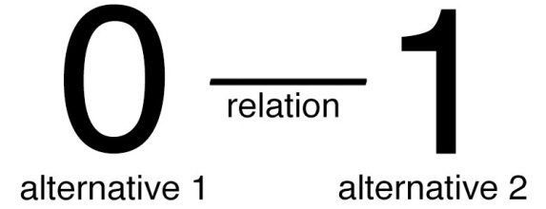
Figure 1: Visual representation of two binary alternatives and the relation between them, with two different symbols (0 and 1) for these alternatives.
Things can have many relations between them; one thing can be bigger than something else, denser, less fragile, and so on. What relations are there between the two alternatives that make up a binary digit? Answer: The relation that expresses they are distinct. And that is the only relation which holds between them. This last fact is difficult to picture, because, for instance, even in a simple representation such as the above figure, the symbols 0 and 1 have different locations on this page, which constitutes another distinction - and thus also another relation - between them. They also have a different shape, and so on.
But despite us using symbols which in other contexts have more properties (i.e. are more complex than having only one relation) than the two parts of a bit are supposed to have, the two parts of a bit are in principle supposed to be absolutely abstract entities, not concrete and complex things like apples. And the only thing that they, by themselves, are supposed to express, is that they are distinct.
The above figure is therefore quite redundant; it states the message of there being two alternatives four times: First by using the distinct symbols 0 and 1. Second, by calling them alternatives. Third, by these symbols occupying different locations in space. Fourth, by mentioning that they have a relation which expresses they are distinct. A bit is so simple that it's hard to give a description that isn't more complex than what's intended to be described. I'll now move on to a portrayal more fitting to a bit's simplicity, by replacing the 0 and the 1 with circles. Circles that look identical in shape and size in their visual depiction on this page. However, the circles don't express identical entities here, since them being distinct is still expressed by their context, viz. the accompanying words 'alternative 1' and 'alternative 2', as well as by the distinct locations in space of these circles, and the term 'relation' which again expresses their distinctness in words.
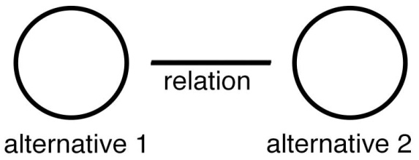
Figure 2: Visual representation of two binary alternatives and the relation between them, with the same symbols for these two alternatives. That they are distinct is here no longer expressed by symbols such as 0 and 1 but is still expressed by context (viz. by their distinct spatial positions on this page and by the accompanying words).
The next figure takes this one step further and omits all the words in the image. The horizontal line still symbolizes a relation expressing their distinctness.
Figure 3: Wordless visual representation of two binary alternatives and the relation between them. That they are distinct is still expressed by there being a symbol for 'relation' between them and by their distinct spatial position on this page.
This figure (Figure 3) is the most elementary depiction of a bit I shall represent. It symbolizes the simplicity of a bit, namely that the only property of each alternative in a bit is that they are distinct. In the next section I present an entity related to bits.
5.3 Picturing a binary distinction
Imagine, again, a bit. But this time change one thing in this thought experiment: In addition to each alternative in a bit being distinct, each alternative in this 'bit', is itself also such a kind of bit. This yields the following picture:
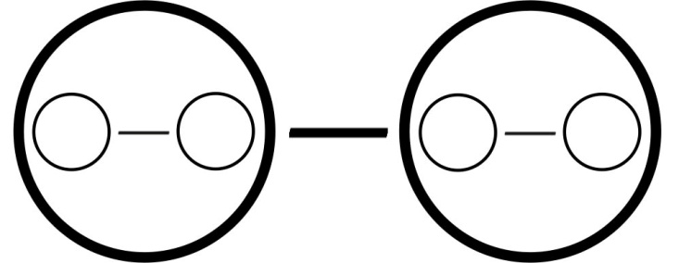
Figure 4: Visual representation of a bit-like concept in which each alternative is itself like a bit.
Now imagine that each of the alternatives in those two new 'bits' are in turn also 'bits' themselves. And so on, ad infinitum. Likewise, imagine that the bit we started from (viz. the one composed of the largest circles in Figure 4) is itself one of the alternatives in an encompassing 'bit', and so on, so that this nested string of 'bits' is now infinite in both directions. Of course an infinite amount of bits (of any kind) can't be portrayed on a page of finite size, so a depiction of this infinite sequence of nested entities always starts at a random point and ends where entities would become too small to be clearly visible. But these practical constraints are a feature of the depiction only, not a feature of the nature of this abstract entity itself; an accurate depiction would show an infinite number of circles.
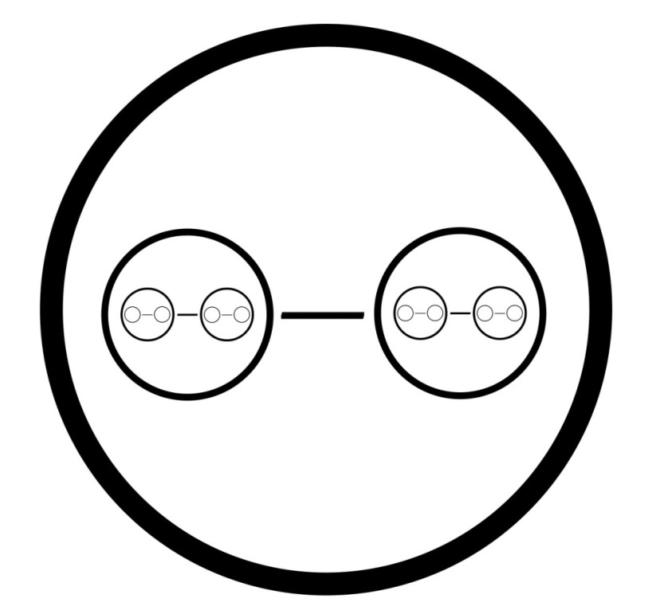
Figure 5: Another visual representation of a finite piece of an infinite nested sequence of bit-like concepts.
I call such a bit-like thing a binary distinction, or bion for short. (Abbreviated as a contraction of the beginning of the first word and the end of the last word, in analogy to how binary digit is shortened to bit). A bion expresses that the two entities which it contains (and which it, along with its third and final component, viz. the relation between those two entities, comprises), are distinct, just like a bit does. There are two differences between bions and bits however. The first one has to do with the fact that the term 'Bits' refers specifically to the context of computation, where they designate one specific category of the standard ingredients of calculation, namely numerical symbols or synonymously 'digits'. Computation is something we engage in inside our universe, in which the existence of things like space and time are a given. The concept of a bion shares one abstract and fundamental property with a bit, namely that it’s a distinction between two otherwise identical things. However, unlike a bit, a bion is meant to be thought of as context-independent; as an abstract thing not necessarily located inside some pre-existing space and not necessarily constituting a unit of computation. The reason bions can be context-independent in this way, arises, as I will argue in this paper, from the fact that in each bion, by definition, each of the two entities which along with the relation between them comprise that bion, itself comprises another bion. (And conversely, that literally every bion is itself one of the two entities that comprise yet another bion).
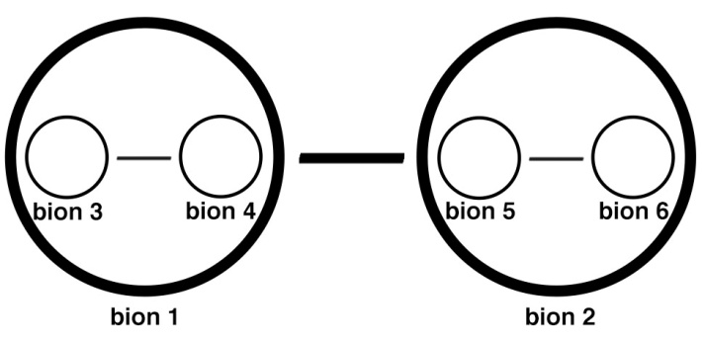
Figure 6: Visual representation of a finite piece of the infinite sequence a bion is always part of, in which the bions are numbered. The numbering here starts with the number 1.
Figure 6 is somewhat misleading, in that it may appear like the sequence of bions (in referring to a connected collection of bions, I use the terms sequence, series, string and web interchangeably) has a beginning, namely bion 1. Since the sequence of bions, however, is infinite, any starting point chosen to start numbering from is arbitrary. They might as well be numbered, for instance, as they are in Figure 7:
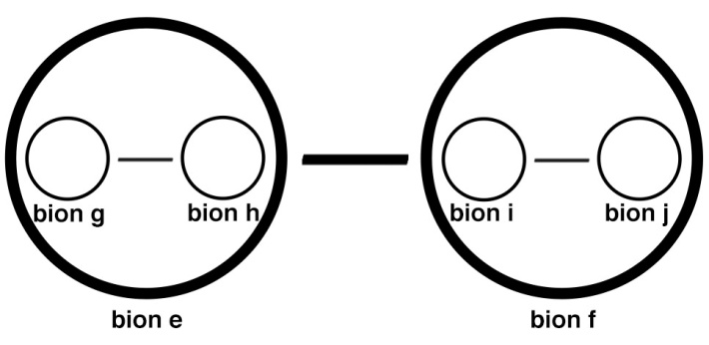
Figure 7: Visual representation of a finite piece of the infinite sequence that a bion is always part of, in which the bions are numbered. The 'numbering' system chosen here is alphabetical and starts randomly with the letter e.
The next sections elaborates on the nature of bions, starting with a brief discussion of what relations are.
5.4 Relations
Kaipayil writes that "The identity of an entity is defined by its relations. These relations include the entity's intra-relations (relations among its constitutive elements) and inter-relations (relations with other entities)." Conversely, the identity of a relation is defined by the entities between which it exists. "If entities disappear, relations also will disappear." (cfr. Section 4.1). He continues with a definition of the philosophical positions of relationism and relativism: "Relationism holds that what ultimately exists are relations and that reality is the totality of relations. [...] Relativism is the view that reality comes to us unsorted and that it is the cognitive subject that arranges the furniture of the world[.]" (2009:8-10)
Bions are an extremely homogenous infinite web of relations arranged in a nested structure. Do entities exist in that structure? The answer is subtle. Every entity in this web of bions constitutes a relation in the next level of its nested structure. (Or more precisely: Every entity in this web of bions constitutes a relation plus two entities in the next level of its nested structure, and the same thing in turn goes for those two entities, ad infinitum). So bions are a special case in which the two (in most contexts mutually exclusive) categories of entity and relation form a false dichotomy. (cfr. ontic structural realism).
Could the ultimate multiverse at its most fundamental level be the infinite nested string of bions? In this paper I argue that this is a possibility (and that this yields a candidate solution to why there is something rather than nothing). And according to the above definition; 'what ultimately exists are relations and reality is the totality of relations', this view can furthermore be classified under the view known as relationism.
5.5 Fractals
The notion of the ultimate multiverse being bions overlaps with Tegmark's notion of a Level IV multiverse. As mentioned in Section 4.1, Tegmark asserts that we live in what he calls 'a relational reality'. His Level IV multiverse consists of mathematical structures, and he defines a mathematical structure as a "Set of abstract entities with relations between them [...]". He further mentions that "Two descriptions of mathematical structures are equivalent if there's a correspondence between them that preserves all relations [...]". (2015:267, cfr. Baeyer's definition of information) One of the mathematical structures which Tegmark presents as a candidate for the structure of the Level IV multiverse is a fractal (2015:322). What it means for a structure to be a fractal, or synonymously what it means for a structure to be scale-invariant or self-similar, is that when you take an image of it and magnify it (e.g. zoom in on it), the magnified piece of the image looks similar to the original image.
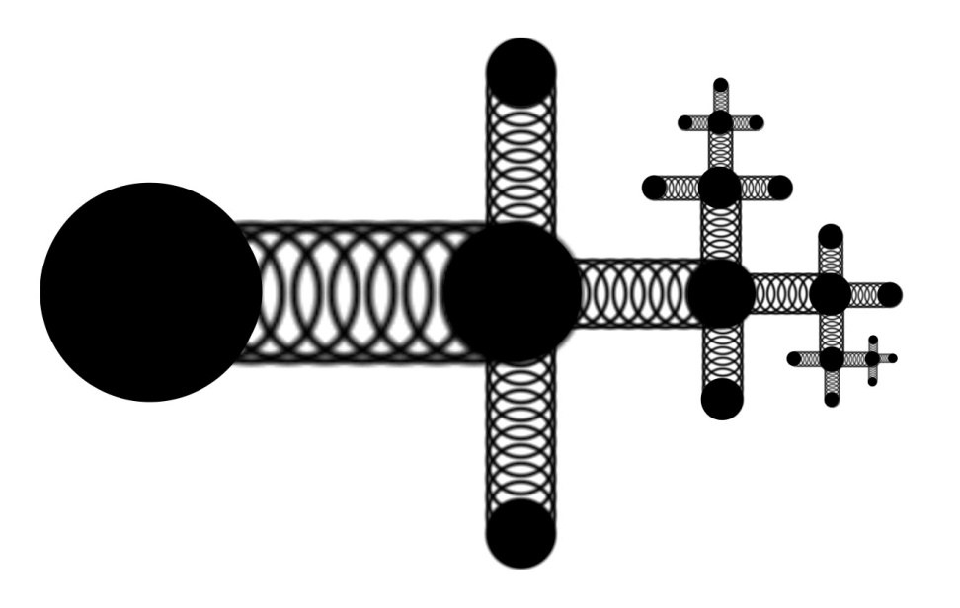
Figure 8: Example of a fractal.
Bions form a fractal. In fact, they exhibit an extreme form of scale-invariance, since each bion is extremely similar (as similar as they can possibly be without being completely identical) to every other bion, thus retaining full homogeneity on every level of their nested structure. Arguably, bions are also the simplest possible structure that can qualify as a fractal, in that each level of the sequence of bions (i.e. each bion) contains the minimum number of relations; one, and the minimum number of 'entities' that a relation can be between; two.
Another, albeit less direct, philosophical analogy to the structure of bions, is found in the structure of Hegelian dialectics: Two distinct and opposing things together form a third thing, which in turn combines with the thing that opposes itself to together form a fifth thing, in an endlessly repeating process.
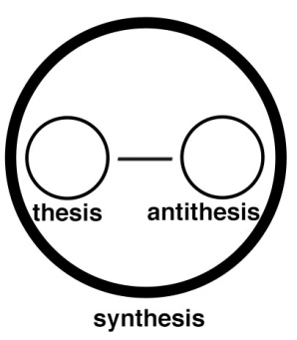
Figure 9: The core idea of Hegelian dialectics expressed through the symbols which this paper uses for bions.
This concludes the topic of describing the nature of bions directly. The next section further elucidates the nature of bions via examining one of their implications: The link of how something as abstract and simple as bions could yield the concrete existence of something as specific and complex as our universe.
5.6 The first way in which bions can constitute information independent of spacetime
Whereas a multiverse composed of a string of bits would be a paradox (since there would first have to exist a medium such as space for those bits 'to be arranged in a specific order in' before the bits could describe - and thereby yield the existence of - something as complex as a medium such as space), I will argue in this section that this problem can be circumvented in the case of bions.
Say one bion exists. The existence of one bion necessitates the existence of an infinite amount of bions. This is because no part of a bion constitutes a self-contained whole, but rather derives part of its meaning/existence from its relation to the next bion (its inter-relation) and the rest from the two bions it itself is composed of (its intra-relation). And the next bion in turn derives part of its meaning from its relation to (and existence of) yet the next bion, and so on. How does the anthropic principle manifest itself in a multiverse of bions?
First we'll visualize the more familiar notion of a string of bits, e.g. 0010111001001001010101. If this string is long and random enough (or infinite and random), then every particular juxtaposition of bits that we can conceive of will occur in it somewhere. Hence the specific piece of string that codes for our universe will also be in there somewhere, and the anthropic principle explains that we will by logical necessity observe the specific universe in which we observers can live and not any of the specific universes in which we cannot live.
One way of picturing what it means for a string of bits to code for concrete things like apples, laws of physics and ourselves, is via the analogy of the game known as Twenty Questions. In this game one person has to guess which word the other person has in mind through asking that person a series of questions with 'yes or no' answers. "[T]he game of Twenty Questions, if played cleverly, can deal with an enormous amount of information. The trick is to divide the possible answers into roughly equal batches, over and over again. As long as each question is designed to differentiate between more or less equally probable alternatives, each answer reveals one bit. In trying to guess the location of a [town in the] US, for example, ask ['Is it east of the Mississippi?', because that question] neatly divide[s] the country into two equal areas." (Baeyer 2004:29) If a description of each thing in the world can be fully specified in the form of a gradual series of binary possibilities (such as in this example happens through asking a series of 'yes or no' questions so as to systematically hone in on a specific word), then perhaps the world is a series of binary possibilities.
The next Figure shows a string of 4 bits. This corresponds with 2^4=16 possibilities. Say possibility 0110 describes our universe (only for the sake of argument, of course, since it would take a whole lot more bits to describe the actual complexity of the universe). The selection of this particular bit string from the 16 possibilities is here symbolized as a diagram of bifurcating paths or branches, in which the selected values of each bit are colored red. The black possibilities here represent alternative universes. The reason a selection occurs is the anthropic principle (viz. that only the universe represented by the red symbols contains us observers).
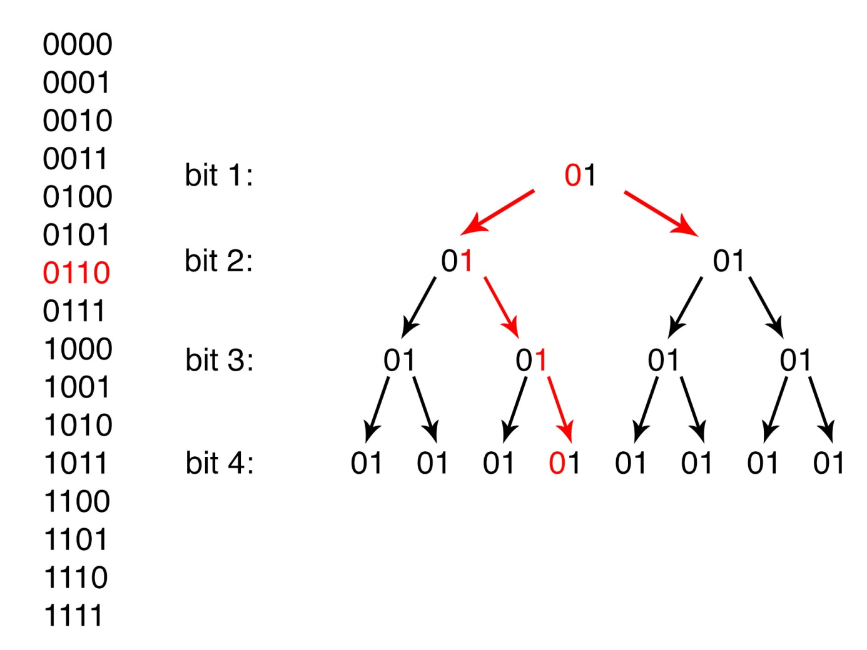Figure 10: A four-bit string visualized as bifurcating paths.
The next figure does the same, but with bions instead of bits. Similar to the structure in Figure 10, a sequence of bions can also be thought of as consisting of bifurcating paths. To ‘read’ Figure 11, start with the largest circles. They correspond with ‘bit 1’ in Figure 10. The two second largest ones with ‘bit 2’, and so on.
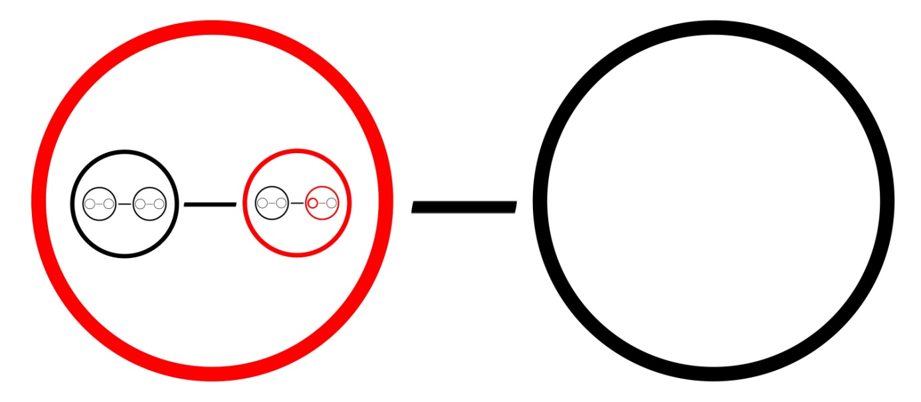Figure 11: Visual representation of a finite piece of an infinite sequence of bions. The bions colored in red constitute the specific information describing (things in) our universe, the bions colored in black correspond with the information describing (things in) alternate universes.
We can now return to the question which Chapter 4 concluded with and formulate an answer: In the absence of space, how can units of information such as bits be arranged into some kind of order? The answer I propose here is that the ultimate multiverse consists of information with bions instead of bits as its basic unit. A string of bions has an internal order, intrinsic to the nature of what bions are, instead of like bits only possessing an order relative to an external frame of reference such as space.
That internal order is that bions are arranged into a juxtaposition in which each bion relates to each other bion in one of three objectively definable ways: Either the two are directly next to each other, or bion x contains bion y (or bion x contains yet another bion which in turn contains yet another bion which in turn contains bion y, and so on), or bion x is contained by (or in other words: nested into) bion y (or bion x is contained by yet another bion which in turn is contained by bion y). To contain and to be contained by are two concepts (more specifically: two relations) which are different from each other in an objective sense, unlike for instance the two concepts being the left thing and being the right thing, which only have meaning relative to where in space the person observing things happens to be standing.
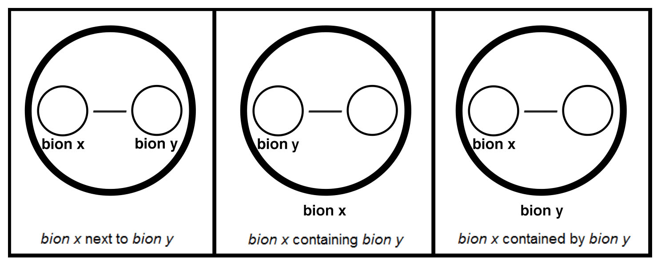Figure 12: The three ways in which the position of a bion can be arranged relative to the position of another bion.
In conclusion, a string of bions has the intrinsic property of being arranged into an order, and 'reading' that order from one particular side to the other is objectively dissimilar to reading it into the other direction. Therefore, unlike in a multiverse made of bits, in a multiverse made of bions the anthropic principle can explain why we live in one particular universe instead of in another without running into the paradox 'Bits derive their ability to describe complex things from the specific order of their arrangement in space, and space exists because there is a specific string of bits which by their specific order describe the existence of space'.
5.7 The second way in which bions can constitute information independent of spacetime
In Figure 11 bions were represented as a string of binary possibilities, of which always one and only one obtains (i.e. actually exists, such as 'our universe or one of the things contained by - and composing - our universe', in contrast with things that only exists in alternate universes). This was how the world looks when we describe or define something in the game of Twenty Questions. I end this chapter by presenting a variant to 'this way of representing which possibilities in a series of bions obtain'.
Again, imagine that every component of the world can be classified into a nested taxonomy in which each level constitutes two diametrically opposed things. For example the two categories 'southern hemisphere' and 'northern hemisphere', of which the latter in turn contains the two categories 'United States of America' and 'not the United States of America', of which the former in turn contains the two categories 'East of the Mississippi' and 'West of the Mississippi'. These categories are in principle mutually exclusive. It is however possible for something to be located in both categories simultaneously, such as a thing extending across the Mississippi river and thereby inhabiting both the Eastern and Western shore (e.g. a bridge).
Another example of two things which are different - and opposite - in one respect only, are protons and their antiparticles; antiprotons. Both these particles have the exact same characteristics, except for their charge, in which they are opposite. Yet both exist. The same goes for electrons and their antiparticles; positrons.
Conversely, there are many opposite things which don't exist. Far more than do exist, in fact. A proton has two thousand times as much mass as an electron, but presumably no particle exists with one thousand times the mass of an electron, or five hundred times, and so on. We can imagine what, if 'the particle with one thousand times the mass of an electron' did exist, its antiparticle (i.e. a thing identical to it in every respect except for having an opposite charge) would look like - yet neither of the two exists.
If we order all these particles into a nested taxonomy, this yields a picture such as in Figure 13:
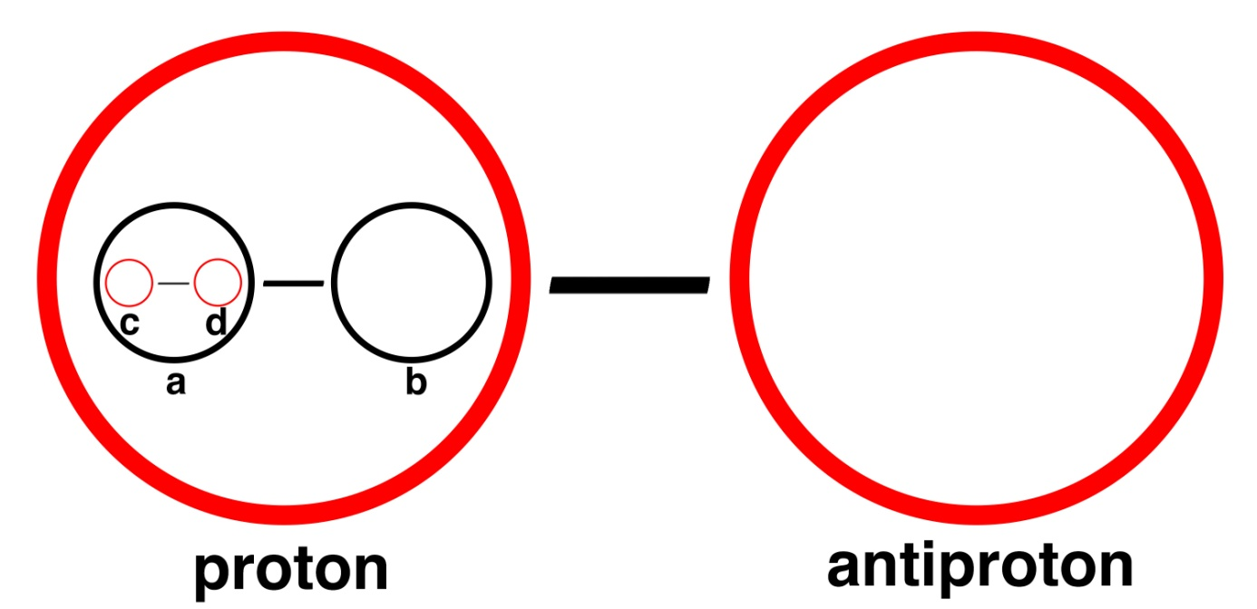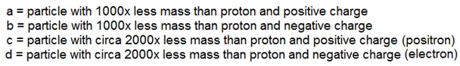Figure 13: Visual representation of a finite piece of an infinite sequence of bions. The bions colored in red constitute the specific information describing things which exist in our universe, the bions colored in black correspond with the information describing things which only exist in alternate universes.
Compare Figure 11 with Figure 13. In the former figure each bion in a sequence always has one alternative which obtains and one which doesn't. In the latter figure some bions have alternatives both of which do obtain, some bions have only one alternative which obtains, and some bions have no alternatives which obtain but can nevertheless contain bions which in turn contain bions which do have an alternative which obtains. Note that the simultaneous existence of, for instance, both electrons and their opposite, positrons, isn't a contradiction: Figure 13 refers to a situation where we describe which things exist, and two distinct things can exist as long as they don't occupy the same location in space at the same time. By contrast, Figure 11 refers to a situation where we define one specific thing by classifying it into mutually contradictory categories, such as 'East of the Mississippi' and 'West of the Mississippi', so here two adjacent red circles would be a contradiction (the game of Twenty Questions only allows for yes-or-no answers, even for things extending across the river, in which case the answer is still either yes or no, in this case chosen at random).
These are the two ways of visualizing how in a series of bions some possibilities obtain and some possibilities don't. Obtain from the perspective of an observer in the universe composed of the specific information those bions express, which, due to the anthropic principle, is all that particular observer can see and consist of. In the next chapter I address the question 'Why are there bions rather than no bion at all?'.

6 Why are there bions rather than no bion at all?

6.1 Introduction
The previous chapter explained how the anthropic principle explains why instead of an infinite amount of bions we observe a finite, specific amount of contingent, concrete things (viz. apples, laws of nature, etc.). In other words, it explained why there is something rather than everything. This leaves the question of why there' initially' was everything rather than nothing.
(Since a specific timeline is something which only exists inside - and as part of - a universe, the cause of - or reason for - the existence of the universe can't have the nature of an event happening at a moment in time. So the term 'initially' in the above sentence doesn't refer to an event preceding another event in time, but rather as something preceding the existence of the universe only in the sense of 'being a cause or reason underlying - and thereby explaining - its existence').
So 'before' the anthropic selection of the universe from the ultimate multiverse of bions took place, why was there an infinite series of bions rather than no bions; no thing of any kind at all? My approach to formulate an answer to the question of why bions exist starts with a concept known as the principle of non-contradiction.
6.2 The principle of non-contradiction
Aristotle considered the principle of non-contradiction to be the most fundamental law that all existing things adhere to, as well as the most elementary logical principle underlying rational thinking. This principle states that two opposing possibilities or assertions can't be true at the same place at the same time. And that likewise no existing thing can ever have all the exact same properties that another existing thing has (otherwise there by definition would be only one thing, not two). This principle "[...] has no specific subject matter, but applies to everything that is." (Gottlieb 2015) The idea that we must avoid making self-contradictory statements is so basic to rational discourse that it, even though understood and obeyed, is rarely mentioned explicitly. When something is logically necessary, it is because its alternative would constitute a logical contradiction.
Would the nonexistence of a bion constitute a logical contradiction? As we saw in Section 2.1, Hume and Kant thought it to be the case that the nonexistence of an entity or being could never qualify as a logical contradiction. But bions, with their peculiar nature, I think are an exception in that regard. To see why, consider the following - this time brief - thought experiment.
6.3 Imagining no bion
Imagine the state of affairs that nothing exists, except for a bion. Now remove the bion from the picture. The way we picture the second state of affairs is by negating the first, i.e. we derive a mental representation of 'no bion' from imagining a bion and then postulating its exact opposite. What is the relation between a bion and no bion? That they are distinct. Therefore, I argue, a bion and its opposite, along with the relation between them which expresses that they are opposite, together form a representation of another bion. Hence we didn't actually succeed in imagining no bion.
By contrast, we can picture the opposite of there being an apple. This is because we automatically place an apple in a contextual framework in which space, color, size, and us observers, exist, all of which remain in existence after the apple is removed. A single relation, such as the relation between the concepts 'an apple' and 'no apple', is far less complex than the nature of an apple itself. But due to a bion's extreme lack of complexity, the relation between 'a bion' and 'no bion' has the same complexity as a bion. As well as having the same nature of referring to two opposite states of affairs. Picturing the opposite of a bion merely constitutes imagining a string of bions and moving your focus from one bion in that string to the next bion in it. That indicates that -and possibly explains why - reality is such that there can be one specific something rather than another specific something, but not no thing whatsoever.
6.4 Bions as logic itself
Is this indeed a conclusive solution to the problem of why there is something rather than nothing, or is this rather a case of the so called philosopher's phallacy, i.e. "mistaking a failure of imagination for an insight into reality." (cfr. Holt 2012:266)? Does the apparent impossibility to imagine a situation where no bion exists, amount to an explanation of why bions do exist? And by which criteria of what comprises an explanation, would - or wouldn't - this be the case?
In a relationist view of the world (see Section 5.4), reality at its most fundamental level consists of relations. A relation always exists between - and thereby distinguishes between - two or more things. A relation thus conforms to the principle of non-contradiction. The simplest relation is between two things. The simplest state of affairs is a relation between two things which themselves have the minimal possible complexity. Arguably, in a relational world, things which possess the minimal possible complexity are those things which themselves exist only in relation to the next two things, and so on, in a nested structure, viz. bions. Rather than only conforming to the principle of non-contradiction, this suggests that this simplest possible relation, a bion, actually is the principle of non-contradiction.
This gives the following interpretation of what occurs when we try to switch from picturing a bion to a situation devoid of any bions: It constitutes trying to imagine a world no longer composed of logic, and therefore no longer describable by logic. Just like it makes no sense to ask what happened the minute before the big bang, because time only exists within - and as part of - the universe, no logical reason can be required for the existence of logic itself.
6.5 Classification
This helps explain why of the nine levels of nothing presented in Section 2.2, arguing that ‘levels eight and nine are possibilities on a par with the other seven levels’ is problematic; in level 8 logic doesn't exist, and therefore any description of it by definition constitutes a nonsensical state of affairs. It's not just that of all the possible places, we happen to live in a place that logic does apply to, but rather the following: We can't infer from anything we know, nor from anything we've ever encountered in reality, that there can exist some alternative to a world where logic does apply, since inferring, reasoning, arguments, rational thoughts, are based on logic, so that outside reality there is nothing to do the inferring with. Conversely, neither does that prove there can't be anything outside of the logic-governed world, merely that we lack any appropriate framework to make any rational statements about that subject.
This corresponds with the statement ‘There is something rather than nothing because the existence of nothing would be a logical contradiction.' This is the option listed at the end of Aristotles' and Rescher's overviews of possible answers presented in Sections 2.1 and 2.3.
But as Kuhn mentions in the introduction to his twenty-seven category classification of responses to the question of why there is something rather than nothing, responses "[...] can be combined in any number of ways - in series, in parallel, and/or nested." (See Section 2.3). The answer bion theory provides, indeed overlaps with several of his categories simultaneously. For instance, demanding a logical reason for why there is logic in the first place, is arguably a case of Kuhn's category "Meaningless question."
And since a world composed of bions would mean that everything that logically can exist, does exist somewhere, it also corresponds with Kuhn’s category "Multiverse by All Possibilities. Generated by the hypothesis that each and every logically possible mode of existence is a real thing and really exists, that possible worlds are as real as the world we inhabit, since the things that we call merely possible (from our perspective) are all of them existing somewhere else[.]"
Another of his categories specifies a particular kind of multiverse: "Multiverse by Mathematics. Generated by Max Tegmark's hypothesis that every conceivable consistent mathematical form or structure corresponds to a physical parallel universe which actually exists." As stated in Section 5.5, the web of bions constitutes a fractal, which is one of the mathematical forms which Tegmark explicitly designates to be one of the candidates for the structure of the Level IV multiverse.
Another highly relevant category is called "Abstract Objects/Platonic forms as Cause. Although philosophers deny that abstract objects can have causal effects on concrete objects (abstract objects are often defined as causally inert), their potential, say as a collective, to be an explanatory source of ultimate reality cannot be logically excluded. (This assumes that abstract objects - such as numbers, logic, universals, propositions - manifest real existence on some plane of existence not in spacetime.)" Bions are abstract objects, overlapping with the concept of logic and existing outside of spacetime. They constitute the potential for concrete objects to arise via the anthropic principle.
The fifth and last of Kuhn’s categories relevant to bion theory is "Beyond Concepts and Categories. Approaching ultimate reality is impossible for human thought, [...] because whatever fundamental existence may be, it must escape all our concepts and categories. This is not a matter of limited knowledge, but rather of absolute unknowability, a boundary that is in principle impenetrable."
(Leslie & Kuhn 2013:250-6)
This last one does not apply to bions, but to whatever next layer or more fundamental reality someone might, justifiably or unjustifiably (and in line with the view of Deutsch an Nozick that each level of explanation requires yet another level of explanation) wish to postulate as underlying bions, or as explaining logic itself. (See previous section).
6.6 Schematic classification overview
A schematic overview of how bion theory fits the combination of these five categories:
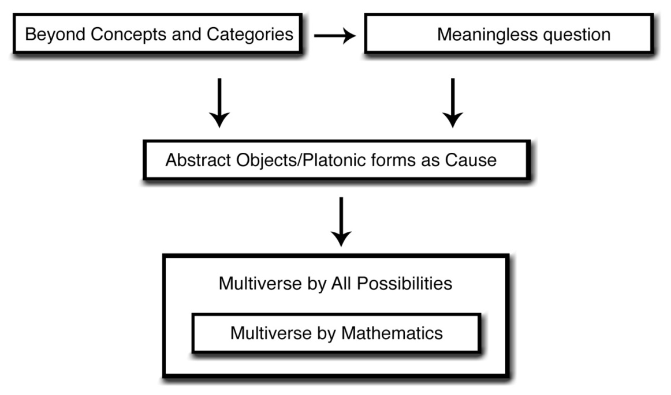
Figure 14: Kuhn's five categories which make up the answer provided by bions as to why there is something rather than nothing. Parallel, serial and nested structures are here symbolized to describe how these categories interrelate.
(The box on the upper left represents Kuhn's Beyond Concepts and Categories. Two arrows depart from it. The one pointing to the right symbolizes the idea that a situation without logic would be beyond any concept or category we can fathom, which renders the question of why there is something rather than nothing to some degree meaningless. The downward arrow indicates that Abstract Objects/Platonic forms exist because the alternative would be the kind of self-contradiction belonging to the realm of Beyond Concepts and Categories. Parallel to this downward arrow is another arrow, pointing downward from the Meaningless question box, which symbolizes that the existence of Abstract Objects can likewise be thought of as self-evident due to the reason that the notion of their nonexistence would be meaningless. The box below embodies the Abstract Object or Platonic form of a bion, or synonymously of the basic logical principle of non-contradiction. Because if there is one bion, there automatically is an infinite amount of bions, a downward arrow departs here as well. This arrow, in series with the two parallel previous ones, points towards the box characterized as Multiverse by All Possibilities, or in other words, the infinite string of bions, which can be said to be caused by the existence of the abstract object of the single bion in the box above it. The last box is the Multiverse by Mathematics, or in other words a vast amount of abstract -yet specific- mathematical configurations which govern and constitute the physical laws and constants that make up our specific universe. These specific mathematical entities are manifestations of selection taking place in the initially undifferentiated string of bions, e.g. via the anthropic principle, and are therefore a constituent of the Multiverse of All Possibilities, i.e. their category is nested into the latter.)
7 Bions as Popperian metaphysics

7.1 Falsifiability of Bion Theory
The nature of bions has now been outlined, and was subsequently fitted into the framework of some existing systematical taxonomies of answers to why there is something rather than nothing. In the current chapter, we'll zoom out further, by addressing the practical implications (or lack thereof) of a world composed of bions. How does a universe yielded by a multiverse of bions differ from a universe not ultimately derived from bions? In other words, what predictions does the theory presented in this paper make, and how can its predictions be used to prove or disprove this theory? On these points, my answer is brief: I think the idea that the world is ultimately composed of bions makes no empirically testable predictions.
Rather, 'no scientific theory about the origin of the universe which I can currently think of' would definitively preclude the possibility that on some sort of deeper level the world consists of bions after all. (By deeper level I mean that there will always exist some philosophical position according to the criteria of which any line of cause and effect constituting scientific explanation can be extended into more abstract levels of reasoning). I don't consider this principal lack of falsifiability a merit, neither in general nor in the specific case of the theory presented in this paper. But I think that bion theory does elucidate the inherent unfalsifiability - and thus the inherently unscientific nature - of the question of why there is something rather than nothing. In other words, that the nature of my answer to the question 'Why is there something rather than nothing?' reflects the nature of that question, and that the bion theory's most significant merit thus lies in its role of clarifying that this question is inherently unscientific (cfr. the category Meaningless question in the previous chapter).
Since explaining the origin of the world via the route of bion theory therefore can't be considered science, how can bion theory be classified instead? My choice for a candidate is metaphysics, specifically Popper's interpretation of that field. The next section starts discussing the Popperian notion of metaphysical explanation based on some of Deutsch's words on the subject.
7.2 On the Popperian interpretation of explanation
Deutsch considers explanation to be more than just prediction. He thereby rejects a purely reductionist interpretation of what science is about. In a reductive form of scientific explanation, things are analyzed into components. "For example, the resistance of a wall to being penetrated or knocked down is explained by regarding the wall as a vast aggregation of interacting molecules. The properties of those molecules are themselves explained in terms of their constituent atoms, and the interaction of those atoms with one another, and so on down to the smallest particles and most basic forces. Reductionists think that all scientific explanations, and perhaps all sufficiently deep explanations of any kind, take that form. The reductionist conception leads naturally to a classification of [...] theories in a hierarchy, according to how close they are to the 'lowest-level' predictive theories that are known. In this hierarchy, logic and mathematics form the immovable bedrock on which the edifice of science is built. [...] Much of basic chemistry has been reduced to physics in this way. But for higher-level sciences the reductionist program is a matter of principle only. No one expects actually to deduce many principles of biology, psychology or politics from those of physics. The reason why higher-level subjects can be studied at all is that under special circumstances the stupendously complex behaviour of vast numbers of particles resolves itself into a measure of simplicity and comprehensibility. This is called emergence: high-level simplicity 'emerges' from low level complexity." This doesn't mean, however, that Deutsch advocates the other extreme: "By the way, the opposite of reductionism, holism - the idea that the only legitimate explanations are in terms of higher-level systems - is an even greater error than reductionism." To a reductionist, physics supplies the deepest possible form of explanation. "But to everyone else scientific knowledge consists of explanations, and the structure of scientific explanation does not reflect the reductionist hierarchy. There are explanations at every level of the hierarchy." (Deutsch 1998:19-21) For bions this means that, although I've argued above that bions are 'the most fundamental constituents of reality that are logically possible', they nevertheless aren't necessarily a more important kind of explanation than higher-level subjects.
Along with induction-based ways of explaining and proving things, such reductionism "[...] and all other prediction-centred theories of knowledge are based on a misconception. What we need is an explanation-centred theory of knowledge: a theory of how explanations come into being and how they are justified; a theory of how, why and when we should allow our perceptions to change our world-view. [T]he prevailing theory of scientific knowledge, which in its modern form is due largely to the philosopher Karl Popper [...] can indeed be regarded as a theory of explanations in this sense. It regards science as a problem-solving process." When existing scientific theories seem inadequate in any way, possibly but not necessarily due to being incompatible with new observations, "[...] that is what constitutes a problem." For example, an existing theory may be too superficial. Or it may be found to violate Occam's razor (See Section 3.1) when compared to an otherwise equal yet less complex explanation for the same phenomenon. Or two theories, despite both appearing compatible with current empirical evidence, may logically contradict each other. (idem: 61-2)
The question of Why is there something rather than nothing? constitutes a problem. Bion theory, despite lacking concrete empirical underpinnings, can in this view be considered a solution to this problem, and the quality of this particular solution can be compared with that of other conjectured solutions on the basis of criteria such as its depth, universality, simplicity or 'possession or lack of internal logical contradictions'. Its inability to be disconfirmed by empirical evidence does however still place it outside of the realm of scientific discourse.
Related to the reductionist idea that a hierarchy exists within the scientific disciplines, is the assumption "[...] that theories can be classified in a hierarchy [...] of decreasing intrinsic reliability[,]" in which the first category consists of things that are entirely mathematical, followed by the category of what can be scientifically proven, and ending with whatever can 'merely' be philosophically researched. "Many people take the existence of this hierarchy for granted, despite the fact that these judgments of comparative reliability depend entirely on philosophical arguments, arguments that classify themselves as quite unreliable! [...] The same assumption occurs in inductivism, which supposes that we can be absolutely certain of the conclusions of mathematical arguments because they are deductive, reasonably sure of scientific arguments because they are 'inductive', and forever undecided about philosophical arguments, which it sees as little more than matters of taste. But none of that is true. Explanations are not justified by the means by which they were derived; they are justified by their superior ability, relative to rival explanations, to solve the problems they address." (idem: 84)
7.3 Popper on problem solving
Regarding what kind of problems it is that philosophy and science address, Popper remarks that "A scientist engaged in a piece of research, say in physics, can attack his problem straight away. He can go at once to the heart of the matter: to the heart, that is, of an organized structure. For a structure of scientific doctrines is already in existence; and with it, a generally accepted problem-situation. This is why he may leave it to others to fit his contribution into the framework of scientific knowledge. The philosopher finds himself in a different position. He does not face an organized structure, but rather something resembling a heap of ruins (though perhaps with treasure buried underneath). He cannot appeal to the fact that there is a generally accepted problem-situation; for that there is no such thing is perhaps the one fact which is generally accepted." (Popper 2002:XV-XVI, see Chapter 1) "Popper further argues that a philosopher must before all else tackle philosophical problems, as well as speaking of philosophy, for ‘genuine philosophical problems are always rooted in urgent problems outside philosophy, and they die if these roots decay’[.] Any means to this end are valid: it is anyway sterile to try to define the correct method, because philosophy would then become application or technique rather than research." (Corvi 1997:144-5).
Rather than rigidly focusing on a particular method of acquiring knowledge, or on a problem-situation formulated necessarily through institutionalized research, Popper advocates a more pragmatic and down-to-earth approach: According to him, in order to get our priorities straight, we should step back to the here and now. "[A]ll problems— including the most complex theoretical ones—ultimately rest upon the practical problem of adaptation to the material environment, often by improving it, or upon the existential problem of the [...] moral conditions of life. The problem-situation is so deeply rooted in life that any solution, however felicitous, ‘opens up in its turn a whole new world of open problems’[,] which cannot be solved, at least not immediately, because knowledge cannot predict its own future conquests [...]" Ultimately, there is no rational reason for us to try to be rational, no matter how much we ponder deep and abstract questions about the nature of knowledge or the world. Instead, if we do engage in rational reasoning, then this is because we made the essentially irrational and highly subjective choice to do so, a choice we make because we have noticed that consistently doing so generally improves the concrete circumstances of ourselves and others. (idem:141-2)
7.4 Relation to Bion Theory
In discussing how the previous paragraph relates to bions, I'll start with Popper's definition of realism. "[T]o be a realist is simply to hold that the world exists and develops independently of human beings [...]" (Corvi 1997:79). There thus exists a reality outside of our model of it. But that reality and that model can easily be confused. Our model of the world arguably develops through psychological processes, unconsciously influenced by the ultimate factor of the interrelation between our genes and the whole of our environment, and the more proximate factor of our emotions or cognitive biases and the immediate problems presented by our environment. We can nevertheless attempt to base our decisions completely on rational reasoning, as if the brain were a blank slate, and as if the whole of our thought processes at any given moment could be fully conscious (and due to some persistent illusions, we are indeed prone to think our decisions are conscious and the product of free will). In that case we would be searching for an ultimate and rational reason to think rationally. Perhaps searching for an answer to 'why there is something rather than nothing' is sometimes an attempt to find an ultimate, rationally comprehensible foundation of reality, and hereby making the mistake of confusing that with an ultimate, rational foundation for the thoughts that compose our model of reality (i.e. confusing reality and the model of reality). By acknowledging that our rational reasoning about even the most abstract subjects ultimately starts as a largely unconscious adaptation to our material environment, I think Popper avoids making that mistake. Conversely, to someone who does seek an ultimately rational reason to be rational, and who does make that mistake (i.e. confuses 'the reason why he or she thinks a certain way about something' with 'the reason why that something exists' ), it may appear that there must be a logical reason even for the existence of logic. And as argued in Chapter 6, the impossibility to imagine 'a situation in which not even a bion exists' explains 'why there is something rather than nothing' because there can't be a logical reason for 'the existence of logic itself.
To sum up the point made thus far in this chapter: I argue that bion theory solves the problem of 'why there is something rather than nothing' according to specifically Popper's interpretation of what problem-solving entails. In the next section I continue elucidating Popper's distinction between the metaphysical element of problem-solving on the one hand, and elements of problem-solving based on falsifiability on the other hand.
7.5 Popper on falsifiability
"What procedure distinguishes natural science from metaphysics?" Popper argues against the notion that science is entirely about induction, i.e. that taking a series of empirical observations and assuming that whatever is constant throughout them thus far, will remain immutable forever and therefore constitutes a law of nature. Since the decision to think rationally cannot itself be made rationally, "[...] scientific discovery is impossible without faith in ideas which are of a purely speculative kind, and sometimes even quite hazy; a faith which is completely unwarranted from the point of view of science, and which, to that extent, is ‘metaphysical’." According to Corvi, this view by Popper "[...] does not involve a methodological abandonment of experience; the theory of knowledge is understood precisely as a ‘theory of empirical method’ [...]—but it is a theory which, in accounting for real scientific procedures and results, goes beyond the mere accumulation of experiential data. In sum, Popper’s problem is to find a distinction between science and pseudo-science that does not dismiss the latter as mere nonsense. Often theories start out as metaphysical or mythical and only subsequently acquire a scientific dimension; it hardly seems consistent to describe as simply unintelligible or meaningless, discourses which at a certain point show themselves to be endowed with meaning. Right from his early reflections, Popper was convinced that metaphysics is not nonsense and that it is impossible to rid science of every metaphysical element— although, of course, he thought it desirable to remove the metaphysical elements whenever that was possible[.]" (Corvi 1997:23-5)
"[A]ny doctrine, whether ontological or not, is defined by Popper as ‘metaphysical’ if it cannot in principle be falsified or refuted." (Corvi 1997:78). But although a metaphysical theory can't be falsified directly through observation, it can be refuted by finding logical contradiction within it. "What is true of science in general thus also applies to Popper’s epistemology: its falsity can be demonstrated but not its truth, and so it is necessary to be content with what proves free of contradiction, both internally and in relation to external reality." (idem:45). Popper considers the principle of non-contradiction the metaphysical equivalent of what falsification is to science. "It is obvious that contradiction is a sign of falsity and that a self-contradictory system must be rejected because it is false, and falsifiability has the same function on an empirical rather than logical level." (idem:27). The way of thinking which Popper proposes, Albert agrees, is "[...] nothing less than the methodological equivalent of the principle of non-contradiction." (idem:163).
In general, metaphysics establishes a picture of the structure that encompasses the whole of scientific theories and the relations between them. (Corvi 1997:129). Popper argues for "[...] the existence of different levels of understanding, [and] he shows how important it is for us to analyze the problem-situation, not only to devise a solution but even to understand the solution itself, by reconstructing the historical stages through which it was elaborated, criticized, modified and finally accepted[.]" (idem:141). Nevertheless, although Popper is convinced of the existence of an external, objective reality of which our knowledge - through rational thinking - can always become an increasingly accurate approximation, he does not believe in certainty. (idem:130).

8 Recapitulation and conclusion

8.1 Recapitulation
In Chapter 5 I introduced bion theory through a visual depiction of bions as bit-like entities arranged into a nested structure. In the subsequent chapters I've established a framework of how that abstract notion of bions can be fitted into existing conceptions of how the world is, and thereby discussed which answers bion theory implies for the question of why there is something rather than nothing. Another approach would be to work in the opposite direction; to begin by advocating a general philosophical position, describe how it relates to that question, and then specifying my individual version of that position step by step until a metaphorical picture of bions emerges from this presented context. In the current chapter I will recapitulate bion theory in the latter direction:
Why is there something rather than nothing? In a Popperian worldview, explanation tends to come in layers, yet the position of one layer vis-à-vis another layer doesn't necessarily correspond with one explanation being superior to another. Therefore, the reason why there is something rather than nothing neither has to be the same kind of explanation as the reason why there is one particular thing rather than another particular thing, nor does it have to be deeper or more fundamental than the latter. Instead, the reason why there is something rather than nothing may not constitute a cause, i.e. an in principle falsifiable and therefore scientific notion. Nor does the relation between the two states of affairs of the existence of something on the one hand and the existence of nothing on the other hand, even necessarily constitute a logical relation. Hence the question may be to some extent meaningless.
I suggest logic is something, and that asking Why isn't there nothing at all? is therefore tantamount to asking What factor external to logic explains why there is logic? And that question of course involves a logical contradiction, similar to asking What happened the minute before time existed? All this amounts to a logical explanation for why Nothing 8 and Nothing 9 from Section 2.2 don't exist - and never have. But according to which criteria is logic something? Logic, after all, is epistemic; it's an abstract method of ascertaining which things concretely exist. Epistemic as opposed to being ontological. The ontological, by contrast, refers to 'the things which concretely exist' themselves.
I also suggest, however, that complex logic on the one hand, and concrete things, such as matter, on the other hand, both originate from the same ancestral entity. I further argue that logic is the basic unit of the epistemic, and that the principle of non-contradiction is in turn the basic unit of logic. And that information is what matter (as well as the ontological in general) consists of, with binary digits being the basic unit of information. And finally, that the binary digit in its most abstract form, is identical to the principle of non-contradiction. In this view, 'logic is something' because on the extremely fundamental level of binary digits making up a universe, there no longer exists any distinction between the epistemic and the ontological.
However, to get to a truly abstract form of the binary digit, we must first divorce it from the concrete context to which we are accustomed, viz. our specific universe with its particular spatial dimensions and timeline. And in doing so, we stumble upon the problem that information can only derive 'its ability to encode complex things' from multiple bits being arranged in a particular sequence within time and space. (In other words: If our universe is a simulation running on a computer, where is that computer itself located?)
We circumvent that problem by replacing bits with a unit of information of which the internal structure allows for multiple bit-like entities to be arranged in an order independent of any spatiotemporal context. Namely the binary distinction, with its infinite branching off into additional bions in a nested, self-defined and thereby self-contained structure. Postulating the existence of bions corresponds with the conjecture that our universe is part of an infinite string of bits in which no particular values (1 versus 0) have been specified. In other words; an infinitely large multiverse of random information, or in different terms still; the existence of everything instead of nothing. That in turn leaves the following question: Why are there, apparently and at least relative to us, only some specific things rather than the existence of everything?
The answer to this is the anthropic principle. This principle states that observers are components of a whole which they can't integrally observe because observers themselves constitute only a specific set of information within that whole. They can only observe the specific circumstances compatible with - and composing - their own existence, since the alternative of course would be a logical contradiction. Thus the anthropic principle explains why at our position in the field of possibilities there only exist some things rather than everything.
8.2 Conclusion
In conclusion: The question Why is there something rather than nothing? is open to many interpretations. In philosophy - Popper's view of philosophy in particular - proposed solutions retroactively shape our understanding of the nature of the problem or question which they have responded to. Through the bion thought experiment, I have arrived at an interpretation of this question along the following lines: When it comes to the origin of the world, what is the nature of the ultimate conceivable boundary to this process?
Its answer, as suggested by the theory presented in this paper, depends on the degree to which someone considers explanation to be hierarchical. For the sake of clarity, I will elaborate on this point by presenting the two extremes of this continuum. For the sake of succinctness, I will discuss only one intermediate viewpoint, although there's a host of other viewpoints in between those two extremes .
On one end is the philosophical position that methods of knowledge-gathering interrelate in a strictly hierarchical way. Whatever way of thinking applies to the base of this hierarchical pyramid (and in this case that base consists of the relation between the existence of something on the one hand, and whatever is to be understood as the alternative state of affairs on the other hand, while layers closer to the top of the pyramid include subjects like the laws of physics, chemistry, biology, psychology and sociology, respectively), is elevated to 'the status of being superior to all other forms of thinking' just because it has that position in the pyramid. In bion theory, the foundation of that hierarchy consists of bions. And the way of thinking that applies to the relation between the existence of something (i.e. bions) and nothing (i.e. the existence of no bions) is logic. Logic in its arguably most basic form, namely the principle of non-contradiction. Because the relation between 'a bion' and 'no bion' is itself a bion, the 'Why is there something rather than nothing?' question is tantamount to requesting 'a reason external to logic' for the existence of logic itself (which in retrospect makes it largely a meaningless question). Therefore the ultimate reason something exists is that 'the existence of nothing' would be a logical contradiction. (Like any rational idea, this answer can of course be refuted by finding a logical contradiction within bion theory).
But at the same time, bion theory turns out not to tell us anything concrete about 'the world here and now'. For example, it doesn't specify the value of constants in physics, such as the speed of light. Although instead, bion theory does explain where the potential comes from for these constants to be selected via the anthropic principle: Namely why an infinite string of initially unspecified information exists - and the anthropic principle itself is also just the application of the principle of non-contradiction. Bion theory thus explains why the higher level, emergent laws of nature such as the speed of light exist, but not what value they have in our specific universe. Therefore, the way of thinking that applies to 'the relation between something and nothing' is not a form of knowledge that's superior to science. This argues against the existence of a strict hierarchy in how fields of knowledge interrelate.
On the other extreme is the idea that there's no hierarchy whatsoever, cfr. relativism. The question of Why is there something rather than nothing? here doesn't a priori get assigned a higher status than any other question. Nor does its answer necessarily have any implications for the nature of knowledge itself. In this view, bion theory is merely a series of tautological statements: The bion thought experiment is a line of reasoning, which sets out with the intent 'to be logically coherent throughout' (like all rational thinking), and I ended this line of reasoning at the moment that I stumbled upon an idea that would entail a contradiction (namely 'the existence of no bion). In other words, I didn't go any further because I had decided not to beforehand; my ending at that point just communicated a repetition of what I already (implicitly) communicated by commencing a line of logical reasoning in the first place.
Conversely, the significance of bion theory resides in the assumption that my small line of reasoning is a continuation of a vast historical line of reasoning about the origin of the world, all the way through the sequence of causes and effects of the physics of the big bang and the chemical synthesis of DNA to the universe with life and observers existing in the here and now: It is only in that context, that 'the fact that the line of reasoning I present contains a point where, contrary to every step before it, it suddenly turns out we can no longer go any further' teaches us something about the world at large. And in the absence of any degree of hierarchy between our pieces of knowledge from different fields, any line drawn to link them is a random and meaningless exercise. To sum up, without a hierarchy bion theory doesn't imply anything.
Hence, both extremes have a problem which bion theory doesn't integrally solve. Popper's worldview lies somewhere in between those extremes, and seems to me to be more compatible with bion theory. In his view, forms of knowledge, such as metaphysics and empirical science, or physics and chemistry within science, are linked. But not in a hierarchy in which one form of knowledge is necessarily superior to another. Their usefulness depends on their ability to answer problems, and which theory best describes 'the relation between fields of knowledge' can likewise be inferred from the problem-solving capacity of one such theory versus another. And finally, Popper advocates the superiority of rationality over irrationality, both as a principle underlying this methodology and as a conclusion consistently emerging from applying this methodology.
My answer to the research question of this paper can therefore be classified as a Popperian version of metaphysics. When it comes to the origin of the world, the nature of the ultimate conceivable boundary to 'the process of the world's origin' is the distinction between rationality and irrationality. I agree with Popper that absolute certainty, on any matter, is an illusion. Nevertheless, as far as I can currently tell, and of course provided that no contradictions are found in bion theory, I do think bion theory supplies an integral answer to why there is something rather than nothing: The ultimate reason something exists is that 'the existence of nothing' would be a logical contradiction.

References

Baeyer, Hans Christian von. Information: The New Language of Science. London: Orion Books, 2004.
Brenner, Andrew. "What do we mean when we ask Why is there Something rather than Nothing?" Erkenntnis 81 (2016): 1305-1322.
Corvi, Roberta. An Introduction to the Thought of Karl Popper. Trans. Patrick Camiller. London: Routledge, 1997. (This edition published in the Taylor & Francis e-Library, 2005.)
Couprie, Dirk L. "Anaximander." Internet Encyclopedia of Philosophy. 2003. 15 Apr. 2017 <http://www.iep.utm.edu/anaximan/>.
Dawkins, Richard. The Greatest Show on Earth. London: Transworld Publishers, 2009.
Deutsch, David. The Fabric of Reality. London: Penguin, 1998.
Gottlieb, Paula. "Aristotle on Non-contradiction." Stanford Encyclopedia of Philosophy. 2015. 17 Apr. 2017 <https://plato.stanford.edu/entries/aristotle-noncontradiction/>.
Greene, Brian. The Hidden Reality: Parallel Universes and the Deep Laws of the Cosmos. New York: Vintage Books, 2011.
Holt, Jim. Why does the World Exist? London: Profile Books, 2012.
Kaipayil, Joseph. Relationalism: A Theory of Being. Bangalore: JIP Publications, 2009.
Krauss, Lawrence M. A Universe from Nothing: Why is there Something rather than Nothing. New York: Free Press, 2012.
Leslie, John, and Robert Lawrence Kuhn, eds. The Mystery of Existence: Why is there Anything at All? Chichester, West Sussex: John Wiley & Sons, Inc, 2013.
Lloyd, Seth. Programming the Universe: A Quantum Scientist takes on the Cosmos. New York: Vintage Books, 2007.
Lowe, E. J. "Metaphysical Nihilism and the Subtraction Argument." Analysis 62.1 (January 2002): 62-73.
Popper, Karl. The Logic of Scientific Discovery. First trans. by Hutchinson & Co. London: Routledge, 2002. (This edition published in the Taylor & Francis e-Library, 2005.)
Tegmark, Max. Our Mathematical Universe: My Quest for the Ultimate Nature of Reality. London: Penguin, 2015.

