Letter to a friend : Creative Thinking and Intuition
Letter to a friend about creative thinking and intuition (art, writing, philosophy, science, etc).
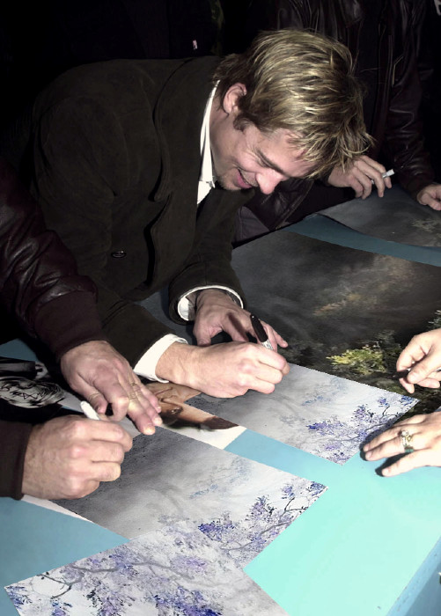
Posters of my work signed by celebrities and donated to Chaity – YES IT IS HIM.

A few of my paintings before the letter –

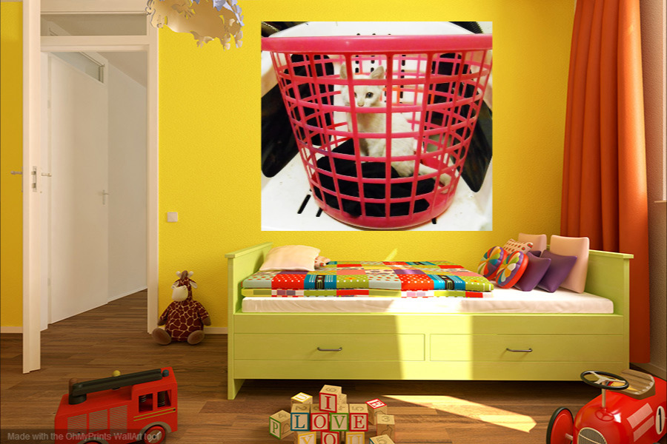
Thanks for link, will try.
Yes painting and writing, especially phil. very lonely - the latter one thinks for hours, days, weeks, months until the whole thing is spun out.
https://www.academia.edu/31511435/Nature_and_Limits_of_philosophy_izing_only_2_Pages_

I saw a LOT by psychologists and philosophers the last few years on intuition - but ignored it as I always thought is too wishy washy speculative - but I had to look at and explore the concept the last month when I wrote on cognition, cognitive sciences.
Einstein etc made much of it - you can be highly intelligent but not creative/have intuition - how it suddenly comes on you - I always disliked the word inspiration - as it seems it's something from outside - apparently intuition come from past experience, memories, insights and built up in the subconscious, It is advised to always have a pen paper and write down when isolated ideas come into your head - then they're out of your head and you can go on with thinking other things, live etc
https://independent.academia.edu/UlrichdeBalbian/Drafts

I took that for granted and always did that - wake up all night and note than bits to get rid of it from mind - then I realized intuition in my case - is like a stream of consciousness - always nonstop and for painting and writing phil/logic/reasoning - I think both side of my brain fired up -
I wake up every night at 2 or 3 and my head full of such things - write it down very fats, cant read it next day - so I just get up and type it our properly - thus all the books the last few months - about 30 I think.
anyway is just something of interest - self-knowledge of this thing
to me phil, sociology, psychology are life savers - I started reading it when young as tools to balance my mind and know myself - many artists commit suicide, alcohol - Pollock drunk himself dead - drugs etc as they cannot cope with the brain overload and dont have the tools to comprehend it - I realized that and that I need reflective skills to deal with it - and thus phil, etc to understand it, intuition, myself, society etc - my liofe savers
just thought you'll see it in yourself as well - reflection on it, being aware of it helps
why I wrote meta-cognition - lack of it for all philosophers - none of them aware of their own reflective skills etc - what I wrote about in my last stuff –
https://www.academia.edu/31495642/_Meta-Philosophy_Meta-Cognition_and_Critique_of_Doing_Philosophizing
https://www.academia.edu/31276710/_Meta-Philosophy_Philosophers_and_their_lack_of_Meta-Cognition
https://www.academia.edu/31278266/_Meta-Philosophy_Where_to_begin_Philosophy
- might be able to sleep a bit after all that off my mind

On 19/02/2017 23:16, D wrote:
> Sent you the wrong website. Did it early. This Kindle has a mind of its own and will correct what it thinks are my misspellings. Again www.onbeing.org
>> This is lonely work. I guess creative stuff is. The homily went well.
>> You and I both have the dog thing. They make me a better person. We're being offered a Brittany Spaniel right now. Nine years old. Fine age for me to spoil.
> On February 19, 2017, at 8:42 AM, writer wrote:
>Thanks D,
> thanks so much for sharing - so much you say and points to the
> ineffable. Please write it down and put it for FREE on Academia. Edu
> where I put mine. Free for academic and such work.
> 'Jesus' is so subtle, complex but I suppose also 'simple' for mother
> Teresa, John of the Cross, etc -
> sad how he is transformed into another product of famous name - like
> what is done with philosophers or some artists who lived for what they
> did, they just had to do it.

> i merely write and paint because I must do it - I'll go mad, van Gogh
> and commit suicide like many artists etc if I dont do those things - not
> to be known ,read etc - there are many others that offer all the
> solutions and answers much better than I ever could - just different
> strokes for different people - I'm just doing what I must do - or
> explode mentally - or take drugs, alcohol etc - just a hermit almost
> totally isolated.

>
>
> On 19/02/2017 13:31, D wrote:
>> Last night we had the pleasure of hearing Krista Tippett, a radio personality who interviews all kinds of people in search of their spiritual values. Her website is www.obeying.org. I admire her work because she engages people conversationally. She keeps her own biases out of sight and allows space for exploring new options without rancor. She spoke a lot about finding civility in public discourse and being aware that so much we took for granted in the 20th century is now gone.
>> I have too many answers left over from the lives of others now. I'm reluctant to tell people that I have a background in ministry and theological studies because they'll jump to conclusions that aren't true. So much that has passed for religion is spiritual abuse. Like Rilke, I'm more aware that I have questions to share on a Sunday morning and an interest in presiding over liturgies that aren't filled faux magic about Jesus or anything else. It's about offering and holding a sacred space for people to raise concerns, give thanks and build beloved community.
>> I have access to two world-class libraries. I often find myself now taking my questions within rather than turning them into just more information. There is so much of my own human wholeness and imagination that's waiting to be tapped if I will only attend the presence of my own heart and enter the cloud of unknowing.
>>Gospel text today concludes with Matthew 5.48 about being perfect. It's tempting to play with this in a didactic way about a detachable God or something. I can't do that any longer. I have no definitions from the past that cover this.
>> I believe that memory that Matthew had was about a process that Jesus put into motion. The idea arises for me within a set of contrasting statements that Jesus is trying to make about the nature of law. Perfection is a holy space between the opposites that are drawn in tension until a point of union arises. Conjunctio oppositorum. Listening with the heart that can hold infinite ambiguities that the mind cannot absorb. Perfection is an inward state of virtue that holds this truth while we strive meet the demands and desires of our blind ignorance.
>>
I believe it's how were wired and Jesus continually reopens that mirror in front of people and invites them to behold themselves free from the law and judgment in their state of final wholeness - salvation. It is a state of revealed divine restlessness. The presence of Spirit.
>> Didn't mean to go on so long, but at least there's a sermon outline here.
>>
>> On February 19, 2017, at 1:14 AM, writer: wrote:
>>
>> As philosophy, doing it, thinking in that way, is essential to me I
>> always had to ask 'what it is' and 'how' it is - I am shocked that the
>> subject is seen as so mysterious and never questioned by the top
>> thinkers and writers -
>>
>These 2 pages show - why I had to ask those questions and a few simple
>> points what philosophy is and how philosophers create their own problems.
>>
And, if they as thinking experts do that - what can we expect from
>> 'ordinary ' thinkers or people, Trump, politicians, etc

------------------------------------------

