Assoc Professor Natalja Deng
Yonsei University
nmdeng@gmail.com

Ms Batoul Hodroj
University of Sydney
batoul.hodroj@sydney.edu.au

Dr Andrew J Latham
Aarhus University
andrew.latham@cas.au.dk

Mr Jordan Lee-Tory
University of Sydney
jlee8488@uni.sydney.edu.au

Professor Kristie Miller
University of Sydney
Kristie.miller@sydney.edu.au

Is present-bias a distinctive psychological kind?

Abstract
Present-bias is the preference, all else being equal, for positive events to be located in the present rather than the non-present, and for negative events to be located in the non-present rather than the present. Very little attention has been given to present-bias in the contemporary literature on time biases. This may be because it is often assumed that present-bias is not a distinctive psychological kind; that what explains people’s being present-biased is just what explains them displaying various other time-biases. According to this view, there is no need to investigate present-bias independently of investigating these other biases, since present-bias is really just a manifestation of these other biases. We call this the manifestation thesis. We take up the question of whether the manifestation thesis is true, and argue that it is not. Thus, by failing to investigate present-bias in its own right we are failing fully to understand the spectrum of ways in which people display time biases. In turn, we suggest, this may have implications for the ways we evaluate whether present-bias is rationally permissible.

1. Introduction
This paper investigates a kind of temporal (or time-biased) preference that has received very little attention to date, which we call present-bias. Call events that one values or finds pleasant (such as enjoying some cake) positive events and events that one dis-values or finds unpleasant (such as having a headache) negative events. Then positive present-bias is the preference, all else being equal, for positive events to be located in the present rather than the past or future. Similarly, negative present-bias is the preference, all else being equal, for negative events to be located in the past or future rather than the present. Thus, present-bias is a preference (all else being equal) to have positive events located in the present (i.e., now) and to have negative events located in the non-present (i.e., in the past or the future).

We know, from previous research, that people show present-biased preferences (see Deng, Latham, Miller and Norton forthcoming). We also know that those preferences are associated with certain sorts of temporal attitudes: attitudes characterised by a concern (or lack thereof) about past or future events. For instance, Deng et al found that non-present-biased people—people who do not exhibit present-bias—have higher degrees of ‘past thinking’ (i.e. thinking about past events), and past emotion (feeling anxious, excited, regretful, nostalgic, and so on about the past) than do present biased people. This is consistent with earlier research which has found that people who are more strongly future oriented tend to save more money (Hershfield et al., 2011); are less likely to exhibit present bias (Bartels and Rips, 2010; Bartels and Urminsky, 2011; Ersner-Hershfield,
Wimmer, and Knutson, 2009); are less likely to engage in risky, delinquent, and unethical behavior (Hershfield, Cohen, and Thompson, 2012; van Gelder, Hershfield, and Nordgren, 2013); and enjoy better present health (Rutchick, Slepian, Reyes, Pleskus, and Hershfield, 2018).

This suggests that understanding present-bias is important in understanding our temporal preferences, and the ways in which these are connected to our temporal attitudes.

Despite this, little if any attention has been paid to present-bias as a phenomenon in its own right. We think that one explanation for this is that it is often assumed that present-bias is simply the limiting case of near-bias, where near-bias is the preference to have positive events located temporally closer rather than further away, and negative ones temporally further away rather than closer. After all, the present is the limiting case of the near, and both psychologists and economists tend to frame discussion of near-bias in terms of discount functions that range over both present and future times.

Even if present-bias is, in this sense, a limiting case of near-bias, however, it does not follow that, psychologically speaking, present-bias is really nothing more than near-bias. In this paper we focus on the question of question of whether present-bias is a distinctive psychological kind. To say that present-bias is not a distinctive psychological kind is (as we will understand it) to say that the psychological explanation of present-bias is the very same explanation as the explanation for one or more of the other time biases: that people are present-biased just because (psychologically speaking) they display one or more other biases. If present-bias is not a distinctive psychological kind, then in some good sense manifestations of present-bias are really no more than manifestations of some other time biases, most likely they are manifestations of those other time biases at their limit. We call this the manifestation thesis.

A natural suggestion is that present-bias is not a distinctive psychological kind because it is a manifestation of near-bias. Above, we said that near-bias is the preference to have positive events temporally near rather than far, and negative events temporally far rather than near. When near-bias is empirically investigated, however, it is almost always prospective near-bias that is the target. Prospective near-bias is the preference, all else being equal, for positive events to be in the near rather than far future and negative events to be in the far rather than near future. By contrast, retrospective near bias is the preference, all else being equal, for positive events to be in the recent rather than distant past and negative events to be in the distant rather than near past. With this in mind, it could be that people’s being positively present-biased is explained by them being both positively prospectively near-biased and positively retrospectively near-biased and their being negatively present-biased is explained by their being negatively prospectively near-biased and negatively retrospectively near-biased. We will call this view near-bias manifestation, since on this view present-bias is a manifestation of retrospective and prospective near-bias.

In fact, it’s worth noting that since empirical investigation of near-bias has typically focussed on prospective near-bias, with less attention paid to retrospective near bias, even if near-bias manifestation is true it’s fair to say that we still don’t know an awful lot about present-bias, since we don’t know much about retrospective near-bias. Nevertheless, clearly if near-bias manifestation is true, then present-bias is not a distinctive psychological kind and need not be empirically investigated separately from investigating prospective and retrospective near-bias.

Again, even if the present is the limiting case of the near, and so present-bias is conceptually the limiting case of near-bias, it does not follow that what psychologically explains why people are near-biased is what psychologically explains why they are present-biased. After all, it could be that people who are present-biased are not near-biased, and that people who are near-biased are not present-biased. So the psychological question regarding present-bias is not answered by seeing that present-bias is, conceptually speaking, the limiting case of near-bias.

Near-bias manifestation is not the only view on which present-bias is not a distinctive psychological kind. A different possibility, and one that as far as we know has not been considered, is that present-bias is to be explained in terms of some other combination of temporal preferences. Consider future-bias, which is the tendency, all else being equal, to prefer positive events to be in the future rather than past, and negative events to be in the past rather than future. More carefully, positive future-bias is the preference, all else being equal, for positive events to be in the future not the past, while negative future-bias is the preference, all else being equal, for negative events to be in the past not the future.

It could be that the mechanisms that, jointly, explain our having prospectively near-biased and future-biased preferences explain our having present-biased preferences. The limiting case of prospective near-bias is a preference for positive events to be now, rather than in the future, and for negative events to be in the future rather than now. Now consider the limiting case of the future, and the limiting case of the past. It is plausible that, conceptually speaking, the present is the limiting case of the future, as well as the limiting case of the past. But of course, if this were psychologically how things seemed to us, then the limiting case of positive future bias would be a preference to have positive events now (i.e. the limiting case of the future) rather than to have them now (i.e. the limiting case of the past), and mutatis mutandis for the limiting case of negative future bias. Since a preference to have something now rather than now makes no sense, however, our suggestion is that psychologically speaking, the present may seem like, or be treated as, the limiting case of the future, while the past is not. If this were correct, then the limiting case positive/negative future-bias is the preference for positive events to be now, rather than in the past, and for negative events to be in the past, rather than now. Thus, it might be that the very same mechanisms that, jointly, generate prospectively near-biased and future biased preferences, also generate present-biased preferences. In that case, present-bias will turn out to be nothing more than a manifestation of the limiting cases of these biases. We call this view near/future manifestation.

Clearly, if the manifestation thesis, in either of its guises, true, then in order to investigate present-bias we simply need to investigate these other temporal preferences in terms of which present-bias is explained. Thus, understanding whether the manifestation thesis is true is important to understanding the descriptive realities when it comes to time biases. Moreover, as we will argue in the next section, whether the manifestation thesis is true also has implications for evaluating the normative status of present-bias.

In this paper we aim to determine whether the manifestation thesis, at least in the two forms we have just outlined, is true. We begin, in Section 2, by outlining out hypotheses and some recent relevant research. Then in Section 3 we describe our methodology and results, before in Section 4 describing the implications of these results for theorising about present-bias and our temporal preferences more generally.

2. Our Hypotheses and Existing Research

Present-bias is a preference for positive events to be now rather than not-now, and negative events to be not-now rather than now. In the metaphysics of time, the present, or the now, is usually conceived of as instantaneous. Amongst temporal dynamists/A-theorists, it is typically agreed that it is a single instant that is objectively present: the single time that exists (presentism) or that is at the edge of a growing block (growing block theory) or that is lit up by the light of now-ness (the moving spotlight). Those who take time to be static (i.e. non-dynamists/B-theorists/C-theorists) deny that there is any non-perspectival present, and so they hold that ‘the present’ simply refers to the time at which one happens to be located. We take it that present-bias cannot be thought of as the preference to have events located in an instantaneous present, since an instantaneous present is not temporally wide enough to house ordinary events about which we have such preferences. So present-biased preferences should not be thought of as being preferences for events to be located at a particular instant in time.

We take it that metaphysically speaking, all of the events about which we have preferences are almost entirely located in the past/future. But time biases are psychological phenomena, not metaphysical ones. It seems very plausible that people have a, probably contextually flexible, notion of now, past, and future, such that some temporally extended events count, for them, as being now, rather than not-now, and some count as being not-now rather than now. For the purposes of this paper we take no stand on how long now can be, or what determines its length. The events in our vignettes are about receiving a favourite or a most disliked meal. We take the receipt and eating of a meal to be an ordinary event that can straightforwardly count as being now, or not-now. Given the way that people categorise events as past, present/now, and future, it could turn out that the preference to have positive events now rather than not-now, and negative events not-now rather than now, just is a matter of manifesting some other time biases, or, alternatively, that it is not.

Importantly, there are potential implications for the rational status of present-bias arising from whether or not the manifestation thesis is true. First of all, you might take the view that there can be normative reasons arising from the nature of the psychological explanation of certain preferences, that speak in favour of, or against, having those preferences. And if you think there can be such reasons, then on the relatively plausible assumption that psychological explanations afford the same normative reasons on the biases that they explain, you will think that there are at least some shared reasons that speak in favour of, or against, having multiple biases. Thus, one might offer what we call the Shared Psychological Explanation Argument, which aims to show that the normative status of present-bias and some other bias, or combinations thereof, are not independent of one another. That is to say, it aims to show that there are at least some shared reasons that speak in favour of, or against, both present-bias and the other bias, or biases. Here is that argument.

The Shared Psychological Explanation For/Against Present-Bias

- The manifestation thesis is true.
- If some version of the manifestation thesis is true, then there is a psychological explanation, E, of both present-bias and some other time-bias or combination of biases, TB.
- E grounds there being a normative reason that speaks in favour of/against present-bias.
- Since E is a shared psychological explanation of both present bias and TB, then E grounds the same reason for/against both present bias and TB.
- Thus, there is some shared reason that speaks in favour of/against both present-bias and TB (from 1, 2, 3, and 4).
- Therefore, the normative status of present-bias and TB are not independent of one another (from 5).

To be clear, we are not endorsing this argument. Even if the manifestation thesis is true, one might resist the Shared Psychological Explanation Argument. First, one might deny that psychological explanations can ground there being normative reasons in favour of, or against, having certain preferences. You might instead take the view that the mechanism responsible for a preference is irrelevant to the normative status of that preference. Then you will reject (3). Or you might reject (4). Even if you think that psychological explanations can be, and in this case are, grounds of normative reasons, you might argue that the mere fact that the same psychological mechanism explains both present bias and the other time bias, does not mean that they ground there being the same reason to have, or not to have, those biases. Instead, it could be that the explanation, say, grounds there being a reason in favour of having one bias, and reason against having another. Still, that being said we think that there is scope to try and show that present-bias and some other bias or biases are not normatively independent via an argument of this kind, and that this makes the manifestation thesis interesting.

There’s also another kind of argument one might offer, which appeals to the manifestation thesis. We call this the Manifestation Argument.

The Manifestation Argument For/Against Present-Bias

- If manifesting present-biased preferences just is a matter manifesting some combination of other time-biased preferences, TB, then there is reason to be present-biased if and only if there is reason to manifest TB.
- Manifesting present-biased preferences just is a matter of manifesting some combination of other time-biased preferences TB (manifestation claim).
- There is/is no normative reason to manifest TB.
- Therefore, there is/is no normative reason to manifest present-bias.

If the manifestation argument succeeds, then it shows that the normative status of present-bias stands or falls with the normative status of the bias or biases that it manifests. Again, then, if sound this argument would provide an important step forward in theorising about the normative status of these biases. And, again, we are not going to try and defend this argument here. It could surely be resisted. (6) might initially seem pretty plausible. If manifesting present-bias is just a matter of manifesting some combination of other biases, then plausibly, there can only be reason to manifest present-bias if and only if there is reason to manifest these other biases. That, however, is not entirely clear. One might deny (6) by arguing that even if manifestation present-bias is just a matter of manifestation near-bias at the limits, it can still be that there are reasons to manifest one but not the other. For instance, at least in principle, it could turn out that manifesting present-bias leaves one worse off in some way and better off in none, while manifesting near-bias does not, for the manifestation of something at the limits, versus not, could have different upshots, and this could be enough to show that (6) is false. Still, we think there is a good chance of showing that (6) is in fact true.

(7) is simply a statement of the manifestation thesis.

Now, one might deny (8) because one thinks that there cannot be normative reasons to have one preference rather than another. Humeans about rationality will take this view. However, plenty of philosophers think there are such reasons, and they appeal to them in arguing that should, or should not, be time biased in various ways. We don’t want to take a stand on this issue here. Our point is just that if you think that time biased preferences can be normatively evaluated, then you will think that present-bias can be too, and so you should care whether the manifestation thesis is true. For, if it is, then the normative status of present-bias will be determined by the normative status of the biases of which it is a manifestation. In turn, you should care not only whether the manifestation thesis is true, but also, if it is, which form of the thesis is true. After all, philosophers disagree about the normative status of near-bias (retrospective and prospective) and future-bias. Hence, what one should think about whether we have reason to be present-biased will in part depend on which biases it is of which present-bias is a manifestation.

In all, then, we think there are several reasons to care whether present-bias is a distinctive psychological kind, arising from the fact that we want to normatively evaluate all three of present-bias, near-bias and future-bias.

So, let’s return to consider our two versions of the manifestation thesis.

According to near-bias manifestation, present-bias is the manifestation of the combination of prospective near-bias and retrospective near-bias. More carefully, positive present-bias is the manifestation of the combination of positive prospective near-bias and positive retrospective near-bias, while negative present-bias is the manifestation of the combination of negative prospective near-bias and negative retrospective near-bias.

If near-bias manifestation is true, then, we should expect to see certain associations, indeed, very strong associations, between present-biased preferences and near-biased ones. After all, according to this view the reason we are present-biased is because we are near-biased: the same mechanism that generates near-bias generates present-bias, and the latter is simply the manifestation of the former, at the limit. This means that if near-bias manifestation is true we should find the following:

H1: There will be a strong association between (a) positive present bias and (b) the conjunction of positive prospective and positive retrospective near-bias.

H2: There will be a strong association between (a) negative present bias and (b) the conjunction of negative prospective and negative retrospective near-bias.

We aim to test both H1 and H2, in order to determine whether there is support for near-bias manifestation.

Now, one might worry that we already have reason to be sceptical of near-bias manifestation. Greene, Holcombe, Latham, Miller and Norton (2021) found that at the population level there were similar patterns of retrospective near-bias as there were prospective near-bias. Yet when they looked further, they discovered this was not because people who tended to be prospectively near-biased also tended to be retrospectively near-biased. Rather, they found no correlation between these two kinds of bias. But, you might think, if present-bias is a manifestation of prospective and retrospective near-bias, we would expect to find an association between these two kinds of bias.

While we do think that these results should give us pause regarding our confidence in the truth of near-bias manifestation, this is not yet enough to reject the view. First, Greene et al is just one study, and those results might not replicate. Second, even if there is no association between prospective and retrospective near-biased preferences, it does not follow that the combination of these preferences is not associated with some third thing (i.e., present-bias). To be sure, present biased people will, if near-bias manifestation is true, be both retrospectively and prospectively near biased. But that is consistent with there not being an association between being prospectively near-biased and being retrospectively near-biased. That will be so if, for instance, people who are not present-biased have one, but not the other preference.

The second version of the manifestation thesis we want to investigate is near/future manifestation, according to which present-bias is the manifestation of a combination of prospective near-bias and future-bias. If near/future manifestation is true, then we should find the following:

H3: There will be a strong association between (a) positive present-bias and (b) the conjunction of positive prospective near-bias and positive future-bias.

H4: There will be a strong association between (a) negative present-bias and (b) the conjunction of negative prospective near-bias and negative future-bias.

We test H3 and H4 as a way to test near/future reductionism.

And, again, we already have some weak reason to doubt that near/future manifestation is true. Latham, Miller and Norton (forthcoming) report an association between near-bias and future-bias. However, the association they found was only a moderate one. But if H3 and H4 are true, you might think that they would have found a strong association. But, once again, this is not so. There can be a strong association between being present-biased and being prospectively near-biased and future-biased, thus vindicating near/future reductionism, without its being the case that there is a strong association between being prospectively near-biased and being future-biased.

Thus, we take it that empirical work to date does not shed light on whether either form of reductionism is supported. Next, we outline our methodology for testing our four hypotheses, and our results. Our experimental hypotheses, materials and data can be found at https://osf.io/4ygka/?view_only=f5545aa2f32246b6a7ab050fd74a4d10.

3. Methodology and Results

3.1 Experiment Methodology
2.2.1 Participants
440 people participated in the study. Participants were recruited and tested online using Amazon Mechanical Turk and compensated $1 for their time. 545 participants had to be excluded from the analyses. That is because they failed to answer all the questions, failed one of the attentional check questions, or failed to answer 3 out of 4 comprehension questions correctly (n = 247). The remaining sample was composed of 193 participants (90 female, 1 trans/non-binary; aged 22-76 mean age 39.85 (SD = 11.63)). Ethics approval for these studies was obtained from the [blanked] Human Research Ethics Committee. Informed consent was obtained from all participants prior to testing. The survey was conducted online using Qualtrics.

2.1.2 Materials and Procedure

In this experiment participants first see a single vignette. Participants were randomly assigned to either the positive (favourite meal) or negative (most disliked meal) valence condition.

Participants first see the following vignette:
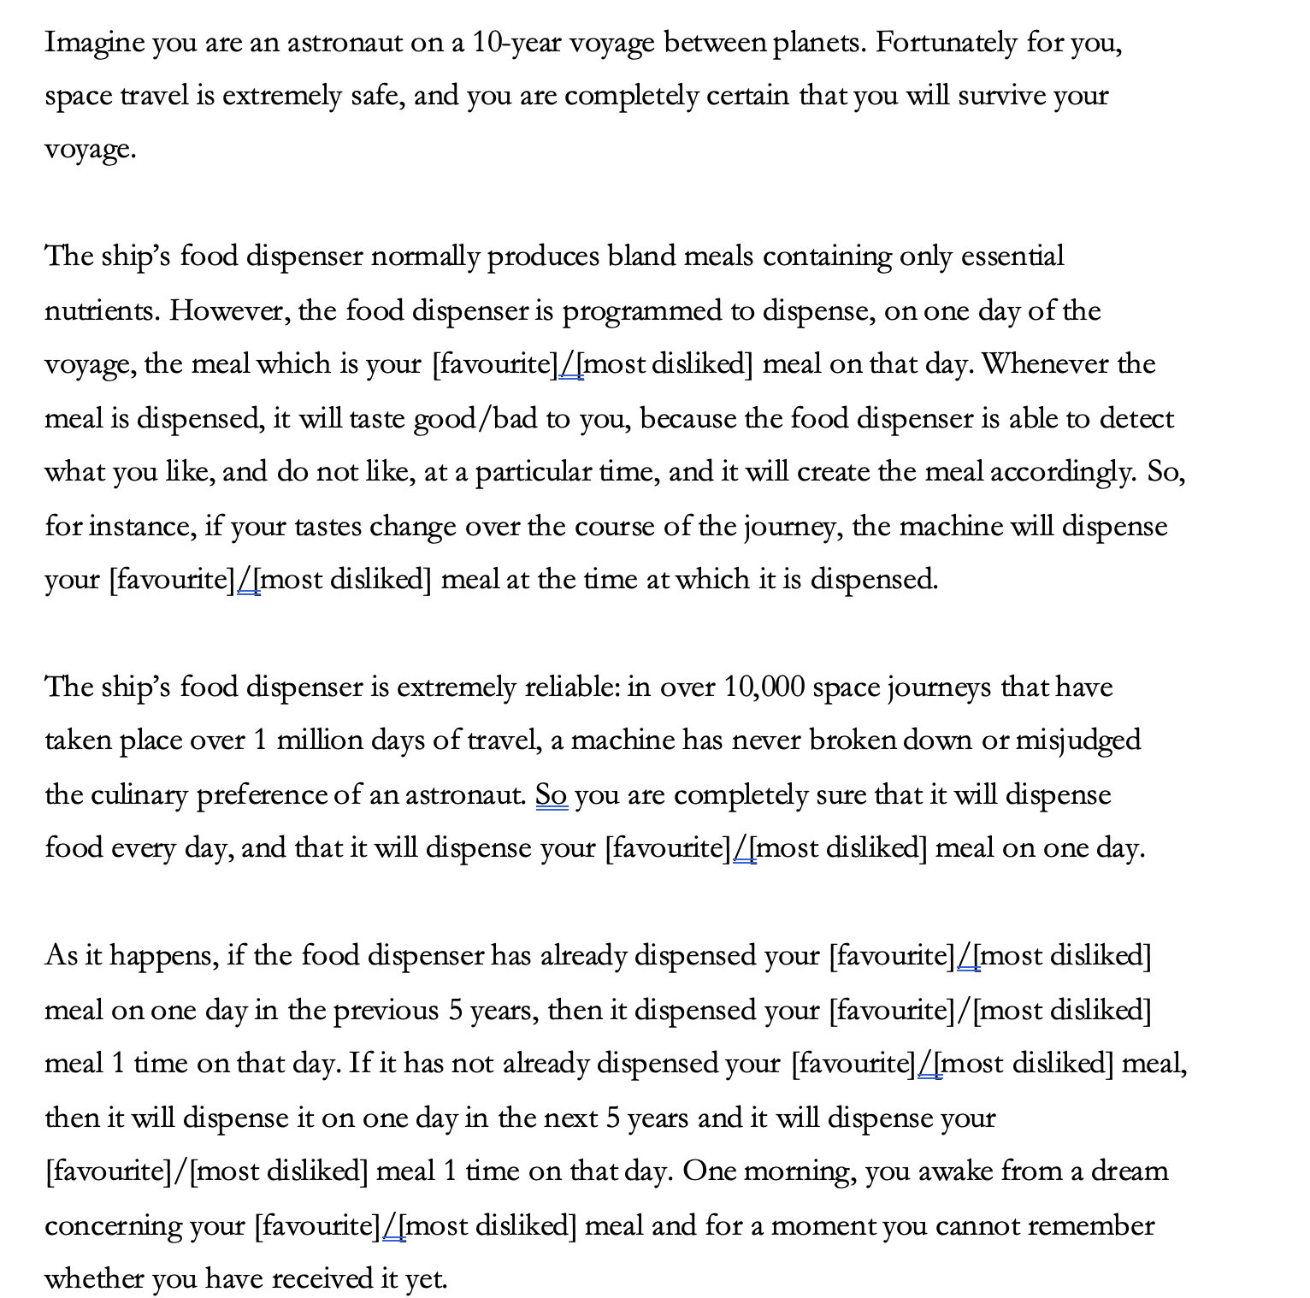

After reading the vignette, participants responded to three comprehension questions and one attention check question. The order of the questions and response options were randomized throughout the experiment. The comprehension questions were as follows:

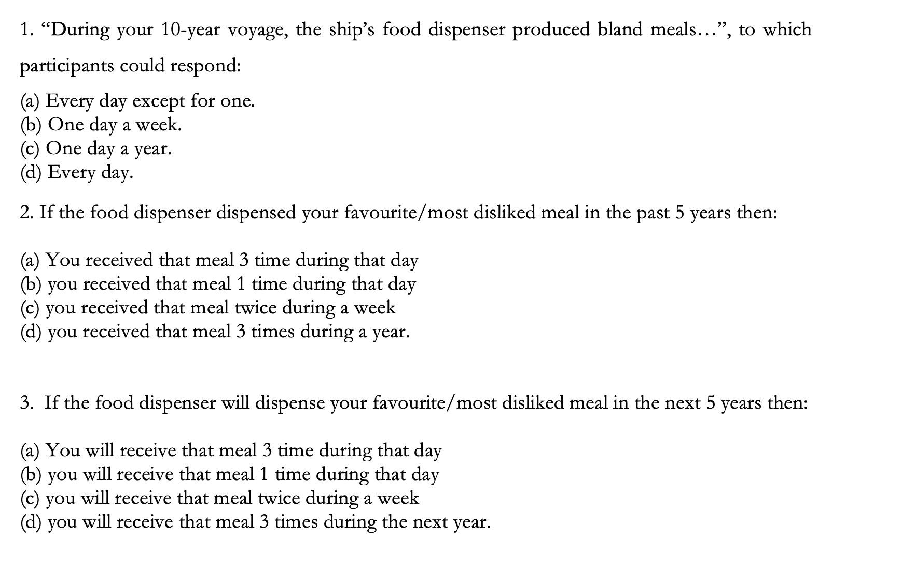
4. In this vignette you were asked to imagine that the ship’s food dispenser is…:

- Extremely good at dispensing food and judging culinary preferences reliably.
- Extremely bad at dispensing food and judging culinary preferences reliably.

The attention check question was:
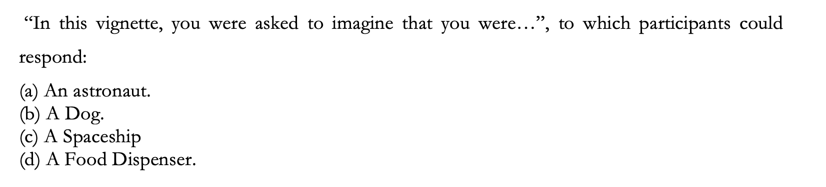

Participants who failed correctly to answer 3 out of 4 comprehension questions and the attention check question were excluded from the analyses.

We then probed participants preferences. Participants were asked to “Please indicate your preference using one of the following statements” and were presented with the four sets of statements below. Once again, the order of the statements and response options were randomized.

Prospective near-bias:

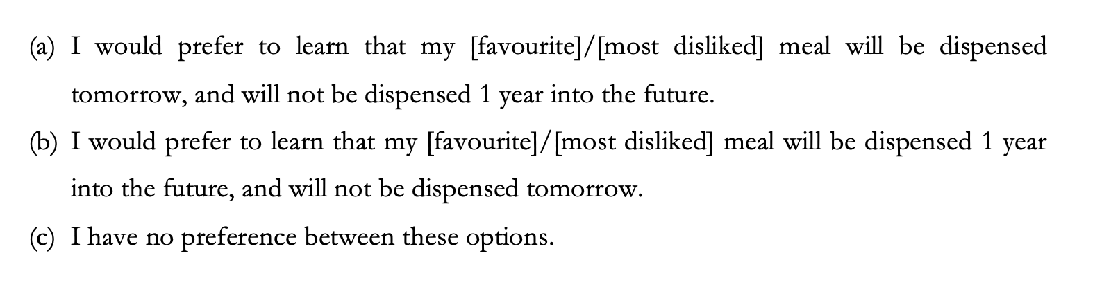
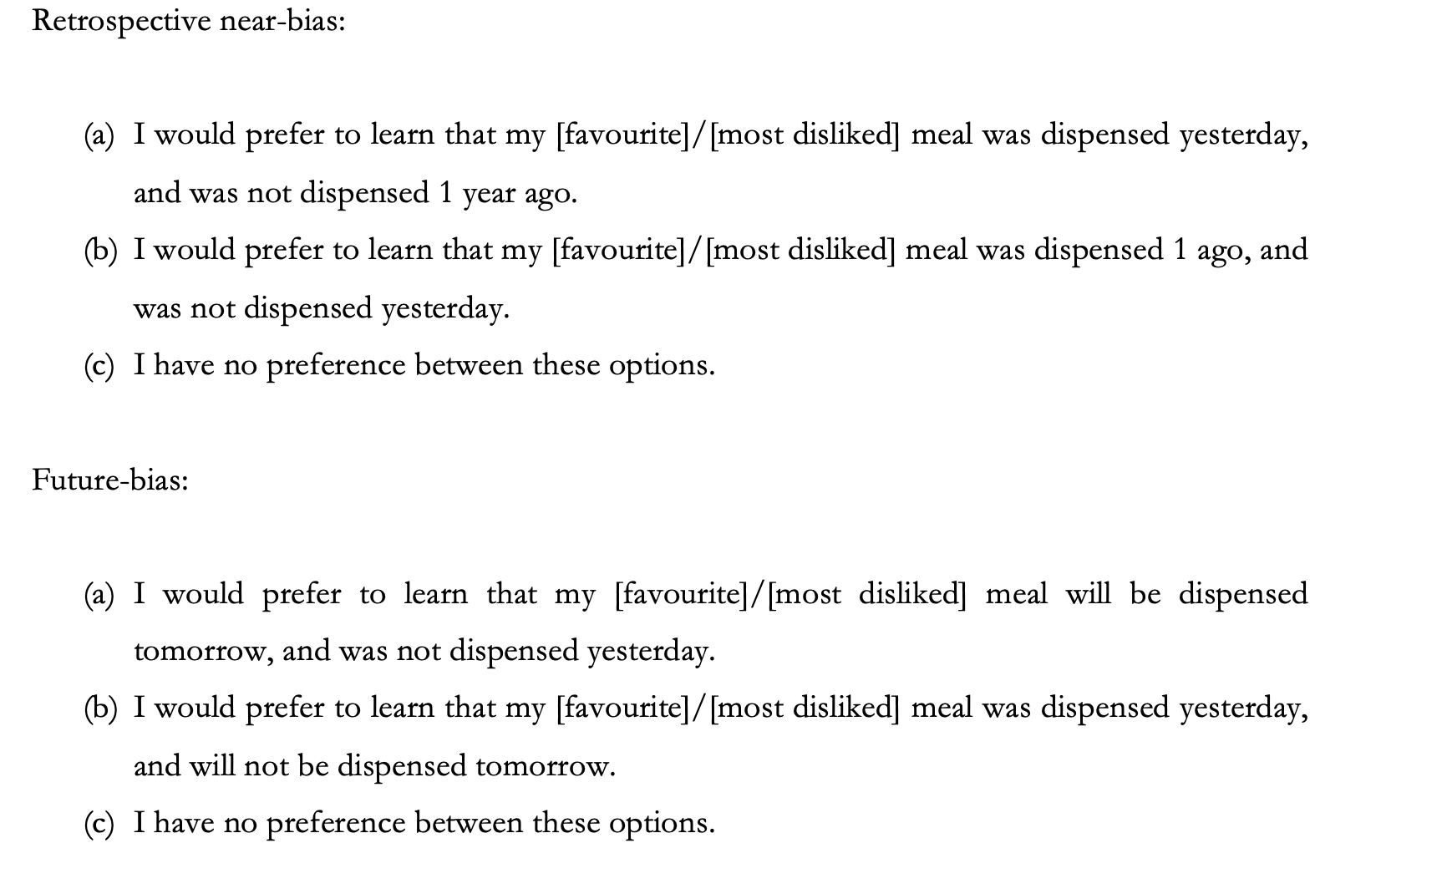
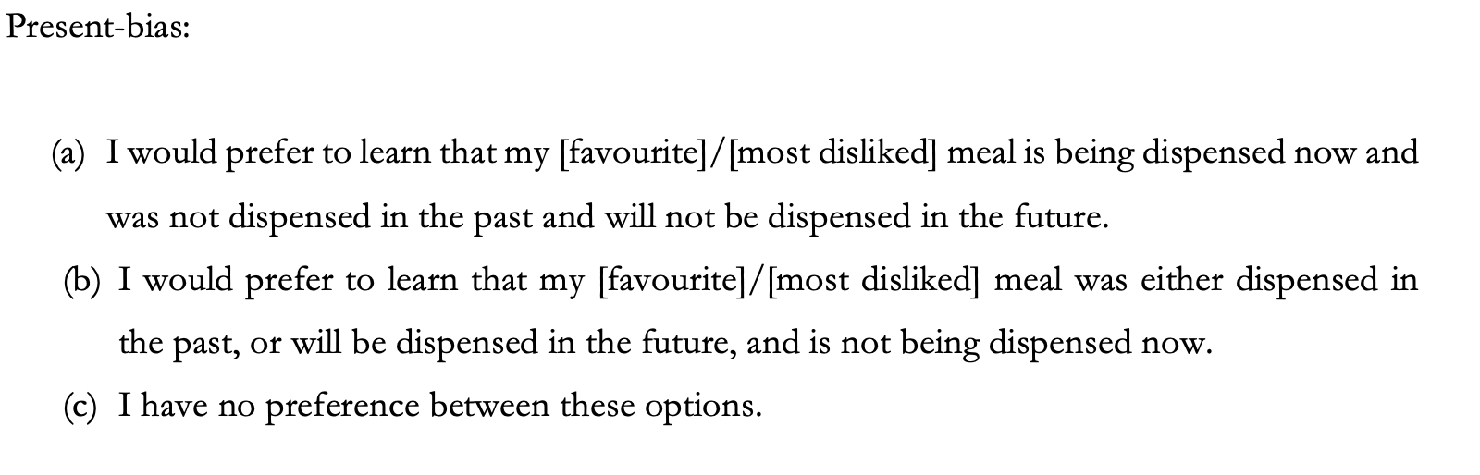

3.1.3 Results
Before reporting our statistics, we will begin by summarising our main findings with respect to each of the hypotheses. First, we hypothesised that there would be a strong association between positive present-bias, and the conjunction of positive prospective and retrospective near-bias (H1), and that there would be a strong association between negative present-bias, and the conjunction of negative prospective and retrospective near-bias (H2). We found evidence that participants who report present-bias are more likely to report both prospective and retrospective near bias, and that participants who report non-present-bias are more likely not to be. This was the case regardless of case valence, but it was only a small association. We also hypothesised that there would be a strong association between positive present-bias and the conjunction of positive prospective near-bias and positive future-bias (H3), and that there would be a strong association between negative present-bias and the conjunction of negative prospective near-bias and negative future-bias (H4). Neither of the hypotheses were vindicated for positive (H3) and negative (H4) valence conditions. However, we found evidence of a moderate association in the positive valence condition between non-present-bias and non-complete future-bias.

Table 1 below summarises the descriptive data of participants reported prospective near-bias preferences. The ‘NB (P)’ column represents the number of participants who report positive and negative prospective near-bias preferences. The ‘FrB (P)’ column represents the number of participants who report positive and negative prospective far-bias preferences. The ‘TN (P) column represents the number of participants who report positive and negative time-neutral preferences. To test whether there was any association between participant’s prospective near-bias preferences and valence we performed a chi-square test of homogeneity. The test found no evidence of an association, χ²(2, N = 193) = 1.671, p = .434.

Table 1. Descriptive data of participants prospective near biased preferences.
Condition | NB(P) | FrB(P) | TN(P)
Positive (n = 105) | 41 (39.0%) | 46 (43.8%) | 18 (17.1%)
Negative (n = 88) | 27 (30.7%) | 46 (52.3%) | 15 (17.0%)

Table 2 below summaries the descriptive data of participants’ reported retrospective near-biased preferences. The ‘NB(R)’ column represents the number of participants who report positive and negative retrospective near-bias preferences. The ‘FrB(R)’ column represents the number of participants who report positive and negative retrospective far-bias preferences. The ‘TN(R)’ column represents the number of participants who report positive and negative time-neutral preferences. To test whether there was any association between participant’s retrospective near-biased preferences and valence we performed a chi-square test of homogeneity. The test found no evidence of an association, χ²(2, N = 193) = 4.086, p = .130.

Table 2. Descriptive data of participants retrospective near biased preferences.
Condition | NB(R) | FrB(R) | TN(R)
Positive (n = 105) | 38 (36.2%) | 41 (39.0%) | 26 (24.8%)
Negative (n = 88) | 23 (26.1%) | 47 (53.4%) | 18 (20.5%)

Table 3 below summaries the descriptive data of participants’ reported future-bias preferences. The ‘FB’ column represents the number of participants who report positive and negative future-biased preferences. The ‘PB’ column represents the number of participants who report positive and negative past-biased preferences. The ‘TN(FB)’ column represents the number of participants who report positive and negative time-neutral preferences. To test whether there was any association between participant’s future bias preferences and valence we performed a chi-square test of homogeneity. The test found no evidence of an association, χ²(2, N = 193) = .454, p = .797.

Table 3. Descriptive data of participants future bias preferences.
Condition | FB | PB | TN(FB)
Positive (n = 105) | 57 (54.3%) | 31 (29.5%) | 17 (16.2%)
Negative (n = 88) | 52 (59.1%) | 23 (26.1%) | 13 (14.8%)

Finally, Table 4 below summarises the descriptive data of participants’ reported present-bias preferences. The ‘PrB’ column represents the number of participants who report positive and negative present-bias preferences. The ‘nonPrB’ column represents the number of participants who report positive and negative non-present-bias preferences. The ‘TN(PrB)’ column represents the number of participants who report positive and negative time-neutral preferences. To test whether there was any association between participant’s present bias preferences and valence we performed a chi-square test of homogeneity. The test found no evidence of an association, χ²(2, N = 193) = 4.107, p = .128.

Table 4. Descriptive data of participants present bias preferences.
Condition | PrB | NonPrB | TN(PrB)
Positive (n = 105) | 47 (44.8%) | 32 (30.5%) | 26 (24.8%)
Negative (n = 88) | 36 (40.9%) | 38 (43.2%) | 14 (15.9%)

Next, we tested whether there was an association between present-bias and the conjunction of both prospective and retrospective near-bias by performing a Breslow-Day test (Breslow & Day 1980). To do this, we first consolidated the data. This was done due to the limited number of responses to several preference combinations and because our interest was primarily in the association between present-bias and the conjunction of prospective and retrospective near-bias. First, we created the new variable ‘Non-Present-Bias’ which included participant’s non-present-biased and time-neutral responses. Then, we created a new variable ‘Complete Near-Bias’ which is the number of participants who reported a prospective near-biased preference and a retrospective near-biased preference. Participants who reported some other preference combination (i.e., prospective near-bias and retrospective far-bias) were included in a new variable ‘Non-Complete Near-Bias’. We found no evidence of an effect of valence on the association between present-bias and complete near-bias, χ²(1, N = 193) = .393, p = .531. Thus, we collapsed participant responses across valence and looked just at the association between present-bias and complete near-bias. The results of a chi-square test of independence found evidence of a small significant association, χ²(1, N = 193) = 8.660, p = .003, w = .212. (see Table 5). Participants who are present-biased are relatively more likely to be completely near-biased, whereas participants who report non-present-bias are relatively more likely to report non-complete near-bias.

Table 5. Association between present bias and near bias preferences.
 | Complete Near Bias | Non-Complete Near Bias
Present Bias | 17 (20.5%) | 66 (79.5%)
Non-Present Bias | 7 (6.4%) | 103 (93.6%)

Finally, we tested whether there was an association between present-bias and the conjunction of both prospective near-bias and future-bias using a separate Breslow-Day test. As per above we used the consolidated ‘Present Bias/Non-Present’ variable, but this time created a new variable ‘Complete Future-Bias’ which is the number of participants who report both a prospective near-biased preference and a future-biased preference. Once again, participants who reported some other preference combination (i.e., prospective near-bias and past-bias) were included in a new variable ‘Non-Complete Future-Bias’. This time the test found evidence of an effect of valence on the association between present-bias and complete future-bias, χ²(1, N = 193) = 4.437, p = .035. Thus, we analysed the association between present-bias and complete future-bias using separate chi-square tests of independence for positive and negative valence. The test showed for positive valence evidence of a moderate significant association, χ²(1, N = 105) = 10.981, p < .001, w = .323 (see Table 6). Participants who report present-bias are relatively more likely to report complete future-bias, whereas participants who report non-present-bias are relatively more likely to report non-complete future-bias. Conversely, the test for negative valence found no evidence of an association, χ²(1, N = 88) = .001, p = .980 (see Table 7).

Table 6. Association between present-bias and future-bias preferences positive.
 | Complete Future Bias | Non-Complete Future Bias
Present Bias | 20 (42.6%) | 27 (57.4%)
Non-Present Bias | 8 (13.8%) | 50 (86.2%)

Table 7. Association between present-bias and future-bias preferences negative.
 | Complete Future Bias | Non-Complete Future Bias
Present Bias | 7 (19.4%) | 29 (80.6%)
Non-Present Bias | 10 (19.2%) | 42 (80.8%)

4. Discussion
Our results cast serious doubt on both versions of the manifestation thesis. While we did find that people who are present-biased are more likely to report both prospective and retrospective near-bias than those who are non-present-biased, the association between present-bias and prospective and retrospective near-bias is low, rather than being the strong association that we posited. We also hypothesised that there would be an association between positive present-bias and the conjunction of positive prospective near-bias and positive future-bias (H3), and that there would be an association between negative present-bias and the conjunction of negative prospective near-bias and negative future-bias (H4). Neither of the hypotheses were vindicated for positive (H3) and negative (H4) valence conditions. However, we found evidence of an association in the positive valence condition between non-present-bias and non-complete future-bias. Again, however, this association was not strong: it was low-moderate.

Rather, what we find is that amongst people who are present-biased (whether positive or negative) we find just about every possible combination of different near versus far-biased prospective and retrospective preferences and future- and past-biased preferences and no strong association between any combination of these.

This suggests that present-bias is a distinctive psychological kind. If manifestations of present-bias were simply the product of the very same mechanisms that either (a) explain near-bias or (b) explain prospective near and future-bias, then we would expect to find a very strong association between present-bias and one or more of these other biases. But this is not what we find. Of course, this is but one study, and we do not know whether these results replicate, or generalise. Indeed, one might worry that there are reasons to be cautious here. Although the vignettes we used are not very cognitively demanding (compared to some presented in experimental philosophy) we did eliminate 62.5% of participants due to both attention checks and comprehension questions. Because of this one might worry that the resulting samples are not representative of the general population. As we see it, this is a general worry for any experimental philosophy of this kind. Perhaps people that pass the comprehension questions are more thoughtful, reflective, or intelligent, than those who did not, and perhaps those people have different preferences from those who did not pass comprehension. We don’t see any particular reason to suppose this to be so, but we cannot rule it out, and so some caution is required in reflecting on these results.

Importantly, even if we are right and present-bias is a distinctive psychological kind, this is consistent with most people who are present-biased also displaying some other time-bias or combination of biases. That would be expected even if present bias is a distinct kind of bias. After all, previous research shows that very few people have time-neutral preferences. Rather, we find a complicated pattern of near- and far-biased preferences (Greene, Holcombe, Latham, Miller and Norton, 2021) and of future- and past-biased preferences (Greene, Latham Miller and Norton 2021b, 2021c). We would hardly expect that people who are present-biased would fail to also display these biases. And that is indeed what we found here: as a group, people who are present-biased display various different combinations of these other biases.

What does this tell us about the normative status of present-bias? Well, on the one hand it suggests that we cannot simply read off the normative status of present-bias from the normative statuses of the other biases. If the manifestation thesis is false, then both the Manifestation Argument and the Shared Psychological Explanation Arguments fail to be sound. If we want to evaluate the normative status of present-bias, we need to look at that bias in its own right.

Of course, that does not mean that we should think that the status of present-bias is entirely unrelated to the status of the other biases. We did find a low association between present-bias and near-bias. This suggests that there may well be a shared partial explanation for both. It may be, that the two biases are not entirely psychologically distinct, but rather, that there is some mechanism that partly explains each of them. So, although the Shared Psychological Explanation Argument is unsound, a related argument could turn out to be sound. Here is that argument.

The Partial Shared Psychological Explanation For/Against Present-Bias

- There is a partial shared psychological explanation, PE for both near-bias and present-bias
- PE grounds there being a normative reason that speaks in favour of/against present-bias and speaks in favour of/against near-bias.
- Since PE is a shared partial psychological explanation for both near-bias and present bias, then it grounds there being the same reason for/against both present bias and near-bias.
- Therefore, there is some shared reason that speaks in favour of/against both present-bias and near-bias.
- Therefore, likely the normative status of present-bias and near-bias are not independent of one another.

Some of the reasons to be sceptical of the Shared Psychological Explanation Argument will equally be reasons to be suspicious of this argument. It, too, requires that psychological explanations can ground normative reasons (12) and that if a particular psychological explanation is a partial explanation of two kinds of preferences, then it grounds the very same normative reason in both cases (13). One might reject one or both of these claims. Still, we think this is an argument worth pursuing in light of our results in this paper. It seems plausible to us, as at least, that the various candidate psychological explanations of near-bias will tend to confer the same reasons to have, or not have, present-biased preferences as they do to have or not have near-biased preferences. For instance, reasons to be near-biased arising from the certainty of the relevant events, or our ability to predict what future selves will value, or our ability to delay gratification, will, insofar as they yield normative reasons to have/not have those preferences, surely yield the same sorts of reasons when it comes to present-bias. Thus, there may well be reason to think that there are shared normative reasons when it comes to present-bias and near-bias, arising from the fact that there is a shared partial psychological explanation of both, something that has perhaps been tacitly assumed, but with little argumentation.

Even if you think that the Shared Partial Psychological Explanation Argument is sound, however, this leaves open that there may be an array of other reasons to suppose that present-bias has a different normative status from the other biases. For instance, if present-bias is a distinctive psychological kind, and if there can be reasons grounded in psychological explanation, then since at least some of the psychological explanations for present-bias are distinct from the psychological explanations of the other biases (otherwise, present-bias would not be a distinctive psychological kind), there may be reasons arising from these distinct psychological explanations that ground reasons that are specific to present-bias. Thus, recognising that present-bias is a distinctive psychological kind opens up the possibility of investigating whether the psychological explanations of that bias which are not shared with the other biases, ground there being reasons to have, or not have that preference, that are distinct from any reasons conferred on the other biases.

Whether there are such reasons or not is, of course, also consistent with there being other reasons specific to the normative status of present-bias, that do not arise in virtue of its being a distinctive psychological kind, but simply from its being the case that present-bias is different from near-bias or future-bias insofar as it can have different consequences. As such, there might be normative considerations that weigh in favour of, or against, present-bias that do not obtain when it comes to near-bias or future-bias. And, of course, if present-bias is a distinctive psychological kind, then this is also consistent with there being plenty of reasons to have, or not to have, that bias which are also reasons to have, or not to have, the other biases: reasons that are not grounded in psychological explanations. For instance, you might think temporal location is normatively irrelevant when it comes to preferences and hence that any time biased preference is arbitrary because time-biased preferences just are preferences that are sensitive to temporal location. Since we have a reason not to have arbitrary preferences, we have a reason to not be time-biased in any way at all: here, then is a reason that generalises to all time-biases, regardless of what it is that psychologically explains them.

In all then, we think that further investigation into the nature of present-bias is called for. We have argued that present-bias is a distinctive psychological kind, at least insofar as it is not merely a manifestation of some other kind(s) of time-bias. Of course, this leaves open many questions. For instance, it could be that present-bias is a manifestation of some other kinds of preferences. Bnefsi (2019) has recently offered an argument in favour of the rationality of present-bias. For our purposes what is most interesting is that this argument might be taken to suggest that present-bias is the manifestation of some other preference, in particular, a manifestation of mild egocentric hedonism.

Hedonism, broadly speaking, is the view that only positive experiences are good for you, and only negative experiences are bad for you. Mild egocentric hedonism is not committed to a claim as strong as this: it takes no stand on whether only such experiences are good or bad for you, though it does require that positive experiences are good for you and negative ones are bad. As defined by Hare (2007), mild egocentric hedonism is committed to the claim that all else being equal, we prefer that pain befall others rather than ourselves, and that pleasure befall ourselves rather than others. Bnefsi takes mild egocentric hedonism to be both a descriptive claim about what we are like, as well as a normative claim to the effect that all else being equal, we should prefer that pain befall others rather than ourselves, and that pleasure befall ourselves rather than others. For the purposes of exploring this new manifestation claim we need only suppose that the descriptive claim is true.

With this in mind suppose that people combine mild egocentric hedonic preferences with a belief (perhaps a tacit one) that objects, most notably the self, perdures rather than endure. That is, people believe that their past and future selves are numerically distinct from their current self, and that they are a temporally extended person of which all these selves are (temporal) parts. It is plausible then that present-bias will at least partly be explained by people’s tacit belief that the self perdures, combined with them having a mild egocentric hedonic preference. For in that eventuality any present self will have reason to prefer that negative experiences are had by some other self, including non-present selves that are parts of the same person, and that positive experiences are had by that very self: the present self. This is just to be present-biased. So, if people act on their reasons, then people will have present-biased preferences.

This idea would be worth empirically investigating. This alternative manifestation thesis relies on several things being true. First, it requires that people in general have a mild egocentric hedonic preference. This seems very plausible but would require empirical vindication. It also requires that people are at least tacitly perdurantist about the self, since if people take their past and future selves to simply be them, having a mild egocentric hedonic preference will not result in having a present-biased preference. Again, this would be worth empirically investigating. To our knowledge, the only work in this area is that of Baron, Latham, Oh and Miller (ms) who probed whether people are (tacitly) endurantists or perdurantists, focussing in particular on whether people are endurantists or perdurantists about the self. They found that people were roughly evenly divided between the two views. If present-bias is more prevalent than is the tacit belief that the self perdures, (which seems likely given the evidence to date), then this would be a reason to be sceptical of this manifestation thesis as a general claim about the population of people who display present-bias. Of course, in that eventuality it could still be that present-bias is a manifestation of mild egocentric hedonism amongst some of the population of people who are present-biased. Again, this would require empirical investigation.

Another reason to be a little sceptical that present-bias is a manifestation of mild egocentric hedonism lies in the nature of mild egocentric hedonism. Recall that mild egocentric hedonism is only the view that, all else being equal, a self has a reason to prefer that a pain be someone’s other than its own, and that a pleasure be its own rather than someone else’s. So, a mildly egocentric self will prefer, all else being equal, that a bad experience worth, say, 10 disutiles befall a past/future self rather than that same bad experience befalling a present self. A mildly egocentric self will not, however, prefer that a bad experience worth, say, 10 disutiles, befalls a past/future self rather than a bad experience worth only 5 disutiles befalling a present self. That preference would be a strongly egocentric one not a mildly egocentric one. In fact though we have good reason to think that people are a strongly present-biased: they prefer more pain befall no-present selves rather than that less pain befalls their present self (and mutatis mutandis for pleasures). If that is right, the present-bias cannot be a manifestation of mild egocentric hedonic, but rather, would need to be a manifestation of strong egocentric hedonism. Of course, perhaps people do have strongly egocentric hedonic preferences: we have no reason to suppose they do not. But evidence would be needed to show that this is so.

Finally, this manifestation thesis requires that people form preferences based on their own reasons: it requires that people see that combining egocentric preferences with a tacit belief about the self perduring, gives them a reason to have present-biased preferences. Again, empirical evidence would be needed to show that people do in fact form their preferences in this manner.

Still, if present-bias could be explained by appeal to this preference pattern, then this would be important in evaluating the normative status of said bias. Bnefsi argues that if present-bias is a manifestation of the aforementioned, then it is at least rationally permissible. If so, that is an interesting and important outcome. Given what we have said so far, however, more would be need to be said in this regard. First, if present-bias turns out to be a manifestation of strong egocentric hedonism, then it would need to be argued that strong, as opposed to merely mild, egocentric hedonism is rationally permissible. And while it might seem rationally permissible that I prefer that some bad experience befall an earlier or later self rather than my present one, it is much less obvious that it is permissible that I prefer that a worse experience befall an earlier or later self rather than that a less bad one befall my current self. More might also be need ot be said to defend the idea that the argument goes through for both the stage version and the worm version of perdurantism. For one might think that if each of us is in fact the temporally extended object (as per the worm view) rather than being one of the short-lived selves (as per stage theory) then it is not so obvious that even mild egocentric hedonism (let alone strong egocentric hedonism) is rational. In fact, we are inclined to the view that Bnefsi is right and that the argument generalises to both views, in part because we think that it is short-lived stages that are the locus of reasons even if persons are in fact the temporally extended worm (since such extended objects have inconsistent preferences) and as such, it is these short-lived selves that have reason, or not, to be present-biased. But, again, more would need to be said in this regard.

Regardless we think that further investigation of the idea that present-bias is a manifestation of some kind of egocentric preferences is warranted. Importantly though, if this were the case then it would still turn out that present-bias is a distinct psychological kind from other temporal biases. After all, it since it seems very unlikely that egocentric preferences can explain both near-bias and future-bias, since it is very hard to see how they could explain future-bias. So, our conclusion that present-bias is a distinct psychological kind would hold, regardless. Still, if this manifestation thesis were true, it would provide scope for additional arguments that could be brought to bear regarding the normative status of present-bias. Hence, further investigation of this idea is warranted.

It would also be useful to have studies that follow up our own study, but which use different methodologies in order to replicate our findings here. Assuming there is such replication, further attention could profitably be paid to investigating present-bias on its own terms; to investigating its connection with other biases and with people’s more general temporal attitudes, and to normatively investigating that bias.

References

Bartels, D. M., and Rips, L. J. (2010). Psychological connectedness and intertemporal choice. Journal of Experimental Psychology: General, 139, 49–69.

Bartels, D. M., and Urminsky, O. (2011). On intertemporal selfishness: How the perceived instability of identity underlies impatient consumption. Journal of Consumer Research, 38, 182–98.

Brink, D. O. (2011). “Prospects for Temporal Neutrality”. in Craig Callender (ed.) The Oxford Handbook of Philosophy of Time. Oxford: Oxford University Press.

Callender, C. (2022). “Is discounting for tense rational?”, in Temporal Asymmetries
in Philosophy and Psychology, Christoph Hoerl, Teresa McCormack & Alison Sutton
Fernandes (eds.), Oxford University Press.

Caruso, E., D. Gilbert and T. Wilson. (2008). ‘A wrinkle in time: asymmetric valuation of past and future events.’ Psychological Science 19:796–801.

D’Argembeau, A. and Linden, M. V (2004) “Phenomenal characteristics associated with projecting oneself back into the past and forward into the future: Influence of valence and temporal distance”. Consciousness and Cognition 13: 844–858

Deng, N., Latham, A. J., Miller, K and Norton, J. (forthcoming). “There’s No Time Like the Present: Present-bias, Temporal Attitudes and Temporal Ontology” Oxford Studies in Experimental Philosophy.

Ersner-Hershfield, H., Wimmer, G. E., and Knutson, B. (2009). Saving for the future self: Neural measures of future self-continuity predict temporal discounting. Social Cognitive and Affective Neuroscience, 4, 85–92.

Loewenstein, G. and Elster, J. (1992). Choice over Time, New York: Russell Sage, 1992, 423 pp.

Greene, P., Latham, A. J., Miller, K, & Norton, J. (2022). “How much do we discount past pleasures?” American Philosophical Quarterly. 59:4): 367-376.

Greene, P., Latham, A. J., Miller, K., and Norton, J (2021a) “Hedonic and non-hedonic bias towards the future”. The Australasian Journal of Philosophy. https://doi.org/10.1080/00048402.2019.1703017 99(1): 148-163.

Greene, P, Latham, A. J. Miller, K., and J Norton (2021b). “Why are People So Darn Past-Biased?”. In Temporal Asymmetries in Philosophy and Psychology. Edited by C Hoerl, T McCormack, and A Fernandes. OUP.

Greene, P., Latham, A. J., Miller. K. & Norton, J. (2021c). “Capacity for Simulation and Mitigation Drives Hedonic and Non-Hedonic Time-Biases”. Philosophical Psychology https://doi.org/10.1080/09515089.2021.1960299

Greene, P., Latham, A. J., Holcombe, A., Miller, K., and Norton, J. (2021). “The Rationality of Near Bias towards both Future and Past Events”. Review of Philosophy and Psychology. DOI: 10.1007/s13164-020-00518-1

Greene, P., Latham, A. J., Miller, K., & Norton, J. (2021). “On Preferring that Overall, Things are Worse.” Philosophy and Phenomenological Research. https://doi.org/10.1111/phpr.12819

Hershfield, H. E., Cohen, T. R., and Thompson, L. (2012). Short horizons and tempting situations: Lack of continuity to our future selves leads to unethical decision making and behavior. Organizational Behavior and Human Decision Processes, 117, 298–310.

Hershfield, H. E., Goldstein, D. G., Sharpe, W. F., Fox, J., Yeykelis, L., Carstensen, L. L., and Bailenson, J. N. (2011). Increasing saving behavior through age progressed renderings of the future self. Journal of Marketing Research, 48, S23–37

Latham, A. J., Miller, K., and Norton, J. (2022). Pure and Impure Time Preferences. Australasian Philosophical Review. 10.1080/24740500.2021.2112123

Latham, A. J., Miller, K., and Norton, J. (forthcoming). “Against a normative asymmetry between near- and future-bias” Synthese.

Latham, Miller, Oh, Shpall and Yu (ms) “Exploring Arbitrariness objections to Time-Biases” https://philpapers.org/rec/LATEAO

Rutchick, A. M., Slepian, M. L., Reyes, M. O., Pleskus, L. N., and Hershfield, H. E. (2018). Future self-continuity is associated with improved health and increases exercise behavior. Journal of Experimental Psychology: Applied, 24, 72–80.

van Boven, L. and Ashworth , L. (2007). “Looking Forward, Looking Back: Anticipation Is More Evocative Than Retrospection” Journal of Experimental Psychology: General 136(2): 289-300.
van Gelder, J. L., Hershfield, H. E., and Nordgren, L. F. (2013). Vividness of the future self predicts delinquency. Psychological Science, 24, 974–80.

The ‘bias’ terminology is not intended to prejudge whether the biases are rational or irrational.
All of the time-biases discussed in this paper are what Callender (2022) calls tensed, i.e., they are about the temporal location of events in an A-series or a series that includes the perspective of the present.
(Ainslie and Haslam (1992, 59)). For example, in the experiments of Thaler (1981), Hausman (1979), and Akerlof (1991), people assigned less value to future money, time, and effort, respectively, than their present analogues. Indeed, Thaler (1981) showed that people prefer less money now to more money later, and Hausman (1979) found that people were willing to buy cheaper air conditioners with higher operating costs down the line. Similar results in animal studies backed this idea; e.g., Green et al. (1981). Since then, literally thousands of studies have been undertaken that aim to probe various aspects of prospective near-bias, including the amount by which we discount the value of future goods, events and experiences, how this varies across different sorts of goods/events; how it varies between people; how it varies across time within the same person, and what sorts of mechanisms might be responsible for such preferences. Interestingly, a meta-analysis done between 1978 and 2002, (Frederick et al. (2002, 377)) found “tremendous variability” in estimates of people’s average discount rate. People have been shown to vary both intra and inter-personally when it comes to the rate with which they discount goods/events (see also Loewenstein & Elster (1992)). In totality, though, this research shows a pervasive tendency to discount future events, goods, and experiences and to do so in conditions of inequality. (For overviews see Soman et al. (2005), Frederick et al. (2002), Ainslie & Haslam (1992) and Hardisty et al. (2012)). In psychology this is sometimes known as having a high time preference (as opposed to having a low time preference). For example, see Fredrick, Loewenstein, & O’Donoghue (2002) and, Lawless, Drichoutis, & Nayga Jr (2013)
Several notable exceptions are Yi, Gatachalian and Bickel (2006), Bickel, Yi, Kowell, and Gatchalian (2008), and Greene, Holcombe, Latham, Miller and Norton (2021) who found that people discount past states of affairs in a similar manner to the way they do future events. That is, on average they tend to be hyperbolic past discounters. Bickel et al. (2008) found that, on average, people are both prospectively and retrospectively near-biased with respect to both positive and negative states of affairs.
There are various reasons why this might be the case, and we take no firm stance on this. For instance, it might be that certain temporal asymmetries underlie this being so. People remember the past, but not the future; quite generally there are records of past times, but not future ones. In addition to epistemic asymmetries there are also causal asymmetries: we can causally intervene on the future, but not the past. And last, there are, as a consequence of these asymmetries, deliberative asymmetries: we deliberate towafds the future, but not the past. As a result, it may be that from a psychological perspective, we treat the present as a limiting case of one temporal direction (the future) but not the past.
If one is opposed to analysing present bias in relation to a temporally extended now, one might instead think of present bias as a preference over the location of the temporally unextended parts of an event in relation to an instantaneous now. When I express my preference for the meal to be now, I might express a preference for some temporally unextended part of the event to be in the present instantaneous moment. For example, in the first moment of the meal, I have the preference for it to be now, at t₁. At the next instantaneous moment, I prefer the next temporally unextended part of the meal to be now at t2, and so on. We in fact think that this is not likely the way in which the folk use the notion of ‘now’, nor how they have preferences over the now. However, it is a possible way of thinking of present bias where it would be right to say that present bias preferences are directed towards something located in the temporally unextended present even if the event is temporally extended. However, since the events that people interact with and have preferences over are almost exclusively temporally extended we cannot ask about people’s preferences over instantaneous events. Thus, we ask about people's preferences regarding events that are relatively short-lived, such as receiving a meal. It seems plausible that since people are being asked about the present moment, and since they likely have multiple ‘present moment’ preferences across the length of the temporally extended event, that in the case of such relatively short events we can still track present bias preferences. In either case, whether one thinks of present bias as a preference over temporally extended events in a temporally extended now, or as a preference over temporally unextended parts of temporally extended events in a temporally unextended now, we take the short-lived, psychologically relevant/accessible events-such as receiving a meal as something that can capture this temporal preference.
At least about fundamental preferences.
See for instance Parfit (1984), Gibbard (1990, 1999), Rawls (1971); Fletcher (2021), Sullivan (2018).
42% of the remaining sample got every comprehension question correct.
We define this shortly.
On the assumption that you think that these are explanations of near-bias itself, rather than merely apparent near-bias.
Indeed, Bnefsi (2019) provides an argument in favour of present bias that does not easily generalise to any other forms of bias.
Hare, of course, goes on to argue for the view that whenever a mild egocentric-hedonist favours a scenario in which she suffers less, she thereby favours a simply better maximal state of affairs. The mild egocentric hedonism need not accept this claim.

