Overthinking: Necessity or Luxury
Tathagata Dey

“We cannot solve our problems with the same level of thinking that created them.”
~ Albert Einstein.

Few days ago, I was struck by a question, asked by one of my fellow seniors, ‘Is Overthinking really bad?’. I took some time and it is nearly a fortnight past that day, when I finally found myself on the verge of writing the whole thought process down.
I am not really going to make a decisive conclusion, but surely going to put some valid arguments through this. Starting with the explanation by Dave Trott,
“A new idea is nothing more than a new combination of old elements, and the ability to make those new combinations depends on your ability to see relationships. And that’s what makes some people more creative.”
~ Dave Trott, ‘One Plus One Equals Three, A Masterclass in Creative Thinking’.
Let us not dive deeper into those words. But what is more important is that, he combined the concepts of Thinking and Creativity. Both of this quote and his book is primarily edged towards this idea.
Indeed, our creativity is indulged by our cognitive thinking, or even our subconscious thinking. For instance, let us think about dreams for a moment. Very rarely we happen to see some realistic past events in our dreams. So, what are dreams, our subconscious playing the memory responses over and over and twisting them every time. So, dreams are nothing but a piece of our creative thinking, whether we instruct it or not. Our genuine reflex activities always incorporate thinking. This, again brings back the idea, why are humans so called superiors over other mammals? Because, humans can think!

Thinking and Overthinking
Speaking from a scientific perspective, to address the question on Overthinking, first we must be able to identify the boundary between Thinking and Overthinking. Cause, we have just outlined the concept of thinking, interpreting that it is a part of genuine human behaviour, which is indistinguishable from usual activities. Physics, dealing with units and measurements, never defined any unit to measure human cognition. Hence, the way psychology deals, is the only way to get to the boundary. The expressions and human behaviour are nothing but a visual representative of what that brain thinks. Let me point you out a straight example. Recall the differences in your behaviours when you are sad and when you are seriously doomed. You see, what I am trying to point out is, when we are doomed, our thoughts are utterly expressed in our regular activities. But, definitely being sad is one of the expressions of our mind, which should get no privilege over other feelings. Hence, definitely all our activities get expressed in all of our activities. The more our mind thinks about something, the more it gets reflected. Although, any certain boundaries can not be defined here, but to my assumption, when one of our thoughts interrupt any other activity or our mind goes back in thinking that while doing something else, we probably can refer it to Overthinking.
To me, the question was never about good or bad. It was about the subject. I hate generalizing things, so evidently, I hated to ask myself as a whole. See, the subject of thinking can vary and according to me, I specify it in two categories. Events, we cannot control and events we can. The first category definitely brings the set of events, whose results are independent of our actions. These events are often past incidents or some distantly occurring incident or even imaginary situations. While, the second category sums up events, whose results do depend on our actions. These events are often our regular life incidents or upcoming incidents or any decisive moments of life.

Things We Think about
Let us now look into each type in details. Thinking about an event, you have no control over will not affect its outcomes. However, it can lead to our destruction. In other words, when you think about something within your control, our actions represent the thoughts. Those actions eventually lead to specific feature diversion in the incident. Whether we want or not, our subconscious leads us to act according to our thinking and we end up manipulating the event. Eventually, the outcomes change which directly entangles our thoughts again. This acts as a feedback mechanism. On the other hand, events we cannot control or the first category events has no such mechanism, as our thoughts are never going to affect the outcomes of the event. Hence, our thinking is technically unbounded. This can cause some serious troubles for us.
The only way such a thinking leaves its remark is upon our behaviour. Especially, when the thoughts are not specifically controlled, it can lead up to any sort of changes in us. A positive sensation can rebuild us, make us strong and confident, whereas a similar negative thought can trigger our reduction of self-esteem. As, I told previously, nothing in philosophy is really explainable by generalisation. Hence, we need to control our thoughts accordingly in specific cases. In simple words, what is the point of thinking about something, we cannot decide? Some of the readers will be enthusiastic to answer this with pointing out the waste of time and energy and decrease in productivity. While, the other group of readers will go for evaluating, how important the subject is to us. They will be eager to prefer the thoughts if the subject is really something memorable or important to us or it makes us feel positive. Indeed, both of them are right. One of the great things about philosophy is there is never a single answer correct question (As I believe). But, rethinking our thoughts is a serious consideration. What I want to point out from here, is to question yourself, what you are thinking about, how is this going to affect you and other and is this really worth thinking about?
Coming back to the diversification, our second category is pretty interesting to me. Events whose outcomes are dependable on our activities have a great influence on us. A genuine observation tells us that, we are more prone to overthinking with this second category. Because, whenever we possess some decisive role in any incident, our subconscious identifies it and questions us, questions our conscious mind about the decision. Questions, what to do? As we discussed previously about the feedback mechanism, indeed these thoughts provoke us to change ourselves accordingly. The outcomes affect our thoughts and definitely, these events are much more self-sufficient. For instance, a chess player thinking about next move. Indeed, his or her thoughts will change accordingly with opponent steps. But misjudging the steps can lead to a destruction and right judgement can lead to winning.
“You don’t have to see the whole staircase, just take the first step”
~ Martin Luther King, Jr.
The difference between thinking and overthinking is exactly the behaviour we incorporate. Our deep thinking leaves a deep remark on us, leading to even enhanced behavioural symptoms. While, we think about our opponent’s next move only, if we misjudge, we have the chance to retreat. Whereas, an overthinker thinks about many more upcoming steps of the opponent. So, misjudging the first step, leads to misjudgement of the second and the third and eventually all of the sequential steps. Now, imagine him or her playing accordingly. Definitely, such a misjudgement will bring a lot more damage than a single step thinker misjudgement. So, evidently an overthinker caused a lot of harm to himself or herself.
But that never refers to the negativity in overthinking. Because, after all this explanation, we must acknowledge that a game of chess is itself a world of overthinking. We cannot expect to win thinking about one step only. So, in small scale overthinking caused harm whereas in a broad perspective it was all about overthinking, always.

Overthinking and Intuition
“The very word intuition has to be understood. You know the word tuition—tuition comes from outside, somebody teaches you, the tutor. Intuition means something that arises within your being; it is your potential, that’s why it is called intuition. Wisdom is never borrowed, and that which is borrowed is never wisdom. Unless you have your own wisdom, your own vision, your own clarity, your own eyes to see, you will not be able to understand the mystery of existence.”
~ Osho, Intuition: Knowing Beyond Logic
Intuition has no logic; it is the unbiased representative of what our subconscious mind feels. But there is a deep relation between Overthinking and Intuition. Let us first have a look on what intuition is.
Intuition is the visualization of what our subconscious mind feels. Our subconscious mind follows no logic and it is subjective by nature. Often it is regarded that our conscious mind is the gardener in the garden of subconscious. Hence, conscious mind commands and subconscious mind obeys those. In other words, we can say, our conscious mind lays the seeds in our subconscious. For instance, once or more we all have come across dreams that mimic our reality. Like, dreams of distorted memories of any event that happened recently in our life or even distant memories. A very careful observation can reveal to us that, often the memories we see again in dreams are either a very recent event or if not, then surely a very memorable one. Indeed, we simply can interpret what happens in there. Subconscious mind being subjective, takes unbiased input from external events. Hence, rational thoughts that our prioritised by our conscious mind are also believed to be preferable by subconscious mind.
Let us discuss this from a different point of view. Suppose, a child who is afraid of ghosts watches a horror film before going to bed. Finishing the movie, he or she listens to a few music and sleeps. A very usual successive event can be drawn as he or she sees a dream of a ghost from the film. Analysing this scenario, we understand that, the child overthought about the horror film. Although he or she did think about some other stuff including the music, the most probable dream is always a horror one. We can explain this by stating the overwhelming dealing of his or her conscious mind with the horror film. Therefore, an unusual increased concentrated thought on a subject does trigger our subconscious mind about it. And subconscious mind, without interrogating logically, refers to the subject as of higher priority.
Similarly, many such incidents happen in our daily life which show us how crucial conscious thinking is for our subconscious mind. So, if the master of our thoughts keeps busy with any subject, naturally the slave has a tendency to follow. This is how, overthinking about any subject can lead to biased feelings of our subconscious mind. Overthinking being the task of conscious mind highly influences our intuitive power. But still a question can be raised, that how this relation is relevant to effectiveness of overthinking. Let us discuss this in the following section.

The Mathematical Perspective
Before connecting the strings of argument, let me get this to an abstract idea; although this whole converges to a single point only. In the last section, we understood how Overthinking is related to our Intuition. Our conscious mind, which continuously deals with a subject, creating the overthought paradigm, also triggers our subconscious mind to be influenced by that. But this intuitive biasness has some serious scientific perspectives. Let us begin with that.
In the year of 1931, mathematician Gödel published his famous theorem of ‘Gödel’s Incompleteness’. It had two axioms but we are going to focus on the first one only. The axiom told us,
“Any consistent formal system F within which a certain amount of elementary arithmetic can be carried out is incomplete; i.e., there are statements of the language of F which can neither be proved nor disproved in F”.
In simple words, any mathematical system which is logically solvable and explainable definitely contains some argument which is never logically provable or disprovable. So, in the world of logic, there exists statements which logic itself cannot prove or disprove. To summarise, ‘Logic has limitations, which is logic itself unaware of’.
But how does it relate with Overthinking? It does! Certainly does! With this incompleteness theorem, scientific world came to know that logic is not ultimate. So, there are solvable arguments, which are beyond the capability of logic. Here, comes the role of intuition. Problems which are beyond logic, are intuitive problems only. This can be represented by the following Venn Diagram image of Mathematical Languages.
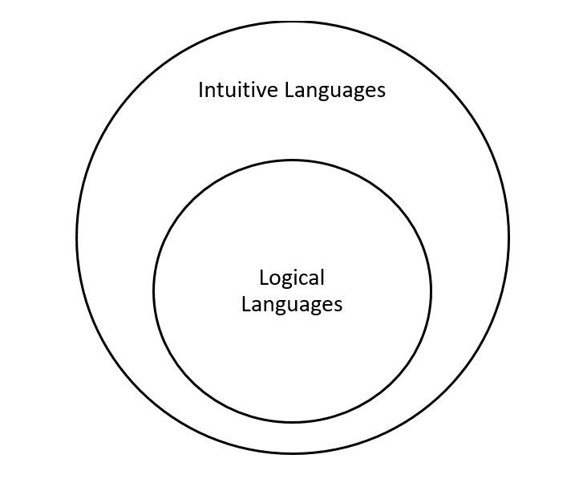
Figure 1: Venn Diagram of Universal Set of Mathematical Arguments
The logical languages have further categories from Recursively Enumerable to Finite languages, but our concern is with the whole set only. This clearly specifies why logic is limited. Today’s world of Computer Science and Mathematics is limited only to the power of logic, as those theoretical machines and computers can only solve a problem through assumptions and theorems of logic. That is why humans are greater than computer, because they have the power of intuition.
This diagram also represents the similar relation between conscious and subconscious mind. We know that, our conscious mind is rational. It can interrogate arguments and prove and disprove with logical thinking. So, it follows the power of logic. On the other hand, subconscious mind has the power of intuition and henceforth is greater than conscious mind. That is why more than 90% of our life is often controlled by the subconscious mind. Conscious and logical mind do possess limitations which subconscious mind never needs to know, the most significant reason for which we undoubtedly consider humans superior than any modern-day machines.
However, there is a small point to note and probably the most crucial of all notions. That is, we know how Overthinking can influence our intuition. How our conscious mind can lead to an irrational presence in the intuitive arguments. Therefore certainly, there does not exist such a strict boundary between logic and intuition as there lies the ‘Cloud of Overthinking’. Overthinking acts as a bridge between logic and intuition. Although, it cannot connect the both completely, but certainly leaves an influential remark. Hence, thinking hard is important for humans.

Overthinking is a limitless ocean of imagination and creativity. It helps us to dive deeper into the subject. Also, Overthinking doesn’t only enhance our intuition but also stands still as a reason why being human is of something to be thankful for. But as with the words of the great,
“Nothing can harm you as much as your own thoughts unguarded.”
~ Buddha
Every notion must posses some other controllable paradigm. Hence, to think is never unhealthy, but to think without hope or aim is. We can dive into the ocean of Overthinking but we definitely need to know how to get to the bank when needed. Coming to the question of necessity or luxury, I prefer to leave it for the reader. But with the words that,
“Overthinking is a sharp weapon. Once dealt carefully, can show wonders of creativity. While, on the hands of underserving can lead to devastating circumstances”.
~ Tathagata Dey.

“A good subject to think about is like an addiction.”
~ Tathagata Dey.

Contact: tathagata2403@gmail.com

