Philosophical Pictures from Philosopher Portraits

Abstract

Portraits of Wittgenstein and Hume are used as test cases in some preliminary investigations of a new kind of philosophical picture. Such pictures are produced via a variety of visual transformations of the original portraits, with a final selection for display and discussion being based on the few results that seem to have some interesting relevance to the character or philosophical views of the philosopher in question.

Key Words
philosophical pictures, philosopher portraits, image transformations, cognitive approaches to experimental aesthetics

1. Introduction

Presumably a good philosophical picture--if there could be such a thing--would be one that embodied some philosophical idea or thesis in an unusual and specifically visual way. Consequently, it should not be readily translatable without loss into standard philosophical language, because if that could be done, the picture would have no specifically visual philosophical value in its own right.

Recently I discovered what seems to be a new category of such images through a series of serendipitous accidents. I was experimenting with some artistic software that can modify images in various ways, and happened to try them out on a few well-known portraits of philosophers. What follows are two case studies of some images that resulted from my experiments on two philosopher portraits--of Wittgenstein and Hume--along with some descriptions of them, plus initial speculations as to what visual and cognitive factors might be involved.

As an initial disclaimer, all of the following is very preliminary. If there is any analogy at all to standard cases of completely unexpected discoveries, such as Alexander Fleming’s discovery of penicillin spores in a petri dish, then what is here is very much at an early observational stage, prior to any well-supported theorizing or testing. But one has to start somewhere, and I hope that others will add their own reactions or examples to these studies to add to our understanding.

One brief note on terminology to be used here. I distinguish an original picture, such as a standard portrait of a philosopher, from other pictures that could be derived from it by various visual transformations, calling the latter cases transformed pictures or TPs. So almost all of the discussions to follow focus on the aesthetic and philosophical qualities of the derived TPs, rather than on those of the original portrait from which they are derived.

Nevertheless, this is not to deny that some TP features might be inherited from, or be closely related to, features of the salient original portrait. Also, sometimes it is helpful to focus on a feature in a TP by contrasting its TP presence with its absence from the original portrait. And in general, it does seem to help in appreciating the special features of a TP if one keeps in mind the portrait from which it is derived.

As for the titles assigned to the TPs, of course any picture can be interpreted in many different ways. So the title for each TP simply reflects what strikes me as being one salient visual interpretation of some Wittgensteinian or Humean philosophical insight, preoccupation or character trait.

2. A Wittgenstein Portrait and Methodology

A familiar portrait of Wittgenstein is this photograph, taken by his friend Ben Richards in 1947. [1]

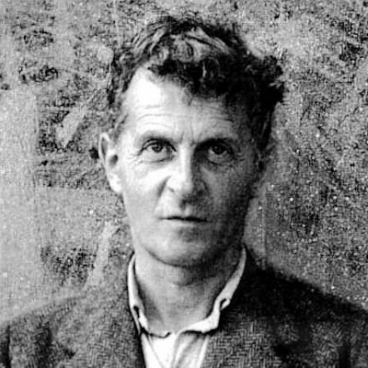

W Ludwig Wittgenstein in 1947

I shall be presenting and discussing twenty transformed versions of this portrait, divided into rough sub-groups. But as a preliminary, here is some general information about the discussions.

First, the picture titles evoke various well-known issues or themes arising from Wittgenstein’s philosophical writings. But since this essay is primarily about the pictures rather than the themes, scholarly references to those themes have been minimized. If desired, a Google search on Wittgenstein’s name plus a picture title will rapidly turn up anything needed to grasp its philosophical significance.

Second, it is generally agreed that one needs experience with many paintings by an artist in order to fully understand any one of them. In the present case, a derivative point applies: in some cases, the title assigned to a transformed picture may depend to some extent on what seem to be the most appropriate titles to assign to the other TPs in the collection. Hence each has a relative place in the overall structure partially defined by the relative places of the others.

3. Initial Wittgenstein Group

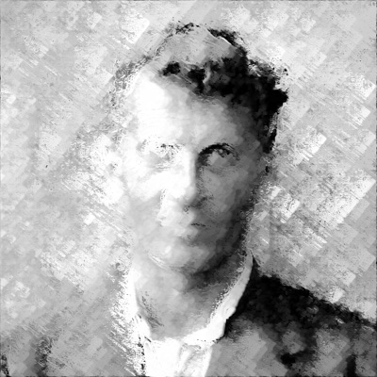

W1 Wittgenstein’s Two Phases

Could any two works of philosophy be more different than Wittgenstein’s early (1921) Tractatus on the one hand, and his later (posthumously in 1953) Philosophical Investigations on the other hand? Nevertheless, as picture W1 shows, these indeed are but two phases in the work of the very same philosopher. The original (1947) portrait W, from which W1 is derived, shows Wittgenstein in his Investigations phase, just four years before his death in 1951.

The left side of W1 shows his earlier Tractatus work as receding and emptied out, while the right side emphasizes--in its laser-like intensity of gaze--his new appreciation of the enormous complexity of ordinary language, as thrown into high relief because of our previously almost complete lack of understanding of those complexities.

Yet W1 is not a conventional Janus-faced portrait separately showing two distinct faces. Instead, it is perhaps one of the first fully psychologically realistic views of an integrated person’s own understanding of two divergent aspects of himself--and one that W1 makes visually salient for us as well.

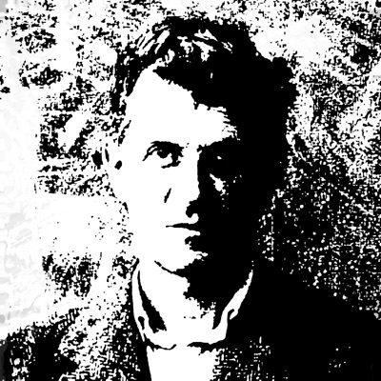

W2 The World is the Totality of Facts

The title echoes Wittgenstein’s Tractatus doctrine that the world is the totality of facts, not of things. This seems an appropriate title for W2, because its stark simplification of the full tonal range of the original suggests an imposed global order that some might find compelling, but others instead find to be metaphysically misleading. As with the thesis itself, picture W2 does not take sides on this issue--but it does make the issue visually salient.

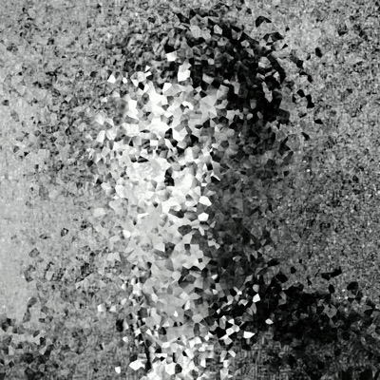

W3 The Totality of Wittgensteinian Facts

W3 shows what would happen if Wittgenstein’s W2 view of the world as the totality of facts were applied to himself. It shows him broken up into the multitude of facts that would constitute his appearance if his doctrine were true. As with W2, W3 does not prove that he is correct, but it does allow us to concretely visualize how things might be if it were so.

4. Aspects Etc.

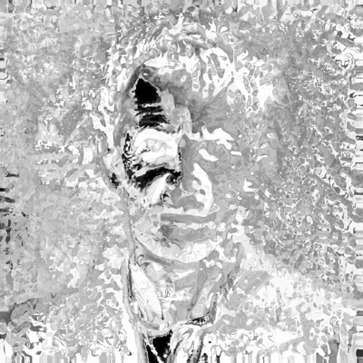

W4 An Aspect Dawns for Wittgenstein

Around the time that our 1947 portrait W of Wittgenstein was taken, he was preoccupied with issues of pictorial interpretation. In particular, the fact that the very same picture, such as Jastrow’s duck-rabbit illustration, could be seen either as a duck or as a rabbit, [2]

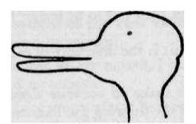

led him to distinguish ordinary object-seeing from what he called ‘aspect-seeing’. Then the ‘dawning of an aspect’ is a kind of aspect-seeing that happens when one suddenly interprets the same picture in a different way--such as by seeing it as a rabbit, when before one had only seen it as a duck.

Picture W4 graphically illustrates such a Wittgensteinian visual dawning, as the meaning of what is seen suddenly seems to change, even though the picture seen has not changed at all.

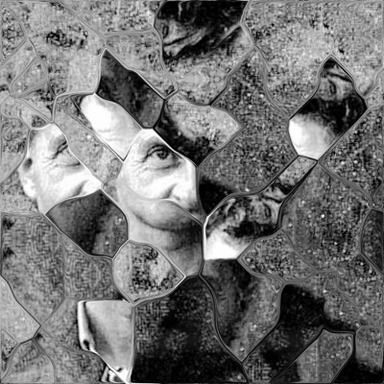

W5 Wittgenstein Seeing As

For Wittgenstein, seeing as is not just a sudden experiential shift in how something looks, as in the case of the dawning of an aspect. More importantly, such experiences show that the concept of seeing itself must be broken down into two separate kinds, with ’seeing as’ being a novel and radically fractured kind which permits multiply discordant views of the same object, such as a duck-rabbit picture. Picture W5 shows one view of Wittgenstein’s own conception of the kind of multiple seeing that results for him.

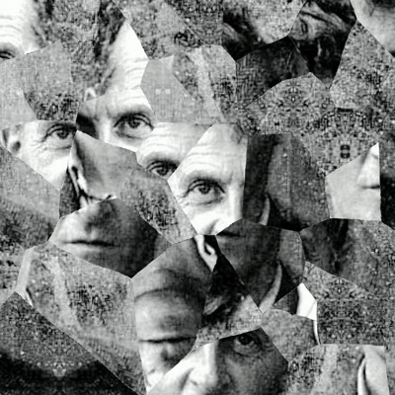

W6 Aspects of Wittgenstein

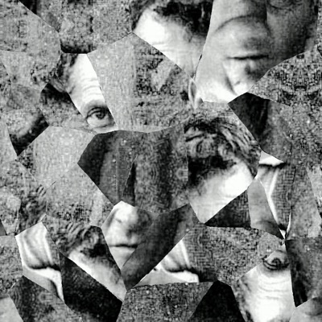

W7 More Aspects of Wittgenstein

Transformed pictures W6 and W7 are in the same structural family as W5, but for me at least, their meaning has shifted. They are naturally interpreted as showing various aspects of Wittgenstein himself, rather than--as with W5--showing what it is like for Wittgenstein to see different aspects of things. But they could be interpreted either way. Yet, as in the duck/rabbit cases discussed above, they cannot simultaneously be seen in both different ways. This is yet another demonstration of the singular power (in both senses) of visual interpretations.

5. Puzzlement and Failures.

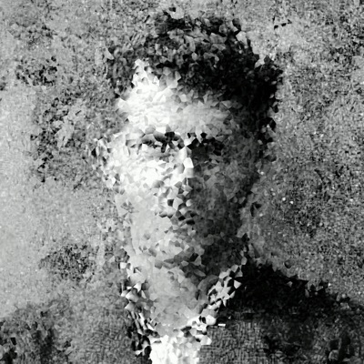

W8 Wittgenstein Puzzled

It is almost uncanny how the original portrait W, showing Wittgenstein as a self-assured intellectual giant, gives way so readily to an image such as W8--an immediate demonstration of his late obsessive puzzlement with anything and everything philosophical.

Yet the visual transformation that produced W8 from W is a relatively minor one, involving no more than some minimal breaking-up of image areas plus some random noise additions. It is almost as if Wittgenstein’s prominent incomprehension of everyday philosophical views lay just below the surface of his public face, so that only a minor adjustment in a visual scrutiny of him is needed to bring his obsession into clear focus.

Perhaps further evidence of this is provided by transformed picture W9:

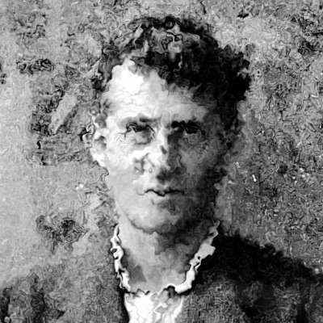

W9 Quizzical Wittgenstein

W9 shows Wittgenstein under siege (as indicated via the impressed visual elements) from views that clearly make no sense to him. But again, the actual visual divergences of W9 from W, though somewhat different from those in the W8 to W transformation, are relatively slight. So, yet more evidence that his late underlying character lies just beneath the visual surface--waiting to be revealed.

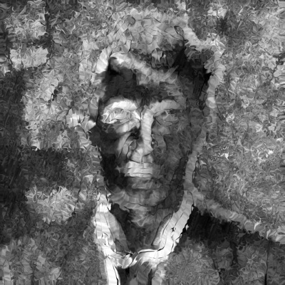

W10 Wittgenstein Imprisoned in the Fly-Bottle

Wittgenstein declares in the Investigations that the aim of philosophy is “..to show the fly the way out of the fly-bottle.” His diagnosis is that normally we are unable to escape from pseudo-philosophical problems that result from our confusions about how ordinary language works. Nevertheless, he often expresses frustration that he too cannot always find a way to dissolve such problems. Picture W10 shows cases in which he is imprisoned in the fly-bottle, with the fly-like darker tones emphasizing his failures to get free.

6. Wittgenstein as Seen by Others

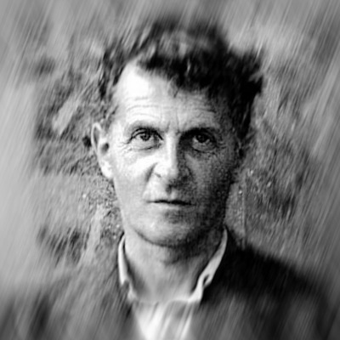

W11 Wittgenstein’s Loss of Problems

In various places Wittgenstein criticizes others for what he calls “loss of problems”, when they offer only superficial or one-dimensional solutions to complex philosophical issues. However, Wittgenstein’s philosophical opponents might in turn criticize his later views, since they dismiss all philosophical problems as mere linguistic confusions that require no positive theoretical solutions at all. W11 shows how Wittgenstein’s opponents might picture his later philosophy.
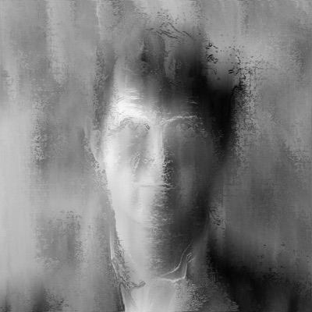

W12 Wittgenstein’s Private Thoughts

A particularly contentious view of Wittgenstein is that the idea of a private language--one referring only to a particular person’s own private sensations--is incoherent, so that there could not be such a language. [3] But those opponents who find Wittgenstein’s writings on this topic and others to be at best mystifying, or at worst incomprehensible, might readily reply with the somewhat sardonic view of his overall thinking as illustrated in picture W12. It shows a hermetic and interminably missing-in-action Wittgenstein, whose writings give no real clue to whatever legitimate thoughts--if any--he might have had while composing them.

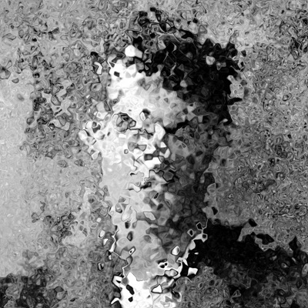

W13 Wittgenstein Dissolving

W13 shows a kind of continuation of the dystopian view of Wittgenstein as evidenced in picture W12. Is there any genuine substance to his later views, or do they all dissolve into remnants--as he does in this picture--on closer examination?
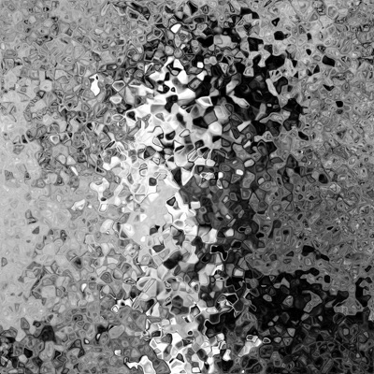

W14 Wittgensteinian Nachlass

A philosopher’s nachlass, or miscellaneous remaining writings, are naturally fragmentary and unfinished to some degree. So picture W14 could simply illustrate this natural state of affairs. But on the other, dystopian view of Wittgenstein’s output, as a whole they amount to nothing philosophically coherent or worthwhile at all--random elements in a confused puzzle.

7. Life as a Weave

In various places Wittgenstein uses the metaphor of mental life as being a kind of weave of complex intersecting patterns of our language, so that, for instance, an emotion such as grief cannot be understood independently of the underlying threads in the weave that partly constitute what it is. Pictures W15-W17 graphically illustrate ways in which he sees his own relation to the weave in which he is immersed:

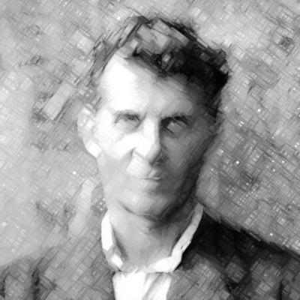

W15 Seeing Life as a Weave

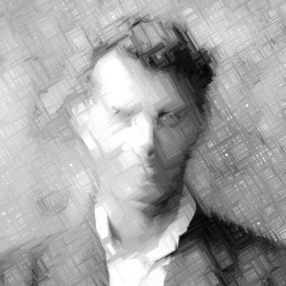

W16 Wittgenstein’s Weave Proliferating

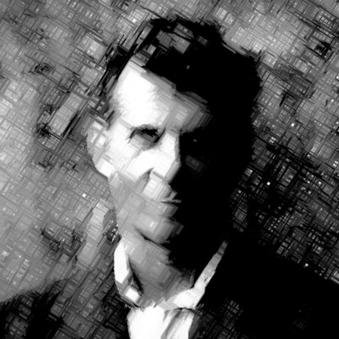

W17 The Weave Takes Over

In picture W17 in particular, Wittgenstein himself seems to have become completely absorbed by, and absorbed into, the weave of life.

8. Wittgenstein Conclusion

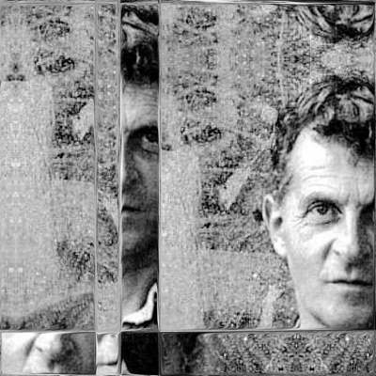

W18 Wittgenstein Self-Observed

Picture W18 shows Wittgenstein as if he were observing himself--an appropriate visual mode for this obsessively self-reflective philosopher.

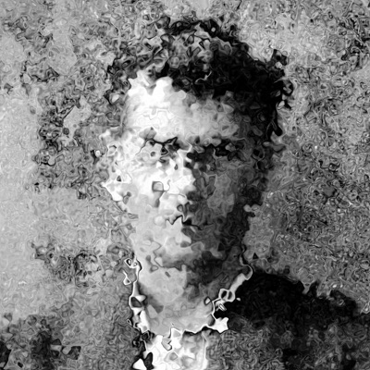

W19 Wittgenstein’s Perpetual Crisis

In picture W19 we see Wittgenstein as a philosopher with a tortured soul, never finding a satisfactory resting place as he pursues his multifarious quests.

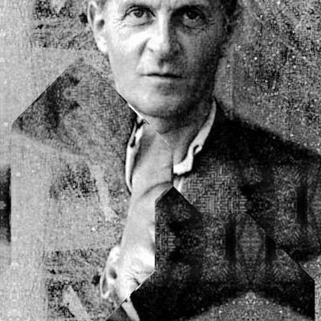

W20 Wittgenstein in Command

And to conclude this Wittgensteinian odyssey, in W20 this most Janus-faced of philosophers shows himself both in his later commanding Investigations gaze, as well as in the inverted vestiges of his earlier Tractatus pronouncements that remain an inseparable part of his influences on the philosophical scene. Moreover, it cannot be denied that Wittgenstein found unsuspected depths--and confounding problems--in a host of traditional philosophical issues. Certainly he has permanently altered the landscape of philosophy, whether one judges it to be for better or for worse.

9. A Portrait of Hume

One of the best-known portraits of the philosopher David Hume was painted by Allan Ramsey in 1766. [4]

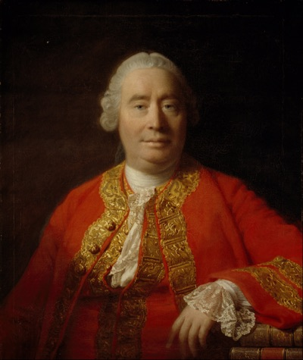

H David Hume in 1766

I shall present sixteen transformed versions of this portrait that illustrate various aspects of Hume’s philosophical views and personality. The transformation methods used are mainly different from those applied in the Wittgenstein cases, so as to achieve a greater overall variety in the results. But this is appropriate in any case, since Hume and Wittgenstein have very different philosophical procedures, in spite of some similar conclusions (for example, both Hume and the early Wittgenstein share an atomistic metaphysics that denies the existence of any genuine connections between things).

10. First Hume Group

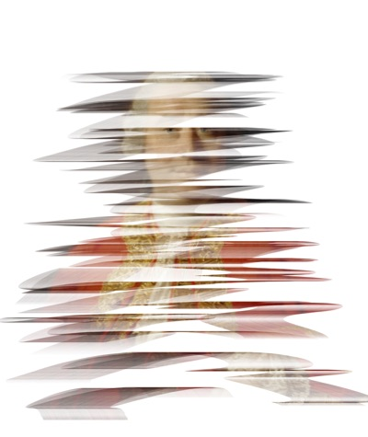
H1 Hume Emerging

Hume famously commented that his first philosophical work, the Treatise of Human Nature, “..fell deadborn from the press”, so that his emergence from philosophical obscurity was at best a gradual process. H1 shows an early stage in this development, with both his potential promise and yet uncertain beginnings clearly in view.

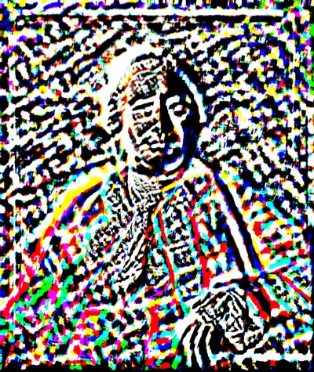

H2 Hume’s Fractured World

Hume radically claims that any apparent causal connections between events are no more than habitual psychological assumptions that we make. Thus for Hume, there are no real causal connections in the world--resulting in his fractured or atomistic world-view as portrayed in picture H2.

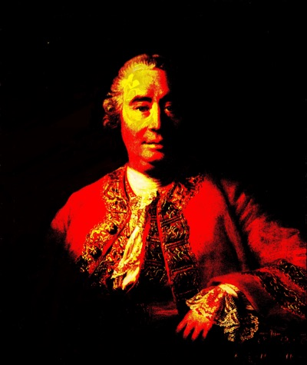

H3 Hume Resolute

In comparison with other early empiricists such as John Locke, one striking feature of Hume is how uncompromising he is in adopting and sticking with radical conclusions to which his arguments have led him, in spite of how unintuitive they might seem in terms of commonsense modes of thinking. Hume’s resolute determination as a philosopher is well captured by picture H3.

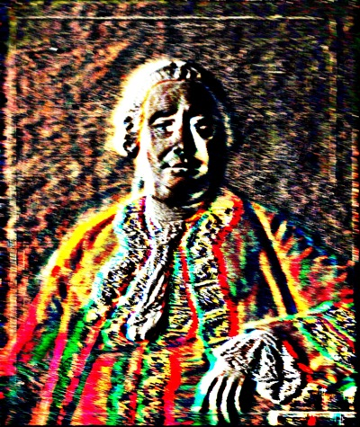

H4 Hume Thinking Deeply

The strong colors and dark tones of picture H4 enable it to show both the depth and richness of Hume’s thinking. It is also remarkable how the straightforward, full-face portrayal of Hume as found in the original painting H has somehow become transformed into this sideways-looking, interior monologue of Hume with himself.

11. Second Hume Group

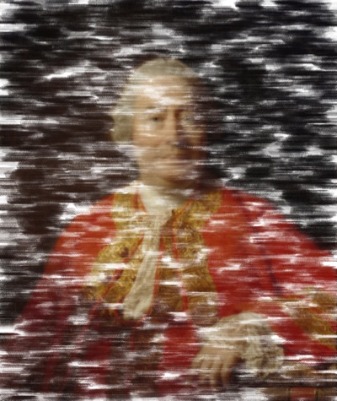

H5 Hume Undecided

Picture H5 is a relatively minor modification of our main Hume portrait H, with a random removal of some small areas that are replaced with plain white background elements. Yet this is enough to significantly change the psychological balance of the portrait, in which Hume now looks significantly less self-assured and more tentative. The exact cognitive mechanisms leading to these changed perceptions are obscure at this stage, but it is hard to deny that H5 looks significantly different in these ways from the original H portrait itself.

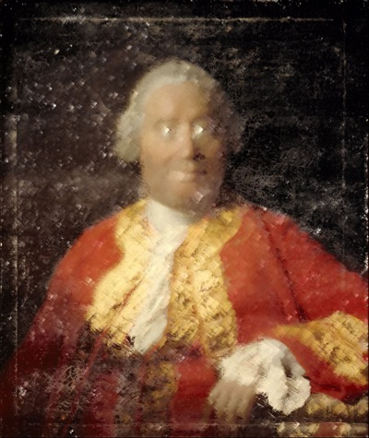

H6 Hume’s Instinctive Distrusts

Picture H6 is another example in which relatively minor modifications in the original picture H have fairly drastically changed how we perceive the result. Hume now seems to be reacting in disbelief to some views he is scrutinizing somewhere on the right side of the portrait, even though no attempt was made in the transformation to change his initial full-frontal direction of gaze.

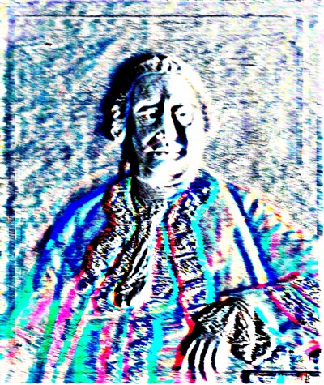

H7 Hume in a Blue Funk

A ‘blue funk’ is a familiar state in which nothing seems to be right or go right for the person experiencing it. I am not sure whether Hume himself was ever in such a state, but if so, picture H7 shows one way in which he might then have appeared.
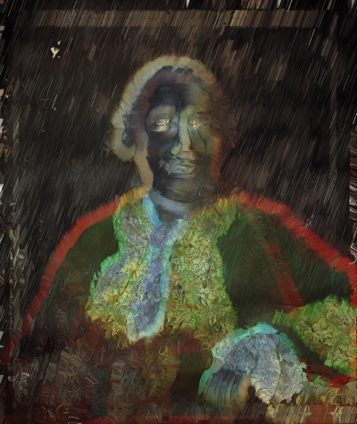

H8 Hume in a Bad Mood

We are all cognizant of bad moods, and it is hard to deny that in picture H8, Hume himself must be in such an unpleasant psychological state. Presumably the muted darker colors plus a loss of sharpness facilitate our changed perception of him, but again, at this stage we simply lack any adequate cognitive theories of aesthetic perception which might precisely explain why picture H8 looks different from picture H in these specific ways.

12. Third Hume Group

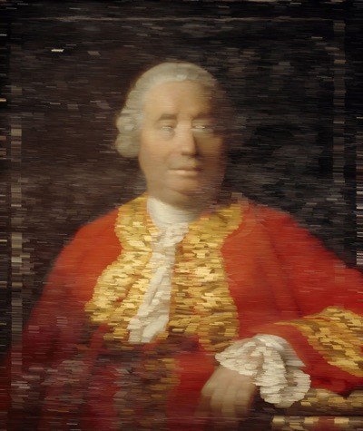

H9 Hume Bemused

Picture H9 gives Hume an uncertain demeanor--apparently he does not know what to make of his object of scrutiny, at least at this moment before his usual resoluteness takes over.

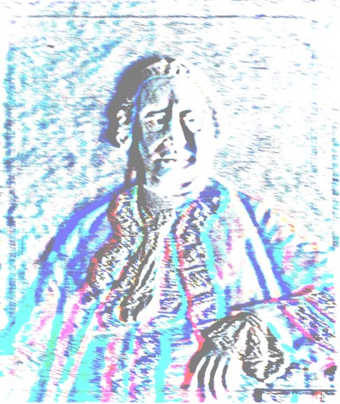

H10 Hume Contemplative

The few strong colors in picture H10 do not disturb its rather quiet, abstracted overall appearance--an apt image of Hume as lost in thought.

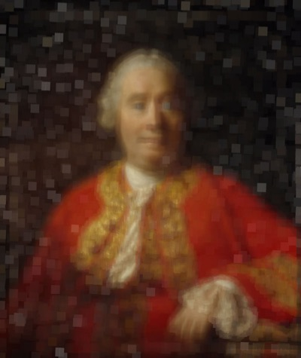

H11 Hume in a Difficult Passage

Trying to read a challenging philosophical passage is an unsettling experience--clear focus has not been established, and everything seems not quite acceptable. This might be what is going on in picture H11 of Hume.

13. Fourth Hume Group

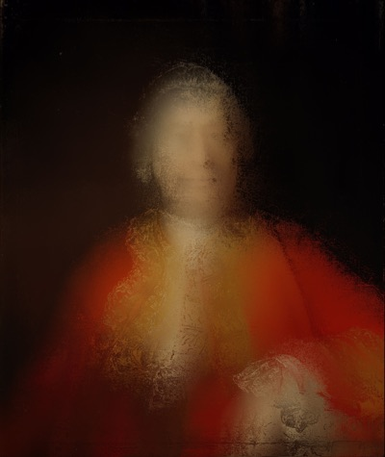

H13 Hume Backing Off

Sometimes even very opinionated and highly organized philosophers, such as Hume indeed was, may suddenly realize that they have gone too far, crucially confused issues, or committed other significant missteps. Picture H13 shows one of these probably quite rare moments in Hume’s own philosophizing.

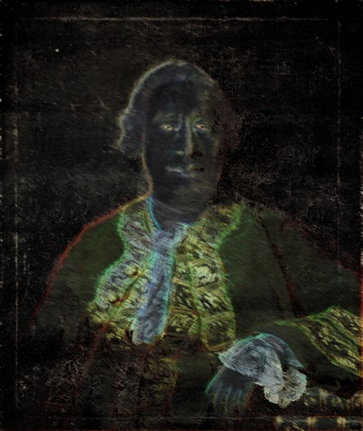

H14 Hume’s Dark Hours

Picture H14 may usefully be compared with picture H8, showing Hume in a bad mood. H14 strikes me rather as showing not his occasionally negative emotions, but rather a more objective realization--even if a temporary one--that he is no longer completely sure that his philosophical system is fully defensible.

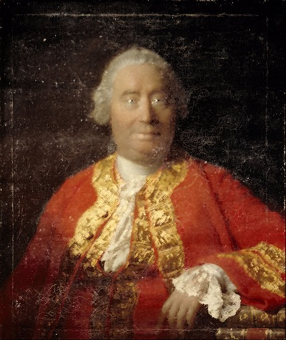

H15 Dawning of a Humean Idea

As so often with portraits, most of the visual effects in picture H15 are closely associated with the eyes, showing Hume in the process of moving from an intuitive sensory impression to a rapidly developing, and quite possibly novel, cognitive idea of his--indeed, showing Hume in the very process of discovery.

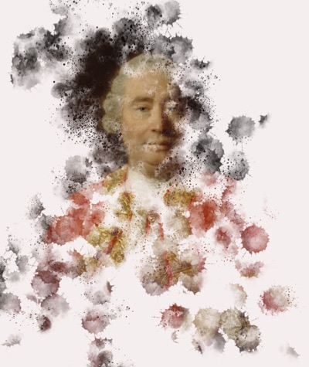

H16 The Revolutionary Hume

And finally, picture H16 aptly sums up Hume’s highly significant philosophical achievements, by showing him radiant in a celebratory starburst of colors. His position as a lodestar in the philosophical firmament remains as secure as ever.

14. Conclusion

This essay has provided an initial investigation of some novel visual effects derived from portraits of philosophers. But I hope that at least some of the images might also provide something for Hume or Wittgenstein enthusiasts that was never available previously—via a way of showing, rather than saying, something of significance about their subjects, to use Wittgenstein’s early Tractatus distinction.

A main issue that remains unresolved for me is how far attempts—such as mine—to describe what is philosophically salient about each picture are genuinely descriptive of them. For instead, at the other extreme, they might be no more than idiosyncratic personal reactions, caused more by the highly unusual nature of the images rather than by any of their intrinsic features. Perhaps such issues might be clarified by cognitive studies in experimental aesthetics on images such as these.

But in any case, I also hope that others too may be encouraged to create their own transformations of favorite philosopher portraits, and provide us with their interpretations as well.

Endnotes

[1] https://en.wikipedia.org/wiki/Ludwig_Wittgenstein, and elsewhere.

[2] [https://earth-and-space-news.blogspot.com/2016/02/ambiguous-duck-rabbit-figure-shifts.html.

[3] See Candlish, Stewart and Wrisley, George, "Private Language", The Stanford Encyclopedia of Philosophy (Fall 2014 Edition), Edward N. Zalta (ed.), URL = <https://plato.stanford.edu/archives/fall2014/entries/private-language/>

[4] https://commons.wikimedia.org/wiki/File:Allan_Ramsay_-_David_Hume,_1711_-_1776._Historian_and_philosopher_-_Google_Art_Project.jpg

