An Expert System for Arthritis Diseases Diagnosis Using SL5 Object
Hosni Qasim El-Mashharawi, Izzeddin A. Alshawwa, Mohammed Elkahlout, Samy S. Abu-Naser
Department of Information Technology
Faculty of Engineering and Information Technology
Al-Azhar University Gaza – Palestine

Abstract: Background: Arthritis is very common but is not well understood. Actually, “arthritis” is not a single disease; it is an informal way of referring to joint pain or joint disease. There are more than 100 different types of arthritis and related conditions. People of all ages, sexes and races can and do have arthritis, and it is the leading cause of disability in America. More than 50 million adults and 300,000 children have some type of arthritis. It is most common among women and occurs more frequently as people get older. Common arthritis joint symptoms include swelling, pain, stiffness and decreased range of motion. Symptoms may come and go. They can be mild, moderate or severe. They may stay about the same for years, but may progress or get worse over time. Severe arthritis can result in chronic pain, inability to do daily activities and make it difficult to walk or climb stairs. Arthritis can cause permanent joint changes. These changes may be visible, such as knobby finger joints, but often the damage can only be seen on X-ray. Some types of arthritis also affect the heart, eyes, lungs, kidneys and skin as well as the joints. Objectives: The main goal of this expert system is to get the appropriate diagnosis of disease and the correct treatment and give the appropriate method of treatment through several tips that concern the disease and how to treat it and we will see it through the application on the expert system. Methods: in this paper the design of the proposed Expert System which was produced to help Orthopedist in diagnosing Arthritis disease through its symptoms such as: pain on pressure in a joint , Inflammation indicated by joint swelling, Stiffness especially in the morning , Loss of flexibility of joint, Limited, joint movement, Deformity of the joints , Weight loss and fatigue , Non-specific fever and Crepitus. The proposed expert system presents an overview about Arthritis disease is given, the cause of diseases is outlined and the treatment of disease whenever possible is given out. SL5 Object Expert System language was used for designing and implementing the proposed expert system. Results: The proposed Arthritis disease diagnosis expert system was evaluated by Orthopedics students and they were satisfied with its performance. Conclusions: The Proposed expert system is very useful for Orthopedist, patients with arthritis and newly graduated Orthopedics students.

Keywords: Artificial Intelligence, Expert Systems, SL5 Object, Arthritis, Orthopedist.

Introduction
Arthritis is a term often used to mean any disorder that affects joints. Symptoms generally include joint pain and stiffness. Other symptoms may include redness, warmth, swelling, and decreased range of motion of the affected joints. In some types other organs are also affected. Onset can be gradual or sudden.
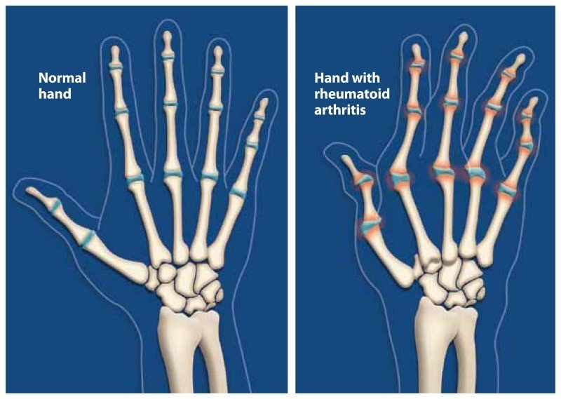
Figure 1: The figure presents a one type from arthritis

There are over 100 types of arthritis. The most common forms are osteoarthritis (degenerative joint disease) and rheumatoid arthritis. Osteoarthritis usually occurs with age and affects the fingers, knees, and hips. Rheumatoid arthritis is an autoimmune disorder that often affects the hands and feet. Other types include gout, lupus, fibromyalgia, and septic arthritis. They are all types of rheumatic disease. Treatment may include resting the joint and alternating between applying ice and heat. Weight loss and exercise may also be useful. Pain medications such as ibuprofen and paracetamol (acetaminophen) may be used. In some a joint replacement may be useful.
Diagnosis of arthritis is a very complex because it has many symptoms and may effect on human health. So, they need Orthopedist with wide experience of arthritis.
For all the aforementioned reasons, we have developed this expert system to help Orthopedist in diagnosing the arthritis, in order to prescribe the appropriate treatment.
Expert System is a computer application of Artificial Intelligence (AI) [3-30] which contains a knowledge base and an inference engine the main components and details are represented in figure 2.
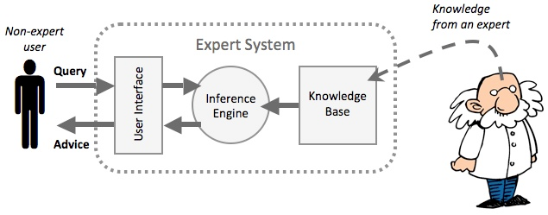
Figure 2: The figure presents the Main Components of an Expert System
The proposed Expert System for Arthritis Diagnosis was implemented using, SL5 Object language [31] which stands for Simpler Level 5 Object. It is a forward chinning reasoning expert system that can make inferences about facts of the world using rules, objects and take appropriate actions as a result. The SL5 Object engine is implemented in Delphi Embarcadero RAD Studio XE6. SL5 Object executes any Expert System looks like frames. It’s easy for the knowledge engineer to build the Expert System and for the end users when they use the system.

MATERIALS AND METHODS
The proposed expert system performs diagnosis for arthritis of all stages of the human life starting with simple symptoms by asking yes or no questions. The proposed expert system will ask the user to choose the correct answer in each screen. At the end of the dialogue session, the proposed expert system provides the diagnosis and recommendation of the disease to the user. Figure 3 shows a sample dialogue between the expert system and the user. Figure 4 shows how the users get the diagnosis and recommendation.

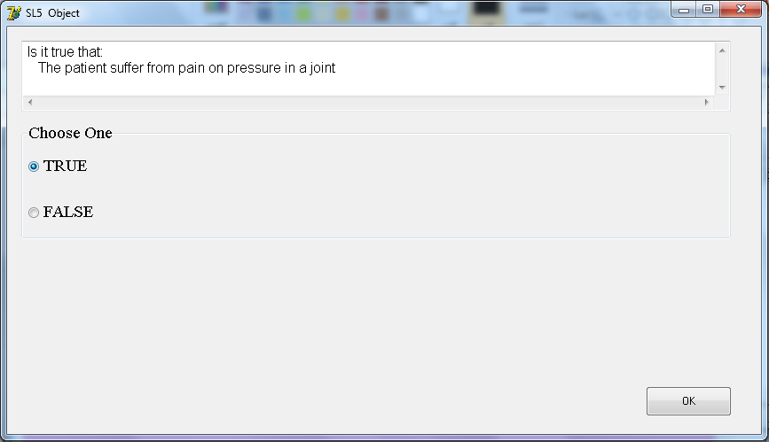

Figure 3: The figure presents shows when the system asks the user

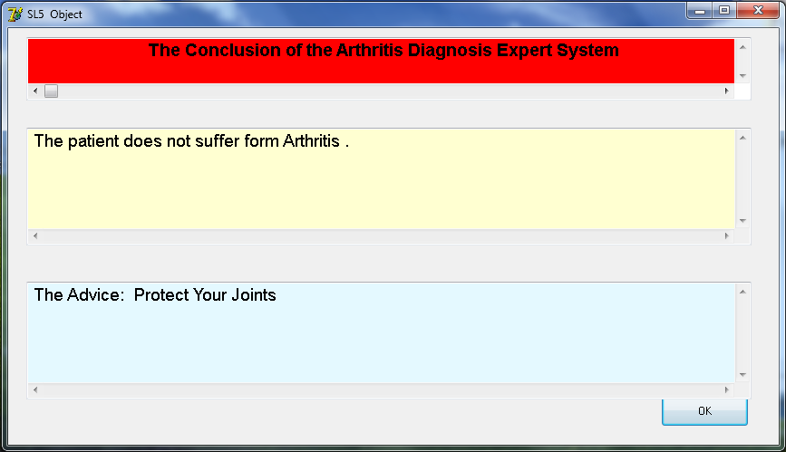
Figure 4: The figure shows diagnosis and recommendation of the expert system

LITERATURE REVIEW
There are many expert systems that are found in the literature a few of them as follows:
- A Proposed Expert System for Skin Diseases Diagnosis [63] was developed using CLIPS(C Language Integrated Production System) to help user diagnose the following skin diseases (Psoriasis, Eczema, Ichthyosis, Acne, Meningitis, Measles, Scarlet Fever, Warts, Insect Bites and Stings).
- Lower Back Pain Expert System Diagnosis and Treatment [40] can be used to positively diagnose low back pain concentration.
- Expert System for Problems of Teeth and Gums [37] assist people with teeth and gums problems to diagnose their problems and receive a recommendation for the treatment. This knowledge based system was developed using SL5 Object language.
- Ear Diseases Diagnosis Expert System Using SL5 Object [31] swiftly diagnoses patient’s condition and proposes a appropriate answer for the problem.
- A Proposed Expert System for Foot Diseases Diagnosis [59] diagnoses eighteen foot problems of all phases of the human life beginning with baby to the grownup by examining with yes/no questions.
- A Knowledge Based System for Neck Pain Diagnosis [45] can diagnose seven neck diseases of different phases of the human life beginning by asking the user many questions according to their pain symptoms.
- An expert system for shoulder problems using CLIPS [57] can help in diagnosing shoulder problems.
- Expert system urination problems diagnosis [61] can diagnose some of the Urination diseases (Pyelonephritis, Kidney Stone, Bladder infection, Prostatitis, Urethritis, Gonorrhea, Interstitial cystitis, Stress incontinence, Trauma in kidney or bladder).
- An Expert System for Genital Problems in Infants [51] diagnoses genital problems in infants which is one of the most common problems that need quick intervention in the newly born stage.
- An expert system for men genital problems diagnosis and treatment [44] to assist men diagnose their genital problems and give them the suitable treatment. Genital problems and injuries usually occur through: recreational activities (such as: Basketball, Football, Hooky, Biking), work-related tasks (such as: contact to irritating chemicals), downhill drop, and sexual activities. SL5 Object expert system language was used to develop this expert system.
- An expert system for nausea and vomiting problems in infants and children[53] to aid users in getting the right diagnosis of problems of nausea and vomiting in infants and children (Gastro-esophageal reflux, Gastroenteritis, Systemic Infection, Bowel obstruction, Tumors, A bleeding disease, tonsillitis, and Hepatitis pharynx). Additionally, this expert system offers information about the disease and how to deal with it.
- An expert system for feeding problems in infants and children [35] to diagnose feeding problems in infants and children.
- Detecting Health Problems Related to Addiction of Video Game Playing Using an Expert System [38] to assist users in getting the correct diagnosis of the health problem of video game addictions that range from (Musculoskeletal issues, Vision problems and Obesity). Furthermore, this expert system delivers information about the problem and tells us how we can solve it.
- An Expert System for Endocrine Diagnosis and treatments using JESS [65] was developed to help in diagnosing endocrine glands diseases.
- Expert System for Hair Loss Diagnosis and Treatment [62] for diagnosing eleven diverse hair loss diseases of the human stages from childhood to adults by asking questions with a Yes or No answer.
- Male Infertility Expert System Diagnoses and Treatment [42] for male infertility diagnosis which helps men to explore everything related to the problems of infertility and infertility diseases such as: Azoospermia, O.T.A syndrome which mean oligo-terato-astheno spermia, Aspermia and Sexual transmitted disease.
- An expert system for diagnosing eye diseases using clips [33] provides the patient with background for suitable diagnosis of a few of the eye diseases.
- An Expert System for Mouth Problems in Infants and Children [45] ask the user to answer the questions about the symptoms of the patient and end up with some information about the disease and some advices telling the user how to deal with the baby.
- Knowledge Management in ESMDA: Expert System for Medical Diagnostic Assistance [36] deals with the design of a prototype expert system that assists patients to diagnose their diseases and offer them the suitable advice.
- Knowledge Based System for Long-term Abdominal Pain (Stomach Pain) Diagnosis and Treatment [56] was made to aid internist physicians in diagnosing numerous of the abdomen diseases for example: gastritis, hiatal hernia, ulcer or heartburn; the proposed expert system offers a summary about abdomen diseases are given, the cause of diseases are drew and the cure of disease when possible is shown up.
- A Ruled Based System for Ear Problem Diagnosis and Treatment [47] was used to classify ear problems into three main sets: a- Inflammation of the inner ear b- Middle ear problems c- External ear problems.
- Knowledge Based System for Ankle Diseases Diagnosis [43] recognized seven ankle diseases: Ankle Sprain, Fracture (of Fibula), Rheumatoid Arthritis, Rheumatoid Fever, Gout, and Osteoarthritis (Degenerative Joint) and they developed the expert system for those ankle diseases using SL5 Object Expert System Language.
- An Expert System for Diagnosing Shortness of Breath in Infants and Children [34] for diagnosing infants and children patients with twelve various shortness of breath in infants and children diseases.
- Polymyalgia Rheumatic Expert System [64] outlined an expert system for classification criteria for PMR, recent advances of diagnostic and therapeutic procedures.
- Expert System for Chest Pain in Infants and Children [50] to assist doctors, parents, and care giver in diagnosing chest pain in infants and children.
- Rickets Expert System Diagnoses and Treatment [39] assist doctors to discover everything connected to the problems of rickets.
- A Proposed Rule Based System for Breasts Cancer Diagnosis [53] was developed to help people in preventing and early detecting breast cancer; since it is known that this disease does not have medication or cure yet.
Although, there are many expert systems that are developed for diagnosing human problems; there is no specialized expert system for diagnosing arthritis available free. The proposed expert system was designed and developed specifically to aid doctors in diagnosing arthritis.

KNOWLEDGE REPRESENTATION
The main sources of the knowledge for this expert system are Orthopedist and specializes websites for arthritis. The captured knowledge has been converted into SL5 Object Knowledge base syntax (Facts, Rules and Object). Currently the expert system has 9 rules which cover arthritis disease.

LIMITATIONS
The current proposed expert system is specialized in the diagnosis only arthritis with the following symptoms: pain on pressure in a joint, Inflammation indicated by joint swelling, Stiffness especially in the morning, Loss of flexibility of joint, Limited, joint movement, Deformity of the joints, Weight loss and fatigue, Non-specific fever and Crepitus

SYSTEM EVALUATION
As a preliminary evolution, Orthopedist students tested this proposed Expert System and they were satisfied with its performance, efficiency, user interface and ease of use.

CONCLUSION
In this paper, a proposed expert system was presented for helping Orthopedist in diagnosing patients with nine different symptoms possible arthritis. Orthopedist and arthritis patients can get the diagnosis faster and more accurate than the traditional diagnosis. This expert system does not need intensive training to be used; it is easy to use and has user friendly interface. It was developed using SL5 Object Expert System language.
.

EXPERT SYSTEM SOURCE CODE

! Written by SAMI AND HOSNI

ATTRIBUTE start SIMPLE

ATTRIBUTE The patient suffer from pain on pressure in a joint SIMPLE

ATTRIBUTE The patient suffer from Inflammation indicated by joint swelling SIMPLE

ATTRIBUTE The patient suffer from Stiffness especially in the morning SIMPLE

ATTRIBUTE The patient suffer from Loss of flexibility of joint SIMPLE

ATTRIBUTE The patient suffer from Limited joint movement SIMPLE

ATTRIBUTE The patient suffer from Deformity of the joints SIMPLE

ATTRIBUTE The patient suffer from Weight loss and fatigue SIMPLE

ATTRIBUTE The patient suffer from Non-specific fever SIMPLE

ATTRIBUTE The patient suffer from Crepitus SIMPLE

INSTANCE the domain ISA domain
WITH start := TRUE

INSTANCE the application ISA application
WITH title display := introduction
WITH conclusion display := Conc

INSTANCE introduction ISA display
WITH wait := TRUE
WITH delay changes := FALSE
WITH items [1 ] := textbox 1

INSTANCE textbox 1 ISA textbox
WITH location := 10,10,800,350
WITH pen color := 0,0,0
WITH fill color := 236,170,236
WITH justify IS left
WITH font := "Cairo"
WITH font style IS bold
WITH font size := 14
WITH text :="
Arthritis Diagnosis Expert System

Written By SAMI AND HOSNI

This Expert System diagnoses Arthritis Problems through a dialogue between the
System and the End User.

The Conclusion of the finding is displayed and an Advice is given for the End User
to solve the problem."

INSTANCE Conc ISA display
WITH wait := TRUE
WITH delay changes := FALSE
WITH items [1] := title textbox
WITH items [2 ] := problem textbox
WITH items [3 ] := advise textbox

INSTANCE title textbox ISA textbox
WITH location := 20,10,800,70
WITH pen color := 0,0,0
WITH fill color := 255,0,0
WITH justify IS center
WITH font := "Arial"
WITH font style IS bold
WITH font size := 14
WITH text := " The Conclusion of the Arthritis Diagnosis Expert System"

INSTANCE problem textbox ISA textbox
WITH location := 20,110,800,130
WITH pen color := 0,0,0
WITH fill color := 255,255,209
WITH justify IS left
WITH font := "Cairo"
WITH font size := 14
WITH text :=" --===--"

INSTANCE advise textbox ISA textbox
WITH location := 20,280,800,130
WITH pen color := 0,0,0
WITH fill color := 228,249,255
WITH justify IS left
WITH font := "Cairo"
WITH font size := 14
WITH text :=" --===--"

RULE R0
IF start
THEN ASK The patient suffer from pain on pressure in a joint

RULE R1
IF The patient suffer from pain on pressure in a joint
THEN ASK The patient suffer from Inflammation indicated by joint swelling

RULE R2
IF The patient suffer from pain on pressure in a joint
AND The patient suffer from Inflammation indicated by joint swelling
THEN ASK The patient suffer from Stiffness especially in the morning

RULE R3
IF The patient suffer from pain on pressure in a joint
AND The patient suffer from Inflammation indicated by joint swelling
AND The patient suffer from Stiffness especially in the morning
THEN ASK The patient suffer from Loss of flexibility of joint

RULE R4
IF The patient suffer from pain on pressure in a joint
AND The patient suffer from Inflammation indicated by joint swelling
AND The patient suffer from Stiffness especially in the morning
AND The patient suffer from Loss of flexibility of joint
THEN ASK The patient suffer from Limited joint movement

RULE R5
IF The patient suffer from pain on pressure in a joint
AND The patient suffer from Inflammation indicated by joint swelling
AND The patient suffer from Stiffness especially in the morning
AND The patient suffer from Loss of flexibility of joint
AND The patient suffer from Limited joint movement
THEN ASK The patient suffer from Deformity of the joints

RULE R6
IF The patient suffer from pain on pressure in a joint
AND The patient suffer from Inflammation indicated by joint swelling
AND The patient suffer from Stiffness especially in the morning
AND The patient suffer from Loss of flexibility of joint
AND The patient suffer from Limited joint movement
AND The patient suffer from Deformity of the joints
THEN ASK The patient suffer from Weight loss and fatigue

RULE R7
IF The patient suffer from pain on pressure in a joint
AND The patient suffer from Inflammation indicated by joint swelling
AND The patient suffer from Stiffness especially in the morning
AND The patient suffer from Loss of flexibility of joint
AND The patient suffer from Limited joint movement
AND The patient suffer from Deformity of the joints
AND The patient suffer from Weight loss and fatigue
THEN ASK The patient suffer from Non-specific fever

RULE R8
IF The patient suffer from pain on pressure in a joint
AND The patient suffer from Inflammation indicated by joint swelling
AND The patient suffer from Stiffness especially in the morning
AND The patient suffer from Loss of flexibility of joint
AND The patient suffer from Limited joint movement
AND The patient suffer from Deformity of the joints
AND The patient suffer from Weight loss and fatigue
AND The patient suffer from Non-specific fever
THEN ASK The patient suffer from Crepitus

RULE R9
IF The patient suffer from pain on pressure in a joint
AND The patient suffer from Inflammation indicated by joint swelling
AND The patient suffer from Stiffness especially in the morning
AND The patient suffer from Loss of flexibility of joint
AND The patient suffer from Limited joint movement
AND The patient suffer from Deformity of the joints
AND The patient suffer from Weight loss and fatigue
AND The patient suffer from Non-specific fever
AND The patient suffer from Crepitus
THEN text OF problem textbox := "The patient suffer from Arthritis ."
AND text OF advice textbox := "The Advice: For people with arthritis, physical activities such as walking, bicycling, and swimming have been shown to have significant benefits, including reducing pain and improving physical function, mental health, and quality of life. Make sure you get at least 30 minutes of moderate physical activity at least 5 days a week. You can get activity in 10- minute intervals "
ELSE text OF problem textbox := "The patient does not suffer from Arthritis ."
AND text OF advice textbox := "The Advice: Protect Your Joints "
END

REFERENCES
- https://www.arthritis.org/about-arthritis/understanding-arthritis/what-is-arthritis.php
- https://www.mayoclinic.org/diseases-conditions/arthritis/symptoms-causes/syc-20350772
- Abu-Naser, S. S., Kashkash, K. A., & Fayyad, M. (2010). Developing an expert system for plant disease diagnosis. Journal of Artificial Intelligence ; Scialert, 3(4), 269-276.
- Barhoom, A. M., & Abu-Naser, S. S. (2018). Black Pepper Expert System. International Journal of Academic Information Systems Research (IJAISR), 2(8), 9-16.
- Almadhoun, H. R., & Abu Naser, S. S. (2018). Banana Knowledge Based System Diagnosis and Treatment. International Journal of Academic Pedagogical Research (IJAPR), 2(7), 1-11.
- Akkila, A. N., & Abu Naser, S. S. (2016). Proposed Expert System for Calculating Inheritance in Islam. World Wide Journal of Multidisciplinary Research and Development, 2(9), 38-48.
- AbuEl-Reesh, J. Y., & Abu Naser, S. S. (2017). A Knowledge Based System for Diagnosing Shortness of Breath in Infants and Children. International Journal of Engineering and Information Systems (IJEAIS), 1(4), 102-115.
- Alajrami, M. A., & Abu-Naser, S. S. (2018). Onion Rule Based System for Disorders Diagnosis and Treatment. International Journal of Academic Pedagogical Research (IJAPR), 2(8), 1-9.
- Abu Naser, S. S., Alamawi, W. W., & Alfarra, M. F. (2016). Rule Based System for Diagnosing Wireless Connection Problems Using SL5 Object. International Journal of Information Technology and Electrical Engineering, 5(6), 26-33.
- Almurshidi, S. H., & Abu-Naser, S. S. (2018). EXPERT SYSTEM FOR DIAGNOSING BREAST CANCER. Al-Azhar University, Gaza, Palestine.
- Azaab, S., Abu Naser, S., & Sulisel, O. (2000). A proposed expert system for selecting exploratory factor analysis procedures. Journal of the College of Education, 4(2), 9-26.
- Bakeer, H., & Abu Naser, S. S. (2017). Photo Copier Maintenance Expert System V. 01 Using SL5 Object Language. International Journal of Engineering and Information Systems (IJEAIS), 1(4), 116-124.
- Khella, R., & Abu Naser, S. S. (2017). Rule Based System for Chest Pain in Infants and Children. International Journal of Engineering and Information Systems, 1(4), 138-148.
- Dahouk, A. W., & Abu-Naser, S. S. (2018). A Proposed Knowledge Based System for Desktop PC Troubleshooting. International Journal of Academic Pedagogical Research (IJAPR), 2(6), 1-8.
- Musleh, M. M., & Abu-Naser, S. S. (2018). Rule Based System for Diagnosing and Treating Potatoes Problems. International Journal of Academic Engineering Research (IJAER), 2(8), 1-9.
- Abu Naser, S. S., Baraka, M. H., & Baraka, A. (2008). A Proposed Expert System For Guiding Freshman Students In Selecting A Major In Al-Azhar University, Gaza. Journal of Theoretical & Applied Information Technology, 4(9).
- AlZamily, J. Y., & Abu-Naser, S. S. (2018). A Cognitive System for Diagnosing Musa Acuminata Disorders. International Journal of Academic Information Systems Research (IJAISR), 2(8), 1-8.
- Nassr, M. S., & Abu Naser, S. S. (2018). Knowledge Based System for Diagnosing Pineapple Diseases. International Journal of Academic Pedagogical Research (IJAPR), 2(7), 12-19.
- Abu-Nasser, B. S., & Abu-Naser, S. S. (2018). Cognitive System for Helping Farmers in Diagnosing Watermelon Diseases. International Journal of Academic Information Systems Research (IJAISR), 2(7), 1-7.
- Ashqar, B. A. M., Abu-Nasser, B. S., & Abu-Naser, S. S. (2019). Plant Seedlings Classification Using Deep Learning. International Journal of Academic Information Systems Research (IJAISR), 3(1), 7-14.
- Abu Naser, S. S. (1993). A methodology for expert systems testing and debugging. North Dakota State University, USA.
- Al-Qumboz, M. N. A., & Abu-Naser, S. S. (2019). Spinach Expert System: Diseases and Symptoms. International Journal of Academic Information Systems Research (IJAISR), 3(3), 16-22.
- Abu Naser, S. S. (1999). Big O Notation for Measuring Expert Systems complexity. Islamic University Journal Gaza, 7(1), 57-70.
- Al-Shawwa, M., & Abu-Naser, S. S. (2019). Knowledge Based System for Apple Problems Using CLIPS. International Journal of Academic Engineering Research (IJAER), 3(3), 1-11.
- Abu Naser, S., & Aead, A. M. (2013). Variable Floor for Swimming Pool Using an Expert System. International Journal of Modern Engineering Research (IJMER), 3(6), 3751-3755.
- Ashqar, B. A. M., & Abu-Naser, S. S. (2019). Image-Based Tomato Leaves Diseases Detection Using Deep Learning. International Journal of Academic Engineering Research (IJAER), 2(12), 10-16.
- El_Jerjawi, N. S., & Abu-Naser, S. S. (2018). Diabetes Prediction Using Artificial Neural Network. International Journal of Advanced Science and Technology, 121, 55-64.
- Abu Naser, S. S., & Zaqout, I. S. (2016). Knowledge-based systems that determine the appropriate students major: In the faculty of engineering and information technology. World Wide Journal of Multidisciplinary Research and Development, 2(10), 26-34.
- Abu Naser, S. S. (2015). Sl5 Object: Simpler Level 5 Object Expert System Language. International Journal of Soft Computing, Mathematics and Control (IJSCMC), 4(4), 25-37.
- Nasser, I. M., Al-Shawwa, M. O., & Abu-Naser, S. S. (2019). Artificial Neural Network for Diagnose Autism Spectrum Disorder. International Journal of Academic Information Systems Research (IJAISR), 3(2), 27-32.
- Abu Naser, S. S., & Abu Hasanein, H. A. (2016). Ear Diseases Diagnosis Expert System Using SL5 Object. World Wide Journal of Multidisciplinary Research and Development, 2(4), 41-47.
- Elqassas, R., & Abu-Naser, S. S. (2018). Expert System for the Diagnosis of Mango Diseases. International Journal of Academic Engineering Research (IJAER), 2(8), 10-18.
- Abu Naser, S. S., & Abu Zaiter, O. A. (2008). An Expert System For Diagnosing Eye Diseases Using Clips. Journal of Theoretical & Applied Information Technology, 4(10).
- AbuEl-Reesh, J. Y., & Abu Naser S. S. (2017). An Expert System for Diagnosing Shortness of Breath in Infants and Children. International Journal of Engineering and Information Systems (IJEAIS), 1(4), 102-115.
- Abu Naser, S. S., & Alawar, M. W. (2016). An expert system for feeding problems in infants and children. International Journal of Medicine Research, 1(2), 79-82.
- Abu Naser, S., Al-Dahdooh, R., Mushtaha, A., & El-Naffar, M. (2010). Knowledge management in ESMDA: expert system for medical diagnostic assistance. AIML Journal, 10(1), 31-40.
- Abu Ghali, M. J., Mukhaimer, M. N., Abu Yousef, M. K., & Abu Naser, S. S. (2017). Expert System for Problems of Teeth and Gums. International Journal of Engineering and Information Systems (IJEAIS), 1(4), 71-88.
- Abu Naser, S. S., & Al-Bayed, M. H. (2016). Detecting Health Problems Related to Addiction of Video Game Playing Using an Expert System. World Wide Journal of Multidisciplinary Research and Development, 2(9), 7-12.
- Al Rekhawi, H. A., Ayyad, A. A., & Abu Naser, S. S. (2017). Rickets Expert System Diagnoses and Treatment. International Journal of Engineering and Information Systems (IJEAIS), 1(4), 149-159.
- Abu Naser, S. S., & AlDahdooh, R. M. (2016). Lower Back Pain Expert System Diagnosis And Treatment. Journal of Multidisciplinary Engineering Science Studies (JMESS), 2(4), 441-446.
- Mettleq, A. S. A., & Abu-Naser, S. S. (2019). A Rule Based System for the Diagnosis of Coffee Diseases. International Journal of Academic Information Systems Research (IJAISR), 3(3), 1-8.
- Abu Naser, S. S., & Alhabbash, M. I. (2016). Male Infertility Expert system Diagnoses and Treatment. American Journal of Innovative Research and Applied Sciences, 2(4).
- Qwaider, S. R., & Abu Naser, S. S. (2017). Expert System for Diagnosing Ankle Diseases. International Journal of Engineering and Information Systems (IJEAIS), 1(4), 89-101.
- Abu Naser, S. S., & Al-Hanjori, M. M. (2016). An expert system for men genital problems diagnosis and treatment. International Journal of Medicine Research, 1(2), 83-86.
- Abu Naser, S. S., & ALmursheidi, S. H. (2016). A Knowledge Based System for Neck Pain Diagnosis. World Wide Journal of Multidisciplinary Research and Development (WWJMRD), 2(4), 12-18.
- Sadek, R. M., Mohammed, S. A., Abunbehan, A. R. K., Ghattas, A. K. H. A., Badawi, M. R., Mortaja, M. N., . . . Abu-Naser, S. S. (2019). Parkinson’s Disease Prediction Using Artificial Neural Network. International Journal of Academic Health and Medical Research (IJAHMR), 3(1), 1-8.
- Abu Naser, S. S., & Al-Nakhal, M. A. (2016). A Ruled Based System for Ear Problem Diagnosis and Treatment. World Wide Journal of Multidisciplinary Research and Development, 2(4), 25-31.
- Elsharif, A. A., & Abu-Naser, S. S. (2019). An Expert System for Diagnosing Sugarcane Diseases. International Journal of Academic Engineering Research (IJAER), 3(3), 19-27.
- Abu Naser, S. S., & Bastami, B. G. (2016). A Proposed Rule Based System for Breasts Cancer Diagnosis. World Wide Journal of Multidisciplinary Research and Development, 2(5), 27-33.
- Khella, A. R., & Abu Naser, S. S. (2017). Expert System for Chest Pain in Infants and Children. International Journal of Engineering and Information Systems (IJEAIS), 1(4), 138-148.
- Abu Naser, S. S., & El Haddad, I. A. (2016). An Expert System for Genital Problems in Infants. EUROPEAN ACADEMIC RESEARCH, 4(10).
- Nasser, I. M., & Abu-Naser, S. S. (2019). Predicting Tumor Category Using Artificial Neural Networks. International Journal of Academic Health and Medical Research (IJAHMR), 3(2), 1-7.
- Abu Naser, S. S., & El-Najjar, A. E. A. (2016). An expert system for nausea and vomiting problems in infants and children. International Journal of Medicine Research, 1(2), 114-117.
- Nasser, I. M., & Abu-Naser, S. S. (2019). Lung Cancer Detection Using Artificial Neural Network. International Journal of Engineering and Information Systems (IJEAIS), 3(3), 17-23.
- Abu Naser, S. S., & Hamed, M. A. (2016). An Expert System for Mouth Problems in Infants and Children. Journal of Multidisciplinary Engineering Science Studies (JMESS), 2(4), 468-476.
- Mrouf, A., Albatish, I., Mosa, M., & Abu Naser, S. S. (2017). Knowledge Based System for Long-term Abdominal Pain (Stomach Pain) Diagnosis and Treatment. International Journal of Engineering and Information Systems (IJEAIS), 1(4), 71-88.
- Abu Naser, S. S., & Hilles, M. M. (2016). An expert system for shoulder problems using CLIPS. World Wide Journal of Multidisciplinary Research and Development, 2(5), 1-8.
- Salman, F. M., & Abu-Naser, S. S. (2019). Expert System for Castor Diseases and Diagnosis. International Journal of Engineering and Information Systems (IJEAIS), 3(3), 1-10.
- Abu Naser, S. S., & Mahdi, A. O. (2016). A proposed Expert System for Foot Diseases Diagnosis. American Journal of Innovative Research and Applied Sciences, 2(4), 155-168.
- Dheir, I., & Abu-Naser, S. S. (2019). Knowledge Based System for Diagnosing Guava Problems. International Journal of Academic Information Systems Research (IJAISR), 3(3), 9-15.
- Abu Naser, S. S., & Shaath, M. Z. (2016). Expert system urination problems diagnosis. World Wide Journal of Multidisciplinary Research and Development, 2(5), 9-19.
- Nabahin, A., Abou Eloun, A., & Abu Naser, S. S. (2017). Expert System for Hair Loss Diagnosis and Treatment. International Journal of Engineering and Information Systems (IJEAIS), 1(4), 160-169.
- Abu Naser, S. S., & Akkila, A. N. (2008). A Proposed Expert System for Skin Diseases Diagnosis. Journal of Applied Sciences Research; www.aensiweb.com/JASR/, 4(12), 1682-1693.
- El Agha, M., Jarghon, A., & Abu Naser, S. S. (2017). Polymyalgia Rheumatic Expert System. International Journal of Engineering and Information Systems (IJEAIS), 1(4), 125-137.
- Abu-Naser, S., El-Hissi, H., Abu-Rass, M., & El-Khozondar, N. (2010). An expert system for endocrine diagnosis and treatments using JESS. Journal of Artificial Intelligence; Scialert, 3(4), 239-251.
- Abu-Nasser, B. (2017). Medical Expert Systems Survey. International Journal of Engineering and Information Systems (IJEAIS), 1(7), 218-22

