**The man has become the 5th Ape by Effect of The Copernican System.**

**Faisal Rahman**

**Conference date 1-4-17, place Dhaka**

Abstract:

***The experiments in Quantum mechanics says the subatomic reality is subjective. The author argues that the large scale universe is also subjective. The Ptolemaic universe is complementary of the Copernican universe. In a previous reality the universe was Ptolemaic and the man was son of Adam , but when man observed the heavens with telescopes the reality shifted , it has become Copernican. The Copernican universe contains heliolatry inside it . This heliolatry forces man to become sons of the apes***

**Key words :, , Copernicanism, evolution, large scale quantum mechanics, subjectivism.**

Introduction :

Scientifically it is a proven fact that man is the progeny of the apes (Darwin 1871, Dawkins 2009). Nobody yet could explain why we have become the 5th ape ? were we always the progeny of the apes ? Or something in the cosmos went wrong, that’s why we have become the 5th ape . The Author of this thesis tries to provide an answer based on two premises .

1. subjectivism of quantum mechanics .

2. Analysis of history.

**Discussion:**

i) Quantum mechanics : We will begin with the infamous double slit experiment

In a nut shell, the experiment is this, if we throw waves through the double slit they will produce interference pattern on the background because of the overlapping and cancelling of the waves.

But if we throw particles through the double slits they will produce bar like patterns on the background .

Now we know the Electrons are tiny particles. So if we throw one particle at a time through the slits they should produce bar like patterns. But in reality when we throw electrons through the double slits they produce interference pattern , like waves , as if a single Electron breaks into two and goes thriough the both slits.

More over , when we set a detector infront of the slits to measure through which slits it goes , the electron produces bar like patterns on the background ,as if it became a single particle and went through a single slit .

So when we don’t observe it , the Electron goes through both of the slits simoultaneously.

But when we observe it , the Electron becomes single particle and goes through one slit.

Another version of this experiment is the Quantum delayed choice experiment.

In simplified version , in this set up the detectors are put behind the screen , instead of infront of the slits. Now the electrons are not watched , so one electron becomes two and go through two slits simoultaneously and falls on the screan to produce interference pattern . but as the beam of Electron is about to fall on the screen , the screan is flipped . so the Electron directly hit the detectors. Now one may think that both the detectors should register a catch , because one Electron became two. But in reality only one detector register a catch . As if the double electron became single Electron, at the moment we wanted to measure it.that is to say in frame of reference of the Electron , it stasrted its journy as a single electron and went through a single slit. This means , our observation changes history (Koberlein 2015).

What this experiment says about reality ?

Max Born said “I am convinced that theoretical physics is actual philosophy. It has revolutionized fundamental concepts, e.g., about space and time”

J. Bronowski says what Max Born meant was that physical reality is not solid ; it ashifts under our gaze. ( Bronowski ,1973). Tom Campbell also says reality is just probability (Campbell, 2012)

This is the premise of this thesis reality exixts but in form of probability and wave function of this probability shifts when we try to observe it.

ii) Analysis of History :

There is a broad line that run over 1500 AD . it divides our history into two . the science and politics before and after 1500 AD is completely opposite.

|  |  |  |
| --- | --- | --- |
|  | Before 1500 AD | After 1500 AD |
| Astronomy | Geocentric | Heliocentric |
| Physics | Caloric | Thermodynamics |
| Anatomy | Galen | Harvey |
| politics | Monarchy | Democracy |
| Means of production | Manual | Machine |
|  |  |  |

This line over 1500 AD is generally called Renaisssance , But the author of this thesis is saying that this is the line where the physical reality shifted , that is why entire physics and politics in

the 16th century changed.

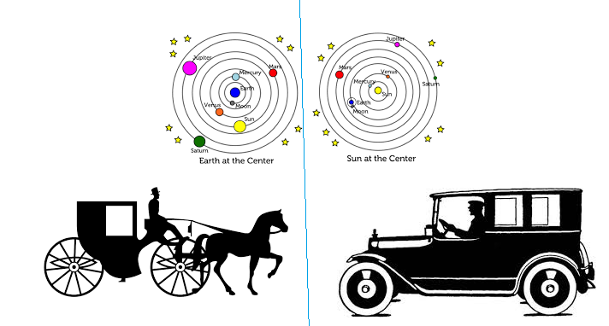

The pictograrm is dipicting this idea ; when the universe was Ptolemaic there was Caloric so, no engine was possible but in 1500 ,the universe became Copernican and the Caloric became thermodynamic that’s why it was possible to invent automobiles.

**Large Scale Complementarity principle :**

The author is trying to argue that there is a large scale complementarity principle , Ptolemaic system is comlplementary of the Cpernican system . When we try to observe the heavens with a telescope the Ptolemaic system vanishes and the universe becomes Copernican.

There exists a Ptolemaic – Copernican Duality in the universe.

iii) **The Large scale observer effect :**

**We** have made the hypothesis that there is a double reality and Geocentric universe is complementary of the Heliocentric universe.

So we assume the previous reality was Ptolemaic and the man man was created by divine intervention.

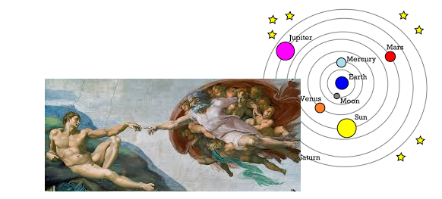

The picture shows in a Ptolemaic reality man was created by the God.Although the Micheal Angello picture dipicts Adam in Primate from , which is scientifically incorrect . nonetheless we take the picture as metaphor of the divine creation. But in 1500s what happened ? man began to watch the heavens with Telescopes, just then the universe reacted Quantum mechanically.

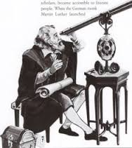 We can say metaphorically, Galileo’s telescope = Heisenberg’s microscope.

When man tried to observe the universe with tescopes , it reacted and it shifted . It became Heliocentric. ( As if the God is protecting his secrets of creation from the human obeservation).

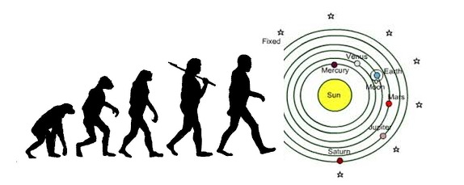

And when the universe became Coper nican , the laws of copernican universe are such that man automatically became the sons of monkey.

Reality is just probability (Campbell ,2012), it is confined in side a box . the heaven is that type of box. So heavens can not be penetrated with probing instrument ,wave function of these probabilitis are observation sensetive . if we try to observe them; wave function collapse; the reality shifts. And that occurred in 1500s.

**iv) Heliocentrism is heliolatry :**

Now , we are assuming that Heliocentrism is the cause why the man has become the progeny of apes. But why the Heliocentric universe cause the man to evolve from monkeys ?

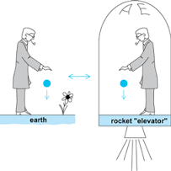The following is my answer :

According to einstein’s theory of General Relativity , gravity is equal to accelaration. Because F=ma =mg , so a=g .

An observer can not distinguish inertia from gravity . therefore gravity is a pseudo force.( Heile , 1982)

I assume the following imaginary situation to put froward my argument,

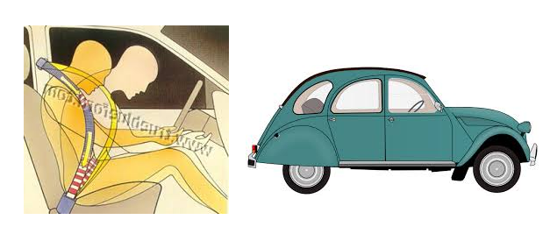If a moving car all of a sudden stops , the passengers inside it will feel inertia of motion , as if a force is pulling them forward.

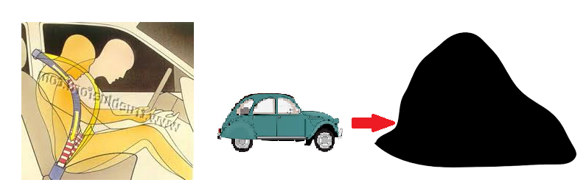

Now if a huge mass is put before the car , this time the car is at rest , the passengers in side the car will experience a gravitational force which will be equal to the inertial mass of the passengers. F= ma =mg.

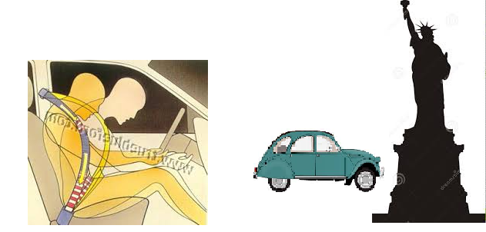

Now we do some art work and transform the rock into an idol ? So what does the inertia experienced by the passengers now means ? the passengers are idol worshipping !

**Therefore , gravity =idolatry.**

Gravity has metaphysical component which is idolatry.

The space curvature contains idolatry. The curved space is a sinister thing.

Another way of putting it sun and earth has consciousness according to the Consciousness based quantum measurement theory. This theory claims every thing has consciousness .( Rae ,2004).

Space–time geometry also raises the intriguing possibility that Orch OR allows consciousness apart from the brain and body, distributed and entangled in space–time geometry,Hameroff says according to *Popular Mechanics* (Frye,2015).

So taking that the Sun and the earth has consciousness and gravity is idolatry , we can say that the sun is forcing the earth to worship it. In the copernican system the sun is the god.

**So , Heliocentrism = Heliolatry.**

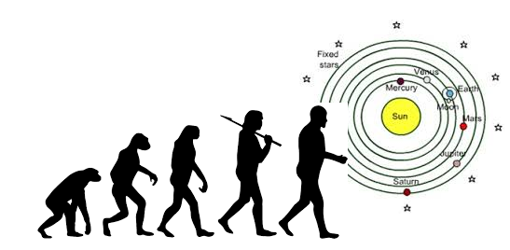

**The** Heliolatrty that resides inside the heliocentric system forces man to evolve from the apes.

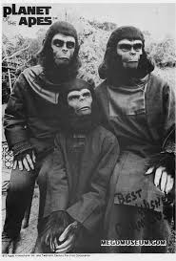

The obnoxioous force of helilatry shapes our appearance as apes

**Conclusion:**

The Quantum phenomenon says the reality is subjective (Campbell,2012). that is the premises of this thesis .what does it mean ? the author is saying that the large scale universe is also subjective . The reality shifts under our gaze. Basically there is two reality , Ptolemaic and Copernican . one is complementery of another. When we don’t observe the probability amplitude of ptolamaic reality becomes eigen but when we observe with a telescope , the wave function collapses and the Copernican reality becomes eigen

The above picture shows previously when the universe was Ptolamaic the man was divine creation but when the reality shifted and became Copernican , man became monkey

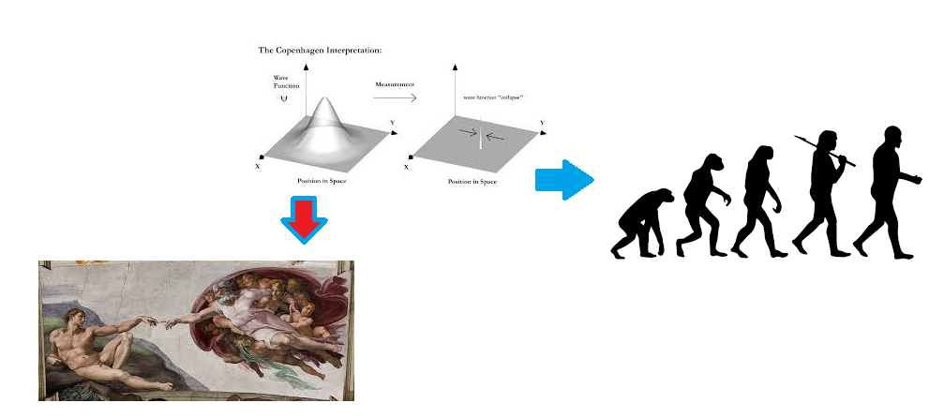

Figure 1wave function collapse and changed human origin

An imaginary Quantum phenomenon; prior to the wave function collapse of the universe , man was son of angels but when the wave function collapsed man became apes.

Why in a heliocentric universe man will become monkey in lieu of god ? because Heliocentrism is heliolatry . The obnoxous force of heliolatry forces the man to evolve from the apes.

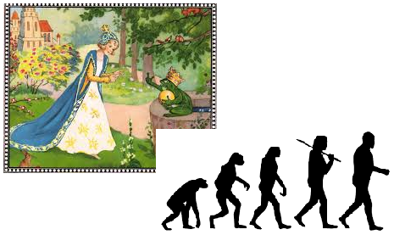

We are suffering from “**Monkey condition** “ like the prince in the frog prince fairy tales, suffered from the frog condition. We have become monkey by dint of Quantum phenomenon. In order to get out of this **“Monkey condition “we have to destroy all the telescopes and abandon the Copernican theoryand st**art **beliving in the Geocentric universe** .

***Supplimentary paper :***

**Islamic interpretation of Copernican system and Darwinism**:

1) Geocentricism:

The Quran believes in Geocentricism,it is written in Quran,

**“A token unto them is night. We strip it of the day, and lo! they are in darkness and the sun runneth on unto a resting-place for him. That is the measuring of the Mighty, the Wise. And for the moon We have appointed mansions till she return like an old shrivelled palm-leaf. It is not for the sun to overtake the moon, nor doth the night outstrip the day. They float each in an orbit.” ( Quran:36:37-40)**

In these verses Night and day ; moon and sun is mentioned in the same context of day and night..The Qur'an mentions many times that the sun and the moon travel in an orbit, but does not mention once that the earth does too. **This is consistent with Geocentricism**.

|  |  |
| --- | --- |
| day | sun |
| night | moon |

The Quran says the universe is Geocentric . Therefore Copernican system is Unislamic .

The value of sun:

The Sun is not value free , if one puts sun in orbit , it becomes Mohammadan , because it goes around the Kaaba . But if it is put at the centre of the Geo-solar system , it becomes a God , because everything on the Earth revolves around it

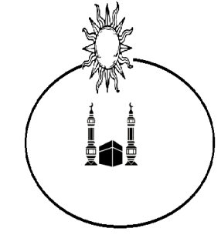

Figure 2 sun goes around Kaaba in geocentric model.

Thus in heliocentric system the man is heliolater; man goes around the sun like fire worshipers go around a fire during worship. So Copernican system is Mushrik (Heliolatry) theory.

This the problem with Copernicus , he introduced a Mushrik theory.

2) Darwinism:

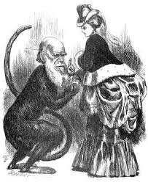

The Darwinism shows that man is scientifically apes , because man has anatomical and biochemical similarity with apes ( Darwin, 1871)

**Then what is the position of man in the universe?**

* He is a Heliolater (Mushrik) because he exists in a cpopernican univese .
* He is an Ape .

The Ape Theory in Quran :

**“Then say: Should I inform you [People of the Book] of those, who will have even worse recompense from Allah than the transgressors? They are those whom Allah has cursed; who have been under His wrath; some of whom were turned into apes and swine; who worshipped taghut [the devil or idols]; those are the people who are in a far worse plight and who have turned farthest away from the Right Way."( Quran ,5:60)**

So the Quran says the Mushriks turn into apes . we write an equation :

Mushrik = Apes

or , Heliolaters = Apes.

Now what is the condition of man after Quran ? Man is heliolater ( Copernican) and ape (Dawinism) . so It is happennning according to the formula of Quran .

The Man has become the fifth ape because of beliving in Copernicanism.

The Quran and Quantum mechanics :

The Double slit experiment in quantum mechanics shows the univese is subjectve.(Physics world ,2015). The Author is asuming that the large scale universe is also subjective our behaviour alters reality.

In original reality the universe was Ptolemaic . as found in Al Quran; the man was divine creation But when the man comitted heliolatry , the universe shifted ,it became Copernican, and the man has become the sons of Apes.

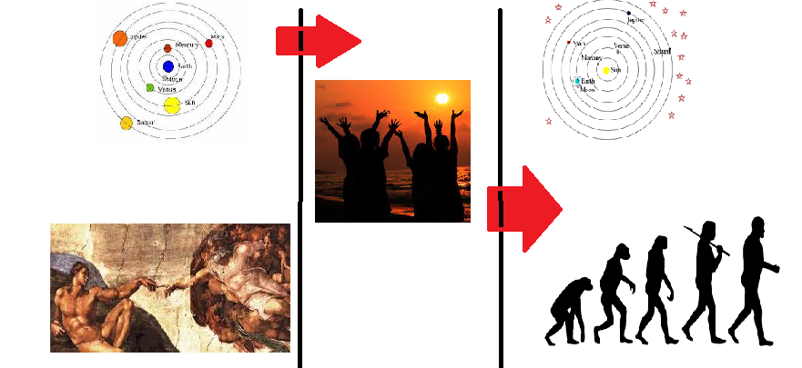

Figure 3 reality shifted as a result of heliolatry and man became apes.

The first chapter in Bronowski’s “the Ascent of man” is “Lower than the Angels” Originally the man was sons of Angels, he was never born in Africa. But sin of Helilatry changed the Natural History as like Quantum Delayed choice experiment shows ; and the man became apes.

-----------------------------------------------End--------------------