Epistemicism and Commensurability Paul Forrester

Abstract: The topic for this paper is the phenomenon of apparent value incommensurability—two goods are apparently incommensurable when it appears that neither is better than the other nor are they equally good. I shall consider three theories of this phenomenon. Indeterminists like Broome (1997) hold that the phenomenon is due to vagueness: when two goods appear to be incommensurable, this owes to the fact that “better than” is vague. Incommensurabilists like Chang (2002) hold that some goods appear to be incommensurable because they genuinely are, because it is determinately the case than neither is better than the other, nor are they equally good. I defend epistemicism, the view that the appearance of value incommensurability is due only to our ignorance of how goods compare. In reality, all goods are commensurable. I offer two arguments for epistemicism and against other views. First, epistemicists are committed to less unexplained axiological structure than are non-epistemicists, who must explain the extra structure that they posit. Second, only epistemicists have an adequate explanation of some facts about the scope of apparent incommensurability. Finally, I identify a class of putative counterexamples to the epistemicist’s analysis, and argue that these counterexamples do not succeed. If my arguments are sound, then, we have very good reason to think that for any two things that are good, either one is (determinately) better than the other, or they are (determinately) equally good.

0. Introduction
My topic for this paper is the phenomenon of value incommensurability. Or, I should say, the phenomenon of apparent value incommensurability, for I shall argue that there really is no such thing as value incommensurability, and our intuitions to the contrary are only due to our normative and factual ignorance. A first pass at a definition is that two goods are apparently incommensurable when it appears that neither good is better than the other, and it appears that they are not equally good. We have difficulty choosing between apparently incommensurable goods, because they are so different or appear to realize different values. Often, choosing between apparently incommensurable goods is thought to result in a dilemma.
Unfortunately, it is not possible to give a more precise characterization of the phenomenon of apparent value incommensurability, at least in a theoretically neutral way. So, to give the reader a better grip on the phenomenon, I will introduce it through a few paradigmatic examples, and then identify the three competing explanations of it which we will be comparing in the paper. A standard example in the literature concerns choosing careers: you are in a position to have a career as a musician or a career as a lawyer. You are highly attracted to both fields, but cannot have both careers, but it is unclear which would be better for you. They realize quite different values, but you are not sure how to compare the values that they realize or even if they can be compared at all—they seem incommensurable. You think that the choice is a dilemma. Another example: Raz (1986) argues that the value of friendship and the value of money are incommensurable, because if someone offered us a sum to end a friendship, then we wouldn’t deliberate and try to determine which was more valuable, but rather would reject the offer in disgust because it is a constitutive feature of friendship that friends cannot be traded for money. There are also problems of commensurability in value aggregation. Some philosophers think there is no way to weigh the disvalue of a large number of headaches against the disvalue of one death. There are analogous cases in population ethics too, where we face difficulties in comparing the value of populations of different sizes.
I should note that I will be primarily concerned with the senses of “good” and its comparative “better” which are of central importance in axiology. I take these to be twofold: goodness simpliciter and goodness for a welfare subject. The literature has an unfortunate tendency to stray into other evaluative comparisons which are not of central importance to axiology. These are often called attributive senses of “good.” For example, if one asks “who is better, Louis Armstrong or Bud Herseth?” this question is not naturally heard as “which person instantiates more goodness simpliciter” or “which person had more lifetime wellbeing,” but rather as “who is the better trumpeter, Armstrong or Herseth?” The incompleteness of natural language comparatives of attributive goodness like “is a better trumpeter than” is a topic entirely different from the one I will take up. To my mind “is a better trumpeter” and other comparative predicates of attributive goodness have more in common with non-normative natural language comparatives like “busier than” or “dirtier than,” than they do with theoretical terms used in ethics, like “better simpliciter” and “better for.” There might not be precise facts about who is busier than whom or what is dirtier than what, just like there might not be precise facts about who is a better trumpeter than whom or who is braver than whom, though the former two comparatives are non-normative and the latter two are normative. Investigating putative failures of comparability for these natural language expressions is an interesting topic, but it is orthogonal to my main thesis in this paper.
I will consider and compare three explanations of this phenomenon. Incommensurabilists say that value incommensurability is genuine, not merely apparent. When it is not the case that A is better than B (~ A>B), not the case that B is better than A (~ B>A) and not the case that A is equal in value to B (~ A=B), I will say that A and B are genuinely incommensurable. When two goods are genuinely incommensurable, they fail to be related by any of the three canonical evaluative relations: better than, worse than or equal to. The incommensurabilist’s thesis is that the phenomenon of apparent value incommensurability is explained by the fact that some goods are genuinely incommensurable. Some incommensurabilists, like Chang (2002), hold that there are many ways that two goods can be related if they fail to be related by these three relations—Chang herself holds that there is a difference between a fourth value relation she dubs “parity” and incommensurability. Other theorists have posited a relation of “rough equality” which is analogous to Chang’s parity. I count all of these theorists as incommensurabilists, despite their differences, since what distinguishes incommensurabilists, for our purposes, is their commitment to cases where each of the three canonical evaluative relations determinately fails to hold.
Indeterminists, like Broome (1997), (2000), think that apparent incommensurability is due to the vagueness of evaluative terms. The three evaluative relations are vague, and the borderline cases of these comparatives are the ones where it appears that the goods are incommensurable. More precisely, when two goods A and B are apparently incommensurable, according to indeterminism, this is because it is indeterminate that A>B, indeterminate that A<B or indeterminate that A=B. This stands in stark contrast with incommensurabilism, which identifies the phenomenon of apparent incommensurability with the determinate failure of each of the three evaluative relations. We have difficulty making choices when our options are apparently incommensurable, according to indeterminists, because it is indeterminate which option is better.
The final—and by far the least popular—position is epistemicism. In general, epistemicists about some phenomenon explain it by appealing to our ignorance of a class of relevant facts. Epistemicists about apparent incommensurability hold that the phenomenon is an artifact of our ignorance of how goods really compare in value. All goods are in fact commensurable: either one is (determinately) better than the other or they are (determinately) equally good. Hard choices are hard because we lack either normative or factual knowledge, not because the options are incommensurable or because it is indeterminate how they compare. According to epistemicism, incommensurability is a feature of the appearances, not reality, and if we had the appropriate knowledge of reality, the misleading appearance of incommensurability would dissolve. This is the view I will defend.
Flanigan and Halstead (2018) develop a view closely related to both epistemism and indeterminism. On their view, evaluative comparisons are vague, and this is what accounts for the appearance of value incommensurability. However, they also accept the epistemic theory of vagueness, according to which the phenomenon of vagueness is due to our ignorance. Therefore, I will label their view “indeterminist epistemicism.” I disagree with both parts of Flanigan and Halstead’s view. That is, first, I do not think that evaluative comparatives are vague terms. And second, I think that the epistemic theory of vagueness is false. I find this view implausible, but I cannot argue against it here. There are a few reasons why I think that evaluative comparatives are not vague terms. First, there is no clear criterion for being a vague term. “Better than” simply seems to have very little in common with the paradigm vague terms like “heap” and “bald.” Second, and perhaps more important, the debate about value incommensurability concerns “better simpliciter” and “better for.” These are quasi-technical terms used in theoretical ethics, not terms in ordinary language. Vagueness is primarily a phenomenon of natural languages. By contrast, theoretical terms in fields of inquiry like ethics can be introduced without the haphazard and incomplete usage that gives rise to vagueness in natural languages. Therefore, on my classification, Flanigan and Halstead’s view is a type of indeterminism, and my view is an epistemicist view.
Even though I have two substantive disagreements with Flanigan and Halstead, our views turn out to be importantly similar. On both views, at the fundamental axiological level, there is perfect commensurability among all goods. Both views entail there would be no phenomenon of apparent incommensurability from the perspective of an omniscient agent—in their case because no terms in that agent’s idiolect would be vague, in my case because they have all of the knowledge of axiological comparisons that ordinary agents lack. In other words, the views agree about the axiology, and stand in contrast to other indeterminist views and incommensurabilist views that are committed to a radically different axiology.
In principle, resources from each of the three approaches—incommensurabilism, indeterminism and epistemicism—can be jointly employed. There are two ways that this could occur. The explanatory domain we have identified, the class of apparently incommensurable goods, might not be a unified one, so that epistemic explanations are called for in some cases, vagueness-based explanations are called for in others, and there is genuine incommensurability in still other cases. Or, we could avail ourselves of the resources of multiple approaches when explaining instances of the phenomenon. Rabinowicz (2008), for example, argues, contra Broome (1997), that indeterminacy can coexist with genuine incommensurability, and builds a model in which both theoretical tools are used to explain how goods are evaluatively related.
I will resist such mixed approaches. This is in part because I find the collapsing principle of Broome (1997) plausible. According to that principle:
Collapsing Principle: For any x and y, if it is false that y is Fer than x and not false that x
is Fer than y, then it is true that x is Fer than y.
This is not a paper on the collapsing principle, since there is a sizeable literature on it already. What is important for my purposes is that Broome uses the collapsing principle as a premise of an argument that the vagueness of a comparative expression is incompatible with genuine incommensurability. If Broome is right, it is not the case that both genuine incommensurability and vagueness could be used to explain the phenomenon of apparent incommensurability.
More importantly, though, I have a strong preference for explanatory unification and theoretical economy. These two preferences, respectively, mean that I am disinclined to parcel up the domain between the three theories, or to use the resources of more than one approach in a unified explanation. One should employ additional theoretical tools only if the explanatory work cannot be done by the tools one already has. As we shall see, epistemicists have the tools to give a unified, parsimonious and attractive account of the phenomenon, but other theorists do not. Thus, if the epistemicist explanation is a good one, as I shall argue, there is no need to posit genuine incommensurability or vagueness, and hence, there is reason to think that all goods are commensurable.
Here is how we will proceed. I will first introduce an analytical tool Broome calls a standard configuration, which will help to further focus our discussion of the issues. Second, I articulate an explanatory demand facing non-epistemicists, which to my knowledge no non-epistemicists have adequately answered. Third, I present my main argument. I will argue that only epistemicists can adequately explain some facts about the range of the appearance of incommensurability. Fourth, I address a class of putative counterexamples to the epistemicist’s analysis of value incommensurability, and argue that they fail. Then, I conclude.

1. The Standard Configuration
Start with a pair of goods which appear to be incommensurable. I will illustrate with one of the standard cases in the literature, choosing careers, but the points are general. Suppose that you are choosing between a particular musical career, M and a particular legal career, L, and these appear incommensurable to you—you experience great difficulty in comparing the values realized by the careers, and it is unclear which would be better for you. The argument that motivates incommensurabilist and indeterminist views is the small improvement argument. One of the factors that determines how good a career is for one is the salary one earns, so we can improve the career in small (or large) increments by varying its salary (or by varying any other dimension which contributes to its goodness). Consider M+, then, which is just like M but in which you earn $10 more in salary over the course of the career. This, unfortunately, does not make the comparison any easier: it is just as difficult to choose between M+ and L as it was to choose between M and L. So, it appeared that M was neither better nor worse than L, and it also appeared that M+ was not better than L. Yet, because of the small improvement, M+ is better than M. This is sufficient to show that M is incommensurable with L, for if M is neither better nor worse than L, M+ is better than M and M+ is not better than L, then because of the transitivity of the equal in value relation, M and L are not equal in value. Hence, none of the three canonical evaluative relations relates M and L, so they are incommensurable.
Yet, small improvements can be iterated to form large improvements. With an extra three million dollars in salary, let us suppose, the career as a musician would indeed be better than L, and likewise, a completely impoverished career as a musician would be worse than L. Thus, we can set up a chain of many musical careers, generated by small improvements and disimprovements from our original career M. Meanwhile, the legal career, L, is held fixed as the standard. The points on the chain fall into three zones:
- The upper zone, points that are better than the standard.
- The lower zone, points that are worse than the standard.
- The incommensurate zone, points which appear incommensurable with the standard.
This is depicted in figure 1 below. The left panel shows the careers case that we have been considering, and the right depicts the abstract standard configuration:
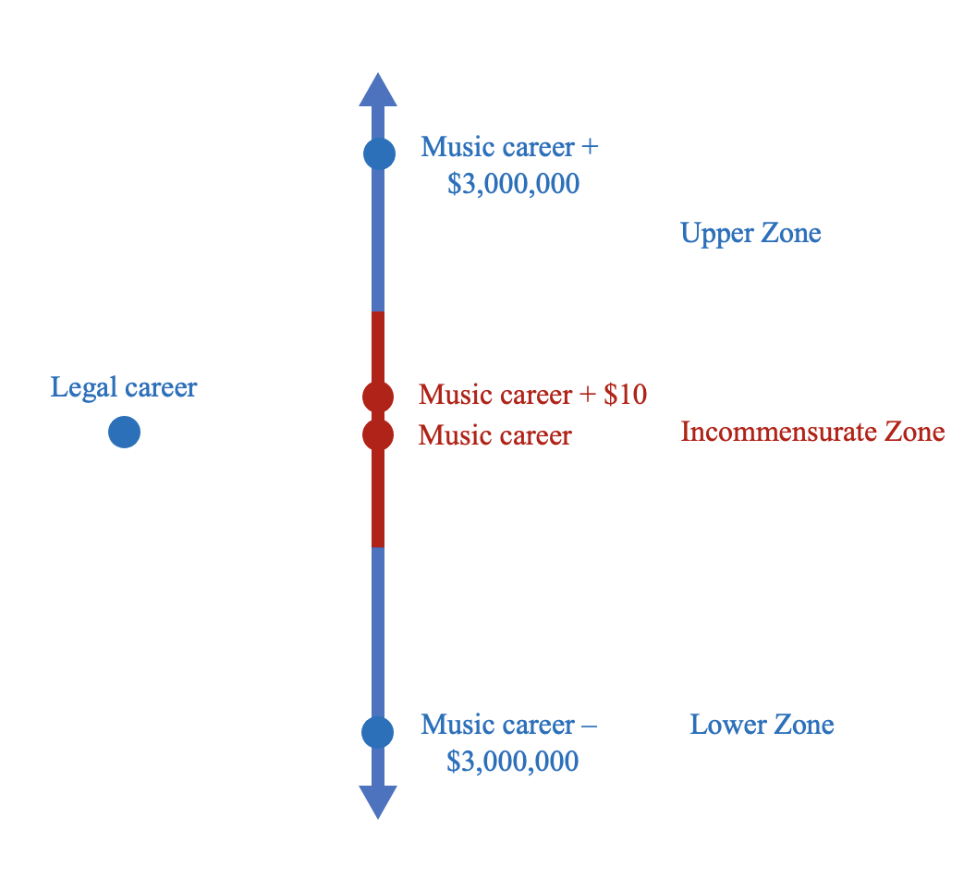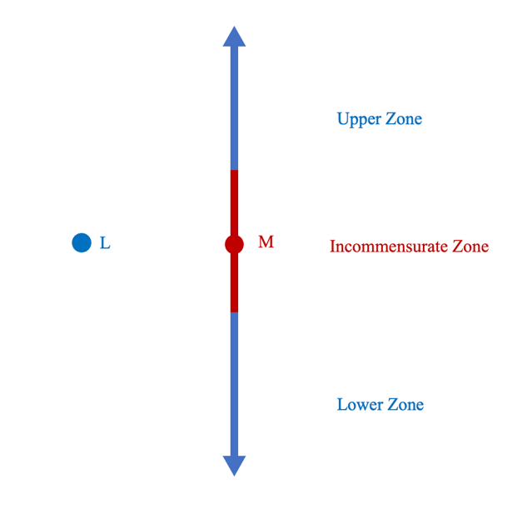
All standard configurations I shall consider are finite, and each point on the chain is (determinately) better than all points below it. The three theories each give different explanations of what is going on in the incommensurate zone. Incommensurabilism says that the incommensurate zone is the set of points such that, determinately, they are neither better, worse, nor equal in value to the standard. Indeterminism says that the incommensurate zone is the set of points such that it is indeterminate how they compare to the standard. For indeterminists, the incommensurate zone is the penumbra of the vague predicate “better than the standard.” Epistemicism says that the incommensurate zone is the set of points such that we do not know how they compare to the standard. Epistemicism entails that there is a pair of points in the incommensurate zone such that one point is at least as good as the standard, and the standard is at least as good as the other point, yet the only difference between the two points is a small improvement. We simply do not know where this pair of points is located, and this ignorance gives rise to the zone of (apparent) incommensurability. We will return to adjudicating the differences in what the theories say about the standard configuration in section 3. First, we will generalize the notion of a standard configuration in order to identify an explanatory demand facing non-epistemicists.

2. Explaining Axiological Structure
The goal of this section is to show that incommensurabilists and indeterminists are committed to more axiological structure than are epistemicists. Since axiological structure needs to be explained, and it seems like non-epistemicists cannot provide an adequate explanation, epistemicism is preferable to the other theories.
Epistemicism entails that all goods are commensurable, but the other two theories entail that some goods are incommensurable. When I use “incommensurable” without qualification, I will take it to include both indeterminacy of evaluative comparison (what indeterminists think explains apparent incommensurability) and genuine incommensurability (what incommensurabilists think explains apparent incommensurability). Anyone who thinks that some goods are incommensurable faces an explanatory demand: they must tell us why some goods are commensurable and others are not. Indeterminists and incommensurabilists need to explain the scope of incommensurability. Epistemicists, of course, must explain why we know how some pairs of goods compare and do not know how other goods compare, since, for them, this is what accounts for the phenomenon of apparent incommensurability. This explanatory burden is not as substantial as the one facing non-epistemicists, for two reasons. First, explaining which subjects know which propositions is an explanatory demand which everyone faces, insofar as they are developing comprehensive philosophical views. Epistemicists can simply take any explanatory account of knowledge off of the shelf and apply it to the axiological case at hand. I will explore how this can be done in the next section. Second, knowledge is not a normatively fundamental feature of the world like goodness is. It would be much worse to leave unexplained facts about which states are good and how good they are than to leave unexplained facts about which subjects know which propositions. Epistemicists face an epistemic explanatory burden which is easy to discharge, but non-epistemicists face an axiological explanatory burden which is difficult to discharge. Let us now consider this burden.
In a simple standard configuration, non-epistemicist theories entail that points in the incommensurate zone are incommensurable with the standard, whereas epistemicism entails that these points are simply such that we do not know how they compare with the standard. Non-epistemicists need to explain why this zone is located where it is, and explain why it is as wide as it is. What is the difference between points outside the zone and those inside it which accounts for the fact that the points in the zone are incommensurable with the standard? This explanatory demand is particularly acute when the incommensurate zone is taken to have sharp borders: a small improvement of $10 in salary can make the difference as to whether two careers are commensurable or not, and it seems hard to explain how $10 could account for this difference. It seems that non-epistemicists draw the borders of the incommensurate zone in an arbitrary place, which calls for explanation. We will consider this issue further in the next section.
We can sharpen this explanatory demand by generalizing. We can think of a standard configuration as comparing one amount of one good (the standard) to a series of amounts of another good (ordered to form the chain). Thought of this way, there is a more general commensurability map comparing different amounts of two goods, of which the standard configuration is simply a vertical or horizontal cross-section. Put amounts of good X (pleasure, say) on the x-axis, and amounts of good Y (virtuous action, say) on the y-axis. A vertical cross section of the map is the chain (formed by amounts of good Y) in a standard configuration, and the x-intercept of the cross section is the standard, some amount of good X. An example of a commensurability map is depicted in figure 2:
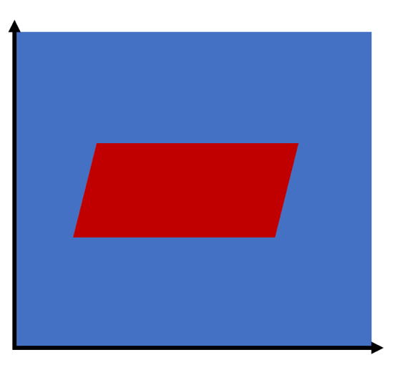
In the figure, red points are such that their x- and y-coordinates are incommensurable, and blue points are such that their x- and y-coordinates are commensurable. Call any red area on a commensurability map an incommensurate area.
There are three possibilities for how the commensurability map of two goods can look. They correspond to answers to the question: “which pairs of amounts of the two goods are commensurable:”
- ALL: All points are commensurable (blue all over).
- SOME: Some, but not all, points are commensurable (blue and red areas).
- NONE: No points are commensurable (red all over).
If all or no amounts of two goods are commensurable, then there are no difficult explanatory demands to discharge. The comparative evaluative structure of two such goods is entirely homogenous, either because all pairs of amounts of the goods are commensurable, or because none are. By contrast, theorists who believe that some but not all amounts of the goods are commensurable have some explaining to do: they must explain why some points are incommensurable and others are not.
Epistemicism entails ALL—it is just our ignorance which is responsible for the appearance that some goods are not really commensurable. Some remarks in Ross (1939) seem to commit him to answering NONE. Ross is most naturally read as believing that no amount of any of the fundamental goods is commensurable with any amount of any of the other fundamental goods. Consider this passage:
[W]e are quite incapable of equating, in respect of goodness, any amount of pleasure with any amount of morally good action … If virtue really were on the same scale of goodness as pleasure, then pleasure of a certain intensity, if enjoyed by a sufficiently large number of persons or for a sufficient time, would counterbalance virtue possess or manifested only by a small number or only for a short time. But I find myself quite unable to think this to be the case; and if I am right about this, it follows that pleasures, if ever good, must be good in a different sense from that in which good activities are so.”
Ross does not believe that any amount of pleasure is commensurable with any amount of virtue (so the commensurability map of these two goods is red all over). Ross at least does not face any demand to explain why some pairs of amounts of pleasure and virtue are commensurable and others are not. However, in my view, Ross-style strong incommensurability is too implausible to be taken seriously. If no amounts of good 1 and good 2 can be compared with each other, we are left to wonder: in virtue of what they are both goods? And the claim that not even the smallest amounts of one good can be compared to the largest amounts of another is no doubt in tension with the idea that they are both goods, which we ought to want to obtain for their own sake. Perhaps Ross’s view could be made to work at the end of the day. In this paper, though, I will set it aside and focus my arguments against theorists who answer SOME to the above question.
Theorists who answer SOME face two explanatory demands. First, they must explain, for each pair of goods, why the commensurability map of those two goods looks the way it does, as opposed to some other way it could have looked. To make this demand more acute, notice that there are very few formal constraints on the possible forms which could be manifested in a commensurability map of two goods. For one, there does not have to be just one incommensurate area in a commensurability map. Rather, there could be any number of isolated pockets of incommensurability. The only formal constraint which governs the way that a commensurability map can look is that vertical and horizontal cross-sections can only cross the border of an incommensurate area twice. And as far as I can see, there are no other formal constraints on the way a commensurability map looks. Hence, there are many logically possible comparative axiological structures which a pair of goods could exhibit, and incommensurabilists and indeterminists must explain why a particular pair of goods exhibits one of these structures and not another.
Second, if there are more than two goods in the axiology, then the question arises of whether all, or only some, pairs of goods are such that some but not all pairs of amounts of those goods are commensurable. If all, then there is no further explanatory challenge (though this view strikes me as implausible, as I’m not sure what would guarantee that all pairs of goods are such that some but not all pairs of amounts of those goods are incommensurable). If some, then there is a further explanatory challenge: what explains the fact that some, but not all, pairs of goods are such that some, but not all, pairs of amounts of those goods are incommensurable?
Indeterminists and incommensurabilists must explain the structure of the comparative profile of two goods, which is what is graphically represented by the commensurability map of the goods. They must explain the structure of evaluative comparisons within and between pairs of goods. Put it this way: epistemicists are committed to axiological facts about which goods are better than which. Indeterminists and incommensurabilists are committed to these too, but are also committed to facts about which goods are incommensurable with which goods. Their axiology has strictly more structure than the epistemicist’s. Unexplained structure is a bad-making feature of a theory. Perhaps this bad-making feature could be compensated for by other features of the theory, such as its ability to fit our intuitive judgments. I shall argue below that it is not.
The point I am making here is a modest one: non-epistemicists should be concerned with and try to answer these explanatory demands. Unfortunately, philosophers who believe in incommensurable goods have not been concerned with demarcating and explaining the scope of incommensurability, which would answer the demands I have identified. Rather, they have merely focused on providing counterexamples to the claim that all goods are commensurable. The lesson here is in fact quite general: counterexamples generate explanatory demands. If a counterexample falsifies the claim “everything is F,” theorists need to explain why some things are F and others are not. In the case at hand, incommensurabilists have been more concerned with identifying putative examples of incommensurable goods than with developing a theoretical approach which would explain the scope of incommensurability. Indeed, if they accomplished the more ambitious task of satisfying the explanatory demands, then this would back up their putative counterexamples in a way that would make them much more difficult to reject. But these explanatory demands are substantial and I do not see how non-epistemicists could make progress on them.

3. Borderline Incommensurability
My first argument generalized the notion of a standard configuration to show that incommensurabilists and indeterminists are committed to more axiological structure than are epistemicists, and that this structure needs explaining. I will return now to the standard configuration to state my argument for epistemicism.
It is widely held that in the careers case, for example, a mere $10 difference in salary could not make one career better than a very different career. Could just $10 make it the case that you should choose a career in music, rather than a career in the law? This is the basis of the small improvement argument. Yet, epistemicism entails that there is a pair of careers in the incommensurate zone of a standard configuration, M and M+ such that M is worse than or just as good as L, but M+ is better than L and the only difference between M and M+ is a mere $10 extra in salary. Epistemicism, of course, also entails that we do not know which careers these are. Non-epistemicists find this hard to believe—they find it highly implausible that such a small difference could result in such a sharp cutoff in value relations.
Perhaps this implication of epistemicism is counterintuitive. However, non-epistemicists are committed to a more implausible result, twice over. Consider the incommensurabilist. According to her theory, there is a pair of adjacent points, $M_{w}$ and $M_{x}$, such that $M_{w}$ is worse than L and $M_{x}$is incommensurable with L. And there is another pair of adjacent points $M_{y}$ and $M_{z}$, such that $M_{y}$ is incommensurable with L and $M_{z}$ is better than L. These pairs of points form the upper and lower borders of the incommensurate zone, respectively. The incommensurabilist motivated her view with the thought that a $10 difference in salary could not make one career better than a very different one. But she is committed to two such sharp transitions: a $10 difference in salary takes one career from being worse than the standard to being incommensurable with it, and a $10 difference in salary takes one career from being incommensurable with the standard to being better than it. Hence, the incommensurabilist is in no position to complain that epistemicism is implausible because it is committed to a sharp transition in evaluative relations, for she is committed to two such transitions.
More importantly, it is more implausible to suppose that $10 could make the difference between the commensurability and incommensurability of two careers than to suppose that $10 could make the difference between one’s being better than the other. We have a fairly straightforward sense of what it takes for one good to be better than another, when we know that the two are comparable with each other. For example, we know that $10 makes M+ better than M, where M+ and M are identical musical careers except one earns an extra $10 in salary in M+. The addition of $10 in salary took M+ from being equal in value to M to being better than it. We have many clear examples like this of how small improvements can make a good better than another good, when before it was worse or equal in value. There is no mystery in how small (dis)improvements can change which of the three canonical evaluative relations holds between commensurable goods.
By contrast, I find it very difficult to understand how effecting a small change in one good could make it incommensurable with another good, when formerly they were commensurable. This is because the difference between commensurability and incommensurability is more substantial than the difference between better and worse, so intuitively it will take a larger change in some underlying magnitude to induce a change from incommensurable to commensurable than to induce a change from worse to better. How could a small change in one good render it impossible to compare that good with another good, when before the change they were comparable?
Let me put it another way: when adding a small improvement to one good makes it better than another when formerly it was worse, the two goods are commensurable with each other both before and after the improvement. When a small improvement takes a good A from being worse than (for example) to incommensurable with another good B, it must make it the case that (1) the improvement must be big enough to make it no longer the case that A < B (2) the improvement must be small enough to not make it the case that A = B or A > B. But it is hard to see what kind of small improvement to A could satisfy both conditions simultaneously. Given A < B there are some properties of A (and B) in virtue of which A and B are similar enough for us to compare. But somehow slightly improved A+ lacks the properties that are the bases of commensurability with B. When the “+” differentiating A+ from A is extrinsic to A’s nature as a good (like money arguably is in cases standardly considered in the literature) it is simply highly implausible that A+ could differ from A in the respect that would render them commensurable with B. If two goods are commensurable, they are similar enough to compare. It is difficult to see how a small improvement to one of two otherwise similar goods could then make them too dissimilar to compare, but it is easy to see how a small improvement could make one good better than another.
Consider how this manifests in a standard configuration. When we are considering a standard configuration case, it does not appear to us that the incommensurate zone has sharp borders. Rather, we are not able to tell where the upper (lower) zone ends and the incommensurate zone begins—it looks like they gradually fade into each other. We are manifestly unable to identify the worst career that is better than the standard legal career and the best career which is incommensurable with it (forming the upper border of the incommensurate zone) or the best career that is worse than the standard and the worst career that is incommensurable with it (forming the lower border of the incommensurate zone). Indeed, it seems as if there are no such careers. This is depicted in figure 3:
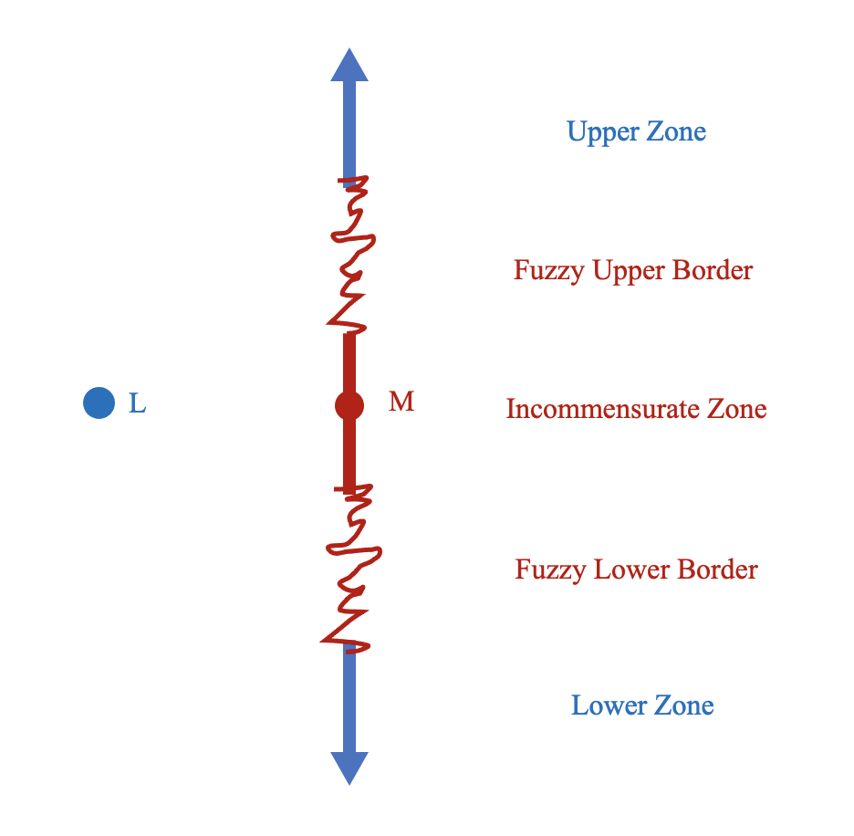
Incommensurabilism and indeterminism entail, implausibly, that there are sharp borders to the incommensurate zone in a standard configuration, but epistemicism does not entail this, and can explain how things appear to us, though the other theories cannot, or so I shall now argue. I will discuss each view in turn.
How might an incommensurabilist avoid or mitigate these implausible consequences of her view? I can see only three possible responses. First, they could postulate a fifth evaluative relation, which holds when it is not clear whether two options are commensurable or incommensurable. Call this relation quasi-incommensurability. When it is unclear whether goods are incommensurable or commensurable, such goods are quasi-incommensurable. But positing this relation seems unmotivated, and lacking a distinctive theoretical role to play. And indeed, the problem simply rearises at the next level, for there will still be an implausible sharp cutoff between commensurability and quasi-incommensurability, and between quasi-incommensurability and incommensurability, which would require the introduction of another relation, quasi-quasi-incommensurability…
The second option is to employ the theoretical resources of indeterminism, by holding that there is an indeterminate area between worse and incommensurable, and between incommensurable and better. This seems initially plausible. However, here is a dilemma for this approach. Note that this approach is inconsistent with the collapsing principle:
Collapsing Principle: For any x and y, if it is false that y is Fer than x and not false that x
is Fer than y, then it is true that x is Fer than y.
If the collapsing principle is true, then there could be no indeterminate zone between the upper and incommensurate zones. Suppose that there is such a zone, and take an arbitrary point, P, in it. It is false that P is better than the standard, and not false that the standard is better than P. If it were false, then P would be squarely in the incommensurate zone, and if it were true, P would be squarely in the upper zone. Hence, by the collapsing principle, it is in fact true that P is better than the standard. The upshot of the collapsing principle is that the notion of an indeterminate case of incommensurability is incoherent—so a theorist can either explain the phenomenon of apparent incommensurability by holding that options are genuinely incommensurable, or by holding that it is indeterminate which is better, but they cannot employ both vagueness and genuine incommensurability in their explanations.
On the second horn, if the collapsing principle is false, there is no logical or conceptual difficulty with holding that there is vagueness as to whether two goods are commensurable or incommensurable. However, by adopting this line, incommensurabilism would lose much of its original motivation. If the fuzziness of the borders of the incommensurate zone were explained by vagueness, then why shouldn’t we just explain its very existence in a similar manner? If the incommensurabilist adopted this response, it is hard to see why they should not just be indeterminists about the whole incommensurability phenomenon. As I mentioned above, we should not want to use both sets of theoretical tools to explain the phenomenon of apparent value incommensurability—a unified explanation of the appearances is highly desirable. Incommensurabilists cannot use their own theoretical resources to explain one aspect of the phenomenon, the fact that the borders of the incommensurate zone do not appear to be sharp, so they have to borrow the resources of a competing theory. Using both theoretical tools seems unparsimonious and ad hoc, when only one is needed to explain what needs explaining.
The final option for the incommensurabilist is to employ epistemicist resources to explain why the borders of the incommensurate zone appear fuzzy. That response would hold that, though the borders of the incommensurate zone are in fact sharp, our epistemic limitations prevent us from knowing exactly where they lie. There really is a small improvement which takes one career from being worse than another to being incommensurable with the other, and there is also a small improvement which takes one career from being incommensurable with another to being better than the other. We simply do not know exactly where these points lie.
This response does explain the appearances. There are two difficulties, though. It does not answer the explanatory demands I canvassed above. It is implausible to posit sharp transitions between goods which are commensurable and goods which are incommensurable, whether or not we know where the transitions are. On this reply, the incommensurabilist is still committed to two such transitions in each standard configuration case, whereas the epistemicist is committed to only one sharp transition between better and worse. Our ignorance just obscures, rather than answers, the explanatory demands. Second, it goes without saying that this response constitutes a substantial concession to the epistemicist, and as such calls the motivations for incommensurabilism into question. As when she took on indeterminist resources in order to solve this problem, we can ask the incommensurabilist: why not just go full epistemicist, and explain the very existence of the incommensurate zone entirely in terms of our epistemic limitations, if we are going to explain the apparent fuzziness of the borders in this way? Thus, we are now in a position to conclude that the incommensurabilist is committed to the implausible claim that the incommensurate zone has sharp borders—there is no way for them to avoid this commitment while preserving the original motivations for their theory.
Now consider how the indeterminist could reply to this problem. For the indeterminist, the incommensurate zone is due to the vagueness of “better than.” Perhaps indeterminists can explain the apparent fuzziness of the borders of the incommensurate zone by appealing to the higher-order vagueness of “better than.” Just as there is no man who is the hairiest bald man, there is also no man who is the hairiest borderline case between “bald” and “neither bald nor non-bald.” The notion of a borderline case is itself vague. In our careers case, there is no musical career that is the worst career that is better than L (vagueness), nor is there a worst career which is a borderline case between “better than L” and “incommensurable with L” (higher-order vagueness). Thus, the indeterminist’s explanation of the fuzzy borders of the incommensurate zone appeals to the higher-order vagueness of “better than.”
Here is the problem with this strategy. The collapsing principle is the primary motivation for indeterminism. Indeterminists motivate their view vis-à-vis incommensurabilism with the thought that many comparative expressions, including evaluative comparative expressions like “better than” are vague. If this is true and the collapsing principle is true, then there can be no genuine incommensurability in a vague comparative, contra incommensurabilism. Unfortunately, however, the reasoning behind the collapsing principle rules out the higher-order vagueness of a comparative expression. This is because, as Carlson (2013, 457-459) points out, anyone who accepts the collapsing principle should also accept the second-order collapsing principle:
Second-order Collapsing Principle: For any x and y, if it is false that y is definitely Fer than x and not false that x is definitely Fer than y, then it is true that x is definitely Fer than y (Carlson 2013, 458).
Carlson then argues that the second-order collapsing principle rules out higher-order vagueness in a manner exactly analogous to how the first-order collapsing principle rules out the combination of vagueness and incommensurability. Consider a point P which is in the upper zone of higher-order vagueness between the incommensurate zone and the upper zone. It is false that the standard is definitely better than P, but not false the P is definitely better than the standard. Hence, by the second-order collapsing principle, it is true that P is definitely better than the standard. Therefore, there is no such zone of higher-order vagueness.
Of course, the indeterminist can appeal to epistemicist resources here, holding that though the borders of the incommensurate zone are in fact sharp, our epistemic limitations preclude us from knowing where they are, giving rise to the appearance that they are fuzzy. It should be obvious what the problem with this reply is: it leaves indeterminism unmotivated. If we appeal to our ignorance to explain the fuzziness of the borders of the incommensurate zone, we might as well appeal to our ignorance to explain its very existence in a similar manner. This appeal amounts to giving different treatments of first- and higher-order vagueness.
We have just seen that incommensurabilism and indeterminism fail to account for the fact that the borders of the incommensurate zone appear not to be sharp. By contrast, epistemicists have a very nice account of this phenomenon. According to epistemicism, a small difference of $10 makes the difference between the best musical career that is worse than L (the standard law career), suppose that this is $M_{600}$, and the worst musical career that is better than L, $M_{601}$. We do not know that $M_{601 }$is better than L. And, since our knowledge is limited because of our imperfect ability to discriminate between options, we need a margin for error. If we do not know that $M_{601}$ is better than L, we also do not know that $M_{602}$is better than L, the difference in goodness of these options is too small for us to reliably perceive. More generally, between $M_{600-y}$ and $M_{601+x}$where x and y are the respective upper and lower margins for error, we do not know that $M_{i}$is better than L and we do not know that $M_{i}$ is not better than L. This is equivalent to the claim that from $M_{600-y}$ to$M_{601+x}$, it is epistemically possible that $M_{i}$is better than L and it is epistemically possible that $M_{i}$is worse than L. The zone of points where it is epistemically possible that they are worse than L and epistemically possible that they are better than L is the incommensurate zone, on the epistemicist account.
Now let us analyze the ends of the incommensurate zone. There are two possibilities: either “knowledge” is a vague term, or it is not. If “knowledge” is a vague term, then the incommensurate zone has imprecise boundaries, as desired, since there can be cases between the incommensurate and the upper zone for which it is indeterminate whether the subject knows that those careers are better than the standard. My view, however, is that “knowledge” is not vague.
If “knowledge” is not vague, then the incommensurate zone has precise borders. But we can still explain why this does not appear to be the case. What allows us to do this is the fact that we need a margin for error for our knowledge of facts about what we know, as well as for facts about what is the case. We need a margin for error on knowledge of facts about which careers are better, because we have a highly coarse-grained and unreliable ability to epistemically access facts about the goodness of careers (and likewise for assessing other axiological facts). And we need a margin for error on our knowledge of facts about what we know about how different careers compare, because we do not have a perfect ability to introspectively access facts about what we know, or facts about how much of a margin for error we need in assessing facts about the goodness of alternatives. Indeed, even if we had accurate beliefs about this, they would not be sensitive because we could have easily required a wider or narrower margin for error without knowing it.
To see this formally, suppose that $M_{704}$is the highest point in the incommensurate zone and $M_{705}$ is the lowest point in the upper zone. Hence, ~K($M_{704}$>L) and K($M_{705}$>L). Now ask, are K~K($M_{704}$>L) and KK($M_{705}$>L) true? Unfortunately, both are false. KK($M_{705}$>L) is false because the margin for error on our knowledge of which careers are better than which could have been slightly different, and if it was slightly wider, then K($M_{705}$>L) would have been false. None of us have acute enough introspective and perceptual faculties to precisely judge the margin for error on our knowledge. Since K($M_{705}$>L) is true but could have easily been false without our noticing, KK($M_{705}$>L) is false. K~K($M_{704}$>L) is false for the same reason—if the margin of error on our knowledge of the goodness of careers had been ever so smaller, K($M_{704}$>L) would have been true, and one cannot know something that is false at a sufficiently close possibility. The falsity of K~K($M_{704}$>L) amounts to the epistemic possibility of K($M_{704}$>L). And, ~K($M_{704}$>L) is epistemically possible because it is epistemically actual: $M_{704}$is in the incommensurate zone. Thus, the zone of fuzziness around $M_{704}$, the upper border of the incommensurate zone, is composed of the musical careers such that it is epistemically possible that one knows that they are better than L and it is epistemically possible that one does not know that they are better than L. This region itself has sharp boundaries (if we continue to assume that “knowledge” is not vague), but will appear to have fuzzy boundaries, because of the margin for error required for knowing that one knows! A similar treatment can be given for the lower end of the incommensurate zone. This is all depicted in figure 4 (only the first three levels, which I analyzed in the text, are depicted; in the figure, ⋄ is the epistemic possibility operator and K is the epistemic necessity, that is, knowledge, operator):
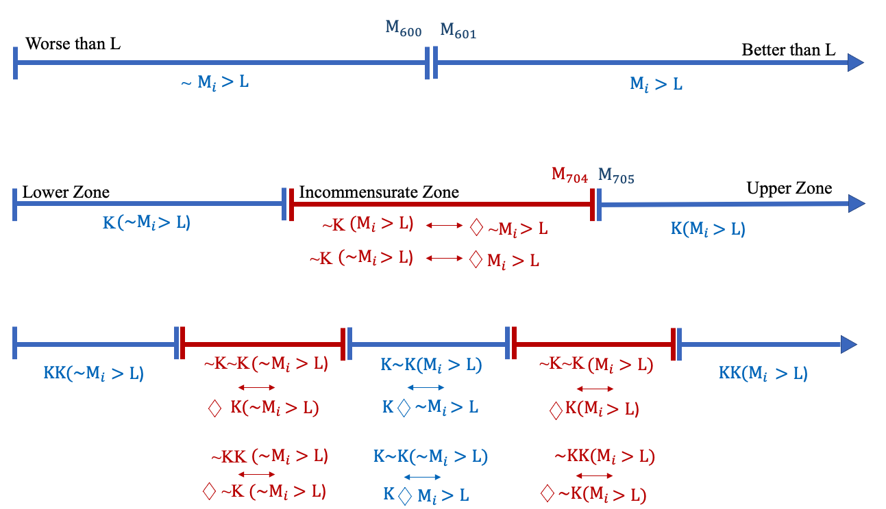
Thus, the incommensurate zone is the set of points for which you do not know how they compare to the standard. This zone has sharp boundaries if “knowledge” is not vague. Even if the borders are sharp, the margin for error required for knowledge (which created the incommensurate zone) creates a fuzzy area around the ends of the incommensurate zone, where you do not know whether you know how L compares to the points in that area. Therefore, the epistemicist theory of incommensurability is the only one which can account for the apparent blurriness of the incommensurate area. This concludes my main argument for epistemicism over its rivals—epistemicism can explain the appearances in a standard configuration case but other theories cannot. I will now consider a class of putative counterexamples to the epistemicist treatment of apparent incommensurability.

4. The Coffee-Tea Objection to Epistemicism
Ruth Chang (2002, 668-673) has raised an important objection to epistemicist accounts of incommensurability. According to her, there are some cases where we have all of the information required to assess which of two options is better, yet it still appears as if the options are incommensurable. Chang’s examples take advantage of our first-person access to certain kinds of information. For example, according to Chang, we can know everything about how a cup of tea tastes and about how a cup of coffee tastes, but it could still seem like neither tastes better than the other. Adding a single grain of sugar to sweeten the tea does not make it taste better than the coffee, which allows us to set up a small improvement argument to show that the unsweetened option is genuinely incommensurable with the alternative. Under conditions of full information, setting up a small improvement argument decisively refutes epistemicism, because the full information rules out the epistemicist’s debunking explanation. Epistemicists cannot plausibly say that the appearance of incommensurability is due to our ignorance in such cases.
One response to examples of this kind is to note that they simply change the subject. As I noted above, the properties of interest to axiology are betterness simpliciter and betterness for a welfare subject. The epistemicist’s thesis is that these comparatives are complete: for any two items which are good simpliciter, either one is (determinately) better simpliciter than the other or they are (determinately) equally good simpliciter, though we may not know which one of these relations holds. Whether some other comparative expression like “tastier than” is complete is beside the point. Perhaps these examples do in fact establish the incompleteness of “tastier than” and the accompanying thesis of gastronomical incommensurability. Gastronomical incommensurability brings up many interesting issues in its own right, but it is uninteresting to us qua ethicists, since we are concerned with value incommensurability not gastronomical incommensurability.
But perhaps attributive goodness could be connected to goodness simpliciter or goodness for a welfare subject. For instance, suppose that desire satisfactionism is true, and that I have a desire to drink tasty drinks. Whether coffee is tastier than tea will influence how much well-being I have, and if the two are incommensurable, then possibly, this incommensurability in the basis of my well-being could trickle up to the level of my well-being, since all things equal, tastier drinks are better for me. Then, there may not be precise facts about who is better-off than whom. Or suppose the objective list theory is true, and becoming a good trumpeter is an achievement contributing to one’s well-being. The better a trumpeter a person is the more well-being they have, all things equal. But if facts about who is a better trumpeter than whom are imprecise then facts about well-being could be imprecise.
I have my doubts about this response. It brings up delicate issues about whether indeterminacy in the grounds of goodness imply indeterminacy in goodness, and more generally, whether indeterminacy in the grounds of a fact imply indeterminacy in that fact itself. These issues are very interesting and I cannot resolve them here. Nevertheless, I would like to concede, for the sake of argument, that there could be such a connection between attributive goodness and welfare value, in order to explore a response available to the epistemicist. If this response could be made to work then it would further reinforce epistemicism. My proposed response is to generalize epistemicism to the case of attributive goodness. Here is the generalized epistemicist position (where Fer than is the comparative form of a predicate of attributive goodness, such as “tastes better than,” “looks more beautiful than” or “is a better trumpeter than”):
Generalized Epistemicism: Whenever it does not seem like x is Fer than y, it does not seem like y is Fer than x, and it does not seem like x and y are equally F, this is because we lack knowledge about how x and y compare with respect to their F-ness.
There are indeed several compelling arguments for generalized epistemicism. First, note that my argument against indeterminism concerning higher-order vagueness carries over perfectly well to this case. If comparative expressions are vague (and for indeterminists this is what is supposed to explain their apparent incommensurability), then they also exhibit higher-order vagueness. But the collapsing principle rules out the higher-order vagueness of comparative expressions, so the indeterminist view here will not work for the same reasons.
Second, those to whom epistemicist positions in general are likely to have some appeal are also likely to be sympathetic to the claim that no condition is luminous. If no condition is luminous, then there will be many instances of comparative expressions for which we are not in a position to know, of two things x and y, whether x is Fer than y or y is Fer than x, or whether they are equally F. Maybe we are not actually in a position to know which of two beverages is tastier, even if as a matter of fact, one is tastier than the other. If no facts are perfectly epistemically accessible, then coffee-tea style counterexamples cannot get off of the ground. So, it is at least open to epistemicists to reject the putative counterexample by denying that we have the relevant perfect first-person access. There is no domain in which nothing is hidden where we have indubitable access to all of the facts about how two things compare.
Third, generalized epistemicism better comports with some of the linguistic data. Consider someone taking the Pepsi Challenge. This is a marketing ploy devised by the Pepsi Company some years ago in which unlabeled glasses of Coke and Pepsi were given to participants, many of whom chose Pepsi as the tastier drink. Some participants, however, could not say which drink was tastier. This is the perfect setup for a coffee-tea style counterexample. However, the assertions that we are inclined to make in such cases are inconsistent with the supposition that there is genuine gastronomical incommensurability. If such a participant was asked which they liked better, they would be inclined to answer with something like “They taste about the same” or something like “I don’t know which is tastier,” rather than something like “neither is tastier than the other, and they are not equally tasty.” If the norm of assertion is to assert the strongest (relevant) proposition that you know, then the first answer entails that the drinks are gastronomically commensurable, because equally tasty. The second answer confirms the epistemicist’s analysis of the situation, since the situation is one in which the subjects lack knowledge (and know this, since that is what they asserted). The third reply is what we would expect if the drinks were genuinely gastronomically incommensurable, for the subjects have full acquaintance with how the drinks taste, and would thus be in a position to know if, to them, neither tasted better than the other nor were they equally tasty. If the drinks were genuinely gastronomically incommensurable for the subject, we would thus expect the subject to assert this when asked. However, it is much more natural to assert, when making difficult judgements about how things compare in terms of attributive goodness, that one “cannot tell” or “is not sure” or “does not know” which is better, rather than to make the (stronger) outright assertion that neither is better nor are they equally good, even though this is what we would expect under conditions of full information if a non-epistemicist theory was true. Indeed, I suspect that only someone in the grip of a philosophical theory would respond to such a question in the way consistent with incommensurabilism.
I have claimed that coffee-tea counterexamples simply change the subject to attributive goodness, and so are not successful against the form of epistemicism that I have been defending throughout the paper. But to defend against an objection, I just completed a schematic argument that epistemicism about attributive goodness (the subject of Chang’s examples) is not as implausible as it may at first seem, though this topic requires a more detailed treatment than I can give it here. The remainder of the paper will refocus on goodness simpliciter and welfare value. I am now in a position to provide general arguments why it is extremely unlikely that there is a counterexample to the epistemicist treatment of the apparent incommensurability of goodness simpliciter or welfare value deriving from cases where we have full information about how goods compare.
We just saw that the fact that we cannot tell which of tea and coffee is tastier to us under conditions of full information does not tell against the epistemicist treatment I have been developing, since it merely changes the subject. The right question is not “is this tea tastier to me than this coffee” but rather “is the state of affairs of my drinking tea better than the state of affairs of my drinking coffee?” Chang may indeed be correct to assert that our first-person access to how things taste to us gives us all of the information we need to answer the first question, and that our inability to do so proves the incompleteness of “__ is tastier than __ to me.” But we do not have all of the information we need, by phenomenal acquaintance or otherwise, to answer the second question, about which state of affairs is better simpliciter. This point is easiest to see from a consequentialist’s perspective. For the consequentialist, which state of affairs is better could turn upon complex issues concerning how one’s drinking coffee or tea affects global supply chains. How the beverage tastes is one factor determining which state of affairs is better, but not the only one, and one is not guaranteed epistemic access to the other factors. No moral theory, save, perhaps, egoism, can guarantee that we have first-person access to all of the factors that determine which of two options is morally better.
There are two reasons for this—our factual and normative uncertainty—which we will examine in turn. Factual uncertainty is a pervasive feature of ordinary decision making. Even if we had perfect knowledge of which states of affairs instantiated how much value, we would often fail to know which courses of action lead to better consequences because we would lack relevant information about which of our actions lead to which states of the world. This pervasive factual uncertainty makes it very difficult to set up a counterexample in which we know all of the relevant propositions and in which the appearance of incommensurability remains.
Perhaps, though, we could stipulate away such uncertainty. We could stipulate exactly what state the world is now in and what state the world will be in as a result of each of the possible actions that you could take. In the careers case, for example, we could simply say exactly what each of the careers will look like: how much money you will earn, how nice your colleagues will be, how much enjoyment you will get from various work tasks, how your career might improve the lives of others, etc. Arguably, once these stipulations are made and we still feel torn between the careers because they realize different values, this is compelling evidence that the incommensurability at issue is not due to our epistemic limitations.
This objection does not go through because we are not able to make all of the appropriate stipulations, down to the finest detail. In order to stipulate all of the relevant facts in the careers case, you would have to know, down to the finest detail, what each day at work is like for you. Exactly how badly were you burned when Jim spilled his coffee on you on November 17, 2034, when you were meeting with your legal clients, an injury which would not have occurred if you had gone into music? These and millions of other questions about how various aspects of a career contribute to your welfare must be (stipulatively) answered in order to truly evaluate how good the careers are for you. And, many more facts about how your pursuit of each career effects the welfare of others must be stipulated in order to assess which state of affairs, your being a musician or your being a lawyer, is better simpliciter. A lot of fine-grained stipulations are required in order to eliminate all of the relevant factual uncertainty in order to preclude the epistemicist’s response. Even if, somehow, all of this stipulation could be done and remembered, no human being has the power to mentally simulate and compare possible options at this level of detail and complexity. Our powers of mental simulation and comparison are notoriously coarse-grained, unreliable, and bias-ridden, as has been emphasized in a long empiricist tradition. Even if the relevant facts were all stipulated, this would not enable us to reliably compare the goodness of two options because of our feeble powers of mental simulation and comparison. Thus, there could not even be a case where we were able to stipulate and consider all of the relevant facts, and where the appearance of incommensurability remains—a counterexample to epistemicism could not be presented. Unfortunately, non-epistemicists idealize these limitations away, in order to present simple and ostensibly compelling examples of incommensurability, leading them to inflate the case for incommensurabilism or indeterminism. The epistemicist can rightly regard this practice as a subtle form of question begging—assuming that the phenomenon of incommensurability remains once its cause, our epistemic other cognitive limitations, has been stipulated or idealized away.
Here is a more promising variant on the stipulation objection: perhaps we can directly stipulate the relevant values. For each value realized by each option, we can stipulate directly how much of each value each option realizes. Suppose we are considering adopting a certain tax policy, P. We can stipulate that adopting P will result in 20 units of social welfare and 10 units of equality, but failing to adopt P will result in 10 units of social welfare and 20 units of equality. In this simple example, social welfare and equality are the basic values, and the more of each we get, the better. Once we have done our stipulating at the level of values, we will be in a position to compare the options, and it is unlikely that when our ignorance is eliminated in this way, the appearance of incommensurability will go away with it.
My first reply is that I am not sure that we can stipulate, in a meaningful way, how much of each value is realized by each option. When we choose what to do, we do not choose between realizing different amounts of different values directly, but rather, we choose between realizing different states of affairs which instantiate different amounts of the different values. And we rarely if ever know exactly how much of a particular value a state of affairs (described in a maximally fine-grained way) instantiates. Accordingly, our intuitions about how amounts of different values as such compare are likely to be unreliable. One additional cause for skepticism owes to the fact that value is multiply realizable. There are a multitude of different ways that a society could instantiate a given level of inequality, and our intuitions may respond differently to these different realizers of the particular level of inequality. Likewise for any other plausible candidate for an intrinsic value: there are many ways for someone to be well-off to degree w, to know P, to manifest a virtue, to experience pleasure etc. Hence, even if we can stipulate directly how much of each intrinsic value is realized in each situation, our intuitions are not likely to be reliable in assessing which situation is better. The unreliability of our intuitions about comparing levels of intrinsic goodness is one source of our normative ignorance.
Second, I will set my scruples aside and grant that we can stipulate the amounts of each value realized by each option. This still does not eliminate our normative uncertainty, which could be the cause of any remaining appearances of incommensurability. Continue to suppose, for simplicity, that the only two values are welfare and equality. For each situation, we can stipulate which people have which amounts of welfare, and how much inequality (in welfare levels) there is between different persons. Different theorists will disagree about which situations are better than which: utilitarians give no weight to equality and maximal weight to welfare, egalitarians do the opposite, and there are many prioritarian positions that fall in between. In addition, some theorists may hold that these values are incommensurable, in some range or on the whole.
Though I am most sympathetic to utilitarianism, I do not have 100% confidence that it is the true moral theory, both because I am not sure whether all of the objections to it can be answered, and because other qualified ethicists believe that utilitarianism is false, providing me with higher-order evidence against utilitarianism. Indeed, I submit that no informed ethicist could rationally hold 100% confidence in their preferred moral theory, given their knowledge of their own fallibility and the evidence provided by the disagreement of their peers. In the context of our example, this translates into normative uncertainty about how welfare and inequality compare in value. The appearance that some amounts of inequality are incommensurable with some amounts of welfare is explained by this normative uncertainty, according to epistemicism. Even once we have completely stipulated what the situation is like at the level of values, our normative uncertainty persists and can account for any remaining appearances of incommensurability. It is unlikely that normative uncertainty can be eliminated. Normative uncertainty is eliminable for one only if all philosophers came to agree about the truth of utilitarianism or prioritarianism or egalitarianism or some other view, and one’s own judgment of the first-order arguments was unambiguously and decisively in favor of the view that all other philosophers endorsed. No philosopher is in such a position, or probably ever will be. Hence, even once we stipulate the relevant values in the relevant examples, there is still normative uncertainty owing to our failure to know which is the true moral theory. The ineliminable nature of our normative uncertainty precludes us from finding a case which is a genuine counterexample to epistemicism.
Importantly, we cannot eliminate our normative uncertainty by stipulating it away, without begging the question, one way or another. If we were to stipulate that utilitarianism is the correct theory, for example, then the appearances of incommensurability would go away, because utilitarianism entails that all goods are commensurable. More generally, if we stipulated that a commensurability-entailing theory was true, there would remain no appearances of incommensurability for which we could set up a counterexample to epistemicism. By contrast, if we stipulated that an incommensurability-entailing theory was true, then this would amount to begging the question against epistemicism, and the epistemicist would not be under any obligation to accept a counterexample to their view which requires the presupposition that their view is false even to formulate. Since all theories are either commensurability-entailing or non-commensurability-entailing, it is impossible to stipulate away normative uncertainty in a way that avoids begging the question. Non-epistemicists must search for other grounds on which to advance their views, since they will not be able to come up with a counterexample to convince epistemicists, owing to our pervasive and persistent normative and factual ignorance.
I hope that this discussion has illuminated the reasons why genuine counterexamples to epistemicism are extremely unlikely to arise. They require conditions of full information, and the cases where we plausibly have full information about the goodness of options are only those where the kind of goodness in question is attributive, not goodness simpliciter or welfare value. Our factual and normative ignorance precludes us from identifying a case in which we have all of the information required to compare how good two options are yet the appearance of incommensurability remains, which blocks any counterexamples which would refute epistemicism. I showed how this ignorance could not just be stipulated away. Factual and normative ignorance are profound and ineliminable features of our moral lives, and, as we have seen, are responsible for appearances of value incommensurability.

6. Conclusion
I think that there is now a strong case for epistemicism, and against incommensurabilism and indeterminism, as an explanation of the phenomenon of apparent value incommensurability. We saw (in section 2) that non-epistemicists are committed to much more axiological structure than are epistemicists, structure that calls out for explanation. Non-epistemicists have not, to my knowledge, explained, or even attempted to demarcate, the scope of incommensurability, but rather have been focused on identifying putative examples of it. We also noted (in section 3) that only the epistemicist can offer a parsimonious and compelling explanation of why the borders of an incommensurate zone seem fuzzy in a standard configuration, and they minimize the number and maximize the plausibility of the sharp transitions between evaluative relations that they posit. We saw also (in the last section), in response to Chang’s coffee-tea cases, that the pervasive nature of our normative and factual uncertainty means that it will be very difficult to set up a case in which we know all of the facts relevant for assessing which of two things is morally (not gastronomically, or otherwise attributively) better, yet it still appears as though they are incommensurable. Such ignorance cannot be simply stipulated away; it is a fundamental feature of our ethical lives. These considerations collectively provide a great deal of support for the view that all goods are commensurable, and that only our ignorance is responsible for any appearances to the contrary.
Bibliography
Andersson, Henrik. 2015. “Propping Up the Collapsing Principle.” Ethical Theory and Moral Practice 18 (3): 475–86.
Andersson, Henrik, and Anders Herlitz. 2018. “A More Plausible Collapsing Principle.” Theoria 84 (4): 325–36. https://doi.org/10.1111/theo.12166.
Broome, John 1997. “Is Incommensurability Vagueness?” In Ruth Chang (ed.),
Incommensurability, Incomparability and Practical Reason. Harvard University Press.
———. 2000. “Incommensurable values.” In Roger Crisp & Brad Hooker (eds.), Well-
Being and Morality: Essays in Honour of James Griffin. Clarendon Press. pp. 21-38.
Carlson, Erik. 2004. “Broome’s Argument Against Value Incomparability.” Utilitas 16 (2): 220–24. https://doi.org/10.1017/s0953820804000548.
———. 2006. “Incomparability in the Measurement of Value.” In The Good, The Right, Life, and Death, edited by McDaniel, Raibley, Feldman and Zimmerman, 19-43. Routledge.
———. 2013. “Vagueness, Incomparability, and the Collapsing Principle.” Ethical Theory and Moral Practice 16 (3): 449–63. https://doi.org/10.1007/s10677-012-9352-9.
Chang, Ruth. 1997. “Introduction.” In Ruth Chang (ed.), Incommensurability, Incomparability and Practical Reason. Harvard University Press.
———. 2002. The possibility of parity. Ethics 112 (4):659-688.
———. 2005. “Parity, Interval Value, and Choice.” Ethics 115 (2): 331–50. https://doi.org/10.1086/426307.
———. 2012. “Are Hard Choices Cases of Incomparability?” Philosophical Issues 22 (1): 106–26. https://doi.org/10.1111/j.1533-6077.2012.00239.x.
Constantinescu, Cristian. 2012. “Value Incomparability and Indeterminacy.” Ethical Theory and Moral Practice 15 (1): 57–70. https://doi.org/10.1007/s10677-011-9269-8.
Elson, Luke. 2014. “Borderline Cases and the Collapsing Principle.” Utilitas 26 (1): 51–60. https://doi.org/10.1017/s095382081300023x.
———. 2017. “Incommensurability as Vagueness: A Burden-Shifting Argument.” Theoria 83 (4): 341–63. https://doi.org/10.1111/theo.12129.
Flanigan, Edmund Tweedy, and John Halstead. 2018. “The Small Improvements Argument, Epistemicism and Commmensurability.” Economics & Philosophy 34 (2): 199–219. https://doi.org/10.1017/S0266267118000019.
Gustafsson, Johan E. 2013. “Indeterminacy and the Small-Improvement Argument.” Utilitas 25 (4): 433–45. https://doi.org/10.1017/S0953820813000034.
Gustafsson, Johan E., and Nicolas Espinoza. 2010. “Conflicting Reasons in the Small-Improvement Argument.” Philosophical Quarterly 60 (241): 754–63. https://doi.org/10.1111/j.1467-9213.2009.648.x.
Hájek, A, Rabinowicz, W. 2021. “Degrees of commensurability and the repugnant conclusion.” Noûs. 1- 23. https://doi.org/10.1111/nous.12388.
Hurka, Thomas. 1993. Perfectionism. New York: Oxford University Press.
Kelly, Chris. 2008. “The Impossibility of Incommensurable Values.” Philosophical Studies 137 (3): 369–82. https://doi.org/10.1007/s11098-006-0005-5.
Klocksiem, Justin. 2011. “Moorean Pluralism as a Solution to the Incommensurability Problem.” Philosophical Studies 153 (3): 335–49. https://doi.org/10.1007/s11098-010-9513-4.
Lemos, R. 1991. Bearers of Value. Philosophy and Phenomenological Research, 51(4), 873-889. doi:10.2307/2108186.
Norcross, Alastair. 2020. “Value Comparability.” In The Oxford Handbook of Consequentialism, edited by Douglas W. Portmore, 357–77. Oxford University Press. https://doi.org/10.1093/oxfordhb/9780190905323.013.3.
Parfit, Derek. 1984. Reasons and Persons. Oxford: Oxford University Press.
Rabinowicz, Wlodek. 2008. “Value Relations.” Theoria 74 (1): 18–49. https://doi.org/10.1111/j.1755-2567.2008.00008.x.
Raz, Joseph. 1985. “Value Incommensurability: Some Preliminaries.” Proceedings of the
Aristotelian Society 86: 117–34.
———. 1997. Incommensurability and Agency. In Ruth Chang (ed.), Incommensurability,
Incomparability and Practical Reason. Harvard University Press.
Regan, Donald. 1997. Value, Comperability and Choice. In Ruth Chang (ed.), Incommensurability, Incomparability and Practical Reason. Harvard University Press.
Ross, W. D. 1939. Foundations of Ethics, Oxford: Oxford University Press.
Sinnott-Armstrong, Walter. 1985. “Moral Dilemmas and Incomparability.” American Philosophical Quarterly 22 (4): 321–29.
Sorensen, Roy. 2001. Vagueness and Contradiction. Oxford University Press.
Williamson, Timothy. 1996. Vagueness. New York: Routledge.
———. 2000. Knowledge and Its Limits. Oxford University Press.

Chang (2002), Broome (2000), Raz (1986) all consider this case.
See Norcross (2020) for a discussion of incommensurability especially as it relates to questions about aggregation.
Parfit (1984, §146).
[Redacted]
Raz (1985), (1997) holds perhaps the purest form of incommensurabilism.
Griffin (1986). Hurka (1993). Parfit (1984, 431).
Incommensurabilists and Indeterminists disagree about what is often called the trichotomy thesis: for any two goods A and B: either A is better than B, A is worse than B, or A is equal in value to B. For indeterminists, this thesis is determinately true even though each disjunct is indeterminate. Anyone who rejects this thesis, on my classification, is an incommensurabilist. I think that the three-fold classification of views I use in this paper is more perspicuous than classifying the views on the basis of whether or not they accept the trichotomy thesis. The truth or falsity of this thesis does not cut at the joints of the nature of evaluative comparison. Thanks to a referee for pushing me to clarify how I classify the views.
Regan (1997) defends the view that all goods are commensurable, which is entailed by epistemicism.
Williamson (1994) and Sorensen (2001), among others, defend the epistemic theory of vagueness.
Hajek and Rabinowicz (2021) develop a model of incommensurability which analyses degrees of commensurability in terms of the proportion of permissible preference orderings which rank two goods consistently—similar to a supervaluatioinist model of vagueness.
Carlson (2004), (2013), Elson (2014), (2017), Constantinescu (2011), Gustafsson (2013), Andersson (2015), Andersson and Herlitz (2018).
See Parfit (1984) and Sinnott-Armstrong (1985) for early discussions, and Chang (2002) and Gustafsson and Espinoza (2010) for more detailed recent analyses.
That is, the incommensurability of two goods may consist in the fact that it is indeterminate how they compare or may consist in the fact that it is determinate that neither is better than the other and it is determinate that they are equally good. I use this disjunctive terminology only when I am grouping together all non-epistemicist views to discuss a common problem that they have.
Ross (1939, 275). The final sentence brings up the relation between pluralism and value incommensurability, and for more on this, see Klocksiem (2011).
This is because there can be at most one incommensurate zone in a standard configuration (which, recall, is a cross-section of the commensurability map). See Broome (1997) for a discussion of why this must be the case.
Perhaps the indeterminist could say that the facts which explain the scope of incommensurability are the same as the facts which explain the scope of the penumbra of any vague predicate: facts about use. Though this seems reasonable at first glance, it commits the indeterminist to an implausible result. If the facts about usage change, then the facts about which goods are commensurable will also change. Yet, it is not the case that a change in how speakers use “better than” could make it the case that one career is better than another, when formerly they were incommensurable, or could make it the case that an instance of pleasure is better than an instance of virtue, when before they were incommensurable. Indeterminists should not tie the axiological facts so closely to facts about use.
Compare: non-epistemicists about vagueness find it hard to believe that a man with n hairs is bald, but a man with n + 1 hairs is not, even though the exact value of n is unknown to us and perhaps unknowable.
Perhaps the fact that there are two sharp transitions for the non-epistemicist is not worse than the fact that there is only one sharp transition for the epistemicist. If the sharp transition could be accounted for this would indeed be true, since both sharp transitions could be accounted for in the same way. But it is my view that the transitions in question cannot be accounted for, and in that case, having two of them is worse than having one.
Chang (2002) recognizes something like this argument, but fails to note that it applies to parity-based views like hers in addition to the other incommensurabilist views she is attacking—Chang is committed to two sharp transitions in a standard configuration: from worse than to parity with, and from parity with to better than. See also Elson (2014) and Flanigan and Halstead (2018, 215-216) for discussions of this point.
Chang (2002, 673-5) would seem to agree with this thought (though for kinds of incommensurability other than her parity-based view), because of what she calls the small unidimensional difference principle.
This argument was developed by Broome (1997).
The incommensurabilist might make the following speech: “one of the data that needs to be accounted for is that it seems determinately true that none of the three evaluative comparatives relates some pairs of items, and it also seems true that the borders of the incommensurate zone are not sharp. We can explain the latter in terms of vagueness, but not the former. We do in fact need both theoretical tools to explain the phenomena.” The reason this speech is off track is that the incommensurabilist has described the phenomenon at issue in a theoretically loaded way. The “intuition” or “seeming” that they purport to have here is no such thing, but rather just a restatement of their theory. When we redescribe the phenomenon in a theoretically neutral way, as I did at the start of this paper by calling it “apparent incommensurability,” we can see that there is no phenomenon that can only be explained by incommensurabilism + vagueness.
Flanigan and Halstead (2018, 215) also makes this point.
An analogy with the debate about vagueness is suggestive again. Some of the main arguments for epistemicism about vagueness hinge on the inability of competing theories of vagueness to adequately model the phenomenon of higher-order vagueness (see Williamson 1994). And I have been arguing that something analogous to the problem of higher-order vagueness, the fuzziness of the edges of the incommensurate zone in a standard configuration, is a phenomenon that non-epistemicist theories of apparent incommensurability cannot adequately explain.
Of course, my arguments in this paragraph do not apply to Flannigan and Halstead’s (2018) version of indeterminism. They rightly give the same treatment to first- and higher-order indeterminacy.
Williamson (1994), (2000) argues for margin of error principles.
In my view this response would not amount to borrowing theoretical resources from the indeterminist to explain the borders of the incommensurate zone, because the indeterminacy in question belongs to epistemic facts not to axiological facts (the indeterminist’s thesis is a thesis about the indeterminacy of axiological facts). The vagueness of “knowledge” may be something that we are committed to for independent reasons. For indeterminist-epistemicists, the two possibilities are in fact one; for them the vagueness of “knowledge” amounts to failures of positive introspection which I model in the next two paragraphs and in figure 4.
Or, alternatively, enough sugar to result in a just perceptible difference in sweetness.
[redacted].
[redacted].
Defended in Williamson (2000).
Thanks to [redacted] for suggesting this example and a helpful discussion of these points.
Nothing here hinges on the claim that states of affairs are the ultimate value-bearers. See Lemos (1991) for a discussion of the question of what the value bearers are.
Or, alternatively, if we wish to cast the question in terms of welfare value, rather than goodness simpliciter: “does my drinking this tea increase my welfare more than drinking this coffee?
Indeed, egoists cannot even guarantee this either, since our powers of memory and our ability to predict the consequences of our actions for our future welfare are severely limited. Only the even less plausible time slice egoism, according to which the only things which are good simpliciter are things that are good for me right now, could guarantee us knowledge of all of the factors determining which of two options is morally better (and even this presupposes that we are always in a position to know how well-off we are and what makes us well-off at a time).
Broome (2000, 23-24) and Chang (2002) are characteristic examples.
Thanks to [redacted] for offering this objection.
[Acknowledgements redacted].

