ITS for Data Manipulation Language (DML) Commands Using SQLite
Mahmoud Jamal Abu Ghali, Samy S. Abu-Naser
Faculty of Engineering and Information Technology
Department of Information Technology,
Al-Azhar University, Gaza, Palestine

Abstract: In many areas, technology has facilitated many things, diagnosing diseases, regulating traffic and teaching students in schools rely on Intelligent systems to name a few. At present, traditional classroom-based education is no longer the most appropriate in schools. From here, the idea of ​​intelligent e-learning for students to increase their culture and keep them updated in life began. E-learning has become an ideal solution, relying on artificial intelligence, which has a footprint in this through the development of systems based on education without a teacher taking into account the individual differences of students. This study describes intelligent tutoring system for teaching the Data Manipulation Language (DML) Commands Using SQLite to non IT students to overcome the difficulties they face. The System was built as education system by using the researcher own authoring tool that based on mobile and web App. The basic idea of this system is a systematic introduction into the concept of Database and its DML query. The system presents the topic of DML Commands, help student to execute what they are learn from the system content using the practical part of the system and administers automatically adapted at run time to the student’s individual growth. The system was assessed by a group of teachers and students and the outcome showed as 91% from the database specialists, 94% from Diploma students group and 89% from the secondary school students group.

Keywords: ITS, Intelligent Tutoring System, Expert system, Database, SQL, DML, Artificial Intelligence.

Introduction
Information and communication technology access grows and gets involved in all aspect of life in the developing countries, that what gives learning technologies an essential role in the educational systems and creates Intelligent Tutoring System (ITS) for the strong learning benefits it offers.
The common concept to describe using computers in learning was known as "computer-assisted instruction"(CAI) also as "computer assisted learning"(CAL).
Unfortunately, the above-mentioned systems have two main flaws:
1- They don't give feedback.
2-They couldn't be individualized for the students.

That meant there is a need for evolution, and the systems did evolve into "Intelligent Tutoring Systems".
ITS is best identified as a computer system that aims to provide immediate and customized instruction or feedback to learners, usually without requiring intervention from a human teacher.

ITS objective is to enhance the learning ability in an effective manner through the use of multiple computing techniques, which were designed to interact directly with students and implement tasks that are reserved for human teachers, to assist the students in many vital fields.

There is no comparison between the number of students that intelligent tutors and human tutors can serve. Moreover, Intelligent tutoring systems can also provide real-time data to those whose passion is to improve the teaching methods.

According to the huge needs for knowing database science for all humans in all fields of the life and the needs to make learning database easy and simple. This study provides ITS for teaching SQL commands for none IT students, also it provides in two Languages Arabic and English.
  - Statement of the Problem
Database science is one of the most important sciences of the present century that everyone has learned and is no longer limited to IT students. In order to start learning databases, the learner must download database management system, which is often large in size and complex or paying great price for these programs also needs to start learning from books or searching for sites through which to learn and this is not always available to everyone, or he needs to look for a teacher to get the science from.
The traditional teaching facing many difficulties such as some people learn slowly, with human teachers and there is no sufficient time, or they don’t have computer or internet connection every time to learn from websites, but many people have smartphone which makes learning much easier, also shyness, confusion, and fear prevents some students from asking the teacher, furthermore referring to books of Database are take time and effort and Teachers are not available every time and everywhere.

All the above problems can be solved by the proposed ITS system developed and worked on the smartphones. ITS gives the students the chance to learn, and students can repeat the lesson and study as many times as they want to be able to understand the lesson as best they can. Besides, ITS gives students an opportunity to check their understanding using the practical application system that is within the ITS system, so it shows the extent of the student's understanding of the material study.
In brief, the statement of problem-related to the problem of students in the learning database and the scarcity of detailed explanations and a comprehensive offline working on smartphones, so we proposed to develop a system based on ITS and works on smartphones to learn databases.
  - Objectives
The main objective is to develop ITS authoring tool using Java code and Android platform to learn database query.
Based on the above objective, we have some following sub-objectives:
- Minimize the difficulties faced in learning Database DML commands
- Creating the suitable environment for learning SQL commands using smartphones so you can access lessons everywhere and anytime.
- Provide ability to learners to repeat the lessons and examples as many times as they want to be able to understand the lessons as best they can.
- Check the learner understanding using the practical application system.
- Provide a testing system for learners to test their skills.
- Provide Supervision and follow-up on education from a human teacher.
  - The Significance of the study
This study is the first of its kind - according to the researcher - which dealt with the subject of learning databases using smartphones, and also the researcher provides a complete tool to learn SQL commands on smartphones.

The researcher offers an easy, attractive and comprehensive approach while designing tool to learn databases. The system is going to bind artificial intelligence and education, which achieves matching of the special needs of each student. Also provides an experimental environment for coding tutorials.

The system adapts its model according to student’s responses. The student’s privacy is achieved including a level of difficulty reached, score obtained. The questions, which are posed to the learner are chosen randomly from the system on the level reached.

The system has two apps, one for the human teacher that will be responsible for adding lessons, examples, and questions, monitor the students level and time spending on the learning for each lesson and monitor student question answers and marks. The other app will be for students responsible on learning the DML commands, show the lesson examples, answer the questions for each lesson and they can check their understanding using the practical part of the system, which will be monitored from the teacher without student’s knowledge.
  - Limitation of the thesis
- The proposed system will not be able to generate questions automatically.
- There was some insufficiency in some aspects of the application because of the high cost and need for more time.
- There was a problem with the practical part interfaces due to the small screen of the smartphones
- The system will not work on all smartphones only on Android OS smartphones, so the students have other smartphones will not get the benefit of the system.
  - Research Methodology
This research is based on building authoring tools using ITS to learn Database so the researcher will use PHP, JAVA programming languages, MySQL, SQLite Databases and Android platform technologies for that.
PHP and MYSQL Database will be used to develop the web services and control panel for the teacher side, on the other hand, Java programming language, Android platform, and SQLite Database will be used to develop the mobile application for the student side.
Then the researcher will be acting as Database lecture so he will collect and organize the lessons, examples, and questions, in order to build the proposed system.

After completing the development of the system, the researcher will test the tool on a sample of students to measure the efficiency and effectiveness of the system. After the completion of the collection of notes and feedback and apply these notes and comments, the system will be valid for public use and can be applied to real students.

THEORETICAL BACKGROUND

  - Introduction
In this era, with the significant technology developments the twenty-first century witnessed and still is, and due to the important involvement of computers in virtual aspects of our lives, like medicine, industry, and education, the engagement of computers in the educational process has eliminated the dimensions of time and place, nowadays there is no need to travel thousands of kilometers and waste valuable time to be in somewhere to learn, when it all computerized, besides designing software’s present effective instruction and guided method and provide education with suitable adapted to student to start the journey of development.
The most important of which is ITS, ITS is a tutoring system of computer technologies and Al techniques to simplify instructions. These systems depend on cognitive learning theory, that is interacted with, and concerned in how information is recognized and handled in a human's memory. They are intelligent systems, know what, how and whom they will teach, based on students' situations, while traditional education system is concerned with student's attendance, and if they (students) don't understand the lesson, then the teacher has to repeat it over and over, not to mention preparing of workshops, quizzes, exams and assignments, which means wasting of time and sources (jobs and salaries for teachers).
One of the main problems is if a student didn't understand, he/she can't repeat the lesson alone at home, it weakens the self-learning process, but with ITS that problem has been solved. Moreover, ITS is an artificial intelligence that uses the artificial methodology to develop the so-called computer-based learning systems, and it enhances education as a course of cooperation between tutor and students, where the tutor tries to present concepts to students.
In general, the tutor is the one controls the procedure. He needs to examine a student's behavior, knowledge, and satisfaction. Therefore, the tutor has to change the teaching approaches accordingly to suit the subject or lesson and serve the student and the educational process better, and to achieve that, there are certain points have to be considered, which are:
- The suitable level of detail.
- The core of explanation.
- Cases to interrupt students.
- Best ways to intervene and correct mistakes.
One of the best features of AI is that by means of intelligence it elucidates teaching and learning. There is a bond between teaching methods, tools of computer science, education and psychology, they are complementary components that are jointly and closely cover the field of Al and education as seen in Figure 1 (Al-Shawwa et. al. 2019).

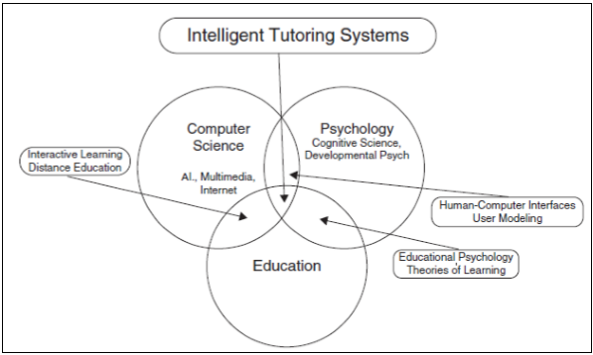
Figure 1: The field of AI and education is grounded in three disciplines: computer science, psychology, and education

    - Definitions
There are many definitions of Intelligent Tutoring Systems, and the following are some of the most important:
Intelligent Tutoring Systems (ITSs) are concerned with the use of artificial intelligence techniques for performing adaptive tutoring to learners according to what they know about the domain (Sleeman & Brown, 1982).

Intelligent Tutoring Systems (ITSs) are computer-based instructional systems with models of instructional content that specify what to teach, and teaching strategies that specify how to teach (Wenger 1987, Ohlsson 1987).

The Intelligent Tutoring System (ITS) is a computer system that aims to provide immediate and customized instruction or feedback to learners, usually without requiring intervention from a human teacher (Psotka, Mutter,1988).
Intelligent tutoring systems (ITSs) are computer programs that are designed to incorporate techniques from the AI community in order to provide tutors which know what they teach, who they teach and how to teach it(Nwana,1990).
Intelligent Tutoring Systems (ITSs) are computer software designed as combined methods from Artificial Intelligence(AI) community to deliver expert tutors which recognize the material to teach, the target students and the technique used(Abu Naser, 2016).

And The researcher defines the Intelligent Tutoring System (ITS) as computerized system, which grants immediate learning and customized notes to students without interference of human teacher.

    - Definitions of Authoring System
ITS "shell" is a generalized framework for building ITSs, and an ITS "authoring system" (or authoring tool) is an ITS shell along with a user interface that allows non-programmers to formalize and visualize their knowledge (Murray, 2003)

Authoring System is a program that helps in creating more than ITS with a relatively easy way and provide the experience of creating ITS without the need of an expert programmer to make it (Naser,2016).

Finally, the researcher can briefly define the authoring system as a computer-based system which allows creating educational software without the need of programmers.
    - Definitions of SQL and DML
The Structured Query Language (SQL) is the main programming language designed to manage data stored in database systems (Silva, Almeida, Queiroz 2016).

Structured Query Language (SQL) is a standard computer language for relational database management and data manipulation. SQL is used to query, insert, update and modify data. Most relational databases support SQL, which is an added benefit for database administrators (DBAs), as they are often required to support databases across several different platforms (Techopedia 2018).
Structured Query Language (SQL) is a standard language for storing, manipulating and retrieving data in databases (w3schools 2018).
The databases composed of four main categories of query we can describe it as following(Tutorials Point,2017) :
- a data definition language (DDL), which allows the specification of database schemas, managing tables, and index structures include CREATE, ALTER, TRUNCATE and DROP query.
- a data manipulation language (DML), which supports operations to retrieve, store, modify and delete data

- a data control language (DCL), which enables database administrators to configure security access to databases as assign and revoke database rights and permissions. Its main statements are GRANT and REVOKE.
- Queries are performed using the ubiquitous yet familiar SELECT statement, which is further divided into clauses, including SELECT, FROM, WHERE and ORDER BY.

A Brief History of SQL (Tutorials Point,2017) :
- 1970 – Dr. Edgar F. "Ted" Codd of IBM is known as the father of relational databases. He described a relational model for databases.
- 1974 – Structured Query Language appeared.
- 1978 – IBM worked to develop Codd's ideas and released a product named System/R.
- 1986 – IBM developed the first prototype of a relational database and standardized by ANSI. The first relational database was released by Relational Software which later came to be known as Oracle.

Why SQL? (Tutorials Point,2017) :
SQL is widely popular because it offers the following advantages:
- Allows users to access data in the relational database management systems.
- Allows users to describe the data.
- Allows users to define the data in a database and manipulate that data.
- Allows to embedding within other languages using SQL modules, libraries & pre-compilers.
- Allows users to create and drop databases and tables.
- Allows users to create a view, stored procedure, functions in a database.
- Allows users to set permissions on tables, procedures, and views.

The researcher can briefly define Structured Query Language (SQL) as a database computer language designed for the retrieval and management of data in a relational database.
    - Definitions of SQLite
SQLite is an in-process library that implements a self-contained, server less, zero-configuration, transactional SQL database engine. The code for SQLite is in the public domain and is thus free for use for any purpose, commercial or private. SQLite is the most widely deployed database in the world with more applications than we can count, including several high-profile projects(SQLite.org,2018).

SQLite is an open source embedded relational database. Originally released in 2000, it was designed to provide a convenient way for applications to manage data without the overhead that often comes with dedicated relational database management systems. SQLite has a reputation for being highly portable, easy to use, compact, efficient, and reliable(Owens, 2006).

And Other researchers defined SQLite as a relational database management system contained in a C programming library. In contrast to many other database management systems, SQLite is not a client-server database engine. Rather, it is embedded into the end program(Wikipedia,2018).
    - Definitions of Android Application
An Android app is a software application running on the Android platform. Because the Android platform is built for mobile devices, a typical Android app is designed for a smartphone or a tablet PC running on the Android OS.
Most Android apps are uploaded and published on the Android Market, an online store dedicated to these applications. (Techopedia 2018)
    - Definitions of Web Application And web Service
In computing, a web application or web app is a client-server computer program which the client (including the user interface and client-side logic) runs in a web browser. (Wikipedia 2018).
A Web service is a software service used to communicate between two devices on a network. More specifically, a Web service is a software application with a standardized way of providing interoperability between disparate applications. (Techopedia 2018).
    - Architecture of ITS
As illustrated in figure 2 we can identify the basic main four components of the general architecture of an ITS as follows (Naser,2016):
- Knowledgebase model.
- Student model.
- Expert model.
- Interface model.
These components interact with each other to accomplish different functions. These components are described in further detail below:

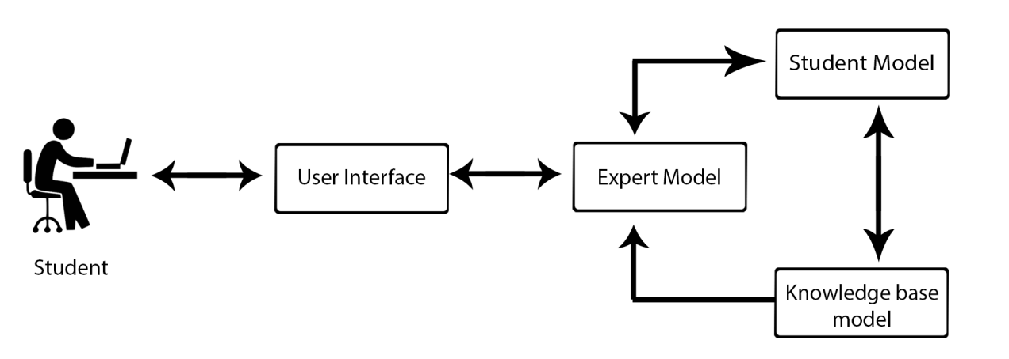
Figure 2: ITS components
      - Knowledgebase Model
This model also called the domain model, it is a reflection of other architectures domain models, it simply presents teachings and materials.
It generates many problems for each lesson, with consideration to individual differences and evaluates the student based on his response to the problems.
In other words, this model contains rules, concepts and strategies of problem solving within the domain to be tutored, it has many roles to fulfill, such as: Knowledge source, a standard to evaluate performance and detecting student’s mistakes. It can be bonded to curriculum, all knowledge elements can be linked together in accordance to pedagogical sequences.
      - Expert Model
Its strongly linked to student model and Knowledgebase (domain)model, it uses the knowledge about students and the structure of their tutorial goal to design the pedagogic activity and makes decisions about tutoring strategies and actions, and monitors the progress of learners then creates a profile of strength and weakness points according to the production rules (known as - knowledge-tracing).
There are many levels for learning martial, each one has a series of lessons and a question at the end to pass the level, that question includes an assessment and certain criteria to progress to the next level.
For example, a student has to get more 60% to move to the next level, in case he didn't, he has to re-answer the question again.
      - Student Model
The essential component of ITS is the student model, it has to contain as much knowledge as it can about the cognitive and affective states of a student and his evolution during the progress of learning process. Student model is normally considered as a dynamic model that executes several functions, mainly:
1- It has to gather explicit data about learners.
2 It has to use these data to embodies students' knowledge and learning process; and
3- The data must be account for by performing some types of diagnosis on the state of the student's knowledge and in terms of choosing the best pedagogical strategies to provide subsequent domain information to the student.
On the same rhythm, Self (1988) identified six main roles of the student model:
- Corrective: to get rid of the student's learning obstacles;
- Interactively: to assist in completing the incomplete student knowledge;
- Strategic: to assist to initiate huge changes in the tutorial strategy rather than tactical decisions of 1 and 2 above;
- Diagnostic: to run diagnoses on bugs in the student's knowledge;
- Predictive: to help predict the student's response to tutorial actions;
- Evaluative: to help assess the ITS or the student
      - User Interface Model
A user interface model It handles the interaction between the user and the system.
Any ITS must has an interface that supports two classes of users: teachers and students.
The student Interfaces has been designed for the student to interacts with the system through which is he can log into the system, add/modify lessons, exercises, answers, initial information about the student. etc.

The student interfaces has been designed for the student to interact with the system through which chooses a lesson from the list of lessons, displays tests for each lesson, the system displays the first difficulty level of the test questions randomly. If the student answered on all questions of the first level, the system moves the student to the next level of difficulty automatically. etc.
    - History of ITS
All ITSs share the same goal: to provide tutorial services that support learning. That being said, they show a vast variety of ways to conceptualize, design and develop these services. Efforts in this direction first began in the 1960s and ’70s, with the development of what was called Intelligent Computer-Assisted Learning (ICAI) by Carbonell (1970). The term “Intelligent Tutoring Systems” was coined by Sleeman and Brown in their volume of the same title (1982). The first ITS conference (1988) provided an opportunity to share and consolidate ideas, and it evolved into a biannual conference with full proceedings.
In 1990, 20 years after its birth, the field had passed its infancy and could reflect on the first generation of contributions, as evidenced by two publications that appeared in that year: an overview of the field (Nwana 1990) and a position paper (Self 1990). In 2008-2009, a generation later, further evolution is described in two volumes: one that reflects the latest developments (Woolf et al. 2008) and one that provides a broad, in-depth survey of the ITS field (Woolf, 2008). These landmark publications will guide our description of a field that has been growing for three generations. (Nkambou, Mizoguchi2010).
Developments and changes of Intelligent Tutoring System can be summarized throughout history as shown in table 1:
Table 1: the summary of the history of ITS
Event | Date | By
tutorial services that support learning called Intelligent Computer-Assisted Learning (ICAI) | first began in the 1960s and ’70s | Carbonell (1970).
The term “Intelligent Tutoring Systems” | 1982 | Sleeman and Brown
The first ITS conference , provided an opportunity to share and consolidate ideas | 1988 | Group of researchers interested in ITS
the first generation of contributions ,  two publications that appeared in that year | 1990 | Nwana 1990,  Self 1990
further evolution is described in two volumes | In 2008-2009 | (Woolf, 2008)

  - Advantages and Benefits of ITS

Intelligent tutoring systems can:
- Always and at any-time available.
- It can provide a real-time data for developers who are looking to improve teaching methods.
- Minimize student’s dependence on human tutors
- Help students to understand the curriculum better, by giving them first the chance to explain their knowledge, then response accordingly
- Create individualized programs due to individual differences.
- Achieve higher scores than any traditional systems test, especially for special education students and non-native English students.
- Provide instant feedback, hints-on-demand, and enhance mastery learning.
  - Study Community
The study community consists of all those interested in learning databases, whether they are specialized in field of information technology or others.

Literature Review
- The study of ( Bakeer et al., 2019) An Intelligent Tutoring System for Learning TOEFL
An e-learning system is increasingly gaining popularity in the academic community because of several benefits of learning anywhere anyplace and anytime. An Intelligent Tutoring System (ITS) is a computer system that aims to provide immediate and customized instruction or feedback to learners, usually without requiring intervention from a human teacher.(ITSB) is the tutoring system Builder Which designed and improved to help teachers in building intelligent tutoring system in many fields. In this paper, the authors have presented an example and evaluation of building an intelligent tutoring system for teaching TOEFL using ITSB tool.

- The study of (Al-Shawwa et. al, 2019) An Intelligent Tutoring System for Learning Java
Java is one of the most widely used languages in Desktop developing, Web Development and Mobile Development, so there are many lessons that explain its basics, so it should be an intelligent tutoring system that offers lessons and exercises for this language. Why tutoring system? Simply because it is one-one teacher, adapts with all the individual differences of students, begins gradually with students from easier to harder level, save time for teacher and student, the student is not ashamed to make mistakes, and more. In this paper, the authors describe the design of an Intelligent Tutoring System for teaching Java to help students learn Java easily and smoothly. Tutor provides beginner level in Java. Finally, we evaluated our tutor and the results were excellent by students and teachers.

- The study of(Albatish et. al., 2018). ARDUINO Tutor: An Intelligent Tutoring System for Training on ARDUINO.
This research aims to help students overcome the difficulties they face when dealing with the Arduino platform by describing the design of a smart desktop Tutorials system. The main idea of this system is a systematic introduction to the Arduino platform. The system shows Arduino printed circuit boards that can be purchased at low cost or assembled from freely accessible packages; and an open source development environment and a library for the Arduino platform. The system adapts to the individual progress of the student. The system works as a special tutor that treats students according to their level and abilities. The evaluation of the system was applied to professionals and non-professionals in this field and the results were good.

- The study of (Al Rekhawi et. al., 2018). An Intelligent Tutoring System for Learning Android Applications Ui Development
In this research, the authors describes the design of a web based intelligent tutoring system for teaching Android Applications Development to students to overcome the difficulties they face. The basic idea of this system is a systematic introduction into the concept of Android Application Development. The system presents the topic of Android Application Development and administers automatically generated problems for the students to solve. The system is automatically adapted at run time to the student’s individual growth. The system provides obvious support for adaptive demonstration constructs. An initial assessment study was done to examine the effect of using the intelligent tutoring system on the performance of students enrolled in Smartphone Applications Development in the University College of Applied Sciences, Gaza. The results showed a positive impact on the evaluators.

- The study of(Hamed et. al., 2017). Intelligent Tutoring System Effectiveness for Water Knowledge and Awareness
In this research, the Intelligent Tutoring System was adopted as a platform in linking the complex Technological fields for obtaining information smoothly, and highlighting the importance of water issues and in the Gaza strip. In the light of the absence and inability of the formal education system to raise awareness of the water crisis and its consequences on the daily life of the Gazans, the Intelligent Tutoring System has been utilized to disseminate knowledge and enhance awareness of water problems. The ITS aims to embrace a new water conservation practices and ensure the sustainability of fresh water. Basically the software of the tutoring system is used to create a program which could be easily used by the public population and specialists in the water field.

- The study of(Al-Bastami et. al., 2017). Design and Development of an Intelligent Tutoring System for C# Language
In this research, the authors aims to help students learn C# programming language using Intelligent Tutoring System. This tutor was developed using ITSB authoring language in order to help the students learn programming professionally and make the learning process very pleasing. A knowledgebase using ITSB authoring language style was used to represent the student’s work and to give him/her tailored feedback and support to the students.

- The study of (Hamed et. al., 2017). An intelligent tutoring system for teaching the 7 characteristics for living things.
In this research, the authors aim to help students learn the science for 7th grade. The
ITSB was used in designing and developing the intelligent tutoring system for learningthe science for 7th grade where the ITS help students in explaining to them the characteristic of living things.

- The study of(Weber and Prusilovsky, 2016). ELM-ART -An interactive and intelligent Web-based electronic textbook.
Web-based Intelligent Tutoring System was designed for teaching students LISP programming. It joins intelligent educational system with electronic textbook program in a sole environment in which the student can extend and deepen formerly acquired knowledge. It was used as an intelligent interactive electronic textbook on LISP logic programming.

- The study of(Mahdi et. al., 2016). An intelligent tutoring system for teaching advanced topics in information security
In this research, the authors aim to help students Advanced Topics in Information Security in the faculty of Engineering and Information Technology at Al-Azhar University in Gaza.
These intelligent tutoring systems enable the students study the course and solve related problems. An evaluation of the intelligent tutoring systems was carried out and the results were positive.

- The study of(Alhabbash et. al., 2016). An Intelligent Tutoring System for Teaching Grammar English Tenses
In this research, the authors aim to help students learn English grammar easily. The authors describe the design and the development of the Intelligent Tutoring System for teaching English language grammar. The ITS system presents all topics of English grammar and generates a set of questions automatically for each topic for the students to solve. The ITS system adapts with all the students individual differences and gradually increase the difficulty level. The intelligent tutoring system was presented to a set of students of all age to test it and to see the impact of the system on the students. The results showed a good satisfaction of the students toward the system.

- The study of(García et. al., 2016)Intelligent tutoring system to integrate people with down syndrome into work environments.
Multiple staged project was develop using the ITS in order to integrate people with Down Syndrome into work environment.
  - Comments about previous studies
Through looking in the previous studies, I discovered that the design of the Intelligent Tutoring Systems were used for a diversity of matters and the previous studies aforementioned aimed to use ITS in many fields such as programming language (Java), TOFEL, water awareness, Science, Mathematics and Learning English grammar.
My thesis is different from the previous studies in its goal that it employs the ITS in Data Manipulation Language (DML) Commands Using SQLite as a design that uses web and mobile app and to overcome the obstacles students face when learn data manipulation language commands using SQLite.

DESIGN AND DEVELOPMENT OF PROPOSED SYSTEM
  - Overview of the Proposed System
The proposed system is one of the educational systems that use smart education systems tools, which targeted all those interested in learning databases whether they are specialists in IT or otherwise. The proposed system works in two parts, one is an application for Android smartphones, and the other is an application on for Web Pages.

And as the traditional educational process consists of two parties (student and teacher), the proposed system presents the educational process through three parties: the learner, smart tutor (the system) and the teacher, who acts as supervisor of the system through specific functions.

The system provides services to the student through the smart phone application, where the system provides a series of lessons with a set of illustrative examples. The lessons include all educational levels of the database course, the system also includes a set of short and long tests to examine the comprehension and progress of a student in the educational process, and provides an experiential environmental system for the student to examine the concepts and commands of the databases so that he is ultimately able to comprehend what is a database, its role, use and orders it provide. Thus, the system covers the theoretical and practical side of the educational process.

The other side of the educational process is the teacher, he deals with another application that works on Web Pages. The teacher manages and controls through this application the educational material for the databases, where he adds lessons and examples as well as short and long tests and quizzes, where he sends notifications to students to be submitted to. Thus, and through the system, the teacher can study students' behavior and the progress of comprehension of each of them, and observe the period of time spent in the educational process of each student.

The researcher designed the interfaces of the system in an easy, attractive and interactive manner to fit the subject of education and the suitability of the devices that area part of the system.
  - Authoring Tool Used
ITUTSYS is the name of the authoring tool that the researcher builds it and use it to build the proposed system.
ITUTSYS is supporting two languages (English and Arabic) and easy to manage throw the student UI screens using mobile app and the Teacher UI screens using web browser.
The ITUTSYS implemented in PHP language to build the control panel for the teacher, and JAVA language to build the app for the student.
Domain experts can smoothly use ITUSYS to design ITS, and they don’t need any programming to build his own ITS.
  - Architecture of the proposed ITS system
A typical ITS have four fundamental models: Knowledgebase model, Student model, Expert Model and user interface model. The proposed system uses the identical architecture of ITS. The proposed ITS system used our own ITS builder) ITUTSYS).
    - Knowledgebase Model
The domain model adds the topics format in a systematic way. the topics may contain lessons, examples, questions and exams, All necessary parts ,items and resources to tutor and user are kept in the domain model .This model handles several important subjects of concern in the system for DML commands. The topics that intelligent tutoring system covers are:
- Introduction to SQL
This topic helps students to understand and know what is SQL? Definition and understanding the Basics of the RDBMS(Relational database Management System), and Types of SQL commands: DDL, DML, DQL, DCL.
- Manipulating Data Using DML.
This topic give an overall overview of data manipulation, This manipulation involves how to insert data into database tables, retrieve existing data, delete data from existing tables and modify existing data
- Inserting Data (Insert Commands)
This topic will detailed describe the INSERT statement , and help students to understand how to perform INSERT statement into a table ,This statement will be with default column list or enumerated column list.
- Retrieving Data (Select Commands)
This topic will detailed describe the SELECT statement, starts with how to execute a basic SELECT statement and ends with list the capabilities of SQL SELECT statements.
- Restricting , Filtering and Sorting Data
This topic will cover the restricting, sorting ,filtering and Limiting the rows that are retrieved by a query, it will describe The WHERE clause, Boolean logic and additional WHERE clause features (IN, BETWEEN, IS NULL/IS NOT NULL).finally will help student to know how to sort the rows that are retrieved by a query using ORDER BY clause in ascending or descending order, based on one or more columns.
- Reporting Aggregated Data. Using the Group Functions
This topic Explains and Identifies the available group functions, it Describes the use of group functions such as COUNT, SUM, MIN/MAX, AVG and help students to understand how to use the pervious function. Also it will help him/her to group data by using the GROUP BY clause and explain how to Include or exclude grouped rows by using the HAVING clause.
- Displaying Data from Multiple Tables
This topic covers the JOIN clause that helps students to Write SELECT statements to access data from more than one table .
- Deleting Data (Delete Commands)
This topic covers Delete statement ,its help students to understand and perform the Deleting rows from a table, also he/she will be able to perform restricting in this topic to delete some rows.
- Update Data (Update Commands)
This topic covers Update statement ,its help students to understand how to update data rows of table, also he/she will be able to perform restricting in this topic to update some rows .
    - Student Model
This model contains a student's personal information, like: Name, e-mail address, phone number, and personal photo.
These information are obtained when the student creates a new account through the mobile application or when the teacher adds a student from the control panel, as well as fundamental information related to the student's education level such as: the current level of the student, the level of difficulty that the student managed to access in each lesson, the number of exams the student has been submitted to, the results and answers of the exams for the student, the final grade, the student's grades, and the level of progress of the student in the educational process.
    - Expert Model
This model explains how the student interacts with the system, once he/she has logged in to the system, the system will display a list of lessons for the student to choose the targeted lesson, after studying the lesson, the student will submit to the exam, where the system will be able to study the student's behavior to ensure his understanding of the comprehensive lesson.
When the student wishes to submit to a test for the lesson, the system will randomly create a list of questions which were added previously, in accordance to the level of difficulty for the student.
If the student manages to get a 75%, the system will increase the difficulty level for that lesson. If the student gets between 50% and 75%, the system will prepare a list of other random questions of the same difficulty level for the student to start answering. But if he gets less than 50%, the system will close the test interface and redirect the student to the lesson again to re-understand and assimilate.

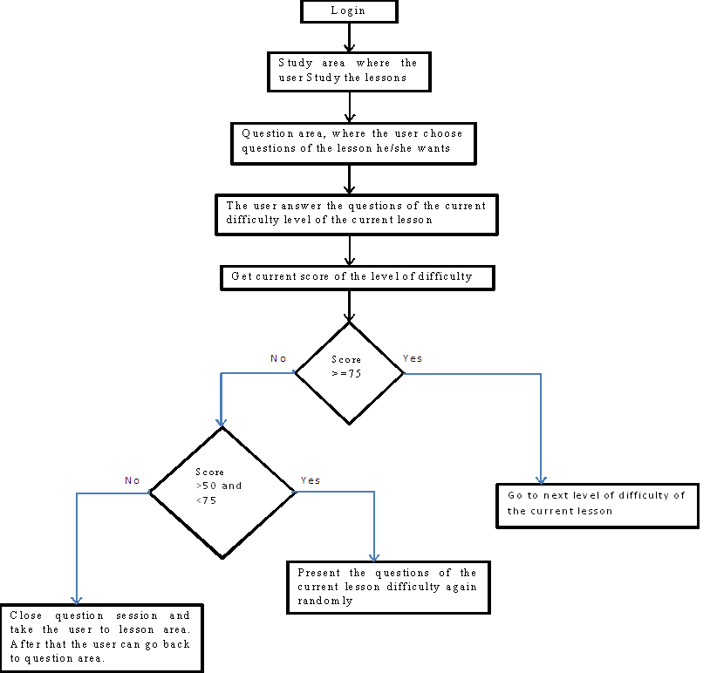
Figure 3: expert model adaption to user level
    - interface model
The user interface has two sections:-
  - Teacher interface :
- Figure 4 is showing the admin login interface that he/she will be able to enter his/her username and password then press login button to check if username and password correct and he/she has authority to login so the system will log him/her in to manage it.

- Figure 5 is showing forget password interface that help admin to recover his/her password using email. He/she will enter email then press submit button that will send private message to his/her email containing link that help him/her to change password (write a new password).

- Figure 6 is showing the add new student interface that give the teacher the ability to add new student to system by entering the basic information for the student such as student name, unique email,unique mobile, password, pic and the gender then he will press submit to create a profile for the student if the student is not resisted to system before using his email and mobile .

- Figure 7 is showing the interface that allows the teacher to display and manage students. He/she can filter students by name or by registration date, also he can manage student such as removing student, edit student profile, enable or disable student from entering the system.

- Figure 8 is showing the interface that helps the teacher to add new Lesson to the system by filling the lesson title, content and resources such as video from YouTube and attachment file then press submits to add the lesson to system.

- Figure 9 is showing the interface that allows the teacher to display and manage Lessons. He/she can filter lessons by keyword or by adding date.

- Figure 10 is showing the interface that allows the teacher to manage Lessons resources and content. He/she can choose what a management situation he/she need to do such as editing the lesson title, content, video, attachment or he/she can choose examples to manage the lesson example ,choose questions to manage lesson questions , delete the lesson , and finally he/she can sent the lesson to archive .

Figure 11 is showing the interface that helps the teacher to Update the Lesson content and title, video from YouTube and attachment file then press submit the changes.

- Figure 12 is showing the interface that allows the teacher to display and manage lesson examples. He/she can filter lessons by keyword or by adding date. And he/she have the ability to choose action to do such as edit, delete, or archive the example.

- Figure 13 is showing the interface that that gives the teacher the ability to update the lesson example content, title, video from YouTube and attachment file then press submits the changes.

- Figure 14 is showing the interface that allows the teacher to display and manage lesson question. He/she can filter question by keyword or by adding date. And he/she have the ability to choose action to do such as edit, delete, or archive the question.

- Figure 15 is showing the interface that helps the teacher to add new test to the system by filling the test title, and then press submit to add the lesson to system, after that he/she will be able to move the test help him to manage the test questions as explain in Figure 16 .

- Figure 16 is showing the interface that allows the teacher to display and manage tests. He/she can filter test by keyword or by adding date. And he/she have the ability to choose actions explained in Figure 17.

- Figure 17 shows the actions that the admin can be do, When he press on action button beside the test row there is a dropdown list appear as shown in the figure that help admin to choose what he want to do for the test such as edit the test title or duration, he can choose questions to enter to test question page that allow him to manage question test, delete the test, or he can close the dropdown list.

- Figure 18 is showing the interface that that gives the teacher the ability to update the test title ,duration ,or he can enable or disable the test to make it visible to student or not then press submit the changes.

- Figure 19 is showing the interface that allows the teacher to display and manage test questions. He/she can filter questions by keyword or by adding date. Also he/she can press to button above called (New Question) to move to new interface that help him/her to add new Question as show in figure 20,and he/she have the ability to choose action to do for the question such as edit, delete, or archive the question .

- Figure 20 is showing the interface that helps the teacher to add new question to test , this question contain from question text and the choices for the question, taking into consideration that the first choice is the correct answer , moreover that the teacher can press to button carries plus icon to add more options and choices to the question .

- Figure 21 is showing the interface that allows the admin to display and manage the overall system admins. Moreover he/she have the ability to choose action to do for someone of them such as edit, delete, or block according to his privileges.

- Figure 22 is showing the option that gives the ability to admin to add another admin to system according to his privilege by entering his email and send him invitation to system to complete his registration after that he can manage the system.

- The student interface is a smartphone interfaces, it conveys all the commands of teaching process, and these commands differ with user’s performance level.

- Figure 23 shows first interface for the app contains the system logo, after three seconds it will move to login screen or to home page according to student login statues.

- Figure 24 shows the student login interface that will appear if the student is not logged in before to the system, this screen contains many options for the student such as he/she can press to signup button in Arabic version called(سجل الآن) then he/she will move to page that help him to signup and create a new student profile ,or he can press to forget my password in Arabic version called (نسيت كلمة المرور) then he/she will move to page that help him to change his password according to some authenticating process .

- Figure 25 shows signup interface that help the user to create his profile to give him the ability to login to system after he/she fill the information required such as email, user name, mobile number ,gender , Date Of birth , Address , password and upload his picture then he/she press to signup button called in Arabic version (تسجيل) to create his profile as a new student to start his/her educational tour.

- Figure 26 shows the home interface that displays the lessons in the center of interface and contains a tab in the bottom of the screen that contains main 4 tabs (home, exams, my profile and more) in Arabic version named Sequentially from left to right(الرئيسية,الامتحانات,حسابي,المزيد) , if the student press to exams tab the system will display the exams and give the student the ability to check if there is a new exam to start ,but if he press to my profile tab the user basic information will be displayed and gave him/her the ability to change his password, also he can press the last tab that called more he/she will show some options such as display the app settings , notifications , exam grads, and contact with the teacher , etc.

- Figure 27 shows the options of the lessons will be displayed if the user pressed to lesson name these options show the lesson video, explanation, examples, exams, load the lesson attached file or start practical part of the system to try the statements he/she understood from the lesson.

- Figure 28 shows the student basic information interface that help the student th change his/her password form it.

- Figure 29 shows the Lesson Explanation interface that Explain in detail the overall lesson with some examples for the lesson.

- Figure 30 shows the Lesson examples interface that Explain in a lot of examples for the lesson.

- Figure 31 shows the screen that will be appear if the student choose to download lesson attachment file, that the progress bar will be displayed to show the percentage downloaded size from the file.

- Figure 32 shows the Practical part of the system to display all retrieved data from table with the ability to color the words with red if the student write the sentence in error way , also the student can insert , edit and delete rows from/to the table at this part moreover he/she can press to rebuilt the database again button called in Arabic version (إعادة بناء قاعدة البيانات) to remove all changes that the student made on the data base and rebuilt it again .

- Figure 33 shows the Practical part of the system to select and display rows with using where clause that display the rows matches used conditions inner to Where clause.

- Figure 34 shows the Practical part of the system to delete some row matches used conditions inner to Where clause.
    - Screen captures
These are some screen samples for the proposed ITS system.

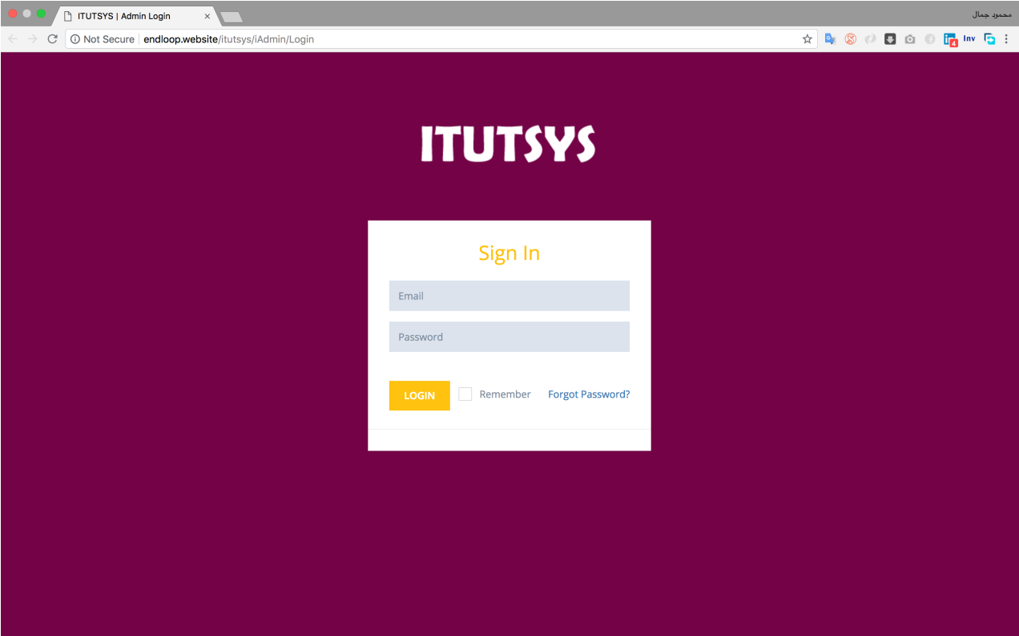
Figure 4Admin login screen

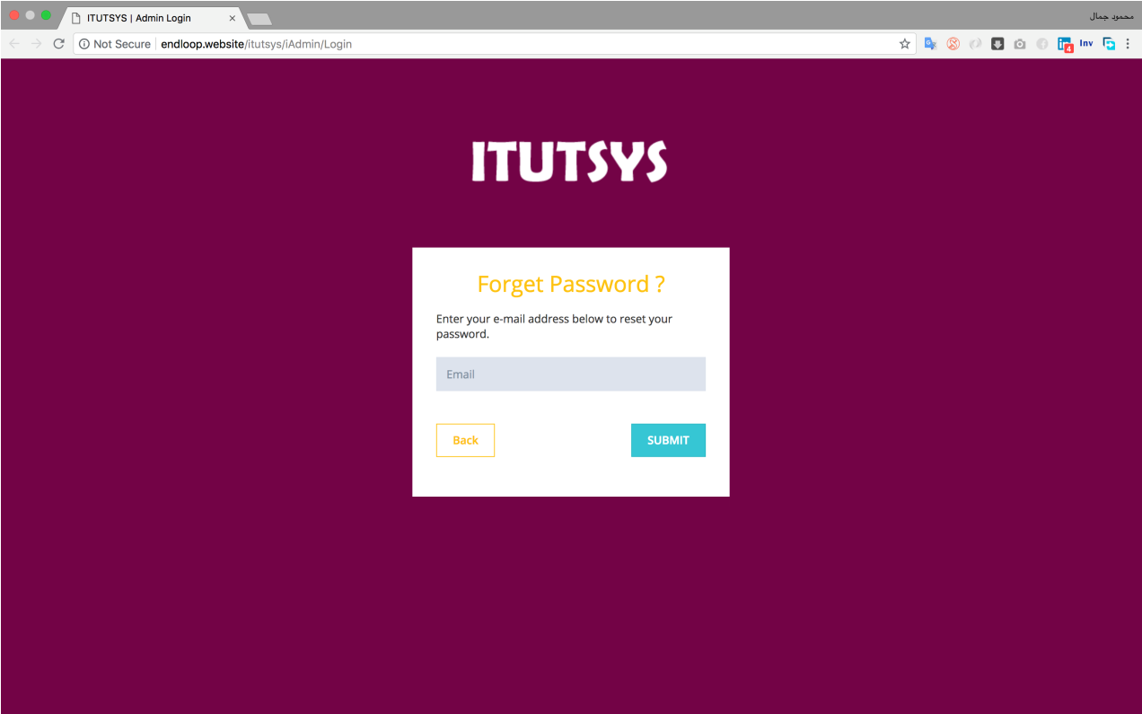

Figure 5Forget Passwordinterface

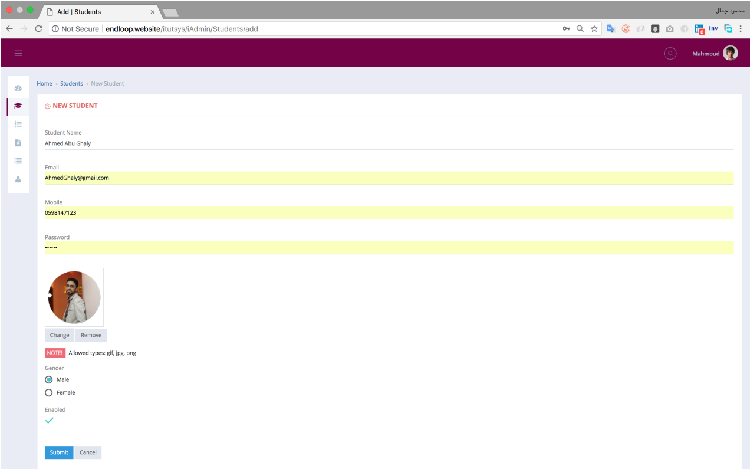

Figure 6 Admin Add new student interface

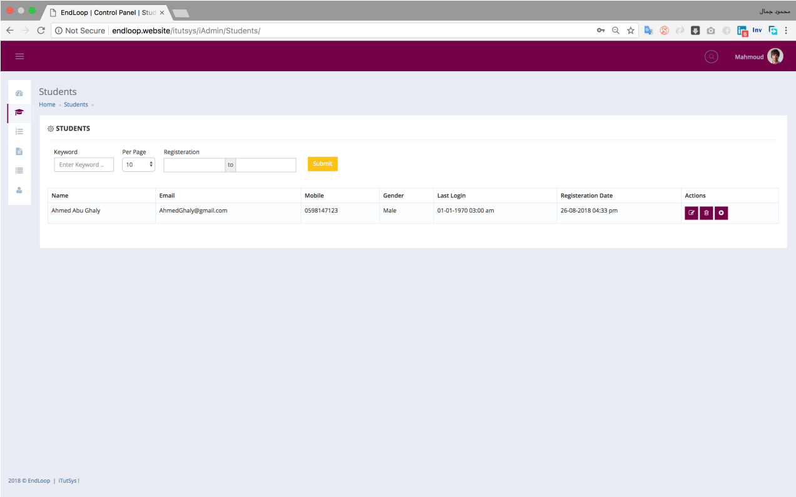

Figure 7 Admin display all students interface

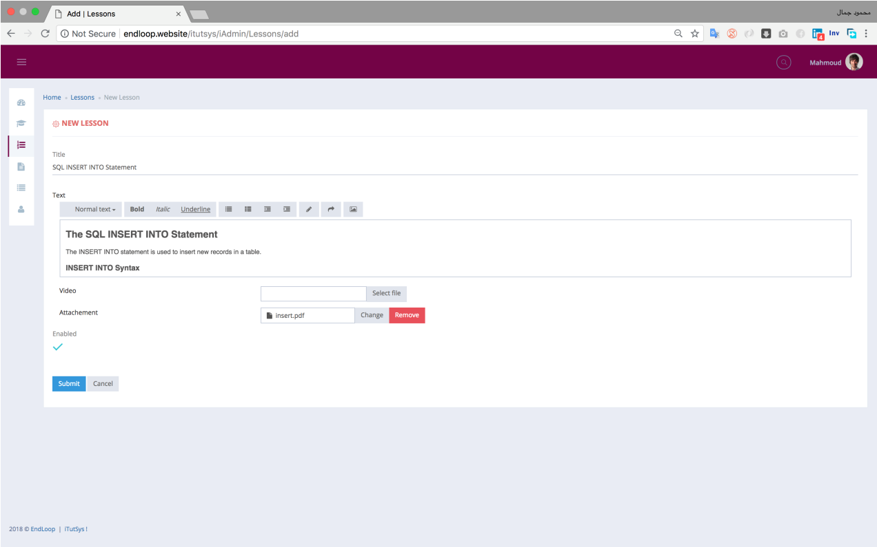

Figure 8 Admin add new lesson interface
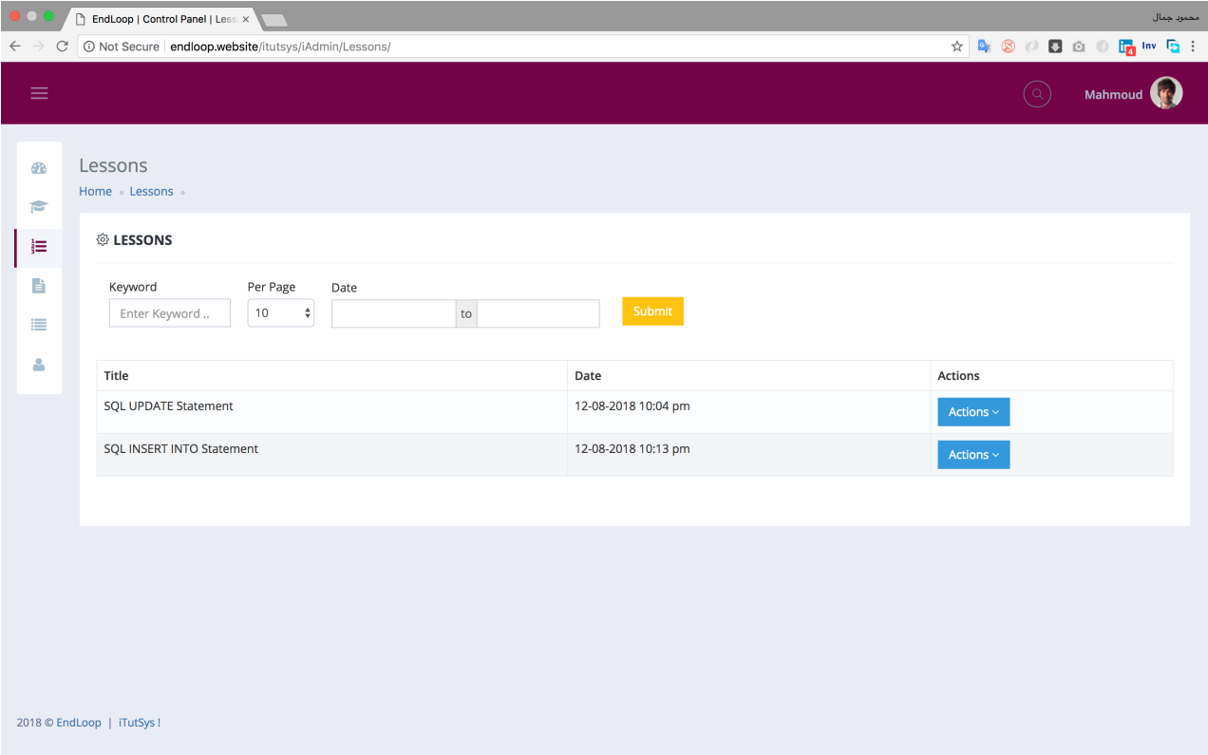

Figure 9 Admin display all lessons interface
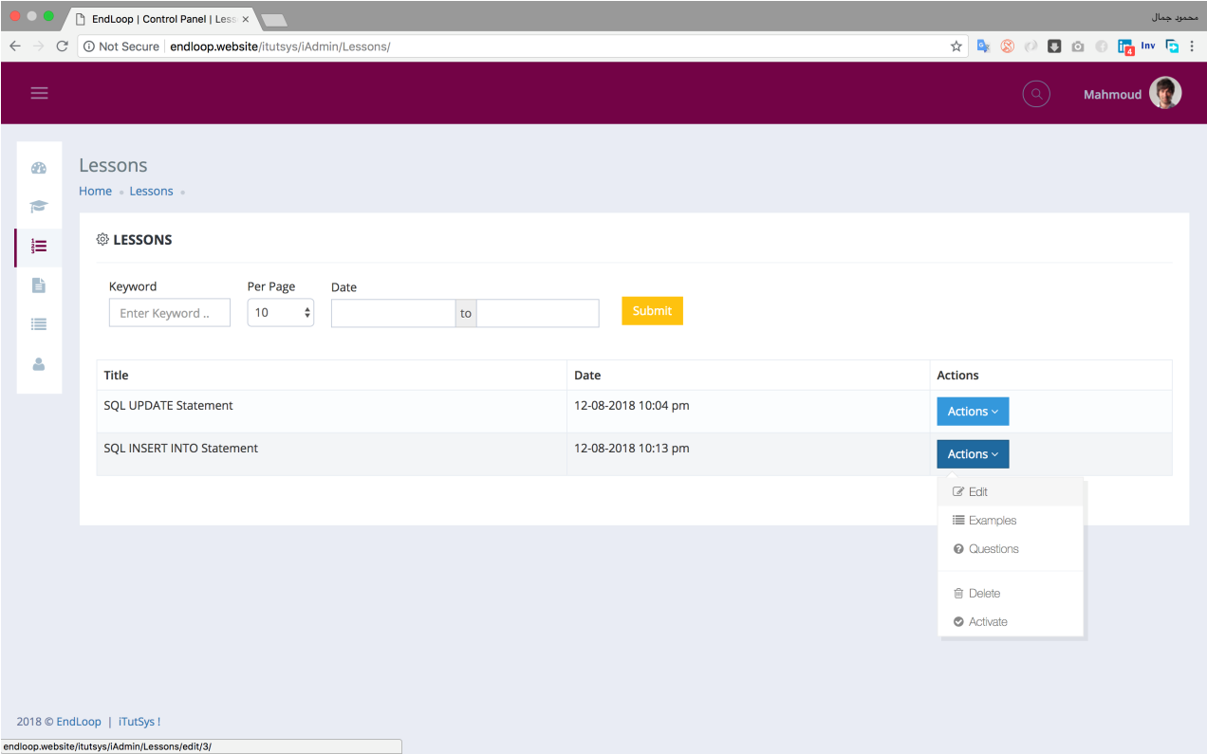
Figure 10 Admin make action for lesson interface
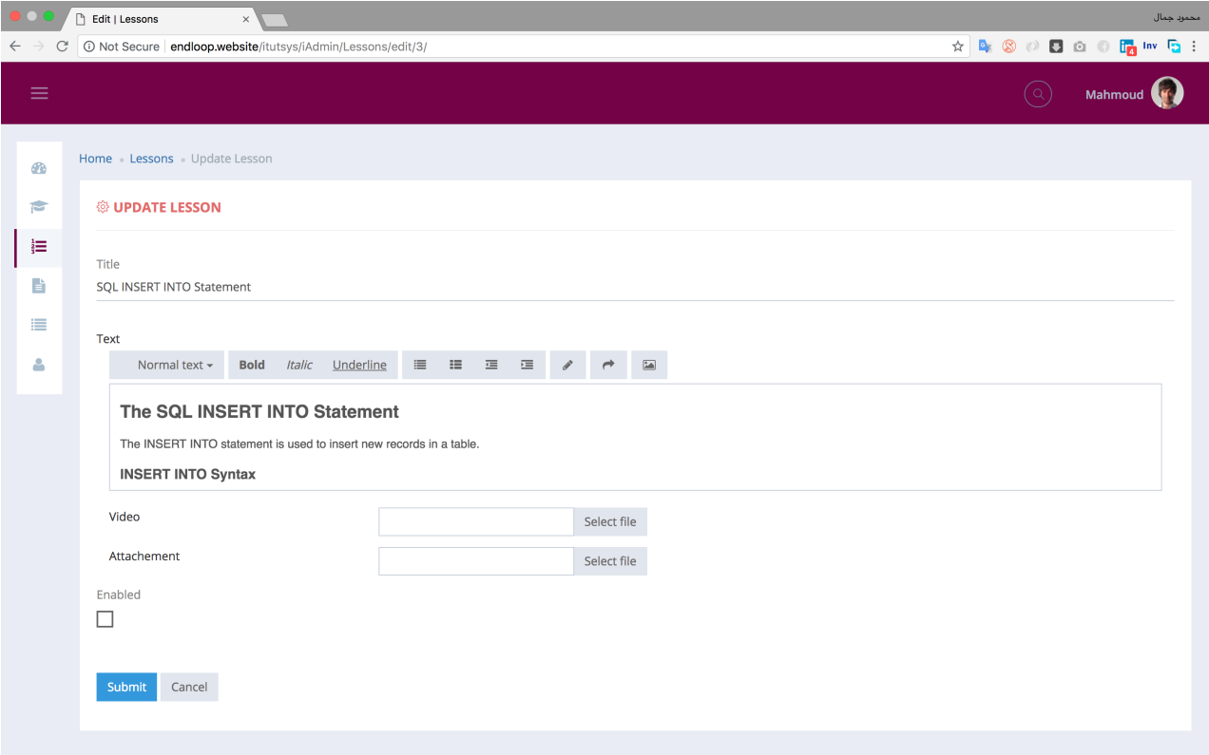
Figure 11 Admin update lesson interface

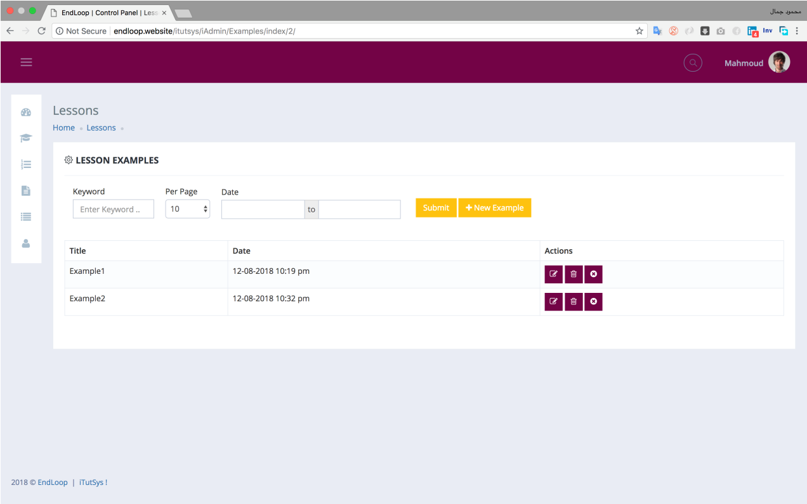
Figure 12 Admin display lesson examples to lesson interface
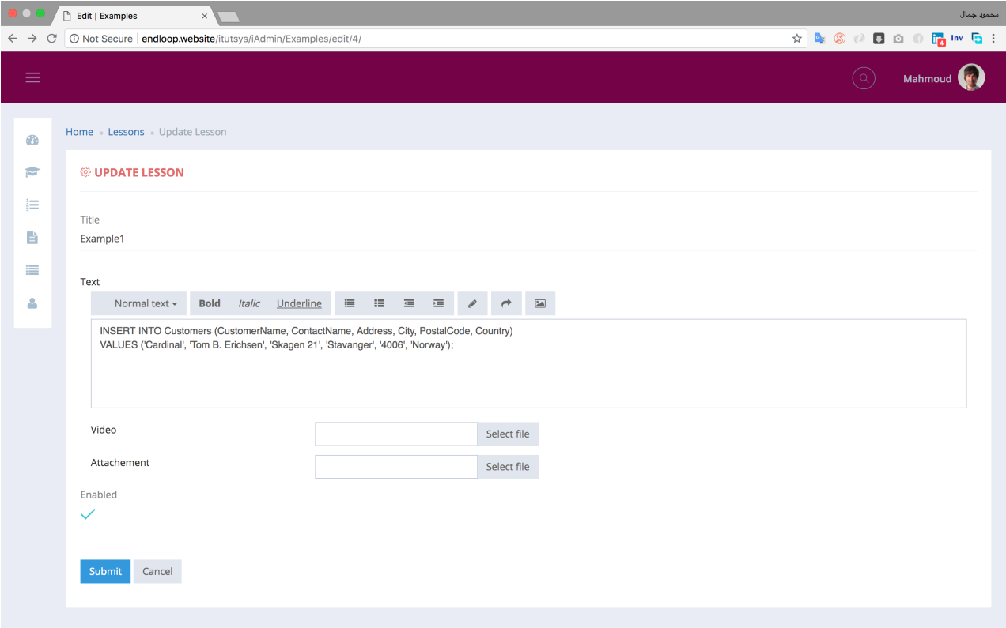
Figure 13 Admin update example interface

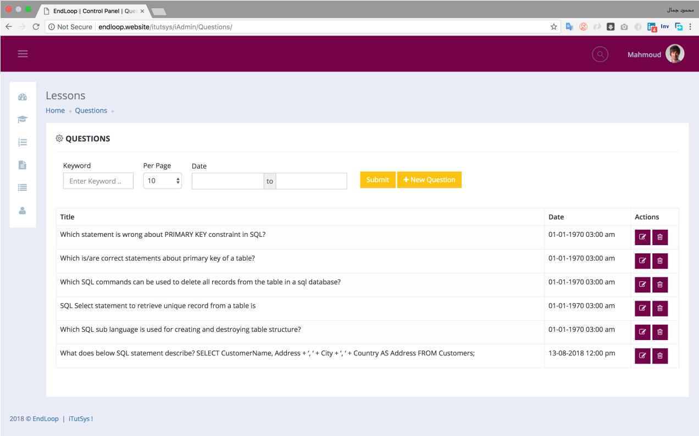
Figure 14 Admin display lesson questions interface
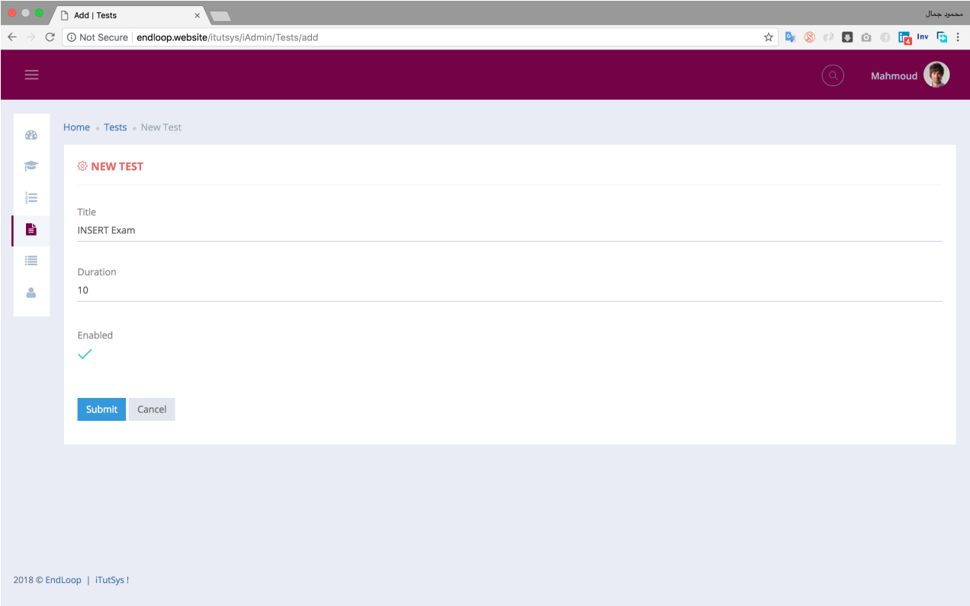
Figure 15 Admin add new test to system interface

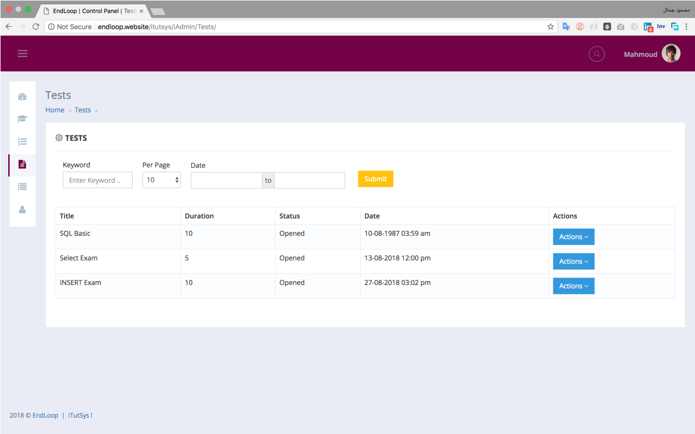
Figure 16 Admin display all tests interface

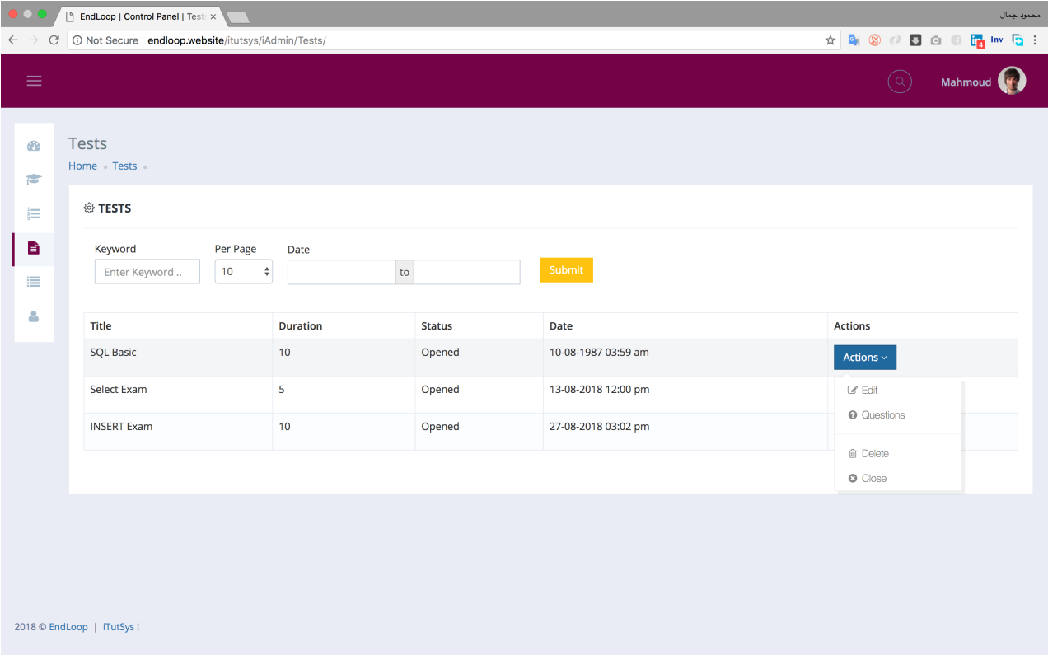
Figure 17 Admin make action to test interface
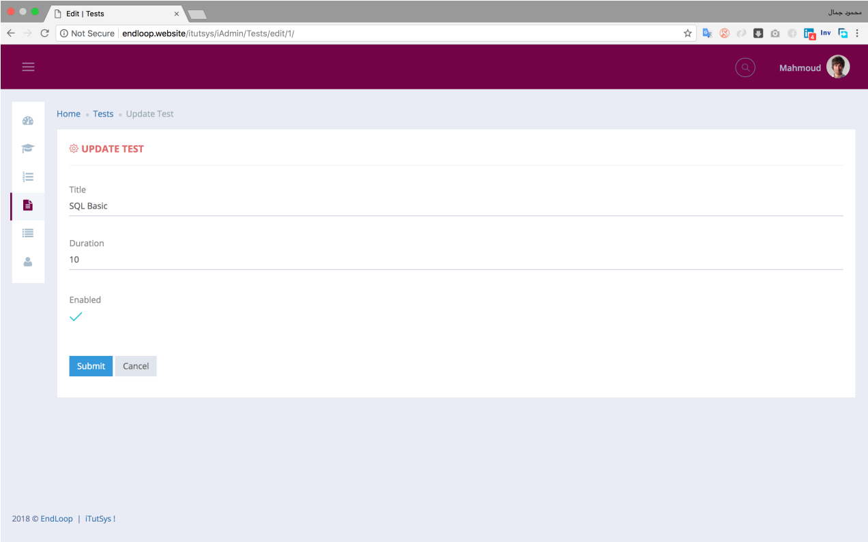
Figure 18 Admin update test interface
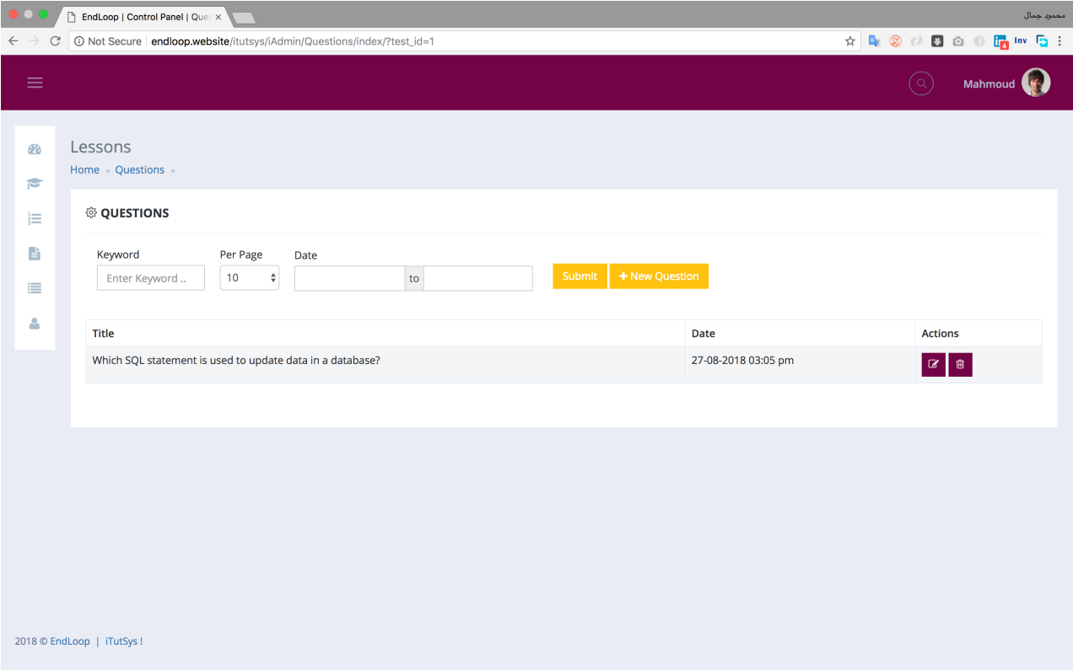
Figure 19 Admin display test questions interface

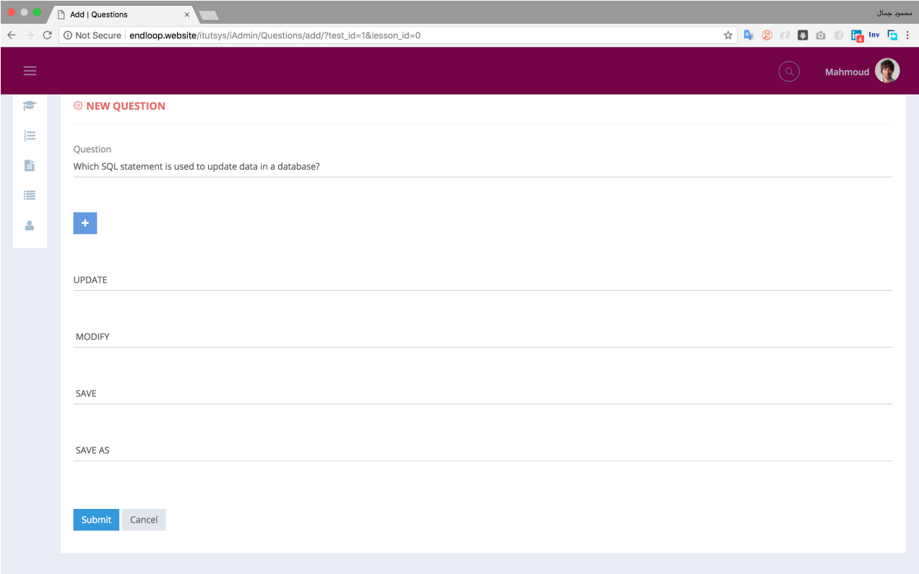
Figure 20 Admin add question to test interface
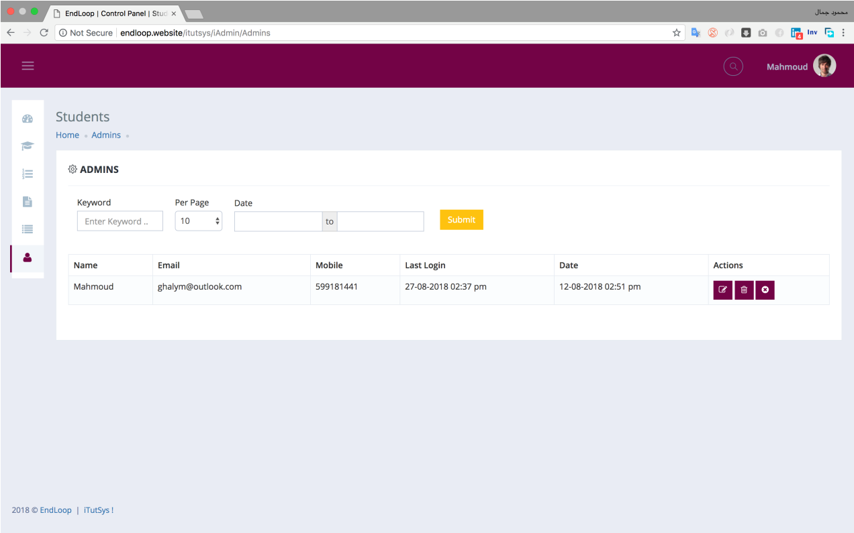
Figure 21 Admin display admins interface
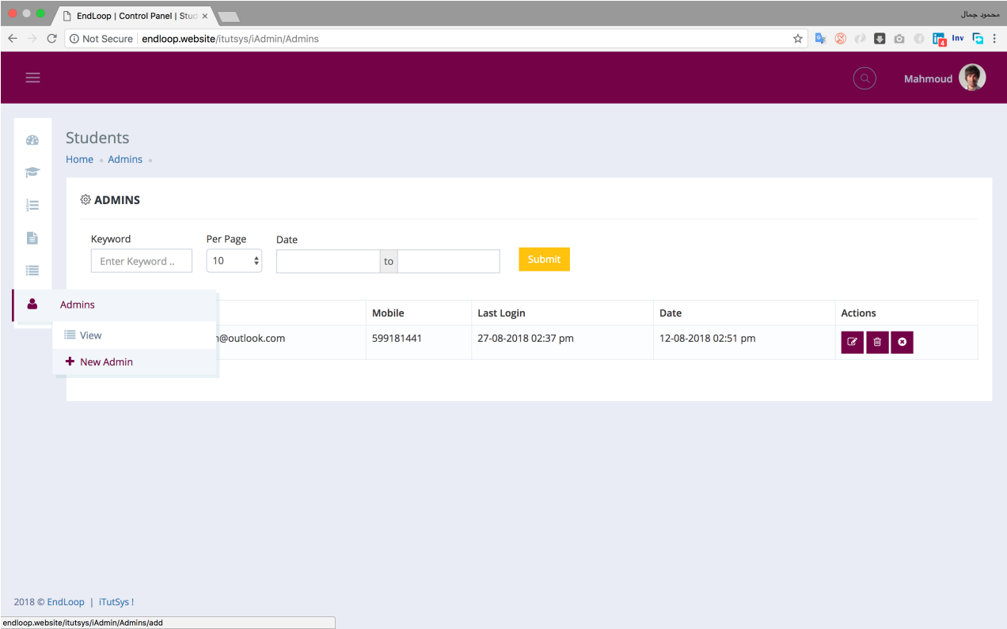
Figure 22 Admin add new admin to system interface

Figure 23 Student Mobile App Splash Screen | 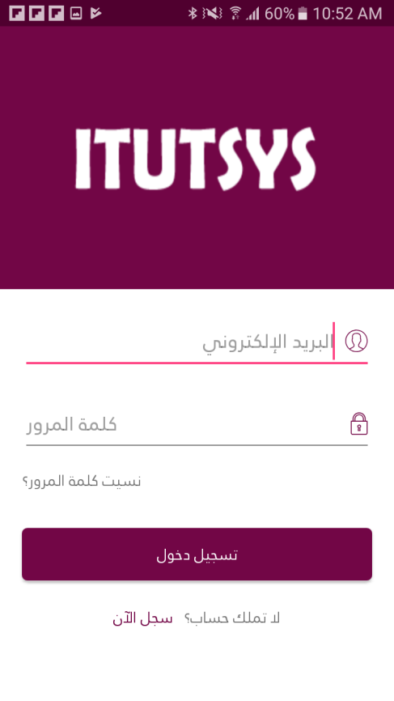  Figure 24 Student Login Screen
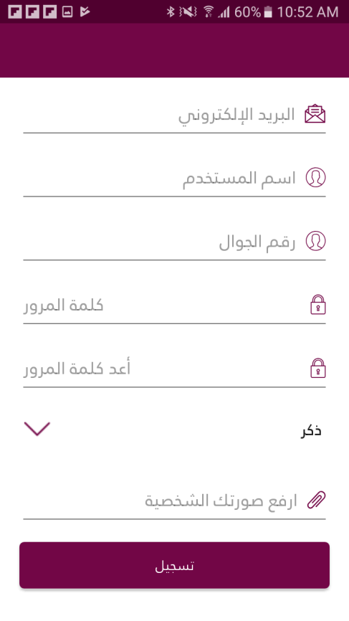  Figure 25 Sign up to create student profile screen | 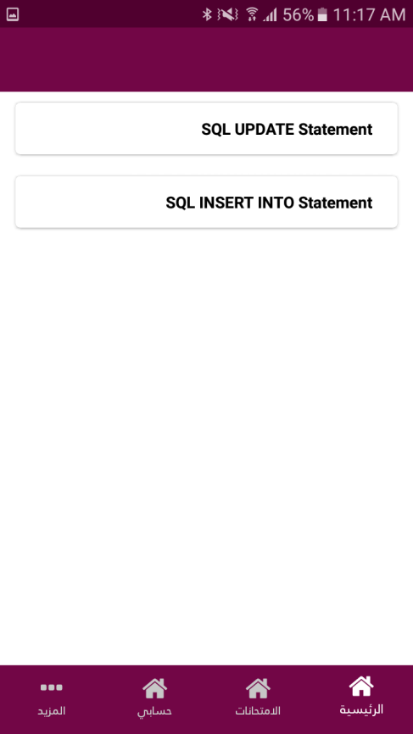  Figure 26 home screen

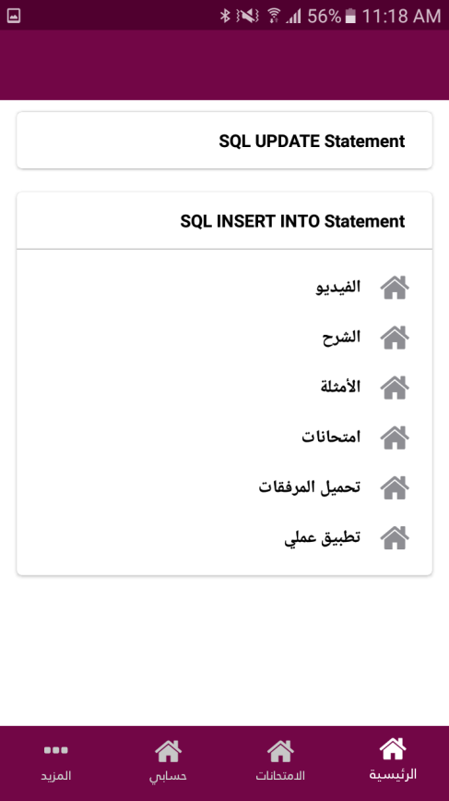  Figure 27 lesson options interface | 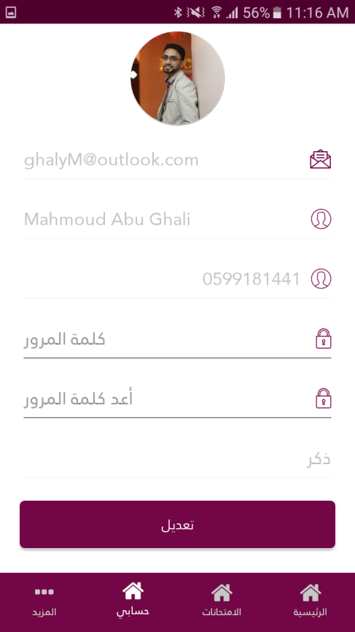  Figure 28 Student profile screen
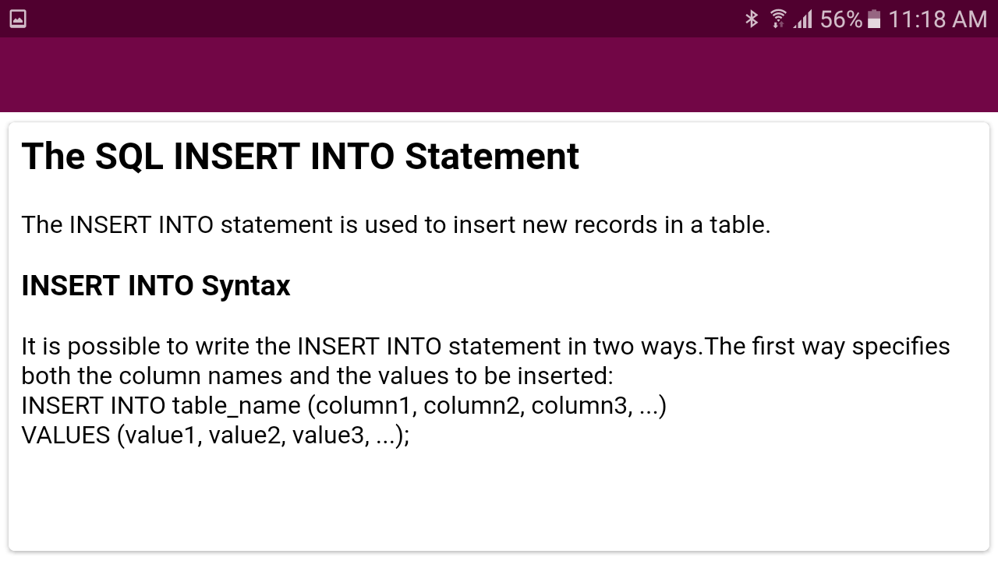
Figure 29 Lesson Explanation Interface

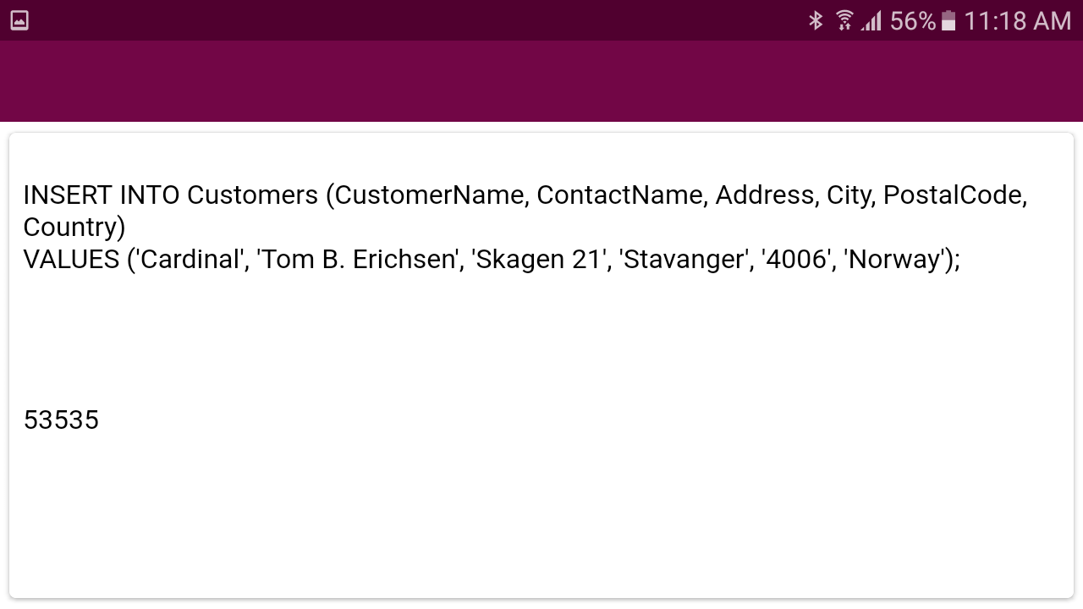
Figure 30 Lesson Examples Interface

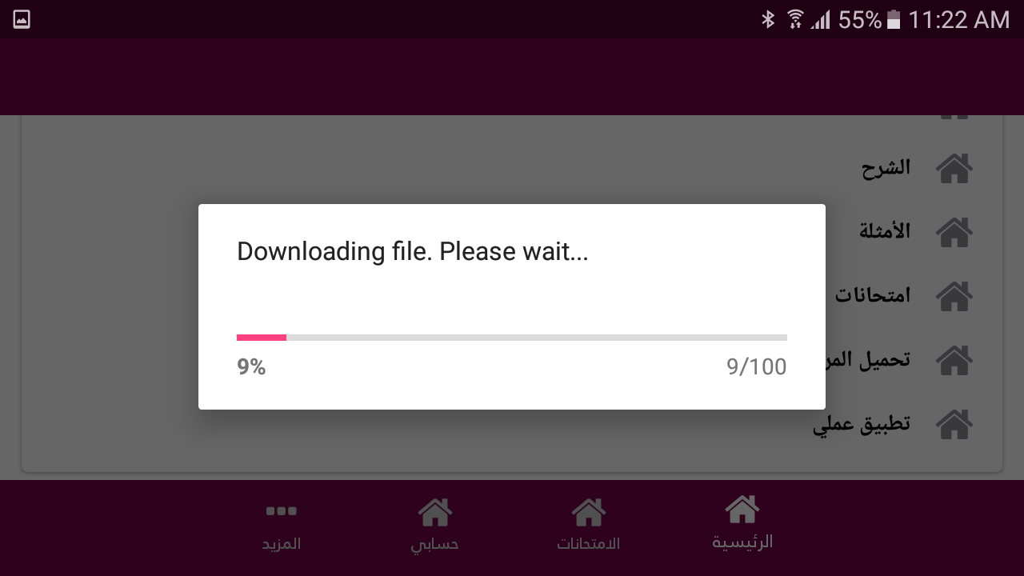
Figure 31 Download the lesson attachment file

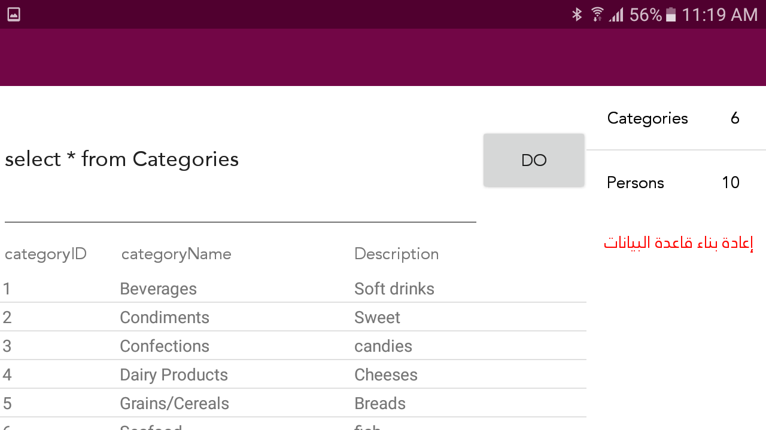
Figure 32 Practical part of the system to display all data interface

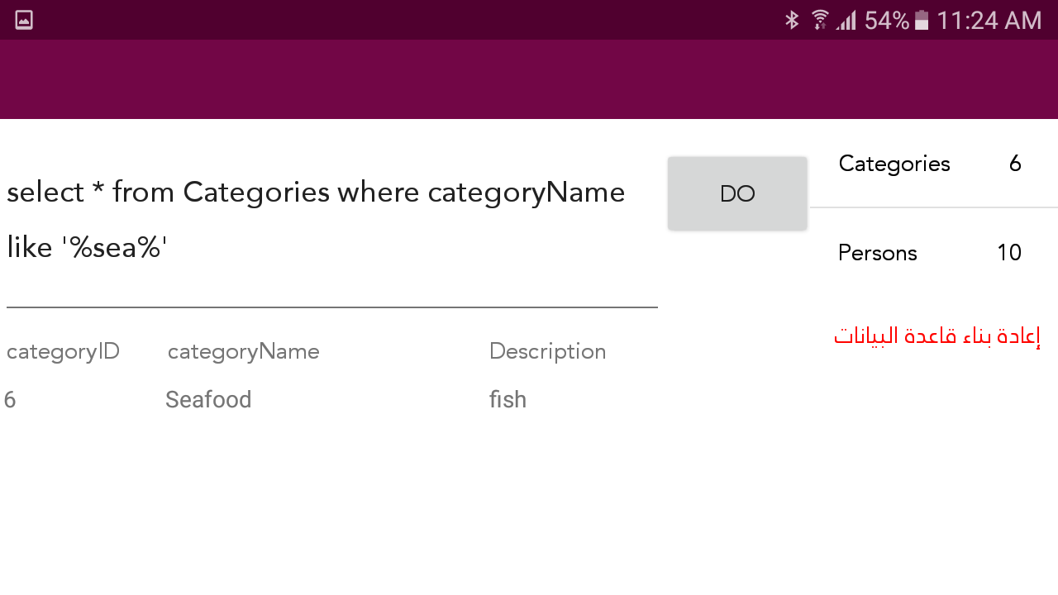
Figure 33 Practical part of the system to display some row interface
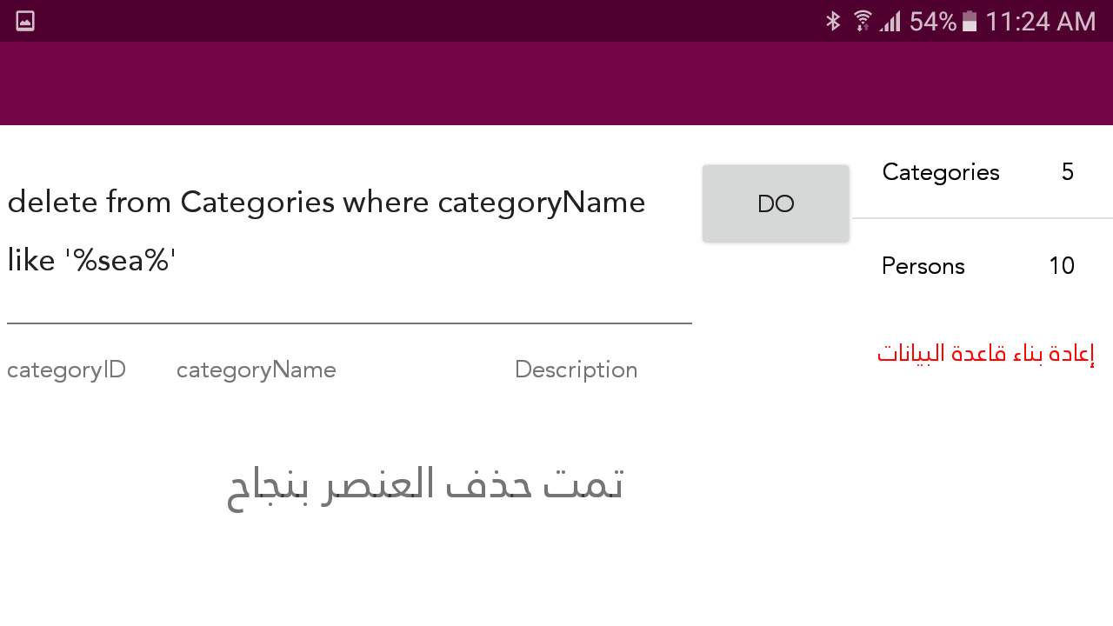
Figure 34 Practical part of the system to delete some row interface

EVALUATION AND RESULT DISCUSSION

  - System Evaluation
The role of system evaluation is to measure the application's quality which indicates its effectiveness, efficiency and user satisfaction of the performance of the application. Usability evaluation considered to be a vital part of the system development process, a set of questions have been founded for the purpose of evaluating ITS by those interested in the effectiveness of using ITS for DML commands Using SQLite.
The proposed ITS system has been presented to 3 groups of concerned people, the 1st one includes 3 Database specialists.2nd group includes 20 Diploma students enrolled in Software and databases at University college of applied science (UCAS) in Gaza (Divided into two groups of students based on gender - the number of male students is 14, and the number of female students is 6).
3rd group includes 15 secondary school students (Divided into two groups of students based on gender - the number of male students is 8 and the number of female students is 7).
Each group was asked to give evaluation to the system and to fill the questionnaire, which was prepared by the researcher and approved by his supervisors.
The results of the first group are in Table 2 and Figure 35, as for the second group, the results are shown in Table 3 and Figure 36.
Finally, the results of the third and last group and are shown in Table 4 and Figure 37.
  - Results of Database Specialists Group:
Table 2 indicates the questions and their average percentages. Figure 35 presents a bar chart of questions and their percentages.
Table 2: Results of questions asked Database specialists
S.N. | Question | Average%
1 | It is easy to use Intelligent Tutoring System | 97%
2 | It is excited Intelligent Tutoring System | 88%
3 | It is very useful Intelligent Tutoring System | 98%
4 | The Intelligent Tutoring System questions are suitable for students | 87%
5 | The topic that the Intelligent Tutoring System explains is important | 90%
6 | The use of the Intelligent Tutoring System compensates the student for attending lectures | 87%
7 | Intelligent Tutoring System has a high quality | 90%
8 | Intelligent Tutoring System helps to understand more scientific material | 96%
9 | Intelligent Tutoring System makes curriculum easy to learn | 92%
10 | I recommend using the Intelligent Tutoring System for other curriculums | 93%
11 | Intelligent Tutoring System can be used as an aid tool with the curriculum | 99%
12 | Intelligent Tutoring System doesn’t need many improvements | 75%

Figure 35: The results were obtained by the Database specialists
  - Results of Diploma Students Group:
Table 3 indicates the questions and their average percentages. Figure 36 presents a bar chart of questions and their percentages.

Table 3: Results of questions asked to Diploma students at UCAS in Gaza
S.N. | Question | Average%  Male | Average%  Female
1 | It is easy to use Intelligent Tutoring System | 95% | 97%
2 | It is excited Intelligent Tutoring System | 90% | 92%
3 | It is very useful Intelligent Tutoring System | 98% | 98%
4 | The Intelligent Tutoring System questions are suitable for students | 89% | 93%
5 | The topic that the Intelligent Tutoring System explains is important | 95% | 95%
6 | The use of the Intelligent Tutoring System compensates the student for attending lectures | 90% | 92%
7 | Intelligent Tutoring System has a high quality | 93% | 91%
8 | Intelligent Tutoring System helps to understand more scientific material | 95% | 97%
9 | Intelligent Tutoring System makes curriculum easy to learn | 94% | 96%
10 | I recommend using the Intelligent Tutoring System for other curriculums | 99% | 99%
11 | Intelligent Tutoring System can be used as an aid tool with the curriculum | 99% | 99%
12 | Intelligent Tutoring System doesn’t need many improvements | 80% | 86%

Figure 36: The results were obtained by the Diploma students at UCAS group
  - Results of Secondary School Students Group:
Table 4 indicates the questions and their average percentages. Figure 37 presents a bar chart of questions and their percentages.

Table 4: Results of questions asked to secondary school students
S.N. | Question | Average%  Male | Average%  Female
1 | It is easy to use Intelligent Tutoring System | 94% | 90%
2 | It is excited Intelligent Tutoring System | 86% | 88%
3 | It is very useful Intelligent Tutoring System | 94% | 95%
4 | The Intelligent Tutoring System questions are suitable for students | 80% | 87%
5 | The topic that the Intelligent Tutoring System explains is important | 83% | 75%
6 | The use of the Intelligent Tutoring System compensates the student for attending lectures | 87% | 84%
7 | Intelligent Tutoring System has a high quality | 90% | 90%
8 | Intelligent Tutoring System helps to understand more scientific material | 94% | 92%
9 | Intelligent Tutoring System makes curriculum easy to learn | 92% | 90%
10 | I recommend using the Intelligent Tutoring System for other curriculums | 95% | 97%
11 | Intelligent Tutoring System can be used as an aid tool with the curriculum | 96% | 96%
12 | Intelligent Tutoring System doesn’t need many improvements | 78% | 80%

Figure 37: The results were obtained by secondary school students group
When evaluators evaluate the proposed ITS, they are required to the proposed system, then give their feedback on the system by filling the twelve questions questionnaire mentioned above. That is how efficiency, effectiveness and satisfaction are measured, and the results were promising and it was very positive as follows:
The total result of database specialists group is 91%, the total result of Diploma students group is 94%, and the total result of secondary school students group is 89%.

Conclusion
In this study, the Intelligent Tutoring System’s theory and architecture have been described.
An Authoring tool and Intelligent Tutoring System (ITS) was designed and developed for enhancing the knowledge of the Database science for the non IT students .The ITS system addressed a lot of information’s about the database science and in details explains the concepts of DML query.
The proposed ITS system was presented to three groups: Database specialists, Diploma students enrolled in Software and databases at University college of applied science (UCAS) in Gaza, and secondary school students to test the system and give their feedback through filling a questionnaire. The outcomes of the evaluation are presented as 91% from the database specialists, 94% from Diploma students group and 89% from the secondary school students group, so we can say that the evaluations were promising.

6.1 Future Work
For future work, we are planning to convert the authoring tool to become more flexible and easy for all subjects and domains not just databases, to expand the system to applicable fields to the domain of learning, such as Law, Public Service, Health, and others.

REFERENCES
- Self J.,(1999). The Defining Characteristics of Intelligent Tutoring Systems, Research: ITSs Care, Precisely, International Journal of Artificial Intelligence in Education, 350-364.
- Peter Brusilovsky, Elmar Schwarz, and Gerhard Weber, (1996). ELM-ART: An Intelligent Tutoring System on World Wide Web.
- Kenneth R. Koedinger, John R. Anderson, William H. Hadley, Mary A. Mark, (1997), Intelligent Tutoring Goes To School in the Big City. International Journal of Artificial Intelligence in Education, 30-43.
- C.J. Butz, S. Hua, R.B. Maguire, (2006). AWeb-based Intelligent Tutoring System for Computer Programming.
- Michał Kosek, (2014). An Intelligent Tutoring System for Learning Chinese with a Cognitive Model of the Learner. University of Oslo.
- Joe Appleton, (2017).Introducing intelligent exercises to support web application programming users. Icicte, 216-225.
- Palestinian Water Authority (2017). General Directorate of Water Resources in Gaza Strip, Gaza, Palestine.
- Palestinian Central Bureau of Statistics (2016).
- Sleeman, D. H., 1987. PIXIE: a shell for developing intelligent tutoring systems, AI & education: Learning environments and intelligent tutoring systems, pp. 239- 265.
- Sarrafzadeh, A., 2008, How do you know that I don’t understand? A look at the future of intelligent tutoring systems, Computers in Human Behavior, Vol 24, no 4, pp 1342-1363.
- Silva Yasin N., AlmeidaIsadora, Queiroz Michell. (2016). SQL: From Traditional Databases to Big Data, p 1
- Owens, Michael. (2006) The Definitive Guide to SQLite pp 1-16
- https://SQLite.org/about.html
- Techopedia(2018).https://www.techopedia.com/definition/1245/structured-query-language-sql
- Wikipedia (2018). https://en.wikipedia.org/wiki/Web_application
- Naser, S. S. A. (2016). ITSB: An Intelligent Tutoring System Authoring Tool. Journal of Scientific and Engineering Research, 3(5), 63-71.
- Alhabbash, M. I., Mahdi, A. O., & Abu Naser, S. S. (2016). An Intelligent Tutoring System for Teaching Grammar English Tenses. EUROPEAN ACADEMIC RESEARCH, 6(9), 7743-7757.
- State of Victoria (Department of Education and Training, (2018). "THE PEDAGOGICAL MODEL".P6
- Chambers, J., & Sprecher, J. (1983). Computer-Assisted Instruction: Its Use in the Classroom. Englewood Cliffs, New Jersey: Prentice-Hall Inc.
- Freedman, R. 1999. Atlas: A Plan Manager for Mixed-Initiative, Multimodal Dialogue. (1999) AAAI Workshop on Mixed-Initiative Intelligence
- Shelby, R. N.; Schulze, K. G.; Treacy, D. J.; Wintersgill, M. C.; VanLehn, K.; and Weinstein, A. (2001). The Assessment of Andes Tutor.
- Al-Bastami, B. G., & Abu Naser, S. S. (2017). Design and Development of an Intelligent Tutoring System for C# Language. EUROPEAN ACADEMIC RESEARCH, 6(10), 8795.
- Hamed, M. A., & Abu Naser, S. S. (2017). An intelligent tutoring system for teaching the 7 characteristics for living things. International Journal of Advanced Research and Development, 2(1), 31-45.
- Joe Appleton, (2017).Introducing intelligent exercises to support web application programming users. Icicte, 216-225.
- Mahdi, A. O., Alhabbash, M. I., & Abu Naser, S. S. (2016). An intelligent tutoring system for teaching advanced topics in information security. World Wide Journal of Multidisciplinary Research and Development, 2(12), 1-9.
- Jorge García, KarmeleLz. de Ipiña, EloyIrigoyen, Jon A. Elorriaga, Nestor Garay, Ekaitz Zulueta, Jokin Rubio, Celina Vaquero, Mikel Peñagarikano, Jose M. López, Aitzol Ezeiza, Jesús Mª Lz. de Ipiña, (2006). Intelligent tutoring
- Abu-Naser, S., Ahmed, A., Al-Masri, N., Deeb, A., Moshtaha, E., &AbuLamdy, M. (2011). An intelligent tutoring system for learning java objects. International Journal of Artificial Intelligence and Applications (IJAIA), 2(2).
- Bakeer, H. M. S, & Abu-Naser, S. S. (2019). An Intelligent Tutoring System for Learning TOEFL. International Journal of Academic Pedagogical Research (IJAPR), 2 (12), 9-15.
- Duff, Wilmer (1908–1916). A Text-Book of Physics (4th ed.). Philadelphia: P. Blakiston's Son & Co. p. 361. Retrieved 1 December 2016.
- https://electronics.howstuffworks.com/capacitor.htm [2-1-2019]
- Charles G. Oakes, PhD, Blue Ember Technologies, LLC. "Safety versus Security in Fire Protection Planning Archived 2012-03-13 at the Wayback Machine,"The American Institute of Architects: Knowledge Communities, May 2009. Retrieved on June 22, 2011.
- Pullman, Bernard (1998). The Atom in the History of Human Thought. Oxford, England: Oxford University Press. ISBN 978-0-19-515040-7.
- IEEE Dictionary of Electrical and Electronics Terms ISBN 978-0-471-42806-0.
- Du Trémolet de Lacheisserie, Étienne; Damien Gignoux; Michel Schlenker (2005). Magnetism: Fundamentals. Springer. pp. 3–6. ISBN 978-0-387-22967-6.
- New World Record Achieved in Solar Cell Technology (press release, 2006-12-05), U.S. Department of Energy.
- http://www.electrical-installation.org [2-1-2019]
- Hilles, M. M., & Abu Naser, S. S. (2017). Knowledge-based Intelligent Tutoring System for Teaching Mongo Database. EUROPEAN ACADEMIC RESEARCH, 6(10), 8783-8794.
- AbuEl-Reesh, J. Y., & Abu-Naser, S. S. (2018). An Intelligent Tutoring System for Learning Classical Cryptography Algorithms (CCAITS). International Journal of Academic and Applied Research (IJAAR), 2(2), 1-11.
- Marouf, A., Yousef, M. K. A., Mukhaimer, M. N., & Abu-Naser, S. S. (2018). AnIntelligent Tutoring System for Learning Introduction to Computer Science. International Journal of Academic Multidisciplinary Research (IJAMR), 2(2), 1-8.
- Albatish, I., Mosa, M. J., & Abu-Naser, S. S. (2018). ARDUINO Tutor: An Intelligent Tutoring System for Training on ARDUINO. International Journal of Engineering and Information Systems (IJEAIS), 2(1), 236-245.
- Almurshidi, S. H., & Abu Naser, S. S. (2017). Design and Development of Diabetes Intelligent Tutoring System. EUROPEAN ACADEMIC RESEARCH, 6(9), 8117-8128.
- Al-Hanjori, M. M., Shaath, M. Z., & Abu Naser, S. S. (2017). Learning computer networks using intelligent tutoring system. International Journal of Advanced Research and Development(2), 1.
- Abu Hasanein, H. A., & Abu Naser, S. S. (2017). An intelligent tutoring system for cloud computing. International Journal of Academic Research and Development, 2(1), 76-80.
- Elnajjar, A. E. A., & Abu Naser, S. S. (2017). DES-Tutor: An Intelligent Tutoring System for Teaching DES Information Security Algorithm. International Journal of Advanced Research and Development, 2(1), 69-73.
- Aldahdooh, R., & Abu Naser, S. S. (2017). Development and Evaluation of the Oracle Intelligent Tutoring System (OITS). EUROPEAN ACADEMIC RESEARCH, 6(10), 8711-8721.
- Akkila, A. N., & Abu-Naser, S. S. (2018). Rules of Tajweed the Holy Quran Intelligent Tutoring System. International Journal of Academic Pedagogical Research (IJAPR), 2(3), 7-20.
- Al Rekhawi, H. A., & Abu Naser, S. S. (2018). An Intelligent Tutoring System for Learning Android Applications Ui Development. International Journal of Engineering and Information Systems (IJEAIS), 2(1), 1-14.
- Alawar, M. W., & Abu Naser, S. S. (2017). CSS-Tutor: An intelligent tutoring system for CSS and HTML. International Journal of Academic Research and Development, 2(1), 94-98.
- Abu Ghali, M., Abu Ayyad, A., Abu-Naser, S., & Abu Laban, M. (2018). An Intelligent Tutoring System for Teaching English Grammar. International Journal of Academic Engineering Research (IJAER), 2(2), 1-6.
- Abu Naser, S. S. (2006). Intelligent tutoring system for teaching database to sophomore students in Gaza and its effect on their performance. Information Technology Journal, 5(5), 916-922.
- AbuEloun, N. N., & Abu Naser, S. S. (2017). Mathematics intelligent tutoring system. International Journal of Advanced Scientific Research, 2(1), 11-16.
- Abu-Nasser, B. S., & Abu-Naser, S. S. (2018). Cognitive System for Helping Farmers in Diagnosing Watermelon Diseases. International Journal of Academic Information Systems Research (IJAISR), 2(7), 1-7.
- Akkila, A. E.-D. N., & Abu Naser, S. S. (2018). ITS-Tutor for Teaching Rules of Tajweed the Holy Quran. Al-Azhar University, Gaza, Palestine.
- Abu Naser, S. (2008). JEE-Tutor: An Intelligent Tutoring System for Java Expression Evaluation. Information Technology Journal, Scialert, 7(3), 528-532.
- Akkila, A. N., & Abu Naser, S. S. (2017). Teaching the right letter pronunciation in reciting the holy Quran using intelligent tutoring system. International Journal of Advanced Research and Development, 2(1), 64-68.
- Abu Naser, S. S., & Sulisel, O. (2000). The effect of using computer aided instruction on performance of 10th grade biology in Gaza. Journal of the College of Education, 4, 9-37.
- Abu Naser, S., Sulisel, O., Alexandrescu, A., Anderson, J., Skwarecki, E., Anderson, J., . . . Brusilovsky, P. (2005). Growth and Maturity of Intelligent Tutoring Systems. Information Technology Journal, 7(7), 9-37.
- Abu-Naser, S., Kashkash, K., Fayyad, M., Azaab, S., Riley, M., Williamson, M., . . . Maloy, O. (2005). Expert system methodologies and applications-a decade review from 1995 to 2004. Journal of Artificial Intelligence, 1(2), 9-26.
- Al Rekhawi, H. A., & Abu-Naser, S. S. (2018). Android Applications UI Development Intelligent Tutoring System. International Journal of Engineering and Information Systems (IJEAIS), 2(1), 1-14.
- Abu Naser, S., Al-Dahdooh, R., Mushtaha, A., & El-Naffar, M. (2010). Knowledge management in ESMDA: expert system for medical diagnostic assistance. AIML Journal, 10(1), 31-40.
- Al-Ani, I. A. R., Sidek, L. M., Desa, M. M., Basri, N. A., Burns, J., Bhutani, J., . . . Fashokun, A. (2007). Water pollution and its effects on human health in rural areas of Faisalabad. Journal of Environmental Science and Technology, 5(5), 1-17.
- Abu Naser, S., & Akkila, A. N. (2008). A Proposed Expert System for Skin Diseases Diagnosis. INSInet Publication. Journal of Applied Sciences Research, 4(12), 1682-1693.
- Abu Naser, S., Ahmed, A., Al-Masri, N., & Abu Sultan, Y. (2011). Human Computer Interaction Design of the LP-ITS: Linear Programming Intelligent Tutoring Systems. International Journal of Artificial Intelligence & Applications (IJAIA), 2(3), 60-70.
- Abu Naser, S. (2008). An Agent Based Intelligent Tutoring System For Parameter Passing In Java Programming. Journal of Theoretical & Applied Information Technology, 4(7).
- Al-Bayed, M. H., & Abu Naser, S. S. (2017). An intelligent tutoring system for health problems related to addiction of video game playing. International Journal of Advanced Scientific Research, 2(1), 4-10.
- Al-Bayed, M. H., & Abu-Naser, S. S. (2018). Intelligent Multi-Language Plagiarism Detection System. International Journal of Academic Information Systems Research (IJAISR), 2(3), 19-34.
- Abu Naser, S. S. (2001). A comparative study between animated intelligent tutoring systems AITS and video-based intelligent tutoring systems VITS. Al-Aqsa Univ. J, 5(1), 72-96.
- Abu Naser, S., Zaqout, I., Ghosh, M. A., Atallah, R., & Alajrami, E. (2015). Predicting Student Performance Using Artificial Neural Network: in the Faculty of Engineering and Information Technology. International Journal of Hybrid Information Technology, 8(2), 221-228.
- Abu Naser, S., & El Haddad, I. (2016). An Expert System for Genital Problems in Infants. World Wide Journal of Multidisciplinary Research and Development (WWJMRD), 2(5).
- Almurshidi, S. H., & Abu Naser, S. S. (2017). Stomach disease intelligent tutoring system. International Journal of Advanced Research and Development, 2(1), 26-30.
- Al-Nakhal, M. A., & Abu Naser, S. S. (2017). Adaptive Intelligent Tutoring System for learning Computer Theory. EUROPEAN ACADEMIC RESEARCH, 6(10), 8770-8782.
- Atallah, R. R., & Abu Naser, S. S. (2014). Data mining techniques in higher education an empirical study for the university of Palestine. IJMER, 4(4), 48-52.
- Atallah, R. R., & Abu Naser, S. S. (2014). Transformation of E-kanban to BPEL Using Information Retrieval Method For Searching. IOSR Journal of Engineering (IOSRJEN), 4(11).
- Bakeer, H., & Abu Naser, S. S. (2017). Photo Copier Maintenance Expert System V. 01 Using SL5 Object Language. International Journal of Engineering and Information Systems (IJEAIS), 1(4), 116-124.
- Chen, R.-S., Tsai, C.-H., Abu-Naser, S., Bishop, A., Bishop, C., Arbaugh, J., . . . Trent, B. (2008). Evaluating structural equation models with unobservable variables and measurement error. Information Technology Journal, 10(2), 1055-1060.
- El Agha, M. I., Jarghon, A. M., & Abu-Naser, S. S. (2018). SQL Tutor for Novice Students. International Journal of Academic Information Systems Research (IJAISR), 2(2), 1-7.
- El Haddad, I. A., & Abu Naser, S. S. (2017). ADO-Tutor: Intelligent Tutoring System for leaning ADO. NET. EUROPEAN ACADEMIC RESEARCH, 6(10), 8810-8821.
- Hamed, M. A., Abu-Naser, S. S., & Abualhin, K. S. (2018). Intelligent Tutoring System Effectiveness for Water Knowledge and Awareness. International Journal of Academic Information Systems Research (IJAISR), 2(4), 18-34.
- Hasanein, H. A. A., & Abu-Naser, S. S. (2018). Developing Education in Israa University Using Intelligent Tutoring System. International Journal of Academic Pedagogical Research (IJAPR), 2(5), 1-16.
- Khella, R. A., & Abu-Naser, S. S. (2018). An Intelligent Tutoring System for Teaching French. International Journal of Academic Multidisciplinary Research (IJAMR), 2(2), 9-13.
- Li, D., Ghosh, M. M. A., Atallah, R. R., & Naser, S. S. A. (2016). A Novel Distributed Index Method for Cloud Computing. Issues(360).
- Li, L., Chen, N., He, C., Lang, F., Li, H., Wang, H., . . . Gong, P. (2011). Hybrid Quantum-inspired genetic algorithm for extracting association rule in data mining. Information Technology Journal, 12(4), 1437-1441.
- Abu Naser, S. S., Baker, J., Cruz, I., Liotta, G., Tamassia, R., Cooper, M., . . . Feldman, M. (2006). Information Visualization. Information Technology Journal, 7(2), pp: 403-404.
- Abu Naser, S. S., Atallah, R. R., & Hamo, S. (2015). Building an Ontology in Educational Domain Case Study for the University of Palestine. International Journal of Research in Engineering and Science (IJRES), 3(1), 15-21.
- Mosa, M. J., Albatish, I., & Abu-Naser, S. S. (2018). ASP. NET-Tutor: Intelligent Tutoring System for leaning ASP. NET. International Journal of Academic Pedagogical Research (IJAPR), 2(2), 1-8.
- Abu Naser, S. S., Anderson, J., Corbett, A., Koedinger, K., Pelletier, R., Beal, C., . . . Soh, L. (2005). Adaptation of Problem Presentation and Feedback in an Intelligent Mathematics Tutor. Information Technology Journal, 5(5), 167-207.
- Naser, S. (2009). Evaluating the effectiveness of the CPP-Tutor an intelligent tutoring system for students learning to program in C++. Journal of Applied Sciences Research, 5(1), 109-114.
- Abu Naser, S. S. (2012). A Qualitative Study of LP-ITS: Linear Programming Intelligent Tutoring System. International Journal of Computer Science & Information Technology, 4(1), 209.
- Ng, S., Wong, C., Lee, T., Lee, F., Abu-Naser, S., El-Hissi, H., . . . James, A. (2010). Ad hoc networks based on rough set distance learning method. Information Technology Journal, 10(9), 239-251.
- Abu Naser, S. S. (2008). Developing visualization tool for teaching AI searching algorithms. Information Technology Journal, Scialert, 7(2), 350-355.
- Owaied, H. H., Abu-Ara, M. M., Qasem, M. M., Fahmy, H., Douligeris, C., Aha, D., . . . Dillon, T. (2009). Using rules to support case-based reasoning for harmonizing melodies. Journal of Applied Sciences, 11(14), pp: 31-41.
- Abu Naser, S. S. (2008). Developing an intelligent tutoring system for students learning to program in C++. Information Technology Journal, 7(7), 1055-1060.
- Qwaider, S. R., & Abu-Naser, S. S. (2018). Excel Intelligent Tutoring System. International Journal of Academic Information Systems Research (IJAISR), 2(2), 8-18.
- Abu Naser, S. S. (2012). Predicting learners performance using artificial neural networks in linear programming intelligent tutoring system. International Journal of Artificial Intelligence & Applications, 3(2), 65.
- Al-Shawwa, M. , Alshawwa I. A., & Abu-Naser, S. S. (2019). An Intelligent Tutoring System for Learning Java. International Journal of Academic Information Systems Research (IJAISR), 3(1), 1-6.
- Alshawwa, I. A., Al-Shawwa, M., & Abu-Naser, S. S. (2019). An Intelligent Tutoring System for Learning Computer Network CCNA. International Journal of Engineering and Information Systems (IJEAIS), 3(2), 28-36.
- Marouf, A., & Abu-Naser, S. S. (2019). Intelligent Tutoring System for Teaching Computer Science I in Al-Azhar University, Gaza. International Journal of Academic and Applied Research (IJAAR), 3 (3), 31-53.
- Abu Elreesh, J. Y., & Abu-Naser, S. S. (2019). Cloud Network Security Based on Biometrics Cryptography Intelligent Tutoring System. International Journal of Academic Information Systems Research (IJAISR), 3(3), 37-70.
- Nassr, M. S., & Abu-Naser, S. S. (2019). ITS for Enhancing Training Methodology for Students Majoring in Electricity. International Journal of Academic Pedagogical Research (IJAPR), 3(3), 16-30.

