Electromigration Revisited: Competition between Kirkendall Shift and Backstress in Pure Metals and Two-Phase Alloys

A. Gusak*, B. Wierzba**, M. Danielewski***

- *Cherkasy National University, Ukraine
- amgusak@ukr.net
** Rzeszow University of Technology, Faculty of Mechanical Engineering and Aeronautics, Research and Development Laboratory for Aerospace Materials.
W. Pola 2, 35-959 Rzeszow, Poland.
bwierzba@prz.edu.pl
*** AGH University of Science and Technology, Cracow, Poland
daniel@agh.edu.pl

Abstract. The first phenomenological model of electromigration in the two-phase alloy (solder) under combined influence of the Kirkendall effect, backstress and sedimentation is presented. It is compared with electromigration in pure metal under conditions of the quasi-equilibrium vacancies (existence of the unlimited power of vacancy sinks-sources) and electromigration in pure metal in the presence of the nonequilibrium vacancies.

Keywords: electromigration; phase separation; ultra-high gravity; backstress; Kirkendall effect

- Introduction.
Already in 1948 Darken [] referred to observation made by Schwartz [] who had noticed that tungsten lamp filaments, heated by direct current, commonly fail by necking down near the positive end, with a simultaneous swelling at the position near the negative filament end. Schwarz explained this phenomenon by the motion of tungsten cations which migrate in the high temperature region from the positive end toward the negative end. Darken concluded that alloying elements in the tungsten may migrate. Nowadays phenomenon is known as electromigration and produces failures of Al, Cu interconnects as well as of solder joints that are the reason of constant attention to the details of this process.
The failure is a consequence of the existence of divergences of the fluxes during the mass transport process. They are caused by very high local current densities due to the small dimensions of the conducting lines in the integrated circuits, which can then lead to significant fluxes of atoms. Improvements in the electromigration time to failure have been achieved empirically. With the continued drive for miniaturization, the electromigration failure remains a concern to integrated circuit manufacturers. Very good reviews of electromigration in pure and in two-phase metals can be found in [Error: Reference source not found,Error: Reference source not found,Error: Reference source not found].
After famous Blech experiment [] and its elegant explanation by Nabarro [] the “backstress” became one of the most frequently used words in the papers on electromigration. The force of electromigation, , comes from the effective charge number concept:
,
where is an electric field vector, are regarded as nominal valence (charge number) of the diffusing metal when the dynamic screening effect is ignored and valence representing the momentum exchange effect due to the electron wind force, respectively [,]. One can express electric field by the local current, and resistivity, ,
and obtain the alternative form of the Eq. :
or simply:
.
Below we will use projections of all vectors on x-axis instead of vectors (the one-dimensional approximation: ).

- Electromigration in pure metal under condition of quasi-equilibrium vacancies

The postulate of the quasi-equilibrium vacancies implies that the high current densities, stresses, etc. do not affect vacancies concentration, which depends on the temperature only, e.g. due to the unlimited power of vacancy sinks-sources. The established models of electromigration assume that quasi-equilibrium is a consequence of the steady-state condition as long as volume is conserved under current stressing. Namely, mechanical force of stress gradient (backstress) acting on migrating i-atom fully compensates the electron wind and electric field forces and hence, makes the diffusion flux equal to zero:
.
On the other hand, diffusion community knows very well an alternative mode of providing volume conservation. Explicitly, it is a lattice drift (Kirkendall effect) caused by the vacancy flux divergence leading to the dislocation climb and subsequently to the formation of extraplanes in accumulation region and dismantling atomic planes in depleting region [Error: Reference source not found,,]. The atomic flux, due to electron wind, is directed from cathode to anode and generates the vacancy flux in the opposite direction. As a result, extraplanes should be “inserted” within the anode region and dismantled within the cathode region. Thus, the whole lattice should move from anode to cathode as a result of drift generated by the electron wind [Error: Reference source not found]. In such a case the drift velocity is determined from the condition of zero flux at interfaces:
.
Together with lattice the inert markers should move from anode to cathode with the same velocity, Eq. . The markers movement is indeed observed in solder joints [Error: Reference source not found,-]. It is evident that equations and cannot be valid simultaneously. It is evident that one should take into account both effects of the electron wind counteraction. In this case, instead of Eqs. and , one should write:
.
In the closed system Eq. becomes []:
.
Naturally, it is impossible now to determine both Kirkendall velocity and backstress from the single conservation constraint. Physically, one must separate the drift related to lattice shift (when all atoms move simultaneously with lattice) and the drift related to migration of individual atoms. In the recent, very interesting paper [] authors investigated the competition of electromigration and creep (but without explicit considering the lattice shift as a one more natural way of balancing the overall atomic flux to zero). They considered nonlinear creep which is characteristic for low temperatures and relatively high deformation rates.
Here we will consider conditions that are typical for solder joints experiments - low creep rates and high temperatures (not far from melting), so that main mechanism of creep should be Nabarro-Herring bulk diffusive creep that is taken into account as a second term in parenthesis of Eqs. and . Unfortunately, it is impossible to find two unknowns (stress gradient and lattice velocity) from the single zero flux constraint. An attempt of simultaneous analysis was recently presented by Turlo et al. [] but authors used the arbitrary fitting parameter. We extend their model and use the relation between divergence of drift velocity and the time derivative of hydrostatic stress as a missing link []. Namely, divergence of drift velocity is determined by the vacancy generation/annihilation rate which means generation or annihilation of lattice sites. This means dilatation of alloy leading to stress:
,
where K is a bulk modulus. Similar relation, but for grain-boundary migration was suggested by Kirchheim [24]. Using hydrostatic tension as a one-third of Spur of stress tensor, one obtains:
.
Taking the spatial derivative of Eq. , using Eq. and neglecting the very small variation of overall concentration, c, and of diffusivity, one gets:
,
where is an effective diffusivity of the deformation field in the metal.
After solving diffusion equation for stress, Eq. , under given boundary conditions, drift velocity is then found from Eq. :
.
Solution clearly depends on boundary conditions.

  - Numerical solution
To solve above equations the non-dimensional variables are introduced. , where l denotes the conductor length (distance between cathode and anode), thus:
Thus, the following equations are solved:
, ,
or, with nondimensional time
(14’)
,
with initial conditions:, and with boundary conditions which depend on whether the cathode or/and anode end are free or fixed.
If the end is free, then the backstress there is absent so that .
If, instead, the end is fixed, then the Kirkendall shift at this end is zero:, so that (according to eq. (15)), .
The following data are used in computations: and . Since the effective charge is typically negative (due to electron wind effect), it means that technical current in our example is directed from left to the right: anode end (plus) is left and cathode end is right (minus), electron wind directed to the left, compression is left, tension is right, Kirkendall shift (if any) is directed to the right (to the cathode).
Nondimensional velocity
(15’)
is plotted at Figures 1-3.
We shall consider 3 main cases:
- Both ends fixed: ;
During the time interval of getting to asymptotic regime markers have option to move, so that initial markers array will redistribute. Maximum Kirkendall shift occurs at the center of the line. Of course, magnitude of redistribution depends on current density. During the asymptotic regime all markers are immovable, Fig. 1. It means that the initially uniform markers distribution will shift to the cathode end and stop.

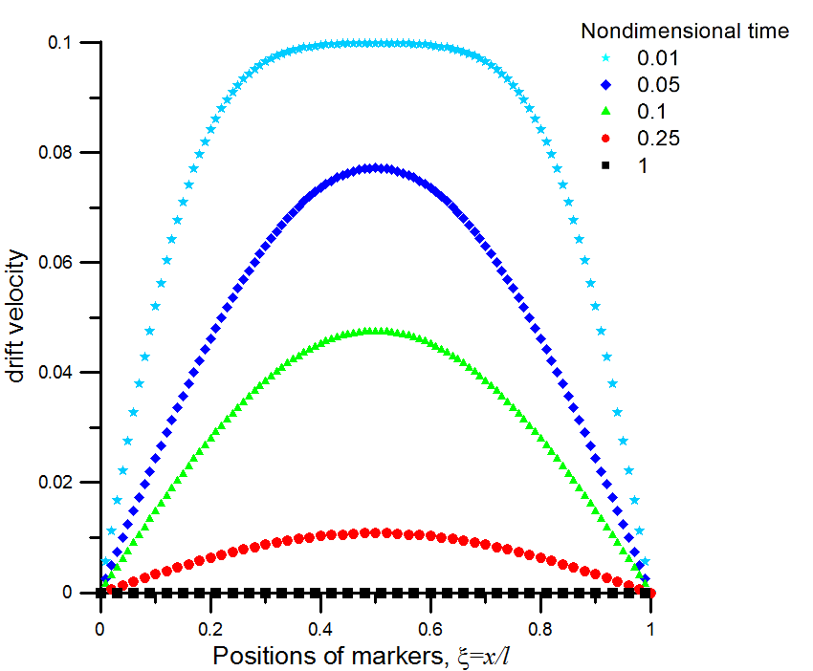
Figure 1. The nondimensional velocity of markers drift as a function of nondimensional coordinate when both ends are fixed. Nondimensional time is introduced as

- One end fixed, another – free:
  - Left (anode) end fixed, right (cathode) end free: .
During the nonstationary period (transition period to steady-state) the markers move, so that initial markers array will continue redistributing, gathering near the cathode end, . Fig. 2.
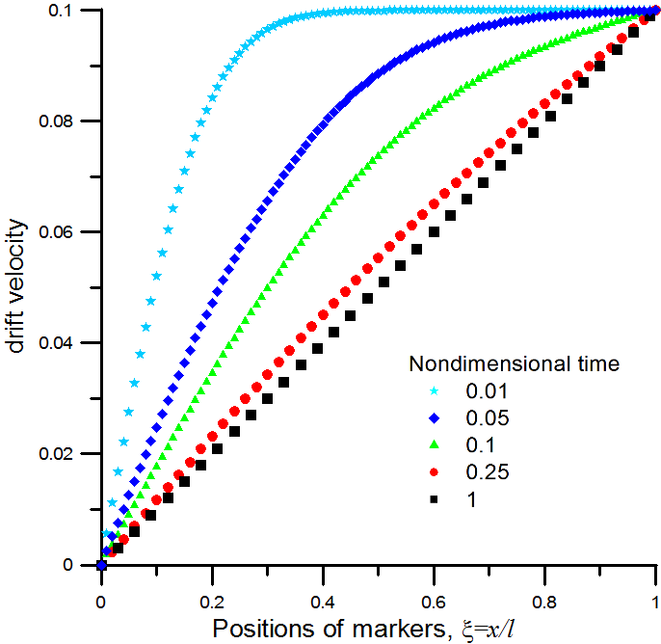
Figure 2. The nondimensional drift velocity at various time moments in the case of left (anode) fixed end and right (cathode) free end.

Markers will move to the right (cathode) end – the closer to the end – the faster. At the end of the day all markers should gather near the cathode end.

  - Left end free, right end fixed:;
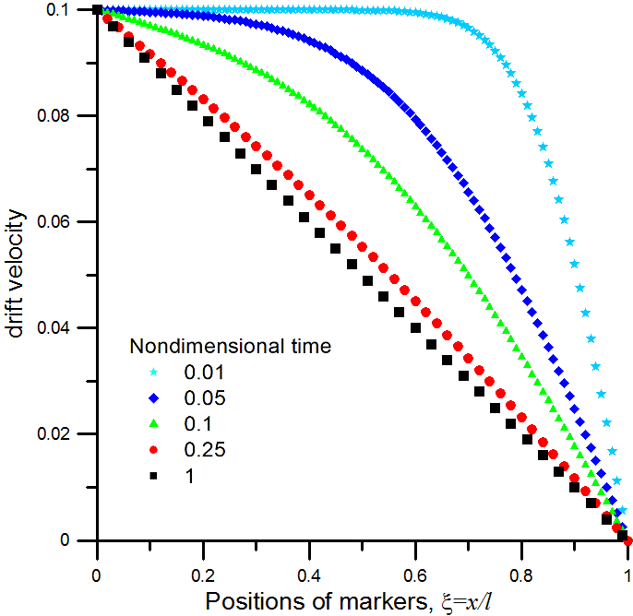
Figure 3. The nondimensional drift velocity at various time moments in the case of left (anode) free end and right (cathode) fixed end.

Markers will move from the left (anode) end to the right (cathode) end – the closer to the cathode end – the slower.

- Both ends “almost” free: . The relative shift does not depend on position as can be seen from Eq. :
.
The last (exotic) case is the simplest one (although difficult for experimental realization): there is no backstress at all, only lattice drift according to Eq. . Strictly speaking, electric current provides the total force upon the wire, so that for an external observer the sample should have acceleration (if to forget about forces at the contact with connecting wires, etc.).

- Electromigration in pure metal with account of nonequilibrium vacancies.
So far we considered the case of powerful vacancy sinks-sources providing equilibrium vacancy concentration anywhere anytime. In reality the power of vacancy sinks-sources can be taken into account by introducing the mean vacancy migration path L_{V} and corresponding vacancy relaxation time, . If one neglects correlation factor, then .
Basic equations:
,
,
,
,
,
,
.
Very similar case was analyzed by Kirchheim in 1992 [] but he did not use the sinks/source term for calculation of lattice drift.

- Electromigration in two-phase alloy (solder) under condition of local quasi-equilibrium between phases.
Let us consider the two-phase fine-grained alloy (mixture) α + β with small solubility of A in β-phase and of B in α-phase. The main equations for interdiffusion fluxes in the bi-velocity form (include the Darken drift of the material) are
,
.
Here has different interpretations for different external driving forces. For example [], in case of electromigration ( is a partial effective charge of B-ions under electron wind), in case of thermomigration , where is a partial heat of transport for B-atoms. In the case of artificial gravitation (e.g., centrifuge) .
Multiplying Eqs. and by corresponding atomic volumes we obtain equations in terms of volume fractions :
Summation of and together with constraint of fixed volume gives:
Condition in our one-dimensional problem with zero fluxes and gradients at infinities gives:
.
Substitution of Eq. into Eqs. and gives:
and, to conservation of matter and volume,
.
On the other hand, divergence of drift velocity determines the rate of stress changes according to Eq. (4). Combining Eqs. (4) and (13), one gets:
Equations and give a self-consistent set of coupled equations of Burgers type for atomic fraction and of diffusion type for stress. Exact solution can be obtained basing on implicit difference methods for differential functional equations []. Numeric solution of these two coupled equations should give the time evolution of the spatial separation of phases and the redistribution of stresses. The computer implementation was based on the steady state approximation for the stress. In such a case Eq. becomes:
,
thus

.
The initial phase fractions are constant for every x. The steady state pressure profile is presented in Fig. 4.
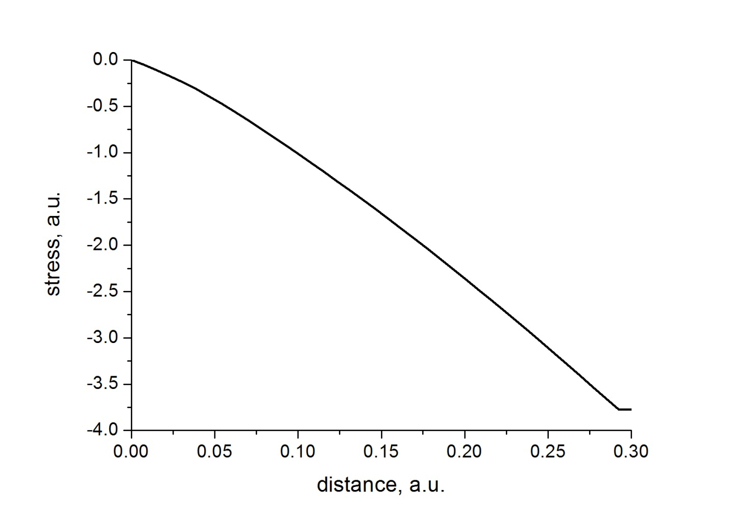
Figure 4. The nondimensional steady state stress distribution

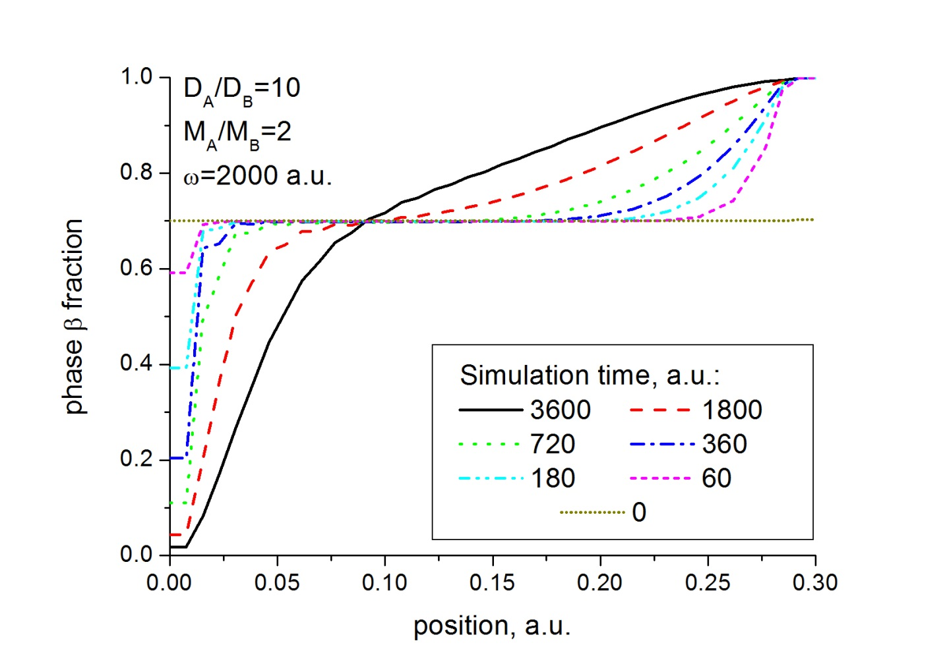
Figure 5. The evolution of the phase fractions in the two-phase zone of the binary alloy during the sedimentation process.
During the time interval of getting to asymptotic regime the two-phase zone evolves. On the left end of the material the pure β-phase is accumulated. The magnitude of redistribution depends on the external force and the difference in components atomic masses. During the asymptotic regime all markers are immovable.

- Summary
Simultaneous action of backstress and of Kirkendall shift during electromigration in pure metals and in two-phase mixtures was described by self-consistent scheme.
The phenomenological model of electromigration in the two-phase alloy (solder) under condition of the local quasi-equilibrium between phases was formulated. The mass transfer occurs under the combined mechanisms of the Kirkendall effect, backstress and external force (sedimentation). The different models of electromigration in pure metals under condition of quasi-equilibrium vacancies (unlimited power of vacancy sinks-sources) and electromigration in pure metal with account of nonequilibrium vacancies were presented.
In this work we neglected an effect of vacancy concentration on molar volumes and the hydrostatic tension was approximated as a one-third of Spur of stress tensor. The presented formalism allows can be extended to avoid above simplications.
Acknowledgements:
This paper is dedicated to memory of Prof. Vitaliy Slezov, who passed away on October 30, 2013. His ideas and rigorous mathematical treatments of the diffusion-controlled first-order phase transformations kinetics (from nucleation to coarsening) are now classical. Discussions with him were very useful for better understanding of stresses-vacancies-Kirkendall synergy. This work is supported by a National Science Center (Poland) decision no. DEC-2011/02/A/ST8/00280. One of authors (AG) is grateful to AGH University for hospitality and also to Ministry of Education and Science of Ukraine and to Ukrainian State Fund for Fundamental Research for partial support.

References

Authors are not aware about such experiments with aluminum or copper lines.
We emphasize this since in some experimental papers authors use both Eqs. and , and that is wrong.
[?] Darken, L. S., (1948) Diffusion, Mobility and Their Interrelation through Free Energy in Binary Metallic Systems, Trans. AIME, 174:184-201.
[?] Schwarz, K. E. (1940) E1ektrolytische Wanderung in flussigen und festen Metallen. J. A. Barth Verlag, Leipzig..
[?] Blech, I. A. (1976) Electromigration in thin aluminum films on titanium nitride, J. Appl. Phys. 47:1203-1208.
[?] Blech, I. A., Nabarro, C. (1976) Stress generation by electromigration, Appl. Phys. Lett., 29:131-133.
[?] Tu, K-N, J. W. Mayer and L. C. Feldman (1992) Electronic Thin Film Science for Electrical Engineers and Material Scientists. Macmillan Publishing Company, New York.
[?] Tu, K-N (2007) Solder Joint Technology: Materials, Properties and Reliability. Springer.
[?] Smigelskas, A. D., Kirkendall, E.O.(1947) Zinc Diffusion in Alpha Brass, Trans. AIME 1947, 171:130−142.
[?] Bardeen, J., Herring, C., Diffusion in alloys and the Kirkendall effect, in Imperfections in Nearly Perfect Crystals, ed. W. Shockley, (Wiley, New York 1952) pp. 261-288.
[?] Zeng, K. and K.N. Tu (2002) Six cases of reliability study of Pb-free solder joints in electronic packaging technology, Materials Sci. and Eng.: R: Reports, 38:55–105.
[?] Lee, T. Y. K. N. Tu and D. R. Frear, J. (2001) Electromigration of eutectic SnPb and SnAgCu flip chip solder bumps and under-bump metallization, J. Appl. Phys. 90:4502-4508.
[?] Gan, H. W.J. Choi, G. Xu, and K.N. Tu, (2002) Electromigration in solder joints and solder lines, JOM 54(6): 34-37.
[?] Tu, K. N.(2003) Recent advances on electromigration in very-large-scale- integration of interconnects, J. Appl. Phys. 94: 5451-5473.
[?] Liang, S. W., Hsiang-Yao Hsiao, Chih Chen, Luhua Xu, K.N. Tu, and Yi-Shao Lai (2009) Nonuniform and negative marker displacements induced by current crowding during electromigration in flip-chip Sn-0.7 Cu solder joints, J. of Electronic Mat., 38: 2443-2448.
[?] Nah, J. W., F. Ren, K. N. Tu, S. Venk, and G. Camara (2006) Electromigration in Pb-free flip chip solder joints on flexible substrates, J. Appl. Phys. 99:023520 - 023520-6
[?] Ye, H., C. Basaran and D. C. Hopkins (2003) Mechanical degradation of microelectronics solder joints under current stressing, Int’l J. of Solids and Str. 40: 4021–4032.
[?] Lin, M., C. Basaran (2005) Electromigration induced stress analysis using fully coupled mechanical–diffusion equations with nonlinear material properties, Comp. Materials Sci. 34: 82–98.
[?] Zhang, X. F., J. D. Guo and J.K. Shanga (2007) Abnormal polarity effect of electromigration on intermetallic compound formation in Sn–9Zn solder interconnect, Scripta Mater. 57: 513–516.
[?] Lu, Y. D. X.Q. He, Y.F. En and X. Wang (2008) Failure mechanism of electromigration in solder joint, Adv. Mat. Research, 44-46: 905-910.
[?] Chen, Ch., H.M. Tong and K.N. Tu (2010) Electromigration and Thermomigration in Pb-Free Flip-Chip Solder Joints, Ann. Rev. of Mater. Research, 40:531-555.
[?] Holly, K. and M. Danielewski (1994) Interdiffusion and free-boundary problem for r-component (r≥ 2) one-dimensional mixtures showing constant concentration, Phys. Rev. B, 50: 13336-13336-20.
[?] Pharr, M., K. Zhao, Z. Suo, Fan-Yi Ouyang, and P. Liu (2011) Concurrent electromigration and creep in lead-free solder, J. of Appl. Phys. 110: 083716-083716-9.
[?] Turlo, V. V., A.M. Gusak and K.N. Tu (2013) Model of phase separation and of morphology evolution in two-phase alloy, Phil. Mag., 93: 2013–2025.
[?] Wierzba, B. and M. Danielewski (2011) Entropy production during interdiffusion under internal stress, Phil. Mag. 91: 3228-3241.
[?] Kirchheim, R.(1992) Stress and electromigration in Al-lines of integrated circuits, Acta Metallurgica 40: 309–323.
[?] Gusak, A. M. et al (2010), Diffusion controlled solid state reactions. Wiley VCH, Berlin,Weinheim.
[?] Sapa, L. (2013) Implicit Difference Methods for Differential Functional Parabolic Equations with Dirichlet's Condition, Zeitschrift fuer Analysis und ihre Anwendungen, 32: 313–337.

