Spatial perception and the sense of touch

Patrick Haggard (1) (2), Tony Cheng (2) (3), Brianna Beck (1), and Francesca Fardo (1) (4)

Affiliations
- Institute of Cognitive Neuroscience, University College London
- Institute of Philosophy, School of Advanced Study, University of London
- Department of Philosophy, University College London
- Danish Pain Research Centre, Aarhus University
Keywords
Touch, Perception, Tactile field, Space

Abstract
It remains controversial whether touch is a truly spatial sense or not. Many philosophers suggest that, if touch is indeed spatial, it is only through its alliances with exploratory movement, and with proprioception. Here we develop the notion that a minimal yet important form of spatial perception may occur in purely passive touch. We do this by showing that the array of tactile receptive fields in the skin, and appropriately relayed to the cortex, may contain the same basic informational building blocks that a creature navigating around its environment uses to build up a perception of space. We illustrate this point with preliminary evidence that perception of spatiotemporal patterns on the human skin shows some of the same features as spatial navigation in animals. We argue (a) that the receptor array defines a ‘tactile field’, (b) that this field exists in a minimal form in ‘skin space’, logically prior to any transformation into bodily or external spatial coordinates, and (c) that this field supports tactile perception without integration of concurrent proprioceptive or motor information. The basic cognitive elements of space perception may begin at lower levels of neural and perceptual organisation than previously thought.

Introduction
Most animals must interact with spatially complex and dynamic environments in order to survive. For example, an animal may navigate through a forest, carefully avoiding some objects, while carefully intercepting others. This ability requires an appropriate sensory apparatus, and the cognitive capacity to interpret the afferent signals into relevant information about the spatial arrangement of its own body within the wider environment. Theoretical (Gibson, 1966; O’Regan & Noë, 2001) and experimental studies (Dupin & Wexler, 2013) have largely focussed on visually-guided self-motion. However, the same logic applies also somatosensory systems. Sensory endings on the skin, and internal to the musculoskeletal system, can specify whether an object is touching the body, along with how and where it is touching. Indeed, bumping our bodies against external objects provides a primitive experiential evidence for realism about the external world. Johnson’s “I refute it thus” to Bishop Berkeley comes to mind.

Here we consider the computations and representations involved in spatial perception on the skin. Classically, cognitive psychology has emphasised that somatosensory spatial information must be transformed into external spatial coordinates for the purposes of functional interaction. For example, Longo and colleagues proposed an additive model in which a stimulus is first localised on the receptor sheet of the skin, then the skin is localised on the body, and finally the body is localised in space (Longo, Mancini, & Haggard, 2015). Proprioceptive information about limb positions in space, encoded in a representation sometimes called the “body schema” (Paillard, 1999), plays a crucial role in this second transformation. Taken together, this set of computations would allow, for example, a reaching movement towards the somatosensory stimulus, as when we swat a mosquito that has alighted on the thigh or the cheek. Studies of tactile remapping suggest that the transformation from localisation on the skin to localisation in external space is rapid, and automatic (Azañón, Camacho, & Soto-Faraco, 2010). Thus, the dominant interest in the field has been in representation of egocentric external space.
In contrast, the spatial perceptual capacities supported by the skin itself have been relatively neglected. Head and Holmes (1911) introduced the concept of a “superficial schema”, which they defined as “a central mapping of somatotopic information derived from tactile information”. However, this concept received relatively little attention in their experimental work. They proposed two-point discrimination thresholds as a marker of the acuity of the superficial schema, but they did not otherwise describe the forms of spatial perception that the superficial schema might support. In this chapter, we aim to redress this balance by reconsidering the spatial perceptual capacities supported by the skin itself, due to the transmission of skin signals to the the cortex to provide a representation of “skin-space”. We focus particularly on whether such a skin-space could suffice for truly spatial percepts caused by tactile stimulation, logically prior to and independent of any representation of the body parts on which the skin lies, or of the position of those body parts in external space. In Jose-Luis Bermudez’ terms (chapter 6, in this volume), we ask whether a description in terms of A-locations may be sufficient to credit an animal with spatial somatosensory perception, in the absence of B-locations.

In developing the idea of skin-space, the concept of a ‘sensory field’ becomes important. Like most philosophers, P. F. Strawson believes that it makes sense to postulate a “visual field” for vision. Spelling out the natureexact nature of the visual field remains a matter of controversy (e.g., Peacocke 1983). Strawson is more sceptical about sensory fields in other modalities, such as the auditory field and the tactile field: “Evidently the visual field is necessarily extended at any moment, and its parts must exhibit spatial relations to each other. The case of touch is less obvious: it is not, e.g., clear what one would mean by a ‘tactual field’” (Strawson, 1959, p. 65; O’Shaughnessy, 1989 and Martin, 1992 further develop this line of thought. For a recent discussion of the auditory field, see Soteriou, 2013). We will come back to this towards the end of this chapter. In what follows we turn to some models of space perception developed by Jean Nicod, because they seem particularly applicable to touch.

What cognitive capacities must an organism have for us to attribute spatial perception to it? Jean Nicod (1970) imagined a creature capable of hopping a fixed distance along a manifold similar to a piano keyboard (see Fig. 1 for an illustration). Landing on each key would produce a musical tone that the creature could hear. Nicod argued that, three primitive cognitive operations would suffice for this creature to have spatial perceptions of its world. First, the creature must grasp the notion of succession (Fig. 1A). That is, hop B comes after hop A, but before hop C. If By cumulatively counting successive hops, the creature can represent that locations A and B are spatially adjacent, that B and C are adjacent, but that A and C are not. In essence, it perceives the relative spatial positions of locations on the keyboard via the temporal order of its own hopping movements. Second, the creature must grasp the notion of resemblance (Fig. 1B). That is, if it can notice that the tone generated by the current hop is identical to a tone it is heard before, it can represent that it is in a previously-visited location. In psychology, this seems to correspond to the distinctive sensory quality associated with each location, or local sign (Lotze, 1884). Finally, the creature must have at least a binary sense of direction (Fig. 1C). In the example above, to grasp that A and C are non-adjacent, it must know whether it has changed direction between two successive hops, or not. That is, direction information is required in order to transform succession into adjacency. Succession, then, involves counting hops. Resemblance involves identifying a specific event with the outcome of a hop, and direction defines the relation between each hop and the one before it. Armed with these three primitives of succession, resemblance and direction, the creature can proceed to compute all the key features of spatial perception, such as distance, interposition, and extrapolation. There is a striking resemblance between Nicod’s creature and the modern neuroscientific concept of a rat acquiring place and grid-cell coding of location as it moves through its environment (O’Keefe, 1994). Interestingly, in Nicod’s own work, succession and resemblance were handled separately from direction. Succession and resemblance were used by the creature on the piano keyboard to provide an ‘external’ perception of space, while direction and resemblance were used by a second creature that acquires an ‘internal’ perception of space from kinaesthetic cues generated as it walks outward from a reference point, reverses its direction, and then retraces its steps. Here we have deliberately conflated Nicod’s two creatures. In our view, neither creature alone would have true space perception, while a hybrid of the two would. Moreover, the three cognitive capacities do, as a matter of biological fact, tend to co-occur in mammalian brains. A discussion of the different contributions of succession, resemblance and direction to space perception is beyond our current scope.
Sources and organisation of afferent information from the skin

Individual mechanoreceptor endings and corpuscles are distributed throughout the human skin. Their density is not uniform, with the density being much higher on skin regions such as the fingertips and lips, producing the characteristic distortion of the somatosensory representation of the contralateral side of the body in the postcentral gyrus of each cerebral hemisphere (the so-called Penfield map, Penfield & Rasmussen, 1950). However, for our purposes, it is the regularity of receptor distribution that matters, rather than the density. The mechanoreceptors effectively cover the skin in an array of sensitive patches, which we can conceptualise as the squares of a chessboard. Each mechanoreceptor projects via an afferent neuron to the spinal cord, and thence via higher order projections neurons to the dorsal column nuclei, thalamus, and somatosensory cortex (Mountcastle, 2005). Neurons at each stage in the somatosensory pathway have a receptive field (RF). This term refers to the region of skin to which a neuron is responsive, in virtue of receiving afferent impulses from the mechanoreceptor located there.
We argue that the human skin can be viewed as a reversed, yet isomorphic version of Nicod’s creature hopping between the keys of the piano keyboard. The RFs of cortical somatosensory neurons have the same status as the piano keyboard environment in Nicod’s thought-experiment, and a tactile stimulus moving across the skin has the same status as Nicod’s hopping creature. The sensory apparatus is inside the creature in Nicod’s case, but in the array of skin RF’s in our case. Nevertheless, either arrangement has the capacity to signal succession, resemblance or local sign, and direction. Thus, the case of an animal navigating its environment, and the case of perceiving location on a sensory sheet, seem isomorphic, and epistemically equivalent, even though the representational intentionality is different in each case. That is, Nicod’s creature is an object that can form a representation of its environment, while the skin is a sensing environment that can form representations of objects that encounter it.
Our view of skin-space based on an inversion of Nicod’s argument is equivalent to postulating a “tactile field” defined by the array of skin RFs. To quote Haggard and Giovagnoli “the tactile field supports computation of spatial relations between individual stimulus locations, and thus underlies tactile pattern perception…” (Haggard & Giovagnoli, 2011, p. 65-6 - more on this in the final section). We now describe how the array of skin RFs can underpin tactile spatial perception.

In Nicod’s example, the relative position of one piano key to another is an objective spatial fact about the external world. The creature is able to learn these spatial facts because it can process information about succession, resemblance and direction. In the case of skin RFs, it is an objective fact that two specific afferent neurons have adjacent RFs on the skin. However, the adjacency of RFs is not transparent, in the way that the successive hops of Nicod’s creature may be transparent. An animal using the skin for spatial perception must somehow discover or infer that firing in two specific cortical neurons in fact refers to adjacent skin regions. Although many textbooks blandly assume that somatotopic mapping offers a sufficient explanation of spatial perception, we argue that this is not so. Rather, true spatial perception using the somatosensory system requires an additional level of representation, namely information about the relation between cortical neurons and the location of their RFs on the skin. The animal must learn the relation between signals arriving at the cortex and locations on the skin surface, which has classically been termed local sign (Lotze, 1884).
Classical local sign theory suggests that this relation is learned through the association between the unique sensory quality that accompanies stimulation of each RF and the orienting movements required to reach or saccade towards the location of the RF in external space. In essence, perception of space and location reduces to the movements needed to reach a target. This seems to work quite well for Nicod’s creature: it learns the location of a particular key on the piano keyboard because it learns that, say, 3 hops in one direction are required to produce a particular tone. However, this reduction of space perception to movement coding seems to work much less well for our animal trying to establish spatial perception through the skin. In particular, I may not be able to make the relevant motor orienting response: I cannot saccade to skin locations on my lower back, and I can scratch there only with difficulty. A strict local sign theory suggests that spatial perception without (potential) orienting movement is impossible. However, spatial pattern perception on skin regions that are rarely or never targets for orienting movement can be surprisingly good (Duke, 1965).

Here, we suggest another possible mechanism that could provide information about RF locations. The statistics of natural interactions with the environment ensure that continuous movement of a stimulus across the skin is a frequent input pattern. For example, a creature that crawls or hops along the arm will stimulate successive afferent neurons in a consistent spatiotemporal pattern. A parent who strokes the arm of their infant will activate a similar pattern in the infant’s brain, as will a leaf that one brushes against while walking in a forest. The consistent patterns of stimulation provided by these common events means that neurons with adjacent RFs will tend to fire in an ordered series. That is, one could learn the spatial adjacency between RFs from the temporal order of afferent signals, due to the average statistics of natural motion – rather than from the temporal order of one’s own movements as in the case of Nicod’s creature. Furthermore, neurons with adjacent RFs will fire in close temporal proximity, strengthening the synaptic weights between the corresponding neurons by Hebbian learning (Hebb, 1949). Lateral inhibitory mechanisms between cortical neurons further sharpen the spatial acuity of skin sensation (Laskin & Spencer, 1979). Therefore, when a stimulus moves across the skin, the pattern of information across multiple afferent neurons allows the spatial path across the skin to be perceived. Importantly, this mechanism of spatial perception does not depend on transforming the RF location into egocentric spatial coordinates. In particular, there is no need to transform skin location into an implicit egocentric orienting-movement, as suggested by local sign concepts of space perception. In fact, spatial perception is possible without any spatial reference frame beyond the skin itself. This form of spatial perception is consistent with Head and Holmes (1911) concept of a superficial schema as “a central mapping of somatotopic information derived from tactile information”. The view that superficial schema suffices for spatial perception contrasts strongly with the ‘orthodox’ view that tactile stimuli are rapidly and obligatorily transformed into external spatial coordinates.

We have shown that core computations underlying spatial perception of the skin are consistent with the general project of sensory grounding of geometry (Nicod, 1924), with one striking difference. The striking difference between our concept of skin space and Nicod’s navigating creature lies in the role of self-motion. Most accounts of sensory geometry, including Nicod’s are based on real or imaginary self-generated movement: the animal must move through the environment, or move its body parts with respect to the environment. In contrast, our concept of skin space does not seem to require this. All that is required is a natural distribution of motions of objects across the skin. These may be caused by the animal’s motions relative to the environment, but they may equally be caused by motion of the environment relative to the static animal.

Testing the idea of skin space
In this section we investigate whether the skin space mechanisms described above contribute to human perception. This is not straightforward: how can we know whether any particular spatial judgement arises from skin space perception alone, or also depends on transforming skin space locations into an external frame of reference such as egocentric space? How can transformation into external egocentric space be excluded? In principle, if Head and Holmes were correct in positing a superficial schema (which we take to be synonymous with our concept of skin space) distinct from the body schema, some unfortunate natural accident should have produced patients whose symptoms amount to a double dissociation. For example, a patient with damage to the superficial schema might not know the locations of stimuli on the skin, but might nevertheless be able to control orienting responses towards the location of the stimulus in external space. The “blind touch” patients described by Paillard et al. (1983) and Rossetti et al. (1995) may seem, to have such a superficial schema deficit. These patients appear to know the location of touches that they do not consciously perceive, . The main negative symptom resulting from the putatively-damaged superficial schema might thus be the failure to perceive that they have been touched – tactile imperception. However, simply detecting touch does not involve any spatial information, so these cases cannot prove that the superficial schema is necessary for spatial perception. In addition, careful studies failed to confirm in healthy volunteers the dissociation between tactile detection and tactile localisation observed in these neurological cases (Harris, Thein, & Clifford, 2004).

Here, we take a different approach to identifying the contribution of skin space to spatial perception. Again, we begin with the isomorphism between a tactile stimulus traversing the RF array on the skin, and Nicod’s creature navigating its environment. In research on animal navigation, the gold standard test that an animal forms a spatial representation of its environment, as opposed to merely orienting towards cues, is the ability to take appropriate shortcuts. The classic behavioural manifestation is a behaviour known as “path integration” (Mittelstaedt & Mittelstaedt, 1980), or dead reckoning. In path integration situations, an animal moves from a home location to a new location via an indirect path, and now wishes to return home. It can, of course, retrace its steps, and follow its original outwards path in reverse, or it can make a straight line back towards the home location. The former behaviour does not require any spatial representational ability at all: the animal could be replaying its outwards movements in reverse order from a motor memory, or it could be following a sensory trail laid on its outward journey. However, the latter behaviour is taken to imply that it computes the position of the home relative to the final position. It is thus able to situate locations it has visited within a map of external space, and use this map to select the optimal homing behaviour. The spatial map is built up by integrating information about the animal’s current heading direction, and its self-generated movement (Etienne & Jeffery, 2004; Müller & Wehner, 1988).

We speculate that a mechanism of path integration operates in skin space (Fig. 2). When a stimulus traces a path across the skin, knowledge of the adjacency relations for the RFs that it stimulates will suffice to compute the position of the end of the path relative to the beginning, just as the homing animal does. The problem is that other mechanisms can also calculate the homing path. For example, the animal could transform the start and end locations into egocentric external coordinates. It could then interpolate a reaching movement from the end location to the start location, and trace the direct line of the homing path. Interestingly, however, animals that perform path integration generally show a characteristic error: the homeward path shows a slight understeer, or bias towards the outward path. The reasons for this error are disputed. On one view, it results from a weighted averaging of the direction information on the outward path (Müller & Wehner, 1988). On another view, it is a strategic adaptation that minimises the risk of missing the home location. Understeer ensures that the animal crosses its outward path on the return journey, at which point it can benefit from memory cues to ensure the final approach (Etienne & Jeffery, 2004). In any case, the understeer error is considered a universal feature of animal navigation, since it is shown by dogs, humans, rodents and insects (Fig. 3).

We therefore investigated whether perception of tactile spatial patterns on the human skin involved the systematic bias towards the outward path that characterises understeer errors in path integration. The full results are reported elsewhere (Fardo, Beck, Cheng, & Haggard, n.d.). Here, we give a brief summary of the concept of the experiment, and its significance for the concept of skin space. Briefly, S-shaped patterns were traced on the hand dorsum of healthy participants using a haptic robot. The patterns varied randomly in their start and end locations. The S shapes consisted of a larger and a smaller convexity, and the locations of these were also randomised. A set of illustrative spatial paths are shown in Fig. 4. The participant’s task was to attend to the S-shaped tactile pattern, and then, after a short delay, to point to a location on the skin exactly midway between the start and endpoints of the S-shape just experienced. The computations involved are analogous to those of path integration by a navigating animal. Importantly, the true bisection point was never on the original S-shape itself. The locations of each bisecting response were recorded and analysed. In this task, understeer error corresponds to a constant error, or bias towards the major convexity of the S shape, since this constitutes the major deviation of the outward path. We averaged over all other factors, such as the start and end locations, direction and location of the major convexity. We found a small but significant overall bias towards the major convexity, indicating that the outward spatial path influenced the perceived vector between start and end points (Fig. 5). The direction and magnitude of this error were consistent with understeer errors in path integration. We interpret this error as a consequence of using a skin-space representation, based on integrating successive transitions of the stimulus across adjacent RFs, to form a spatial percept of the stimulus as a whole. Of course, this error could possibly also be explained by other factors, such as a shift of spatial attention towards the spatial centre of mass of the S-shape. These alternative explanations will require explicit testing in further experiments. However, the bisection error cannot readily be explained in terms of transformation of skin locations into egocentric external coordinates. In our data, we also found two characteristic patterns of bisection errors linked to egocentric spatial localization. We found an overall radial bias to bisect towards the radial (thumb) side of the hand. We also found an overall distal bias, shifting the bisection point away from the wrist and towards the fingertips. Both of these have been reported previously (Mancini, Longo, Iannetti, & Haggard, 2011). Importantly, they are independent of the bias induced by the S-shaped path on the skin.

Field organisation, modality and perception
The notion of a tactile field has important implications for both psychological theory, and for philosophy of perception. Our starting point has been Nicod’s account of space perception. His view is interestingly similar to though not exactly the same as P. F. Strawson’s view in chapter 2 of Individuals (1959). There Strawson imagines a “no-space” world. Strawson probes the plausibility of the Kantian thesis that “space is a necessary condition for objective experience” (Evans, 1980, p. 250). Strawson concludes that space or idea of space is not necessary, because a continuous “master sound” can serve as an analogy of space, though Evans (1980) found that the master sound concept was neither helpful, nor even necessary. A detailed discussion of this topic is beyond the scope of this piece. Evans instead proposed a “travel-based space”. This is similar to Nicod’s and our thinking (ibid., p. 255, 283) in two ways. First, both notions require movement of an observer relative to one or more environmental objects. In Evans and Nicod’s formulation, the observer moves relative to objects that remain static, such as the piano keys. In our skin-space model, the stimulus object moves relative to an ‘environment’ of sensory transducers in the skin. Second, we emphasised the spatial adjacency of RFs as the starting point of spatial perception. As an object impinges on an ordered series of RFs, one may extract the relation between one RF and another, though not the absolute location of any RF, whether stimulated or not. However, relative RF positions may suffice for perceiving spatial patterns.

Furthermore, what we offered above can be seen as a response to Strawson on sensory fields: there is a clear sense of a tactile field that is sustained by skin-space. In particular, tactile RFs form the ‘parts’ of an extended sensory field. Not only do these parts have specific spatial relations to one another as a matter of anatomical fact, but the natural statistics of typical motions across the field allow these spatial relations to be learned, and exploited for spatial perception. Thus, postulating a tactile field not only helps in explaining relevant behavioural data, but also has a plausible physiological underpinning.

Now finally, we would like to say a bit more about the explanatory value of our concept of a tactile field defined on the skin. To reprise, the crucial explanatory power of it is to explain the relavant behavioural data. The tactile field concept has two further roles. First of all, it can help us individuate the senses: the Aristotelian conception of five senses is the traditional classification, but it has proven to be unsatisfactory for various reasons (Macpherson 2011). Within the somatosensory system, researchers distinguish between the nociceptive system, the thermal system, and the tactile system. In this work we have shown that we need to postulate a sensory field in the tactile case. However, other studies suggest that nociceptive and thermal senses have quite different spatial properties, and may lack a field-like organizing principle (Mancini, F., Stainitz, H., Steckelmacher, J., Iannetti, G. D., and Haggard, P., 2015, Marotta, A., Ferrè, E. R., and Haggard, P., 2015). Having a sensory field or not might constitute a partial reason for discriminating between different sensory channels (Cheng, 2015), and thus provide a logical starting point for modality individuation.

Second, our field-based view of tactile object perception might be a nice supplement to the constancy-based view of object and objective perception, which has gained its currency in the recent philosophical literature (Smith 2002, Burge 2010): on their view, perceptual constancy is a basis of object perception. For Burge, the characteristic feature of object constancy is “a capacity to track objects perceptually – where tracking requires coordination of perception with perceptual memory and perceptual anticipation” (Burge, 2011, p. 125). Fulkerson (2014) also emphasizes the importance of object perception in the case of touch. For him, what makes touch a single sense is the way that multiple tactile sensations, or features, are bound to produce a representation of a single perceptual object. In the above discussions, we have been able to describe how people have a spatial perception of an object moving across the skin, using only the basic properties of receptors. This can be part of the explanation of perceptual constancy in touch, if we take perceptual constancy in a loose, minimal sense of spatiotemporal continuity. We have described the perception of stimuli that move continuously across the skin. We have not directly investigated whether people perceive our stimuli as one and the same object, but it seems reasonable that they do. That is, the object touching RF1 at time t1 is assumed to be the same object as that touching adjacent RF2 at time t2. Indeed, in cases of apparent tactile motion, a series of discrete tactile contacts is perceived as a continuous motion of a single stimulus (Carter, Konkle, Wang, Hayward and Moore, 2008), suggesting that spatiotemporal continuity is an important prior in tactile perception. However, this kind of spatiotemporal continuity implies a a different, and perhaps thinner, notion of object constancy than may be intended by Burge. Textbook examples of perceptual constancy generally refer to primary properties of objects, such as shape, size and colour. Our view thus supplements Burge’s perspective, since any constancy constraint in our approach is limited to a spatiotemporal continuity of the stimulus object. In Burge’s work, the focus has generally been on vision, which affords a much richer object-based content than the passive touch studied here. In our view, if there is any perceptual constancy at all, it seems to derive from the field-like organization of the receptor-based sensory apparatus, rather than from any elaborated representation of an object having specific perceptual properties. Our approach opens the intriguing possibility that field-based organization is sufficient for the minimal form of perceptual constancy linked with spatiotemporal continuity, and that this mimimal form of perceptual constancy may occur without rich representation of object properties.

Conclusions
To conclude, we have argued that some somatosensory spatial perceptual capacity may be based on skin-space, rather than on the more familiar frames of reference defined by body-parts, by orienting movements, or by stimulus location in external egocentric space. We do not deny that tactile information can be, and most frequently is, transformed into external spatial coordinates. However, the core features of spatial perception may be found already in the array of RFs in the skin. If correct, our position has several interesting perceptual consequences. First, it emphasises the strong isomorphism between perceiving stimuli on the receptor surface, and perceiving one’s location in the environment during navigation. Second, it replaces the motoric solution to the local sign problem with a physics-based solution, reflecting learning about spatial adjacency through natural statistics of environmental motion. Third, it implies the existence of a “tactile field” (Martin, 1992) that does not depend on the body as either volumetric object, or locus of orienting movements. It would seem fruitful to consider whether the spatial perceptual capacity that we have considered for skin might apply to other receptor surfaces, notably the retina.

Acknowledgements
PH acknowledges generous support from a donation by Shamil Chandaria to School of Advanced Study. This research was further supported by ERC Advanced Grant HUMVOL (agreement number 323943). The article benefitted from PH’s fellowship at the Paris Institute for Advanced Studies (France), with the financial support of the French State managed by the Agence Nationale de la Recherche, programme “Investissements d’avenir”, (ANR-11-LABX-0027-01 Labex RFIEA+). FF was supported by EU FP7 Project VERE WP1 and by Novo Nordisk Foundation (number NNF14OC0011633). BB was supported by an MRC grant (number MR/M013901/1) to PH.

We are grateful to Colin Blakemore for advice and discussion.

FIGURES
Fig. 1
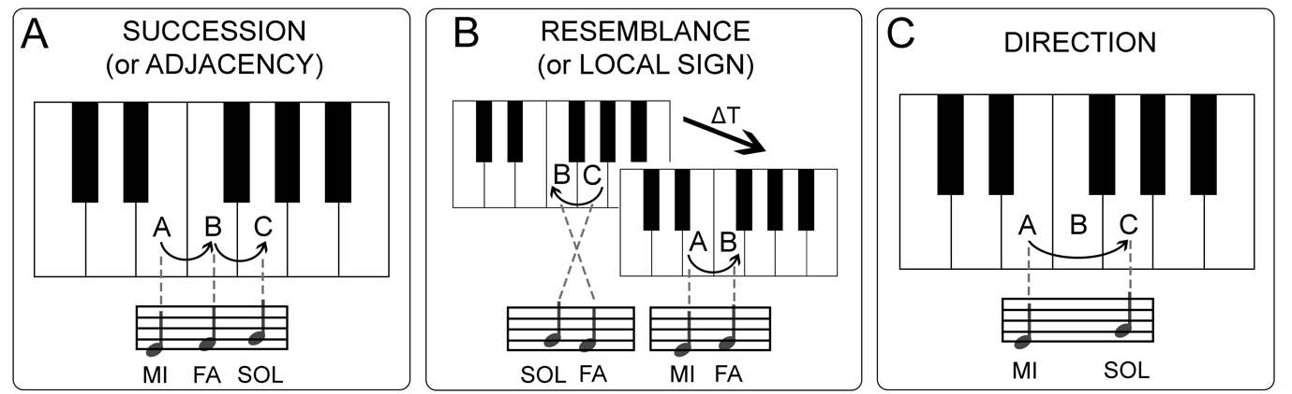

Fig. 1. Illustration of the three primitive cognitive operations underlying the spatial perception of the world, postulated by Jean Nicod (1924). A) The notion of succession refers to the cumulative counting of successive movements and allows the learning of spatial adjacency between A and B, B and C. B) The notion of resemblance refers to the ability to learn specific associations between locations and sensory qualities (e.g., the location A is associated with the sound “MI”). This concept is similar to the local sign mechanism proposed by Lotze (1884). C) Finally, the notion of direction allows the creature to perceive the relation between one hop and the next: whether the second hop is a repetition or a reversal of the first.

Fig. 2

Fig. 2. A) Illustration of a moving stimulus in skin-space (S-space). The skin surface contains a mosaic of receptive fields that are arranged like the cells of spreadsheet, or the pixels of a screen. When an object moves on to the skin, it activates a pattern of adjacent receptive fields depending on the motion direction. The central nervous system might leverage the natural statistics of adjacent RFs to represent a map of the S-space. B) This map can support the computation of spatial relations, such as the inference of the direct path between two points via a novel route (i.e., path integration).

Fig. 3
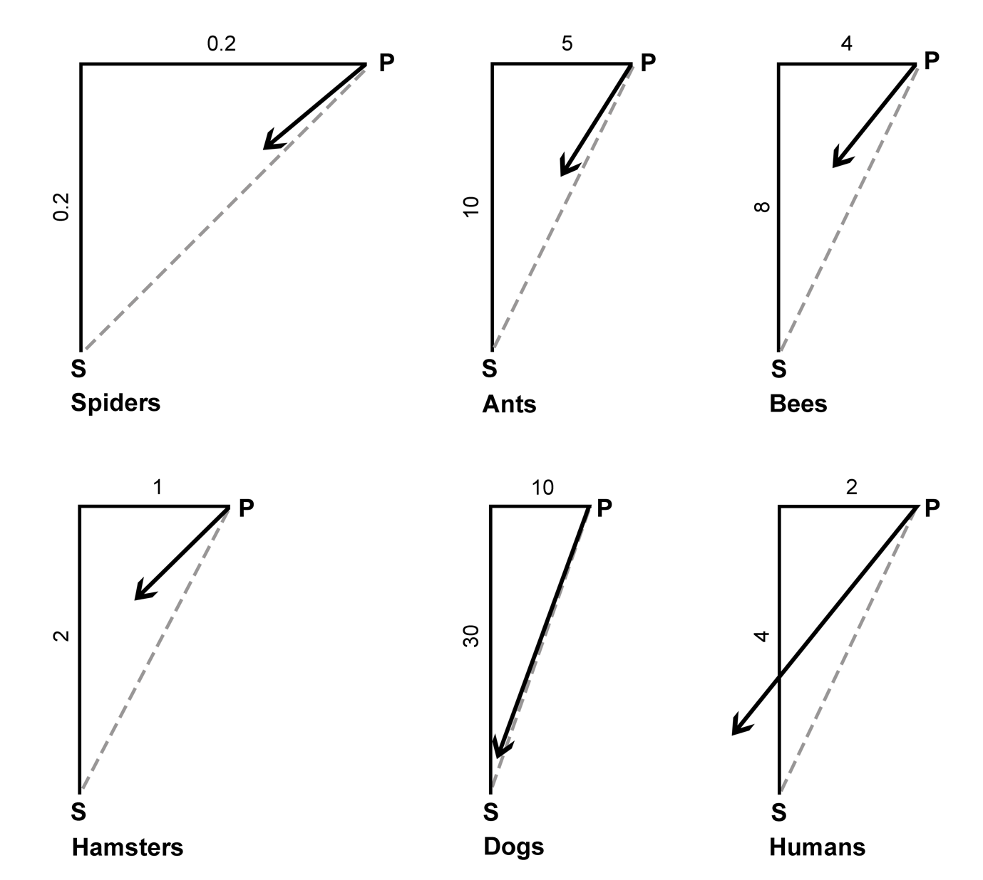

Fig. 3 Systematic path integration errors across species, when returning from point P to the starting point S. The black L shape indicates the path travelled, while the grey dashed line represents the shortest route (ideal path) between P and S. The black arrow indicates the actual integrated path. These data suggest that the understeer error, or bias towards the outward path, is common across species. The figure is redrawn from Etienne and Jeffery (2004).

Fig. 4

Fig. 4. Illustration of several S-shaped paths on the dorsum of the hand. The participants’ task was to attend to each point of the stimulation, and then provide a bisection judgement between the starting point and the end point of each single stimulus. Every trial was a unique path, with variable starting point, rotatory angle, distance and position of the biggest convexity. The large convexity was either distal-medial, distal-lateral, proximal-medial or proximal-lateral, with equal probability.

Fig. 5

Fig. 5. Experimental data from healthy volunteers bisecting the starting and ending point of S-shaped tactile motion stimuli. The black S shapes depict two categories of possible paths: on the left, with convexity towards the thumb (i.e., medial); on the right, with convexity towards the little finger (i.e., lateral). The crosses represent the true bisection point, while the black diamonds indicate group-average actual attemps to bisection. The grey dots represent single-subject actual averages. Bisection judgements were influenced by the position of the convexity. This is particularly prominent in the medial condition. Although, the judgment is not positive for all participants in the lateral condition, it is significantly shifted to the right with respect to the former condition. Note that there is an overall bias shifting the bisection points toward the radius. This has been previously reported elsewhere (Mancini et al., 2011), and could reflect bodily landmarks. Crucially, it is independent of the shape of the S stimulus.

REFERENCES
Azañón, E., Camacho, K., & Soto-Faraco, S. (2010). Tactile remapping beyond space. European Journal of Neuroscience, 31(10), 1858–1867.
Burge, T. (2010). Origins of objectivity. Oxford: Oxford University Press.
Carter, O. , Konkle, T., Wang, Q., Hayward, V., & Moore, C. (2008). Tactile rivalry demonstrated with an ambiguous apparent-motion quartet. Current Biology, 18, 1050-1054.
Cheng, T. (2015). Book review: The first sense. Frontiers in Psychology, 6, 1196.
Duke, J.D. (1965). Perception of Finger Drawings upon the Body Surface, Journal of General Psychology, 75, 305-314.
Dupin, L., & Wexler, M. (2013). Motion perception by a moving observer in a three-dimensional environment. Journal of Vision, 13(2), 15–15.
Etienne, A. S., & Jeffery, K. J. (2004). Path integration in mammals. Hippocampus, 14(2), 180–192.
Evans, G. (1980). Things without the mind - a commetary upon chapter two of Strawson's Individuals. In Collected papers. New York: Oxford University Press.
Fardo, F., Beck, B., Cheng, T., & Haggard, P. (n.d.). Mechanisms of spatial perception on the human skin. Manuscript in preparation.
Fulkerson, M. (2014). The first sense: a philosophical study of human touch. Cambridge, MA: MIT Press.
Gibson, J. (1966). The Senses Considered as Perceptual Systems. Oxford: Houghton Mifflin.
Haggard, P., & Giovagnoli, G. (2011). Spatial patterns in tactile perception: Is there a tactile field? Acta Psychologica, 137(1), 65–75. https://doi.org/10.1016/j.actpsy.2011.03.001
Harris, J. A., Thein, T., & Clifford, C. W. G. (2004). Dissociating Detection from Localization of Tactile Stimuli. Journal of Neuroscience, 24(14), 3683–3693.
Head, H., & Holmes, G. (1911). Sensory Disturbances from Cerebral Lesions. Brain, 34(2–3), 102–254.
Hebb, D. O. (1949). The organization of behavior: A neuropsychological theory. New York: John Wiley and Sons.
Laskin, S. E., & Spencer, W. A. (1979). Cutaneous masking. II. Geometry of excitatory andinhibitory receptive fields of single units in somatosensory cortex of the cat. Journal of Neurophysiology, 42(4), 1061–1082.
Longo, M. R., Mancini, F., & Haggard, P. (2015). Implicit body representations and tactile spatial remapping. Acta Psychologica, 160, 77–87.
Lotze, H. (1884). Mikrokosmos. Leipzig: Hirzel.
Macpherson, F. (ed.) (2011). The Senses: Classic and Contemporary Philosophical Perspectives. Oxford: Oxford University Press.
Mancini, F., Longo, M. R., Iannetti, G. D., & Haggard, P. (2011). A supramodal representation of the body surface. Neuropsychologia, 49(5), 1194–1201.
Mancini, F., Stainitz, H., Steckelmacher, J., Iannetti, G. D. & Haggard, P. (2015). Poor judgment of distance between nociceptive stimuli. Cognition, 143, 41-47.
Marotta, A., Ferrè, E. R. & Haggard, P. (2015). Transforming the thermal grill effect by crossing the fingers. Current Biology, 25(8), 1069-1073.
Martin, M. G. F. (1992). Sight and touch. In The contents of experience (pp. 196–215). Cambridge, UK: Cambridge University Press.
Mittelstaedt, M.-L., & Mittelstaedt, H. (1980). Homing by path integration in a mammal. Naturwissenschaften, 67(11), 566–567.
Mountcastle, V. B. (2005). The Sensory Hand: Neural Mechanisms of Somatic Sensation. Harvard University Press.
Müller, M., & Wehner, R. (1988). Path integration in desert ants, Cataglyphis fortis. Proceedings of the National Academy of Sciences of the United States of America, 85(14), 5287–5290.
Nicod, J. (1970).Geometry and Indicution. Berkeley/Los Angeles: University of California Press.
O’Keefe, J. (1994). Cognitive maps, time and causality. In C. Peacocke (Ed.), Objectivity, Simulation and the Unity of Consciousness. Oxford: Oxford University Press.
O’Regan, J. K., & Noë, A. (2001). A sensorimotor account of vision and visual consciousness. Behavioral and Brain Sciences, 24(5), 939-973-1031.
O’Shaughnessy, B. (1989). The sense of touch. Australasian Journal of Philosophy, 67(1), 37-58.
Paillard, J. (1999). Body schema and body image: a double dissociation in deafferented patients. In Motor control, Today and Tomorrow. Eds. G. N. Gantchev, S. Mori, J. Massion.
Paillard, J., Michel, F., & Stelmach, G. (1983). Localization without content. Archives of Neurology, 40, 548–551.
Peacocke, C. (1983). Sense and Content: Experience, Thought and Their Relations. Oxford: Oxford University Press.
Penfield, W., & Boldrey, E. (1937). Somatic Motor and Sensory Representation in the Cerebral Cortex of Man as Studied by Electrical Stimulation. Brain, 60(4), 389–443.
Penfield, W., & Rasmussen, T. (1950). The cerebral cortex of man: A clinical study of localization of function. Journal of the American Medical Association, 144(16), 1412–1412.

Rossetti, Y., Rode, G., & Boisson, D. (1995). Implicit processing of somaesthetic information: a dissociation between where and how? Neuroreport, 6(3), 506–510.
Smith, A. D. (2002). The Problem of Perception. Cambridge, MA: Harvard University Press.
Smythies, J. (1996). A note on the concept of the visual field in neurology, psychology, and visual neuroscience. Perception, 25, 369-371.
Soteriou, M. (2013). The Mind's Construction: The Ontology of Mind and Mental Action. Oxford: Oxford University Press.
Strawson, P. F. (1959). Individuals: An Essay in Descriptive Metaphysics. London: Methuen.

