Maslow’s Hierarchy and the Rise of the Utilitarian Consumer
Author: Ghazal Hakemi

Abstract: It is the focus of this paper to tackle the topic of how consumers affect their surrounding environment and, more specifically, how they can affect animal welfare. Through comparisons with the Darwinist survivalist consumption habits and Maslow´s hierarchy, our modern society´s needs and habits are evaluated. Finally a Utilitarian approach, with the goal of the rise of the conscious consumer, is suggested for our so-called advanced societies.

Keywords: Utilitarianism, Maslow´s Hierarchy, Animal Rights, Consumers.

“Animals share with us the privilege of having a soul” were the words of Ovid, a renowned ancient Roman poet. However Ovid is not the only honorable figure paying homage to animals as sentient beings. The list is long as, in fact, innumerable great personalities from the past pledged to renounce the killing and consumption of animals. Such figures include: Albert Einstein, Leonardo da Vinci, Sir Isaac Newton, Abraham Lincoln, Jeremy Bentham, Pythagoras and Plato only to mention few. From this it can be deduced that the Animal Rights movement is not a new wave. Vegetarianism, Veganism and with them, the renunciation of inflicting harm and sufferance upon innocent sentient beings is a matter that has been tackled for centuries now.

However extreme the concept of renouncing or diminishing the use of animal-based products might sound to be, it is not impossible. For those of us who have a sensitive side, a strong conscience and the will to abdicate hypocrisy, it is only a matter of what we would call “consumer awareness”. In fact, customers are demanding transparency as they take an increasing interest in the ethical practices of those they buy from ^{[1]}. All we have to do is check the label, content and conditions of the products before we decide to purchase them. In the future methods such as ID–tagging will be used more and more to aid consumers in their choices. For example RFID (Radio Frequency Identification) could allow consumers to scan their products and retrieve all necessary information from product retrieval to sales ^{[2]} (some companies such as UPM Raflatac are already providing RFID for product and information labelling). This way each customer can find out the exact history of the animal he or she is going to consume or wear, bringing us all closer to a more conscientious consumer approach.

In our day and age, there are more reasons than ever to either renounce or to diminish the consumption of animal products and the use of their skins. Firstly, we do not hunt the animals. Hunting used to be the main way to eat and clothe in the primitive days; especially in colder areas where there was lack of natural resources for a rich plant-based diet. Hunters used to eat the flesh and use the fur from the same animal to make their clothing, it was a matter of survival. Nowadays we have plenty of food and clothing options and, as society advances, we are spoiled with the luxury of having increasingly sustainable un-harming ways of enjoying life. After all our homo-sapiens ancestors did not have the comfort we possess today. They were at the bottom of Maslow’s pyramid (see figure 1), making their hunt coherent with the “Utilitarian philosophy” which is generally held to be the view that the morally right action is the action that produces the most good^{[3]}: i.e. one bison could feed and at the same time clothe a whole family and perhaps even a tribe. Nowadays it has become the reverse: one person would feed and clothe on many animals, creating waste and a rather misbalanced approach to our resources and life itself. Today one person feeding on one chicken would wear a fur coat that required the lives of several minks and, more often than we think, even dogs and cats. Is this sustainable? Is it not rather illogical and wasteful? Does this comply with the utilitarian way of thinking? Is this a respectable lifestyle? Is it a respectful approach to life?

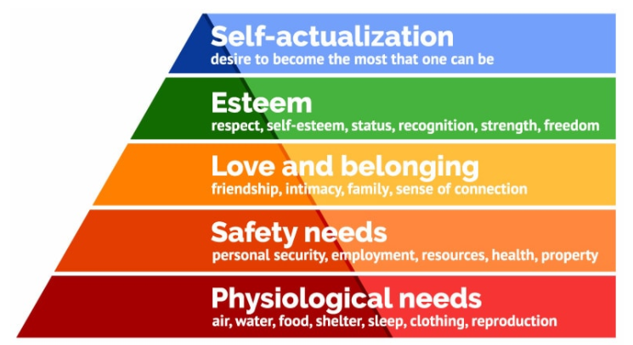
Figure 1: Maslow’s hierarchy of needs^{[9]}

Besides the animal rights aspect when purchasing animal-based items from a supermarket or in a fashionable store on the high street, there are both environmental and health consequences associated with eating meat such as CO2 emission increase^{[4]} and antibiotic resistance due to the use of high quantities of antibiotics in the infamous Factory Farming industries^{[5]}. Of course a lot of people decide to take the Vegetarian or the Vegan route, whatever their motive might be.

However difficult it might be to find a justification for advising against consumption of animal flesh, the reason to stop wearing exotic animal skins & furs should be an easy matter. Every year, millions of animals are slaughtered for the clothing industry, all in the name of fashion. “Whether the clothes come from Chinese fur farms, Indian slaughterhouses, or the Australian outback, an immeasurable amount of suffering goes into every fur-trimmed jacket, leather belt, and wool sweater”^{[6]}. Of course one must distinguish among the various skins used as sometimes leather is produced from the animals (mainly cows) which are butchered to serve our tables as well, making it slightly more compliant to the Utilitarian way. This means no parts of the animal go “wasted” at least.

What gives much thought though, is the wearing of fur and exotic skins and fur. If this were for survival reasons, it would be justifiable. If the fur was used by someone in the same socio-environmental conditions as the Homo Sapiens mentioned above who hunted animals for both nourishment and clothing reasons, the wearing of the skin would be in line with the natural development and progression of the Darwinian theory of survival. However it is to be considered that survival is at the bottom of Maslow’s pyramid (see “Physiological” in figure 1) and our society, the way we know it, is far from the bottom nowadays. With all the comfort and luxury we are surrounded by, we could actually be at the top. But this target will be difficult to reach since some of us still think the use of exotic skins and fur (originally used for survival) is fashionable. For sure it is not as fashionable nor as avant-garde as we might think since, if we wish to be worthy of being called “advanced society” and at the top of Maslow’s hierarchy, we should adopt more compassionate and Utilitarian ways.

There are plenty of non-cruel options available to us and the power is all in our hands as consumers. According to the principle of “Supply and Demand”^{[7]} as long as you (the consumer) keep on demanding, there will be supply so, through simple logical induction, as consumers we are all responsible because through our “Demands” we raise the “Supplies”. Sometimes these goods are actual lives of other beings and through the request of their flesh and skins we are also causing other undesired effects (accelerated environmental pollution and our own physical resistance to antibiotics to name a few). Every time a product is scanned, a “Demand” request is being sent all the way up to the producers and suppliers. Supply can diminish if an order is not there therefore as customers, in order to stop the vicious circle, we can start by quitting the request of immoral products. Of course governments can also roll in by adding higher taxes to unsustainable and unethical goods, but these laws need to be approved by the majority and, until the majority is not sensitized about all the consequences, no change will happen. By increasing taxes on unsustainable and unethical goods, the market could potentially be controlled as higher taxes would affect the demand from customers. Such regulations have already existed in many countries for a long time on legal products such as tobacco and alcohol ^{[5]}. A study has shown that the introduction of a tax imposition, could reduce emissions by up to 12 % in the meat industry sector ^{[8]}.

Since we are mostly living in developed countries and advanced societies, we need to show our progress in accordance with Maslow’s pyramid. We should demonstrate that our morals advance as much as our science and technology and we therefore need to adopt increasingly the Utilitarian philosophy. Hence before buying, we need to think and ask ourselves if we really need the items we are about to purchase, and we should dwell on whether the sufferance that was behind them or other not so imminent damaging consequences, are worth the joy of us using them for a moment as individuals. If we don’t stop and think, the word “Developed” cannot really be accurate for referring to our society, and even our ancestors would be surprised at our lack of Darwinist instinct of not conservation, purposefully harming our surroundings and the environment. In a world of almost 8 billion inhabitants, gluttony and vanity of the individual person should not take the extreme lead that we are currently witnessing.

Minimalism, which I strongly interrelate to Utilitarianism, is the basis of many beautiful philosophies and art forms, from the oriental Feng Shui, Zen and Buddhism to what we now simply see in the modern Scandinavian architecture for example. Living un-wastefully will be the way forward for the future generations and it is all just a matter of awareness, giving rise to a more conscious, compassionate and Utilitarian consumption lifestyle.

References and further reads:
[1] “The rise of the conscious consumer: why businesses need to open up”, Jessi Baker,The Guardian, 02.04.2015
[2] “Tracing Food History: Auto-Identification Technology Could Revolutionize Food Safety”, Bill Hardgrave, Auburn Univeristy, Food Quality & Safety April/May 2012

[3] “The History of Utilitarianism” Julia Driver, Edward N. Zalta, Stanford Encyclopedia of Philosophy Winter 2014

[4] “Giving up beef will reduce carbon footprint more than cars, says expert”, Damian Carrington, The Guardian 21.07.2014

[5] “Meat tax ‘inevitable’ to beat climate and health crises, says report”, Damian Carrington, The Guardian 11.12.2017

[6] “Animals used for clothing”, PETA Australia, https://www.peta.org.au/issues/clothing/

[7] “The Wealth of Nations”, Adam Smith, Book 1 Chapter 7, Harriman House Ltd 2007

[8] “Effects of an environmental tax on meat and dairy consumption in Sweden”, SarahSäll, Ing-MarieGren, Food Policy, Elsevier, 2015

[9] Image from https://www.simplypsychology.org/maslow.html

