|  |  |
| --- | --- |
| ***Al-Azhar University-Gaza***  ***Deanship of Postgraduate Studies***  ***Faculty of Engineering & Information Technology***  ***Master in Computing and Information Systems*** |  |

**The Effectiveness of Using an Intelligent Tutoring System in Water Knowledge and Awareness**

**Prepared by**

**Mohammed Amin Hamed**

**Supervised by**

**Prof. Dr. Samy S. Abu Naser**

**Assist. Prof. Khaldoun S. Abualhin**

**A Thesis Submitted in Partial Fulfillment of the Requirements for the Degree of Master in Computing and Information Systems**

March – 2018

|  |  |
| --- | --- |
|  | **جامعـــــــــة الأزهــــــــــــــــر – غــــــــــــزة**  **عمـــــــــادة الدراســــــــــــات العليـــــــــــــــا**  **كليـــــــــــــة الهندسة وتكنولوجيـا المعلومات**  **ماجستير الحـــــوسبة ونظـــــم المعلومــــات** |

**فعالية استخدام نظام التعليم الذكي في المعرفة و التوعية المائية**

**إعداد الباحث:**

**محمد أمين حمد**

**إشراف**

**أ.د. سامي سليم ابو ناصر**

**د. خلدون سلمان أبو الحن**

**قدمت هذه الرسالة استكمالاً لمتطلبات الحصول على درجة**

**الماجستير في الحوسبة ونظم المعلومات**

جماد الاخر - 1439



# DECLARATION

I declare that I have written this thesis and that this work has not being submitted -as a whole or any part of them- for any other degree or professional qualification or any other.

I confirm that this work that submitted is my own, except where work which has formed part of jointly-authored publications has been included. My contribution and those of the other authors to this work have been explicitly indicated below.

I confirm that appropriate credit has been given within this thesis where reference has been made to the work of others.

**Mohammed Amin Hamed**

# DEDICATION

To My great Father

To My Mother for Their Love, Pray, And Continuous Sacrifices…

To All Of My Brothers And Sisters And Their Kids…

To My Wife…

To My Friends, Colleagues and My Teachers…

With All My Love.

# ACKNOWLEDGEMENTS

All praises and much gratitude to almighty Allah, the most compassionate and magnificent, who gave me the power to work hard and persistence to complete this research work.

I would like to specially thank my supervisors **Prof. Dr. Samy Abu Naser and Assist. Prof. Khaldoun S. Abualhin,** who always provided me with the greatest support and help whenever I needed throughout my research work. They were readily available for consultation, shared their knowledge with me as well as motivated me for successful completion of this research work.

I would like to thank the discussion committee: **Dr. Mazen T. Abu Al-Taif and Dr. Ihab S. Zaqout**.

I cannot forget the successful support of my beloved parents, my brothers, my sisters, and my wife, who always have shown desire and prayed for my success in my academic life in addition to the financial and honorable support through my life.

I would like to thank all my reputable professors, honest friends and all those people in the Faculty who aided me throughout this research project and made this thesis blossom.

**Mohammad Amin Hamed**

# ABSTRACT

Due to the tremendous progress in technology and the methods used in its application to facilitate and refine human's life, Intelligent Tutoring System was created to contribute in this era. In this study, the Intelligent Tutoring System was adopted as a platform in linking the complex Technological fields for obtaining information smoothly, and highlighting the importance of water issues and in the Gaza strip. In the light of the absence and inability of the formal education system to raise awareness of the water crisis and its consequences on the daily life of the Gazans, the current Intelligent Tutoring System (ITS) has been utilized to disseminate knowledge and enhance awareness of water problems. The ITS aims to embrace a new water conservation practices and ensure the sustainability of fresh water.

Basically the software of the tutoring system is used to create a program which could be easily used by the public population and specialists in the water field. The resulting program was fed with plenty of information about the current local water status and its related problems which are considerably useful for anyone interested to raise his/her level of knowledge and awareness about the local water status in addition to the researchers by reducing their dependency on human sources.

The ITS system was presented to two groups of people: The first one consists of specialized water experts and the other consists of master student enrolled in Institute of Water and Environment in Al-Azhar University in Gaza who are interested in water problems. Both groups were requested to use the final version of the system and give their feedback by filling a questionnaire, and then the averages of the answered questions were measured for each group. It was found that the overall impressions of the users were positive.

**Keywords**: Artificial Intelligent, Intelligent Tutoring System, Expert system,   
 Water Education.

# الملخص

نظرا للتطور الهائل في التكنولوجيا وطرق توظيفها في تسهيل حياة الانسان, صمم نظام التدريب الذكي ليكون جزء من التطور في هذا العصر, وفي ضوء دراستي, تم اختيار نظام التدريب الذكي كمنبر لربط المجالات التكنولوجية المعقدة بتصميم يسهل عملية الحصول على المعلومات واعطاء أهمية كبرى لقضايا المياه العالمية والمحلية خاصة في قطاع غزة, ومن هنا كانت هذه الفكرة لتكون موضوع بحثي, حيث تم توظيف نظام تدريب في نشر المعرفة حولها وزيادة الوعي بها.

بشكل أساسي تم برمجة نظام التدريب ليكون برنامج سهل الاستخدام بالنسبة لعامة الناس وللمختصين في مجال المياه أيضا, حيث زود البرنامج الناتج بمعلومات وفيرة حول حالة المياه المحلية والمشاكل المتعلقة بها, على اعتبار مدى فائدته على مختلف الاصعدة بالنسبة للمتعلمين الباحثين في هذا المجال أو المهتمين في زيادة وعيهم ومدى معرفتهم حول أوضاع المياه المحلية.

تم تقديم نظام ITS لمجموعتين من الأشخاص: الأول يتكون من خبراء متخصصين في المياه والآخر يتكون من طلبه ماجستير مسجلين في معهد المياه والبيئة بجامعة الأزهر في غزة المهتمين بمشاكل المياه. طُلب من المجموعتين استخدام الصيغة النهائية للنظام وإبداء ملاحظاتهما عن طريق ملء استبيان ، ثم تم قياس متوسط الأسئلة التي تمت الإجابة عليها لكل مجموعة. ووجد أن الانطباعات العامة للمستخدمين كانت إيجابية.

**كلمات مفتاحية:**  الذكاء الاصطناعي , نظام التدريب الذكي, نظام خبير, التعليم في مجال المياه.

# TABLE OF CONTENTS

DECLARATION iii

DEDICATION iv

ACKNOWLEDGEMENTS v

ABSTRACT vi

الملخص vii

TABLE OF CONTENTS viii

LIST OF TABLES x

LIST OF FIGURES xi

LIST OF ABBREVIATIONS xii

Chapter 1 INTRODUCTION 1

1.1 Introduction 2

1.2 Statement of the Problem 3

1.3 Objectives 3

1.3.1 General objective 3

1.3.2 Specific objectives 4

1.4 Significance of the study 4

1.5 Scope of the Thesis 4

1.6 Thesis organization 5

Chapter 2 THEORETICAL BACKGROUND 6

2.1 Intelligent Tutoring Systems 7

2.1.1 Definitions of ITS 8

2.1.2 Architecture of ITS 9

2.1.2.1 Domain Model 9

2.1.2.2 Pedagogical Model 10

2.1.2.3 User Model 10

2.1.2.4 Dialogue Model 11

2.1.3 History of ITS 11

2.2 Advantages of ITS 12

2.3 Study Community 13

2.4 Institute of Water and Environment 13

2.4.1 Mission Statement 14

Chapter 3 LITERATURE REVIEW 15

3.1. Literature Review 16

3.2. Comments about previous studies 22

Chapter 4 DESIGN AND DEVELOPMENT OF PROPOSED SYSTEM 23

4.1. Overview of the Proposed System 24

4.2. Authoring Language Used 24

4.3. Architecture of the current ITS system 25

Chapter 5 EVALUATION AND RESULT DISCUSSION 39

5.1. System Evaluation 40

5.2. Results of water specialists group: 40

5.3. Results of Master Students in IWE group: 41

Chapter 6 CONCLUSION 43

6.1 Conclusion 44

6.2 Future Work 44

REFERENCES 45

# LIST OF TABLES

Table 1 Results of questions asked to the water specialists 40

Table 2 Results of questions asked to Master Students in IWE group 41

# LIST OF FIGURES

Figure 1: The field of AI and education is grounded in three disciplines: computer science, psychology, and education 7

Figure 2 ITS components 9

Figure 3 CAI to ITS metamorphosis 12

Figure 4: Pedagogical model adaption to user level 30

Figure 5Admin login screen 31

Figure 6 user login screen 31

Figure 7 Admin interface 32

Figure 8 User lessons and examples interface 32

Figure 9 Interface for modifying Fonts of all screens of the system 33

Figure 10 Interface for adding constants of the system 33

Figure 11 Interface for adding constants of the system 34

Figure 12 Interface for adding Lessons and Examples 34

Figure 13 Interface for adding Lessons and Example 35

Figure 14 Interface for adding questions and answers 35

Figure 15 User lessons and examples interface 36

Figure 16 User Exercises interface1 36

Figure 17 User Exercises interface2 37

Figure 18 The result is good 37

Figure 19 The result is not good 38

Figure 20 Interface for modification Lessons 38

Figure 21 The results were obtained by the Water Specialists 41

Figure 22 The results were obtained by the Master Students in IWE group 42

# LIST OF ABBREVIATIONS

|  |  |
| --- | --- |
| Artificial Intelligent | AI |
| Intelligent Tutoring System | ITS |
| Mode Based Remediation | MBR |
| World Wide Web | WWW |
| Episodic Learner Model | ELM |
| ELM Adaptive Remote Tutor | ELM-ART |
| The Pittsburgh Urban Mathematic Project | PUMP |
| Pump Algebra Tutor or Practical Algebra Tutor | PAT |
| Programmed Instructions | PI |
| Computer Aided Instruction | CAI |
| Intelligent Computer Aided Instruction | ICAI |
| Institute of Water and Environment | IWE |
| Water Research Center | WRC |
| Bayesian Intelligent Tutoring System | BITS |
| Animated Data Structure Intelligent Tutoring System | ADIS |
| Intelligent Tutoring System Builder | ITSB |

Chapter 1  
  
  
  
  
INTRODUCTION

* 1. Introduction

Being in the 21st century , surrounded by a growing number of technology related theses and their applications, that requires a high level of challenge to be updated and keeping up with the new prospects of science and knowledge.

The revolution of computer science has brought a countless number of advantages and features to the world .Over the course of the recent decades, the applications of computer science have become an inseparable part in every aspect of life such as education, health, arts, industry and communications.

With the modern times, the daily activities continuously tend to be carried out by using unconventional methods especially in terms of education as it is a lifelong continuous process with a wide range of execution methods.

The idea of incorporation the Artificial Intelligent (AI) techniques with education dates back to 1970s. Since then, it has been consistently improved till reaching the use of Intelligent Tutoring Systems (ITS) which considered as one of the AI application in the field of Education.

ITS has been created to provide a beneficial educational tool in order to promote the educational process and to facilitate the accessibility to information and other learning process contents. The program has not been produced to replace the original educational process but to work side by side with the conventional educational approaches and as a complementary tool with the ongoing human requirements and aspirations in their targets smoothly and with the minimum efforts and resources required.

This study is based on an Intelligent Tutoring System which was selected to be designed because of its flexibility to cover any crucial issues such as water pollution that is currently deemed as one of the world wide crisis in our planet. Furthermore, it can be used as a helpful tool in raising the level of awareness about its consequences.

The designed system has sufficiently been supplied with an enormous amount of reliable, valuable and updated information, which was classified and divided according to the different entities or titles related to the main topic that’s would assist the users to access the targeted information quickly and precisely.

* 1. Statement of the Problem

Natural freshwater resource is threatened by depletion globally and Palestine is one of most effected countries in the world, Gaza in particular. The Coastal Aquifer is the source of water for more than 1.8 million people in Gaza Strip. Gaza Strip consumes approximately one hundred and seventy million cubic meters annually (90 Million cubic meters for human consumption and 80 million cubic meters for agricultural consumption). Rainfall is the only source of groundwater recharge for drinking water. It is very limited due to the nature of the dry area. The average annual rainfall is estimated at 125 million cubic meters, of which about 50 million cubic meters per year are in the aquifer. The remainder is wasted as a result of evaporation, soil quality, urban sprawl and lack of fisheries. As a result, the aquifer suffers from a severe shortage of water, with a consumption rate of more than three times the recharge rate of the aquifer. In addition, the groundwater reservoir suffers from salinization and pollution due to the excessive use of its water, and the leakage of many pollutants from many sources, making a very large proportion of water to reach the consumer is not suitable for drinking according to international standards [1, 2, 3].

According to estimates by the Central Bureau of Statistics, the population of Gaza Strip will exceed 3,362,336 people by 2020, which will increase the demand for water and thus increase the quantities of wastewater produced. The water crisis in Gaza Strip continues to deteriorate [4]. This requires rapid solutions and strategies for managing the water and sanitation sector to meet the needs of the present and the future.

Artificial Intelligence in general and Intelligent tutoring systems in particular can help in water problems by informing people about water importance and the danger of the water shortage that Gazans are facing.

Thus, an Intelligent Tutoring System is proposed to help teaching and promoting people awareness of water, its importance, problems, and how to conserve it.

* 1. Objectives

The objectives of using ITS in the water field are:-

* + 1. General objective

Disseminate awareness and knowledge about the water crisis among users in an organized, effective and convenient, self-learning manner, and provoke the audience to practice and adopt water saving culture.

* + 1. Specific objectives

1. Using ITS to address all the topics of water problems and their consequences on human's life.
2. Using ITS to promote people's commitment and their participation in the development and management of water resources.
3. Using this system as a reference for getting more information about water issue.
4. Explain the water resources and the groundwater characteristics and the major pollutant in its simplest form using graphs and statistical charts.
5. Present the proposed solutions to alleviate the water crisis and how to apply it and adopt it by young people and institutions.
   1. Significance of the study

ITS is not widely used by researchers even though it have become more popular in the recent decades. There are many reasons for that, but the most important one is that although there are many ITS in the market, few of them have been used in practical teaching. Given the advantages of ITS, it is important to integrate them into decision maker sector so that they will be widely admissible and accorded by specialists of water.

This study contributes to this aim by assessing the using of ITS to enhance the consciousness of people in Gaza strip and increasing their knowledge about water case in order to overcome its obstacles.

ITS have a lot of advantages, some of which are explored in this study:-

1. It is available at any time.
2. It reduces dependency on human resources.
3. It provides a one-to-one teaching environment.
4. It reduces learners travel time because the ITS can be used in the home.

* 1. Scope of the Thesis

This thesis provides an overview of the scientific papers and studies that apply the ITS and its effect on the water field until now.

This study uses a systematic review of the literature to evaluate the effectiveness of ITS on raising the people's awareness and knowledge of water issues.

* 1. Thesis organization

The structure of thesis consists of six chapters, the first Chapter will include the introduction, the second chapter will cover two theoretical backgrounds of the subject content, the third chapter gives brief literature review about the subject, the fourth chapter will outline the methodology, the fifth one will show the evaluation done for the system and the final chapter will conclude the thesis.

Chapter 2  
  
  
  
  
THEORETICAL BACKGROUND

* 1. Intelligent Tutoring Systems

Intelligent Tutoring Systems apply Artificial Intelligent techniques and methodology to the development of computer based learning systems in order to construct adaptive systems. An ITS focuses education as a process of cooperation between tutor and user in which the tutor tries to teach concepts to the user. In general, the process is guided by the tutor, who must analyze the behavior, the knowledge and the satisfaction of the user. The tutor has to determine and apply the more appropriate teaching strategies at every moment. These strategies must answer a series of questions to ensure that the learning process is carried out successfully. These questions are: what to explain, what detail level is necessary, when and how to interrupt the user and how to detect and to correct errors. The four basic components that classically are identified in an ITS are: Domain Model, Pedagogic Model, User Model and Dialogue Model.

One trademark of the field of AI and education is by means of intelligence to reason about teaching and learning. Representing what, when, and how to teach necessitates foundation from within a few academic disciplines, containing computer science, education, and psychology [5]. Several methods and tools of computer science, education, and psychology are complementary and jointly supply closely comprehensive coverage of the field of AI and education as seen in Figure 1.

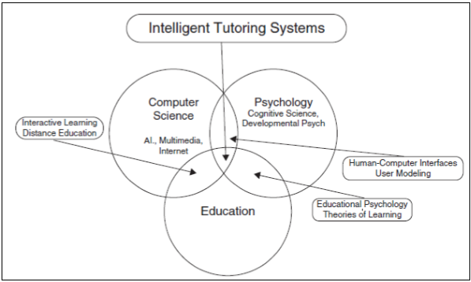

Figure 1: The field of AI and education is grounded in three disciplines: computer science, psychology, and education

* + 1. Definitions of ITS
* "ITS is a computer program that would be defined as good teaching because its design includes cognitive science, which is a combination of computer science, cognitive psychology, and educational research" [6].
* "An intelligent tutoring system (ITS) is a software application that tries to replicate the performance of a human tutor by supporting the theory of “learning by doing” and providing personalized feedback and customized instruction to a user or a trainee while performing a task within a problem domain such as mathematics, medical diagnosis, or even game play [7].
* "ITSs are computer software systems that seek to mimic the methods and dialog of natural human tutors, to generate instructional interactions in real time and on demand, as required by individual users. Implementations of ITSs incorporate computational mechanisms and knowledge representations in the fields of artificial intelligence, computational linguistics, and cognitive science" [8].
* "Broadly defined, an intelligent tutoring system is educational software containing an artificial intelligence component. The software tracks users' work, tailoring feedback and hints along the way. By collecting information on a particular user's performance, the software can make inferences about strengths and weaknesses, and can suggest additional work" [9].
* "In particular, ITSs are computer-based learning systems which attempt to adapt to the needs of learners and are therefore the only such systems which attempt to ’care’ about learners in that sense. Also, ITS research is the only part of the general IT and education field which has as its scientific goal to make computationally precise and explicit forms of educational, psychological and social knowledge which are often left implicit" [5].
  + 1. Architecture of ITS

There are four components in an intelligent tutoring system that represents tutoring and communication knowledge: domain model, pedagogical model, user model, and dialogue model (as in Figure 2).

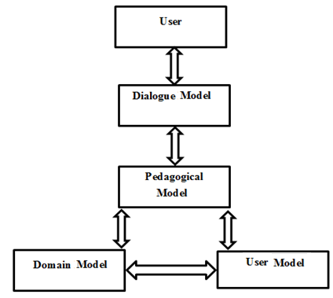

Figure 2 ITS components

* + - 1. Domain Model

The Domain model represents the facts and rules of a specific domain to be conveyed to users. The Domain model has the knowledge of which things should be taught to users; it is also called the knowledge of experts. This model generates questions, explanations, answers, hints, and comments and provides standards to check users’ performance. Domains vary in difficulty and structure, from simple (well defined) to complex, and from well-structured to ill-structured. They fall into three different categories:

1. Problem-solving domains.

2. Analytic and unveriﬁable domains.

3. Design domains.

For the simple and well-defined domains, the collection of training problems is presented using existing teaching strategies. However, there is no formal theory for veriﬁcation for the complex and ill-structured domains [6].

* + - 1. Pedagogical Model

Pedagogical model represents teaching strategies, (examples, and analogies) and includes methods for encoding reasoning about the feedback. In another words, pedagogical model controls the overall functions of the Intelligent Tutoring System.

In other words, the pedagogical model accepts information from the domain and user models and makes choices about tutoring strategies and actions. At any point in the problem-solving process the learner may request guidance on what to do next, relative to their current location in the model. In addition, the system recognizes when the learner has deviated from the production rules of the model and provides timely feedback for the learner, resulting in a shorter period of time to reach proficiency with the targeted skills [10]. The pedagogical model may contain several hundred production rules that can be said to exist in one of two states, *learned* or *unlearned*.

* + - 1. User Model

User model represents users’ mastery of the domain and defines how to reason about their understanding. It comprises both stereotypic user knowledge of the domain (usually user skills) and information about the present user (e.g., time spent on problems, possible misconceptions, correct answers, preferred learning style, and hints requested). In other words, the knowledge and skills of users are represented in this model. ITS cannot exist without understanding of users’ knowledge, so users’ knowledge, behavior, and all other aspects that can affect users’ performance should to be included in this model. For many reasons, such as the communication channel (keyboard) is a restrictive communication channel, it is nearly impossible to build a user model that models all aspects of the user. On the other hand, sources such as voice and facial gestures could easily help human teachers to get information about users. Also, human tutors could easily know when users get motivated or fatigued.

The User model’s functions are classified into six types:

1. Corrective: to help eradicate bugs in the user's knowledge.
2. Elaborative: to help correct 'incomplete' user knowledge.
3. Strategic: to help initiate significant changes in the tutorial strategy other than the tactical decisions of 1 and 2 above.
4. Diagnostic: to help diagnose bugs in the user's knowledge.
5. Predictive: to help determine the user's likely response to tutorial actions.
6. Evaluative: to help assess the user or the ITS.
   * + 1. Dialogue Model

Dialogue model represents methods for communicating between users and computers. It includes discussing user reasoning, managing communication, and sketching graphics to illustrate a point, showing or detecting emotion, and explaining how conclusions were reached.

* + 1. History of ITS

In the 1800s, Chartes Babbage designed a mechanical computer and visualizes the programmable computer. By the year of 1926, Pressey determined the first use of a machine for teaching and focus on a system that delivers multiple choice questions and gives an immediate feedback for each question.

However, this system differs from the system of Intelligent Tutoring System (ITS) because it was used only to check the response of the user weather was correct or not. But these programmed instructions (PI) were improved in 1960s to teach programming concept step by step and provide a feedback and remediation immediately.

Basically, artificial intelligence and education field was established by a dozen commanders, consisting (John Self, Jaime Carbonell and William Clancey).

In the 1970s, Ph.D. thesis of Jaime Carbonell used the earliest Intelligent Tutor which is based on a system that varied from computer assisted instruction and it procreated individual responses to user's statements and that by crossing on indicative network of geography knowledge.

Later, the programmed instruction in a computer was extended to be a Computer Aided Instruction (CAI). However, CAI is not intelligent enough to examine the response of the user and choose the education content based on the analysis and that because the (CAI) is used to give only defined education content. After that, this (CAI) is developed to be Intelligent Computer Aided Instruction (ICAI) which is an application of machine learning algorithms in tutoring has a long history, there is no a significant differences between (CAI) and intelligent computer aided instruction (ICAI),but it can be said that (ICAI) is a more sophisticated version of (CAI).

By the year of 1973, Hartly and Sleeman decided that intelligent tutoring system must have three crucial features related to the knowledge of education strategies (adaptation strategies), knowledge of the domain (learning model) and the knowledge of the learner (user model). So, the intelligent tutoring system used as an application that analyzes the user's knowledge, misclassification and skills, and accordingly, it adapts the learning content.

This system differed from the traditional computer based programmed instructions.

In recent decades, ITS has developed to be used in the education system in many domains, such as physics, chemistry, mathematics, and computer science(See Figure 3).

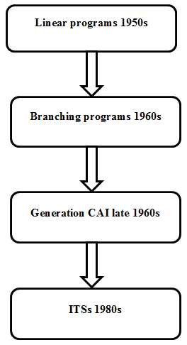

Figure 3 CAI to ITS metamorphosis

* 1. Advantages of ITS

1. ITS is a computer program that would be defined as good teaching because its design includes cognitive science, which is a combination of computer science, cognitive psychology and educational research.
2. ITS providers the research with a very good environment for many theories from cognitive psychologists.
3. ITS is a software can model the cognitive and emotional states of learners with goal of adapting and personalizing instruction.
4. ITS is a computer application used to provide users with one to one supplemental tutoring tailored to the users learning style and pace, so it has been of interest to educators for improving user learning and this is one of the biggest advantages of the system.
5. ITS can serve the requirements of users

* It evaluates user’s potential and manages their knowledge.
* It is considered a system that can support a lot of users need and users working in groups.

1. ITS has evolved to be used in the education system in many domains, such as physics, chemistry, mathematics, and computer science.
2. The ITS can provide immediate feedback and individualization to users on every question that has been asked and that is so important and more of effective when it happens in direct reply to the user's needs.
3. Using ITS in the education system can simplify the learning process in many areas:

* Helps facilitate learning.
* Improve the course navigation.
* Reworks the available information and teaching methodology.
* Explains errors to user and answer any user’s questions.
* Provide users with web links for further information and also offer videos for every subject that users study. So that in addition to the hints and the links there would be videos to help users understand the topic effectively.
* It is available at any time, unlike classroom teachers who are available just during school time.
* It reduces dependency on human resources.
* It reduces user travel time because the ITS can be done in their homes.
  1. Study Community

The society of the study consists of the specialists of water field, Water Authority, Coastal Municipalities Authority, Municipalities, and Public institutions for water.

* 1. Institute of Water and Environment

Institute of Water and Environment (IWE) is affiliated to AL Azhar University in Gaza, Palestine. As an Institute of Water and Environment management and science. It is fully furnished and has the entire necessary requirement to provide education, training, consultancy service and undertakes applied research for Palestinian water and environment sectors.

IWE was founded on May 1995 as a Water Research Center (WRC), and on August 2007, the WRC integrated to IWE.

* + 1. Mission Statement

The aim of the IWE is to assist in building the infrastructure of water and environment, which will raise the living standard of the Palestine people besides offering a higher studies program of master degree in Water and Environmental Science.

Chapter 3  
  
  
  
  
LITERATURE REVIEW

* 1. Literature Review

Information Technology abounds with many studies on artificial intelligence and intelligent training. In this part of the study, the researcher reviewed what has been written in previous studies whether directly or indirectly. The researcher will present and analyze some of the previous studies that were obtained, which are relevant to the subject of the current study, and the previous studies were presented according to their importance of the current study.

* **The study of (Albatish et. al., 2018). ARDUINO Tutor: An Intelligent Tutoring System for Training on ARDUINO.**

This paper aims at helping trainees to overcome the difficulties they face when   
dealing with Arduino platform by describing the design of a desktop based intelligent   
tutoring system. The main idea of this system is a systematic introduction into the concept of Arduino platform. The system shows the circuit boards of Arduino that can be purchased at low cost or assembled from freely-available plans; and an open-source development environment and library for writing code to control the board topic of Arduino platform. The system is adaptive with the trainee's individual progress. The system functions as a special tutor who deals with trainees according to their levels and skills. Evaluation of the system has been applied on professional and unprofessional trainees in this field and the results were good [11].

* **The study of (Al-Bastami and Abu-Naser, 2017). Design and Development of an Intelligent Tutoring System for C# Language**

In this paper, the authors try to help users learn C# programming language using Intelligent Tutoring System. This ITS was developed using ITSB authoring tool to be able to help the user learn programming efficiently and make the learning procedure very pleasing. A knowledge base using ITSB authoring tool style was used to represent the user's work and to give customized feedback and support to users [12].

* **The study of (Hamed and Abu-Naser, 2017). An intelligent tutoring system for teaching the 7 characteristics for living things.**

ITS was used in designing a learning system of science for 7th grade user explaining the characteristic of living things [13]**.**

* **The study of (Appleton, 2017). Introducing intelligent exercises to support web application programming users.**

A prototype system was designed wing the ITS to help user in learning the web language Java Script [14].

* **The study of (Weber and Prusilovsky, 2016). ELM-ART -An interactive and intelligent Web-based electronic textbook.**

ELM –ART (ELM (Episodic Learner Model) – ART (Adaptive Remote Tutor) is a Web-based Intelligent Tutoring System (WITS) designed for teaching users programming in LISP (List Processing) programming language. It integrates intelligent educational system with electronic textbook program in a unique environment in which the user can broaden and deepen previously acquired knowledge. It was used as an intelligent interactive electronic textbook on programming in LISP programming language logic [15, 16].

* **The study of (Mahdi et. al., 2016). An intelligent tutoring system for teaching advanced topics in information security**

This intelligent tutoring systems target the users enrolled in Advanced Topics in Information Security in the faculty of Engineering and Information Technology at Al-Azhar University in Gaza. Through which the user will be able to study the course and solve related problems. An evaluation of the intelligent tutoring systems was carried out and the results were good [17].

* **The study of (Alhabbash et. al., 2016). An Intelligent Tutoring System for Teaching Grammar English Tenses**

In this paper, the authors describe the design of an Intelligent Tutoring System for teaching English language grammar to help users learn English grammar easily and smoothly. The system provides all topics of English grammar and generates a series of questions automatically for each topic for the users to solve. The system adapts with all the individual differences of users and begins gradually with users from easier to harder level. The intelligent tutoring system was given to a group of users of all age groups to try it and to see the impact of the system on users. The results showed a good satisfaction of the users toward the system [18].

* **The study of (García et. al., 2016) Intelligent tutoring system to integrate people with down syndrome into work environments.**

Multiple staged project was develop using the ITS in order to integrate people with Down Syndrome into work environment [19]**.**

* **The study of (Kosek, 2014). An Intelligent Tutoring System for Learning Chinese with a Cognitive Model of the Learner.**

System as created using the ITS to simulate a Chinese-English dictionary for users depending on linguistically motivated cognitive [20]**.**

* **The study of (Cabada et. al., 2014). Intelligent Tutoring System with Affective Learning for Mathematic.**

This paper presents the implementation of an Intelligent and Affective Tutoring System for learning second-grade mathematics that is integrated into a learning social network. The system uses a feed-forward neural network to recognize the affective state of the user and a fuzzy expert system which integrates cognitive user data (such as mistakes, time and number of aids to solve a problem) with affective data as the user emotional state [21]**.**

* **The study of (Dimitrios and Ioannis, 2013). An Intelligent Web-Based Algebra Tutoring School.**

A web based Algebra Tutoring School was created using a model-tracing tutor which provides a teaching of 16-top-level math skills in addition to involving the usual teaching tasks [22]**.**

* **The study of (Weragama and Reye, 2013) The PHP Intelligent Tutoring System.**

This research concentrates on building such an ITS to teach the PHP scripting language for developing web pages [23]**.**

* **The study of (Amalathas et. al., 2012). Decision-making tutor: Providing on the job training for oil palm plantation managers.**

DM-Tutor (Decision-Making Tutor) is a constraint- based tutor intelligent tutoring system (ITS) which is embedded within an existing system, the management information system (MIS) for oil palm plantation management. The goal of DM-Tutor is to provide scenario based training using real-life operational data and actual plantation conditions. The goal of DM-Tutor is to help users apply theoretical concepts of plantation analyses into real-life plantation decision-making [24].

* **The study of (Abu-Naser et. al., 2011). An Intelligent Tutoring System for Learning Java Objects.**

A web based intelligent tutoring system was designed to facilitate teaching Java objects to users and was built up to provide an automatically generated problem for the user to solve [25]**.**

* **The study of (**[**Vincent**](https://content.iospress.com:443/search?q=author%3A%28%22Aleven,%20Vincent%22%29) **et. al., 2009). A New Paradigm for Intelligent Tutoring Systems: Example-Tracing Tutors.**

In the above mentioned research, the cognitive tutor authoring tools were used in order to create a new type of tutors called which differs from the others in being flexible to be used in evaluating user’s behavior in solving complex problem in a step by step model rather than depending on the end-find results [26]**.**

* **The study of (Aleven et. al., 2009). Scaling Up Programming by Demonstration for Intelligent Tutoring Systems Development: An Open-Access Web Site for Middle School Mathematics Learning.**

An open-access web site for middle school Mathematics learning using the example tracing tutor a novel type of ITS which built by demonstration without programing using cognitive tutor authoring tools (CTATs) to provide a contribution that a large -scale tutor authoring could be executed by demonstrate, and find out if an open-access website with software tutor, could be reliable to attract users interest [27]**.**

* **The study of (Butz et. al., 2007). A Web-based Bayesian intelligent tutoring system for computer programming.**

BITS (Bayesian Intelligent Tutoring System) is a Web - based intelligent tutoring system (WITS) for computer programming. The decision making process conducted in BITS intelligent system is guided by a Bayesian network. BITS can help the user in navigation through the materials online, and also can suggest learning target and purpose and generate suitable learning sequences. As an example, a user may want to learn (adding operation) without having to learn every concept discussed in the previous materials. BITS can determine the minimum prerequisite knowledge needed in order to understand (adding operation) and display the links for these concepts in the correct learning sequence [28, 29].

* **The study of (Sykes, 2007). Developmental process model for the Java intelligent tutoring system.**

JITS (Java Intelligent Tutoring System) is the research project that involves the development of a programming tutor designed for users in their first programming course in Java at the college and university level. This project is a prototype being constructed which will model the domain of a small subset of the Java programming language in a very specific context [30].

* **The study of (Suraweera and Mitrovic, 2002). KERMIT: A Constraint-Based Tutor for Database Modeling.**

KERMIT is a system which focuses on the intelligent tutoring system (ITS) to teach conceptual database design and this design is an open-ended test which teaches a database language (SQL) and is used also to teach punctuation and capitalization rules (CAPIT). Both systems are implemented in classrooms in many schools and with users how to take a database course and as a result the experience was very effective and the users were very excited when they use it in studying their lessons [31]**.**

* **The study of (Zin et. al., 2000). A knowledge-based automated debugger in learning system**

Adil (Automated Debugger in Learning System) is a software system for automated debugging based on knowledge, designed as an (ITS). It assists users in mastering basic debugging skills of their programs, as a target for the C programming language. It localizes bugs and explains to these programs. Given a syntax error-free program and its specification, this debugger called Adil (Automated Debugger in Learning system) will be able locate, pinpoint and explain logical errors of programs. If there are no errors, it will be able to explain the meaning of the program [32].

* **The study of (Koedinger et. al., 1997). Intelligent Tutoring Goes To School in the Big City.**

This study reports on a large-scale experiment introducing and evaluating intelligent tutoring in an urban High School setting. Critical to the success of this project has been a client-centered design approach that has matched our client's expertise in curricular objectives and classroom teaching with our expertise in artificial intelligence and cognitive psychology. The Pittsburgh Urban Mathematics Project (PUMP) has produced an algebra curriculum that is centrally focused on mathematical analysis of real world situations and the use of computational tools. We have built an intelligent tutor, called PAT that supports this curriculum and has been made a regular part of 9th grade Algebra in 3 Pittsburgh schools. In the 1993-94 school year, they evaluated the effect of the PUMP curriculum and PAT tutor use. On average the 470 users in experimental classes outperformed users in comparison classes by 15% on standardized tests and 100% on tests targeting the PUMP objectives. This study provides further evidence that laboratory tutoring systems can be scaled up and made to work, both technically and pedagogically, in real and unforgiving settings like urban high schools [33]**.**

* **The study of (Warendorf and Tan 1997). ADIS - An animated data structure intelligent tutoring system or putting an interactive tutor on the WWW.**

ADIS (Animated Data Structure Intelligent Tutoring System) is a Java based Web enabled intelligent tutoring system (ITS) developed as a teaching support to enhance

Users' understanding of data structures such as linked-lists, stacks, queues, trees and graphs. ADIS has the capability to display data structures graphically on the computer screen as well as allowing graphical manipulation of the data structure created. There is a tutorial mode incorporating exercises, where users can learn basic algorithms (insertion, deletion etc.) of data structures visually. ADIS is completely implemented in Java to allow platform-independent standalone usage or internet delivery [34].

* **The study of (Sleeman et al., 1988). Diagnosis and Remediation in the Context of Intelligent Tutoring Systems.**

The study aims to provide an overview of the four major aspects of the PIXIE project: the field work undertaken to determine how teachers diagnose and remediate during introductory algebra courses, the set of experiments run to determine the relative effectiveness of Model Based Remediation (MBR) and Reteaching, systems work carried out to remedy shortcomings noted earlier in the Intelligent Tutoring System (PIXIE), and an experiment run to determine whether it is possible to enhance teachers' diagnostic capabilities[35]**.**

* 1. Comments about previous studies

Through reading these previous studies, I found that the design of Intelligent Tutoring System is used for a variety of matters and the previous studies above aim to use it in many fields such as programming language (Java, PHP, C#), Algebra, Mathematics and Learning English grammar.

My thesis is different from the previous studies in its goal that it employs the ITS in the water field as a design that addresses the water issue and it’s a obstacles in order to overcome them by encouraging people to use it and promote their participation and commitment in the development of water resources.

Chapter 4  
  
  
  
  
DESIGN AND DEVELOPMENT OF PROPOSED SYSTEM

* 1. Overview of the Proposed System

The following sequence of steps describes the creation of the overall proposed system:

1. Gather the proper material about water.
2. Organize the material into lessons.
3. Add the lessons to the proposed system.
4. Prepare examples to each lesson.
5. Add the examples to the proposed system with link to the appropriate lesson.
6. Using text, graphic, sound and video in explaining of the material.
7. Prepare questions for each lesson (with difficulty levels).
8. Add the questions, answers with style (True/False) or (multiple choice) to the proposed system.
9. Execute and test the system.
10. Let specialized users to try the system, and take their feedback with a question list.
11. Check the system again and again depending on the feedback gained.
    1. Authoring Language Used

Language learning has proved to be more effective with the use of Intelligent Tutoring Systems (ITSs), also called knowledge based tutors. And as we know that (ITS) is a design establishes on the individualized instruction and this instruction should be adapt to the needs of each user separately. Furthermore, it gives users the possibility of teaching in situation which more closely approximate the ones in which they will use their knowledge, although ITSs are become more famous designing an ITS needs careful preparation in terms of describing the knowledge and behaviors of tutors.

However, it is very difficult for tutors to be accustomed with the complex   
programming of this systems, these drawbacks can be resolved by the use of the   
authoring language because it provides an environment that can be intelligent and adaptive to individual user.

The design of an authoring tool addresses the following issues:

* + 1. Using efficient methods, so that the build of an ITS is a cost-effective and a time-saving process.
    2. Reducing the technical knowledge and decreasing the skill threshold (programming skills) for authoring and ITS.
    3. Providing user interface friendliness.
    4. Helping tutors adapt the teaching material to specific needs.
    5. Designing methods of testing the tutors. The resulting authoring language incorporates a knowledge based approach which includes the following design principles:
* Represent instructional content and instructional strategies separately.
* Modularize the instructional content for multiple uses and re-use.
* Creating generic teaching strategies that can be used with different instructional content.
* Explicitly represent abstract pedagogical entities.
* Design at the pedagogical level, when possible.
  1. Architecture of the current ITS system

A typical ITS have four fundamental models: Domain model, user model, Pedagogical Model and user interface. The proposed ITS system uses the typical architecture of ITS. The proposed ITS system used the Intelligent Tutoring System Builder (ITSB) programming language, which was developed by Prof. Dr. Samy S. Abu Naser using Delphi Language [36].

* + 1. **Domain Model**

The domain model adds the course format in a systematic way. The course may contain parts, such as division, sub division and topic. These parts are kept in the domain model with all the items and resources that is necessary to tutor a user.

The domain of my ITS system covers the following lessons:

1. **Introduction:**

As we know that water is one of the essentials of life on this earth. Water is the lifeblood of all living things on earth. Water is the source of life on the planet, and many children and elderly people have died because of the lack of water and the lack of clean drinking water.

So, in this introduction I will address the importance of water for human being**,** plants and animals.

1. **Groundwater and reservoir types:**

In this lesson, we will review what is meant by groundwater and types of reservoirs in terms of the nature of their existence (such as free reservoirs, restricted reservoirs, semi-complex reservoirs and suspended tanks). These types of reservoirs are defined and their characteristics explained.

1. **Characteristics of potable water and agriculture:**

In this subsection, we will clarify the criteria for assessing the validity of drinking water adopted by the Palestinian Water Authority in cooperation with the Palestinian ministries and institutions concerned in this field, where we will review:

* + 1. Biological characteristics
    2. Microbiological characteristics
    3. Physical properties
    4. Chemical standards
    5. Heavy and toxic elements
    6. Pesticides and organic pollutants
    7. Radioactive materials

We will also explain the criteria for assessing the validity of arable water and the determinants of water quality:

* + - 1. Total dissolved salts.
      2. Concentration of sodium and its proportion to the proportion of calcium, magnesium and bicarbonate.
      3. Concentration of boron, lithium and heavy toxic metals.
      4. Concentration of chloride and nitrate ions in some areas, due to their importance for some types of land. And to clarify the methods of measuring the quality of water and how to divide water quality

1. **Water Resources in Palestine:**

Here, the importance of the study of rainfall in terms of proportions and distribution and the number of rainy days is clarified by showing some maps and charts that show that this rain is the main and perhaps the only source of water in Palestine whether it is used for drinking purposes and domestic use or for agricultural purposes or other uses.

The limited water resources in Palestine and the Israeli control over these sources, in addition to the climate changes and the clear fluctuations in precipitation amounts, we must take all necessary measures to ensure the best and sustainable use of water resources.

1. **The reality of water in the Gaza Strip:**

I will explain the reality of the water in the Gaza Strip, the amount of water consumed for human and agricultural use, the amount of water shortage in the groundwater, the number of wells that are available and how it is distributed in the Gaza Strip and the water characteristics of these wells.

1. **Water Problems in the Gaza Strip:**

There is no doubt that the Gaza Strip suffers from many problems in the water and suffers from a state of quantitative and qualitative deterioration, so I have in this part first: I will mention the reasons that led to this:

* 1. The role of the Israeli occupation in depriving the Palestinians of their water resources and their siege as mentioned above.
  2. Limited groundwater resources and increased demand, which led to the depletion of the aquifer and the increase The annual deficit of the water budget continuously, especially after the rains.
  3. Sewage water leakage into the coastal aquifer due to lack of sufficient infrastructure.
  4. Excessive use of nitrogen fertilizers for agricultural purposes, especially in areas characterized by soil High transmittance.
  5. The increasing water deficit led to a decrease in groundwater levels at a large rate, which in turn led to a decrease in water levels to increase the proportion of salts in these waters due to the overlap of sea water, in addition to the rush of water high salinity from bottom of tank to above.
  6. The percentage of water losses in the water networks in most areas of the Gaza Strip due to leakage of water illegal connections, in addition to unrecorded readings and lack of good counters during the past years as a result of the blockade.
  7. Several water sector projects have been halted as a result of the blockade.
  8. Lack of community awareness of the importance of water and excessive use of water.

Second: The problems facing the water sector in the Gaza Strip, especially in the sanitation sector.

1. **Solutions to water problems in the Gaza Strip:**

In this lesson, emphasis is placed on providing solutions to water problems in the Gaza Strip, including:

1. Desalination plants in the Gaza Strip.
2. Sewage treatment plants.
3. Importing water.
4. **Wastewater and treatment sewage in the Gaza Strip:**

In this lesson we show the suffering of the wastewater, which is reflected in all the daily scenes experienced by the citizen of Gaza, where the wastewater has become a dreaded disease that does not leave the owner, where the estimated proportion of treated wastewater is about 90% of the total quantities of wastewater, covering sewage networks In the Gaza Strip 60% of the housing, while 40% depends on cesspits. 80% of the wastewater goes to the sea and the remaining 10% is leaking into the groundwater reservoir contaminated with water and soil.

I will present the ways of disposing of wastewater and treatment sewage in the Gaza Strip.

1. **Future warnings:**

In this lesson I will draw the results of some researches that warn of future problems in the water issue in the Gaza Strip because these problems will lead to humanitarian disasters.

1. **English terms related to water:**

This lesson contains a set of special translated terms on the subject of water, and definitions of these terms which can facilitate the process of understanding the scientific material.

1. **Water related entities:**

This lesson highlights the water stakeholders in Palestine, especially in the Gaza Strip and highlights the most important goals, achievements of these stakeholders and their projects in the development and protection of water sources, including:

1. Palestinian Water Authority

2. Environmental Quality Authority

3. Water and Environment Institute at Al-Azhar University.

Snapshot of the domain topics is shown in Figure 15.

* + 1. **User Model**

In the proposed ITS system a new user account must be created to have a profile. The profile has information about the user such as user name, last session date, user number, current score, overall score, level of difficulty in each lesson, and problem number during the each session. The current score represents user score for each level within the lesson. The overall score represents user score for all levels. Figures11 shows snapshot scree of the teacher/admin entering basic data about the user.

* + 1. **Pedagogical Model**

The Pedagogical or the teaching model which is called the control engine, it controls the entire system, by accepting inputs from the other three models. For example Pedagogical model control how a user can answer questions starting from first difficulty level and how the user can move to higher difficulty levels. If the user got 75% score or higher in any level, the user can move to next difficulty level. However, If the user score below 75% and above 50 % the ITS system force user to repeat the exercises of the same difficulty level again where the questions are randomized. In the case the user get score of 50% or below, the ITS system force the user to go back and study the related lesson then come back to answer the exercises of that same level of difficulty (as shown in Figure 4, 16-19).

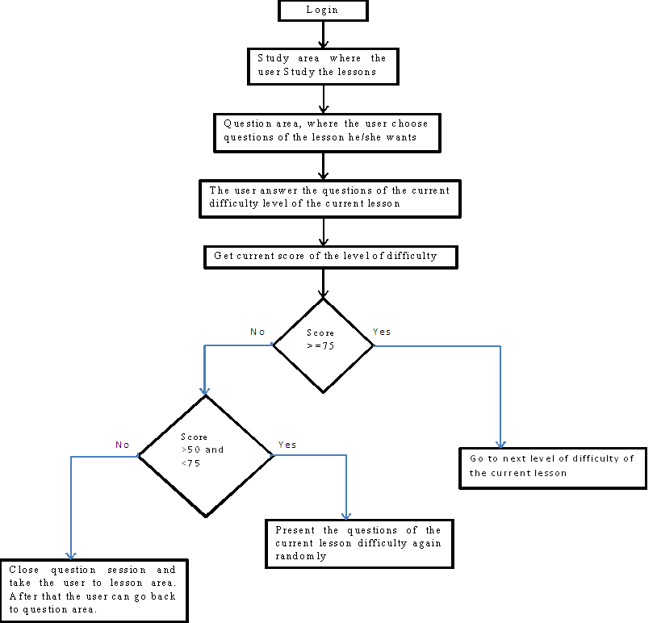

Figure 4: Pedagogical model adaption to user level

* + 1. **User interface model**

The user interface has two sections:-

* 1. Admin's interface is Familiarized to arrange amend the system its different part. So, it conducts as the authoring too. By this interface, the admin can add new lessons, adjust the determinant ones, and revise teaching methods. Figure 5 shows the admin login interface and Figures: 7, 9, 10, 11, 12, 13, 14, 15, and 20 shows different snapshots of the admin screens.
  2. The user' interface conveys all the commands of teaching process, these commands differs with user's performance level. Figure 6 shows the user login interface. Figures: 8, 16, 17, 18, and 19 shows the different snapshots of the user/user screens.
     1. **Screen captures**

These are some screen samples for the proposed ITS system.

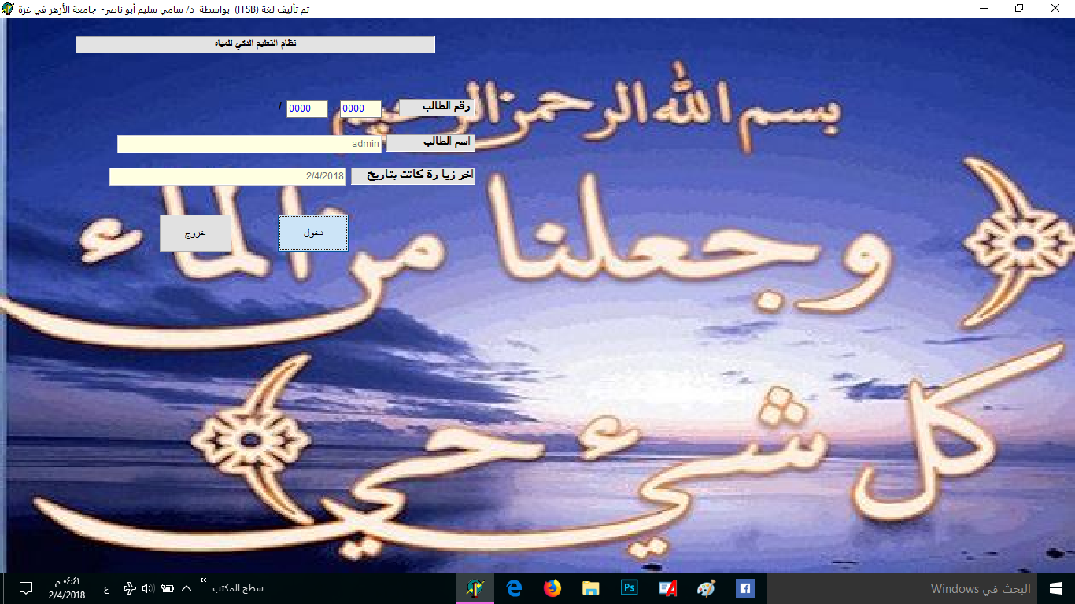

Figure 5Admin login screen

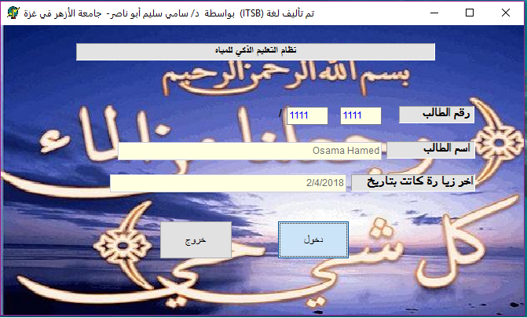

Figure 6 user login screen

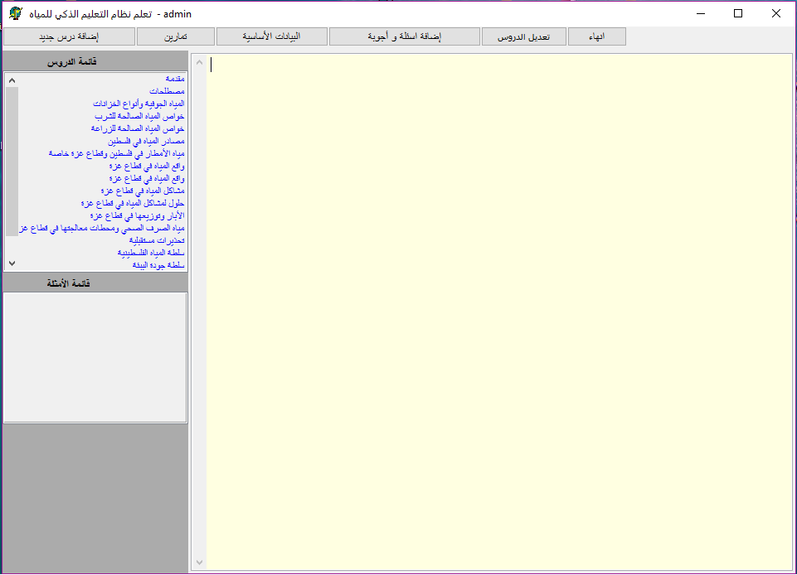

Figure 7 Admin interface

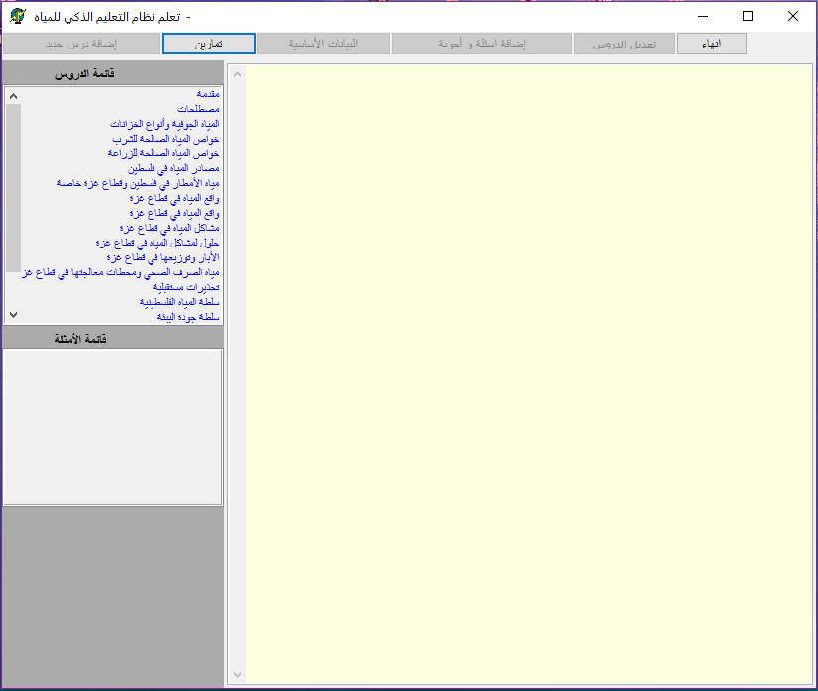

Figure 8 User lessons and examples interface

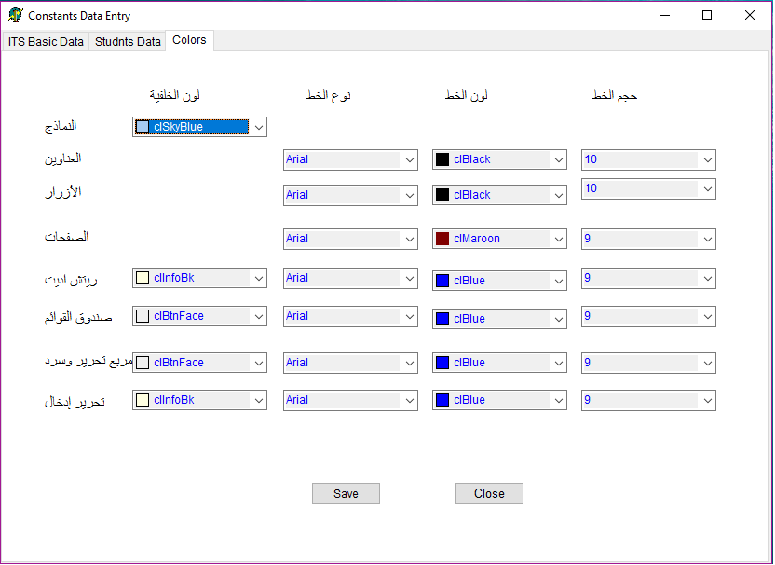

Figure 9 Interface for modifying Fonts of all screens of the system

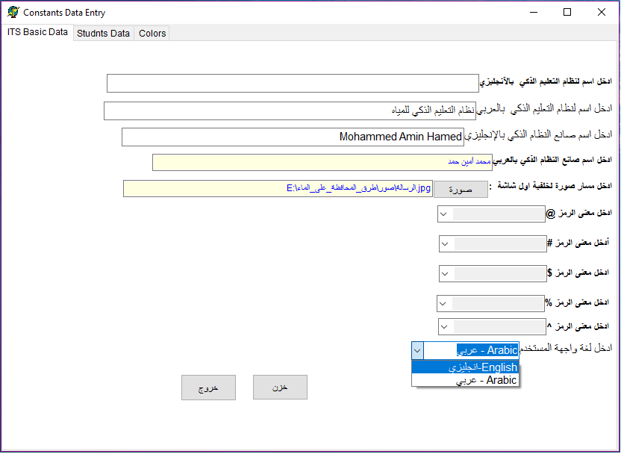

Figure 10 Interface for adding constants of the system

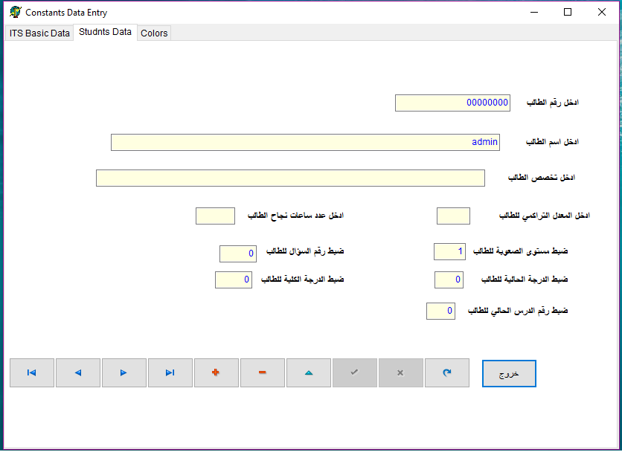

Figure 11 Interface for adding constants of the system

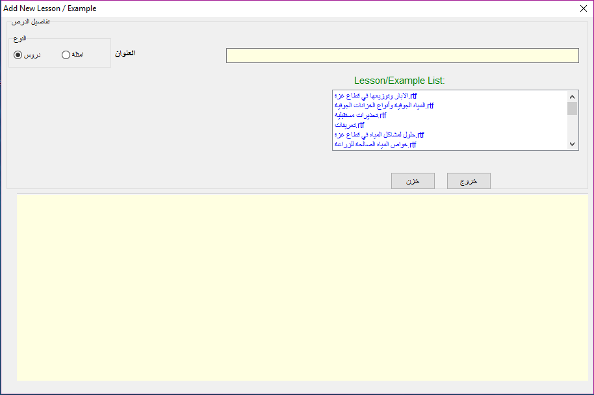

Figure 12 Interface for adding Lessons and Examples

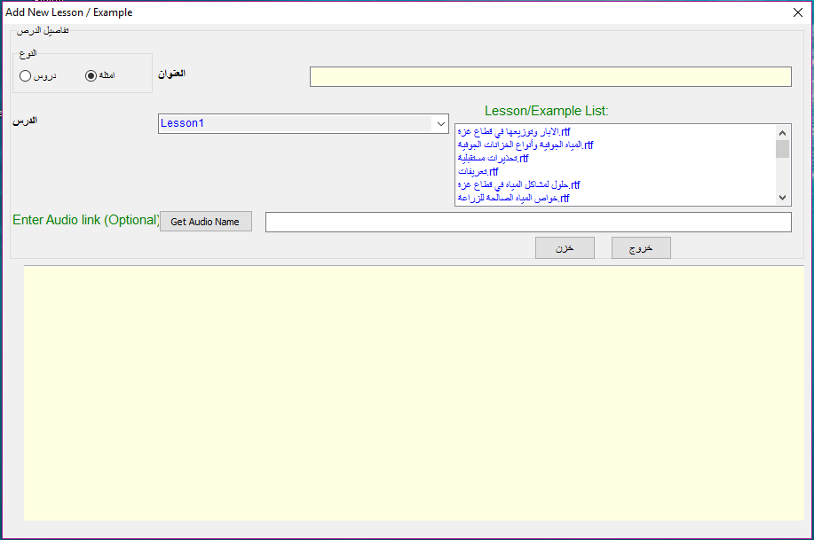

Figure 13 Interface for adding Lessons and Example

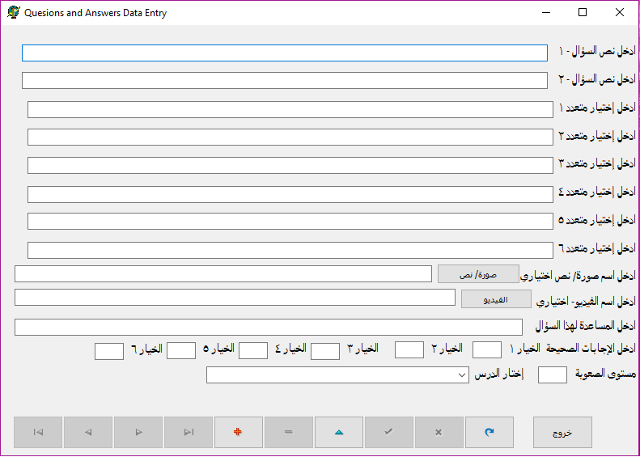

Figure 14 Interface for adding questions and answers

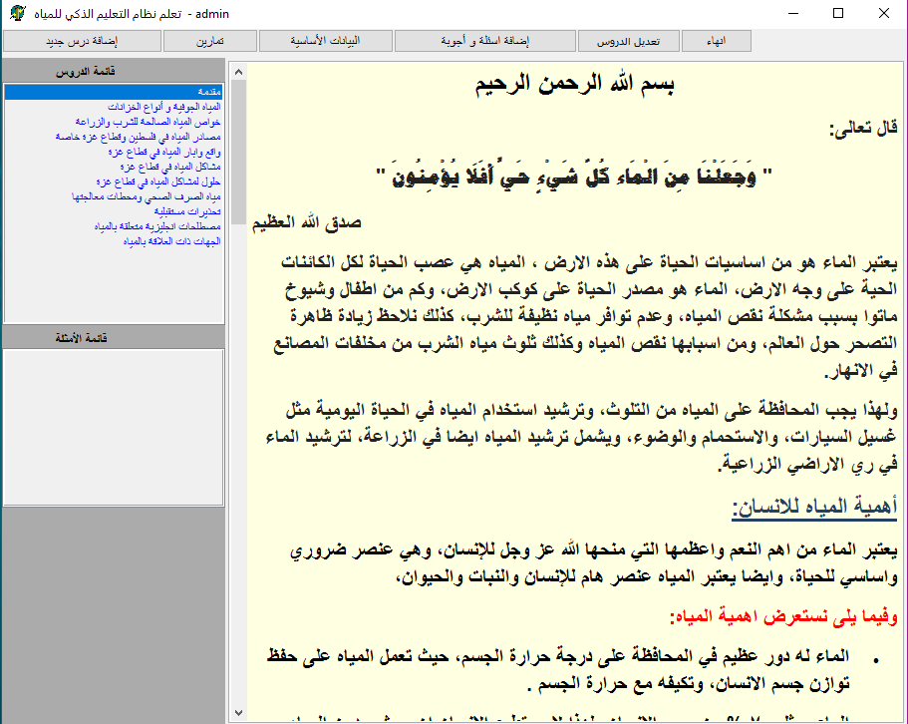

Figure 15 User lessons and examples interface

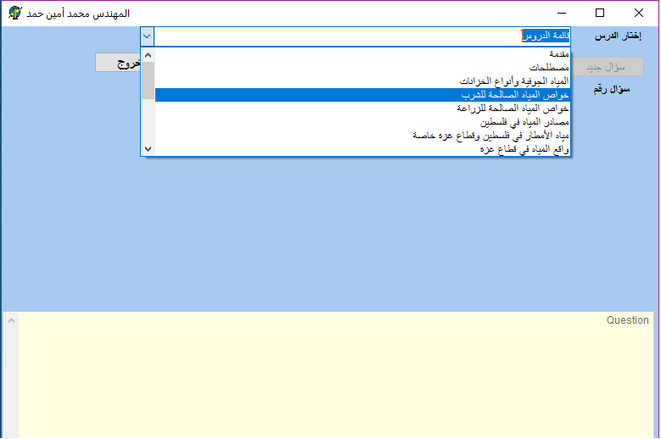

Figure 16 User Exercises interface1

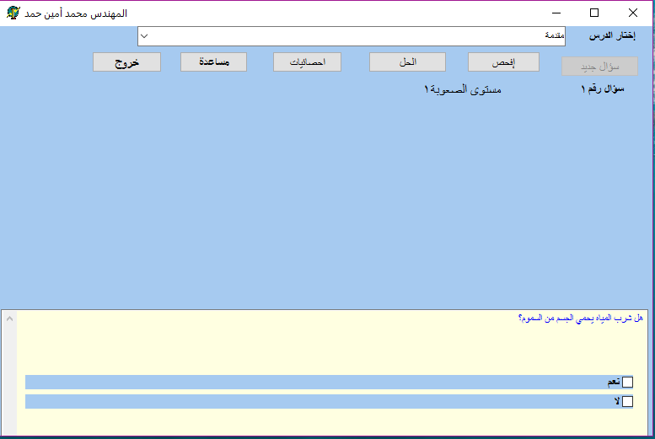

Figure 17 User Exercises interface2

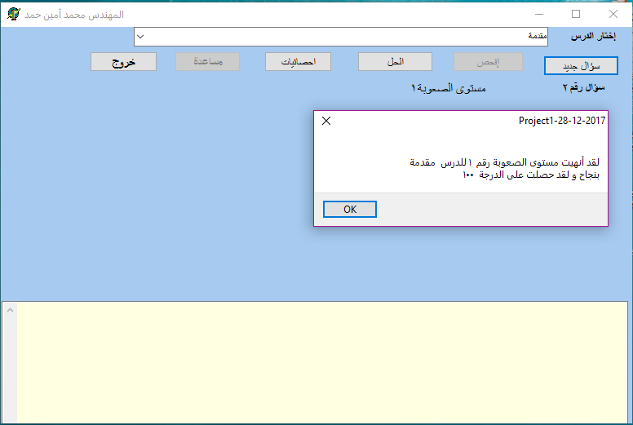

Figure 18 The result is good

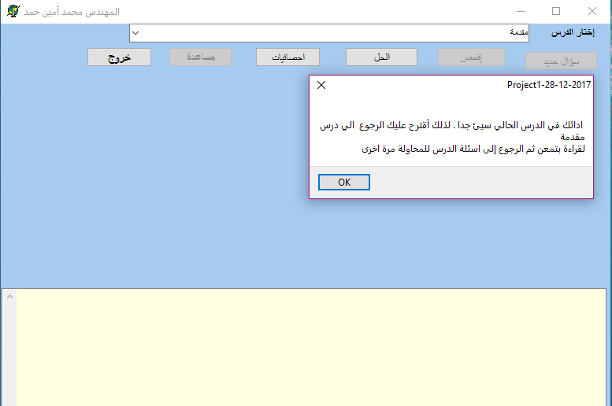

Figure 19 The result is not good

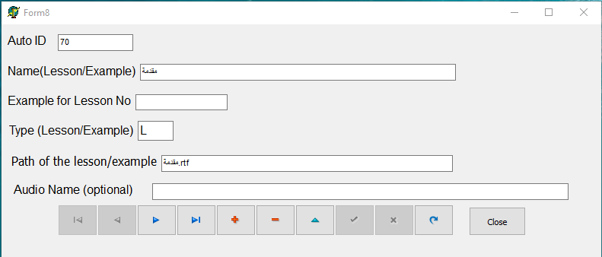

Figure 20 Interface for modification Lessons

Chapter 5  
  
  
  
EVALUATION AND RESULT DISCUSSION

* 1. System Evaluation

System evaluation is used to measure the quality of an application that indicates the efficiency, effectiveness and user satisfaction of the performance of tasks done using the application. The usability evaluation is an vital part of the system development process, and a range of questions have been established to evaluate the ITS system by people interested in learning about the effectiveness of using an Intelligent Tutoring System in Water Knowledge and Awareness.

The proposed ITS system has been presented to two groups of people. The first group consists of seven specialists in water. The second group consists of eight master students enrolled in the Institutes of Water and Environment (IWE) at Al-Azhar University in Gaza. Both groups were requested to evaluate the proposed ITS system and to fill the questionnaire about it. The questionnaire was prepared by the researcher from the ITS literatures [38-68] and approved by his supervisors. The results of the questionnaire of water specialists are shown in Table 1 and Figure 21; furthermore, the results of the questionnaire of the master students enrolled in the Institutes of Water and Environment at Al-Azhar University in Gaza are shown in Table 2 and Figure 22.

* 1. Results of water specialists group:

Table 1 outlines each question and its average percentage. Figure 22 shows a bar chart of each question and its percentage.

Table 1 Results of questions asked to the water specialists

|  |  |  |
| --- | --- | --- |
| **S.N.** | **Question** | **Average%** |
| 1 | How easy to use the ITS system? | 95% |
| 2 | How is the water material covered in the ITS system organized? | 92% |
| 3 | How easy to learn using the ITS system? | 96% |
| 4 | How comfortable and pleasant using this system? | 93% |
| 5 | How much friendly is the user interface of this system? | 94% |
| 6 | How much the utilization of the multimedia features benefits you? | 97% |

Figure 21 The results were obtained by the Water Specialists

* 1. Results of Master Students in IWE group:

Table 2 shows each question and its average percentage. Figure 22 shows a bar chart of each question and its percentage.

Table 2 Results of questions asked to Master Students in IWE group

|  |  |  |
| --- | --- | --- |
| **S.N.** | **Question** | **Average%** |
| 1 | How easy to use the ITS system? | 76% |
| 2 | How is the water material covered in the ITS system organized? | 77% |
| 3 | How easy to learn using the ITS system? | 82% |
| 4 | How comfortable and pleasant using this system? | 84% |
| 5 | How much friendly is the user interface of this system? | 81% |
| 6 | How much the utilization of the multimedia features benefits you? | 87% |

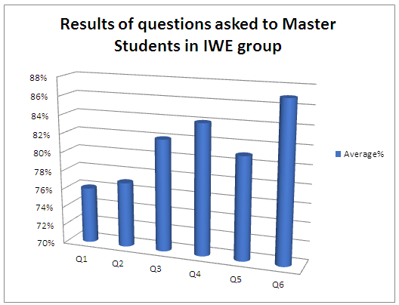

Figure 22 The results were obtained by the Master Students in IWE group

In evaluating the proposed ITS system, evaluators were required to use the proposed ITS system. After that, they were asked to provide their feedback about the proposed ITS system through filling the questionnaire which consisted of the six questions mentioned above.

In this way, effectiveness, efficiency and satisfaction of the proposed ITS system were measured as shown in the above figures. The results were very positive and similar to other systems [69-82].

Chapter 6  
  
  
  
  
CONCLUSION

* 1. Conclusion

In this study, the Intelligent Tutoring System's theory and architecture have been described.

An Intelligent Tutoring System (ITS) was designed and developed for enhancing the future of water conditions in the Gaza strip by encouraging people to use this system to increase their awareness and knowledge about water issues. The ITS system addressed some information about the problems that water sector currently faces.

The proposed ITS system was presented to two groups: water specialists and master students enrolled in IWE in Al-Azhar University to test the system and give their feedback through filling a questionnaire. The outcomes of the evaluation were promising.

It is necessary to follow the existing results in the field of the artificial intelligent and water sector in parallel in order to produce a reasonable method for effective and efficient implementations purposes.

* 1. Future Work

For future work, I am planning to convert the ITS system into mobile application, and expand the system to applicable fields beyond the domain of learning, for example, health, environmental awareness, and companies guidance.

# REFERENCES

1. Abu Naser, S. S. (2016). ITSB: An Intelligent Tutoring System Authoring Tool. Journal of Scientific and Engineering Research, 3(5), 63-71.
2. Shrenik Devasani, (2011). Intelligent Tutoring System Authoring Tools for Non-Programmer.
3. Intelligent tutoring, http://www.adlnet.gov/technologies/tutoring/index.cfm.
4. Intelligent Tutoring Systems (a subtopic of education), <http://www.aaai.org/AITopics/html/tutor.html>.
5. Self J.,(1999). The Defining Characteristics of Intelligent Tutoring Systems, Research: ITSs Care, Precisely, International Journal of Artificial Intelligence in Education, 350-364.
6. D. Sleeman, A.E. Kelly, R. Martinak, R.D. Ward, and J. Moore. (1988). Diagnosis and Remediation in the Context of Intelligent Tutoring Systems. Army Research Institute for The Behavioral And Social Sciences, 88-66.
7. Peter Brusilovsky, Elmar Schwarz, and Gerhard Weber, (1996). ELM-ART: An Intelligent Tutoring System on World Wide Web.
8. Kenneth R. Koedinger, John R. Anderson, William H. Hadley, Mary A. Mark, (1997), Intelligent Tutoring Goes To School in the Big City. International Journal of Artificial Intelligence in Education, 30-43.
9. Pramuditha Suraweera and Antonija Mitrovic, (2002). KERMIT: A Constraint-Based Tutor for Database Modeling. Springer-Verlag Berlin Heidelberg, 377–387.
10. C.J. Butz, S. Hua, R.B. Maguire, (2006). AWeb-based Intelligent Tutoring System for Computer Programming.
11. Jorge García, Karmele Lz. de Ipiña, Eloy Irigoyen, Jon A. Elorriaga, Nestor Garay, Ekaitz Zulueta, Jokin Rubio, Celina Vaquero, Mikel Peñagarikano, Jose M. López, Aitzol Ezeiza, Jesús Mª Lz. de Ipiña, (2006). Intelligent tutoring system to integrate people with down syndrome into work environments.
12. [Aleven Vincent](https://content.iospress.com:443/search?q=author%3A%28%22Aleven,%20Vincent%22%29), [McLaren Bruce M.](https://content.iospress.com:443/search?q=author%3A%28%22McLaren,%20Bruce%20M.%22%29), [Sewall Jonathan](https://content.iospress.com:443/search?q=author%3A%28%22Sewall,%20Jonathan%22%29), [Koedinger Kenneth R](https://content.iospress.com:443/search?q=author%3A%28%22Koedinger,%20Kenneth%20R.%22%29), (2009). A New Paradigm for Intelligent Tutoring Systems: Example-Tracing Tutors. [International Journal of Artificial Intelligence in Education](https://content.iospress.com:443/journals/international-journal-of-artificial-intelligence-in-education), 105-154.
13. Vincent Aleven, Bruce M. McLaren, and Jonathan Sewall, (2009). Scaling Up Programming by Demonstration for Intelligent Tutoring Systems Development: An Open-Access Web Site for Middle School Mathematics Learning. IEEE transactions on learning technologies, (64-78).
14. Abu-Naser, S., Ahmed, A., Al-Masri, N., Deeb, A., Moshtaha, E., & AbuLamdy, M. (2011). An intelligent tutoring system for learning java objects. International Journal of Artificial Intelligence and Applications (IJAIA), 2(2).
15. Maria Virvou and Christos Troussas, (2011). Knowledge-Based Authoring Tool for Tutoring Multiple Languages. Intelligent Interactive Multimedia, 163-175.
16. Sklavakis Dimitrios, Refanidis Ioannis, (2013). An Intelligent Web-Based Algebra Tutoring School, International Journal of Artificial Intelligence in Education, 191-218.
17. Dinesha Weragama and Jim Reye, (2013). The PHP Intelligent Tutoring System. K. Yacef et al. (Eds.): AIED, 583-586.
18. Michał Kosek, (2014). An Intelligent Tutoring System for Learning Chinese with a Cognitive Model of the Learner. University of Oslo.
19. Ramón Zataraín Cabada, María Lucía Barrón Estrada, Francisco González Hernández, and Raúl Oramas Bustillos, (2014). Intelligent Tutoring System with Affective Learning for Mathematics. A. Gelbukh et al. (Eds.): MICA, 483–493.
20. Hamed, M. A., & Abu Naser, S. S. (2017). An intelligent tutoring system for teaching the 7 characteristics for living things. International Journal of Advanced Research and Development, 2(1), 31-45.
21. Joe Appleton, (2017). Introducing intelligent exercises to support web application programming users. Icicte, 216-225.
22. Palestinian Water Authority (2017). General Directorate of Water Resources in Gaza Strip, Gaza, Palestine.
23. Palestinian Central Bureau of Statistics (2016).
24. Palestinian Water Authority (2017). Drinking Water in Gaza City Reality and Solutions, General Directorate of Water Resources and Planning, Gaza, Palestine.
25. Coastal Municipalities Water Utility (2013). Annual Report on the Status of Water in the Gaza Strip, Palestine.
26. M. Zin, A. Aljunid, Z. Shukur, and M.J. Nordin. (2000). A knowledge-based automated debugger in learning system,” In: Proceedings of 4th International Workshop on Automated Debugging (AADEBUG-2000).
27. K. Warendorf, and C. Tan.(1997). “ADIS - An animated data structure intelligent tutoring system or putting an interactive tutor on the WWW,” In: Proceedings of 8th World Conference on Artificial Intelligence in Education (AI-ED'97), pp. 54-60.
28. C. J. Butz, S. Hua, and R. B. Maguire(2006). A Web-based Bayesian intelligent tutoring system for computer programming, Web Intelligence and Agent Systems, Vol. 4, No. 1, 2006, pp.77-97.
29. S. Amalathas, A. Mitrović, R. Saravanan.(2012). Decision-making tutor: Providing on the job training for oil palm plantation managers, Research and Practice in Technology Enhanced Learning, Vol. 7, No. 3, pp. 131-152.
30. G. Weber, P. Brusilovsky. (2016). ELM-ART-An interactive and intelligent Web-based electronic textbook, International Journal of Artificial Intelligence in Education, Vol. 26, No. 1, pp. 72-81.
31. E.R. Sykes. (2007). Developmental process model for the Java intelligent tutoring system, Journal of Interactive Learning Research, Vol. 18, No. 3, pp. 399-410.
32. Mahdi, A. O., Alhabbash, M. I., & Abu Naser, S. S. (2016). An intelligent tutoring system for teaching advanced topics in information security. World Wide Journal of Multidisciplinary Research and Development, 2(12), 1-9.
33. Alhabbash, M. I., Mahdi, A. O., & Abu Naser, S. S. (2016). An Intelligent Tutoring System for Teaching Grammar English Tenses. EUROPEAN ACADEMIC RESEARCH, 6(9), 7743-7757.
34. Al-Bastami, B. G., & Abu Naser, S. S. (2017). Design and Development of an Intelligent Tutoring System for C# Language. EUROPEAN ACADEMIC RESEARCH, 6(10), 87-95.
35. Albatish, I., Mosa, M. J., & Abu-Naser, S. S. (2018). ARDUINO Tutor: An Intelligent Tutoring System for Training on ARDUINO. International Journal of Engineering and Information Systems (IJEAIS), 2(1), 236-245.
36. Corbett, Albert T. and Anderson, John R., "User Modeling and Mastery Learning in a Computer-Based Programming Tutor" (2008). Department of Psychology. Paper 18. <http://repository.cmu.edu/psychology/18>.
37. ALI TALIB QASIM AL-AQBI, (2017). Intelligent Tutoring System Effects on the Learning Process. Wright State University. [https://www.wright.edu/ eve nts/masters- thesis-defense](https://www.wright.edu/%20eve%20nts/masters-%20thesis-defense)%E2%80%9Cintelligent-tutoring-system-effects-le arning process%E2%80%9D-ali-talib-qasim
38. Anderson, H.; Koedinger, M. (1997). "Intelligent tutoring goes to school in the Big City". International Journal of Artificial Intelligence in Education. 8: 30–43.
39. Akkila, A. N., & Abu Naser, S. S. (2017). Teaching the right letter pronunciation in reciting the holy Quran using intelligent tutoring system. International Journal of Advanced Research and Development, 2(1), 64-68.
40. Abu Naser, S. (2008). JEE-Tutor: An Intelligent Tutoring System for Java Expression Evaluation. Information Technology Journal, Scialert, 7(3), 528-532.
41. Almurshidi, S. H., & Abu Naser, S. S. (2017). Stomach disease intelligent tutoring system. International Journal of Advanced Research and Development, 2(1), 26-30.
42. Aldahdooh, R., & Abu Naser, S. S. (2017). Development and Evaluation of the Oracle Intelligent Tutoring System (OITS). EUROPEAN ACADEMIC RESEARCH, 6(10), 8711-8721.
43. Al-Bayed, M. H., & Abu Naser, S. S. (2017). An intelligent tutoring system for health problems related to addiction of video game playing. International Journal of Advanced Scientific Research, 2(1), 4-10.
44. El Agha, M., Jarghon, A., & Abu Naser, S. S. (2017). Polymyalgia Rheumatic Expert System. International Journal of Engineering and Information Systems (IJEAIS), 1(4), 125-137.
45. Abu Naser, S. S. (2008). Developing an intelligent tutoring system for students learning to program in C++. Information Technology Journal, 7(7), 1055-1060.
46. El Haddad, I. A., & Abu Naser, S. S. (2017). ADO-Tutor: Intelligent Tutoring System for leaning ADO. NET. EUROPEAN ACADEMIC RESEARCH, 6(10), 8810-8821.
47. Abu Naser, S. (2008). An Agent Based Intelligent Tutoring System For Parameter Passing In Java Programming. Journal of Theoretical & Applied Information Technology, 4(7).
48. Hilles, M. M., & Abu Naser, S. S. (2017). Knowledge-based Intelligent Tutoring System for Teaching Mongo Database. EUROPEAN ACADEMIC RESEARCH, 6(10), 8783-8794.
49. Hamed, M. A., & Abu Naser, S. S. (2017). An intelligent tutoring system for teaching the 7 characteristics for living things. International Journal of Advanced Research and Development, 2(1), 31-45.
50. Abu Naser, S. S., & Sulisel, O. (2000). The effect of using computer aided instruction on performance of 10th grade biology in Gaza. Journal of the College of Education, 4, 9-37.
51. Qwaider, S. R., & Abu Naser, S. S. (2017). Expert System for Diagnosing Ankle Diseases. International Journal of Engineering and Information Systems (IJEAIS), 1(4), 89-101.
52. AbuEl-Reesh, J. Y., & Abu Naser, S. S. (2017). An Expert System for Diagnosing Shortness of Breath in Infants and Children. International Journal of Engineering and Information Systems (IJEAIS), 1(4), 102-115.
53. Elnajjar, A. E. A., & Abu Naser, S. S. (2017). DES-Tutor: An Intelligent Tutoring System for Teaching DES Information Security Algorithm. International Journal of Advanced Research and Development, 2(1), 69-73.
54. Al Rekhawi, H. A., Ayyad, A. A., & Abu Naser, S. S. (2017). Rickets Expert System Diagnoses and Treatment. International Journal of Engineering and Information Systems (IJEAIS), 1(4), 149-159.
55. Almurshidi, S. H., & Abu Naser, S. S. (2017). Design and Development of Diabetes Intelligent Tutoring System. EUROPEAN ACADEMIC RESEARCH, 6(9), 8117-8128.
56. Abu Ghali, M. J., Mukhaimer, M. N., Abu Yousef, M. K., & Abu Naser, S. S. (2017). Expert System for Problems of Teeth and Gums. International Journal of Engineering and Information Systems (IJEAIS), 1(4), 198-206.
57. Khella, R. A., & Abu Naser, S. S. (2017). Expert System for Chest Pain in Infants and Children. International Journal of Engineering and Information Systems (IJEAIS), 1(4), 138-148.
58. AbuEloun, N. N., & Abu Naser, S. S. (2017). Mathematics intelligent tutoring system. International Journal of Advanced Scientific Research, 2(1), 11-16.
59. Bakeer, H. M. S., & Naser, S. S. A. (2017). Photo Copier Maintenance Expert System V. 01 Using SL5 Object Language. International Journal of Engineering and Information Systems (IJEAIS), 1(4), 116-124.
60. Nabahin, A., Abou Eloun, A., & Abu Naser, S. S. (2017). Expert System for Hair Loss Diagnosis and Treatment. International Journal of Engineering and Information Systems (IJEAIS), 1(4), 160-169.
61. Al-Nakhal, M. A., & Abu Naser, S. S. (2017). Adaptive Intelligent Tutoring System for learning Computer Theory. EUROPEAN ACADEMIC RESEARCH, 6(10), 8770-8782.
62. Abu Hasanein, H. A., & Abu Naser, S. S. (2017). An intelligent tutoring system for cloud computing. International Journal of Academic Research and Development, 2(1), 76-80.
63. Alawar, M. W., & Abu Naser, S. S. (2017). CSS-Tutor: An intelligent tutoring system for CSS and HTML. International Journal of Academic Research and Development, 2(1), 94-98.
64. Al-Hanjori, M. M., Shaath, M. Z., & Abu Naser, S. S. (2017). Learning computer networks using intelligent tutoring system. International Journal of Advanced Research and Development (2), 1.
65. Shaath, M. Z., Al-Hanjouri, M., Abu Naser, S. S., & Aldahdooh, R. (2017). Photoshop (CS6) intelligent tutoring system. International Journal of Academic Research and Development, 2(1), 81-87.
66. Mrouf, A., Albatish, I., Mosa, M., & Abu Naser, S. S. (2017). Knowledge Based System for Long-term Abdominal Pain (Stomach Pain) Diagnosis and Treatment. International Journal of Engineering and Information Systems (IJEAIS), 1(4), 71-88.
67. Naser, S. (2009). Evaluating the effectiveness of the CPP-Tutor an intelligent tutoring system for students learning to program in C++. Journal of Applied Sciences Research, 5(1), 109-114.
68. Al Rekhawi, H. A., & Abu Naser, S. (2018). An Intelligent Tutoring System for Learning Android Applications Ui Development. International Journal of Engineering and Information Systems (IJEAIS), 2(1), 1-14.
69. Abu Naser, S. S. (2012). Predicting learners performance using artificial neural networks in linear programming intelligent tutoring system. International Journal of Artificial Intelligence & Applications, 3(2), 65.
70. Mosa, M. J., Albatish, I., & Abu-Naser, S. S. (2018). ASP. NET-Tutor: Intelligent Tutoring System for leaning ASP. NET. International Journal of Academic Pedagogical Research (IJAPR), 2(2), 1-8.
71. Abu Naser, S. S. (2006). Intelligent tutoring system for teaching database to sophomore students in Gaza and its effect on their performance. Information Technology Journal, 5(5), 916-922.
72. Abu Ghali, M., Abu Ayyad, A., Abu-Naser, S. S., & Abu Laban M. (2018). An Intelligent Tutoring System for Teaching English Grammar. International Journal of Academic Engineering Research (IJAER), 2(2), 1-6.
73. Marouf, A., Abu Yousef, M. K., Mukhaimer, M. N., & Abu-Naser, S. S. (2018). An Intelligent Tutoring System for Learning Introduction to Computer Science. International Journal of Academic Multidisciplinary Research (IJAMR), 2(2), 1-8.
74. [Abu-Nasser](https://papers.ssrn.com/sol3/cf_dev/AbsByAuth.cfm?per_id=2854927), B. S. (2017). Medical Expert Systems Survey. International Journal of Engineering and Information Systems (IJEAIS), 1(7), 218-224.
75. Qwaider, S. R., & Abu-Naser, S. S. (2018). Excel Intelligent Tutoring System. International Journal of Academic Information Systems Research (IJAISR), 2(2), 8-18.
76. Abu Naser, S. S. (2008). Developing visualization tool for teaching AI searching algorithms. Information Technology Journal, Scialert, 7(2), 350-355.
77. AbuEl-Reesh, J. Y., & Abu-Naser, S. S. (2018). An Intelligent Tutoring System for Learning Classical Cryptography Algorithms (CCAITS). International Journal of Academic and Applied Research (IJAAR), 2(2), 1-11.
78. Abu Naser, S. S. (2012). A Qualitative Study of LP-ITS: Linear Programming Intelligent Tutoring System. International Journal of Computer Science & Information Technology, 4(1), 209.
79. El Agha, M. I., Jarghon, A. M., & Abu-Naser, S. S. (2018). SQL Tutor for Novice Students. International Journal of Academic Information Systems Research (IJAISR), 2(2), 1-7.
80. Khella, R. A., & Abu-Naser, S. S. (2018). An Intelligent Tutoring System for Teaching French. International Journal of Academic Multidisciplinary Research (IJAMR), 2(2), 9-13.
81. Marouf, A., Yousef, M. K. A., Mukhaimer, M. N., & Abu-Naser, S. S. (2018). AnIntelligent Tutoring System for Learning Introduction to Computer Science. International Journal of Academic Multidisciplinary Research (IJAMR), 2(2), 1-8.
82. Akkila, A. N., & Abu-Naser, S. S. (2018). Rules of Tajweed the Holy Quran Intelligent Tutoring System. International Journal of Academic Pedagogical Research (IJAPR), 2(3), 7-20.
83. Abu Naser, S. S. (2001). A comparative study between animated intelligent tutoring systems AITS and video-based intelligent tutoring systems VITS. Al-Aqsa Univ. J, 5(1), 72-96.