Marian Hillar

WHAT DOES MODERN SCIENCE SAY ABOUT THE ORIGIN OF RELIGION?

ABSTRACT

The origin of religion has fascinated philosophers and evolutionary scientists alike. This article reviews several mechanisms which might have led humans to various forms of religious beliefs. Modern studies and archaeological records suggest that religion may promote cooperation through development of symbolic behavior.
Keywords: Mental faculties; mind theory; the world as living organism; imagination, brain patterns; rules of behavior.

In almost every society we find gods, worshipped in magnificent and imposing buildings construction of which consumed enormous resources and efforts. This worship is accompanied by elaborate rituals and most often written texts considered the direct revelation of divinities for the purpose of explaining humans’ place in the world and relations toward god(s) and other humans. Since antiquity people pondered the question of existence or nonexistence of god(s) and tried to explain the origin of religion. Epicurus claimed that we must admit the existence of gods because this knowledge is implanted in our minds from birth. So we have a preconception or “an innate idea” or a prior knowledge of the divine. Others denied any existence of gods. Still others such as Protagoras of Abdera wrote that “we are not able to say whether the gods existed or not.”
When Darwin posited the idea of human origin from the animal world he immediately concluded that “As so as the important faculties of the imagination, wonder, and curiosity, together with some power of reasoning, had become partially developed, man would naturally crave to understand what was passing around him, and would have vaguely speculated on his own existence.” And he suggested, after Herbert Spencer, that in “the earliest forms of religious belief human was led through dreams, shadows, and other causes to look at oneself as a double essence, corporeal and spiritual. As the spiritual being is supposed to exist after death and to be powerful, it is propitiated by various gifts and ceremonies, and its aid is invoked. He then further shews names or nicknames given from some animal or other objects, to the early progenitors or founders of a tribe, are supposed after a long interval to present the real progenitor of the tribe; and such animal or object is then naturally still to exist as a spirit, is held sacred, and worshipped as a god. Nevertheless I cannot but suspect that there is a still earlier and ruder stage, when anything which manifests power or movement is thought to be endowed with some form of life, and with mental faculties analogous to our own.”
Eventually, “The same high mental faculties which first led man to believe in unseen spiritual agencies, then in fetishisms, polytheism, and ultimately in monotheism, would inevitably lead him, as long as his reasoning powers remained poorly developed, to various strange superstitions and customs.”
Modern exploration of the archaeological records and effects of religion in societies suggest that religion may promote cooperative behavior through the development of symbolic behavior. Other studies following the lead of Darwin through the investigation of the mind itself (psychology, anthropology, and neuroscience) suggest that there are certain functional properties in our cognitive systems that lean toward a belief in a supernatural agent. We see agents, minds like our own, working in the world. Thus we endow even inanimate objects with human characteristics, emotions, desires, and consciousness. This would explain the psychological basis for the ancient view of the world as a “living organism,” and the Greek Logos doctrine.

WHEN AND WHY DID RELIGIOUS BELIEF BEGIN?
ARCHAEOLOGICAL STUDIES

This is a fundamental question which cannot be answered easily. Many paleontologists and archaeologists suggest that religious belief and symbolic behavior may have started with the first abstract forms such as the geometrical carvings found in Blombos Cave (South Africa) on a piece of ochre going back to some 70,000 ago (Figure 1). Another suggestion comes from the burial sites discovered in a cave in Jebel Qafzeh-Skhul in Israel (on the slopes of Mount Carmel) dated from about 95,000 years ago. This site included some 12 significant fossilized human skeletons of anatomically modern humans, including a child holding deer antlers in its arms. Many of the bones are stained with red ochre (Figure 2) which may suggest that it was used for the burial process, indicating ritual behavior symptomatic of symbolic thought. Also Neanderthals are known to have buried the dead from about 65,000 years ago.

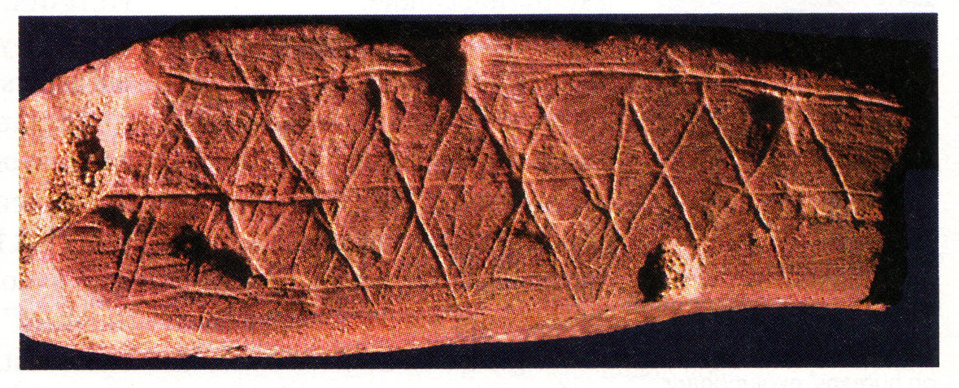
Figure 1. The first documentation of “symbolic art” from Blombos Cave (South Africa)
dated from some 70,000 years ago.

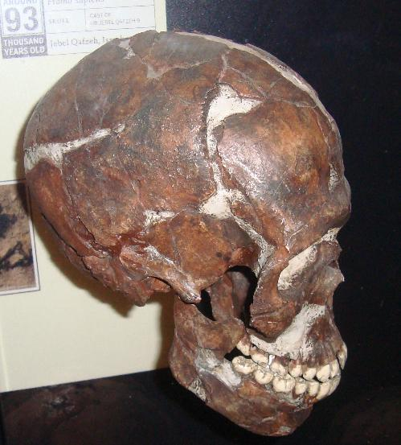

Figure 2. Qafzeh Skull with ochre staining.
Burial itself does not indicate the birth of gods. There may be many reasons to bury the dead though it could be associated with the idea of life existing after death. Some researchers point to the moment when about 30,000 to 35,000 years ago there appeared in Europe realistically painted animals, and half-animal and half-human figures in a cave in France (Grotte Chauvet) and impressive carved figurines. These figurines represented female figures nicknamed “Venus figurines” dated from about 35,000 to about 11, 000 years. They were found in various places in Eurasia and were carved in soft stone, bone ivory, or in fired clay. The oldest was fond in Germany (Venus of Hoble Fels) dating from 35,000 years ago (Figure 3). Another ivory figurine represented a lion-man, a man’s body with a lion’s head (Figure 4). It is the oldest known zoomorphic sculpture. The figurine was determined to be about 32,000 years old and is believed to represent a deity. Ancient Egyptian, Mesopotamian, and Jewish religion had many creatures which derived from animal representations and performed various functions (Figure 5).

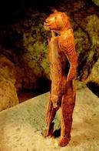
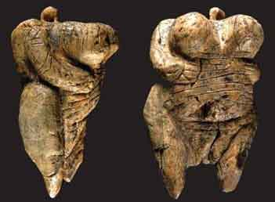

Figure 3. 35,000 year old statuette of Venus of Hoble Fels.
Figure 4. 32,000 years old figurine of lion-man from Stadel-Höhle cave in Hohlenstein, Germany.

The structure which is considered the first temple was built some 11,000 years ago in Göbekli Tepe in Turkey. It consists of 6-meter-high circular rows of standing stone carved with image of wild animals (Figures 6, 7).
Scientists indicate, however, that we may not know for sure that we have a religious culture until we have a written record of the names of gods in literate societies and social organization. And we find such oldest records in the early empires in Mesopotamia and in Egypt from about 5,000 years ago which had both secular and religious hierarchies.

PSYCHOLOGICAL COGNITIVE SCIENCE OF RELIGION

Archaeological investigations give us an insight into the outward expression of symbolic behavior, cognitive studies of religious beliefs gives us an insight into the working of our minds. The basic model is consistent with the pattern that we are hypersensitive to the idea of an “agent” who is constructed on the pattern of our own person. We ascribe to this “agent” the actualization of random natural phenomena. We invent agents describing them as “spirits,” “jins,”

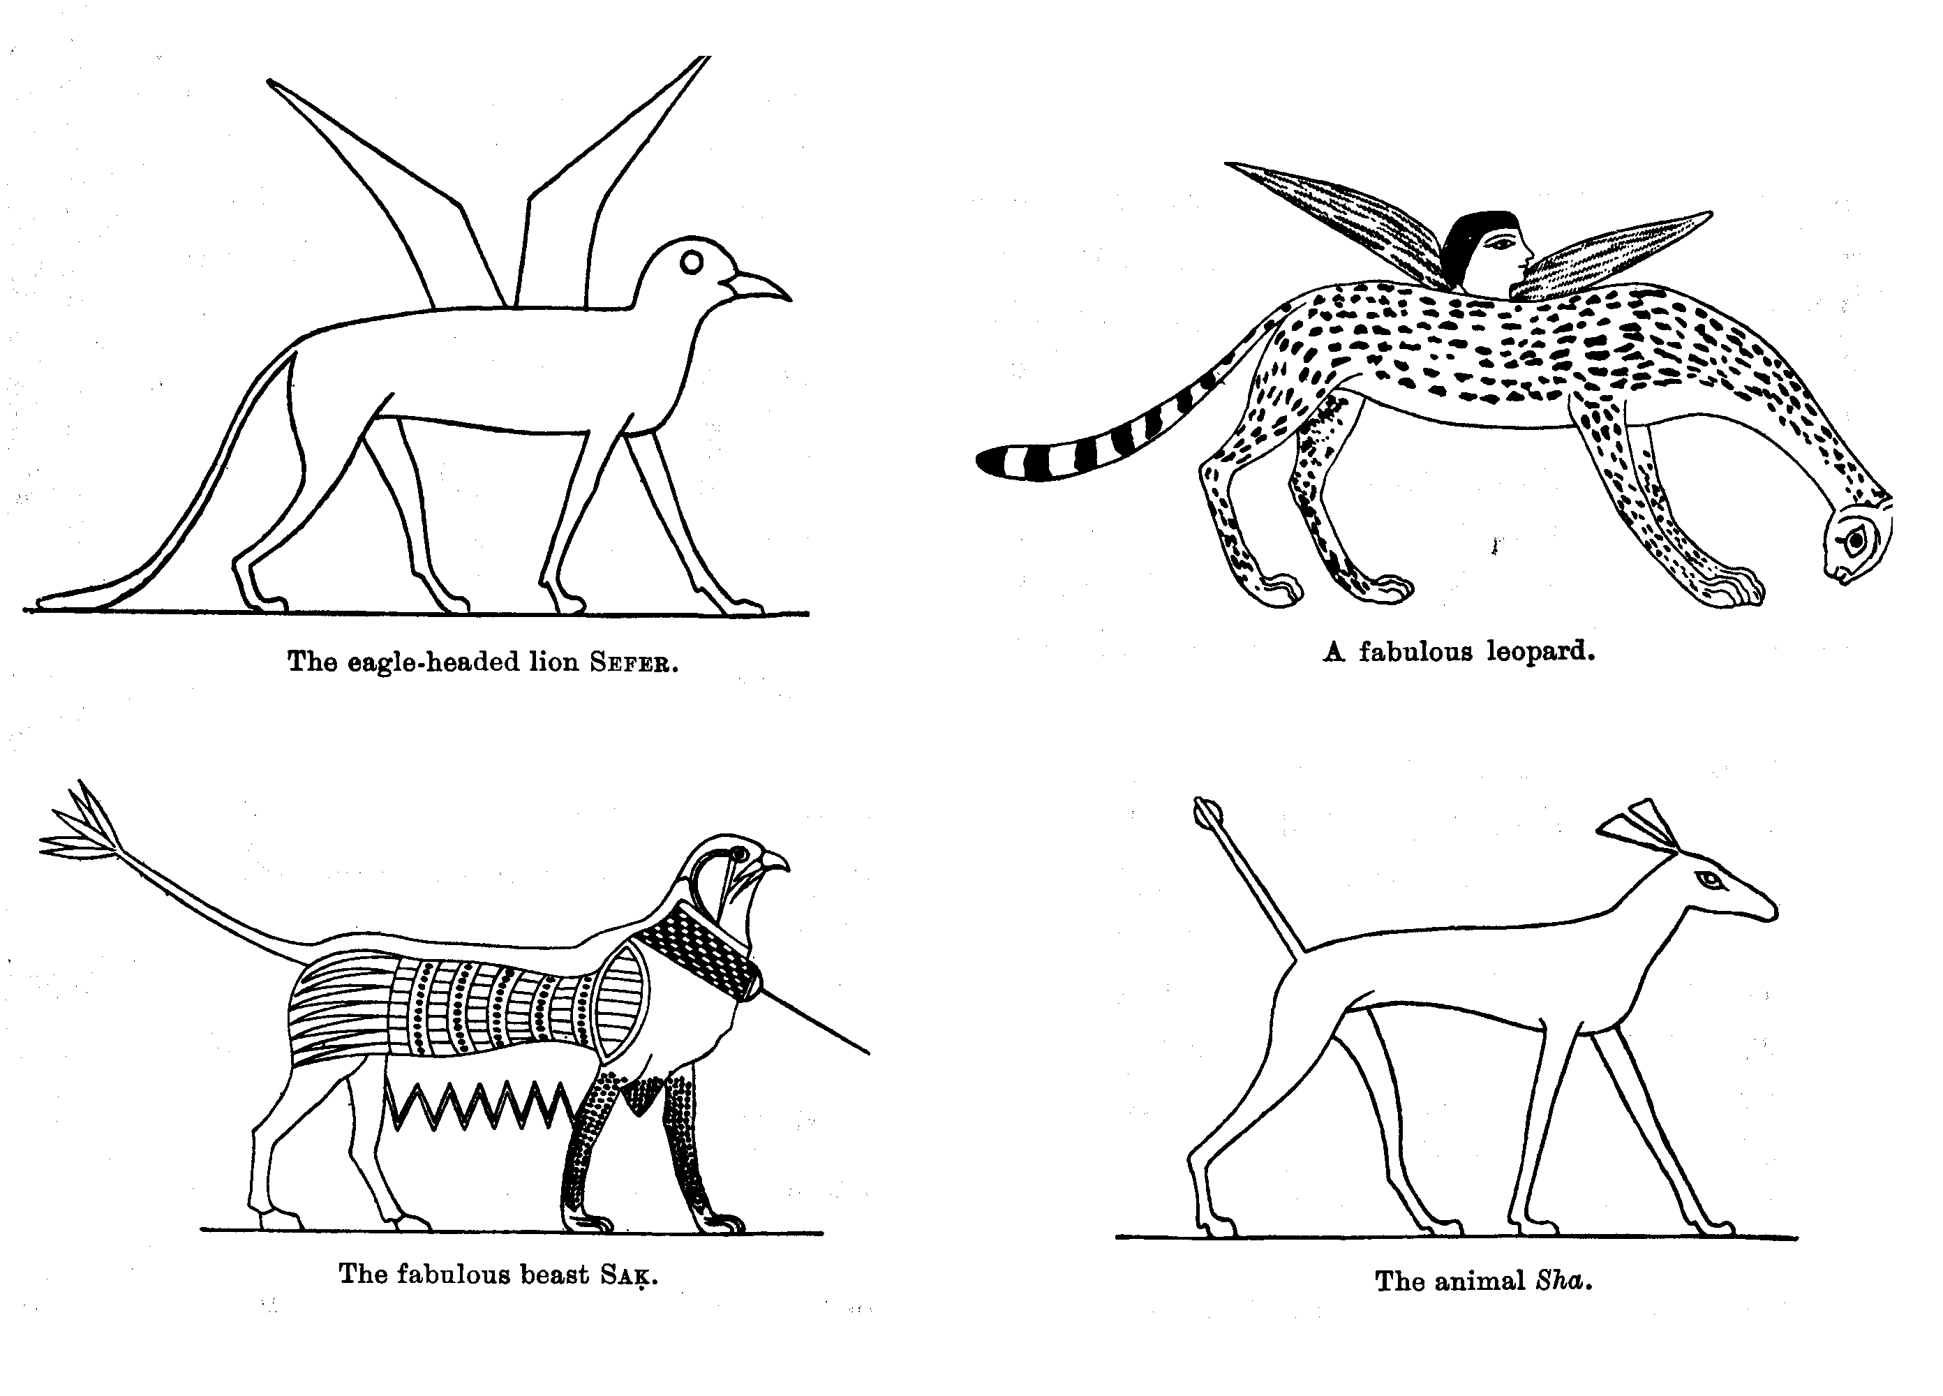

Figure 5. Various animal creatures from the Egyptian culture

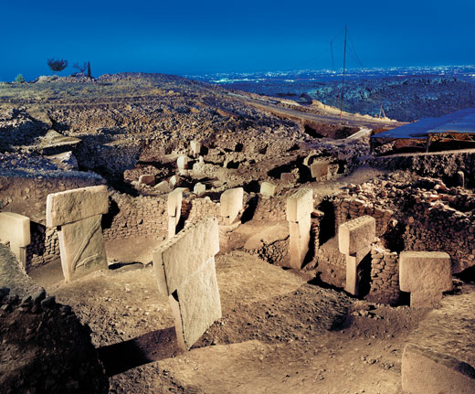

Figure 6. Overview of the “First Temple” from Göbekli Tepe (11,000 years ago)

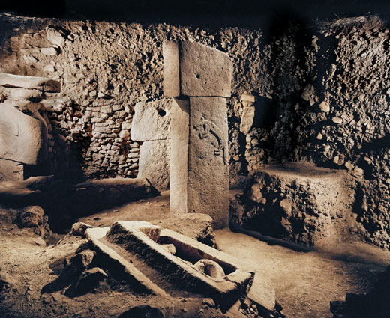

Figure 7. Detail of the carved animal

“angels,” “devils,” and a variety of other imagined beings. We eventually visualize the world as a living being, we personify natural forces, or in more sophisticated systems we consider the universe to be alive because of the permeating agent, “logos” or the “soul.” Such thinking is attested by many Greek philosophical doctrines. To this type of thinking belongs the question most frequently asked “Who made the universe?” which is a projection of the pattern of human activity on the nature. We ascribe natural phenomena to the agency of another being that is like ourselves equipped with a thinking mind. Pascal Boyer describes this attitude as “hypertrophy of social cognition.” Studies with young children demonstrate that we prefer teleological, or purpose-driven, explanations of natural phenomena. Children in first through fourth grades e.g., when asked whether rocks are pointy because of the arrangement of the composing material or in order to keep animals from sitting on them, gave teleological explanations. The same interpretation is given by uneducated adults and even undergraduate students. Psychologists conclude that we may be intuitive “theists” seeing a natural world as purposefully designed.
Anthropologists, for example Stewart Guthrie, discovered that we tend to attribute agency to inanimate objects (hypersensitive agency detection device). This is easily understood when we consider how we explain an occurrence of a noise in the night, whether produced by wind or by a burglar. Such reactions may have some evolutionary implications as being developed through natural selection in avoiding false alarms.
The combination of such tendencies with the theory of mind, that is, the understanding that other beings have the same intentions, desires, feelings, and beliefs as we do, leads through a higher cognitive process to the development of the concept of a god. In fact such ability develops in children and is present at the age of 5. Already Darwin stated this in a succinct way that the belief in spiritual agencies would pass into the belief of a god or gods and humans “would naturally attribute to spirits the same passions, the same love of vengeance or simplest form of justice, and the same affections which they themselves feel.” Archaeologists suggest that already the Paleolithic cave paintings and carvings of half-animal half-human figures demonstrated that the early Homo sapiens was applying the theory of mind to other animals as long ago as 30,000 years.
Thus the mental states of the beings not visibly present should be represented in the function of our brains, and functional magnetic resonance imaging (fMRI) studies should be able to localize what parts of the brain are involved in this process. A recent report of such studies where researchers asked subjects to evaluate statements about God’s emotion such as “God is removed from the world” or “God is forgiving” indicate that the area which was activated in the brain was the inferior frontal gyrus on both sides of the brain, the same area which is involved in the theory of mind. These studies revealed three psychological dimensions of religious belief (God's perceived level of involvement, God's perceived emotion, and doctrinal/experiential religious knowledge), which were localized within networks processing theory of mind concerning intent and emotion, abstract semantics, and imagery. This suggests that religious belief is not associated with any singular area of the brain but distributed in various regions including those that are involved in the theory of mind.
Other researchers demonstrated that children between the ages of 4 to 12 are predisposed to think that the mind persists after death. If, for example in the studies of Bering, they were shown a puppet show in which crocodile ate a mouse, they agreed that the body of the mouse did not function anymore but its psychological state would persist because it still would feel hunger. This indicates that we have a predisposition to believe that mind continues after death, thus it is immortal. This feeling seems to be universal.
These studies, however, are contradicted by other researchers like Paul Harris who worked with children in Spain and Madagascar. He asked similar questions to those which were asked by Bering, but got different answers. Adults and older children were more inclined to think that psychological states continue after death. Also people in many cultures distinguish between the mind that learns and changes with time, and something that is not changing, something like a soul. So Harris suggests that people have an intuition of triadism: they are disposed to believe in the mind, body and soul. Thus it seems that more studies are needed to distinguish between what is learned and what is innate.
Other researchers suggest that there is much more involved in religion than just patterns in the brain. Ara Norenzayan promotes another model to explain the prominence of religion in many cultures. His explanation is that religion promotes cooperative behavior among strangers and creates stable groups. Religion encourages helpful behavior enhancing the biological survival of groups and reproduction of their members. Moreover, the strict rules of behavior may discourage a free ride which may plague cooperative groups. Helpful behavior is more common when people have the impression that they are watched. So the idea of a supernatural god would be advantageous for the group. Cognitive tendencies thus led to religion which then spread because it increased fitness. But the case may still be open; it would require demonstration that religious recommendations are actually followed by members of the group.

ABOUT THE AUTHOR — Professor of Philosophy and Religious Studies and of Biochemistry and Molecular Biology at Texas Southern University (USA), where he is also Director of the Center for Philosophy and Socinian Studies.
His books include: Michael Servetus: Intellectual Giant, Humanist and Martyr (2002), and The Case of Michael Servetus. The Turning Point in the Struggle for Freedom of Conscience (1997). He is also editor in chief of Essays in the Philosophy of Humanism, a publication of the American Humanist Association. Currently (with Christopher A. Hoffman) he is translating the major work of M. Servetus Christianismi restitutio.

Cicero, The Nature of the Gods. Translated by Horace C. P. McGregor, with an Introduction by J. M. Ross (Harmondsworth, Middlesex, England: Penguin Books, 1986), pp. 88–95. Modern views on religion and god are reviewed in Peter Angeles, ed., Critiques of God, Buffalo, NY: Prometheus Books, 1976.
Charles Darwin, The Descent of Man and Selection in Relation to Sex (Toronto: Modern Library, no date), pp. 469–470.
Colin Renfrew, Prehistory: The Making of the Human Mind (Modern Library, 2008).
Justin Barrett, Why Would Anyone Believe in God? (Altamira Press, 2004). Paul Bloom, How Children Learn the Meanings of Words (Learning, Development, and Conceptual Change, (MIT Press, 2002).
C . B. Stringer, R. Grün, H. P. Schwarcz, P. Goldberg http://www.nature.com/nature/journal/v338/n6218/abs/338756a0.html
http://en.wikipedia.org/wiki/Qafzeh
http://en.wikipedia.org/wiki/File:Venus-of-Schelklingen.jpg
http://en.wikipedia.org/wiki/Lion_man
http://www.smithsonianmag.com/history-archaeology/gobekli-tepe.html#
Pascal Boyer, Religion Explained. The Evolutionary Origin of Religious Thought (New York: basic Books, 2001).
Deborah Kelemen, quoted by Richard Dawkins, The God Delusion (New York: Mariner Books, 2008), p. 254. Elizabeth Culotta, “On the Origin of Religion,” Science, 6 November 2009, vol. 326, p. 785.
Stewart Elliott Guthrie, Faces in the Clouds. A New Theory of Religion (New York: Oxford University Press, 1995).
Darwin, op. cit., pp. 469–470.
Steven Mithen, The Prehistory of the Mind: The Cognitive Origins of Art, Religion and Science, (New York: Thames and Hudson, 1999). Steven Mithen, The Singing Neanderthals: The Origins of Music, Language, Mind, and Body (Cambridge, MA: Harvard University Press, 2007).
Dimitrios Kapogiannis, Aron K. Barbey, Michael Su, Giovanna Zamboni, Frank Krueger, and Jordan Grafman, “Cognitive and neural foundations of religious belief,” in Proceeding of the National Academy of Sciences, 2009 106:4876–4881, 24 March, 2009.
Jesse Bering, “Never Say Die: Why We Can’t Imagine Death. Why so many of us think our minds continue on after we die.” In Scientific American. Mind, 22 October, 2008. Jesse Bering, Under God’s Skin: The Hidden Psychology of Souls, Destiny and the Meaning of Life (in preparation, New York: W.W. Norton, 2010).
Paul L. Harris, in Janet W. Astington, Paul L. Harris, David R. Olson, eds., Developing Theory of Mind (Cambridge: Cambridge University Press, 1990). Science, vol. 326, p. 787.
Ara Norenzayan, in Mark Schaller, Ara Norenzayan, Steven Heine, Tatsuya Kameda, “Evolution, Culture, and the Human Mind” (New York: Psychology Press, 2009).
Pascal Boyer, op. cit.

