Alethic Openness and the Growing Block Theory of Time

Word count: 9988
Abstract

Whatever its ultimate philosophical merits, it is often thought that the growing block theory presents an intuitive picture of reality that accords well with our pre-reflective or folk view of time, and of the past, present and future. This is partly motivated by the idea that we find it intuitive that in some sense the future is open and the past closed, and that the growing block theory is particularly well suited to accommodate this being so. In this paper we empirically investigate three claims. First, that people’s intuitive or pre-reflective sense that the future is open is at least partly captured by there being truth-gaps for future contingents: what we call alethic openness. Second, that people, perhaps tacitly, believe that the fact that the future is alethically open is a reason to endorse the growing block theory, and third, that part of what explains why people tend to naively represent our world as a growing block is that they represent the future as alethically open. We found evidence in support of the first two claims. We consider the implications of these findings for several debates in the philosophy of time.

    - Introduction

A common model of the nature of time is the growing block theory. On this view while past and present events exist, future events do not. The totality of events grows as time passes; present events—those on the edge of being—become past as new events come into existence in the present. It is often assumed, or suspected, that the growing block model of time aligns well with people’s intuitions, or their pre-reflective ideas, of what our world is like. Although the root of this intuition is elusive, it has been suggested that there is some connection between our intuitions about the plausibility of the growing block theory and the intuition that the future is open. If people have a pre-reflective, or folk, or naïve, view that the future is open, then the growing block theory might better capture, or better align with, this view about the future.

This paper explores the connection between our pre-reflective views about future openness and the growing block view. We empirically investigate one candidate view regarding in what our pre-reflective view that the future is open might consist: namely that it might consist in a us representing the future to be alethically open. We seek to determine (a) whether people’s pre-reflective or intuitive sense that the future is open is, at least in part, captured by our naively representing the future as alethically open and, (b) whether people’s pre-reflective or naïve view of time is closer to a view on which our world is a growing block or a block universe and (c) whether people, perhaps tacitly, take the fact that a world is alethically open, to be a reason to think it is a growing block rather than a block universe and (d) whether, insofar as people naively represent our world to be a growing block, part of the explanation for this is that they naively represent the future as alethically open.

We begin, in Section 2, by outlining the relevant recent research and clarifying several central notions. We then develop several hypotheses to be empirically investigated. Section 3 will outline our methodology and the results of this investigation. Finally, in Section 4 we consider the consequences of these results for understanding both people’s pre-reflective views about openness, and their connections with their views about time.

    - Extant Research

There is a cluster of phenomena connected to future openness about which we might want to theorise. We have temporally asymmetric practices: we plan for and deliberate about the future, but not the past. Indeed, we take past facts as fixed, and as inputs into deliberation about the future. This practice seems deeply connected to our taking ourselves often to be able to causally influence the future, but not the past. We have also temporally asymmetric attitudes and emotions. We prefer that negatively valenced events be located in the future not the past. We anticipate future events not past ones; we regret past ones not future ones, and so on. We also observe temporally asymmetric phenomena. We observe that (at least around here) we remember the past, but not the future, and more generally that we have records of the past, but not the future. We observe that certain physical processes seem to be temporally asymmetric: things age and decay, but we do not find the reverse of these processes. Entropy tends to increase towards the future and decrease towards the past. Perhaps we also have certain phenomenal states as of the future being open. That is, perhaps we have experiences with a certain phenomenal character, in which it feels to us, as though the future is open.

We take all of these phenomena to be important aspects of the way we experience the future as open. None of these, however, is our focus in this paper. Rather, we focus on our naïve, or pre-reflective, or folk views of, or beliefs about, future openness. By a naïve representation we intend a mental representation, i.e. a contentful mental state, which is cognitive (i.e. belief-like) rather than conative, and thus is a state that represents the world as being thus and so: in this case, it represents the future as being thus and so. As such, it is a state that can be more, or less, accurate. It is naïve insofar as it is a mental state of people who are not philosophers or scientists.

Such representations need not be explicit. Their content need not be able to be clearly articulated by those who have them, nor need it be that those who have them often, or ever, explicitly token these representations. It might be that these representations are tacit, in that they are rarely if ever tokened, but they play an important role in guiding various behaviours. We do assume, however, that we can probe the content of these representations by getting people to use them, even if we cannot directly ask about their content.

Moreover, we do not assume that in representing x, someone must represent that thing as x. For instance, consider alethic openness. We are interested in whether people naively represent the future as alethically open. But of course, most non-philosophers have never heard the expression ‘alethically open’ or ‘bivalent’ or related expressions. So, they certainly do not have any sort of explicit belief that involves tokening sentences of the form ‘the future is alethically open or ‘future contingent claims do not take a determinate truth-value’. What, then, would it be for someone to naively represent the future as alethically open? Well, we will say that someone (perhaps tacitly) believes that some future-tensed statements are neither true nor false if, were they to be asked whether those statements are true, or whether they are false, they would be inclined to judge that they are not true, and to judge that they are not false, or to judge that they are ‘neither true nor false’. Then we will say that someone naively represents the future as alethically open just in case they believe (perhaps tacitly) that some future-tensed contingents are neither true nor false.

As we are thinking of things, then, a naïve representation of the future as open is a sort of naïve (likely tacit) belief regarding the future. Now, we would expect this state to be connected to our practices, emotions/attitudes, observations, and phenomenology. It is a plausible hypothesis that if in fact we naïvely represent the future as alethically open, that this is in part because we have a phenomenology as of the future being open (assuming we have such a phenomenology), and because we have certain time-asymmetric practices, and because we have certain time-asymmetric attitudes and emotions, and because we make time-asymmetric observations. But the naïve representation itself is none of these things, even if it is explained by our having these things. To see this, notice that it is possible to naively represent the future as alethically open even if one has no phenomenology as of the future being open, does not observe time asymmetric phenomena, does not have temporally asymmetric attitudes or emotions, and does not have temporally asymmetric practices.

Importantly then, investigating people’s naïve representation of future openness is not to investigate all aspects of the way that people experience the future as open. Nevertheless, we think it is one important way to do so.

So, in this paper we are interested in probing both our naïve representation of the future and our naïve representation of time and the connection between these.

Let's first focus on our naïve representation of the future. We are interested in whether we naively represent the future to be open. Philosophers model future openness in different ways. We can think of these models as corresponding to different ways people might naïvely represent the future as being. These include (but are perhaps not exhausted by) representations of alethic openness, epistemic openness, and nomic openness. Each of these, or some combination, are candidates to constitute people’s naively representing the future as open.

If our naïve representation of the future as open (assuming we have one) at least partly consists in our representing the future as alethically open, then we naïvely represent some, or all, future contingents as lacking a truth-value. If our naïve representation of future openness at least partly consists in our representing the future as epistemically open, then we naïvely represent that our epistemic access to the future is different from our access to the past, such that we can make predictions about the future, but lack access to the future through traces and records in the way that we have access to (some of) the past. If our naïve representation of future openness at least partly consists in our representing the future as nomically open, , then we naively represent that the future is indeterminate, such that the complete way the world is at some time does not entail the way the world is at every future time. Finally, Torre (2011) has suggested that our intuitive sense of openness might instead correspond to a general sense that we can shape the future (but not the past) rather than to any of these philosophical senses of openness. This notion probably comes closest to what Latham and Miller (ms) call deliberative openness, which is the sense we have that we can deliberate about what to do, such that what we end up choosing is the result of our deliberations, and such that had we deliberated otherwise, we would have chosen otherwise.

In this paper we direct our attention specifically to alethic openness. We are interested in whether people represent the future as alethically open. If they do, then this is good reason to conclude that at least part of what constitutes people’s naïve representation that the future is open, is that they represent it as alethically open. This leaves open that people’s naïve representation of the future as open might also involve something more than representing it as alethically open.

Now let us turn our attention to naïve representations of time. Following Latham, Miller and Norton (2019), naïve representations of time are (probably tacit) models of time and temporal ontology, which can more closely resemble the models that philosophers entertain (such as the block universe, presentism, the growing block, the moving spotlight and so on). In what follows, when we talk of people naively representing our world as being a growing block as opposed to a block universe world, we mean that when asked, they judge that our world more closely resembles a growing block world than a block universe world (and likewise for the converse).

Latham, Miller and Norton (2019) compared six different models of time and found that a majority of people naïvely represent time as dynamical; that is, their representations consist of some events being objectively present, such that which events these are, changes. Across several studies they found that of the people who represent time as dynamical (roughly ~70%), between a third and one half of those had a representation that most closely resembled the growing block view, as compared to any of the other dynamical views. This work suggests that many people have naïve representations that resemble the growing block view. Hence there is some support for the idea that growing block theorists advocate, according to which their view is intuitive and captures our ordinary pre-reflective view about the world.

Unlike other models of time, the growing block theory has a built-in asymmetry between past and future. The past exists and is located somewhere in space-time, whereas the future is yet to happen and does not exist. By contrast, presentism holds that neither the future nor the past exists, whereas eternalism (in both the block universe version and the moving spotlight version) holds that both future and past exist. This asymmetry has been hypothesised to better capture people’s intuitive sense that the future is open and the past is closed, than do views that lack this asymmetry.

In what follows distinguish three separate questions about the connection between people’s naïve representation of the future and their naïve representation of time.

First, is our naïve representation of future openness such that the content of that representation is vindicated if our world is a growing block (and perhaps is not vindicated if our world is some other way)? Call the claim that our naïve representation of future openness is vindicated if our world is a growing block world, the vindication claim. The growing block theorist might defend the vindication claim, alongside the further claim that other models of time do not vindicate our naive representation of future openness. She might then use this to try to argue that it gives us a reason to prefer the growing block view to those of its competitors that fail to vindicate our naïve representation of future openness.

In order to evaluate the vindication claim we would need to know much more about the content of our representation of future openness. While this paper will certainly not fully explicate that content of that representation, it will at least speak to the question of whether that representation involves a representation of alethic openness. So, it will provide the beginnings of the sort of account we would need if we were going to try to determine whether the vindication claim is true.

Second, do people believe, perhaps tacitly, that there is a connection between a world being alethically open and its being a growing block world? Do people believe, perhaps tacitly, that a world’s being alethically open is a reason to think that world is a growing block world rather than a block universe world? Call the claim that they do, the reason claim.

One might, in addition, have a particular hypothesis about what sort of reason this might be. It could be that people naively represent the future to be alethically open because they take certain relevant future contingents to lack truth-values, where there is nothing more to be said about why this is. Then they take this to be a reason to think our world is a growing block.

It seems more likely, however, that insofar as people do naively represent the future to be alethically open, that this is tied to views about deliberation, freedom, and related ideas. One possibility, then, is that people suppose that it makes sense for them to deliberate about what to do in the future, because the future depends (in part) on those deliberations. They then, in turn, reason (perhaps tacitly) that were the future alethically closed, then such deliberations would not make sense since there would already be a truth about what they will do in the future. (Notice, we are not suggesting that this reasoning is good, only that people might find it persuasive). Hence, people might reason from the fact that the future is the product of their deliberations, to its being alethically open, to, in turn, it being a growing block world. We will call the claim that the explanation of why the reason claim is true is because people (perhaps tacitly) engage in, or endorse, this particular form of reasoning, the deliberative reasoning claim.

Third, is what (at least partly) explains why people naively represent our world to be a growing block, that they naively represent the future to be alethically open> Call the claim that this is indeed what (at least partly) explains why people naively represent our world to be a growing block, the explanation claim.

At this point we should pause. Our aim in this paper is to investigate several psychological explanations of why it is that non-philosophers have a certain belief (that our world is a growing block world). The psychological explanations we are interested in, very broadly speaking, are ones according to which non-philosophers come to have the belief that our world is a growing block world in virtue of having certain other (perhaps tacit) beliefs about future openness, perhaps in conjunction with beliefs about the nature of free will, and beliefs regarding the connection between free will and future openness. The various claims we just articulated regarding what explains (psychologically speaking) why people believe that our world is a growing block involve people having beliefs about (at least some of) the connections between metaphysics/ontology, semantics (namely whether bivalence is true) and free will. We, however, are taking no stand on whether these beliefs, if people have them, are true. Philosophers have taken widely divergent views about these matters, and we take no stance on the correct answers.

Importantly, even if the psychological explanation that we are investigating proves to be correct, it does not follow that people’s beliefs about how metaphysics, semantics and free will are connected, is correct. For instance, even if what explains why people believe that the world is a growing block is that they believe that it is alethically open, it does not follow that what really does explain why the world is a growing block is that it is alethically open.

We are concerned with whether people believe that the worlds being alethically open is a reason to think it is a growing block rather than a block universe world (the reason claim). We are interested in whether people actually reason from the fact that the future is a product of their deliberation, to its being alethically open, to, in turn, it being a growing block world (the deliberative reasoning claim). We are interested in whether what (at least partly) explains why people naively represent our world to be a growing block, is that they naively represent the future to be alethically open (the explanation claim). These claims can be evaluated independently of whether people’s beliefs about the connections between metaphysics, semantics, and free will, are true.

Matters are a little more complicated when we consider the vindication claim. There, we are interested in whether our naïve representation of future openness is such that the content of that representation is vindicated if our world is a growing block (and perhaps is not vindicated if our world is some other way). The status of the vindication claim, then, depends both on the content of our naïve representation of future openness, and on whether our world being a growing block does in fact vindicate that representation, and the latter is a matter to be determined by considering the connection between alethic openness and our world being a growing block. In this regard, philosophers have taken different views. Some have thought that if our world is a growing block (of the kind they have in mind) then a restricted form a bivalence holds, and hence, let’s suppose for simplicity, they hold that the future is not alethically open. By contrast, others have in mind a version of the growing block on which the future is alethically open. So, whether people’s naïve representation of the future as open is vindicated if our world is a growing block will depend on which of these philosophers is right, and on the exact details of the views they defend. We will have more to say about this in Section 4.

While there has been essentially no empirical work on the vindication claim or the reason claim, there has been some relevant work on the deliberative reason claim and the explanation claim.

A recent study by Latham and Miller (ms) probed the explanation claim as it pertains to a different form of future openness: deliberative openness. They explored whether people tend to naively represent our world as a growing block because they represent the future as deliberatively open. They found that ~87% of people judged that our world is deliberatively open, suggesting that insofar as people represent the future as open, Torre (2011) is right to think that this involves them representing it to be deliberatively open. That study, however, found no association between people judging that our world is deliberatively open and judging that it is a growing block world.
Latham et al concluded that although most people do judge our world to be deliberatively open, this does not explain why people naively represent our world to be a growing block. This leaves two questions unanswered. First, it leaves unanswered whether people’s naïve representation of future openness also involves people representing the future as alethically open, and second, whether, if it does, this might partly explain why people naively represent our world as a growing block.

In that study Latham and Miller also explored whether people endorsed a form of reasoning that went from the future being deliberatively open, to its being the case that future events do not exist. They found that most people did not endorse this reasoning. This is not quite the same as investigating the deliberative reason claim. Latham and Miller explored whether people endorsed reasoning of the following kind: it must be the case that future events do not exist, because the future is deliberatively open. On the other hand, in this paper we are interested in exploring whether people endorse reasoning of the following kind: the future must be alethically open because it is deliberatively open, and, because it is alethically open, it must be that future events do not exist.

In experiment 1 we aim to determine whether people’s naïve representation of the future involves them representing the future as alethically open. We present participants with two alethic vignettes; one that describes an alethically open world, and one that describes an alethically closed world. We operationalize alethic openness/closedness in terms of there being future contingent claims that are neither true nor false (alethically open) or no future contingent claims that are neither true nor false (alethically closed). In the vignettes we focus on particular future contingent claims, namely those relevant to decision and action, since we take it that these are most likely to be relevant to people’s representation of future openness. Having seen the two vignettes, participants are then asked which world is most like our world (alethically open or closed). Our first hypothesis (H1) is that more people will judge that the alethically open world is most like our world than the alethically closed world. If most people naively represent the future as alethically open then it seems reasonable to say that their naïve representation of the future as open at least in part consists in them representing the future in this matter.

Participants are then presented with two time vignettes, one describing a growing block world and one describing a block universe world. They are then asked which world is most like our world. We predicted (H2) that more people would judge that our world is like the growing block world than the block universe world. This hypothesis is motivated by previous work on the way that people naively represent time, including that of Latham, Miller and Norton (2019, 2020a, 2021) and would replicate these findings.

We then investigate the explanation claim. To do so we sought to determine whether there is an association between people’s judgements about which alethic vignette describes a world that is most like our world, and which time vignette describes a world that is most like our world. We predicted (H3) that there would be an association between people judging that the alethically open world is most like our world and judging that the growing block world is most like our world. If the explanation claim is true, we would expect to find H3 to be supported.

To investigate the reason claim we then presented participants with either just the alethically open or just the alethically closed vignette. Those who see the alethically open vignette are told that Katie is in a world just like that, and are then asked whether she is more likely to be in the growing block or the block universe world. Those who see the alethically closed vignette are told that Katie is in a world just like that, and are then asked whether she is more likely to be in the growing block or the block universe world. We predicted (H4) that people would judge that if Katie is in the alethically open world, then she is more likely to be in the growing block world, and if she is in the alethically closed world, then she is more likely to be in the block universe world. Thus, H4 tests the idea that if one believes that someone is in an alethically open world, this gives one reason to think they are in a growing block as opposed to a block universe world, and if one believes that someone is in an alethically closed world, this gives one reason to think that they are in a block universe world as opposed to a growing block world. That is, it tests the reason claim.

Experiment 2 tests the deliberative reason claim. Here, participants are presented with a single vignette that describes an interaction between two characters (George and Helena). George reasons from the fact that our world is deliberatively open, to the conclusion that it is alethically open, and from there, to the conclusion that future events do not exist. Helena rejects George’s reasoning and explains where she thinks it goes awry. Participants are asked which character is correct. If the deliberative reason claim is true, then we should find that people will judge that George is correct. We predicted (H5) that most people will judge that George, rather than Helena, is correct. The final part of this experiment focuses on whether people can see the inferential connection between accepting or rejecting this reasoning. Participants are asked which world (growing block or block universe) the two characters will take themselves to be in. We predicted (H6) that participants would judge that Helena will take herself to be in a block universe while George will take himself to be in a growing block world.

3. Methodology and Results

3.1 Experiment 1 Methodology
2.2.1 Participants
708 people participated in the study. Participants were recruited and tested online using Amazon Mechanical Turk and compensated $2 for their time. 545 participants had to be excluded from the analyses. That is because they failed to answer all the questions (n = 121), failed one of the attentional check questions (n = 101), or failed to answer 2 out of 3 comprehension questions correctly for each of the openness vignettes or 3 out of 4 comprehension questions correctly for each of the time vignettes (n = 323). The remaining sample was composed of 163 participants (65 female, 5 trans/non-binary; aged 20-72 mean age 38.31 (SD = 9.96)). Ethics approval for these studies was obtained from the [blanked] Human Research Ethics Committee. Informed consent was obtained from all participants prior to testing. The survey was conducted online using Qualtrics.

2.1.2 Materials and Procedure

The hypotheses for this experiment, H1-H4, were pre-registered on Open Science Framework as well as the rest of the experimental materials and can be accessed through the following link: https://osf.io/td9fs/.

Participants first saw two vignettes. The first describes a world in which the universe is Alethically Open—Universe A. The second describes a world where the universe is Alethically Closed—Universe B.

Participants first see both of the following openness vignettes:

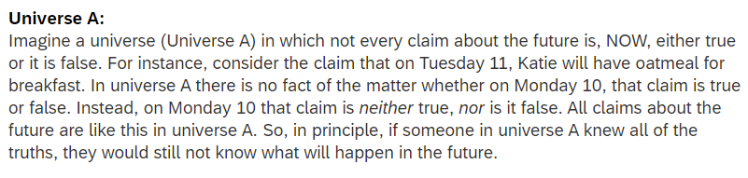
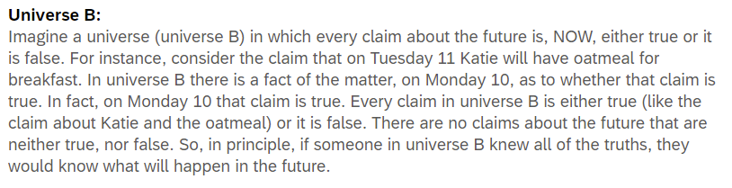

After reading both vignettes, participants responded to three comprehension questions to which they could answer (a) true or (b) false.

- In Universe [A/B] claims about the future are neither true, nor false.
- In Universe [A/B] if someone knew all of the truths, they would know exactly what will happen in the future.
- In Universe [A/B] there is no fact of the matter whether certain claims about the future are true or not

Participants who did not correctly answer 2 out of 3 of these questions for each vignette were excluded from the analyses.

Participants are then asked, “Which universe do you think is most like our universe?” and given two options (a) Universe A or (b) Universe B.

Participants then see both of the following time vignettes:

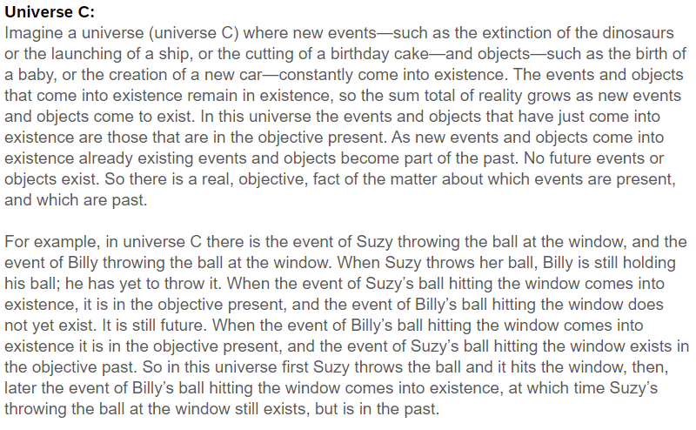

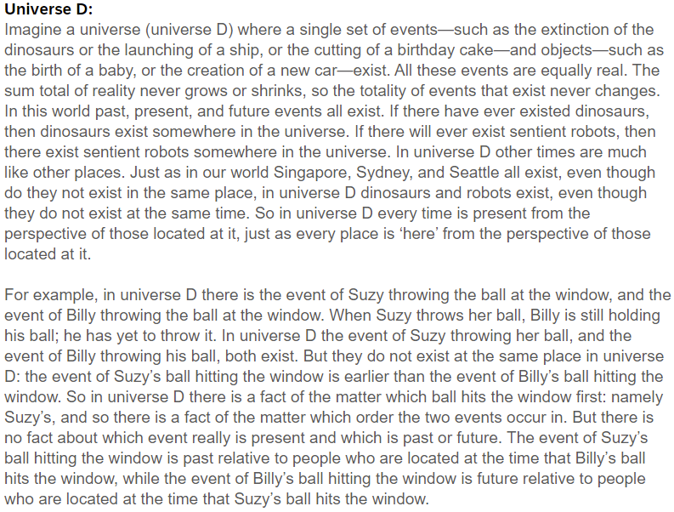
After reading both time vignettes, participants responded to four comprehension questions to which they could answer (a) true or (b) false.
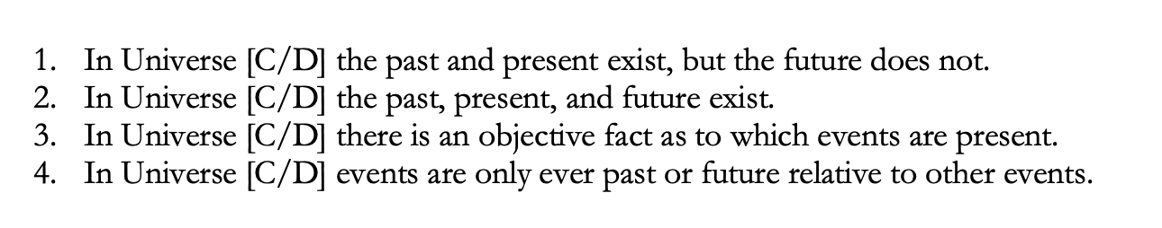
Participants who failed correctly to answer 3 out of 4 of these questions for each vignette were excluded from the analyses.

Participants are then asked, “Which universe do you think is most like our universe?” and are given two options (a) Universe C or (b) Universe D.

Finally, participants then saw either the alethically open or alethically closed vignette again along with both time vignettes and responded to the following question: “Katie is in a universe just like A/B. Do you think that Katie is more likely to be in Universe C or more likely to be in Universe D?’ and are given two options (a) Universe C or (b) Universe D.

3.1.3 Results
Before presenting the statistical analysis, we will start by summarising our main findings. We first hypothesised that (H1) more people will judge that the alethically open world is most like our world than the alethically closed world. This hypothesis was supported with the majority of participants judging that our world is most like the alethically open world as opposed to the alethically closed world. We then hypothesised that (H2) most people would judge that our world is a growing block world rather than a block universe world. This hypothesis too was supported. The majority of participants judged that our world is most like the growing block world rather than the block universe world.

Next, we hypothesised that (H3) there would be an association between judging that our world is a growing block world and judging that it is alethically open. This hypothesis was not supported. We found no evidence of an association between participants’ judgements regarding whether our world is alethically open or alethically closed, and judgements regarding whether our world is a growing block world or block universe world.

Finally, we hypothesised that (H4) participants who are told that a character (Katie) is in an alethically open world will be more likely to judge that she is in a growing block world than a block universe world (and participants who are told that she is in an alethically closed world will be more likely to judge that she is in a block universe world than a growing block world). This hypothesis was supported. We found evidence of an association between which alethic openness vignette participants were asked to consider and their judgment about which time vignette it was associated with.

Table 1 below summaries the descriptive data of participants’ judgments regarding which alethic vignette (alethically open; alethically closed) is most like actual, and which time vignette (growing block world; block universe world) is most like actual.

Table 1. Participants’ judgments regarding which alethic world and time world is most like actual world.
World | Growing Universe Block | Block Universe
Alethically Open | (67) 41.10% | (40) 24.54%
Alethically Closed | (29) 17.79% | (27) 16.56%

Separate one-way chi-square tests were performed to test whether (a) most participants judged that the alethically open world was more like our world compared to the alethically closed world, and whether (b) most participants judged that our world is a growing block world than a block universe world. The results of those tests showed that the first hypothesis was supported and that participants were more likely to judge the world was alethically open (107, 65.6%) as opposed to being alethically closed (56, 34.4%; χ²(1, N = 163) = 15.967, p < .001). Similarly, participants judged that our world was more like a growing block world (96, 58.9%) as opposed to a block universe world (67, 41.1%; χ²(1, N = 163) = 5.160, p = .023), supporting hypothesis 2.

To test whether there was an association between participants judging that our world is a growing block word, and judging that it is alethically open, we performed a chi-square test of independence. This association was not vindicated, χ²(1, N = 163) = 1.781, p = .182. This means that judging our world is alethically open was not associated with also judging that our world is a growing block world.

Finally, we performed a chi-square test of homogeneity to test whether people who are told that Katie is in an alethically open world would be more likely to judge that she is in a growing block universe world (and whether people who are told that she is in an alethically closed world would be more likely to judge that she is in a block universe world). There was a significant association, χ²(1, N = 163) = 12.129, p < .001. Participants who were told that Katie is in an alethically open world were more likely to judge that she was also in a growing block world. Meanwhile participants who were told that that Katie is in an alethically closed world were more likely to judge that she was also in a block universe world.

3.3 Experiment 2 Methodology

3.3.1 Participants
694 people participated in the study. Participants were recruited and tested online using Amazon Mechanical Turk, and compensated $2 for their time. 548 participants had to be excluded for from the analyses. That is because they failed to answer all the questions (n = 154), failed one of the attentional check questions (n = 43), or failed to answer 3 out of 4 comprehension questions correctly for the discussion vignette or failed to answer 3 out of 4 comprehension questions correctly for each of the time vignettes (n = 351). The remaining sample was composed of 146 participants (52 female, 1 trans/non-binary; aged 24-72 mean age 40.40 (SD = 11.21)). Ethics approval for these studies was obtained from the [blanked] Human Research Ethics Committee. Informed consent was obtained from all participants prior to testing. The survey was conducted online using Qualtrics.

3.3.2 Materials and Procedure

The hypotheses H5-H6 and the rest of the experimental materials were pre-registered and can be accessed as the following link on Open Science Framework: https://osf.io/td9fs/.

In this study participants first see a single vignette—the alethic discussion vignette—in which Helena and George present different views about the connection between alethic openness and the existence of the future.

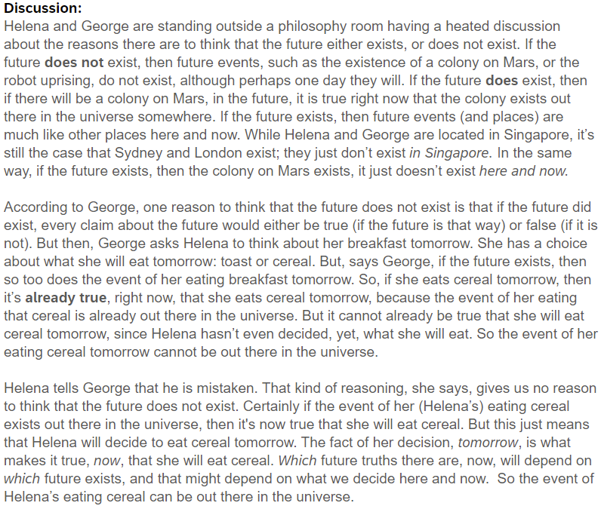
Participants then answered four comprehension statements to which they can respond either (a) true or (b) false.

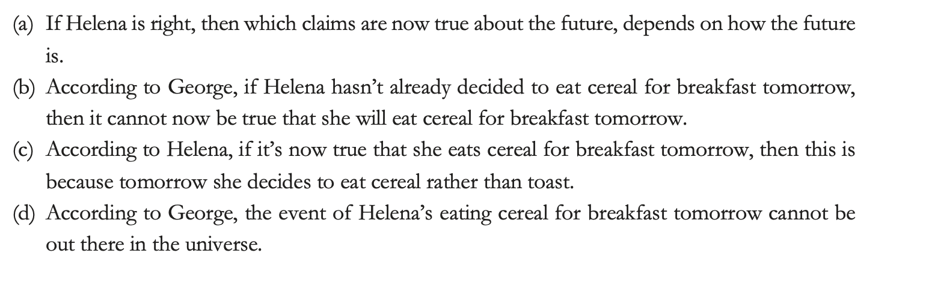

Participants who failed correctly to respond to 3 out of 4 of these statements were excluded from the analyses.

Participants are then asked, “Which of the two parties, Helena or George, do you think is right?” and are given two options (a) George or (b) Helena.

Participants then see both time vignettes and associated comprehension statements (see experiment 1). Participants who failed to correctly respond to 3 out of 4 of these statements for each vignette were excluded from the analyses.

Finally, participants then saw the alethic discussion vignette again along with both time vignettes They were then presented with two questions:

- “Which universe do you think Helena will think is most like the universe she is in?”
- “Which universe do you think George will think is most like the universe he is in?”

For each question they are given the two options (a) Universe C or (b) Universe D.

3.3.3 Results
As in experiment 1, we also tested H2 by asking participants which world they believed was most like our world (i.e., growing block world or block universe world) and predicted that most people would judge that our world is a growing block world rather than a block universe world. Again, this hypothesis was supported with a majority of participants judging that our world is most like the growing block world rather than the block universe world.

We hypothesised that (H5) if the deliberative reasoning claim is right, then most people should judge that George, rather than Helena, is right in the alethic discussion vignette. We found that this hypothesis was not supported and that participants were split with half judging George to be right and the other half judging Helena to be right.

Finally, we hypothesised that (H6) people will judge that Helena will take herself to be in a block universe, and that George will take himself to be in a growing block universe. This hypothesis was supported.

Separate one-way chi-square tests were performed to test whether (a) most participants will judge that our world was more like a growing block world, (b) most participants will judge that George was right in the alethic openness discussion, (c) most participants will judge that Helena will take herself to be in a block universe, and that (d) most participants will judge that George will take himself to be in a growing block universe. The results of those tests showed that (a) most participants judged that our world was more like a growing block world (94, 64.4%) as opposed to a block universe world (52, 35.6%; χ²(1, N = 146) = 12.082, p = .001), supporting hypothesis H2. Contrary to H5, however, participants were divided between judging that George or Helena was right. That is, half of the participants (69, 47.3%) judged that George was right, and the other half (77, 52.7%; χ²(1, N = 146) = .438, p = .508) judged Helena to be right. H6 was vindicated: most participants judged that Helena would take herself to be in the block universe world (106, 72.6%; χ²(1, N = 146) = 29.836, p < 0.001), and that George would take himself to be in the growing block world (107, 73.3%; χ²(1, N = 146) = 31.671, p < 0.001).

4. Discussion

There are several notable aspects of our results. Before we get to these, it is worth considering some limitations of these studies. First, one might worry that the vignettes are too cognitively demanding for non-philosophers to understand, and hence that the results may not indicate much about people’s naïve representation of the future (or time). To address this concern, we included attention checks and comprehension check questions. These served two purposes. First, they weeded out the use of bots, and people selecting answers at random or without thought, to quickly receive payment (Ahler, Roush, and Sood 2020). This is something which needs to be militated against when running studies online and can result in large numbers of exclusions. The numbers of participants excluded here are consistent with other recent online studies such as those of Latham Miller, Tarsney and Tierney (2021a, 2021b). Second, the checks enabled us to achieve a sample composed of people who understood the vignettes. While the final sample sizes are small, they are consistent with Latham and Miller (ms) whose methods the current study is based on. As we will soon discuss, our current results not only replicate some of their key findings but are relevantly similar to those found elsewhere using different methods, which suggests the results are informative.

Still even if the current results are informative, one might worry that they are only narrowly so because the remaining sample is not representative of the general population. This is possible and is something to bear in mind. Having said that, we see little reason to suppose it to be true. Perhaps those who passed the comprehension checks are more thoughtful, reflective, or intelligent, than those who did not. But even if this is so (and there is no reason to think that it is) there is no reason to think that such people have a different naïve representation of the future than the remaining population. Indeed, prior research has found that people’s levels of education and familiarity with the sciences made no difference to their naïve representation of time, so there is some reason to doubt that people’s naïve representation of the future should be sensitive to such factors (Latham, Miller, and Norton 2019). Finally, as has been already noted, the fact that our current results are relevantly similar to those found elsewhere tends to undermine the thought that this sample is (especially) unrepresentative.

Bearing this in mind, let’s return to our results. As expected, we found that most people judged our world to be alethically open. This suggests that people do naïvely represent the future as open, and, indeed, that this representation is at least in part a matter of representing the future to be alethically open. So, while we cannot say that people’s naïve representation of the future’s being open is exhausted by them representing it to be alethically open, we can certainly say that representing alethic openness is some component of their representation of future openness. Interestingly, and in line with Torre’s (2011) suggestion, we found that ~65% of participants judged our world to be alethically open, compared to the ~87% of participants who Latham and Miller found judged the future to be deliberatively open. That suggests that although representing alethic openness is a component of many people’s representation of future openness, it is a less powerful aspect, or at least, a less common one, than is representing the future to be deliberatively open.

This has implications for the vindication claim. Both models of time vindicate deliberative openness. The block universe theory, in its standard non-branching form, does not vindicate alethic openness. So, if the growing block theory does vindicate alethic openness, then we can conclude that the growing block theory vindicates both of these aspects of our naïve representation of openness, while the block universe theory vindicates only one. Then insofar as you think that the fact that a view better vindicates some aspect of our naïve representation of the world gives us some reason to prefer that view, we would have some reason to prefer the growing block view to the block universe view.

There are several things to say here. First, whether the growing block theory vindicates people’s representation of the future as alethically open will depend on the details of the view in question. Some versions of the theory embrace alethic openness, and some do not. Growing block theorists who endorse a version of the growing block theory that does not posit alethic openness clearly cannot argue in favour of the growing block theory over the block universe view by appealing to the vindication claim Those who do endorse a version on which the future is alethically open can make such an argument, and they might even use something like those considerations to argue in favour of a version of the growing block on which the future is alethically open, over one on which it is not.

Second, it’s worth bearing in mind that a minority of people did not represent the future as alethically open. It may be that the (standard non-branching) block universe theory vindicates those people’s naïve representation. Although those people are not in the majority, they are a substantial minority. The fact that there is such a substantial minority might tend to undermine the idea that there is an argument to be made on the basis of claims about which theory vindicates people’s naïve representation, since such claims seem to presuppose that there is a single, widely shared, naïve representation to be vindicated. Our results call that idea into question. At most, only some people’s naïve representation can be vindicated by any view. So, even if in general one thinks that the fact that a view better vindicates some aspect of our naïve representation gives us some reason to prefer that view, one might think that such considerations are moot when there is no widely shared naïve representation.

Third, even if one holds that because a view better vindicates some aspect of a majority of people’s naïve representation this gives us some reason to prefer that view, that reason is certainly defeasible. The block universe theorist will surely argue that in this case it is in fact defeated. So, it remains unclear how persuasive any argument based on the vindication claim can ultimately prove to be. Moreover, one might deny that the fact that a view better vindicates some aspect of our naïve representation of the world gives us any reason to prefer that view. Still, we take it that the empirical findings here will in general be welcome news to defenders of the growing block theory who take their view to be friendly to alethic openness.

Second, our results replicated those of earlier studies that found that a majority of people are temporal dynamists (Latham, Miller and Norton 2019, 2020a, 2021). Returning to a worry from earlier, this gives us some reason to think that our sample size was not unrepresentative. These previous studies found the split between those who think our world is dynamical, versus static is somewhere between 60%/40% and 70%/30% in favour of dynamical theories. This is consistent with our results. It’s worth noting that a very sizeable minority of people in this and earlier studies represent our world as non-dynamical. So, it is not overwhelmingly the case that dynamical views of time are the more folk friendly views.

Moving on, we also found evidence in favour of the reason claim. As predicted in H4, we found that people take the fact that a world is alethically open to be a reason to think it is more likely to be a growing block rather than a block universe world. People judge that if Katie is in an alethically open world she is more likely to be in a growing block than a block universe world, and that if she is in an alethically closed world, she is more likely to be in a block universe than a growing block world.

We did not, however, find any evidence in favour of the deliberative reasoning claim. Interestingly, the results regarding H6 show that people follow the deliberative reasoning that George presents. For, as predicted, most people judged that George will take himself to be in a growing block world and that Helena will take herself to be a block universe. In order for this to be, people must have understood the reasoning that went from deliberative openness, to alethic openness, to the non-existence of future events. Interestingly though, only about 50% of people endorse this reasoning (i.e., H5 was not vindicated). This is consistent with the results found by Latham and Miller, who, recall, found that people did not endorse reasoning that proceeded from the deliberative openness of the future to the non-existence of future events. But this finding is particularly interesting since the results of experiment 1 supported the reason claim. Taken jointly, these results suggest that although people think that the fact that a world is alethically open gives us reason to think it is a growing block world, the reason in question is not the one that George articulates.

Finally, we found no evidence in favour of the explanation claim. We failed to find any association between people judging that our world is alethically open and judging that it is a growing block world. If the fact that people judge our world to be a growing block world is partly explained by them judging that it is alethically open, we would expect to find such an association. This suggests that while taking our world to be alethically open is seen by people to be a reason to think it is a growing block world, it is not in fact the explanation for people naively representing our world to be a growing block.

In general, our results tend to suggest that while people do naively represent the future as alethically open, and while they do, on reflection, see this as a reason to think that our world is a growing block world, as a matter of fact what explains people naively representing our world as a growing bock is not that they naively represent the future as alethically open. This might seem puzzling. One possibility is that when people are presented with a fairly detailed description of both a block universe and a growing block world, they see that the fact that a world is alethically open is a reason to think that it is not a block universe and hence is a reason to think that it is a growing block world (given that these are the only two options we present them with). This is consistent with its being the case that prior to seeing these detailed descriptions, people did not, even tacitly, make this inferential connection, and hence that when we first asked probed their judgements about whether our world is alethically open/closed and whether it is a block/growing block, this reasoning played no role in their respective judgements. Hence, although people come to recognise this as a reason, it plays no role in explaining why they in fact naively represent time as they do.

There is another possibility, which is that people do, perhaps tacitly, recognise this reason, and as a result they are predisposed to naively represent our world to be a growing block world conditional on naively representing it to be alethically open. But then other views about the nature of our world (views which are not present when we simply ask people about a random counterfactual world inhabited by Katie) affect people’s judgements about alethic openness, or time, and as a result the predicted association is eliminated.

This could be the case, but we think it less likely. To see how it might go, suppose that some participants do not naively represent our world as a block universe but rather, represent it as such on the basis of more sophisticated scientific knowledge. Then it could be that these participants are in fact predisposed to judge that our world is a growing block on the basis of judging that is alethically open, but that their more scientifically informed beliefs lead them to judge that our world is a block universe. Suppose, too, that they do not reflect on the implications of this belief, but still naively represent the future as alethically open, and hence also make that judgement. If there were sufficiently many such people, we might fail to find an association between judging that our world is alethically open and judging that it is a growing block.

We do not think, however that this particular explanation for failing to find the predicted association is very plausible. As noted earlier, Latham, Miller and Norton (2019) found that people’s level of education and scientific background played no role in how they represented time (i.e. whether as a block universe or not). Of course, this leaves open that there are other factors that explain why people judge our world to be alethically open/closed and a growing block/block universe which upset the predicted association. However, it is not obvious what these factors could be. (For example, discussion of alethic openness outside of philosophy is not very prevalent). Given this, we are tempted to conclude that the former explanation is better, and that people are not, in fact, even predisposed to judge that our world is a growing block on the basis of judging that it is alethically open.

If that is right, then it leaves an important question unanswered. Why is it that people tend to naively represent our world as a growing block? It could be that some version of the explanation claim is true, but that the relevant explanation is not that we naively represent the future to be alethically open, but rather, that we represent it to be open in some other manner. Perhaps, for instance, because we represent it to be nomically open or epistemically open. It would be a useful to investigate these connections further. This is particularly so given that this issue has broader implications in the philosophy of time. Latham and Miller’s (ms) study was motivated by a desire to explain why people represent our world as temporally dynamical (where one notable way to represent it as such is by representing it as a growing block) given that evidence suggests that it does not strongly, or ubiquitously, seem to people, in experience as though time robustly passes (Latham, Miller, and Norton 2020b). Latham and Miller hypothesised that perhaps people come to represent the world as a growing block (and hence dynamical) because they represent the future as deliberately open rather than because it seems to them as though time robustly passes. Their study failed to provide support for that hypothesis. The current study also fails to suggest that the reason people naively represent time as a growing block is because they represent the future as alethically open.

Still, if it could be shown that the reason we tend to represent time as dynamical is because of the way we represent the future as open (in some way or other) this would help to bolster certain deflationary views about the content of our temporal phenomenology. Many contemporary block universe theorists, namely so-called deflationists, hold that it does not seem to us in experience, as though time robustly passes (Hoerl 2015, Prosser 2016, Deng 2013, 2018, Bardon 2013, Miller, Holcombe and Latham 2018, Miller 2019, Miller forthcoming). Deflationists need to explain why we come to represent time as dynamical if it does not seem to us in experience to be dynamical. Had our results supported the explanation claim, we would have been able to offer the deflationist an account to which they could appeal. We cannot do that; but the support we found for the reason claim suggests that there may be a fruitful avenue of investigation present here. Perhaps part of why we come to naively represent time as dynamical, by representing it as a growing block, is connected to the ways we represent the future as open. This is a suggestion made by Prosser (2016) and one that would be well worth further exploration.

References

Adams, Robert Merrihew (1986). Time and Thisness. Midwest Studies in Philosophy 11 (1):315-329.
Ahler, D., Roush, C., & Sood, G. The micro-task market for lemons: data quality on Amazon’s Mechanical Turk. Unpublished manuscript, 22 January 2020. URL: http://gsood.com/research/papers/turk.pdf
Bardon, A. (2013). A Brief History of the Philosophy of Time. OUP.
B. Barcellan and A. Zanardo. Actual futures in peircean branching-timelogic, 1999. [Introducing actualism]
Barnes, Elizabeth & Cameron, Ross (2008). The open future: bivalence, determinism and ontology. Philosophical Studies 146 (2):291-309.
Barnes, Elizabeth, and Ross P. Cameron (2011). Back to the Open Future. Philosophical perspectives 25, no. 1: 1–26.
Barnes, Elizabeth, and J. Robert G Williams (2011). A Theory Of Metaphysical Indeterminacy. Oxford Studies in Metaphysics. Oxford: Oxford University Press.
Belnap, N. (1992) 'Branching Space-Time.' Synthese 92.3, 385-434.
Belnap, N. (2005) ‘Agents and Agency in Branching Space-times’ Logic, Thought and Action, Daniel Vanderveken (ed.), Dordrecht: Springer, 291-313.
Belnap, N., & Green, M. (1994). Indeterminism and the thin red line. Philosophical Perspectives, 8, 365–388.
Belnap, N., Perloff, M., and Xu, M., 2001, Facing the Future. Agents and Choices in Our Indeterminist World, Oxford: Oxford University Press.
Bigelow. (1996). Presentism and Properties. Noûs (Bloomington, Indiana), 30, 35–. https://doi.org/10.2307/2216235
Braüner, T., Hasle, P., and Øhrstrøm, P., 1998, “Ockhamistic Logics and True Futures of Counterfactual Moments”, Proceedings of Fifth International Workshop on Temporal Representation and Reasoning, Sanibel Island, Florida, USA, L. Khatib and R. Morris (eds.), Piscataway: IEEE, 132–139.
Briggs, R. and Forbes, G. (2012). “The Read Truth about the Unreal Future.” In Karen Bennett & Dean Zimmerman (eds.), Oxford Studies in Metaphysics, volume 7.

Broad, C. D (1923). Scientific Thought. London: Routledge & Kegal Paul
Deng, N. (2018). On ‘Experiencing time’: a response to Simon Prosser. Inquiry: An Interdisciplinary Journal of Philosophy 61 (3):281-301.
Deng, N. (2013). On Explaining Why Time Seems to Pass. Southern Journal of Philosophy 51 (3):367-382.
Forbes, G. (2016). ‘The Growing Block’s Past Problems’. Philosophical Studies 173(3): 699-709.
Forbes, Graeme A. & Briggs, R. A. (2019). The future, and what might have been. Philosophical Studies 176 (2):505-532.
Forrest, P. (2004). The real but dead past: A reply to Braddon-Mitchell. Analysis, 64, 358–362.
Grandjean, V. (2019). “How is the Asymmery Between the Open Future and the Fixed Past to be Characterised.?” Synthese (3):1-24.
Grandjean, V. (2021). “Symmetric and Asymmetric Theories of Time.” Synthese 199 (5-6):14403-14426.
Hoerl, C. (2014), Do we (seem to) perceive passage? Philosophical Explorations, 17, 188–202.
Ismael, J. Decision and the Open Future. In A Bardon (ed.) The Future of the Philosophy of Time. (New York: Routledge, 2012) 149-169.
Lathan, A. J., and Miller, K. (ms) “Why do people represent time as dynamical? An investigation of temporal dynamism and the open future.” Accessed at https://philpapers.org/rec/LATWDP
Latham, A.J., Miller, K. and Norton, J. (2021). “An empirical investigation of the role of direction in our concept of time”. Acta Analytica. 36(1) 25-47 DOI: 10.1007/s12136-020-00435-z
Latham, A. J., Miller, K and Norton, J. (2020(a)) “Do the Folk Represent Time as Essentially Dynamical?” Inquiry.
https://doi.org/10.1080/0020174X.2020.1827027
Latham, A. J. Miller, K and Norton, J. (2020(b)). “An Empirical Investigation of Purported Passage Phenomenology”. The Journal of Philosophy. 10.5840/jphil2020117722 117(7): 353-386.
Latham, A. J., Miller, K and Norton, J. (2019) “Is Our Naïve Theory of Time Dynamical?”. Synthese. DOI: 10.1007/s11229-019-02340-4 198:4251-4271
Latham, A. J., Miller, K. Tarsney, C. and Tierney, H. (2021a). “Belief in Robust Temporal Passage (Probably) Does Not Explain Future-Bias.” Philosophical Studies. 10.1007/s11098-021-01748-4
Latham, A. J. Miller, K., Tarsney, C and Tierney, H. (2021b). “Robust Passage Phenomenology Probably Does Not Explain Future-Bias” Synthese 10.1007/s11229-022-03514-3
Lucas. (1984). Space, time, and causality : an essay in natural philosophy. Clarendon Press.
MacFarlane, J. (2003) ‘Future Contingents and Relative Truth’ The Philosophical Quarterly 53, 321-336.
MacFarlane, J. (2008) ‘Truth in the Garden of Forking Paths’ in Relative Truth, ed. Max Kölbel and Manuel García-Carpintero, Oxford: Oxford University Press, 81–102.
Markosian, N. (1995) ‘The Open Past’ Philosophical Studies 79, 95-105.
McCall, S. (1994) A Model of the Universe, Oxford: Oxford University Press.
Miller, K., Holcombe, A., & Latham, A. J. (2018). Temporal phenomenology: phenomenological illusion versus cognitive error. Synthese, 1-21.
Miller, K. (2019). “Does it really seem as though time passes?” in The Illusions of Time: Philosophical and Psychological Essays on Timing and Time Perception, ed V Artsila, A. Bardon, S. Power, and A. Vatakis, pp 17-33. Palgrave McMillan https://doi.org/10.1007/978-3-030-22048-8_2
Miller, K. (forthcoming). “Against Passage Illusionism”. Ergo.
Prior, A. N. (1996/1998). Some free thinking about time. In P. van Inwagen & D. W. Zimmerman (Eds.), Metaphysics: The big questions (pp. 104–107). Oxford: Blackwell Publishing.
Prosser, S. (2016). Experiencing Time. OUP.
Rosenkranz, S and Correia, C. (2018). Nothing to Come: a Defence of the Growing Block Theory of Time. Springer Verlag
Tooley, M. (1997). Time, Tense, and Causation. Oxford University Press.
Torre, S. (2011). “The Open Future”. Philosophy Compass 6(5): 360-373.
Williams, J. R. G (2008). Ontic Vagueness and Metaphysical Indeterminacy. Philosophy compass 3, no. 4: 763–788.
Wilson, Jessica M (2013). A Determinable-Based Account of Metaphysical Indeterminacy. Inquiry (Oslo) 56, no. 4: 359–385.
Williams, J. R. G. (unpublished). “Aristotelian Indeterminacy and the Open Future.”

Defended by, inter alia, Broad (1923), Tooley (1997), Forrest (2004), Forbes (2016) Grandjean (2019) and Rosenkranz and Correia (2018).
See Briggs and Forbes (2012); Forbes (2016), Grandjean (2019, 2021). Rosenkranz and Correia (2018).
Setting aside the worry that if there were no such time asymmetries then perhaps there could not be representational states at all.
There is a more general, and perhaps related idea, of metaphysical indeterminacy or unsettledness (Barnes & Cameron (2008), (2009), (2011), Barnes & Williams (2011), Williams (2008), Wilson (2013), Grandjean (2019). We leave open that there might be other types of openness other than alethic, epistemic, nomic and deliberative openness, as well as the idea that there might be interesting connections between these types of openness. There may even be a more general notion of metaphysical indeterminacy or unsettledness which future openness might be spelled out in terms of, or be a component of. However, for our purposes we are limiting our focus to in alethic openness, and thus it will suffice to concentrate the discussion on this type of openness rather than any broader notion of openness or indeterminacy.
See Markosian (1995), Williams (ms), MacFarlane (2003), Tooley (1997).
Ismael 2012 has a view of this kind.
Belnap (1992), (2005), MacFarlane (2003), (2008), and McCall (1994).
For follow up work on whether people’s naïve concept of time is dynamical or not, see Latham, Miller and Norton (2020a).
Forbes (2016), Grandjean (2019, 2021). Rosenkranz and Correia (2018).
Something that Grandjean (2019, 2021) and Rosenkranz and Correia (2018) point to.
We take future contingents to be any future tensed contingent claim. It may be that only certain relevant future contingents might be such that representing that they lack a truth-value, constitutes, or partially constitutes, people representing the future as open. For instance, it might be that future tensed contingent claims about what one will do, and what decisions one will make, are particularly important in this regard, while it might be that some other future tensed contingents are such that whether or not they take a truth-value is irrelevant to people’s representation of the future as open. We take no stand on this. Given this, however, the future tensed contingents we include in our vignettes are ones regarding choices and decisions. We think it plausible that if people do not even represent the future as alethically open with regard to these sorts of claims, then representing alethic openness is very likely not any part of their representation of future openness.
Of course, it is massively controversial what connection there is between our having free will and our world being alethically open. Compatibilists hold that even if the reason that our world is alethically closed is that it is deterministic, that this is nevertheless compatible with free will, while incompatibilists deny this. Again, we don’t aim to take any stand on which of these positions is the correct one.
Broad (1923); Tooley (1997),
Correia & Rosenkranz (2018) Grandjean (2019), Briggs and Forbes (2016).
We don’t, for instance, suggest to participants that there are multiple futures that ‘branch off’ from the present moment (either concrete branches or ersatz branches), although this is one way of modelling alethic openness (See Belnap and Green (1994), OhrstrOm (1981), Brauner, 0hrstr0m, and Hasle (1998), Barcellan and Zanardo (1999), Belnap, Perloff, Xu (135-136, 2001), Briggs and Forces (2012; 2019). McFarlane (2003), though one might take this to be consistent with bivalence, as do Barnes and Cameron (2008), who hold that although it is not determinately the case that P, and not determinately the case that not P, it is determinately the case that either P or not P. One of these will determinately come to pass, but it is just as yet unsettled which one. Nor do we suggest that alethic openness is the product of there being no truthmakers to render such statements true or false (See for instance Bigelow (1996, p.39). Broad who takes this to be a necessary feature of the growing block view (1923, p73), Adams (1986) argues that future entities do not yet exist and hence do not have any thisness properties and there cannot be propositions about them until they come into existence. Lucus (1986) similarly defends future openness on the basis of future entities not yet existing, as do Prior (1998, 104-107) and Tooley (1997, 43–48).
25% of the remaining sample got every comprehension question correct.
Note that the Open Science Framework links are not active while the paper is under blind refereeing status.
You might worry that the combination of claims made about Universe A is incoherent. We think that is probably too strong. It may be that universe A includes a branching future, or it may be that there is some kind of metaphysical indeterminacy. For our purposes though it doesn’t really matter whether this combination of views is in fact coherent, since we are primarily interested in what sets of beliefs non-philosophers have: and these beliefs may not turn out to be compatible.
23% of the remaining sample got every comprehension question correct.

