Our Naïve Representation of Time and of the Open Future
Abstract
It’s generally thought that we naively or pre-theoretically represent the future to be open. While philosophers have modelled future openness in different ways, it’s unclear which, if any, captures our naïve sense that the future is open. In this paper we focus on just one way the future might count as being open: by being nomically open, and empirically investigate whether our naïve representation of the future as open is partly constituted by representing the future as nomically open. We also investigate the connection between our naïve representation of the future as open, and our representation of time. One of the purported advantages of the growing block theory of time is that it captures our naive sense that the future is open, and the past closed. We investigate whether there is an explanatory connection between people representing the future to be nomically open and representing our world to be a growing block and reflect on the implications of our findings for theorising about future openness and temporal ontology.
1. Introduction
It’s often thought that our intuitive or pre-reflective view of the world is one in which in some sense or other the future is open. It has also been thought that our intuitive, pre-reflective, or folk view of the world is one in which the totality of our world grows as new being comes into existence in the present moment and then becomes past as yet more being comes into existence. This latter view is the view that our world is a growing block.
In what follows rather than talking about pre-reflective or folk views, we will talk of naïve representations of the world. As we will understand them, naïve representations are contentful mental states, i.e. representations, of various aspects of our world, which are not informed by (or at least, are largely not the product of engagement with) current science or philosophy. These are folk theories, or folk models, of aspects of the world. These representations may be tacit, in the sense that the people whose representations they are may not be able to specify the content of the representation when asked. Nevertheless, we take it that these representations guide people’s behaviours (linguistic and otherwise) and that we can probe their content by giving people tasks that require them to use those representations.
We are interested in two sorts of naïve representations. The first of these are our naïve representation of the future; the second are our naïve representation of time. Ultimately, we will be interested in whether these representations are connected.
We will take the claim that our pre-reflective view of the world is one in which the future is open, to be the claim that we naively represent the future as open. Philosophers have offered various accounts of the open future. In fact, we can (and should) distinguish at least two rather different projects with which philosophers are engaged. The first of these aims to model the open future. On one natural interpretation of such a project, which we will call the capturing project, the aim is to work out which model of, or theory of, the open future, is the one that best captures our intuitive sense that the future is open. As we will construe this project, the aim is to offer a model of the open future that best captures our naïve representation of future openness. The second project, which we will call the explanatory project, focuses on explaining various “open future” practices (conceived of very broadly) and attempts to explain why it is that we have such practices; what it is about our world that grounds our having such practices. These practices might include (but not be limited to) practices of deliberating about the future but not the past, taking ourselves to be able to causally intervene on the future but not the past, having a certain kind of phenomenology in which the future feels, or seems, to us to be open in the way the past does not, taking ourselves to have a kind of access to past states that we do not have to future ones, and so on.
These two projects might be connected, or not. It might be that what explains why we have the open future practices we do is the very thing that in fact captures our naïve representation of the future. In that case we will say that our naïve representation of the future is vindicated. Alternatively, it could be that what explains our open future practices does not capture our naïve representation of the future as open. To see this, consider several of the views that philosophers have put forward as models of the open future, and suppose these are claims about our naïve representation of future openness.
The first models future openness in terms of alethic openness. On this view our naïve representation of the open future consists in, or at least includes, our representing its being the case that (some or all) future-tensed contingent statements fail to take a determinate truth-value. The second of these is epistemic openness. On this view, our naïve representation of the future being open consists in, or at least includes, our representing its being the case that we have epistemic access to the future only by making predictions and forming intentions and not by having records of what will happen. The third is nomic openness. On this view our naïve representation of the future being open consists in, or at least includes, our representing its being the case that future-directed indeterminism is true. There are multiple ways the future could go, consistent with how it has already gone.
It could be that our naïve representation of the future as open consists in our representing the future to be open in some, or all, of these ways. Suppose it were to turn out that our naïve representation of future openness consists entirely in our representing the future to be alethically open. Suppose, however, that our world is not in fact alethically open. Still, something explains why we have the open future practices that we do. It might be that the fact that there is an epistemic asymmetry between past and future is what explains our having these practices. It might even be that the world being this way legitimises or makes rationally permissible (or obligatory) those practices. Still, it will turn out that what explains our having the open future practices we do, does not vindicate our naïve representation of the future as open.
This paper will have nothing to say about why we have the open future practices we do. We set aside the explanatory project and focus entirely on the question of what our naïve representation of future openness consists in. This is a vital first step if we are interested in the question of whether what it is that explains our practices (whatever that might be) vindicates our naïve representation of the future as open.
Some work in this area has already been untaken. Previous research by Hodroj, Latham, Lee-Tory and Miller (ms) suggests that our naïve representation of the future as open at least partly consists in our representing the future to be alethically open. So, in this paper we focus on nomic openness. We will suppose that a world is nomically open just in case that world is future-wise indeterministic. That is, a world, w, is nomically open just in case for any time t in w, it is not the case that a complete specification of the way the world is at t, in conjunction with the laws of nature of w, logically entails the way the world is at all times later than t. This leaves open that w may or may not be past-wise nomically open: that is, whether the way the world is at t, in conjunction with the laws of nature, logically entails the way the world at all times earlier than t. Then we are interested in whether our naïve representation of the future involves our representing the future to be nomically open.
We are also interested in the connection between our naïve representation of the future as open, and our naïve representation of the temporal dimension. That is because it has been suggested that part of what explains why the growing block theory is intuitively plausible is that we naively represent the future as open, and the growing block theory better captures, or better accords with this.
According to the growing block model of time past events and objects exist, but future ones do not. There is a set of events that is objectively present, and these are the events that sit at the end of the block looking out into the non-existent future. Temporal passage consists in the coming into existence of new being on the edge of reality, where that new being becomes the objective present until more being comes to exist (at which point it becomes part of the objective past). Hence the growing block theory is a version of the A-theory on which there exists robust temporal passage: there is a fact of the mater which events are present, and which those are, changes. By contrast, the block universe theory is a version of the B-theory. On this view, past, present, and future events/objects exist on a four-dimensional manifold and bear unchanging relations of earlier-than, later-than, and simultaneous-with to one another. None of these events is singled out as objectively present and so time does not robustly pass since there is no change in which events are objectively present.
Unlike other models of time, the growing block theory has a built-in asymmetry between past and future. The past exists and is located somewhere in space-time, whereas the future is yet to happen and does not exist. By contrast, presentism holds that neither the future nor the past exists, and the block universe theory holds that both future and past exist. This asymmetry has been hypothesised to better capture people’s intuitive sense that the future is open and the past is closed, than do views that lack this asymmetry.
Following Latham, Miller and Norton (2019) we take a naïve representation of time to be a (probably tacit) representation of time and temporal ontology in our world. People’s naïve representation of time might be closer to one, or other, of the models of time that philosophers engage with.
Following Hodroj et al, we can distinguish three aspects of the idea that the growing block theory better accommodates people’s intuitive sense that the future is open.
First, according to the vindication claim, our naïve representation of future openness has a content that is vindicated if our world is a growing block. The narrow version of the vindication claim that will be of interest to us in this paper is the claim that our naïve representation of future openness has a content that is vindicated if our world is a growing block and is not vindicated if our world is a block universe. Henceforth we will call this the narrow vindication claim.
One might be particularly interested in the narrow vindication claim if one thinks that if the growing block vindicates our naïve representation of the open future, and the block universe view does not, that this gives us a reason (albeit defeasible) to prefer the former over the latter.
Second, according to the reason claim, people believe, perhaps tacitly, that the fact that a world has an open future is a reason to think that that world is a growing block world rather than a block universe world.
Third, according to the explanation claim people naively represent our world to be a growing block because they naively represent the future to be open.
Our aim is not to investigate all these claims in their full generality, but rather, to investigate certain aspects of these claims as they pertain to nomic openness.
Consider, first, the narrow vindication claim. In order to evaluate the narrow vindication claim we would need to know the content of our naïve representation of future openness. This paper will speak to the issue of whether our naïve representation of future openness is partly constituted by our representing it to be nomically open. So, it will provide the beginnings of the sort of account we would need to determine whether the narrow vindication claim (and indeed the vindication claim itself) is true.
Next, consider the reason claim. We investigate whether people take the fact that a world is nomically open, to be a reason to think that it is a growing block world rather than a block universe world. We also investigate a particular view about what this reasoning might consist in. According to this view, people reason from their ability to deliberate and to act freely, to the idea that the future is nomically open. They then reason from the nomic openness of the future to the idea that future events do not exist, because they think that if future events did exist, “out there in spacetime”, then those events must be determined because facts about them already obtain. But in representing that future events do not exist, and will later come to exist, one represents one crucial element of the growing block view. Thus it might be that in representing the world as nomically open people to come to represent it to be a growing block.
Now, to be clear, we are not endorsing either stage of this reasoning from freedom/deliberation to nomic openness, nor from nomic openness to the non-existence of future events (indeed, this last inference is clearly false). We are merely hypothesising that people (likely tacitly) reason in something like this manner, and so they take the presence of nomic openness in a world to be a reason to think that the world is a growing block world rather than a block universe world. We will call the claim that people reason in this way, the deliberative reasoning claim.
Finally, according to the version of the explanation claim that we investigate here, the fact that people naïvely represent the future as nomically open is part of what explains why they represent our world to be a growing block. Notice that the reason claim and the explanation claim can come apart. It could be that people naïvely represent our world as a growing block because they represent it as nomically open even though they do not tacitly suppose that the latter is a reason to think our world is a growing block (perhaps there is a common cause of both representations). Equally it could be that people do think that a world being nomically open is a reason to think it is a growing block rather than block universe, but that this does not in fact explain why people think our world is a growing block world (either because they don’t think it is a growing block or because they don’t think our world is nomically open, or because other factors completely swamp this reason and do all the explanatory work).
In experiment 1 we seek to determine whether people’s naïve representation of the future involves nomic openness. We present participants with two nomic vignettes; one that describes a nomically open world, and one that describes a nomically closed world. Having seen the two vignettes, participants are then asked which world is most like our world (nomically open or closed). Our first hypothesis (H1) is that more people will judge that the nomically open world is most like our world than the nomically closed world. If most people naively represent the future as nomically open, then it seems reasonable to say that their naïve representation of the future as open at least in part consists in them representing the future in this matter.
Participants are then presented with two time vignettes, one describing a growing block world and one describing a block universe world. They are then asked which world is most like our world. We predicted (H2) that more people would judge that our world is like the growing block world than the block universe world. This hypothesis is motivated by previous work on the way that people naively represent time, including that of Latham, Miller and Norton (2019, 2020a, 2021) and, if vindicated, would replicate these findings.
If the explanation claim is true, then we should find an association between people judging that the nomically open world is most like our world and judging that the growing block world is most like our world, and between judging that the nomically closed world is most like our world and judging that the block universe world is most like our world. This was H3.
In order to investigate the reason claim we present participants with just one of the nomic vignettes. Those who see the nomically open vignette are told that Katie is in a world just like that, and then asked whether she is more likely to be in the growing block or the block universe world. Those who see the nomically closed vignette are told that Katie is in a world just like that, and then asked whether she is more likely to be in the growing block or the block universe world. If the reason claim is true, then people should judge that if Katie is in a nomically open world, then she is more likely to be in a growing block world as opposed to block universe world, and if Katie is in a nomically closed world, then they should judge that she is are more likely to be in a block universe world as opposed to a growing block world. This was our H4.
Experiment 2 tests the deliberative reason claim. Here, participants are presented with a single vignette that describes an interaction between two characters (George and Helena). George reasons from the fact that our world is deliberatively open, to the conclusion that it is nomically open, and from there, to the conclusion that future events do not exist. Helena rejects George’s reasoning and explains where she thinks it goes awry. Participants are asked which character is correct. If the deliberative reason claim is true, then we should find that more people will judge that George is correct. This is H5. The final part of this experiment focuses on whether people can see the inferential connection between accepting or rejecting this reasoning. Participants are asked which world (growing block or block universe) the two characters will take themselves to be in. We predicted that participants would judge that Helena will take herself to be in a block universe world while George will take himself to be in a growing block world (H6).
We begin, in section 2 by outlining our methodology and results. Then in Section 3 we consider the upshot of those results for understanding our pre-reflective views of the world, and the connection between them.

2. Methodology and Results

2.1 Experiment 1 Methodology
2.2.1 Participants
856 people participated in the study. Participants were recruited and tested online using Amazon Mechanical Turk and compensated $2 for their time. 732 participants had to be excluded from the analyses. That is because they failed to answer all the questions (n = 80), failed one of the attentional check questions (n = 73), or failed to answer 2 out of 3 comprehension questions correctly for the openness vignettes or 3 out of 4 comprehension questions correctly for both time vignettes (n = 579)). The remaining sample was composed of 124 participants (46 female; aged 21-72 mean age 38.98 (SD = 9.95)). Ethics approval for these studies was obtained from the [blanked] Human Research Ethics Committee. Informed consent was obtained from all participants prior to testing. The survey was conducted online using Qualtrics.

2.1.2 Materials and Procedure

Participants first see both of the following openness vignettes. The first vignette describes a world in which the universe is Nomically Open—which we called Universe A. The second vignette describes a world in which the universe is Nomically Closed—which we called Universe B.
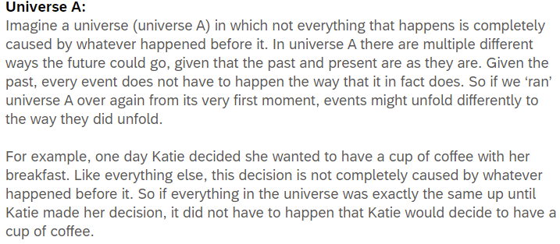
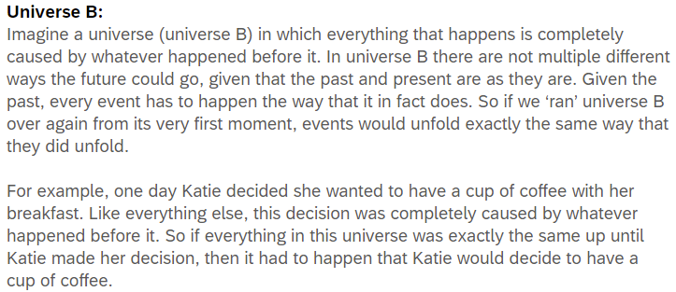

After reading both vignettes, participants responded to three comprehension questions to which they could either response (a) true or (b) false.
- If we ‘re-ran’ Universe [A/B] over and over again, we would always get the very same events occurring in the very same order.
- In Universe [A/B] the way things are now could not have been any different from how it is, unless the past had been different from how it is.
- In Universe [A/B] there is only way the future can unfold given that the past and present are the way they are.

Participants who did not correctly answer 2 out of 3 of these questions for each vignette were excluded from the analyses.

Participants are then asked, “Which universe do you think is most like our universe?” and given two options (a) Universe A or (b) Universe B.

Participants then see both of the following time vignettes. The first vignette describes a universe which is a growing block world—which we called Universe C. The second vignette describes a block universe world.

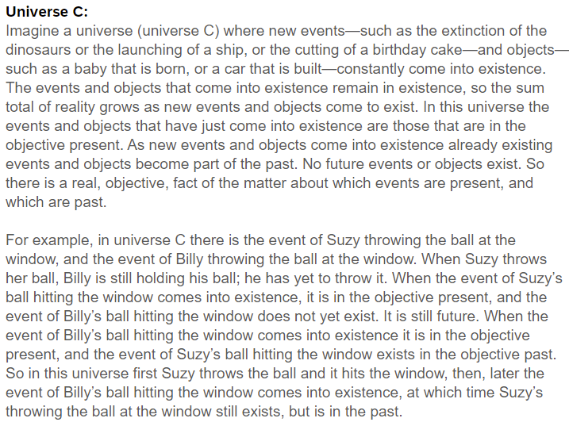
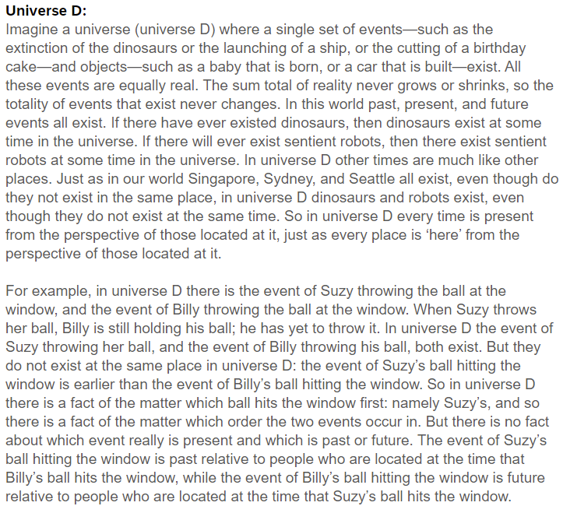
After reading both time vignettes, participants responded to four comprehension questions to which they could respond (a) true or (b) false.
- In Universe [C/D] the past and present exist, but the future does not.
- In Universe [C/D] the past, present, and future exist.
- In Universe [C/D] there is an objective fact as to which events are present.
- In Universe [C/D] events are always past or future relative to other events.

Participants who failed correctly to answer 3 out of 4 of these questions for each vignette were excluded from the analyses.
Participants are then asked, “Which universe do you think is most like our universe?” and are given two options (a) Universe C or (b) Universe D.

Finally, participants then see either the nomically open or nomically closed vignette again along with both time vignettes and respond to the following question: “Katie is in a universe just like A/B. Do you think that Katie is more likely to be in Universe C or more likely to be in Universe D?’ and are given two options (a) Universe C or (b) Universe D.
2.1.3 Results
Before presenting the statistical analysis, we will start by summarising our main findings. We first hypothesised that (H1) more people will judge that the nomically open world is most like our world than the nomically closed world. This hypothesis was supported. Participants were more likely to judge that our world is more like a nomically open world compared to a nomically closed world. We then hypothesised that (H2) most people would judge that our world is a growing block world rather than a block universe world. This hypothesis was not supported.
Next, we hypothesised, (H3) that there would be an association between people judging that the nomically open world is most like our world and judging that the growing block world is most like our world, and between judging that the nomically closed world is most like our world and judging that the block universe world is most like our world. This hypothesis was not supported. While there was a significant association between people’s judgements about nomic openness and time; the association we found was not the one we hypothesised. Instead, there was an association between judging that our world is nomically closed and judging it to be a growing block world. Participants who judged our world to be nomically open were roughly divided in their likelihood to judge our world to be a growing block world or a block universe world.
Finally, we hypothesised that (H4) that participants who are told that a character (Katie) is in an nomically open world will be more likely to judge that she is in a growing block world than a block universe world (and participants who are told that she is in a nomically closed world will be more likely to judge that she is in a block universe world than a growing block world). We found evidence for this.
Separate one-way chi-square tests were performed to test whether (a) most participants judged that the nomically open world was more like our world compared to the nomically closed world, and whether (b) most participants judged that our world is a growing block world than a block universe world. The results of those tests showed that the first hypothesis was vindicated. This means that participants are more likely to judge the world as nomically open (76, 61.3%) as opposed to being nomically closed (48, 38.7%; χ²(1, N = 124) = 6.323, p = .012). Our hypothesis that participants will judge that our world was more like a growing block world (69, 55.9%) as opposed to a block universe world (55, 44.4%; χ²(1, N = 124) = 1.582, p = .209), was not statistically significant, indicating that participants are equally likely to judge our world as being either a growing block world or a block universe world.
Table 2 below summaries the descriptive data of participants’ judgments regarding which nomic vignette (nomically open; nomically closed) is most like our world, and which time vignette (growing block world; block universe world) is most like our world. To test whether there was an association between whether participants who judged our world to be nomically open also judged our world to be a growing block world, we performed a chi-square test of independence. This hypothesis was not supported. Instead, there was an association between participants judging our world to be nomically closed and judging it to be a growing block world (χ²(1, N = 124) = 5.449, p = .020). Participants who judged our world to be nomically open were divided between judging it to be a growing block world and a block universe world.

Table 2. Participants judgments to which nomic universe and time vignette is most like actual world.
World | Growing Block World | Block Universe
Nomically Open | (36) 29.0% | (40) 32.3%
Nomically Closed | (33) 26.6% | (15) 12.1%

Finally, we performed a chi-square test of homogeneity to test whether participants who are told that Katie is in a nomically open world would be more likely to judge that she is in a growing block world (and whether people who are told that she is in a nomically closed world would be more likely to judge that she is in a block universe world). There was a significant association, χ²(1, N = 124) = 6.613, p = .010. Participants who are told that Katie is in a nomically open world were more likely to judge that she was also in a growing block world. Meanwhile, participants who are told that Katie is in a nomically closed world were more likely to judge that she was also in a block universe world (see Table 3).

Table 3. Participants judgments to which universe Katie is more likely to be in based on associations between nomic openness and time
World | Growing Block World | Block Universe
Nomically Open | (38) 65.5% | (20) 34.5%
Nomically Closed | (28) 42.4% | (38) 57.6%

2.2 Experiment 2 Methodology

2.2.1 Participants
856 people participated in the study. Participants were recruited and tested online using Amazon Mechanical Turk, and compensated $2 for their time. 732 participants had to be excluded from the analyses. That is because they failed to answer all the questions (n = 124), failed one of the attentional check questions (n = 54), or failed to answer 3 out of 4 comprehension questions correctly for the discussion vignette or failed to answer 3 out of 4 comprehension questions correctly for the time vignettes (n = 554). The remaining sample was composed of 124 participants (49 female, 2 trans/non-binary; aged 20-78 mean age 36.58 (SD = 9.716)). Ethics approval for these studies was obtained from the [blanked] Human Research Ethics Committee. Informed consent was obtained from all participants prior to testing. The survey was conducted online using Qualtrics.
2.2.2 Materials and Procedure
In this study participants first see a single vignette—the nomic discussion vignette—in which Helena and George present different views about the connection between nomic openness and the existence of the future.
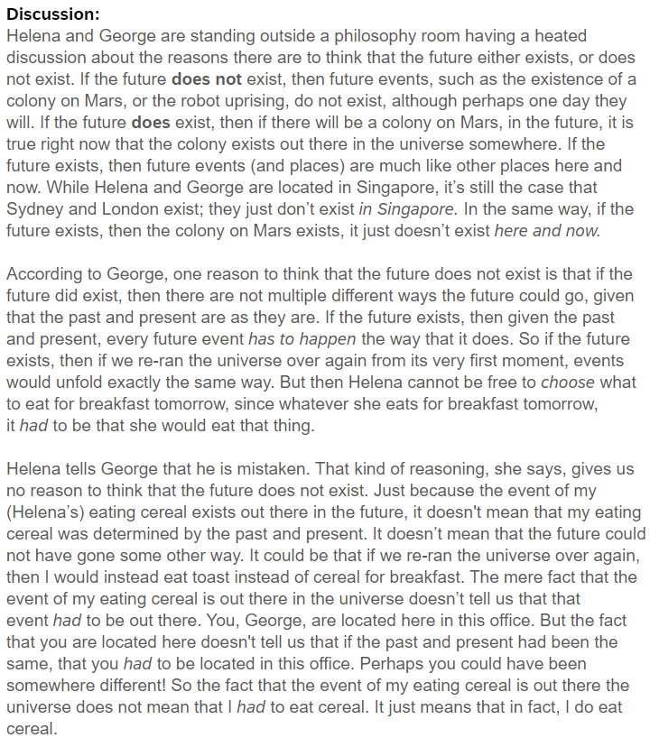
Participants then answered four comprehension questions to which they can answer either (a) true or (b) false.
- If Helena is right, then if the future exists it can still be true that there are multiple ways the future could go, given that the past and present are as they are.
- If George is right, then if the future exists it can still be true that there are multiple ways the future could go, given that the past and present are as they are.
- According to Helena, if the event of her eating cereal tomorrow exists, then it could still be that the past and present did not determine that she would decide to eat cereal.
- According to George, if the event of her eating cereal tomorrow exists, then it must be that the past and present determined that she would decide to eat cereal.
Participants who failed to correctly answer 3 out of 4 of these questions were excluded from the analyses.
Participants are then asked, “Which of the two parties, Helena or George, do you think is right?” and are given two options (a) George or (b) Helena.
Participants then see both the time vignettes and associated comprehension questions (see experiment 1). Participants who failed to correctly answer 3 out of 4 of these questions for each vignette were excluded from the analyses.
Finally, participants then saw the nomic discussion vignette again along with both time vignettes. They are then presented with two questions:
- “Which universe do you think Helena will think is most like the universe she is in?”
- “Which universe do you think George will think is most like the universe he is in?”
For each question they are given the two options (a) Universe C or (b) Universe D.
2.3.3 Results
As in experiment 1, we also tested H2 by asking participants which world they believed was most like our world (i.e., growing block world or block universe world) and predicted that most people would judge that our world is a growing block world rather than a block universe world. Again, H2 was not supported. People were divided between judging that our world is most like a growing block world and a block universe world.
We hypothesised that (H5) if the deliberative reasoning claim is right, then most people should judge that George, rather than Helena, is right in the nomic discussion vignette. This hypothesis was not supported. Instead, contrary to our prediction we found that most participants judged that Helena, rather than George is right.
Finally, we hypothesised that (H6) people will judge that Helena will take herself to be in a block universe world, and that George will take himself to be in a growing block world. This hypothesis was supported.
Separate one-way chi-square tests were performed to test whether (a) most participants will judge that our world was more like a growing block world, (b) most participants will judge that George was right in the nomic openness discussion, (c) most participants will judge that Helena will take herself to be in a block universe world, and that (d) most participants will judge that George will take himself to be in a growing block world. The results of those tests showed that (a) participants were divided between judging that our world is more like a growing block world (64; 51.6%) and a block universe world (60, 48.4%; χ²(1, N = 124) = .124, p = .129), which does not support hypothesis 2. Further, (b) contrary to H5, more participants judged that Helena (87; 70.2%), rather than George (37; 29.8%) was right in the nomic openness discussion, χ²(1, N = 124) = 20.161, p < .001). H6 was vindicated: most participants (c) judged that Helena would take herself to be in the block universe world (80, 64.5%; χ²(1, N = 124) = 10.452, p < .001), and that (d) George would take himself to be in the growing block world (80, 64.5%; χ²(1, N = 124) = 10.452, p < .001).
3. Discussion
There are several notable aspects of our results. First, as predicted we found that a majority of people judged our world to be nomically open rather than closed. These results are of interest to those aiming to model our naïve representation of future openness. Taken in conjunction with previous work in this area, they begin to paint a picture of people’s naïve representation of the future.
Hodroj, Latham, Lee-Tory and Miller (ms) found that a majority of people (66%) judged our world to be one in which the future is alethically open rather than closed. Latham and Miller (ms) report that a majority of people (87%) judged our world to be deliberatively open rather than deliberatively closed: that is, they judged the future to be one in which what we do in the future is the product of our earlier deliberations, so that had we deliberated differently, we would have made different choices and subsequently done different things. These results, taken together with our current results, suggest that people’s naïve representation of the future probably involves at least a combination of representing the future to be deliberatively, alethically, and nomically open. It also suggests that it may be deliberative openness that is most important when it comes to capturing people’s naïve representation of the open future (something Torre (2011) gestures towards).
These results may also suggest that there are several naïve representations of future openness, all, or almost all of which include representing the future as deliberatively open, but only some of which include representing it as nomically and/or alethically open. Perhaps this is not surprising given evidence regarding people’s naïve representation of time. Baron, Miller and Tallant (2022) cite a range of experiments that, jointly, they take to show that there is no single, shared, naïve representation of time. What is true of time might also be true of naïve representations of the open future.
Our results also have implications for the narrow vindication claim. According to that claim, recall, the growing block theory vindicates our naïve representation of the future as open, and the block universe theory does not. There is some support for this claim given the results of this study alongside that of Hodroj et al and Latham et al, despite the fact that these studies jointly suggest that most aspects of our naïve representation of future openness (and the most important of these) are consistent with our world being a block universe world.
The study by Latham et al suggests that a vast majority of people have naïve representations of the future according to which the future is deliberatively open. But the presence of deliberative openness is clearly consistent with our world being either a block universe or a growing block world. So, arguably the most powerful aspect of our naïve representation of the future is one that can be vindicated by either view of time.
The current study found that a majority of people represent the future as nomically open not closed. But, again, the future being nomically open is consistent with our world being either a block universe or a growing block. So either view can vindicate this aspect of our naïve representation.
The only good news for the growing block theorist lies in the Hodroj et al study, which found that a majority of people represent the future as alethically open. On standard (i.e. nonbranching) versions of the block universe, the future is not alethically open, while on standard versions of the growing block theory it is. So, the growing block theory does vindicate this aspect of openness while the block universe view does not.
Still, it’s worth bearing in mind that according to the Hodroj study, ~34% of people did not judge the future to be alethically open. So it may be that a substantial minority of people have a naïve representation of the future that is equally vindicated by both the growing block and block universe theories. And of course, even if the narrow vindication claim is true, it remains open to dispute whether it gives us much, if any, reason to prefer the growing block view to the block universe view. Still, what these studies suggest is that insofar as growing block theorists want to try and argue for their view via something like the (narrow) vindication claim, they might do well to focus more on alethic openness than other forms of openness.
Moving on, we did not find that a majority of people represent our world to be a growing block rather than a block universe. Instead, across both experiments people were evenly split between the two models. This should perhaps not be such a surprise. Latham, Miller and Norton (2019) found that across two experiments ~70% of people judged our world to be dynamical (either growing block, moving spotlight or presentist) and of those, between ~35 and ~50% judged it to be a growing block. Even though in these studies only ~25 and ~35% of all people judged our world to be most like a growing block world, we expected that given a forced choice between a growing block and a block universe world, most people would judge it to more like a growing block world than a block universe world given that most people judge our world to be temporally dynamical.
Our results suggest that although people are drawn to dynamical theories of time, their naïve representation of time might be less strongly dynamical than has otherwise been thought. This might explain why, given that the block universe and growing block views are very similar in a number of ways, when given a forced choice between the two people tended to be roughly evenly divided in which world they thought was most like ours.
This brings us to the explanation and reason claims. Our results here are both startling and puzzling. Consider, first, the explanation claim. Our hypothesis here (H3) was not vindicated. While we did find an association, it was the opposite of the one we predicted. We found an association between judging a world to be nomically closed and judging it to be a growing block world. Amongst people who judged our world to be nomically open, people were evenly split between judging it to be a growing block or a block universe. While the latter absence of an association is not such a surprise (given that in fact nomically open words are no more likely to be growing block worlds as opposed to block universe worlds it is perhaps heartening to see people’s judgements in this regard) the presence of the converse association is very puzzling. It’s hard to see why people who judge the future to be nomically closed would tend to judge it to be a growing block. The best we can come up with is that perhaps some people think that the laws of nature ‘push’ the world along and cause it to grow, and they imagine this growth process must be deterministic (else the world would not know what to grow into). If this is the reason why (some) people judge our world to be nomically closed, then we would expect those people to judge that our world is a growing block. All we can really say is that further investigation of the association here would be useful.
Certainly though, the lack of any association between people judging our world to be nomically open, and judging it to be a growing block world, suggests that it is unlikely that the fact that people naively represent the future as nomically open is what even partially explains why they represent it to be a growing block. This finding is interesting given our results regarding the reason claim. Our hypothesis in this regard was vindicated: participants judged that Katie was more likely to be in a growing block world than a block universe world if she was in a nomically open world, and to be in a block universe rather than a growing block world if she was in a nomically closed world. Thus, people do seem to think that the fact that a world is nomically open is a reason to think it is a growing block world rather than a block universe world. The reason claim seems to be vindicated.
The vindication of the reason claim does suggest that there is some sense in which the growing block view of time better accords with our naïve representation of the future as nomically open. It accords in at least this sese: if the only thing someone knows about a world is that is nomically open, they will think it more likely that the world is a growing block rather than a block universe world. So, there is some important connection between people’s naïve representation of the future, and their naïve representation of time. The former, we might say, predisposes them to thinking that our world is a growing block world, since if all they know about our world is that it is nomically open, people will tend to judge that it is a growing block world.
But of course, this is not all that people know about our world, and presumably this explains why we found no association between people judging that our world is nomically open and that it’s a growing block world. One thought about what might be going on here is that contemporary scientific knowledge is pushing people who judge that our world is nomically open, to judge that it is a block universe world rather than a growing block world. If so, that could tend to eliminate the predicted association. But, first, we know from previous research by Latham, Miler and Norton (2019) that levels of education and levels of scientific knowledge, especially in physics, have no effect on people’s judgements about which view of time they think is true of our world. Second, in this study we found that ~50% of people judged our world to be a growing block. So, it seems unlikely that this explains why we found no association.
Another possibility is that the reason at least some people judge our world to be nomically open is because they are aware of quantum mechanics, rather than on the basis of their naïve representation of the future. If so, it may be that those who naïvely represent the future as nomically open are more inclined to represent it as growing block, but that many of those who represent the future as nomically open are employing a scientifically informed representation of the future, and perhaps those people also tend to represent the world to be a block universe. If so, that could eliminate the association. It would be useful to do follow up work here that attempts to determine to what extent people’s representation of the future as nomically open is naïve, as opposed to scientifically informed.
What we can say, though, is that at best people are predisposed to represent our world to be a growing block in virtue of representing it to be nomically open, but that as matter of fact what explains why people represent the world to be a growing block is not that they represent it to be nomically open. This is further suggested by the results of our second experiment, in which only ~30% of people judged that George’s reasoning was correct. Most people, then, do not endorse the deliberative reasoning claim we investigated.
In all, then we think there is little evidence for the idea that part of what explains why people naively represent our world to be a growing block is because they naively represent the future as nomically open. This will be of interest to A- and B-theorists alike. B-theorists have recently resisted what has become known as the argument from temporal phenomenology (Baron, Cusbert, Farr, Kon and Miller 2015)—according to which we have reason to think our world is temporally dynamical because this is how it seems to us to be, in perceptual experience—by denying that it does seem this way to us in experience (Hoerl 2014, Prosser 2016, Deng 2013, 2018, Bardon 2013, Miller, Holcombe and Latham 2018, Miller 2019, Miller forthcoming, Latham, Miller, and Norton 2020b). Such views have often known as deflationist.
We know, however, that people naively represent our world as temporally dynamical (Latham, Miller and Norton 2019, 2020a, 2021). If, as deflationists suppose, it does not seem to us, in experience as though time is dynamical (and there is some suggestion from Latham, Miller and Norton 2020b that this might be right) then the question arises as to why we naively represent it that way. Deflationists, it seems, owe us some kind of explanation here.
One possibility, alluded to by Prosser (2016), is that part of what explains why we represent time as dynamical is that we represent the future as open. This study had the potential to show that part of what explains why we represent time as dynamical (by representing it as a growing block) is because we represent it as nomically open. Unfortunately for deflationists we found no evidence of this.
Having said that, Prosser’s suggestion is rather different from the one we investigated here. He hypothesises that because people represent the future as being objectively open (as opposed to merely perspectivally or subjectively open) and because we represent that this openness moves (as what was once open becomes closed and part of the past) we must represent that there is a privileged and moving moment in time that is the border between the closed past and the open future. Further work, taking up the specific details of Prosser’s view would be welcome, given that we found no evidence in favour of the hypotheses we tested in this regard.
In all, we think that there is much more that can be learned about both our naïve representation of the open future and the ways in which this representation connects to our naïve representation of time. That work can shed light on the best way to model future openness (insofar as that modelling is attempting to capture some naïve representation of the future) and on whether what explains our open future practices also vindicates our naïve representation of the open future. It can, we hope, also shed light on the connection between our naïve representation of the future and of time, and hence on extant debates in the philosophy of time.

References
Bardon, A. (2013). A Brief History of the Philosophy of Time. OUP.
Barnes, E. and Cameron, R. (2009).’ The Open Future: Bivalence, Determinism and Ontology. Philosophical Studies. 146: 292-309
Baron, S. Cusbert, J. Farr, M, Kon, M, and Miller, K. (2015) “Temporal Experience, Temporal Passage and the Cognitive Sciences” Philosophy Compass. 10 (8): 56—571.
Baron, S. Miller, K. and Tallant, J. (2022) Out of Time. OUP.
Belnap, N. (1992) 'Branching Space-Time.' Synthese 92.3, 385-434.
Belnap, N. (2005) ‘Agents and Agency in Branching Space-times’ Logic, Thought and Action, Daniel Vanderveken (ed.), Dordrecht: Springer, 291-313.
Briggs, R. and Forbes, G. (2012). “The Read Truth about the Unreal Future.” In Karen Bennett & Dean Zimmerman (eds.), Oxford Studies in Metaphysics, volume 7.

Broad, C. D (1923). Scientific Thought. London: Routledge & Kegal Paul
Broad, C. D. (1938). Examination of McTaggart’s Philosophy: Vol II Part I Cambridge: CUP.
Callender, C. (2017). What Makes Time Special? Oxford University Press.
Deng, N. (2018). On ‘Experiencing time’: a response to Simon Prosser. Inquiry: An Interdisciplinary Journal of Philosophy 61 (3):281-301.
Deng, N. (2013). On Explaining Why Time Seems to Pass. Southern Journal of Philosophy 51 (3):367-382.
Forbes, G. (2016). ‘The Growing Block’s Past Problems’. Philosophical Studies 173(3): 699-709.
Forrest, P. (2004). The real but dead past: A reply to Braddon-Mitchell. Analysis, 64, 358–362.
Grandjean, V. (2019). “How is the Asymmery Between the Open Future and the Fixed Past to be Characterised.?” Synthese (3):1-24.
Hoerl, C. (2014), Do we (seem to) perceive passage? Philosophical Explorations, 17, 188–202.
Hodroj, B., Latham, A. J., Lee-Tory, J., and Miller, K (ms). “Alethic Opennes and the Growing Block Theory of Time.” Accessed at https://philpapers.org/rec/HODAOA
Ismael, J. Decision and the Open Future. In A Bardon (ed.) The Future of the Philosophy of Time. (New York: Routledge, 2012) 149-169.
Lathan, A. J., and Miller, K. (ms) “Why do people represent time as dynamical? An investigation of temporal dynamism and the open future.” Accessed at https://philpapers.org/rec/LATWDP
Latham, A.J., Miller, K. and Norton, J. (2021). “An empirical investigation of the role of direction in our concept of time”. Acta Analytica. 36(1), 25-47 DOI: 10.1007/s12136-020-00435-z

Latham, A. J., Miller, K and Norton, J. (2020(a)) “Do the Folk Represent Time as Essentially Dynamical?” Inquiry. https://doi.org/10.1080/0020174X.2020.1827027
Latham, A. J. Miller, K and Norton, J. (2020(b)). “An Empirical Investigation of Purported Passage Phenomenology”. The Journal of Philosophy. 10.5840/jphil2020117722 117(7): 353-386.
Latham, A. J., Miller, K and Norton, J. (2019) “Is Our Naïve Theory of Time Dynamical?”. Synthese. DOI: 10.1007/s11229-019-02340-4 198:4251-4271
Leininger, L. (2021). “Temporal B-Coming: Passage Without Presentness”. Australasian Journal of Philosophy:1-18.
Lewis, D. (1987) ‘Counterfactual Dependence and Time’s Arrow’ plus postscripts in his Philosophical Papers, 2, 32-66.
MacFarlane, J. (2003) ‘Future Contingents and Relative Truth’ The Philosophical Quarterly 53, 321-336.
MacFarlane, J. (2008) ‘Truth in the Garden of Forking Paths’ in Relative Truth, ed. Max Kölbel and Manuel García-Carpintero, Oxford: Oxford University Press, 81–102.
Markosian, N. (1995) ‘The Open Past’ Philosophical Studies 79, 95-105.
Markosian, N. (2004) “A Defense of Presentism” in D. Zimmerman ed Oxford Sudies in Metpahysics Volume I Oxford: OUP.
McCall, S. (1994) A Model of the Universe, Oxford: Oxford University Press.
Miller, K., Holcombe, A., & Latham, A. J. (2018). Temporal phenomenology: phenomenological illusion versus cognitive error. Synthese, 1-21.
Miller, K. (2019). “Does it really seem as though time passes?” in The Illusions of Time: Philosophical and Psychological Essays on Timing and Time Perception, ed V Artsila, A. Bardon, S. Power, and A. Vatakis, pp 17-33. Palgrave McMillan https://doi.org/10.1007/978-3-030-22048-8_2
Miller, K. (forthcoming). “Against Passage Illusionism”. Ergo.
Prosser, S. (2016). Experiencing Time. OUP.
Rosenkranz, S and Correia, C. (2018). Nothing to Come: a Defence of the Growing Block Theory of Time. Springer Verlag
Tooley, M. (1997). Time, Tense, and Causation. Oxford University Press.
Torre, S. (2011). “The Open Future”. Philosophy Compass 6(5): 360-373.
Williams, J. R. G. (unpublished). “Aristotelian Indeterminacy and the Open Future.”

Callender (2017) takes this to be part of the manifest image; Ismael (2012) likewise.
See Forbes (2016). Latham, Miller and Norton (2019) confirmed empirically that, of the ~70% of people who are temporal dynamists, the most popular view is the growing block view.
Defenders of this view include Broad (1923, 1928), Forbes (2016) Rosenkranz and Correia (2018), Tooley (1997) and Forrest (2004).
See for instance Markosian (1995) and Williams (ms), McFarlane (2003), Tooley (1997).
See for instance Lewis (1987).
Belnap (1992), (2005), MacFarlane (2003), (2008), and McCall (1994).
This is not to say that these are the only such ways. For discussion of the ways in which we could model openness see Torre (2011) and Markosian (1995).
See for instance Briggs and Forbes (2012); Forbes (2016), Grandjean (2019, forthcoming). Rosenkranz and Correia (2018).
Something that Grandjean (2019, forthcoming) and Rosenkranz and Correia (2018) point to.
22% of the remaining sample got every comprehension question correct.
16% of the remaining sample got every comprehension question correct.

