**The *Fundamental Interrelationships Model* – An Alternative Approach to the *Theory of Everything,* Part 1**

**Subtitle: Introducing the *Fundamental Interrelationships Model* and Unifying the Big Bang theory with the evolutionary theory**

**Abstract**

The quest for a unified “*Theory of Everything*” that explains the fundamental nature of the universe has long been a holy grail for scientists and philosophers, dating back to the ancient Greeks’ search for Arche. The mainstream of this research primarily focuses on the lifeless phenomena and laws of physics while ignores the realm of biology.

However, a fundamentally different approach to the ToE has been put forward, presenting a viable alternative to address the challenge of a *Theory of Everything*. This approach does not seek the ultimate “building block” but rather aims to uncover the intangible rules that fundamentally govern everything in the universe, seeking their universality across the vast spectrum, from the minute subatomic world to the mega mass cosmic world and the magical biological world.

To address this challenge, a set of fundamental interrelationships is introduced and represented by a model, the *Fundamental Interrelationships Model.* This model serves as a foundation for representing and unifying a collection of the well-established laws of physics and theories, including the Big Bang theory and evolutionary theory.

Thus, unlike most existing candidates, the *Fundamental Interrelationships Model* offers a comprehensive framework, encompassing both non-biological and living phenomena. As a truly all-inclusive theory, ToE shouldn’t only encompass non-biological processes and the laws of physics but extend to all facets of life, including evolution of life, evolution of society (civilization), humour, and justice, because life is an integral part of the dynamic cosmic system - the universe. Therefore, any hypothesis failing to integrate biology and sociology shouldn’t be considered a comprehensive *Theory of Everything*

A groundbreaking research has, for the first time, put forward a new hypothesis to unify the Big Bang theory with the evolutionary theory and published in 2022 in the book, *Behind Civilization* (3rd. Ed.), Subtitle: *the fundamental rules in the universe*. This marks a significant stride toward addressing the longstanding challenge of a comprehensive *Theory of Everything.*

This achievement was gained by revealing the fundamental similarities between the evolution of life and the evolution of the universe. The resemblances between the two events can be attributed to self-similarity as the evolution of life is a part of the evolutions of the universe. At a deeper level, the fundamental level, these similarities are due to both events following the same set of fundamental interrelationships.

These fundamental interrelationships encompass a wide range of concepts, including serial-parallel relationships, transition of state, critical point, continuation-discontinuation, convergence-divergence, contraction-expansion, singularity-plurality, commonality-difference, similarity, symmetry-asymmetry, dynamics-stability, order-disorder, limitation-without limitation, hierarchical structure, and cohesiveness. These interrelationships found in nature can be interpreted as the fundamental laws of physics. They can be represented and unified by a model, The *Fundamental Interrelationships Model.*

The *Fundamental Interrelationships Model*, abbreviated as the *Interrelationships Model* (IRM) is a conceptual framework presented in the form of a diagram. Crucially, the *Interrelationships Model* asserts that everything, including all biological features in life and those well-established laws of physics, are specific expressions of the fundamental interrelationships it represents.

The biological features include adaptation, natural selection, driving force of evolution, transition from unicellularity to multicellularity, increase of complexity, division of labor, coordination, cooperation and negligible conflict.

The laws of physics include Newton’s three laws of motion, four laws of thermodynamics, Noether’s theorem, Einstein’s space-time relationship, Heisenberg’s uncertainty principle, chaos theory, wave function collapse, and other phenomena in physics including atomic electron transition.

Notably, unlike the current theories for a *Theory of Everything* (ToE) that predominantly focus on lifeless phenomena, the *Interrelationships Model* can directly represent living entities.

Here is the *Fundamental Interrelationships Model:*

**1 Introducing the *Fundamental Interrelationships Model:***

The *Fundamental Interrelationships Model*, abbreviated as the *Interrelationships Model* (IRM) is a conceptual framework presented in the form of a diagram. This model aims to cohesively represent and unify a set of fundamental interrelationships found in nature which can be interpreted as the fundamental laws of physics.

These fundamental interrelationships encompass a wide range of relationships, including serial-parallel relationships, transition of state, critical point, continuation-discontinuation, convergence-divergence, contraction-expansion, singularity-plurality, commonality-difference, similarity, symmetry-asymmetry, dynamics-stability, order-disorder, limitation-without limitation, hierarchical structure, and cohesiveness.

Building upon these fundamental interrelationships, the model is further developed to represent key laws of physics, such as Newton’s three laws of motion, four laws of thermodynamics, Noether’s theorem, Einstein’s space-time relationship, Heisenberg’s uncertainty principle, chaos theory, wave function collapse, and other phenomena in physics including atomic electron transition.

Crucially, the *Interrelationships Model* asserts that these well-established laws of physics are specific expressions of the fundamental interrelationships it represents. Notably, unlike the current theories for a *Theory of Everything* (ToE) that predominantly focus on lifeless phenomena, the *Interrelationships Model* can directly represent living entities. Subsequent research suggests that this model has the potential to unify the Big Bang theory with evolutionary theory, marking a significant stride toward addressing the longstanding challenge of a comprehensive *Theory of Everything.*

The presentation of this hypothesis serves as an invitation for further discussion and critique, proposing an alternative perspective to address the overarching issue of a *Theory of Everything.*

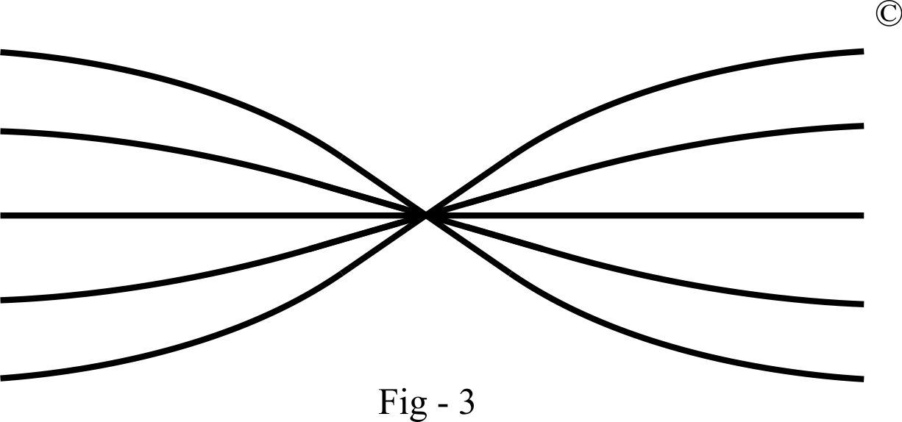

This video aids in understanding these fundamental interrelationships:

<https://www.youtube.com/watch?v=noc40X6ySUg>

**Representing the fundamental interrelationships:**

***Serial relationship***

A serial relationship is a fundamental connection. For example, the linkage of multiple components in series within an electrical circuit is a well-known instance. In a family, the relationship between grandmother, mother, daughter, and granddaughter exemplifies a serial relationship. Similarly, the cause-and-effect relationship widely observed in nature, such as the collision of cars on a highway, is another illustration. In this scenario, the first car triggers the second car's collision, and this chain continues.

These relationships can be represented as E1, E2, E3, E4, where events are in a serial relationship, as depicted in Figure 4. The first event causes the second, the second causes the third, and so on. This representation aligns with the law of conservation of energy, which is also an expression of a serial relationship. The model for a serial relationship evolves from the *Interrelationships Model*.

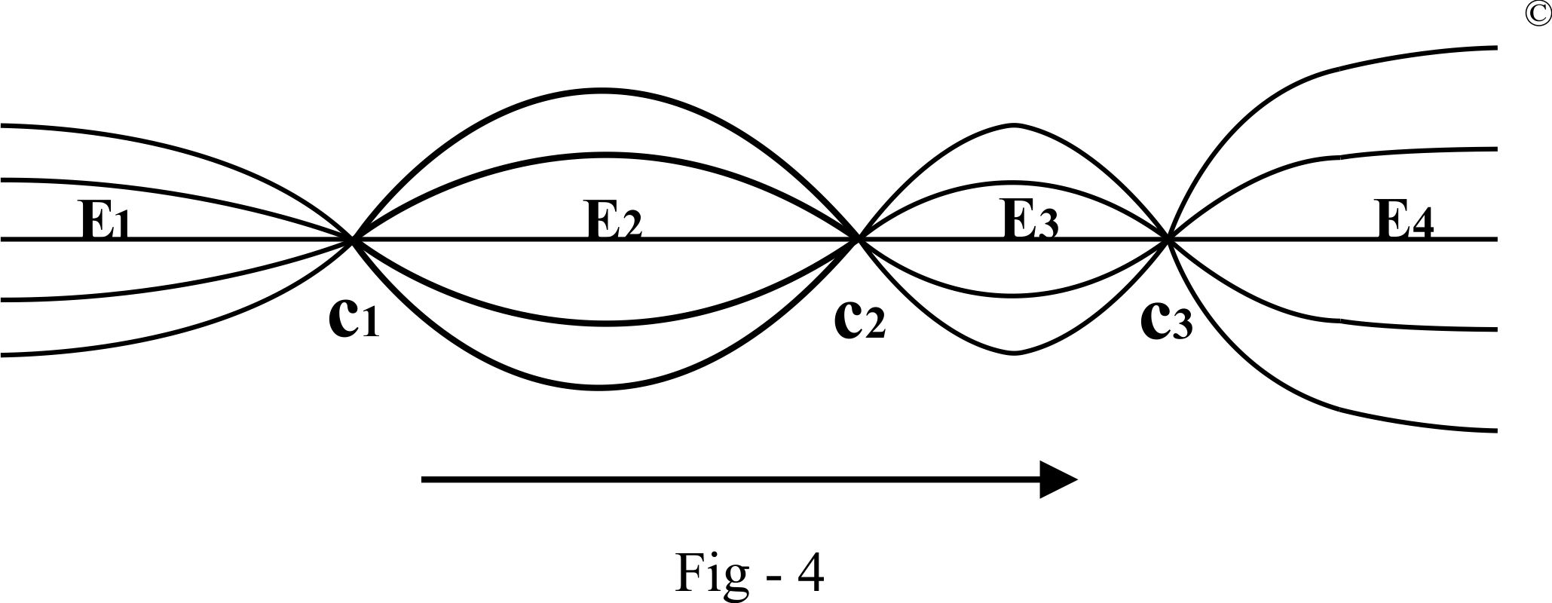

***Parallel Relationship***

A parallel relationship is one of the fundamental connections in the universe. For example, components linked in parallel in an electrical circuit exhibit a parallel relationship. Similarly, the relationship between brother and sister or planets in the solar system can be considered parallel. Unlike serial relationships, parallel events do not involve cause and effect.

A parallel relationship can be based either on an object's position in space or on a common mechanism. For instance, components in a car share a spatial parallel relationship. Another form of a parallel relationship is based on a common mechanism, as seen in all mammals sharing a parallel relationship due to their common mammalian mechanism. The parallel relationship is represented in Figure 5.

Both parallel relationships based on spatial orientation and a common mechanism can coexist. For example, twins in a family are spatially parallel to each other; at the same time, they share an intangible common mechanism – the same set of genes. This common mechanism leads to similarities between twins.

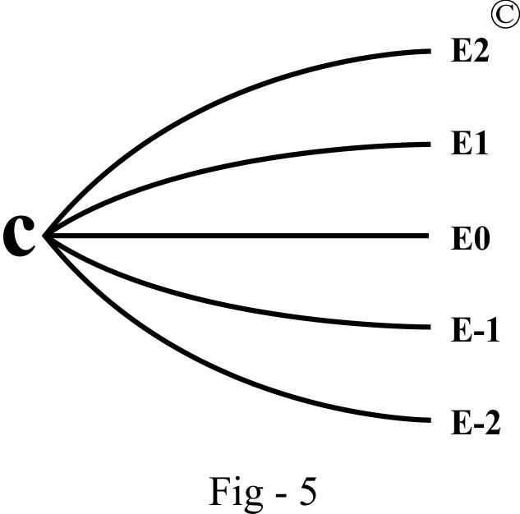

***Serial-parallel Relationship***

Contrary to the notion that relationships are strictly either serial or parallel, in reality, they can coexist simultaneously.

Consider the creation of higher-order multicellular organisms, which begins with just two cells: the male sperm cell (spermatozoa) and the female egg cell (ovum) [1]. The relationship between these two cells is parallel. However, as the sperm cell fuses with the egg cell to become a zygote, the relationship between the sperm cell and the zygote becomes serial, and a similar serial relationship exists between the egg cell and the zygote. [2]

Turning our attention to the inorganic world, the periodic table organizes elements systematically based on their physical and chemical properties, forming a parallel relationship among them. For instance, hydrogen atoms (H) forming hydrogen gas molecules (H2) relate to oxygen atoms (O) forming oxygen gas molecules (O2) in an independent but parallel manner. However, when they combine, the hydrogen and oxygen atoms form two separate serial relationships with the resulting water molecule (H2O).

In organic chemistry, the relationship between carbon, hydrogen, and oxygen atoms forming various carbohydrate compounds is strictly parallel. Yet, each element also forms a separate serial relationship with the resulting compounds. Carbohydrates, being the building blocks of life, show serial relationships between life and hydrogen atoms, and life and oxygen atoms, while the relationships among different types of atoms (i.e., elements) are parallel.

Applying the *Interrelationships Model*, we can decipher complex interrelationships among various objective existences. From cosmic examples to taxonomic hierarchies[3], the model unveils the intricate relationships within and between different levels.

From a taxonomic perspective, each level forms a serial relationship with those above and below it, while within each level, various organisms exist in parallel. For instance, the cat family (Felidae) is divided into parallel genera such as Felis, Panthera, and Lynx. The genus Panthera can then be divided into separate parallel species, and even further into parallel subspecies.[4]

Applying the same approach to human society, we observe that Confucius and his descendants are serially related. Ignoring temporal separation, each of Confucius’ descendants represents a unique and independent individual, forming a specific parallel existence. Thus, the interrelationships represented by this model can be interpreted as parallel-serial and serial-parallel.

*Top of Form*

***Similarity***

Similarity is a prevalent phenomenon in the universe, emerging from the interplay of commonality and difference. For instance, domestic cats and tigers both belong to the cat family, sharing numerous biological features while exhibiting distinct differences. Similarly, potassium and sodium, both metallic elements, demonstrate common properties of metals but differ significantly in terms of chemical reactivity.

As discussed earlier, similarity is the manifestation of a parallel relationship grounded in a common mechanism. Put simply, if entities display similarity, they must possess a shared mechanism. For instance, a group of organisms exhibits similar features due to their identical DNA sequences. Likewise, potassium and sodium showcase metallic properties because of their common characteristic: fewer electrons in the outer orbit, a hallmark of metallic elements. Therefore, we can infer that all entities displaying similarity are interconnected through a common mechanism.

Representing similarity, the *Interrelationships Model* offers a visual depiction, as illustrated in the diagram below. Building on the concept of similarity, it can be effectively represented using the *Interrelationships Model*, facilitating a comprehensive understanding of the interconnectedness of entities in the universe.

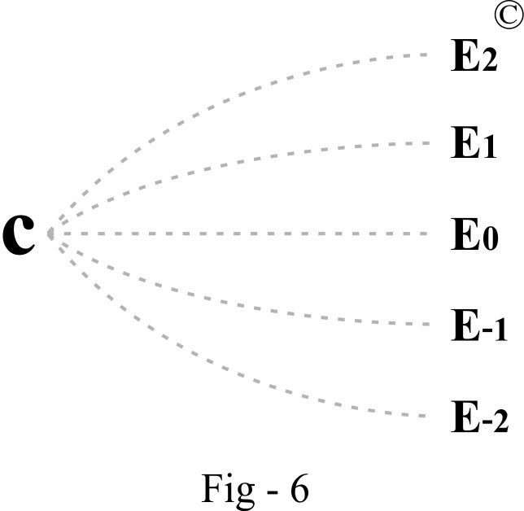

In the presented diagram, C represents a common mechanism, which is intangible. Entities such as E0, E1, E2, E-1, E-2 symbolize parallel existences with similarity. Dotted lines denote intangible links between these parallel existences and the common mechanism. The distance between the parallel lines signifies relative similarity, with greater distance indicating more difference and less commonality, and a shorter distance indicating greater commonality and less difference.

This model effectively explains the phenomenon of similarity. Applying it to the example of a group of trees, seemingly independent parallel trees are interconnected through a common point –the abstract common mechanism, C. While intangible, this mechanism finds expression in physical existence. For instance, the common genetic coding shared by these trees is an abstract component of the common mechanism. The arrangement of molecules in this genetic coding serves as the physical expression of the abstract mechanism.

Extending the model to life forms, any life form is essentially a unique expression of biology. All living things, including bacteria, viruses, amoeba, plants, insects, mammals, birds, fish, and humans, are parallel biological existences based on the common mechanism of life. They share common characteristic features such as reproduction, competition, and metabolism—the commonality—while also exhibiting their unique features, the differences.

A unicellular organism and a colony of multicellular organisms both manifest universal life features. For instance, reproduction, competition, and metabolism are evident, but they can also display vastly different characteristics. Animals increase their numbers through sexual reproduction,[5] whereas most bacteria and viruses multiply strictly through asexual means.[6] Most animals breed during specific times of the year, whereas human beings are sexually receptive year-round. Sexual receptiveness can even be induced medically, as humans are willing to invest vast resources in the development, mass production, and marketing of drugs such as Viagra.

Whether a single cell, an individual, or a group of individuals, similarities exist, but none are exactly the same. Therefore, both commonality and difference coexist.

***Transition of State and Critical Point***

Transition of state is a widespread phenomenon in the universe and serves as an expression of a serial relationship. An illustrative example of this phenomenon is observed when ice is heated, causing it to melt into water, and when water is further heated, transforming it into steam. Notably, with each transition, the physical properties of the substance undergo corresponding changes. Ice exists in a solid form, water in a liquid state, and steam as a gaseous entity.

The critical point marks the juncture at which such transitions initiate. For instance, 0°C represents the critical point at which ice transitions into water, and 100°C is the critical point[7] for water evolving into steam.

Visualizing and understanding the process of the transition of state can be facilitated by the *Interrelationships Model*, as depicted in Figure 7. In this model, the convergence and subsequent divergence of lines signify the critical point – a recognized turning point. The left side of the model signifies the state before transition, while the right side represents the state after transition. Thus, the model effectively captures the entire process of the transition of state. Applying this model to the example of ice melting into water, the left side represents ice, where water molecules (H2O) exist in a solid form. At the center, the critical point (0°C) signifies the transition from a solid to a liquid state. The right side represents water, where water molecules exist in a liquid form.

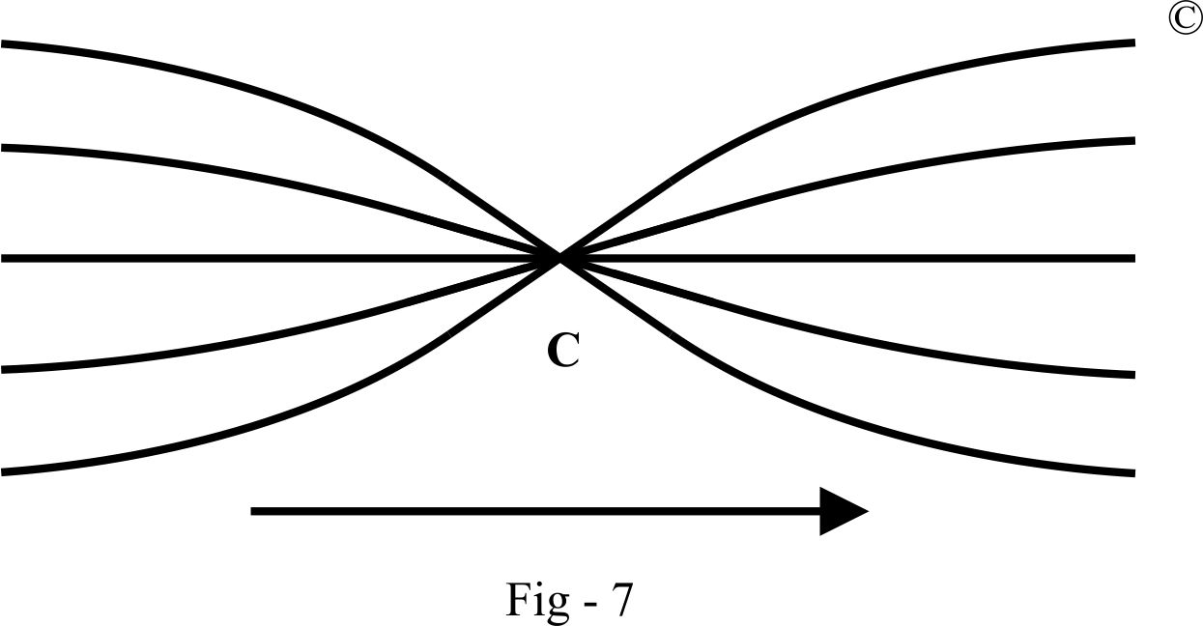

The region between two critical points signifies a distinct form of existence. Beyond this region, an object adopt different forms of existence.

The transition of state and critical points are evident in various physical, chemical, and biological phenomena, such as the boiling of water. In the case of water, temperature and pressure, represented by lines to the left of the critical point, determine its phase. To the left of the critical point, water exists in a liquid state, and to the right, it exists in a gaseous state. The precise moment water starts to boil represents a phase transition[8], with the boiling point serving as the critical point. A similar principle applies to nuclear substances, where reaching a critical point, known as critical mass[9], triggers a nuclear reaction, transforming energy from matter to nuclear energy.

The concept of transition of state and critical points also exists in human society. For instance, individuals experience numerous critical points in their lives, moments where a change of state occurs in an instant. The first critical point is the fusion of a sperm cell with an egg cell, giving rise to a unique person[10]. This individual transitions from their birth, through significant milestones like receiving a testamur at their university graduation ceremony, to the pivotal moment of saying “I do” at their wedding, and further to the day their first child is born, marking their entry into parenthood. Moreover, the critical moment of the last heartbeat marks the end of life, encapsulating the entire spectrum of human existence.

Numerous critical points punctuate the history of human civilization, each catalyzing transformative shifts in our understanding of the world and our technological capabilities. Examples include Copernicus’ heliocentric model challenging the Earth-centric view, Newton’s laws of physics revolutionizing our comprehension of motion, and Einstein’s theory of relativity fundamentally altering our understanding of space and time. The invention of the steam engine ushered in the Industrial Revolution, reshaping economies and societies, while the creation of computers marked the onset of the digital age, revolutionizing communication and information processing.

All these instances, whether in individual lives or in human civilization, represent transitions of state and critical points existing in the physical world. These phenomena can be effectively represented and understood through the *Interrelationships Model*.

***Continuation-Discontinuation***

From the preceding discussion, it becomes evident that all forms of change embody the concept of continuation-discontinuation. For instance, when ice melts into water, the solid form of water molecules is discontinued; when water boils, the liquid form of water molecules is discontinued. Importantly, these changes in existing states do not alter the nature of water molecules – they persist as water molecules throughout. This dynamic process can be aptly illustrated using Fig-4, where the horizontal straight line represents continuation, and curved lines ending at a convergent point depict discontinuation, characterized as continuation-discontinuation.

Any developmental process, by its very nature, follows a path of continuous progression. Despite its inherent continuity, this progression often appears disrupted due to the varying forms in which the constituent elements of the process manifest or are perceived. Points of convergence and divergence within this continuous progression represent specific transition points where forms undergo change

Extending this idea to broader processes of development, it becomes evident that continuation-discontinuation is a fundamental aspect of dynamic systems, whether at the molecular level or within complex developmental processes.

***Convergence-Divergence***

The old Chinese proverb, “extended togetherness leads to separation, while prolonged separation leads to togetherness,” encapsulates many common events in the objective world, offering a straightforward explanation of the convergence-divergence model. This model aligns with the converging and diverging tendencies observed in these events.

For instance, the fusion of a sperm cell with an egg cell, forming a zygote, represents a convergent process. Subsequent zygotic cellular division, leading to the gradual progression from embryo to fetus, neonate, and eventually to an adult, exemplifies a divergent process. From an energetic perspective, this progression essentially signifies a convergent process as energy accumulates progressively. However, as an individual ages and life expires due to old age, this becomes a divergent process – energy is lost, the body degenerates, and ultimately disintegrates.

Applying this principle to broader scenarios, consider the telecommunications industry. Bell, once the sole telecommunications company in the USA, experienced a divergence when it was divided into several independent companies[11]. However, in the competitive landscape, annexation occurred, resulting in the emergence of several large telecommunications companies – a clear example of convergence. Similarly, the motor industry, which initially comprised numerous production firms, has now converged to only a few remaining companies in each country, with others being annexed or eliminated.

These examples underscore the dynamic nature of convergence and divergence, shaping the unfolding patterns in both natural and human-made systems.

***Singularity-Plurality***

The dynamic changes inherent in convergence-divergence often manifest as singularity-plurality. This phenomenon unfolds as multiple existences, a state of plurality, converge into a single existence, a state of singularity. A tangible illustration of this concept is observed in sports competitions, where multiple teams compete, eventually converging into a single champion. This convergence encapsulates the transformation of multiple possibilities into a singular reality, a common occurrence in the pursuit of truth.

Building on the dynamics of convergence-divergence, we can observe a similar interplay in the concept of singularity-plurality. It represents the fluidity and adaptability of systems, where a multitude of entities can either coalesce into a unified whole or diverge into diverse entities. This duality highlights the dynamic nature of processes, both in natural phenomena and human endeavors.

***Contraction-Expansion***

Contraction and expansion represent a ubiquitous phenomenon in the natural and human-made world. When temperature rises, the size of an object expands, and conversely, when temperature decreases, the object contracts. Applying this principle to various domains, human body size contracts with aging and expands with development, mirroring the ebb and flow of life. Similarly, economic size undergoes expansion during periods of development and contracts during economic recessions.

All these dynamic phenomena find representation and understanding through the lens of the *Interrelationships Model*. This model captures the essence of contraction-expansion, illustrating the inherent interplay of opposing forces that shape the diverse processes observed in the world around us.

***Symmetry-Asymmetry***

Symmetry-Asymmetry is a pervasive phenomenon observed across a spectrum of existence. Whether in celestial bodies like planets, the intricate structures of crystals and atoms, or the biological realm, the interplay of symmetry and asymmetry is a fundamental aspect of the natural order.

Symmetry reveals itself in the organization of planets, the solar system, and galaxies. In smaller scales, crystal structures showcase symmetrical arrangements, and atoms display symmetry in the distribution of electrical charges, with positive charges in the nucleus and negative charges in electrons. Even in the biological realm, the human body is morphologically symmetrical, and the sympathetic nerve system is functionally symmetrical to the parasympathetic nerve system[12].

Extending this concept to living organisms, asymmetry is also prevalent. Consider the human body with two legs, expressing a form of symmetry, yet the lengths of the legs are not absolutely symmetrical. Conversely, the presence of only one head introduces an element of asymmetry in contrast to the symmetry of two legs.

The interplay between symmetry and asymmetry is effectively represented by the *Interrelationships Model*, as visualized in Fig-8. This model serves as a comprehensive illustration of the dynamic balance and interaction between symmetry and asymmetry in the context under discussion.

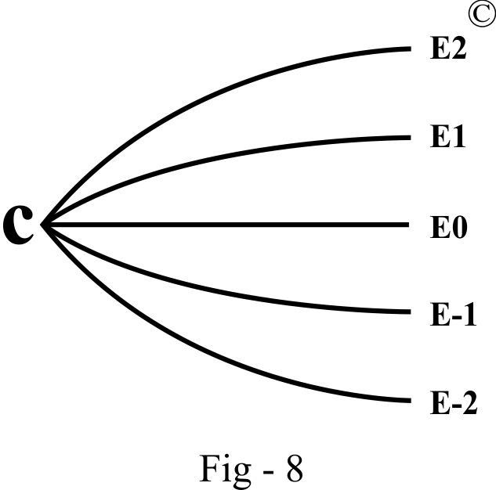

In the above diagram, the lines exhibit both symmetry and asymmetry around the horizontal axis. For example, E2 is symmetrical to E-2 in quality as they are positioned on opposite sides and also symmetrical in quantity. Thus, E2 and E-2 share both qualitative and quantitative symmetry. On the other hand, E2 is symmetrical to E-1 in quality as they are oppositely positioned, but they are asymmetrical in quantity. Therefore, E2 and E-1 are symmetrical in quality but asymmetrical in quantity, akin to the configuration of two legs.

This example illustrates that symmetry and asymmetry are inherently intertwined. Another representation of this association can be observed by rotating Fig-8 90 degrees clockwise, presenting an upright hierarchical system. In this system, the highest point, C, is in a state of singularity – a form of asymmetry within the framework of left-right symmetry. Below this point, the left and right sides of the system are symmetrical. This symmetry-asymmetry relationship is akin to the structure of a human body with one head and two legs. These discussions highlight the consistent association between symmetry and asymmetry.

The association described is also depicted in an alternative manner within the diagram above: if Fig-8 is rotated 90 degrees clockwise, it transforms into an upright hierarchical system. Within this arrangement, the lines on the left and right denote symmetry. Directly beneath the apex, labeled as C, any point on one line possesses a mirrored counterpart on the opposite line, signifying symmetry. However, the apex itself, denoted as C, exists as a singularity, lacking a symmetrical counterpart within this system. Therefore, it represents a form of asymmetry within the context of left-right symmetry. This symmetry-asymmetry relationship is analogous to the configuration of a human body system with one head and two legs: while the legs exhibit symmetry, the presence of one leg constitutes an asymmetry. Similarly, based on the same principle, the presence of one head represents asymmetry.

Symmetry and asymmetry exhibit the ability to transition into their opposites. In an upright hierarchical system, symmetry shifts towards asymmetry when progressing from the base to the apex, while asymmetry transforms into symmetry in the reverse direction. Moreover, symmetry and asymmetry can interchange when transitioning beyond their current system boundaries. For instance, within a hierarchical arrangement, the highest point embodies asymmetry. However, this same point becomes part of a symmetrical system when juxtaposed with another hierarchical structure. For instance, when two individuals stand side by side, a single head becomes part of a symmetrical arrangement consisting of two heads. Similarly, within the context of the human body, the head represents asymmetry. Nevertheless, when considered independently, a solitary head embodies symmetry, as the left side mirrors the right side. From these discussions, it becomes evident that symmetry and asymmetry are invariably interconnected.

Additionally, symmetry is manifested in the left and right sides of the model in Fig-7, where the converging and diverging halves are symmetrical to each other.

Symmetry-asymmetry emerges as a crucial aspect of the fundamental interrelationships, as reflected in the orientation and configuration of lines within the *Interrelationships Model*. These lines not only visually represent the distribution of power within a system but also extend beyond the system. This intricate interplay is intimately connected to the overarching themes of stability and dynamics, topics that will be further explored in the following description.

***Order-Disorder***

Order and disorder are two common phenomena in the universe: the orderly state of the crystal structure of ice and the disorderly state of liquid water; the orderly state of a harmonious society and the disorderly state of a violent society. They are fundamental aspects of the interrelationships in the universe.

In fluid dynamics, laminar flow is an orderly state where all layers within the fluid are consistent in direction. On the contrary, turbulent flow, seemingly chaotic, is a disordered state where the flow is composed of numerous independent eddies of varying velocities and circulating directions. In each eddy, fluid circulates around its own center, making each eddy “self-centric” and possessing its own order. From this example, it can be concluded that disorder arises from the presence of more than two sets of conflicting orders within the same system. Therefore, a more precise definition of disorder would be the presence of two or more sets of orders with conflicting directions within a system.

The concepts of order and disorder can be effectively represented by the *Interrelationships Model*.

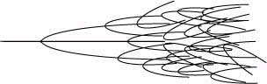

Fig – 9

In the *Interrelationships Model* (Fig-3), as long as two or more lines (representing events) proceed in the same direction while remaining parallel and sufficiently spaced, they will not conflict with one another. In this scenario, the system remains in order. However, when individual lines begin to converge from different directions, these independent lines or events, each following an independent set of rules, are destined to collide. Since each line represents an independent event with its own unique order, conflict becomes inevitable when two or more sets of orders govern the same system, resulting in a disordered system.

Fig-9 illustrates the transition from order to disorder. As the system progresses, existing lines continue to branch out into multiple parallel branches, and each branch further divides into even more parallel branches. With ongoing branching, the spaces between resulting branches decrease. When two or more branches finally come into contact, they may either clash or merge. Consequently, the orderly state is disturbed and transforms into a disorderly state. Further clashes or merges may then give rise to a new form of order. In this way, the *Interrelationships Model* represents order, disorder, and the transitions between these two states.

A disordered system gives the illusion that no rules govern it, but this is not the case. The difficulty arises in identifying the multiple underlying sets of rules in a disordered system. This stems from our inability to recognize and establish a logical connection between the various forms of orders or rules within a particular system.

Order and disorder are two fundamental processes in the universe, and these processes can interchange. Every stable physical existence must maintain an orderly form. Clashes and conflicts may lead to disorder, followed by disintegration or merging. Ultimately, a new set of orders emerges as a consequence of the interaction of previous determining orders. This new set of orders results from the integration of several different subsets of orders or rules. The characteristics of these new orders or rules are defined by the constituent with the greatest power.

***Periodicity***

Periodic changes are ubiquitous in nature, manifesting in various phenomena such as annual seasonal transitions, daily day-night cycles, alternating current directional oscillations, economic growth and depression cycles, body circulation, neural command-feedback, and the female menstrual cycles. These rhythmic expressions of periodicity find representation within the structured framework of the *Interrelationships Model.*

In this model, the region above the horizontal axis is designated as the positive area, while the area below is labelled the negative area. Let's denote a variable, represented by "a," which initiates its journey in the positive area. Passing the first turning point, "a" traverses into the negative area. Continuing its progression, it reaches the second turning point, re-entering the positive area. From the standpoint of progression, periodicity is a specialized form of serial relationship. However, concerning the horizontal axis, it also exhibits the characteristic of symmetry.

This symmetrical oscillation around the horizontal axis elegantly captures the essence of periodicity within the *Interrelationships Model*. To visualize this rhythmic symphony, consider referring to the accompanying *Interrelationships Model*, where the periodic dance of elements mirrors the ebb and flow of various cyclic phenomena in the world around us.

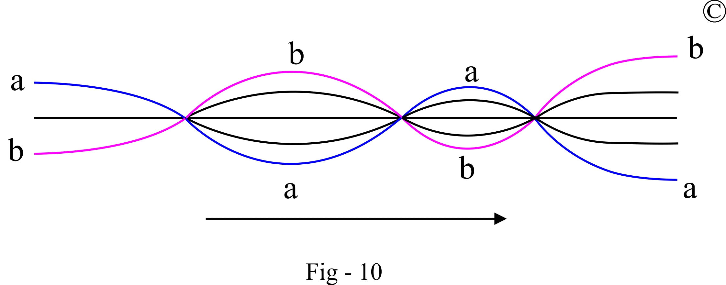

**Dynamics-Stability**

Dynamics, the perpetual dance of change, gracefully unfolds in various phenomena – from the shifting seasons and the thawing of ice in spring to the pulsating flow of a river, the metamorphosis of an embryo, and the majestic birth of stars and galaxies. Every transition between serial-parallel relationships, contraction-expansion, convergence-divergence, singularity-plurality, order-disorder, limitation-without limitation, continuation-discontinuation, and symmetry-asymmetry encapsulates the essence of dynamics. The dynamics not only presents as the transition between the two contradict paring states but can also presents as the transition between different pairs. For example, not only contraction can transit into expansion but contraction-expansion can transit into convergence-divergence.

In this continuous ebb and flow, dynamics reveals a fascinating interplay with stability. Consider the stability of buildings, where changes are normally subtle and imperceptible. However, when the balance between opposing forces is disrupted, as in the dramatic collapse of a building, change becomes palpable and profound.

The dynamic equilibrium between change and stability finds expression in the symmetrical and asymmetrical states of a system. When two opposing forces find equilibrium, symmetry prevails, and the system attains stability. Conversely, if the system exists in an asymmetrical state, change ensues, driving the dynamics of the system. An illustrative example is the transfer of heat from a higher temperature system to a lower temperature system, a dynamic process fueled by the asymmetry of temperature differences. As the temperatures reach equilibrium, symmetry is restored, and the system stabilizes.

The *Interrelationships Model* adeptly captures these intricate dynamics. The diagram, Fig-10, showcases the dynamic changes in a process through multiple stages: transitions of state, critical points, and more.

Additionally, the model below elegantly represents the delicate balance between stability and change, offering a visual narrative of the symphony of dynamics playing out in the world around us.

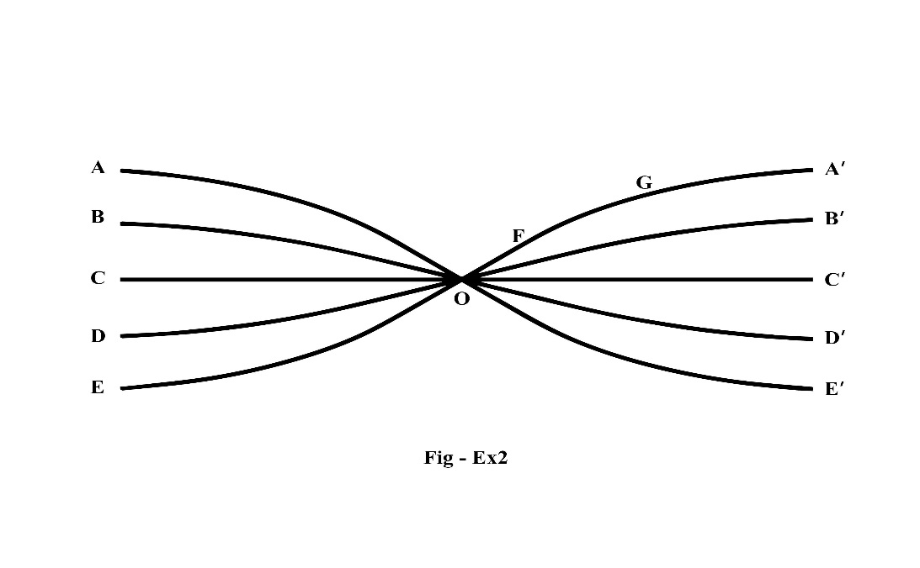

In this model, lines A and E together represent symmetry, resulting in a horizontal straight line, OC’. This line’s position on the Y-axis remains constant as it moves from left to right, representing stability. Conversely, lines A and D together represent asymmetry, resulting in an ascending curved line, OA’. This line exhibits changes on the Y-axis, representing dynamics.

In the video from 1:32 to 1:57, the *Interrelationships Model* not only represents the first law of thermodynamics (the law of conservation of energy) but also embodies dynamics

[**https://www.youtube.com/watch?v=x_5uxiCflc0**](https://www.youtube.com/watch?v=x_5uxiCflc0)

***Limitation-Without Limitation and the Degree of Freedom***

Moving on to the intricate dance of Limitation and Without Limitation within the *Interrelationships Model*, let's explore how these concepts manifest in both serial and parallel fashion.

On the far left of the model, we observe symbolic convergence towards a point along the central horizontal line. As we move towards the right, a new divergence unfolds, creating cycles of convergence and divergence that appear never-ending. This perpetual process is an expression of 'Without Limitation,' a term encompassing two situations: infinity and infinite decimals, presented in a serial form.

The concept of Without Limitation extends its reach in a parallel fashion within the model. Each individual line, representing a specific event or course of events, can branch out into multiple parallel lines or subdivide into smaller lines. This branching and subdividing illustrate how each event can induce or be broken down into multiple events, embodying the continuous and limitless nature of Without Limitation in a parallel fashion. However, it's crucial to note that there is a parallel limitation, as each line can only branch out into a defined number of parallel lines on a specific level.

Therefore, the preceding discussion suggests that every system has its limitations. However, each system can perpetually extend or expand, whether in a serial or parallel fashion, beyond its predefined boundaries. This perpetual extension is an expression of “Without Limitation”.

The limitation in each system is expressed through its boundary or restraint. The system's boundary can be defined by the upper and lower lines connecting two adjacent critical points (such as C1 and C2 in Fig-4). The space between these two lines represents the freedom of the system, and the size of this space determines its degree of freedom. Therefore, freedom and restraint within a system constitute its degree of freedom. Within the confines of a system's boundary, an object is free to move but is restrained by the system’s limits. For example, blood cells can move freely within the space of blood vessels but are restricted by the vessel walls. Similarly, a train can move along railway tracks but is constrained by those tracks; without this restraint, a train would be derailed.

The concept of “Without Limitation” found in both serial and parallel developments leads to the speculation that the universe might be unlimited. However, within a serial relationship, a specific event between two adjacent critical points is limited, marked by the starting and ending points. In a parallel relationship, each line can only branch out into a given number of parallel lines on a particular level, representing a parallel limitation in a system. These observations indicate that every system has its inherent limitations.

Enter the concept of Limitation within each system, expressed by its boundaries or restraints. These boundaries, represented by the upper and lower lines linking adjacent critical points, delineate the freedom of a system. The space between these lines defines the system's degree of freedom, where a larger space signifies greater freedom. Consider the analogy of blood cells freely navigating within blood vessels but restrained by the vessel walls. Similarly, a train moves on railway tracks, constrained by the tracks to prevent derailment.

In essence, the interplay of Without Limitation and Limitation, coupled with the degree of freedom, defines the boundaries and possibilities within every system in the vast and interconnected tapestry of the *Interrelationships Model*.

***Hierarchy***

Building upon the continuous branching discussed earlier, the *Interrelationships Model* seamlessly transforms into a typical hierarchical structure – a fundamental interrelationship captured within the model.

Hierarchical structures are pervasive in the universe, manifesting in various scales and contexts. Take the human body, for example: atoms intricately assemble into molecules, molecules unite to form cells and interstitial substances, cells collaborate to constitute tissues, and the hierarchical pattern continues – tissues construct organs, organs collaborate to build systems, and multiple systems coalesce to form an individual's intricate body system. This intricate web of interconnected components exemplifies the hierarchical structure embedded within the human body.

However, the hierarchical structure is not confined to the realm of the human body alone; it permeates the entire biological landscape. From familial relationships to societal frameworks, hierarchical structures shape the very fabric of existence. The taxonomic system in biology serves as a quintessential example, illustrating the hierarchical arrangement of species into kingdoms, phyla, classes, orders, families, genera, and species.

In essence, the *Interrelationships Model*, through its hierarchical structure, mirrors the inherent order and interconnectedness that characterize the diverse and complex systems present in the universe.

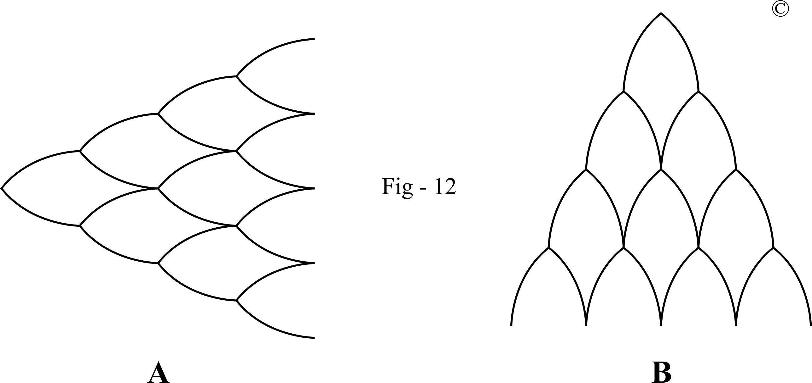

The concept of hierarchical structure isn't confined solely to the organic realm but extends its influence into the inorganic world, orchestrating the organization of subatomic particles into atoms, atoms into molecules, and beyond. This hierarchical dance is evident in the formation of materials, the composition of our planet, and the assembly of celestial bodies within the solar system.[13]

A hierarchical system typically comprises multiple subsystems arranged in both serial and parallel relationships. The serial relationship manifests as serially related levels, while the parallel relationship presents as parallel branches. All subsystems collectively contribute to the integrity of a hierarchical system.

In Fig-12B, the entire hierarchical system is presented in an orderly form, where each subsystem adheres to the same set of order, reflected in consistent size, shape, and orientation. In contrast, Fig-9 displays the entire system in a disorderly form due to subsystems having different sets of orders, reflected in varying sizes, shapes, and orientations

In an orderly system, each subsystem is symmetrical, consisting of two qualitatively and quantitatively symmetrical lines, while in the disorderly system, such symmetry is absent. Therefore, it can be asserted that symmetry is fundamental to maintaining the orderly state of a system. In the orderly system, the integrity of a subsystem is established by one line together with its symmetrically opposite line. This can be interpreted as a constituent line of a subsystem interactively maintaining its symmetrical counterpart in a proper position. Such interaction not only ensures the integrity of the specific subsystem but also plays a crucial role in upholding the overall integrity of the entire system.

This concept of symmetry can be extrapolated to societal structures. The role of symmetry in maintaining order and integrity is evident in the context of society. Consider human nature, where the coexistence of opposite roles of non self-centeredness and self-centeredness forms the integrity of human nature. Non self-centeredness serves as a check on the self-centered aspect. If these forces become asymmetrical, with self-centeredness surpassing non self-centeredness, the integrity of behavioral coherence cannot be maintained.

To preserve order and integrity, the cognitive level, specifically logical thinking, steps in as a higher-level force. Moral and ethical concepts play a crucial role in balancing and controlling the nature of self-centeredness. This represents a higher level of symmetrical force, often referred to as "human behavior internal controlling forces," aimed at regulating self-centered tendencies. Should these internal forces falter in maintaining balance, an even higher symmetrical force, the law enforcement force at the societal level which is termed "external controlling forces," intervenes to keep selfish behavior in check.

From this example, it becomes apparent how symmetry plays a pivotal role in sustaining the order and integrity of a societal system.

***Cohesiveness: the interconnection between the fundamental interrelationships***

All the fundamental interrelationships cohesively exist or simultaneously occur in the development of a system. They are interconnected in a cohesive fashion

As depicted in Fig-12 A, the progression unfolds from left to right in a **serial-parallel** fashion, resulting in multiple levels and branches. The serial aspect expresses cause-effect relationships, while the parallel aspect represents **similarity** resulting from a **common mechanism**, **commonality** and **difference**. Simultaneously, this process manifests as an **expansion** and **divergence**, transitioning **dynamically** from **singularity** to **plurality**. This **transition of state** is illustrated as a single point transforming into multiple lines, signifying an **increase in complexity**.

As the process advances, a **hierarchical system** gradually emerges, wherein **symmetry** and **asymmetry** coexist. In Fig-12 B, the left side is symmetrical to the right side, and the higher level is asymmetrical to the lower level, with the higher level possessing greater power. Within this hierarchical system, a subsystem mirrors the entire system, demonstrating **self-similarity**. Additionally, the **convergence** of lines within a hierarchical system denotes **critical points**, potentially resulting in **order** (as depicted in Fig-12 A and B) or **disorder** (as depicted in Fig-9).

In a subsystem, space represents **freedom**, and demarcation lines symbolize **restriction**. Together, they define the **degree of freedom**. Thus, each subsystem within a hierarchical system has its **limitations**, while the overall developmental tendency of the entire system remains **without limitation –** a concept interpretable as both **discontinuation** and **continuation**. Similarly, the convergent lines can be understood as a form of **contraction**.

In a hierarchical system, a specific portion may exhibit one particular relationship at a given time. However, all these seemingly separate relationships are **cohesively** interconnected. All sub-models can mutually transform. They can undergo dynamic transformations from one type to another, such as from serial to parallel or vice versa, or from serial-parallel to order-disorder. Furthermore, one relationship can encompass others; for instance, a serial relationship may contain parallel relationships, and vice versa. These intricate **interconnections** are facilitated by the arrangement represented in the *Interrelationships Model*.

**2 Representing the Laws of Physics:**



<https://www.youtube.com/watch?v=x_5uxiCflc0>

***Representing and unifying Newton’s three laws of motion***

Newton’s first law states: *“An object at rest remains at rest, and an object in motion remains in motion at constant speed and in a straight line unless acted on by an unbalanced force.”* [14]

In the *Interrelationships Model*, the left side illustrates various forces acting on objects. Curved lines represent these forces, with symmetry between upper and lower lines denoting opposing but balanced forces. On the right side, a horizontal straight line symbolizes the outcome of balanced forces.

To clarify, imagine a Cartesian coordinate system where the horizontal axis represents time (X-axis) and the vertical axis represents the speed (Y-axis). The horizontal straight line on the right side of the model signifies that, over time, the speed remains constant when balanced forces are at play. This mirrors Newton’s first law, as objects maintain their state of motion unless acted upon by an unbalanced force.

By aligning the elements of the *Interrelationships Model* with Newton’s laws, we gain a visual representation of the fundamental interrelationships governing motion and force.

Newton's second law states: *“In an inertial reference frame, the vector sum of the forces F on an object is equal to the mass m of that object multiplied by the acceleration a of the object: F=ma*.” [14]

In the *Interrelationships Model*, the upper curved lines represent the driving force, while the lower curved lines symbolize resistance. When these forces are equal (symmetrical), denoted by A = E, the object maintains its current state – moving in a straight line. However, if the driving force exceeds the resistance, such as A > D, the symmetry is disrupted, and the horizontal straight line transforms into an ascending line, indicating acceleration. This transition aligns with the mathematical equation of the second law, F = ma.

As time progresses, a moving object will eventually reach its speed limit, represented by the line from point G to point A’ levelling off into a plateau in the *Interrelationships Model*. Eventually, the object will lose energy and return to its baseline. This entire process is depicted by the curved lines ascending from one critical point and then descending to the next critical point along the baseline.

By illustrating these dynamics within the *Interrelationships Model*, we can visualize the interplay between forces and motion, demonstrating how Newton’s laws emerge as specific expressions of the fundamental interrelationships.

Newton's third law states: *“When one body exerts a force on a second body, the second body simultaneously exerts a force equal in magnitude and opposite in direction on the first body.”* [14]

In the *Interrelationships Model*, the symmetrical lines above and below the straight horizontal line C represent forces and counterforces, respectively. For example, line A represents the force exerted by one body, while line E represents the counterforce exerted by the second body.

This representation aligns with Newton's third law, where every action is met with an equal and opposite reaction. When one body applies a force on another, the second body responds with a counterforce of equal magnitude but opposite direction. This symmetry in the model reflects the fundamental interrelationship of forces and counterforces in physical interactions.

By visualizing these dynamics within the *Interrelationships Model*, we can better understand how Newton's laws emerge as specific expressions of the fundamental interrelationships governing motion and force.

***Representing and unifying the four laws of thermodynamics***

Zeroth law of thermodynamics: *“If two systems are in thermal equilibrium with a third system, they are in thermal equilibrium with each other.”* [15]

In the *Interrelationships Model*, line A is symmetrical to its mirrored image, line A', which is also symmetrical to line E'. Then, all these lines are symmetrical to each other. This symmetrical relationship between all three lines (A, A’ and E’) represents thermal equilibrium between items, aligning with the principles of the zeroth law of thermodynamics.

First law of thermodynamics: *“Known as the law of conservation of energy, states that energy can neither be created nor destroyed; energy can only be transferred or changed from one form to another.”* [16]

The sub-model in Figure 4 represents the law of conservation of energy, illustrating how energy is transferred or transformed within a system. Therefore, this sub-model also effectively represents the first law of thermodynamics.

Second law of thermodynamics: *“The entropy of any isolated system always increases.”* [16]

The sub-model in Figure 9 illustrates the transition from order to disorder, reflecting the increase in entropy as described by the second law of thermodynamics.

Third law of thermodynamics: *“The entropy of a system approaches a constant value as the temperature approaches absolute zero.”* [16]

Line D' represents temperature approaching absolute zero, while line E' represents entropy approaching a constant value. This alignment with the *Interrelationships Model* illustrates the principles of the third law of thermodynamics.

By visually representing these laws within the *Interrelationships Model*, we can better understand the fundamental Interrelationships governing thermodynamic systems and their interactions.

**3 Representing other theories and phenomena in physics:**

The following discussions continue to explore the applications of the *Fundamental Interrelationships Model* in physics:

Top of Form

***Representing Spacetime Symmetry in Special Relativity***

Spacetime symmetry, a fundamental concept in Special Relativity, can be visualized using the symmetry concept of the *Interrelationships Model*. In Special Relativity, space expands and time contracts, and vice versa. This dynamic interplay between space and time can be represented by the symmetrical interactions within the *Interrelationships Model*.

***Representing Uncertainty Principle in Quantum Mechanics***

*“According to quantum mechanics, the more precisely the position (momentum) of a particle is given, the less precisely can one say what its momentum (position) is. This is (a simplistic and preliminary formulation of) the quantum mechanical uncertainty principle for position and momentum”.* - The Uncertainty Principle, Stanford Encyclopedia of philosophy

The Heisenberg Uncertainty Principle in quantum mechanics, which describes the trade-off between the precision of position and momentum measurements, can be understood through the concept of symmetry in the *Interrelationships Model*. The uncertainty principle highlights the inherent uncertainty in measuring complementary properties of particles, such as position and momentum. This uncertainty is mirrored in the symmetrical nature of *the Interrelationships Model*.

***Representing Grand Unified Theory***[17]

In the Grand Unified Theory, which seeks to unify the electromagnetic, weak, and strong forces, the separation of these forces can be represented by the divergence concept of the *Interrelationships Model*. The moment of separation, where distinct forces emerge, can be depicted using the concepts of critical points and transitions of state within the *Interrelationships Model*.

***Representing Noether’s Theorem***

*“All fine technical point aside, Noether’s theorem can be stated informally: If a system has a continuous symmetry property, then there are corresponding quantities whose values are conserved in time”.*[18]

Noether’s Theorem, which states that for every continuous symmetry in a physical system, there is a corresponding conserved quantity, can be understood through the concept of symmetry in the *Interrelationships Model*. The conservation of quantities over time, as described by Noether’s Theorem, reflects the symmetrical nature of interactions within the *Interrelationships Model*.

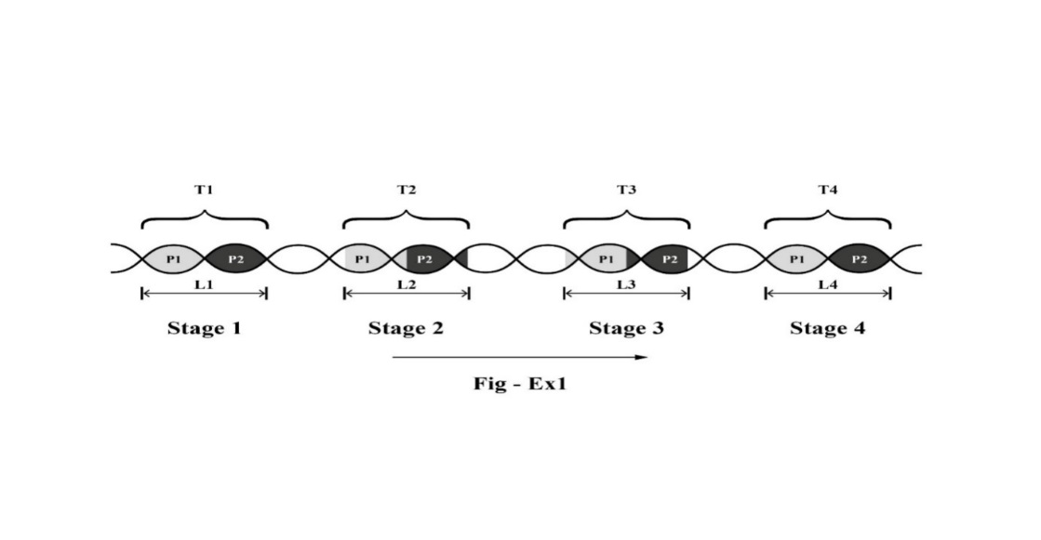

In the above diagram, P1 maintains continuous symmetry with P2, with the volume of P1 always equal to P2 at all stages. T1, T2, T3, and T4 represent the invariant volume of the system at different stages as it transitions from left to right.

***Representing Wave Function Collapse***[19]

Wave function collapse is depicted by the concept of plurality-singularity within the *Interrelationships Model*.

When questioned about the model's applicability to represent wave function collapse, a theoretical physicist responded and expanded upon the model as follows:

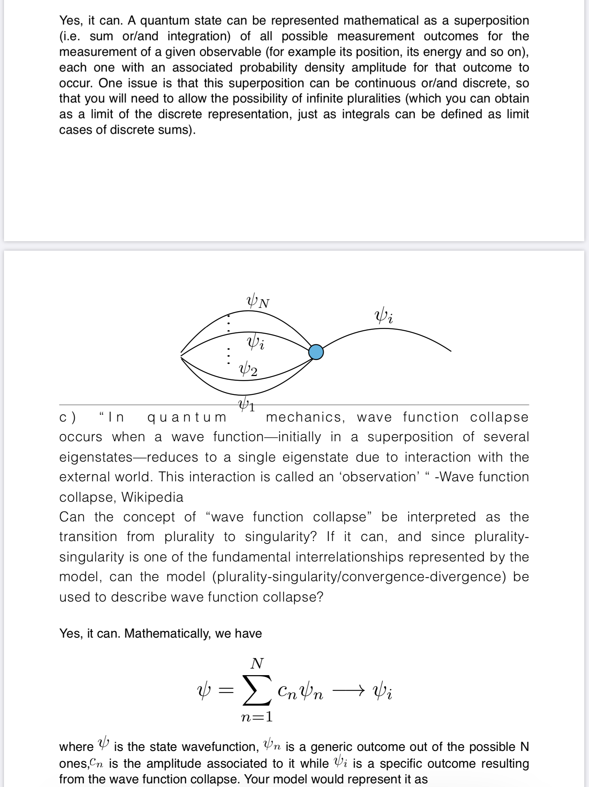

***Representing Chaos Theory***[20]

To elucidate the chaos theory, various sub-models representing different interrelationships are employed here:

*“Self-similarity”*. This principle is encapsulated within the sub-model of hierarchical structure (Fig-12), where each sub-system mirrors the characteristics of the entire system. It underscores the idea that a cell's structure and function resemble those of the human body, and by extension, an individual's role within society reflects the broader societal structure.

*“Constant feedback loops and repetition”*

This concept finds representation in Fig-14 and can also be illustrated by line b in Fig-10.

*“The main idea of chaos theory is that a minor difference at the start of a process can make a major change in it as time progress”.*

This concept can be illustrated using the sub-model of expansion, wherein the initial difference is minor but progressively magnifies over time.

*The butterfly effect:*

*“The butterfly effect, an underlying principle of chaos, describes how a small change in one state of a deterministic nonlinear system can result in large differences in a later state (meaning that there is sensitive dependence on initial conditions). A metaphor for this behavior is that a butterfly flapping its wings in China can cause a hurricane in Texas.”*

a) Utilizing the sub-model representing serial relationship/causality, which essentially embodies the causality within a serial progression.

Top of Form

b) *“How a small change in one state of a deterministic nonlinear system can result in large differences in a later state”.*

Fig-12 A depicts an exponential change, specifically a squared exponential (x^2). This sub-model exemplifies how a small change in the initial state of a deterministic system can lead to a significant difference in the later state. This behavior highlights the system’s nonlinearity.

Top of Form

c) *“Within the apparent randomness of chaotic complex systems, there are underlying patterns, interconnectedness”.*

Although the aforementioned discussion describes a hierarchical system to model the exponential change in chaos theory, this sub-model’s representation with absolute symmetry is unrealistic. In reality, such perfect symmetry is impossible. When asymmetry occurs, the system becomes disordered. Examining such a system reveals all the fundamental interrelationships: serial, parallel, transition of state, critical points, convergence, divergence, and so on. These interrelationships, also known as underlying patterns or interconnectedness, create the impression of a lack of rules, disorder, or chaos within the system.

***Representing some physical phenomena and concepts***

**1)** *Atomic electron transition*

*“Atomic electron transition is a change of an electron from one energy level to another within an atom or artificial atom. It appears discontinuous as the electron “jumps” from one energy level to another in a few nanoseconds or less. It is also known as atomic transition, quantum jump, or quantum leap”.*[21]

Reflected on the *Interrelationships Model*, when a electron’s energy level reaches a critical point (represented by point C), it undergoes a transition of state, “jumping” from one energy level to another. The multiple parallel curved lines in the model can be visualized as representing the electron orbits within an atom. The transition from one obit to another appears discontinuous as the electron ‘jumps’ from one energy level to another. This concept aligns with the model’s continuation-discontinuation principle.

**2)** *Nuclear force*

*“The nuclear force is powerfully attractive between nucleons at distances of about 1 femtometre (fm, or 1.0 x 10-15 metres), but it rapidly decreases to insignificance at distances beyond about 2.5 fm. At distances less than 0.7 fm, the nuclear force becomes repulsive”.*[22]

These changes can be represented by the *Interrelationships Model* as the transition of state.

**3)** *Quantum*

*“In physics, a quantum (plural: quanta) is the minimum amount of any physical entity (physical property) involved in an interaction. The fundamental notion that a physical property may be “quantized” is referred to as “the hypothesis of quantization”. This means that the magnitude of the physical property can take on only discrete values consisting of integer multiples of one quantum”.*[23]

As the concept of discrete falls under the broader concept of limitation and the distance between two adjacent critical points in the *Interrelationships Model* represents limitation, thus, the concept of a quantum can be represented using the *Interrelationships Model*, which imposes limitations on the possible values of physical properties. Hence, the *Interrelationships Model* can represent the idea “*that the magnitude of the physical property can take on only discrete values consisting of integer multiples of one quantum”.*

**4)** *Nuclear fission, nuclear fusion, and particle decay*

Nuclear fission, nuclear fusion, particle decay[24] and radioactive decay[25] (such as alpha decay and beta decay) can be represented by the concepts of transition of state, critical point and convergence-divergence of the *Interrelationships Model*.

Top of Form

**5)** *The similarities between particles*

For instance, protons and neutrons exhibit similarities in their properties, yet they also possess differences.[26] This duality can be effectively illustrated by the concept of similarity within the *Interrelationships Model*, which emphasizes parallel existences based on a common mechanism expressing similarity.

**6)** The dynamic interplay between particle-antiparticle pairs, baryon asymmetry, and the manifestation of positive and negative charges within an atomic system finds representation through the concept of symmetry-asymmetry within the *Interrelationships Model*.

***Unifying the Big Bang theory with the evolutionary theory and beyond***

In 2021, groundbreaking research achieved the first-ever unification of the Big Bang theory with evolutionary theory. This significant development was published in 2022 in the third edition of the book “*Behind Civilization”*, subtitled “*The Fundamental Rules in the Universe*”.

The book explores the fundamental similarities between the evolution of the universe, as described by the Big Bang theory, and the evolution of life. This is self-similarity,[27] signifying that a part of the system is similar to the entire system, as the evolution of life is a component of the broader evolution of the universe.

The mechanism behind these similarities lies in the fact that both events are based on a common mechanism governing everything in the universe. This mechanism is the set of fundamental interrelationships or fundamental laws of physics. All biological features in the evolution of life, including adaptation, natural selection, the driving force of evolution, the transition from unicellularity to multicellularity, the increase of complexity, the last common ancestor, division of labor, coordination, cooperation, and negligible conflict,[28] are simply specific expressions of these fundamental interrelationships. These events can be cohesively represented by the *Interrelationships Model*. In parallel, the events in the Big Bang are also specific expressions of these fundamental interrelationships. In other words, the similarity between these two events arises from both of them adhering to the same set of fundamental interrelationships, notably the cohesive interconnection pattern between the fundamental interrelationships depicted in Fig-12 A and B. Through this, the *Fundamental* *Interrelationships Model*, particularly the hierarchical structure model, unifies the Big Bang theory with evolutionary theory.

The preceding discussions provide insight into the interconnections among fundamental interrelationships, emphasizing their cohesiveness within a dynamic system. This exploration of cohesive dynamics opens the pathway for comprehending the evolution of the universe and the evolution of life at their fundamental level. Based on the aforementioned descriptions, an interpretation is hereby drawn:

The Big Bang theory describes a *dynamic* process from a *singularity* to *plurality* through a *divergent* *expansion* in which a *series of transition of state*, *critical point*, *divergence-convergence*, *expansion-contraction*, *symmetry-asymmetry*, *order-disorder* and *hierarchical* developments *cohesively* occurred.

Singularity expresses as “*the gravitational singularity*”. Plurality expresses as the multifarious diversity of the present-day’s universe. Serial relationship expresses as a series of transition of state from Planck epoch 🡪 grand unification epoch 🡪 electroweak epoch… Expansion is expressed as the spatial expansion of the universe. Divergence expresses as the separation of four forces. Convergence expresses as quarks combining into baryons, baryons combining into nuclei, nuclei combining electrons into atoms… Hierarchy expresses in the structural formation of the universe. All these processes can be cohesively represented with the *Interrelationships Model*.

Similar to the Big Bang, life also originated from a singularity in the form of a common ancestor evolving into the present-day’s plurality of increasingly complex and diversified organisms, with approximately *“1 trillion species currently living on earth”*[29] From a singularity to plurality, the evolution of the universe and evolution of life went through a divergent process as both of them follow the interrelationship of divergence.

In the early stage of this journey, life only existed in the form of unicellular organisms. They replicated themselves and expanded their existence following the interrelationship of expansion. Following the same interrelationship, the evolution of the universe also experiences a similar process of spatial expansion. Cohesively, the fundamental interrelationship of divergence leads to the separation of the four fundamental forces in the evolution of the universe, paralleling the differentiation observed in the evolution of life. In the evolution of life, while the process of divergence was happening, a convergent process also occurred: unicellular organisms converged to form their aggregation, a process similar to quarks converging to form neutrons and protons; molecular gas clouds converge and condense to form galaxies and stars while the universe is expanding. In evolution, life progressively evolved from unicellular, colonial, filamentous, pseudoparenchymatous, and parenchymatous forms.[30] Such serial transitions are similar to the earliest phases of the Big Bang in which transitions occurring from the Plank epoch 🡪 grand unification epoch 🡪 cosmic inflation 🡪electroweak epoch…as both of these processes are governed by the fundamental interrelationships of serial, transition of state and critical point. These two processes are also the expressions of continuation-discontinuation. In the evolution of the universe, the nature of energy continued while the form of energy discontinued. In the evolution of life, life continues while the form of life discontinues.

Cohesively with all these processes, life on Earth continues to evolve hierarchically forming “the evolutionary tree”. *“More complex forms of life took longer to evolve, with the first multicellular animals not appearing until about 600 million years ago.”*[31] This is similar to the *structure formation in the Big Bang model proceeding hierarchically*[32] as both events follow the fundamental interrelationship of hierarchy.

Apart from the aforementioned discussions, embryonic development, technological advancement, social progress, and the entire process of civilization can be represented by this model, as they all follow the same set of fundamental interrelationships.

**4 Representing Social Phenomena:**

Moreover, The *Interrelationships Model* extends beyond natural sciences to encompass social sciences as well. Concepts like justice and humor can be depicted within the model’s framework.

In the context of social decision-making (i.e., legal disputes), the model can illustrate the impartiality of a just decision when parties contribute equally. If two parties have equal contributions, as represented in the model (Fig-Ex2) by lines A and E, then a just decision should be impartial to both. The justice of this decision is represented by the straight line C’ on the right side, which is not biased toward either line A or line E.

Similarly, the model can capture the asymmetry of decisions when contributions differ, aligning with concepts found in Newton's laws of motion. If one party’s contribution is greater than the other, such as if A is greater than D, then the decision should be favorable toward A. This can be represented by the initial section of line A’ (line OF), which moves toward side A and away from D.

This demonstrates that the model can effectively represent social science concepts as well. Notably, the model suggests a common underlying mechanism between social decision-making processes and physical laws like Newton’s first and second laws of motion.

In the realm of humor, the model can reflect the parallelism between drawn images that exaggerate features and real-life figures. This exaggeration, represented by the model, might be a key mechanism that elicits amusement.

**5 An Alternative Approach to the *Theory of Everything*:**

Concepts and their underlying existences are related through a cause-effect relationship. Existence in the objective world acts as the initial cause, giving rise to the concept within the human brain as the effect. Fig-7 exemplifies this, portraying existence on the left and its corresponding induced concept on the right. This demonstrates a symmetrical relationship between the cause and effect. This symmetry is further elucidated in Fig-18, where the inverted hierarchical system represents all existences, while the upright hierarchical system symbolizes their associated concepts. At the central point, C, lies the crux of the inverted hierarchy, embodying the objective fundamental mechanism/fundamental interrelationships of the universe. This point simultaneously, serves as the apex of the upright hierarchy, covering all related concepts. Hence, the corresponding concept to the fundamental mechanism is the set of fundamental laws of physics, envisioned as a *Theory of Everything* (ToE).

Thus, a truly all-inclusive *Theory of Everything* should not only encompass lifeless phenomena and the laws of physics but extend to all facets of life, including intelligence-driven occurrences such as civilization, humour, and justice, as they are an integral part of the dynamic cosmic system - the universe. Therefore, any hypothesis failing to integrate biology and sociology cannot be considered a comprehensive *Theory of Everything*. As such, unlike most existing candidates for a ToE, the *Interrelationships Model* offers a comprehensive framework, covering both lifeless and living phenomena, presenting a viable alternative to address the challenge of a *Theory of Everything*.

**Next article:**

**The *Fundamental Interrelationships Model* – An Alternative Approach to the *Theory of Everything*, Part 2**

***Subtitle: Unifying the Evolution of Multicellularity, Development of Multicellular Organisms, Evolution of Society, Evolution of the Universe and four fundamental forces***

**Bibliography**

[1] Zygote, Wikipedia

[2] Zygote, Wikipedia

[3] Taxonomy (biology), Wikipedia

[4] Felidae, Wikipedia

[5] Sexual Reproduction, Wikipedia

[6] Asexual Reproduction, Wikipedia

[7] Critical Point, Wikipedia

[8] Phase Transition, Wikipedia

[9] Critical Mass, Wikipedia

[10] Human embryogenesis, Wikipedia

[11] Breakup of the Bell system, Wikipedia

[12] Symmetry, Wikipedia

[13] Subatomic Particle, Wikipedia

[14] Newton’s laws of motion, www1.grc.nasa.gov

[15] Laws of thermodynamics, Wikipedia

[16] The Three Laws of Thermodynamics, Introduction to Chemistry. course.lumenlearning.com

[17] Grand Unified Theory, Wikipedia

[18] Noether’s theorem, Wikipedia

[19] The use of the IRM to represent wave function collapse in the form of formalization is credited

to an European theoretical physicist who does not want to be named.

[20] Chaos theory, Wikipedia

[21] Atomic electron transition, Wikipedia

[22] Nuclear force, Wikipedia

[23] Quantum, Wikipedia

[24] Particle decay, Wikipedia

[25] Radioactive decay, Wikipedia

[26] Baryon, Wikipedia

[27] Self-similarity, Wikipedia

[28] Major evolutionary transitions in individuality, PNAS, by Stuart west, Roberta Fisher, Andy

Gardner and Toby Kiers

[29] History of life, Wikipedia

[30] *The origins of multicellular organisms*, by Karl J. Niklas, stuart A. Newman

[31] *How did multicellular life evolve*, by Charles Q. Choi, astrobiology magazine

[32] Chronology of the universe, Wikipedia