The Fundamental Interrelationships Model – An Alternative Approach to the Theory of Everything, Part 3
Subtitle: Medicine Provides a New Paradigm to Understand the Nature of Civilization and the Universe.
Traditionally, the field of medicine has been devoted to safeguarding and enhancing human health. According to conventional wisdom, "Medicine is the science and practice of caring for a patient..."^{[1]}. However, ground-breaking research now suggests a novel perspective: medicine can serve as a gateway to unravel the intricacies of a chaotic society and, unexpectedly, emerge as an avenue to address the most fundamental and intriguing issue of all – a Theory of Everything.
1 The amazing similarity between human body and society
A research initiative that commenced in the mid-1980s unveils the striking similarities between the human body and a society. It is well known that the administration system in society bears a striking resemblance, both structurally and functionally, to the neural system. They both represent the apex of their respective hierarchical systems. Both neural and administration systems exhibit hierarchical organization, where serial orders cascade from the highest to the lowest levels. In both systems, the higher level exercises control over the activities of the lower levels. The brain, particularly the prefrontal cortex, occupies the summit of the neural system.^{[2]} Extending from top to bottom, each level sends nerve fibers to connect with others, while peripheral nerves establish connections with various organs. A similar pattern exists in the social administration system, featuring not only serial levels but also parallel branches dedicated to specific functions.

In addition to neural control, humoral control is another system that maintains the ordered state of the human body, with the endocrine system playing a major role.^{[3]} Considering the endocrine system in the human body, what serves as its counterpart in society? The answer is the financial system. These two systems exhibit remarkable similarities. Hormones circulate in the blood; they are not structural proteins and do not contribute to the construction of tissues and organs. Instead, they signal cells by stimulating receptors, regulating cells' metabolism and functions, such as increasing or decreasing biochemical production. For instance, insulin stimulates glycogen synthesis, while glucagon suppresses it. Growth hormone stimulates protein synthesis for body development.^{[4]}

Similarly, currency circulates in society and does not physically construct any part of the social environment. Buildings are not physically constructed with currency. The role of currency is to regulate the performance of individuals and organizations. For example, currency can regulate the performance of companies, schools, hospitals, and individuals. Investing more currency into these organizations can increase their output. Providing more money to an individual allows him to be more socially active. Reducing the money supply to individuals and organizations can suppress their activity. Just as the normal level of thyroid hormone maintains the normal level of body metabolism, the normal level of currency circulating in society maintains the normal level of 'social metabolism,' or social activity. These examples illustrate that the role of currency in controlling society is analogous to the role of hormones in controlling the human body. From this perspective, currency is not a material substance but rather a signal that regulates 'social physiological activities.

Neural control acts rapidly; for instance, neural reflexes respond promptly to stimuli. On the other hand, endocrine control is relatively slower but has a more prolonged impact.^{[5]} Similarly, executive orders from administration take less time to show effects, while financial measures require more time but also have a long lasting impact.

By comparing the body's control systems with social management systems, intriguing similarities emerge. This opens a new horizon for exploring our society through the lens of medical sciences. In this context, the mechanisms of body control can be employed to study management, akin to using knowledge of the endocrine system for financial research.

In the human body, metabolism comprises two sub-processes: anabolism and catabolism. Anabolism involves synthesizing substances essential for the body's functions and structures, such as proteins, lipids, and glycogens, serving as building materials and energy sources. Conversely, catabolism encompasses activities that consume substances and energy, such as immune responses and the heart's pumping action, both vital for the body's survival. These activities highlight that while not all bodily processes produce substances and energy, they are all geared towards ensuring survival. The neural and endocrine systems play a crucial role in coordinating catabolism and anabolism to maintain a delicate balance.

In society, production and consumption mirror the interconnected processes of anabolism and catabolism. They constitute integral components of social activities. Production serves as the source of energy and materials, essential for constructing the infrastructure of our environment and facilitating various social functions like healthcare, defense, and education. These activities collectively aim to maintain social integrity and ensure the survival of society.

Similar to the body's system, there is an autonomous mechanism that balances social “anabolism” and “catabolism”. Economic theory posits that consumption stimulates production, akin to muscle exercises where energy consumption increases muscle catabolism. However, this also leads to muscle anabolism, signifying an elevated synthesis of muscle protein. ^{[6]}

Although these processes are generally regulated by their autonomous mechanism, demand and supply, the government also plays a crucial role in their regulation, especially in situations where the supply-demand mechanism may falter. For instance, if consumption fails to stimulate production due to a complete lack of production capability, direct government intervention becomes necessary.

“Social neural system” influences “social endocrine system”
One crucial method through which a government regulates “social metabolism” is via its treasury and finance departments, influencing the financial system. This plays a pivotal role in the government's social coordination. Considering the endocrine system is parallel to the financial system, and the neural system is parallel to the administration, it is evident that the impacts of the neural system on the endocrine system are similar to the government’s influences on the financial system.

The neural system can regulate the activities of the endocrine system, allowing indirect control over the body's activities. Consider the following: hormones are synthesized and stored in glands, being released in an orderly manner in normal situations under the influence of neural, endocrine, and other biochemical controls.^{[7]}, circulating in the blood. Similarly, currencies are issued by central or federal reserve banks and stored in financial institutions like banks and investment entities. They are released into and circulate within society, guided by government policies and various social factors.

The hypothalamus, as a component of the neural system, can release hormones to influence a crucial endocrine gland - the pituitary gland. The pituitary gland, in turn, releases hormones that affect various endocrine glands like the thyroid gland, adrenal glands, ovaries, and testes.^{[8]} Drawing a parallel, the treasury, as part of the governmental system, establishes financial policies that indirectly impact the interest rate of the reserve bank. The role of the reserve bank is akin to that of the pituitary gland in the endocrine system, exerting influence on the interest rates of commercial banks. Similar to endocrine glands releasing hormones to affect bodily activities, commercial banks release currency - the "social hormone" - into social circulation, influencing "social metabolism" and the functions of "social organs."

By comparing these two parallel systems, we gain a clearer understanding of how a government coordinates related subsystems in social activities through the financial system. These relationships are depicted in the following diagram, Fig – 20:

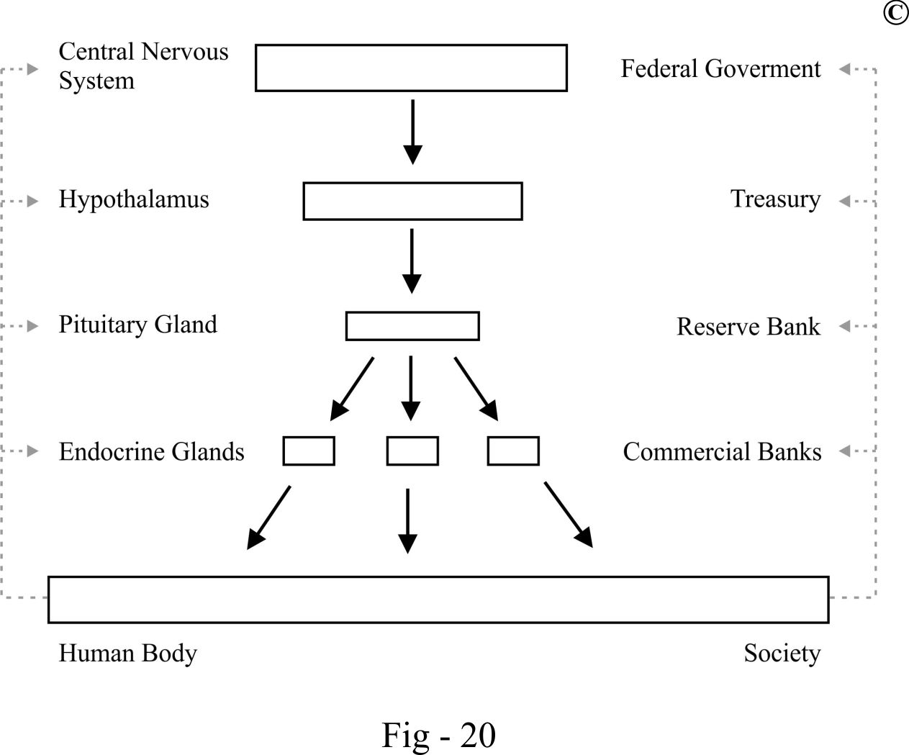

Through the control of "social hormone" release, a government can stimulate or suppress the "metabolism" of certain social subsystems and further regulate their roles in society. Utilizing "endocrine control" approaches such as fundraising, controlling money supply, interest rates, taxes, and even price control, a government can manage social metabolic activities. This process bears similarities to the neural system's influence on the endocrine system to further control the body's activities.

If an excessive amount of currency is released into a society, it can significantly stimulate an economy. Injecting more currency into consumption may lead to increased demand, consequently stimulating increased production. However, this excessively heightened demand may result in an overheated economy. If production cannot keep up with demands, it may lead to price increases and currency depreciation (inflation), negatively impacting demand. This hyper-dynamic "social metabolism" is akin to hyperthyroidism.

On the other hand, if more currency is injected into production, it may increase the supply to meet consumption. If there isn't enough demand, particularly if there is insufficient currency for consumption, and demand decreases after being met, product prices may decline (deflation). This could negatively impact production and cause economic contraction, representing a hypo-dynamic "social metabolism" similar to hypothyroidism. Thus, without proper government control, an economy may start with overheating and end with recession. Therefore, a mechanism to control production and consumption is necessary.

In this mechanism, the government plays a crucial role in maintaining the balance between demand and supply to address these "social metabolic disorders." One approach involves controlling the release of currency into society.

In the hyper-dynamic "social metabolism," the government's approach is akin to the treatment of hyperthyroidism. Similar to using medications to suppress the release and synthesis of thyroxin, the government will apply strict monetary policies to reduce currency released into society by raising interest rates, tightening loans, and reducing money supply.

On the other hand, insufficient thyroxin in the body will cause hypothyroidism, a hypo-metabolic disorder. A patient will experience a lack of energy, fatigue, and other symptoms. Similarly, insufficient currency circulating in society may cause social disorder such as low economic growth or even recession – a "social hypothyroidism."

In a more severe situation, the lack of adrenal cortical steroid hormone in Addison’s disease can cause acute adrenal crisis, resulting in serious damage to the body or even death. Likewise, suddenly withdrawing large amounts of currency from an economy can cause the economy to collapse. If the government does not provide “medical intervention”, the situation will deteriorate, leading to severe social crisis.

To address this “social metabolic disorder,” the government's approach mirrors the treatment of endocrine disorders, utilizing supplemented hormones to restore normal physiological order. During economic recession, the government may inject more currency into society by lowering interest rates, encouraging spending, increasing money supply, and, in some cases, resorting to printing more money. These actions reflect the parallels between how society handles economic disorders and how the human body manages metabolic imbalances.

Given the parallels between the impact of the endocrine system on the human body and the influence of the financial system on society, it becomes apparent that the significance of financial institutions, such as banks and investment funds, mirrors that of the major endocrine glands on the body. Much like their corresponding departments in administration, these financial entities play a pivotal role in shaping and sustaining the overall health and functioning of the respective systems.

2 The mechanism behind the similarities
Why are there amazing similarities between a human body and a society? This is a fundamental question about the nature of similarity.

Similarity is a prevalent phenomenon in the universe, emerging from the interplay of commonality and difference. For instance, domestic cats and tigers both belong to the cat family, sharing numerous common biological features while exhibiting distinct differences. Similarly, potassium and sodium, both metallic elements, demonstrate common properties of metals but differ significantly in terms of chemical reactivity.

Fundamentally, similarity is the manifestation of a parallel relationship grounded in a common mechanism. Put simply, if entities display similarity, they must possess a shared mechanism. For instance, identical twins are similar due to their identical DNA sequences (with extremely minor differences). Likewise, potassium and sodium showcase metallic properties because of their common characteristic: fewer electrons in the outer orbit, a hallmark of metallic elements. Therefore, we can infer that all entities displaying similarity are interconnected through a common mechanism.

Representing similarity, the Interrelationships Model offers a visual depiction, as illustrated in the diagram below. Building on the concept of similarity, it can be effectively represented using the Interrelationships Model, facilitating a comprehensive understanding of the interconnectedness of entities in the universe.

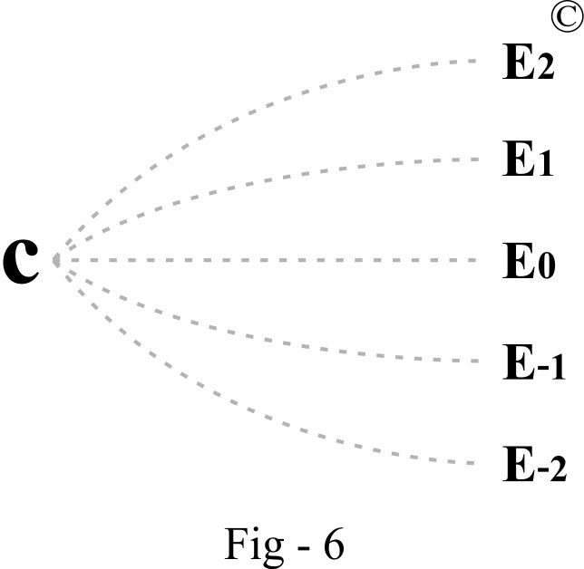

In the presented diagram, C represents a common mechanism, which is intangible. Entities such as E0, E1, E2, E-1, E-2 symbolize parallel existences with similarity. Dotted lines denote intangible links between these parallel existences and the common mechanism. The distance between the parallel lines signifies relative similarity, with greater distance indicating more difference and less commonality, and a shorter distance indicating greater commonality and less difference.

This model effectively explains the phenomenon of similarity. Applying it to the example of a group of trees, seemingly independent parallel trees are interconnected through a common point –the abstract common mechanism, C. While intangible, this mechanism finds expression in physical existence. For instance, the common genetic coding shared by these trees is an abstract component of the common mechanism. The arrangement of molecules in this genetic coding serves as the physical expression of the abstract mechanism.

Extending the model to life forms, any life form is essentially a unique expression of biology. All living things, including bacteria, viruses, amoeba, plants, insects, mammals, birds, fish, and humans, are parallel biological existences based on the common mechanism of life. They share common characteristic features such as reproduction, competition, and metabolism - the commonality - while also exhibiting their unique features, the differences.

A unicellular organism and a colony of multicellular organisms both manifest universal life features. For instance, reproduction, competition, and metabolism are evident, but they can also display vastly different characteristics. Animals increase their numbers through sexual reproduction,^{[9]} whereas most bacteria and viruses multiply strictly through asexual means.^{[10]} Most animals breed during specific times of the year, whereas human beings are sexually receptive year-round. Sexual receptiveness can even be induced medically, as humans are willing to invest vast resources in the development, mass production, and marketing of drugs such as Viagra.

Whether a single cell, an individual, or a group of individuals, similarities exist, but none are exactly the same. Therefore, both commonality and difference coexist.

Similarity is an integral part of the fundamental interrelationships which govern everything in the universe. For a deeper exploration of these interrelationships, please see the previous article, "The Fundamental Interrelationships Model: An Alternative Approach to the Theory of Everything."
https://philarchive.org/rec/HUATFI
3 Applying medical knowledge to understand technological development
The nature of civilization is social evolution which is in parallel to an individual’s development. Being a part of the social evolution, technological development is in parallel to an individual’s development. Thus, using medical knowledge, including anatomy, physiology and embryology to predict technological development is theoretically valid.

It is now widely agreed that the Industrial Revolution was a mechanical revolution represented by the steam engine. Then, what is the relationship between the Industrial Revolution and a human body?
The nature of civilization is social evolution, which parallels the development of an individual. Technological advancement, as a crucial part of social evolution, also mirrors an individual's growth and development. Consequently, using medical knowledge, such as anatomy, physiology, and embryology, to predict the trajectory of technological progress is theoretically valid.
Consider the Industrial Revolution, widely recognized as a mechanical revolution symbolized by the advent of the steam engine. One might ask: what is the connection between the Industrial Revolution and the human body?
Today, human beings no longer need to walk to reach destinations thousands of kilometers away; we simply drive cars. In this scenario, the car’s wheels serve as a substitute for human legs. But what powers these wheels? The engine. Similarly, what powers human legs? The muscles. This illustrates that the engine acts as an external supplement to human muscles.
Human muscles are integral to the musculoskeletal system, which comprises muscles, bones, cartilage, tendons, ligaments, joints, and connective tissue^{[11]}. Since the invention of the steam engine, mechanical devices have increasingly supplemented various components of the musculoskeletal system. For instance, cranes and bulldozers replicate the functions of human arms, while cars and ships mimic the actions of human legs. However, these devices are not merely supplementary; they represent an external revolution of the musculoskeletal system. This revolution has endowed humanity with unprecedented power to achieve our desires. Today, a set of engines can propel a 300,000-ton oil tanker—a scale of power that far surpasses the intrinsic capabilities of the human body.
What, then, is the technological revolution that follows the Industrial Revolution? Unlike machines with mechanical functions, computers do not perform any mechanical tasks. They are not products of the Industrial Revolution. Instead, their primary function is computation, acting as external aids to the human brain. The brain is part of the neural system, which operates in parallel to the musculoskeletal system. Thus, it can be concluded that the technological revolution symbolized by computers is fundamentally different from the Industrial Revolution. It represents an external revolution of the neural system.
When examining the essence of the Industrial and Information Revolutions, we notice that both externally aid the human body. The Industrial Revolution involves external enhancements to the musculoskeletal system through machinery, while the Information Revolution externally supplements the capabilities of the human neural system via computers and digital technology. They both are the external revolutions of the human body. Since these are external revolutions, then what is the internal revolution of the human body? The answer is genetic engineering because this technology internally alters the biological structure of humans at the most fundamental level. Genetic engineering not only affects humans but also extends to all living organisms, leading to what is termed the "Biological Revolution."
However, the Biological Revolution is not parallel to the information revolution and the industrial revolution on the same level. Instead, it parallels the lengthy process of biological evolution that began with the origins of life and culminated in the development of human beings. This evolutionary process endowed humans with intelligence far superior to other living creatures. It is this superior intelligence that empowers human beings with absolute dominance as the ruler of the animal kingdom. It is also this superior intelligence that reduces other living species to extinction in the competition for survival. It is this intelligence that allows civilization to flourish in human society. This change broke the power balance in the biological world, bringing profound ramifications and irreversibly changing the power structure in the animal kingdom.
Historically, intelligence and evolution were driven by environmental pressures and were not within the control of any species. However, genetic engineering introduces the unprecedented ability to enhance intelligence and other traits at will. This marks a significant shift where humans can guide their own evolution based on their desires. In this context, humans have assumed a role akin to that of a creator, wielding a power previously attributed only to divine beings, becoming the holders of a fearsome power that is second only to God’s.
Strictly speaking, humans that emerge through genetic engineering are no longer "human" in the traditional sense but rather "human derivatives." This revolution, therefore, signifies a profound transformation with fundamental implications for the future of humanity.
The evolution of the information network and the human neural network are parallel processes underpinned by a common mechanism. This parallelism allows us to draw insightful comparisons between them. By leveraging our understanding of the anatomy, histology, embryology, and physiology of the neural system, we can better analyze and predict the trajectory of the information revolution.
Development of the Neural System
During embryonic development, the formation of the neural system begins with the "production" of neurons through the division of precursor cells known as glial cells. These newly formed neurons then migrate to their designated locations within the developing organism. Following this migration, neurons extend their nerve fibers, axons and dendrites,^{[12]} to establish connections with other neurons, forming an intricate neural network.

As the network matures, nerve fibers innervate target cells, creating a complex system that links various parts of the body together.^{[13]} This neural network performs a multitude of essential functions. It supports logical thinking, which guides human behavior, and memory, which facilitates the storage and retrieval of information. By conducting electrical impulses, the neural network senses environmental stimuli and transmits command signals to target cells, enabling appropriate responses to external conditions. The overarching goal of these functions is to maintain the orderly functioning of the body.

In this dynamic system, the neural network is responsible for controlling and coordinating the body’s activities, ensuring that all parts work harmoniously. This intricate coordination mirrors how modern information networks operate, linking various digital components to process, store, and transmit data efficiently.

Development of the “External Neural System”

When we explore the parallel relationship between the human neural system and the “external neural system” - comprising computers, networks, and digital devices - it's intriguing to consider how these technological advancements might reflect similar developmental and functional processes. What can we infer about the “anatomical structure,” “embryonic development,” and “physiological functions” in this “external neural revolution”?

The “Embryonic Development” and “Anatomical Structure” of the “External Neural System”:
In the context of this analogy, any device equipped with an electronic chipset, such as a computer, can be thought of as an “external neuron.” Just as neurons are generated and then migrate to specific locations in the body, these devices are manufactured in factories and then distributed to their intended locations within society.

During the development of the human neural system, neurons connect with each other through synapses and extend their nerve fibers (axons and dendrites) to various parts of the body, including muscles, organs, skin, and glands. Similarly, the "external neurons" in our analogy - computers and digital devices - start to network and establish connections with each other, forming an expansive web that innervates individuals and “social organs” such as companies, schools, hospitals, and other societal structures.

The functionalities of the “External Neural System”:
This “external neural system” performs functions analogous to those of the human neural system. The human neural system is responsible for logical thinking, memory storage, and transmitting information across the body. In parallel, the “external neural system” encompasses capabilities like artificial intelligence (logical thinking), databases (information storage), and communication networks (information transmission). How remarkably similar these systems are!
Artificial Intelligence (AI) in information technology is the function of logical thinking analogous to the human brain. This facet of technological advancement stands as the most important cornerstone of the Information Revolution, with its influence surpassing all other breakthroughs within the information era. Even the transformative impact of the Internet, whose primary role is to facilitate the transmission functions of the "external neural system," pales in comparison to the potential of AI.
Currently, while computers are not yet capable of creative thinking on par with the human brain, history suggests that technological advancements often outstrip human capacities in specific domains. For example, the steam engine revolutionized human muscle power, achieving levels of force unattainable by human strength alone. Similarly, computers already surpass human memory in terms of storage capacity and outpace the brain in certain aspects of processing speed. These precedents indicate that AI is on a trajectory to eventually exceed human intelligence. In the future, the comparison between human intelligence and artificial intelligence is akin to comparing the muscle power of a human body with the colossal engine power of a 300,000-ton oil tanker.

Once artificial intelligence reaches full maturity, the “artificial brain” can automatically input information from the “external sensory system” and retrieve information from the “external memory system” for various thinking processes, including analytical thinking, problem solving and decision making. As a result, the “artificial brain” will output new concepts of invention and discovery. It will automatically instruct various “social organs” to perform social functions and will be able to adjust its instructions according to the feedback. Social management will be under the control of such an intelligent network. Its tasks will include automatically and precisely managing every aspect of social activities, ranging from personal to the whole society. When such an independent system is developed, it indicates the Information Revolution has come to its maturity.

The scale of this intelligent system may vary, from autonomous robots to expansive networks managing entire societies. Until AI reaches maturity, human intelligence will remain the primary force behind societal management. However, with the advent of fully developed AI, these systems will operate independently. The integration of the “External Neural System”, “External Musculoskeletal System” (mechanical devices), and innovations from the Biological Revolution will culminate in the creation of artificial humans - products of human desires. These entities will possess autonomous functionality, capable of self-maintenance and continuous development. Their unparalleled capabilities in information collection, storage, and analysis will far exceed those of their human counterparts.

The evolution of the information revolution mirrors the developmental trajectory of the nervous system. “Cephalization” also happen in information revolution and is expressed as increasing number of more powerful chipsets “packed” into servers in networks, resulting in more powerful servers and further a more powerful network.

The human neural system and the “external neural system” both embody complex networks designed to process and relay information. While the former does so through biological means, the latter achieves similar outcomes through technological constructs. Both systems facilitate the coordination and operation of their respective domains - the body in the case of human neural networks and society in the case of external digital networks.

Not only do biological evolution, social development and information revolution development display similarities, they also have similarities to the development of a human individual from the embryonic stage onwards. All of these similarities are the expressions of parallel relationship of these four existences.
It has come to my attention that certain aspects of the “external neural system” description may no longer reflect current understanding as the outcome of the primary research on this topic originated in the late 1980s and early 1990s.
For further exploration of how medical knowledge can be use3999999d to understand society and explore philosophy, particularly through the lens of fundamental interrelationships, please see the book, Behind Civilization, Third Edition, subtitled "The Fundamental Rules in the Universe."
Bibliography
[1] Medicine, Wikipedia
[2] 1) Principles of neural science 5th edition, Eric Kandel and etc.; 2) Frontal lobe, Wikipedia; 3) Executive functions, Wikipedia;
[3] Human physiology, from cells to system 8th, Lauralee Sherwood
[4] Textbook of chemistry with clinical correlations 7th edition, Thomas M. Devlin
[5]Advanced biology, by Michael Roberts, Michael Jonathan Reiss, Grace Monger, published by Walton-on-Thames: Nelson, 2000
[6] Resistance exercise increases postprandial muscle protein synthesis in humans, Witard OC, Tieland M, Tipton KD, van Loon LJ, Koopman R. Med Sci Sports Exerc, 2009 Jan; 41(1) 144-54. 10.1249/MSS.0b013e31818844e79
[7] 1) Hormone, Wikipedia; 2) Harrison’s principles of internal medicine, 18th edition; 3) Medical physiology 2nd edition W. F. Boron, E. L. Boulpaep
[8] 1) Harrison’s principles of internal medicine, 18th edition; 2) Principles of neural science 5th edition, Eric Kandel and etc.
[9] 1) Guyton and Hall Textbook of Medical Physiology Twelfth edition, by John E. Hall, PhD; 2) Principles of neural science 5th edition, Eric Kandel and etc.
[10] Asexual reproduction, Wikipedia
[11] Human musculoskeletal system, Wikipedia
[12] Principles of neural science 5th edition, Eric Kandel and etc.
[13] Principles of neural science 5th edition, Eric Kandel and etc.
[14] Embryology, Fertilization, Rebecca Oliver; Hajira Basit, National Library of Medicine
[15] Taxonomy (biology), Wikipedia
[16] Felidae, Wikipedia
[17] Phase transition, Wikipedia
[18] Critical mass, Wikipedia
[19] Fertilization, Wikipedia
[20] Breakup of the Bell System, Wikipedia
[21] Principles of neural science 5th edition, Eric Kandel and etc.
[22] Star system, wiki
[23] The origins of multicellular organisms, by Karl J. Niklas, Stuart A. Newman, National Library of Medicine

