The Importance of Leadership and Its Connection to Motivation and Reward

Executive Summary
Berwick Estate Agent Ltd was founded in 2005, in Minnesota as a limited liability company which offers services in buying properties especially houses. Our team provides comprehensive marketing and sales services to a wide array of clientele. Our team, with its office spread across United States, handles every aspect of sales, right from negotiations to making a sales deed. Ours is a fully integrated company that includes dedicated marketing team. To date our company has been involved in the sale of hundreds of real properties valued in excess of millions of dollars. The company is led by Jane, its founding principal along with Anthony Brian, David Allen, Susan Archer and Robert Footnote. Last year Berwick Estate was also awarded a contract to procure two bedroom apartments for a famous Fortune 500 company staff.
We continuously search for prime houses and apartments across all asset classes. As the real estate industry is all set for another growth, the market is saturated with buyers, resulting in a highly competitive environment and record-setting prices. Success in real estate is linked to local knowledge of markets; laced with in-depth wisdom of local property market our marketing personnel provide valuable insight not available to most of other real estate agencies.
Management Summary
Mrs. Jane is a graduate of the University of Stony Brook. She has had extensive experience in the real estate business, first with South Realty in San Francisco, CA and then later for Frontline, where she became head of operations. She brings with her a huge experience in real estate business especially in the housing sector.

Our Services
We offer a very comprehensive real property buying and mortgage services under one roof. We have a reputation for giving our valued clients the best houses at prime location across United States. We offer total services to facilitate the purchasing of real estate including:
An upto date online database
Most competitive quotes
Mortgage consulting
Approval of loans
Title transfer
Courtesy

Mission
As a full service real estate company, the mission of Berwick Estate Agent is to provide efficient and honest real estate services in a way which makes our clients happy and satisfied.
Objectives
Our objective is to attract and retain the retirement age couples who are on the lookout for a peaceful community which offers prime services to such age group and income levels. Our first priority is to help the buyer get a prime property at a realistic price.

Leadership style and motivational mix
When an organization is born, a leader is required to steer it to success. It is the leader whose leadership can make or break the organization. What is leadership in actuality? It is the attitude and manner through which one provides direction to implement plans and achieve goals by way of a tremendous amount of motivation which he pours into the hearts and minds of his people. This was found by Kurt Lewin (1939) who led a group of researchers to identify various manners and styles of leadership. "This early study has been very influential and established three major leadership styles.” (Lewin, LIippit, White,1939).
There are a lot of arguments in support and against the effective leadership styles; for example there are situations where one assumes that the best way to lead is an authoritarian leadership style, which is not considerate to fellow workers opinions. But the authoritarian leader creates low motivation and morale amongst workers, they remain un-inspired and the result is poor outcome. A charismatic leader on the other hand becomes like a 'guru' to his colleagues and in turn they are so much inspired that they become reliant on the leader, whose absence may spell doom. Because leadership is motivation and leaders are born to motivate, effective style of leadership is very important.
With all these pros and cons, one believes that no one leadership styles is the best. In order to be the best leader, one must be a flexible and considerate leader and that is probably the best leadership style. (Hammill G. Mixing and Managing Four Generations of Employees, 2012)
Leaders are so called leaders because they have the ability to sway emotions which in turn enhances productivity. Driving the emotions positively, a leader can bring out everyone’s best which is known as resonance. Creating resonance through positive emotions e.g., enthusiasm, passion, excitement, fun, provides the foundation for people to turn into a 'super performer'. But when these emotions are negative, it slows down productivity and is known as dissonance. A wise leader creates the environment for productivity to flourish. We believe in resonance and a resonant leader.
There is the famous Abraham Maslow’s theory of motivation. Maslow theory reinforces the importance of knowing peoples' behavior and function in order to motivate them. Maslow introduced five levels of needs: (Motivation: Emily R. Lai, A Literature Review)
Psychological needs
Safety needs
Social needs
Ego needs
Self-actualization needs
To climb up the scale of needs, it is necessary to complete level one first. People’s final aim is to reach the level of self-actualization. Once at this level they try to be whatever they wanted to be by trying to give their best in every outlook. It is wise to praise the employees for their work done with some incentives. Even if one employee is at the highest level of competence it does not however means he or she is also that much motivated. Motivation happens when an employee is satisfied within a job environment.
Maslow’s hierarchy of needs, as critics say, should have fewer levels; because it is impossible for even the very hard working employee to reach the highest level. Furthermore, motivation is a necessity for every employee and it is essential to recognize motivation techniques to get the best production possible. (http://www.shirlawsonline.com/editorials/51-motivation-and-leadership-styles)
Similarly there is another famous motivation theory. This is the Herzberg’s Two-Factor Theory of Motivation. Herzberg’s Two-Factor Theory of Motivation which states that if the given factors are non-existent at workplace, then they lead to dissatisfaction. This factor means to pacify the employees and do not make them dissatisfied. It includes:
Pay: It should be reasonable and acceptable
Company policies and administrative policies: They should not be too rigid rather fair, like flexible working hours, vacation, and etcetera.
Fringe benefits: Healthcare benefits for the family of the employee etcetera.
Working conditions: A safe and hygienic working environment.
Relations: The relationship of the employees’ superiors and subordinates must be acceptable.
Job Security: Every employee should have job security.
Motivational factors:
Herzberg states that the above factors are not the only motivators. The motivational factors are:
Recognition: Reorganization for employee for their accomplishments.
Sense of achievement: There must be a reward of some sort in the work
Growth and promotional opportunities: Advancement opportunities motivate the employees to work to their full potential.
Responsibility: Employees should be given ownership of the work.
Compensation Package:
When we say compensation package we should consider fairness. A fair wage can be determined in a fast and easy way which will help to establish compensation guidelines for the businesses. The easiest was asking other employees in similar businesses to determine the "market" value for a specific job. An individual’s performance should be evaluated over time so as to avoid excessive risk-taking.( http://www.managementstudyguide.com/herzbergs-theory-motivation.htm)
Today it is not enough to give someone a basic paycheck and say 'so far so good'. Now it is all about offering greater equity and additional and rewarding benefits and perks. We have to choose Pay Scale to benchmark salaries. And being a new entity giving some equity is also an optional part of the total compensation package. Because employees turn excited when then come to know that they have partial ownership. Pay for Performance remains a good option to reward the sales people who perform exceptionally well.
Sales Team Members and their customized compensation package:
1. Anthony Brian
2. David Allen
3. Susan Archer
4. Robert Footnote.

Details of the Sales team:
Name | Gender | Age | Marital  Status | Culture | Depen-dents | Tenure | Personality | Education
Jenny | F | 49 | D | Aust | 1 | 12 yrs | Reserved, ambitious, confident | High School
Anton | M | 25 | M | NZ | 1 | 11 mths | Competent, assertive, adventurous | Uni
Melissa | F | 22 | S | Aust | 0 | 3 yrs | Extroverted, sociable, intelligent | TAFE  Diploma
Leigh | M | 31 | M | Asian | 2 | 6 yrs | Serious, smart, ambitious | Uni

There are various theories regarding employees’ motivation. One of such theory states that there should be a complete faith by the employees that effective performance will lead in getting certain rewards. Like if a particular target is achieved it will lead the employee to a bonus and appraisal from others. This theory also says that the rewards offered should be attractive for some of the employees while others would be pleased with a fringe benefit, such as pension, being offered as this will help them with retirement security at an old age. This theory goes on to add that the employees must have firm belief that a considerable level of individualistic effort is surely going to help achieve the corporation's standards of performance. (http://www.articlesbase.com/organizational-articles/motivation-reward-system-and-the-role-of-compensation-1308078.html)
Employee's satisfaction is related to what he expects and how much he gets. Our organization has retained above-average talent and demanded higher levels of output and productivity to get the premium compensation and greater success. Companies which pay above the market packages have higher retention rates and productivity. Every study that has been carried out on the importance of pay packages versus other potential rewards has proved that pay is of prime importance. Pay package ranks among the best of awards an employee can get. We would however, adopt this strategy at the base-pay level by offering highly competitive salary package. We have followed the normally used tool to assign salary packages to the team. (Robert H. Making the Job Offer, 2013)
Considerable evidence is given about the fact that making the link between work and value usually activates motivation, as stated by the Wharton Professor Adam Grant.
In an experiment, by Adam Grant, which is known as the call center experiment, it was seen that the span of time on phone went up by nearly142% and the revenues jumped from 171% to 400%. Adam Grant in his other experiment also noticed a 33% jump in volume of product used when the healthcare providers' hand washing benefits were correctly positioned for the patients. (http://smartblogs.com/leadership/2013/05/09/finding-the-motive-in-motivation/)

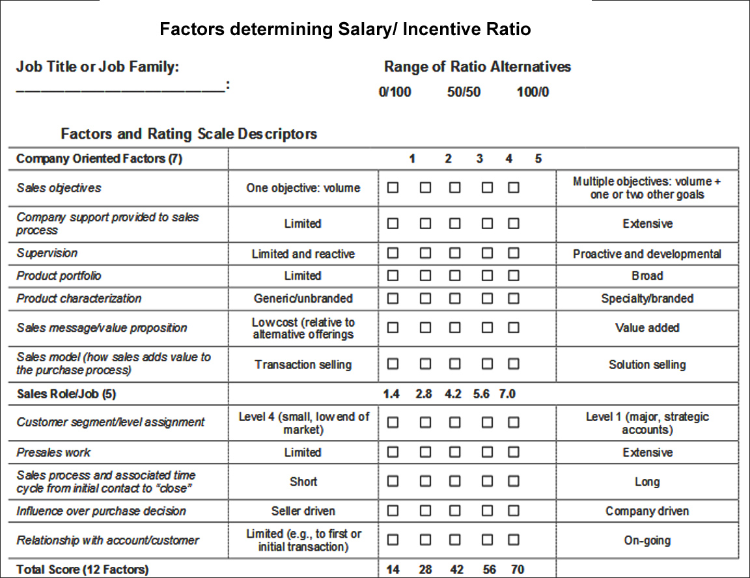
2002 Colletti-Fiss, LLC

Compensation package for the team members:
The median salary for a typical Real Estate Sales Agent in the United States is approximately $40,000/= hence to attract and retain our sales force we have increased it.
Salary: $50,000 per year
1. Customer Contracts: To be given a commission of 5% of the Total Contract Value.
2. Customer Renewals: To be given a commission of 2.5% of the Total Contract Value.
3. Corporate Contracts: To be given commission and plus 1% increase
Commission is calculated on the sales amount. A commission of 50% is to be paid in the very next commission pay cycle. 50% commission that remains will be paid when an order is fully executed and payment received.
Achievement % Low | Achievement % High | Rate of Commission
0.00% | 100.00% | 5
100.00% | 124.99% | 6
125.00% | 149.99% | 8
150.00% | Over | 10

In this scenario which relates to us, the commissions to be paid are calculated when sales amount is multiplied by the rate of commission. The matrix which is used to determine the commission rate is given under. For determining the level of achievement or attainment, we have to compare the credit transaction of each member against quota which helps us determine the attainment or achievement levels. These determined rate will also apply to prorated transaction amounts.. (Office of Human Resources, Handbook of compensation planning).
Sales compensation plan level is related to the expertise of the salesperson, because the more experienced the sales fellow is the more developed skills he has and hence his productivity. (Spiro, McGraw Hill Answers).
New Business Incentive
We will also pay ‘New Business Incentive’ which is to be paid based on getting more business by the Sales team in their territory for the month.
No of units sold | Amt per New unit in range.
1-10 | 100
11-20 | 200
21 and above | 300

As a team leader, I recognize that market positions change in the course of time and so does the company. Therefore a sales compensation plan must reflect our company's evolution in its business environment. This type of plan is required because we are just new and want to expand our reach and revenues. We will, in the course of time, when we introduce new products and services, strive to match the culture by a new compensation plan at that time.
Legalities
Before paying commissions and incentives we have to understand the legalities. Clear definitions in a sales compensation and commission plan are crucial. Like what happens if a sales fellow has collected too many draws with no sales. Similarly most states, so far as compensation packages and incentives are concerned, are governed by each State’s Labor Laws. Although they vary from state to state but are set by the US Department of Labor. (US Dept. of Labor: Wages). For example in New Mexico, if a real estate salesman doesn’t sell a single unit, the employer is bound to pay the salesperson minimum wage. This is the reason that we have checked with local Department of Labor to ensure we are following labor laws on employee payouts. Leadership alone is not the end. What we require is Leadership, Management, Command, and Control. Every leader should understand this because if used properly, the business will grow. Leadership drives the interpersonal aspects of the organization, such as moral and team spirit. Management deals with the conceptual issues of the organization. Command guides the organization; while control provides structure to the organization in order to make it more efficient.

References:
EQ Leader Inc. Retrieved May 15th, 2013.http://www.eqleader.net/six_leadership_styles.htm
Mind Tools. Leadership Style Matrix: Retrieved May 15th, 2013
http://www.mindtools.com/pages/article/leadership-style-matrix.htm
Leadership Styles: Retrieved May 15th, 2013
http://www.nwlink.com/~donclark/leader/leadstl.html
Kendra Cherry. Psychology: Retrieved May 15th, 2013
http://psychology.about.com/library/quiz/bl-leadershipquiz.htm
Sarah L. Fogleman. Creative compensation. Retrieved May 15th, 2013 http://nature.berkeley.edu/ucce50/ag-labor/7article/article33.htm
Colletti-Fiss. Factors Determining the Salary/Incentive Ratio: Retrieved May 15th, 2013 http://www.reliablegrowth.com/incentive_mix.pdf
Article Base. Retrieved May 15th, 2013, http://www.articlesbase.com/organizational- articles/motivation-reward-system-and-the-role-of-compensation-1308078.html
Leadership Blog. Retrieved May 15th, 2013
http://smartblogs.com/leadership/2013/05/09/finding-the-motive-in-motivation/
Handbook for Compensation Planning Office of Human Resources
Spiro. McGraw Hill Answers: Retrieved May 15th, 2013
http://answers.mheducation.com/marketing/sales-management/sales-force-compensation
Management Study Guide: Retrieved May 15th, 2013
http://www.managementstudyguide.com/herzbergs-theory-motivation.htm
Shirlaws: http://www.shirlawsonline.com/editorials/51-motivation-and-leadership-styles
Robert H. Making the Job Offer. Retrieved on 17th May, 2013:
http://www.roberthalffinance.com/JobOffer
Hammill G. Mixing and Managing Four Generations of Employees: EduMag, 2012
Retrieved on 17th May, 2013: http://www.fdu.edu/newspubs/magazine/05ws/generations.htm
Motivation: Emily R. Lai, A Literature Review: Retrieved on 17th May, 2013
http://www.pearsonassessments.com/hai/images/tmrs/Motivation_Review_final.pdf

US Dept. of Labor: Wages, Retrieved on 17th May 2013
http://www.dol.gov/dol/topic/wages/lastpaycheck.htm

